**EMP191 Rocket Lab 2**

Warren Yuan

28 September 2018

**Abstract:**

Students made circuit boards with transistor chips, LEDs, and resistors and capacitors. They learned how to solder the components to the circuit boards, and measured voltage afterwards. With the recorded data, students investigated the time differences between components flashing, and used the data to make inferences on the frequency of the flashing lights.

**Introduction:**

In this lab we learned better how to use a oscilloscope, while also applying more skills on Matlab. We learned how solder the boards and troubleshoot, and we measured the voltage across different components on the board to understand how it works.

**Measurement procedure:**

While the actual soldering of the board proceeded quite nicely, the board had some issues and did not work initially. I came back on Friday, and it turned out it was an improperly connected battery cable. Other than that, I followed the procedure carefully

**Plots of data:**

Figure 1 Figure 2

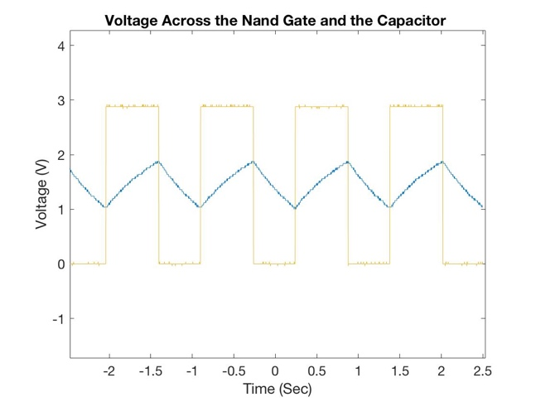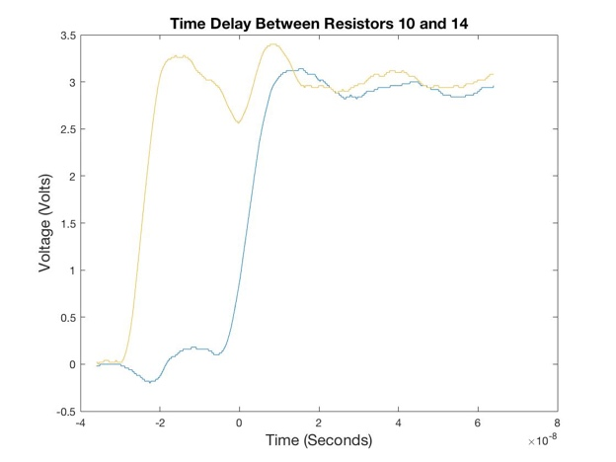

**Analysis results:**

c) i) Looking at figure 1, the clock frequency is approximately 1 flash per second. F = number of flashes/second.

ii) The high levels for the NAND Gate are around 3 volts (this makes sense because we have two 1.5V batteries, so the system has 3volts). The low level of the NAND Gate is 0 volts.

d) ii) The time difference between the blue and the yellow graph (figure 2) (which represent R10 and R14, LED Q3 and Q1 respectively) is about 2 to 4*10^(-8) seconds or 20 through 40 nanoseconds.

iii) The Texas Instrument source lists propagation delay for the chips as 3.3-5 nanoseconds–since there are four LEDs, we multiply that range by 4 to get a range of 13.2-20 nanoseconds, which overlaps with the data we got.

**Conclusions:**

I have definitely become more confident in my usage of Matlab and the Oscilloscope, and I found that Nick and Junyi (and most of all Professor!) have been really useful resources for me to ask questions. I also successfully troubleshooted the circuit board with their help, so I learned a bit of lab resilience.