Industrial Internship Report on
”Full-stack Project of e-commerce platform for delivery of automotive parts ”
Prepared by
Ayush Bisht
Linkedin profile: https://www.linkedin.com/in/ayush-bisht-593434380/

Executive Summary
This report provides details of the Industrial Internship provided by upskill Campus and The IoT Academy in collaboration with Industrial Partner UniConverge Technologies Pvt Ltd (UCT).
This internship was focused on a full stack project of developing a e-commerce platform for delivering automotive parts provided by UCT. I had to finish the project including the report in 6 weeks’ time.
My project was about making a website for delivering of automotive parts in which Users can login and select the components to buy and make payments for it
This internship gave me a very good opportunity to get exposure to Industrial problems and design/implement solution for that. It was an overall great experience to have this internship.

TABLE OF CONTENTS
- Preface .................................................................................................................
- Introduction .......................................................................................................
  - About UniConverge Technologies Pvt Ltd .....................................................
  - About upskill Campus.....................................................................................
  - Objective ........................................................................................................
- Problem Statement ............................................................................................
- Existing and Proposed solution ..........................................................................
- Proposed Design/ Model ...................................................................................
- Performance Test ...............................................................................................
......................................................................................
- My learnings .......................................................................................................
- Future work scope .............................................................................................

➢ Preface

Project Summary: AutoParts Hub

❖ Project Title
A full stack e-commerce platform for delivering automotive spare parts

❖ Project Overview
AutoParts Hub is a full-featured web-based platform that allows users to. browse, search, and purchase automotive parts online. It supports user registration, shopping cart, order management, and admin features. The project uses the MERN stack (MongoDB, Express.js, React.js, Node.js) and is styled using Bootstrap 5 for a modern UI.

❖ Modules by Week

Week Module Description
- Project Planning + Folder Setup Tech stack setup, folder structure, requirements gathering
- Backend API & MongoDB Integration RESTful API, product schema, database connectivity
- Frontend Setup + Product UI React app setup , Axios calls, Bootstrap cards
- Cart System (placeholder), UI Enhancements Bootstrap styling, structure improvements
- Admin Panel & Product Management (optional) Add/edit/delete products, CRUD functionality
- Testing, Deployment (future scope) Bug fixes, documentation, deployment to Render/Netlify

➢ Introduction
❖ About UniConverge Technologies Pvt Ltd
A company established in 2013 and working in Digital Transformation domain and providing Industrial solutions with prime focus on sustainability and RoI.
For developing its products and solutions it is leveraging various Cutting Edge Technologies e.g. Internet of Things (IoT), Cyber Security, Cloud computing (AWS, Azure), Machine Learning, Communication Technologies (4G/5G/LoRaWAN), Java Full Stack, Python, Front end etc.
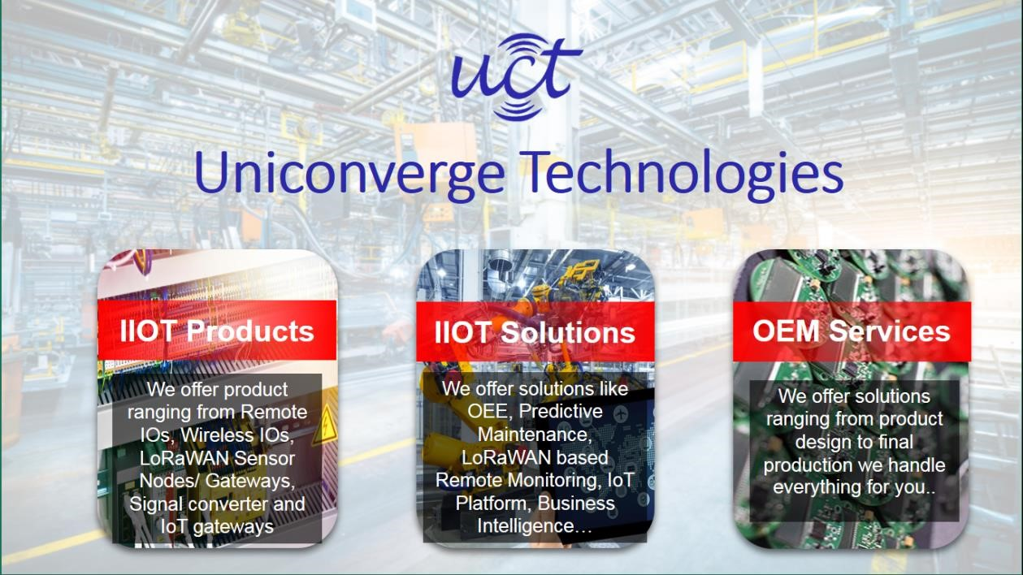

i. UCT IoT Platform ()
UCT Insight is an IOT platform designed for quick deployment of IOT applications on the same time providing valuable “insight” for your process/business. It has been built in Java for backend and ReactJS for Front end. It has support for MySQL and various NoSql Databases.
- It enables device connectivity via industry standard IoT protocols - MQTT, CoAP, HTTP, Modbus TCP, OPC UA
- It supports both cloud and on-premises deployments.
It has features to
- Build Your own dashboard
- Analytics and Reporting
- Alert and Notification
- Integration with third party application(Power BI, SAP, ERP)
- Rule Engine

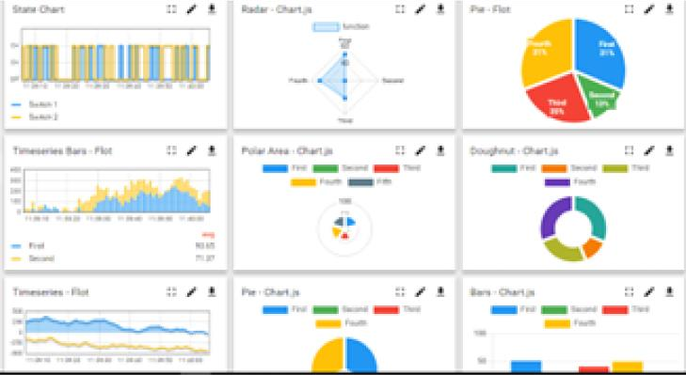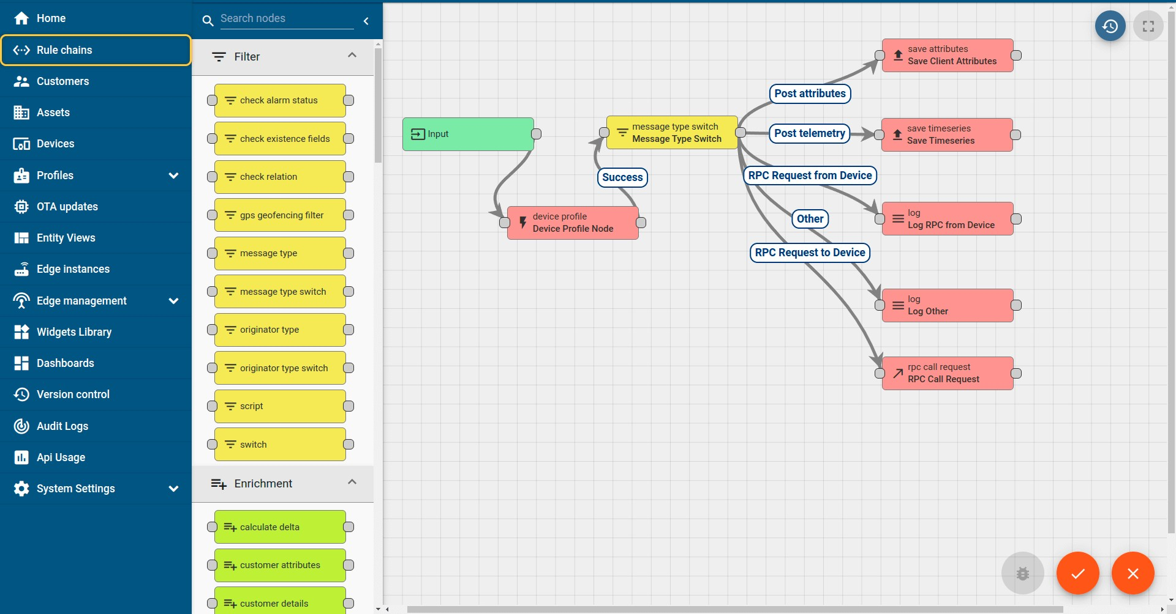

ii. Smart Factory Platform ()
Factory watch is a platform for smart factory needs.
It provides Users/ Factory
- with a scalable solution for their Production and asset monitoring
- OEE and predictive maintenance solution scaling up to digital twin for your assets.
- to unleased the true potential of the data that their machines are generating and helps to identify the KPIs and also improve them.
- A modular architecture that allows users to choose the service that they what to start and then can scale to more complex solutions as per their demands.
Its unique SaaS model helps users to save time, cost and money.
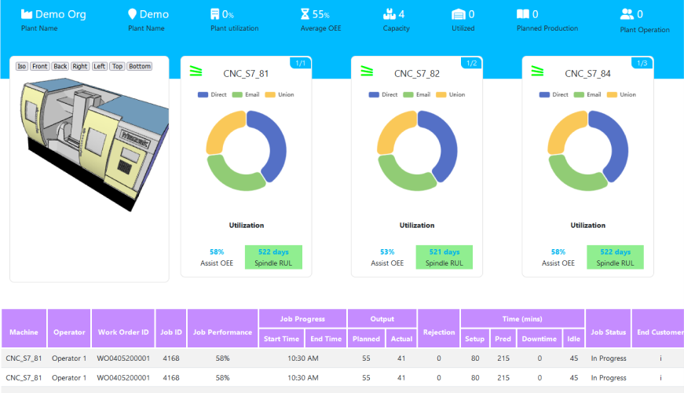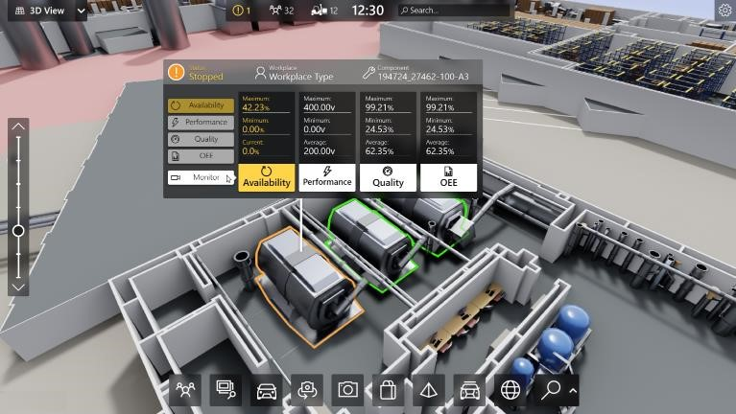

iii. 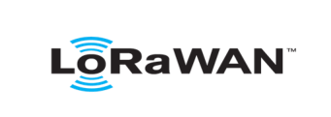 based Solution
UCT is one of the early adopters of LoRAWAN teschnology and providing solution in Agritech, Smart cities, Industrial Monitoring, Smart Street Light, Smart Water/ Gas/ Electricity metering solutions etc. iv. Predictive Maintenance
UCT is providing Industrial Machine health monitoring and Predictive maintenance solution leveraging Embedded system, Industrial IoT and Machine Learning Technologies by finding Remaining useful life time of various Machines used in production process.
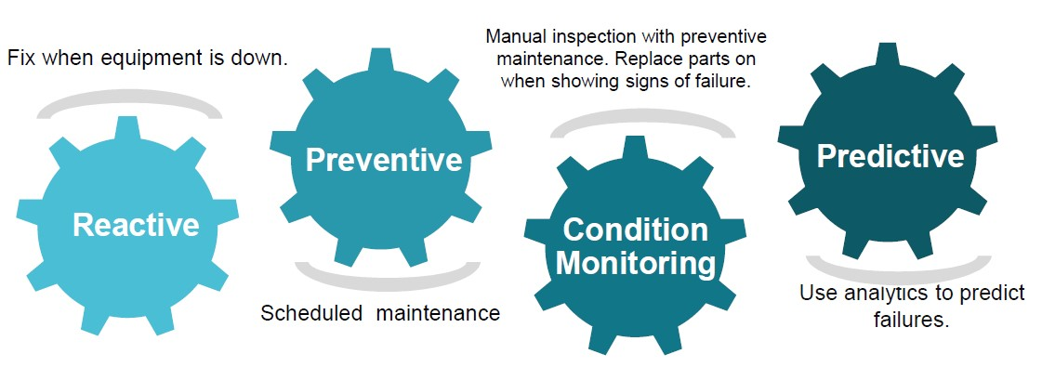
6.1 About upskill Campus (USC)
upskill Campus along with The IoT Academy and in association with Uniconverge technologies has facilitated the smooth execution of the complete internship process.
USC is a career development platform that delivers personalized executive coaching in a more affordable, scalable and measurable way.

upSkill Campus aiming paced manner along-with

Seeing need of upskilling in self
to upskill 1 million additional support services e.g. learners in next 5 year
Internship, projects, interaction with Industry experts, Career
growth Services
https://www.upskillcampus.com/

Career growth/upskilling
Interview Preparation
and skill building
upskilling Courses
Skill Assessment
Profile building
Professional networking
Alumni
Connections
Mentorship
Discussion/QA
forum
Collaboration platform
Project
collaboration
Discussion forum
Tech updates
Job/internship platform
Job portal
Internship portal
Freelancing
projects

- The IoT Academy
The IoT academy is EdTech Division of UCT that is running long executive certification programs in collaboration with EICT Academy, IITK, IITR and IITG in multiple domains.

- Objectives of this Internship program
The objective for this internship program was to ☛ get practical experience of working in the industry.
☛ to solve real world problems.
☛ to have improved job prospects.
☛ to have Improved understanding of our field and its applications.
☛ to have Personal growth like better communication and problem solving.

Problem Statement
For this Industrial Internship I was given a problem statement of developing a e-commerce platform for delivering automotive parts in which user can login and select items to order and can do successful payment of the order

Existing and Proposed solution
- User Features:
- Browse automotive products
- Responsive product listing with Bootstrap cards
- View product details
- Add to cart (cart system can be added)
- Persistent shopping experience
- Checkout with address details (payment integration possible)
- Account view with order history (future scope)
- Admin Features (To be expanded):
- Add/update/delete products
- View orders
- Inventory management

Code submission (Github link) : https://github.com/Ayush90405/upskillcampus-final-report
Report submission (Github link) : https://github.com/Ayush90405/upskillcampus-final-report

Proposed Design/ Model
Tech Stack

Layer Technologies Used
Frontend React.js, Bootstrap 5, Axios
Backend Node.js, Express.js
Database MongoDB with Mongoose
Auth (future-ready) JWT, bcrypt (placeholders ready)
Styling Bootstrap 5
Tooling npm, Git

Performance Test

How to Run
• Backend:
cd server npm install npm start
• Frontend:
cd client npm install npm start
App runs on:
- React frontend: http://localhost:3000

- Node backend: http://localhost:5000/api/products
• Conclusion

This 6-week full stack project demonstrates the development of a scalable and functional e-commerce platform for automotive parts. It covers frontend and backend integration, user and admin functionality,
secure payments, and a modern user experience. The platform is ready for further feature enhancements and scaling.

➢ My learnings

Week 1 – Requirement Analysis & Project Planning

Objectives:
- Understand client requirements.
- Finalize the scope of the automotive e-commerce platform.
- Create technical roadmap.

Activities:
- Identified two primary user roles: Customer and Admin.
- Defined key modules: User Auth, Product Listing, Cart, Orders, Payments, Admin Panel.
- Selected MERN stack (MongoDB, Express.js, React.js, Node.js).
- Sketched wireframes and user journey flows using tools like Draw.io or Figma.
- Set up GitHub repository and organized folder structure.
- Divided development into six weekly phases.

Outcome:
- Clear vision and structure for the project.
- Roadmap ready with defined deliverables per week.

Week 2 – Backend Setup & Database Design

Objectives:
- Build a scalable and secure backend.
- Design MongoDB schema.

Activities:
- Initialized Node.js project and installed dependencies (express, mongoose, bcryptjs, jsonwebtoken, dotenv).
- Created MongoDB models: User, Product, and Order.
- Built REST APIs for user auth and product listing.
- Tested APIs with Postman.

Outcome:
- Backend server running locally with functioning APIs and MongoDB integration.

Week 3 – Frontend Setup & UI Development

Objectives:
- Set up React frontend and build user interface.

Activities:
- Initialized project using create-react-app.
- Installed axios, react-router-dom, redux, redux-thunk.
- Built reusable components: Navbar, Footer, Product Cards, Login/Signup Forms.
- Implemented routing and global state management.
- Connected frontend with backend API.

Outcome:
- Functional and responsive frontend for users to browse and view products.

Week 4 – Checkout, Payment & Order Handling

Objectives:
- Enable cart management and payment integration.

Activities:
- Implemented Add to Cart and Remove from Cart functionality.
- Integrated Stripe for secure payment processing.
- Created checkout form and order confirmation screen.
- Stored orders in MongoDB after successful payment.
- Users can view their order history.

Outcome:
- Fully working checkout system with payment and order tracking.

Week 5 – Admin Panel & Inventory Management

Objectives:
- Add admin features for managing products and orders.

Activities:
- Developed admin dashboard to create, update, and delete products.
- Enabled order status update features.
- Protected admin routes with role-based access.
- Added stock and inventory management.

Outcome:
- Admin can now manage catalog and monitor order processing.

Week 6 – Testing, Deployment & Documentation

Objectives:
- Finalize and launch the project.

Activities:
- Performed unit and integration testing on backend APIs and frontend components.
- Deployed backend on Render and frontend on Vercel.
- Used .env files to configure environment-specific settings.
- Verified responsive UI and functional behavior across devices.
- Compiled documentation including this project report and deployment guide.

Outcome:
- Project is live and production ready with complete documentation.

➢ Future work scope

Future Scope
- Add authentication with JWT
- Add secure payment gateway (e.g., Stripe)
- Admin dashboard with charts and metrics
- Product filtering (by make/model)
- Reviews, ratings, and search intelligence

