Emotion Recognition using deep neural

Network

Amit Yadav[1]

Computer Science and Engineering

Noida Institute of Engineering and Technology

Greater Noida, India

0201csml114@niet.co.in

Anurag

Computer Science and Engineering

Noida Institute of Engineering and Technology

Greater Noida, India

Ag075261@gmail.com

Anand Gupta

Computer Science and Engineering

Noida Institute of Engineering and Technology

Greater Noida, India

ayadav102301@gmail.com

Dr. Vikas Sagar

Computer Science and Engineering

Noida Institute of Engineering and Technology

Greater Noida, India

drvikas.sagar@niet.co.in

*Abstract*—Emotions are one of the maximum essential detail which determines in predicting the human nature and information the human behaviour. Though it is an easy task for human being for recognizing human’s emotion but it is not the same for a computer to understand. And so let a research is being conducted to predict the behaviour correctly with higher precision and accuracy.

This paper demonstrates the real time facial emotion recognition in one of the seven categories o emotion that are angry, disgust, fear, happy, neutral, sad and surprise. We are using a simple 4-layer Convolution Neural Network(CNN). We also have implemented various filter and pre-processing to remove the noise and also have taken care of over-fitting the curve. We have tried to improve the accuracy o model by applying various filters and optimizing the data for feature extraction and obtaining the accurate data prediction. The dataset used for testing and training is FER2013 and the proposed trained model gives an accuracy of about 73%. Keyword: Emotion Recognition, Convolution Neural Network(CNN), pre-processing, Over-fitting, Optimization, features extraction.

# I INTRODUCTION

Emotion constitute an important part in processing human behaviour. Understand human behaviour and predicting it can revolutionize the business model of our society. The ability to understand these emotion will play a role in understanding non-verbal communication. The makes use of emotion popularity is limitless , think about a case whilst a dealer will without problems realize whether or not the consumer appreciated the product or now no longer or

with the aid of using how a whole lot have he appreciated it. This definitely has a massive marketplace capacity to be discovered .. Not only this is also has huge potential in

security, robotics, surveillance, marketing, industries and a lot.

It may be very smooth for a human to recognize other’s emotion via way of means of searching at his face, the mind robotically does the work, however the case isn't for a device to carry out. It want to do numerous calculation and carry out numerous algorithms and optimize numerous records units to teach the model..

In recent year scientists have developed various algorithm like K nearest neighbour (KNN), Decision Tree (DT),

Probabilistic neural network(PNN), Random Forest, Support Vector Machine, Convolution Neural Network(CNN) etc.

In this paper we have use four convolution layers with rectified Linear Unit (ReLU) as activation function. The proposal model undergoes a series of pre-processing and feature detection and feature extraction using techniques such as Haar Cascade. We have sorted over-becoming the version through growing out after each layer. It may be very smooth for a human to recognize other’s emotion via way of means of searching at his face, the mind robotically does the work, however the case isn't for a device to carry out. It want to do numerous calculation and carry out numerous algorithms and optimize numerous records units to teach the model. In recent year scientists have developed various algorithm like K-nearest neighbour (KNN), Decision Tree (DT),

Probabilistic neural network(PNN), Random Forest, Support Vector Machine, Convolution Neural Network(CNN) etc.

This paper purpose a CNN architecture because it has shown better results in contrast to different algorithms in area of emotion popularity with more accuracy an precision.

In this paper we have use four convolution layers with rectified Linear Unit (ReLU) as activation function. The proposal model undergoes a series of pre-processing and feature detection and feature extraction using techniques

such as Haar Cascade. We have taken care of over-fitting the model by developing out after every layer. And the proposed version is skilled with FER2013 statistics set and the beat software program rating out of seven emotion expression as bathe as discover result.

II LITERATURE SURVEY

Various deep gaining knowledge of and system gaining knowledge of setoff rules are being applied and numerous peoples are running on unique algorithm.[36][37][38][39]

|  |  |  |  |  |
| --- | --- | --- | --- | --- |
| Date& Year | Member Name | Problem Description | Possible Solution | Reference |
| 2017 | Jiaxing Li, Dexiang Zhang, Jingjing Zhang, Jun Zhang, Teng Li, Yi Xia, Qing Yan, Lina Xun | Facial Expression  recognition | Faster R-CNN  (Faster Regions with Convolution Neural Networks Features) | The school of Electrical Engineering and Automation Anhui University, Hefei 230601,  China |
| 2017 | Xuan Liu, Junbao Li, Cong Hu,Jeng-Shyang Pan | Age and Gender Classification with Facial Image | D-CNN  (Deep Convolutional Neural Networks) | Harbin Institute of Technology, Harbin 150080,China  Fujian University of Technology, Fuzhou 350108, China |
| 14th-16th March,  2018 | Raghav Puri, Mohit Tiwari, Archit Gupta, Nitish Pathak, Manas Sikri, Shivendra Goel | Emotion Detection Using Image Processing | Using Python (version 2.7) and Open Source Computer Vision Library (Open CV) and numpy | Electronics & Communication Engineering Bharati Vidyapeeth’s College of Engineering New Delhi, India |
| 2018 | Liu Hui,  Song Yu-jie | Research on face recognition algorithm | F-CNN  (Fisher Convolutional Neural Networks)  P-SVM  (Profile Support Vector Machine) | College of Information Science and Engineering Wuhan University of Science and Technology Wuhan, China |
| 2013 | Christopher Pramerdorfer, Martin Kampel | Facial Expression  recognition | Using Convolutional Neural Networks | Computer Vision Lab, TU Wien Vienna, Austria |
| 2020 | Huibai Wang,  Siyang Hou | Facial Expression Recognition | The Fusion of CNN and  SIFT Features | College of Information Science and Technology North China University of Technology Beijing, China |
| 2020 | Chen Jia,  Chu Li Li,  Zhou Ying | Facial expression recognition | Ensemble learning of CNNs | School of Electronics and Information Engineering, Liaoning university of technology JinZhou, China |

|  |  |  |  |  |
| --- | --- | --- | --- | --- |
| ­­­­­­­Date  &  Year | Member Name | Problem Description | Possible Solution | Reference |
| 30th May,2021 | Lutfiah Zahara, Purnawarman Musa, Eri Prasetyo Wibowo, Irwan Karim, Saiful Bahri Musa | Facial Emotion Recognition (FER-2013) Dataset for Prediction System of Micro-Expressions Face | Using the Convolutional Neural Network (CNN) Algorithm based Raspberry Pi | Department of Computer Science Gunadarma University Depok, Indonesia |
| 25th-27th May, 2018 | Xuefeng Liu, Qiaoqiao Sun, Yue Meng, Congcong Wang , Min Fu | Feature Extraction and Classification of Hyperspectral Image | 3D- CNN  (3D-Convolution Neural Network) | College of Automation & Electronic Engineering, Qingdao University of Science and Technology, Qingdao, China |
| 2018 | Yi Dian, Shi Xiaohong,  Xu Hao | Dropout Method of Face Recognition | Using a Deep Convolution Neural Network | Shanghai Maritime University china, Shanghai 1241975543@qq.com |
| 2019 | Gu Shengtao,  Xu Chao,  Feng Bo | Facial expression recognition | Global and Local feature fusion with CNNs | School of Electronics and Information Engineering, AnHui University |
| 26th-28th July, 2017 | Kewen Yan , Shaohui Huang, Yaoxian Song, Wei Liu1 , Neng Fan | Face Recognition | Using Convolution Neural Network | School of Automation, Hangzhou Dianzi University, HangZhou 310018 |
| 2017 | Ahmed Ali Mohammed Al-Saffar, Hai Tao, Mohammed Ahmed Talab | Image Classification | Deep Convolution Neural Network | Faculty of Computer Systems and Software Engineering University Malaysia Pahang Pahang, Malaysia |
| 21st-23rd November, 2019 | George-Cosmin Porușniuc, Florin Leon, Radu Timofte, Casian Miron | Architectures for Facial Expression Recognition | CNNs  (Convolutional Neural Networks) | “Gheorghe Asachi” Technical University, Iași, Romania University of Eastern Finland, Joensuu, Finland , ETH Zurich, Zurich, Switzerland |

# III DATA SET

# The data set used for training is FER2013, which is open source dataset contains 25,887 48X48 pixel grayscale images of different emotion into seven categories that are angry, disgust, fear, joy(happy), neutral, sad and surprise respectively. The CSV contain 2 columns in which the first columns contains the emotion cable from 0-6 and the second columns contains string surrounded in quote. The string pixel value of the image

## Fig. 1. Sample taken form FER2013 data set

Fig. 2. Face detection and Feature extraction

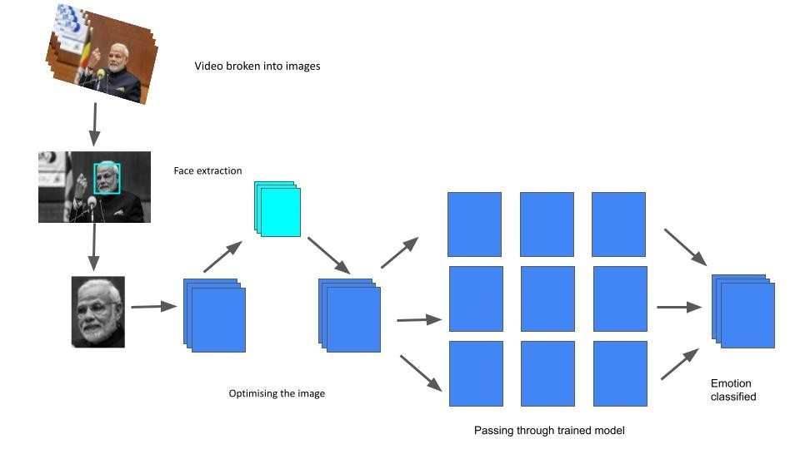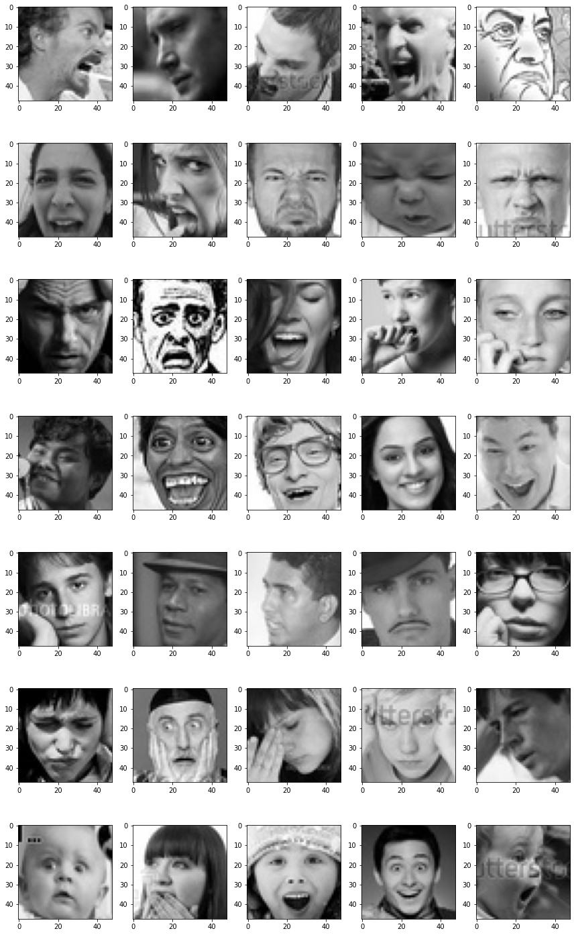

* The FER2013 dataset is divided into two directories

i.e.,

1.train

2. test

* Each of them consists of seven sub-directories which are further divide into seven sub categories.
* Each subdirectory contains images of specific expressions taken from various sources

IV METHODOLOGY

Now we discuss various methods which we have used for predicting the emotion.

We went through several steps to extract data and find faces and then run them through the trained model, which is based on the CNN architecture.[12]

*A. Face and Feature Detection*

This is one of the early stage of image processing where we break the video into pictures and then process image by image and try to detect face and if multiple face are found it will work on that also. Before face and Feature extraction we are resizing the frames and converting the image in 48x48 pixel and convert into greyscale. Then we are using OpenCV for Face detection.[9][10][11][13]

For thi**s,** we use the Harr Cascade classifier fromOpenCV**.** The classifier is quite effective and works flawlessly which was proposed by Paul Viola and Michael Jones in 2001. .[5][6][7][8]

*B. Feature Extraction*

In this step, the maximum 8 critical components of the face are extracted and cut the eyebrows, eyes, nose, chin, mouth and jaw and are used and optimized for greater precision. The extracted data is saved in numpy format. for example in Fig. 2. green part of the face is extracted and is cropped and it is stored in numpy format and later on it is passed to the ANN layers for extraction and processing .[20][24][26][27][29]

## *C. CNN architecture*

The next step is to develop the cape and for that we got used to CNN. In deep learning, a convolutional neural community (CNN, or ConvNet) is a category of synthetic neural community, maximum usually implemented to research visible imagery. Convolutional neural community consists of a couple of constructing blocks, inclusive of convolution layers, pooling layers, and completely related layers, and is designed to analyse spatial hierarchies of functions robotically and adaptively via a backpropagation algorithm. It was first proposed by a scientist Yann LeCunn who was inspired by the way humans could the encircling [31][32][35] and understand them. CNNs have proved itself to have greater success in the research area of Facial Emotion Recognition(FER) because they could perform feature extraction and image simultaneously with high precision, making it the ideal methodology for image the classification.[14][15][16][17][18][21]

VI IMPLEMENTATION

We have Trained the model on Train data set available in the FER2013 i.e., 28709 in numbers and for testing purpose we have reserved 7178 pictures which again is in FER2013 in Test sub folder . All the images are of 48x48 pixels and are grayscale and are in PNG format.[19][22][23][25][27]

There are two steps in this proposed model . The first part involves processing the image and extracting the faces using the Harr cascade as is shown in Fig. 3. and the image is and the image is scaled down to 48x48 pixels, otherwise it is Converted to grayscale. It is then passed to CNN architecture which is our second module.

Our CNN architecture consists of five convolution layer and uses reLU as the activation function. Each layer uses a filter of 1,32,64,128, 128 respectively with a 3x3 kernel matrix. Each convolution layer is saved in 3x3 matrix and dot product is calculated after which is handed to max_pooling which converts 3x3 matrix into 2x2 and then to mange the over-fitting the model 0.25 of the data is eliminated and again and then once again to max_pooling. After that once again process is repeated and finally all layers are flattened and a hidden dense layer of 1024 nodes is created. Dropout of 0.50 50 is done and another output will classify the photo into

this seven categories. The proposed model using five dense layer is procreated having softmax as the activation function with seven output which layer of convolution neural network and many complex neurons produces an accuracy of 63% on this data set. The illustration of the above implementation is shown in Fig. 4. Various thing like the input and output of various layers is shown along with the batch i.e., how many image will it process at a given time and the output layer is also shown . The model was later tested for various epochs and efficiency is tested at various epochs and what we found was the accuracy stops increasing after about 20 epochs as shown in graph[40]

### Chart, line chart Description automatically generatedFig. 5. and Fig. 6 Fig. 5 . Epoch vs accuracy graph for 10 epoch

### Chart, line chart Description automatically generatedFig. 6. epoch vs accuracy for 100 epoch

# VI CONCLUSION

We have tried implementing the CNN and various pre-processing algorithms and have reached efficiency and accuracy of more than 63 percent on this FER2013 dataset this in itself is difficult and we can also try to improve and adjust the set of rules to achieve better precision. For testing purpose we have taken 100 images randomly from each of the expression’s test sub folder and passed the image through the predicting model and if the model predicts correctly , accuracy counter is increased . So after doing the experiment on 700 images taken randomly and evenly form different data set we correctly predicted 443 out of 700 image which offer the accuracy of 63.2 % .

# VII REFERENCE

1. I. S. Jacobs and C. P. Bean, “Fine particles, thin films and exchange anisotropy,” in Magnetism, vol. III, G. T. Rado and H. Suhl, Eds. New York: Academic, 1963, pp. 271–350.
2. R. Nicole, “Title of paper with only first word capitalized,” J. Name Stand. Abbrev., in press.
3. Y. Yorozu, M. Hirano, K. Oka, and Y. Tagawa, “Electron spectroscopy studies on magneto-optical media and plastic substrate interface,” IEEE Transl. J. Magn. Japan, vol. 2, pp. 740–741, August 1987 [Digests 9th Annual Conf. Magnetics Japan, p. 301, 1982].
4. M. Young, The Technical Writer’s Handbook. Mill Valley, CA: University Science, 1989.
5. Syaffeza A R, Khalil-Hani M, Liew S S, et al. Convolutional neural network for face recognition with pose and Illumination Variation[J]. International Journal of Engineering & Technology, 2014, 6(1): 4457.
6. Toshev A, Szegedy C. Deeppose: Human pose estimation via deep neural networks[C]. 2014 IEEE Conference on Computer Vision and Pattern Recognition(CVPR). Los AIamitos: IEEE, 2014: 16531660.
7. Lawrence S, Giles C L, Tsoi A C, et al. Face recognition: a convolutional neural-network approach [J]. IEEE Transactions on Neural Networks, 1997, 8(1):98.
8. R?zvanDaniel Albu. Human Face Recognition Using Convolutional Neural Networks[J]. Journal of Electrical & Electronics Engineering, 2009, 2(2):110.
9. Chen L, Guo X, Geng C. Human face recognition based on adaptive deep Convolution Neural Network[C]. Chinese Control Conference. 2016:6967-6970.
10. Moon H M, Chang H S, Pan S B. A face recognition system based on convolution neural network using multiple distance face[J]. Soft Computing, 2016:1-8
11. Krizhevsky A, Sutskever I, Hinton G E. Imagenet classification with deep convolutional neural networks[C]. Advanees in neural information processing systems. 2012: 1097-1105.
12. Goodfellow, I.J., Erhan, D., Carrier, P.L., Courville, A., Mirza, M., Hamner, B., Zhou, Y.: Challenges in representation learning: a report on three machine learning contests. In: Lee, M., Hirose, A., Hou, Z. G., Kil R.M. (eds.) Neural Information Processing, ICONIP 2013. Lecture Notes in Computer Science, vol. 8228, Springer, Berlin, Heidelberg (2013)
13. Simonyan, K., Zisserman, A.: Very deep convolutional networks for large-scale image recognition. arxiv:cs/arXiv:1409.1556 (2014)
14. Wan, W., Yang, C., Li, Y.: Facial Expression Recognition Using Convolutional Neural Network. A Case Study of the Relationship Between Dataset Characteristics and Network Performance. Stanford University Reports, Stanford (2016)
15. Liu, K., Zhang, M., Pan, Z.: Facial expression recognition with CNN ensemble. In: International Conference on Cyberworlds IEEE, pp. 163–166 (2016)
16. Shin, M., Kim, M., Kwon, D.-S.: Baseline CNN structure analysis for facial expression recognition. In: 2016 25th IEEE International Symposium on Robot and Human Interactive Communication (ROMAN). IEEE (2016)
17. Li, S., Deng, W.: Deep Facial Expression Recognition: A Survey arXiv:1804.08348 (2018)
18. Ruder, S.: An Overview of Gradient Descent Optimization Algorithms. arXiv:1609.04747 (2016)
19. Sang, D.V., Dat, N.V., Thuan, D.P.: Facial expression recognition using deep convolutional neural networks. In: 9th International Conference on Knowledge and Systems Engineering (KSE) (2017)
20. Liu, C., Wechsler, H.: Gabor Feature Based Classification Using the Enhanced Fisher Linear Discriminant Model for Face Recognition. IEEE Trans. Image Process. 11, 4, 467–476 (2002).
21. Girshick, Ross . "Fast R-CNN." Computer Science (2015).
22. A. Agrawal, Y.N.Singh, “An efficient approach for face recognition in uncontrolled environment [J]. Multimedia Tools and Applications 76 (8):1-10, 2017.
23. P. J. Phillips, J. R. Beveridge, B. A. Draper, G. Givens, A. J. O’Toole, D. S. Bolme, J. Dunlop, Y. M. Lui, H. Sahibzada, and S. Weimer, “An introduction to the good, the bad, & the ugly face recognition challenge problem,” in 2011 IEEE International Conference on Automatic Face & Gesture Recognition and Workshops (FG). IEEE, pp. 346–353, 2011.
24. Y. Taigman, M. Yang, M. Ranzato, and L. Wolf. “Deepface: Closing the gap to human-level performance in face verification”, IEEE Conference on Computer Vision and Pattern Recognition (CVPR). IEEE, pp. 1701–1708, 2014.
25. K. O’Shea, and R. Nash. “An Introduction to Convolutional Neural Networks”, arXiv:1511.08458v2, 2015.
26. A. Krizhevsky, I. Sutskever, and G. E. Hinton. “Imagenet classification with deep convolutional neural networks”. In Proc. NIPS, 2012.
27. A. G. Howard. “Some Improvements on Deep Convolutional Neural Network Based Image Classification”, https://arxiv.org/abs/1312.5402, 2013.
28. K. Simonyan and A. Zisserman. “Very deep convolutional networks for large-scale image recognition”. In ICLR, 2015.
29. C. Szegedy,W. Liu, Y. Jia, P. Sermanet, S. Reed, D. Anguelov, D. Erhan, V. Vanhoucke, and A. Rabinovich. “Going deeper with convolutions”. CVPR, 2015.
30. K. He, X.Zhang, S.Ren, and J.Sun. “Deep Residual Learning for Image Recognition”, In CVPR, 2016.
31. G.B. Huang, H. Lee, & E. Learned-Miller, “Learning hierarchical representations for face verification with convolutional deep belief networks”. In Proc. of Computer Vision and Pattern Recognition (CVPR), 2012.
32. S. Yi, , W. Xiaogang, T. Xiaoou, “Hybrid Deep Learning for Face Verification”, ICCCV 2013.
33. Y. Sun, X. Wang, and X. Tang. “Deep learning face representation from predicting10,000 classes”. In Proc.CVPR, 2014.
34. M. D. Zeiler and R. Fergus. “Visualizing and understanding convolutional neural networks”. In ECCV, 2014.
35. Y. Sun, X. Wang, and X. Tang. “Deep learning face representation by joint identification-verification”. Technical report, arXiv:1406.4773, 2014
36. Y.Sun, D.Liang, X.Wang and X.Tang. “DeepID3: Face Recognition with very Deep Neural Networks”, arXiv:1502.00873v1, 2015.
37. The Database of face94, face95 and face96, D. L. Spacek, “Face recognition data,” University of Essex. UK. Computer Vision Science Research Projects, 2012.
38. The Database of Grimace, D. L. Spacek, “Face recognition data,” University of Essex. UK. Computer Vision Science Research Projects, 2007.
39. K. Zhang, M. Sun, Tony X. Han, X. Yuan, L.Guo, and T. Liu, “Residual Networks of Residual Networks: Multilevel Residual Networks”, IEEE 2016.
40. C. Szegedy, W. Liu, Y. Jia, P. Sermanet, S. Reed, D. Anguelov, D. Erhan, V. Vanhoucke, and A. Rabinovich, “Going Deeper with Convolutions,” in IEEE Conference on Computer Vision and Pattern Recognition (CVPR), 2015.

VIII BIBLOGRAPHY

<https://docs.python.org/2/library/glob.html>

<https://opencv.org/>

<http://docs.python.org/3.4/library/random.html>

<https://www.tutorialspoint.com/dip/>

<https://pshychmnemonics.wordpress.com/2015/07/03/primary-emtions>

<https://docs.scipy.org/doc/numpy-dev/user/quickstart.html>

<https://github.com/warriorwizard/Facial_expression_recognitioin_facial_expression/blob/main/20211103-015517_train.png>

https://www.engineersgarage.com/articles/image-processing-tutorialapplications

https://github.com/ayushrag1/opencv