MongoDB

Create Operations:

1. use shopDB -> to create database
2. db.products.insertOne({}) -> for entering records
3. show collections -> it will show all the collections made
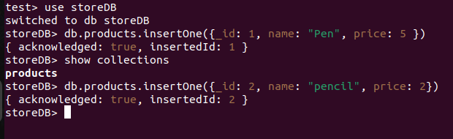

Reading And Queries:

1. db.products.find() -> it will show all the information
2. db.products.find({name: “pencil”}) -> shows data having name pencil
3. db.products.find({price: {$gt: 2}}) -> shows products having price > 2
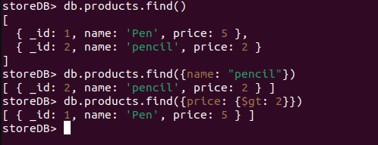

Updation:

1. db.products.updateOne({_id: 1}, {$set: {stock: 32}}) -> it will add the stock column having value 32.
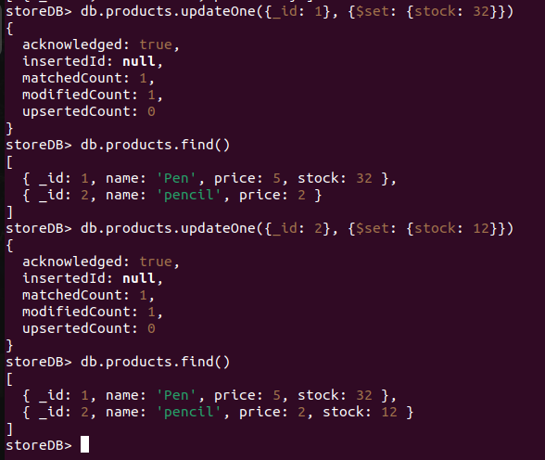

Deletion:

1. db.products.deleteOne({_id: 2}) -> deleted the record having id as 2

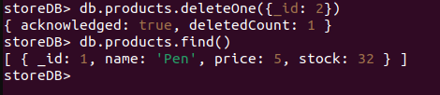

Relationships:

1. We can directly insert data by typing in any editor and pasting it in mongoDB.

db.products.insert(
{
_id: 3,
name: "Eraser",
price: 3,
stock: 40,
reviews: [
{
author: "John",
rating: 5,
review: "Awesome product"
},

{
author: "Emily",
rating: 5,
review: "Great job"
}





