Brain Mapper: Project Log Book
Development Journey, Dataset Collection, AI Annotation & Offline LAN Exam Design
Project Name | Brain Mapper — Cognitive-Aware Knowledge Tracing & Student Performance Prediction
Team Members | Waruna Silva (Leader), Pramudi Biyonika, Dilshan Kodithuwakku, Tharindu
Log Period | August 4, 2026 – November 10, 2026
Repository | https://github.com/waruna-2003/Brain-Mapper.git (Main Branch)

Project Timeline Overview (Aug 4 – Nov 10, 2026)
Timeline | Phase / Milestone | What We Did
Aug 4 – Aug 18 | School Data Collection Attempt | Contacted schools for Grade 10/11 & 12/13 papers and marks; hit answer script & timeline bottlenecks.
Aug 19 – Aug 26 | Found XES3G5M Benchmark | Adopted XES3G5M (AI4ED / NeurIPS) + ExRec English dataset (7,652 Qs, 18,066 students, 5.5M events).
Aug 29 – Sep 10 | LLM API Trials & Cost Analysis | Evaluated Gemini, DeepSeek, ChatGPT, and Groq APIs; hit daily quotas & high vision token costs.
Sep 11 – Oct 19 | Zero-Cost DeepSeek Extension | Leader Waruna proposed browser automation; built Chrome Extension + Python Bridge Server ($0 cost).
Oct 20 – Nov 10 | Team Annotation & Bug Fixes | Fixed Windows locks, <think> parsing, and tab reload issues; team annotated 5,076 / 7,652 Qs (66.3%).
Oct 28 – Nov 10 | Multi-LLM Cross-Validation | Built Gemini Web extension (500 text Qs) to cross-check without human grading; upgraded to Gemini Pro.
Nov 1 – Nov 10 | LAN Exam & Figma Frontend | Set up Router/Hotspot LAN server + QR login; designed Figma UI & built user connect and quiz creator.

[Aug 4 – Aug 26, 2026] 1. Starting Data Collection & Finding the XES3G5M Dataset
First, we started our data collection process. Just as we planned in our research proposal, we decided to collect real question papers and term test marks from Grade 10 and 11 students (and we also checked Grade 12 and 13 classes). We contacted many schools, teachers, and principals to ask for past test data. Some schools agreed to share their students' data with us, while others declined.
Even when we visited the schools that agreed, we ran into a practical roadblock when collecting from students: usually schools hand evaluated answer scripts straight back to the students after marking is done, and most students had already lost or misplaced their papers. Within our limited time period, we could not gather enough continuous question-and-answer histories to train a Knowledge Tracing model properly. Our plan is to complete local school data collection in Phase 2 using our own exam platform, and in the meantime, we needed a strong benchmark dataset so we could train our model, beat the accuracy of existing models (like DKT, qDKT, and QKT), and prove that our approach predicts student performance better. That led us to find the XES3G5M dataset.
About the XES3G5M Dataset:
- The dataset was developed and published by the AI4ED research initiative (TAL Education Group) in the NeurIPS track.
- XES3G5M is widely recognized as the premier benchmark for multimodal mathematical knowledge tracing.
- Our team incorporated the ExRec benchmark (Özyurt et al.), which gave us validated English translations of the question statements, answer choices, and curriculum knowledge components.
- It contains 18,066 unique secondary school students, 5,549,184 sequential interaction events, and 7,652 unique mathematical problems (including 2,214 visual geometry problems accompanied by 2,459 real diagram PNGs).
[Aug 29 – Sep 10, 2026] 2. Second Effort: Checking Commercial LLM APIs & Costs
Our second major effort was to annotate all 7,652 questions with cognitive skill scores using Large Language Models (LLMs). At first, we decided to use commercially available LLM APIs to annotate the dataset automatically. Before running the full corpus, we calculated the estimated API cost and practical limits for annotating each question one by one across four popular LLM APIs (Gemini, DeepSeek, ChatGPT, and Groq), as shown below:
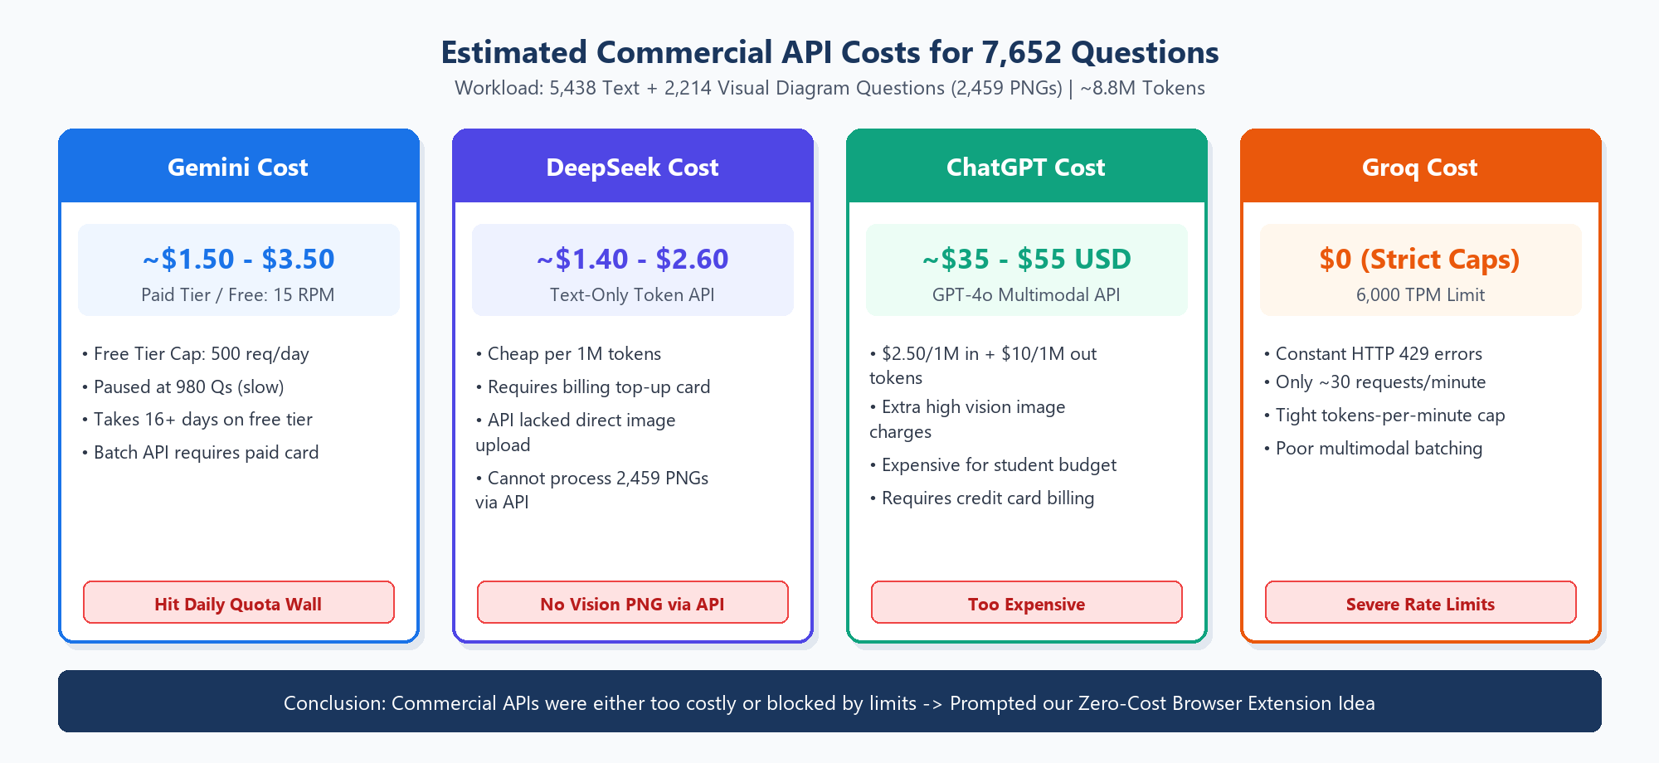
Figure 1: Cost and rate-limit comparison across Gemini, DeepSeek, ChatGPT, and Groq APIs for 7,652 questions.
As the numbers showed, paying per question on ChatGPT (~$35–$55 USD for multimodal GPT-4o vision) or setting up paid billing projects on Gemini/DeepSeek was expensive for our student budget. Meanwhile, free API tiers were heavily restricted: Gemini's free tier capped out at 500 requests per day (stopping us after 980 questions), Groq hit strict token-per-minute limits, and DeepSeek's text API couldn't easily process our 2,459 diagram PNGs directly.
[Sep 11 – Oct 26, 2026] 3. Zero-Cost DeepSeek Annotation via Browser Extension & Local Server
To solve this cost issue, our team leader Waruna brought up an idea to annotate the entire dataset without any cost. Here was the idea: we can use DeepSeek's frontier model in normal web chat conversations for free instead of calling a paid API. We created a Chrome browser extension to communicate between the browser and a local Python server running on our PC. The extension automates inputting each question (along with attaching any geometry diagram images) and collects the generated JSON answer, while the local server is responsible for validating the scores and saving all collected data safely to disk. Here is the architecture of how it works:
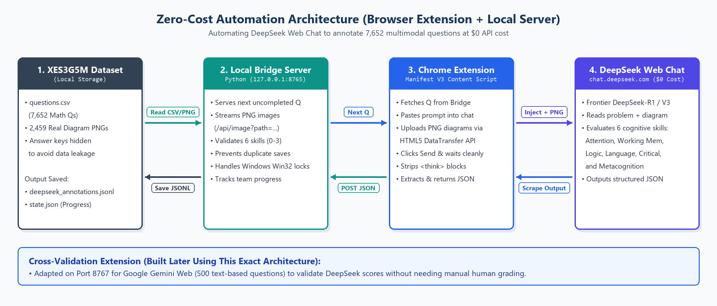
Figure 2: Zero-Cost Browser Extension and Local Python Bridge Server Architecture.
While running this system across our computers (Waruna, Pramudi, and Dilshan), we fixed several practical bugs—such as stripping DeepSeek-R1's <think> blocks cleanly, adding anti-stale checks so it never grabs an old message by mistake, prompting the user to press F5 if a browser tab was opened early, and fixing Windows OneDrive file locking issues (WinError 32). By November 10, 2026, our team successfully completed 5,076 out of 7,652 questions (66.34%), with 2,576 questions remaining.
[Oct 28 – Nov 10, 2026] 4. Validating Annotations Across Multiple LLMs (Cross-Validation)
Because we didn't have human manual verification for all 7,652 questions, we decided to validate our dataset annotation process by having different LLMs annotate a sample of questions and checking how similar their answers were. At first we created a test extension for ChatGPT, though its web editor made consistent automation difficult. So we switched to Google Gemini and built a separate Chrome extension and local bridge server (port 8767) specifically focused on 500 text-based questions.
An initial validation run using a free Gemini account (202 paired questions) showed strong agreement with DeepSeek—achieving 95.2% within-1-point agreement across all 6 cognitive skills (with almost identical averages on Working Memory: 2.13 vs 2.10, and Logical Reasoning: 2.14 vs 2.08). On November 10, 2026, we cleared the free-tier test run and reset the Gemini server to run a clean, full 500-question cross-validation pass using a Gemini Pro account.
[Nov 1 – Nov 7, 2026] 5. Application Development: Offline LAN Network & QR Code Login
Next, we started developing our examination application so that in Phase 2 we can easily collect real student data from Grade 10 and 11 classes inside schools without needing an internet connection. First, we designed our LAN network setup, which is created using a simple wireless router or a mobile hotspot. Inside the instructor's PC, we run a local virtual server (QuizServer). Because all student phones, tablets, or laptops are connected to the same local Wi-Fi network, they can communicate directly with the instructor's PC via its IP address.
To make joining super easy for students—without needing to manually type a confusing IP link—we wrapped the server URL inside a QR code. Now students just scan the QR code with their phone camera and log straight into the instructor's virtual server. Here is how our main examination network works:
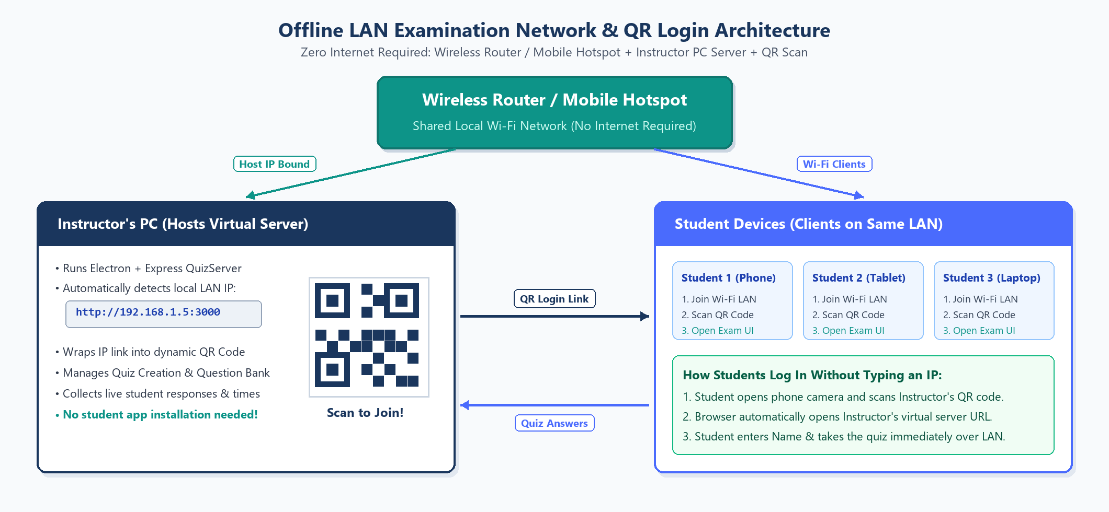
Figure 3: Offline LAN Examination Network & QR Code Student Login Architecture.
[Nov 4 – Nov 10, 2026] 6. Creating Main Frontend User Interfaces (Figma -> Implementation)
Then we designed the user interfaces of the application in Figma and started building the frontend screens. Specifically, we implemented the user connecting part (displaying the instructor's LAN IP, scannable QR code, and live participant count alongside the student join screen) and the quiz creating part (where the instructor enters quiz titles, adds questions and options, attaches images, and sets timers). The full LAN exam platform is still under active development as we work toward integrating our Knowledge Tracing model and analytics.
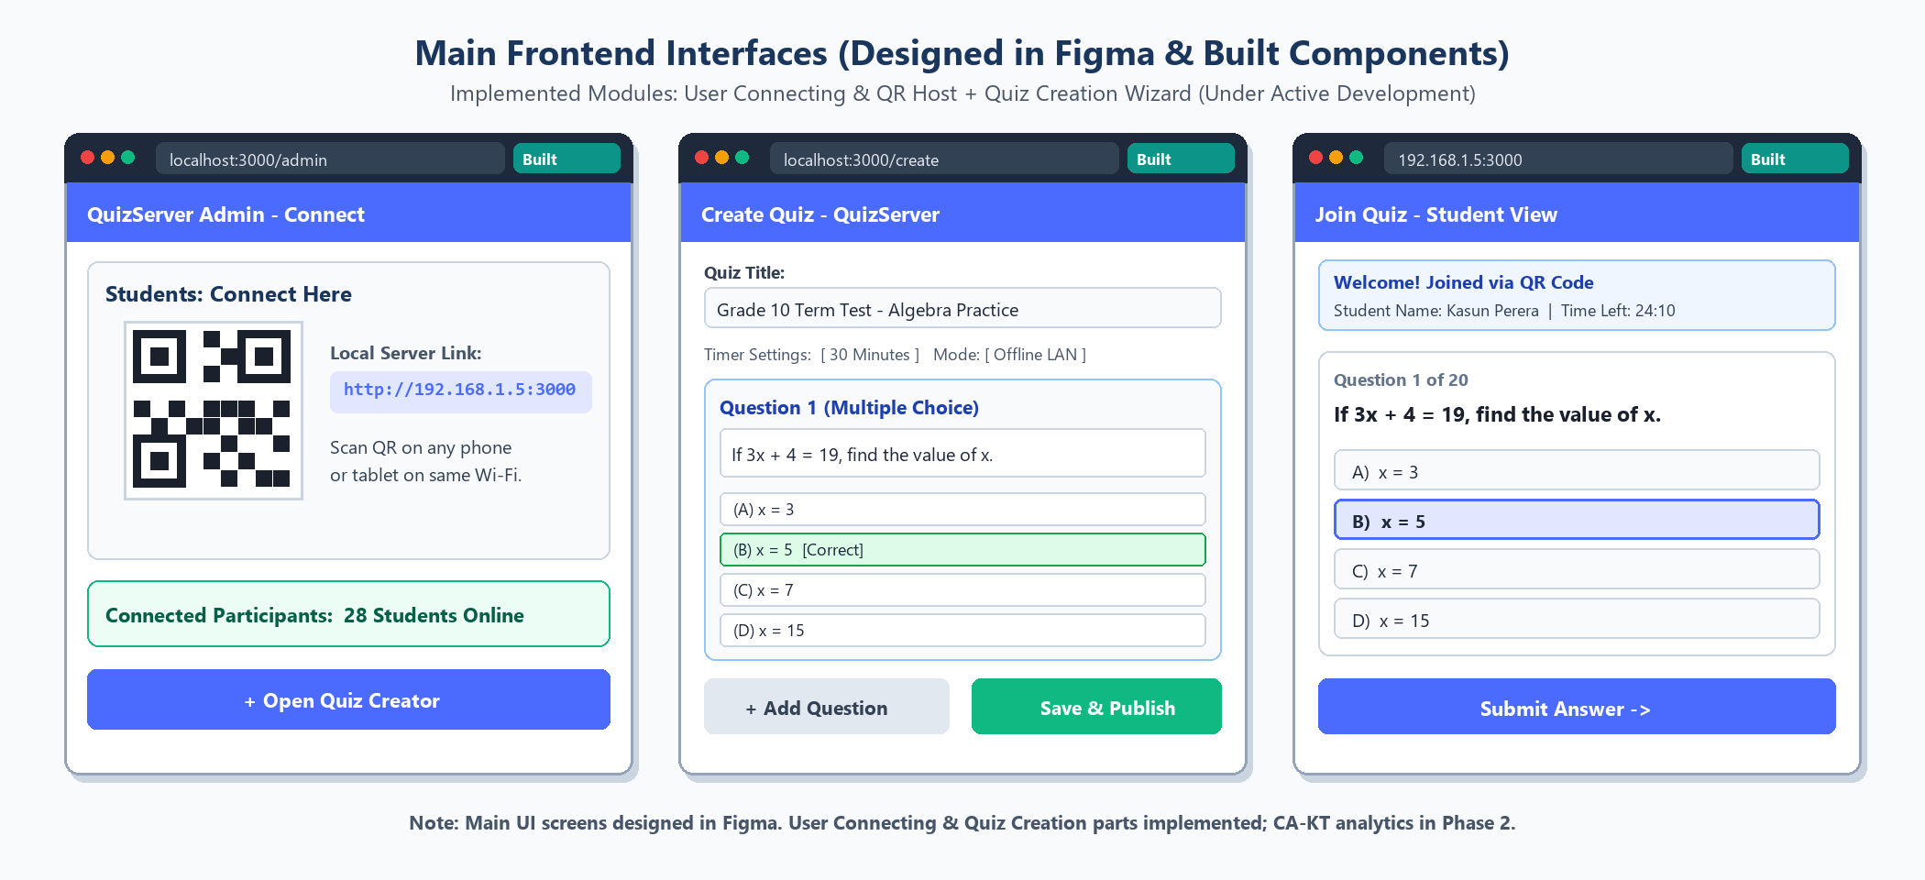
Figure 4: Main Frontend Interfaces (Figma Design implemented for QR Connection, Quiz Creation, and Student View).
[Nov 10, 2026] 7. Current Project Status Snapshot
Component | Current Status
DeepSeek Annotation Corpus | 5,076 / 7,652 completed (66.34%); 2,576 remaining (resuming at Q#3360).
Gemini Pro Cross-Validation | Extension built on Port 8767 for 500 text-only Qs; reset cleanly to 0/500 for Gemini Pro run.
LAN Examination Application | Figma UI designed; User Connecting (QR + LAN IP) & Quiz Creation parts built; CA-KT analytics pending.
Automated Test Suites | 29 / 29 Python tests passing + 4 / 4 Node.js LAN Exam server tests passing.

