SmartCare v0.3 - Domain Model Workbook
Week 6 student resource

Completed response - Student ID: u3314395

Requirement-to-Concept Trace
Requirement | Concept | State/behaviour | Decision
FR-01/02 | Patient | patient_id, name; searchable identity | Patient is a core class.
FR-03 | Practitioner | practitioner_id, name, specialty | Practitioner is a core class.
FR-04 | Practitioner + Appointment | practitioner association; appointment_time | Schedule view derives from linked appointments.
FR-05 | Appointment | appointment_id, time; references Patient/Practitioner | Appointment is a core class.
FR-06 | Appointment/booking rule | practitioner + time + active status | Rule uses Appointment data; no new entity needed.
FR-07 | AppointmentStatus | SCHEDULED/CANCELLED | Represent as enum/value, not entity.
FR-08/09 | Appointment | cancel transition | Behaviour belongs to Appointment in Stage 4.
FR-10 | Appointment collection | status values for summary | Reporting can read appointments; no Report entity yet.
FR-11 | Appointment | cancelled object retained | History comes from keeping Appointment records.
FR-12 | Appointment | patient/practitioner/time/status | Appointment exposes recorded details.

CRC Cards

Patient
Responsibilities | Collaborators
Maintain patient identity and name | Appointment
Provide identity referenced by appointments | Appointment

Practitioner
Responsibilities | Collaborators
Maintain practitioner identity/name/specialty | Appointment
Be referenced by scheduled appointments | Appointment

Appointment
Responsibilities | Collaborators
Link exactly one Patient and Practitioner | Patient, Practitioner
Hold appointment ID, time and status; own status transition | Patient, Practitioner

Optional class
Responsibilities | Collaborators
No optional core class added | -
Current requirements are covered without another entity | -

UML Class Diagram
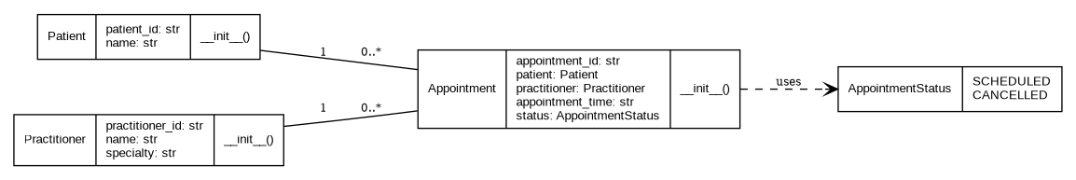

Design Rationale
Explain class selection, responsibility allocation and key relationships.

Patient, Practitioner and Appointment are the only core entity classes because each has a clear identity and directly supports confirmed SmartCare requirements. Name is an attribute, cancellation is Appointment behaviour, and status is a small enum/value. Appointment references exactly one Patient and one Practitioner, while each Patient or Practitioner can participate in zero or many Appointments over time. These are associations rather than inheritance because an Appointment is not a type of Patient or Practitioner and those objects have independent lifecycles. The model deliberately avoids database, UI, notification and manager/controller classes because they are technical or architectural concerns rather than confirmed domain concepts. Duplicate-booking prevention depends on comparing appointments for a practitioner/time and is therefore a collection/application rule rather than a reason to invent another domain entity.

AI Design Review Record
AI suggestion | Evidence | Decision | Reason | Model change
Keep Patient, Practitioner and Appointment as core classes | FR-01 to FR-12 | Accepted | Directly traceable to requirements. | No change.
Represent appointment status as enum/value | FR-07 to FR-11 | Modified/Accepted | Status is important state but does not need entity identity. | Added AppointmentStatus enum.
Add NotificationManager | None | Rejected | Notifications are unsupported/out of scope. | No class added.
Add ClinicController and three Manager classes | None | Rejected | Premature architecture; not domain concepts. | No classes added.
Add ScheduleEngine | FR-04/FR-06 | Modified/Deferred | Scheduling rule exists, but separate service is not justified yet. | Keep rule outside core entity model for now.

