Freight Rate Prediction
Modeling, validation, and December 2025 rate forecast
Holdout RMSE  $113 | Holdout MAE  $44 | Holdout MAPE  1.84% | Holdout R²  0.9933

The final model is a log-linear Ridge regression with distance, weight, equipment, calendar, and out-of-fold lane-level target encodings. It was selected on a time-based holdout that mimics the future Nov-Dec prediction task. Clear rate anomalies were excluded from training, and the model is deliberately robust to the weak and non-stationary market-index features.

1. Data overview
The labeled development set contains 48,000 loads from 2025-01-01 through 2025-10-31. The final validation set contains 12,000 loads from 2025-11-01 through 2025-12-31. Because validation is strictly after the labeled period, every split in this analysis is chronological.
- Target: posted rate, with median $2.15 per mile across the training set.
- Lane coverage: 4,014 distinct pickup-delivery lanes in training.
- Validation contains 1,461 loads on lanes never seen in training.
- The rate-distance relationship is strongly non-linear in levels but close to linear in logs.
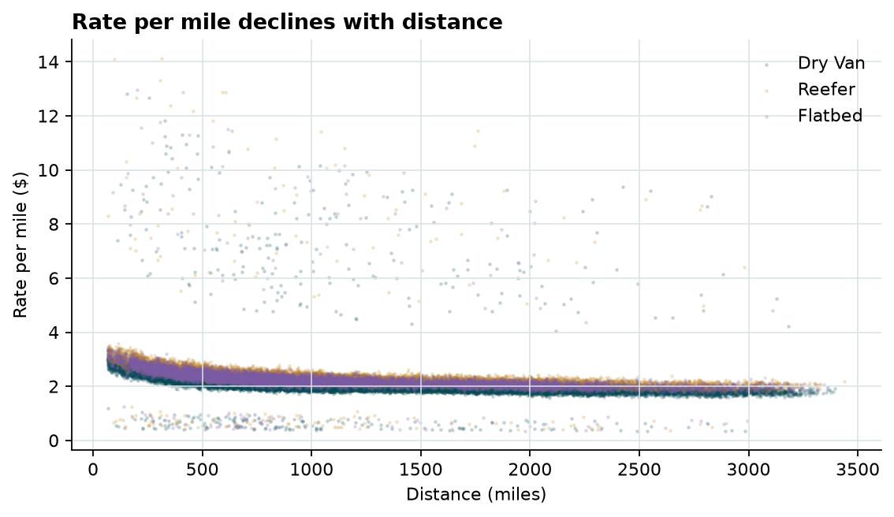
Rate per mile falls with distance; equipment types sit at different levels.
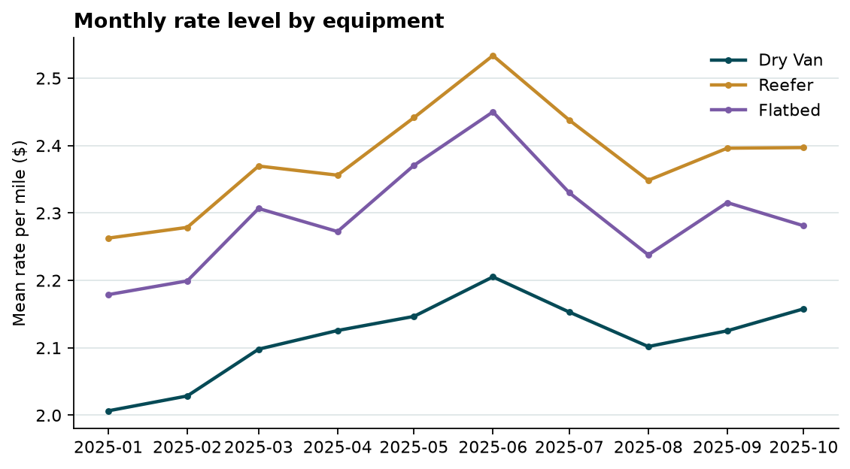
Monthly rate level rises through mid-year and eases in late summer.

2. Data-quality findings and treatment
Finding | Train | Validation | Treatment
Negative weights | 292 | 145 | Sign flips; use absolute value
Missing weight | 300 | 165 | Median by equipment
Impossible rate anomalies | 670 | Unknown | Exclude from training; report separately
Missing market index | 374 | 249 | Not used by final model
Unseen validation lanes | — | 1,461 | Smoothed target-encoding fallback

The target contains exactly 335 loads below $1.20 per mile and 335 loads above $4.50 per mile. These are symmetric, randomly distributed across dates and equipment types, and are inconsistent with the overwhelming majority of the data. They are treated as corrupted labels rather than genuine market outcomes: they are excluded from model fitting and are also excluded from the headline holdout metrics. The full holdout metric is still reported so the impact is transparent.
Weight is approximately symmetric around zero only because a small share of rows have the sign flipped; the absolute distribution is consistent with normal truckload weights. Distance is more reliable than a straight-line calculation: the supplied distance is about 1.20 times the great-circle distance, consistent with road routing, so the supplied field is used directly.

3. Validation strategy
A random split would leak information across calendar time and would not replicate the actual task of predicting November and December from a model fit through October. Two forward-in-time folds were used:
- Primary fold: fit on January-August, validate on September-October.
- Secondary fold: fit on January-July, validate on August-September.
- Final model: refit on January-October after model selection.
Target encodings are computed out-of-fold inside the training window, and all imputations and scalers are fit only on the training portion of each fold. The model is selected by average RMSE on the clean portion of both folds.

4. Feature engineering and model
- Log target: log(posted_rate), which stabilizes the heavy right tail.
- Distance and weight enter as logs, with quadratic and interaction terms; equipment-specific slopes are included.
- Day-of-week indicators capture a persistent weekly rate pattern.
- Out-of-fold, smoothed mean residual encodings for pickup city, delivery city, and lane capture persistent lane effects without leaking the current row's target.
- Missing weights are imputed by equipment median; signals where the abs weight is used first.
- Ridge regularization is selected over alphas from 0.01 to 100.
The final specification is intentionally parsimonious. Gradient-boosted trees and market-index features were evaluated during development but generalized worse in the forward holdout: the market index is strongly related to the training-period rate level but its relationship shifted in September-October, and tree models overfit those unstable patterns. The selected linear-in-logs model extrapolates the stable distance, weight, equipment, lane, and weekday relationships instead.
Selected variant: full; Ridge alpha: 1.00. Training rows used after excluding corrupted labels: 47,330 of 48,000 (98.60%).

5. Validation results
Model | Clean holdout RMSE | Clean holdout MAE | MAPE | R²
Median-rate baseline | $1,420.07 | $1,108.93 | 67.92% | -0.0569
Base log-linear (distance + weight + equipment) | $129.22 | $65.05 | 2.93% | 0.9912
Selected Ridge model | $113.18 | $43.80 | 1.84% | 0.9933

Holdout slice | RMSE | MAE | MAPE | R²
2025-09 | $132.10 | $46.59 | 1.92% | 0.9910
2025-10 | $91.27 | $41.11 | 1.76% | 0.9956
Dry Van | $136.20 | $39.23 | 1.71% | 0.9892
Flatbed | $82.53 | $54.50 | 2.27% | 0.9967
Reefer | $66.37 | $46.13 | 1.80% | 0.9980

Across both clean validation folds the selected model averages $107.23 RMSE and $43.39 MAE. Fold-level results are 113.2 RMSE / 43.8 MAE; 101.3 RMSE / 43.0 MAE. The full primary holdout, including the 142 corrupted targets, has RMSE $630.80. That gap is entirely driven by labels that are not predictable from the supplied features.
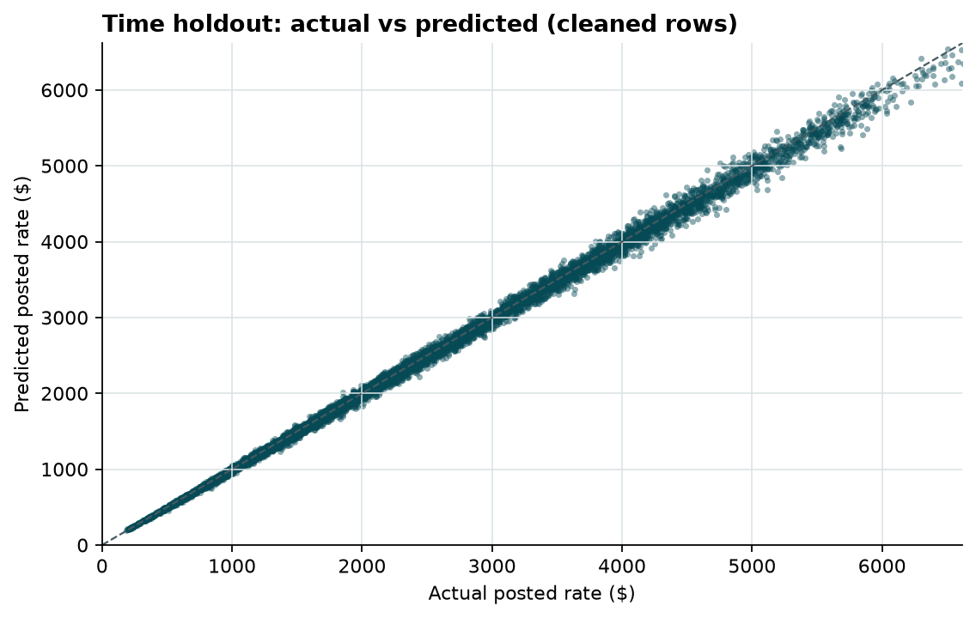
Predicted versus actual rate on the September-October holdout; corrupted labels are excluded.
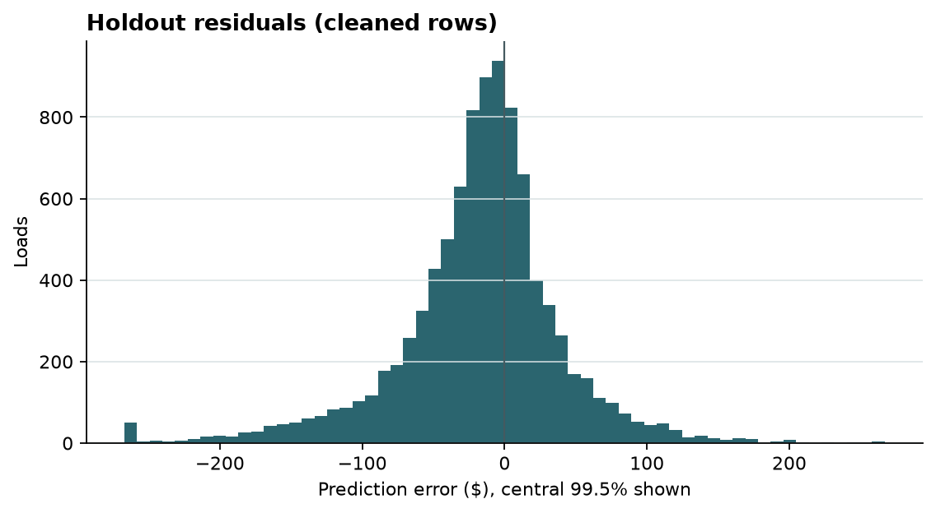
Residual distribution for cleaned holdout rows.

6. December 2025 prediction
The December chart keeps pickup, delivery, distance, equipment, and weight fixed at Lexington to Fort Wayne, 360 miles, Dry Van, and 32,000 lb. Only the date changes. Predictions are therefore driven by the learned weekday pattern and the lane, distance, weight, and equipment effects. The model does not require market_index or quote_signal, so the missing fields in the December inputs are not a problem.
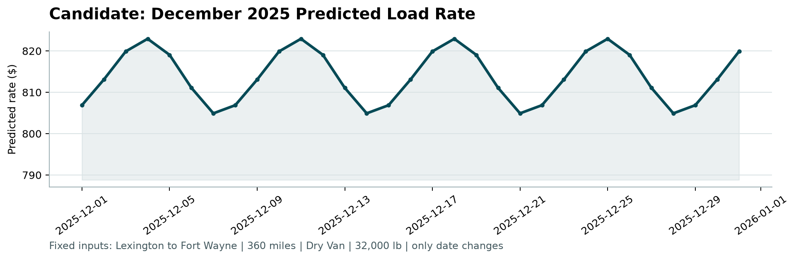
Official score.py output: candidate December 2025 predicted load rate.
December predictions range from $804.91 to $822.94, averaging $813.91. The repeating weekly shape mirrors the weekday effect observed in the labeled data. No market-index trend is imposed because that relationship did not hold in the forward validation, so the safer choice is to hold the seasonal level flat and let the strong deterministic features drive the forecast.

7. Limitations and next steps
- Corrupted rate labels are random and unpredictable; they will inflate any RMSE computed on an uncleaned evaluation set.
- The December forecast does not extrapolate a macro rate trend; with labeled November-December data, a forward seasonal adjustment could be added.
- About 12% of validation loads are on unseen lanes; smoothed pick-up and delivery encodings and the base distance-weight-equipment model provide the fallback.
- A production version would retrain monthly and monitor lane-level drift and anomaly rates.

8. Reproducibility
Install the pinned requirements, run the pipeline, validate with the supplied scorer, and rebuild this report:
python -m venv .venv
source .venv/bin/activate
pip install -r requirements.txt
python freight_rate.py
python score.py --predictions validation_predictions.csv --december-predictions data/december-chart-inputs.csv
python make_report.py
Artifacts: validation_predictions.csv, data/december-chart-inputs.csv, scorer_results/candidate_december.png, reports/metrics.json, reports/model_comparison.csv, reports/holdout_predictions.csv, and models/freight_rate_model.joblib.

Appendix: top model configurations
Rank | Variant | Ridge alpha | Mean clean RMSE | Mean clean MAE
1 | full | 1 | $107.23 | $43.39
2 | full | 0.1 | $107.27 | $43.41
3 | full | 0.01 | $107.28 | $43.42
4 | full | 10 | $107.63 | $43.95
5 | full | 100 | $109.53 | $45.91
6 | full_no_dow | 1 | $109.53 | $46.06
7 | full_no_dow | 0.1 | $109.57 | $46.07
8 | full_no_dow | 0.01 | $109.58 | $46.07

