CSE145 - Introduction to Computing
Assignment 2: Turing Machines
Name: Muhammad Wasay Farrukh ERP No.: 35538
R = 38 V = 2 B = 100110 n = 7
(R = last two digits of 35538 = 38, V = 38 mod 4 = 2, B = 38 in binary = 100110, digit sum = 3+5+5+3+8 = 24, 24 mod 5 = 4, n = 4 + 3 = 7)
GitHub repository: https://github.com/wasaay/35538-cse145-a2-tm

Q3 - Binary Transformer (V = 2, so the operation is x2)
Task A - Algorithm
Multiplying a binary number by 2 shifts every bit one place to the left, which is the same as writing a 0 at the right end of the number. So the machine doesn't have to move any bits, it just has to get to the right end and write a 0 on the first blank. q0 looks at the first bit, then q1 moves right over the 0s and 1s, and when it reaches the blank it writes 0 and turns around into q3. q3 walks back to the left end and then steps right onto the first digit and halts in q4, so the tape holds only the answer with the head at its start. The special case is the number 0: if the input is just "0" (q0 -> q2 -> blank) nothing is appended, because 0 x 2 = 0 and "00" would not be a clean answer. If the tape is empty the machine writes a single 0.
Task B - Transition table and state diagram
State | Meaning
q0 (start) | read the first bit
q1 | move right to the end of the number
q2 | first bit was 0, check if the number is just "0"
q3 | move back left to the start
q4 | halt (done)

Current state | Read | Write | Move | Next state
q0 | 1 | 1 | R | q1
q0 | 0 | 0 | R | q2
q0 | B | 0 | L | q3
q1 | 0 | 0 | R | q1
q1 | 1 | 1 | R | q1
q1 | B | 0 | L | q3
q2 | 0 | 0 | R | q1
q2 | 1 | 1 | R | q1
q2 | B | B | L | q3
q3 | 0 | 0 | L | q3
q3 | 1 | 1 | L | q3
q3 | B | B | R | q4

Task C - Simulator run
Starting tape: 100110 (my B). Files: Q3/q3_run1_B.json, Q3/q3_run1_B_initial.png (before) and Q3/q3_run1_B.png (after). Link is in README.md (line "Q3 Run 1").
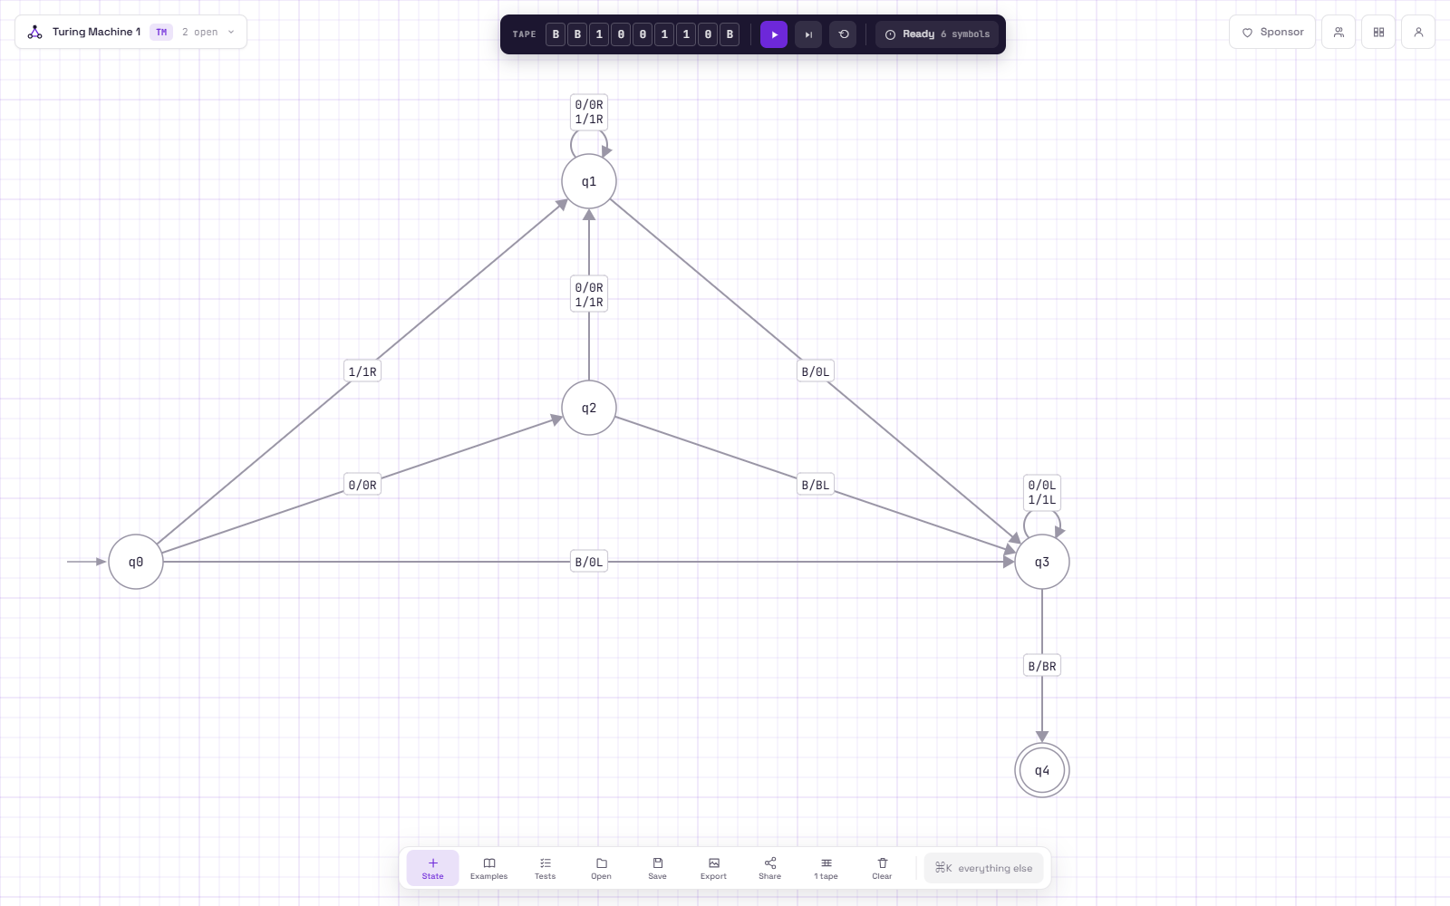
Before: tape holds 100110
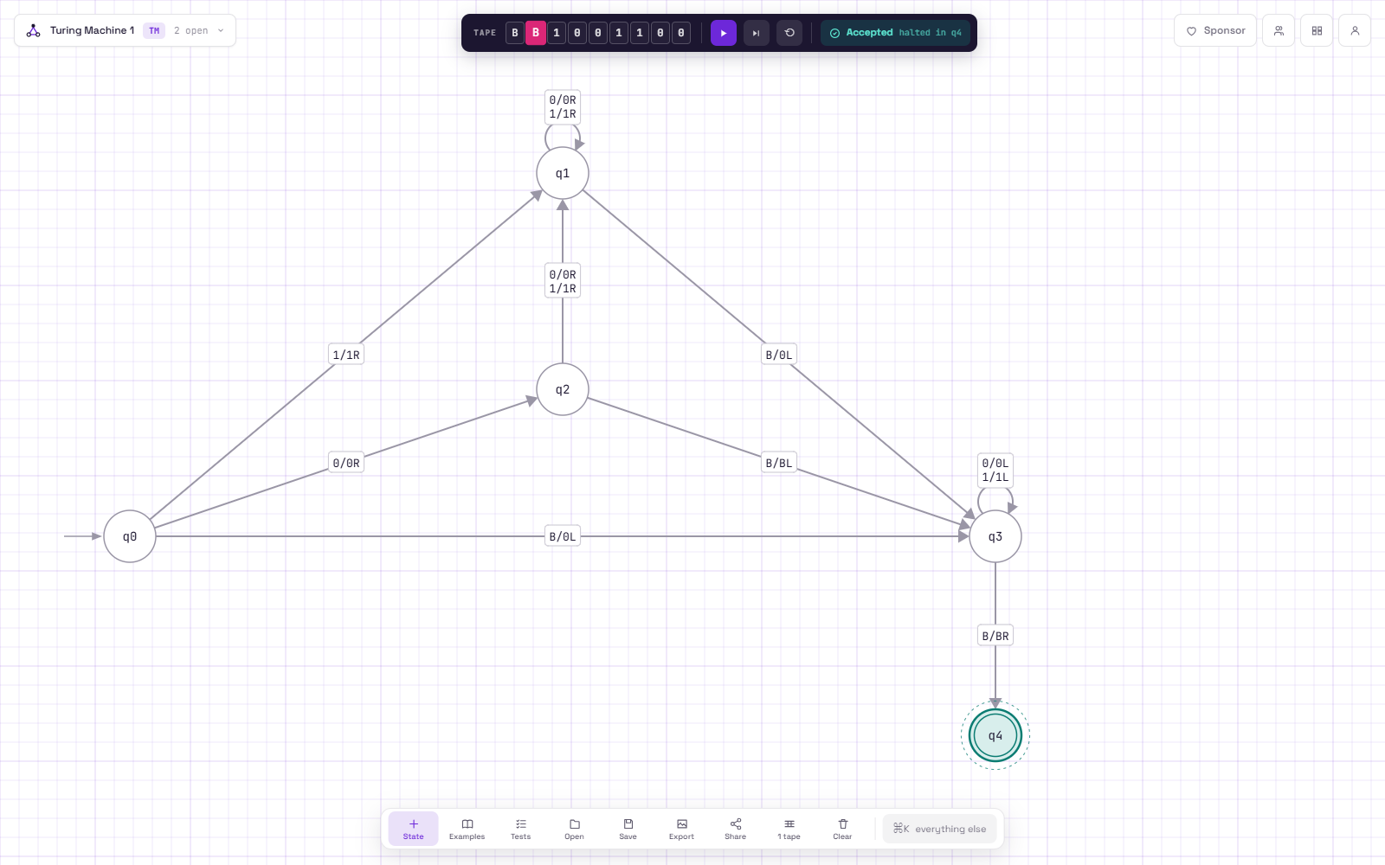
After: tape holds 1001100, halted in q4
Working by hand:
B = 100110 = 32 + 4 + 2 = 38
38 x 2 = 76
76 = 64 + 8 + 4 = 1001100 in binary
Final tape in the simulator: 1001100, which is 76. So it matches.
Task D - Edge case
The edge case I had to handle is the input 0. If the machine just appended a 0 every time, 0 would come out as 00, which is the right value but not a clean binary answer, so q2 checks for it and leaves 0 alone. Also the change has to be made at the right end of the number, not the left. If I tried to do it by changing the leftmost bit, for example putting the extra 0 right after the first 1, 100110 would become 1000110 = 70 instead of 1001100 = 76, so the head really has to go all the way to the end first.

