CSE145 - Introduction to Computing
Assignment 2: Turing Machines
Name: Muhammad Wasay Farrukh ERP No.: 35538
R = 38 V = 2 B = 100110 n = 7
(R = last two digits of 35538 = 38, V = 38 mod 4 = 2, B = 38 in binary = 100110, digit sum = 3+5+5+3+8 = 24, 24 mod 5 = 4, n = 4 + 3 = 7)
GitHub repository: https://github.com/wasaay/35538-cse145-a2-tm

Q2 - Scaled-Count Recognizer (V = 2, so L = { a^2n b^n })
Task A - Strategy
The idea is to match two a's with one b in every round. Starting from the left, the machine crosses off the first unmarked a by writing X (q0 to q1), then crosses off the next a with an X too (q1 to q2). In q2 it moves right over the remaining a's and any Y's until it finds the first b that is not marked yet, and changes it to Y. Then q3 walks back left over a's and Y's until it hits the last X, steps right and is in q0 again for the next round. When q0 sees a Y instead of an a, all the a's have been used, so the machine goes to q4 and checks that there is nothing but Y's up to the blank. If it gets to the blank it accepts in q5. If it ever finds something it does not expect (a b when it needs the second a, a blank while looking for a b, or a leftover a or b in q4) it goes to the reject state q6. I took n >= 0, so the empty string is accepted straight from q0.
Task B - Transition table and state diagram
State | Meaning
q0 (start) | cross the 1st a of a pair, or start the final check
q1 | cross the 2nd a of the pair
q2 | go right to the first unmarked b
q3 | go back left to the last X
q4 | final check, only Y's allowed
q5 | accept
q6 | reject

Current state | Read | Write | Move | Next state
q0 | a | X | R | q1
q0 | Y | Y | R | q4
q0 | B | B | R | q5
q0 | b | b | R | q6
q1 | a | X | R | q2
q1 | b | b | R | q6
q1 | Y | Y | R | q6
q1 | B | B | R | q6
q2 | a | a | R | q2
q2 | Y | Y | R | q2
q2 | b | Y | L | q3
q2 | B | B | R | q6
q3 | a | a | L | q3
q3 | Y | Y | L | q3
q3 | X | X | R | q0
q4 | Y | Y | R | q4
q4 | B | B | R | q5
q4 | a | a | R | q6
q4 | b | b | R | q6

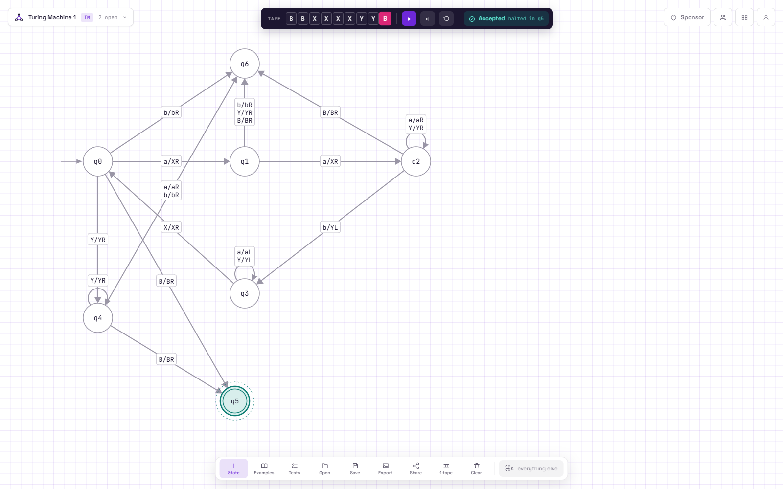
State diagram in AutomataVerse (screenshot from run 3)
Task C - Simulator runs
n = 7, so my string is a^14 b^7. Files are in the Q2 folder and links in README.md (lines "Q2 Run 1/2/3").
Run | Input | Result | Correct? | Files
1 | aaaaaaaaaaaaaabbbbbbb (14 a, 7 b) | Accepted, halted in q5, tape XXXXXXXXXXXXXXYYYYYYY | Yes, 14 = 2 x 7 | q2_run1_n7.json / .png
2 | aaaaaaaaaaaaaabbbbbb (one b removed, 14 a, 6 b) | Rejected, halted in q6 | Yes, 14 is not 2 x 6 | q2_run2_one_b_removed.json / .png
3 | aaaabb (n = 2) | Accepted, halted in q5 | Yes, 4 = 2 x 2 | q2_run3_own.json / .png

In run 2 the first six rounds use up 12 a's and all 6 b's. In round 7 the machine crosses the last two a's but q2 then finds a blank instead of a b, so it goes to q6.
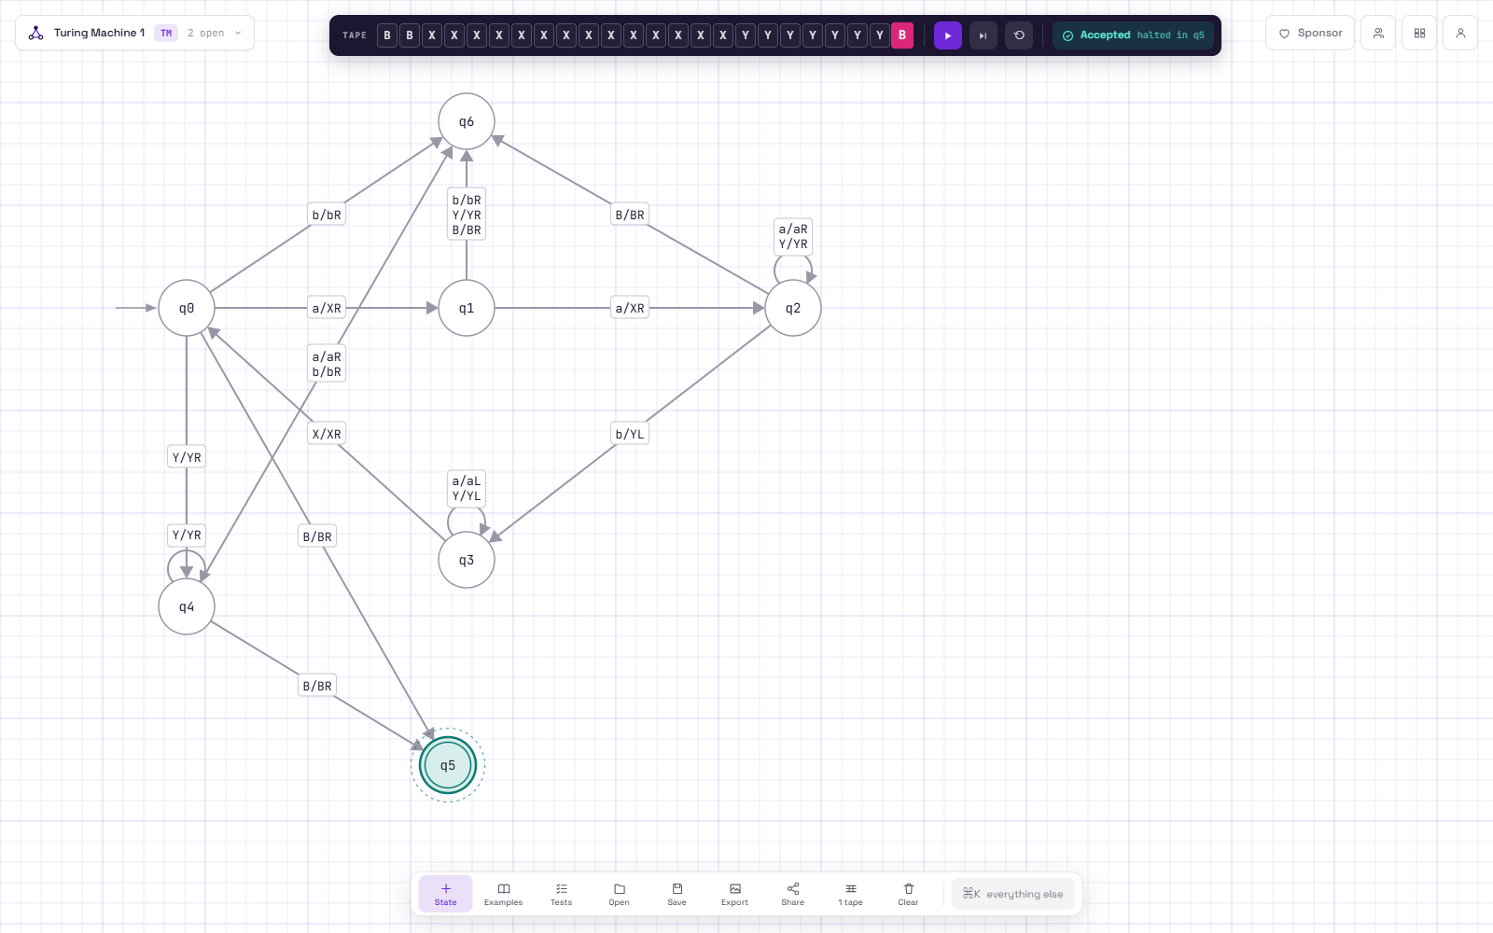
Run 1: a^14 b^7, accepted
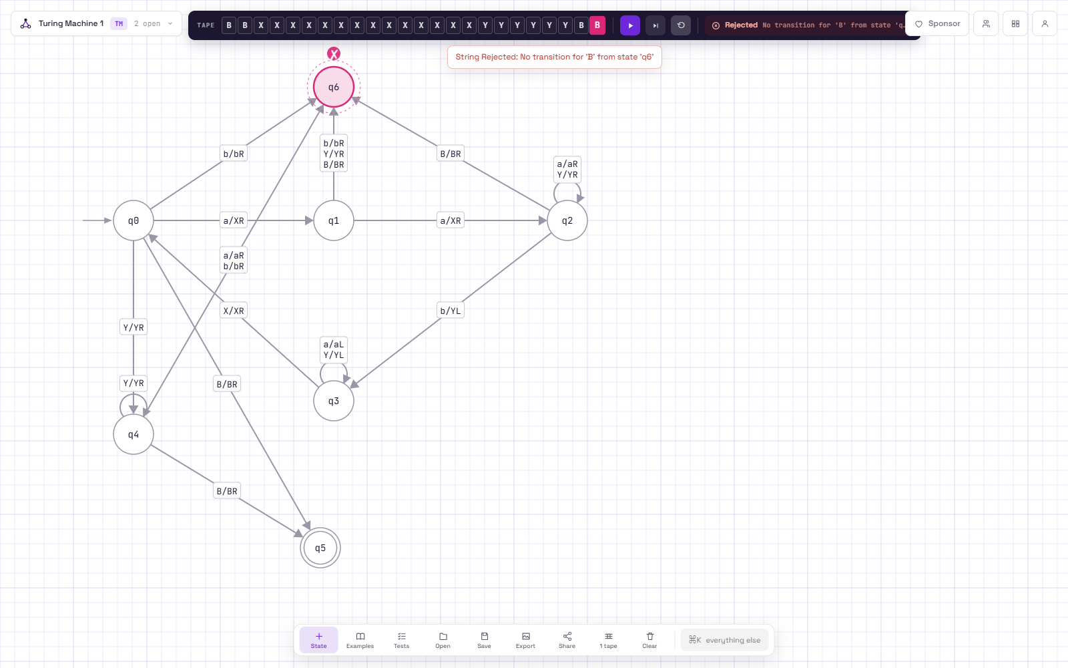
Run 2: a^14 b^6, rejected
Run 3: aaaabb, accepted
Task D - Where an off-by-one error could happen
The easiest place to get it wrong is the q0 -> q1 -> q2 part, which is what makes the ratio 2 to 1. If I only had one "cross an a" state the machine would accept a^n b^n instead, and if q1 did not reject when it sees a Y, an odd number of a's could get through. The other spot is the end: when q0 sees a Y the machine has to make sure there are no a's or b's left, which is what q4 does. To check it I traced a few small strings by hand: aab is accepted, aaab is rejected because q1 reads Y after the first round, and aabb is rejected because q4 finds the second b. Then in the simulator, runs 1 and 2 differ by exactly one b and give accept and reject, so the count is exact in both directions.

