CSE145 - Introduction to Computing
Assignment 2: Turing Machines
Name: Muhammad Wasay Farrukh ERP No.: 35538
R = 38 V = 2 B = 100110 n = 7
(R = last two digits of 35538 = 38, V = 38 mod 4 = 2, B = 38 in binary = 100110, digit sum = 3+5+5+3+8 = 24, 24 mod 5 = 4, n = 4 + 3 = 7)
GitHub repository: https://github.com/wasaay/35538-cse145-a2-tm

Q4 - Palindrome-Family Recognizer (V = 2, even-length palindromes over {a,b})
Task A - Strategy
The machine compares the outermost symbols and then works its way inward. In q0 it reads the leftmost symbol that is left, erases it (writes B) and remembers what it was by going to q1 for an a or q2 for a b. It then runs right to the end of the string and steps back onto the last symbol. In q3 the last symbol has to be an a, and in q4 it has to be a b. If it matches, it is erased as well and q5 walks the head back to the left end for the next pair. If it does not match the machine goes to the reject state q7. Since only even-length palindromes count, the middle matters: if q3 or q4 finds a blank instead of a symbol, the symbol I just erased was alone in the middle, so the length was odd and the machine rejects. When q0 finds a blank at the start of a round, every pair matched and nothing was left over, so it accepts in q6.
Task B - Transition table and state diagram
State | Meaning
q0 (start) | erase the leftmost symbol and remember it
q1 | remembered a, go to right end
q2 | remembered b, go to right end
q3 | last symbol must be a
q4 | last symbol must be b
q5 | go back to the left end
q6 | accept
q7 | reject

Current state | Read | Write | Move | Next state
q0 | a | B | R | q1
q0 | b | B | R | q2
q0 | B | B | R | q6
q1 | a | a | R | q1
q1 | b | b | R | q1
q1 | B | B | L | q3
q2 | a | a | R | q2
q2 | b | b | R | q2
q2 | B | B | L | q4
q3 | a | B | L | q5
q3 | b | b | L | q7
q3 | B | B | L | q7
q4 | b | B | L | q5
q4 | a | a | L | q7
q4 | B | B | L | q7
q5 | a | a | L | q5
q5 | b | b | L | q5
q5 | B | B | R | q0

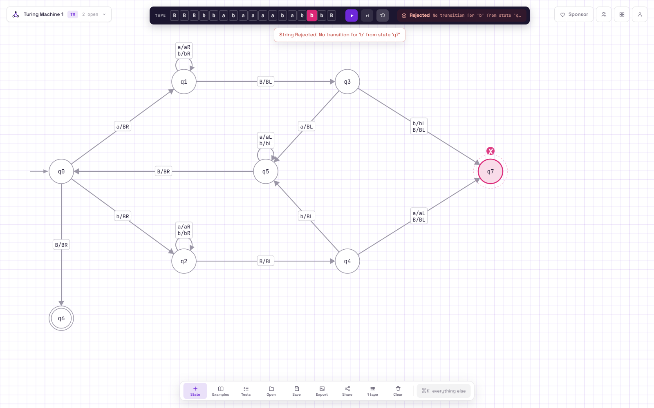
State diagram in AutomataVerse (screenshot from run 2)
Task C - Simulator runs
n = 7 so 2n = 14. Files are in the Q4 folder and links in README.md (lines "Q4 Run 1/2/3").
Run | Input | Result | Correct? | Files
1 | abbabaaaababba (length 14, abbabaa followed by its reverse) | Accepted, halted in q6 | Yes | q4_run1_in.json / .png
2 | abbabaaaababbb (length 14, last letter changed to b) | Rejected, halted in q7 | Yes, first a vs last b | q4_run2_not_in.json / .png
3 | a (single symbol) | Rejected, halted in q7 | Yes, length 1 is odd | q4_run3_single.json / .png

For run 3 I picked a single symbol because that is the boundary for the even-length version: "a" is a palindrome but has odd length so it has to be rejected, while the empty string (length 0) is accepted straight away by the q0 on B transition.
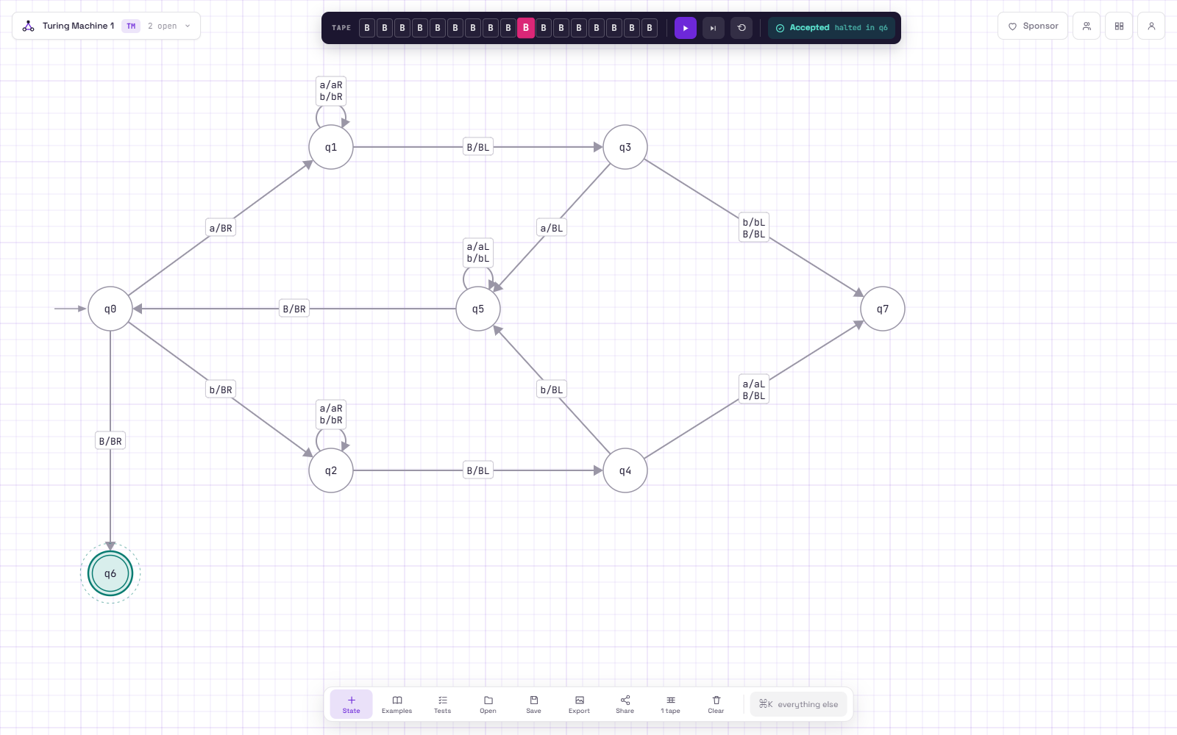
Run 1: abbabaaaababba, accepted (all symbols erased)
Run 2: abbabaaaababbb, rejected
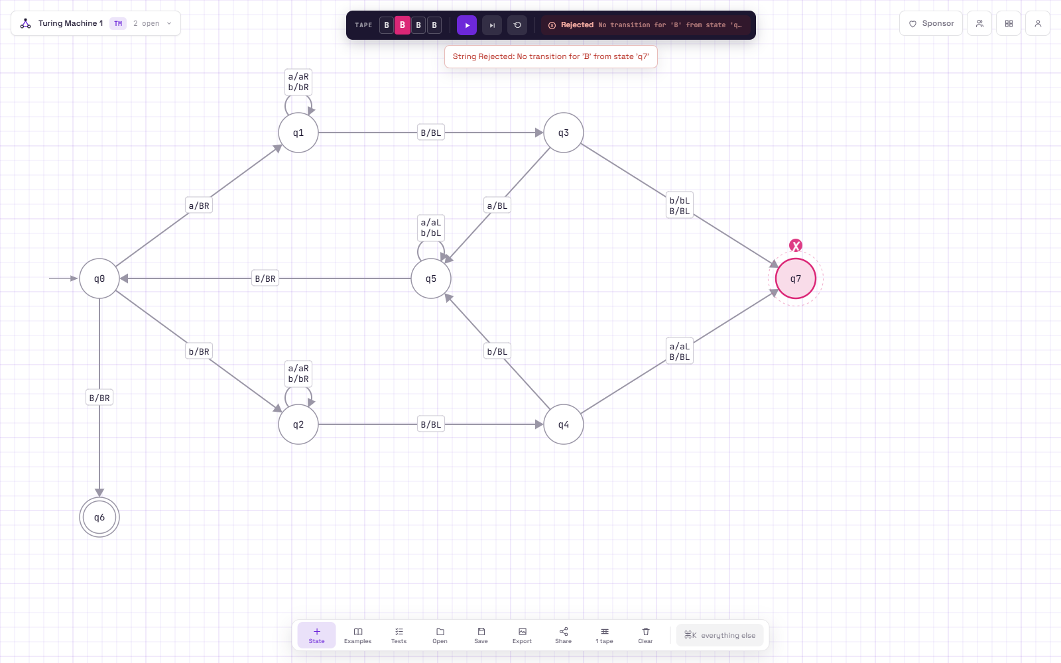
Run 3: a, rejected
Task D - Why several sweeps are needed
The head can only see one cell at a time and the only thing the machine remembers is its current state. To check the first symbol against the last one it has to carry the first symbol (as q1 or q2) all the way to the other end, and then come all the way back to fetch the next symbol, and so on. With only one left-to-right pass the machine would have to remember the whole first half of the string in its states before it could compare anything, and since the string can be any length that would need an unlimited number of states. Erasing the matched pair and sweeping back and forth lets the tape do the remembering. For my 14 letter input that was 7 round trips.

