CSE145 - Introduction to Computing
Assignment 2: Turing Machines
Name: Muhammad Wasay Farrukh ERP No.: 35538
R = 38 V = 2 B = 100110 n = 7
(R = last two digits of 35538 = 38, V = 38 mod 4 = 2, B = 38 in binary = 100110, digit sum = 3+5+5+3+8 = 24, 24 mod 5 = 4, n = 4 + 3 = 7)
GitHub repository: https://github.com/wasaay/35538-cse145-a2-tm

Q6 - Debug the Broken Machine
Task A - Hand traces
Notation: the cell in [ ] is where the head is. Cell 0 is the first cell of the input. ⊔ is blank.
Input "" (empty string):
Step | State | Tape | Head at cell | Transition used
0 | q_even | [⊔] ⊔ | 0 | (q_even, ⊔) -> write ⊔, R, q_odd
1 | q_odd | ⊔ [⊔] | 1 | (q_odd, ⊔) -> write ⊔, R, q_reject
2 | q_reject | ⊔ ⊔ [⊔] | 2 | halts, REJECT

Input "11":
Step | State | Tape | Head at cell | Transition used
0 | q_even | [1] 1 ⊔ | 0 | (q_even, 1) -> write 1, R, q_odd
1 | q_odd | 1 [1] ⊔ | 1 | (q_odd, 1) -> write 1, R, q_even
2 | q_even | 1 1 [⊔] | 2 | (q_even, ⊔) -> write ⊔, R, q_odd
3 | q_odd | 1 1 ⊔ [⊔] | 3 | (q_odd, ⊔) -> write ⊔, R, q_reject
4 | q_reject | 1 1 ⊔ ⊔ [⊔] | 4 | halts, REJECT

Both inputs end up rejected, but both have an even number of 1s (zero and two), so they should be accepted.
Task B - Finding the wrong row
The wrong row is: q_even, ⊔, ⊔, R, q_odd.
In both traces the machine was in q_even at the exact moment it first read a blank (step 0 for "" and step 2 for "11"). Being in q_even at the blank means the whole input has been read and the number of 1s was even, so this is the point where it should accept. Instead that row sends it to q_odd, even though no 1 was read, and then q_odd reads another blank and goes to q_reject. So both wrong answers came from the same row. The other rows behaved correctly in the traces: 0 keeps the state, 1 flips between q_even and q_odd, and q_odd on blank going to q_reject is right because an odd count must be rejected. Another hint is that nothing in the table ever goes to q_accept, so the machine could never accept anything.
Corrected row: q_even, ⊔, ⊔, R, q_accept.
Task C - Simulator runs
AutomataVerse always uses q0 as the start state, so I named the states like this: q0 = q_even, q1 = q_odd, q2 = q_accept, q3 = q_reject. The blank is B.
Broken machine (exactly as given):
Current state | Read | Write | Move | Next state
q0 (q_even) | 0 | 0 | R | q0 (q_even)
q0 (q_even) | 1 | 1 | R | q1 (q_odd)
q0 (q_even) | B | B | R | q1 (q_odd)
q1 (q_odd) | 0 | 0 | R | q1 (q_odd)
q1 (q_odd) | 1 | 1 | R | q0 (q_even)
q1 (q_odd) | B | B | R | q3 (q_reject)

Fixed machine (only the q0 on B row changed):
Current state | Read | Write | Move | Next state
q0 (q_even) | 0 | 0 | R | q0 (q_even)
q0 (q_even) | 1 | 1 | R | q1 (q_odd)
q0 (q_even) | B | B | R | q2 (q_accept)
q1 (q_odd) | 0 | 0 | R | q1 (q_odd)
q1 (q_odd) | 1 | 1 | R | q0 (q_even)
q1 (q_odd) | B | B | R | q3 (q_reject)

Summary of the eight runs (links in README.md, lines "Q6 Broken Run 1-4" and "Q6 Fixed Run 1-4"):
String | Broken | Fixed | Correct answer
"" (empty) | Reject | Accept | Accept (zero 1s)
11 | Reject | Accept | Accept (two 1s)
1 | Reject | Reject | Reject (one 1)
111 | Reject | Reject | Reject (three 1s)

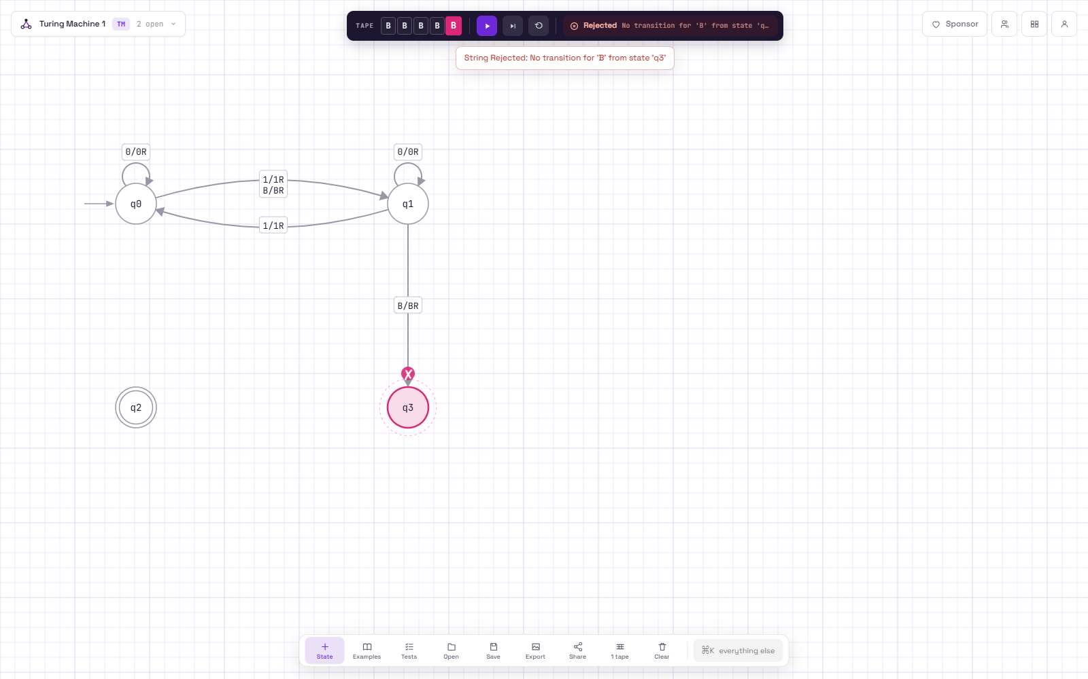
Broken machine, run 1: input "" rejected (q6_broken_run1_empty.json)
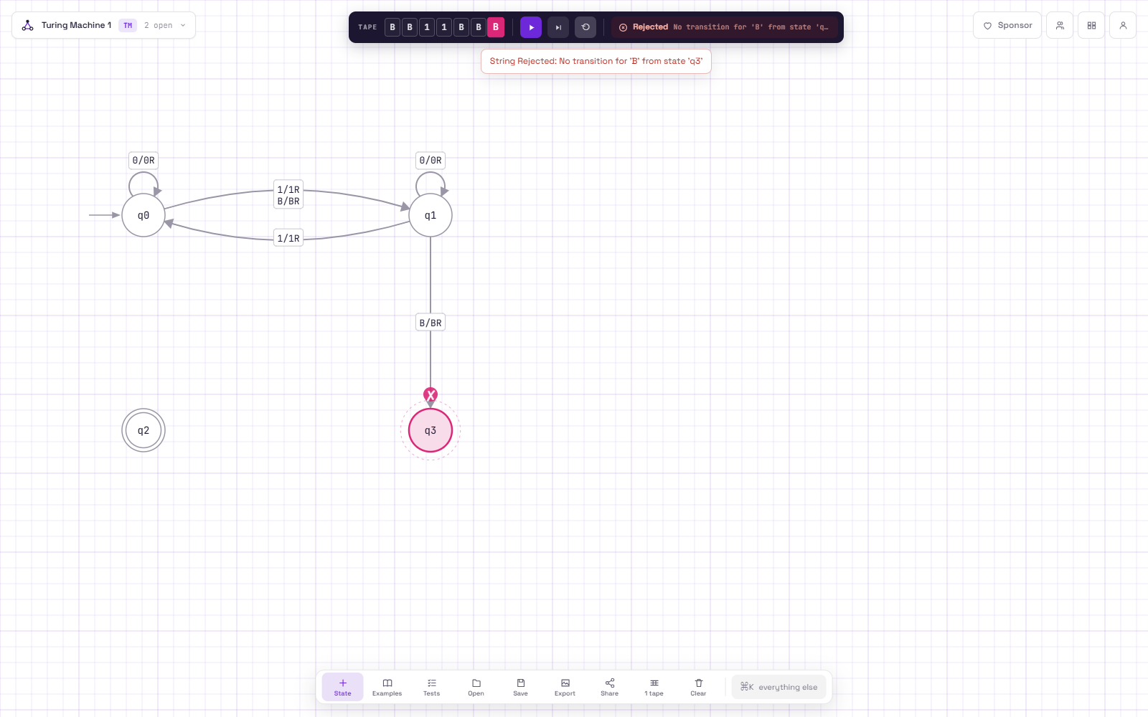
Broken machine, run 2: input "11" rejected (q6_broken_run2_11.json)
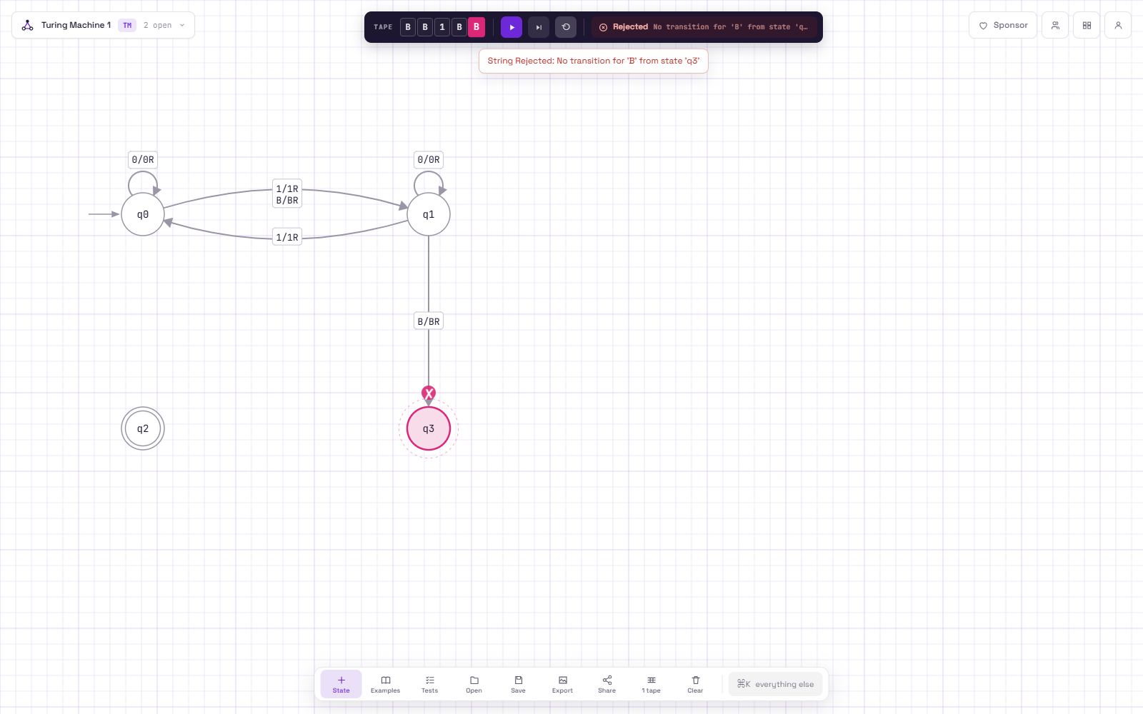
Broken machine, run 3: input "1" rejected (q6_broken_run3_1.json)
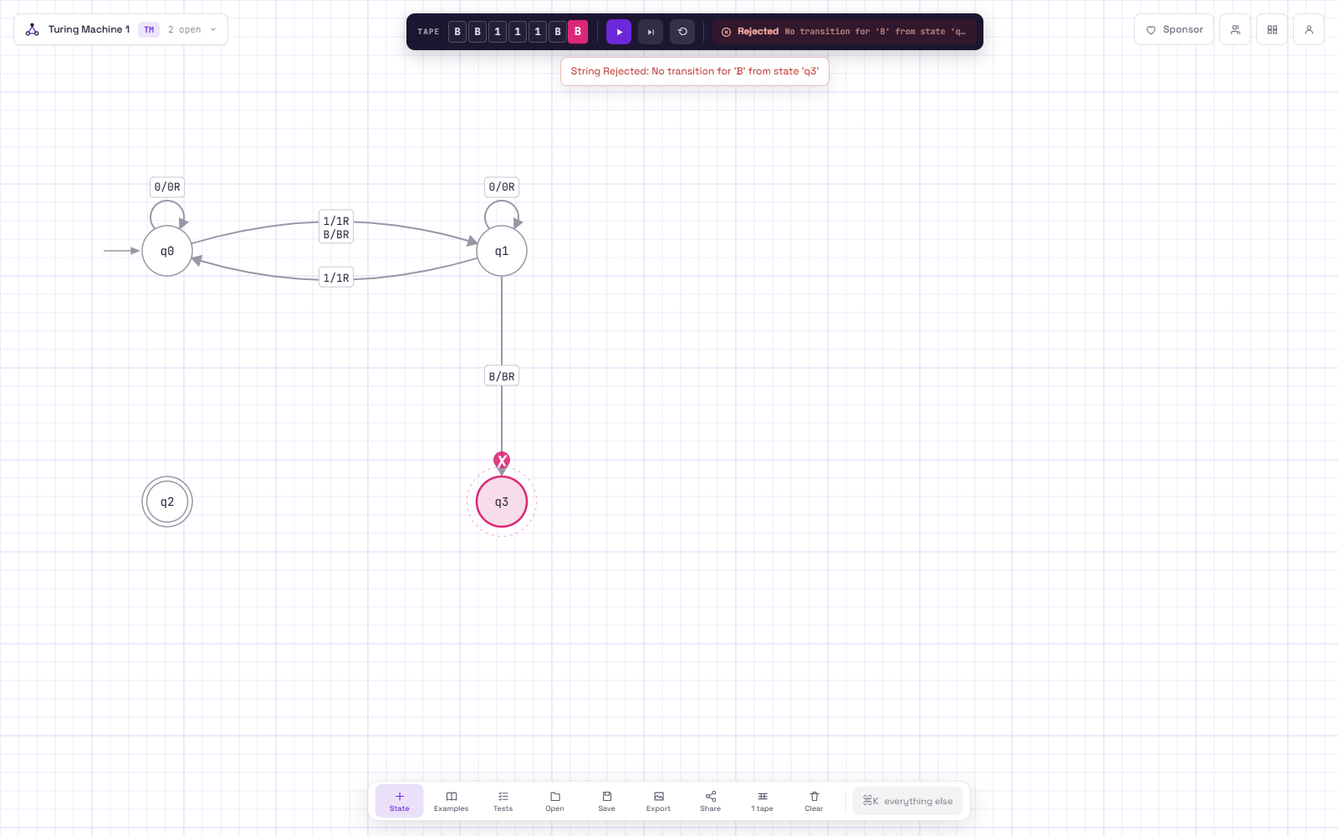
Broken machine, run 4: input "111" rejected (q6_broken_run4_111.json)
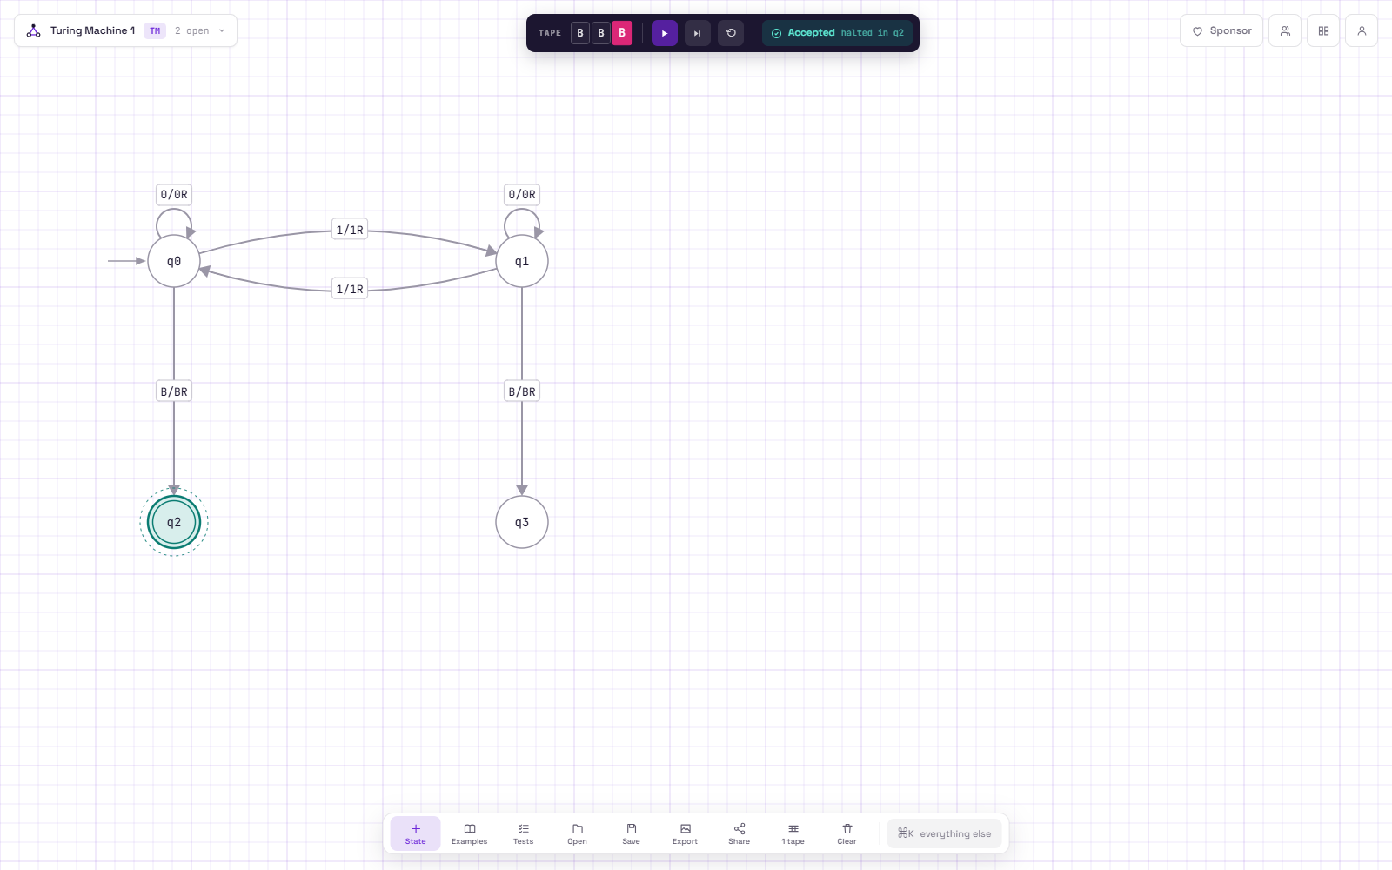
Fixed machine, run 1: input "" accepted (q6_fixed_run1_empty.json)
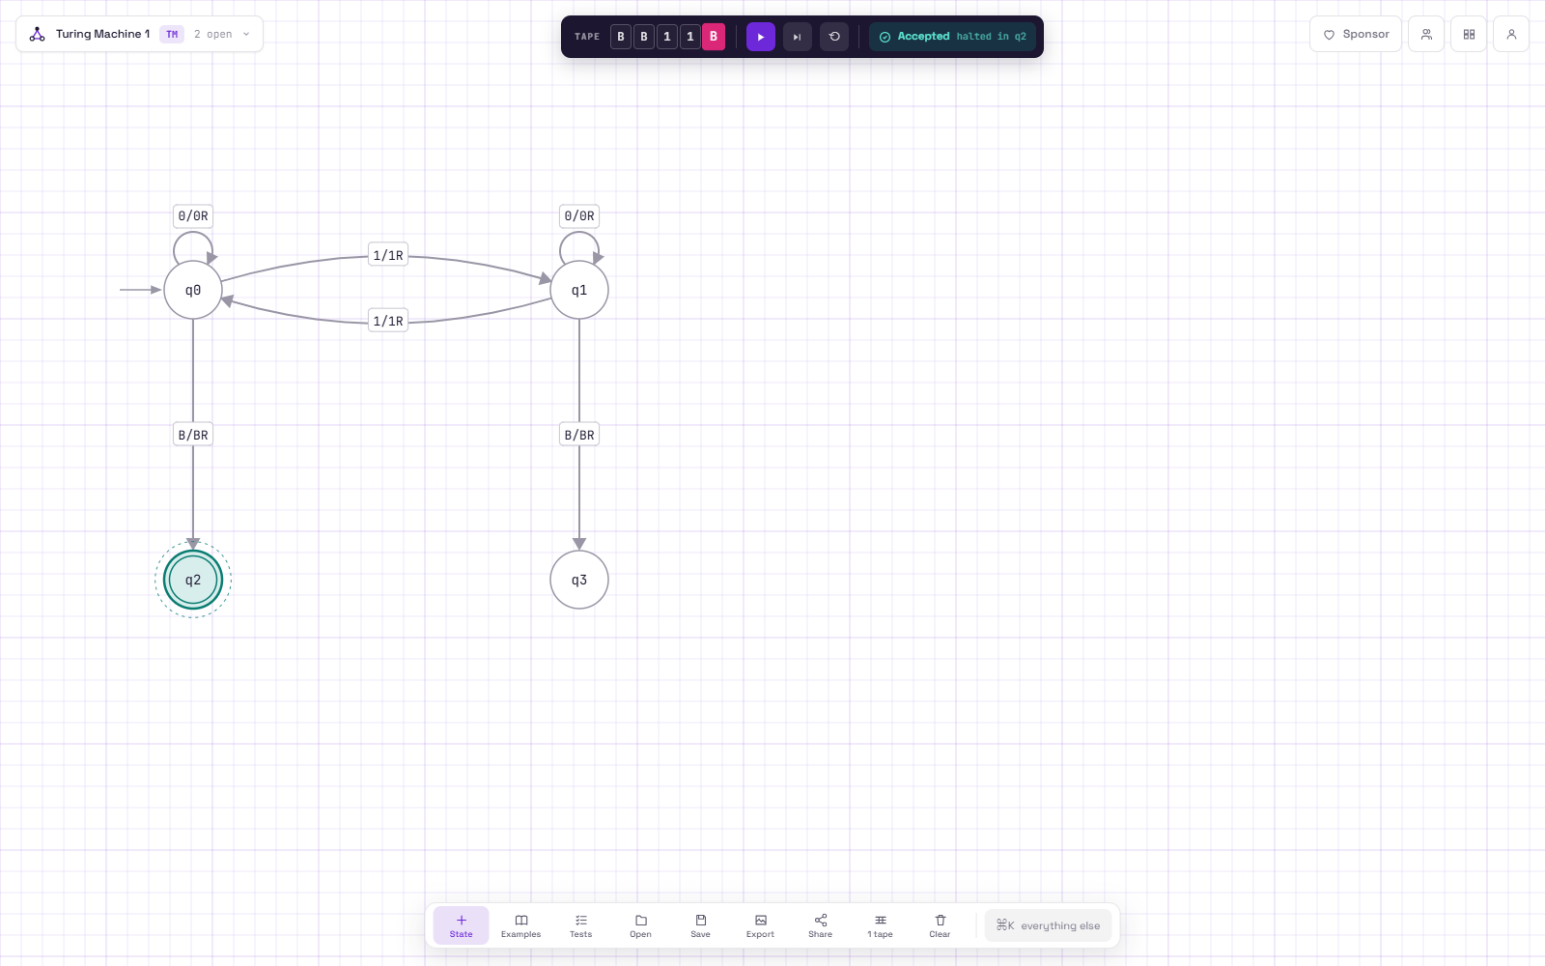
Fixed machine, run 2: input "11" accepted (q6_fixed_run2_11.json)
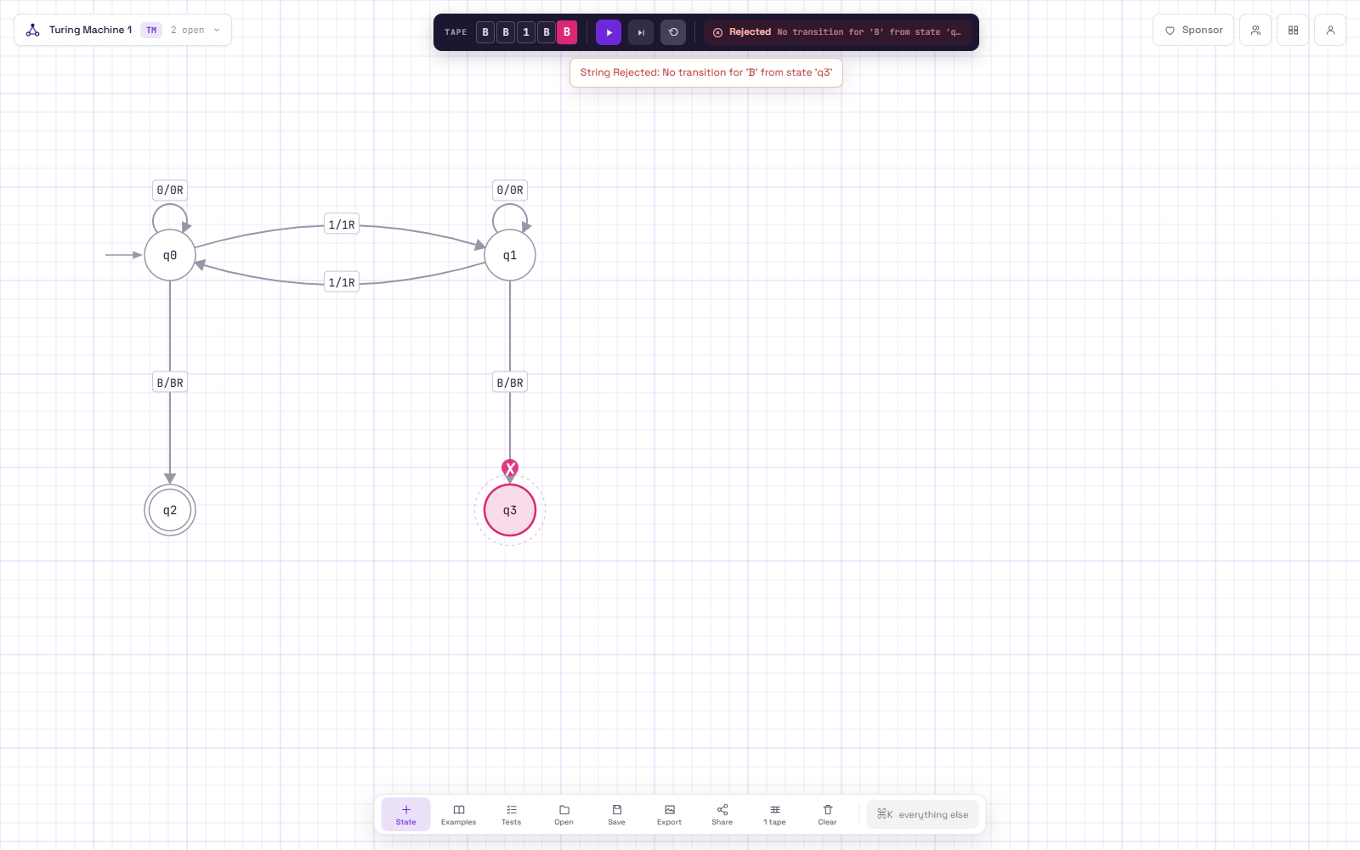
Fixed machine, run 3: input "1" rejected (q6_fixed_run3_1.json)
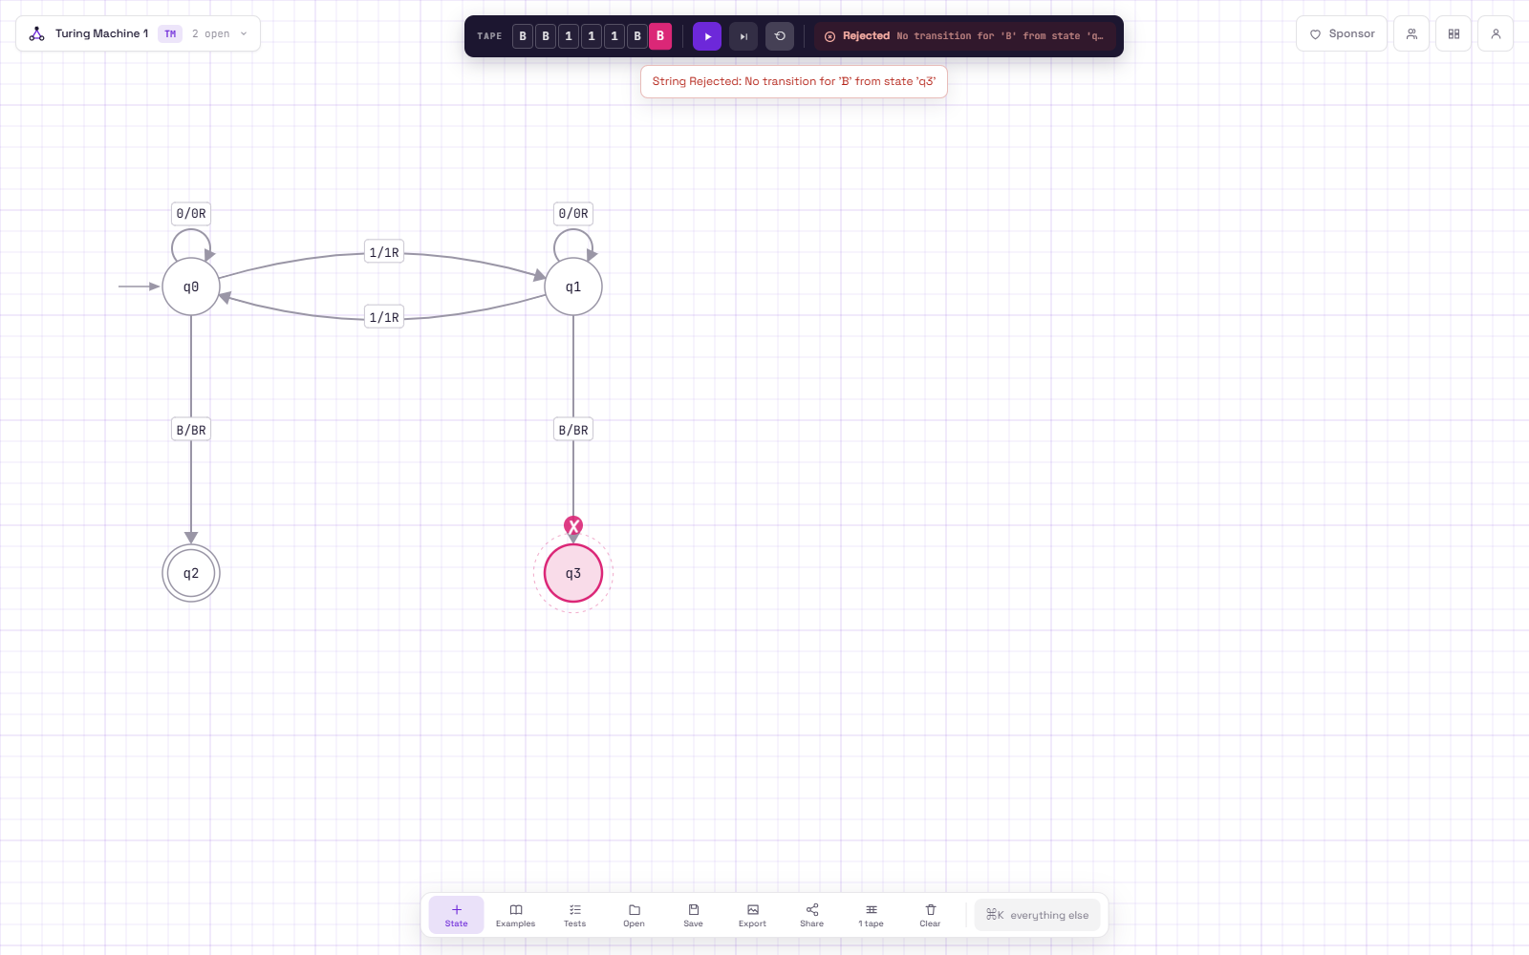
Fixed machine, run 4: input "111" rejected (q6_fixed_run4_111.json)
Task D - Reflection
The strings 1 and 111 on their own would not have shown the bug. Both have an odd number of 1s so the right answer is reject, and the broken machine rejects them too because it reaches the blank in q_odd, which uses a correct row. The bug only shows up on inputs that reach the blank in q_even, meaning strings that should be accepted, like "" and 11. So when I test my own machines I should not only try strings that should be rejected, I should make sure there is at least one test that ends in each halting row, including the accepting one, and always try edge cases like the empty string.

