CSE145 - Introduction to Computing
Assignment 2: Turing Machines
Name: Muhammad Wasay Farrukh ERP No.: 35538
R = 38 V = 2 B = 100110 n = 7
(R = last two digits of 35538 = 38, V = 38 mod 4 = 2, B = 38 in binary = 100110, digit sum = 3+5+5+3+8 = 24, 24 mod 5 = 4, n = 4 + 3 = 7)
GitHub repository: https://github.com/wasaay/35538-cse145-a2-tm

Q5 - Marked-Comparison Recognizer (V = 2, L = { a^i # b^j : i > j })
Task A - Strategy
My machine works in two phases. First, q0, q1 and q2 check the format: some a's, then one #, then some b's, and anything else goes to the reject state q8. q2 then rewinds the head to the left end. In the second phase every round crosses off one a on the left by writing X (q3 to q4), moves right past the other a's and the # (q4), skips the b's already marked as Y (q5) and marks the first unmarked b as Y. q6 walks back left until it reaches an X and steps right into q3 for the next round. The loop can end in two ways. If q5 is looking for a b to pair with the a it just crossed and finds the blank, that a has no partner, so i > j and the machine accepts in q7. If q3 is looking for the next a and finds the # instead, every a got a b, so i <= j and it rejects in q8.
Task B - Transition table and state diagram
State | Meaning
q0 (start) | format check: a's before #
q1 | format check: b's after #
q2 | rewind to the left end
q3 | cross the next a (X)
q4 | move right to the #
q5 | find the next unmarked b and mark it Y
q6 | go back left to the last X
q7 | accept
q8 | reject

Current state | Read | Write | Move | Next state
q0 | a | a | R | q0
q0 | # | # | R | q1
q0 | b | b | R | q8
q0 | B | B | R | q8
q1 | b | b | R | q1
q1 | B | B | L | q2
q1 | a | a | R | q8
q1 | # | # | R | q8
q2 | a | a | L | q2
q2 | b | b | L | q2
q2 | # | # | L | q2
q2 | B | B | R | q3
q3 | a | X | R | q4
q3 | # | # | R | q8
q4 | a | a | R | q4
q4 | # | # | R | q5
q5 | Y | Y | R | q5
q5 | b | Y | L | q6
q5 | B | B | L | q7
q6 | Y | Y | L | q6
q6 | # | # | L | q6
q6 | a | a | L | q6
q6 | X | X | R | q3

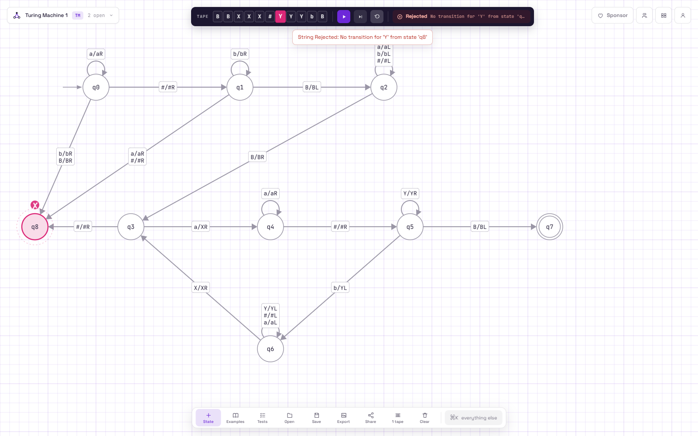
State diagram in AutomataVerse (screenshot from run 2)
Task C - Simulator runs
Building the left side from B: B = 100110. Writing an a for every 1-bit and a b for every 0-bit gives a b b a a b, which is three a's (from the 1-bits) and three b's (from the 0-bits). My language only allows a's on the left of the #, so I put the a's from the three 1-bits on the left: aaa, which means i = 3. Then I chose the right side so that the first string has more a's than b's and the second one has more b's than a's.
Run | Input | i, j | Result | Correct? | Files
1 | aaa#bb | i = 3, j = 2 | Accepted, halted in q7, tape XXX#YY | Yes, 3 > 2 | q5_run1_in.json / .png
2 | aaa#bbbb | i = 3, j = 4 | Rejected, halted in q8, tape XXX#YYYb | Yes, 3 is not > 4 | q5_run2_not_in.json / .png

Links are in README.md (lines "Q5 Run 1" and "Q5 Run 2").
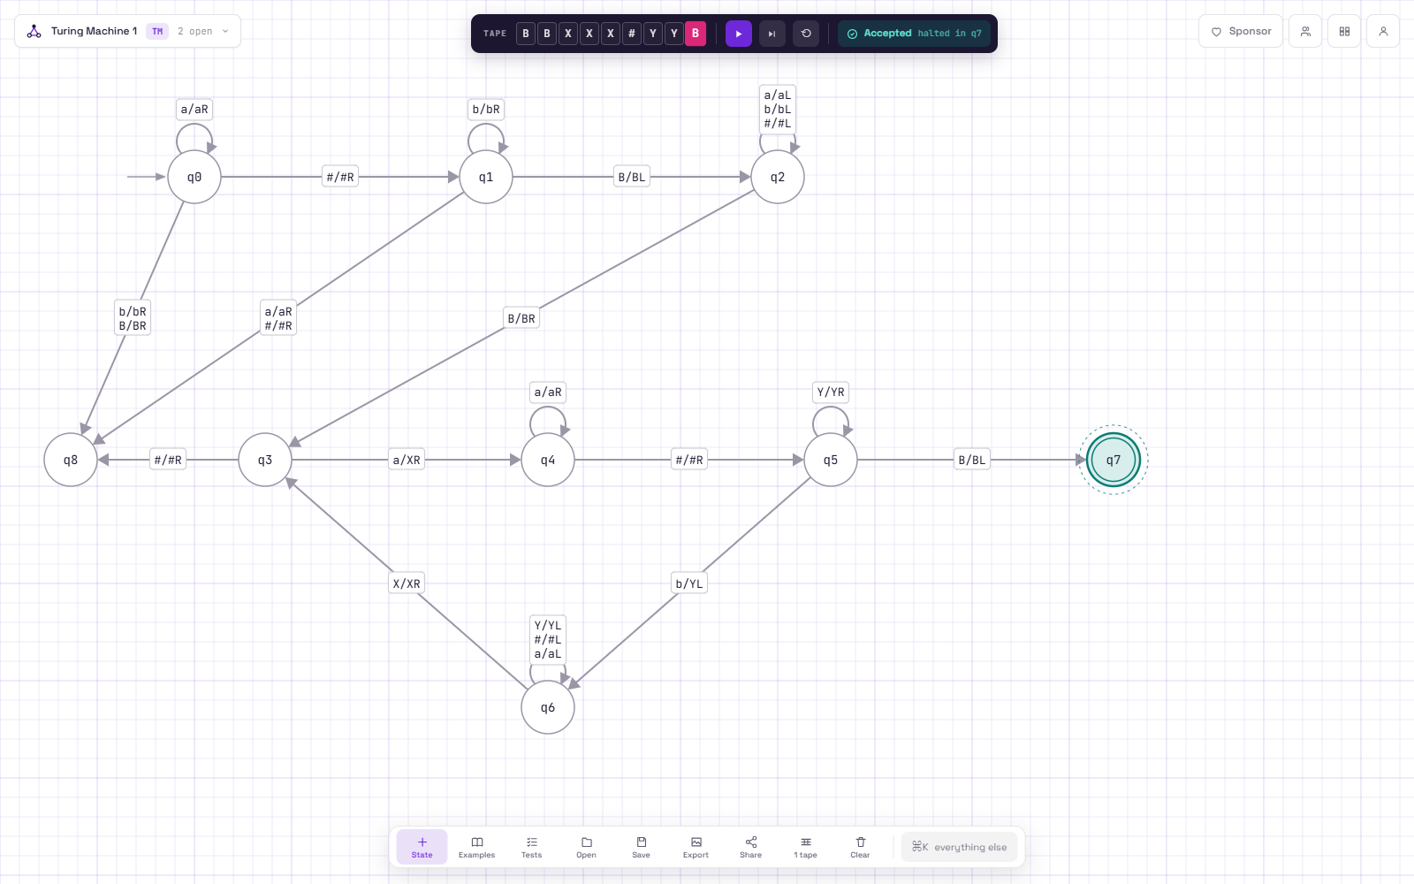
Run 1: aaa#bb, accepted
Run 2: aaa#bbbb, rejected
Task D - Why one pass is not enough
To decide whether i > j the machine has to compare two counts that can be any size. If it only went left to right once, by the time it reached the b's it would have to remember how many a's it had seen, and a finite number of states can only count up to some fixed number, so long enough strings would break it. My machine uses the tape as memory instead: the X's on the left show which a's are already paired and the Y's on the right show which b's are used. The head cannot be on both sides at the same time, so after marking a b on the right (q5) it has to come back left (q6) to find the next a, and that is the back and forth movement.

