CSE145 - Introduction to Computing
Assignment 2: Turing Machines
Name: Muhammad Wasay Farrukh ERP No.: 35538
R = 38 V = 2 B = 100110 n = 7
(R = last two digits of 35538 = 38, V = 38 mod 4 = 2, B = 38 in binary = 100110, digit sum = 3+5+5+3+8 = 24, 24 mod 5 = 4, n = 4 + 3 = 7)
GitHub repository: https://github.com/wasaay/35538-cse145-a2-tm

Q1 - Divisible-by-M Recognizer (V = 2, so M = 5)
Task A - Strategy
My machine reads the binary number from left to right and only keeps track of the remainder of the number read so far when it is divided by 5. There are only five possible remainders (0 to 4), so I used one state for each: q0 means remainder 0, q1 means remainder 1, and so on up to q4. When the head reads the next bit, the number so far becomes (old number x 2 + bit), so the new remainder is (2r + bit) mod 5 and the machine moves to that state. The head does not change the tape, it writes back the same bit and moves right each time. When it reaches the blank after the last bit it goes to the accept state q5 if it is in q0, and to the reject state q6 from any other state. The empty string never leaves q0, so it gets accepted as the number 0.
Task B - Transition table and state diagram
In AutomataVerse the blank symbol is B and the start state is always q0.
State | Meaning
q0 (start) | remainder 0 so far
q1 | remainder 1
q2 | remainder 2
q3 | remainder 3
q4 | remainder 4
q5 | accept (halting)
q6 | reject (halting)

Current state | Read | Write | Move | Next state
q0 | 0 | 0 | R | q0
q0 | 1 | 1 | R | q1
q0 | B | B | L | q5
q1 | 0 | 0 | R | q2
q1 | 1 | 1 | R | q3
q1 | B | B | L | q6
q2 | 0 | 0 | R | q4
q2 | 1 | 1 | R | q0
q2 | B | B | L | q6
q3 | 0 | 0 | R | q1
q3 | 1 | 1 | R | q2
q3 | B | B | L | q6
q4 | 0 | 0 | R | q3
q4 | 1 | 1 | R | q4
q4 | B | B | L | q6

q5 and q6 have no outgoing transitions, so the machine halts as soon as it enters them. The diagram below is the same machine as drawn in AutomataVerse (q5 is the double circle).
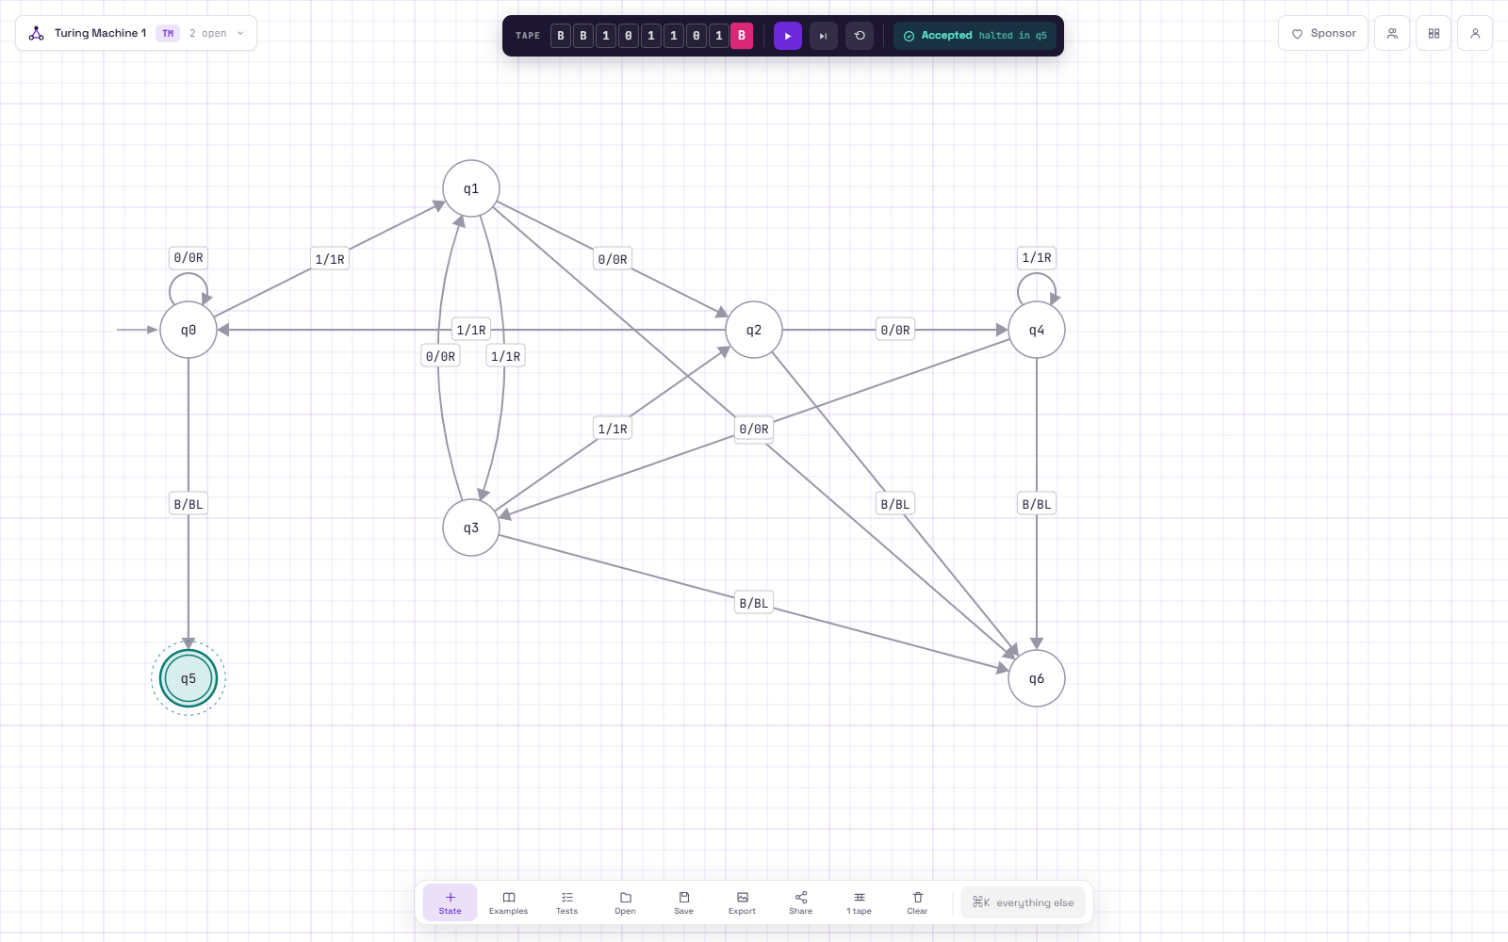
State diagram in AutomataVerse (screenshot from run 2)
Task C - Simulator runs
All JSON exports and screenshots are in the Q1 folder of the repository and the share links are in README.md (lines "Q1 Run 1", "Q1 Run 2" and "Q1 Run 3").
Run | Input | Decimal | States visited | Result | Correct? | Files
1 | 100110 (my B) | 38 (38 mod 5 = 3) | q1 q2 q4 q4 q4 q3 -> q6 | Rejected | Yes, 38 is not divisible by 5 | q1_run1_B.json / .png
2 | 101101 | 45 (45 = 5 x 9) | q1 q2 q0 q1 q2 q0 -> q5 | Accepted | Yes, 45 is divisible by 5 | q1_run2_divisible.json / .png
3 | 1011 | 11 (11 mod 5 = 1) | q1 q2 q0 q1 -> q6 | Rejected | Yes, 11 is not divisible by 5 | q1_run3_not_divisible.json / .png

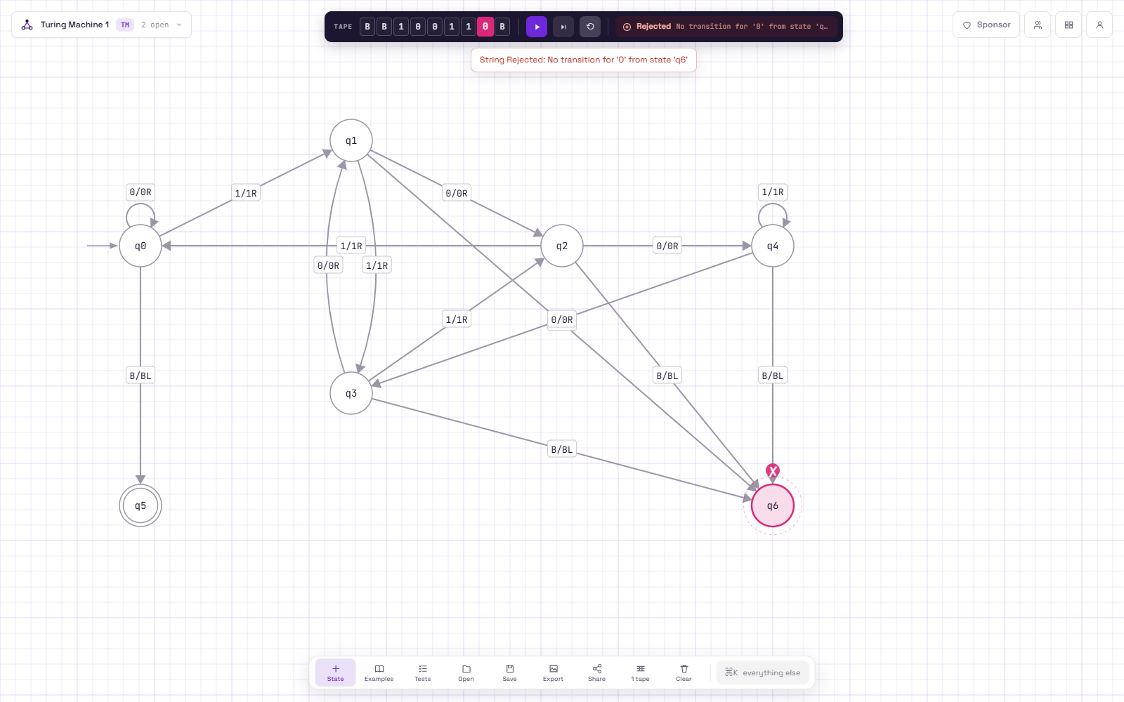
Run 1: input 100110 (B), rejected, halted in q6
Run 2: input 101101, accepted, halted in q5
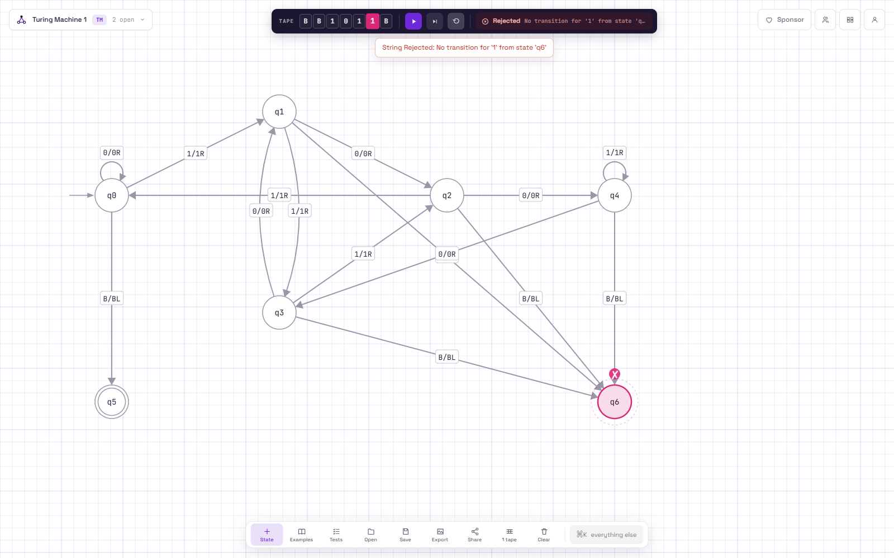
Run 3: input 1011, rejected, halted in q6
Note: when the machine halts in q6 AutomataVerse shows the message "No transition for ... from state q6". That is just how it reports a halt in a non-accepting state, q6 is my reject state.
Task D - Why the machine only works for M = 5
The value 5 is built into the states themselves. My machine has exactly five remainder states and every arrow was worked out using (2r + bit) mod 5, for example q2 on 1 goes to q0 only because 2x2+1 = 5. For another M I would need M remainder states instead of 5, and every transition would have to be recalculated using mod M, so basically the whole table changes and only the general idea of tracking the remainder stays the same.

