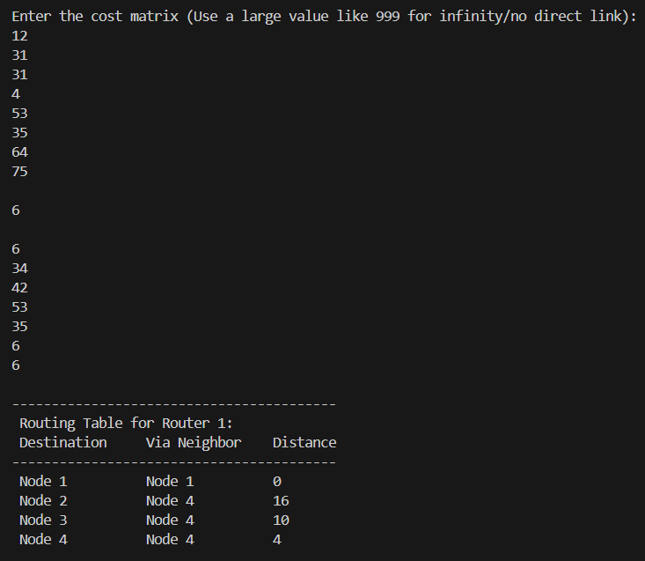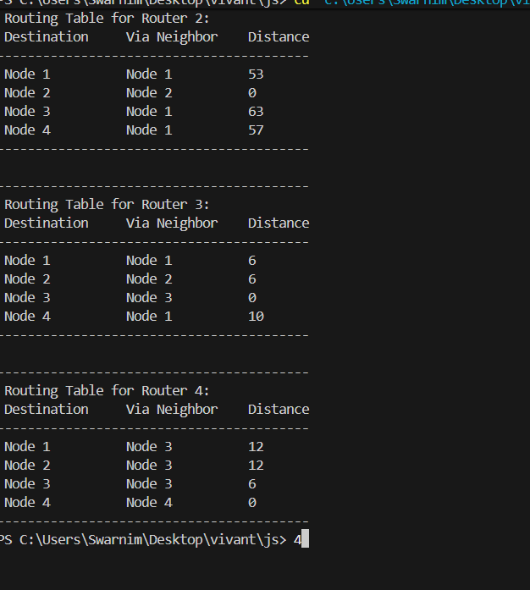#include <stdio.h>

// swarnim Diwan 24070521126
struct node {
unsigned dist[20]; // Array tracking distances to all other nodes
unsigned from[20]; // Array tracking the next hop node
} rt[20];

int main() {
int costmat[20][20];
int nodes, i, j, k, count = 0;

printf("========= Distance Vector Routing Simulation =========\n");
printf("Enter the number of nodes: ");
scanf("%d", &nodes);

printf("\nEnter the cost matrix (Use a large value like 999 for infinity/no direct link):\n");
for (i = 0; i < nodes; i++) {
for (j = 0; j < nodes; j++) {
scanf("%d", &costmat[i][j]);

// Distance to self is always 0
if (i == j) {
costmat[i][j] = 0;
}

// Initializing the routing table configurations
rt[i].dist[j] = costmat[i][j];
rt[i].from[j] = j; // Initially, next hop is the destination itself
}
}

// Iteratively update the routing tables until convergence (no more changes)
do {
count = 0;
for (i = 0; i < nodes; i++) { // For each source router 'i'
for (j = 0; j < nodes; j++) { // For each destination 'j'
for (k = 0; k < nodes; k++) { // Via intermediate neighbor 'k'

// Bellman-Ford condition checking for a shorter alternate route
if (rt[i].dist[j] > costmat[i][k] + rt[k].dist[j]) {
rt[i].dist[j] = costmat[i][k] + rt[k].dist[j];
rt[i].from[j] = k; // Update the next hop
count++; // Flag that an update occurred
}
}
}
}
} while (count != 0); // Loop terminates when the routing environment stabilizes

// Displaying the final converged routing tables
for (i = 0; i < nodes; i++) {
printf("\n-----------------------------------------");
printf("\n Routing Table for Router %d:", i + 1);
printf("\n Destination\t Via Neighbor\t Distance");
printf("\n-----------------------------------------");
for (j = 0; j < nodes; j++) {
printf("\n Node %d\t\t Node %d\t\t %d", j + 1, rt[i].from[j] + 1, rt[i].dist[j]);
}
printf("\n-----------------------------------------\n");
}

return 0;
}

