# Arduino Pinout

## Arduino Pro Mini Description

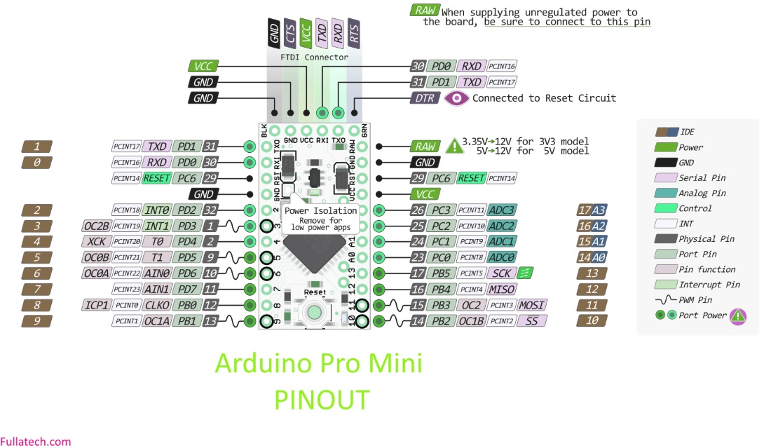

## Pin Assignment

|  |  |  |
| --- | --- | --- |
| Device | ARduino Pin | Device Pin |
| RFM95W | 3.3V | 3.3V |
|  | GND | GND |
|  | 12 | MISO |
|  | 11 | MOSI |
|  | 13 | SCK |
|  | 10 | NSS |
|  | A0 | RESET |
|  | A1 | DIO0 |
|  |  |  |
| NTC | A2 | - |
|  | A3 | - |
|  |  |  |
| DTH11 | 4 | 1 |
|  | 3 | 2 |
|  | 2 | 4 |
|  |  |  |
| Hx711 |  | VDD |
|  |  | VCC |
|  |  | DAT |
|  |  | CLK |
|  | GND | GND |