Record-yehan

1. TO DO LIST

1. Speed up dlib’s Facial Landmark Detector(working on it)
2. make matlab detector work

2. Get output

command line

1. go to the directory

cd /usr/local/lib/dlib/examples/build

1. if change code, then compile

cmake --build . --config Release

1. run webcam file

./webcam_face_pose_ex

./webcam_face_pose_ex > testRecordDDMMYY.txt

image of landmark

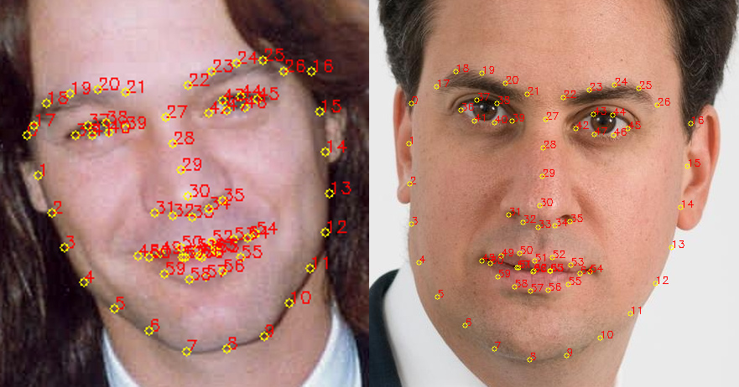

range of landmark

FACE_POINTS = list(range(17, 68))

MOUTH_POINTS = list(range(48, 61))

RIGHT_BROW_POINTS = list(range(17, 22))

LEFT_BROW_POINTS = list(range(22, 27))

RIGHT_EYE_POINTS = list(range(36, 42))

LEFT_EYE_POINTS = list(range(42, 48))

NOSE_POINTS = list(range(27, 35))

JAW_POINTS = list(range(0, 17))

CHIN_POINTS=list(range(6,11))

real time output example:

Number of faces detected: 1

number of parts: 68

pixel position of point 0: (507, 271)

pixel position of point 1: (515, 317)

pixel position of point 27: (675, 243)

pixel position of point 30: (683, 338)

pixel position of point 16: (865, 232)

pixel position of point 15: (866, 281)

Number of faces detected: 1

…

More output in testRecord301116.txt

3. connections between face actions and points on face (Alex)

-useful web: ibug

<http://ibug.doc.ic.ac.uk/resources/facial-point-annotations/>

-SVM