Computer science

Chapter 1: GitHub

How to upload on GitHub
- Open git bash
- $ git config -- global user . name " Sébastien Combéfis "
- $ git config -- global user . email " seb478@gmail . com "
- Link your directory from the github repository you’ve created
git clone https :// github . com / < votreNom >/ AdvancedPython2BA - Labo1 .git
- git add file.py
- git commit -m"description"
- git push

Chapter 2: regex
- Import re
- Pattern = r’[0-9]{9}’ =>patterne qu’on recherche
- P = re.compile(pattern)
- Print(p.match(“789464341”)) => if not correct it will return None
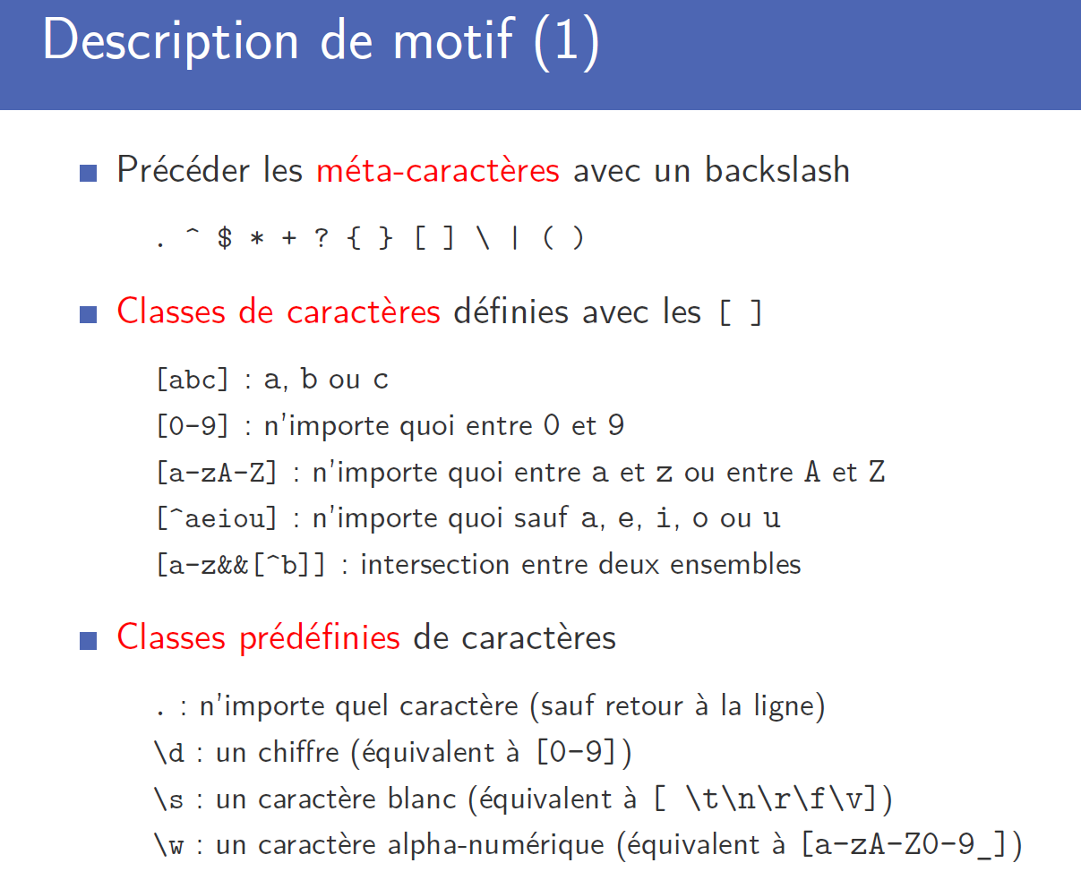
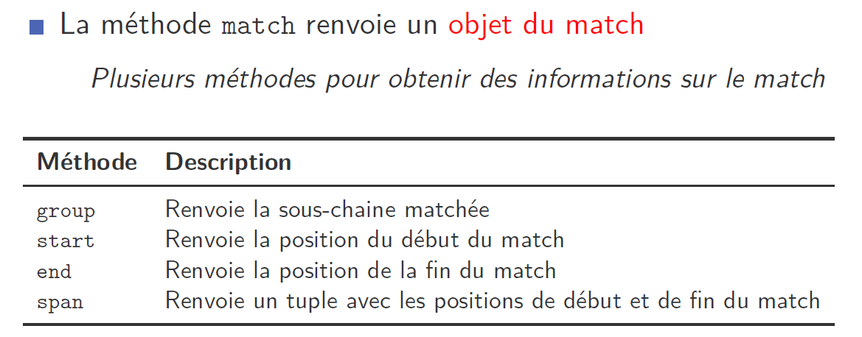
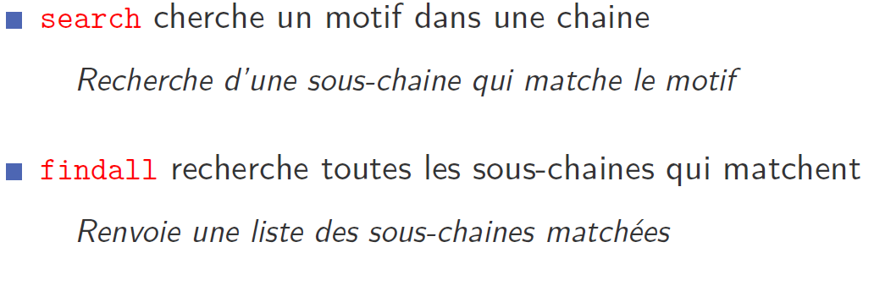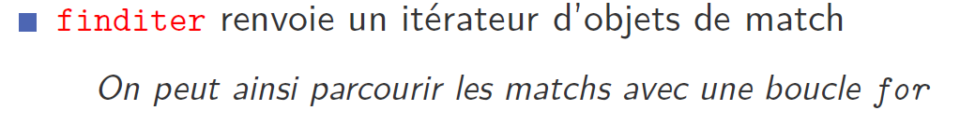
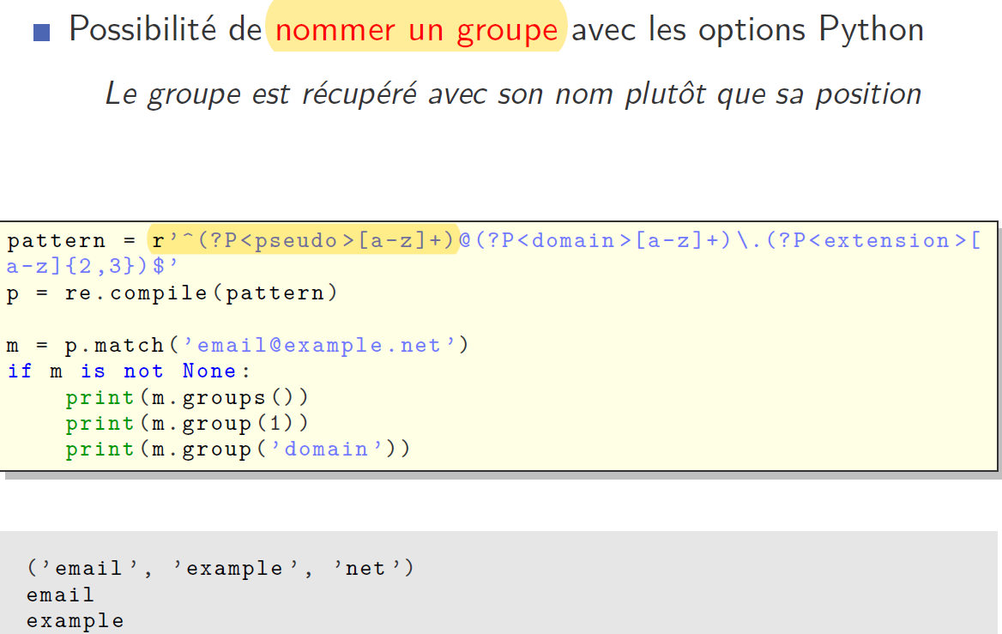

Examples from the lab 2 :
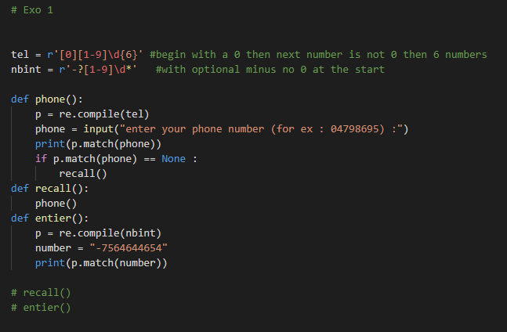
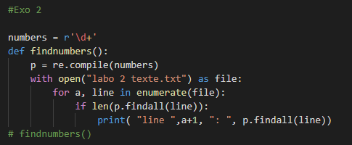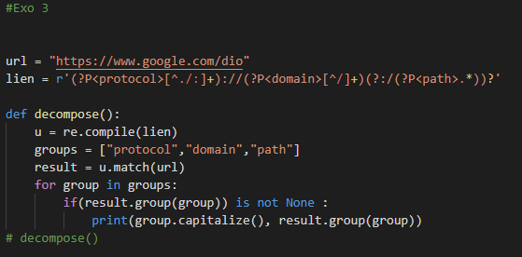
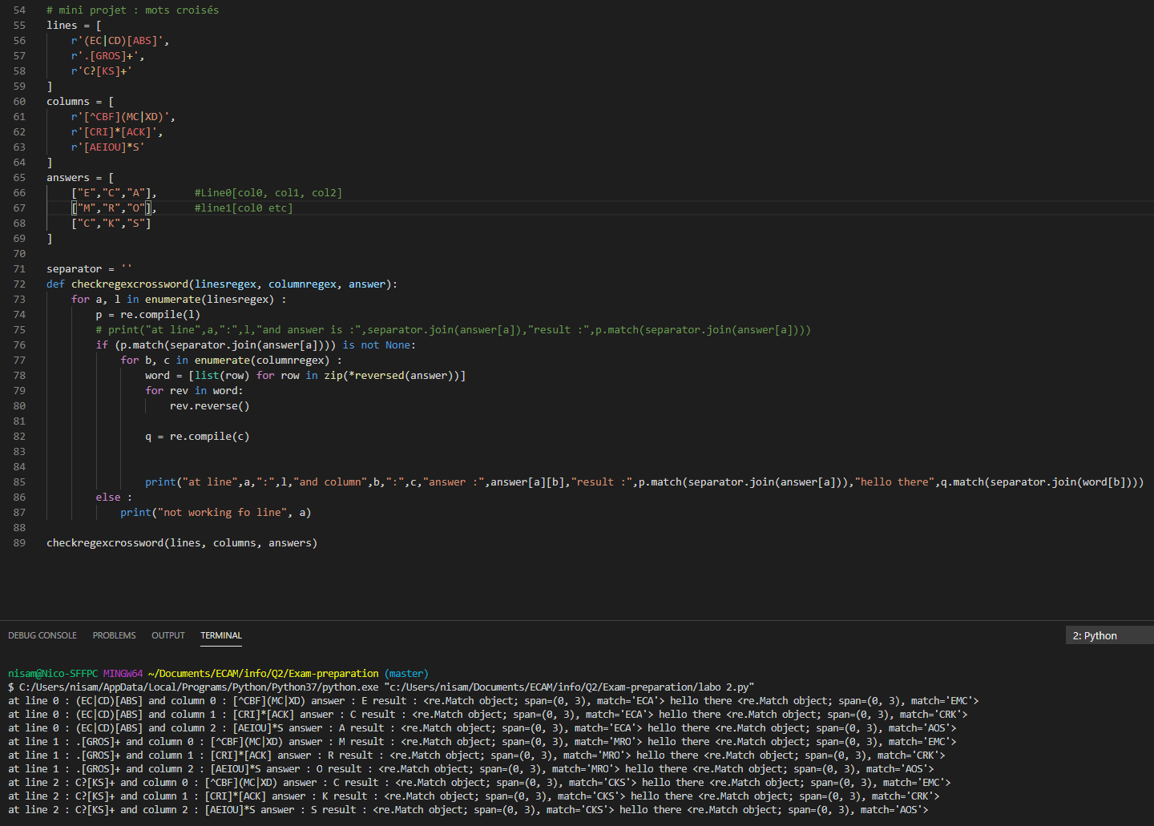

Chapter 3 & 4: Functional computing and decorators

Functional computing
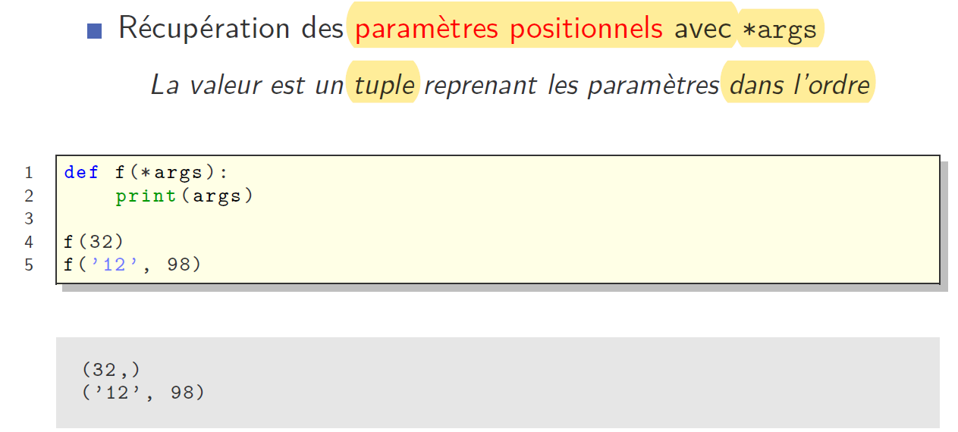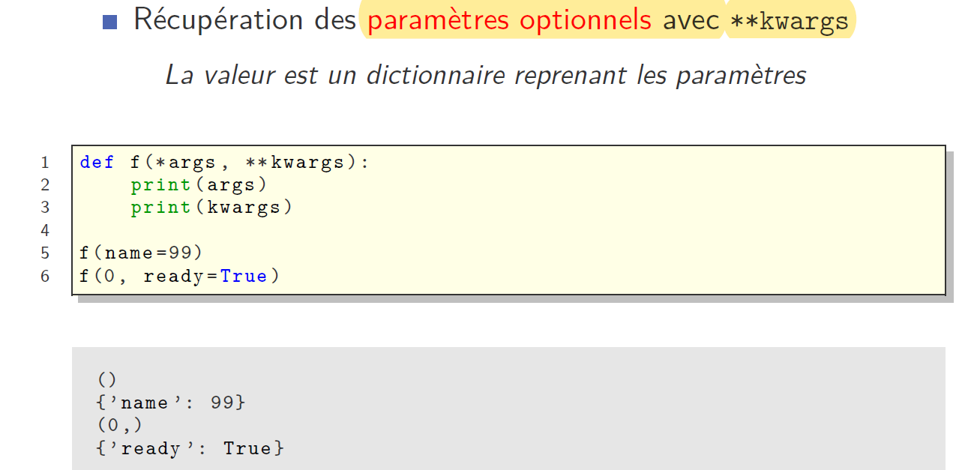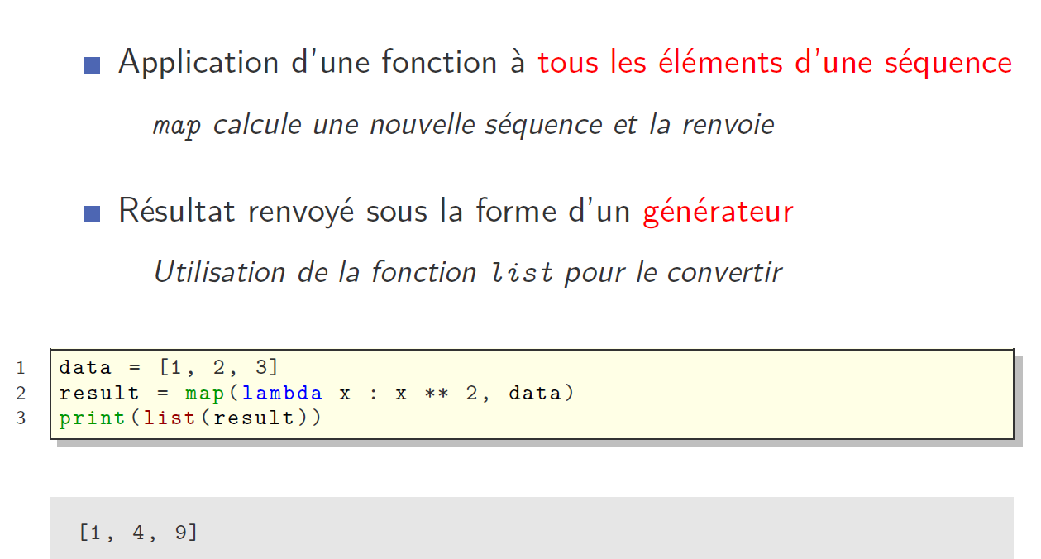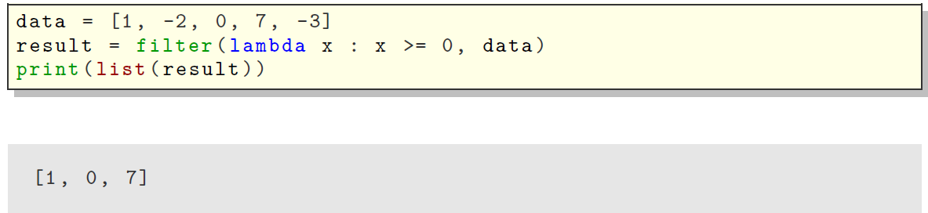
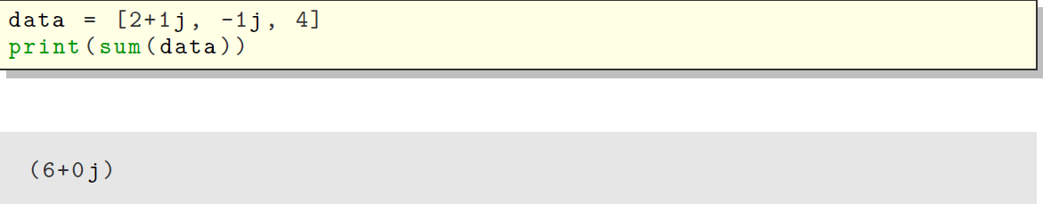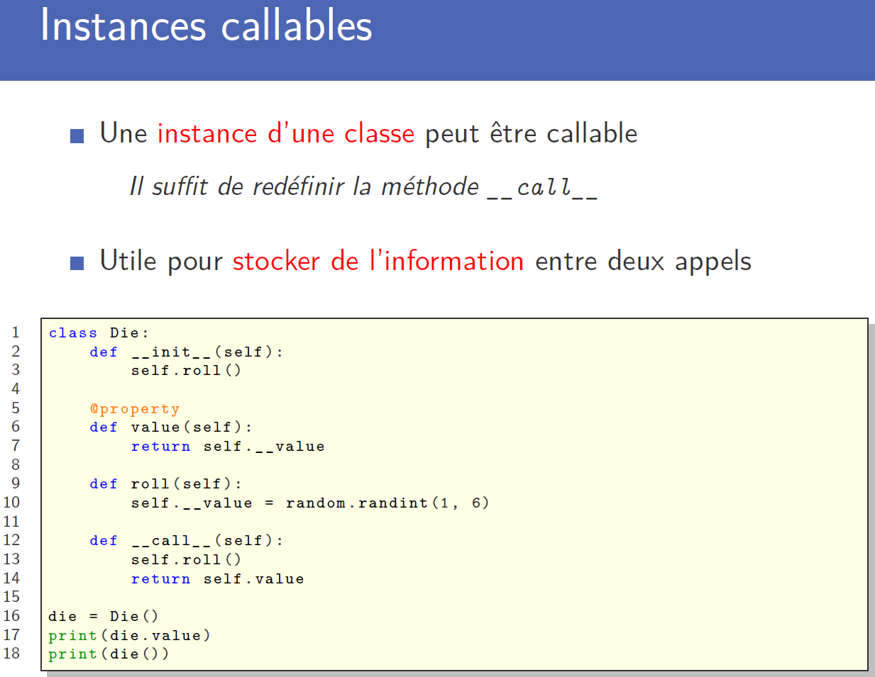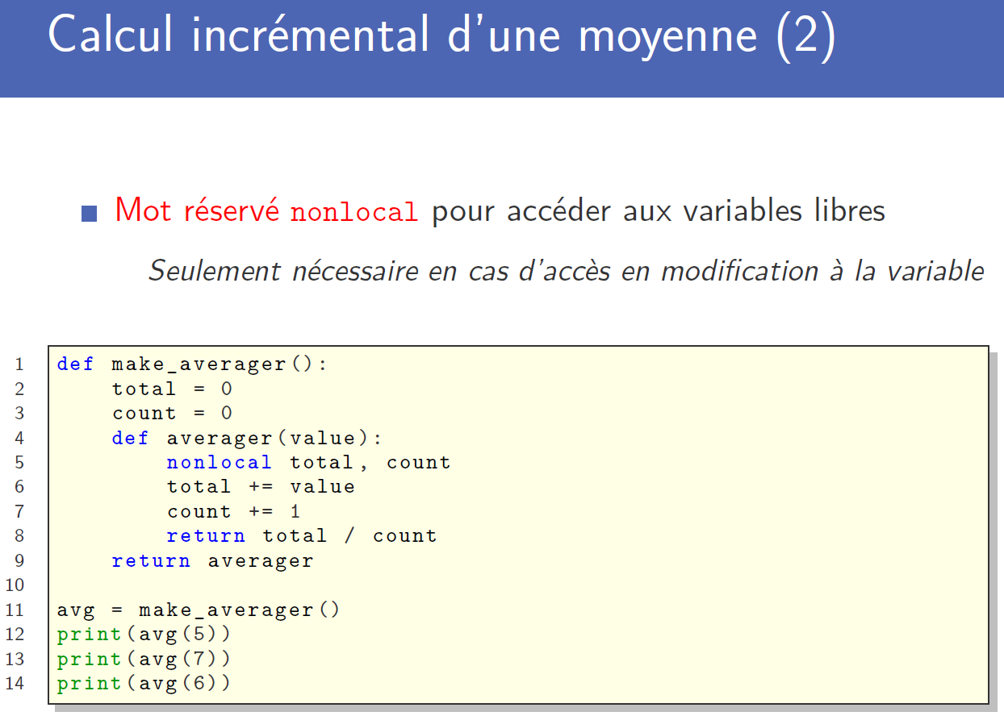

Decorator
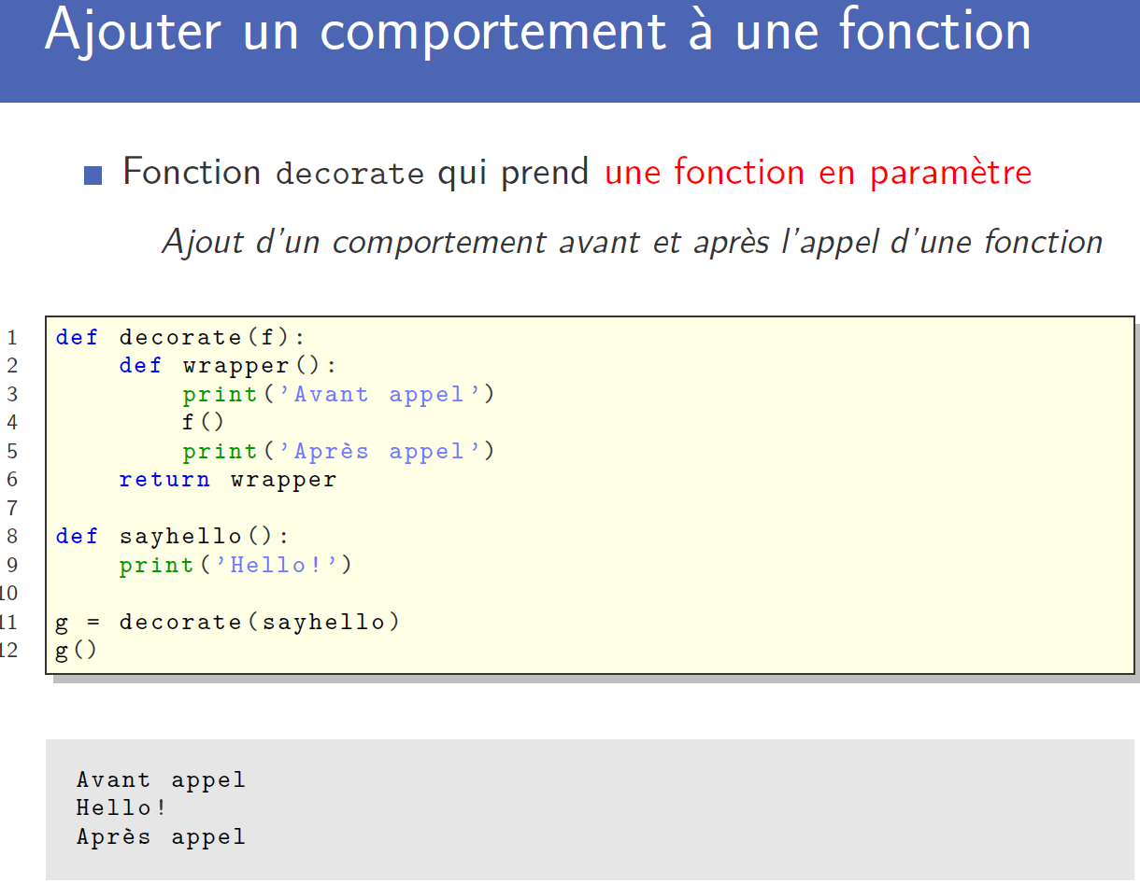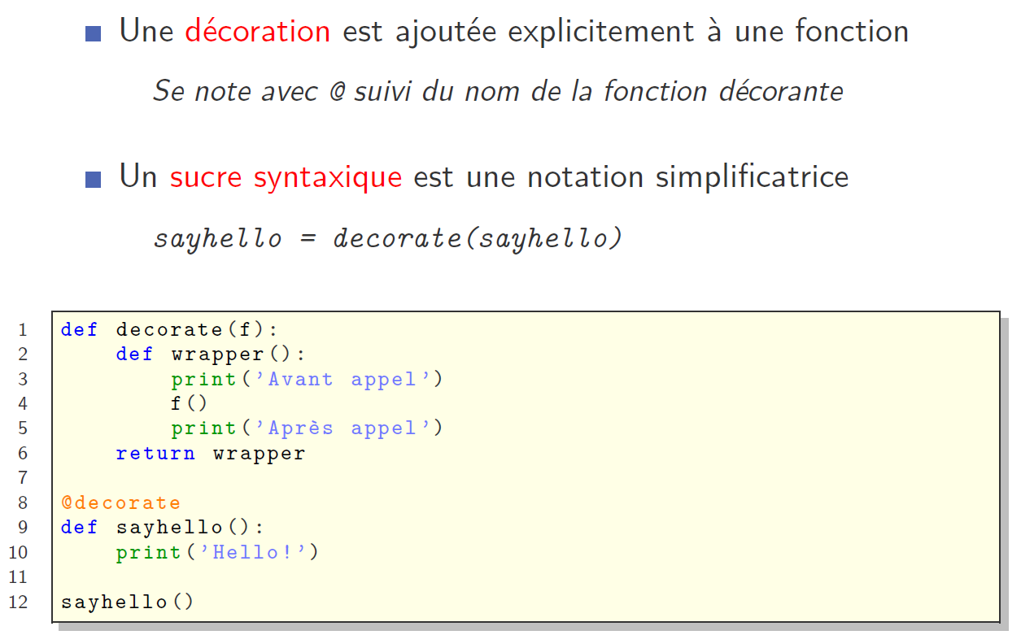

Generator

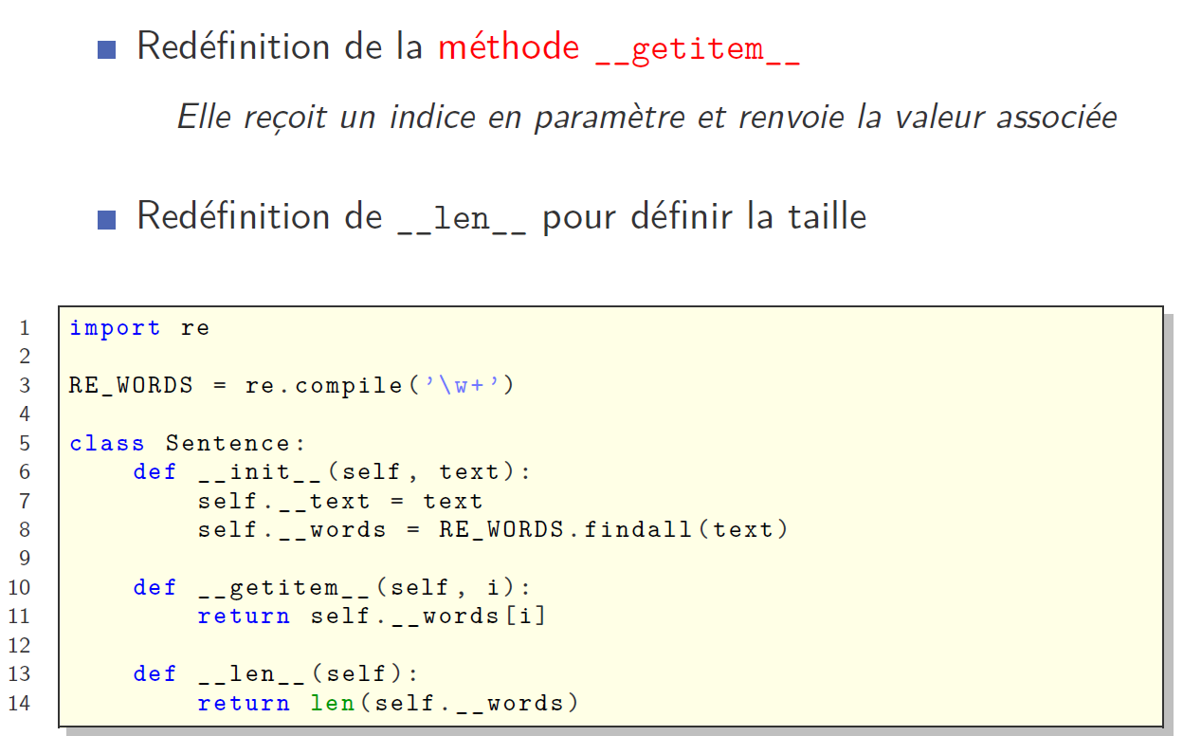
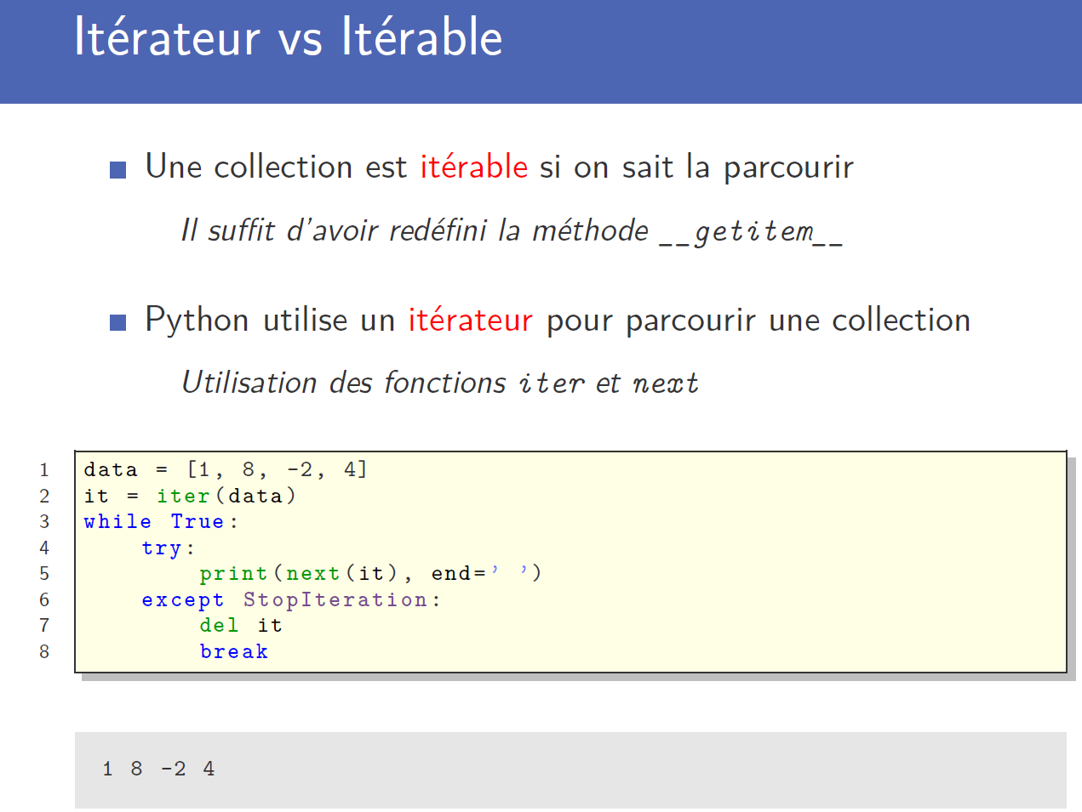
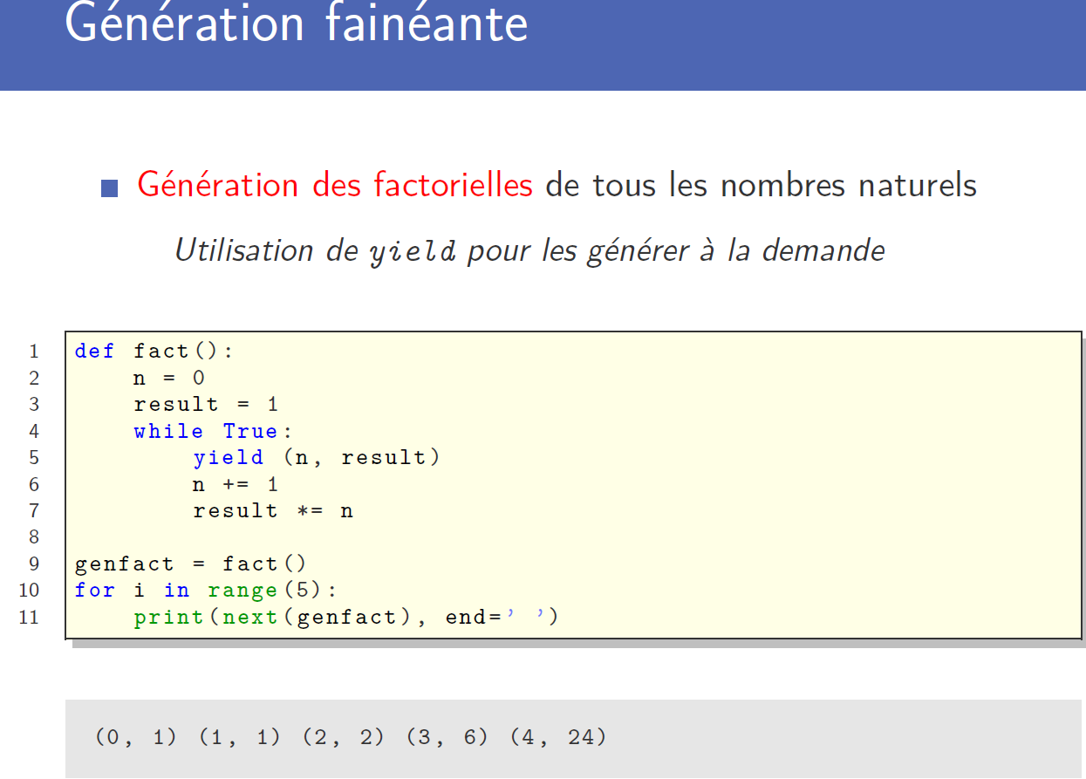

Examples:
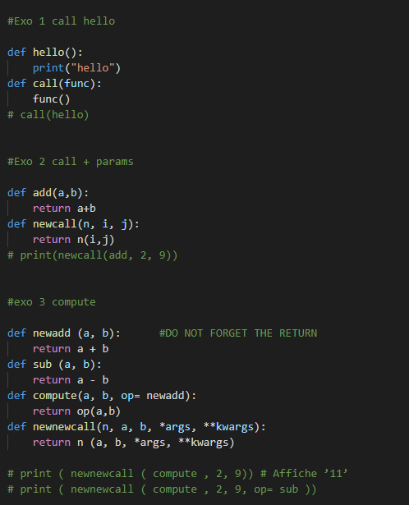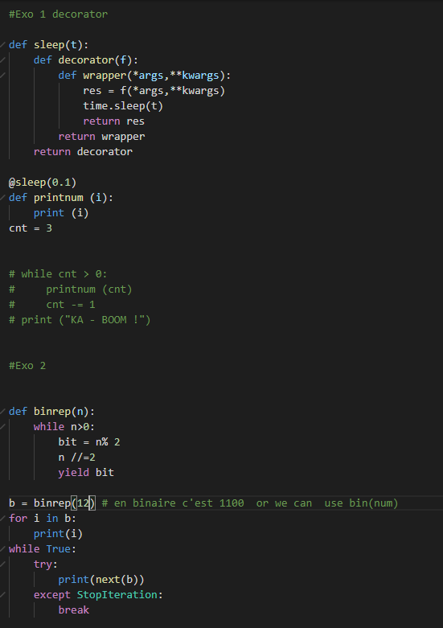

Chapter 5&6: Network computing

Network communication:
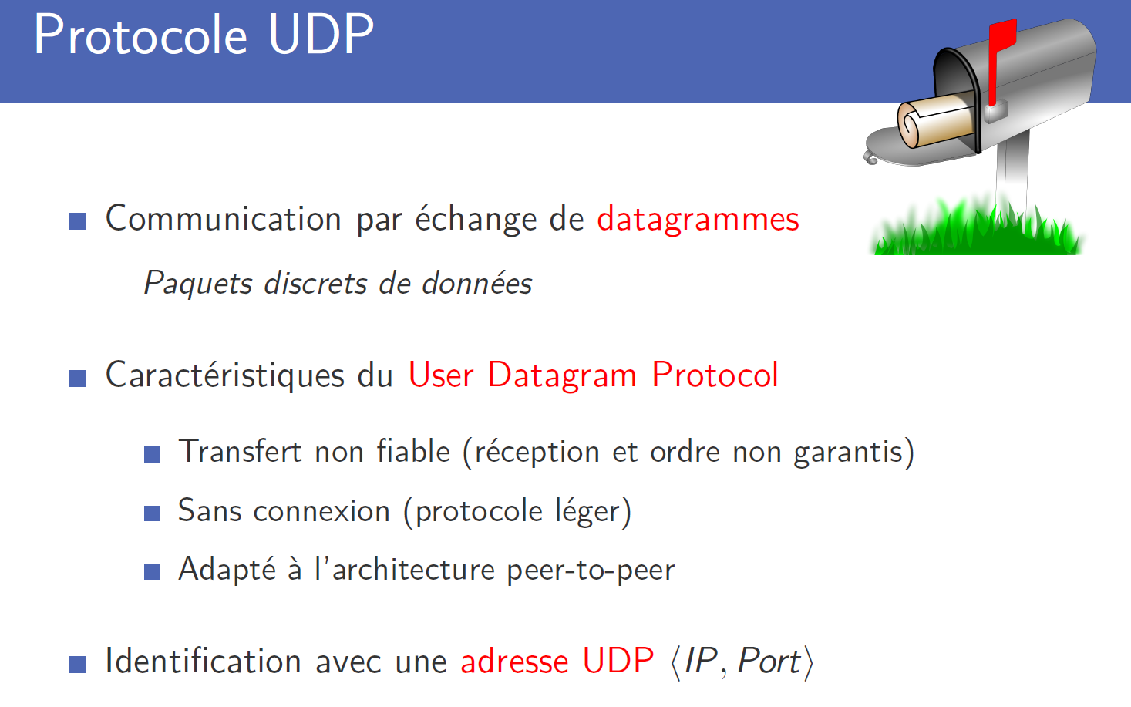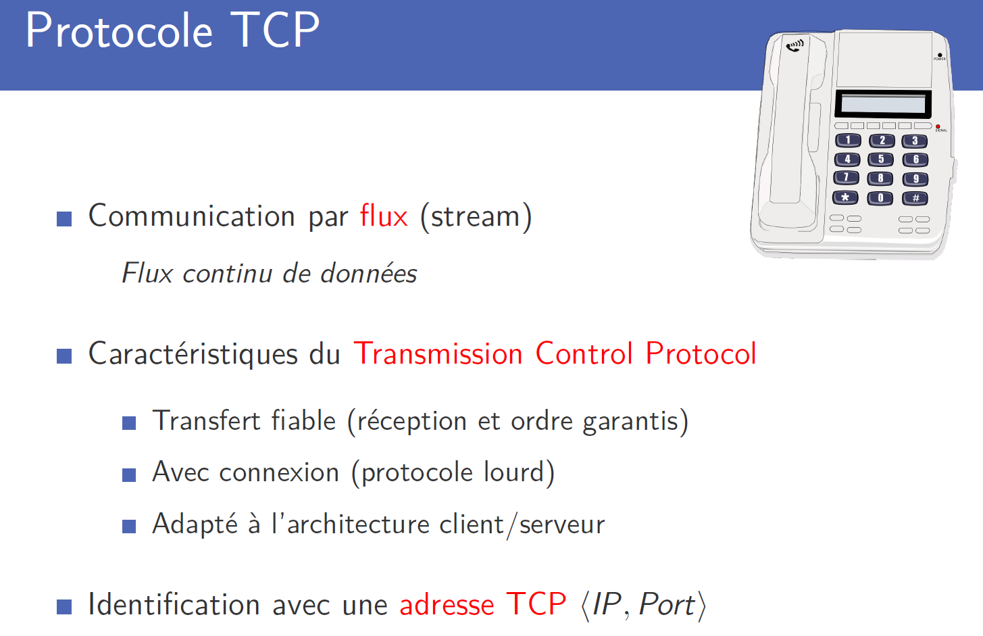

Import module “socket”
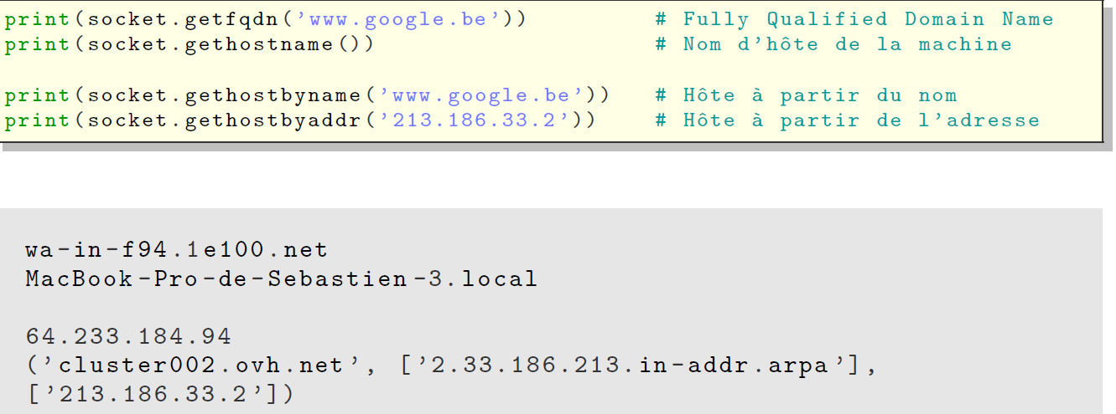
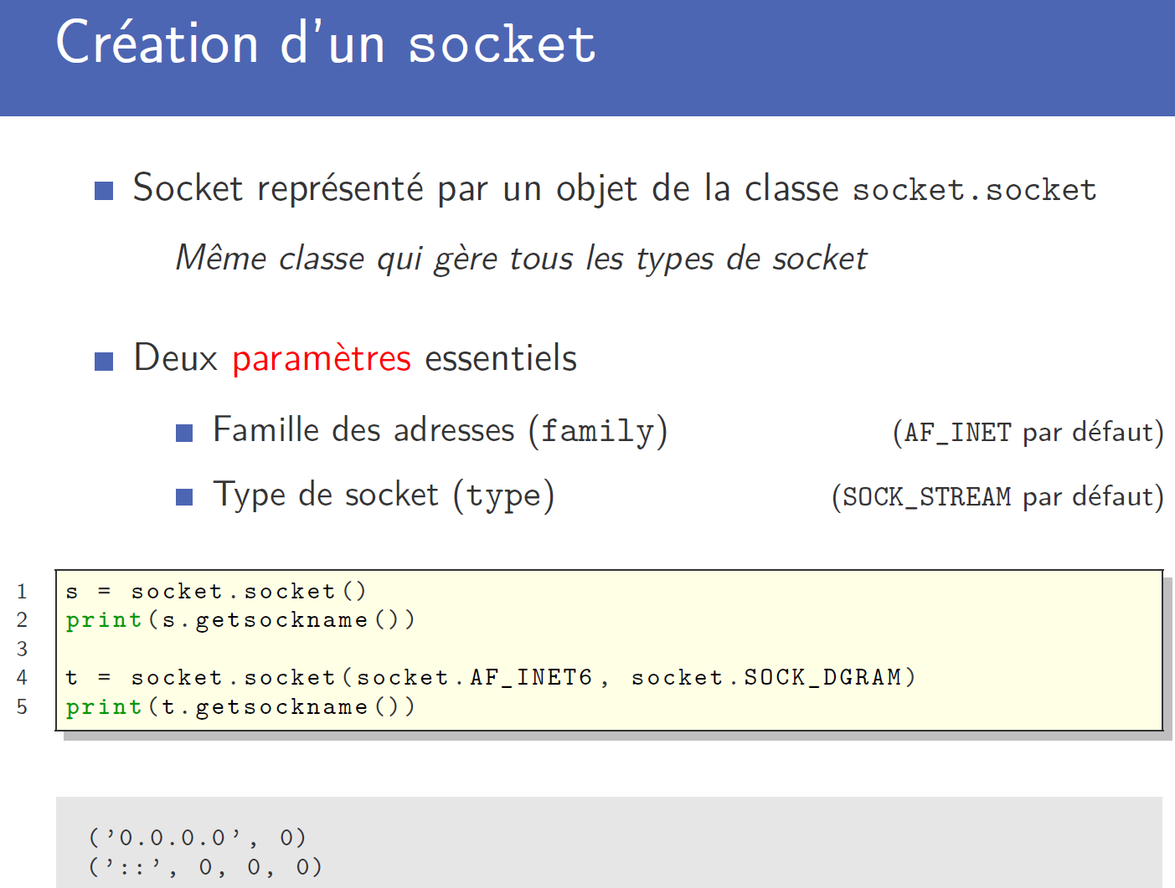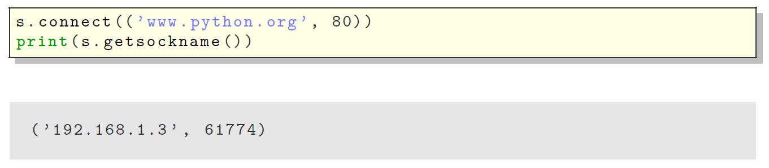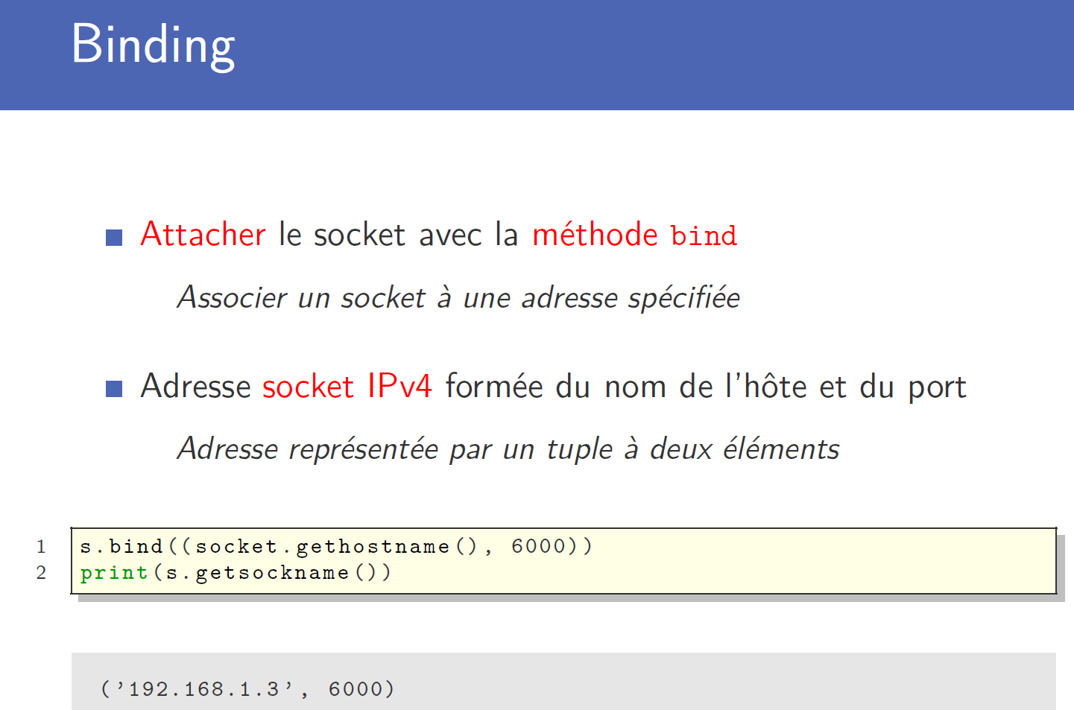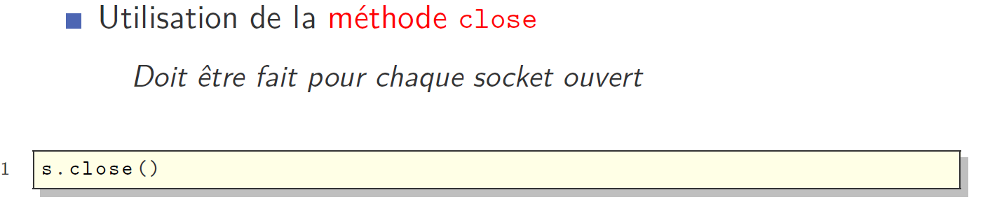

Chat application
- Create a socket:
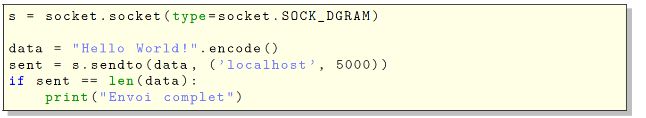
Or with a loop:
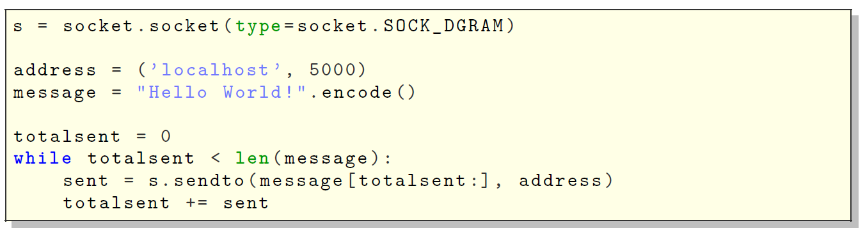
- Reception:
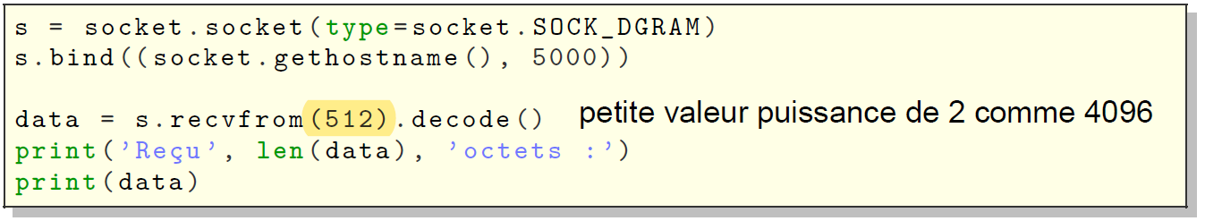
- Chatting:
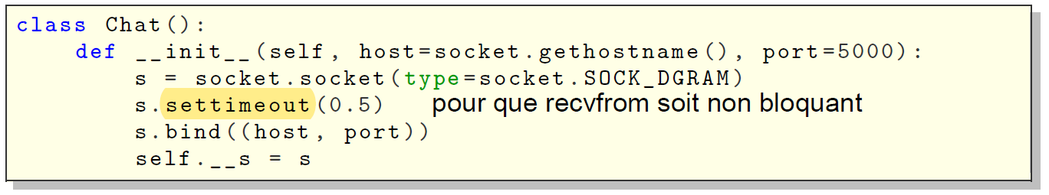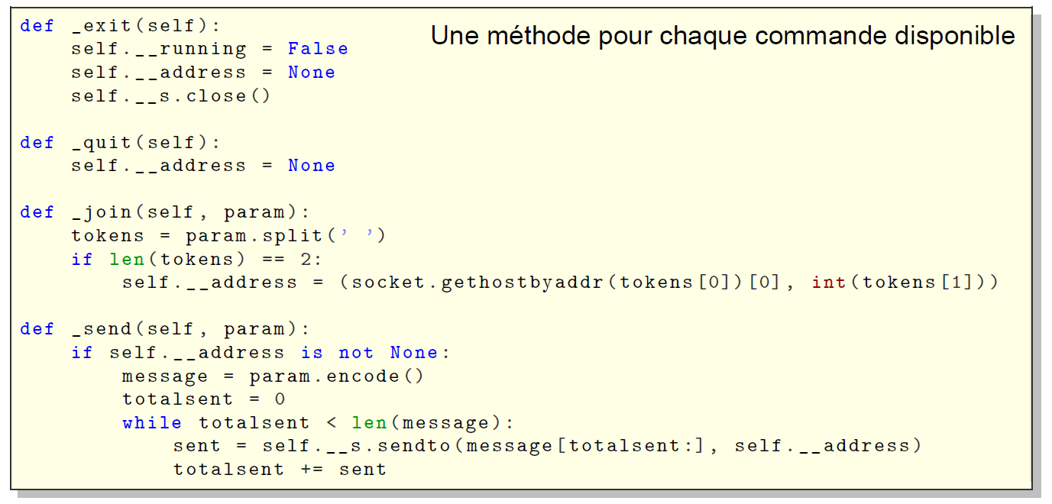
- Receive the message: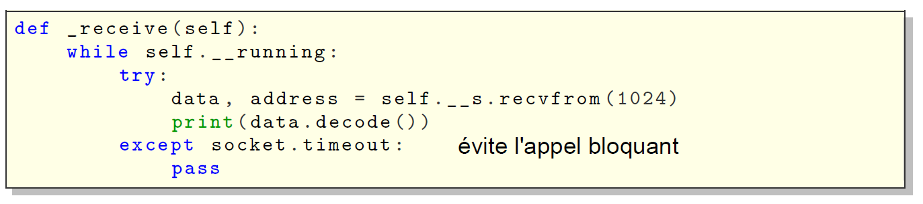
- Listening: 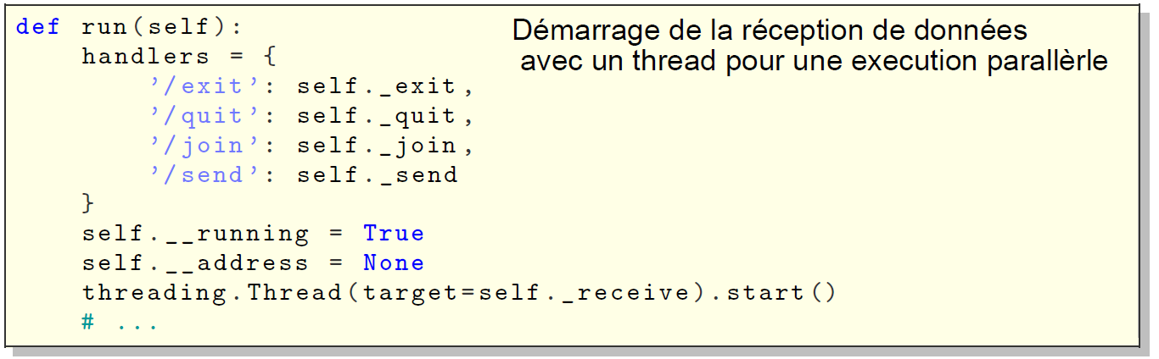
- Extract the commands: 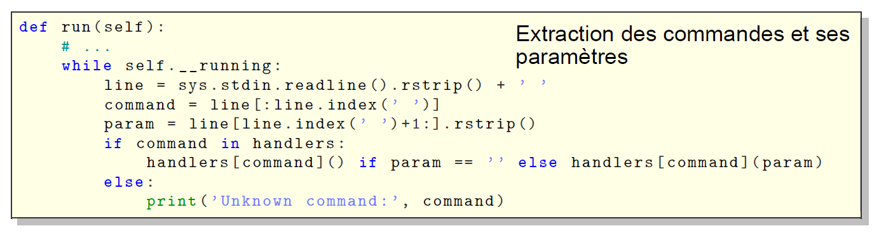

Client/server application
- Create a listening server: 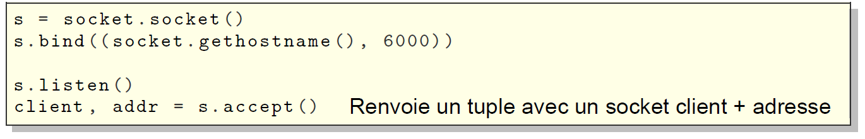
- Create a client and connect (TCP): 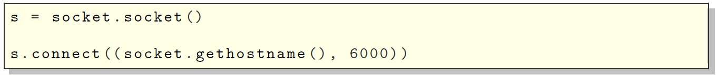
- Send and recv to communicate:
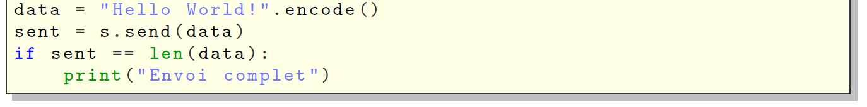
With a loop:
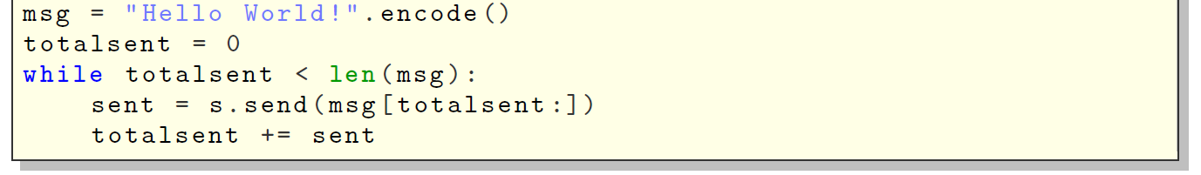
- Receive:
Or with a loop: 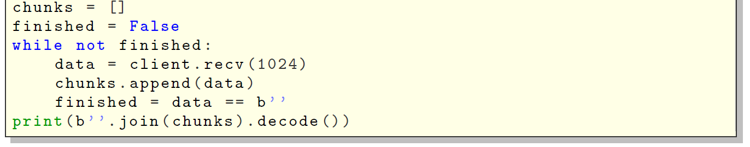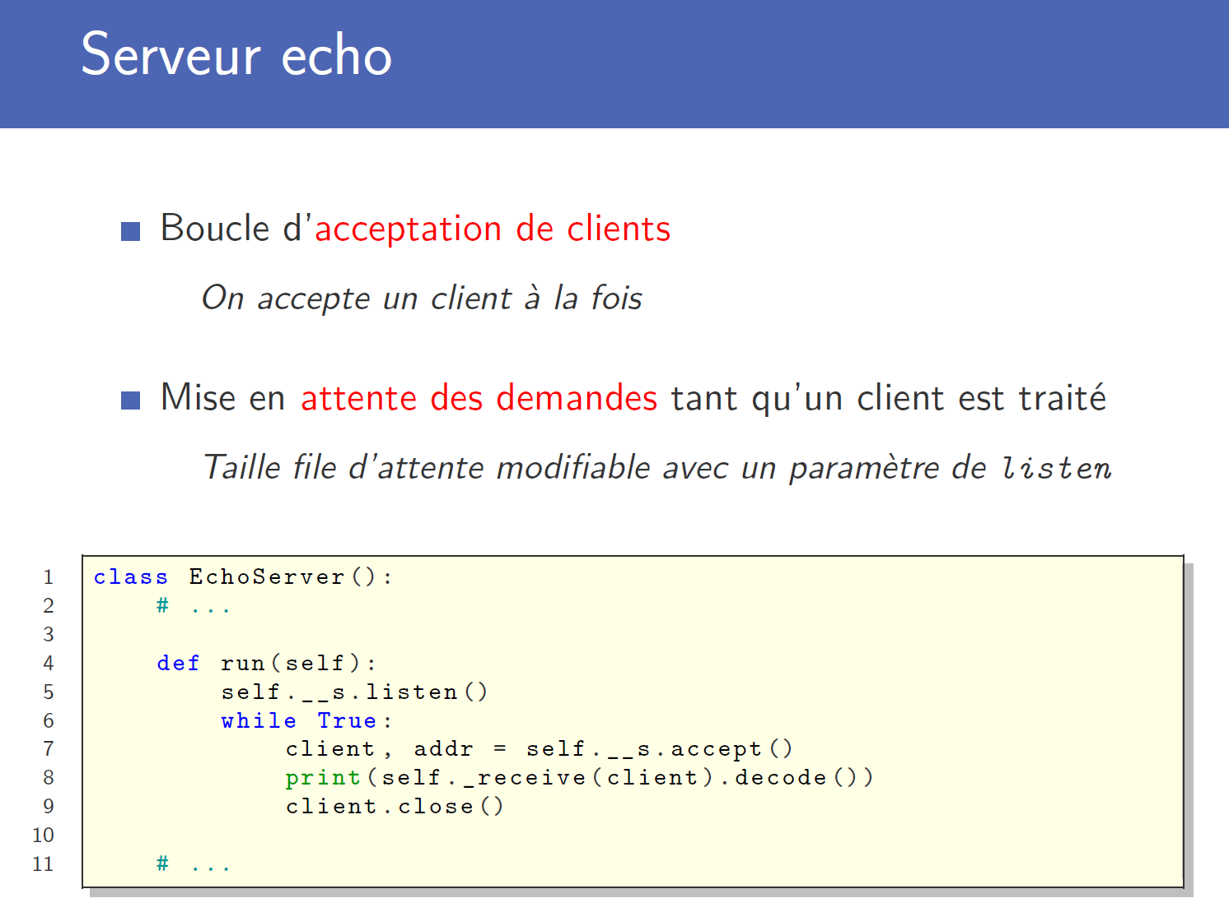 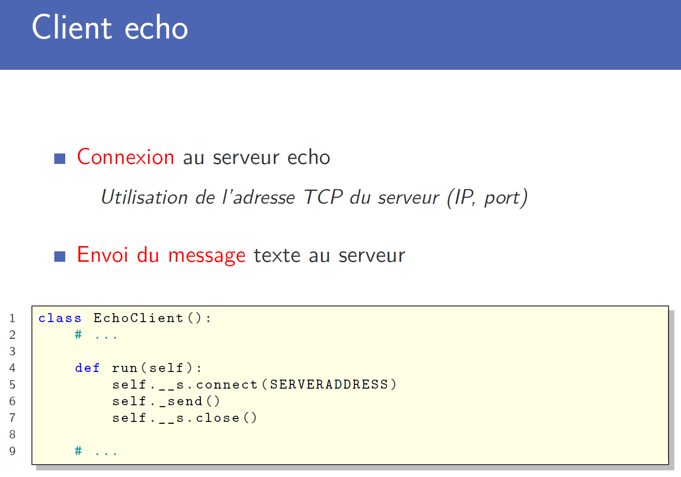

Communication protocols
- Check errors: 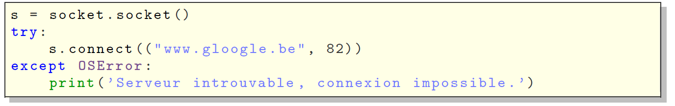
- Types of what we want to send: 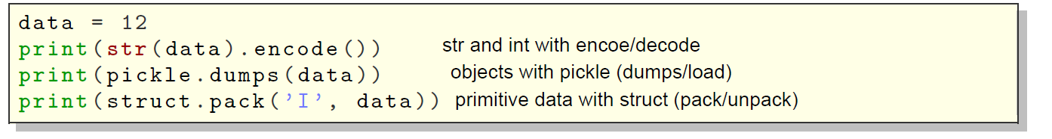

CherryPy
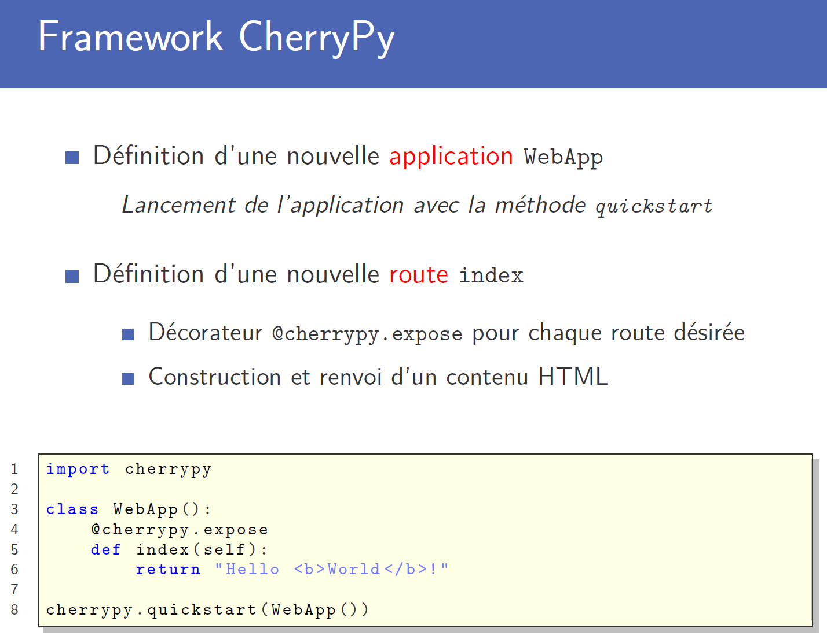
Go on website http://localhost:8080
- With a parameter: 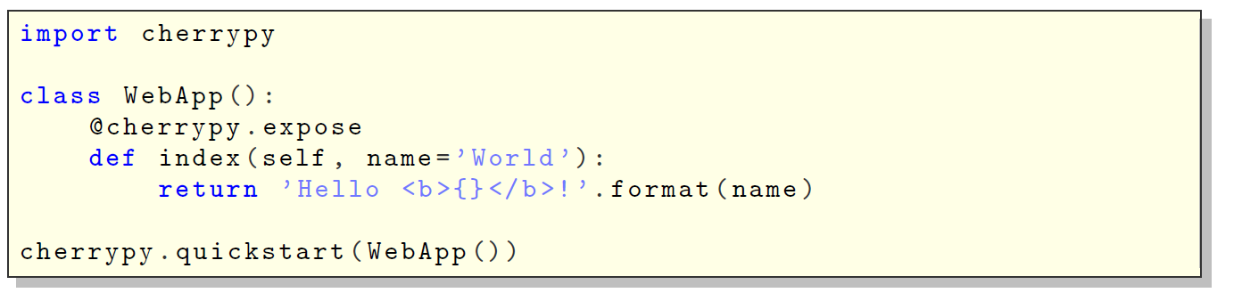
- Configurations:
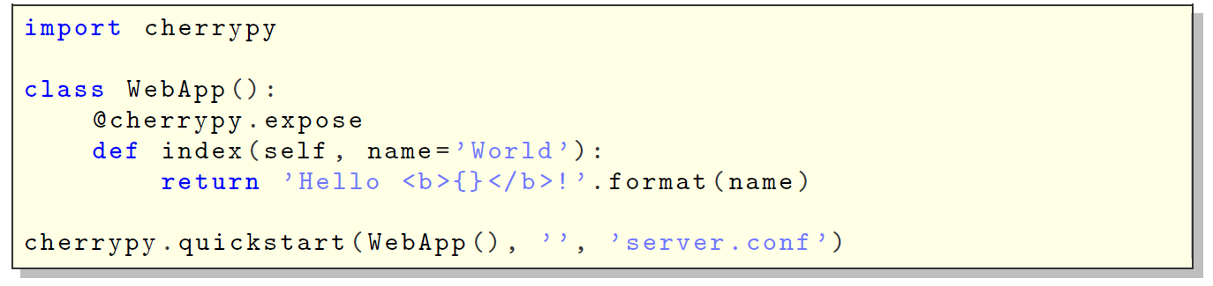
- Default route:
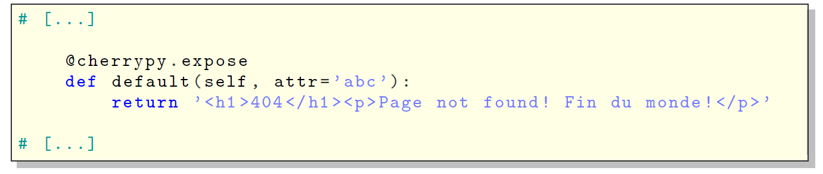
- To have an input: 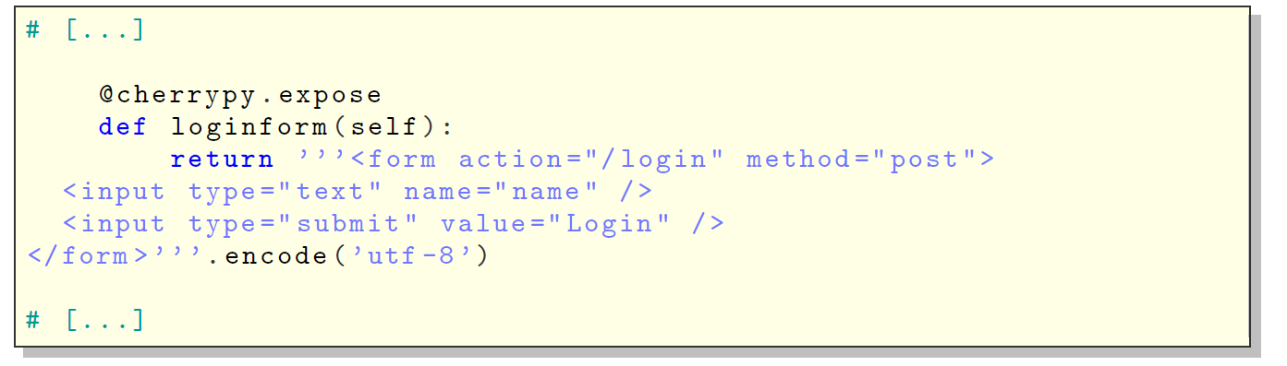 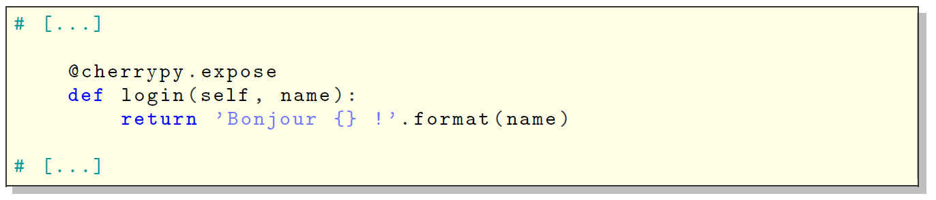
- Take a JSON:
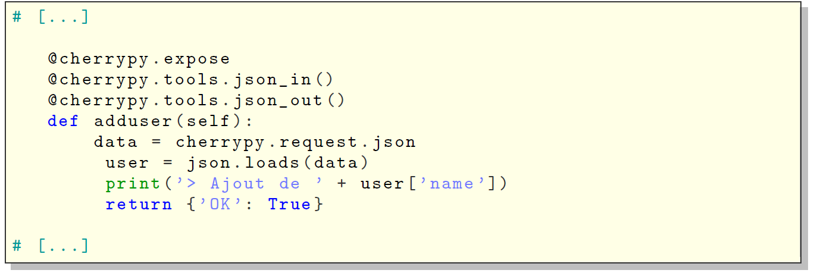

Code examples

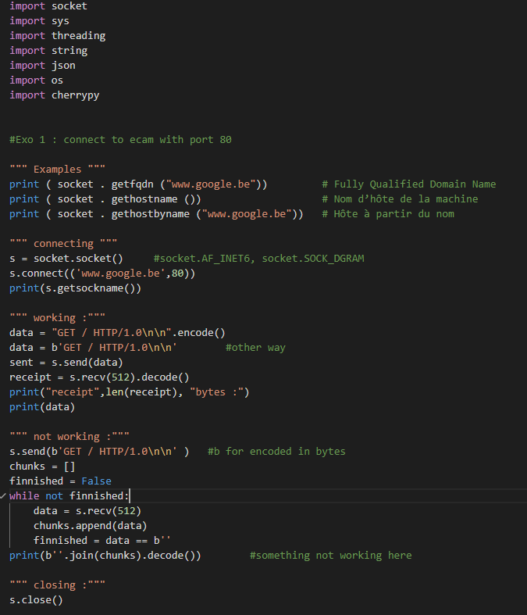
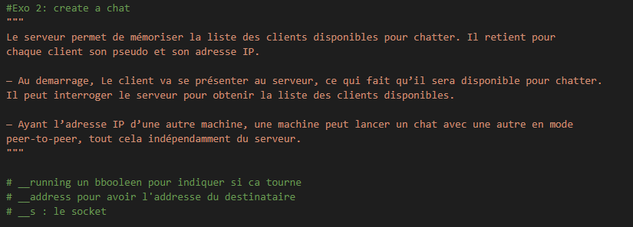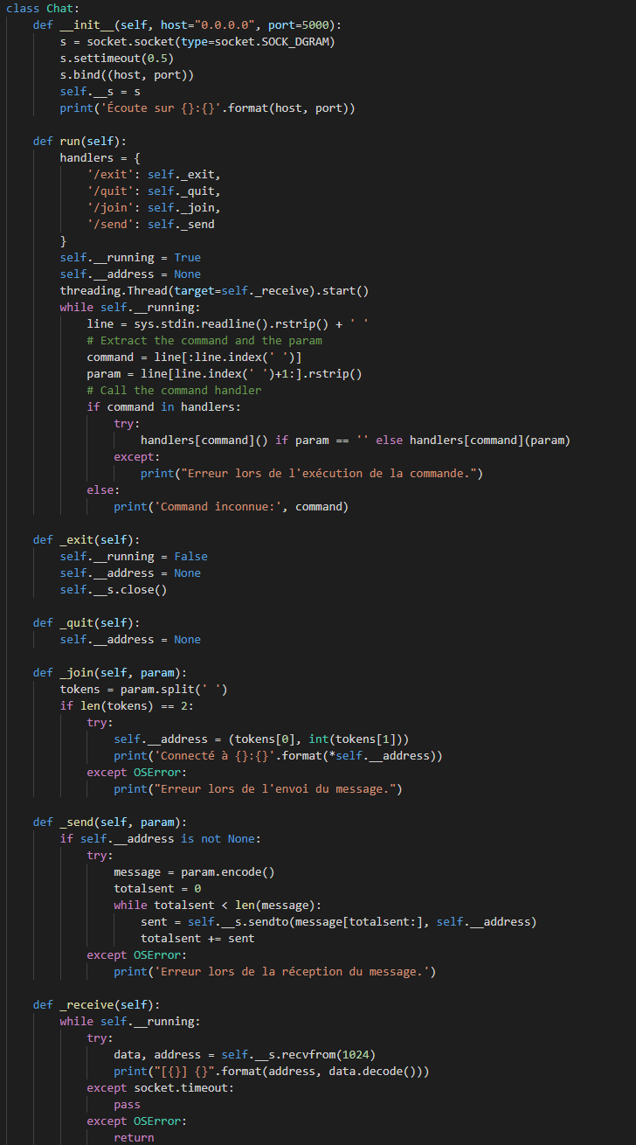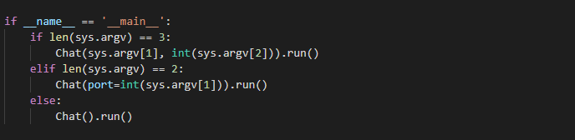
Exo 2 not finnished!!!
