Customer Personality Analysis
Cluster Evaluation & Customer Profiling — Final Report
Dataset: marketing_campaign.csv (synthetic, modeled on the Kaggle "Customer Personality Analysis" schema) — 598 customers after cleaning.
Method: K-Means clustering (k = 4) on standardized income, spending, recency, and channel-usage features. Silhouette score = 0.286 — reasonable, well-separated segment structure (confirmed visually via PCA, see Section 7).

Executive Summary
The customer base splits into four clearly distinct segments. Premium Loyal Customers (21.6% of customers) drive disproportionate value — average spending of $1390 versus an overall average of $552, and the highest campaign response rate at 40.3%. At the other end, Low-Value Inactive Customers (27.1%) spend the least, engage the least, and respond the least to marketing. The remaining two segments — Digital-First Deal Seekers and Store-Oriented Traditional Customers — represent different paths to growth: one young and digital, one older and store-loyal.
The sections below walk through the demographic, spending, channel, and campaign evidence behind each segment, followed by business-ready names, personas, and marketing recommendations.

1. Cluster Statistics & Demographic Analysis
598 customers were grouped into 4 clusters. Segment sizes are reasonably balanced, ranging from 129 to 162 customers.
Segment | N | % of Total | Avg Age | Avg Income | Avg Family Size | Avg Children | Top Education | Top Marital Status
Premium Loyal | 129 | 21.6% | 48.6 | $83,816 | 2.3 | 0.7 | PhD | Married
Digital-First Deal Seekers | 160 | 26.8% | 30 | $42,563 | 2.9 | 1.4 | Graduation | Single
Low-Value Inactive | 162 | 27.1% | 39.9 | $31,079 | 2.6 | 1.1 | Graduation | Single
Store-Oriented Traditional | 147 | 24.6% | 52.8 | $56,103 | 3 | 1.3 | Graduation | Married

Key demographic patterns: the Premium Loyal segment skews older with higher education (PhD most common) and smaller households, while the Digital-First Deal Seekers are markedly younger with larger families and more children at home. The Store-Oriented Traditional segment has the largest average family size and the oldest average age, consistent with an established-household profile.

2. Spending Behavior Analysis
Segment | Wine | Fruit | Meat | Fish | Sweets | Gold | Total Spend
Premium Loyal | $637 | $65 | $433 | $88 | $61 | $107 | $1390
Digital-First Deal Seekers | $105 | $14 | $73 | $18 | $17 | $25 | $252
Low-Value Inactive | $47 | $8 | $43 | $11 | $8 | $16 | $133
Store-Oriented Traditional | $289 | $29 | $168 | $41 | $26 | $50 | $603

Highest-spending segment: Premium Loyal Customers ($1390 average). Lowest-spending segment: Low-Value Inactive Customers ($133 average) — roughly a 10x gap between the two. Wine and meat are the two largest spend categories across every segment, but the gap between segments widens most on these two categories, making them the best lever for premium upsell.

Product Spending by Segment
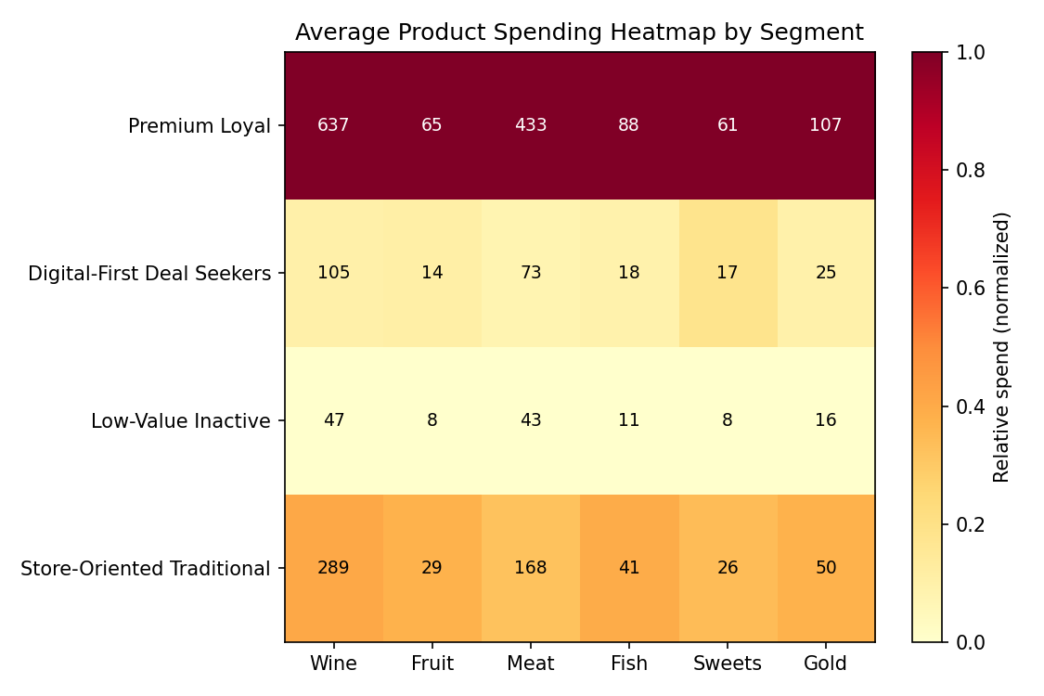

3. Shopping Channel & Customer Engagement Analysis
Segment | Web Purch. | Catalog Purch. | Store Purch. | Deals Purch. | Web Visits/mo | Avg Recency (days)
Premium Loyal | 5.2 | 6.3 | 8 | 1.4 | 2.9 | 25.3
Digital-First Deal Seekers | 6.4 | 0.9 | 2.7 | 5.1 | 7 | 47
Low-Value Inactive | 1.8 | 0.5 | 2.4 | 1.2 | 5 | 54.6
Store-Oriented Traditional | 2.6 | 2 | 7.3 | 2.1 | 4 | 32.6

Digital-First Deal Seekers are the clearest digital-first group (highest web purchases and web visits, lowest catalog use). Store-Oriented Traditional Customers are the most store-oriented (7.3 average store purchases vs. only 2.6 web purchases). Premium Loyal Customers lean on catalog purchases more than any other segment. Digital-First Deal Seekers also lead on deal-seeking behavior (5.1 deal purchases/period). By recency, Premium Loyal Customers are the most recently active (25.3 days on average) and Low-Value Inactive Customers the least active (54.6 days).

Channel Comparison
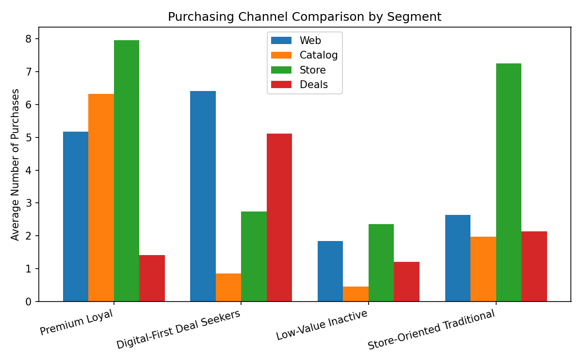

Recency Comparison
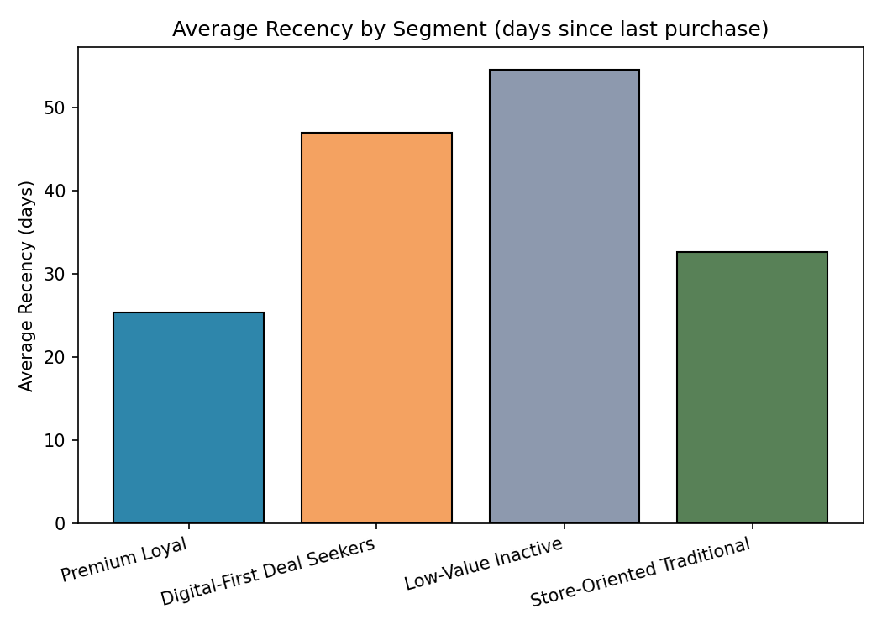

4. Marketing Campaign Analysis
Segment | Avg Campaigns Accepted (of 6) | Final Campaign Response | Complaint Rate
Premium Loyal | 2 | 40.3% | 1.6%
Digital-First Deal Seekers | 0.5 | 15.6% | 0.6%
Low-Value Inactive | 0.2 | 8% | 1.9%
Store-Oriented Traditional | 0.7 | 18.4% | 1.4%

Premium Loyal Customers are by far the most campaign-responsive group, accepting an average of 2 of 6 campaigns — roughly 4x the overall base rate. Low-Value Inactive Customers are the most marketing-resistant (0.2 campaigns accepted on average, 8% final response). A small group of otherwise decent past spenders who have gone quiet and accepted zero campaigns were flagged separately as re-engagement candidates, concentrated in the Store-Oriented and Digital-First segments.

Campaign Response by Segment
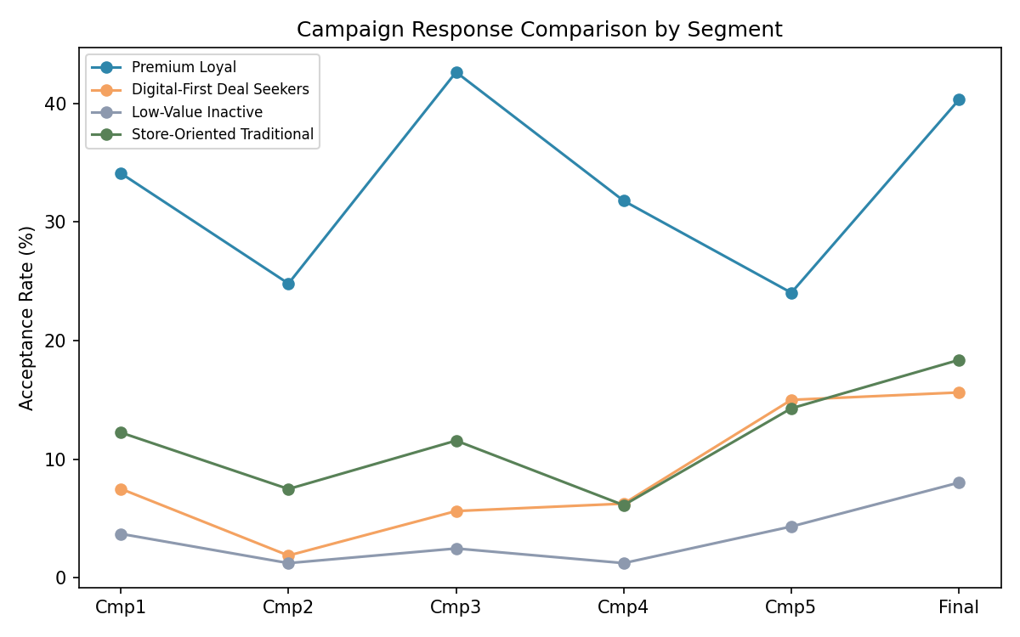

5. Business Segmentation & Cluster Naming

Premium Loyal Customers (21.6% of customers)
Highest income ($83.8K avg), by far the highest total spending ($1,390 avg — over 2.5x the overall average), and the strongest campaign engagement (2.0 campaigns accepted on average, 40% final-campaign response rate). They buy heavily across every product category, especially wine and meat, and split their purchases across catalog and in-store channels rather than the web.
Recommended strategy: Protect and grow this segment with a loyalty/VIP program, early access to premium product lines, and personalized catalog offers. They respond well to campaigns, so they're a safe target for higher-margin, higher-frequency promotions.

Digital-First Deal Seekers (26.8% of customers)
Youngest segment (avg age 30), moderate income ($42.6K), and the most web-native shopping pattern (6.4 web purchases/month and 7.0 site visits/month — both the highest of any cluster) combined with the heaviest deal-seeking behavior (5.1 deal purchases). Spending is modest and campaign response is low (16%), suggesting price sensitivity over brand loyalty.
Recommended strategy: Lead with digital channels: app-based discounts, flash sales, and referral incentives. Avoid catalog spend on this group — it doesn't convert. Consider a 'first purchase' or loyalty-points mechanic to build habit before they age into higher spending power.

Low-Value Inactive Customers (27.1% of customers)
Lowest income ($31.1K), lowest total spending ($133 avg — the smallest basket by a wide margin), longest average recency (54.6 days since last purchase), and the weakest campaign response of any segment (only 8% final response, 0.2 campaigns accepted on average). This is a low-engagement, low-value, largely inactive segment.
Recommended strategy: Low-cost re-engagement only: occasional value-tier promotions or win-back emails. Not a priority for premium campaign spend — the acquisition cost is unlikely to be recovered given current spending patterns.

Store-Oriented Traditional Customers (24.6% of customers)
Older, established households (avg age 53, largest average family size at 3.0), moderate-to-good income ($56.1K), and a clear preference for in-store shopping (7.3 store purchases vs. only 2.6 web purchases). Spending is solid ($604 avg, driven by wine and meat) but campaign engagement is modest (18% response).
Recommended strategy: In-store promotions, loyalty cards, and direct mail/catalog offers will outperform digital-only campaigns here. Bundle deals for families and seasonal in-store events are a natural fit given the household size and shopping preference.

6. Customer Persona Development

Patricia, the Premium Provider
Attribute | Detail
Age Range | 42–58
Income Level | High ($70K–$110K+)
Family Status | Married/partnered, 0–1 children at home
Shopping Habits | Frequent, high-value shopping trips; buys across nearly every category
Preferred Products | Wine, meat, premium/gourmet items
Preferred Channel | Catalog and in-store, moderate web use
Marketing Responsiveness | High — accepts ~2 of 6 campaigns on average, 40% final-offer response
Key Challenge | Time-poor; wants curated, high-quality options rather than having to browse
Recommended Strategy | VIP loyalty tier, early access to new products, personalized catalog mailers
Estimated CLV | High — top-tier annual spend and strong repeat engagement

Jordan, the Digital Deal Hunter
Attribute | Detail
Age Range | 22–35
Income Level | Moderate ($30K–$55K)
Family Status | Single or partnered, often with young children
Shopping Habits | Shops online frequently, waits for deals, price-compares before buying
Preferred Products | Wine (entry-level) and everyday goods; low spend per category
Preferred Channel | Web — highest of any segment, low catalog/store use
Marketing Responsiveness | Low-moderate — 16% final-offer response, favors deal-driven offers over branded campaigns
Key Challenge | Price sensitivity limits basket size; not yet a high-value customer
Recommended Strategy | App notifications, flash sales, gamified loyalty points to build long-term habit
Estimated CLV | Low today, but highest growth potential as income rises with age

Sam, the Occasional Shopper
Attribute | Detail
Age Range | 28–55 (wide range)
Income Level | Lower ($18K–$40K)
Family Status | Often single, mixed household sizes
Shopping Habits | Infrequent purchases, longest gaps between visits, minimal category breadth
Preferred Products | Low spend across all categories, no clear favorite
Preferred Channel | No dominant channel — low usage everywhere
Marketing Responsiveness | Very low — 8% final-offer response, largely ignores past campaigns
Key Challenge | Disengaged; unclear if this is a budget constraint or genuine low interest
Recommended Strategy | Low-cost win-back emails only; not a priority for paid campaign spend
Estimated CLV | Low, with limited near-term upside

Robert & Linda, the Traditional Household
Attribute | Detail
Age Range | 45–65
Income Level | Moderate-to-good ($45K–$70K)
Family Status | Married, larger household (avg family size 3.0)
Shopping Habits | Regular in-store shopping, values consistency over novelty
Preferred Products | Wine and meat, steady mid-range spend across categories
Preferred Channel | In-store — by far the dominant channel; low web engagement
Marketing Responsiveness | Moderate — 18% final-offer response, better with direct/catalog offers than digital ones
Key Challenge | Under-engaged by digital marketing; risk of being overlooked in web-first campaigns
Recommended Strategy | In-store promotions, mailed coupons, family-size bundle deals
Estimated CLV | Moderate-to-good — stable, reliable spend over time

7. Cluster Visualization & Final Documentation

Cluster Distribution
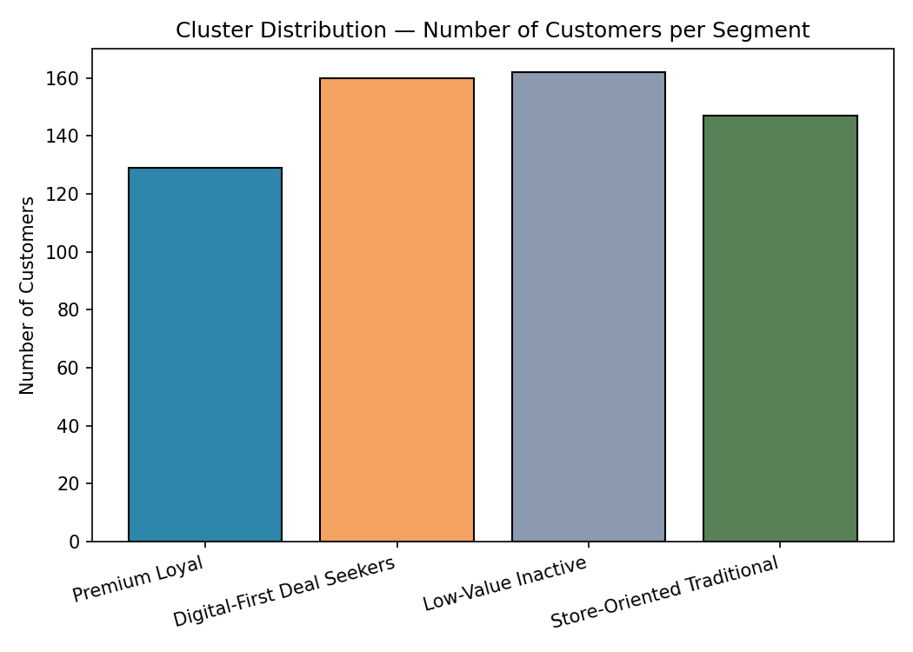

Income Comparison
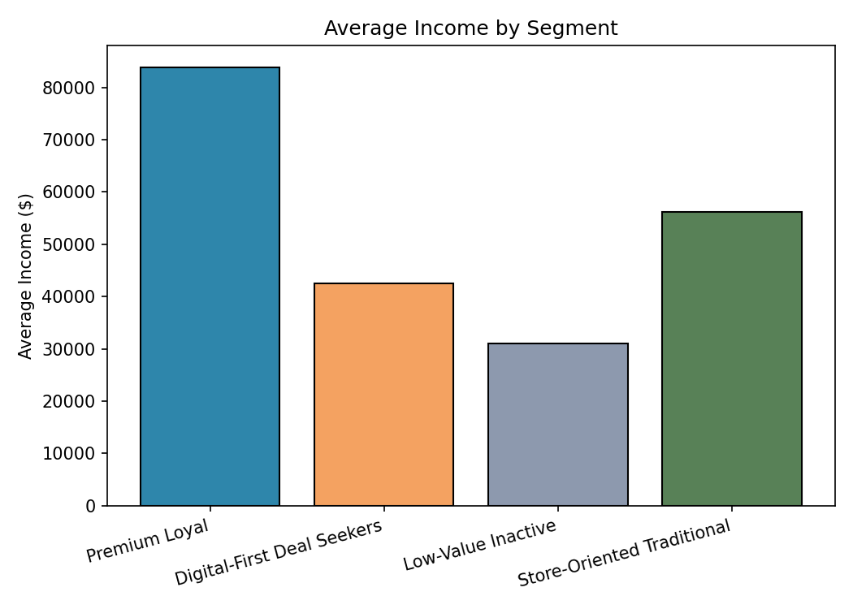

Spending Comparison
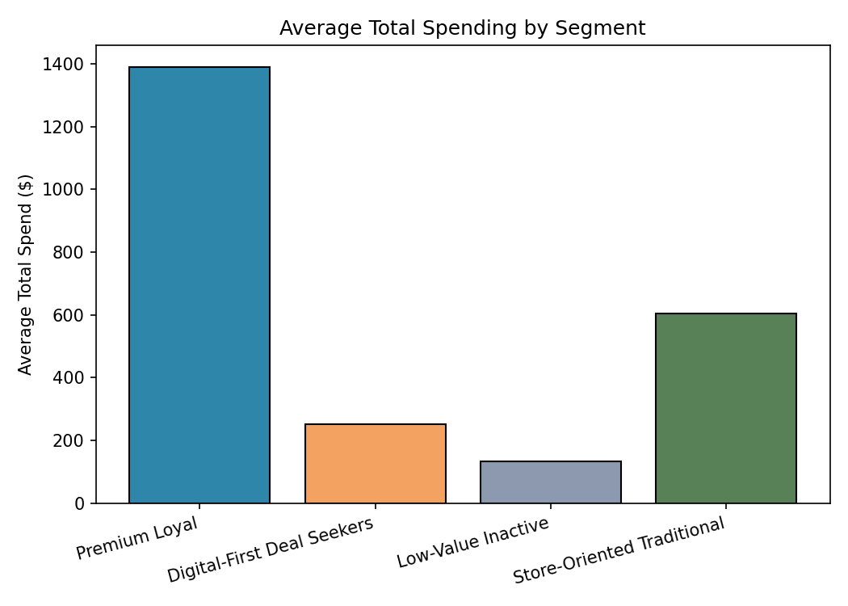

Radar Chart of Cluster Characteristics
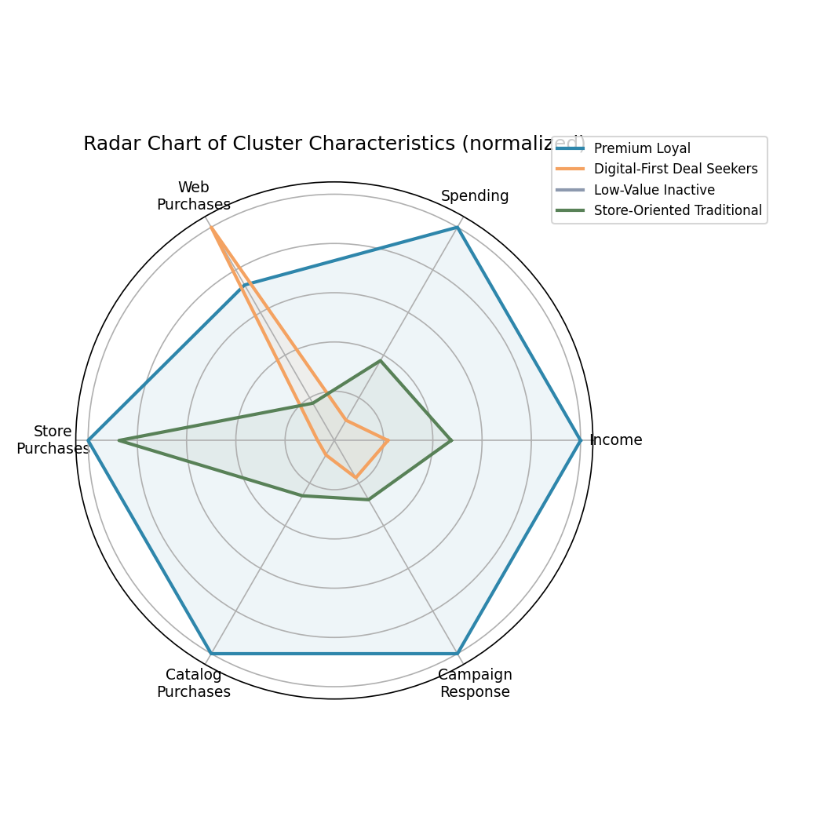

PCA Cluster Visualization
Reducing the 8 standardized clustering features to 2 principal components (explaining ~67% of total variance) confirms the segments are genuinely separable, not an artifact of the algorithm — the four groups form clearly distinct regions with limited overlap.
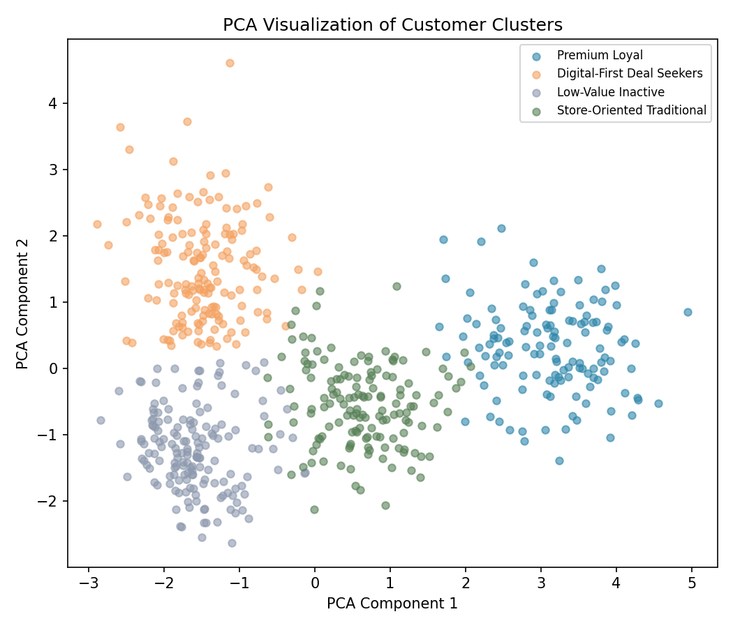

Final Business Recommendations
• Protect the Premium Loyal segment with a loyalty program and early access to new products — they're only 22% of customers but drive the highest spend and campaign ROI.
• Invest in mobile/app engagement for Digital-First Deal Seekers — they're young, high-frequency, and price-driven; converting habit now pays off as their income grows.
• Keep marketing spend low on Low-Value Inactive customers until a cheap win-back campaign proves engagement is recoverable — over a quarter of the base falls here, so even small efficiency gains matter, but broad campaign spend is unlikely to pay back.
• Shift Store-Oriented Traditional customers toward in-store and direct-mail offers rather than digital campaigns, and consider family/bundle pricing given their larger household size.
• Build a lightweight re-engagement track (win-back email + modest discount) targeted at the ~13 customers identified as high-recency, zero-campaign-acceptance, but historically above-median spenders — a small, high-leverage list.

