CDI College
BDA400: Data Science Tools and Techniques

Technical Analysis using R
Preliminary Stage: Setup, Data Import and Basic Statistics

Student: Wasay Ahmed
Assignment: Assignment 2 (5%)
Submission date: October 2026

GitHub repository: https://github.com/YOUR-GITHUB-USERNAME/TechnicalAnalysis/tree/main/Assignment2

TO DO before submitting (delete this box): (1) insert your own screenshots in the dashed boxes; (2) run main_analysis.R on your PC so the charts and the statistics table show live Yahoo Finance data, then replace the sample figures below with the PNG files from your output/ folder; (3) replace YOUR-GITHUB-USERNAME in the links.

Overview
This report documents the first stage of my three-part technical analysis project. I set up a GitHub repository, installed R and RStudio, installed the packages needed for technical analysis, created a portfolio file and wrote R functions that import daily price data for every stock in the portfolio, compute basic statistics and display the results in several ways.
Deliverable | File in repository
Portfolio of stock symbols | Assignment2/portfolio.txt
Package installation script | Assignment2/install_packages.R
Import and statistics functions | Assignment2/stock_functions.R
Display and visualisation functions | Assignment2/display_functions.R
Configuration and run script | Assignment2/main_analysis.R
Outputs (charts, CSV, console log) | Assignment2/output/
This report | Assignment2/WasayAhmed_BDA400_A02_Report.docx

Step 1: GitHub Account and Repository
- Went to https://github.com and created a free account (or signed in to my existing account).
- Installed Git for Windows from https://git-scm.com/download/win, accepting the default options, and confirmed the installation with git --version in Command Prompt.
- Configured my identity: git config --global user.name "Wasay Ahmed" and git config --global user.email "<my email>".
- On GitHub clicked New repository, named it TechnicalAnalysis, set it to Public, ticked Add a README file and clicked Create repository.
- Cloned it to my PC: git clone https://github.com/YOUR-GITHUB-USERNAME/TechnicalAnalysis.git.
- Created one subfolder per assignment (Assignment2, Assignment5, Assignment6) so every stage of the project lives in its own folder.
[INSERT SCREENSHOT] GitHub sign-up / sign-in page

[INSERT SCREENSHOT] Create a new repository form with the name TechnicalAnalysis

[INSERT SCREENSHOT] git --version and git config output in Command Prompt

[INSERT SCREENSHOT] Repository page showing the Assignment2 folder after the first push

Step 2: Installing R and RStudio
- Opened https://cran.rstudio.com, chose Download R for Windows, then base, and downloaded the latest R installer.
- Ran the installer with the default options (64-bit, default install folder).
- Opened https://posit.co/download/rstudio-desktop and downloaded RStudio Desktop for Windows.
- Ran the RStudio installer with the default options.
- Started RStudio and confirmed in the Console that R is detected: R.version.string.
[INSERT SCREENSHOT] CRAN download page for Windows

[INSERT SCREENSHOT] R installer wizard (setup / finish screen)

[INSERT SCREENSHOT] RStudio download page and installer

[INSERT SCREENSHOT] RStudio open with R.version.string in the Console

Step 3: Installing R Packages
All packages are installed by one script, so the setup can be repeated on any PC. It installs only what is missing and then prints the version of each package as proof that it loads.
# Author: Wasay Ahmed | BDA400 Assignment 2
# install_packages.R : one-time installation of the packages used in the
# TechnicalAnalysis project. Run once in RStudio: source("install_packages.R")

required <- c("quantmod", # downloads prices from Yahoo Finance
"TTR", # Technical Trading Rules (installed with quantmod)
"xts", "zoo", # time-series containers used by quantmod
"ggplot2", # charts
"knitr", # tables in R Markdown
"rmarkdown") # knitting the report

missing <- required[!required %in% rownames(installed.packages())]
if (length(missing) > 0) {
install.packages(missing, repos = "https://cloud.r-project.org")
} else {
message("All packages already installed.")
}

# Confirm that each package loads and print its version
for (p in required) {
suppressPackageStartupMessages(library(p, character.only = TRUE))
cat(sprintf("%-10s %s\n", p, as.character(packageVersion(p))))
}
Package | Purpose
quantmod | Downloads OHLCV price data from Yahoo Finance with getSymbols()
TTR | Technical Trading Rules (moving averages, RSI, MACD); installed with quantmod
xts / zoo | Time-series objects returned by quantmod
ggplot2 | Charts
knitr / rmarkdown | Tables and knitted reports

[INSERT SCREENSHOT] RStudio Console running source("install_packages.R") and the package version list

[INSERT SCREENSHOT] RStudio Packages tab showing quantmod and TTR ticked

Step 4: Project Configuration and Initialization
The portfolio is a plain-text file with one ticker per line. The reader ignores blank lines and lines starting with #, converts symbols to upper case and removes duplicates, so the file can be edited safely.
# portfolio.txt
AAPL
MSFT
GOOGL
AMZN
NVDA
All run settings (portfolio file, date range, data source, moving-average periods, output folder) are kept in one config list at the top of main_analysis.R, so the analysis is initialised in one place.
config <- list(
portfolio_file = "portfolio.txt",
from = "2025-01-01",
to = "2026-09-30",
source = "yahoo",
ma_short = 20,
ma_long = 50,
output_dir = "output"
)

Step 5: Function to Import and Load Stock Data
load_stock_data() reads portfolio.txt and calls quantmod::getSymbols() once per symbol with auto.assign = FALSE. Each xts result is converted into a data frame with the columns Date, Open, High, Low, Close, Volume and Adjusted. The function returns a named list (stocks$AAPL, stocks$MSFT, ...) and, when assign_env = globalenv() is given, also stores every stock as a separate data frame (AAPL_df, MSFT_df, ...).
Every download is wrapped in tryCatch(). If Yahoo Finance cannot be reached (no internet, firewall, rate limit), the function prints a warning and substitutes a clearly labelled simulated series so the rest of the analysis can still be demonstrated. The data source is stored in attr(df, "source") and printed on every table and chart, so simulated data can never be mistaken for real prices.
stocks <- load_stock_data("portfolio.txt", from = "2025-01-01", to = "2026-09-30",
src = "yahoo", assign_env = globalenv())
ls(pattern = "^[A-Z]+_df$")
#> "AAPL_df" "AMZN_df" "GOOGL_df" "MSFT_df" "NVDA_df"
[INSERT SCREENSHOT] RStudio Environment pane showing AAPL_df ... NVDA_df and the stocks list

Step 6: Function to Compute Basic Statistics
calculate_statistics() takes one stock data frame and returns a list with a one-row summary data frame and the data frame with 20- and 50-day moving-average and daily-return columns added. calculate_portfolio_statistics() applies it to every stock and binds the summaries into one table.
Statistic | How it is calculated
Moving average (20 and 50 day) | Trailing mean with stats::filter(x, rep(1/n, n), sides = 1); NA for the first n-1 days
Mean | mean(Close)
Median | median(Close)
Mode | Custom stat_mode(): base R has no data mode, and prices are continuous, so closes are rounded to whole dollars and the most frequent value is returned
Standard deviation | sd(Close) (sample standard deviation)
Extras | Min, max, last close, average daily return, daily volatility, average volume

Step 7: Utilities to Display Output
After browsing Yahoo Finance, I wrote display functions that present the data the way finance sites do:
- display_quote_summary(): last price, change and % change, previous close, open, day range, 52-week range, volume and 3-month average volume (Yahoo "Summary" panel).
- display_stock_table(): most recent rows of the OHLCV table, newest first (Yahoo "Historical Data" tab).
- display_statistics(): one table comparing the statistics of all stocks.
- plot_price_ma(): closing price with 20- and 50-day moving averages.
- plot_volume(): daily volume bars coloured by up or down day.
- plot_distribution(): histogram of closing prices with mean, median and mode marked.
- plot_portfolio_comparison(): growth of $100 in each stock, for side-by-side performance.

Sample output
AAPL 144.36 -2.14 (-1.46%) as of 2026-09-30
Field Value
Previous Close 146.50
Open 146.25
Day's Range 143.91 - 146.74
52 Week Range 142.69 - 254.61
Volume 51,355,339
Avg. Volume (3M) 39,827,618

===== AAPL : historical prices (SIMULATED (offline fallback)) =====
Date Open High Low Close Adjusted Volume
2026-09-30 146.25 146.74 143.91 144.36 144.36 51,355,339
2026-09-29 144.16 147.36 142.69 146.50 146.50 33,795,027
2026-09-28 146.80 147.55 143.46 143.67 143.67 27,029,783
2026-09-25 149.06 149.06 145.65 146.50 146.50 64,423,310
2026-09-24 145.64 150.74 143.92 150.14 150.14 69,917,691
Symbol | Last close | Mean | Median | Mode | Std dev | MA20 | MA50
AAPL | 144.36 | 224.53 | 213.81 | 207 | 35.41 | 159.98 | 169.69
MSFT | 253.52 | 316.98 | 324.48 | 253 | 50.95 | 243.07 | 244.83
GOOGL | 127.42 | 117.45 | 111.11 | 93 | 21.35 | 123.41 | 112.96
AMZN | 150.77 | 152.65 | 150.99 | 139 | 13.59 | 147.01 | 143.74
NVDA | 70.22 | 56.86 | 52.40 | 43 | 13.97 | 69.11 | 74.84

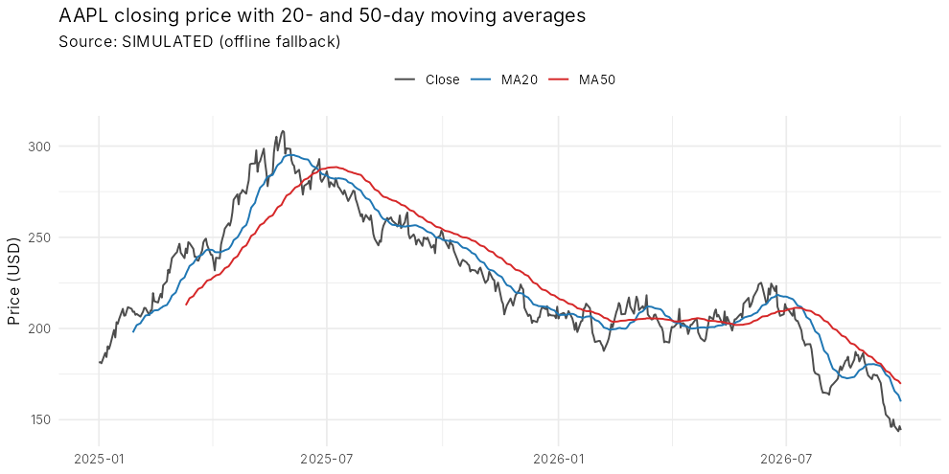
Figure 1: Closing price with 20- and 50-day moving averages
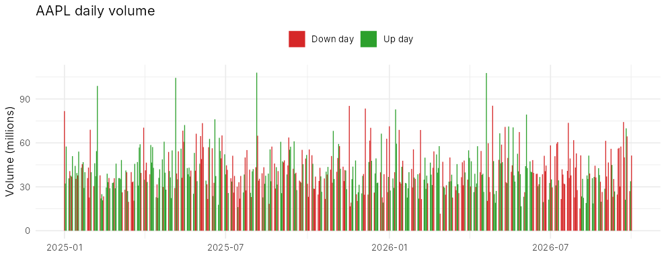
Figure 2: Daily volume (green = close above open)
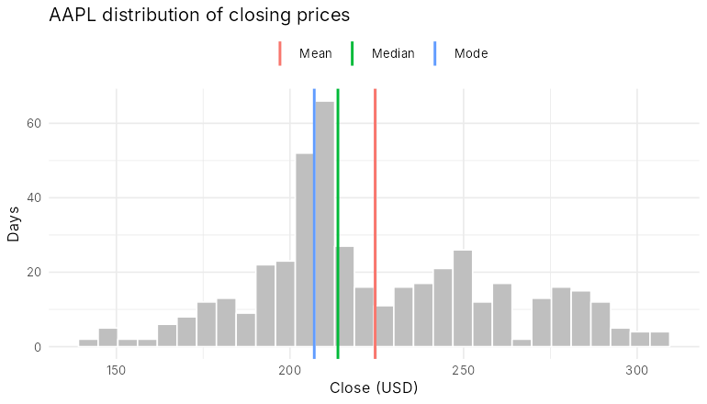
Figure 3: Distribution of closing prices with mean, median and mode
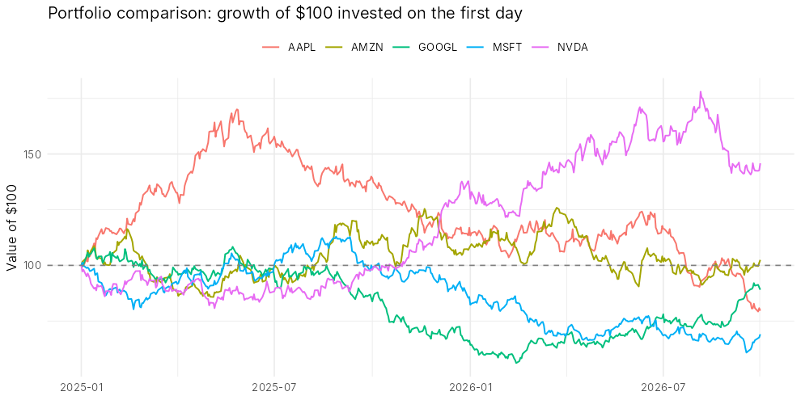
Figure 4: Growth of $100 invested in each stock
[INSERT SCREENSHOT] RStudio Console running source("main_analysis.R") on your PC (live Yahoo data)

Step 8: How to Run
- Clone the repository and open the Assignment2 folder in RStudio.
- Session > Set Working Directory > To Source File Location.
- Run source("install_packages.R") once.
- Run source("main_analysis.R"). Tables print in the Console; charts and portfolio_statistics.csv are written to output/.
- To analyse different stocks, edit portfolio.txt; to change the period, edit from / to in config.

Repository Link
https://github.com/YOUR-GITHUB-USERNAME/TechnicalAnalysis

