CDI College
BDA400: Data Science Tools and Techniques

Technical Analysis using R
Visualization Phase: Portfolio Dashboard in R Shiny

Student: Wasay Ahmed
Assignment: Assignment 6 (15%)
Submission date: October 2026

GitHub repository: https://github.com/YOUR-GITHUB-USERNAME/TechnicalAnalysis/tree/main/Assignment6

Project Description
An interactive R Shiny dashboard that fetches historical stock data from Yahoo Finance with quantmod (or from an uploaded CSV, with an offline demo mode if the internet is unavailable), and visualises it as a candlestick, OHLC bar, line or area chart for a chosen date range and a daily, weekly or monthly time frame. The technical indicators I implemented in Assignment 5 (SMA, EMA, MACD, standard deviation via Bollinger Bands, linear regression, RSI and Stochastic RSI) can each be switched on or off as overlays or stacked panels. Four customisable trading rules (MA crossover, MA crossover with an RSI filter, RSI reversal, MACD crossover) generate Buy, Sell and Hold signals, which are annotated on the price bars and evaluated with a simple long-only back-test.

How to Run
install.packages(c("shiny", "ggplot2", "quantmod", "patchwork", "DT"))
shiny::runApp("Assignment6") # from the repository root

Sections of app.R
Brief step | Where in app.R
Step 1: Data collection and setup | Packages, fetch_yahoo(), read_csv_upload(), simulate_ohlc(), server raw() with tryCatch fallback
Step 2: Visualising stock data | ui (date range, time frame, chart type widgets), to_frame(), price_chart()
Step 3: Overlay technical indicators | add_indicators(), overlay lines, volume_panel(), rsi_panel(), stoch_panel(), macd_panel(), on/off checkboxes
Step 4: Trading rules and annotations | generate_signals(), Buy/Sell markers and labels in price_chart(), optional Hold marks, backtest()

Screenshots
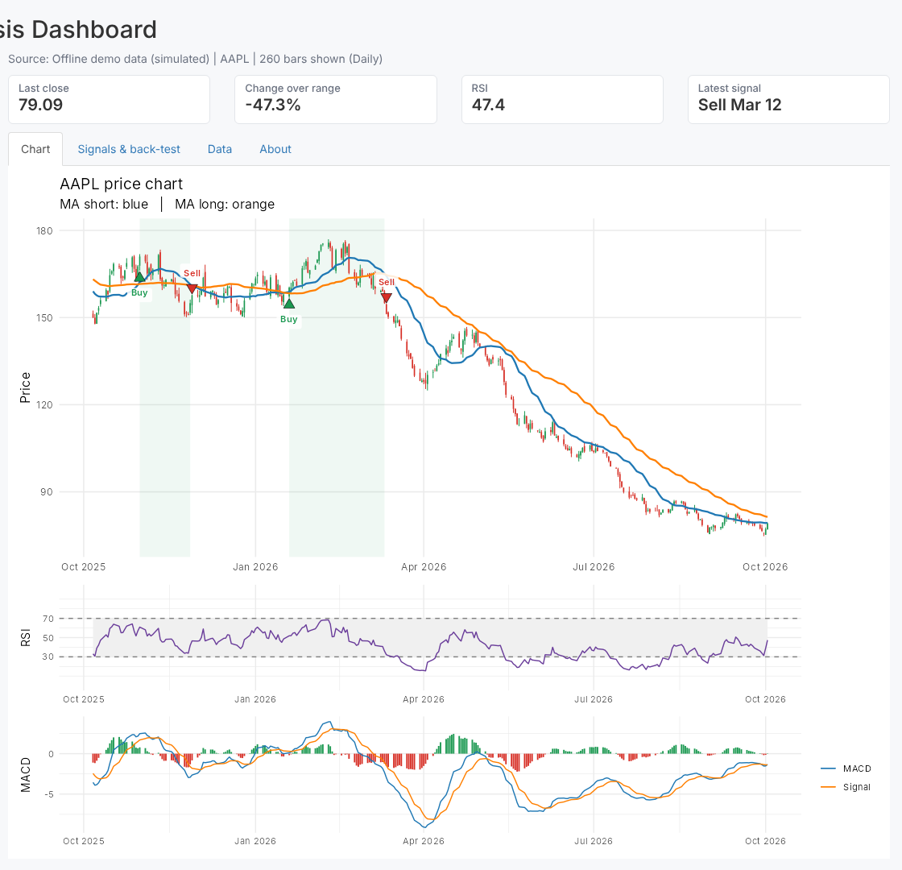
Candlestick chart, moving averages, RSI and MACD panels, MA-crossover signals
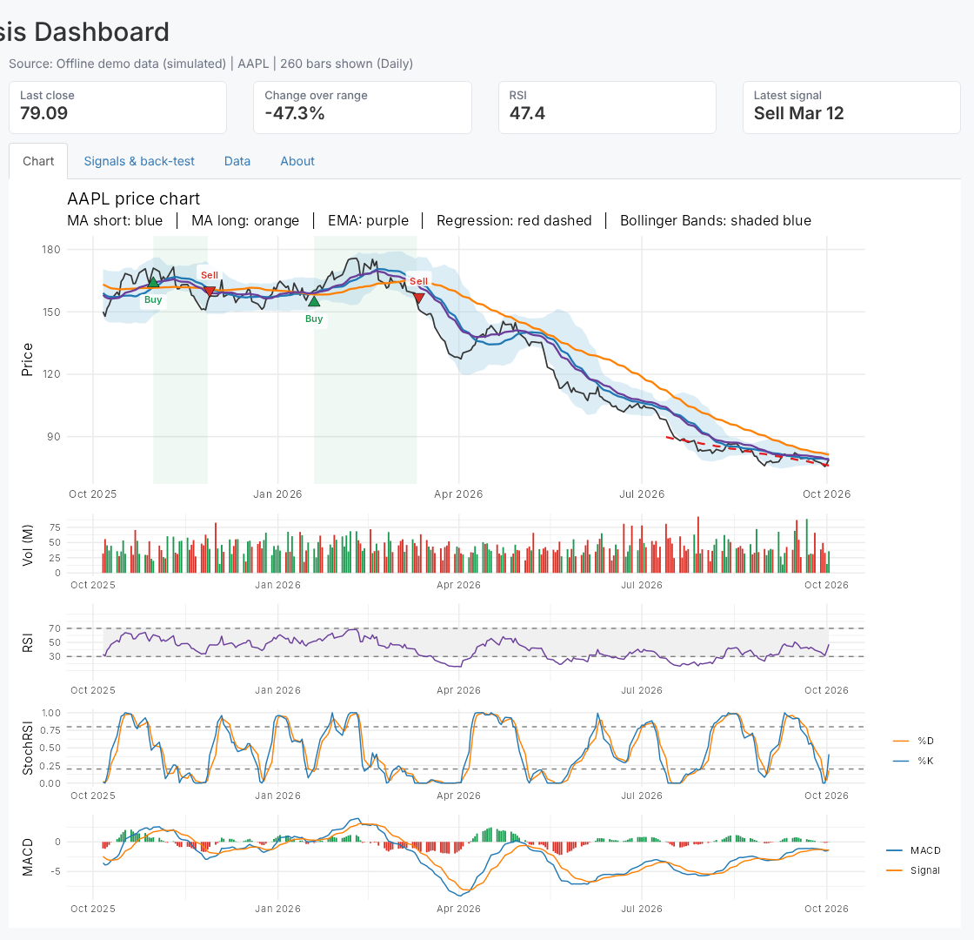
Line chart with every indicator switched on and the combined MA + RSI rule
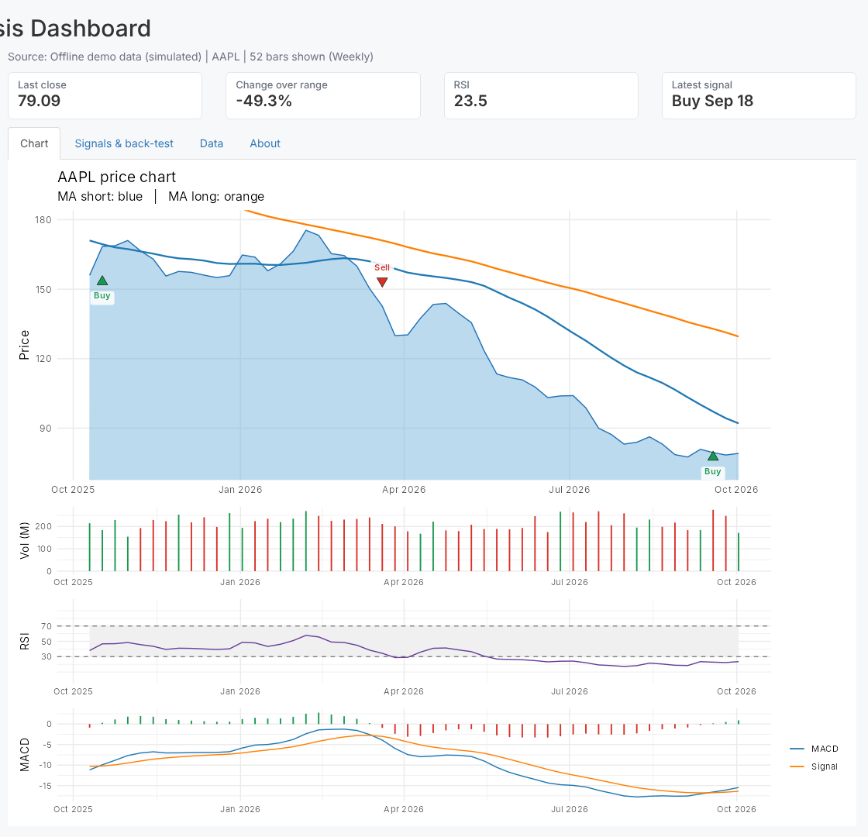
Area chart on the weekly time frame with the MACD crossover rule
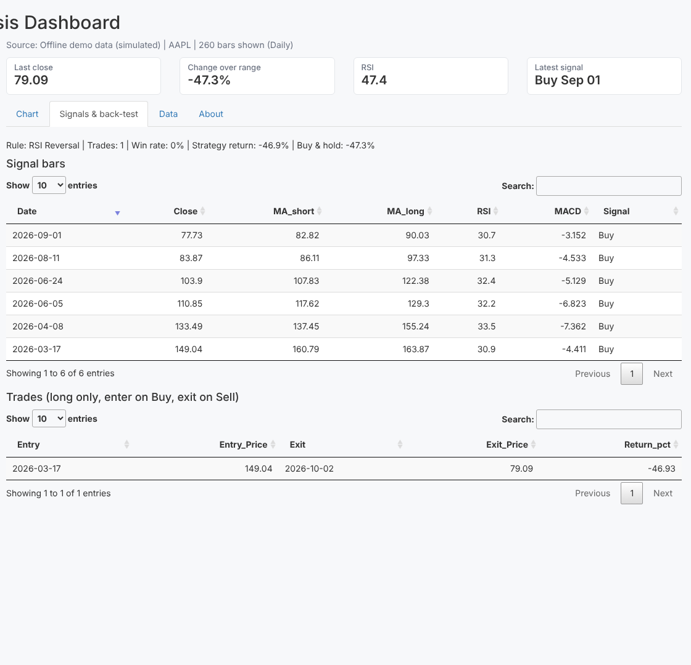
Signals and back-test tab
These screenshots were captured in offline demo mode. On a PC with internet access the app loads live Yahoo Finance data by default.

Repository Link
https://github.com/YOUR-GITHUB-USERNAME/TechnicalAnalysis/tree/main/Assignment6

