1. Null Hypothesis

There is no correlation between no of tweets about H1N1 and H1N1Incidents

1. Find result of correlation test and reproduce it here

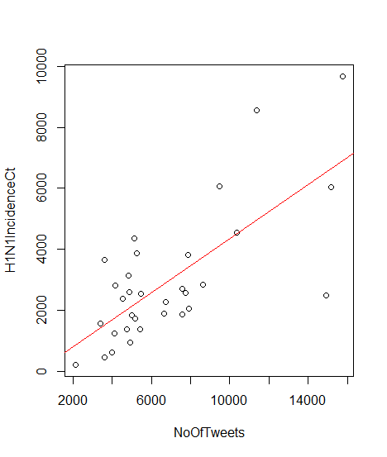

Pearson's product-moment correlation

data: x and y

t = 5.6727, df = 30, p-value = 3.491e-06

alternative hypothesis: true correlation is not equal to 0

95 percent confidence interval:

0.4948286 0.8538916

sample estimates:

cor

0.7193954

1. Conclusion based on the p value obtained?

Correlation is high (0.7193954) and because the p-value is very low (3.491e-06) hence we can reject the null hypothesis.