

Institute of Technology of Cambodia
Java Report Course:
Object Oriented Programming
Instructor:
HOK Tin
Student:
Rith Chankolboth

Example 1
#include <iostream>
using namespace std;
int main(){
int age;
string name, gender, major;
cout << "Please enter your name: ";
cin >> name;
cout << "Please enter your major: ";
cin >> major;
cout << "Please enter your gender (male or female): ";
cin >> gender;
cout << "Please enter your age: ";
cin >> age;
if ( gender.compare("male")==0){
cout << "Hi, Mr "<<name<<"! your age is "<<age<<" year old and you learn "<<major<<endl;
}
if ( gender.compare("female")==0){
cout << "Hi, Ms "<<name<<"! your age is "<<age<<" year old and you learn "<<major<<endl;
}
if (age>=18){
cout<<"you can vote!";
}
else{
cout<<"you cant vote!";
}
return 0;
}
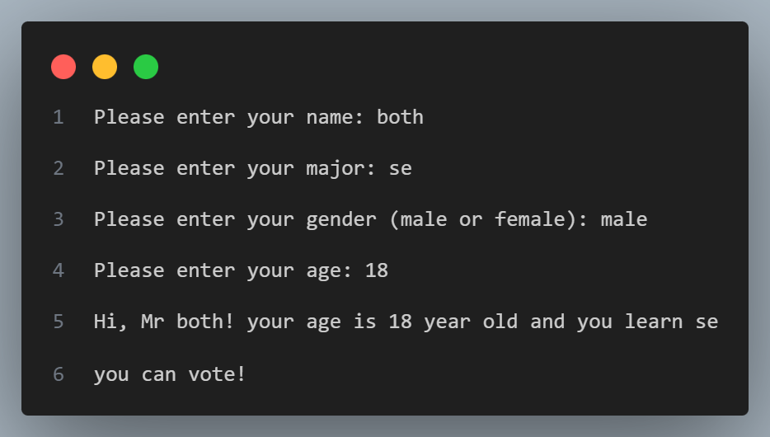

Example 2
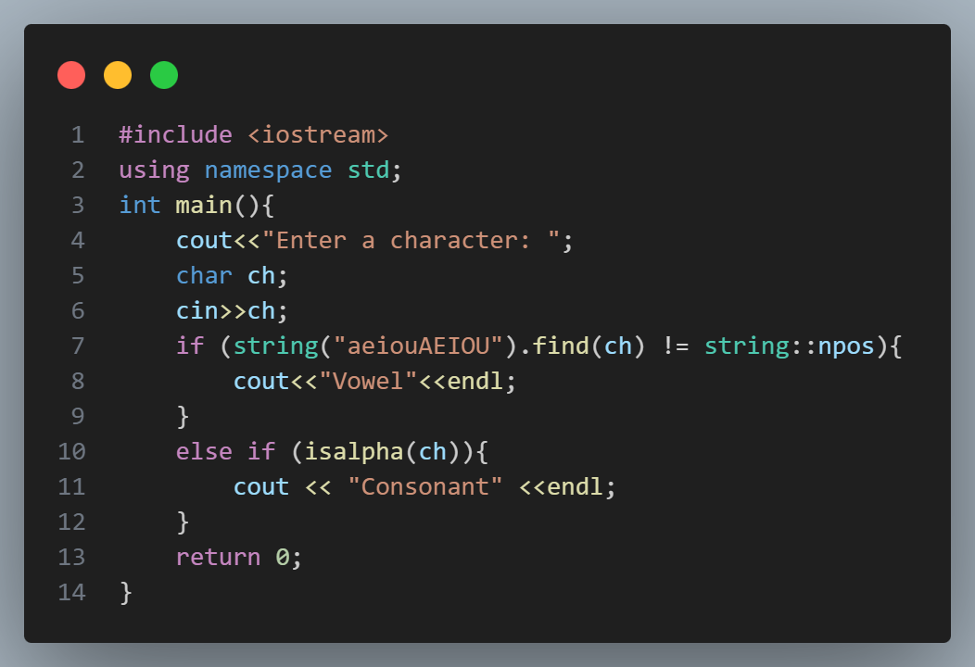

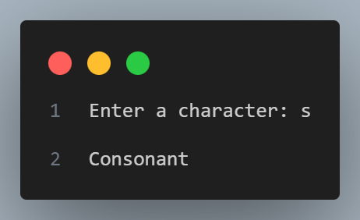
Example 3
#include <iostream>
using namespace std;
int main(){
string name, gender;
double salary;
cout<<"Enter name : ";
cin>>name;
cout<<"Enter gender (male or female): ";
cin>>gender;
cout<<"Enter salary : ";
cin>>salary;
double tax;
if (gender == "male"){
if (salary > 1000){
tax = salary*0.095;
}
if (salary <=1000 && salary >500){
tax = salary*0.07;
}
if (salary<=500 && salary>300){
tax = salary*0.05;
}
}
else if (gender == "female"){
if (salary > 1000){
tax = salary*0.08;
}
if (salary <=1000 && salary >500){
tax = salary*0.065;
}
if (salary<=500 && salary>300){
tax = salary*0.035;
}
}
else {
tax = 0;
}
cout<<"Your tax are : "<<tax;
return 0;
}

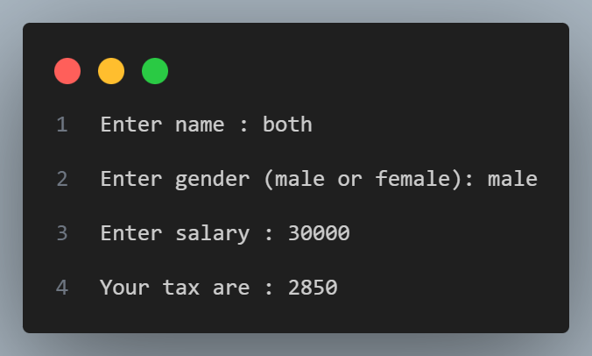
Example 4
#include <iostream>
using namespace std;

int random(int min, int max){
return min + rand() % (max-min+1);
}
int main(){
// Create a C++ program that can play a game Rock-Paper-Scissor.
// The game plays between the user against the computer.
srand(time(0));
int user_score = 0, computer_score = 0;
string option[] = {"rock","paper","scissor"};
int i;

while(true) {
cout<<"What will the user choose?"<<endl;
cout<<"1. Scissor"<<endl;
cout<<"2. Paper"<<endl;
cout<<"3. Rock"<<endl;
cout<<"4. Exit"<<endl;
cout<<"option : ";
cin>>i;
cout<<endl<<endl;

if(i == 4) {
cout<<"Exiting the game..."<<endl;
break;
}

if(i >= 1 && i <= 3) {
int j = random(0,2);
string opp = option[j];
cout<<"User picks : "<< option[i-1]<<"\tI pick :"<<opp<<endl;
if(option[i-1] == "rock" && opp == "scissor") {
cout<<"User wins!"<<endl;
user_score++;
}
else if(option[i-1] == "paper" && opp == "rock") {
cout<<"User wins!"<<endl;
user_score++;
}
else if(option[i-1] == "scissor" && opp == "paper") {
cout<<"User wins!"<<endl;
user_score++;
}
else if(option[i-1] == opp) {
cout<<"It's a tie!"<<endl;
}
else {
cout<<"Computer wins!"<<endl;
computer_score++;
}
cout<<"Score - User: "<<user_score<<" | Computer: "<<computer_score<<endl<<endl;
}
else {
cout<<"Invalid option!"<<endl<<endl;
}
}

cout<<"\nFinal Score - User: "<<user_score<<" | Computer: "<<computer_score<<endl;
return 0;
}
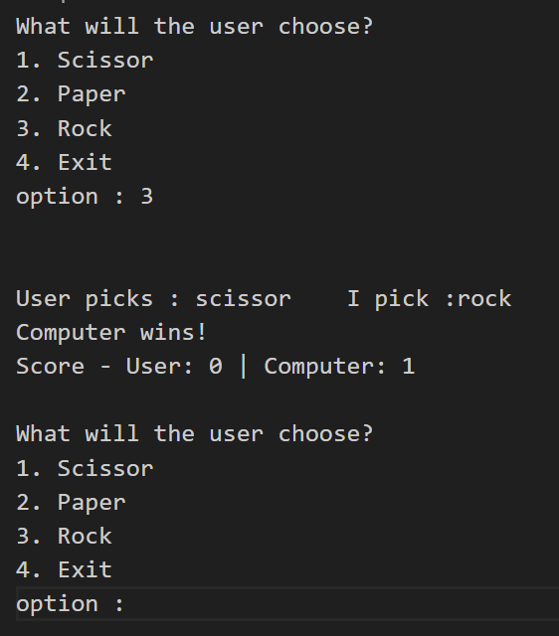

Example 5
#include <iostream>
using namespace std;

int main() {
long long minutes;

cout << "Enter minute(s): ";
cin >> minutes;

if (minutes < 0) {
cout << "Minutes must be non-negative." << endl;
return 1;
}

long long hours = minutes / 60;
long long remainingMinutes = minutes % 60;
long long seconds = remainingMinutes * 60;

cout << "Time format (h:m:s) = "
<< hours << ":" << remainingMinutes << ":" << seconds << endl;

return 0;
}

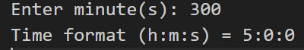
Example 6
#include <iostream>
using namespace std;

int main() {
int n;

cout << "Enter n (n > 50): ";
cin >> n;

while (n <= 50) {
cout << "Invalid input. Please enter n greater than 50: ";
cin >> n;
}

long long sum = 0;
for (int i = 1; i <= n; i++) {
if (i == 10 || i == 30) {
continue;
}
sum += i;
}

cout << "Summation from 1 to " << n
<< " (except 10 and 30) = " << sum << endl;

return 0;
}

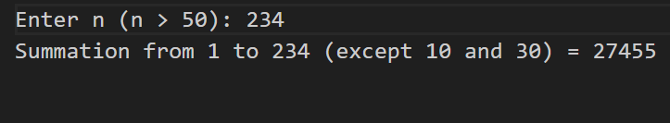

Example 7
#include <iostream>
#include <iomanip>
#include <string>
#include <vector>
using namespace std;

struct Book {
int bookID;
string isbn;
string title;
int publishedYear;
vector<string> authorNames;
double price;
};

void displayBookByISBN(Book books[], int size, string isbn) {
for (int i = 0; i < size; i++) {
if (books[i].isbn == isbn) {
cout << "Book found:" << endl;
cout << "Book ID: " << books[i].bookID << endl;
cout << "ISBN: " << books[i].isbn << endl;
cout << "Title: " << books[i].title << endl;
cout << "Published Year: " << books[i].publishedYear << endl;
cout << "Authors: ";
for (size_t j = 0; j < books[i].authorNames.size(); j++) {
cout << books[i].authorNames[j];
if (j + 1 < books[i].authorNames.size()) {
cout << ", ";
}
}
cout << endl;
cout << fixed << setprecision(2);
cout << "Price ($): " << books[i].price << endl;
return;
}
}

cout << "No book with ISBN " << isbn << " was found." << endl;
}

void displayAllBooks(Book books[], int size) {
cout << "\nAll books:" << endl;
for (int i = 0; i < size; i++) {
cout << "------------------------------" << endl;
cout << "Book ID: " << books[i].bookID << endl;
cout << "ISBN: " << books[i].isbn << endl;
cout << "Title: " << books[i].title << endl;
cout << "Published Year: " << books[i].publishedYear << endl;
cout << "Authors: ";
for (size_t j = 0; j < books[i].authorNames.size(); j++) {
cout << books[i].authorNames[j];
if (j + 1 < books[i].authorNames.size()) {
cout << ", ";
}
}
cout << endl;
cout << fixed << setprecision(2);
cout << "Price ($): " << books[i].price << endl;
}
cout << "------------------------------" << endl;
}

int main() {
Book books[5] = {
{1, "1234", "The C Programming Language", 1988, {"Brian W. Kernighan", "Dennis M. Ritchie"}, 45.50},
{2, "7654", "Effective C++", 2005, {"Scott Meyers"}, 39.99},
{3, "3545", "Design Patterns", 1994, {"Erich Gamma", "Richard Helm", "Ralph Johnson", "John Vlissides"}, 55.75},
{4, "9999", "Clean Code", 2008, {"Robert C. Martin"}, 42.00},
{5, "8888", "Fluent Python", 2015, {"Luciano Ramalho"}, 49.90}
};

displayAllBooks(books, 5);

string searchISBN;
cout << "\nEnter ISBN to search: ";
cin >> searchISBN;

displayBookByISBN(books, 5, searchISBN);

return 0;
}

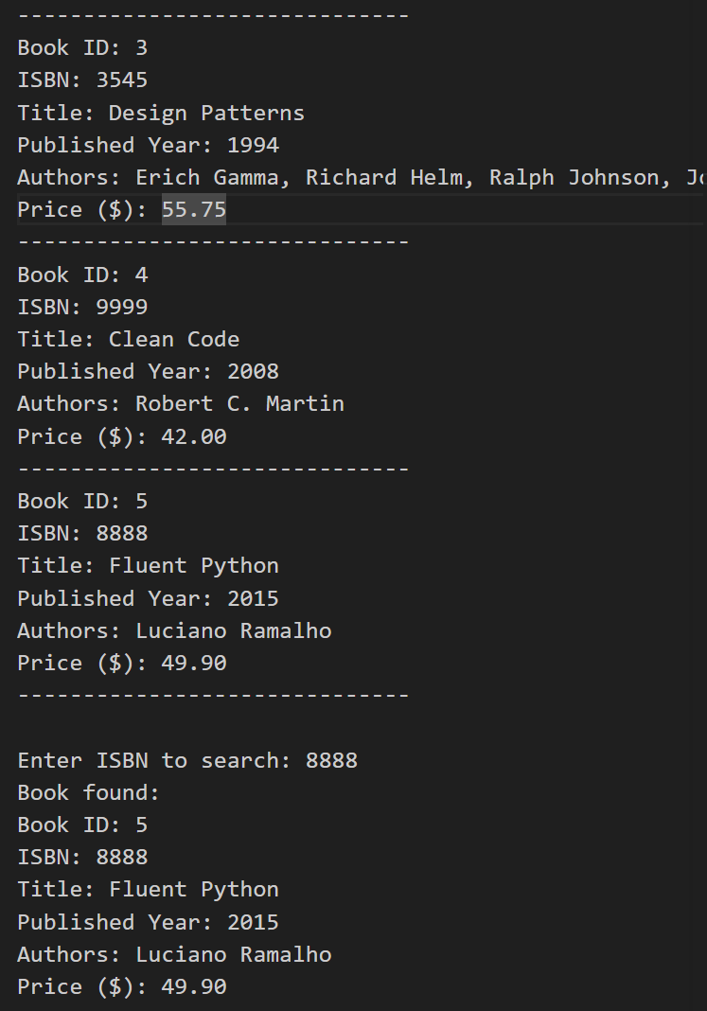
Example 8
#include <iostream>
#include <cmath>
#include <limits>
using namespace std;

double celsiusToFahrenheit(double celsius) {
return (celsius * 9.0 / 5.0) + 32;
}

double fahrenheitToCelsius(double fahrenheit) {
return (fahrenheit - 32) * 5.0 / 9.0;
}

void quadraticRoots(double a, double b, double c) {
if (a == 0) {
cout << "Not a quadratic equation because a = 0." << endl;
return;
}

double discriminant = b * b - 4 * a * c;

if (discriminant > 0) {
double x1 = (-b + sqrt(discriminant)) / (2 * a);
double x2 = (-b - sqrt(discriminant)) / (2 * a);
cout << "Two real roots: x1 = " << x1 << ", x2 = " << x2 << endl;
} else if (discriminant == 0) {
double x = -b / (2 * a);
cout << "One real root: x = " << x << endl;
} else {
double realPart = -b / (2 * a);
double imaginaryPart = sqrt(-discriminant) / (2 * a);
cout << "Two complex roots: x1 = " << realPart << " + " << imaginaryPart << "i"
<< ", x2 = " << realPart << " - " << imaginaryPart << "i" << endl;
}
}

double computeBMI(double weightKg, double heightM) {
return weightKg / (heightM * heightM);
}

void showBMICategory(double bmi) {
if (bmi < 18.5) {
cout << "BMI = " << bmi << " -> underweight" << endl;
} else if (bmi < 25) {
cout << "BMI = " << bmi << " -> normal weight" << endl;
} else if (bmi < 30) {
cout << "BMI = " << bmi << " -> overweight" << endl;
} else {
cout << "BMI = " << bmi << " -> obese" << endl;
}
}

long long sumExceptDivisibleBy3(int n) {
long long sum = 0;
for (int i = 1; i <= n; i++) {
if (i % 3 != 0) {
sum += i;
}
}
return sum;
}

int main() {
int choice;

do {
cout << "\n===== MENU =====" << endl;
cout << "1. Celsius to Fahrenheit" << endl;
cout << "2. Fahrenheit to Celsius" << endl;
cout << "3. Root of quadratic equation" << endl;
cout << "4. Compute BMI and category" << endl;
cout << "5. Sum 1..n except numbers divisible by 3" << endl;
cout << "0. Exit" << endl;
cout << "Choose an option: ";
cin >> choice;

if (cin.fail()) {
cin.clear();
cin.ignore(numeric_limits<streamsize>::max(), '\n');
cout << "Invalid input." << endl;
continue;
}

if (choice == 1) {
double c;
cout << "Enter Celsius: ";
cin >> c;
cout << "Fahrenheit = " << celsiusToFahrenheit(c) << endl;
} else if (choice == 2) {
double f;
cout << "Enter Fahrenheit: ";
cin >> f;
cout << "Celsius = " << fahrenheitToCelsius(f) << endl;
} else if (choice == 3) {
double a, b, c;
cout << "For ax^2 + bx + c = 0" << endl;
cout << "Enter a, b, c: ";
cin >> a >> b >> c;
quadraticRoots(a, b, c);
} else if (choice == 4) {
double weight, height;
cout << "Enter weight (kg): ";
cin >> weight;
cout << "Enter height (m): ";
cin >> height;

if (height <= 0) {
cout << "Height must be greater than 0." << endl;
} else {
double bmi = computeBMI(weight, height);
showBMICategory(bmi);
}
} else if (choice == 5) {
int n;
cout << "Enter n: ";
cin >> n;
if (n < 1) {
cout << "n must be at least 1." << endl;
} else {
cout << "Sum = " << sumExceptDivisibleBy3(n) << endl;
}
} else if (choice == 0) {
cout << "Program ended." << endl;
} else {
cout << "Invalid choice." << endl;
}

} while (choice != 0);

return 0;
}

