📊 Data Types & Distributions
Normal Distribution • All Chart Types • Python Code
Beginner-Friendly Guide for Data Science & Machine Learning
💡 What This Chapter Covers
✅ Types of Data — Categorical vs Numerical (and sub-types)
✅ All major Probability Distributions explained in simple words
✅ Normal / Gaussian Distribution — the MOST important one in ML
✅ The 68-95-99.7 Rule — from your images
✅ All chart types — Histogram, Box Plot, Bar Chart, and more
✅ Discrete vs Continuous distributions
✅ How to detect if data is normally distributed
✅ How to normalize data — methods and Python code
✅ Complete Python code for every concept

Quick Overview — Distribution Family Map

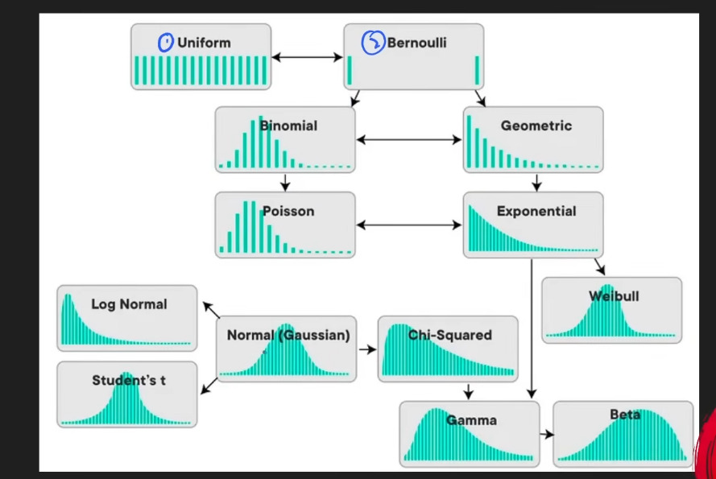
Figure 1: How all probability distributions relate to each other

1️⃣ Types of Data
💡 Why Data Types Matter
Before you can choose a chart, distribution, or analysis method,
you MUST know what TYPE of data you are working with.
The wrong type assumption = wrong chart = wrong model = wrong conclusions.

🔷 Categorical Data — Data with Labels or Groups
Categorical data represents qualities or labels — things you can PUT INTO GROUPS.
You cannot do math on these (you cannot add 'Red' + 'Blue').

Sub-type | What it is | Examples | Python dtype
Nominal | Labels with NO order — one is not 'more' than another | Blood type (A/B/O), Colours, Country, Gender | object / str / pd.Categorical
Ordinal | Labels WITH order — but gaps between ranks are not equal | Star ratings (1★-5★), Education level, Survey scale (Bad/OK/Good) | pd.Categorical(ordered=True)

🧠 Nominal vs Ordinal — Easy Trick
Nominal = No order. Red is not 'more' than Blue.
Ordinal = Has order. 5 stars IS more than 1 star. But is 5★ FIVE TIMES better than 1★? Not necessarily.

The key: ordinal has RANK but NOT equal spacing between ranks.

🔶 Numerical Data — Data with Actual Numbers
Numerical data represents measurements or counts. You CAN do math on these.

Sub-type | What it is | Examples | Key property
Discrete | Countable whole numbers — you CANNOT have half a value | Number of students, Number of goals, Coin flips | Finite or countably infinite gaps between values
Continuous | Any value in a range — infinite possibilities between two points | Height (1.731 m), Temperature, Weight, Time | Can take any decimal value — no gaps
Interval | Numbers WITH equal spacing but NO true zero point | Temperature in °C (0°C is NOT 'no temperature'), Years | Can add/subtract, CANNOT multiply/divide meaningfully
Ratio | Numbers WITH equal spacing AND a true zero point | Height, Weight, Speed, Income (0 = truly nothing) | Full math allowed — ratios make sense (2x as tall)

🧠 Interval vs Ratio — The Zero Point Test
Ask: Does zero mean TRULY NOTHING?

Temperature 0°C = NOT 'no temperature'. It's just freezing point. → INTERVAL
Height 0 cm = truly no height. Zero means nothing. → RATIO
Income Rs. 0 = truly no income. → RATIO

Only RATIO lets you say '2x as much'. You cannot say 20°C is twice as hot as 10°C!

📋 Complete Data Type Map
DATA
│
├── CATEGORICAL (labels / groups)
│ ├── Nominal → No order (colors, blood type, country)
│ └── Ordinal → Has order (ratings, education level)
│
└── NUMERICAL (actual numbers)
├── Discrete → Whole numbers only (goals, students, coin flips)
├── Continuous→ Any value (height, weight, temperature)
├── Interval → Equal gaps, no true zero (temperature °C, year)
└── Ratio → Equal gaps + true zero (height cm, income)

💻 Python — Identifying Data Types
import pandas as pd
import numpy as np

df = pd.DataFrame({
'name' : ['Ali', 'Sana', 'Bilal'], # Nominal categorical
'grade' : ['A', 'B', 'A'], # Ordinal categorical
'score' : [85, 72, 90], # Discrete numerical
'height_cm' : [170.5, 162.3, 175.8], # Continuous numerical
'temp_c' : [36.6, 37.1, 36.9], # Interval
'income_pkr' : [50000, 80000, 120000], # Ratio
})

print(df.dtypes) # shows int64, float64, object
print(df.describe()) # stats for numerical columns only
print(df.nunique()) # unique values per column

# Convert to ordered categorical:
df['grade'] = pd.Categorical(df['grade'], categories=['C','B','A'], ordered=True)
print(df['grade'] > 'B') # True/False — ordering works now

2️⃣ Normal / Gaussian Distribution — The Most Important One
⭐ Why Normal Distribution is the KING of Statistics & ML
Most real-world measurements naturally follow this shape:
heights of people, exam scores, errors in measurements, weight, IQ scores.

Most ML algorithms ASSUME your data is normally distributed.
Linear Regression, Logistic Regression, PCA, Neural Network weight init —
ALL rely on this assumption.

Understanding Normal Distribution = Understanding the foundation of ML.

🔍 What Does It Look Like?
A perfect bell curve — symmetric, with most values clustered in the middle and fewer at the extremes.

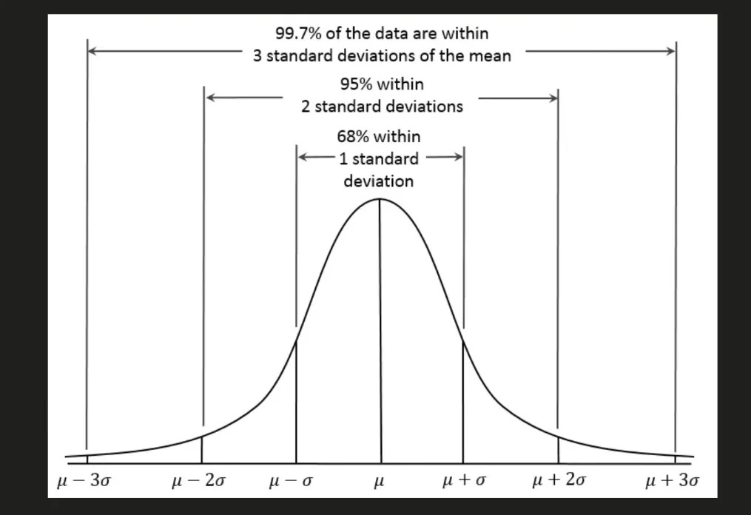
Figure 2: Normal Distribution — the Bell Curve showing μ ± 1σ, 2σ, 3σ

📐 The Formula (You Don't Need to Memorise — Just Understand)
1 -(x - μ)²
f(x) = ───────── × exp(──────────)
σ√(2π) 2σ²

Where:
μ (mu) = mean → controls the CENTER (where the peak is)
σ (sigma) = std dev → controls the WIDTH (how spread out it is)
x = any data point

Larger σ → bell curve is WIDER and FLATTER
Smaller σ → bell curve is NARROWER and TALLER

🎯 The 68-95-99.7 Rule (Empirical Rule) — CRITICAL
This is one of the most used rules in all of statistics and ML. Memorise it.

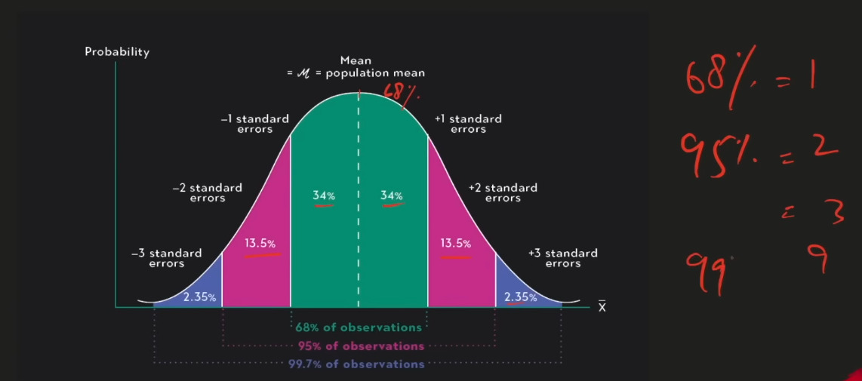
Figure 3: The Empirical Rule — 68%, 95%, 99.7% of data within 1, 2, 3 standard deviations

Range | % of Data | In your data | Real-life meaning
μ ± 1σ | 68% | Between (mean − std) and (mean + std) | About 2 in 3 students fall within 1 std of the average
μ ± 2σ | 95% | Between (mean − 2×std) and (mean + 2×std) | 19 out of 20 values fall here — used for 95% confidence intervals
μ ± 3σ | 99.7% | Between (mean − 3×std) and (mean + 3×std) | Almost everything. Values outside are extreme outliers (0.3%)

🏫 Real-Life Example — Exam Scores
Exam scores: Mean (μ) = 70, Std Dev (σ) = 10

68% of students scored between 70 − 10 = 60 and 70 + 10 = 80
95% of students scored between 70 − 20 = 50 and 70 + 20 = 90
99.7% of students scored between 70 − 30 = 40 and 70 + 30 = 100

If someone scores 95, they are more than 2σ above mean → top 2.5% of class.
This is how Z-scores work — measuring HOW MANY standard deviations from mean.

🤔 Why is Normal Distribution Important in Data Science & ML?
Where It Appears | Why It Matters
Central Limit Theorem | Sample means follow Normal distribution regardless of original data shape. This is WHY statistical tests work.
Linear Regression | Assumes errors (residuals) are normally distributed. If not, predictions are unreliable.
Neural Networks | Weights are initialized from Normal distribution. Random init avoids symmetry breaking problems.
Feature Scaling | StandardScaler assumes Normal dist. It shifts mean to 0 and std to 1. Only works well if data is Normal.
Confidence Intervals | The 95% CI formula uses ±1.96σ — directly from the Normal distribution's 95% rule.
Hypothesis Testing | Z-tests and t-tests assume Normal distribution of test statistics.

💻 Python — Working with Normal Distribution
import numpy as np
import matplotlib.pyplot as plt
from scipy import stats

# ── Generate normally distributed data ───────────────────────────────
mu = 70 # mean
sigma = 10 # standard deviation
data = np.random.normal(mu, sigma, 1000) # 1000 random values

# ── Basic stats ──────────────────────────────────────────────────────
print(f'Mean : {np.mean(data):.2f}') # ≈ 70
print(f'Std : {np.std(data, ddof=1):.2f}') # ≈ 10

# ── 68-95-99.7 Rule check ─────────────────────────────────────────
within_1sd = np.sum((data > mu-sigma) & (data < mu+sigma)) / len(data)
within_2sd = np.sum((data > mu-2*sigma) & (data < mu+2*sigma)) / len(data)
within_3sd = np.sum((data > mu-3*sigma) & (data < mu+3*sigma)) / len(data)
print(f'Within 1σ: {within_1sd*100:.1f}%') # ≈ 68%
print(f'Within 2σ: {within_2sd*100:.1f}%') # ≈ 95%
print(f'Within 3σ: {within_3sd*100:.1f}%') # ≈ 99.7%

# ── Plot the bell curve ──────────────────────────────────────────────
plt.figure(figsize=(10, 5))
plt.hist(data, bins=40, density=True, alpha=0.6, color='steelblue')
x = np.linspace(mu-4*sigma, mu+4*sigma, 300)
plt.plot(x, stats.norm.pdf(x, mu, sigma), 'r-', lw=2, label='Normal PDF')
plt.axvline(mu, color='black', linestyle='--', label=f'Mean={mu}')
plt.axvline(mu+sigma, color='orange', linestyle='--', label='±1σ')
plt.axvline(mu-sigma, color='orange', linestyle='--')
plt.legend()
plt.title('Normal Distribution — Bell Curve')
plt.show()

🔎 How to Know if Your Data is Normally Distributed?
In real ML work you rarely have perfectly normal data. Here are the tests:

Method | What it does | Python
Histogram | Visual check — should look like a bell | plt.hist(data, bins='auto')
Q-Q Plot | Points should follow diagonal line if Normal | stats.probplot(data, plot=plt)
Shapiro-Wilk Test | p > 0.05 → data is Normal (best for small samples) | stats.shapiro(data)
K-S Test | Kolmogorov-Smirnov test for larger samples | stats.kstest(data, 'norm')
Skewness/Kurtosis | Skew≈0 and Kurtosis≈3 means Normal | stats.skew(data), stats.kurtosis(data)

from scipy import stats
import numpy as np
import matplotlib.pyplot as plt

data = np.random.normal(70, 10, 200)

# ── Method 1: Histogram ──────────────────────────────────────────────
plt.hist(data, bins=20) # look for bell shape
plt.title('Is this Normal? — check the shape')
plt.show()

# ── Method 2: Q-Q Plot ───────────────────────────────────────────────
fig, ax = plt.subplots()
stats.probplot(data, dist='norm', plot=ax)
ax.set_title('Q-Q Plot — points on line = Normal')
plt.show()

# ── Method 3: Shapiro-Wilk Test ──────────────────────────────────────
stat, p_value = stats.shapiro(data)
print(f'Shapiro-Wilk: stat={stat:.4f}, p={p_value:.4f}')
if p_value > 0.05:
print('✅ Data is likely NORMAL (fail to reject H0)')
else:
print('❌ Data is NOT normal (reject H0)')

# ── Method 4: Skewness & Kurtosis ────────────────────────────────────
skew = stats.skew(data)
kurt = stats.kurtosis(data) # excess kurtosis (Normal = 0)
print(f'Skewness : {skew:.4f} (should be near 0 for Normal)')
print(f'Kurtosis : {kurt:.4f} (should be near 0 for Normal)')

3️⃣ How to Normalize Data — Methods & Python Code
💡 What is Normalization / Standardization?
ML models get confused when features have very different scales.
Example: Age (20–80) vs Income (10,000–5,000,000) — income dominates by scale alone.

Normalization: rescales data to a standard range (usually 0–1).
Standardization: rescales data to have mean=0 and std=1.

These are the main tools to 'fix' your data before feeding it to ML models.

Method | Formula | Output Range | Best For
Min-Max Normalization | (x − min) / (max − min) | [0, 1] | When you know data has fixed bounds; Neural Networks
Z-score Standardization | (x − mean) / std | Unbounded, mean=0, std=1 | When data is approximately Normal; most ML algorithms
Robust Scaling | (x − median) / IQR | Unbounded, outlier-resistant | When data has many outliers
Log Transform | log(x) or log(x+1) | Unbounded | Right-skewed data; income, prices
Box-Cox Transform | Finds best λ automatically | Near-Normal | Make non-normal data more Normal

💻 Python — All Normalization Methods
import numpy as np
import pandas as pd
from sklearn.preprocessing import MinMaxScaler, StandardScaler, RobustScaler
from scipy import stats

data = np.array([[10], [20], [30], [40], [500]]) # 500 is an outlier

# ── Method 1: Min-Max Normalization ─────────────────────────────────
scaler_mm = MinMaxScaler() # scales to [0, 1]
data_minmax = scaler_mm.fit_transform(data)
print('Min-Max:', data_minmax.flatten())
# Output: [0. 0.021 0.041 0.061 1. ] ← 500 becomes 1.0

# ── Method 2: Z-score Standardization ───────────────────────────────
scaler_std = StandardScaler() # mean=0, std=1
data_std = scaler_std.fit_transform(data)
print('Z-score:', data_std.flatten())

# ── Method 3: Robust Scaling (handles outliers) ──────────────────────
scaler_rob = RobustScaler() # uses median & IQR
data_robust = scaler_rob.fit_transform(data)
print('Robust:', data_robust.flatten())
# Outlier 500 has much less influence here

# ── Method 4: Log Transform (manual) ────────────────────────────────
data_log = np.log1p(data) # log(x+1) to handle zeros
print('Log:', data_log.flatten())

# ── Method 5: Box-Cox (needs all positive values) ───────────────────
positive_data = np.array([10, 20, 30, 40, 100])
data_boxcox, best_lambda = stats.boxcox(positive_data)
print(f'Box-Cox lambda: {best_lambda:.3f}')
print('Box-Cox:', data_boxcox)

4️⃣ All Probability Distributions Explained
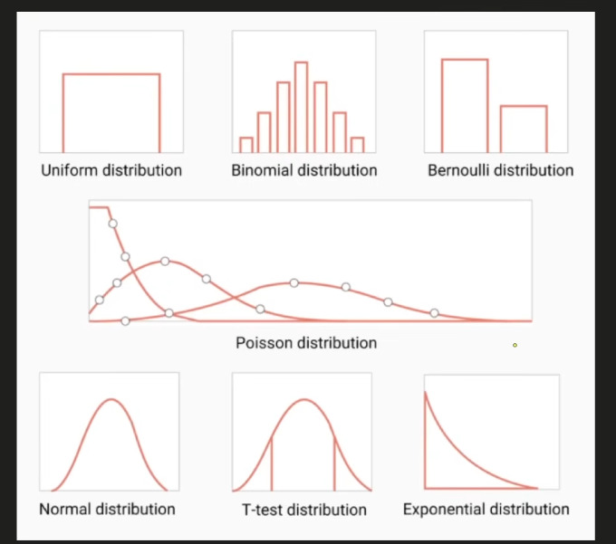
Figure 4: Types of Probability Distributions at a glance

💡 Discrete vs Continuous Distributions
DISCRETE: Data can only take specific separate values (whole numbers).
Examples: Binomial, Bernoulli, Poisson, Geometric
Think: Number of goals, coin flip outcomes, number of emails per hour

CONTINUOUS: Data can take any value in a range (infinite possibilities).
Examples: Normal, Exponential, Uniform (continuous), T-distribution
Think: Height, weight, time, temperature

4.1 — Uniform Distribution
Every outcome has the SAME probability. Flat, equal chance for everything.

🎲 Real-Life Analogy
Rolling a fair die: 1, 2, 3, 4, 5, 6 — each has exactly 1/6 chance.
Picking a random number between 1 and 10 — every number equally likely.
Random number generator in computers — perfectly uniform.

Discrete Uniform | Continuous Uniform
Finite outcomes — each has equal probability  Example: fair die (1-6) | Any value in [a, b] equally likely  Example: random number in [0, 1]

import numpy as np
import matplotlib.pyplot as plt
from scipy import stats

# Discrete Uniform — rolling a die 1000 times
die_rolls = np.random.randint(1, 7, 1000)
plt.hist(die_rolls, bins=6, rwidth=0.8, color='steelblue')
plt.title('Discrete Uniform — Die Rolls')
plt.show()

# Continuous Uniform — between 0 and 10
data = np.random.uniform(0, 10, 1000)
plt.hist(data, bins=20, color='teal')
plt.title('Continuous Uniform Distribution')
plt.show()

4.2 — Bernoulli Distribution
The SIMPLEST distribution — only TWO possible outcomes: SUCCESS (1) or FAILURE (0).
One single trial. One event. One probability p.

🪙 Real-Life Analogy
Flipping one coin: Heads (1) or Tails (0).
One patient: Recovered (1) or Not recovered (0).
One email: Spam (1) or Not spam (0).
One click: Clicked (1) or Not clicked (0).

Bernoulli(p) — p is the probability of success (1).
If p=0.7 → 70% chance of success, 30% chance of failure.

from scipy import stats
import numpy as np

p = 0.7 # probability of success (heads)

# Single Bernoulli trial
outcome = stats.bernoulli.rvs(p) # 0 or 1
print(f'Outcome: {outcome}') # e.g., 1 (heads)

# 1000 coin flips
flips = stats.bernoulli.rvs(p, size=1000)
print(f'Heads: {flips.sum()}, Tails: {1000-flips.sum()}')

# In ML: this is exactly what Logistic Regression outputs!
# Output probability → threshold at 0.5 → Bernoulli outcome (0 or 1)

4.3 — Binomial Distribution
Binomial = MULTIPLE Bernoulli trials. How many successes in n trials?

🪙 Real-Life Analogy
Flip a coin 10 times. How many heads do you get?
That count (0 to 10) follows a Binomial distribution.

Binomial(n, p):
n = number of trials
p = probability of success in each trial
X = number of successes (this is what we're finding)

Bernoulli = special case of Binomial where n=1.

from scipy import stats
import numpy as np
import matplotlib.pyplot as plt

n = 10 # 10 coin flips
p = 0.5 # fair coin

# Probability of getting exactly 6 heads
prob_6 = stats.binom.pmf(6, n, p) # pmf = probability mass function
print(f'P(exactly 6 heads) = {prob_6:.4f}') # 0.2051

# Probability of 6 or fewer heads
prob_leq6 = stats.binom.cdf(6, n, p) # cdf = cumulative distribution
print(f'P(6 or fewer heads) = {prob_leq6:.4f}') # 0.8281

# Simulate 1000 experiments of 10 flips each
results = stats.binom.rvs(n, p, size=1000)
plt.hist(results, bins=range(12), rwidth=0.8, color='steelblue')
plt.xlabel('Number of Heads')
plt.title('Binomial(n=10, p=0.5) — 1000 Simulations')
plt.show()

4.4 — Poisson Distribution
How many times does an event happen in a FIXED time period?
Used when events happen randomly but at a known average rate (λ, lambda).

📧 Real-Life Analogy
You receive on average 5 emails per hour (λ = 5).
What is the probability you get exactly 3 emails in the next hour?

Other examples:
Number of cars passing a toll booth per minute (λ = avg per minute)
Number of goals in a football match (λ = avg goals per match)
Number of server crashes per day (λ = avg crashes per day)

Key conditions: events are independent, constant average rate.

from scipy import stats
import numpy as np
import matplotlib.pyplot as plt

lam = 5 # average 5 emails per hour

# Probability of exactly 3 emails
prob_3 = stats.poisson.pmf(3, lam)
print(f'P(3 emails) = {prob_3:.4f}') # 0.1404

# Probability of 8 or fewer emails
prob_leq8 = stats.poisson.cdf(8, lam)
print(f'P(≤8 emails) = {prob_leq8:.4f}') # 0.9319

# Plot Poisson distribution for different lambdas
x = np.arange(0, 20)
for lam in [1, 4, 10]:
plt.plot(x, stats.poisson.pmf(x, lam), marker='o', label=f'λ={lam}')
plt.title('Poisson Distribution — different λ values')
plt.legend()
plt.show()

4.5 — Normal / Gaussian Distribution (Continuous)
Already covered in detail in Section 2. Key reminder:

📌 Quick Recap
Shape: Perfect bell curve, symmetric around mean (μ).
Parameters: μ (mean = center) and σ (std dev = width).
Rule: 68% within 1σ, 95% within 2σ, 99.7% within 3σ.
Special case: Standard Normal has μ=0, σ=1.
Z-score = (x − μ) / σ tells you how many std devs from the mean.

4.6 — T-Distribution (Student's t)
Similar to Normal distribution but with HEAVIER tails — used when sample size is SMALL.

🔬 Real-Life Analogy
You want to estimate the average height of all Pakistanis.
But you only measured 15 people (small sample).

With a small sample, you are LESS certain about the true mean.
The t-distribution accounts for this extra uncertainty — its tails are wider.

As sample size grows → t-distribution becomes Normal.
Rule of thumb: use t when n < 30.

Used in: t-tests (comparing means), confidence intervals with small samples.

from scipy import stats
import numpy as np
import matplotlib.pyplot as plt

x = np.linspace(-4, 4, 300)

# Compare Normal vs t-distribution
plt.plot(x, stats.norm.pdf(x), label='Normal (infinite df)', lw=2)
plt.plot(x, stats.t.pdf(x, df=3), label='t (df=3)', lw=2, linestyle='--')
plt.plot(x, stats.t.pdf(x, df=10), label='t (df=10)', lw=2, linestyle='-.')
plt.title('t-distribution vs Normal')
plt.legend()
plt.show()

# One-sample t-test: is sample mean significantly different from μ=70?
sample = np.random.normal(72, 10, 20) # small sample (n=20)
t_stat, p_value = stats.ttest_1samp(sample, popmean=70)
print(f't-statistic: {t_stat:.4f}')
print(f'p-value : {p_value:.4f}')
if p_value < 0.05:
print('Significantly different from 70')

4.7 — Exponential Distribution
How long until the NEXT event happens? Time between events.
Continuous counterpart of Poisson. Memoryless — the past doesn't affect future.

⏱️ Real-Life Analogy
You know customers arrive at 5 per hour on average (Poisson).
How long do you WAIT until the next customer? → Exponential!

More examples:
How long until the next earthquake? (given average rate)
How long until the next server request?
Battery lifetime — how long until failure?

Parameter: λ (rate). Mean waiting time = 1/λ.
If λ=5 (5 per hour), mean wait = 1/5 hour = 12 minutes.

from scipy import stats
import numpy as np
import matplotlib.pyplot as plt

lam = 5 # 5 customers per hour → scale = 1/lam = 12 minutes

# Probability of waiting more than 20 minutes (1/3 hour)
# P(X > 1/3) = 1 - CDF(1/3)
prob_gt20 = 1 - stats.expon.cdf(1/3, scale=1/lam)
print(f'P(wait > 20 min) = {prob_gt20:.4f}') # 0.1889

# Simulate wait times
wait_times = stats.expon.rvs(scale=1/lam, size=1000)
plt.hist(wait_times, bins=40, color='salmon')
plt.xlabel('Wait Time (hours)')
plt.title('Exponential Distribution — Time Between Customers')
plt.show()

5️⃣ All Chart Types — Explained with Python
💡 Why Different Charts?
Different data types and questions need different visualisations.
Using the wrong chart is like using a spoon to cut bread — technically possible but wrong!

Rule of thumb:
Want to see DISTRIBUTION of data? → Histogram or Box Plot
Want to COMPARE categories? → Bar Chart
Want to see RELATIONSHIP between two variables? → Scatter Plot
Want to see CHANGE over time? → Line Chart

📊 Histogram — The Distribution Detective
Groups data into bins and shows how many values fall in each bin.
Best for: understanding the SHAPE and DISTRIBUTION of a single numerical variable.

🧠 Histogram vs Bar Chart — Key Difference
Histogram: X-axis is NUMERICAL (continuous). Bars touch each other (no gap).
Used for one numerical variable's distribution.

Bar Chart: X-axis is CATEGORICAL. Bars have gaps between them.
Used to compare values across different categories.

Easy trick: if there are gaps between bars → Bar Chart.
If bars are touching → Histogram.

import matplotlib.pyplot as plt
import seaborn as sns
import numpy as np

data = np.random.normal(70, 15, 500) # exam scores

# ── Histogram (matplotlib) ───────────────────────────────────────────
plt.figure(figsize=(10, 4))
plt.subplot(1, 2, 1)
plt.hist(data, bins=20, color='steelblue', edgecolor='white')
plt.title('Histogram — Exam Scores')
plt.xlabel('Score')
plt.ylabel('Frequency')

# ── Histogram with KDE (seaborn — much prettier) ─────────────────────
plt.subplot(1, 2, 2)
sns.histplot(data, kde=True, color='steelblue', bins=20)
plt.title('Histogram + KDE (seaborn)')
plt.tight_layout()
plt.show()

# When to use: understanding if data is Normal, skewed, bimodal etc.
# bins parameter: more bins = more detail, fewer bins = smoother view

📦 Box Plot — The Outlier Detector
Shows the 5-number summary: Min, Q1, Median, Q3, Max — plus outliers as dots.
Best for: comparing distributions across groups and spotting outliers instantly.

import matplotlib.pyplot as plt
import seaborn as sns
import numpy as np
import pandas as pd

data = {
'Math' : np.random.normal(70, 10, 100),
'Science' : np.random.normal(65, 15, 100),
'English' : np.random.normal(75, 8, 100),
}
df = pd.DataFrame(data)

# ── Box plot (matplotlib) ────────────────────────────────────────────
plt.figure(figsize=(10, 4))
plt.subplot(1, 2, 1)
plt.boxplot(df.values, labels=df.columns)
plt.title('Box Plot — 3 Subjects')
plt.ylabel('Score')

# ── Box plot (seaborn — much easier) ─────────────────────────────────
plt.subplot(1, 2, 2)
df_melt = df.melt(var_name='Subject', value_name='Score')
sns.boxplot(x='Subject', y='Score', data=df_melt)
plt.title('Box Plot (seaborn)')
plt.tight_layout()
plt.show()

# Reading a box plot:
# Bottom line = Min (or lower whisker)
# Box bottom = Q1 (25th percentile)
# Middle line = Median
# Box top = Q3 (75th percentile)
# Top line = Max (or upper whisker)
# Dots = Outliers

📶 Bar Chart vs Bar Plot
Bar Chart: compares values across CATEGORIES. Bars are separate with gaps.
Bar Plot (in seaborn): same idea but can also show error bars (confidence intervals).

import matplotlib.pyplot as plt
import seaborn as sns
import pandas as pd

subjects = ['Math', 'Science', 'English', 'History']
avg_score = [72, 68, 75, 60]
df = pd.DataFrame({'Subject': subjects, 'Average': avg_score})

# ── Bar Chart (matplotlib) ───────────────────────────────────────────
plt.figure(figsize=(10, 4))
plt.subplot(1, 2, 1)
plt.bar(subjects, avg_score, color=['steelblue','teal','salmon','gold'])
plt.title('Bar Chart — Average Scores')
plt.ylabel('Score')

# ── Bar Plot (seaborn) ────────────────────────────────────────────────
plt.subplot(1, 2, 2)
sns.barplot(x='Subject', y='Average', data=df, palette='Blues_d')
plt.title('Bar Plot (seaborn)')
plt.tight_layout()
plt.show()

📈 Line Chart — For Trends Over Time
Shows how a value CHANGES over time or a sequence. Best for time series data.

import matplotlib.pyplot as plt
import numpy as np

months = ['Jan','Feb','Mar','Apr','May','Jun']
sales = [120, 135, 148, 162, 155, 178]

plt.figure(figsize=(8, 4))
plt.plot(months, sales, marker='o', color='steelblue', linewidth=2)
plt.fill_between(months, sales, alpha=0.2, color='steelblue') # area under line
plt.title('Monthly Sales — Line Chart')
plt.ylabel('Sales (units)')
plt.grid(True, alpha=0.3)
plt.show()

🔵 Scatter Plot — Relationship Between Two Variables
Each dot = one data point (x, y). Shows if two variables are related (correlated).

import matplotlib.pyplot as plt
import seaborn as sns
import numpy as np

height = np.random.normal(170, 10, 200)
weight = height * 0.4 + np.random.normal(0, 5, 200) # correlated

# ── Scatter plot ─────────────────────────────────────────────────────
plt.figure(figsize=(10, 4))
plt.subplot(1, 2, 1)
plt.scatter(height, weight, alpha=0.5, color='steelblue')
plt.xlabel('Height (cm)')
plt.ylabel('Weight (kg)')
plt.title('Scatter Plot — Height vs Weight')

# ── Scatter with regression line (seaborn) ───────────────────────────
plt.subplot(1, 2, 2)
sns.regplot(x=height, y=weight, scatter_kws={'alpha':0.4})
plt.title('Scatter + Regression Line')
plt.tight_layout()
plt.show()

🥧 Other Important Charts
Chart | Best For | Python
Pie Chart | Show proportions/percentages of a whole | plt.pie(values, labels=labels)
Violin Plot | Like box plot but shows full distribution shape too | sns.violinplot(x, y, data=df)
Heatmap | Show correlation matrix or 2D data as colour grid | sns.heatmap(df.corr(), annot=True)
Pair Plot | All scatter plots between all variable pairs at once | sns.pairplot(df)
KDE Plot | Smooth version of histogram (probability density) | sns.kdeplot(data)
Q-Q Plot | Check if data is Normal | stats.probplot(data, plot=plt)
Count Plot | Count of each category (like bar for categoricals) | sns.countplot(x='col', data=df)

📋 All Charts — Quick Decision Guide
What do you want to show?

Distribution of ONE numerical variable?
→ Histogram (shape, skew, outliers)
→ KDE Plot (smooth histogram)
→ Box Plot (IQR, outliers, 5-number summary)
→ Violin (box plot + density shape)

Compare VALUES across CATEGORIES?
→ Bar Chart (single comparison)
→ Grouped Bar (multiple groups)

Show PROPORTIONS of a whole?
→ Pie Chart (use sparingly — hard to read accurately)

Relationship between TWO numerical variables?
→ Scatter Plot
→ Scatter + Regression Line

CHANGE OVER TIME?
→ Line Chart

Correlation between MANY variables?
→ Heatmap (correlation matrix)
→ Pair Plot (all scatter plots at once)

Check if data is NORMAL?
→ Q-Q Plot
→ Histogram with KDE

6️⃣ Task Answers — Your Questions

Q1: Why is Normal Distribution Important in Data Science & Analytics?

⭐ The Short Answer
Because MOST real-world data is approximately Normal, AND most ML algorithms
are BUILT on assumptions that rely on it.
Understanding Normal distribution = understanding why most of statistics works.

Reason | Explanation
1. Central Limit Theorem | No matter what shape your original data is, the MEAN of many samples follows Normal dist. This is WHY statistical tests work on any data.
2. Most real data is Normal | Heights, weights, measurement errors, IQ scores, blood pressure — all naturally Normal. Nature tends toward it.
3. ML Model Assumptions | Linear Regression assumes residuals are Normal. Logistic Regression, Naive Bayes, LDA — all use Normal assumptions internally.
4. Neural Network Weight Init | Weights are initialised from Normal(0, σ). This prevents vanishing/exploding gradients and makes training stable.
5. Feature Scaling | StandardScaler (Z-score) works BEST when data is Normal. It makes all features comparable in scale.
6. Confidence Intervals | The ±1.96σ formula for 95% CI comes directly from Normal distribution. Without it, interval estimation would not work.
7. Hypothesis Testing | Z-tests, t-tests, ANOVA — all assume Normal distribution of test statistics.

Q2: How to Normalize Data — All Methods

Method | Formula | Range | When to Use
Min-Max Normalization | (x−min)/(max−min) | [0, 1] | Neural networks, known bounded data
Z-score / Standardization | (x−μ)/σ | Any, mean=0, std=1 | Most ML algorithms, normally distributed data
Robust Scaling | (x−median)/IQR | Unbounded | Data with many outliers
Log Transform | log(x) or log(x+1) | Unbounded | Right-skewed data (income, prices)
Sqrt Transform | √x | Unbounded | Moderately skewed data, count data
Box-Cox Transform | Searches for best λ | Near-Normal | When you don't know which transform to use
Yeo-Johnson | Like Box-Cox but allows zeros/negatives | Near-Normal | Box-Cox but data has 0 or negative values

💻 Complete Normalization Python Code
import numpy as np
import pandas as pd
from sklearn.preprocessing import (MinMaxScaler, StandardScaler,
RobustScaler, PowerTransformer)
from scipy import stats
import matplotlib.pyplot as plt

# Sample skewed data (like income)
np.random.seed(42)
raw = np.random.exponential(scale=10, size=500) # right-skewed
raw = raw.reshape(-1, 1) # reshape for sklearn

# ── Min-Max Normalization ────────────────────────────────────────────
mm = MinMaxScaler()
data_mm = mm.fit_transform(raw).flatten()

# ── Z-score Standardization ─────────────────────────────────────────
std = StandardScaler()
data_std = std.fit_transform(raw).flatten()

# ── Robust Scaling ───────────────────────────────────────────────────
rob = RobustScaler()
data_rob = rob.fit_transform(raw).flatten()

# ── Log Transform ────────────────────────────────────────────────────
data_log = np.log1p(raw.flatten()) # log(x+1) handles zeros

# ── Box-Cox (sklearn's PowerTransformer) ────────────────────────────
pt_bc = PowerTransformer(method='box-cox') # data must be positive
data_bc = pt_bc.fit_transform(raw).flatten()

# ── Yeo-Johnson (handles negatives too) ──────────────────────────────
pt_yj = PowerTransformer(method='yeo-johnson')
data_yj = pt_yj.fit_transform(raw).flatten()

# ── Compare all transforms visually ─────────────────────────────────
fig, axes = plt.subplots(2, 3, figsize=(15, 8))
datasets = [('Original', raw.flatten()), ('Min-Max', data_mm),
('Z-score', data_std), ('Log', data_log),
('Box-Cox', data_bc), ('Yeo-Johnson', data_yj)]
for ax, (name, d) in zip(axes.flatten(), datasets):
ax.hist(d, bins=30, color='steelblue', edgecolor='white')
ax.set_title(name)
plt.suptitle('Effect of Different Normalization Methods')
plt.tight_layout()
plt.show()

# ── Check if result is Normal after transform ────────────────────────
for name, d in [('Log', data_log), ('Box-Cox', data_bc)]:
stat, p = stats.shapiro(d[:50]) # Shapiro needs small sample
print(f'{name}: p={p:.4f} — {"Normal" if p>0.05 else "Not Normal"}')

⚡ Final Cheat Sheet — Everything at a Glance

Data Types
Type | Sub-type | Example | Python
Categorical | Nominal | Blood type, country | pd.Categorical / object
Categorical | Ordinal | Star ratings, grade | pd.Categorical(ordered=True)
Numerical | Discrete | Number of goals | int64
Numerical | Continuous | Height, weight | float64
Numerical | Interval | Temperature °C | float64
Numerical | Ratio | Income, height cm | float64

Distributions
Distribution | Type | Parameter | Real-World Use
Normal / Gaussian | Continuous | μ, σ | Heights, errors, ML weight init, most ML algorithms
Uniform | Both | a, b | Fair dice, random number generation
Bernoulli | Discrete | p | Single coin flip, spam/not spam, click/no click
Binomial | Discrete | n, p | n coin flips — how many heads?
Poisson | Discrete | λ (rate) | Events per time unit (emails/hr, goals/match)
Exponential | Continuous | λ | Time BETWEEN events (wait time, battery life)
T-distribution | Continuous | df (degrees) | Small sample testing (n<30)

Charts
Chart | Best For | Code
Histogram | Distribution of one numerical var | plt.hist(data) / sns.histplot(data, kde=True)
Box Plot | Outliers, IQR, compare groups | sns.boxplot(x, y, data=df)
Bar Chart | Compare categories | plt.bar(cats, vals) / sns.barplot()
Scatter Plot | Relationship between 2 variables | plt.scatter(x, y) / sns.regplot()
Line Chart | Change over time | plt.plot(x, y, marker='o')
Violin Plot | Distribution shape per group | sns.violinplot(x, y, data=df)
Heatmap | Correlations, 2D data | sns.heatmap(df.corr(), annot=True)
Q-Q Plot | Check if Normal | stats.probplot(data, plot=plt)

