Lab No: 3
Student Name: Waseem Ullah
Roll No: NUM-BSCS-2024-78
CLO | 1 | 2
Total Marks | 08 | 02
Marks Obtained

Task 1:
Code: | #include <iostream>  #include <unistd.h>  #include <sys/types.h>  using namespace std;  int main()  {  pid_t pid= fork();  if ( pid < 0 )  {  cout<<"fork failed "<<endl;  }  else if ( pid ==0 )  {  cout<<"child process running "<<endl;  cout<<"child PID :"<<getpid()<<endl;  cout<<"parent PID :"<<getppid()<<endl;  }  else {  cout<<"parent process running "<<endl;  cout<<"parent PID :"<<getppid()<<endl;  cout<<"child PID :"<<getpid()<<endl;  }  return 0;  }
Screenshot: | 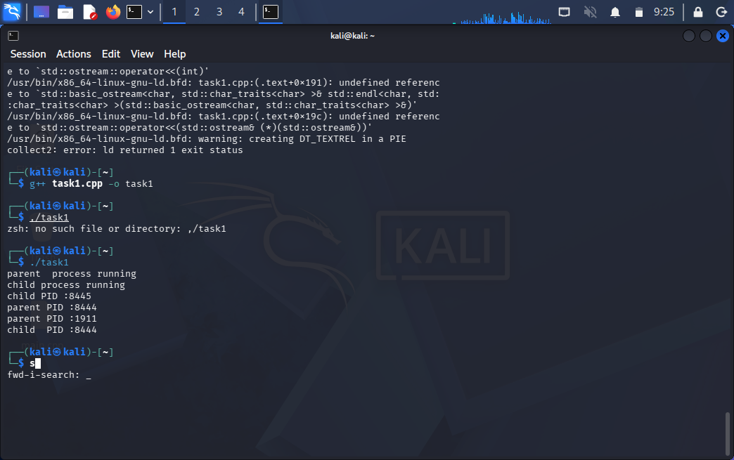
Explanation: | In this task, i used the fork() system call to create a child process. The child process used getpid() to print its own PID and getppid() to print the PID of its parent process. The parent process printed its own PID and the PID of the child. This helped us understand how a parent and child process are created and identified.
Task 2:
Code: | #include <iostream>  #include <unistd.h>  #include <sys/types.h>  using namespace std;  int main()  {  int x=10;  pid_t pid=fork();  if(pid < 0)  {  cout<<"fork failed"<<endl;  }  else if(pid == 0)  {  x=20;  cout<<"child process x: "<<x<<endl;  }  else {  cout<<"parent process x: "<<x<endl;  }  return 0;  }
Screenshot: | 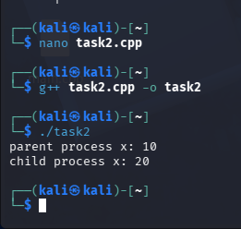
Explanation: | In this task, i declared an integer variable and then used fork() to create a child process. The child process changed the value of the variable and printed it, while the parent printed its own value. I observed that the change made by the child did not affect the value in the parent. This showed that both processes have separate address spaces.

Task 3:
Code: | #include <iostream>  #include <unistd.h>  #include <sys/types.h>  using namespace std;  int main()  {  fork();//first fork creates two processes  fork();//second fork :each process creates another processes  cout<<"process PID :"<<getpid()<<endl;  return 0;  }
Screenshot: | 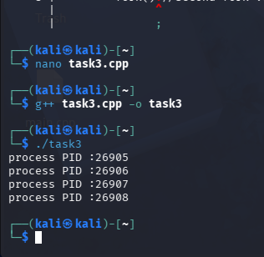
Explanation: | In this task, i used fork() two times in the program. The first fork() created two processes, and then both processes executed the second fork(). Because of this, a total of four processes were created. The print statement therefore ran four times, once in each process. This helped us understand how multiple fork() calls create more processes.

Task 4:
Code: | #include <iostream>  #include <unistd.h>  #include <sys/types.h>  #include <sys/wait.h>  using namespace std;  int main()  {  pid_t pid=fork();  if(pid < 0)  {  cout<<"fork failed"<<endl;  }  else if(pid == 0)  {  execlp("date","date",NULL);  cout<<"exec failed"<<endl;  }  else  {  int status;  wait(&status);  cout<<"child process finished "<<endl;  if(WIFEXITED(status));  {  cout<<"child exit status :"<<WEXITSTATUS(status)<<endl;  }  }  return 0;  }
Screenshot: | 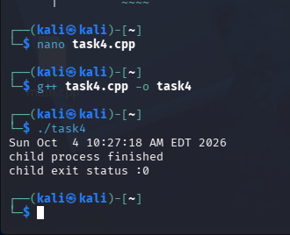
Explanation: | In this task, I used fork() to create a child process and then used execlp() in the child to run the date command. The child displayed the current date and time and then finished its execution. The parent process used wait() so that it could wait for the child to complete. After the child finished, the parent printed its exit status.

Task 5:
Code: | #include <iostream>  #include <unistd.h>  #include <sys/types.h>  #include <sys/wait.h>  using namespace std;  int main()  {  for(int a=0;a<3;a++)  {  pid_t pid=fork();  if(pid < 0)  {  cout<<"fork failed"<<endl;  }  else if ( pid ==0)  {  cout<<"child "<<a+1<<" is running"<<endl;  sleep(a+1);  cout<<"child " <<a+1<<" is exiting"<<endl;  _exit(a+1);  }  }  for (int b=0;b<3;b++)  {  int status;  pid_t child_pid=wait(&status);  if(child_pid < 0 && WIFEXITED(status))  {  cout<<"child PID "<<child_pid<<" exit code "<<WEXITSTATUS(status)<<endl;  }  }  return 0;  }
Screenshot: | 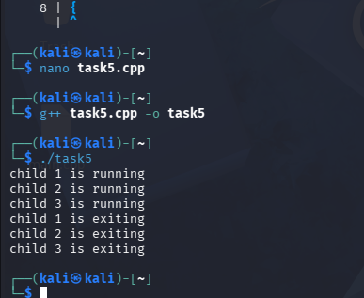
Explanation: | In this task, I created three child processes using a loop. Each child was given a different sleep time and a different exit status. The parent process used wait() to wait for all the children to finish. After each child finished, WEXITSTATUS() was used to get its exit code. This showed us how a parent process can manage and collect the results of multiple child processes.

