Lab No: 2
Student Name: Waseem Ullah
Roll No: NUM-BSCS-2024-78

CLO | 1 | 2
Total Marks | 08 | 02
Marks Obtained

Task 1:
Code: | 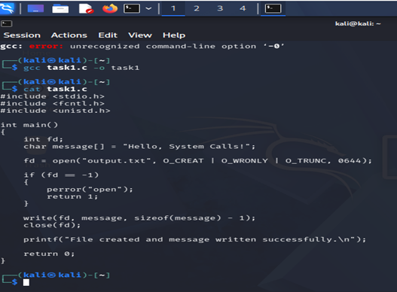
Screenshot:
Explanation: | The program uses open() to create output.txt, write() to write "Hello, System Calls!", and close() to close the file. This demonstrates basic file creation and writing using system calls.
Task 2:
Code: | 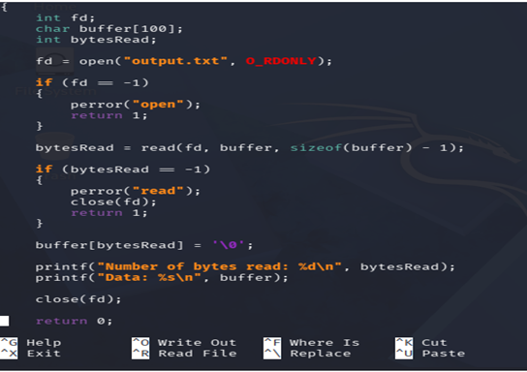
Screenshot: | 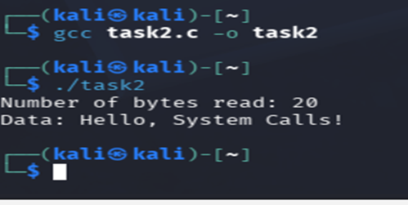
Explanation: | The program uses open() to open output.txt and read() to read its contents. It displays the number of bytes read and the actual data stored in the file.

Task 3:
Code: | #include <stdio.h>  #include <fcntl.h>  #include <unistd.h>  #include <sys/stat.h>  int main()  {  int fd;  char buffer[11];  off_t newPosition;  off_t fileSize;  int bytesRead;  struct stat fileInfo;  fd = open("output.txt", O_RDONLY);  if (fd == -1)  {  perror("open");  return 1;  }  newPosition = lseek(fd, 7, SEEK_SET);  if (newPosition == -1)  {  perror("lseek");  close(fd);  return 1;  }  bytesRead = read(fd, buffer, 10);  if (bytesRead == -1)  {  perror("read");  close(fd);  return 1;  }  buffer[bytesRead] = '\0';  if (stat("output.txt", &fileInfo) == -1)  {  perror("stat");  close(fd);  return 1;  }  fileSize = fileInfo.st_size;  printf("New file position: %ld\n", newPosition);  printf("Data read: %s\n", buffer);  printf("File size: %ld bytes\n", fileSize);  close(fd);  return 0;  }
Screenshot: | 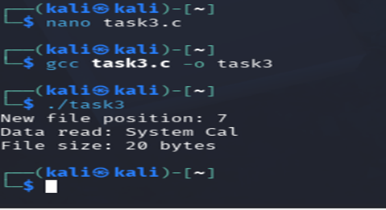
Explanation: | The program uses lseek() to move the file pointer 7 bytes from the beginning and then reads 10 bytes from that position. It also displays the new file position and the total file size.
Task 4:
Code: | #include <stdio.h>  #include <fcntl.h>  #include <unistd.h>  int main()  {  int fd;  char message[] = "This line was appended.\n";  fd = open("append.txt", O_WRONLY | O_CREAT | O_APPEND, 0644);  if (fd == -1)  {  perror("open");  return 1;  }  write(fd, message, sizeof(message) - 1);  close(fd);  printf("Line appended successfully.\n");  if (unlink("append.txt") == -1)  {  perror("unlink");  return 1;  }  printf("File deleted successfully.\n");  return 0;  }
Screenshot: | 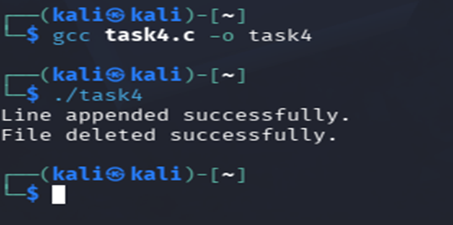
Explanation: | The program opens a file using the O_APPEND flag and adds a new line at the end of the file. After closing it, unlink() is used to delete the file from the filesystem.

Task 5:
Code: | #include <stdio.h>  #include <sys/stat.h>  int main()  {  struct stat fileInfo;  char filename[] = "output.txt";  if (stat(filename, &fileInfo) == -1)  {  perror("stat");  return 1;  }  printf("File size: %ld bytes\n", fileInfo.st_size);  printf("Permissions: %o\n", fileInfo.st_mode & 0777);  printf("Inode number: %ld\n", fileInfo.st_ino);  if (chmod(filename, 0444) == -1)  {  perror("chmod");  return 1;  }  if (stat(filename, &fileInfo) == -1)  {  perror("stat");  return 1;  }  printf("\nAfter chmod:\n");  printf("Permissions: %o\n", fileInfo.st_mode & 0777);  return 0;  }
Screenshot: | 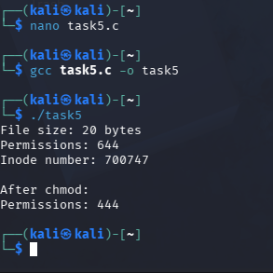
Explanation: | The program uses stat() to display the file size, permissions, and inode number. It then uses chmod() to change the permissions to 0444 (read-only) and verifies the new permissions.
Explanation:

