- To install Vite on your computer run following command
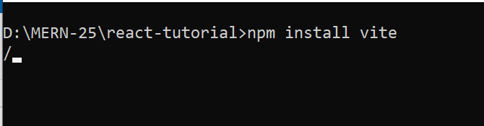

- To create the application run following command
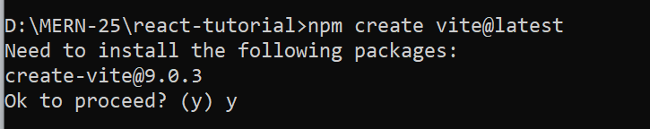

- It will ask you to enter the project name so, mention a unique name of your project as given in below screenshot
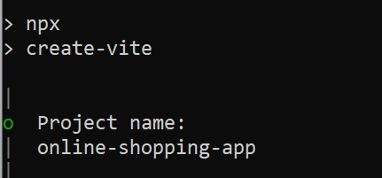

- Select the framework React from the given list of frameworks as given below
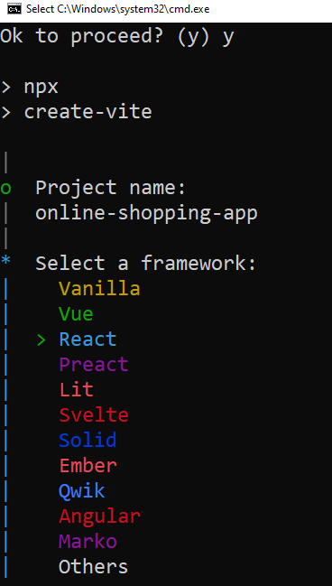

- Select the variant of React from the given list (We are selecting JavaScript) –
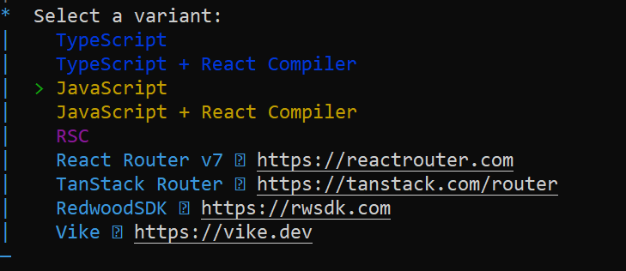

- Select Yes to install it with NPM
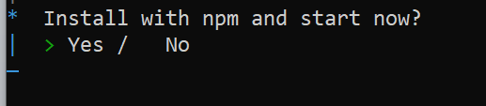

- Once completed these above steps then move to project directory using cd command
- To run the application use following command
