
Success4Sure Academy
BOOK ONE
AP ENVIRONMENTAL SCIENCE
COMPLETE STUDY GUIDE
All Nine Units • Skills • Unsolved Classroom Examples

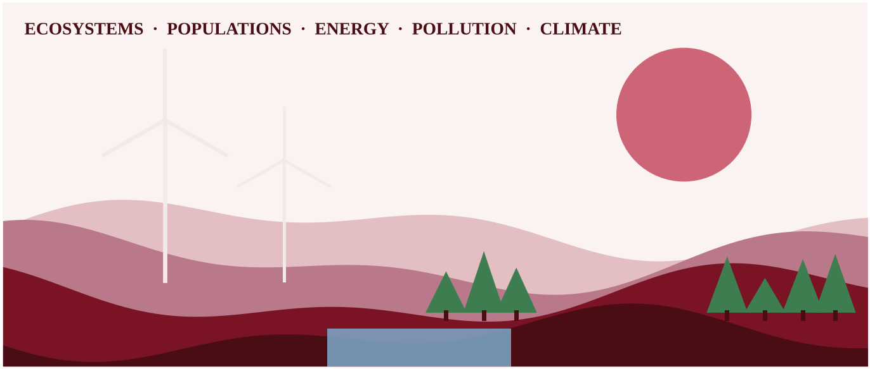
Clear explanations, original diagrams and the math skills every AP Environmental Science student needs.
Prepared by Mr. Waseem Allabadi
Published by Success4Sure Academy
2026–2027 Edition | Aligned to the 2026 Course and Exam Description

AP ENVIRONMENTAL SCIENCE
COMPLETE STUDY GUIDE
All Nine Units • Skills • Unsolved Classroom Examples

Clear explanations, original diagrams and the math skills every AP Environmental Science student needs.
Prepared by
Mr. Waseem Allabadi
Published by
Success4Sure Academy
2026–2027 Edition
Copyright & Important Information
© 2026 Success4Sure Academy | All Rights Reserved | Unauthorized Printing, Copying, Reproduction & Distribution Prohibited.
Book One teaches all nine units of AP Environmental Science. Classroom examples are intentionally unsolved; complete worked solutions are provided in Book Three of this collection.
AP® and Advanced Placement® are registered trademarks of the College Board. This publication was produced independently by Success4Sure Academy and is not endorsed by, affiliated with, or sponsored by the College Board.
All explanations, diagrams, examples, practice questions and solutions identified as original were written for Success4Sure Academy. Unless a page states otherwise, no College Board question text or figure is reproduced in this book.
Prepared by Mr. Waseem Allabadi. Published by Success4Sure Academy. First edition, 2026–2027.
Table of Contents
Unit 1 — The Living World: Ecosystems
Topic 1.1 — Introduction to Ecosystems
Topic 1.2 — Terrestrial Biomes
Topic 1.3 — Aquatic Biomes
Topic 1.4 — The Carbon Cycle
Topic 1.5 — The Nitrogen Cycle
Topic 1.6 — The Phosphorus Cycle
Topic 1.7 — The Hydrologic (Water) Cycle
Topic 1.8 — Primary Productivity
Topic 1.9 — Trophic Levels
Topic 1.10 — Energy Flow and the 10% Rule
Topic 1.11 — Food Chains and Food Webs
Unit 1 Review — Quick Concept Summary
Unit 2 — The Living World: Biodiversity
Topic 2.1 — Introduction to Biodiversity
Topic 2.2 — Ecosystem Services
Topic 2.3 — Island Biogeography
Topic 2.4 — Ecological Tolerance
Topic 2.5 — Natural Disruptions to Ecosystems
Topic 2.6 — Adaptations
Topic 2.7 — Ecological Succession
Unit 3 — Populations
Topic 3.1 — Generalist and Specialist Species
Topic 3.2 — K-Selected and r-Selected Species
Topic 3.3 — Survivorship Curves
Topic 3.4 — Carrying Capacity
Topic 3.5 — Population Growth and Resource Availability
Topic 3.6 — Age Structure Diagrams
Topic 3.7 — Total Fertility Rate
Topic 3.8 — Human Population Dynamics
Topic 3.9 — Demographic Transition
Unit 4 — Earth Systems and Resources
Topic 4.1 — Plate Tectonics
Topic 4.2 — Soil Formation and Erosion
Topic 4.3 — Soil Composition and Properties
Topic 4.4 — Earth's Atmosphere
Topic 4.5 — Global Wind Patterns
Topic 4.6 — Watersheds
Topic 4.7 — Solar Radiation and Earth's Seasons
Topic 4.8 — Earth's Geography and Climate
Topic 4.9 — El Niño and La Niña
Unit 5 — Land and Water Use
Topic 5.1 — The Tragedy of the Commons
Topic 5.2 — Clearcutting
Topic 5.3 — The Green Revolution
Topic 5.4 — Impact of Agricultural Practices
Topic 5.5 — Irrigation Methods
Topic 5.6 — Pest Control Methods
Topic 5.7 — Meat Production Methods
Topic 5.8 — Overfishing
Topic 5.9 — Environmental Impacts of Mining
Topic 5.10 — Urbanization
Topic 5.11 — Ecological Footprints
Topic 5.12 — Introduction to Sustainability
Topic 5.13 — Methods to Reduce Urban Runoff
Topic 5.14 — Integrated Pest Management
Topic 5.15 — Sustainable Agriculture
Topic 5.16 — Aquaculture
Topic 5.17 — Sustainable Forestry
Unit 6 — Energy Resources and Consumption
Topic 6.1 — Renewable and Nonrenewable Resources
Topic 6.2 — Global Energy Consumption
Topic 6.3 — Fuel Types and Uses
Topic 6.4 — Distribution of Natural Energy Resources
Topic 6.5 — Fossil Fuels
Topic 6.6 — Nuclear Power
Topic 6.7 — Energy from Biomass
Topic 6.8 — Solar Energy
Topic 6.9 — Hydroelectric Power
Topic 6.10 — Geothermal Energy
Topic 6.11 — Hydrogen Fuel Cell
Topic 6.12 — Wind Energy
Topic 6.13 — Energy Conservation
Unit 7 — Atmospheric Pollution
Topic 7.1 — Introduction to Air Pollution
Topic 7.2 — Photochemical Smog
Topic 7.3 — Thermal Inversion
Topic 7.4 — Atmospheric CO₂ and Particulates
Topic 7.5 — Indoor Air Pollutants
Topic 7.6 — Reduction of Air Pollutants
Topic 7.7 — Acid Rain
Topic 7.8 — Noise Pollution
Unit 8 — Aquatic and Terrestrial Pollution
Topic 8.1 — Sources of Pollution
Topic 8.2 — Human Impacts on Ecosystems
Topic 8.3 — Endocrine Disruptors
Topic 8.4 — Human Impacts on Wetlands and Mangroves
Topic 8.5 — Eutrophication
Topic 8.6 — Thermal Pollution
Topic 8.7 — Persistent Organic Pollutants (POPs)
Topic 8.8 — Bioaccumulation and Biomagnification
Topic 8.9 — Solid Waste Disposal
Topic 8.10 — Waste Reduction Methods
Topic 8.11 — Sewage Treatment
Topic 8.12 — Lethal Dose 50% (LD50)
Topic 8.13 — Dose Response Curve
Topic 8.14 — Pollution and Human Health
Topic 8.15 — Pathogens and Infectious Diseases
Unit 9 — Global Change
Topic 9.1 — Stratospheric Ozone Depletion
Topic 9.2 — Reducing Ozone Depletion
Topic 9.3 — The Greenhouse Effect
Topic 9.4 — Increases in the Greenhouse Gases
Topic 9.5 — Global Climate Change
Topic 9.6 — Ocean Warming
Topic 9.7 — Ocean Acidification
Topic 9.8 — Invasive Species
Topic 9.9 — Endangered Species
Topic 9.10 — Human Impacts on Biodiversity
Unit 1 — The Living World: Ecosystems
An ecosystem is a place where living things and their non-living surroundings work together as one system. Sunlight flows in, atoms of carbon, nitrogen, phosphorus and water circle around, and thousands of species compete, cooperate and eat each other. This unit gives you the vocabulary and the mental models for the whole course. Nearly every later unit, from biodiversity to pollution to climate change, rests on the ideas you meet here.
Topic 1.1 — Introduction to Ecosystems
LEARNING OBJECTIVES
• Explain how the availability of resources influences interactions between species.
• Identify predator–prey relationships, the three types of symbiosis, and competition.
• Explain how resource partitioning reduces the harm of competition.

An ecosystem includes the biotic (living) parts and the abiotic (non-living) parts of an area and the interactions among them. Abiotic factors include sunlight, temperature, water, soil minerals and oxygen. Biotic factors include every organism and the relationships between them. The central idea of Topic 1.1 is simple: resources are limited, so organisms interact over them. Food, water, light, nesting space and mates are all resources. When a resource is scarce, the interactions around it become stronger and more important for survival.
CONCEPT MADE SIMPLE
Think of an ecosystem as a crowded apartment building with a fixed food supply. Some residents eat other residents (predation), some share the kitchen and help each other (mutualism), some borrow without anyone noticing (commensalism), some take and harm their host (parasitism), and some simply fight over the same shelf in the fridge (competition).

Predator–prey relationships
A predator is an organism that kills and eats another organism, the prey. The two populations affect each other. When prey is plentiful, predators have more food and may become more numerous. As predators multiply, more prey are eaten and the prey population declines. Predators then face a food shortage, and their numbers fall. This cause-and-effect loop often produces linked rises and falls in both populations.
Symbiosis
Symbiosis is a close, long-term interaction between two species. There are three types, and the key to identifying them is asking who benefits and who is harmed.
Type | Species A | Species B | Example
Mutualism | benefits | benefits | Bees collect nectar while pollinating flowers; reef-building coral and the algae living inside them
Commensalism | benefits | not affected | Orchids growing on a tree branch for light; barnacles riding on a whale
Parasitism | benefits | harmed | Ticks feeding on a deer; tapeworms in an intestine

Competition and resource partitioning
Competition occurs when organisms need the same limited resource. It can be intraspecific (within one species, for example two oak seedlings competing for light) or interspecific (between different species). Competition lowers the survival and reproduction of the competitors. Over time, species that use the same resource in the same way cannot easily coexist. Coexistence becomes possible through resource partitioning: using the resource in a different way, in a different place, or at a different time. Several warbler species feeding in the same spruce tree can coexist if each forages in a different part of the tree. Owls and hawks both hunt rodents but at night and during the day, respectively.
COMMON STUDENT MISTAKES
• Parasitism is not predation: a parasite lives on or in its host and does not usually kill it quickly; a predator kills its prey.
• Commensalism needs the second species to be truly unaffected; if both benefit it is mutualism.

AP EXAM STRATEGY
When a question describes an interaction, write the effect on each species as a plus, minus or zero. (+,+) is mutualism, (+,0) is commensalism, (+,−) is parasitism or predation, and (−,−) is competition. Then use words from the scenario to justify your answer.

CLASSROOM EXAMPLE SG-U1-E001
Four species of small seed-eating birds live in the same grassland. Observers record the plant height at which each species feeds: species P feeds at 0–10 cm, species Q at 10–30 cm, species R at 30–60 cm, and species S at 60–100 cm. (a) Name the interaction pattern that allows these four species to share the same seed supply. (b) Explain how this pattern reduces the negative impact on each species' survival. (c) If a drought reduces total seed production by half, state whether you expect competition to increase, decrease or stay the same, and give a reason.

QUICK CONCEPT SUMMARY
• Ecosystems = biotic + abiotic parts interacting; limited resources drive species interactions.
• Predation, mutualism, commensalism, parasitism and competition are distinguished by who gains and who loses.
• Resource partitioning (different ways, places or times) lets similar species coexist.

Topic 1.2 — Terrestrial Biomes
LEARNING OBJECTIVES
• Describe the global distribution and main environmental features of the major terrestrial biomes.
• Explain how climate shapes the plants and animals of a biome.
• Explain why the distribution of non-mineral natural resources and of biomes varies and can change.

A biome is a large region with a characteristic community of plants and animals that are adapted to its climate. Temperature and precipitation are the two main drivers. Because both change with latitude (distance from the equator) and altitude (height above sea level), biomes form recognizable bands and patterns around the globe.
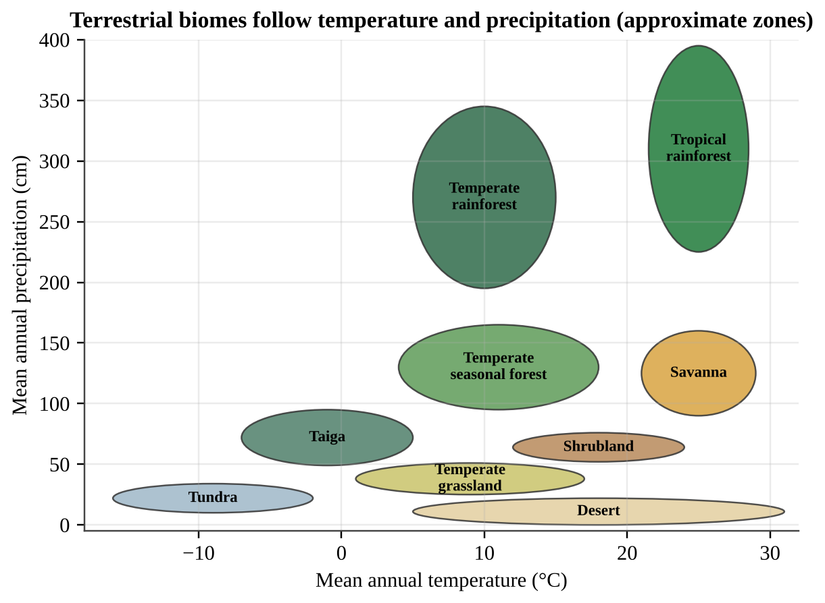
Figure 1.1 — Terrestrial biomes sorted by mean annual temperature and precipitation. Zones are approximate and overlap in nature.
Reading a biome climate graph
Find the site's temperature (x-axis) and precipitation (y-axis) and read which zone contains the point; where zones overlap, other clues (seasonality, soil, vegetation) decide. Cold biomes lie on the left and wet biomes at the top. At a given temperature, more precipitation shifts desert to grassland to forest.
The nine major terrestrial biomes
Biome | Climate | Typical features
Tundra | Very cold, low precipitation, short growing season | Permafrost; low shrubs, mosses, lichens; slow decomposition
Taiga (boreal forest) | Long, cold winters; short, mild summers | Evergreen conifers; acidic, nutrient-poor soil; large expanses
Temperate rainforest | Cool, very wet, mild temperatures | Tall conifers, ferns and mosses; moist, rich in biomass
Temperate seasonal forest | Four distinct seasons; moderate precipitation | Deciduous trees that drop leaves in winter; fertile soil
Tropical rainforest | Hot all year, very wet | Greatest biodiversity; nutrients locked in biomass; thin, poor soil
Shrubland | Hot dry summers, mild wet winters | Drought-tolerant, fire-adapted shrubs
Temperate grassland | Hot summers, cold winters, moderate-to-low rain | Grasses; deep fertile soil; fire and grazing maintain it
Savanna | Warm year-round, distinct wet and dry seasons | Grasses with scattered trees; large grazing herds
Desert | Very low precipitation (typically under about 30 cm/yr) | Drought-adapted plants; animals that avoid daytime heat

Tropical rainforest soil is poor even though the forest is lush: warmth and moisture make decomposition fast and plants absorb nutrients at once, so little is stored in the soil. In cold biomes, decomposition is slow and organic matter accumulates.
Reading a climatograph (monthly data)
Monthly graphs show precipitation as bars and temperature as a line. Ask: How warm is the line, and does it change? Is rain spread evenly, or is there a dry season? Does rain fall in the warm or the cool months? In Figure 1.1b, a flat warm line with tall bars every month is tropical rainforest (A); warmth with a long dry season is savanna (B); a mild wet winter and nearly rainless summer is shrubland (C); a freezing winter with rain peaking in summer is temperate grassland (D). Very short bars in every month mean desert.
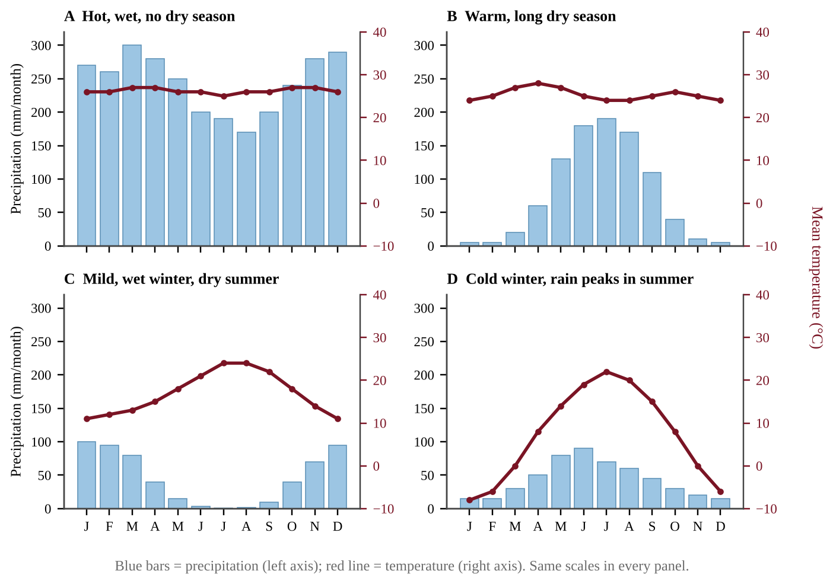
Figure 1.1b — Four climatographs. Compare the temperature line (right axis) and the rainfall bars (left axis) to identify the biome.
Comparing biomes
Species diversity and net primary productivity (NPP) per square meter both peak where warmth and water are abundant all year. Diversity ranks tropical rainforest, temperate seasonal forest, temperate grassland, tundra (high to low); NPP is highest in tropical rainforest and lowest in desert and tundra. On a world map, rainforest lies near the equator, temperate seasonal forest at mid-latitudes, then taiga and tundra toward the pole.
Why resources and biomes are not spread evenly
Non-mineral natural resources such as fresh water and timber are unevenly distributed because of climate, geography, latitude and altitude, nutrient availability and soil. Timber is concentrated in forest biomes; water is abundant in rainforests and scarce in deserts; a mountain range can create a dry "rain shadow" on its far side.
Biome distribution is dynamic. It has changed in the past, for example when ice sheets advanced and retreated, and it may shift again as a result of global climate change. Warming can push forest boundaries toward the poles and up mountainsides.
COMMON STUDENT MISTAKES
• Deserts are defined by low precipitation, not heat; some are cold.
• Tropical rainforest soils are nutrient-poor; the nutrients are held in living plants.

CLASSROOM EXAMPLE SG-U1-E002
Use Figure 1.1. Three field stations report the following climate data. Station A: mean annual temperature 25 °C, precipitation 300 cm/yr. Station B: mean annual temperature −9 °C, precipitation 22 cm/yr. Station C: mean annual temperature 18 °C, precipitation 12 cm/yr. (a) Identify the most likely biome at each station. (b) Explain why decomposition and nutrient turnover would differ between the biomes at Stations A and B.

CLASSROOM EXAMPLE SG-U1-E011
Station M: temperature 24–28 °C every month; precipitation 150–230 mm per month from November to April and under 15 mm per month from May to October. Station N: temperature −6 °C in January and 20 °C in July; precipitation 15–25 mm per month in winter and 60–90 mm per month from May to August. (a) Identify the biome at each station and cite two pieces of evidence for each. (b) Explain how the dry season at Station M shapes its plant community. (c) Predict how Station N's biome would change if the region warmed and became drier, and justify it.

QUICK CONCEPT SUMMARY
• Biomes are shaped by climate (temperature and precipitation), which varies with latitude and altitude.
• Know the nine terrestrial biomes, their climate and signature adaptations.
• Resource distribution and biome boundaries are dynamic and may shift with climate change.

Topic 1.3 — Aquatic Biomes
LEARNING OBJECTIVES
• Describe the distribution and main environmental features of freshwater and marine biomes.
• Explain how salinity, depth, turbidity, nutrients and temperature shape aquatic life and resources.

Aquatic biomes are defined by the properties of the water: salt, depth, clarity, nutrients and temperature.
Freshwater biomes
Freshwater biomes include streams, rivers, ponds and lakes. They contain little dissolved salt (typically under about 0.5 parts per thousand). They are a vital source of drinking water, irrigation and food.
Marine biomes
Marine biomes are salty (the open ocean averages about 35 parts per thousand).
• Oceans cover most of Earth's surface. Surface algae (phytoplankton) supply a large portion of Earth's oxygen and take in carbon dioxide from the atmosphere.
• Coral reefs occur in warm, clear, shallow water. They host great biodiversity and rely on a mutualism between coral animals and algae. They are sensitive to warming and pollution.
• Marshland (including salt marshes and mangroves) is shallow and nutrient-rich, with plants rooted in saturated soil; it filters runoff and protects coasts.
• Estuaries form where a river meets the sea, creating water of intermediate salinity that varies with tides. They are nutrient-rich, turbid and serve as nurseries for many fish and shellfish.
Why aquatic resources vary
The distribution of non-mineral marine resources such as different fish varies with salinity, depth, turbidity, nutrient availability and temperature. Fish that need cold, nutrient-rich water gather in areas where deep water rises to the surface, bringing nutrients with it. Turbid (cloudy) water blocks light and limits photosynthesis to a thin surface layer. Depth controls how much light reaches photosynthesizers (see Topic 1.8): photosynthesis is limited to the sunlit surface layer, often only the top tens of meters, so the dark deep ocean has no photosynthesizers and its food web depends mainly on dead matter sinking from above.
COMMON STUDENT MISTAKES
• Algae and phytoplankton, not large plants, produce most marine oxygen.
• Do not call an estuary "freshwater." Its salinity is intermediate and changes with the tides.

CLASSROOM EXAMPLE SG-U1-E003
A student records data for two aquatic sites. Site X: salinity 34 parts per thousand, temperature 27 °C, depth 8 m, very clear water, with corals and many fish species. Site Y: salinity 12 parts per thousand where a river meets a bay, depth 2 m, cloudy water full of sediment and rich in nutrients, with young fish and oysters. (a) Identify the aquatic biome at each site. (b) Explain how low turbidity at Site X helps its primary producers, and state one reason Site Y supports so many young fish.

QUICK CONCEPT SUMMARY
• Freshwater biomes: streams, rivers, ponds, lakes. Marine biomes: oceans, coral reefs, marshland, estuaries.
• Salinity, depth, turbidity, nutrients and temperature control where aquatic life and fisheries occur.
• Marine algae produce a large share of Earth's oxygen and absorb atmospheric CO₂.

Topic 1.4 — The Carbon Cycle
LEARNING OBJECTIVES
• Explain the steps of the carbon cycle and the interactions among its reservoirs.
• Distinguish short-term from long-term carbon reservoirs.
• Explain how burning fossil fuels changes the cycle.

All life is built on carbon. The carbon cycle is the movement of atoms and molecules containing carbon between sources (reservoirs that release it) and sinks (reservoirs that take it in). A reservoir can be a source in one process and a sink in another. A growing forest is a sink; a burning forest is a source.
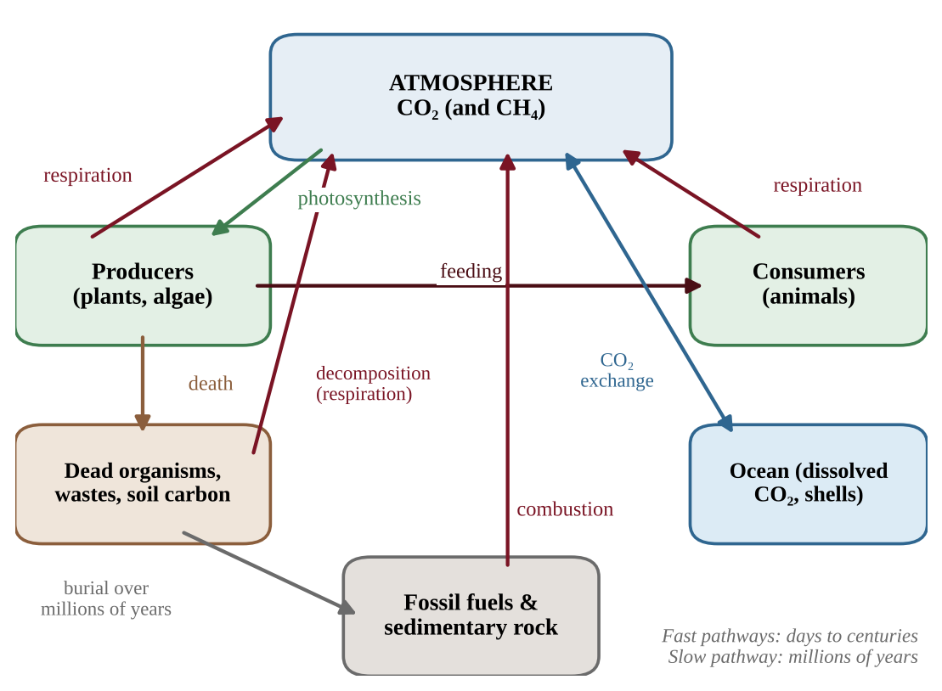
Figure 1.2 — The carbon cycle. Red arrows return carbon to the atmosphere; the grey path is the slow geologic route.
How carbon moves
• Photosynthesis moves carbon from atmospheric CO₂ (or CO₂ dissolved in water) into organic compounds in producers.
• Cellular respiration moves carbon back into the air as CO₂ when producers, consumers and decomposers break down organic compounds for energy.
• Feeding passes carbon through food chains.
• Decomposition releases CO₂ (and, in low-oxygen places such as wetlands and landfills, methane, CH₄) from dead matter and waste.
• Gas exchange with the ocean: CO₂ dissolves in surface water and is released from it. Some marine organisms build shells of calcium carbonate, which sink and become sediment.
• Burial and fossilization: plant and animal remains buried and compressed over millions of years form coal, oil and natural gas, and carbonate sediments form limestone.
• Combustion of fossil fuels and wood moves carbon rapidly into the atmosphere as CO₂.
Short-term and long-term reservoirs
Some reservoirs hold carbon for a short time (atmosphere, living organisms, surface ocean, soil organic matter), while others hold it for very long periods (deep ocean sediments, sedimentary rocks and fossil fuels). Fossil fuels took millions of years to form; burning them returns that stored carbon to the atmosphere within decades. That difference in speed is why extra atmospheric CO₂ is accumulating, a theme in Unit 9.
Carbon budgets and seasonal data
To find the net change in atmospheric carbon from a flux diagram, add every arrow into the atmosphere and subtract every arrow out, keeping the units (for example Gt C/yr). A positive result means the reservoir is growing.
An ecosystem's carbon balance is carbon taken up by photosynthesis minus carbon released by all respiration (plants, animals, soil microbes). Positive is a net sink; negative is a net source. Add all seasons before judging: a tundra can release carbon in winter and still absorb more over the year.
Atmospheric CO₂ at a Northern Hemisphere station zigzags yearly: land plants photosynthesize from late spring to early autumn, so CO₂ falls; in cold months respiration and decay win, so it rises. The rising baseline is fossil fuel burning adding carbon faster than sinks remove it.
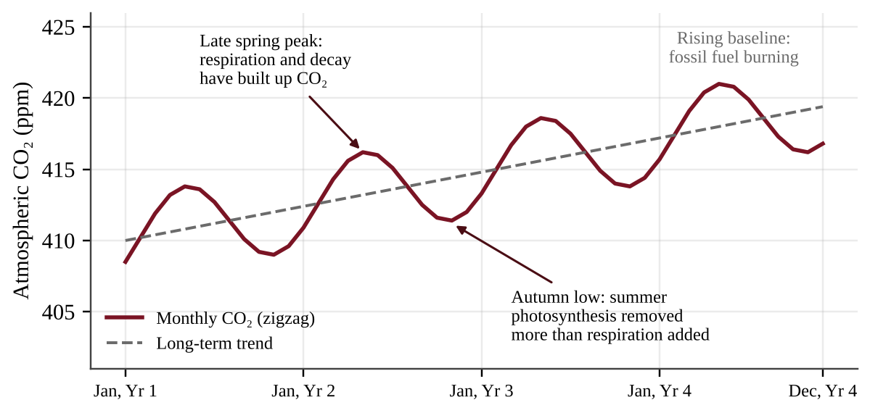
Figure 1.2b — Seasonal rise and fall of atmospheric CO₂ on top of a long-term upward trend.
Stored soil carbon becomes a source when disturbed. In cold or waterlogged soils (peat, mangrove, permafrost, prairie) decomposition is slow for lack of warmth or oxygen. Draining, plowing, burning and warming speed it up and release CO₂. Long-term sinks include limestone, sea-floor sediment and buried organic matter.
FORMULA & MATH SKILL
Net change in reservoir = Σ inputs − Σ outputs Ecosystem carbon balance = GPP − total respiration (positive = net sink) Mass of CO₂ = mass of C × 44 ÷ 12 ≈ mass of C × 3.67 (molar masses CO₂ 44, C 12)

PROCESS & CAUSE-AND-EFFECT
Atmosphere CO₂ → (photosynthesis) → carbon in producers → (feeding) → consumers → (respiration, decomposition) → atmosphere CO₂ Dead organisms → (burial, millions of years) → fossil fuels → (combustion) → atmosphere CO₂

FORMULA & MATH SKILL
Photosynthesis: 6 CO₂ + 6 H₂O + light energy → C₆H₁₂O₆ + 6 O₂ Cellular respiration: C₆H₁₂O₆ + 6 O₂ → 6 CO₂ + 6 H₂O + usable energy Combustion of a hydrocarbon (fossil fuel): fuel + O₂ → CO₂ + H₂O + heat

COMMON STUDENT MISTAKES
• Plants also respire, releasing CO₂; they are not only sinks.
• Fossil fuel carbon was out of the fast cycle for millions of years; burning it adds new carbon to it.

AP EXAM STRATEGY
In a carbon-cycle diagram question, label each arrow with its process name and say whether it moves carbon into or out of the atmosphere. Then state whether the reservoir you are asked about is acting as a source or a sink.

CLASSROOM EXAMPLE SG-U1-E004
A carbon atom is part of a coal seam. A power plant burns the coal, and the carbon enters the air. Later that atom is taken up by a wheat plant, the wheat is eaten by a cow, and the cow exhales it. (a) List, in order, the four named processes that move the atom from the coal seam to the exhaled breath, and give the form of the carbon after each step. (b) State whether the coal seam acted as a source or a sink in this sequence, and explain why this carbon was not part of the fast cycle before the plant was built.

CLASSROOM EXAMPLE SG-U1-E012
A 50-ha peatland stores 600 Mg of carbon per hectare in its top 1 m of soil. After it is drained and plowed, 12% of that carbon is oxidized to CO₂ over ten years. (a) Calculate the mass of CO₂ released, in Mg. (b) Explain why draining speeds up the release. (c) State whether the peatland has become a source or a sink, and give one action that would help restore its function as a sink.

QUICK CONCEPT SUMMARY
• Carbon moves between sources and sinks; photosynthesis and respiration link living things to the atmosphere.
• Short-term reservoirs: atmosphere, organisms, soil, surface ocean. Long-term: fossil fuels, rocks, sediments.
• Burning fossil fuels moves carbon stored for millions of years into the atmosphere within decades.

Topic 1.5 — The Nitrogen Cycle
LEARNING OBJECTIVES
• Explain the steps of the nitrogen cycle (fixation, assimilation, ammonification, nitrification, denitrification).
• Explain the role of soil microorganisms and why nitrogen often limits primary production.
• Identify the largest nitrogen reservoir and the speed at which most others turn over.

Nitrogen is a key part of proteins, DNA and chlorophyll. The cruel irony is that air is about 78% nitrogen gas (N₂), yet most organisms cannot use it. The two nitrogen atoms in N₂ are held together by a very strong triple bond. The nitrogen cycle is the movement of nitrogen-containing atoms and molecules between sources and sinks, and microorganisms in the soil do most of the work.
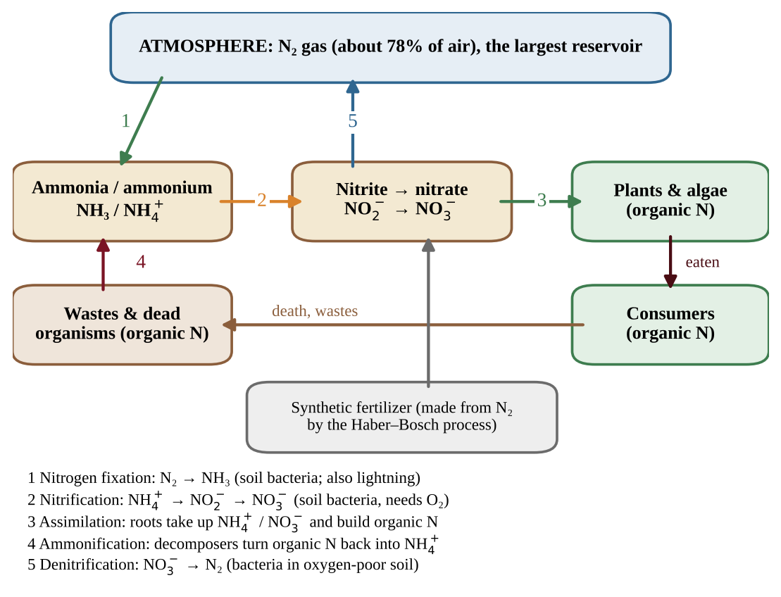
Figure 1.3 — The nitrogen cycle. Numbers match the five steps described in the text.
The five steps
1. Nitrogen fixation converts atmospheric N₂ into ammonia (NH₃) by certain soil bacteria, including bacteria in root nodules of legumes such as beans and clover. In soil, ammonia quickly becomes ammonium (NH₄⁺), which plants can take up. Lightning also fixes a smaller amount.
2. Nitrification is the conversion of ammonium to nitrite (NO₂⁻) and then nitrate (NO₃⁻) by soil bacteria that need oxygen. Nitrate is the main form that plant roots absorb, and it dissolves easily, so it is also easily lost by leaching.
3. Assimilation is the uptake of ammonium and nitrate by plants and algae and their conversion into proteins and nucleic acids. Animals assimilate nitrogen by eating plants or other animals.
4. Ammonification (decay) is the conversion of nitrogen in wastes and dead organisms back to ammonium by decomposers.
5. Denitrification is the conversion of nitrate to nitrogen gas by bacteria in oxygen-poor (anaerobic) conditions such as waterlogged soils, returning nitrogen to the atmosphere.
Reservoirs and limits
The atmosphere is the largest reservoir of nitrogen, but it is not directly available. Most of the other reservoirs (soil nitrate and ammonium, living organisms, wastes) hold nitrogen for relatively short periods. Because the rate of fixation controls how much usable nitrogen enters ecosystems, nitrogen often limits primary production in many ecosystems: when more nitrogen is added, plants grow faster.
Humans have greatly increased fixation. The Haber–Bosch process makes ammonia from N₂ for fertilizer, and burning fossil fuels at high temperature makes nitrogen oxides. Excess nitrogen runs off fields into waterways and causes eutrophication (Unit 8).
PROCESS & CAUSE-AND-EFFECT
Atmospheric N₂ → (fixation) → NH₃/NH₄⁺ → (nitrification) → NO₂⁻ → NO₃⁻ → (assimilation) → plant protein → (eaten, death, waste) → organic N in soil → (ammonification) → NH₄⁺ NO₃⁻ → (denitrification, low oxygen) → N₂ gas to the atmosphere

COMMON STUDENT MISTAKES
• Plants cannot take up N₂ from the air; only certain bacteria (and lightning) fix it.
• Nitrification needs oxygen; denitrification occurs when oxygen is scarce.

CLASSROOM EXAMPLE SG-U1-E005
A farmer notices that, after a week of flooding, an oxygen-poor, waterlogged field has much less nitrate and the corn is yellowing and stunted. (a) Name the process that increased in the waterlogged soil and state the product that leaves the soil. (b) Explain why the loss of nitrate reduces plant growth. (c) Name the process by which dead corn leaves, left on the field, would become a new supply of ammonium.

QUICK CONCEPT SUMMARY
• Nitrogen cycle steps: fixation, nitrification, assimilation, ammonification, denitrification.
• The atmosphere is the largest reservoir, but N₂ is unusable until fixed. Most other reservoirs turn over quickly.
• Nitrogen frequently limits plant growth; humans add large amounts through fertilizer and combustion.

Topic 1.6 — The Phosphorus Cycle
LEARNING OBJECTIVES
• Explain the steps of the phosphorus cycle and its major reservoirs.
• Explain why phosphorus is often a limiting nutrient.

Phosphorus is part of DNA, ATP (the cell's energy molecule) and cell membranes. The phosphorus cycle is the movement of phosphorus-containing atoms and molecules between sources and sinks. It differs from the carbon and nitrogen cycles in one important way: it has no significant atmospheric component.
The steps
1. Weathering slowly breaks down phosphorus-bearing rock and releases phosphate (PO₄³⁻) into soil and water.
2. Uptake by plants and algae takes up dissolved phosphate through roots or cell surfaces.
3. Transfer moves phosphorus through the food chain as consumers eat producers.
4. Return occurs through wastes and decomposition, which release phosphate back to the soil or water for reuse.
5. Sedimentation carries phosphate to the ocean and lake bottoms, where it forms sediments. Over millions of years, uplift can bring sedimentary rock back to land, restarting the cycle.
The major reservoirs are rock and ocean sediments that contain phosphorus-bearing minerals. Because the rate at which rocks weather is very slow, phosphorus is relatively scarce in ecosystems. It is therefore often a limiting nutrient for producers, particularly in freshwater ecosystems and some terrestrial ecosystems. This is why a small addition of phosphorus (from fertilizer, sewage or some detergents) can cause an algal bloom in a lake.
Designing and judging a nutrient experiment
A limiting nutrient is found by adding it and watching the response.
• Hypothesis: an "if … then …" prediction naming both variables and the direction: if phosphorus limits growth, bottles with added phosphorus will hold more algae than bottles without it, because phosphorus is scarce.
• Independent variable: what you change (nutrient added). Dependent variable: what you measure (chlorophyll a, or algal biomass).
• Control: identical water with nothing added, the baseline for comparison.
• Treatments: nitrogen alone, phosphorus alone, both, and the control; two nutrients can limit together.
• Constants: light, temperature, volume, water source and duration, so only the nutrient differs.
• Replication: several bottles per treatment, averaged, so one odd bottle does not mislead.
If nitrogen alone changes little, phosphorus alone raises growth a lot, and both together raise it most, phosphorus is the main limiting nutrient and nitrogen limits next. Growth in the control does not show that nothing limits it. Change one factor at a time: fertilizing plots in a different field, adding several things at once, or comparing only "before and after" with no untreated plots cannot isolate the cause.
PROCESS & CAUSE-AND-EFFECT
Rock → (weathering) → phosphate in soil and water → (uptake) → plants → (eating) → consumers → (waste, decomposition) → phosphate in soil and water → (sedimentation) → sediments → (uplift, millions of years) → rock

COMMON STUDENT MISTAKES
• Do not include an atmospheric reservoir or a gas phase in the phosphorus cycle.
• Phosphorus is limiting in many freshwater lakes; nitrogen is more often limiting in many marine and terrestrial systems. Both can be limiting, so use the data in the question.

CLASSROOM EXAMPLE SG-U1-E006
Researchers add nutrients to four identical experimental ponds for six weeks and measure algae concentration as chlorophyll in micrograms per liter (µg/L). Control (nothing added): 10 µg/L. Nitrogen only: 11 µg/L. Phosphorus only: 38 µg/L. Nitrogen and phosphorus together: 40 µg/L. (a) Identify the limiting nutrient in these ponds and justify your answer using the data. (b) Calculate the percent increase in algae concentration in the phosphorus-only pond compared with the control. (c) Explain why phosphorus is naturally scarce in freshwater ecosystems.

QUICK CONCEPT SUMMARY
• Phosphorus moves through rock, soil, water, organisms and sediments, with no significant atmospheric reservoir.
• Slow weathering makes it scarce, so it often limits producers, especially in fresh water.
• Added phosphorus can trigger rapid algal growth.

Topic 1.7 — The Hydrologic (Water) Cycle
LEARNING OBJECTIVES
• Explain the steps of the water cycle and the interactions among its reservoirs.
• Identify the primary reservoir of water at Earth's surface.

The hydrologic cycle, powered by the sun, is the movement of water in its solid, liquid and gaseous phases between sources and sinks. Solar energy evaporates water, and gravity returns it to Earth.
Processes
• Evaporation changes liquid water to vapor from oceans, lakes and soil.
• Transpiration is the release of water vapor from plant leaves. Evaporation plus transpiration together are called evapotranspiration.
• Condensation changes vapor to liquid droplets, forming clouds.
• Precipitation returns water as rain, snow, sleet or hail.
• Infiltration and percolation move water into and through soil to groundwater. Water stored in porous rock is an aquifer.
• Runoff is water flowing over land surfaces into streams, lakes and the ocean. The land that drains to one stream or river is its watershed.
• Sublimation, freezing and melting move water between ice and the other phases.
Reservoirs
The oceans are the primary reservoir of water at Earth's surface, holding roughly 97% of it. Ice caps and glaciers hold most of the fresh water, and groundwater holds much of the remainder, together as much smaller reservoirs. Water spends only days in the atmosphere, but it can stay in a deep aquifer or an ice cap for thousands of years, so the speed of turnover differs greatly among reservoirs.
Residence time, water budgets and land use
Residence time is the average time a water molecule stays in a reservoir. A watershed's water budget balances what arrives against where it goes.
FORMULA & MATH SKILL
Residence time = volume stored ÷ rate of inflow (or outflow) Precipitation (P) = evapotranspiration (ET) + runoff + change in storage Volume = depth × area (convert units first: 1 km² = 10⁶ m²; 1,000 mm = 1 m)

Pavement, roofs and compacted soil block infiltration, so more precipitation leaves quickly as runoff and less recharges groundwater. Clearing vegetation lowers transpiration, so more of the same precipitation is left to run off. Intact forest and wetland soils slow runoff and feed groundwater.
PROCESS & CAUSE-AND-EFFECT
Ocean/lake/soil → (evaporation) and plants → (transpiration) → water vapor → (condensation) → clouds → (precipitation) → land → (runoff, infiltration) → streams, groundwater → ocean

COMMON STUDENT MISTAKES
• Transpiration is water loss from plants; evaporation is from surfaces.
• Most fresh water is in ice and groundwater, not in lakes and rivers.

CLASSROOM EXAMPLE SG-U1-E007
A watershed has an area of 25 km² and receives 80 cm of precipitation in a year. Of the precipitation, 60% returns to the atmosphere by evapotranspiration, and the remaining water leaves the watershed as stream flow (ignore groundwater storage and change). (a) Calculate the volume of stream flow in cubic meters per year. Use 1 km² = 10⁶ m². (b) Name the process by which the largest portion of the water leaves the watershed, and give one biological contributor to it.

CLASSROOM EXAMPLE SG-U1-E013
A groundwater aquifer stores 3.0 × 10³ km³ of water. Recharge and natural discharge are each 12 km³ per year. (a) Calculate the average residence time of water in the aquifer. (b) A city covers part of the recharge area with pavement, so recharge falls to 9 km³ per year while natural discharge stays at 12 km³ per year. Calculate the annual change in stored water and state whether the aquifer is growing or shrinking. (c) Explain how pavement changes infiltration and runoff.

QUICK CONCEPT SUMMARY
• The sun-powered water cycle moves water as solid, liquid and gas among oceans, ice, groundwater, surface water, soil, organisms and the air.
• Oceans are the largest surface reservoir; ice caps and groundwater are much smaller.
• Key processes: evaporation, transpiration, condensation, precipitation, infiltration, runoff.

Topic 1.8 — Primary Productivity
LEARNING OBJECTIVES
• Explain how solar energy is captured and stored by producers.
• Distinguish gross from net primary productivity and use the correct units.
• Explain how light availability affects photosynthesis in aquatic ecosystems.

Energy from the sun enters ecosystems through photosynthesis. Primary productivity is the rate at which solar energy is converted into organic compounds through photosynthesis over a unit of time.
GPP and NPP
Gross primary productivity (GPP) is the total rate of photosynthesis in an area. Producers use part of that energy for their own cellular respiration (R). Net primary productivity (NPP) is the rate of energy storage by photosynthesizers in an area after subtracting the energy lost to respiration. NPP is the energy available to consumers.
FORMULA & MATH SKILL
NPP = GPP − R GPP — gross primary productivity; R — energy used in the producers' respiration; NPP — net primary productivity. Units: energy per unit area per unit time, for example kcal/m²/yr (the CED example). Carbon units such as g C/m²/yr are also used.

Productivity is a rate, so its units include time. Biomass (total mass of organisms) is an amount at one moment. A forest can have very large biomass but moderate productivity, while an algal bloom can have small biomass but fast turnover.
What controls productivity
Light, temperature, water and nutrients set the rate of photosynthesis. Tropical rainforests, estuaries, marshes and coral reefs have high NPP per unit area; deserts, tundra and the open ocean have low NPP per unit area (the ocean still contributes much in total because of its size).
Totals, seasons and comparisons
• Total NPP = NPP per unit area × area (convert 1 km² = 10⁶ m²). The open ocean has low NPP per m², but its enormous area gives it the largest total NPP of any ecosystem type.
• Seasonal data: find NPP = GPP − R for each month. It is negative when respiration exceeds photosynthesis, as in a temperate forest's winter, when leaves are absent but living tissue still respires. Annual NPP = annual GPP − annual R. Percent of GPP lost to respiration = total R ÷ total GPP × 100.
• Photosynthesis stores energy as glucose; oxygen is a by-product. If insects strip leaves, GPP falls while respiration continues, so NPP falls.
Light in aquatic ecosystems
Water absorbs light. Most red light is absorbed in the upper 1 m of water, and blue light penetrates deeper than 100 m only in the clearest water. Photosynthesis therefore concentrates near the surface, and productivity falls with depth. Aquatic photosynthesizers are adapted to low light: floating phytoplankton stay in the sunlit surface layer, and some algae have accessory pigments that capture the wavelengths that penetrate deeper. Turbid water makes the problem worse.
COMMON STUDENT MISTAKES
• GPP is always greater than NPP (unless R = 0).
• Productivity is a rate (per time); biomass is an amount at one moment.

AP EXAM STRATEGY
In a graph or data table of productivity, check the units (kcal/m²/yr). Calculating NPP needs both GPP and R. If the question gives NPP and GPP, then R = GPP − NPP.

CLASSROOM EXAMPLE SG-U1-E008
Two ecosystems are studied. Ecosystem A: GPP = 6,000 kcal/m²/yr; producer respiration = 4,200 kcal/m²/yr. Ecosystem B: GPP = 2,400 kcal/m²/yr; producer respiration = 600 kcal/m²/yr. (a) Calculate the NPP of each ecosystem. (b) Calculate NPP as a percentage of GPP for each ecosystem. (c) A student claims that Ecosystem A supports more consumers because its GPP is higher. Evaluate this claim using your results.

QUICK CONCEPT SUMMARY
• Primary productivity is the rate at which producers convert sunlight into organic compounds.
• NPP = GPP − R, measured in energy per area per time (for example kcal/m²/yr).
• Water absorbs light, so aquatic photosynthesis is concentrated near the surface.

Topic 1.9 — Trophic Levels
LEARNING OBJECTIVES
• Explain how energy flows and matter cycles through trophic levels.
• Explain why ecosystems need a continuous input of energy but recycle matter.

A trophic level is a feeding level: the position of an organism in a food chain. Producers (autotrophs) make their own organic compounds, most by photosynthesis. Consumers (heterotrophs) get energy from other organisms. Primary consumers are herbivores that eat producers, secondary consumers eat primary consumers, and tertiary consumers eat secondary consumers. Omnivores eat both plants and animals, so they can occupy more than one level. Detritivores (for example earthworms and dung beetles) eat dead matter, and decomposers (bacteria and fungi) break down dead matter chemically, returning nutrients to the soil.
Energy flows, matter cycles
All ecosystems depend on a continuous inflow of high-quality energy, usually sunlight, to maintain their structure and function. In terrestrial and near-surface marine communities, energy flows from the sun to producers in the lowest trophic level and then upward to higher trophic levels. At each step some energy is converted to low-quality heat that radiates away; it cannot be recycled. That is why the flow is one-way.
Matter behaves differently. Atoms of carbon, nitrogen, phosphorus, oxygen and hydrogen move between the environment and organisms through biogeochemical cycles (Topics 1.4–1.7). Each cycle demonstrates the conservation of matter: atoms are not created or destroyed, only moved and rearranged.
PROCESS & CAUSE-AND-EFFECT
Energy: Sun → producers → primary consumers → secondary consumers → tertiary consumers, with heat lost at every step (one-way). Matter: environment → producers → consumers → decomposers → environment (a cycle).

KEY DEFINITIONS
Autotroph (producer) — organism that makes its own food, usually by photosynthesis. Heterotroph (consumer) — organism that obtains energy by eating other organisms. Detritivore — consumer that feeds on dead organic matter (detritus). Decomposer — organism, mainly a fungus or bacterium, that breaks down dead matter and wastes into simple nutrients. Biogeochemical cycle — pathway by which a chemical element or compound moves through living and non-living parts of Earth.

COMMON STUDENT MISTAKES
• Energy flows one way; only matter cycles.
• An omnivore can belong to more than one trophic level; decomposers act on dead matter from every level.

QUICK CONCEPT SUMMARY
• Producers capture energy; consumers pass it up the trophic levels; detritivores and decomposers recycle dead matter.
• Ecosystems need a continuous input of high-quality energy but recycle matter through biogeochemical cycles.
• Biogeochemical cycles illustrate conservation of matter.

Topic 1.10 — Energy Flow and the 10% Rule
LEARNING OBJECTIVES
• Determine how energy decreases as it flows through trophic levels.
• Apply the 10% rule in calculations with correct units.
• Explain energy loss using the laws of thermodynamics.

Of all the energy a trophic level takes in, only a fraction is stored in its tissues and available to the next level. The 10% rule approximates that in a transfer of energy from one trophic level to the next, only about 10% of the energy is passed on. The rest is lost mostly as heat from respiration, and also in wastes, uneaten parts (bones, roots, fur) and dead matter that goes to decomposers.
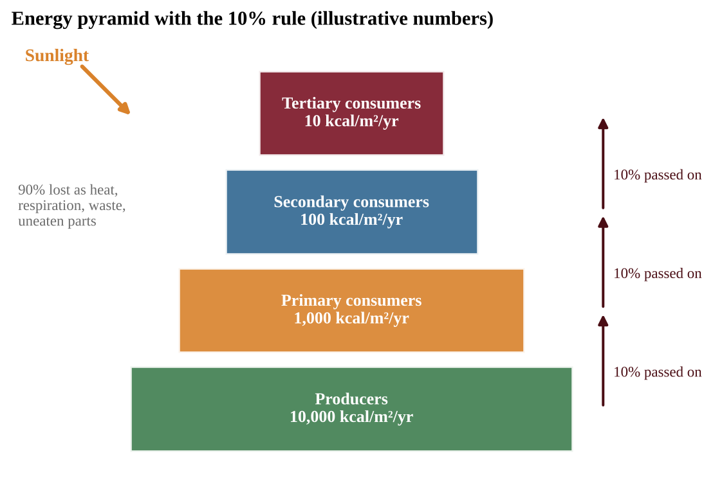
Figure 1.4 — An energy pyramid. Each step passes on about 10% of the energy of the level below.
Why the loss happens: thermodynamics
• The first law of thermodynamics states that energy cannot be created or destroyed, only converted from one form to another. The sunlight captured by producers becomes chemical energy in sugar, then movement and heat.
• The second law of thermodynamics states that every energy conversion increases disorder (entropy), and some energy is always converted to low-quality heat. No conversion is 100% efficient. Every organism spends energy to move, grow, stay warm and reproduce, and that energy ends up as heat.
Consequences: food chains are short (usually 3 to 5 levels), top predators are rare, and a large base of producers is needed to support few top consumers.
Doing the math
FORMULA & MATH SKILL
Energy at level n+1 = energy at level n × 0.10 Energy after k transfers = starting energy × (0.10)ᵏ Ecological efficiency (%) = (energy at the higher level ÷ energy at the lower level) × 100 Units: the same as the data, such as kcal/m²/yr or joules. To go downward (find the energy needed at the lower level), divide by 0.10 for each step.

The 10% figure is an approximation (real efficiencies often range from about 5% to 20%); use 10% unless told otherwise. Count transfers, not levels: producers are level 1, so an organism at level 4 is three transfers above them.
Harder 10% problems
• Efficiency from data: for each step, higher level ÷ lower level × 100. Similar values near 10% support the rule; the missing energy is lost mostly as heat (second law), not destroyed.
• From harvest to area: harvest mass × energy per kg = energy needed at the top level; divide by 0.10 per transfer down to the producers; divide by NPP (kcal/m²/yr) for area in m²; convert (1 ha = 10⁴ m²). Carry units on every line.
• Diet and land: each step up multiplies the energy and land needed by about 10, or by the factor given (if 1 kcal of beef needs 20 kcal of corn, 5,000 kcal of beef needs 100,000 kcal of corn). Eating lower on the food chain wastes less energy, so the same land feeds more people. People fed = energy per year ÷ (kcal per person per day × 365).
REAL-WORLD EXAMPLE
Raising beef requires many times more plant energy (and land) than growing grain for direct human consumption, because the cow is a primary consumer: about 90% of the energy in the feed is lost as heat and waste before the human eats the meat.

AP EXAM STRATEGY
Write the trophic level labels next to the numbers, then draw an arrow for each transfer and multiply by 0.10. Show units, state the answer and check that each lower level has about 10 times the energy of the one above.

CLASSROOM EXAMPLE SG-U1-E009
In an ocean food chain, phytoplankton fix 25,000 kcal/m²/yr. The chain is phytoplankton → zooplankton → small fish → tuna. Assume 10% of the energy is passed on at each transfer. (a) Calculate the energy available to the tuna in kcal/m²/yr. (b) Calculate how much phytoplankton energy would be needed to support 400 kcal/m²/yr in the small fish. (c) Explain, using the second law of thermodynamics, why the tuna receive less energy than the small fish.

QUICK CONCEPT SUMMARY
• About 10% of energy is passed to the next trophic level; about 90% is lost, mainly as heat.
• Energy loss follows from the first and second laws of thermodynamics.
• Short food chains and few top predators are consequences of energy loss.

Topic 1.11 — Food Chains and Food Webs
LEARNING OBJECTIVES
• Describe food chains and food webs and classify their members by trophic level.
• Explain the role of detritivores and decomposers.
• Predict the effects of adding or removing a species, including feedback loops.

A food chain shows a single pathway of energy and matter from producers (autotrophs) to primary consumers (herbivores), secondary and tertiary consumers (carnivores and omnivores). The arrows point from the organism being eaten to the organism that eats it, which is the direction of energy flow. Detritivores and decomposers play an essential role: they return nutrients to the soil, where producers use them again.
A food web is a model of the interlocking pattern of food chains in an ecosystem. It is more realistic than a single chain because most consumers eat more than one thing and are eaten by more than one predator. In a food web, one organism can sit at several trophic levels. A hawk that eats a mouse (a primary consumer) is a secondary consumer, but a hawk that eats a snake that ate a mouse is a tertiary consumer.
To read a food web, find the producers (arrows only leave them), count steps from a producer to give each consumer's trophic level (list every level if there are several paths), and, to predict the effect of removing a species, follow every arrow that enters or leaves it.
Feedback loops and changing the web
When one species is added to or removed from a food web, the rest of the web can change. Feedback loops often drive these changes.
• A negative (balancing) feedback loop counteracts a change and stabilizes the system. When rabbits increase, foxes find more food and multiply, so rabbits are reduced.
• A positive (reinforcing) feedback loop amplifies a change. In a lake, a large algal bloom dies, decomposers use up the dissolved oxygen as they consume it, fish die, and their decay uses still more oxygen.
A trophic cascade is a chain of effects across levels. When sea otters (which eat sea urchins) are removed, urchins increase, they graze down the kelp, and the kelp forest that sheltered many other species disappears.
Tracing effects and judging evidence
To predict a change, start with the first change and flip the direction at each link. In a lake, removing bass lets minnows increase; more minnows eat more zooplankton; fewer zooplankton graze less, so algae and chlorophyll a rise. Read data tables the same way: the species that changes first was disturbed, and later columns show the ripple. Predators such as wolves are far fewer than their prey because only about 10% of energy passes up a level; when wolves return, deer browse less and vegetation recovers.
Two sites that differ (a no-fishing reserve and a fished reef) show an association, not proof of cause, because depth, temperature or nutrients may also differ. Stronger evidence comes from several matched sites, before-and-after data at one site, or an experiment that removes or adds the predator with untreated controls.
COMMON STUDENT MISTAKES
• Arrows point from the food to the eater (direction of energy flow).
• A web with alternative prey is more resilient; removing one species does not always collapse the next level.

CLASSROOM EXAMPLE SG-U1-E010
A food web in a dry grassland has these feeding relationships (prey → predator): grass → grasshoppers; grass → rabbits; grasshoppers → lizards; lizards → hawks; rabbits → foxes; rabbits → hawks. (a) Write the longest food chain in this web and identify the trophic level of the hawk in that chain. (b) A disease eliminates nearly all lizards. Predict the direction of change in the grasshopper population, assuming lizards are the only predator of grasshoppers, and explain. (c) As rabbits increase, foxes increase, and then rabbits decline. Identify the type of feedback and justify your answer.

QUICK CONCEPT SUMMARY
• Food chains show one energy pathway; food webs combine many chains; arrows point from food to eater.
• Detritivores and decomposers return nutrients to the soil.
• Adding or removing a species affects the rest of the web through positive and negative feedback loops.

Math & Skills Toolkit
• Percent change = (new − original) ÷ original × 100. Divide by the original value. Percent of whole = part ÷ whole × 100.
• Conversions and scientific notation: multiply by a fraction equal to 1 so units cancel (80 cm × 1 m ÷ 100 cm = 0.80 m; 25 km² = 25 × 10⁶ m²).
• Volume = area × depth (use m² and m, answer in m³).
• 10% rule: × 0.10 per upward transfer; ÷ 0.10 per step down. NPP = GPP − R.
• Showing work: formula, substitution with units, answer with units; then check it is sensible (energy falls up a food chain; NPP ≤ GPP).
• Graphs: read axes and units, state the trend in words, quote two data points, and explain the cause.
Unit 1 Review — Quick Concept Summary
QUICK CONCEPT SUMMARY
• Species interactions: scarce resources drive predation, symbiosis and competition; resource partitioning allows coexistence.
• Biomes: terrestrial biomes follow temperature and precipitation; aquatic biomes follow salinity, depth, turbidity, nutrients and temperature.
• Cycles: carbon links photosynthesis and respiration (fossil fuels are a slow reservoir); nitrogen needs fixation (the atmosphere is the largest reservoir); phosphorus has no atmospheric phase and is often limiting; the sun-powered water cycle is stored mostly in the oceans.
• Energy: NPP = GPP − R; energy flows one way and about 10% passes up each trophic level (thermodynamics), while matter cycles.
• Food webs link chains; decomposers recycle nutrients; adding or removing a species triggers feedback loops.

Unit 2 — The Living World: Biodiversity
Why does a rainforest bounce back from a storm while a cornfield needs fertilizer, seed, and a farmer every single year? Why do tiny islands hold strange animals found nowhere else? Why can a trout survive in one stream and die in another a few kilometers away? Unit 2 answers these questions. It shows how ecosystems are built from many kinds of variety, how that variety helps people, how it changes when conditions change, and how it rebuilds after damage. This unit is worth about 6–8% of the exam, and its ideas return in Units 3, 5, 6 and 9.
Topic 2.1 — Introduction to Biodiversity
LEARNING OBJECTIVES
• Explain the three levels of biodiversity: genetic, species, and habitat diversity.
• Explain why genetic diversity helps a population respond to stress and how a bottleneck reduces it.
• Explain why species-rich ecosystems recover from disruption more readily.
• Describe how habitat loss affects specialists, generalists, and wide-ranging species.
• Define species richness.

CONCEPT MADE SIMPLE
Biodiversity is variety, counted at three scales. Think of a school. The students differ from one another (genetic variety within one species). The school has many kinds of clubs (variety of species). The campus has a gym, library, garden, and cafeteria (variety of habitats). A healthy ecosystem is like a school with lots of variety at every scale: when something goes wrong, someone can always step in.

The three levels
Genetic diversity is the variety of genes (alleles) among the individuals of one species. Two dandelions in the same lawn are not identical; they carry different versions of many genes. Species diversity is the variety of different species in an ecosystem. Habitat diversity (also called ecosystem diversity) is the variety of physical environments, such as forest, meadow, stream, and wetland, that exist in an area. Each habitat supports its own set of species, so more habitats usually means more species.
KEY DEFINITIONS
Biodiversity — the variety of life in an ecosystem, including genetic, species, and habitat diversity. Genetic diversity — variation in the genes of individuals within a population or species. Species richness — the number of different species found in an ecosystem. It counts kinds, not individuals. Habitat diversity — the variety of distinct habitats within an area. Population bottleneck — a sharp drop in population size that leaves the survivors with only a small sample of the original genes. Specialist — a species with narrow requirements for food, habitat, or conditions. Generalist — a species that can use many foods and habitats and tolerate a wide range of conditions.

Why genetic diversity matters
A genetically diverse population contains individuals with many different traits. When an environmental stressor arrives, such as a new disease, a hot summer, or a pesticide, a few individuals are likely to carry traits that let them survive and reproduce. Those survivors rebuild the population. A population with little genetic variety may have no such individuals, so the same stressor can wipe out nearly everyone. This is why a field planted with one identical crop variety can be lost to a single fungus, while a mixed wild meadow rarely is.
A bottleneck causes loss of genetic diversity. When a population collapses, whether from hunting, fire, or disease, only the survivors pass genes forward. Rare alleles are often lost by chance, and even if numbers recover, the population stays genetically uniform. The population is bigger again but not more diverse, and it remains vulnerable. Remember this: recovering numbers does not restore lost genes.
PROCESS & CAUSE-AND-EFFECT
Stressor kills most of population → few survivors (bottleneck) → many alleles lost → population regrows from the survivors → low genetic diversity → reduced ability to handle the next stressor

Species richness and recovery
Species richness is simply the number of species. If a meadow plot contains 14 plant species, its richness is 14, whether it holds 20 plants or 2,000. Ecosystems with more species are more likely to recover from disruptions. The reasons are cause-and-effect: more species means more different ways of doing the same job (several kinds of plants fix carbon, several kinds of insects pollinate). If a drought or pest eliminates one species, another with a different tolerance fills in. A low-diversity system depends on a few species, so losing one leaves a gap nothing can fill.
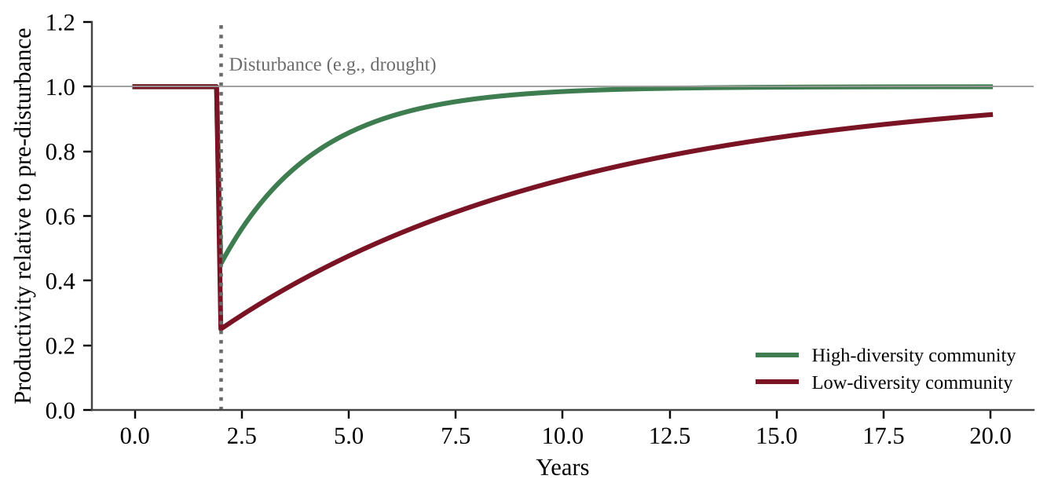
Figure 2.1 — A high-diversity community loses less productivity after a disturbance and recovers faster than a low-diversity community.
Reading the graph: both lines start at 1.0 (normal productivity). The drop at the dotted line shows the size of the damage; the climb back to 1.0 shows resilience. The green line drops less and returns sooner. A steeper, faster return means a more resilient system.
Habitat loss
When habitat is destroyed or fragmented, species do not vanish all at once. Specialists go first because they cannot use any other habitat or food. Generalists follow later if the loss continues. Species with large territorial requirements (wolves, big cats, eagles) decline in number early, because a shrunken or chopped-up patch cannot hold enough territories. Habitat loss is the leading cause of biodiversity loss worldwide, which is why you will see it again in Unit 9.
Low genetic diversity in practice. Crops and livestock bred from a few uniform lines carry fewer alleles than wild populations, so one disease can strike every plant or hive. Small populations share the weakness, and breeding among close relatives makes harmful alleles show up more often. Wild species are seldom wiped out by one disease because some individuals carry resistance genes. Of two populations, the one with more alleles copes better.
Fragmentation. Roads, fields, and clear-cuts split one large habitat into small patches. A small patch is mostly edge, where sun, wind, and outside predators change conditions, so forest-interior specialists lose space first, and a patch smaller than one territory holds none of the species that need it. Corridors (strips of habitat joining patches) let animals move between them. To decide who vanishes first, compare patch size with territory size, then ask how narrow the species' needs are.
COMMON STUDENT MISTAKES
• Confusing richness with total number of individuals. A plot with 500 ants of one species has richness 1.
• Saying a recovered population has "regained genetic diversity." A bottleneck loss of alleles is not undone by regrowth in numbers.
• Believing generalists are the first to disappear from habitat loss. Specialists go first.
• Treating "biodiversity" as only species. Genetic and habitat diversity are part of it too.

AP EXAM STRATEGY
When a question asks you to explain why diversity helps, always give a chain: more genetic or species variety → some individuals or species tolerate the stressor → they survive and reproduce or take over the lost function → the ecosystem keeps functioning or recovers sooner. A bare statement such as "diversity is good" earns no credit.

CLASSROOM EXAMPLE SG-U2-E001
For each situation, name the level of biodiversity (genetic, species, or habitat) that is being described, and say in one sentence whether it is high or low in that situation. (a) A cheetah population descended from a few dozen survivors shows almost no variation in the genes that control immune response. (b) A 40-hectare reserve contains pine forest, a lake, a peat bog, and open grassland. (c) A 100 m² plot of coral reef holds 63 fish species.

QUICK CONCEPT SUMMARY
• Biodiversity has three levels: genetic, species, and habitat diversity.
• Genetic diversity helps a population respond to stressors; bottlenecks reduce it.
• Species richness is the number of species; richer ecosystems recover from disruption more readily.
• Habitat loss removes specialists first, then generalists, and cuts species with large territories.

Topic 2.2 — Ecosystem Services
LEARNING OBJECTIVES
• Describe the four categories of ecosystem services.
• Describe the economic and ecological results of human disruption of ecosystem services.

CONCEPT MADE SIMPLE
Ecosystem services are the free benefits nature provides. You do not pay a bill for a wetland that filters your drinking water or for the bees that pollinate your fruit, but if they stopped, you would pay a great deal to replace them.

The four categories
KEY DEFINITIONS
Ecosystem services — the benefits that people obtain from functioning ecosystems. Provisioning services — the material goods ecosystems supply: food, fresh water, timber, fiber, fuel, medicines. Regulating services — the ways ecosystems control conditions: climate regulation (carbon storage), flood control, water purification, pollination, disease and pest control, erosion control. Cultural services — the non-material benefits: recreation, tourism, spiritual value, education, and beauty. Supporting services — the basic processes on which all the others depend: nutrient cycling, soil formation, photosynthesis (primary production), and habitat for species.

A quick memory trick: provisioning = products; regulating = rules of the environment; cultural = culture and enjoyment; supporting = the foundation. One ecosystem usually gives all four. A mangrove forest supplies fish and wood (provisioning), buffers storm surge and traps sediment (regulating), draws ecotourists (cultural), and acts as a nursery for young fish while recycling nutrients (supporting).
Service category | Wetland example | Forest example
Provisioning | Fish, rice, drinking water | Timber, mushrooms, medicinal plants
Regulating | Absorbs floodwater, filters pollutants | Stores carbon, reduces erosion on slopes
Cultural | Bird watching, education | Hiking, spiritual significance
Supporting | Nutrient cycling, nursery habitat | Soil formation, wildlife habitat

Human disruption of ecosystem services
Anthropogenic (human-caused) activities can damage or remove these services, and the results are both ecological and economic. Cutting a mountain forest for timber gains short-term income (a provisioning service), but it can also destroy flood control and erosion control (regulating services). The next rains send mud into the river, the reservoir silts up, and the downstream town spends money on dredging and flood repair. Pollinator decline from pesticide overuse reduces crop yields and forces farmers to pay for hand pollination or rented hives. Draining wetlands removes natural water purification, so a city must build an expensive treatment plant.
PROCESS & CAUSE-AND-EFFECT
Human activity (clearing, draining, polluting) → ecosystem function damaged → service lost → ecological consequence (flooding, soil loss, fewer species) → economic consequence (repair costs, lower yields, lost tourism)

Classifying a benefit. Ask what it does: supplies a good (provisioning), moderates a process or hazard such as floods or water quality (regulating), gives enjoyment (cultural), or keeps the ecosystem running (supporting). Native pollinators serve native plants best because they evolved together.
Putting a dollar value on services
Two common methods compare costs and benefits. Market value is quantity × price (a harvest). Replacement cost is what a machine or plant would cost to do the same job (a treatment plant replacing a wetland's filtering).
FORMULA & MATH SKILL
Value of a service ($/yr) = area (ha) × rate (units/ha/yr) × price ($/unit) Cost over t years = one-time cost + (annual cost × t) Net benefit = total benefits − total costs
• Convert every service to $ per year before adding; compare options over the same number of years.
• Example: 40 ha × 150 kg/ha/yr × $5/kg = $30,000/yr.

When an ecosystem is converted, compare the developer's profit with the total value of all services lost; the loss usually falls on the public. Solutions: build on already-degraded land, restore habitat elsewhere, require new building to stay back from the shore, or make the developer pay for lost services. Each has a cost, which is its tradeoff.
CLASSROOM EXAMPLE SG-U2-E009
A 120-ha tidal marsh filters nutrients from a bay. A treatment plant doing the same job would cost $9 million to build and $0.5 million per year to run. Protecting the marsh costs $120 per hectare per year. The marsh also supports 90 kg/ha/yr of shellfish worth $8/kg. (a) Calculate the yearly value of the shellfish harvest. (b) Calculate the 15-year cost of the plant and of protecting the marsh, and the difference. (c) Classify the filtering and the shellfish as ecosystem services. (d) State one tradeoff of relying on the marsh.

CLASSROOM EXAMPLE SG-U2-E002
A river valley has a floodplain forest. Classify each of the following benefits as provisioning, regulating, cultural, or supporting: (i) the forest soaks up spring floodwater; (ii) families harvest wild nuts; (iii) leaf litter decomposes and returns nitrogen to the soil; (iv) a canoe-rental company runs tours. Then, if the forest were cleared for farmland, describe one ecological and one economic consequence for the town downstream.

QUICK CONCEPT SUMMARY
• Four categories: provisioning, regulating, cultural, supporting.
• One ecosystem usually supplies all four.
• Human disruption of services produces ecological and economic consequences, such as flooding, soil loss, lower yields, and costly replacements.

Topic 2.3 — Island Biogeography
LEARNING OBJECTIVES
• Describe island biogeography.
• Describe how island conditions shape evolution, including specialists, generalists, and invasive species.

CONCEPT MADE SIMPLE
An island is a small, isolated world, and its number of species depends on its size and distance. Big islands have room for more species and for larger populations that are less likely to die out. Islands near a mainland receive new arrivals more often. So the biggest, nearest island has the most species; the smallest, farthest island has the fewest.

What is island biogeography?
Island biogeography is the study of the ecological relationships and distribution of organisms on islands, and of the community structure of those organisms. The ideas apply to any isolated habitat: a mountaintop, a lake, a forest fragment surrounded by farmland, or a nature reserve in a city.
Every island's species were not always there. Islands have been colonized in the past by species that arrived from elsewhere: birds flying, seeds blown by wind or carried in feathers, insects rafting on floating logs, and sometimes human introductions. The number of species on an island reflects a balance between new species arriving (colonization) and species being lost (extinction).
PROCESS & CAUSE-AND-EFFECT
Distance: island near mainland → more colonists arrive → more species. Island far away → fewer colonists → fewer species. Size: large island → more habitats and resources → larger populations → lower extinction rate → more species. Small island → small populations → more likely to disappear → fewer species.

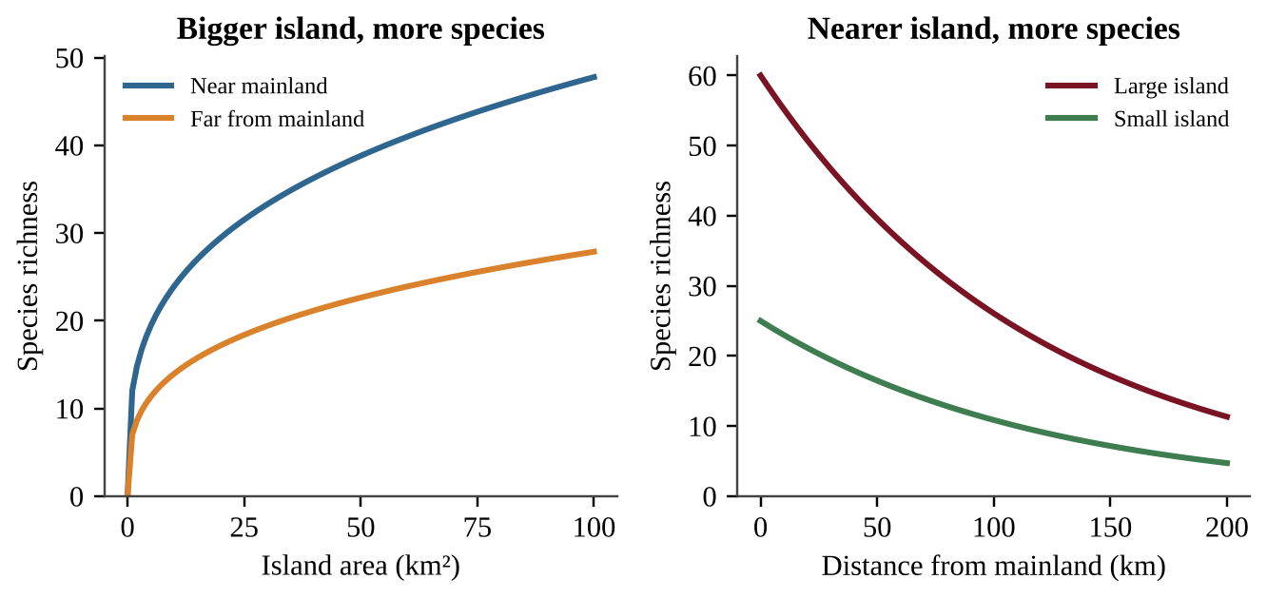
Figure 2.2 — Species richness rises with island area (left) and falls with distance from the mainland (right).
Reading the graphs: on the left, both lines rise with area, and the near-mainland line sits higher at every size. On the right, richness drops as distance grows, and the large-island line sits above the small-island line. Describe both variables when you answer a data question: "richness increases with island area and decreases with distance."
Equilibrium: arrivals balance losses
As an island fills, fewer new species remain to arrive, so the immigration rate falls. More species means smaller populations and more competition, so the extinction rate rises. Where the curves cross is the equilibrium: arrivals equal losses and richness stays steady. Read the number of species straight down from the crossing.
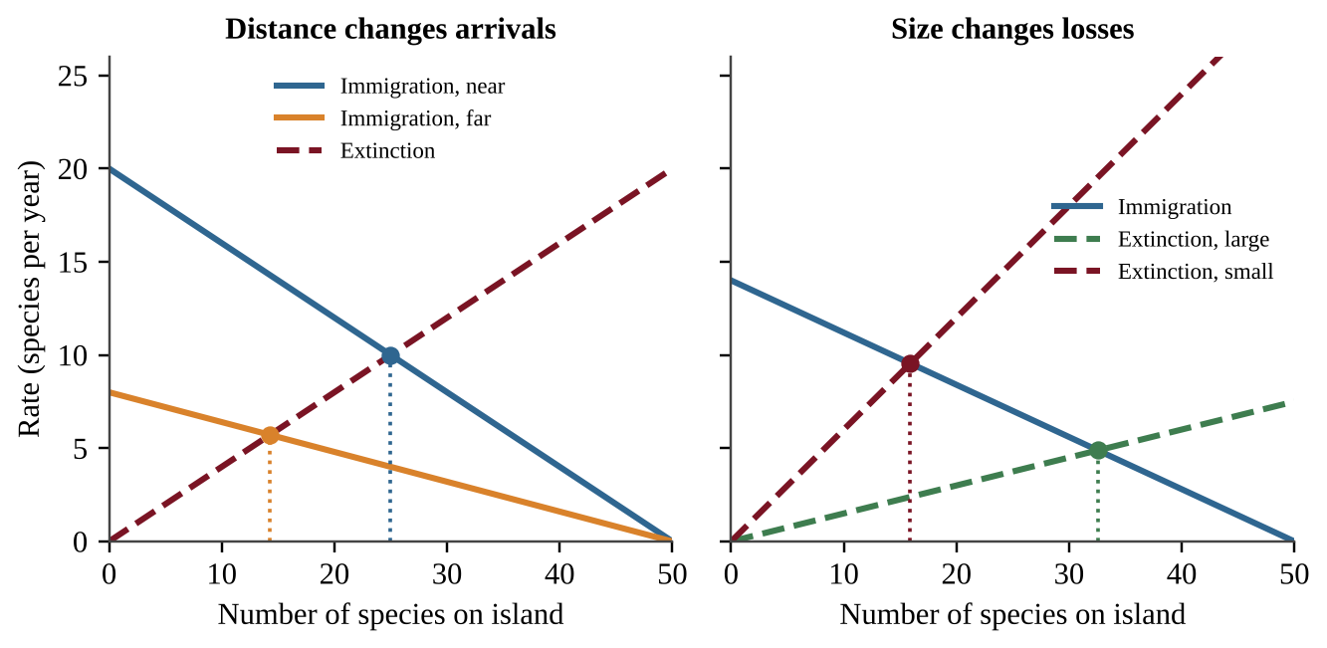
Figure 2.2b — Distance lowers the immigration curve (left); small size raises the extinction curve (right). Each dot marks an equilibrium.
Reading the graphs: a far island has a lower immigration curve and a small island a steeper extinction curve; both push the crossing left. Compare islands by subtracting their equilibrium values. Equilibrium is a number, not a fixed list: species keep arriving and disappearing (turnover), so two surveys can show the same richness but different species. If 18 species are found in each survey and 13 appear in both, then 5 were lost and 5 gained. Habitat fragments, mountaintops, and ponds behave like islands.
Species–area graphs. Richness rises quickly on small areas and slowly on large ones. On a logarithmic area axis each equal step multiplies area by 10, so 300 ha sits about halfway between the 100 and 1,000 ha marks. To predict an island's richness, bracket its area between islands at a similar distance.
Island biogeography and evolution
Island resources such as food and territory are limited. Over time many island species evolve to be specialists that use one narrow food or habitat, which reduces competition among the few species present. Isolation also lets populations diverge from mainland relatives, so islands are well known for unusual species found nowhere else.
This specialization carries a risk. Invasive species that arrive on islands are typically generalists: they eat many foods, tolerate many conditions, and reproduce quickly. A generalist can outcompete a specialist for food or space, or prey on animals that evolved without defenses against such predators. The long-term survival of island specialists can therefore be jeopardized when invasive species are introduced.
COMMON STUDENT MISTAKES
• Saying a bigger island has more species "because it is closer." Size and distance are two separate variables; keep them separate.
• Claiming islands have more species than the mainland. Islands generally have fewer species than a comparable mainland area.
• Assuming invasive species are specialists. They are typically generalists.

CLASSROOM EXAMPLE SG-U2-E003
Four islands were surveyed for land-bird species.
Island | Area (km²) | Distance from mainland (km) | Bird species
P | 4 | 10 | 18
Q | 4 | 120 | 9
R | 90 | 10 | 41
S | 90 | 120 | 24

(a) Describe the effect of distance on bird richness, using a pair of islands that differ only in distance, and give the percent decrease for that pair. (b) Describe the effect of area on richness for islands at the 120 km distance. (c) Predict which island is most likely to lose a specialist species through chance extinction, and justify your choice.

QUICK CONCEPT SUMMARY
• Island biogeography studies the distribution and community structure of organisms on islands.
• Richness increases with island area and decreases with distance from the colonist source.
• Islands were colonized by species arriving from elsewhere.
• Limited resources favor specialists; invasive generalists can outcompete them.

Topic 2.4 — Ecological Tolerance
LEARNING OBJECTIVES
• Describe ecological tolerance.
• Recognize that tolerance applies to both individuals and species.

CONCEPT MADE SIMPLE
Every organism has a comfort zone, and beyond its edges it gets hurt or dies. A polar bear is comfortable in cold; it overheats in a desert. A cactus handles drought; it rots in a swamp. The width of the zone is the organism's tolerance.

Ecological tolerance is the range of conditions, such as temperature, salinity, flow rate, and sunlight, that an organism can endure before injury or death results. Each factor has its own range. A trout may tolerate a narrow temperature range but a wide range of sunlight; an estuary crab may tolerate wide swings in salinity.
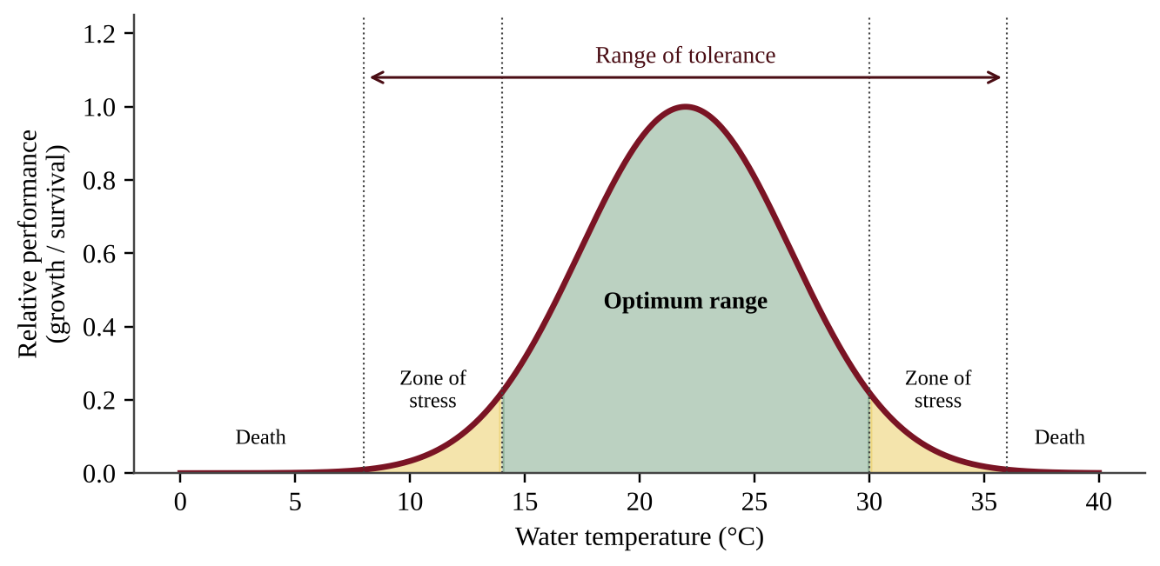
Figure 2.3 — A tolerance curve: performance is highest in the optimum range, falls in the zones of stress, and reaches zero beyond the limits of tolerance.
Reading the graph: the x-axis is the environmental factor, the y-axis is how well the organism does. The peak is the optimum. The two outer limits mark the range of tolerance; outside them survival is not possible. A species with a wide curve is a generalist for that factor, and one with a narrow curve is a specialist.
Individuals and species. Tolerance applies at two levels. An individual has a tolerance that can shift a little with age, health, and acclimation (a runner adapts to altitude over weeks). A species has a tolerance range for the whole group, because individuals vary. A species' range is wider than any single individual's because it includes the hardiest and most sensitive members. Limiting factors that exceed tolerance determine where a species can live, so tolerance helps explain geographic range, and why a small shift in temperature, salinity, or flow can remove sensitive species from a stream.
KEY DEFINITIONS
Ecological tolerance — the range of environmental conditions an organism can endure before injury or death. Optimum range — the conditions in which an organism grows and reproduces best. Zone of stress — conditions where the organism survives but performs poorly.

Reading tolerance graphs and tables
• The range is where performance is above zero (or the interval in a table); the optimum is the peak. Height shows performance at the best; width shows tolerance.
• Test the new condition against each species' range. Inside: it persists, perhaps with reduced growth. Outside: it is lost, however wide its range is elsewhere.
• Rainfall or salinity gradients read the same way.
• Exposure time matters: a temperature survived for a week may kill within a month.
Designing a tolerance experiment
A field survey shows only an association: distance from a road also changes shade, depth, and predators (confounding variables). Only an experiment that changes one factor shows cause. A good design has:
• a hypothesis in the form "If X increases, then Y will decrease, because the organism's tolerance limit is exceeded";
• an independent variable (the one factor you change, at several graded levels) and a dependent variable (what you measure, such as percent survival);
• a control (the natural or zero-stress level) and replicates (several containers per level, each with the same number of organisms);
• constants (temperature, volume, food, light, age and source of organisms, duration).
Graph response against level; the tolerance limit is where survival drops sharply. Removing a suspected keystone species from some plots and comparing them with untouched plots uses the same logic.
CLASSROOM EXAMPLE SG-U2-E010
Acid rain may be lowering the pH of ponds where a salamander breeds. Design an experiment to find the range of pH its larvae can tolerate. (a) State a testable hypothesis. (b) Identify the independent and dependent variables. (c) Describe the treatments, control, and replication. (d) Name two constants. (e) Explain how you would find the tolerance limit.

COMMON STUDENT MISTAKES
• Mixing up tolerance with adaptation. Tolerance is the range an organism can already survive; adaptation is a heritable change across generations (Topic 2.6).
• Thinking the optimum and the limit are the same thing. Organisms can survive in the zone of stress but do poorly.
• Stating that tolerance is one number. It is a range with an upper and lower limit, for each factor.

CLASSROOM EXAMPLE SG-U2-E004
Laboratory trials recorded the survival of two freshwater snail species after 7 days at different water temperatures.
Temperature (°C) | Species A survival (%) | Species B survival (%)
6 | 0 | 0
10 | 0 | 55
14 | 80 | 90
18 | 100 | 95
22 | 95 | 85
26 | 70 | 40
30 | 0 | 0
34 | 0 | 0

(a) Using only the temperatures tested, identify the lowest and highest tested temperatures at which each species survived at all. (b) Which species is better described as having the wider tolerance for temperature? Justify with the data. (c) A power plant will raise stream temperature from 20 °C to 28 °C. Predict which species is affected more and explain.

QUICK CONCEPT SUMMARY
• Ecological tolerance is the range of conditions an organism can endure before injury or death.
• Factors include temperature, salinity, flow rate, and sunlight.
• It applies to individuals and to species.
• Narrow tolerance means a specialist for that factor; wide means a generalist.

Topic 2.5 — Natural Disruptions to Ecosystems
LEARNING OBJECTIVES
• Explain how short-term and long-term natural disruptions affect ecosystems.
• Describe periodic, episodic, and random Earth system processes.
• Describe long-term changes in climate and sea level and the habitat changes and migration they cause.

CONCEPT MADE SIMPLE
Nature itself disturbs ecosystems all the time, and sometimes harder than humans do. One volcanic eruption or one huge wildfire can reshape thousands of square kilometers in a day. What matters is size, how often, and how long the effects last.

Short-term and long-term disruptions
Natural disruptions include fires, floods, hurricanes, volcanic eruptions, earthquakes, drought, disease outbreaks, and slow shifts in climate. Short-term disruptions (a storm, a fire) act over hours to years. Long-term disruptions (an ice age, a change in sea level) act over thousands to millions of years. The consequences of a natural disruption, for a given occurrence, may be as great as or greater than those of many human-made disruptions. A major eruption can bury a whole landscape in ash, and a hurricane can flatten a forest, killing organisms, changing habitat, and resetting the ecosystem. Natural does not mean harmless.
Scales of time: periodic, episodic, random
Earth system processes operate over a range of time scales, and they differ in how predictable they are:
KEY DEFINITIONS
Periodic — happens at regular, predictable intervals (seasons, annual monsoon flooding, daily tides). Episodic — happens in occasional bursts, with some pattern in how often but not on a fixed schedule (hurricane seasons with active and quiet years; large wildfires every few decades). Random — has no predictable pattern in timing (a meteorite impact, a single earthquake or volcanic eruption).

Climate and sea level over geological time
Earth's climate has changed over geological time for many reasons, including changes in Earth's orbit and tilt, variations in solar output, volcanic activity, shifting continents, and changes in greenhouse gas levels in the atmosphere. During cold periods (glacial periods) large amounts of water are locked in continental ice, so sea level falls. During warm periods ice melts and sea level rises. Sea level has therefore varied significantly as a result of changes in the amount of glacial ice on Earth. Falling sea level can expose land bridges and shallow shelves; rising sea level floods coastal lowlands.
PROCESS & CAUSE-AND-EFFECT
Climate cools → more water frozen as glacial ice → sea level falls → coastal shelves exposed, habitats shift toward the equator or downslope Climate warms → ice melts → sea level rises → low coastal habitats flooded, habitats shift poleward or upslope

Habitat change and migration
Major environmental change or upheaval commonly results in large swaths of habitat changes: grassland may turn to desert, forest may retreat or advance, shorelines move inland. Wildlife responds. Migration may be short-term (a seasonal trip to avoid winter, or fleeing a fire and returning) or long-term (a species' range shifting poleward over centuries as climate warms). Animals migrate for many reasons, including food, breeding, temperature, and natural disruptions.
A wet winter in a fire-prone region grows extra grass and shrubs; once dry, that fuel makes the next fire larger. As climate warms, species track their temperature range poleward or upslope, but a narrow-tolerance species stranded on a mountaintop or island may have nowhere to go. Continental-shelf islands often share mammals with the mainland because lower glacial sea level once joined them by land.
COMMON STUDENT MISTAKES
• Believing that natural disruptions are always smaller than human ones. A single natural event can exceed many human-caused disruptions.
• Mixing up "episodic" and "periodic." Periodic = regular clock-like timing; episodic = occasional bursts; random = unpredictable.
• Saying sea level falls when ice melts. Melting land ice raises sea level.

CLASSROOM EXAMPLE SG-U2-E005
A valley forest has a net primary productivity of 1,200 g/m²/yr before a hurricane. The measured values afterward are: Year 1 = 300, Year 3 = 540, Year 5 = 780, Year 8 = 1,020. (a) Calculate the percent decrease in productivity in Year 1 compared with the pre-hurricane value. (b) Calculate the average increase in productivity per year between Year 1 and Year 5. (c) Classify hurricanes as periodic, episodic, or random for a coastal region with several active years and several quiet years, and justify. (d) Describe one way wildlife might respond in the short term.

QUICK CONCEPT SUMMARY
• Natural disruptions can have impacts as large as or larger than many human-caused ones.
• Earth processes may be periodic, episodic, or random in timing.
• Climate and sea level have changed over geological time; more glacial ice means lower sea level.
• Major upheaval creates large-scale habitat change, and wildlife responds with short- or long-term migration.

Topic 2.6 — Adaptations
LEARNING OBJECTIVES
• Explain how natural selection acts on heritable traits to cause adaptation.
• Explain how organisms respond when the environment changes suddenly or gradually: alter behavior, move, or perish.

CONCEPT MADE SIMPLE
Adaptation is a population change across generations, not something an individual does. A giraffe did not stretch its neck to get taller offspring. Instead, longer-necked giraffes in the past got more food, had more young, and passed on the genes for long necks.

Natural selection
Individuals in a population vary, and many differences are heritable (passed from parents to offspring through genes). Some variants help an organism survive and reproduce in its particular environment. Those individuals leave more offspring, so the helpful trait becomes more common in the next generation. Over many generations these incremental changes at the genetic level make the population adapted to its environment.
PROCESS & CAUSE-AND-EFFECT
Variation in a heritable trait → environment favors some variants (better survival and reproduction) → favored individuals leave more offspring → trait becomes more common over generations → population is better adapted

Example: a beetle population contains green and brown beetles. Birds in a brown, dry landscape eat green beetles more often. Brown beetles survive longer, breed more, and the next generation has a higher percentage of brown beetles. No individual beetle changed color. The population's gene frequencies shifted. This links to Topic 2.1: genetic diversity supplies the variation that natural selection needs. A population with no variation cannot adapt.
KEY DEFINITIONS
Natural selection — the process in which individuals with heritable traits that improve survival and reproduction leave more offspring, so those traits become more common. Adaptation — a heritable trait that increases an organism's fitness in its environment; also the process of a population becoming better suited over generations. Heritable trait — a trait controlled by genes that can be passed to offspring.

When the environment changes
Environmental change may be sudden (a volcanic eruption, an oil spill) or gradual (slow warming, a rising sea). Either may threaten a species' survival. Individuals have three possible outcomes: alter behavior (hunt at night when days get too hot), move (migrate to a better area), or perish. Behavioral change and movement happen within an individual's lifetime and are not genetic adaptation. Whether the species survives depends on whether enough individuals can do one of these or whether the population has heritable variation that selection can act on quickly enough. Fast change, few individuals, long generation times, and low genetic diversity all work against survival.
Kinds of adaptation and selection in action
Adaptations may be structural (large heat-shedding ears), physiological (concentrated urine that saves water), or behavioral (nocturnal activity). A behavior counts as an adaptation when it is inherited; a one-time response to a situation is not. Mutations are random changes in DNA that supply new alleles. The environment does not cause helpful mutations on demand; it only decides which existing variants survive.
Resistance is natural selection. Each spraying of one pesticide or herbicide kills susceptible individuals and leaves resistant ones to breed, so the resistant fraction rises every generation, fastest in species with many offspring and short generations. To slow it, reduce selection pressure: leave untreated refuges so susceptible individuals keep mating with survivors, rotate products with different modes of action, and spray only when needed. Higher doses or more frequent spraying strengthen selection.
Reading trait graphs. If the bell curve of a trait (shell thickness) shifts after a predator arrives, the population was selected for the shifted trait; no individual changed. Two populations of one species that differ in a trait on islands with different food point to different selection pressures.
CLASSROOM EXAMPLE SG-U2-E011
A weed species was sprayed with the same herbicide for six seasons. The share of resistant plants rose: 3% (season 1), 9%, 26%, 58%, 81%, 93% (season 6). (a) Describe the trend. (b) Explain it as natural selection, naming the variation, the selective agent, and the outcome. (c) Propose one change that would slow resistance and justify it.

COMMON STUDENT MISTAKES
• Saying "the organism adapted because it needed to." Selection acts on existing variation; needs do not create traits.
• Claiming individuals evolve during their lives. Populations change across generations.
• Confusing learned behavior or acclimation (not inherited) with adaptation (heritable change).

CLASSROOM EXAMPLE SG-U2-E006
A population of 2,000 field mice is reduced to 40 individuals by a disease outbreak, then recovers to 2,000 over six years. Before the outbreak, 5 different alleles of an immune-response gene were present; after recovery only 2 of them are found. (a) Name the process that explains the loss of alleles and state what happened to genetic diversity even though the population size returned to normal. (b) A new, more virulent disease then appears. Explain why this population is at greater risk than the original population. (c) Distinguish between a mouse changing its behavior to avoid the disease and the population adapting to it.

QUICK CONCEPT SUMMARY
• Natural selection acts on heritable traits and produces adaptation over generations through incremental genetic changes.
• Genetic variation is the raw material of selection.
• When the environment changes, individuals alter behavior, move, or perish.
• Sudden or gradual change can threaten a species, especially when diversity is low.

Topic 2.7 — Ecological Succession
LEARNING OBJECTIVES
• Describe primary and secondary succession.
• Describe keystone species and indicator species.
• Describe how pioneer species affect ecosystems, including the possible origin of new species.
• Describe how succession changes biomass, species richness, and net productivity over time.

CONCEPT MADE SIMPLE
Succession is an ecosystem rebuilding itself in stages. First hardy species move in, then they change the place (more soil, more shade) in ways that let new species move in, and the community keeps changing until it becomes stable.

Primary and secondary succession
KEY DEFINITIONS
Primary succession — community development in an area with no soil, such as bare rock after a lava flow, a retreating glacier, or a new sand dune. It starts from nothing and takes hundreds to thousands of years. Secondary succession — community development in an area where soil remains after a disturbance, such as an abandoned field, a burned forest, or a cleared lot. It is faster because the soil already holds nutrients, organic matter, and seeds. Pioneer species — the first species to colonize unoccupied or newly disturbed habitat, usually hardy, fast-growing, and good at dispersing. Keystone species — a species whose activities play a particularly significant role in determining community structure, much more than its abundance would suggest. Indicator species — a plant or animal whose presence, abundance, scarcity, or chemical composition shows that some distinctive aspect of the character or quality of an ecosystem is present.

Primary succession typically proceeds: bare rock → lichens and mosses (pioneers) that slowly break down rock and add organic matter → thin soil → grasses and herbs → shrubs → trees → mature community. Secondary succession skips the soil-building stage: the field or burned forest starts with weeds and grasses, then shrubs, fast-growing trees, and finally a mature forest.
Pioneers and the origin of new species
Pioneer members of an early successional species commonly move into unoccupied habitat. Over time they adapt to its particular conditions, which may result in the origin of new species. This links to Topic 2.3 and 2.6: a founding population in a new, isolated place faces new selective pressures and can diverge from its parent population. Pioneers also change the environment: lichens create soil, and early plants add organic matter and shade, a process that makes the habitat suitable for later species.
What changes during succession
Succession in a disturbed ecosystem will affect total biomass (the mass of living organisms), species richness, and net productivity (the rate at which producers store energy as new biomass, after their own respiration) over time.
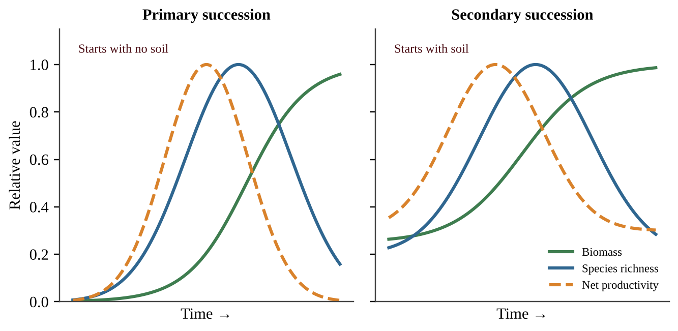
Figure 2.4 — Typical trends during primary (left) and secondary (right) succession. Secondary succession starts with higher values because soil is already present.
• Biomass increases steadily and levels off in a mature community, where large long-lived plants store much material.
• Net productivity is highest during the fast-growing middle stages and declines as the community matures, because a large mature community uses much of what it produces for its own respiration and maintenance.
• Species richness generally increases through the early and middle stages as habitats become more varied, and may level off or decline slightly late in succession when a few dominant, shade-casting species crowd others out.
Reading the graph: identify the type of succession from where the lines begin (near zero means no soil, so primary; already substantial means soil present, so secondary). Then describe each line using words such as "increases," "peaks," and "levels off" with approximate years or stages.
Species replacement, soil building, and productivity per biomass
Pioneers are fast-growing, sun-loving, and widely dispersed. As the canopy closes, light at the ground falls, so pioneers decline and shade-tolerant species take over, leading to a stable mature (climax) community. On a multi-species graph each species rises and falls in turn; richness peaks in the middle, when pioneers and later species overlap, then falls as shade-tolerant dominants crowd others out. Mature-forest trees need many decades to return after clear-cutting. A storm or fire that leaves the soil restarts secondary succession, faster than the original primary succession, in which weathering and pioneer lichens break rock and add organic matter to make soil.
FORMULA & MATH SKILL
Productivity per biomass (yr⁻¹) = NPP ÷ total biomass
• Young stands give high ratios; old stands give low ratios.
• Reason: a mature stand holds much woody tissue that adds no growth but needs energy for respiration.
• Example: NPP 0.9 kg/m²/yr with biomass 6.0 kg/m² → 0.9 ÷ 6.0 = 0.15 yr⁻¹.

Keystone and indicator species
A keystone species has an influence far larger than its numbers. Sea otters eat sea urchins; without otters, urchins overgraze kelp, and the kelp forest community collapses. Beavers build dams that create wetlands for dozens of other species. Removing a keystone species can change the whole community. An indicator species signals something about ecosystem condition. Certain stonefly larvae need clean, oxygen-rich water, so their presence indicates good water quality and their disappearance suggests pollution. Lichens that are sensitive to air pollution work the same way. The difference: a keystone species shapes the community; an indicator species reports on it.
COMMON STUDENT MISTAKES
• Saying primary succession occurs after a forest fire. Burned forest keeps its soil, so that is secondary.
• Assuming a keystone species must be abundant or large. Its importance comes from its effect, not its numbers.
• Treating indicator and keystone species as the same. One reports conditions; the other controls community structure.
• Stating that net productivity keeps rising until the end of succession. It peaks in the middle and falls in mature stages, while biomass keeps climbing and then levels off.

CLASSROOM EXAMPLE SG-U2-E007
Researchers measured two plots after a disturbance. Plot X began as bare, scoured rock after a glacier retreated. Plot Y was a farm field abandoned after plowing.
Year | Plot X species | Plot Y species | Plot Y biomass (kg/m²)
1 | 0 | 12 | 0.3
10 | 3 | 26 | 2.1
30 | 9 | 31 | 6.5
80 | 15 | 24 | 14.0

(a) Identify the type of succession in each plot and justify using the data. (b) Calculate the percent increase in Plot Y biomass between Year 10 and Year 30. (c) Describe the trend in Plot Y species richness over the 80 years and give one reason the trend changes after Year 30. (d) A lichen species grows only on Plot X's rock in Year 1–10; explain how lichens make later colonists possible.

CLASSROOM EXAMPLE SG-U2-E008
A coastal island 80 km from the mainland has an area of 6 km². Its only ground-nesting bird, species G, eats only the seeds of one native grass and has a population of about 300. A generalist invasive rat arrives. In 15 years the rat population reaches 40,000 and species G declines to about 20 birds. (a) Describe two reasons a species like G is vulnerable on this island, using island biogeography and specialist-versus-generalist concepts. (b) Calculate the percent decrease in species G. (c) Propose one action to protect the remaining G population and justify it. (d) Explain why even a successful rat removal would leave species G with reduced ability to respond to future stressors, if its numbers stay near 20 for several generations.

QUICK CONCEPT SUMMARY
• Primary succession starts without soil; secondary starts with soil and is faster.
• Pioneer species colonize first, change the habitat, and may give rise to new species by adaptation.
• Keystone species shape community structure; indicator species signal ecosystem conditions.
• During succession biomass rises and levels off, net productivity peaks mid-succession then declines, and species richness generally rises and may level or decline late.

Math & Skills Toolkit
1. Species richness. Count the number of different species. Ignore how many individuals each has. Example: a table lists oak (12 trees), maple (3), birch (1). Richness = 3.
2. Percent change.
FORMULA & MATH SKILL
Percent change = (new value − old value) ÷ old value × 100
• A positive result is an increase; a negative result is a decrease.
• Always divide by the original (old) value.
• Report with a % sign. Example: richness falls from 40 to 30 species → (30 − 40) ÷ 40 × 100 = −25%, a 25% decrease.

3. Average rate of change. (value at end − value at start) ÷ time elapsed. Include units, such as g/m²/yr per year. Example: biomass rises from 2 to 8 kg/m² in 12 years → (8 − 2) ÷ 12 = 0.5 kg/m² per year.
4. Comparing islands, plots or populations. Change one variable at a time. Same area but different distance means any richness difference points to distance.
5. Reading graphs. For tolerance curves, range = upper limit − lower limit. For recovery and succession graphs, note the starting value, the peak, where each line levels off, and give a cause.
QUICK CONCEPT SUMMARY
• Biodiversity has genetic, species, and habitat levels; diversity builds resilience and ecosystems provide four types of services that humans can disrupt.
• Island richness depends on area and distance; island specialists are vulnerable to invasive generalists.
• Tolerance ranges, natural disruptions, and natural selection explain where species live and how they respond to change.
• Succession rebuilds communities: primary from bare substrate, secondary from remaining soil, with predictable changes in biomass, richness, and net productivity.
• Be fluent in percent change, richness counts, and describing graphs with numbers and causes.

Unit 3 — Populations
A population is a group of individuals of one species living in the same place at the same time. Unit 3 asks two big questions. First, why do populations of different species grow, shrink and survive in such different ways? Second, how do the same ideas explain the growth of the human population and the choices that shape it? This unit carries 10–15% of the AP exam and is the most math-heavy unit in the course, so work the calculations with a pencil as you read.
Topic 3.1 — Generalist and Specialist Species
LEARNING OBJECTIVES
• Identify differences between generalist and specialist species.
• Predict which type is advantaged when a habitat stays constant and when it changes.

CONCEPT MADE SIMPLE
A niche is a species' job and address: what it eats, where it lives, and the conditions it tolerates. A generalist is a "jack of all trades" with a wide niche. A specialist is a "master of one" with a narrow niche. Specialists win when life stays the same. Generalists win when life keeps changing.

Two ways to make a living
A generalist species can eat many foods, live in many habitats, and tolerate a wide range of temperature, moisture and other conditions. Raccoons, cockroaches, coyotes, house mice and white-tailed deer are classic examples. A specialist species has a narrow diet, a narrow habitat, or narrow tolerance limits. A koala eats almost only eucalyptus leaves. A giant panda depends overwhelmingly on certain bamboo species. A tropical coral reef fish may live only in one kind of coral.
Think of a tool kit. A generalist carries a Swiss army knife: it does everything adequately. A specialist carries a surgeon's scalpel: it does one job superbly but is useless for anything else.
Why habitat stability decides who wins
In a constant habitat (a stable rain forest or a deep, unchanging cave) a specialist can fine-tune its body and behavior to exact conditions. It out-competes the generalist for its one resource because it uses that resource more efficiently, and there are few surprises that could remove it.
In a changing habitat the story flips. If a fire, a drought, a new road or climate change removes the specialist's one food or one habitat, the specialist has nowhere to turn and its population crashes. The generalist simply switches to another food or moves to another place, so its population holds steady or grows.
PROCESS & CAUSE-AND-EFFECT
Stable habitat → specialist uses its one resource very efficiently → specialist is favored Habitat changes or is lost → specialist's only resource disappears → specialist declines or goes extinct Habitat changes → generalist switches food or habitat → generalist persists or spreads

KEY DEFINITIONS
Niche — the role of a species in its ecosystem, including its food, habitat and tolerance range. Generalist species — a species with a broad niche (many foods, habitats, tolerances); advantaged in changing habitats. Specialist species — a species with a narrow niche; advantaged in constant habitats and vulnerable to change.

REAL-WORLD EXAMPLE
A coastal wetland is drained for farmland and crop fields replace the reed beds. A rare marsh bird that nests only in tall reeds disappears within two seasons. Crows and starlings, generalists that eat grain, insects and scraps and nest almost anywhere, increase in the same area. The same environmental change produced opposite results because of niche width.

COMMON STUDENT MISTAKES
• Do not say a generalist is "better." It is better only when conditions change. In a stable habitat the specialist wins.
• Specialist does not mean rare by definition. It means narrow niche, though narrow niches do make a species more vulnerable to extinction.
• Living in a small area does not make a species a specialist; niche width (diet and tolerance) is what counts.

CLASSROOM EXAMPLE SG-U3-E001
Two beetle species live in a mixed forest. Beetle A lays its eggs only on the bark of one tree species and its larvae eat only that bark. Beetle B eats wood of more than twenty tree species and can survive in forests, parks and wood piles. A fungal disease kills nearly all trees of the species Beetle A depends on. (a) Classify each beetle as a generalist or a specialist. (b) Predict what happens to each population over the next five years and explain why. (c) State which beetle would likely be favored if the forest stayed completely unchanged for a century, and give one reason.

Testing the idea in the field
To test whether a disturbance favors generalists, compare paired plots: several similar disturbed plots (for example, partly logged) and several undisturbed ones, with equal trapping effort in every plot and counts of at least one generalist and one specialist species. Replicates separate the disturbance from ordinary differences between sites. One plot, one species, or a published number from another forest cannot answer the question. Design rules are in Topic 3.5.
QUICK CONCEPT SUMMARY
• Generalists have broad niches; specialists have narrow niches.
• Specialists are advantaged in constant habitats; generalists are advantaged in changing habitats.
• Habitat change hits specialists hardest because they cannot switch resources.

Topic 3.2 — K-Selected and r-Selected Species
LEARNING OBJECTIVES
• Identify differences between K-selected and r-selected species.
• Define biotic potential and explain that many species are not purely r or K.
• Explain why invasive species affect K-selected species more strongly.

CONCEPT MADE SIMPLE
Every species has a limited energy budget. It can spend it on many cheap babies (the r strategy) or on a few expensive babies (the K strategy). Mice and dandelions buy lottery tickets in bulk. Elephants and oak trees invest heavily in each ticket.

The two strategies
The letters come from population math. r stands for the growth rate of a population and K stands for carrying capacity. r-selected species put their energy into rapid reproduction, so they can grow fast when conditions are good. K-selected species stay near the carrying capacity of their environment and put their energy into surviving and competing.
Trait | r-selected | K-selected
Body size | Small | Large
Offspring per birth event | Many | Few
Energy invested per offspring | Minimal | Large; long parental care
Age at maturity | Early | Late (long youth)
Life span | Short | Long
Reproduction | Often once, or in a burst | Several times in a lifetime
Habitat and competition | Disturbed or unpredictable; competition usually low | Stable; competition usually high
Examples | Bacteria, weeds, mosquitoes, mice | Elephants, whales, humans, oaks

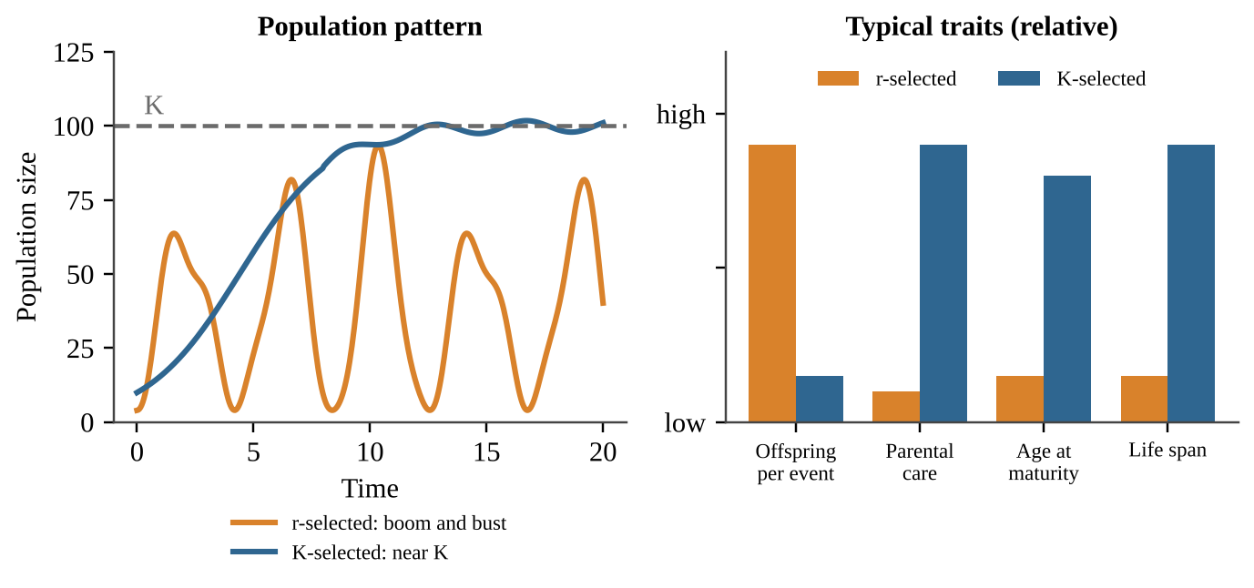
Figure 3.1 — r-selected populations tend to boom and bust, while K-selected populations settle near carrying capacity. The traits on the right are relative, not exact.
Biotic potential and the real world
Biotic potential is the maximum reproductive rate of a population under ideal conditions: unlimited food, no predators, no disease. A bacterium has an enormous biotic potential; an elephant has a tiny one. Biotic potential is almost never reached in nature because environmental resistance (limited resources, predators, disease) holds populations back.
Most real species fall between the two extremes, and many change strategy with conditions. A sea turtle lives a long time (K-like) but lays more than a hundred eggs (r-like). A tree may produce seeds in huge numbers but then live for centuries. Always describe a species by its tendencies, not as a perfect r or K.
Invasive species
Most invasive species are r-selected: they reproduce quickly, spread widely, and tolerate disturbance. They tend to hit K-selected natives hardest, because K-selected species reproduce slowly and cannot replace losses quickly. An island's slow-breeding native bird, for example, is hurt far more by introduced rats than the rats' own fast-breeding relatives would be. r-selected natives are minimally affected because they rebound quickly.
KEY DEFINITIONS
r-selected species — small, many offspring, little investment per offspring, early maturity, short life, often reproduce once; usually low competition. K-selected species — large, few offspring, high investment, late maturity, long life, reproduce repeatedly; usually high competition. Biotic potential — the maximum reproductive rate of a population in ideal conditions.

COMMON STUDENT MISTAKES
• r and K are tendencies on a spectrum. Do not claim "all large animals are K and all small animals are r" without checking the traits.
• "r-selected" does not mean "inferior." Their strategy succeeds in unstable, disturbed habitats.
• Do not confuse K the strategy with K the carrying capacity. They are connected (K-selected species live near K) but they are not the same thing.

AP EXAM STRATEGY
On the exam, answer "compare" prompts with a trait pair, such as "r-selected species produce many offspring while K-selected species produce few." A list of traits with no comparison earns less credit than one clear contrast per trait.

CLASSROOM EXAMPLE SG-U3-E002
A biologist records the following about three species. Species P: adult mass 2 g, 400 eggs per season, matures at 3 months, lives about 1 year. Species Q: adult mass 4,500 kg, one calf every 3 years, matures at 12 years, lives 60 years. Species R: adult mass 25 kg, 2 pups per year, matures at 2 years, lives 12 years. (a) Classify P and Q as r-selected or K-selected, citing two traits each. (b) State which of P and Q would be more severely harmed by an aggressive invasive predator and explain why. (c) Explain why R is difficult to classify as purely r or purely K.

Ranking biotic potential and predicting recovery
To rank species by biotic potential, weigh three traits together: more offspring per reproductive event, an earlier age at first reproduction, and a shorter time between generations. A mouse that breeds at 2 months can add many generations in a year; a whale that first breeds at 10 years cannot. Large body size and long life add nothing to reproductive speed. The same logic predicts recovery: after hunting or a disaster removes 30% of a population, an r-selected species rebounds within a few seasons, but a K-selected species needs many years. Slow breeders are the most vulnerable to overharvest and to invasive predators.
QUICK CONCEPT SUMMARY
• r-selected: small, many offspring, early maturity, short life; K-selected: large, few offspring, late maturity, long life.
• Biotic potential is the maximum reproduction rate under ideal conditions.
• Many species mix strategies; most invasive species are r-selected and K-selected natives suffer most.

Topic 3.3 — Survivorship Curves
LEARNING OBJECTIVES
• Explain what a survivorship curve shows.
• Distinguish Type I, Type II and Type III curves.
• Connect survivorship type to r- and K-selection.

CONCEPT MADE SIMPLE
Follow 1,000 newborns of one species. Draw a graph of how many are still alive at each age. If most live long and die old, you get Type I. If death strikes evenly at every age, Type II. If most die very young, Type III.

A survivorship curve displays the relative survival of a cohort (a group of individuals born at the same time) from birth to the greatest age reached by any member. The x-axis is age, often as a percent of maximum life span so species can be compared. The y-axis is the number (or percent) of the cohort still alive, commonly on a log scale so that a drop from 1,000 to 10 survivors is as visible as a drop from 100 to 1.
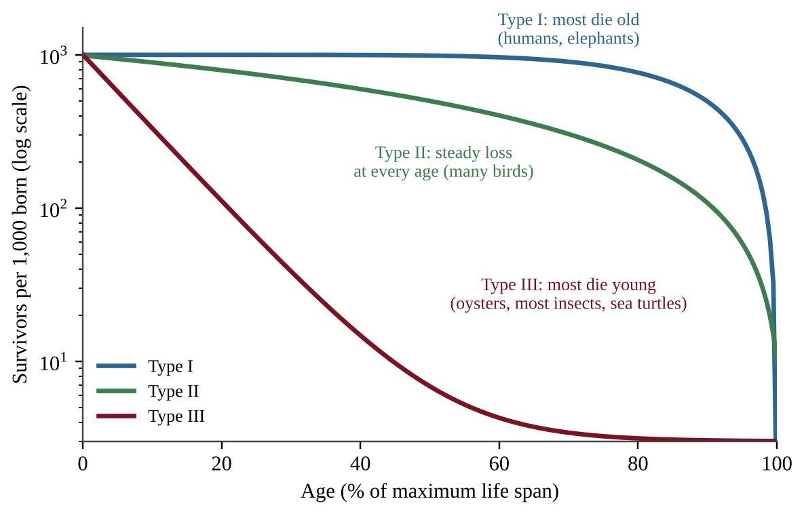
Figure 3.2 — The three survivorship curves. The y-axis is logarithmic, so equal vertical distances mean equal percentage losses.
Type | Shape | Pattern of death | Typical species and strategy
I | Flat early, then drops steeply late | Low death at young and middle ages; most die in old age | Humans, elephants, large mammals (K-selected); heavy parental care
II | Straight diagonal line | Roughly constant chance of dying at every age | Many songbirds, some lizards and rodents (intermediate)
III | Steep early drop, then flat | Very high death of the young; survivors often live long | Oysters, most fish, insects, sea turtles, weeds (r-selected); many offspring, little care

Reading the curve
Steepness tells you where deaths happen. A steep section means many individuals are dying in that age range. A flat section means few are dying. Type III species compensate for massive early losses by producing huge numbers of offspring, so a few survive. Type I species produce few offspring but protect each one, so most reach adulthood. The link is cause and effect: high parental investment → high juvenile survival → Type I; low investment → high juvenile mortality → Type III.
FORMULA & MATH SKILL
Percent surviving to age x = (number alive at age x ÷ number in starting cohort) × 100 Variables: number alive and cohort size are counts of individuals; the result is a percent. Number dying in an interval = survivors at start of interval − survivors at end of interval.

COMMON STUDENT MISTAKES
• The curve shows survival, not population size. A Type III curve does not mean the population is shrinking.
• Do not say Type III species "live short lives." Many survivors live long. The point is high mortality when young.
• On a log scale, a straight line means a constant percent loss per time step, not a constant number lost.

AP EXAM STRATEGY
First locate where the curve is steepest, then name the life stage (young, middle, old), and finally name the type. Support it with a number read from the graph. For example: "Only 8% survive to 10% of maximum age, so most deaths occur in the young."

CLASSROOM EXAMPLE SG-U3-E003
A researcher follows a cohort of 800 tree-frog eggs. Survivors at the end of each age: age 0: 800; age 1 year: 160; age 2 years: 80; age 4 years: 40; age 8 years: 20. (a) Calculate the percent of the cohort that survives to age 1 year. (b) Calculate how many individuals die between age 1 and age 2. (c) Identify the survivorship type and state whether the species is more likely r-selected or K-selected, giving a reason based on the data.

Working from a survivorship table
Tables list survivors at chosen ages. Convert each count to a percent of the starting cohort (survivors ÷ cohort × 100); the percent that died before an age is 100 minus that. Then compare the percent lost in each interval, not the raw number. If the ages are unevenly spaced (0, 1, 2, 4, 8 years), divide each loss by the length of its interval before comparing yearly rates. Decision rule: most of the cohort gone in the first interval, then slow loss means Type III; almost no loss until late, then rapid loss means Type I; about the same percent lost in every equal interval means Type II.
QUICK CONCEPT SUMMARY
• A survivorship curve tracks a cohort from birth to maximum age.
• Type I (K-selected, much parental care), Type II (steady mortality), Type III (r-selected, high juvenile mortality).
• Steepness shows when most deaths occur.

Topic 3.4 — Carrying Capacity
LEARNING OBJECTIVES
• Describe carrying capacity (K).
• Describe overshoot and its environmental impacts, including resource depletion and dieback.

CONCEPT MADE SIMPLE
A lake can feed only so many ducks. Carrying capacity (K) is the largest population an environment can support indefinitely with its food, water, space and other resources. Push past it and the habitat gets damaged, and the population then crashes.

K and the S-curve
When a few individuals enter a new, resource-rich area, the population first grows slowly, then rapidly, then levels off near K. The graph is an S-shaped (logistic) curve. With no limits, growth would follow a J-shaped (exponential) curve, climbing faster and faster. Real populations may follow a J-curve briefly, but limiting factors always bend it into an S or into a boom-and-bust pattern.
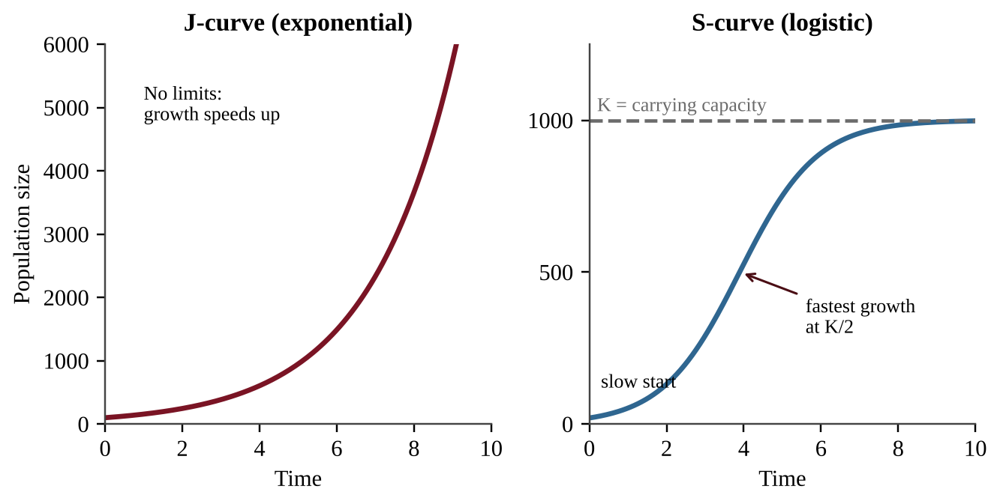
Figure 3.3 — Left: unlimited exponential growth (J-curve). Right: growth limited by resources (S-curve) leveling at carrying capacity K.
Carrying capacity is not a fixed number. It changes when conditions change: a wet year increases plant growth and raises K for deer, a drought or a pollutant lowers it, and a new competitor can reduce it for the original species.
Overshoot and dieback
Overshoot happens when a population exceeds K. Often the population keeps growing for a time after resources start to run short because of a time lag: births that were already underway, long-lived adults, and slow feedback. During overshoot the population consumes resources faster than they regenerate, so the habitat is damaged: vegetation is overgrazed, soil erodes, water and prey are depleted. The result is dieback (also called a population crash), a sharp, often severe decline caused by famine, disease or conflict. Because habitat was damaged, the new carrying capacity may be lower than the old one, and the population may oscillate around K or take a long time to recover.
PROCESS & CAUSE-AND-EFFECT
Population is below K → resources plentiful → population grows (S-curve rising) Population exceeds K (overshoot) → resource use > resource renewal → resource depletion and habitat damage Resource shortage → famine, disease, conflict → dieback → population falls to or below K (K may be lower)

KEY DEFINITIONS
Carrying capacity (K) — the maximum population size an environment can sustain over the long term with available resources. Overshoot — a population exceeding K. Dieback — a severe decline of a population after overshoot due to resource shortage.

REAL-WORLD EXAMPLE
A small number of goats is released on a rocky island with sparse grass. The herd grows quickly for years, eats nearly all the ground cover, and then starves in a dry summer. The remaining hillside is bare and erodes in winter storms, so a smaller herd could be supported afterward. Overshoot, dieback and a lowered K occurred in one story.

COMMON STUDENT MISTAKES
• K is not "the number of births." It is a ceiling set by resources.
• K is not permanent. A question that says "K changed" is not a contradiction.
• Overshoot does not instantly cause dieback; the lag allows a population to overshoot before the crash.

CLASSROOM EXAMPLE SG-U3-E004
Deer were introduced to a 25 km² island. Population counts: year 0: 30; year 2: 80; year 4: 190; year 6: 330; year 8: 430; year 10: 480; year 12: 495; year 14: 500; year 16: 500. (a) Estimate the carrying capacity and calculate the population density at that size in deer per km². (b) Identify which two-year interval had the greatest increase in number of deer, and show the calculation. (c) Explain, in terms of resources, why growth slowed after year 8.

CLASSROOM EXAMPLE SG-U3-E005
On a small island, the forage supports a carrying capacity of 300 goats. Goats are released and the herd grows to 560 before a severe drought. Afterward the herd falls to 140. (a) Calculate by what percent the herd exceeded carrying capacity at its peak. (b) Name the term for the decline from 560 to 140. (c) Explain two environmental impacts of the overshoot and one reason the new carrying capacity might be below 300.

What holds a population at K
At low density each individual finds plenty to eat, so the per-capita birth rate (births per individual per year) is high and the per-capita death rate is low. As density rises, competition, disease and stress push births down and deaths up; these are density-dependent effects. The population grows while births per individual exceed deaths per individual, stops growing where the two are equal, and shrinks beyond that. That density is K.
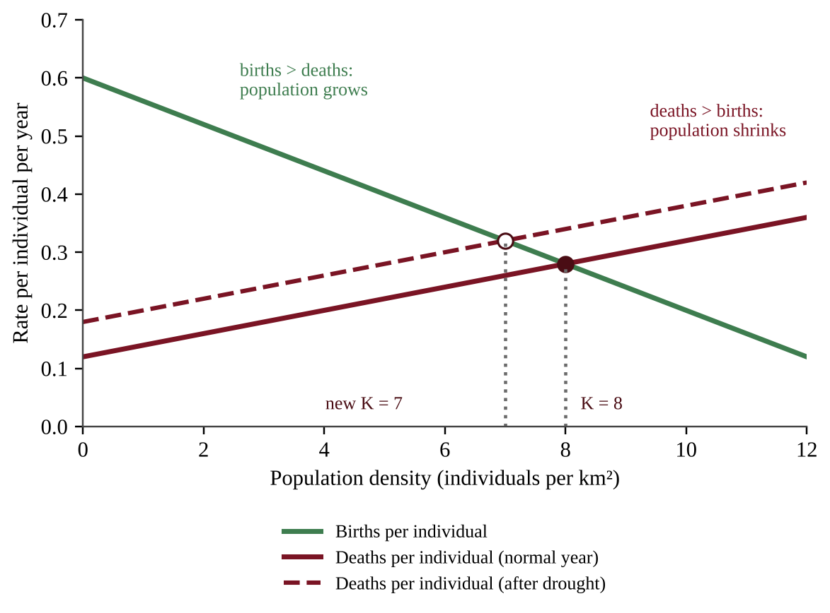
Figure 3.4 — Per-capita birth and death rates change with density. K lies where the lines cross. Extra mortality (dashed) moves the crossing to a lower density, so K falls.
Finding K from a table. Look for the density where the birth and death values are equal. If no row matches, find the two rows where births switch from above deaths to below them; with straight-line trends, K lies between them, in proportion to the gaps (a gap of +0.10 at density 6 and −0.10 at density 8 crosses at 7). A stress that raises deaths or lowers births at every density moves the crossing to the left, so K falls; more food or shelter moves it right, so K rises.
Predators and prey
Predation is a density-dependent limit. When prey are plentiful, predators eat well and increase; more predators remove more prey; prey decline; predators then go hungry and decline; prey recover. This is a negative feedback loop. It often produces linked cycles in which the predator peak comes after the prey peak, because predators need time to breed.
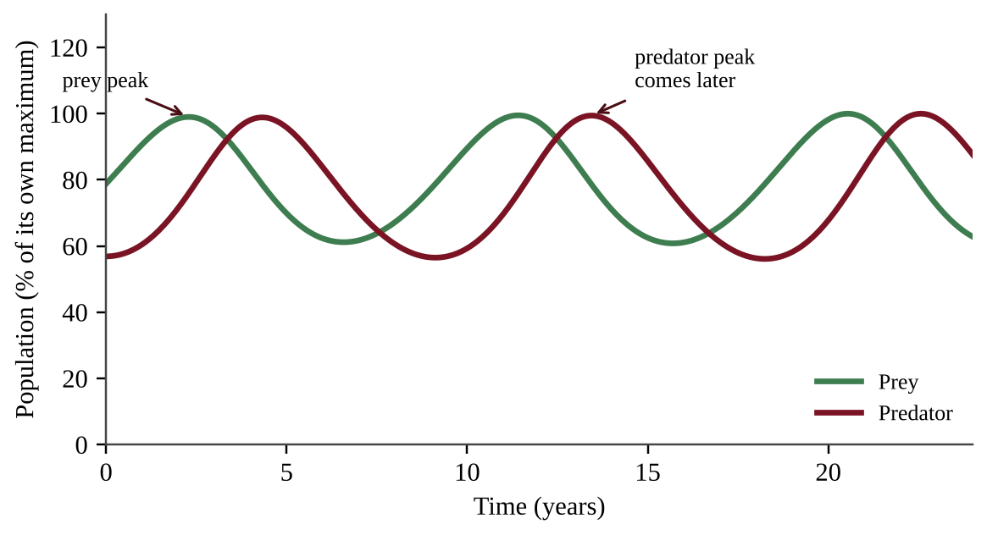
Figure 3.5 — Predator and prey cycles. The predator peak lags behind the prey peak.
In a census table, find the prey peak first, then the predator peak; the predator column trails. A prey decline that follows a predator rise is predation, not necessarily overshoot of the prey's own K.
Reading growth graphs and tables
• On a labeled graph: the steep early climb is the exponential phase (resources abundant); the dashed line is K; a peak above it is overshoot; the low point after the peak is the dieback; a later plateau is the new K.
• In a census table, the greatest increase is the largest difference between consecutive counts. If the gaps differ, divide by the years to compare yearly change. Percentage growth is usually highest very early, when N is small, even though the largest numerical gain comes near K/2.
• Estimate K as the plateau.
CLASSROOM EXAMPLE SG-U3-E013
A vole population was sampled at five densities (voles per hectare): 2, 4, 6, 8, 10. Births per vole per year: 0.70, 0.58, 0.46, 0.34, 0.22. Deaths per vole per year: 0.30, 0.38, 0.46, 0.54, 0.62. (a) Identify the carrying capacity and explain your reasoning. (b) Calculate the net change per vole per year at 4 voles per hectare and state whether the population is growing or shrinking there. (c) A disease raises deaths by 0.05 per vole per year at every density. Estimate the new carrying capacity by straight-line interpolation and state the direction of the change.

CLASSROOM EXAMPLE SG-U3-E014
Census counts on a prairie. Year: 0, 2, 4, 6, 8, 10. Rabbits: 900, 1,500, 1,100, 600, 800, 1,400. Foxes: 40, 60, 90, 70, 40, 55. (a) Identify the years of the rabbit peak and the fox peak and state the lag. (b) Explain the lag in terms of fox reproduction and food supply. (c) Calculate the percent decrease in rabbits from year 2 to year 6. (d) Name the type of feedback loop and state whether predation is density-dependent or density-independent.

QUICK CONCEPT SUMMARY
• K is the maximum population an environment can support long term; it can change.
• J-curve is unlimited growth; S-curve levels at K.
• Overshoot → resource depletion → dieback from famine, disease or conflict.

Topic 3.5 — Population Growth and Resource Availability
LEARNING OBJECTIVES
• Explain how resource availability affects population growth.
• Apply mathematical relationships (percent change, growth rate, logistic growth) with work shown.

CONCEPT MADE SIMPLE
Food, water and space are a bank account. When the account is full, a population spends freely and grows faster and faster. When the account shrinks, there is not enough to go around, and the population stops growing or shrinks.

The logic of limits
Population growth is limited by environmental factors, above all the available resources and space. These resources are finite at every scale of time: a year's rain, a lake's fish, an island's soil. When resources needed for growth are abundant, growth usually accelerates. When the resource base shrinks, resources are shared unequally: some individuals get enough and others do not. The result is higher mortality, lower fecundity (fewer offspring), or both, so growth falls to or below carrying capacity.
Math: growth and percent change
FORMULA & MATH SKILL
Percent change = [(final value − initial value) ÷ initial value] × 100 Average annual growth rate (%) = percent change ÷ number of years Variables: values are numbers of individuals; time in years; the answer is in % per year. Example setup (not a problem): 400 → 450 in 5 years gives (50 ÷ 400) × 100 = 12.5% total, 2.5% per year.

Math: logistic growth
In a limited environment the speed of growth depends on how much room is left. The idea of the logistic model is that the growth rate is the unlimited rate multiplied by the fraction of capacity still open:
FORMULA & MATH SKILL
Population change per time (dN/dt) = r × N × [(K − N) ÷ K] N = current population (individuals); K = carrying capacity (individuals); r = per-capita rate of increase under ideal conditions (per year); dN/dt = individuals added per year. When N is small, (K − N) ÷ K ≈ 1, so growth is nearly exponential. When N = K/2, growth is fastest. When N = K, growth is 0. When N > K, growth is negative.

Reading a growth graph. On an S-curve the steepest part (the fastest addition of individuals) occurs about halfway to K, not at K. Above K the curve falls, which is a sign of overshoot. If a graph shows the population falling after peaking far above a dashed K line, say "overshoot followed by dieback."
COMMON STUDENT MISTAKES
• Do not say the fastest growth is "at K." The fastest growth in numbers is near K/2.
• Percent change uses the initial value in the denominator, not the final value.
• A population that is still growing may be growing at a slower rate. Rate and size are different things.

AP EXAM STRATEGY
Write the formula, substitute with units, calculate, and put a unit on the answer. Partial credit depends on visible work, and calculators are allowed, so there is no reason to skip steps.

CLASSROOM EXAMPLE SG-U3-E006
A lake's carrying capacity for a fish species is K = 2,000 fish, and the species' per-capita rate of increase is r = 0.40 per year. Use dN/dt = r × N × (K − N) ÷ K. (a) Calculate the yearly population change when N = 500, when N = 1,000, and when N = 1,900. (b) State at which of these sizes growth is fastest and explain why growth is slowest of the three at 1,900. (c) Calculate dN/dt when N = 2,600 and interpret the sign of your answer.

Exponential growth and projecting forward
Exponential growth means a constant percentage increase each period, so the population takes the same time to double again and again (the J-curve). Linear growth adds a constant number each period. Growth at biotic potential is exponential. To project forward, count doublings: doublings = years ÷ doubling time, and N = N₀ × 2^doublings. A population of 3 million growing 1.4% per year doubles in 70 ÷ 1.4 = 50 years and reaches 12 million after 100 years (two doublings). For a decline of p%, final = initial × (1 − p ÷ 100).
Resource budget: carrying capacity from supply and need
When one resource is the limit, carrying capacity is a division, and human demand is a multiplication.
FORMULA & MATH SKILL
K = total resource supplied per year ÷ amount one individual needs per year Percent over capacity = (N − K) ÷ K × 100 Demand = population × need per person Shortfall = demand − supply (a positive answer is a deficit) Convert units first: per day → per year (× 365), kg → metric tons (÷ 1,000). Supply and demand must share one unit.

K changes in proportion to the supply: 25% less forage means 25% fewer animals can be fed.
Designing an investigation
• Hypothesis: an if–then statement with a direction, such as "If nitrate is added to tanks, then the algae population will reach a larger plateau."
• Independent variable: the one factor you change. Dependent variable: what you measure (a count, a birth rate). Controlled variables: everything else held equal (light, temperature, container size, starting number).
• Control group: an untreated group for comparison.
• Replicates: several units per treatment, so chance differences average out. This improves reliability. Assigning treatments at random and changing only one factor improves validity. Count at regular intervals and long enough to see the plateau.
• Supporting results: treated groups plateau higher than the control. Small-scale results may not scale to a whole lake.
CLASSROOM EXAMPLE SG-U3-E015
A pasture yields 240,000 kg of usable forage per year, and one sheep needs 600 kg per year. A farmer keeps 520 sheep. (a) Calculate K. (b) Calculate by what percent the flock exceeds K. (c) A drought cuts forage by 25%. Calculate the new K and the number of sheep that must be removed. (d) A town of 80,000 people eats 0.45 kg of rice per person per day and its farms supply 12,000 metric tons per year. Calculate the annual demand in metric tons and the shortfall.

CLASSROOM EXAMPLE SG-U3-E016
A student suspects that phosphorus limits a green alga in a pond. She has 12 identical clear tanks, pond water, a phosphorus solution and a light bank. (a) Write an if–then hypothesis. (b) Identify the independent and dependent variables and two controlled variables. (c) Describe the treatment and control groups, how many tanks each gets, and why. (d) State the results that would support the hypothesis and one reason the result might not apply to the whole pond.

QUICK CONCEPT SUMMARY
• Abundant resources → accelerating growth; shrinking resource base → higher mortality and lower fecundity → growth falls toward or below K.
• Percent change = (final − initial) ÷ initial × 100.
• Logistic growth: dN/dt = rN(K − N)/K; fastest at K/2, zero at K, negative above K.

Topic 3.6 — Age Structure Diagrams
LEARNING OBJECTIVES
• Explain how to read an age structure diagram.
• Use the shape to infer growth rate and the proportion of young people.

CONCEPT MADE SIMPLE
An age structure diagram (population pyramid) stacks bars for each age group, males on one side, females on the other. A wide base means lots of children: the population will grow. A narrow base means few children: the population will shrink.

Each horizontal bar shows the number or percent of people in an age band. The population is often split into three groups: pre-reproductive (under 15), reproductive (about 15–44), and post-reproductive (45 and older). The shape predicts where the population is heading, because today's children become tomorrow's parents.
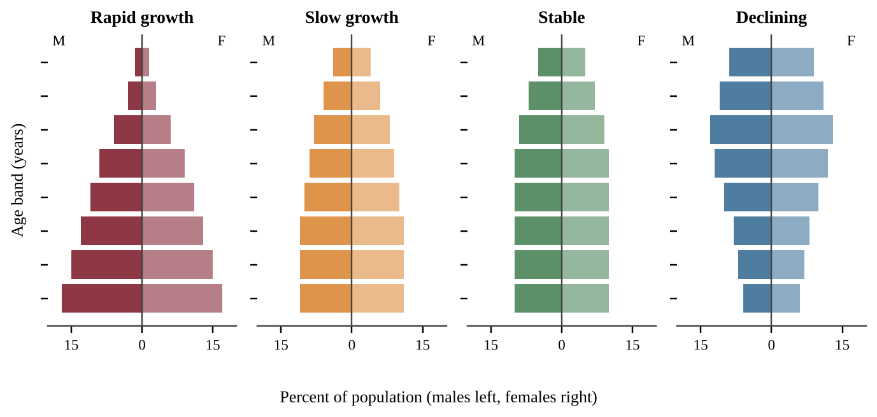
Figure 3.6 — Age structure diagrams for four patterns. Each bar is a 10-year age band; males on the left, females on the right.
Shape | What it means | Proportion of young
Wide base, narrowing quickly (triangle) | Rapid growth: many children will become parents | Highest
Wider at base, gentle taper | Slow growth | Moderate
Nearly vertical sides | Stable, near zero growth | Lower
Narrow base, bulge in middle or top | Declining population | Lowest

A rapidly growing population has a higher proportion of young people than a stable or declining one. This produces population momentum: even if each family chose to have fewer children, the population keeps growing for decades because so many young people are about to enter their reproductive years.
Reading tips: a bulge in the middle ages (a "baby boom") will move upward over time; a sudden narrow band shows a past drop in births, a famine, a war or an epidemic. A pyramid with a narrow base and a large top predicts a rising proportion of elderly people and fewer workers.
KEY DEFINITIONS
Age structure diagram — a graph of the number or percent of a population in each age group, split by sex. Pre-reproductive / reproductive / post-reproductive — age groups before, during and after the child-bearing years. Population momentum — continued growth caused by a large young group entering reproductive age even after fertility falls.

COMMON STUDENT MISTAKES
• A pyramid does not show growth over time on its own; it shows the current structure from which you infer the trend.
• Do not read the width of the top bars for growth. The base (young ages) predicts growth.
• Do not confuse "high proportion of young" with "high death rate." A shape alone does not give either rate.

AP EXAM STRATEGY
Describe the shape first ("wide base, sharply tapering"), then state the inference ("rapid growth because many young will reproduce"), then give a consequence (schools, jobs, health care).

CLASSROOM EXAMPLE SG-U3-E007
The table gives the percent of each country's population in three age groups.
Country | Under 15 | 15–44 | 45 and over
A | 41 | 40 | 19
B | 25 | 41 | 34
C | 13 | 36 | 51

(a) Identify which country is growing fastest and which is most likely declining, and justify each using the data. (b) Explain what population momentum means and name the country where it is strongest. (c) Describe one challenge that Country C's age structure is likely to create.

Adding bars and comparing ratios
To find the largest age range, add the bars in each range; several narrow bars can outweigh one wide bar. The support ratio is people aged 15–64 ÷ people aged 65 and older. A falling ratio means fewer workers for each older person, which strains pensions and health care. A stable age distribution means the proportion in each age group stays constant over time; the whole population may still grow or shrink, as long as every group changes by the same percent. A straight-sided (columnar) diagram with similar young and middle bars indicates near-replacement fertility.
CLASSROOM EXAMPLE SG-U3-E017
Percent of population by age. Country P: under 15, 36; 15–64, 59; 65 and older, 5. Country Q: under 15, 14; 15–64, 66; 65 and older, 20. (a) Calculate the support ratio for each country. (b) State which country faces greater pension and health-care strain and explain why. (c) Describe the shape of each country's diagram and state which has the greater population momentum.

QUICK CONCEPT SUMMARY
• The base of a diagram predicts growth: wide = rapid growth, narrow = decline.
• Rapidly growing populations have a higher proportion of young people.
• Population momentum keeps populations growing after fertility drops.

Topic 3.7 — Total Fertility Rate
LEARNING OBJECTIVES
• Explain the factors that affect total fertility rate (TFR).
• Explain replacement-level fertility and the factors that affect infant mortality.

CONCEPT MADE SIMPLE
Total fertility rate is the average number of children a woman would have in her lifetime if she lived through all her childbearing years at today's age-specific birth rates. A TFR of about 2.1 is "replacement," because it just replaces the parents (and allows for some children who die before adulthood).

What the numbers mean
Replacement-level fertility is about 2.1 children per woman in countries with low infant mortality. The extra 0.1 covers children who die young and the slightly higher number of boys than girls born. In places with high infant mortality, replacement is higher, because more children are needed to ensure two survive to adulthood. If TFR is at replacement level, the population is considered relatively stable (ignoring migration, and with a lag because of momentum). Above it the population grows; below it the population eventually shrinks.
FORMULA & MATH SKILL
Total fertility rate (TFR) = (sum of age-specific fertility rates for all age groups) × (width of age group in years) ÷ 1,000 Age-specific fertility rate = births per 1,000 women in that age group per year; for 5-year groups, width = 5. TFR is in children per woman. Infant mortality rate (IMR) = (deaths of infants under 1 year ÷ live births) × 1,000, in deaths per 1,000 live births.

Factors that lower TFR
• Age at first child. When women have their first child later, they have fewer years to bear children and tend to have fewer overall.
• Educational opportunities for females. Educated women gain job options and delay marriage and childbirth.
• Access to family planning. Contraception and information let families choose the number and timing of children.
• Government acts and policies. Examples include incentives or penalties, family-planning programs, and laws on marriage age or women's rights.
Infant mortality
Infant mortality falls when mothers have access to good healthcare (prenatal care, safe delivery, vaccines) and good nutrition, and when families have clean water and sanitation. When infant mortality falls, families no longer need many births to ensure survivors, and fertility tends to fall after a lag. In a rapidly growing country with high IMR, improving maternal health care can reduce both.
COMMON STUDENT MISTAKES
• TFR is not the number of babies per 1,000 people. That is the crude birth rate.
• TFR of 2.1 does not instantly stop growth, because of momentum.
• Replacement level is not exactly 2 and is higher where infant mortality is high.

CLASSROOM EXAMPLE SG-U3-E008
In Country Z, age-specific fertility rates (births per 1,000 women per year) are: ages 15–19: 10; 20–24: 70; 25–29: 105; 30–34: 85; 35–39: 40; 40–44: 8; 45–49: 0. (a) Calculate the total fertility rate, using 5-year age groups. (b) Compare it with the replacement level of 2.1 and state whether, ignoring migration, the long-term population is likely to grow, stay stable or decline. (c) Describe two factors that could change Country Z's TFR and the direction each would push it.

Very low fertility and policy responses
TFR can fall far below 2.1 where housing and child-rearing are costly, women have wide education and career options, and urban life, late marriage and late first births are the norm. Such countries face a shrinking workforce and a rising share of older people. Governments may adopt pro-natalist policies that encourage births (child allowances, paid parental leave, priority housing or tax breaks for larger families) or anti-natalist policies that discourage them (family-planning programs, schooling for girls, financial penalties for larger families). Adding an incentive for more children raises TFR; removing one lowers it.
Association is not causation
A table or scatter plot may show TFR falling as girls' schooling rises. That is a negative association. It supports "countries with more schooling tend to have lower TFR." It does not prove that schooling alone caused the fall, because contraceptive access, income, urbanization and infant survival usually change at the same time. It gives no exact effect per percentage point and no prediction beyond the data range. Use "associated with" and "tends to." Statements with "always," "every" or "directly causes" are usually wrong unless an experiment controlled the other factors.
QUICK CONCEPT SUMMARY
• TFR is children per woman; about 2.1 is replacement.
• Lower TFR is linked with later first births, female education, family planning and policy.
• Infant mortality falls with healthcare and nutrition, and lower infant mortality contributes to lower fertility.

Topic 3.8 — Human Population Dynamics
LEARNING OBJECTIVES
• Explain how human populations grow and decline through births, deaths, immigration and emigration.
• Describe density-dependent and density-independent limiting factors and Malthusian limits.
• Calculate rate of natural increase, growth rate and doubling time.

CONCEPT MADE SIMPLE
A population is like a bathtub. Births and immigrants are water coming in; deaths and emigrants are water going down the drain. If more comes in than leaves, the level rises. The only questions are how fast and for how long.

The four inputs
Human population growth or decline is controlled by four rates: birth, death, immigration and emigration. Birth and death rates are strongly affected by access to education, family planning, healthcare and nutrition.
FORMULA & MATH SKILL
Rate of natural increase (RNI, %) = (crude birth rate − crude death rate) ÷ 10 CBR and CDR are births and deaths per 1,000 people per year; dividing by 10 converts per 1,000 to percent. Population growth rate (%) = [(births + immigrants) − (deaths + emigrants)] ÷ starting population × 100 or = (CBR − CDR + immigration rate − emigration rate) ÷ 10, with every rate per 1,000 per year. Doubling time (years) ≈ 70 ÷ annual growth rate (%) (the Rule of 70)

The Rule of 70 is an estimate. A growth rate of 2% gives about 35 years to double; 1% gives about 70 years; 3.5% gives about 20 years. After one doubling the population is 2× the original; after two doublings, 4×; after three, 8×. Note that RNI ignores migration, so a country can have a high RNI but a lower total growth rate if many people leave.
Limits to human population
Carrying capacity of Earth. Earth's resources (food, fresh water, energy, space, a stable climate) are finite, so human population ultimately has a limit, though technology, diet and consumption level change where that limit lies.
Malthusian theory. Thomas Malthus argued that population grows geometrically (like 2, 4, 8, 16) while food production grows only arithmetically (like 2, 4, 6, 8). Eventually population outruns food and is held back by famine, disease and war (and, he argued, by restraint). Modern technology has delayed these limits for humans, but the basic idea, that growth in numbers cannot continue forever on finite resources, remains central to the debate.
Density-dependent and density-independent factors
Kind | Effect depends on population density? | Examples
Density-dependent | Yes; stronger when crowded | Competition for food, clean water and air, disease transmission, territory size, predation
Density-independent | No; hits regardless of size | Major storms, fires, heat waves, droughts, floods

A crowded city is more likely to see a fast-moving epidemic (density-dependent), but a hurricane harms a village and a city equally per person (density-independent). Density-dependent factors tend to regulate populations near K, while density-independent events can cause sudden crashes at any size.
KEY DEFINITIONS
Crude birth rate (CBR) — births per 1,000 people per year. Crude death rate (CDR) — deaths per 1,000 people per year. Rate of natural increase (RNI) — CBR minus CDR, usually expressed as a percent. Doubling time — years for a population to double at a constant growth rate. Density-dependent factor — a limit whose strength changes with population density. Density-independent factor — a limit that acts regardless of density.

COMMON STUDENT MISTAKES
• Forgetting to convert per 1,000 to percent: a difference of 20 per 1,000 is 2.0%, not 20%.
• Putting growth rate as a decimal in 70 ÷ r. Use the percent number (2, not 0.02).
• Mixing RNI with total growth: RNI ignores migration.

AP EXAM STRATEGY
In a calculation FRQ, label each step with its unit (people per year, %, years). Use dimensional analysis: write units in the setup so they cancel to the unit asked for.

CLASSROOM EXAMPLE SG-U3-E009
A coastal town has 25,000 residents at the start of a year. During the year there are 400 births, 250 deaths, 300 people moving in and 150 people moving out. (a) Calculate the town's population growth rate as a percent for the year. (b) Use the Rule of 70 to estimate the doubling time. (c) Identify whether the town's growth in this year came mostly from natural increase or from net migration, and show the two numbers you compared.

CLASSROOM EXAMPLE SG-U3-E010
Country M has a crude birth rate of 28 per 1,000, a crude death rate of 8 per 1,000 and an emigration rate of 1.5 per 1,000 per year. Immigration is negligible. (a) Calculate the rate of natural increase as a percent. (b) Calculate the overall population growth rate as a percent. (c) Calculate the doubling time using the overall growth rate and state how many times larger the population would be after three doubling times. (d) Classify an earthquake and an increase in disease transmission as density-independent or density-dependent factors.

Testing for density dependence
A factor is density-dependent if its rate changes with density. Compare rates, not totals: percent infected, deaths per individual, eggs per female. Percent infected rising with density, or eggs per female falling as density rises, shows density dependence. A flood that kills about the same percent at every density is density-independent.
Numbers times appetite
Environmental impact depends on how many people there are and how much each uses: total use = population × use per person. Slowing population growth does not end resource concerns if rising incomes raise per-person consumption.
CLASSROOM EXAMPLE SG-U3-E018
Hares in four meadows. Density (hares per hectare): 5, 10, 20, 40. Percent infected with a parasite: 4, 9, 18, 37. Percent killed by a spring flood: 12, 11, 13, 12. (a) Identify which factor is density-dependent and which is density-independent, citing the rates. (b) Explain why the total number of infected hares would be a poor test. (c) Country S has 10 million people each using 8 tons of a resource per year; Country T has 40 million people each using 1 ton. Calculate each country's total use and state which has the larger impact.

QUICK CONCEPT SUMMARY
• Growth depends on births, deaths, immigration and emigration, influenced by education, family planning, healthcare and nutrition.
• RNI = (CBR − CDR) ÷ 10; doubling time ≈ 70 ÷ growth rate (%).
• Malthus: population grows geometrically, food arithmetically; Earth's carrying capacity limits humans.
• Density-dependent factors (disease, food, water, territory) vs. density-independent (storms, fires, heat waves, droughts).

Topic 3.9 — Demographic Transition
LEARNING OBJECTIVES
• Define the demographic transition and describe the four stages of the model.
• Describe characteristics of developing versus developed countries.

CONCEPT MADE SIMPLE
As a country develops, death rates fall first (better food, medicine and sanitation). Birth rates fall later (families adjust). In the gap between, the population surges. The demographic transition model (DTM) tells that story in four stages.

The demographic transition is the shift from high birth and death rates to low birth and death rates as a country moves from a pre-industrial to an industrialized economy. The DTM shows it in four stages.
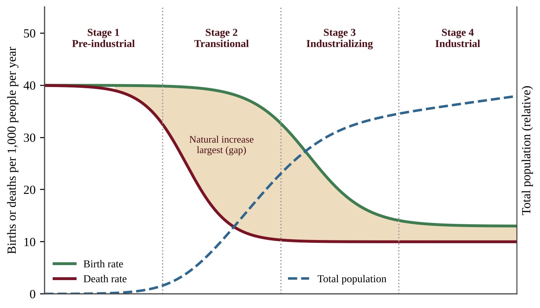
Figure 3.7 — The demographic transition model. The shaded gap between birth and death rates drives population growth; total population (dashed) rises most steeply in Stage 2.
Stage | Birth rate | Death rate | Growth | What is happening
1 Pre-industrial | High | High | Very slow | Famine, disease and poor sanitation; many children die; children help with farm work
2 Transitional | High | Falling fast | Rapid | Better food supply, clean water, medicine; infant mortality drops but families still large
3 Industrializing | Falling | Low | Slowing | Urbanization, women's education and work, family planning, children cost more
4 Industrial | Low | Low | Very slow, near zero or negative | Stable or aging population; TFR near or below replacement

Why death rates fall before birth rates. Public health and food improvements spread quickly because they are cheap and obvious, but family size depends on social and economic change (education, jobs, urban living, cost of children, expectations), and those change over decades. The lag creates Stage 2 growth.
Developing versus developed countries
Developing countries (Stages 2 and early 3) typically have higher infant mortality, more children in the workforce, lower female education, lower income, and a young age structure. Developed countries (Stage 4) have low infant mortality, children in school rather than in the workforce, high education levels and an older age structure. A single country can be placed in the model by comparing its birth and death rates and age structure.
PROCESS & CAUSE-AND-EFFECT
Stage 1: high births and deaths → Stage 2: death rate falls (medicine, sanitation, food), births stay high → population surge Stage 3: birth rate falls (education, family planning, urbanization, women's work) → growth slows Stage 4: low births and deaths → stable, aging population

KEY DEFINITIONS
Demographic transition — the move from high to low birth and death rates as a country industrializes. Demographic transition model (DTM) — the four-stage model describing this shift.

REAL-WORLD EXAMPLE
A country in Stage 2 sees its death rate fall from 30 to 12 per 1,000 after a vaccination campaign and clean-water projects, while its birth rate stays at 38. The RNI jumps from nearly zero to 2.6%. Its schools and cities strain to keep up. Twenty years later, as girls' schooling and family planning spread, the birth rate falls to 22 and the country enters Stage 3.

COMMON STUDENT MISTAKES
• Stage 4 is not zero growth in every country; some have slight growth or decline. Describe it as "very slow, near zero."
• The population is largest in Stage 4, but it is growing fastest in Stage 2.
• Death rate falls first, not birth rate.

AP EXAM STRATEGY
To place a country in a stage, compare the two rates: both high = 1; birth far above death with death falling = 2; birth falling toward death = 3; both low and close = 4. Then check the age structure for agreement.

CLASSROOM EXAMPLE SG-U3-E011
A country reports these rates per 1,000 people per year.
Year | Birth rate | Death rate
1900 | 44 | 41
1930 | 43 | 30
1960 | 38 | 14
1990 | 24 | 9
2020 | 12 | 10

(a) Calculate the rate of natural increase (as a percent) for each year. (b) Assign each year to a stage of the demographic transition model. (c) Identify the year of fastest natural growth and explain the cause of the gap between birth and death rates then. (d) Describe the likely age structure shape in 2020.

CLASSROOM EXAMPLE SG-U3-E012
Country X has 36 million people, a growth rate of 2.8% per year, a total fertility rate of 4.8, an infant mortality rate of 62 per 1,000 live births, and only 28% of girls completing secondary school. (a) Estimate the doubling time and the population after 50 years if the growth rate stayed constant. (b) Identify the stage of the demographic transition model that best fits Country X and justify it with two data values. (c) Propose two policies and explain, for each, how it would lower TFR over time. (d) Explain why the population would probably keep growing for decades even if TFR fell to 2.1 tomorrow.

Placing a country in a stage
Stage names vary between sources: Stage 3 may be called "industrial" and Stage 4 "post-industrial." Rely on the rates. Birth rate falling but still clearly above the death rate, so growth is still positive, is Stage 3. For example, birth 16 and death 5 per 1,000 gives 1.1% growth: Stage 3, even though both numbers look low. Rates both low and nearly equal (growth near zero or negative) is Stage 4. On a graph, read both curves at the year asked, subtract, divide by 10, then apply the Rule of 70.
For quality of life, developed countries typically show long life expectancy, low infant mortality, high literacy and schooling, and high income per person. Developing countries show the reverse. The pair "long life expectancy and low infant mortality" signals better health care, nutrition and sanitation.
CLASSROOM EXAMPLE SG-U3-E019
A country's rates per 1,000: 1950, birth 36, death 20; 1970, birth 33, death 10; 1990, birth 21, death 8; 2010, birth 12, death 9. (a) Plot both rates against year on one graph with labeled axes and scales. (b) Calculate the RNI for 1970 and the doubling time, then give the year the population would double if that rate continued. (c) Assign 1970, 1990 and 2010 to a stage and justify each from the rates.

Math & Skills Toolkit
1. Unit conversions. Per 1,000 → percent: divide by 10. Percent → per 1,000: multiply by 10. Always write units next to numbers.
2. Percent change = (final − initial) ÷ initial × 100. A negative answer means decline.
3. Growth rate from components. Add inputs (births, immigrants), subtract outputs (deaths, emigrants), divide by the starting population, multiply by 100.
4. Rule of 70. Doubling time = 70 ÷ growth rate (%). Use the percent number. For halving of a declining population, divide by the percent decline. Year of doubling = starting year + doubling time.
5. Repeated doubling. After n doubling times the population is N₀ × 2ⁿ. For a constant annual percent rate, N after t years ≈ N₀ × (1 + rate)ᵗ with rate as a decimal.
6. Density = number of individuals ÷ area (individuals per km²). Use the same area unit throughout. With numbers in millions, divide millions by millions (144 million people ÷ 0.14 million km² ≈ 1,000 per km²); write powers of ten explicitly.
7. Reading graphs.
• J-curve: unlimited growth, doubling again and again. S-curve: levels at K. Dashed horizontal line usually marks K.
• Fastest increase on an S-curve is near K/2; any drop after a peak above K means dieback.
• Survivorship: locate steepest drop, name the type, then link to r or K.
• Age structure: read the base first; compare the proportion of young.
• Demographic transition: both rates high, then death rate falls, then birth rate falls; the gap equals growth.
8. Exam routine for calculations. Formula → substitution with units → answer with units → one-sentence interpretation (for example "the population doubles about every 35 years"). Round at the end, and keep two or three significant figures.
9. Plotting data. Put the independent variable (time, density) on the x-axis and the measured variable on the y-axis. Label both axes with units, choose an even scale that uses most of the grid, plot every point, and join the points or draw a smooth curve as directed. Plot two data sets on one grid with a key.
10. Command words. Calculate needs numbers and units. Describe states what the data show. Explain gives a cause-and-effect reason. Justify supports a claim with evidence from the data. Propose a solution names a specific action and its effect.
QUICK CONCEPT SUMMARY
Unit 3 at a glance
• Generalists thrive when habitats change; specialists thrive when habitats are constant.
• r-selected species: small, many offspring, little care, early maturity, short life, Type III survivorship, boom and bust. K-selected: large, few offspring, much care, late maturity, long life, Type I or II, near K. Most invasive species are r-selected; K-selected natives suffer more.
• Carrying capacity (K) is the long-term maximum; overshoot leads to resource depletion and dieback.
• Resources limit growth; abundant resources accelerate it, shrinking resources raise mortality and lower fecundity. Logistic growth: dN/dt = rN(K − N)/K.
• Age structure: wide base = rapid growth; narrow base = decline; momentum persists after fertility falls.
• TFR of about 2.1 is replacement; later first births, female education, family planning and policy lower TFR; healthcare and nutrition lower infant mortality.
• RNI = (CBR − CDR) ÷ 10; doubling time = 70 ÷ growth rate (%); Malthus: geometric population vs. arithmetic food; density-dependent vs. density-independent factors.
• DTM: Stage 1 both high; Stage 2 death rate falls and population surges; Stage 3 birth rate falls; Stage 4 both low.

Unit 4 — Earth Systems and Resources
This unit explains the physical stage on which every other unit is played: the moving crust beneath us, the thin skin of soil we grow food in, the layered air above us, the winds and ocean patterns that spread the sun's energy around the planet, and the geography that bends all of this into local weather and climate. Unit 4 carries 10–15% of the exam. Many of its questions are visual: a map, a diagram, a soil triangle, a temperature profile or a wind-pattern figure. Learn to read pictures and to explain the cause-and-effect chain behind each one.
Topic 4.1 — Plate Tectonics
LEARNING OBJECTIVES
• Describe the geological changes and events at convergent, divergent and transform plate boundaries.
• Use maps of plate boundaries to locate volcanoes, island arcs, earthquakes, hot spots and faults.
• Explain how an earthquake occurs when stress overcomes a locked fault.

CONCEPT MADE SIMPLE
Earth's rigid outer shell is cracked into giant slabs called plates. They ride very slowly (about as fast as your fingernails grow) on hot, soft rock beneath them. Where slabs push together, pull apart or slide past each other, the crust crumples, splits or snaps. Mountains, volcanoes and earthquakes are mostly found along those cracks.

The engine: moving plates
Earth's outer layer, the lithosphere (crust plus the rigid top of the mantle), is broken into about a dozen large plates and many small ones. They float on the hotter, plastic asthenosphere. Heat flowing out of the deep Earth sets up slow convection in the mantle, and together with the pull of cold, dense plate edges sinking back into the mantle, this moves plates a few centimeters per year. Plate boundaries are where almost all geologic activity concentrates, so a map of boundaries is also a map of risk.
Three boundary types
At a convergent boundary two plates move toward each other. What happens depends on the crust involved.
• Oceanic plate meets continental plate. The denser oceanic plate sinks beneath the continental plate in a subduction zone, forming a deep ocean trench. Water released from the sinking slab helps rock above it melt, and the magma rises to build a chain of volcanoes and mountains on the continent (the Andes, the Cascades). Powerful earthquakes occur along the slab.
• Oceanic plate meets oceanic plate. One sinks, forming a trench and a curved chain of volcanic islands called an island arc (Japan, the Aleutians).
• Continental plate meets continental plate. Neither sinks easily, so the crust buckles upward into very high mountains (the Himalayas). Earthquakes are common but volcanoes are rare.
At a divergent boundary plates move apart. Magma rises into the gap and hardens, creating new crust. Under the ocean this is a mid-ocean ridge with seafloor spreading; on land it creates a rift valley (the East African Rift). Volcanoes and shallow earthquakes accompany it.
At a transform boundary plates slide horizontally past each other. Crust is neither created nor destroyed, but friction makes the plates stick, and the result is earthquakes (the San Andreas Fault in California).
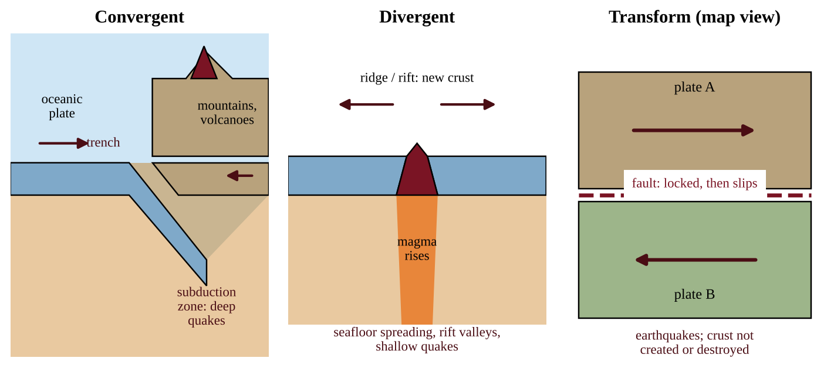
Figure 4.1 — Cross-sections of convergent and divergent boundaries and a map view of a transform boundary
PROCESS & CAUSE-AND-EFFECT
Plate motion → plates lock along a fault and stress (strain energy) builds → stress exceeds the friction holding the fault → sudden slip → stored energy released as seismic waves → shaking at the surface (the epicenter lies directly above the underground focus where slip began).

Earthquakes and their effects
An earthquake occurs when stress overcomes a locked fault, releasing stored energy. Magnitude scales are logarithmic: each whole-number step up is a tenfold larger wave amplitude and about 32 times more energy released. Earthquakes under the sea can displace water and cause tsunamis. Damage depends on magnitude, depth, distance, ground type and construction quality.
Hot spots and reading global maps
A hot spot is a place where a plume of hot rock rises from deep in the mantle, far from any plate edge. The plate drifts over the plume, so volcanoes form in a line: the active volcano sits over the plume and older, extinct ones lie farther along the direction of plate motion (the Hawaiian Islands).
When a question gives a map of plate boundaries, apply a short routine. Volcanoes and earthquakes that trace a long narrow line mark a boundary. A line of volcanoes just inland from a trench points to oceanic–continental subduction; a curved island chain beside a trench points to an island arc. Earthquakes without volcanoes along a straight line point to a transform fault or a continental collision. A volcano far from any boundary suggests a hot spot. The "Ring of Fire" around the Pacific holds most of the world's earthquakes and active volcanoes because so many subduction zones lie there.
What drives the plates, and what depth, speed and tsunamis tell us
Plate motion is powered by heat from Earth's interior (mantle convection and the pull of sinking, cold slabs), not by the Sun. Sunlight drives weather, ocean currents and photosynthesis, but not tectonics.
A sinking slab dips into the mantle at an angle, so near a trench the earthquakes are shallow, and farther inland they occur at greater and greater depth, tracing the slab downward. A graph of earthquake depth against distance from the trench that slopes steadily down to the right is therefore the signature of subduction. A transform fault produces only shallow earthquakes. Rifts and hot spots heat groundwater, giving hot springs and geothermal energy.
An undersea earthquake that suddenly lifts or drops the seafloor displaces the water above it and sends out a tsunami. Where the waves reach shallow coasts they flood land, wash away habitat, and contaminate soil and freshwater with salt and debris.
FORMULA & MATH SKILL
Plate speed = distance between two volcanoes ÷ difference in their ages Age of a farther volcano = its distance from the active volcano ÷ plate speed. The active volcano has age 0. Unit shortcut: 1 km per million years = 0.1 cm per year. Check: 100 km in 2 million years is 50 km per million years, which is 5 cm per year.

CLASSROOM EXAMPLE SG-U4-E011
Three extinct volcanic islands lie along a chain that ends at an active hot-spot volcano. Island P is 140 km from the active volcano and 2.0 million years old; Island Q is 350 km away and 5.0 million years old; Island R is 630 km away and 9.0 million years old. (a) Calculate the plate's speed from the data for Island R, in km per million years and in cm per year. (b) Check your answer with Island P. (c) Predict the age of an island 1,050 km from the active volcano. (d) State which direction the plate is moving relative to the hot spot and explain why the volcanoes are not found at a plate boundary.

REAL-WORLD EXAMPLE
Cities on subduction coasts, such as Seattle or Santiago, face earthquakes, tsunamis and volcanic ash from one process. Planners respond with building codes, tsunami warning sirens, evacuation routes and zoning that keeps hospitals and schools off soft, water-saturated ground. Reading the plate map tells you which hazards to plan for.

COMMON STUDENT MISTAKES
• Saying plates "float on liquid magma." The asthenosphere is solid but flows slowly; most of the mantle is not liquid.
• Saying transform boundaries make volcanoes or new crust. They make earthquakes only.
• Saying all convergent boundaries make volcanoes. Continent–continent collisions build mountains with few or no volcanoes.

AP EXAM STRATEGY
For a boundary question, name three things: the motion (toward, apart, sideways), the landform (trench, ridge, mountains) and the hazard (earthquake, volcano). Use the CED words: island arcs, seafloor spreading, rift valleys, hot spots, faults.

CLASSROOM EXAMPLE SG-U4-E001
A geologist studies three sites. Site 1 is a line of active volcanoes 150 km inland, parallel to a deep ocean trench offshore. Site 2 is a long underwater mountain chain where new basalt is found and the seafloor gets older with distance on both sides. Site 3 is a straight valley where a road has been offset 4 m sideways by an earthquake, with no volcanoes nearby. (a) Identify the type of plate boundary at each site. (b) For Site 2, describe what happens to the plates and name the process that adds new crust. (c) State which site is most likely to produce a tsunami, and justify your choice in one sentence.

QUICK CONCEPT SUMMARY
• Plates move on the asthenosphere; boundaries concentrate quakes and volcanoes.
• Convergent: subduction, trenches, volcanic mountains, island arcs, or collision mountains. Divergent: ridges, seafloor spreading, rift valleys. Transform: earthquakes.
• Hot spots lie inside plates and leave chains of volcanoes.
• An earthquake is stored stress released when a locked fault slips.

Topic 4.2 — Soil Formation and Erosion
LEARNING OBJECTIVES
• Describe how soil forms from parent material by weathering, transport and deposition.
• Describe soil horizons and what distinguishes them.
• Explain how wind and water erode soil and why protecting soil protects water quality.

CONCEPT MADE SIMPLE
Soil is crushed rock mixed with dead plant and animal matter, air, water and living things. It takes hundreds to thousands of years to make a centimeter of it, but one heavy storm can wash it away. Soil also acts like a coffee filter for the water passing through it.

How soil forms
Soil begins as parent material: bedrock or loose sediment. Weathering breaks it down.
• Physical weathering breaks rock without changing its chemistry: freeze–thaw cycles, roots wedging cracks open, temperature swings, abrasion.
• Chemical weathering changes minerals: weak acids in rainwater and from roots, oxidation (rusting) and hydrolysis dissolve and alter them.
• Biological activity (lichens, roots, burrowing animals, microbes) contributes to both and adds organic matter.
Weathered material may stay where it formed (residual soil) or be transported by water, wind, ice or gravity and deposited elsewhere (river floodplains, windblown loess, glacial till). Soil character depends on parent material, climate (warm, wet climates weather quickly), organisms, slope (topography) and time. Humus, the dark, stable end product of decomposition, gives fertile soil its color, crumbly structure and ability to hold nutrients.
Soil horizons
Soils develop layers called horizons that differ in composition and organic content. A vertical cut through all of them is a soil profile.
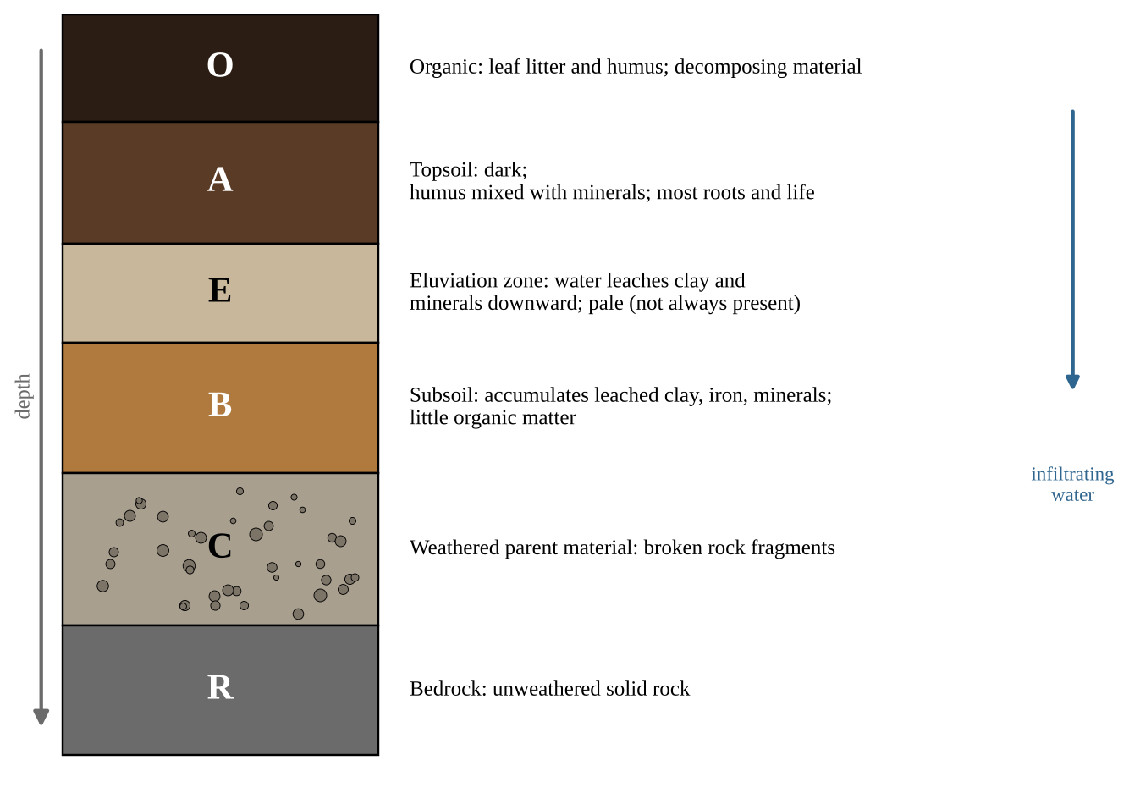
Figure 4.2 — A generalized soil profile with its horizons
Water moving down carries dissolved minerals and fine clay out of the upper layers (leaching or eluviation) and drops them in the B horizon (accumulation). The A horizon is the most biologically active and is what we mean by topsoil. Not every soil has every horizon; young soils and dry-climate soils may lack a distinct E horizon.
KEY DEFINITIONS
Parent material — the rock or sediment from which a soil develops. Weathering — the physical and chemical breakdown of rock into smaller pieces and dissolved minerals. Humus — dark, partly stable organic matter that improves fertility and water retention. Horizon — a layer of soil that differs from those above and below it in composition and organic content. Leaching — the downward removal of dissolved or fine material by percolating water.

Erosion and soil protection
Erosion moves soil particles from one place to another. Wind lifts loose, dry, bare soil (think of the dust storms of the 1930s Great Plains). Water erodes in stages: splash from raindrop impact, sheet erosion in thin layers, rills (small channels) and gullies (deep channels). Erosion is worst on bare, steep, loose soil, and the topsoil is lost first, taking nutrients and organic matter with it.
Eroded soil is not just a farm problem. Sediment, along with attached fertilizer, pesticides and bacteria, ends up in streams, clouding water, smothering fish eggs and fueling algal blooms. Intact soil, in contrast, filters and cleans water: particles trap sediment, humus and clay hold on to many pollutants and nutrient ions, and soil microbes break down some contaminants. Protecting soils therefore protects water quality.
Conservation methods include keeping living cover (cover crops, perennial vegetation), no-till or reduced tillage, contour plowing, terracing steep slopes, strip cropping, windbreaks (rows of trees), and vegetated buffer strips along streams. Each works by slowing wind or water, binding soil with roots, or keeping the surface covered.
What speeds or slows soil formation, and how to measure loss
Climate sets the pace. Warmth speeds chemical weathering and decomposition; cold slows them (freeze–thaw still cracks rock). Moderate to heavy rainfall speeds weathering and plant growth; a very dry climate slows both; torrential rain on a bare slope removes soil faster than it forms. Wind can add particles (loess) or strip them. On brand-new ground, such as cooled lava or bare rock, primary succession starts the process: lichens and mosses release acids that break the rock down, and their remains add organic matter, producing a thin first soil for later plants.
The A horizon has biotic parts (roots, earthworms, fungi, bacteria) and abiotic parts (sand, silt, clay, minerals, water, air). Cropping without returning residue or manure lets organic matter fall, because decomposition continues while inputs stop. Soluble nutrients such as nitrate are not held tightly by soil particles, so fertilizer beyond what crops take up leaches to groundwater or washes into streams. Soils formed on limestone or other carbonate rock neutralize acid rain; soils on granite have little buffering.
FORMULA & MATH SKILL
Net soil change = formation rate − erosion rate (same units, such as t/ha/yr) Total net change = net rate × area (ha) × time (yr) Depth of soil lost = mass lost ÷ (bulk density × area) Bulk density is soil mass per volume (t/m³); 1 ha = 10⁴ m²; multiply meters by 1,000 for mm. Loss is sustainable only if the depth lost per year does not exceed the depth formed per year.

On an erosion graph, compare curves at the same x-value: the higher line has lost more soil.
CLASSROOM EXAMPLE SG-U4-E012
A 25-ha field loses soil at 12 t/ha/yr while new soil forms at 1.0 t/ha/yr. The soil's bulk density is 1.25 t/m³. (a) Calculate the net loss per hectare per year. (b) Calculate the total net loss from the whole field over 30 years. (c) Calculate the depth of soil lost per year, in mm, from the erosion rate. (d) New soil forms at about 0.08 mm per year. Justify whether the erosion is sustainable, and propose one practice to bring it closer to the formation rate.

REAL-WORLD EXAMPLE
A farm field slopes toward a creek. Plowing up and down the slope creates channels that speed runoff, and the creek turns brown after storms. Switching to contour rows and planting a grass buffer strip slows water, traps sediment, and the creek runs clearer. The farmer loses less topsoil and the stream gains cleaner water.

COMMON STUDENT MISTAKES
• Confusing weathering with erosion. Weathering breaks rock down in place; erosion moves material away.
• Calling the whole soil "topsoil." Topsoil is the A horizon (with the O above it when present).
• Thinking soil is a quickly renewable resource. On human time scales it is effectively non-renewable.

AP EXAM STRATEGY
When asked to explain a soil-protection method, give how it works (slows water, binds soil, covers surface) and what it protects (topsoil, nutrients, nearby water quality). If asked to identify a research method, name what was measured, such as sediment collected in a catch basin from plots with different cover.

CLASSROOM EXAMPLE SG-U4-E002
A soil pit shows these layers from the top down. P (0–3 cm): loose, dark, partly decayed leaves. Q (3–15 cm): dark brown, crumbly, many roots, rich in humus. R (15–28 cm): pale gray, sandy, few nutrients. S (28–60 cm): reddish brown, sticky, clay-rich. T (60–110 cm): angular broken rock pieces with a little clay. U (below 110 cm): solid, unbroken rock. (a) Match each layer to its horizon letter (O, A, E, B, C or R). (b) Explain why layer R is pale and nutrient-poor while layer S is clay-rich. (c) Identify the layer that a farmer loses first when heavy rain erodes a bare field, and describe one practice that would reduce this loss.

QUICK CONCEPT SUMMARY
• Soil forms as parent material is weathered, transported and deposited; humus adds fertility.
• Horizons (O, A, E, B, C, R) differ in composition and organic content; leaching moves material downward.
• Wind and water erode soil; conservation practices keep cover and slow flow.
• Healthy soil filters water, so protecting soil protects water quality.

Topic 4.3 — Soil Composition and Properties
LEARNING OBJECTIVES
• Compare properties of different soil types: texture, porosity, permeability, water-holding capacity and fertility.
• Explain how particle size and horizon composition affect porosity, permeability and fertility.
• Describe methods for testing the physical, chemical and biological properties of soil.
• Use a soil texture triangle to identify and compare soil types.

CONCEPT MADE SIMPLE
Soil is a mixture of three sizes of mineral grain, plus air, water and organic matter. Coarse grains (sand) let water drain right through, like gravel in a bucket. Very fine grains (clay) hold water tightly, like a sponge that is hard to wring out. A balanced mix, loam, gives the best of both.

Sand, silt and clay
Mineral particles are sorted by diameter. Sand is the largest (0.05–2.0 mm) and feels gritty. Silt (0.002–0.05 mm) feels smooth, like flour. Clay (smaller than 0.002 mm) is sticky when wet and can be rolled into a ribbon. Texture is the proportion of the three. Soil also contains organic matter, air and water, and the living community of bacteria, fungi, earthworms and insects.
Porosity, permeability and water-holding capacity
Porosity is the percentage of a soil's volume that is empty space (pores). Permeability is how quickly water moves through the soil. They are different: clay can have high total porosity, but its pores are tiny, so water moves through very slowly (low permeability). Water-holding capacity is the total amount of water a soil can hold against gravity, and it is what keeps plants supplied between rains.
Property | Sandy soil | Silty soil | Clay soil
Pore size | Large | Medium | Very small
Permeability | High | Medium | Low
Water-holding capacity | Low | Medium–high | High
Nutrient retention | Poor (leaches) | Moderate | Good
Problems | Droughty, nutrient loss | Easily eroded | Waterlogging, hard to till

Water retention contributes to land productivity: soils that hold water and nutrients support more plant growth. A horizon's particle size and composition affect all of these properties. A sandy A horizon over a clay-rich B horizon drains quickly at the top but may perch water above the clay, while an organic-rich A horizon holds more water and nutrients than a pale, humus-poor one. Fertility depends on nutrients (nitrogen, phosphorus, potassium), pH, organic matter and the soil community.
The soil texture triangle
A soil texture triangle plots the percentages of clay, silt and sand, which always add to 100%, and shows which named soil type the mixture is. Each of the three sides carries one component's scale. To use it: find the percentage of clay and trace its line across the triangle; do the same for silt and sand; the three lines meet at one point, which lies inside one labeled region. In practice two components are enough because the third is 100% minus the other two. Loam, a blend of clay, silt and sand, supports a wide variety of crops because it drains yet still holds water and nutrients.
On the exam the triangle is given. For the worked examples in this guide we use the simplified key below, which follows the main regions of the standard triangle.
Texture class (simplified key) | Rule (percent by mass)
Sand | sand ≥ 85
Clay | clay ≥ 40
Silt | silt ≥ 80
Loam | sand 23–52, silt 28–50, clay 7–27

Any mixture that fits none of these rows is an "intermediate texture" in this guide.
Using the full triangle
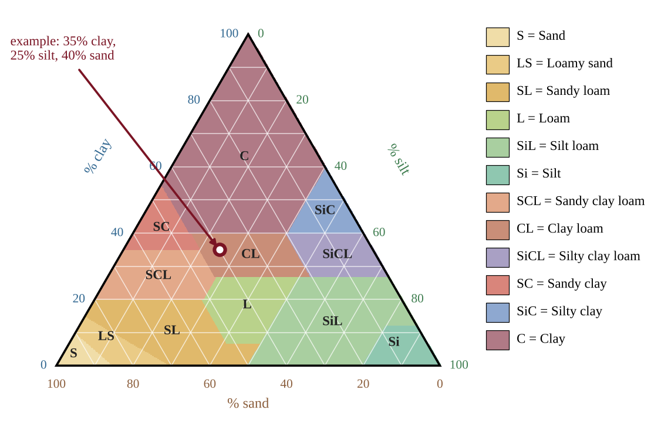
Figure 4.2b — The soil texture triangle with its twelve classes. The circled point is a soil with 35% clay, 25% silt and 40% sand (clay loam)
Each side of the triangle is the scale for one component. To plot a soil: (1) find the clay percentage on the left scale and follow its horizontal line; (2) find the sand percentage on the bottom scale and follow its line up and to the left; (3) the lines cross at the soil's point, and the colored region it falls in is the class. The silt line through the same point is a check. Two components are enough. In the figure the point 35% clay and 40% sand lies in clay loam.
Group | Classes | Water intake and drainage | Water and nutrient holding
Sandy | sand, loamy sand, sandy loam | Fast | Low to moderate
Loamy | loam, silt loam, silt | Moderate | Moderate to high
Clay-loamy | clay loam, sandy clay loam, silty clay loam | Moderately slow | High
Clayey | sandy clay, silty clay, clay | Very slow | Highest (held tightly)

Use the table to choose a soil. Sandy loam suits crops that need good drainage (citrus); adding sand or compost helps a waterlogged soil; a landfill liner needs clay-rich soil, whose tiny pores block leachate.
Reading a jar test and an infiltration test
In a jar test the layers settle in order of size, so each reading you take is a cumulative depth of sediment: about one minute for sand, a few hours for silt, a day or more for clay. A layer's thickness is the difference between successive readings. Percent of a component = layer thickness ÷ total sediment depth × 100.
Infiltration rate is how fast water enters the soil surface: depth of water ÷ time it takes to soak in (mm/h). If rain falls faster than the soil can take it in, the excess runs off: runoff rate = rainfall rate − infiltration rate. If rainfall is slower than infiltration, there is no runoff. Sandy and loose soils have high rates; clay, crusted or compacted soils have low rates.
CLASSROOM EXAMPLE SG-U4-E014
A ring is filled with 30 mm of water on Field A and on Field B. The water soaks in completely in 45 minutes on A and in 6 hours on B. (a) Calculate the infiltration rate of each field in mm/h. (b) A storm drops 12 mm of rain per hour for 3 hours. Calculate the runoff depth from each field during the storm, assuming the rates stay constant. (c) Identify which field is more likely to be compacted clay and state one effect on a nearby stream.

Testing soil
Different tests answer different management questions.
• Physical: texture by the jar (sedimentation) test: shake soil in water and let it settle; sand drops in about a minute, silt over hours, clay stays suspended for a day or more, giving layers whose thickness estimates percentages. Sieving separates particles by size. A percolation test times how fast measured water drains through a soil sample. Water-holding capacity is the volume held after draining.
• Chemical: pH with a meter or test strips; nutrient test kits or lab analysis for N, P and K; salinity (electrical conductivity).
• Biological: organic matter content, earthworm counts, and soil respiration (CO₂ release), all indicators of microbial activity.
Results guide decisions: sandy soil may need more frequent, lighter irrigation; a low-phosphorus result calls for targeted fertilizer rather than blanket spreading; a low pH may call for lime; a waterlogged clay may need drainage or raised beds.
FORMULA & MATH SKILL
Percent by mass of a component = (mass of component ÷ total mass of sample) × 100 Use grams for mass. The three texture percentages must sum to 100%. Water retained (mL) = water poured in − water drained out Percent retained = (water retained ÷ water poured in) × 100

Designing a soil investigation
For an experiment, state a testable question, then identify the independent variable (what you change, for example soil type), the dependent variable (what you measure, for example drained volume after 10 minutes), the controlled variables (same soil volume, same water volume and temperature, same container and time) and the replicates (repeat each soil at least three times and average). Describe what the data would show if your hypothesis were right.
REAL-WORLD EXAMPLE
A community garden has sandy soil that dries out within a day of watering. Adding compost raises organic matter, which increases water-holding capacity and nutrient retention. A percolation test before and after confirms the change.

COMMON STUDENT MISTAKES
• Mixing up porosity and permeability. Clay has many tiny pores (can be highly porous) yet low permeability.
• Reading the triangle with only one percentage. You need two (the third follows) and all three lines should cross at the same point.
• Calling loam "all loam equals equal parts." Loam has a specific range, not 33/33/33.

AP EXAM STRATEGY
In an investigation question, always name the independent, dependent and controlled variables separately, and say why replicates matter. In a data question, quote numbers from the table to justify the soil that holds the most water or drains the fastest.

CLASSROOM EXAMPLE SG-U4-E003
A technician oven-dries and sieves a 50.0 g soil sample and obtains 21.0 g of sand, 18.0 g of silt and 11.0 g of clay. (a) Calculate the percent by mass of sand, silt and clay. (b) Using the simplified key in this guide, name the texture class. (c) State which of the three components is most responsible for holding water against gravity, and explain why in terms of pore size.

CLASSROOM EXAMPLE SG-U4-E004
A student tests three soils (X, Y, Z). For each, she places 400 g of dry soil in an identical funnel lined with filter paper, pours in 200 mL of water at once, and records the volume that has drained into a cylinder after 10 minutes. Results: soil X, 170 mL; soil Y, 110 mL; soil Z, 40 mL. (a) Calculate the percent of the poured water retained by each soil. (b) Identify the independent variable, the dependent variable and two controlled variables. (c) One soil is a sand, one a loam and one a clay. Assign each, and justify using the drained volumes. (d) Propose one improvement that would make her conclusion more reliable.

QUICK CONCEPT SUMMARY
• Texture is the sand–silt–clay proportion; loam is a balanced blend supporting many crops.
• Coarse soil: high permeability, low water-holding. Fine soil: high water-holding, low permeability.
• Particle size and horizon composition shape porosity, permeability and fertility.
• Physical, chemical and biological tests guide irrigation and fertilizer decisions.
• A soil texture triangle uses clay, silt and sand percentages (summing to 100%) to name a soil.

Topic 4.4 — Earth's Atmosphere
LEARNING OBJECTIVES
• Identify the major gases of the atmosphere and their relative abundance.
• Describe the layers of the atmosphere and how temperature changes within them.

CONCEPT MADE SIMPLE
The atmosphere is a thin blanket of gas held by gravity. It is thickest near the ground and thins out gradually into space. Scientists divide it into five layers by whether the air gets colder or warmer as you climb.

Composition
Dry air is about 78% nitrogen (N₂) and 21% oxygen (O₂), with about 0.9% argon. Everything else, including carbon dioxide (about 0.04%, or roughly 420 ppm), neon, helium, methane and ozone, are trace gases. Water vapor varies from near 0 to about 4% depending on place and weather. Trace gases matter far more than their size suggests: CO₂, methane and water vapor warm the planet, and ozone absorbs ultraviolet radiation.
Layers defined by temperature
The layers are separated not by composition but by temperature gradients: where the temperature trend changes direction, a layer ends.
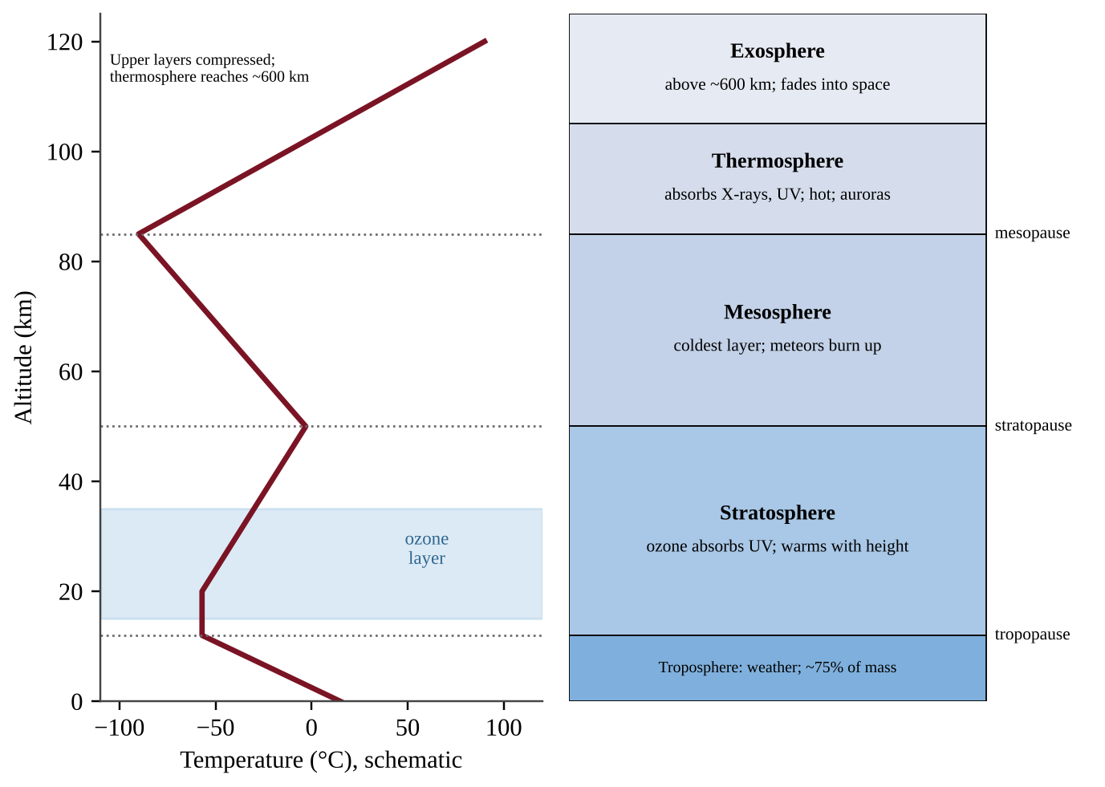
Figure 4.3 — Atmospheric layers with a schematic temperature profile (layer heights are approximate and the upper layers are compressed)
• Troposphere (surface to about 12 km; thinner at the poles, thicker at the equator): temperature falls with height, by about 6.5°C per km on average. It holds about 75% of the atmosphere's mass and nearly all water vapor, so it is where weather happens.
• Stratosphere (about 12–50 km): temperature rises with height because the ozone layer (roughly 15–35 km) absorbs ultraviolet radiation. This warm-over-cold arrangement is stable, so there is little vertical mixing and little weather.
• Mesosphere (about 50–85 km): temperature falls again, reaching the coldest values in the atmosphere (about −90°C). Most meteors burn up here.
• Thermosphere (about 85–600 km): temperature rises sharply as sparse molecules absorb high-energy X-rays and short-wave UV. Auroras occur here, and the International Space Station orbits in this layer.
• Exosphere: the outermost region, where molecules are so few that they drift off into space.
The boundary between layers is named with the suffix -pause: the tropopause, stratopause and mesopause.
KEY DEFINITIONS
Troposphere — lowest layer; contains most air and all everyday weather; cools with height. Stratosphere — layer containing the ozone layer; warms with height. Mesosphere — coldest layer; cools with height. Thermosphere — hot, thin layer that absorbs X-rays and UV; warms with height. Exosphere — outermost layer, merging into space.

FORMULA & MATH SKILL
Average lapse rate = (T at the lower altitude − T at the higher altitude) ÷ (altitude difference in km) Units: °C per km. In the troposphere the typical value is about 6.5°C/km.

Reading the profile
On the temperature–altitude graph, altitude is on the vertical axis. Find where the line changes direction; those turning points are the tropopause, stratopause and mesopause. A line sloping to the left going up means the air cools with altitude. The reason the stratosphere warms is the ozone absorbing UV; the reason the troposphere cools is that it is heated from the ground below, so the air farthest from the ground is the coolest.
Pressure and density. Air pressure and density fall steadily with altitude in every layer. About 75% of the molecules lie in the troposphere; the exosphere has the lowest pressure.
Why particles linger in the stratosphere. Warm air lies above cooler air there, so the layer is stable, with little vertical mixing, almost no water vapor and no rain to wash particles out. Volcanic aerosols there can stay a year or more; tropospheric particles are removed in days to weeks. A thermal inversion is different: a local warm layer in the lower troposphere that traps cooler air and pollutants beneath it (Topic 7.3).
COMMON STUDENT MISTAKES
• Thinking the layers are separated by gas composition. They are separated by temperature trends.
• Thinking the ozone layer is in the troposphere. The protective ozone layer is in the stratosphere; ozone near the ground is a pollutant (Unit 7).
• Thinking it is always colder higher up. The stratosphere and thermosphere get warmer with altitude.

AP EXAM STRATEGY
When you see a temperature–altitude graph, mark the three turning points first, then name each section by its trend (cool, warm, cool, warm). Link each warm layer to its absorber: ozone in the stratosphere, high-energy radiation in the thermosphere.

CLASSROOM EXAMPLE SG-U4-E005
A weather balloon records these temperatures: 0 km, 18°C; 4 km, −8°C; 8 km, −34°C; 12 km, −60°C; 16 km, −60°C; 25 km, −47°C; 50 km, −3°C. (a) Calculate the average rate of temperature change (°C per km) from 0 to 12 km. (b) Identify the layer from 0 to 12 km and the layer from 16 to 50 km. (c) Explain, using a specific gas, why the temperature trend reverses at about 12–16 km. (d) State the altitude at which the tropopause is located in these data.

QUICK CONCEPT SUMMARY
• Air is ≈78% N₂, ≈21% O₂, ≈0.9% Ar, with small, important amounts of CO₂, water vapor and others.
• Layers, from the ground up: troposphere (cools), stratosphere (warms, ozone), mesosphere (cools), thermosphere (warms), exosphere.
• Layers are based on temperature gradients; weather occurs in the troposphere.

Topic 4.5 — Global Wind Patterns
LEARNING OBJECTIVES
• Explain how intense solar radiation at the equator, density differences and the Coriolis effect produce global wind patterns.
• Interpret diagrams of the Hadley, Ferrel and Polar cells.

CONCEPT MADE SIMPLE
The equator gets the most direct sunlight, so air there heats up and rises. Cooler air flows in at the bottom to replace it, and the rising air spreads toward the poles, cools and sinks again. Because Earth spins, these air flows are bent sideways, making the steady winds sailors have used for centuries.

The cause: uneven heating
Global wind patterns primarily result from the most intense solar radiation arriving at the equator, resulting in density differences and the Coriolis effect. Air warmed at the equator expands, becomes less dense and rises, creating a belt of low pressure. Rising air cools, and its water vapor condenses into clouds, so the equator is wet. This belt of converging air near the equator is the intertropical convergence zone (ITCZ), which tracks the overhead sun north and south through the year. The dry air that has lost its moisture moves poleward aloft and, by about 30° latitude, has cooled enough to sink, forming belts of high pressure. Sinking air warms and dries as it descends, which is why many of the world's great deserts lie near 30° N and 30° S (Sahara, Arabian, Kalahari, Australian interior).
Three cells in each hemisphere
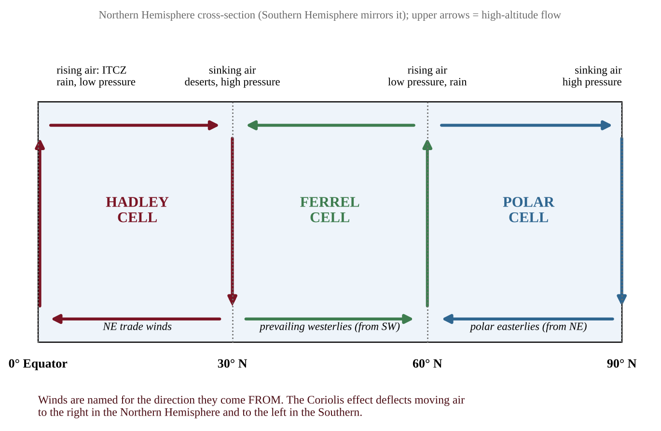
Figure 4.4 — Hadley, Ferrel and Polar cells in the Northern Hemisphere
• The Hadley cell (0°–30°): air rises at the equator, flows poleward aloft, sinks near 30° and returns toward the equator at the surface.
• The Polar cell (60°–90°): cold, dense air sinks over the poles and flows toward lower latitudes at the surface, rises near 60° and returns aloft.
• The Ferrel cell (30°–60°) lies between the two and is driven by them: surface air flows poleward, rises near 60° (where it meets cold polar air), and returns aloft toward 30°.
Rising air means low pressure, clouds and rain (near 0° and 60°). Sinking air means high pressure and dry conditions (near 30° and 90°).
The Coriolis effect
If Earth did not rotate, surface winds would blow straight from high to low pressure, north–south. But Earth rotates eastward, and points near the equator move faster (about 1,670 km/h) than points near the poles (almost zero). Moving air keeps the eastward speed of where it started, so it appears to curve relative to the ground: to the right in the Northern Hemisphere and to the left in the Southern Hemisphere. This apparent deflection is the Coriolis effect. It turns the surface flows as follows.
Latitude | Wind belt | Blows from | Hemisphere detail
0°–30° | Trade winds | East (NE in north, SE in south) | Air moving toward equator curves westward
30°–60° | Prevailing westerlies | West (SW in north, NW in south) | Air moving poleward curves eastward
60°–90° | Polar easterlies | East (NE in north, SE in south) | Air moving equatorward curves westward

Winds are named for the direction they come from. Storms in middle latitudes generally move west to east, carried by the westerlies.
If Earth did not rotate, there would be no Coriolis deflection. Air heated at the equator would rise, flow poleward aloft, sink at the pole and return along the surface in one large cell per hemisphere, so surface winds would blow straight from the poles toward the equator, with no trades, westerlies or polar easterlies. Rotation is what breaks the flow into three cells and bends the winds.
PROCESS & CAUSE-AND-EFFECT
Intense sunlight at the equator → surface air warms, expands, becomes less dense → air rises (low pressure, rain at ITCZ) → air flows poleward aloft and cools → air sinks near 30° (high pressure, dry) → surface air flows back toward the equator → Earth's rotation deflects it (Coriolis) → easterly trades.

COMMON STUDENT MISTAKES
• Saying winds blow from the direction they go to. A westerly comes from the west.
• Saying the Coriolis effect causes wind. Pressure differences cause wind; Coriolis only turns it.
• Putting deserts at the equator. They are mainly near 30° where air sinks.

AP EXAM STRATEGY
Start any wind question at the equator and work poleward: rising (low, wet), sinking at 30° (high, dry), then add the deflection (right in the north, left in the south). Check that the surface wind name matches the cell.

CLASSROOM EXAMPLE SG-U4-E006
A sailing ship leaves the coast of West Africa at about 15° N, bound for the Caribbean. (a) State the name and the direction of origin (compass direction the wind comes from) of the prevailing wind that helps it. (b) Explain, using the Coriolis effect, why that wind does not blow directly from the north. (c) Later, a storm system forms near 45° N over the North Atlantic. State the direction in which it is most likely to be carried and the global wind belt responsible. (d) Explain why a large desert is expected near 30° N on the African continent.

QUICK CONCEPT SUMMARY
• Strongest solar heating at the equator drives rising air and a global circulation.
• Hadley (0–30°), Ferrel (30–60°) and Polar (60–90°) cells; rising air = low pressure and rain, sinking air = high pressure and dry.
• Coriolis deflects air right in the north, left in the south, producing trades, westerlies and polar easterlies.

Topic 4.6 — Watersheds
LEARNING OBJECTIVES
• Describe a watershed by its area, length, slope, soil, vegetation types and divides.
• Explain how these characteristics influence the flow of water and pollutants.

CONCEPT MADE SIMPLE
A watershed is the whole area of land that drains to one river, lake or sea, like a giant bowl or funnel. Every raindrop that lands inside the rim ends up at the same outlet, carrying along whatever it picked up on the way.

What a watershed is
A watershed (drainage basin) is all the land that drains into a common water body. Its boundary, a ridge or high ground, is the divide, which separates it from adjoining watersheds. A drop falling on one side of a divide goes one way; one inch away, the other way. Small watersheds nest inside larger ones: a creek's watershed lies inside a river's, which lies inside a major basin such as the Mississippi.
Characteristics that control flow
Characteristic | Effect on water movement
Area | Larger area collects more rain and produces more total runoff and flow
Length | A long, narrow watershed delivers flow to the outlet more slowly and evenly than a short, round one
Slope | Steeper slopes speed runoff, increase erosion and give a quick, high peak flow
Soil | Permeable soils soak up water and recharge groundwater; clay or compacted soils increase runoff
Vegetation | Roots and leaf litter slow water, increase infiltration, reduce erosion; bare or paved ground does the opposite
Divides | Define which land contributes water and pollutants to the outlet

Natural cover and permeable soil mean most rain infiltrates and moves slowly as groundwater, giving a steady stream. Impervious surfaces (roofs, roads) force water into runoff, which reaches the stream quickly, raising peak flows, causing flash floods and carrying oil, fertilizer, sediment and trash. Because pollutants anywhere in the watershed flow to the outlet, a watershed is the natural unit for managing water quality.
FORMULA & MATH SKILL
Runoff volume = precipitation depth × area × runoff coefficient (C) Precipitation depth in m, area in m² (1 km² = 10⁶ m²), result in m³. The runoff coefficient C is the fraction of rain that leaves as surface runoff (0 to 1); forest has a low C, pavement a high C. On pavement or a roof, where nearly all rain runs off, volume ≈ depth × area (for example, 0.02 m of rain on a 30 m × 40 m roof gives 24 m³). Discharge (m³/s) = volume (m³) ÷ time (s); one year = 3.15 × 10⁷ s. Mass of material carried = concentration × volume; 1 m³ = 1,000 L, and 1 metric ton = 10⁹ mg. Overflow = inflow − capacity.

Reading hydrographs and land-use graphs
A hydrograph plots a stream's discharge (m³/s) against time after a storm begins. Compare three features: the peak (highest discharge), the lag time (how long the peak takes to arrive) and the total area under the curve. A mostly paved watershed gives a taller, earlier, steeper peak than a forested one, because rain runs off instead of soaking in and being released slowly. On a bar graph of land use for several watersheds, the one with more urban cover has flashier flow and more road pollutants; more cropland means more nutrient and sediment runoff and more algae; more forest or wetland means steadier, cleaner flow.
CLASSROOM EXAMPLE SG-U4-E015
Birch Creek drains a 90 km² watershed that receives 1,200 mm of precipitation a year, with an average runoff coefficient of 0.35. Its water carries 80 mg/L of suspended sediment, and 15% of the watershed is cropland. (a) Calculate the annual runoff volume in m³. (b) Calculate the average discharge in m³/s. (c) Calculate the mass of sediment carried each year, in metric tons. (d) Assuming all sediment comes from the cropland and the soil's bulk density is 1.2 t/m³, calculate the average depth of soil lost from the cropland per year, in mm.

REAL-WORLD EXAMPLE
A town upstream converts forest to a shopping center and parking lots. The stream downstream floods more often and carries more sediment and road pollutants, because the larger impervious area increased runoff. Retention ponds, permeable pavement and restored wetlands reduce the effect.

COMMON STUDENT MISTAKES
• Treating a watershed boundary as a political border. It follows ridges, not county or state lines.
• Saying a larger watershed always means faster flooding. Steepness, soil and cover matter as much as size.

AP EXAM STRATEGY
For any watershed question, list the six characteristics in the CED and ask of each: does it speed up or slow down water? A change that raises runoff (clearing, paving, compaction) raises flood peaks and pollution loads.

CLASSROOM EXAMPLE SG-U4-E007
A watershed covers 120 km² and receives 0.90 m of precipitation in a year. Before development its runoff coefficient is 0.30 everywhere. (a) Calculate the annual runoff volume in m³ before development, in scientific notation. (b) Later, 20 km² of the watershed is covered with pavement and rooftops (C = 0.85) while the other 100 km² keeps C = 0.30. Calculate the new annual runoff volume in m³. (c) Calculate the percent increase in runoff caused by development. (d) Explain, in terms of infiltration, why runoff increased, and name one watershed characteristic from this topic that changed.

QUICK CONCEPT SUMMARY
• A watershed is all land draining to one outlet; divides separate adjoining watersheds.
• Area, length, slope, soil, vegetation and divides shape how fast and how cleanly water moves.
• More impervious area means more runoff, faster peaks and more pollutants.

Topic 4.7 — Solar Radiation and Earth's Seasons
LEARNING OBJECTIVES
• Explain how incoming solar radiation (insolation) depends on latitude and season.
• Explain how the angle of the sun's rays determines intensity.
• Explain how Earth's axial tilt causes seasons and changes in daylight hours.

CONCEPT MADE SIMPLE
Imagine a flashlight shining straight down on a table, then tilted so the beam hits at a slant. The straight beam makes a small, bright spot; the slanted beam spreads the same light over a bigger, dimmer area. Earth's curved surface does the same with sunlight, which is why the equator is hot and the poles are cold.

Insolation, angle and latitude
Insolation (incoming solar radiation) is Earth's main energy source, and it depends on season and latitude. The angle of the sun's rays determines intensity. Because Earth is a sphere, the sun's rays strike the surface at a right angle (90°) at only one latitude at a time, the place directly under the sun (where the sun is directly overhead). There the same amount of energy is spread over the smallest area and passes through the least atmosphere, so intensity is greatest. At higher latitudes the rays arrive at a slant, spread over a larger area and traverse a longer path through the atmosphere, where more is absorbed, scattered or reflected. As a result, the highest solar radiation per unit area is received at the equator and decreases toward the poles.
The tilt makes the seasons
Earth's axis of rotation is tilted about 23.5° from the plane of its orbit, and it points at the same direction in space all year. Therefore as Earth travels around the sun, the Northern Hemisphere leans toward the sun for half the year and away for the other half.
• June solstice (about June 21): the Northern Hemisphere is tilted toward the sun. The sun is directly overhead at the Tropic of Cancer (23.5° N). Northern days are longest and sun angles highest: northern summer, southern winter.
• December solstice (about December 21): the opposite. The sun is overhead at 23.5° S (Tropic of Capricorn); the Northern Hemisphere has its shortest days and lowest sun: northern winter.
• Equinoxes (about March 20 and September 22): the sun is overhead at the equator; day and night are nearly equal everywhere.
The tilt also controls day length. At the equator, day length stays near 12 hours all year. In the summer hemisphere days grow longer at higher latitudes, and above the Arctic Circle the sun may stay up for 24 hours. So a location receives the most radiation on its longest summer day and the least on its shortest winter day: high sun angle and long daylight work together.
FORMULA & MATH SKILL
Noon sun angle above the horizon = 90° − |latitude − latitude of the direct sun| Latitude of the direct sun is +23.5° (N) on the June solstice, 0° at the equinoxes and −23.5° on the December solstice (use north as positive and south as negative). A larger angle means more intense radiation.

Comparing intensity, reading day length, and albedo
Intensity on flat ground is proportional to the sine of the noon sun angle. To compare two dates, find each angle with the formula, take its sine (calculator in degree mode) and divide. For angles of 60° and 30°: 0.866 ÷ 0.500 ≈ 1.7, so the 60° sun is about 1.7 times as intense.
On a day-length graph, a city whose day length barely changes is near the equator (about 12 hours all year); a larger swing means a higher latitude; longest days in June mean the Northern Hemisphere, and in December the Southern. At the December solstice places south of the Antarctic Circle (66.5° S) have 24 hours of daylight while places north of the Arctic Circle (66.5° N) have none; in June it reverses. If Earth had no tilt, every latitude would keep the same sun angle and day length all year and there would be no seasons, which is nearly true at the equator.
FORMULA & MATH SKILL
Energy absorbed = incoming sunlight × (1 − albedo) Albedo is the fraction of sunlight a surface reflects (0 to 1). Extra energy absorbed when a bright surface is replaced by a dark one = incoming × (albedo of old surface − albedo of new surface). Units: W/m². Fresh ice and snow have high albedo; open water has low albedo (Unit 9 uses this in the ice–albedo feedback).

CLASSROOM EXAMPLE SG-U4-E016
A city is at 52° N. (a) Calculate the noon sun angle on the June and December solstices. (b) Calculate how many times more intense the noon sunlight is in June than in December, using the sine of each angle. (c) A snow-covered field with albedo 0.80 receives 180 W/m² and then melts to bare soil with albedo 0.15. Calculate the increase in energy absorbed per square meter. (d) Explain why a city at 5° N has much smaller seasonal temperature changes than this city.

COMMON STUDENT MISTAKES
• Saying the seasons happen because Earth is closer to the sun in summer. Earth is actually closest to the sun in early January, during northern winter. Tilt, not distance, causes the seasons.
• Saying the tilt changes during the year. The tilt stays the same; Earth's position in its orbit changes.

AP EXAM STRATEGY
Give two linked reasons for seasonal change: (1) sun angle (intensity per unit area) and (2) day length (hours of exposure). Always trace both back to the tilt.

CLASSROOM EXAMPLE SG-U4-E008
A city lies at 40° N. (a) Calculate the noon sun angle at the city on the June solstice and on the December solstice using the formula in this guide. (b) Identify which date gives more intense radiation per unit area at the city, and explain why with reference to area and atmospheric path length. (c) State a second reason, other than sun angle, that the city receives more total energy on the June solstice than on the December solstice. (d) At which latitude is the sun directly overhead on the March equinox?

QUICK CONCEPT SUMMARY
• Insolation depends on latitude and season; intensity depends on the angle of the sun's rays.
• Highest per-area radiation at the equator, decreasing to the poles.
• Earth's 23.5° tilt, not distance from the sun, causes the seasons and varying daylight hours.

Topic 4.8 — Earth's Geography and Climate
LEARNING OBJECTIVES
• Describe how mountains, ocean temperature and other geographic factors affect weather and climate.
• Explain how a rain shadow forms.

CONCEPT MADE SIMPLE
Sunlight sets the basic climate for each latitude, but land and water modify it. Mountains wring the rain out of passing air, and oceans act like giant heaters and coolers for the coast.

Geologic and geographic factors
Weather and climate are affected not only by the sun's energy but by geologic and geographic factors, such as mountains and ocean temperature.
• Elevation: air temperature drops about 6.5°C per km of elevation, so mountain tops are cold even in the tropics.
• Proximity to oceans: water heats and cools more slowly than land (it has a high specific heat), so coastal climates are milder with smaller temperature ranges than inland (continental) climates at the same latitude.
• Ocean currents: warm currents (the Gulf Stream) carry heat poleward and warm coasts such as western Europe; cold currents (the California Current) cool coasts and favor fog. Coastal air above cold surface water also holds less moisture, one reason for some coastal deserts.
• Mountains: force air upward and shape where precipitation falls.
Rain shadows
A rain shadow is a region of land that has become drier because a higher elevation area blocks precipitation from reaching the land.
PROCESS & CAUSE-AND-EFFECT
Moist air blows toward the mountains (windward side) → forced to rise → expands and cools (about 6.5°C per km when saturated, roughly 10°C per km when dry) → water vapor condenses into clouds → heavy rain or snow on the windward slope → air crosses the crest, now dry → descends on the leeward side → compresses and warms → clouds evaporate, little rain → dry leeward desert (rain shadow).

In the westerlies of the western United States, the Pacific air rises over the Cascades and Sierra Nevada. Western slopes are lush rain forest or green foothills, while the land to the east (eastern Washington, the Great Basin of Nevada) is semi-arid or desert. The Atacama Desert lies in the shadow of the Andes and also beside a cold ocean current.
When reading a climate graph or map, check the wind direction first (global wind belt, from Topic 4.5), identify the mountain range, and then place the wet side upwind and the dry side downwind.
West coast versus east coast. In the middle latitudes the prevailing westerlies carry ocean air onto west coasts (Pacific Northwest, western Europe), giving mild winters, cool summers and a small temperature range. East coasts receive air that has crossed the continent, so their winters are colder and summers warmer. Global climate is set by solar input, atmospheric gases, the layout of land and ocean, and Earth's rotation and orbit; a thermal inversion is local weather, not a driver of climate.
Reading a climatogram. Bars show monthly precipitation (mm) and the line shows monthly mean temperature (°C). Annual precipitation is the sum of the 12 bars; the annual temperature range is the warmest month minus the coldest. Look for a dry season, and compare: a large range suggests an inland site, a small range a coastal one. For "A is X% less than B," use (B − A) ÷ B × 100, with B (the one after "than") as the base.
COMMON STUDENT MISTAKES
• Putting the desert on the windward side. The rain shadow is behind the mountain (leeward).
• Saying the mountain "makes the air dry by itself." The air loses its moisture as rain on the way up; descending air then warms and cannot easily form clouds.

AP EXAM STRATEGY
Use the sequence "up, cool, rain; down, warm, dry." Always tell the grader the wind direction and which side is windward.

CLASSROOM EXAMPLE SG-U4-E009
A mountain range runs north–south in a region where the prevailing winds blow from the west. City M lies on the western foot of the range at 100 m elevation and receives 1,850 mm of precipitation per year. City N lies 60 km away on the eastern foot of the range, also at about 100 m elevation, and receives 420 mm per year. (a) Calculate how many times greater City M's precipitation is than City N's, to the nearest tenth. (b) Identify which city is in the rain shadow. (c) Explain the sequence of events in the air that causes the difference. (d) Predict how the vegetation at City N would differ from City M, and state one reason a coastal city at the same latitude would have a smaller annual temperature range than an inland one.

QUICK CONCEPT SUMMARY
• Mountains, elevation, ocean temperature and currents modify the climate set by the sun.
• A rain shadow forms on the leeward side of high ground because rising air drops its moisture on the windward side.

Topic 4.9 — El Niño and La Niña
LEARNING OBJECTIVES
• Describe the environmental changes and effects that result from El Niño and La Niña events (El Niño–Southern Oscillation, ENSO).
• Explain how geologic and geographic factors influence ENSO and why its effects differ by location.

CONCEPT MADE SIMPLE
Every few years the Pacific Ocean's surface temperature pattern flips for a while. In an El Niño, a big pool of warm water slides east and the rain follows it; in a La Niña, the cold water along the eastern Pacific gets even colder. Because the Pacific is so large, these changes alter weather around the world.

Normal (neutral) conditions
In a typical year the trade winds blow from east to west across the tropical Pacific. They push warm surface water westward, piling a deep warm pool near Indonesia and Australia. Along the coast of South America, surface water moves away and cold, nutrient-rich water upwells from below, feeding plankton and rich fisheries. Warm, moist air rises over the western Pacific, bringing heavy rain; the air returns aloft and sinks in the east, which stays drier.
El Niño
El Niño and La Niña are phenomena associated with changing ocean surface temperatures in the Pacific Ocean, and together with the linked atmospheric pressure shift (the Southern Oscillation) make up ENSO. In an El Niño, the trade winds weaken or even reverse. The warm pool spreads east, the boundary between warm and cold water (the thermocline) flattens, and upwelling off South America weakens or stops. Evaporation and rising air shift toward the central and eastern Pacific.
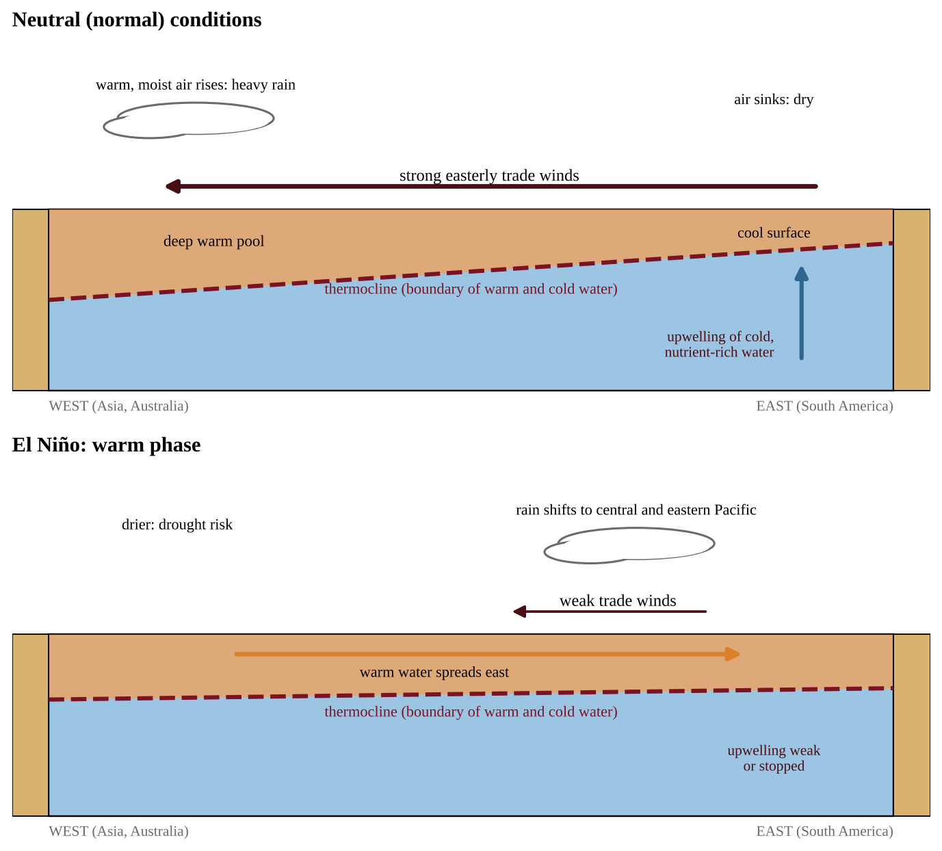
Figure 4.5 — Pacific cross-section: neutral conditions and El Niño
La Niña
In a La Niña, the trade winds strengthen. More warm water is pushed west, upwelling off South America intensifies, and the eastern Pacific becomes cooler than normal, an exaggeration of normal conditions.
Effects
These phenomena can cause global changes to rainfall, wind and ocean circulation patterns, but effects differ by place. The typical tendencies are:
Region | El Niño | La Niña
Coastal Peru and Ecuador | Heavy rain, floods; fish catch collapses (upwelling lost) | Drier; strong upwelling, rich fishing
Indonesia and Australia | Drought, wildfire risk | Heavier rain, flooding
Southern United States | Wetter, cooler winter | Drier, warmer winter, drought risk
Northwestern United States | Warmer, often drier winter | Cooler, wetter winter
Atlantic hurricanes | Often fewer (more wind shear) | Often more
Global average temperature | Tends to rise | Tends to dip

Other impacts include coral bleaching, crop failures and flood-related disease. ENSO events recur every two to seven years, and forecasts help governments and farmers prepare. ENSO reaches North America by shifting the jet stream, the fast high-altitude river of air that steers storms.
Upwelling feeds the whole food web, so lost nutrients in an El Niño lower phytoplankton, then anchovies, then fish-eating seabirds, whose chicks starve.
ENSO is influenced by geological and geographic factors: the size and shape of the Pacific basin, the position of continents and islands, the sloping thermocline, and the trade winds and ocean currents shaped by them. Because each region sits differently relative to the ocean and the mountains, the same event can bring flood to one place and drought to another.
PROCESS & CAUSE-AND-EFFECT
El Niño: weaker trade winds → warm water flows east → thermocline deepens in the east → less upwelling → warm surface water in the eastern Pacific → rain shifts east → drought in the west Pacific, flooding on the Peru coast, altered weather worldwide. La Niña: stronger trades → more upwelling in the east → cooler eastern Pacific → rain concentrated in the west → opposite regional effects.

REAL-WORLD EXAMPLE
Fishers off Peru depend on cold upwelling water for anchovies. In an El Niño year the anchovy catch drops sharply and seabirds starve. Fisheries agencies use ENSO forecasts to cut quotas early and help communities plan.

COMMON STUDENT MISTAKES
• Treating El Niño as a local event. It starts in the tropical Pacific but changes weather worldwide.
• Mixing up the two: El Niño is the warm phase; La Niña the cool phase.
• Assuming every region gets the same effect. Effects vary by location.

AP EXAM STRATEGY
Link ENSO phases to a cause chain (trade winds → warm water position → upwelling → rainfall) and give one effect with its location, such as "drought in Indonesia."

CLASSROOM EXAMPLE SG-U4-E010
A monitoring program reports the sea-surface temperature anomaly (difference from the long-term average) in the eastern tropical Pacific for four years, along with the anchovy catch off Peru. Year 1: +2.1°C, catch 4 million tonnes. Year 2: −0.3°C, catch 9 million tonnes. Year 3: −1.6°C, catch 11 million tonnes. Year 4: +0.2°C, catch 8 million tonnes. Use this rule: an anomaly of +0.5°C or more is El Niño, −0.5°C or less is La Niña, anything between is neutral. (a) Classify each year. (b) Calculate the percent change in catch from Year 2 to Year 1, to the nearest whole percent. (c) Explain, in terms of trade winds and upwelling, why the catch was lowest in the year you identified as El Niño. (d) Predict the rainfall effect in Indonesia in Year 1 and in Year 3.

QUICK CONCEPT SUMMARY
• ENSO is a Pacific ocean–atmosphere cycle: El Niño (warm, weak trades, less upwelling) and La Niña (cool, strong trades, more upwelling).
• Effects on rainfall, wind and ocean circulation spread globally but differ by place.
• Geology and geography (basin shape, thermocline, trade winds) influence ENSO.

Math & Skills Toolkit
1. Soil composition percentages. Divide each component's mass by the total mass and multiply by 100. The three must sum to 100% (small rounding differences are fine). Then compare to the triangle or key. If only two percentages are given, find the third by subtraction.
2. Water retention from a drainage test. Retained = poured − drained. Percent retained = retained ÷ poured × 100. A larger percent retained means higher water-holding capacity; a faster drainage time means higher permeability.
3. Lapse-rate and temperature-profile reading. Rate = temperature change ÷ altitude change. Identify layers by where the trend reverses. Remember the cool–warm–cool–warm pattern.
4. Watershed and runoff reasoning. Convert units first (km² to m² by × 10⁶; mm to m by ÷ 1,000). Runoff = depth × area × C. For mixed land cover, calculate each part separately and add: total runoff = depth × (A₁C₁ + A₂C₂ + …). Percent change = (new − old) ÷ old × 100.
5. Reading climate graphs and maps. On a climate graph, a large temperature range suggests an inland site, a small range a coastal or tropical one, and a pronounced dry season suggests sinking air or a rain shadow. On maps, find the prevailing wind belt, then the mountains, then place the wet and dry sides.
6. Reading anomaly data. An anomaly is the deviation from average, not the actual temperature: positive means warmer than normal. Classify with the rule given, and then connect to expected effects.
7. Sun angle. Noon angle = 90° − |latitude − direct-sun latitude|; the result must lie between 0° and 90°. To compare intensity, use the ratio of the sines of the two angles.
8. Chains of conversions. Write each step with units so they cancel (km² → m², mm → m, L → m³, mg → t, years → seconds). Quantity = rate × time; part of a total = total × percent ÷ 100.
9. Rates and speeds. Plate or hot-spot speed = distance ÷ time (1 km per million years = 0.1 cm/yr); runoff rate = rain rate − infiltration rate; discharge = volume ÷ time.
QUICK CONCEPT SUMMARY
Unit 4 in brief: plate boundaries make earthquakes, volcanoes and mountains. Soil forms by weathering, has horizons, gets its properties from sand, silt and clay, and filters water. The atmosphere has five temperature-defined layers. Equatorial heating, density differences and the Coriolis effect create the three circulation cells and the trades, westerlies and polar easterlies. Watersheds funnel runoff. Axial tilt sets sun angle, day length and seasons. Mountains create rain shadows, oceans moderate climate, and ENSO shifts rainfall and currents worldwide.

Unit 5 — Land and Water Use
Every meal you eat, every board in a house, every phone battery and every paved parking lot began as a decision about land or water. This unit asks a single question in many forms: when people use natural resources, how do they change natural systems, and how can we use land and water so that they last? You will meet the problems first (Topics 5.1–5.11) and then the solutions built around sustainability (Topics 5.12–5.17). The unit is worth 10–15% of the AP exam, and it is rich in applied scenarios, calculations and "propose and justify a solution" tasks.
Topic 5.1 — The Tragedy of the Commons
LEARNING OBJECTIVES
• Explain the concept of the tragedy of the commons (EIN-2.A).
• Apply the concept to a new shared resource and propose a way to prevent depletion.

CONCEPT MADE SIMPLE
Imagine a shared pizza in the middle of a table with no rule about slices. Each hungry person thinks, "If I do not take another slice, someone else will." Everyone takes more than a fair share, and the pizza is gone in minutes. No one wanted that result, yet everyone's sensible-looking choice caused it. That is the tragedy of the commons.

A commons is a resource that belongs to everyone and so to no one in particular: a fishing ground, the air, a groundwater aquifer, a public pasture, the open ocean, the atmosphere's capacity to absorb carbon dioxide. Such a resource is usually rival (my use leaves less for you) and hard to exclude people from. Because each user gets the full benefit of taking more but shares the cost of depletion with everyone, the rational self-interested choice is to take more.
KEY DEFINITIONS
Tragedy of the commons — the idea that individuals acting in their own self-interest will use a shared resource in ways that do not serve the common good, thereby depleting or degrading it. Commons (common-pool resource) — a shared resource open to many users, such as a fishery, aquifer, pasture or the atmosphere. Externality — a cost of an activity that falls on people who did not choose it (for example, the pollution from a factory that harms downstream fishers).

PROCESS & CAUSE-AND-EFFECT
Open access to a shared resource → each user gains the full benefit of extra use → the cost (depletion) is spread across all users → every user has an incentive to take more → total use exceeds the resource's ability to renew itself → the resource declines or collapses → everyone, including the heaviest users, loses.

Why it happens and how it is prevented
The problem is not that people are evil; it is that the rules reward overuse. Solutions therefore change the rules:
• Regulation and quotas: catch limits for each fishing season, pumping limits on a shared aquifer, permits for grazing on public land, emissions caps.
• Privatization or assigned shares: if a person owns the pasture or a transferable share of the fishery, he or she pays the long-term cost of overuse. The drawback is that ownership can favor the wealthy and may ignore the ecosystem services that benefit everyone.
• Community management: a village that sets its own rules for a shared forest or irrigation canal, enforced by social pressure, often succeeds when the group is small and can monitor itself.
COMMON STUDENT MISTAKES
• Believing the tragedy happens only to land. Air, oceans, groundwater and the climate are commons too.
• Saying people are "greedy" or "ignorant." On the exam, the cause is self-interest combined with lack of rules or enforcement.

AP EXAM STRATEGY
When a question gives a shared resource, answer in three moves: (1) identify the commons and who uses it, (2) explain that each user benefits fully from taking more while the cost is shared, and (3) propose a specific rule (quota, permit, fee) and state one limitation of it.

CLASSROOM EXAMPLE SG-U5-E001
Eight ranchers each graze cattle on a public meadow that can feed 80 cattle per year without losing grass cover. Each rancher currently grazes 14 cattle. A rancher who adds one more animal gains the full sale value of that animal, while the loss of grass is shared among all eight ranchers. (a) Calculate the total number of cattle on the meadow and by what percent it exceeds the sustainable number. (b) Explain, using the concept of the tragedy of the commons, why each rancher might add another animal even though all of them know the meadow is overgrazed. (c) Propose one rule that would prevent further damage and identify one drawback of that rule.

QUICK CONCEPT SUMMARY
• The tragedy of the commons: self-interested use of a shared resource depletes it for everyone.
• Cause: full personal benefit, shared cost, no enforceable limits.

Topic 5.2 — Clearcutting
LEARNING OBJECTIVES
• Describe the effects of clearcutting on forests (EIN-2.B).
• Connect forest removal to erosion, stream temperature, flooding and climate change.

CONCEPT MADE SIMPLE
A forest is like a giant sponge wearing an umbrella. The canopy softens rain, roots hold soil in place, and shade keeps streams cool. Clearcutting removes the umbrella and the roots all at once.

Clearcutting is the harvest of all or nearly all trees in an area in one operation. It is popular with timber companies because it is the cheapest and fastest method: heavy machines can reach every tree, the logging roads are simple, and the sunlit ground can be replanted with one fast-growing species. That economic advantage is real, which is why you must acknowledge it in a balanced answer. But the ecological costs are large.
PROCESS & CAUSE-AND-EFFECT
Trees removed → roots die and no longer hold soil, and rain strikes bare ground → soil erosion increases → sediment washes into streams and clouds the water → the loss of shade raises soil and stream temperatures → warmer water holds less dissolved oxygen, stressing cold-water fish → with no canopy interception and less water uptake by roots, runoff rises → flooding downstream increases.

Climate and pollution effects
Forests are carbon sinks. Trees absorb carbon dioxide during photosynthesis and store the carbon in wood, roots and soil, and their leaves capture some air pollutants such as particulates and ozone. When trees are cut and burned, or when the wood and debris decay, the stored carbon is released as CO₂, which adds to the greenhouse effect and contributes to climate change. Less forest also means less future CO₂ uptake, so the loss is felt twice. Clearcutting also destroys habitat, reducing biodiversity, and the exposed soil loses nutrients and organic matter, slowing regrowth. A second economic advantage is that clearing frees land for crops, pasture or buildings, which is a main reason forests are cleared; the other main reasons are timber, fuelwood and charcoal, and urban growth.
From stored carbon to CO₂
Forest data are usually given as the mass of carbon in the wood, but the gas released is CO₂, which also contains oxygen. One carbon atom (12 g/mol) becomes one CO₂ molecule (44 g/mol), so each tonne of carbon released as CO₂ is 44 ÷ 12 ≈ 3.67 tonnes of CO₂.
FORMULA & MATH SKILL
Carbon released = stored carbon per hectare × hectares × fraction released Mass of CO₂ = mass of carbon × 44 ÷ 12 Units: tonnes of C, then tonnes of CO₂. Apply the fraction released first and the 44/12 conversion last; the 44/12 step is only needed when the question asks for CO₂ rather than carbon.

CLASSROOM EXAMPLE SG-U5-E002
A 100-hectare watershed is clearcut. In the following year, monitors record that the stream's maximum summer temperature rises from 14 °C to 21 °C, that suspended sediment in the stream increases, and that peak flow during a storm is much higher than before the cut. (a) Explain how removing the trees causes each of these three changes. (b) Describe one effect of this clearcut on the carbon cycle. (c) State one economic advantage of clearcutting that explains why it is still used.

CLASSROOM EXAMPLE SG-U5-E012
A 30-hectare stand holds 140 tonnes of carbon per hectare. It is clearcut, and 65% of the stored carbon is released as CO₂ within a few years (C = 12 g/mol, CO₂ = 44 g/mol). (a) Calculate the tonnes of carbon released. (b) Convert your answer to tonnes of CO₂. (c) Describe one way wood could still be obtained while keeping more of this carbon stored.

QUICK CONCEPT SUMMARY
• Clearcutting is cheap and efficient but increases erosion, stream and soil temperature, and flooding.
• Forests absorb pollutants and store CO₂; cutting and burning releases CO₂ and adds to climate change.

Topic 5.3 — The Green Revolution
LEARNING OBJECTIVES
• Describe changes in agricultural practices that began with the Green Revolution (EIN-2.C).
• Evaluate positive and negative results, including mechanization and fossil-fuel reliance.

CONCEPT MADE SIMPLE
Before the Green Revolution, a farmer's field was like a small family garden that produced what the soil and rain allowed. The Green Revolution turned fields into factories: improved seeds, fertilizer, pesticides, irrigation and machines were added so the same land produced far more food.

Beginning in the mid-20th century, plant breeders developed high-yield varieties of staple crops such as wheat and rice that responded strongly to fertilizer and water. Combined with other technologies, they greatly increased food production in many countries and helped feed a rapidly growing human population. Together, these practices are called the Green Revolution.
Strategy | What it does | Benefit | Cost or risk
Mechanization | Tractors, harvesters, planters | Higher efficiency and profit; less labor | Fossil-fuel use, equipment cost, fewer farm jobs
High-yield and genetically modified crops (GMOs) | Selected or engineered traits | Higher yield, pest or drought tolerance | Seed cost; loss of genetic diversity
Synthetic fertilizer | Adds nitrogen, phosphorus | Higher yield per hectare | Nutrient runoff, eutrophication
Irrigation | Adds water | Farming in dry regions; extra harvests | Depleted aquifers, salinization
Pesticides | Kill pests | Less crop damage | Resistance, toxicity to wildlife

Mechanization raises profit and efficiency because one operator with a machine can plant, spray or harvest what once took many workers. But machines burn fossil fuels, so farms become dependent on oil prices, and heavy equipment compacts soil. Fertilizers and pesticides are often made with fossil energy too.
KEY DEFINITIONS
Green Revolution — the shift, beginning in the mid-1900s, to high-yield crops plus fertilizer, irrigation, pesticides and machinery to increase food production. Genetically modified organism (GMO) — an organism whose DNA has been altered by genetic engineering to give it a desired trait. Mechanization — the use of machinery in place of human or animal labor. Yield — the amount of crop harvested per unit of land, for example tonnes per hectare.

Reading for perspective (skill 3.B): if an author praises the Green Revolution only in tonnes of grain, ask what the author values, what evidence is left out (such as water pollution) and who benefits from that view.
CLASSROOM EXAMPLE SG-U5-E003
A district grows wheat on 12,000 hectares. Before adopting Green Revolution methods the district averaged 1.8 t/ha; after adopting them it averaged 3.6 t/ha, while nitrogen fertilizer use rose from 10 kg/ha to 90 kg/ha and diesel use for machinery rose from 20 L/ha to 55 L/ha. (a) Calculate the percent increase in yield and the total additional grain, in tonnes, from the whole district. (b) Calculate the additional kilograms of nitrogen fertilizer applied to the district each year. (c) Describe one environmental consequence of the increased fertilizer use and one of the increased diesel use.

QUICK CONCEPT SUMMARY
• Green Revolution = high-yield crops, fertilizer, irrigation, pesticides, GMOs and mechanization.
• It raised food production but increased reliance on fossil fuels and created pollution and genetic-diversity problems.

Topic 5.4 — Impact of Agricultural Practices
LEARNING OBJECTIVES
• Describe agricultural practices that cause environmental damage: tilling, slash-and-burn and fertilizer use (EIN-2.D).

CONCEPT MADE SIMPLE
Farming is a trade: we take food, and the land pays. Tilling exposes the soil, burning wipes out forest, and fertilizer escapes to the water. Each practice works in the short term and has a hidden cost.

Tilling
Tilling (plowing) turns over the soil to bury weeds, loosen the ground and prepare a seedbed. It also leaves bare soil exposed for months, breaks up soil structure, speeds the decomposition of soil organic matter (releasing CO₂), and leaves fine particles easy for wind and rain to carry away. Erosion removes the fertile topsoil, which takes hundreds of years to form, and the sediment fills streams and reservoirs, clouding water and burying aquatic habitat. Heavy machinery also compacts soil and burns fuel.
Slash-and-burn agriculture
In slash-and-burn farming, trees are cut and burned to clear land. Ash adds a pulse of nutrients, so the first crops grow well. In tropical forests, however, most nutrients are held in living biomass rather than in thin soils, so fertility declines within a few years and farmers move on. When population density is low and fields are left to regrow for decades, the system can recover; when too many farmers use it, forest is lost for good. Burning releases CO₂ and particulates, destroys habitat and biodiversity, and exposed soil erodes.
Fertilizers
Crops remove nutrients from the soil, so farmers replace them with fertilizer, mainly nitrogen and phosphorus compounds. Plants take up only part of what is applied. The rest runs off or leaches into surface water and groundwater. Nutrient pollution (Unit 8 covers eutrophication in detail) fertilizes algae in lakes and coastal waters; when the algae die, bacteria decompose them and use up dissolved oxygen, creating low-oxygen "dead zones." Nitrate in drinking water is a health risk for infants. Fertilizer production and denitrification also release nitrous oxide (N₂O), a greenhouse gas.
KEY DEFINITIONS
Tilling — mechanical turning of soil before planting. Slash-and-burn — clearing land by cutting vegetation and burning it. Topsoil — the upper, organic-rich soil layer most important for plant growth. Nutrient runoff — dissolved or particle-bound nutrients carried from fields by water.

QUICK CONCEPT SUMMARY
• Tilling: erosion, soil structure loss, CO₂ release.
• Slash-and-burn: quick fertility, then decline; CO₂, habitat loss, erosion.

Topic 5.5 — Irrigation Methods
LEARNING OBJECTIVES
• Describe different methods of irrigation (EIN-2.E).
• Describe the benefits and drawbacks of each method, including waterlogging, salinization and aquifer depletion (EIN-2.F).

CONCEPT MADE SIMPLE
Irrigation is like watering a houseplant. You could flood the pot, dribble water along the edge, spray it overhead, or give it a few drops at the roots. The more precisely you water, the less is wasted, but precision costs more.

Globally, about 70% of human freshwater consumption is used for agriculture. Because agriculture is the biggest water user, even a modest gain in irrigation efficiency saves large volumes of water. Irrigation efficiency is the percentage of the water applied that actually reaches the crop roots.
The methods
Method | How it works | Water lost to evaporation and runoff | Cost and energy
Furrow | Channels are cut between crop rows and filled with water | about 1/3 | Inexpensive
Flood | The whole field is covered with water | about 20% | Inexpensive; can cause waterlogging
Spray | Groundwater is pumped to spray nozzles over the field | 1/4 or less | More expensive than flood and furrow; requires energy
Drip | Perforated hoses release small amounts of water at the roots | about 5% | Most efficient but expensive, so used less often

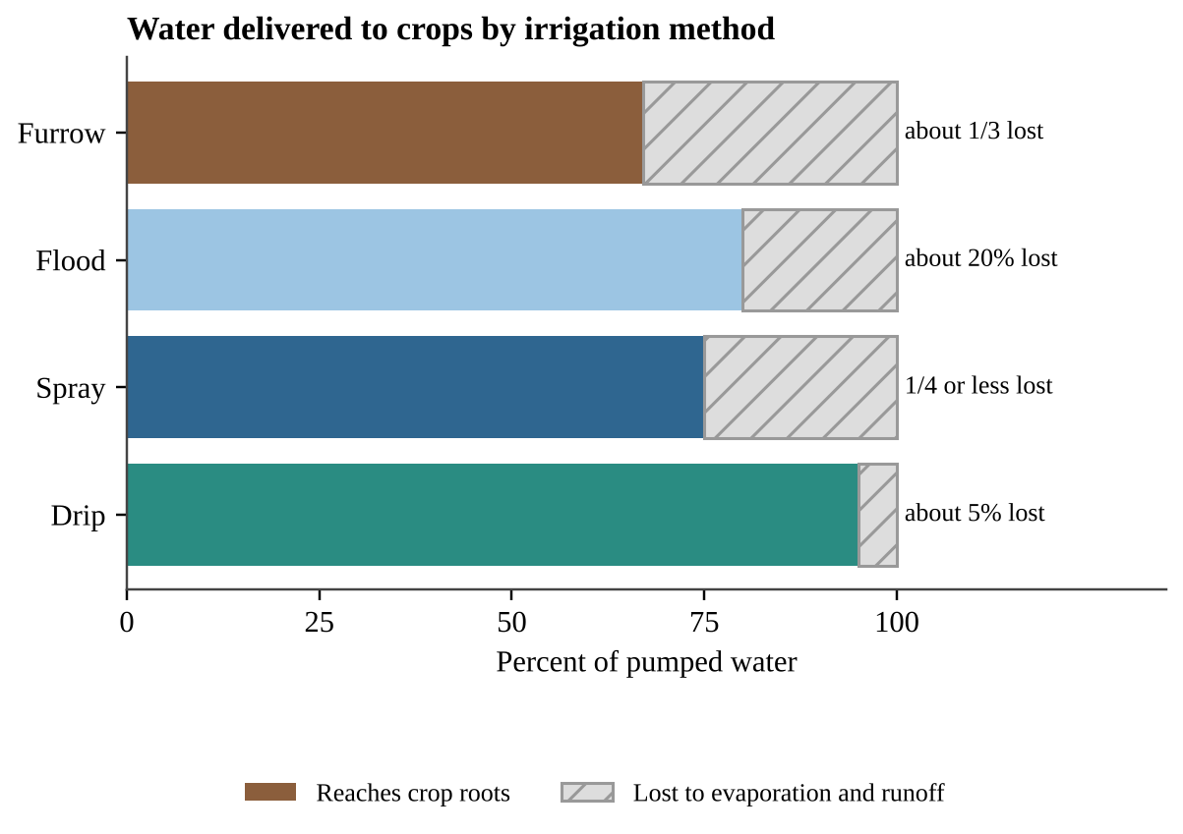
Figure 5.1 — Share of pumped water that reaches the crop roots for four irrigation methods, using the loss values given in the course framework.
Problems caused by irrigation
Waterlogging happens when too much water sits in the soil. It raises the groundwater table until the root zone is saturated, so roots cannot absorb the oxygen they need and plants suffocate. Flood irrigation is especially prone to it.
Salinization occurs when irrigation water, which contains dissolved salts, evaporates and leaves the salts behind. Over time the soil becomes salty enough to be toxic to many plants, reducing yields or forcing farmers to abandon the field. It is worst in hot, dry climates and in poorly drained soils. A white salt crust on the surface is the classic sign. In a flood-irrigated arid field both problems often appear together: the water table rises into the root zone (waterlogging, so plants wilt in wet soil) while salts build up near the surface.
Aquifer depletion occurs when water is pumped out faster than rain recharges the aquifer. The Ogallala Aquifer under the central United States supports large areas of irrigated farming, and in many places it has been drawn down severely because recharge is very slow. When the water table falls, wells must be deepened and pumping costs rise until farming becomes uneconomical. This is also a tragedy of the commons (Topic 5.1).
Aquifer budgets and rates of change
An aquifer works like a bank account: net change = recharge − withdrawal. The water table falls whenever withdrawal exceeds recharge, even if pumping is shrinking; it stops falling only when pumping drops to the recharge rate. If pumping falls from 1,800 to 1,300 million m³ per year but recharge is only 200 million m³ per year, the aquifer is still losing 1,100 million m³ every year. Sustainable groundwater use means withdrawal ≤ recharge. Water per person works the same way: renewable supply ÷ population falls whenever population grows faster than supply.
FORMULA & MATH SKILL
Net rate = recharge − withdrawal (negative = decline) Average rate of change = (final value − initial value) ÷ (final year − initial year) Years until depletion = amount remaining ÷ net annual loss Units: m/yr or m³/yr; put both rates in the same units first. A negative sign means decline; quote it, or write "declined by".

PROCESS & CAUSE-AND-EFFECT
Irrigate a hot, dry field → water evaporates → dissolved salts stay behind → salts build up in the root zone → soil becomes toxic to plants → yields fall and land may be abandoned.

KEY DEFINITIONS
Irrigation efficiency — (water that reaches the crop ÷ water applied) × 100%. Waterlogging — saturation of soil by excess water, raising the water table and depriving roots of oxygen. Salinization — build-up of salts in soil as irrigation water evaporates. Aquifer — underground rock or sediment layer that holds and transmits groundwater.

FORMULA & MATH SKILL
Water to apply = water needed by crop ÷ efficiency (as a decimal) Water lost = water applied × fraction lost Units: m³, L or acre-feet; efficiency = 1 − fraction lost. Example structure: if drip loses 5%, efficiency = 0.95.

REAL-WORLD EXAMPLE
A dry-valley orchard switches from flood to drip irrigation. Water use and salt build-up fall, but the grower must buy hoses, filters and pumps and maintain them. With the aquifer dropping, the investment pays off.

COMMON STUDENT MISTAKES
• Treating "efficiency" as the percent lost. Efficiency is the percent delivered.
• Saying drip irrigation is "free of problems." It is expensive and can clog; and because water is applied only at the roots, salts can still collect at the edges of the wetted zone.

AP EXAM STRATEGY
In "compare irrigation methods" questions give a cost point and an efficiency point for each method. Many students supply only efficiency.

CLASSROOM EXAMPLE SG-U5-E004
A 40-hectare farm needs 5,700 m³ of water per hectare to reach its crop roots during the growing season. Assume the loss percentages are exactly 1/3 for furrow irrigation and 5% for drip irrigation. (a) Calculate the volume of water, in m³, that must be pumped for the whole farm using furrow irrigation. (b) Calculate the volume that must be pumped using drip irrigation. (c) Calculate how many cubic meters of water the farm would save per year by switching, and give one reason a farmer might still keep the furrow system.

CLASSROOM EXAMPLE SG-U5-E013
An aquifer holds 36 m of saturated thickness. Pumping lowers the water table by 1.1 m per year and recharge raises it by 0.2 m per year; both rates stay constant. (a) Calculate the net change per year and the number of years until the aquifer is dry. (b) Pumping is then cut by 40% while recharge is unchanged. Calculate the new net change and state whether use is now sustainable. (c) Name one change in irrigation that could cut pumping and one drawback of it.

QUICK CONCEPT SUMMARY
• About 70% of human freshwater consumption goes to agriculture.
• Efficiency rank (best to worst): drip (about 5% lost), spray (≤ 1/4), flood (about 20%), furrow (about 1/3). Cost generally rises with efficiency.

Topic 5.6 — Pest Control Methods
LEARNING OBJECTIVES
• Describe the benefits and drawbacks of different methods of pest control (EIN-2.G).
• Make a claim that proposes a solution to a pest problem in an applied context (skill 7.E).

CONCEPT MADE SIMPLE
Spraying a pesticide is like using one antibiotic over and over. It kills most of the target, but the few that survive pass on their toughness, and soon the treatment stops working.

A pest is any organism that harms crops, livestock or people. Farmers use pesticides: insecticides (insects), herbicides (weeds), fungicides (fungi), rodenticides (rodents). The benefit is clear: less crop damage and higher yield. The drawbacks are also real: toxicity to non-target species such as pollinators and fish, contamination of water, and residues on food.
Resistance by artificial selection
Within any pest population, individuals vary genetically. A few may survive a chemical because of a gene that makes them resistant. When farmers spray repeatedly, the susceptible individuals die and the resistant survivors reproduce, so the proportion of resistant pests rises each generation. Because humans apply the selective pressure, scientists call this artificial selection. Pests with short generation times and many offspring evolve resistance fastest, and farmers respond with stronger or more frequent doses, a cycle sometimes called the "pesticide treadmill."
Selection can be followed with arithmetic. Suppose 1 insect in 500 (0.2%) is resistant, and a spray kills 95% of the susceptible insects and none of the resistant ones. Of 500,000 insects, 1,000 are resistant and 499,000 are susceptible. After the spray, 1,000 resistant and 5% × 499,000 ≈ 24,950 susceptible survive, so resistant insects are 1,000 ÷ 25,950 ≈ 3.9% of the survivors, up from 0.2%. The survivors breed the next generation. Rotating pesticide types, leaving untreated refuge areas and spraying only when pests pass a threshold (Topic 5.14) all weaken this selection.
Genetically engineered crops
Crops can be genetically engineered to increase resistance to pests and diseases, which can cut pesticide use and raise yield. One common trait is a built-in insect toxin (Bt crops), which reduces insecticide sprays; another is tolerance to a herbicide, so weeds can be sprayed without killing the crop, although repeated use of one herbicide selects for resistant weeds. The risk is a loss of genetic diversity: if farmers plant only one variety, a single new disease or pest that overcomes its resistance can destroy the entire crop, and traditional varieties may be abandoned. Resistance can also evolve in pests that feed on such crops continuously.
KEY DEFINITIONS
Pesticide — a chemical used to kill pests (insecticide, herbicide, fungicide, rodenticide). Artificial selection — selection by humans, intentional or not, of which individuals survive and reproduce. Resistance — heritable ability of an organism to survive a chemical that once killed its ancestors. Genetic diversity — variation in genes within a species or crop.

COMMON STUDENT MISTAKES
• Writing that pests "adapt" or "learn" to resist. Resistance is selection acting on existing genetic variation, not an individual changing.

CLASSROOM EXAMPLE SG-U5-E005
A cabbage grower sprays an insecticide each generation. In generation 1, 2% of the moths carry a resistance allele. Assume the resistant share of the population doubles in every generation, and that the population is rebuilt to its original size each time. (a) Calculate the percentage of resistant moths in generations 2, 3 and 4. (b) Explain why this is an example of artificial selection. (c) Propose one change in pest control that would slow this process, and describe one disadvantage of your proposal.

CLASSROOM EXAMPLE SG-U5-E014
A population of 400,000 beetles contains 0.5% resistant individuals. A spray kills 90% of the susceptible beetles and none of the resistant ones. (a) Calculate the number of resistant beetles and the percent of the survivors that are resistant. (b) Explain why a second identical spray would raise the resistant share further. (c) Name two practices that would slow resistance.

QUICK CONCEPT SUMMARY
• Pesticides cut crop damage and raise yield but harm non-target organisms and select for resistance.
• Genetically engineered crops can resist pests but may reduce crop genetic diversity.

Topic 5.7 — Meat Production Methods
LEARNING OBJECTIVES
• Identify methods of meat production: CAFOs, feedlots, rotational grazing, free-range (EIN-2.H).
• Describe benefits and drawbacks, including overgrazing, desertification and the effects of eating less meat (EIN-2.I).

CONCEPT MADE SIMPLE
Beef is a second-hand way to eat grass or grain. A cow first eats the plants, burns most of the energy to stay alive and warm, and only a little turns into meat. Eating the plants directly is like skipping the middleman, so it needs less land and water.

Why meat has a bigger footprint
Energy is lost at every step in a food chain; on average only about 10% passes from one trophic level to the next (Unit 1 and Unit 3 develop this idea). That is why meat production needs more land, water and energy per gram of protein than plant foods and why it raises nutrient pollution and greenhouse gas emissions such as methane (CH₄).
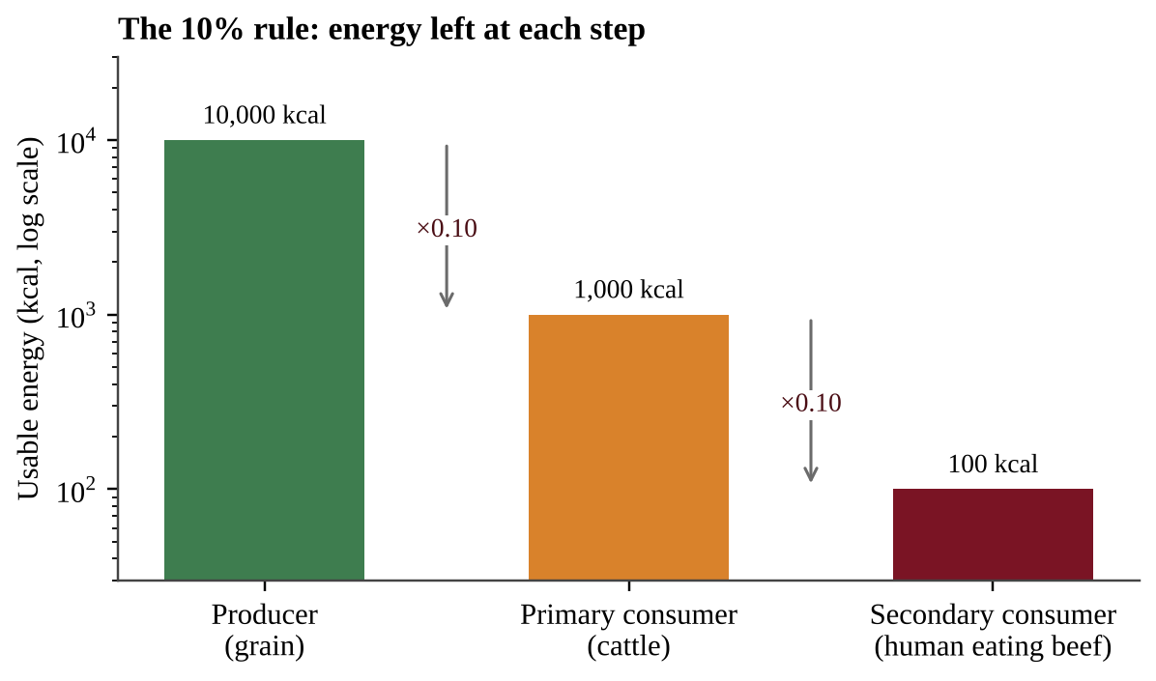
Figure 5.2 — Following 10,000 kcal of grain energy through two trophic steps leaves about 100 kcal for a person who eats beef from grain-fed cattle (vertical axis is logarithmic).
Impact varies with the animal and the system. Ruminants (cattle, sheep) have the largest effect because gut microbes produce methane and they need more feed per kilogram of meat.
Feature | Feedlots / CAFOs | Pasture-based (rotational or free-range)
Housing | Confined animals in small spaces | Animals graze outdoors
Feed | Grain and soy | Grass and forage
Land needed | Less | More
Cost to consumers | Lower (more economically efficient) | Higher
Waste | Large concentrated manure; may contaminate water if not managed | Manure fertilizes soil; runoff and erosion if too many animals
Antibiotics | Routine use can contribute to global antibiotic resistance | Not always antibiotic-free

A concentrated animal feeding operation (CAFO) raises many animals in confined spaces. Its high concentration of manure can contaminate nearby waterways with nutrients and pathogens, create odors, and release methane and ammonia. Routine low-dose antibiotics can select for resistant bacteria, a global health risk.
Free-range or pasture-based grazing lets animals eat grass for most of their lives. Manure adds nutrients to pasture soil. Rotational grazing moves livestock between paddocks so vegetation can regrow, improving sustainability. It requires fencing and management, and since it needs more land, consumer costs are higher. Note: not all free-range systems are antibiotic-free.
Feed conversion and carrying capacity
The feed conversion ratio (FCR) is the mass of feed an animal eats per mass of weight it gains. An FCR of 7 means 7 kg of feed for each 1 kg of body mass; the smaller the ratio, the less feed (and land) per kilogram of meat. Chains of conversions are multiplied in order, keeping the units at each step. For example, if a feed is 25% fishmeal and each kilogram of fishmeal needs 4 kg of wild fish, then 1 kg of farmed fish that ate 1.5 kg of feed used 1.5 × 0.25 × 4 = 1.5 kg of wild fish. Footprint tables are often given per 100 g of protein, so scale by the protein served: emissions = value per 100 g × (protein served ÷ 100 g).
The number of animals a range can support (its carrying capacity for grazing) depends on how much forage may be eaten without harming regrowth. Keeping more animals than this number is overgrazing.
FORMULA & MATH SKILL
Feed needed = FCR × body mass gained Usable forage = forage per hectare × hectares × fraction allowed to be eaten Animals supported = usable forage ÷ forage eaten per animal per year Units: kg of feed or forage; keep "per year" and "per hectare" consistent.

Overgrazing and desertification
Overgrazing occurs when the number of animals exceeds the land's ability to regenerate vegetation. Plant cover shrinks, soil is exposed and compacted, erosion increases and fertility drops. Biodiversity falls and the land stores less carbon. In arid and semi-arid regions, overgrazing can lead to desertification, the conversion of productive land into desert-like land that can no longer support vegetation. Restoration, soil conservation and better grazing practices can slow or reverse the process.
Eating less meat
Less consumption of meat, especially from ruminants, can reduce emissions of CO₂, CH₄ and N₂O; conserve fresh water; and reduce reliance on antibiotics and growth hormones. Better feed quality and precision farming can also reduce impacts. How large the benefit is depends on production methods and on what is done with the land no longer used for livestock (for example, restored to forest versus converted to another intensive use).
KEY DEFINITIONS
CAFO — a facility that confines large numbers of animals, feeding them grain and soy. Rotational grazing — moving livestock among pastures on a schedule to allow regrowth. Overgrazing — livestock numbers exceed vegetation regeneration. Desertification — degradation of arid or semi-arid land into desert-like condition. Ruminant — a grazing mammal with a multi-chambered stomach, such as cattle or sheep, that produces methane.

COMMON STUDENT MISTAKES
• Believing free-range always means antibiotic-free or low impact. The CED states otherwise.

CLASSROOM EXAMPLE SG-U5-E006
A grain farmer produces 900,000 kcal of grain energy per hectare per year. Assume that only 10% of the energy in feed is stored in the bodies of cattle fed that grain, and that a person gets all of the energy stored in the cattle's bodies. (a) Calculate the kilocalories of beef that one hectare could provide if all the grain were fed to cattle. (b) A person needs 2,000 kcal per day. Calculate how many person-days of food one hectare could supply as grain eaten directly and as beef. (c) Explain two other environmental drawbacks of cattle production beyond land use.

CLASSROOM EXAMPLE SG-U5-E015
A ranch has 600 hectares that produce 1,800 kg of dry forage per hectare per year; managers allow cattle to eat 40% of it. Each cow eats 3,000 kg per year. (a) Calculate the largest number of cows the ranch can support sustainably. (b) The owner keeps 400 cows. Calculate by what percent the herd exceeds the sustainable number. (c) A feedlot with an FCR of 7 adds 25,000 kg of beef. Calculate the feed it needs, and state one environmental problem of the feedlot system.

QUICK CONCEPT SUMMARY
• Meat needs more land, water and energy per gram of protein than plants and adds nutrient pollution and methane.
• CAFOs: cheap and efficient, but manure, antibiotics and confinement. Pasture systems: manure benefits soil but need more land and cost more.

Topic 5.8 — Overfishing
LEARNING OBJECTIVES
• Describe causes of and problems related to overfishing (EIN-2.J).
• Describe responses or approaches to overfishing (skill 7.B).

CONCEPT MADE SIMPLE
A fish population is like a bank account that earns interest. You can spend the interest forever, but if you spend the principal, the interest shrinks and the account empties.

Overfishing is harvesting fish faster than the population can replace itself. It has made some species extremely scarce, which can reduce biodiversity in aquatic systems and harm people who depend on fishing for food and commerce. The fishery is a classic commons, so the tragedy of the commons applies.
Causes
• Growing demand for seafood as population and incomes increase.
• Technology (sonar, GPS, factory ships), open access in international waters, weak enforcement and subsidies.
Fishing methods and their impacts
Method | Description | Main problems
Bottom trawling | Weighted net dragged along the seafloor | Destroys bottom habitat; heavy bycatch
Purse seining | Net encircles a school and is closed at the bottom | Bycatch (dolphins, sharks)
Drift-net or gill-net | Long walls of netting that hang in the water | Entangles non-target animals, including turtles and marine mammals
Longlining | Line with thousands of baited hooks | Hooks seabirds, turtles and sharks

Bycatch is the unintended capture of non-target species. Removing top predators or a keystone species can cascade through the food web and reduce biodiversity; for example, spearfishing out the herbivorous fish on a reef lets algae overgrow and smother the coral.
Reading fishery data
Total catch alone can mislead. Catch per unit effort (CPUE) is the total catch divided by the fishing effort (boats, boat-days or hours fished). In a healthy stock, adding boats raises the catch and CPUE stays about the same. In a shrinking stock, each boat finds fewer fish even with sonar and bigger nets, so CPUE falls while effort rises. Total catch can stay high for years because more boats and better technology hide the decline, and then collapse. Always work out CPUE before concluding that a stock is healthy.
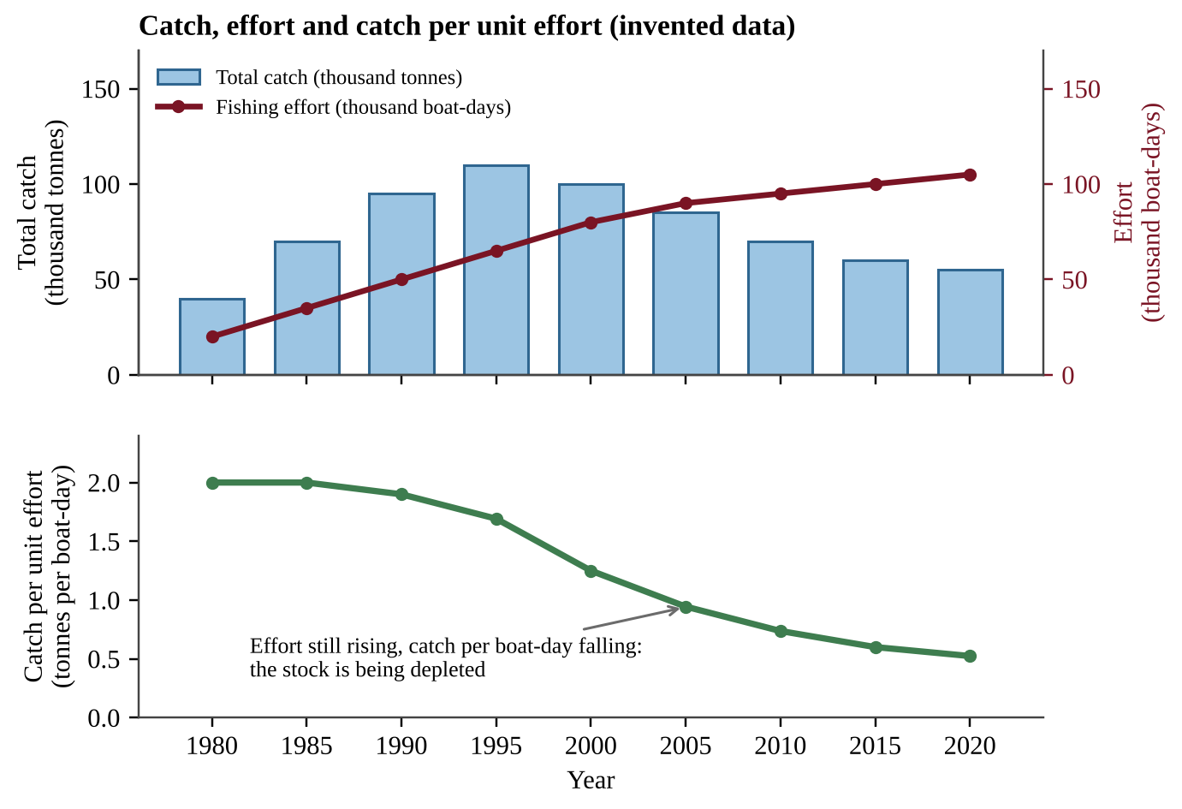
Figure 5.3 — Total catch, fishing effort and catch per unit effort for a fishery (invented data). Catch peaks and falls while effort keeps rising, and CPUE falls throughout.
FORMULA & MATH SKILL
CPUE = total catch ÷ fishing effort (for example, tonnes per boat-day) Change in stock = natural growth − harvest (per year)

Sustainable yield
The sustainable yield (Topic 5.12) of a fishery is the amount that can be harvested without reducing the supply. The fish stock replaces itself fastest at intermediate stock sizes. A harvest below the peak of the growth curve can continue indefinitely; a harvest above it will shrink the stock every year.
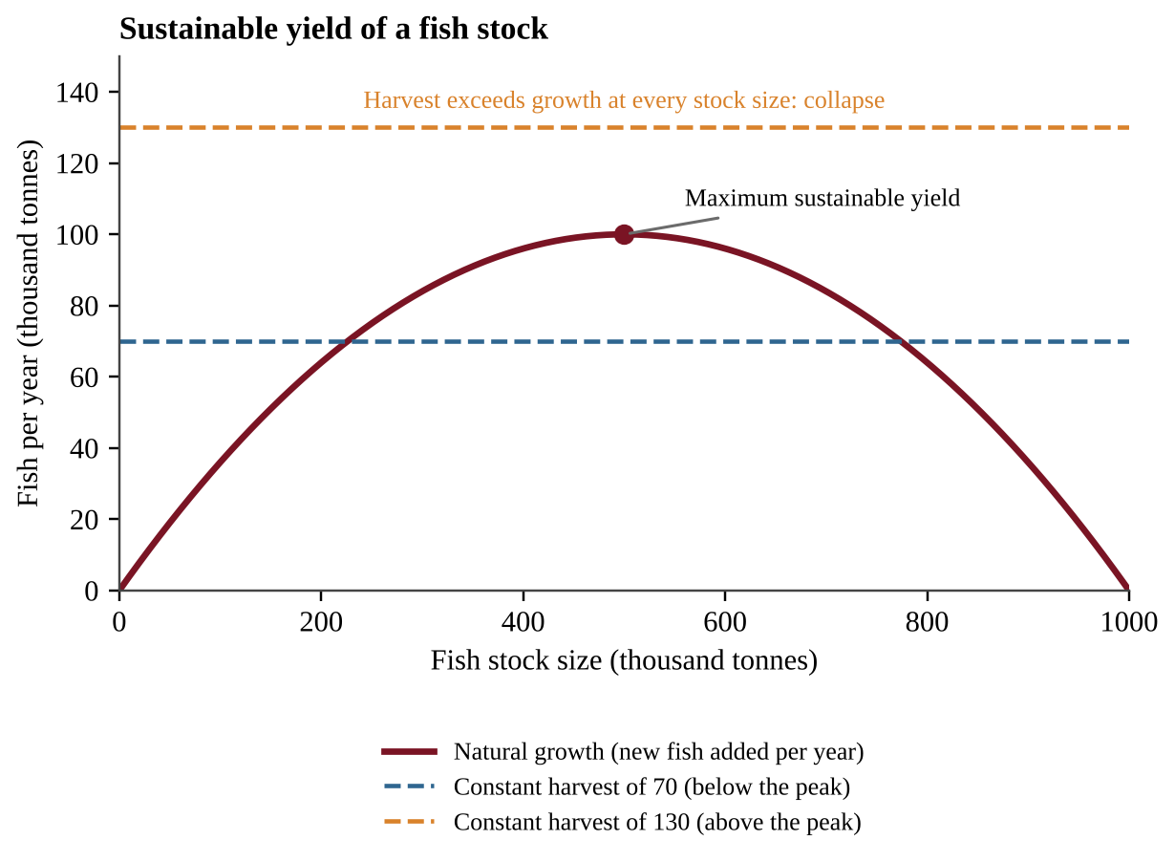
Figure 5.4 — Natural growth of a fish stock at different stock sizes with two constant harvest levels (invented numbers). The peak is the maximum sustainable yield.
To read a growth curve with a flat harvest line, compare the curve with the line at the stock size you start from. Where the curve is above the line, growth exceeds harvest and the stock rises; where it is below, the stock falls. A point where the line meets the curve is an equilibrium. The right-hand crossing is stable: a small drop in stock makes growth exceed harvest, so the stock recovers. The left-hand crossing is unstable: below it the stock keeps falling to collapse. A harvest line above the peak never meets the curve, so the stock collapses from any starting size. Harvesting exactly at the peak leaves no safety margin, so quotas are set below it.
Solutions
• Catch limits and quotas based on stock surveys.
• Closed seasons and marine protected areas where fish can breed.
• Gear restrictions: larger mesh sizes, turtle-excluder devices, bans on destructive methods.
• Certification, international agreements, enforcement and aquaculture (Topic 5.16).
CLASSROOM EXAMPLE SG-U5-E007
A fish stock's natural growth, measured as tonnes of new fish added in a year, depends on stock size as follows: stock 200 → growth 64; stock 400 → growth 96; stock 500 → growth 100; stock 600 → growth 96; stock 800 → growth 64 (all in thousands of tonnes). A fleet takes 90 thousand tonnes every year. (a) State the maximum sustainable yield shown by the data and the stock size at which it occurs. (b) If the stock is 800 thousand tonnes, calculate the change in stock after one year of fishing. (c) Predict what will happen to the stock if the stock falls to 200 thousand tonnes while the fleet still takes 90, and explain how this relates to the tragedy of the commons.

CLASSROOM EXAMPLE SG-U5-E016
A lake fishery records effort of 30,000 boat-days and a catch of 60,000 tonnes in 2005; 50,000 boat-days and 70,000 tonnes in 2015; and 80,000 boat-days and 56,000 tonnes in 2025. (a) Calculate the catch per unit effort for each year. (b) Describe the trend in total catch and in CPUE, and state what each suggests about the fish stock. (c) Explain why the 2015 total catch could mislead a manager, and propose one management action.

QUICK CONCEPT SUMMARY
• Overfishing: harvest exceeds replenishment. It reduces biodiversity and harms fishing communities.
• Destructive gear causes bycatch and habitat damage.

Topic 5.9 — Environmental Impacts of Mining
LEARNING OBJECTIVES
• Describe natural resource extraction through mining (EIN-2.K).
• Describe the ecological and economic impacts of mining (EIN-2.L).

CONCEPT MADE SIMPLE
Mining is like eating a cake from the outside in: the thick, rich pieces go first. Later you must dig through more and more plain cake to get the same sweetness. In mining the rich parts are high-grade ore, and as they run out, more rock must be moved for each tonne of metal.

Mining extracts minerals, metals and fuels such as coal from the Earth. Mining supplies low-cost energy and the materials used to build everything from wires to bridges, and it provides jobs. Its drawbacks are habitat destruction, pollution and large volumes of waste.
Ore grade and diminishing returns
An ore is rock containing enough valuable mineral to be mined profitably. The grade is the concentration of the valuable material in the ore. As the most accessible, highest-grade ores are mined to depletion, operations are forced to use lower-grade ores. This requires more energy, water and machinery, and it produces more waste and pollution per tonne of product.
Mining methods
Method | How it works | Example impact
Surface mining | Soil and rock above the ore, called overburden, are removed | Habitat loss, erosion, dust
Strip mining | Vegetation and overburden removed in long strips to expose a shallow seam | Vegetation loss makes the area susceptible to erosion; acidic runoff
Open-pit mining | Large pit dug to reach ore close to the surface | Huge pits, tailings piles
Mountaintop removal | Mountain summit blasted off to reach coal seams, debris dumped in valleys | Stream burial, large-scale habitat loss
Subsurface (underground) mining | Shafts and tunnels reach deeper deposits | Very expensive; hazards to miners; subsidence; methane

When shallow coal seams run low, it becomes necessary to use subsurface mining, which is much more expensive.
Waste and pollution
Mining wastes include the soil and rock moved to gain access to the ore (overburden or spoil) and the tailings and slag that remain after minerals are separated or smelted. Water that touches exposed sulfide minerals can become acidic (acid mine drainage) and carry heavy metals into streams and groundwater. The chemistry is simple: pyrite (iron sulfide) exposed to air and water is oxidized, and its sulfur ends up as sulfuric acid, so stream pH can fall to about 3–4 and metals dissolve; the process continues long after a mine is abandoned. Some metal mines, such as gold mines, separate the metal with chemicals such as cyanide solutions, so leaks from tailings ponds can poison water, and tailings dumped into a lake can leach heavy metals into it. Coal mining can destroy habitat, contaminate groundwater, and release dust particles and methane, a greenhouse gas.
PROCESS & CAUSE-AND-EFFECT
High-grade ore depleted → miners turn to lower-grade ore → more rock must be excavated per tonne of metal → more energy, water and chemicals are used → more overburden and tailings → more land disturbance and pollution.

KEY DEFINITIONS
Reclamation — restoring mined land (regrading, topsoil, replanting) after mining. Ore — rock containing a valuable mineral in a concentration high enough to mine. Overburden — soil and rock removed to reach ore. Tailings / slag — waste left after minerals are separated from ore (tailings) or smelted (slag). Reclamation — restoring mined land to a productive state.

FORMULA & MATH SKILL
Ore needed = mass of metal wanted ÷ ore grade (as a decimal) Waste mass = ore mined − metal recovered Units: tonnes (t); grade as a decimal (0.5% = 0.005). A lower grade means more ore and more waste for the same amount of metal.

Grades can also be given as a fraction of the volume (very small values such as 2 × 10⁻⁶ are common for gold). Then:
FORMULA & MATH SKILL
Volume of metal = volume of rock × grade (as a fraction) Mass of metal = volume of metal × density (1 m³ = 10⁶ cm³, so convert volume to cm³ if density is in g/cm³) Break-even price = total cost of mining and processing ÷ mass of metal recovered Method: write each conversion as a fraction equal to 1 (for example 10⁶ cm³/1 m³) so the unwanted units cancel.

REAL-WORLD EXAMPLE
A copper mine that began with 2% ore now processes 0.5% ore, so four times as much rock is crushed for each tonne of copper. Energy use, dust and the tailings pile all grow.

COMMON STUDENT MISTAKES
• Saying mining waste is only "overburden." Tailings and slag are separate.
• Thinking mining is purely harmful. Describe both economic benefit and ecological cost.

CLASSROOM EXAMPLE SG-U5-E008
A mine must produce 1,000 tonnes of copper per year. Assume all of the copper in the ore is recovered and the rest of the ore becomes tailings. (a) Calculate the tonnes of ore that must be processed per year when the ore grade is 0.8% copper and when it is 0.4% copper. (b) Calculate the tonnes of tailings produced per year at each grade. (c) Explain why the lower-grade ore is likely to increase both the cost and the environmental impact of the mine, and propose one way to reduce the demand for newly mined copper.

CLASSROOM EXAMPLE SG-U5-E017
A block of rock measures 50 m × 40 m × 10 m. Gold makes up 3 × 10⁻⁷ of its volume, and gold has a density of 19 g/cm³. Mining and processing the block costs $400,000. (a) Calculate the volume of the rock and the volume of the gold in m³. (b) Calculate the mass of gold in kilograms. (c) Calculate the break-even price per gram, and explain why a fall in the ore grade would raise it.

QUICK CONCEPT SUMMARY
• Surface mining removes overburden (strip mining, open-pit, mountaintop removal); subsurface mining is deeper and costlier.
• Declining ore grade means more waste, energy and pollution per tonne.

Topic 5.10 — Urbanization
LEARNING OBJECTIVES
• Describe the effects of urbanization on the environment (EIN-2.M).
• Describe disadvantages, advantages or unintended consequences of potential solutions (skill 7.C).

CONCEPT MADE SIMPLE
A city is a giant machine that takes in water, energy, food and land and gives out waste, heat and runoff. The more people packed in or spread out, the larger the inputs and outputs.

Urbanization is the growth of cities as more people move from rural areas into urban areas. Cities can be efficient (shared transport, shared buildings), but they concentrate resource demand and waste.
Effects on resources and cycles
• Resource depletion and the water cycle: Large populations draw heavily on rivers and aquifers. In coastal cities, pumping groundwater lowers the water table and lets salt water move into the freshwater aquifer, called saltwater intrusion, which makes wells unusable.
• Carbon cycle: Burning fossil fuels for vehicles, power and heating, and the decomposition of waste in landfills, add CO₂ (and methane from landfills) to the atmosphere, increasing the greenhouse effect.
• Impervious surfaces: Roads, roofs, sidewalks and parking lots do not allow water to infiltrate the soil. Rain that would soak in becomes fast surface runoff, causing flash floods, carrying oil, metals and trash into streams, and giving less groundwater recharge.
• Heat: Dark pavement and buildings absorb sunlight and retain heat (the urban heat island effect, Unit 8).
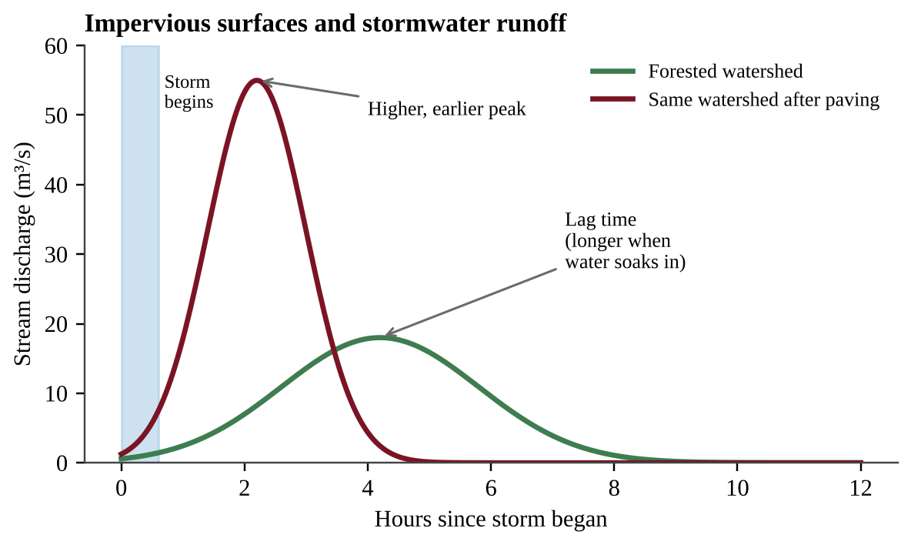
Figure 5.5 — Stream discharge during the same storm before and after a watershed is paved (invented data). Impervious surfaces create a higher, earlier flood peak.
Read a hydrograph by comparing three features: the peak height (how severe the flood is), the lag time (how long between rainfall and peak) and the total area under the curve (total runoff volume). Pavement raises the peak, shortens lag time and increases total runoff, because less water infiltrates.
When a site has several surfaces, find the runoff from each (area × depth × its coefficient) and add them; rainfall given in cm or mm must be converted to m first, and a percent change is divided by the original value. Where old cities send storm runoff and sewage down one pipe, a heavy storm can exceed the treatment plant's capacity and release untreated mixture into streams.
Urban sprawl
Urban sprawl is the spread of low-density development from city centers into surrounding rural land. The population shifts from dense areas to low-density suburbs. Typical consequences: loss of farmland and habitat, more roads and parking (more impervious surface), longer commutes and more vehicle emissions, higher infrastructure costs per person, and greater energy use per household.
KEY DEFINITIONS
Urbanization — increase in the share of a population living in cities. Impervious surface — human-made surface (road, roof, parking lot) that does not allow water to soak into the soil. Urban sprawl — the outward spread of low-density development into rural land. Saltwater intrusion — movement of salt water into a coastal freshwater aquifer, often because of overpumping.

REAL-WORLD EXAMPLE
A suburb paves a 6-hectare mall parking lot on a former meadow. After the next heavy storm the stream below floods a neighborhood that never flooded before, and the water carries oil and road salt.

CLASSROOM EXAMPLE SG-U5-E009
A 40-hectare site is a forest. A 25-mm rainstorm falls on it. Use runoff coefficients of 0.15 for pervious ground and 0.90 for impervious surfaces, and runoff volume = area (m²) × rainfall depth (m) × coefficient. (1 hectare = 10,000 m²). (a) Calculate the runoff volume from the forested site. (b) The site is developed so that 60% of its area is impervious. Calculate the new runoff volume and how many times greater it is than before. (c) Describe one consequence for the stream below the site and one design change that would reduce the runoff.

CLASSROOM EXAMPLE SG-U5-E018
A 12-hectare school campus has 3 ha of roofs and 4 ha of asphalt (runoff coefficient 0.90 each) and 5 ha of lawn (0.20). A storm drops 3.0 cm of rain. (a) Calculate the runoff volume in m³. (b) Half of the asphalt is replaced by permeable pavement (coefficient 0.35). Calculate the new runoff volume and the percent reduction. (c) Describe one limitation of permeable pavement.

QUICK CONCEPT SUMMARY
• Urbanization depletes resources, can cause saltwater intrusion, and adds CO₂ through fossil-fuel use and landfills.
• Impervious surfaces prevent infiltration, causing flooding.

Topic 5.11 — Ecological Footprints
LEARNING OBJECTIVES
• Explain the variables measured in an ecological footprint (EIN-2.N).
• Explain what footprint data imply about environmental issues (skill 5.E).

CONCEPT MADE SIMPLE
Your ecological footprint is the total land and water area needed to supply the things you use and to absorb the waste you make. It is like a receipt for your lifestyle, written in hectares.

An ecological footprint compares the resource demands and waste production of an individual or a society with the Earth's capacity. It adds up the area needed for:
• food: cropland, pasture and fishing grounds;
• wood and fiber: forest products;
• built-up land: housing, roads and industry;
• energy: the forest area needed to absorb the CO₂ released from fossil-fuel use.
Footprints are usually expressed in global hectares (gha) per person: a global hectare is a hectare of average biological productivity. Biocapacity is the productive area available to supply resources and absorb waste. When the footprint exceeds biocapacity, there is an ecological deficit: the region is using resources faster than they regenerate or importing them from elsewhere. When biocapacity is larger, there is an ecological reserve.
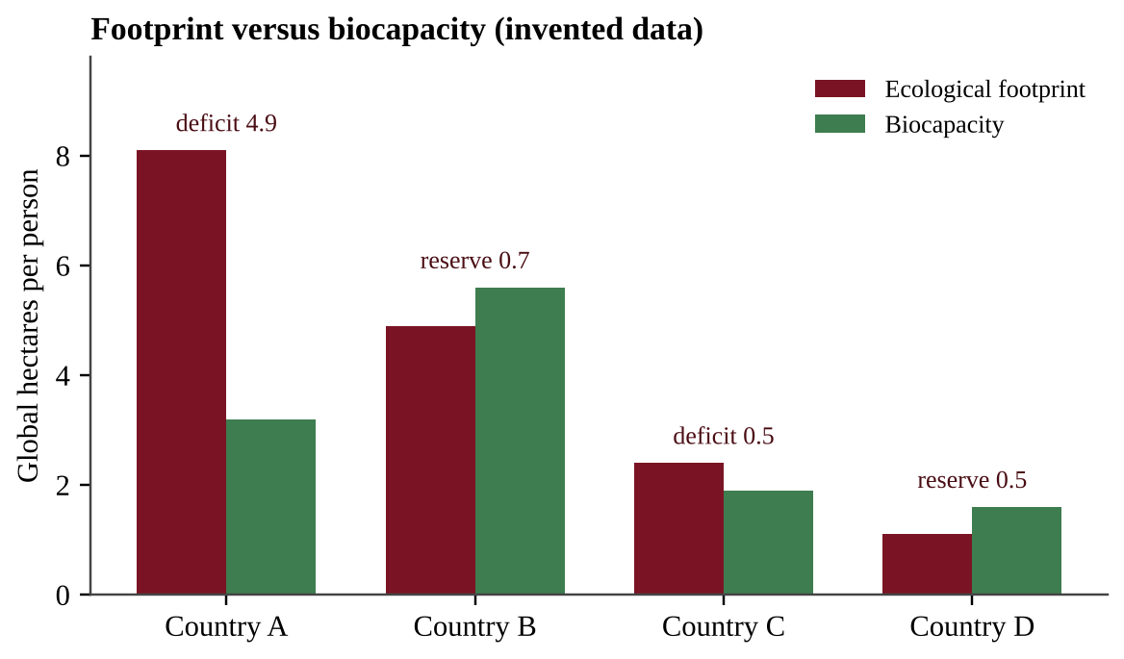
Figure 5.6 — Per-person footprint and biocapacity for four invented countries. A deficit means the footprint exceeds biocapacity.
Reading footprint data
Footprints are larger where consumption of energy, meat and goods is high. Distinguish per-person from total values.
FORMULA & MATH SKILL
Total footprint = per-person footprint × population Deficit (or reserve) = biocapacity − footprint (negative = deficit); for a population, multiply the per-person deficit by the number of people Percent cut needed to reach biocapacity = (footprint − biocapacity) ÷ footprint × 100% Earths required = global footprint per person ÷ biocapacity available per person on Earth Units: global hectares (gha) or gha per person.

KEY DEFINITIONS
Ecological footprint — estimate of the land and water area required to supply a person's or society's resources and absorb its wastes. Biocapacity — capacity of ecosystems to regenerate resources and absorb waste. Ecological deficit — footprint greater than biocapacity.

COMMON STUDENT MISTAKES
• Confusing ecological footprint with carbon footprint. The latter is only the greenhouse gases produced; the former includes all land uses.

AP EXAM STRATEGY
For footprint data questions, identify the unit, compare footprint with biocapacity, then say what drives the difference (consumption, population, or limited land).

CLASSROOM EXAMPLE SG-U5-E010
Country X has 20 million people, a footprint of 6.0 gha per person and a biocapacity of 4.5 gha per person. (a) Calculate Country X's total footprint and total biocapacity in millions of global hectares. (b) Calculate the size of its ecological deficit as a number and as a percent of its biocapacity. (c) Identify two ways the country could reduce its deficit and one way it can meet its demand without lowering its footprint, and state a consequence of the latter.

QUICK CONCEPT SUMMARY
• Footprint = resource demand and waste production of a person or society, measured in area (global hectares).
• Compare with biocapacity: footprint > biocapacity = deficit.

Topic 5.12 — Introduction to Sustainability
LEARNING OBJECTIVES
• Explain the concept of sustainability (STB-1.A).
• Explain what environmental indicator data imply about sustainability (skill 5.E).

CONCEPT MADE SIMPLE
Sustainability means living on Earth's income, not on its savings. We can use the interest, the forests that regrow, the fish that breed, but we cannot keep spending the principal.

Sustainability refers to humans living on Earth and using resources without depleting them for future generations. It has environmental, economic and social sides: a practice that wrecks the soil, bankrupts the farmer or ignores the community will not last.
Environmental indicators
An environmental indicator is a measurement that tells us whether we are moving toward or away from sustainability. The CED names these:
• Biological diversity: number of species and genetic variety; falling diversity signals ecosystem stress.
• Food production: per-person food output and soil health; falling output signals degraded land and water.
• Average global surface temperature and CO₂ concentration: rising values indicate climate change from greenhouse gas emissions.
• Human population: growth increases resource demand.
• Resource depletion: declining stocks of fish, water, forests, soil or minerals.
Sustainable yield
Sustainable yield is the amount of a renewable resource that can be taken without reducing the available supply. If a forest grows 20 m³ of wood per hectare per year, cutting more than 20 m³ per hectare per year will reduce the forest. Renewable does not mean unlimited; it means renewable if use does not exceed regeneration. Non-renewable resources such as ore have no sustainable yield; sustainable use means reducing demand, recycling and substituting.
KEY DEFINITIONS
Sustainability — using resources in a way that meets present needs without depleting them for future generations. Sustainable yield — the amount of a renewable resource that can be harvested without reducing the supply. Environmental indicator — a measure of environmental condition such as biodiversity or atmospheric CO₂.

QUICK CONCEPT SUMMARY
• Sustainability: meet present needs without depleting resources for the future.
• Indicators: biodiversity, food production, temperature and CO₂, population, resource depletion.

Topic 5.13 — Methods to Reduce Urban Runoff
LEARNING OBJECTIVES
• Describe methods for mitigating problems related to urban runoff (STB-1.B).
• Identify a research method, design and/or measure used in a runoff experiment (skill 4.B).

CONCEPT MADE SIMPLE
If a city is a roof over a sponge, we can fix the flooding by letting the sponge breathe again: use surfaces that let water soak in, plant trees that drink it up, and build in ways that cover less ground.

The goal is to increase infiltration, the movement of water into soil, so that less water leaves as runoff. The CED lists these methods:
Method | How it helps | Limitation
Permeable pavement | Replaces traditional pavement so water seeps through to the soil | Can clog with sediment; higher cost; not for all heavy-traffic roads
Planting trees (and green spaces) | Roots and soil absorb water, leaves intercept rain, shade reduces heat | Takes years to grow; needs space and maintenance
Public transportation | Fewer cars means fewer lanes, garages and parking lots, and less pollution | Needs funding and enough population density
Building up, not out | Taller buildings on smaller footprints leave more open land | Cost and building regulations; may crowd the skyline and increase local density

Designing an investigation (skill 4.B)
Many Unit 5 questions ask you to test a land-use idea: permeable pavement, mulch on a slope, fertilizer rate, rotational grazing, ladybugs against aphids. Use this checklist.
• Hypothesis: testable and directional, for example "If slopes are covered with mulch, then less sediment will wash into runoff than from bare slopes."
• Independent variable: the one thing you change (surface type, fertilizer amount, grazing system). Dependent variable: what you measure, with units (runoff volume in L, nitrate in mg/L, percent plant cover, aphids per plant, turbidity).
• Control group: the group that gets no treatment or the standard treatment (bare soil, asphalt, continuous grazing, no compost). It gives the baseline. Do not confuse it with controlled variables, the conditions kept the same in every plot: slope, soil, area, rainfall, temperature, starting condition, measurement time.
• Replication and randomization: several plots per treatment, with treatments assigned at random so a sunnier corner or wetter patch does not line up with one treatment. Report the mean; error bars or a range show how much the replicates scatter.
• Data collection: state what is measured, how (a quadrat for percent cover, a collection bucket after each storm, samples from the same stream point), and how often.
• Supporting result: the treatment mean differs from the control in the predicted direction by more than the scatter among replicates.
A paired-watershed design compares a treated area (a clear-cut) with an intact reference area, measured at the same times. Weak designs change two variables at once, have no control group, use one plot, or compare different places or different years.
CLASSROOM EXAMPLE SG-U5-E019
A town wants to know whether a layer of wood-chip mulch on bare construction slopes reduces the sediment that reaches a creek. (a) Write a hypothesis. (b) Identify the independent variable, the dependent variable (with a unit), the control group and two controlled variables. (c) Describe how many plots you would use, how you would assign treatments and what result would support your hypothesis.

QUICK CONCEPT SUMMARY
• Methods: permeable pavement, trees, public transportation, building up rather than out.
• All aim to raise infiltration, cut runoff and reduce flooding and pollution.

Topic 5.14 — Integrated Pest Management
LEARNING OBJECTIVES
• Describe integrated pest management (STB-1.C).
• Describe its benefits and drawbacks (STB-1.D).

CONCEPT MADE SIMPLE
IPM is a toolbox rather than a hammer. A smart farmer watches the field, uses helpers like ladybugs first, and reaches for a chemical only when the damage will cost more than the spray.

Integrated pest management (IPM) combines methods to control pest species effectively while minimizing disruption to the environment. It uses biological, physical and limited chemical methods.
Tool | Example | Why it works
Biocontrol | Release or protect natural predators, parasites or pathogens of the pest | Pest numbers fall without chemicals
Crop rotation | Change the crop each season | Pests of one crop starve when the next crop is not their host
Intercropping | Plant two or more crops together | Confuses pests and supports natural enemies
Monitoring and thresholds | Scouting fields, spraying only when pest numbers pass an economic threshold | Avoids unnecessary spraying
Limited chemicals | Targeted, low-toxicity pesticides, applied precisely | Reduces non-target harm and slows resistance

Benefits and drawbacks
IPM reduces the risk that pesticides pose to wildlife, water supplies and human health, and it slows resistance because the selection pressure is weaker. It minimizes environmental disruption and threats to human health. A biocontrol organism brought in from elsewhere can also be a risk: if it is not specific to the pest it may attack native or beneficial species or become invasive, so it must be tested first. IPM can be complex and expensive: farmers need training, careful monitoring and sometimes more labor, and results are slower than a quick spray.
KEY DEFINITIONS
Integrated pest management (IPM) — a combination of biological, physical and limited chemical methods to control pests while minimizing environmental harm. Biocontrol — use of a pest's natural enemies to control it. Intercropping — growing two or more crops in the same field. Crop rotation — planting different crops in sequence on the same land.

REAL-WORLD EXAMPLE
An apple orchard uses pheromone traps to count moths, flowering strips that attract wasps, and sprays a narrow-spectrum product only when trap counts pass a threshold. Pesticide use falls by more than half and beneficial insects return.

COMMON STUDENT MISTAKES
• Believing IPM bans all pesticides. It allows limited chemical use.
• Saying IPM is cheaper. The CED notes it can be complex and expensive.

AP EXAM STRATEGY
For "propose a solution" questions about pests, name two or more IPM tools matched to the pest in the scenario, give a benefit, and give a drawback (cost, training, slower results).

CLASSROOM EXAMPLE SG-U5-E011
A farm with 50 hectares compares four soil and pest-management plans on separate trial plots. Data per hectare per year: Plan 1 (conventional tillage, weekly insecticide) loses 18 t of soil and uses 12 sprayings; Plan 2 (no-till, weekly insecticide) loses 4 t of soil and uses 12 sprayings; Plan 3 (no-till plus IPM) loses 4 t of soil and uses 3 sprayings; Plan 4 (terraced plus IPM) loses 3 t of soil and uses 3 sprayings. (a) Calculate the percent reduction in soil loss from Plan 1 to Plan 2, and the total tonnes of soil saved per year on the whole farm by Plan 4 compared with Plan 1. (b) Identify which plan best reduces both soil loss and pesticide use, with data, and describe the pest-control tools it likely uses. (c) Justify why a farmer might still choose Plan 2 despite its environmental disadvantage.

QUICK CONCEPT SUMMARY
• IPM = biocontrol, crop rotation, intercropping, physical methods, monitoring, and limited chemicals.
• It lowers risk to wildlife, water and human health, but can be complex and expensive.

Topic 5.15 — Sustainable Agriculture
LEARNING OBJECTIVES
• Describe sustainable agricultural and food production practices (STB-1.E).
• Make a claim that proposes a solution to an agricultural problem in an applied context (skill 7.E).

CONCEPT MADE SIMPLE
Good soil is a bank that took centuries to fill. Sustainable farming protects the vault (stop erosion) and makes regular deposits (restore fertility).

Soil conservation: preventing erosion
Practice | What the farmer does | How it works | Trade-off
Contour plowing | Plow across the slope rather than up and down | Furrows slow runoff and trap soil | Best on gentle slopes; needs careful layout
Terracing | Build step-like flat platforms on steep slopes | Breaks long slopes into short flat sections that hold water | Expensive, labor-intensive
Strip cropping | Alternate rows of row crops and dense cover crops along contours | Dense strips catch soil washed from the row crops | More complex planting and harvesting
Windbreaks | Rows of trees or shrubs along field edges | Slow wind and reduce wind erosion | Take land and years to grow
Perennial crops | Plant crops that live many years | Roots hold soil year-round; fewer plowings | May take years to produce income
No-till agriculture | Plant seeds directly into last year's residue without plowing | Residue protects soil; stores carbon; saves fuel | May need more herbicide; seeds need special equipment

Soil fertility strategies
• Crop rotation: alternate crops, for example a nitrogen-hungry grain with a legume. Legumes host bacteria that convert atmospheric nitrogen to forms plants can use, so soil nitrogen is replenished, and pests are disrupted.
• Green manure: growing cover crops and plowing them in (or leaving them as mulch) adds organic matter and nutrients.
• Limestone: raises the pH of acidic soils, improving nutrient availability for crops.
Rotational grazing
Rotational grazing moves livestock regularly between pastures to avoid overgrazing in any one area. Plants have time to regrow, soil stays covered and manure is spread across the land (Topic 5.7).
COMMON STUDENT MISTAKES
• Mixing up contour plowing (along the slope) and terracing (building steps).

QUICK CONCEPT SUMMARY
• Soil conservation: contour plowing, windbreaks, perennial crops, terracing, no-till, strip cropping.
• Soil fertility: crop rotation, green manure, limestone.

Topic 5.16 — Aquaculture
LEARNING OBJECTIVES
• Describe the benefits and drawbacks of aquaculture (STB-1.F).
• Describe disadvantages, advantages or unintended consequences of a solution (skill 7.C).

CONCEPT MADE SIMPLE
Aquaculture is farming in water. Instead of chasing wild fish across the sea, we raise fish, shrimp or shellfish in ponds, tanks or ocean pens, much as a farmer raises cattle.

Aquaculture is the farming of fish, shellfish and aquatic plants. It has expanded because it is highly efficient, requires only small areas of water, and uses little fuel (no long trips to far fishing grounds). It can relieve pressure on wild fish stocks, produce a reliable supply, and provide jobs in coastal and rural communities.
Drawbacks
• Wastewater contamination: uneaten feed, feces and chemicals flow into surrounding water, adding nutrients and causing eutrophication.
• Escapes: farmed fish that escape may compete with wild fish for food and habitat, or breed with them and change the wild gene pool.
• Disease: crowded fish have high disease and parasite rates, and these can spread to wild fish.
• Other impacts: some systems, such as shrimp ponds, replace coastal mangroves; carnivorous farmed species may be fed wild-caught fish, so wild stocks can still be harmed.
QUICK CONCEPT SUMMARY
• Benefits: efficiency, small water area, little fuel.
• Drawbacks: waste contaminates water, escapees compete and breed with wild fish, and dense populations spread disease.

Topic 5.17 — Sustainable Forestry
LEARNING OBJECTIVES
• Describe methods for mitigating human impact on forests (STB-1.G).
• Justify a proposed forestry solution by explaining its potential advantages (skill 7.F).

CONCEPT MADE SIMPLE
A sustainable forest is managed like a garden: harvest some, plant more, keep the soil and the stream safe, and clear the dry brush before it catches fire.

Reducing deforestation
• Reforestation: replanting trees after harvest or on degraded land, restoring habitat, soil protection and carbon storage.
• Sustainably harvested wood: choosing and buying wood from ecologically sustainable forestry, often identified by third-party certification. Methods include selective cutting (removing only certain mature trees), strip cutting (cutting narrow bands and leaving the rest to reseed), and harvesting no more than regrowth.
• Reusing wood: reclaimed lumber, recycled paper and reuse of furniture reduce demand for new harvest.
Compare these with clearcutting (Topic 5.2): selective cutting costs more per tonne and requires more skill, but it keeps a canopy, so there is less erosion, less stream warming and more habitat.
Protecting forests from pests and fire
• Pathogens and insects: use IPM (Topic 5.14) and remove affected trees to stop the spread. Removing infested trees too late is less effective; healthy, diverse forests resist outbreaks better than single-species plantations.
• Prescribed burns: forests are deliberately set on fire under controlled conditions (specific weather, trained crews) to burn off the dry underbrush and litter. This reduces the fuel that feeds large natural fires, so a wildfire is less likely to become an intense crown fire. Drawbacks: smoke and air pollution, risk of escape, and need for skilled management. Suppressing every small fire has the opposite effect: litter and dense, stressed trees accumulate, so later fires and insect outbreaks are more severe.
QUICK CONCEPT SUMMARY
• Reduce deforestation with reforestation, sustainable wood and reuse.
• Protect forests with IPM, removal of affected trees and prescribed burns that reduce wildfire fuel.

Math & Skills Toolkit
Calculators are allowed. Always write the formula, the substitution with units, and the answer with units.
• Percent change = (new − old) ÷ old × 100%. Divide by the old value. Yield rising from 2.0 to 3.0 t/ha is a 50% increase.
• Yield (productivity per area) = harvest ÷ area; harvest = yield × area. Convert units first (1 ha = 10,000 m²).
• Irrigation water to apply = water needed at the roots ÷ (1 − fraction lost). Dividing by 0.67 is not the same as multiplying by 1.33.
• Trophic energy with a 10% transfer: next level = 0.10 × current level, so two steps give 0.01. Going backward, divide by 0.10 for each step.
• Ore grade: ore = metal ÷ grade; waste = ore − metal. Halving the grade doubles the ore for the same metal.
• Runoff = area × rainfall depth × coefficient. Convert millimeters to meters first.
• Sustainable yield: harvest ÷ regeneration × 100%; above 100% is unsustainable.
• Footprint: total = per-person × population; deficit = biocapacity − footprint.
• Percent of total = part ÷ whole × 100%; rate of change = change ÷ time (read both points from the graph and quote units).
• Carbon to CO₂: multiply by 44 ÷ 12. CPUE = catch ÷ effort. Aquifer: net = recharge − withdrawal; years left = remaining ÷ net loss. Stocking: forage × allowed fraction ÷ forage per animal.
• Chained conversions: multiply the factors in order (fraction eaten × fraction stored × fraction edible), and cancel units such as m³ → cm³ using fractions equal to 1.
• Graphs: name the variables and units before describing a trend; on a growth curve the peak is the maximum sustainable yield; on a hydrograph compare peak height, lag time and area; check whether a bar shows percent lost or delivered; quote data values in your answer.
• Task verbs: Describe = give characteristics; Explain = give cause and effect; Calculate = formula, substitution, answer with units; Justify = reason plus evidence or mechanism; Propose = name a specific action.
QUICK CONCEPT SUMMARY
Unit 5 at a glance
• Problems of use: tragedy of the commons (shared resources are overused when benefits are personal and costs shared); clearcutting (erosion, warming streams, floods, carbon release); the Green Revolution (more food, more fossil fuels and pollution); tilling, slash-and-burn and fertilizers (erosion, deforestation, dead zones).
• Water and pests: irrigation efficiency (drip about 5% lost, spray ≤ 1/4, flood about 20%, furrow about 1/3) with waterlogging, salinization and aquifer depletion; pesticides select for resistance, and genetic engineering can reduce diversity.
• Food and extraction: meat takes more land, water and energy per gram of protein; CAFOs versus pasture; overgrazing and desertification; overfishing beyond sustainable yield; mining waste grows as ore grade falls; surface versus subsurface mining.
• Cities and footprints: impervious surfaces cause flooding; sprawl spreads low-density development; the ecological footprint compares demand with biocapacity.
• Solutions (sustainability): sustainable yield and indicators; permeable pavement, trees, public transportation, building up; IPM; contour plowing, terracing, strip cropping, windbreaks, no-till, perennial crops, crop rotation, green manure, limestone, rotational grazing; aquaculture (efficient but polluting, escapes and disease); reforestation, sustainable harvest, reuse, IPM and prescribed burns in forests.
• Exam habit: every solution has an advantage and a limitation; state both with data and mechanism.

Unit 6 — Energy Resources and Consumption
LEARNING OBJECTIVES
• Tell renewable from nonrenewable energy sources and explain why the difference matters.
• Describe who uses energy, which sources dominate, and what drives changes in demand.
• Identify fuel types, how fossil fuels, nuclear, biomass, solar, hydro, geothermal, hydrogen and wind systems generate power, and what each costs the environment.
• Use energy, power, efficiency, capacity factor, cost, payback, EROEI, half-life and per-capita math with correct units.
• Describe household and large-scale ways to conserve energy.

Energy is the "currency" of modern life. Every light, phone charge, bus ride and loaf of bread depends on it, and every energy choice leaves an environmental bill: air pollution, land use, water use, waste, or habitat change. This unit has two jobs. First, learn how each energy source works and what its trade-offs are. Second, learn the arithmetic that lets you compare them fairly. On the AP exam, Unit 6 is worth 10–15% of the points, and calculation questions from this unit appear very often in the free-response section.
Topic 6.1 — Renewable and Nonrenewable Resources
LEARNING OBJECTIVES
• Identify differences between nonrenewable and renewable energy sources (ENG-3.A).

CONCEPT MADE SIMPLE
Think of a bank account. A nonrenewable source is a savings account with a fixed balance: each withdrawal leaves less, and the bank does not refill it in your lifetime. A renewable source is a paycheck: new money arrives continuously, but you can only spend what arrives each pay period.

The two categories
Nonrenewable energy sources exist in a fixed amount and are replaced so slowly that, on a human timescale, they are not replaced at all. Coal, crude oil and natural gas formed from organisms buried over millions of years. Uranium-235, the fuel for nuclear plants, is mined from ores that formed with the Earth itself. Using these sources means transforming stored energy that cannot easily be put back.
Renewable energy sources are replenished naturally at or near the rate we consume them, and they can be reused. Sunlight, wind, flowing water, the heat of the Earth's interior and fast-growing plant biomass fit here. Notice the phrase at or near the rate of consumption. Wood is renewable only if trees are replanted and regrow as fast as they are cut. A forest cut faster than it regrows is being mined, not harvested.
KEY DEFINITIONS
Nonrenewable energy source — an energy source that exists in a fixed amount and cannot be replaced at the rate it is used.
Renewable energy source — an energy source that is replenished naturally at or near the rate of consumption and can be reused.
Fossil fuel — a fuel formed from the buried remains of ancient organisms: coal, crude oil and natural gas.

Source | Category | Why
Coal, oil, natural gas | Nonrenewable | Formed over millions of years; used far faster than formed
Uranium-235 | Nonrenewable | Fixed supply of ore
Sunlight, wind, moving water | Renewable | Driven continuously by solar energy and gravity
Geothermal heat | Renewable | Heat flows continuously from Earth's interior (if water use is sustainable)
Biomass | Renewable if regrown | Plants regrow within years to decades

COMMON STUDENT MISTAKES
• "Renewable means clean." Not always. Burning biomass releases particulates and nitrogen oxides, and a large dam floods habitat. Renewable describes supply, not pollution.
• "Nuclear is renewable because it makes no air pollution." Nuclear is nonrenewable; uranium is finite. "Clean air" and "renewable" are separate questions.
• "Nonrenewable means it will run out tomorrow." It means it is used up faster than it forms; supplies may last decades, but they decline.

AP EXAM STRATEGY
When a question asks you to "identify" or "distinguish," state the test explicitly: is it replenished at or near the rate of use? Then apply it to the named source in a short clause.

CLASSROOM EXAMPLE SG-U6-E001
A student sorts five energy sources into two columns: wind, uranium-235, natural gas, sunlight, and coal. (a) List which belong in the nonrenewable column. (b) Using the definition of nonrenewable, explain in one sentence why natural gas is placed there even though it burns more cleanly than coal. (c) One of the nonrenewable sources releases no air pollutants during operation. Identify it.

QUICK CONCEPT SUMMARY
• Nonrenewable: fixed amount, not replaced on human timescales. Renewable: replenished at or near the rate of use.
• Renewable does not automatically mean low impact; nonrenewable does not mean "runs out soon."

Topic 6.2 — Global Energy Consumption
LEARNING OBJECTIVES
• Describe trends in energy consumption (ENG-3.B): unequal distribution, the dominance of fossil fuels, and what drives demand.
• Calculate energy use per person and energy shares, with correct units.

CONCEPT MADE SIMPLE
Energy use follows wealth and industry. A country with factories, cars, air conditioning and many appliances uses far more energy per person than a country where most people cook with wood and have little electricity. As poorer countries industrialize, their total demand rises, and today that growth is met mainly by fossil fuels.

Who uses energy, and from what?
The use of energy is not evenly distributed. Developed countries have a small share of the world's people but use a large share of its energy, so their energy use per capita (per person) is high. Developing countries use less per person, but they have most of the world's population and their total demand is growing fastest.
Worldwide, the most widely used sources are fossil fuels: oil, coal and natural gas together supply the large majority of primary energy. Renewable energy, including hydro, wind, solar and biomass, supplies a smaller share, although it is growing quickly.
Trends and their causes
• Industrialization raises demand. Factories, mining, transport, cement and steel need energy, and rising incomes mean more electricity, vehicles and appliances.
• Development increases fossil-fuel reliance. Developing countries often rely first on traditional biomass (firewood, charcoal, dung) because it is nearby and free. As incomes rise they shift to coal, oil and gas, which are concentrated, transportable and often cheap, so fossil fuel use increases before cleaner sources catch up.
• Availability, price and government regulation shape choices. A country with abundant coal tends to burn coal. A price rise in oil pushes users toward alternatives. Subsidies, carbon taxes, emission standards and renewable-energy mandates change which source is cheapest or required.
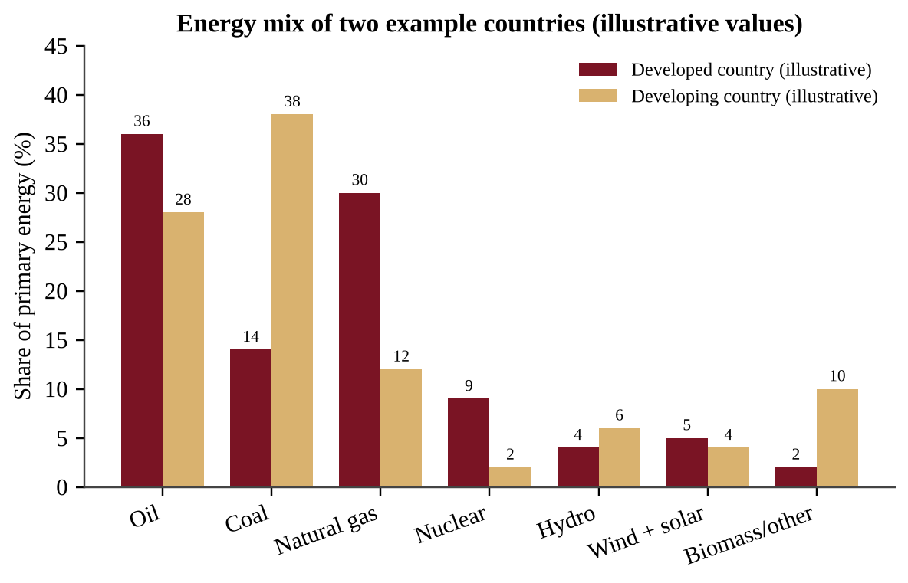
Figure 6.1 — Energy mix of two example countries (illustrative values). Each country's shares total 100%.
Reading Figure 6.1. Notice the pattern before using numbers. The developing country gets a much larger share from coal (38% versus 14%) and from biomass (10% versus 2%), while the developed country relies more on oil and natural gas and has more nuclear. Both countries are dominated by fossil fuels: add oil, coal and gas to get 80% and 78%. A good analysis states the pattern, gives one comparison with numbers, and links it to a cause such as local resources or stage of development.
FORMULA & MATH SKILL
Energy per capita = total energy used ÷ population
Percent share = (energy from one source ÷ total energy) × 100
Percent change = (new − old) ÷ old × 100
Units: energy in joules (J), megajoules (MJ = 10⁶ J), gigajoules (GJ = 10⁹ J), exajoules (EJ = 10¹⁸ J); or kWh. Per capita is reported as J, GJ or kWh per person per year.
Conversions: 1 kWh = 3.6 × 10⁶ J = 3.6 MJ. 1 BTU ≈ 1,055 J. 1 kWh ≈ 3,412 BTU.

REAL-WORLD EXAMPLE
Worked example. A country of 50 million people uses 4.0 × 10¹⁸ J (4.0 EJ) of energy in a year, and 3.0 EJ of that comes from fossil fuels.
Per capita: 4.0 × 10¹⁸ J ÷ 5.0 × 10⁷ people = 8.0 × 10¹⁰ J per person = 80 GJ per person. Fossil share: 3.0 ÷ 4.0 × 100 = 75%. If next year's total use is 4.4 EJ, percent change = (4.4 − 4.0) ÷ 4.0 × 100 = 10% increase.

AP EXAM STRATEGY
Always write the units in each line of a calculation and cancel them. If your answer to "energy per person" has units of J/person/year, it must come from J/year divided by people. Big powers of ten are the usual error source; write them in scientific notation.

CLASSROOM EXAMPLE SG-U6-E002
Country A has 300 million people and uses 90 EJ of energy in a year. Country B has 1,500 million people and uses 45 EJ. (a) Calculate each country's energy use per person in GJ. (b) Calculate how many times greater Country A's per-person use is than Country B's. (c) Country B gets 60% of its energy from coal. Calculate the energy from coal in EJ. (d) Describe one reason Country B's total use is likely to rise over the next 20 years.

Total demand, doubling time and energy history
Total demand depends on both population and use per person, so a country with low use per person but a huge population (China is the standard case) can still have very large total energy use and CO₂ emissions.
FORMULA & MATH SKILL
Total energy use = energy per capita × population
Doubling time (years) = 70 ÷ annual growth rate (%) (rule of 70)
Percent of capacity used = demand ÷ plant capacity × 100

The rule of 70 works for any steady percentage growth: at 3.5% per year, demand doubles in 70 ÷ 3.5 = 20 years. For a table of towns, find each town's demand (people × kW per person), add them, and compare with plant capacity.
Energy history: wood gave way to coal in the 1800s (deforestation, and coal's higher energy content), then oil and gas overtook coal in the 1900s as vehicles multiplied. On a graph of shares, a source can fall in share while its amount still rises, so check the axis. State only causes the data support: a falling coal share beside a rising gas share shows competition, not by itself a cause such as price.
CLASSROOM EXAMPLE SG-U6-E013
A city of 400,000 people uses 3.0 kW per person and a town of 90,000 uses 5.0 kW per person; one 2,000 MW plant serves both. (a) Calculate the percent of capacity used. (b) Demand grows 3.5% per year; use the rule of 70 to estimate the doubling time. (c) Explain why the plant will be overloaded before that time has passed.

QUICK CONCEPT SUMMARY
• Energy use is uneven: higher per person in developed countries; demand grows fastest where industrialization is happening.
• Fossil fuels are the most widely used sources globally; developing countries lean more on fossil fuels as they develop.
• Availability, price and regulation influence which sources people choose.

Topic 6.3 — Fuel Types and Uses
LEARNING OBJECTIVES
• Identify types of fuels and their uses (ENG-3.C), including cogeneration.
• Calculate efficiency and combined efficiency of cogeneration.

CONCEPT MADE SIMPLE
Fuels are "energy in a package." The better packed (more energy per kilogram, less water and ash), the more useful and usually the more expensive. Wood is a loose package; gasoline is a compact one.

Fuels you must know
• Wood. Used as firewood and as charcoal (wood heated with little oxygen so that it is mostly carbon). It is common in developing countries because it is accessible and often free. Heavy use can cause deforestation, and indoor smoke harms health.
• Peat. Partially decomposed plant material from waterlogged bogs. It is the early stage on the way to coal, burns smokily, and is dug and dried for fuel. Peat bogs also store large amounts of carbon, so harvesting them releases CO₂.
• Coal. Formed from buried plant matter that was compressed and heated. Heat, pressure and depth of burial determine the type. Three types are used as fuel: lignite (soft, brown, lowest energy content, least buried), bituminous (the most commonly burned type, medium to high energy) and anthracite (hard, shiny, highest carbon and energy content, most heat and pressure). Higher rank means more carbon, more energy per kilogram, and less moisture.
• Natural gas. Mostly methane (CH₄). It is the cleanest fossil fuel per unit of energy: it releases less CO₂ and almost no particulates or sulfur dioxide. Leaked methane is itself a strong greenhouse gas.
• Crude oil and tar sands. Crude oil is pumped from underground reservoirs. Tar sands are a mix of clay, sand, water and a thick tar-like hydrocarbon called bitumen; oil is recovered from them by mining or by heating the deposit, which takes a lot of energy and water and disturbs land.
• Refined fuels. Crude oil is separated by boiling point into specialized fuels: gasoline for cars, diesel for trucks and trains, kerosene for jet fuel, heating oil, and propane. Each fuel's properties match a use; a jet engine and a lawn mower need different fuels.
Cogeneration
Making electricity in a thermal power plant wastes about two-thirds of the fuel's energy as heat. Cogeneration (combined heat and power, CHP) captures that heat and uses it for something useful, such as heating buildings or supplying industrial steam, while the same fuel also produces electricity. The result is a much higher total efficiency, so less fuel is burned and less pollution is released for the same useful output.
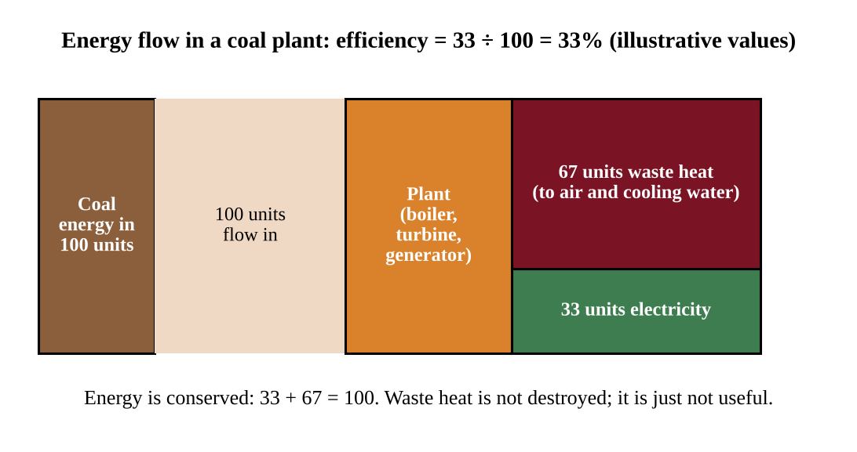
Figure 6.2 — Energy flow in a coal plant (illustrative values). The 67 units of waste heat are the energy that cogeneration tries to put to use.
FORMULA & MATH SKILL
Efficiency (%) = (useful energy output ÷ total energy input) × 100
Cogeneration efficiency (%) = (electrical output + useful heat output) ÷ fuel energy input × 100
Energy is conserved: input = useful output + waste (lost) energy. Use the same unit (J, kWh or BTU) for every term.

KEY DEFINITIONS
Cogeneration — using one fuel source to produce both useful heat and electricity.
Bitumen — thick, tar-like hydrocarbon in tar sands.
Charcoal — fuel made by heating wood with little oxygen.

COMMON STUDENT MISTAKES
• Saying "efficiency means energy is lost." Energy is never destroyed. Waste heat is still energy, just spread out and not useful for the task.
• Calling natural gas "pollution-free." It is the cleanest fossil fuel, not a clean one.

CLASSROOM EXAMPLE SG-U6-E003
A cogeneration plant burns fuel containing 200 MJ of energy. It produces 60 MJ of electricity and delivers 90 MJ of useful heat to nearby buildings. (a) Calculate the plant's overall efficiency. (b) Calculate the energy that is wasted, in MJ. (c) Explain why a plant that produced only the 60 MJ of electricity would need more fuel to supply the same electricity plus the same heating.

QUICK CONCEPT SUMMARY
• Know wood and charcoal, peat, coal ranks (lignite < bituminous < anthracite), natural gas (mostly methane, cleanest fossil fuel), crude oil and tar sands (bitumen).
• Crude oil is refined into specialized fuels.
• Cogeneration uses waste heat, raising overall efficiency.

Topic 6.4 — Distribution of Natural Energy Resources
LEARNING OBJECTIVES
• Identify where natural energy resources occur (ENG-3.D) and explain why their distribution is not uniform.

CONCEPT MADE SIMPLE
You can only find a resource where nature made it. Coal needs ancient swamps; oil and gas need ancient seas and the right rock traps. Where those conditions never happened, there is no deposit, no matter how much people want one.

The global distribution of natural energy resources such as ores, coal, crude oil and natural gas is not uniform. It depends on each region's geologic history: what environments existed there millions of years ago, how sediments were buried, and how rock layers were folded and sealed.
• Coal formed in warm, wet, swampy lowlands where large amounts of plant matter were buried. Such regions (for example parts of North America, China, India, Russia, Australia and Europe) now have coal beds.
• Oil and natural gas formed from marine microorganisms buried in sedimentary basins, then trapped under impermeable rock. The Middle East, parts of Russia, North America and offshore basins are rich in oil and gas; many countries have none.
• Uranium ores occur where particular geological processes concentrated the mineral, in countries such as Kazakhstan, Canada and Australia.
• Renewable resources are also uneven. Geothermal heat is best near tectonic plate boundaries and volcanic hot spots (Iceland, parts of the Pacific Ring of Fire); sunlight is strongest in low-latitude, cloud-free regions; wind is steadier on coasts, plains and mountain passes.
Uneven distribution has consequences. Countries without resources must import, so prices and politics affect them; resource-rich countries may gain income, and resource extraction can lead to conflict or environmental damage.
When a question gives a map or table of reserves and production, describe where resources are concentrated, compare regions, and connect the pattern to a geologic cause. To compare regions fairly on a graph, divide a region's share of world reserves by its share of world consumption. A ratio above 1 marks a region that holds more than it uses (likely an exporter); below 1 marks an importer. The Middle East holds the largest share of proven oil reserves and has long led petroleum exports; the United States has very large coal reserves. A useful ratio is reserves-to-production (R/P), which estimates how long known reserves would last at the current rate of use.
FORMULA & MATH SKILL
R/P ratio (years) = proven reserves ÷ annual production
Units: reserves and production must use the same unit (for example billion barrels and billion barrels per year). The result assumes production stays constant and no new reserves are found.

REAL-WORLD EXAMPLE
A region has 150 billion barrels of proven oil reserves and produces 3.0 billion barrels per year. R/P = 150 ÷ 3.0 = 50 years. If annual production rises to 5.0 billion barrels, the same reserves would last 30 years. Faster use shortens the lifetime of a fixed resource.

COMMON STUDENT MISTAKES
R/P is not a prediction of the "day oil runs out." Reserves change with technology and price, and use changes with demand. Present it as an estimate under stated assumptions.

CLASSROOM EXAMPLE SG-U6-E004
A country has proven natural gas reserves of 240 billion cubic meters (bcm) and produces 4.0 bcm per year. (a) Calculate the R/P ratio in years. (b) Production rises by 25%. Calculate the new annual production and the new R/P ratio. (c) Explain, using geologic history, why a country with no ancient sedimentary basins is unlikely to have natural gas reserves.

QUICK CONCEPT SUMMARY
• Coal, oil, gas and ores are unevenly distributed because of regional geologic history.
• Renewable resources are uneven too (geothermal at plate boundaries, sun and wind by climate and geography).
• R/P = reserves ÷ annual production estimates reserve lifetime at current use.

Topic 6.5 — Fossil Fuels
LEARNING OBJECTIVES
• Describe the use and methods of fossil fuels in power generation (ENG-3.E).
• Describe the effects of fossil fuels on the environment (ENG-3.F).

CONCEPT MADE SIMPLE
A fossil-fuel power plant is a giant kettle. Burn fuel to boil water; the steam spins a turbine like a pinwheel; the turbine spins a generator that makes electricity.

Combustion and power generation
Combustion is a chemical reaction between a fuel and oxygen that releases energy. For hydrocarbon fuels the products are carbon dioxide and water. For methane, the main component of natural gas:
CH₄ + 2 O₂ → CO₂ + 2 H₂O + energy
Real fuels also contain impurities (sulfur, nitrogen, metals), and combustion in air makes nitrogen oxides, so burning fossil fuels produces SO₂, NOₓ, particulates and, when oxygen is limited, carbon monoxide (CO).
PROCESS & CAUSE-AND-EFFECT
Fuel burned in boiler → heat boils water → high-pressure steam → steam spins turbine → turbine spins generator → electricity → steam cooled in condenser and returned as water (waste heat released to air or cooling water)

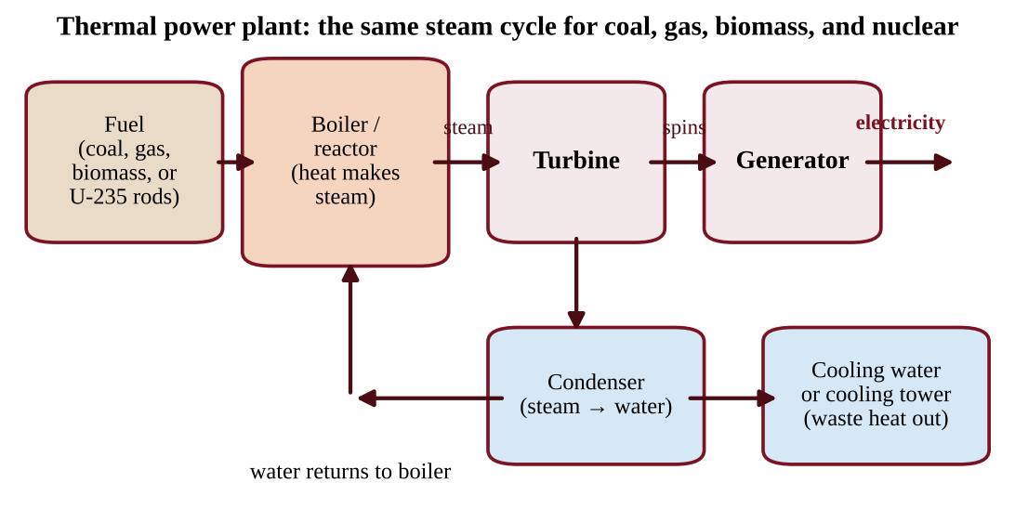
Figure 6.3 — The steam cycle used by coal, gas, biomass and nuclear plants. Only the heat source differs.
Natural gas plants can also use a combined cycle: hot exhaust gas first spins a gas turbine, then heats water to run a steam turbine, giving higher efficiency than a coal plant.
Extraction methods
• Surface (strip) mining removes soil and rock above shallow coal. It is cheaper and safer for workers but destroys habitat, erodes soil and can send acidic, metal-rich drainage into streams. Mountaintop removal is an extreme form.
• Subsurface mining uses shafts and tunnels for deep coal. It is more expensive and dangerous (collapses, gas explosions, lung disease) and can cause land subsidence and acid mine drainage.
• Drilling pumps oil and gas from wells on land or offshore. Spills, leaks, habitat disruption and, in offshore drilling, risk of blowouts are concerns.
• Hydraulic fracturing (fracking) injects water, sand and chemicals at high pressure to crack tight rock and free oil or gas. It can contaminate groundwater if wells or wastewater storage fail, and can release volatile organic compounds (VOCs) and methane to the air. It also uses large volumes of water, and disposal of the wastewater is a concern.
• Tar sand extraction uses mining or heating of the deposit and is energy- and water-intensive.
Environmental effects of using fossil fuels
• Climate: combustion releases CO₂, a greenhouse gas; natural gas leaks release methane.
• Air quality: SO₂ and NOₓ cause acid deposition and smog; particulates harm lungs; mercury is released from burning coal.
• Water: thermal pollution from cooling water, oil spills, mine drainage.
• Land: mining scars, habitat loss.
Why do societies keep using them? They are energy dense, widely available, easy to store and transport, and supported by existing infrastructure, so they are often the lowest-cost choice at the point of use.
KEY DEFINITIONS
Combustion — chemical reaction of a fuel with oxygen that releases energy, producing CO₂ and H₂O for fossil fuels.
Hydraulic fracturing (fracking) — injecting fluid at high pressure into rock to open cracks and release oil or gas.
Volatile organic compounds (VOCs) — carbon-based chemicals that evaporate easily and can form smog.

COMMON STUDENT MISTAKES
• Saying water is the source of energy in a steam plant. Water is only the working fluid that carries heat.

AP EXAM STRATEGY
For "describe the environmental effects of X," name a specific pollutant or impact, say where it goes (air, water, land) and what harm it causes. "It pollutes" earns no credit; "SO₂ forms sulfuric acid that acidifies lakes" does.

CLASSROOM EXAMPLE SG-U6-E005
Methane burns according to CH₄ + 2 O₂ → CO₂ + 2 H₂O. Use atomic masses C = 12, H = 1, O = 16. (a) Calculate the mass of CO₂, in kg, released when 16 kg of methane is burned completely. (b) A gas-fired plant produces electricity with an efficiency of 40%. If it uses 500 MWh of fuel energy in an hour, calculate its electrical output in MWh and the energy released as waste heat. (c) Identify the energy transformation sequence from heat to electricity in the plant.

Power, fuel and emissions in a plant
A plant's efficiency links the electricity it sends out to the fuel energy it must take in. Everything that is not electricity ends up as waste heat, mostly at the condenser. Work in power (MW = MJ/s) and keep the plant's electrical output and its thermal (fuel) input separate.
FORMULA & MATH SKILL
Fuel (thermal) power in = electrical power out ÷ efficiency (as a decimal)
Waste heat = power in − power out
Fuel mass = fuel energy needed ÷ energy content of the fuel (MJ/kg)
CO₂ emitted = energy (kWh) × emission factor (kg CO₂/kWh), or fuel burned × emission per unit of fuel
Average emission factor of a grid = Σ (share of each source × its factor)
CO₂ avoided by switching = energy × (old factor − new factor)

REAL-WORLD EXAMPLE
Worked example. A 300 MW electric plant runs at 40% efficiency on coal containing 25 MJ/kg. Power in = 300 ÷ 0.40 = 750 MW, so waste heat = 750 − 300 = 450 MW. Fuel use = 750 MJ/s ÷ 25 MJ/kg = 30 kg/s = 108 metric tons per hour (30 × 3,600 ÷ 1,000). A grid that is 60% coal (1.0 kg CO₂/kWh), 30% gas (0.45) and 10% wind (0) averages 0.60 × 1.0 + 0.30 × 0.45 + 0 = 0.735 kg CO₂/kWh. Unit helpers: 1 GWh = 10⁶ kWh; 1 metric ton = 1,000 kg.

Three more points. In fracturing, the sand props the new cracks open, and wastewater injected deep underground can trigger small earthquakes. Coal pollution is cut by scrubbers (remove SO₂), filters and precipitators (capture particulates), low-sulfur coal and fuel switching. A utility bill leaves out the external costs (illness, lost workdays, ecosystem damage) that society pays. Natural gas is called a bridge fuel because it emits less CO₂ and almost no SO₂ per unit of energy than coal, though methane leaks limit the benefit.
CLASSROOM EXAMPLE SG-U6-E014
A coal plant delivers 200 MW of electric power at 32% efficiency; its coal holds 24 MJ/kg and it emits 1.0 kg CO₂ per kWh. (a) Calculate the waste heat in MW. (b) Calculate the coal burned per hour in metric tons. (c) A gas plant emitting 0.45 kg CO₂/kWh replaces it. Calculate the CO₂ avoided in 8,000 operating hours, in metric tons.

QUICK CONCEPT SUMMARY
• Combustion: fuel + O₂ → CO₂ + H₂O + energy. Heat → steam → turbine → generator → electricity.
• Extraction methods: surface and subsurface mining, drilling, fracking, tar sand mining, each with land, water or air impacts.
• Fracking risks: groundwater contamination and VOC release.

Topic 6.6 — Nuclear Power
LEARNING OBJECTIVES
• Describe nuclear energy in power generation (ENG-3.G) and its environmental effects (ENG-3.H).
• Use half-life to calculate remaining radioactivity.

CONCEPT MADE SIMPLE
A nuclear plant is also a giant kettle, but the heat comes from splitting atoms instead of burning anything. A tiny amount of uranium releases a huge amount of heat, but the leftover waste stays dangerous for a very long time.

Fission in a reactor
Nuclear power comes from fission. A neutron strikes an atom of uranium-235 (U-235), which is stored in fuel rods. The nucleus splits into smaller nuclei and releases heat plus extra neutrons, which strike other U-235 nuclei, creating a chain reaction. The heat boils water; the steam turns a turbine; the turbine spins a generator (the same steam cycle as in Figure 6.3).
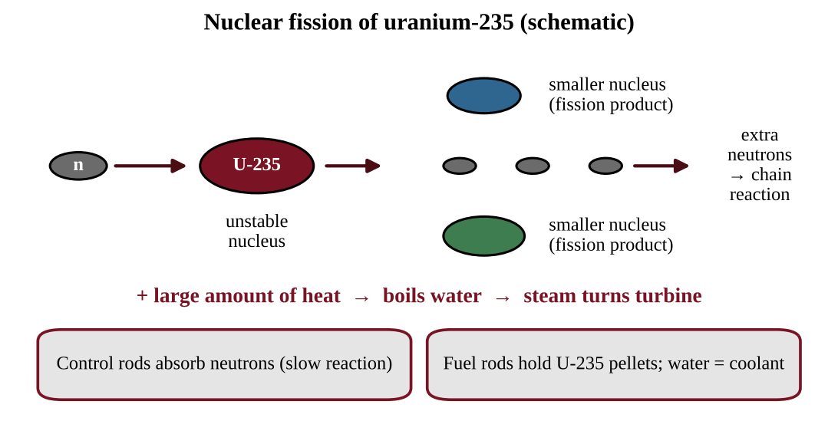
Figure 6.4 — Fission of uranium-235 (schematic, not to scale).
Key parts: fuel rods (U-235 pellets), control rods (absorb neutrons to slow or stop the reaction), coolant/moderator (usually water that removes heat), a containment structure (thick concrete and steel shell), and a cooling system.
Radioactivity and waste
Radioactivity occurs when the nucleus of a radioactive isotope loses energy by emitting radiation. Spent fuel contains radioactive isotopes. U-235 and some fission products stay radioactive for a very long time, so waste disposal is the core challenge: spent fuel is first stored in cooling pools, then in dry casks, and long-term plans call for deep geologic repositories that remain stable for thousands of years. Low-level waste (gloves, equipment) is less hazardous.
Advantages and disadvantages
• Nonrenewable: uranium is mined and finite.
• No air pollutants or CO₂ from operation, so it is considered cleaner for air and climate.
• Releases thermal pollution (warm cooling water can harm aquatic life) and hazardous solid waste.
• Very high capacity factor (see Figure 6.5), high construction cost, long building time.
• Mining uranium disturbs land and can leave radioactive tailings.
• Accident risk is low but consequences can be severe.
Accidents
• Three Mile Island (USA, 1979): a partial meltdown caused by equipment failure and operator error; containment held and only a small radiation release occurred, but the accident reshaped public trust and regulation.
• Chernobyl (Ukraine, then USSR, 1986): a reactor explosion and fire released large amounts of radioactive material across Europe. A wide exclusion zone remains and many people were exposed, with long-term health effects and contaminated land.
• Fukushima Daiichi (Japan, 2011): an earthquake and tsunami knocked out cooling power; reactors overheated and released radiation, requiring evacuation and long cleanup, and contaminated water had to be managed.
Half-life math
A radioactive isotope's half-life is the time for half of the nuclei in a sample to decay. After each half-life, the amount remaining is halved, and the radioactivity falls the same way. It sets the rate of decay and tells us how long waste stays dangerous.
FORMULA & MATH SKILL
Remaining amount = initial amount × (½)ⁿ, where n = elapsed time ÷ half-life
Or halve the amount once for each half-life that passes. Elapsed time and half-life must use the same time unit.
Example: 800 units with half-life 5 years. After 15 years n = 3, so 800 → 400 → 200 → 100 units.

REAL-WORLD EXAMPLE
Iodine-131 has a half-life of about 8 days and concentrates in the thyroid, so it is a short-term hazard after accidents. Cesium-137 has a half-life of about 30 years, so land contaminated with it stays hazardous for decades. Plutonium and uranium isotopes with half-lives of thousands to millions of years are why repositories must work over very long periods.

KEY DEFINITIONS
Fission — splitting of a heavy nucleus into smaller nuclei, releasing heat and neutrons.
Chain reaction — neutrons released by fission cause further fissions.
Half-life — time for half of a radioactive sample to decay.
Radioactivity — emission of radiation by an unstable nucleus losing energy.

COMMON STUDENT MISTAKES
• Believing a half-life means the sample is gone after two half-lives. It is 25% remaining, not zero.
• Thinking "a long half-life means a more intense source." A long half-life decays slowly, so each unit is less intense per second but stays dangerous far longer.
• Calling nuclear "emission-free" in every way. It emits no air pollutants in operation but does produce thermal pollution and hazardous solid waste.

CLASSROOM EXAMPLE SG-U6-E006
A waste sample contains an isotope with a half-life of 8 days. The sample's activity is 640 units today. (a) Calculate its activity after 32 days. (b) Calculate how many days are needed for the activity to fall to 10 units. (c) A second isotope in the same waste has a half-life of 24,000 years. Explain why that isotope, not the first, drives the need for very long-term storage.

More on cooling, waste and half-life
In most reactors the reactor water, the steam loop and a separate cooling loop through the condenser stay sealed apart. The cooling water leaving the condenser carries the plant's waste heat; discharged to a river it causes thermal pollution (warm water holds less dissolved oxygen and can exceed organisms' tolerance), and intakes can trap fish. Cooling towers reduce the heat released. Low-level waste (tools, clothing) is short-lived and stored in shielded containers; high-level waste (spent fuel) stays hazardous for thousands of years and needs deep geologic storage. Radioactive iodine is absorbed by the thyroid, so thyroid cancer is the typical health effect of an accident.
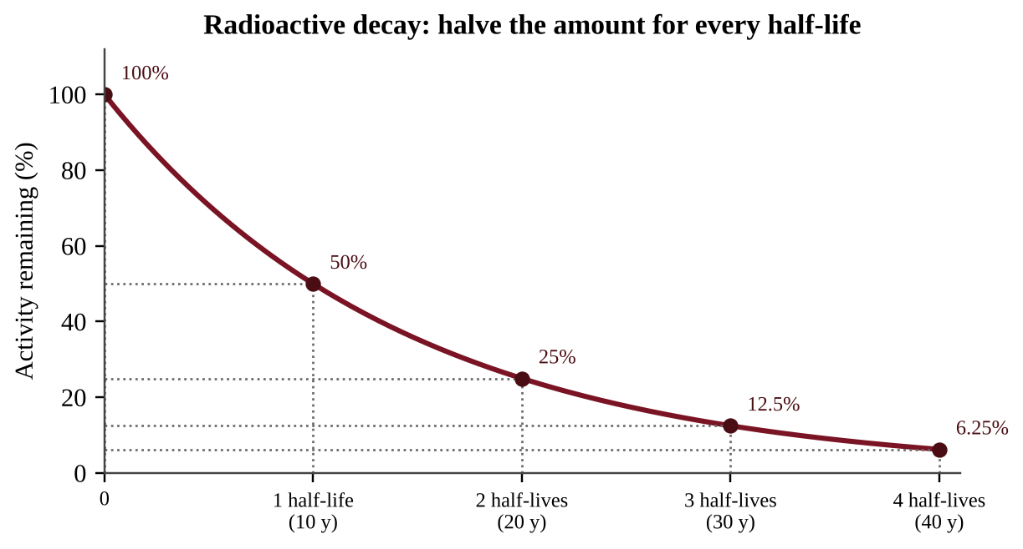
Figure 6.4b — Decay curve for an isotope with a 10-year half-life: every 10 years the amount is cut in half.
Half-life skills. (1) 50%, 25%, 12.5%, 6.25% are 1, 2, 3, 4 half-lives; 1/16 is (½)⁴. (2) Find the half-life as elapsed time ÷ number of halvings, or read the time at which a curve falls to half its start. (3) A common rule of thumb treats waste as essentially decayed after about 10 half-lives (about 0.1% left). The longest-lived isotope controls storage time.
CLASSROOM EXAMPLE SG-U6-E015
A strontium-90 sample (half-life 29 years) has an activity of 480 units. (a) Calculate its activity after 87 years. (b) Calculate the time to fall to 6.25% of the start. (c) A different isotope falls from 0.80 mol to 0.10 mol in 21 days. Calculate its half-life.

QUICK CONCEPT SUMMARY
• Fission of U-235 in fuel rods releases heat; steam turbine; generator. Control rods slow the reaction.
• Nuclear is nonrenewable, no air pollutants in operation, but thermal pollution and long-lived hazardous waste.
• Three Mile Island, Chernobyl and Fukushima are the accident case studies.
• Half-life math: halve the amount for each half-life elapsed.

Topic 6.7 — Energy from Biomass
LEARNING OBJECTIVES
• Describe the effects of using biomass in power generation on the environment (ENG-3.I).
• Calculate energy return on energy investment (EROEI).

CONCEPT MADE SIMPLE
Biomass is stored sunlight in plants. Burn it and you get heat; the carbon it releases was recently taken from the air by the plant, so, if the plants are regrown, the carbon cycle is roughly balanced. The catch is that growing, harvesting and processing it also take energy.

Biomass is organic material from plants and animals used as fuel: wood, crop residues, manure, and fuel crops. Burning biomass produces heat at relatively low cost, which is why it is the main fuel for cooking and heating for billions of people. But combustion also produces CO₂, carbon monoxide, nitrogen oxides, particulates and VOCs, and in homes without chimneys, indoor smoke causes respiratory disease. Overharvesting trees for fuel causes deforestation, which removes habitat, causes soil erosion and removes carbon sinks.
Biofuels
Ethanol is alcohol made by fermenting sugars from corn, sugarcane or other crops. It can replace some gasoline (blends such as E10 and E85). Burning ethanol does not introduce additional carbon into the atmosphere in the sense that the carbon was absorbed by the crop recently, but the energy return on energy investment (EROEI) of ethanol is low, because farming (fertilizer, machinery), transport and distillation all use energy, often from fossil fuels. Growing fuel crops can also compete with food crops for land and water and add fertilizer runoff.
FORMULA & MATH SKILL
EROEI = energy delivered by the fuel ÷ energy invested to obtain it
Net energy = energy delivered − energy invested
EROEI > 1 means a net energy gain. The higher it is, the more attractive the source. Both quantities must be in the same units (for example MJ per liter).

REAL-WORLD EXAMPLE
A distillery uses 8.0 MJ of energy to grow, harvest and process the corn for each liter of ethanol, and the liter contains 21 MJ. EROEI = 21 ÷ 8.0 = 2.6; net energy = 21 − 8.0 = 13 MJ per liter. By contrast, a high-quality oil field that returns 15 MJ for every 1 MJ invested has an EROEI of 15.

COMMON STUDENT MISTAKES
• "Biomass is carbon neutral, so it has no climate impact." Only true when regrowth truly replaces what is burned, and fossil fuel inputs for farming and processing add CO₂.

CLASSROOM EXAMPLE SG-U6-E007
Producing one liter of a biofuel requires 12 MJ of energy inputs, and the liter contains 24 MJ of usable energy. A gasoline-like crude oil source returns 18 MJ for each 1.0 MJ invested. (a) Calculate the biofuel's EROEI and its net energy per liter. (b) State which source returns more energy per unit invested. (c) Describe two environmental effects of replacing forest with fuel crops.

Net energy, land use and blends
The net gain from an investment is (EROEI − 1) × energy invested: an EROEI of 1.56 turns 100 MJ invested into 156 MJ delivered, a net gain of 56 MJ.
Biofuel questions chain calculations. Land = fuel volume ÷ yield per hectare. Water = land × irrigation per hectare. Blend emissions = each component's volume × its life-cycle factor, added (in B20, 20% of the volume uses the biodiesel factor). Biofuel factors are not zero because farming, fertilizer, processing and trucking burn fossil fuel.
Compare fuels pollutant by pollutant: wood pellets give far less fossil CO₂ than natural gas but more particulates and nitrogen oxides. State both sides. Irrigated fuel crops in dry regions also compete with food for water and land.
CLASSROOM EXAMPLE SG-U6-E016
A fleet uses 200,000 L of fuel a year. Petroleum diesel emits 3.2 kg CO₂e per liter over its life cycle and biodiesel 1.1. The fleet changes to 30% biodiesel by volume; the crop yields 1,500 L/ha per year and needs 5,000 m³/ha of irrigation. (a) Calculate the percent reduction in emissions. (b) Calculate the hectares and irrigation water needed. (c) A fuel has an EROEI of 3.0; calculate its net gain per 100 MJ invested.

QUICK CONCEPT SUMMARY
• Biomass burning is cheap but releases CO₂, CO, NOₓ, particulates and VOCs; overharvesting causes deforestation.
• Ethanol can substitute for gasoline, and burning it adds no extra carbon beyond what the crop absorbed, but its EROEI is low.

Topic 6.8 — Solar Energy
LEARNING OBJECTIVES
• Describe solar energy in power generation (ENG-3.J) and its environmental effects (ENG-3.K).
• Calculate capacity factor, energy produced, cost savings and payback.

CONCEPT MADE SIMPLE
Solar energy is free sunshine caught two ways: panels that turn light directly into electricity, and heat collectors that warm water or air. The challenge is that the sun does not always shine and the equipment costs money upfront.

Three kinds of solar systems
• Photovoltaic (PV) cells capture light energy and transform it directly into electrical energy. Output depends on sunlight, so it falls on cloudy days and is zero at night. PV can be rooftop (small, distributed) or in large solar farms.
• Active solar systems use mechanical and electrical equipment (pumps, fans, collectors) to heat a liquid and to collect and store the energy captured from the sun, for example solar water heaters with storage tanks. Large "concentrating" plants use mirrors to focus sunlight on a fluid to make steam.
• Passive solar systems absorb heat directly from the sun without mechanical or electric equipment. Examples: large south-facing windows (in the Northern Hemisphere), thick dark thermal-mass floors, and overhangs that block summer sun. Passive systems do not collect or store energy for later use except as the heat held in the building itself.
Environmental effects
Solar has low environmental impact and produces clean energy (no air pollution or CO₂ during operation), but equipment can be expensive. Manufacturing panels needs mining and energy. Large solar farms can harm desert ecosystems by clearing land, disturbing soil and fragmenting habitat of species such as desert tortoises. Rooftop solar avoids this land use.
Energy, power and capacity factor
Many students lose points by mixing up power and energy. Power is the rate of using or producing energy; energy is power multiplied by time. A 1 kW heater running for 1 hour uses 1 kilowatt-hour (kWh) of energy.
FORMULA & MATH SKILL
Energy = Power × Time (kWh = kW × h; J = W × s)
Electricity cost = energy (kWh) × price ($/kWh)
Capacity factor (%) = actual energy produced ÷ (rated capacity × hours) × 100
Payback period (years) = upfront cost ÷ annual savings
Units: 1 kW = 1,000 W; 1 MW = 1,000 kW; 1 W = 1 J/s; a year has 8,760 hours. A plant's capacity (kW or MW) is its maximum output; the capacity factor tells you how much of that maximum it actually delivers on average.

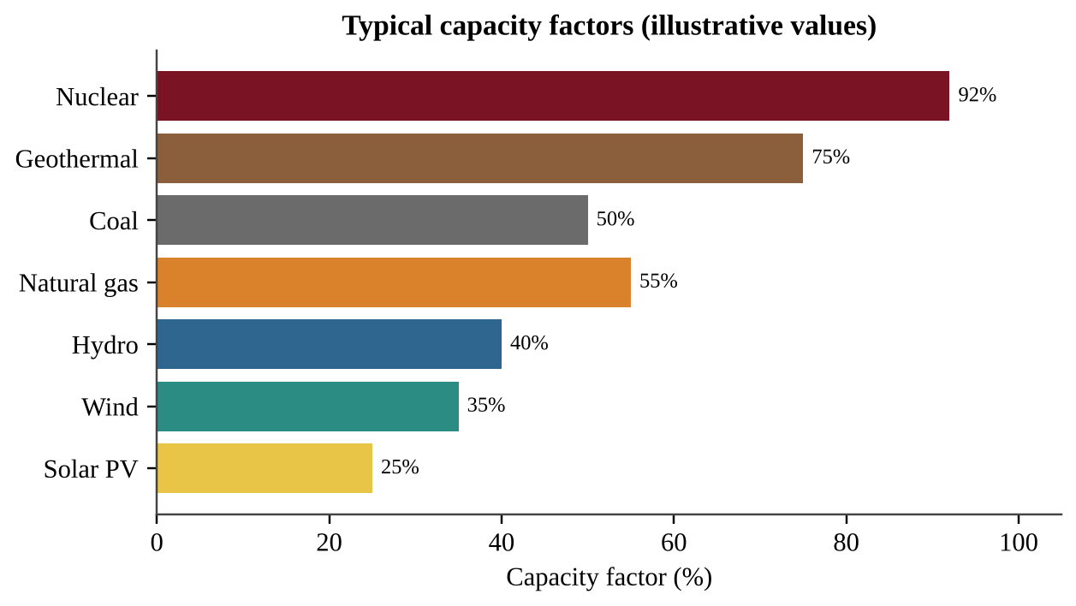
Figure 6.5 — Typical capacity factors of electricity sources (illustrative values). Fuel-based baseload plants run most of the time; sun- and wind-dependent sources produce less than their rated maximum on average.
Reading Figure 6.5. A plant that produces power around the clock (nuclear, geothermal) has a high capacity factor. Solar PV and wind are lower because the sun sets and the wind varies, not because the equipment is poor. So a 100 MW solar farm cannot be compared to a 100 MW nuclear plant on capacity alone; compare the energy actually produced.
REAL-WORLD EXAMPLE
Worked example. A rooftop PV array has a rated capacity of 5.0 kW. Over a year it produces 7,300 kWh. Possible output at full power all year = 5.0 kW × 8,760 h = 43,800 kWh. Capacity factor = 7,300 ÷ 43,800 × 100 = 16.7%. At $0.14 per kWh, savings = 7,300 × 0.14 = $1,022 per year. If the system cost $9,000, payback = 9,000 ÷ 1,022 ≈ 8.8 years.

COMMON STUDENT MISTAKES
• Mixing kW and kWh. kW is a rate (power); kWh is an amount (energy). A utility bill charges for kWh.
• Using 24 hours instead of 8,760 hours (or the wrong number of days) in the capacity-factor denominator.
• Calling passive solar "no technology." It is design, not machines; it uses no mechanical or electric equipment.

AP EXAM STRATEGY
For payback questions, compute annual savings first, then divide. State that payback ignores things such as panel degradation and maintenance, and note that after payback the energy is essentially free for the rest of the system's life.

CLASSROOM EXAMPLE SG-U6-E008
A 6.0 kW solar PV system installed for $12,000 produces 10,000 kWh in one year. Electricity costs $0.15 per kWh. (a) Calculate the system's capacity factor for the year. (b) Calculate the annual savings and the payback period in years. (c) Express the year's production in megajoules (1 kWh = 3.6 MJ). (d) Distinguish passive solar heating from active solar heating in one sentence.

Sizing PV and building a solar system
The energy a PV array makes depends on how much sunlight lands on it and what fraction the cells convert (their efficiency, typically 15–22%).
FORMULA & MATH SKILL
PV energy (kWh/day) = area (m²) × sunlight (kWh/m²/day) × efficiency (decimal)

A home system has panels (make direct current, DC), an inverter (changes DC to AC for appliances) and optionally a battery (stores energy for night). A grid-connected system can skip the battery by selling surplus and buying power at night. Concentrating plants use mirrors to reach the high temperatures needed for steam; an insulated hot-water or molten-salt tank is their storage element. Sunlight is strongest and steadiest near the equator; at high latitudes the sun is lower and seasons swing widely, so a site with large winter shortfalls needs more storage or backup. Panels face the equator. PV output peaks near midday but home demand often peaks in the evening.
CLASSROOM EXAMPLE SG-U6-E017
A school installs 800 m² of PV panels at 19% efficiency on a site averaging 4.8 kWh/m² of sunlight per day. The school uses 400,000 kWh per year at $0.13 per kWh, and the grid emits 0.45 kg CO₂ per kWh. (a) Calculate the array's annual output. (b) Calculate the percent of use supplied, the annual savings and the CO₂ avoided in metric tons. (c) Describe one mismatch between PV output and school demand, and propose a response.

QUICK CONCEPT SUMMARY
• PV: sunlight → electricity directly. Active: equipment collects and stores heat. Passive: building design absorbs heat with no equipment.
• Solar is clean and low-impact but expensive and limited by sunlight; big farms can harm deserts.
• Energy (kWh) = power (kW) × time (h). Capacity factor = actual ÷ possible. Payback = cost ÷ annual savings.

Topic 6.9 — Hydroelectric Power
LEARNING OBJECTIVES
• Describe hydroelectricity in power generation (ENG-3.L) and its environmental effects (ENG-3.M).
• Justify hydropower as a solution by explaining its advantages.

CONCEPT MADE SIMPLE
Moving water pushes a turbine. A dam stores water high up, like a battery that can be released on demand; when the water falls through pipes, it spins the turbine.

Types of hydroelectric power
• Dam and reservoir. A dam across a river collects water in a reservoir. Released water flows through the dam, spins a turbine and then a generator. The water's stored (potential) energy becomes kinetic energy, then electricity. Operators can release more water when demand is high, so hydro can be adjusted quickly.
• Run-of-river. Turbines placed in small rivers use the flowing water directly without a large reservoir. They flood much less land but produce less power and depend on the river's flow.
• Tidal energy. Turbines placed in tidal flows are turned by the in-and-out movement of tides. It is predictable, but suitable sites are limited and equipment must survive harsh marine conditions.
• Pumped storage (a related idea): surplus electricity pumps water uphill; later, the water runs back down through turbines. It stores energy rather than producing it.
Advantages and effects
Advantages (use these to justify hydropower): no air pollution or fuel waste during operation; renewable supply driven by the water cycle; low operating cost and long plant life; flood control, irrigation and recreation from reservoirs; can supply power on demand.
Disadvantages: construction is expensive; reservoirs flood forests, farms and towns, forcing people to relocate and causing loss or change of habitat; dams block fish migration (such as salmon), trap sediment that would nourish downstream floodplains and deltas, change river temperature and flow, and decaying plants in new reservoirs release methane and CO₂. Output falls in droughts.
Responses to these problems include fish ladders and managed river flows. Dam removal can restore fish migration, sediment flow and downstream floodplains (whose seasonal floods deposit nutrient-rich silt), but it gives up electricity, irrigation water and recreation, and may release stored sediment. A reservoir also loses water by evaporation: volume lost = surface area × depth evaporated, after converting km² to m² (× 10⁶) and m³ to liters (× 1,000). Wave converters are another renewable ocean source.
REAL-WORLD EXAMPLE
A planned dam would generate electricity with no air pollutants and supply peak power, so a planner can justify it using those two advantages. A strong answer also acknowledges one trade-off, such as fish migration, and proposes a response such as fish ladders or environmental flow releases.

KEY DEFINITIONS
Reservoir — artificial lake formed behind a dam.
Run-of-river hydro — turbines in a flowing river with little or no storage.
Tidal energy — electricity from turbines turned by tidal flows.

COMMON STUDENT MISTAKES
• "Hydro has no environmental impact." It changes habitat, river flow and sediment even though it emits no air pollutants.

CLASSROOM EXAMPLE SG-U6-E009
A dam has a rated capacity of 1,200 MW and operates at a capacity factor of 45%. (a) Calculate the electrical energy it generates in a year, in MWh. (b) An average home in the region uses 10,000 kWh per year. Calculate how many homes the dam could supply. (c) Describe two ecological effects of building the dam and identify one advantage that could be used to justify it.

CLASSROOM EXAMPLE SG-U6-E018
A reservoir of 80 km² loses 1.5 m of water to evaporation yearly. A city of 600,000 people uses 120 L per person per day. (a) Calculate the evaporated volume in m³. (b) Calculate the city's annual use in m³ and the evaporation as a percent of it.

QUICK CONCEPT SUMMARY
• Hydro uses falling or flowing water to spin turbines: dams with reservoirs, small-river turbines, and tidal flow.
• No air pollution or waste; expensive to build; habitat loss and changed river ecosystems.

Topic 6.10 — Geothermal Energy
LEARNING OBJECTIVES
• Describe geothermal energy in power generation (ENG-3.N) and its environmental effects (ENG-3.O).

CONCEPT MADE SIMPLE
The Earth is hot inside. In a few places the heat is close to the surface. Pump water down, let the rock heat it, bring it back as steam, and use the steam to spin a generator.

Geothermal energy uses the heat stored in the Earth's interior. Wells are drilled to hot rock and water; heated water returns to the surface as steam, which drives a turbine and generator. The cooled water is usually injected back underground. The best sites are near plate boundaries and volcanic areas where hot rock is near the surface (for example Iceland, Kenya's Rift Valley, and the western United States).
Geothermal plants run day and night and have high capacity factors, so they provide steady "baseload" power. Smaller-scale geothermal heat pumps use the stable temperature of shallow ground to heat and cool buildings. Plants come in three designs: dry steam (natural steam spins the turbine), flash (very hot, high-pressure water turns to steam when pressure drops) and binary (hot water heats a second fluid that boils at a lower temperature). Hot fluid can carry corrosive salts, and venting steam is noisy.
Limits and effects. The cost of drilling and accessing geothermal energy can be prohibitively expensive, and good sites are not easily accessible in many parts of the world. Plants can release hydrogen sulfide (H₂S), a gas with a rotten-egg smell that is toxic at high concentrations. Other issues include dissolved minerals and salts in the water, land use at drilling sites, possible small earthquakes, and local depletion of a reservoir if water is removed faster than it recharges.
QUICK CONCEPT SUMMARY
• Heat from the Earth's interior heats water → steam → turbine → generator.
• Steady and low-emission, but limited to certain locations, costly, and can release hydrogen sulfide.

Topic 6.11 — Hydrogen Fuel Cell
LEARNING OBJECTIVES
• Describe hydrogen fuel cells in power generation (ENG-3.P) and their environmental effects (ENG-3.Q).

CONCEPT MADE SIMPLE
A hydrogen fuel cell is like a battery that you refill with hydrogen gas. Hydrogen and oxygen go in, electricity and water come out. No flame is needed.

A hydrogen fuel cell uses hydrogen as fuel. Hydrogen combines with oxygen from the air to form water and release energy as electricity:
2 H₂ + O₂ → 2 H₂O + electrical energy (and some heat)
Water is the only product at the point of use, so a fuel-cell vehicle has no tailpipe CO₂ or air pollutants. Fuel cells are an alternative to nonrenewable fuels in cars, buses, backup power and some buildings.
The catch: hydrogen is not an energy source, it is an energy carrier. There is almost no free hydrogen gas on Earth, so it has to be made, and making it requires energy. Hydrogen produced by electrolysis (using electricity to split water into H₂ and O₂) produces no CO₂ if the electricity is from renewable sources. Today, most hydrogen is made from natural gas, which does release CO₂. Hydrogen made from natural gas (steam reforming) or coal gasification releases CO₂ at the plant; electrolysis powered by wind or solar has the lowest net CO₂. Other drawbacks: the technology is expensive, hydrogen is hard to store and transport (it is a very light gas, stored at high pressure or very low temperature), and a refueling network is limited.
PROCESS & CAUSE-AND-EFFECT
Renewable electricity → splits water (electrolysis) → hydrogen gas stored → fuel cell combines H₂ + O₂ → electricity + water → motor or grid

FORMULA & MATH SKILL
Overall system efficiency = (useful energy delivered ÷ energy originally put in) × 100. When a chain has several steps, multiply step efficiencies: for electrolysis (η₁) then fuel cell (η₂), overall = η₁ × η₂.

COMMON STUDENT MISTAKES
"Hydrogen fuel cells are always zero-emission." The cell itself emits only water, but if the hydrogen comes from natural gas or from fossil-fueled electricity, CO₂ is released upstream.

CLASSROOM EXAMPLE SG-U6-E010
Producing 1.0 kg of hydrogen by electrolysis uses 55 kWh of electricity. A fuel cell converts that 1.0 kg of hydrogen back into 20 kWh of electricity. (a) Calculate the overall efficiency of the electricity-to-hydrogen-to-electricity chain. (b) The electricity for electrolysis comes from a coal plant that emits 0.9 kg of CO₂ per kWh. Calculate the CO₂ emitted to produce the 1.0 kg of hydrogen. (c) Explain why this fuel cell is not "zero-emission" in this case, even though its only exhaust is water.

QUICK CONCEPT SUMMARY
• Fuel cell: H₂ + O₂ → H₂O + electricity; water is the emission.
• Low impact and no CO₂ when hydrogen comes from water using clean electricity, but expensive and still needs energy to make hydrogen.

Topic 6.12 — Wind Energy
LEARNING OBJECTIVES
• Describe wind energy in power generation (ENG-3.R) and its environmental effects (ENG-3.S).

CONCEPT MADE SIMPLE
A wind turbine is the opposite of a household fan: moving air spins the blades, and the blades turn a generator.

Wind turbines use the kinetic energy of moving air to spin blades connected to a shaft and a generator, producing electricity. Wind is driven by uneven heating of the Earth by the sun, so it is renewable. Wind farms are placed where winds are strong and steady: plains, ridges, coasts and offshore. Offshore sites have stronger, steadier winds but cost more to build and maintain. Power available in wind rises very rapidly with wind speed, so site choice matters.
Advantages: renewable and clean (no air pollution or CO₂ during operation), no fuel cost, and land between turbines can still be farmed or grazed. Disadvantages: wind is intermittent, so output varies and backup or storage is needed; birds and bats may be killed if they fly into spinning blades; noise, visual impact; and building farms disturbs land or seabed. Siting away from migration routes, slowing blades at certain times, and painting blades are ways to reduce bird and bat deaths.
REAL-WORLD EXAMPLE
Worked example. A wind farm has 20 turbines rated 3.0 MW each, so its capacity is 60 MW. With a capacity factor of 35%, annual energy = 60 MW × 8,760 h × 0.35 = 183,960 MWh. If this displaces electricity from a plant that emits 0.8 tonnes CO₂ per MWh, avoided CO₂ = 183,960 × 0.8 ≈ 147,000 tonnes per year.

AP EXAM STRATEGY
Common FRQ move: "Propose a solution" for a region that wants more wind power. Name the benefit (clean, renewable), name one drawback (bird/bat deaths or intermittency), and give a specific response to it (siting away from flyways, battery storage, or pairing with other sources).

CLASSROOM EXAMPLE SG-U6-E011
A wind farm has 40 turbines, each rated at 2.5 MW, and operates at a capacity factor of 35%. (a) Calculate the farm's annual electricity generation in MWh. (b) The farm replaces electricity from a coal plant that emits 0.9 tonnes of CO₂ per MWh. Calculate the CO₂ emissions avoided per year. (c) Identify one environmental drawback of the wind farm and one action that would reduce it.

The power in wind rises with the cube of wind speed. Doubling the speed gives 2³ = 8 times the power, and 5.0 m/s versus 7.5 m/s gives (7.5 ÷ 5.0)³ ≈ 3.4 times. A turbine's power curve shows what it actually delivers.
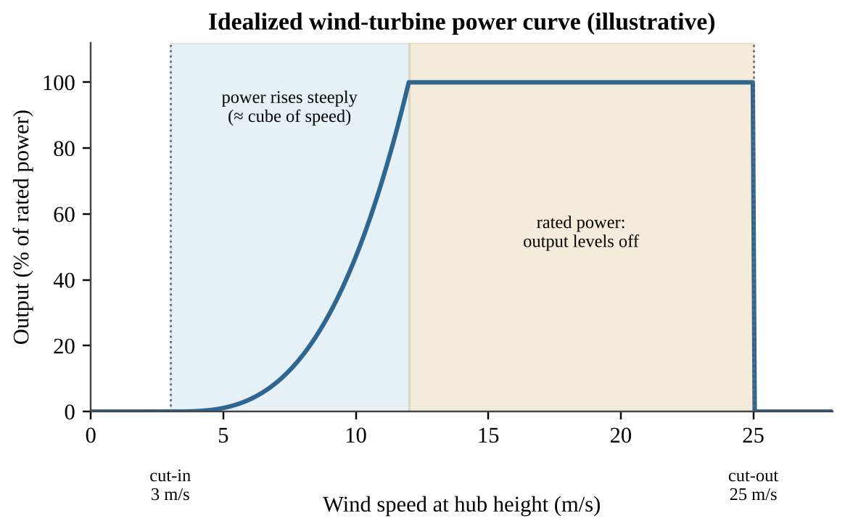
Figure 6.5b — Idealized power curve: no output below cut-in speed, steep rise, a plateau at rated power, then shutdown at cut-out speed to protect the blades.
Reading a curve. Read the output at each speed and divide for a ratio. Curtailment means holding blades still at low wind: if bat deaths are highest in light winds when little power is made, a higher cut-in speed on migration nights saves many bats and costs little electricity. Choose such a rule from a table by finding where harm is highest and energy lowest.
CLASSROOM EXAMPLE SG-U6-E019
One site averages 6.0 m/s and another 9.0 m/s. (a) Calculate how many times more power the wind carries at the second site. (b) Bat deaths per turbine-night are 0.9 at 3–5 m/s, 0.4 at 5–7 m/s and 0.1 above 7 m/s. Propose an operating rule and justify it with the data. (c) Explain why output stops rising above rated speed.

QUICK CONCEPT SUMMARY
• Wind: kinetic energy of air → turbine → generator → electricity.
• Renewable and clean, but intermittent, and birds and bats may be killed by blades.

Topic 6.13 — Energy Conservation
LEARNING OBJECTIVES
• Describe methods for conserving energy at home and on a large scale (ENG-3.T).
• Calculate energy savings, fuel economy, cost and payback.

CONCEPT MADE SIMPLE
The cheapest, cleanest unit of energy is the one you never use. Conservation means using less energy for the same job (efficiency) or doing without some of the job (behavior change).

Around the home (ENG-3.T.1)
• Adjust the thermostat: lower it in winter and raise it in summer. Heat flow depends on the temperature difference between inside and outside, so a smaller difference means less heating or cooling.
• Conserve water, especially hot water: heating water takes a lot of energy, and treating and pumping water uses electricity too.
• Use energy-efficient appliances (ENERGY STAR refrigerators, LED bulbs, heat pumps). An LED gives the same light as an incandescent bulb using about one-sixth of the power.
• Insulation, sealing and efficient windows. Insulation is rated by R-value: higher R-value means slower heat flow. Sealing air leaks around doors and windows often saves more than anything else per dollar.
• Conservation landscaping: shade trees on the sun side reduce summer cooling needs, windbreaks cut winter heat loss, and native, drought-tolerant plants reduce watering.
On a larger scale (ENG-3.T.2)
• Improving fuel economy of vehicles. In the United States, CAFE (Corporate Average Fuel Economy) standards set average fuel-economy targets for automakers' fleets.
• Hybrid vehicles (engine plus battery; regenerative braking recovers energy) and BEVs, battery electric vehicles (no tailpipe emissions; their total emissions depend on how the electricity is produced).
• Public transportation, carpooling and urban planning that shortens trips: one bus or train moves many people on less fuel per person.
• Green building design: orientation to sun, thick insulation, cool or green roofs, daylighting, efficient heating and cooling, and use of recycled materials. Rating systems such as LEED certify these features.
Running cost per mile. Gasoline: price ÷ mpg ($3.75 ÷ 25 = $0.15 per mile). Electric: charging energy = charger kW × hours (4.0 × 7.0 = 28 kWh), times the electricity price. CO₂ = gallons burned × CO₂ per gallon. Policies that push conservation include rebates, tax credits, fuel taxes, efficiency standards such as CAFE, and public charging stations.
Efficiency and the "rebound" idea
An efficiency gain saves energy only if use does not rise to cancel it. Some people drive more after buying a more efficient car (called the rebound effect). Policies can pair efficiency with price signals or standards.
FORMULA & MATH SKILL
Fuel economy = distance ÷ fuel used (miles per gallon, mpg; or km per liter)
Fuel used = distance ÷ fuel economy
Annual cost savings = (energy or fuel saved) × price
Payback period (years) = extra upfront cost ÷ annual savings
Energy saved (kWh) = (power_old − power_new in kW) × hours of use
Insulation: heat loss rate is proportional to (temperature difference) ÷ (R-value). Doubling the R-value halves the heat flow for the same temperature difference.

REAL-WORLD EXAMPLE
Worked example. An incandescent bulb uses 60 W and an LED bulb gives the same light with 9 W. Used 4 hours per day for 365 days: energy saved = (0.060 − 0.009) kW × 4 h × 365 = 74.5 kWh per year. At $0.15/kWh this is about $11.17 per year. If the LED costs $3.00, payback = 3.00 ÷ 11.17 ≈ 0.27 year, about 3 months.

COMMON STUDENT MISTAKES
• Comparing cars by miles per gallon differences. Going from 15 to 20 mpg saves more fuel than going from 40 to 45 mpg over the same distance. Convert to gallons used before comparing.
• Forgetting that a BEV is only as clean as the grid that charges it.
• Counting only upfront price. The cheapest appliance may cost more over its lifetime.

AP EXAM STRATEGY
For payback and cost questions, set up a three-line plan: (1) energy or fuel saved per year, (2) money saved per year, (3) upfront cost ÷ yearly savings. Label units at every step.

CLASSROOM EXAMPLE SG-U6-E012
A household drives 12,000 miles per year. Its current car gets 25 mpg. A hybrid gets 40 mpg and costs $4,200 more. Gasoline costs $3.50 per gallon. (a) Calculate the gallons of gasoline used per year by each car. (b) Calculate the annual fuel cost savings with the hybrid. (c) Calculate the payback period for the extra cost, in years. (d) Describe one factor not included in the calculation that could make the real payback longer or shorter.

QUICK CONCEPT SUMMARY
• Home: thermostat, water conservation, efficient appliances, insulation and sealing, conservation landscaping.
• Large scale: better fuel economy (CAFE), hybrids and BEVs, public transit, green building design.
• Conservation is usually the cheapest and cleanest "source" of energy.

Math & Skills Toolkit
1. Power versus energy. Power is the rate (W, kW, MW). Energy is power × time (J, kWh). If a question gives kW and hours, the answer is kWh. If it gives kWh and hours, divide to get kW.
2. Unit conversions. Write every conversion as a fraction equal to 1 and cancel units.
Conversion | Value
1 kWh | 3.6 × 10⁶ J = 3.6 MJ
1 kWh | ≈ 3,412 BTU
1 BTU | ≈ 1,055 J
1 MW | 1,000 kW = 10⁶ W
1 year | 8,760 hours
Prefixes | k = 10³, M = 10⁶, G = 10⁹, T = 10¹², P = 10¹⁵, E = 10¹⁸

3. Efficiency. Efficiency = useful output ÷ total input × 100. Chains multiply: a plant at 35% sending power through a line at 90% delivers 0.35 × 0.90 = 31.5% of the fuel energy. Efficiency can never exceed 100%.
4. Capacity factor. CF = actual energy ÷ (capacity × time). Rearranged: energy = capacity × time × CF.
5. Cost and payback. Cost = kWh × price. Payback = upfront cost ÷ annual savings. Lifetime savings = annual savings × lifetime − upfront cost.
6. Energy return. EROEI = energy out ÷ energy in. Above 1 is a net gain.
7. Half-life. Remaining = initial × (½)ⁿ with n = time ÷ half-life.
8. Energy-source comparison. Use this table to structure a "compare two sources" answer.
Source | Main advantage | Main environmental drawback
Coal | Cheap, abundant | CO₂, SO₂, particulates, mining damage
Natural gas | Cleanest fossil fuel | CO₂, methane leaks, fracking effects
Oil | Portable liquid fuel | CO₂, spills, air pollutants
Nuclear | No air pollutants, high output | Long-lived waste, thermal pollution, accident risk
Biomass | Low cost, available | Particulates, deforestation, low EROEI (ethanol)
Solar | Clean, low impact | Cost, sunlight-limited, desert land use
Hydro | No air pollution, on demand | Habitat change, expense
Geothermal | Steady output | Site-limited, cost, H₂S
Hydrogen fuel cell | Water-only emission | Expensive, energy needed to make H₂
Wind | Clean, renewable | Intermittent, bird and bat deaths

9. Graph and table skills. For any energy table or chart: (a) read the title and units, (b) state the largest and smallest values, (c) compare using numbers, (d) give a cause. Always use "per capita" or "percent" when comparing countries of different sizes.
10. Designing and analyzing an energy investigation (fracking and groundwater, panel direction, bats and wind speed).
• Hypothesis (if–then): "If methane is measured farther from the well pad, then concentrations will be lower." The independent variable is what you change or compare (distance, panel direction); the dependent variable is what you measure (methane in mg/L, kWh).
• Controls: keep other factors constant (same method, depth, tilt, season). Take a baseline before the activity and use an untouched control site.
• Reliability: take replicates at each location and repeat over time.
• Natural variation: a change counts only if it exceeds the spread of the baseline readings. A distance graph typically falls, then levels off at the background value.
CLASSROOM EXAMPLE SG-U6-E020
A town asks whether a new wind farm raises noise at nearby homes. (a) State an if–then hypothesis and identify the independent and dependent variables. (b) Describe a design with a baseline, a control location and replicates. (c) Explain how you would decide that an increase exceeds normal variation.

11. Command-word reminders. Calculate: show formula, substitution and units. Describe: state facts about the source or effect. Explain: give a cause-and-effect reason. Justify: support a choice with a reason from the data or science. Propose a solution: name an action and say how it helps.
QUICK CONCEPT SUMMARY
Unit 6 at a glance
• Nonrenewable (coal, oil, gas, uranium) exist in fixed amounts; renewable sources are replenished at or near the rate of use.
• Fossil fuels dominate world energy; use per person is highest in developed countries; demand and fossil-fuel use rise with industrialization; availability, price and regulation shape choices.
• Fuels: wood and charcoal, peat, coal (lignite, bituminous, anthracite), natural gas (mostly methane, cleanest fossil fuel), crude oil and tar sands, refined fuels; cogeneration uses heat and electricity from one fuel.
• Distribution of resources follows geologic history; R/P = reserves ÷ annual production.
• Fossil and nuclear plants use the steam cycle; combustion yields CO₂ and H₂O; fracking risks groundwater contamination and VOCs.
• Nuclear: U-235 fission, control rods, no air pollutants but thermal pollution and long-lived waste; Three Mile Island, Chernobyl, Fukushima; half-life halves the amount per period.
• Biomass: cheap heat but pollutants and deforestation; ethanol low EROEI. Solar: PV, active and passive; clean but costly. Hydro: dams, run-of-river, tidal; habitat loss. Geothermal: Earth's heat; H₂S and cost. Hydrogen fuel cell: water emission but energy needed to make H₂. Wind: clean but bird and bat deaths.
• Conservation at home and at scale is the cheapest source; calculate savings and payback with energy = power × time.

Unit 7 — Atmospheric Pollution
Topic 7.1 — Introduction to Air Pollution
LEARNING OBJECTIVES
• Identify the major air pollutants, their sources, and their effects on people and ecosystems (STB-2.A).
• Link coal combustion and fossil-fuel combustion to specific pollutants.
• Distinguish primary pollutants from secondary pollutants.
• Explain how the Clean Air Act and the regulation of lead cut lead in the air.

CONCEPT MADE SIMPLE
The air around you is mostly nitrogen and oxygen. Air pollution is anything added to that mix, in an amount large enough to harm living things or materials. Most of it comes from one habit: burning things. When a fuel burns, the carbon, sulfur and nitrogen in it, and the nitrogen in the air itself, end up as gases and tiny solid specks that go up the chimney or out the tailpipe.

Why burning makes pollution
A perfect fuel burned with plenty of oxygen would give only CO₂ and water. Real fuels are not perfect. Coal and oil carry sulfur and metals. Hot flames in engines force nitrogen from the air to combine with oxygen. Engines and furnaces also burn imperfectly, leaving carbon monoxide, unburned hydrocarbons and soot. Complete burning of a hydrocarbon gives only CO₂ and water (CH₄ + 2O₂ → CO₂ + 2H₂O). Everything else is an impurity or a sign of a hot or incomplete burn: SO₂ from sulfur in the fuel, NOₓ from the hot flame, and CO, VOCs and soot from incomplete burning.
The pollutants to know
In the United States the Environmental Protection Agency (EPA) tracks six "criteria" pollutants under the Clean Air Act: carbon monoxide, lead, nitrogen dioxide, ground-level ozone, particulate matter, and sulfur dioxide. The table adds the other emissions the CED names.
Pollutant | Main sources | Main effects
Carbon dioxide (CO₂) | Burning any carbon fuel (coal, oil, gas); respiration; decomposition | Traps heat (climate change, Unit 9); not toxic at normal outdoor levels
Carbon monoxide (CO) | Incomplete combustion: vehicles, furnaces, stoves, wildfires | Binds to hemoglobin, blocking oxygen delivery; headaches, death at high doses
Sulfur dioxide (SO₂) | Coal-burning power plants, diesel fuel, smelters, volcanoes | Lung irritation; forms acid rain; forms fine sulfate particles
Nitrogen oxides (NOₓ) | Vehicle engines, power plants (hot combustion of air) | Lung irritation; ozone and smog; nitric acid in acid rain
Particulate matter (PM) | Coal and diesel combustion, dust, construction, wildfires | Lung and heart disease; haze; soot on buildings
Hydrocarbons / VOCs | Unburned fuel, fuel vapor, solvents, trees | Smog ingredient; some are toxic
Lead (Pb) | Leaded gasoline (historic), old paint, smelters | Damage to the nervous system, especially in children
Toxic metals (e.g., mercury) | Coal combustion, waste incineration | Nerve damage; travels on wind, falls into water, where microbes make toxic methylmercury that builds up in food webs
Ground-level ozone (O₃) | Formed in the air from NOₓ + VOCs + sunlight | Lung damage, asthma attacks, plant damage; also a greenhouse gas

Two details the CED stresses. First, coal combustion releases CO₂, SO₂, toxic metals and particulates all at once, which is why coal plants are the main target of control devices (Topic 7.6). Second, sulfur dioxide depends on the sulfur in the fuel: diesel and other high-sulfur fuels release more SO₂, while low-sulfur fuels release less.
Primary and secondary pollutants
KEY DEFINITIONS
Primary pollutant — a pollutant released straight into the air from its source, in the form in which it harms (CO, SO₂, soot, lead). Secondary pollutant — a pollutant that forms in the air when primary pollutants react, often with sunlight or water (ozone, PAN, nitric acid, sulfuric acid). Criteria pollutant — one of the six common pollutants the EPA regulates by setting health-based air quality standards. Tropospheric (ground-level) ozone — O₃ in the air we breathe. It is a harmful secondary pollutant here, unlike the protective stratospheric ozone layer.

A simple test: can you point to a pipe it came out of? If yes, it is probably primary. If it only appears after a reaction in the air, it is secondary. NO from an engine is primary; the O₃ it helps create is secondary.
PROCESS & CAUSE-AND-EFFECT
Burning fossil fuel → primary pollutants (CO, SO₂, NOₓ, VOCs, PM) → reactions in air with sunlight, oxygen and water → secondary pollutants (O₃, PAN, HNO₃, H₂SO₄, fine sulfate and nitrate particles) → health and ecosystem damage downwind

Lead: a regulation success story
Lead was once added to gasoline to stop engine knock. Cars spread it through every city. Under the Clean Air Act the EPA ordered lead removed from fuel. Blood-lead levels in children and lead in the air dropped dramatically. The lesson for the exam: regulating a pollutant at its source works, and lead is the standard example.
The Clean Air Act and trend graphs
The Clean Air Act (CAA) is the main U.S. air law. It lets the EPA set health-based limits for the criteria pollutants and regulate emissions from power plants, factories and vehicles. Its 1990 amendments targeted acid rain by capping total SO₂ emissions from power plants. CO₂ is not a criteria pollutant.
Trend graphs often use an index: the starting year is set to 100 and every later value is a percentage of it. An index of 40 means the pollutant fell to 40% of its starting level, a decrease of 60%. Compare lines by how far they move from 100, not by their original units. Lines that all fall while the law was in force support its effectiveness; they do not prove it, because other changes (cleaner engines, fuel switching, a recession) happened too. A line for something the law does not target, such as atmospheric CO₂, can keep rising.
CLASSROOM EXAMPLE SG-U7-E010
An index graph (1990 = 100) shows these values for 2020: SO₂ emissions 35, NOₓ emissions 52, lead emissions 6, atmospheric CO₂ concentration 118. (a) Calculate the percent decrease in SO₂ emissions from 1990 to 2020. (b) Identify the pollutant that fell the most in relative terms and the one that rose. (c) Explain why this graph alone does not prove that regulation caused the SO₂ decline.

COMMON STUDENT MISTAKES
• Calling ozone "bad" everywhere. High in the stratosphere it blocks UV light and protects us. At ground level it is a pollutant.
• Saying CO₂ is a criteria pollutant. It is a greenhouse gas, but it is not one of the six criteria pollutants.
• Thinking that secondary means "less harmful". Ozone and acids are often more harmful than the pollutants that made them.

CLASSROOM EXAMPLE SG-U7-E001
Five air pollutants are listed: (1) carbon monoxide from a car exhaust pipe, (2) ground-level ozone measured on a hot afternoon, (3) sulfur dioxide from a coal plant stack, (4) nitric acid dissolved in rainwater, (5) soot from a diesel truck. (a) Classify each as a primary or a secondary pollutant. (b) For the two you classified as secondary, name one primary pollutant that is a precursor to each. (c) Identify which of the five is an asphyxiant and explain, in one sentence, how it harms the body.

QUICK CONCEPT SUMMARY
• Burning fuel produces CO₂, CO, SO₂, NOₓ, VOCs, particulates, toxic metals and (historically) lead.
• Coal releases CO₂, SO₂, toxic metals and particulates; fossil-fuel combustion releases NOₓ, CO, hydrocarbons and PM.
• Primary pollutants are emitted directly; secondary pollutants form in the air from them.
• The Clean Air Act and the EPA's removal of lead from fuel sharply cut atmospheric lead.

Topic 7.2 — Photochemical Smog
LEARNING OBJECTIVES
• Explain the causes and effects of photochemical smog and ways to reduce it (STB-2.B).
• Describe how NOₓ, VOCs, sunlight and heat produce ozone and other pollutants.
• Interpret daily and seasonal patterns of NOₓ and ozone.

CONCEPT MADE SIMPLE
Smog is a recipe. Ingredients: nitrogen oxides from engines and VOCs from fuel vapor and plants. Cooking conditions: strong sunlight and warm air. Product: ground-level ozone and a brown, stinging haze. No sun, no smog; too few engines, too little smog.

The chemistry at the level you need
1. Vehicles and power plants emit NO, which converts in the air to NO₂.
2. Sunlight splits NO₂ into NO and a free oxygen atom (O).
3. The oxygen atom joins an oxygen molecule (O₂) to make ozone (O₃).
4. In clean air, ozone would quickly react back with NO. VOCs change this: they convert NO back to NO₂ without using up ozone, so the cycle repeats and ozone builds up.
5. VOCs and NOₓ also form other irritants such as PAN (peroxyacetyl nitrate), aldehydes and fine particles. Together they give photochemical smog its brownish haze.
KEY DEFINITIONS
Photochemical smog — a mixture of secondary pollutants (mainly ozone) formed when sunlight and heat drive reactions between nitrogen oxides and volatile organic compounds. Volatile organic compound (VOC) — a carbon-based chemical that evaporates or sublimates at room temperature, such as gasoline vapor and formaldehyde. Trees give off natural VOCs. Precursor — a chemical that reacts to form a secondary pollutant (NOₓ and VOCs are the precursors of ozone).

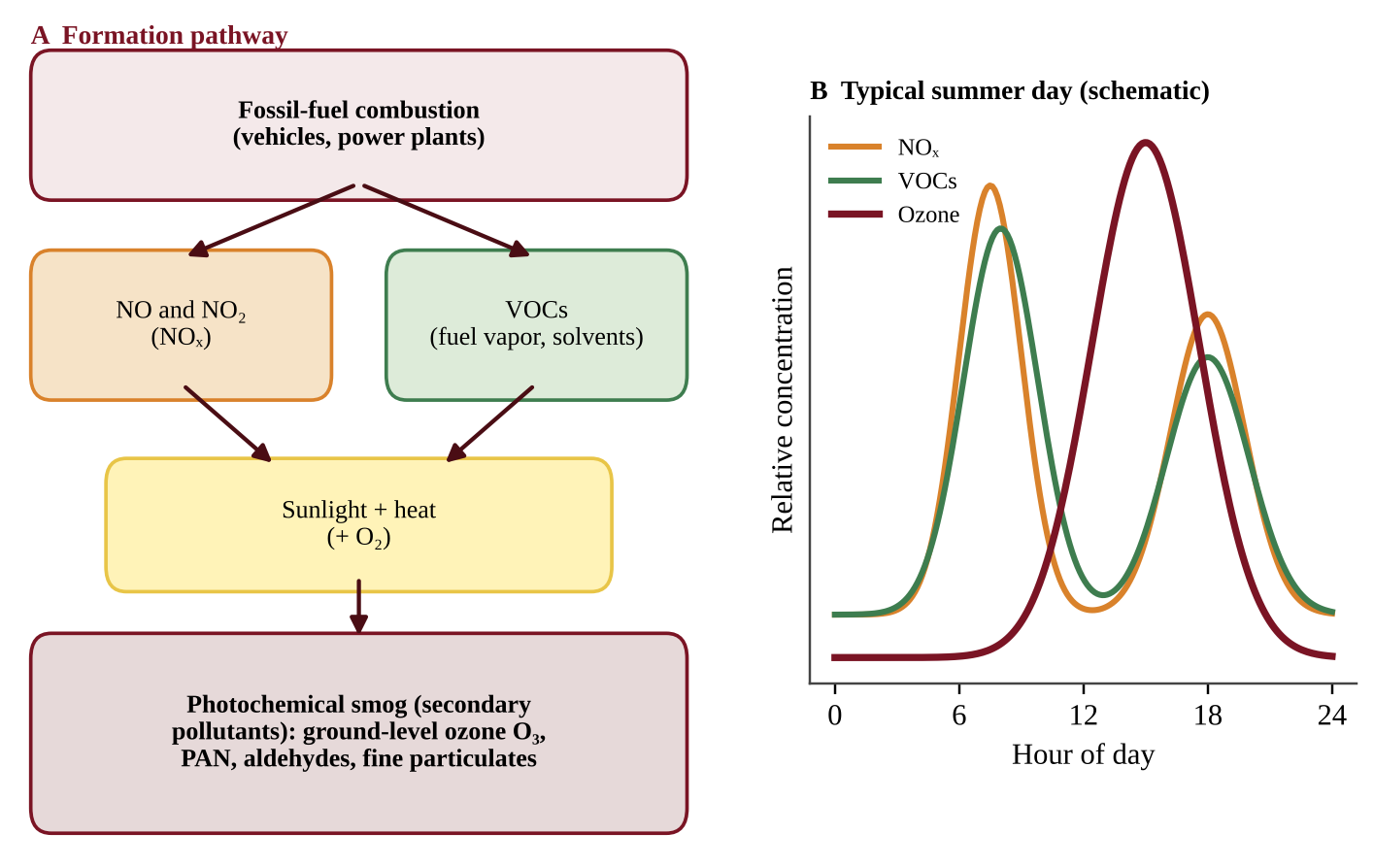
Figure 7.1 — Photochemical smog forms when NOₓ and VOCs react in sunlight (A); on a summer day NOₓ rises with the morning rush while ozone peaks in the afternoon (B)
Reading the daily pattern
Look at panel B of Figure 7.1. NOₓ and VOCs peak early, during the morning commute. Ozone lags and peaks in the afternoon, when sunlight and heat have had hours to drive the reactions. Ozone then falls after sunset because the reactions need light. This lag is a standard data-interpretation point. It is also why smog alerts are issued for afternoons, and why people are advised to exercise in the morning on bad-ozone days.
Ozone is also higher in summer: more intense sunlight, longer days, and higher temperatures that speed reactions and make fuels and plants release more VOCs.
Telling NO, NO₂ and ozone apart
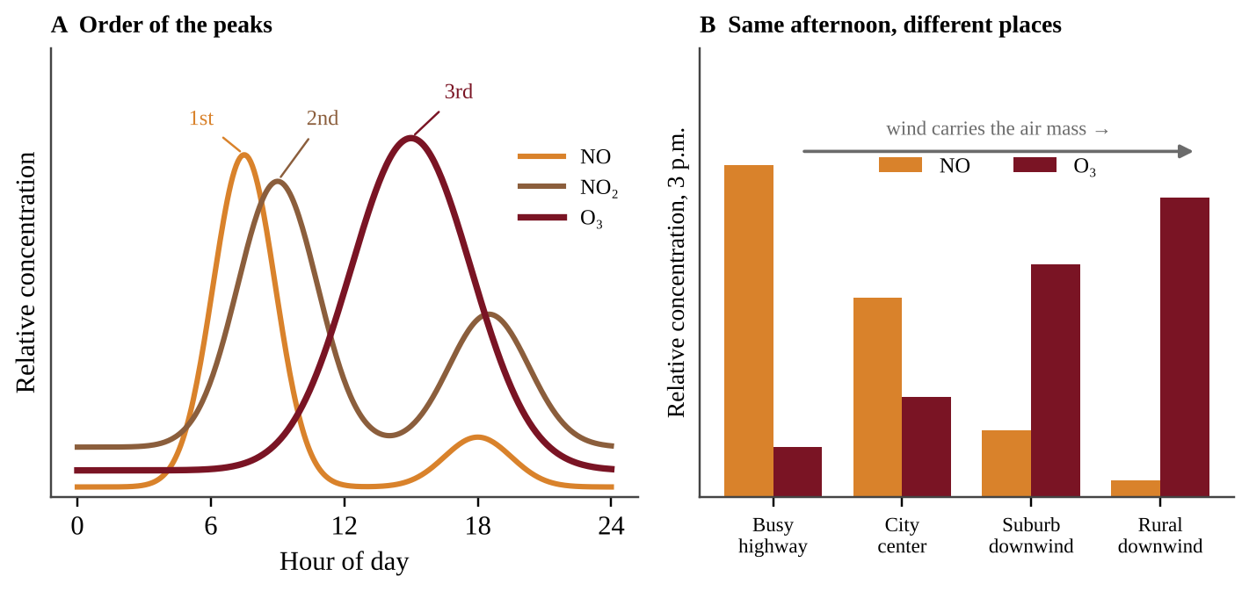
Figure 7.2 — The three gases peak in order (A); where the air has traveled matters as much as when (B). Schematic values
NO comes straight from engines, so it rises and peaks first with the morning rush, then falls as it turns into NO₂, a reddish-brown gas that tints smog and peaks a little later. Ozone peaks last. Place matters too. Fresh NO reacts with ozone and removes it, so beside a busy highway NO is high and O₃ is low. As the polluted air drifts downwind, the NO is used up, sunlight keeps driving the reactions, and ozone is highest in suburbs and rural areas downwind of the city, peaking later the farther the air has traveled. Low ozone at a busy road does not mean clean air; it means NO is still present.
Factors that shape smog
Many vehicles (so smog is mainly urban); strong sunlight and heat; basins and valleys ringed by mountains (Los Angeles, Mexico City); stagnant, windless weather; and thermal inversions (Topic 7.3).
Effects and reduction
Smog harms human health through respiratory problems (coughing, asthma attacks, reduced lung function) and eye irritation. Ozone also damages crops and forests by injuring leaves, and cracks rubber.
Since the precursors are NOₓ and VOCs, smog is reduced by cutting NOₓ and VOCs: catalytic converters, vapor recovery nozzles, low-VOC paints, public transit, electric vehicles, and limiting driving on high-ozone days.
REAL-WORLD EXAMPLE
A valley city checks NO₂ at 8 a.m. and ozone at 3 p.m. A school moves outdoor practice to 7 a.m., because the chemistry predicts the ozone peak in the afternoon.

COMMON STUDENT MISTAKES
• Saying NOₓ and ozone peak at the same time. NOₓ peaks with the morning rush; ozone peaks later in the afternoon.
• Describing smog as "smoke plus fog". The word here means photochemical smog, a chemical product, not a mixture of smoke and fog.
• Forgetting that nature also gives off VOCs. Trees emit them, but the smog problem in cities exists because human NOₓ and VOC emissions are added.

AP EXAM STRATEGY
For "explain why ozone peaks in the afternoon" give a cause-and-effect chain: morning traffic releases NOₓ and VOCs → sunlight and rising temperature drive reactions during the day → ozone accumulates → peak in mid-to-late afternoon.

CLASSROOM EXAMPLE SG-U7-E002
A monitoring station in a city recorded these hourly averages on a hot, sunny summer day.
Time | NO₂ (ppb) | Ozone (ppb)
6:00 | 18 | 12
8:00 | 40 | 20
10:00 | 25 | 45
12:00 | 15 | 70
14:00 | 12 | 95
16:00 | 14 | 88
18:00 | 30 | 60
20:00 | 20 | 35

(a) Identify the time of the NO₂ peak and the time of the ozone peak. (b) Calculate how many hours separate the two peaks. (c) Explain, using the chemistry of smog, why the ozone peak comes later than the NO₂ peak. (d) Predict how the ozone curve would change on a cool, cloudy day with the same traffic, and justify your prediction.

QUICK CONCEPT SUMMARY
• Photochemical smog = NOₓ + VOCs + sunlight and heat → ozone and other pollutants.
• NOₓ peaks in the morning; ozone peaks in the afternoon and is highest in summer.
• Dense vehicle traffic makes smog an urban problem; weather and topography make it worse.
• Smog causes breathing problems and eye irritation; it is reduced by cutting NOₓ and VOCs.

Topic 7.3 — Thermal Inversion
LEARNING OBJECTIVES
• Describe a thermal inversion and how it relates to air pollution (STB-2.C).
• Compare the normal temperature gradient with an inversion using a graph.

CONCEPT MADE SIMPLE
Normally the ground warms the air above it, and warm air rises, carrying pollution up and away like a chimney. In an inversion, the layers are upside-down: cool air sits under a layer of warm air. The warm air above is a lid. The cool air below cannot rise through it, so pollution stays trapped where we live.

Normal conditions
During the day, sunlight warms the ground and the ground warms the air next to it. Temperature falls as you go up through the lower atmosphere (the troposphere). Warm, light air near the surface rises and mixes with the cooler air above, so pollutants are carried upward and diluted.
Inversion
In a thermal (temperature) inversion the usual pattern is altered: the air temperature at the surface is cooler than the air at a higher altitude. The warmer, less dense air above acts as a lid. Because cool surface air is denser than the warm air over it, it will not rise. Air stops mixing vertically, and pollutants, especially smog and particulates, are trapped close to the ground.
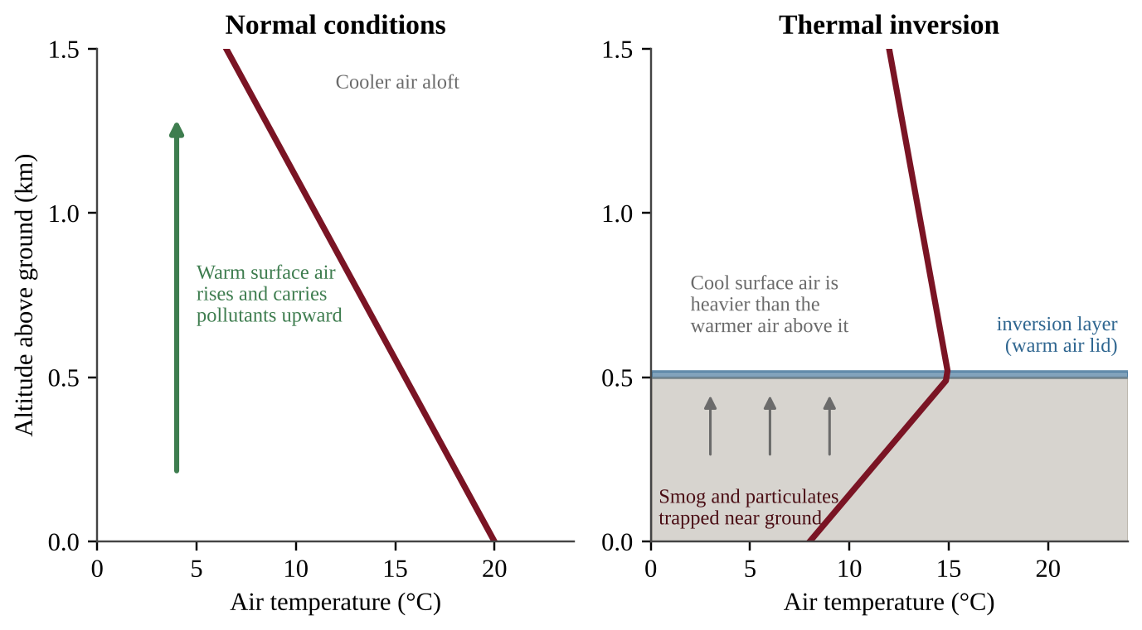
Figure 7.3 — Temperature versus altitude in normal air (left) and during a thermal inversion (right)
How to read Figure 7.3: each graph plots temperature (x) against altitude (y). A line that slopes to the upper left (temperature drops with height) is normal. A line that bends to the right as height rises (temperature rises with height) shows the inversion layer; that rising portion is where the warm lid lives.
KEY DEFINITIONS
Thermal inversion — a layer of warm air above cooler air near the ground, reversing the normal drop in temperature with height and trapping pollutants. Temperature gradient — the change in air temperature with altitude.

PROCESS & CAUSE-AND-EFFECT
Clear, calm night → ground loses heat quickly and chills the air near it (or warm air flows over cold air in a valley) → cool dense air sits under warmer air → no vertical mixing → pollutants trapped near the surface → concentration of smog and particulates rises → health problems

Inversions usually break up when the sun heats the ground, but a strong one can last for days and cause serious pollution episodes.
What favors an inversion. Long, clear, calm nights, when the ground loses heat to space and chills the air above it (cloud cover works like a blanket and prevents this); cold winter ground or snow; and valleys or basins ringed by mountains, where cold air drains and pools and the slopes block wind. This is why winter inversions raise particulates (heating smoke plus trapped air), while ozone is mainly a summer problem.
Where the pollution sits. Pollutants are trapped in the cooler, denser air below the top of the warm layer. If temperature rises from the ground up, the trapped layer is the air near the ground. If it first falls and then rises higher up, the trapped layer is everything below the height where the line turns warmer. Where the line again falls with height, normal mixing resumes.
AP EXAM STRATEGY
If a graph of temperature versus altitude is given, find the altitude range where the line moves toward warmer temperatures as altitude increases. That layer is the inversion, and the pollutants will be trapped below it.

CLASSROOM EXAMPLE SG-U7-E003
A weather balloon measured the air temperature above a valley town on two mornings.
Altitude above ground (m) | Day X temperature (°C) | Day Y temperature (°C)
0 | 14 | 6
250 | 12 | 9
500 | 10 | 12
750 | 8 | 11

(a) Identify which day had a thermal inversion and state the altitude range in which it occurred. (b) Calculate the temperature change from 0 m to 500 m on Day Y. (c) The town measured fine particulate matter of 15 µg/m³ on one of the days and 55 µg/m³ on the other. Predict which day had which value and explain.

QUICK CONCEPT SUMMARY
• Normally air cools with altitude, and warm surface air rises and disperses pollution.
• In an inversion, surface air is cooler than the air above it, forming a lid.
• Inversions trap smog and particulates near the ground, raising concentrations.

Topic 7.4 — Atmospheric CO₂ and Particulates
LEARNING OBJECTIVES
• Describe natural sources of CO₂ and particulates (STB-2.D).
• Distinguish natural from human sources, and recognize that natural does not mean harmless.

CONCEPT MADE SIMPLE
Not all air pollution is man-made. Living things, volcanoes, fires and wind all put CO₂ and dust into the air. The air always contains some of these. It becomes a pollution problem when people add so much that it changes the balance, or when natural events (a big eruption, a wildfire) overload the air.

Natural sources of CO₂
• Respiration. Every plant, animal, fungus and microbe releases CO₂ when it breaks down food for energy.
• Decomposition. Decomposers in soil and water release CO₂ from dead organisms.
• Volcanic eruptions. Volcanoes vent CO₂ from deep in Earth, along with SO₂ and ash.
These flows are normally balanced by photosynthesis and ocean uptake (the carbon cycle, Unit 1). Human burning of fossil fuels adds extra CO₂ on top of the natural flows, so atmospheric CO₂ has risen steadily since the Industrial Revolution (Unit 9).
Natural sources of particulates
Particulate matter (PM) is made of tiny solid and liquid particles suspended in air. PM10 is 10 µm or smaller; PM2.5 is 2.5 µm or smaller. The smaller the particle, the deeper it penetrates your lungs, and PM2.5 can reach the bloodstream.
Natural sources include:
• volcanic ash;
• wildfire smoke;
• dust storms and wind-blown soil;
• sea spray salt;
• pollen and mold spores;
• sulfate and organic particles formed from natural gases.
KEY DEFINITIONS
Particulate matter (PM) — solid or liquid particles small enough to stay suspended in the air; classified by diameter (PM10, PM2.5). Anthropogenic — caused by human activity.

Natural versus human
A natural source can still do damage: wildfire smoke or ash from an eruption can cause serious respiratory problems and block sunlight. For human sources, the key difference is that people control them. Coal and diesel combustion, construction, farming and road dust add particulates in cities, and fossil-fuel burning is the largest source of added CO₂. For CO₂, the policy discussion is about the additional human flows.
Designing and judging an air-quality investigation
Exam questions ask you to plan a study or to judge one. Use this checklist.
• Hypothesis: an if–then statement that names the direction (If the renovation released VOCs, then Wing B will have more formaldehyde than Wing A).
• Variables: the independent variable is what you compare or change (location, distance, wing, time); the dependent variable is what you measure, with a unit (µg/m³ of PM2.5). Controlled variables are kept the same: same instrument, same height, same hours, same season or ventilation.
• Control or background site: a sensor upwind of a source, or outdoors, or in an unaffected room measures what is there anyway. The source's contribution ≈ downwind reading − background reading.
• Replication: many sites, days or samples, then compare the mean and the spread. A few days, or one reading, leaves room for chance.
• Confounding variable: something else that changes along with your independent variable and could explain the result (wind direction when you compare distances from a plant; heating season when you compare months). Measure it, hold it constant, or compare only matched days.
• Correlation is not proof of cause. Say the data are consistent with or support a cause when a plausible mechanism and a fair comparison exist, and name a factor that was not ruled out. To judge a policy, compare before and after in the same season, check that the change followed the policy, and note other possible causes.
• Fair test with living things: change one factor only. Dishes at different pH must share light, temperature, seed type and water amount, and need a neutral-water control.
CLASSROOM EXAMPLE SG-U7-E011
A town suspects that a new gravel quarry raises PM10 in a neighborhood 1 km to its east. Monitors can be placed anywhere, and the wind usually blows from the west. (a) State a testable hypothesis that gives the expected direction. (b) Identify the independent and dependent variables and two variables to control. (c) Describe where and when to place monitors, and what the upwind site is for. (d) Higher PM10 is found at the east site. Explain why this does not by itself prove the quarry is the cause.

CLASSROOM EXAMPLE SG-U7-E004
A valley town recorded PM2.5 (µg/m³) on six winter days. Days 3, 4 and 6 had a thermal inversion; Days 1, 2 and 5 did not.
Day | 1 | 2 | 3 | 4 | 5 | 6
PM2.5 | 14 | 11 | 46 | 58 | 17 | 52

(a) Describe the relationship between inversion and PM2.5 shown by the data. (b) Calculate the mean PM2.5 for the inversion days and for the non-inversion days. (c) Calculate the percent by which the inversion-day mean exceeds the non-inversion mean. Round to the nearest whole percent. (d) Propose one action the town could take to lower winter PM2.5 and justify it.

QUICK CONCEPT SUMMARY
• Natural CO₂ sources: respiration, decomposition, volcanic eruptions.
• Natural particulates: volcanic ash, wildfire smoke, dust, sea spray, pollen, spores.
• Natural does not mean harmless, but human activity adds large extra amounts of both.
• PM2.5 is finer and more dangerous to health than coarse PM10.

Topic 7.5 — Indoor Air Pollutants
LEARNING OBJECTIVES
• Identify indoor air pollutants and classify them by source (STB-2.E).
• Describe the effects of indoor pollutants, including radon exposure (STB-2.F).
• Explain patterns in data, such as radon test results.

CONCEPT MADE SIMPLE
We spend most of our time indoors. A closed building traps whatever is inside: gases leaking from furniture, smoke from burning, radioactive gas from the soil below. Indoor air can be more polluted than outdoor air because there is less dilution.

Three kinds of sources
Source type | Examples
Natural | Radon, mold, dust
Human-made (building materials and furnishings) | Insulation, VOCs from furniture, paneling, carpets; formaldehyde from building materials and upholstery; lead from paint; asbestos
Combustion | Carbon monoxide, nitrogen oxides, sulfur dioxide, particulates, tobacco smoke

Key pollutants
KEY DEFINITIONS
Asphyxiant — a gas that harms by starving the body of oxygen. Carbon monoxide (CO) is an odorless, colorless asphyxiant: it binds to hemoglobin far more strongly than oxygen does. Particulate indoor pollutants — asbestos, dust and smoke. Radon-222 — a naturally occurring radioactive gas formed by the decay of uranium in some rocks and soils. Formaldehyde — a VOC released from building materials, furniture, upholstery and carpets; an eye and lung irritant and a carcinogen.

• Carbon monoxide comes from faulty furnaces, gas stoves and heaters, wood stoves and idling cars in garages. At high concentration it causes headaches, dizziness and death. A CO detector is the safeguard because humans cannot sense it.
• Asbestos fibers from old insulation, floor tiles and roofing become dangerous when disturbed and inhaled, causing lung scarring, lung cancer and mesothelioma.
• VOCs and formaldehyde off-gas from new carpet, paneling, glues, paints and cleaners and cause irritation and headaches.
• Lead from old paint chips and dust harms the nervous system, especially in young children.
• Mold grows in damp places and triggers allergies and asthma. The cure for mold is controlling moisture.
• Combustion products (NOₓ, SO₂, particulates, tobacco smoke) irritate lungs. In many developing regions, cooking over open fires indoors is a leading cause of illness from smoke.
Radon
Radon is the unusual one. Uranium in some rocks and soils decays through a series of steps to radium and then to radon-222, a gas that moves up through soil. It enters homes through cracks in foundations and walls, gaps around pipes and floor drains, and also dissolved in well water. Radon cannot be seen or smelled. Once inhaled, it and its decay products emit radiation inside the lungs.
Radon-induced lung cancer is the second leading cause of lung cancer in the United States, after smoking. Homeowners can test with a simple kit, and the EPA recommends action at 4 pCi/L (picocuries per liter) or more. Fixes include sealing cracks and installing a pipe and fan that vent the soil gas from beneath the foundation to the outdoors.
PROCESS & CAUSE-AND-EFFECT
Uranium in rock and soil → decays to radon-222 gas → gas rises through soil → enters basement through cracks (or is carried in well water) → builds up in a closed house → inhaled → radiation damages lung tissue → increased lung cancer risk

Cutting exposure indoors
Remove the source first, then ventilate to the outdoors, then detect or filter.
Pollutant | Ways to reduce exposure
Carbon monoxide | Repair combustion appliances, vent them outdoors, use CO detectors, never run engines in a garage; replace a gas stove with electric
Radon | Test; seal foundation cracks; sub-slab pipe and fan; treat well water
Asbestos | Leave sealed material alone; licensed workers remove or seal it; avoid sanding or breaking it
Mold | Fix leaks, control humidity, ventilate, remove damp material
VOCs, formaldehyde | Choose low-VOC products; ventilate; let new materials off-gas before use
Lead paint | Keep paint intact; wet-clean dust; certified removal
Smoke from cooking fires | Chimney or vented, cleaner-burning stove; cleaner fuel; no smoking indoors

Children are at greater risk because they breathe more air per kilogram of body weight, their lungs and nervous systems are still developing, and they play near floors and put hands in their mouths. Indoor pollutants cause asthma, respiratory disease, lung cancer, headaches and fatigue; skin cancer comes from ultraviolet light, not indoor air.
REAL-WORLD EXAMPLE
A basement test shows 6.3 pCi/L. The owners seal foundation cracks and add a vent pipe and fan under the slab; a retest shows a much lower reading.

COMMON STUDENT MISTAKES
• Saying radon is a chemical pollutant from factories. It is natural and radioactive.
• Thinking that a new, tightly sealed home is automatically safe. Tight sealing can trap indoor pollutants if ventilation is poor.
• Classing carbon monoxide as a particulate. It is a gas and an asphyxiant.
• Masking a pollutant (air fresheners, incense) or opening one window while the source keeps burning. Remove the source or vent it outdoors.

CLASSROOM EXAMPLE SG-U7-E005
A health department tested the basements of five homes for radon. The EPA action level is 4.0 pCi/L.
Home | 1 | 2 | 3 | 4 | 5
Radon (pCi/L) | 2.1 | 5.6 | 3.9 | 8.4 | 3.0

(a) Identify which homes exceed the action level and calculate the percentage of tested homes that do. (b) Calculate the mean radon level for the five homes. (c) Explain how radon gas enters a house from the ground. (d) Propose one way to reduce radon in Home 4 and justify why it works.

QUICK CONCEPT SUMMARY
• Indoor pollutants come from natural sources (radon, mold, dust), human-made materials (VOCs, formaldehyde, asbestos, lead paint) and combustion (CO, NOₓ, SO₂, particulates, tobacco smoke).
• CO is an asphyxiant; asbestos, dust and smoke are particulates.
• Radon-222 comes from uranium decay, seeps in through foundations and well water, and is the second leading cause of lung cancer in the U.S.

Topic 7.6 — Reduction of Air Pollutants
LEARNING OBJECTIVES
• Explain how air pollutants can be reduced at the source (STB-2.G).
• Describe how vapor recovery nozzles, catalytic converters, wet and dry scrubbers and electrostatic precipitators work.
• Use evidence to support a solution.

CONCEPT MADE SIMPLE
There are three ways to attack air pollution. Use less of the dirty thing (conservation). Switch to something cleaner (alternative fuels). Capture what is made before it escapes (control devices). Laws then make people actually do it.

Strategies
• Regulatory practices: the Clean Air Act, emission standards, air quality standards, permits, fuel standards (such as removing lead and cutting sulfur).
• Conservation: driving less, public transit, efficient buildings and appliances, which cut fuel burned and all its pollutants at once.
• Alternative fuels: natural gas instead of coal, renewable electricity, electric vehicles, low-sulfur fuels.
• Control devices (below).
Devices to know
KEY DEFINITIONS
Vapor recovery nozzle — a device on a gasoline pump that stops fuel vapors (VOCs) escaping while a vehicle is refueled. Catalytic converter — a device in a vehicle's exhaust system that uses metal catalysts (platinum, palladium, rhodium) to convert CO, NOₓ and hydrocarbons into less harmful CO₂, N₂, O₂ and H₂O. Wet scrubber — a device that sprays water or a water-and-limestone mixture through exhaust to dissolve or capture gases such as SO₂ and to trap particles. Dry scrubber — a device that injects a dry powder (such as lime) into exhaust that reacts with acidic gases and is then filtered out. Electrostatic precipitator — a device that gives particles an electric charge so they stick to oppositely charged plates, from which they are shaken off and collected.

PROCESS & CAUSE-AND-EFFECT
Catalytic converter: CO + O₂ → CO₂; NO → N₂ + O₂; hydrocarbons + O₂ → CO₂ + H₂O. Wet scrubber: SO₂ in flue gas + water–limestone spray → solid calcium sulfite/sulfate sludge, cleaner gas out the stack. Electrostatic precipitator: charged particles → attracted to plates → collected as ash.

Which device for which job? A catalytic converter is for the gases in vehicle exhaust, not for particulates. Scrubbers remove SO₂ (and some other gases and particulates) from power plant exhaust. An electrostatic precipitator removes particulates only, not gases. Coal power plants often use scrubbers and precipitators together. Vapor recovery nozzles address VOC evaporation at the pump.
Trade-offs
Control devices create waste (scrubber sludge, collected ash), use energy and cost money, and a catalytic converter does nothing about CO₂. Preventing pollution at the source by using less fuel is generally cheaper and cleaner than capturing it afterward. Fuel switching has its own trade-offs: low-sulfur coal costs more or is in limited supply, natural gas still emits CO₂, and wind and solar are intermittent and need storage or backup.
Calculations with emissions
FORMULA & MATH SKILL
Sulfur to SO₂: S + O₂ → SO₂. With atomic mass 32 for S and molecular mass 64 for SO₂, every 1 metric ton of S gives 2 metric tons of SO₂. mass of S = mass of fuel × (% sulfur ÷ 100) uncontrolled SO₂ = mass of S × (64 ÷ 32) SO₂ removed = uncontrolled SO₂ × (% removal ÷ 100); SO₂ emitted = uncontrolled SO₂ − removed Cost per metric ton removed = annual cost ($/yr) ÷ SO₂ removed (metric tons/yr) Inventory = number of sources × activity each (miles/yr) × emission factor (g/mile)

For an inventory, line up the units like fractions so unwanted units cancel (dimensional analysis), and multiply by conversion fractions equal to 1, such as 1 metric ton ÷ 10⁶ g or 1 kg ÷ 1000 g. A "ton" in a problem is a metric ton or comes with its own conversion (a U.S. ton is about 907,000 g); use what the problem gives. Use cost per ton removed to compare options: an option with a smaller bill can still cost more per ton if it removes much less.
CLASSROOM EXAMPLE SG-U7-E012
A city runs 400 diesel buses. Each travels 30,000 miles per year and emits 0.35 g of particulate matter per mile. A retrofit filter on every bus cuts particulate emissions by 80% and costs $9,000 per bus. (a) Calculate the fleet's yearly particulate emissions before the retrofit, in kilograms. (b) Calculate the kilograms of particulates removed per year. (c) Taking the filters' cost as one-time and spread over 10 years, calculate the cost per kilogram removed.

CLASSROOM EXAMPLE SG-U7-E013
A power plant burns 5.0 × 10⁵ metric tons of oil per year. The oil is 0.8% sulfur by mass and all of the sulfur becomes SO₂. A dry scrubber removes 85% of the SO₂ and costs $15 million per year. (a) Calculate the mass of sulfur burned each year. (b) Calculate the SO₂ the plant would release with no scrubber. (c) Calculate the SO₂ emitted with the scrubber. (d) Calculate the scrubber's cost per metric ton of SO₂ removed.

COMMON STUDENT MISTAKES
• Claiming an electrostatic precipitator removes SO₂. It removes particulates only.
• Saying a catalytic converter removes CO₂. It produces CO₂ from CO.
• Forgetting that devices create waste products that need disposal.
• Calling taller smokestacks a fix. They dilute and move the pollution farther downwind; the amount emitted is unchanged.

AP EXAM STRATEGY
In a "propose a solution" question, state the device or policy, say exactly which pollutant it cuts, give the mechanism in one line, and add one drawback or trade-off. That earns the justify point.

CLASSROOM EXAMPLE SG-U7-E006
A region has two coal-burning power plants and a population of 400,000. Plant A emits 180,000 metric tons of SO₂ per year; Plant B emits 70,000 metric tons per year. Plant A installs wet scrubbers that remove 90% of its SO₂. Plant B makes no change. (a) Calculate the region's total SO₂ emissions after the installation. (b) Calculate the percent decrease in the region's total SO₂ emissions. (c) Calculate the region's SO₂ emissions per person after the installation, in kilograms per person per year. (d) Identify one by-product of operating a wet scrubber and one pollutant the scrubber does not reduce.

QUICK CONCEPT SUMMARY
• Reduce pollutants with regulation, conservation and alternative fuels, plus control devices.
• Vapor recovery nozzle: stops fuel vapor at the pump.
• Catalytic converter: turns CO, NOₓ, hydrocarbons into CO₂, N₂, O₂, H₂O.
• Wet and dry scrubbers remove gases (and particles); electrostatic precipitators remove particulates.

Topic 7.7 — Acid Rain
LEARNING OBJECTIVES
• Describe the formation of acid deposition and its sources (STB-2.H).
• Describe its effects on soils, water bodies, structures and regions with different bedrock (STB-2.I).
• Use the pH scale to compare acidity.

CONCEPT MADE SIMPLE
When coal and fuels burn they release SO₂ and NOₓ. In the air these gases turn into sulfuric acid and nitric acid, which fall to Earth in rain, snow, fog or dry particles, often hundreds of kilometers from where they started. The land and water that receive them are made more acidic.

How acid deposition forms
Acid deposition includes both wet deposition (acid rain, snow, fog) and dry deposition (acidic gases and particles settling out). It begins with two gases:
• Sulfur oxides: SO₂ from coal-burning power plants (and natural sources such as volcanoes) reacts with oxygen and water in air to form sulfuric acid (H₂SO₄).
• Nitrogen oxides: NOₓ from motor vehicles and coal-burning power plants (and natural sources such as lightning) reacts to form nitric acid (HNO₃).
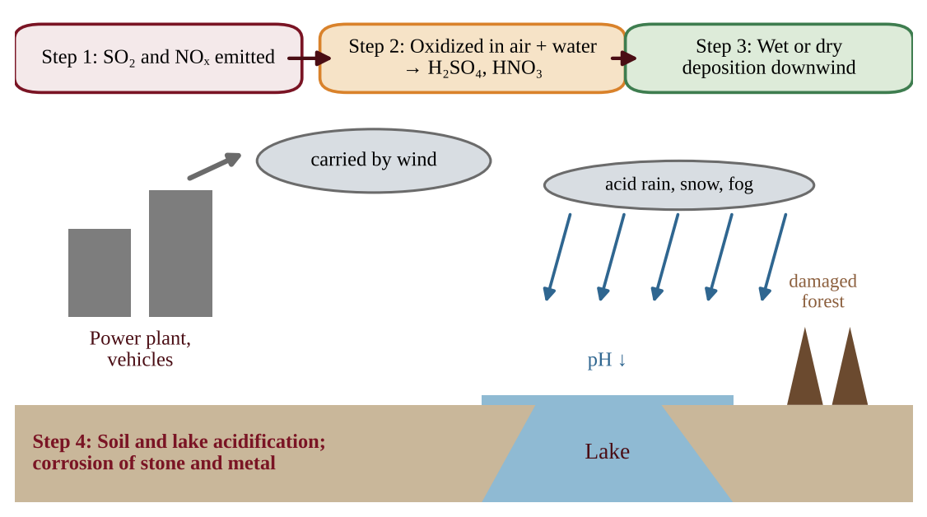
Figure 7.4 — Pathway of acid deposition from sources to damaged lakes, forests and structures
The pH scale
FORMULA & MATH SKILL
pH = −log₁₀[H⁺], where [H⁺] is the hydrogen ion concentration in moles per liter. The scale runs 0 to 14: below 7 is acidic, 7 is neutral, above 7 is basic. Each whole pH unit is a factor of 10 in H⁺ concentration. Change of 1 unit = 10× difference; change of 2 units = 10² = 100×; change of 3 units = 1000×.

Clean rain is already slightly acidic, about pH 5.6, because CO₂ dissolves in it to form weak carbonic acid. Rain is called acid rain when its pH is below about 5.6, and typical acid rain is pH 4.2 to 4.4. A change from pH 5.6 to 4.6 is not a small step: rain at pH 4.6 has ten times the hydrogen ions of rain at 5.6.
Differences need not be whole numbers. Rain at pH 4.3 versus clean rain at 5.6 differs by 1.3 units, so it has 10^1.3 ≈ 20 times the H⁺ (use the 10ˣ key; never say "1.3 times"). To go from concentration to pH, take −log: [H⁺] = 1 × 10⁻⁵ mol/L gives pH 5.
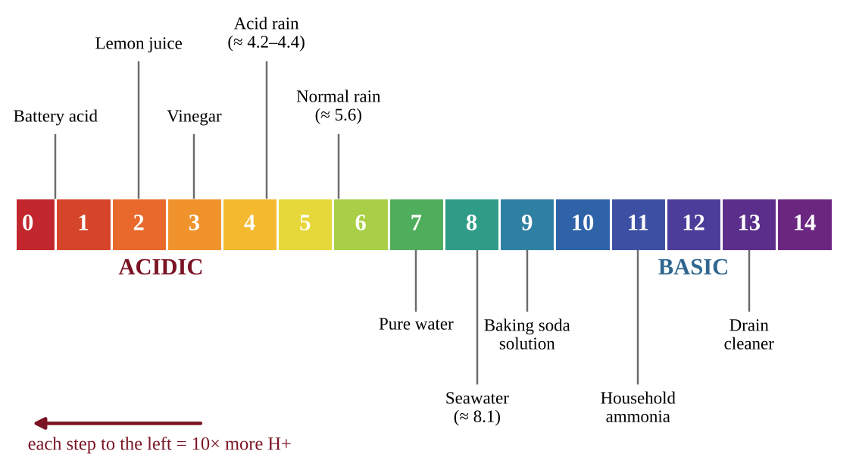
Figure 7.5 — The pH scale with example substances; each step is a tenfold change in H⁺
Effects
1. Soils. Acid leaches nutrients such as calcium and magnesium away and frees toxic aluminum, harming tree roots and weakening forests. Leaves and needles are damaged, and trees tolerate cold, insects and disease less well, especially at high elevations bathed in acid fog.
2. Lakes and streams. Falling pH harms fish eggs, amphibians and invertebrates; many fish species decline below about pH 5. Released aluminum and other metals are toxic to fish.
3. Structures. Acid dissolves limestone and marble and corrodes metals in buildings, statues and bridges.
4. Human health. The acids form fine particles that reach the lungs.
Why some places are hit harder
Acid deposition mainly affects communities downwind of coal-burning power plants, because wind carries the pollutants. In the eastern United States, winds carry emissions from Midwest power plants to the Northeast and eastern Canada.
Bedrock and soil make a difference. Limestone (calcium carbonate) and soils rich in carbonate buffer acid: they neutralize it and keep lake pH near neutral. Lakes on granite and thin, sandy soils have little neutralizing capacity, so they acidify quickly. Two lakes under the same rain can end up very different.
KEY DEFINITIONS
Acid deposition — the falling of acids and acid-forming pollutants from the air as wet (rain, snow, fog) or dry (gases, particles) deposition. Buffering capacity — the ability of water or soil to neutralize acids and resist a drop in pH; limestone bedrock supplies it. Downwind — in the direction the wind blows, away from the source.

PROCESS & CAUSE-AND-EFFECT
Burning coal and fuels → SO₂ and NOₓ emitted → oxidized in air and dissolved in water → H₂SO₄ and HNO₃ → carried downwind → wet and dry deposition → soil and lake pH falls → nutrient loss, aluminum release, fish and tree damage, stone corrosion

Solutions
Reduce the gases at the source: scrubbers on power plants, low-sulfur coal and fuels, switching to natural gas and renewables, catalytic converters, and cap-and-trade programs. Short-term local fixes include adding crushed limestone ("liming") to acidified lakes, which treats symptoms rather than the cause. Recovery lags behind emission cuts: after decades of acid input, soils have lost much of their calcium and magnesium, so lake pH rises more slowly than emissions fall and may stay below its natural level for years.
REAL-WORLD EXAMPLE
A plant's SO₂ falls as acid on a granite-based mountain lake hundreds of kilometers downwind. Nearby residents see little damage, but the remote lake loses its fish.

COMMON STUDENT MISTAKES
• Saying pH 4 is "twice as acidic" as pH 5. It is ten times.
• Calling pure rain "pH 7". Clean rain is about 5.6 because of dissolved CO₂.
• Assuming that acid rain only falls near the source. Wind carries it downwind for long distances.
• Forgetting dry deposition and natural sources (volcanoes, lightning).
• Writing that taller smokestacks solve acid rain. They only carry the acid farther downwind.

AP EXAM STRATEGY
Questions on acid rain nearly always want a full chain: source → gas → acid → deposition site → effect. If a map or data on bedrock is given, decide whether the area can buffer acid (limestone) or not (granite).

CLASSROOM EXAMPLE SG-U7-E007
Three rain samples were collected: Sample A has pH 5.6, Sample B has pH 4.6, and Sample C has pH 3.6. (a) Rank the samples from most acidic to least acidic. (b) Calculate how many times greater the hydrogen ion concentration of Sample C is than that of Sample A. (c) Identify the two gaseous pollutants most responsible for rain with a pH below 5.6 and name one human source of each. (d) Explain why clean, unpolluted rain has a pH below 7.

CLASSROOM EXAMPLE SG-U7-E014
Rain over a downwind forest has a pH of 4.2; rain over a remote ocean has a pH of 5.6. A lake sample has an H⁺ concentration of 1 × 10⁻⁶ mol/L. (a) Calculate how many times greater the H⁺ concentration of the forest rain is than that of the ocean rain. (b) Calculate the pH of the lake sample and state whether it is acidic. (c) Another lake has pH 6.3. Calculate how many times lower its H⁺ concentration is than that of the forest rain.

CLASSROOM EXAMPLE SG-U7-E008
Two lakes receive acid rain of the same pH from the same distant power plants. Lake P lies on granite bedrock with thin soil; its pH fell from 6.0 to 5.0 over 30 years. Lake Q lies on limestone bedrock and its pH stayed at 7.1. (a) Calculate the factor by which the hydrogen ion concentration of Lake P increased. (b) Explain why Lake Q's pH did not fall. (c) Predict which lake has the greater risk of fish loss and justify. (d) Propose one action at the source and one local action that would help Lake P, and state which treats the cause.

QUICK CONCEPT SUMMARY
• Acid deposition comes from SO₂ (coal plants, volcanoes) and NOₓ (vehicles, coal plants) converting to H₂SO₄ and HNO₃.
• Each pH unit is a tenfold change in H⁺; clean rain is about 5.6.
• Effects: acidified soils and lakes, aluminum release, forest decline, corrosion of stone and metal.
• Downwind communities are hit most; limestone bedrock buffers, granite does not.

Topic 7.8 — Noise Pollution
LEARNING OBJECTIVES
• Describe human activities that produce noise pollution and its effects (STB-2.J).
• Use the decibel scale to compare sound levels.
• Describe effects on animals in ecosystems.

CONCEPT MADE SIMPLE
Noise is unwanted sound. It leaves nothing behind in the air, yet it can raise stress, damage hearing and drown out the signals animals use to find food and mates. Noise pollution is sound loud enough or constant enough to harm.

Sources and the decibel scale
In cities the main sources are transportation (road traffic, trains, aircraft), construction, and domestic and industrial activity (machinery, power tools, lawn equipment, loud music).
Sound loudness is measured in decibels (dB) on a logarithmic scale, like pH. Every increase of 10 dB means ten times more sound intensity. An increase of 20 dB is 100 times the intensity, and 30 dB is 1000 times.
Sound | Approx. level (dB)
Whisper | 30
Normal conversation | 60
Busy city traffic | 80
Chain saw | 110
Jet taking off nearby | 130

Hearing damage depends on both level and time. Compare sound levels with a reference line on a graph by checking which bars lie above it, and treat noise-versus-wildlife data as correlation unless other factors are controlled (see Topic 7.4). Long exposure to levels around 85 dB or higher can cause permanent hearing loss, and very loud sounds cause damage in minutes.
FORMULA & MATH SKILL
Intensity ratio = 10^(Δ dB ÷ 10) where Δ dB is the difference between two sound levels in decibels. Example form: a 30 dB difference gives 10³ = 1000 times the intensity; a 25 dB difference gives 10^2.5 ≈ 320 times.

Effects on people
Physiological stress (higher heart rate, raised blood pressure, disturbed sleep) and hearing loss, plus difficulty concentrating and learning.
Effects on animals
• Stress hormones rise.
• Masking of sounds animals use to communicate or hunt: birds must sing louder or at higher pitch near roads, and ship noise interferes with whale and dolphin calls and sonar.
• Damaged hearing from very loud sources such as blasts and sonar.
• Changed migration routes, as animals avoid noisy zones.
Reducing noise
Quieter engines and mufflers, sound barriers, buffer zones and zoning, speed limits, quiet pavement, restricting night flights and ship speeds, and ear protection for workers. Like other pollutants, it is best controlled at the source.
KEY DEFINITIONS
Noise pollution — sound at levels high enough to cause physiological stress and hearing loss. Decibel (dB) — the unit of sound level; every 10 dB represents a tenfold change in intensity. Masking — when noise covers up sounds that animals use to communicate, find prey or detect predators.

CLASSROOM EXAMPLE SG-U7-E009
A factory floor measures 95 dB with all machines running. Workers wearing no hearing protection spend 8 hours a day there. A quiet office elsewhere in the building measures 55 dB. Near the factory, a wetland supports a population of frogs that call at night to attract mates. (a) Calculate how many times greater the sound intensity is on the factory floor than in the quiet office. (b) Explain why a worker is at risk of hearing loss at 95 dB. (c) Describe how noise from the factory could reduce frog breeding success. (d) Propose one source-level and one worker-level control to reduce harm.

QUICK CONCEPT SUMMARY
• Noise pollution is sound that is loud enough to cause stress and hearing loss.
• Sources: transportation, construction, domestic and industrial activity.
• Decibels are logarithmic: +10 dB = 10× the intensity.
• Wildlife are stressed, masked, damaged and pushed to change their migration routes.

Math & Skills Toolkit
FORMULA & MATH SKILL
pH change: factor = 10^(difference in pH), also for non-whole differences (1.3 units ≈ 20×). Lower pH is more acidic: pH 4 has 10× more H⁺ than pH 5, and 100× more than pH 6. ppm and ppb: 1 ppm = 1 part per million (1 in 10⁶); 1 ppb = 1 part per billion (1 in 10⁹). So 1 ppm = 1000 ppb. Convert by multiplying ppm by 1000 to get ppb, or dividing ppb by 1000 to get ppm. Emissions per capita: emissions per person = total emissions ÷ population (watch units: 1 metric ton = 1000 kg). Percent change: percent change = (new − old) ÷ old × 100. A negative answer is a decrease. Percent removal: remaining = original × (1 − percent removed ÷ 100). Decibels: intensity ratio = 10^(Δ dB ÷ 10).

AP EXAM STRATEGY
Show the setup in every calculation: formula, numbers with units, then the answer with units. On FRQ 3 you earn points for the correct setup even if you slip in arithmetic. Check that the answer is reasonable (a scrubber cannot remove more than 100%, and a pH difference of 2 means ×100).

QUICK CONCEPT SUMMARY
Unit 7 at a glance
• Air pollutants come largely from burning fossil fuels: CO₂, CO, SO₂, NOₓ, VOCs, particulates, toxic metals; lead was cut by Clean Air Act regulation.
• Primary pollutants are emitted directly; secondary pollutants form in the air. Ozone is the key secondary pollutant of photochemical smog (NOₓ + VOCs + sunlight and heat), peaking in the afternoon and in summer.
• A thermal inversion puts cool air under warm air and traps smog and particulates near the ground.
• Natural sources of CO₂ and particulates exist (respiration, decomposition, volcanoes, dust, fire), but human sources add more.
• Indoor pollutants come from natural, human-made and combustion sources; CO is an asphyxiant and radon is a leading cause of lung cancer.
• Control devices: vapor recovery nozzles, catalytic converters, wet and dry scrubbers, electrostatic precipitators; also regulation, conservation and alternative fuels.
• Acid deposition (H₂SO₄ and HNO₃ from SO₂ and NOₓ) acidifies soils and lakes and corrodes structures, most strongly downwind and where bedrock cannot buffer; every pH unit is ×10.
• Noise pollution (dB, ×10 per 10 dB) causes stress and hearing loss in people and masking and stress in wildlife.

Unit 8 — Aquatic and Terrestrial Pollution
Every pollution story here asks three questions: where did it come from, what did it do to the ecosystem, and how do we stop it? Keep asking them and the 15 topics become one connected idea.
Topic 8.1 — Sources of Pollution
LEARNING OBJECTIVES
• Distinguish point sources from nonpoint sources of pollution.
• Give examples of each and explain why one type is harder to regulate.

CONCEPT MADE SIMPLE
Imagine you find a puddle of dirty water. If you can follow it back to one pipe, you have found a point source. If the dirt arrived from the whole neighborhood at once, washed in by rain from every lawn, street, and field, you have a nonpoint source. One pipe can be fixed with a filter or a fine. A whole neighborhood is much harder to fix.

A pollutant is any substance, or form of energy such as heat or noise, that is added to the environment faster than natural processes can remove it, and that harms living things. Pollution can enter air, water, or soil, and pollutants often move between them. A chemical sprayed on a field can enter the air as a drift, the soil as a residue, and a river as runoff.
KEY DEFINITIONS
Point source — a single, identifiable place where a pollutant enters the environment, such as a smokestack or a waste discharge pipe. Nonpoint source — a diffuse source spread over a wide area with no single outlet, such as pesticide spraying or urban runoff.

Why the difference matters
A point source has a location, an owner, and a measurable flow. Regulators can place a monitor on the pipe, set a permit limit, and fine the owner who exceeds it. A nonpoint source has thousands of small contributors: every driveway that leaks oil, every farm that spreads fertilizer, every lawn that is over-treated. Rain collects these contributions and carries them to the nearest stream. Because no single outlet exists, nonpoint pollution is harder to identify, measure, and control, and in many watersheds it is now the larger problem. In the United States the Clean Water Act works mainly through permits that limit what a point source may discharge; a limit can be checked against a measurement at the pipe, so a reading above it is a violation. The Safe Drinking Water Act sets limits for contaminants in public drinking water.
COMMON STUDENT MISTAKES
• Thinking that "nonpoint" means "natural." A nonpoint source can be entirely human-caused, such as lawn fertilizer.
• Calling a very large source a nonpoint source. A giant factory is still a point source if the pollutant leaves through an identifiable outlet. Size is not the test; identifiability is.

CLASSROOM EXAMPLE SG-U8-E001
For each source, state whether it is a point source or a nonpoint source and justify your choice in one sentence: (i) exhaust leaving the stack of a coal-fired power plant; (ii) oil and tire residue washed from a city's streets into storm drains during a rainstorm; (iii) treated wastewater leaving a municipal plant through a single underwater pipe; (iv) fertilizer washing off 200 separate cornfields into a river. Then explain why a regulator could set a measurable discharge limit for only some of these.

QUICK CONCEPT SUMMARY
• A point source has one identifiable outlet; a nonpoint source is diffuse.
• Point sources are easier to monitor and regulate; nonpoint sources require changes in land use across a whole area.
• Examples: smokestack and discharge pipe (point); pesticide spraying and urban runoff (nonpoint).

Topic 8.2 — Human Impacts on Ecosystems
LEARNING OBJECTIVES
• Explain tolerance ranges and how pollutants stress organisms.
• Describe the human impacts on aquatic ecosystems listed in the course: coral reef damage, oil spills, dead zones, oxygen sag, heavy metals, litter, sediment, and mercury.
• Read and explain an oxygen sag curve, and use dissolved oxygen and BOD correctly.

CONCEPT MADE SIMPLE
Every living thing has a "comfort zone" for each environmental factor: temperature, pH, salt, oxygen, toxins. Inside the zone it thrives. Pushed toward the edges it gets stressed. Pushed beyond the edges it dies. Human pollution often pushes water outside the comfort zone of the species living there.

Range of tolerance
Organisms have a range of tolerance for every pollutant and every physical factor. Within an optimum range an organism can maintain homeostasis, which means keeping its internal conditions steady. Outside that range it experiences physiological stress, then limited growth and reduced reproduction, and in extreme cases death. Different species have different ranges. A trout needs cold, well-oxygenated water; a carp tolerates warm, low-oxygen water. This is why species composition is a useful indicator of water quality. Finding stoneflies and mayflies suggests clean water; finding only sludge worms suggests heavy organic pollution.
Coral reefs
Reefs are damaged by rising ocean temperature (corals expel their symbiotic algae, called bleaching), by sediment runoff that smothers them and blocks light, and by destructive fishing such as dynamite or bottom trawling.
Oil spills
Oil in marine water harms life in several ways. Hydrocarbons in the oil are toxic and kill organisms directly. Oil that floats coats the feathers of birds and the fur of marine mammals, which destroys their insulation and buoyancy. Some components of oil sink to the bottom and kill bottom-dwelling organisms. Oil that washes ashore has economic costs because it can close fisheries and drive away tourists from beaches.
Dead zones, dissolved oxygen, and the oxygen sag curve
Dissolved oxygen (DO) is oxygen gas dissolved in water, measured in mg/L. Fish and most aquatic animals need roughly 5 mg/L or more; below about 2 mg/L most cannot survive. Oxygen enters water from the atmosphere and from photosynthesis, and it is removed by respiration and decomposition.
When organic waste such as sewage or manure enters a stream, bacteria decompose it using oxygen. The amount of oxygen microbes would need to break down the organic matter in a water sample is called biochemical oxygen demand (BOD). High BOD means a heavy load of decomposable material and predicts a drop in DO. Clean streams have low BOD; raw sewage has very high BOD.
An oxygen sag curve is a plot of dissolved oxygen versus distance from a source of pollution, usually excess nutrients and biological refuse. It has a recognizable shape.
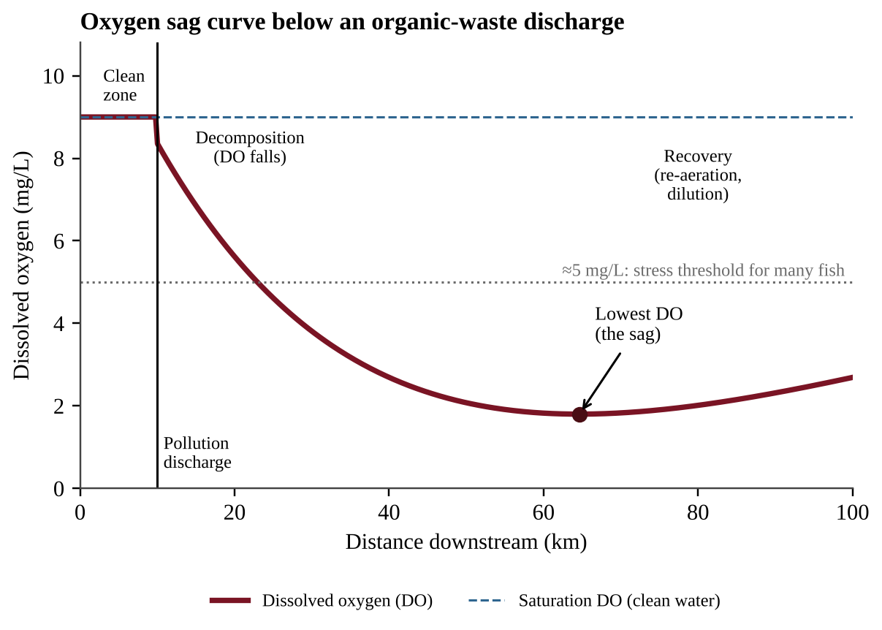
Figure 8.1 — Oxygen sag curve: DO is high upstream, falls as bacteria decompose waste below the discharge, reaches a minimum, then recovers as the stream re-aerates and the waste is used up.
PROCESS & CAUSE-AND-EFFECT
Organic waste enters stream → bacteria decompose it and consume oxygen (BOD) → DO falls downstream → minimum DO (the sag) where decomposition outpaces re-aeration → waste is used up while oxygen enters from air and photosynthesis → DO recovers toward saturation.

How to read the graph. The horizontal axis is distance downstream. Before the discharge point the water sits near its saturation DO. The steepest fall is just below the outfall, the lowest point marks where oxygen is most scarce (fish kills occur here), and the rise afterward shows recovery. A larger waste load, warmer water, or slow flow makes the sag deeper and longer; a treated discharge (lower BOD) makes it shallower. If the lowest value falls below the tolerance level for a species, that species disappears from the affected stretch.
BOD is often plotted on the same axes as DO. Because the two are linked, the curves mirror each other: BOD jumps at the outfall, falls as microbes consume the waste, and DO is lowest a little farther downstream, where the waste is still being broken down faster than oxygen enters. As BOD returns toward its upstream value, DO climbs back. A sudden jump in BOD with a drop in DO marks the discharge point on an unlabeled graph.
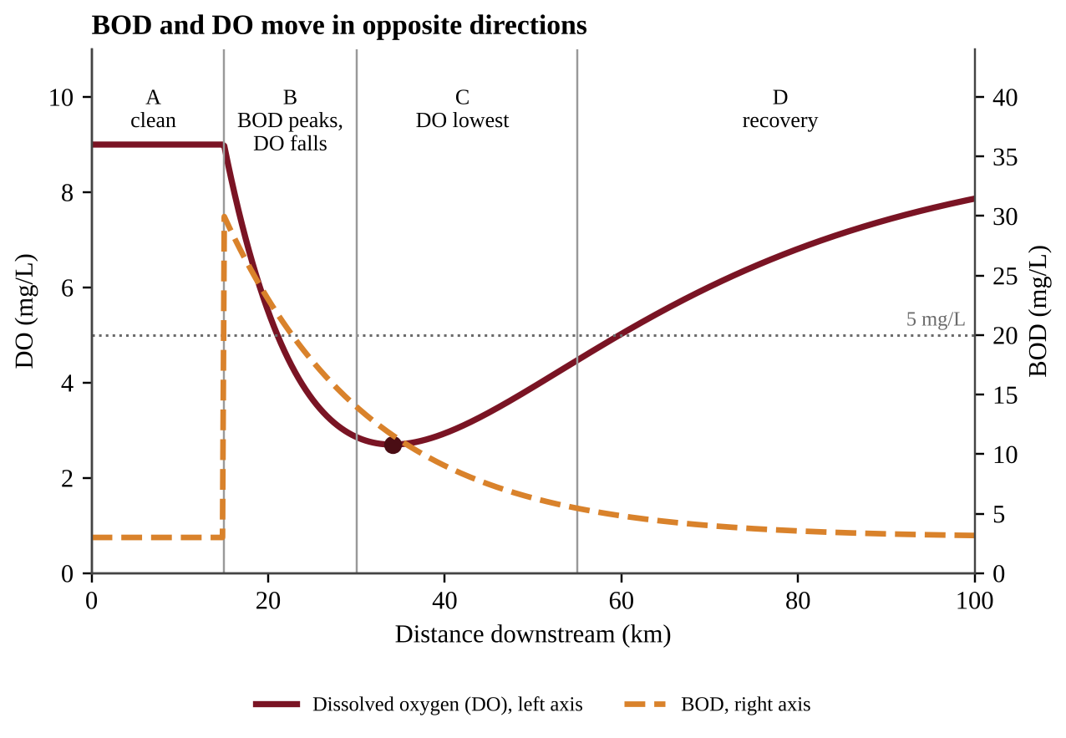
Figure 8.1b — BOD and DO plotted together: BOD peaks at the discharge, DO is lowest farther downstream, then both recover. The dotted line marks the 5 mg/L level most fish need.
Which species live where. Each species needs a minimum DO. Where the curve sits below 7 mg/L, sensitive insect larvae such as stonefly nymphs vanish; below about 5 mg/L, most fish and mussels vanish; the lowest stretch keeps only tolerant animals such as sludge worms. To find which organism could live at the lowest point of a graph, read the minimum DO and choose the organism whose requirement is at or below it.
Reading water-quality data from a table
Questions often give measurements from several stream sites and ask which site is downstream of a particular source. First find the unaffected reference site (clear, high DO, low nutrients), then compare each site with it and match the pattern:
Likely source | Turbidity (cloudiness) | Nutrients (N, P) | DO | Other signs
Construction site or eroding bank | Much higher | About the same | About the same or slightly lower | Settled silt, fewer sight-feeding fish
Fertilizer or animal-manure runoff | Little change | Much higher | Lower | Algal bloom; manure also adds pathogens
Raw or poorly treated sewage | Higher | Higher | Much lower | High BOD; many pathogens; few sensitive species
Heated cooling water | No change | No change | Lower | Temperature clearly higher

Several sites in one pattern also show a trend: a measurement that worsens at one site and recovers farther down points to a single source between them.
Oceanic dead zones are areas of low oxygen in the world's oceans caused by increased nutrient pollution. The mechanism, covered in Topic 8.5, is the same as the sag: nutrients cause algal growth, decomposers consume the oxygen when the algae die.
Other impacts
• Heavy metals such as lead, arsenic, and cadmium from industry, especially mining and the burning of fossil fuels, can reach groundwater and contaminate drinking water supplies. Lead, for example, comes from old paint, old water pipes, and the leaded gasoline of the past; it damages the nervous system, and children are the most vulnerable.
• Litter that reaches water is unsightly, but it can also cause intestinal blockage and choking in wildlife and carry toxic substances into the food chain.
• Sediment in waterways reduces light penetration, which harms primary producers and visual predators (animals that hunt by sight). When it settles, it smothers and disrupts habitats such as spawning gravel and coral.
• Mercury. Elemental mercury, released by coal burning and mining, enters aquatic environments, where bacteria convert it into highly toxic methylmercury, the form that accumulates in organisms (see Topic 8.8).
KEY DEFINITIONS
Dissolved oxygen (DO) — the concentration of oxygen gas dissolved in water, in mg/L. BOD — biochemical oxygen demand; the oxygen consumed by microbes decomposing organic matter in water. More organic waste means higher BOD and lower DO. Dead zone — a region of water so low in oxygen (hypoxic) that most animals cannot live there.

COMMON STUDENT MISTAKES
• Saying the sag is caused by the pollutant being "poisonous." In an organic-waste sag the oxygen is used up by bacteria feeding on the waste.
• Thinking DO keeps falling forever. The curve rises again because the waste is used up and the water re-aerates.
• Mixing up BOD and DO: high BOD goes with low DO.

CLASSROOM EXAMPLE SG-U8-E002
A stream receives treated effluent from a cannery at kilometer 10. Dissolved oxygen was measured at several sites:
Distance (km) | DO (mg/L)
0 | 8.8
10 | 8.8
15 | 6.5
20 | 4.2
30 | 2.9
40 | 3.6
60 | 6.1
80 | 8.0

(a) Identify the site with the lowest DO and give its value. (b) List the sampled sites where DO was below the 5 mg/L level needed by most fish. (c) Calculate the percent decrease in DO from the discharge point (km 10) to the lowest value. (d) Explain, using BOD, why DO falls between km 10 and km 30, and explain why it rises between km 40 and km 80.

QUICK CONCEPT SUMMARY
• Organisms have a range of tolerance; outside their optimum range they suffer stress, reduced growth and reproduction, or death.
• Reefs are damaged by warming, sediment, and destructive fishing; oil harms by toxicity, coating, sinking, and economic loss.
• Oxygen sag curve: DO drops below an organic-waste source, bottoms out, then recovers. High BOD means low DO.
• Dead zones, heavy metals in groundwater, litter, sediment, and methylmercury are further impacts.

Topic 8.3 — Endocrine Disruptors
LEARNING OBJECTIVES
• Describe what endocrine disruptors are.
• Describe their effects on organisms and ecosystems.

CONCEPT MADE SIMPLE
Hormones are the body's chemical text messages. Glands send the messages and cells with the right receptors read them. An endocrine disruptor is a chemical that sends fake messages, blocks real ones, or scrambles the sending. The cells then do the wrong thing at the wrong time, even at very low concentrations.

The endocrine system is the set of glands that release hormones controlling growth, development, metabolism, and reproduction. Endocrine disruptors are chemicals that can interfere with the endocrine system of animals. Some mimic natural hormones (for example, imitating estrogen), some block hormone receptors, and some change how much hormone the body makes. Examples include certain pesticides, PCBs, some plastics chemicals, and compounds from medications that pass through sewage treatment and enter rivers.
Effects on ecosystems arise because hormones control development and reproduction, so disruption shows up there first. Endocrine disruptors can lead to birth defects, developmental disorders, and gender imbalances in fish and other species. In a documented pattern, fish living downstream of wastewater outfalls show male fish developing female traits, which skews sex ratios, lowers breeding success, and can shrink the whole population. Because amphibians absorb chemicals through thin skin and develop in water, they are especially vulnerable.
KEY DEFINITIONS
Endocrine disruptor — a chemical that can interfere with the endocrine system of animals by imitating, blocking, or altering hormone signals.

QUICK CONCEPT SUMMARY
• Endocrine disruptors interfere with animals' hormone systems.
• Results: birth defects, developmental disorders, gender imbalances in fish and other species, and thus reduced reproduction.

Topic 8.4 — Human Impacts on Wetlands and Mangroves
LEARNING OBJECTIVES
• Define wetlands and describe the ecological services they provide.
• Identify the threats to wetlands and mangroves and describe responses.

CONCEPT MADE SIMPLE
A wetland is nature's sponge and kidney. It soaks up floodwater like a sponge, filters pollutants like a kidney, and shelters a huge number of species. When people fill in or drain wetlands, they lose all of those free services at once.

Wetlands are areas where water covers the soil, either part or all of the time. They include marshes, swamps, bogs, and mangroves, which are salt-tolerant forests along tropical and subtropical coasts, with tangled roots that stand in the water.
Ecological services
• Water purification and filtration. Plants and microbes trap sediment and remove excess nutrients and some toxins as water slows and passes through.
• Flood protection. Wetlands store large volumes of floodwater and release it slowly, and mangroves and coastal marshes absorb wave energy and storm surge.
• Habitat. Wetlands are nurseries for fish and shellfish and refuge for birds and many other animals. Mangrove roots shelter juvenile fish that later live on reefs and in open water.
Threats
Threats to wetlands and mangroves include commercial development (filling land for buildings, roads, and aquaculture ponds), dam construction (which changes water flow and sediment supply), overfishing, and pollutants from agriculture and industrial waste. When a wetland is lost, nearby communities lose natural flood control and water treatment, and they must build levees and treatment plants at great cost.
Responses include laws limiting wetland filling, restoring drained wetlands, replanting mangroves, buffer zones, and cutting upstream fertilizer runoff.
Wetland services also have economic value: nursery habitat supports commercial fisheries, scenery supports tourism, and buffering storms and floods reduces damage to property and the cost of building water-treatment plants.
Calculating how much a wetland removes
A pollutant load is the mass that moves past a point in a given time. It equals concentration × volume of water. A useful shortcut: a concentration of 1 mg/L is the same as 1 g/m³ (because 1 m³ = 1,000 L and 1 g = 1,000 mg), so mg/L × m³ gives grams.
FORMULA & MATH SKILL
Load (g/day) = concentration (mg/L) × flow (m³/day) Load (kg/day) = load in g ÷ 1,000 Mass removed = load × fraction removed (percent ÷ 100)

Illustration. A canal carries 10,000 m³/day with 3 mg/L of phosphate. Load = 3 × 10,000 = 30,000 g = 30 kg/day. If a marsh removes 50%, it removes 15 kg/day, and 15 kg/day still passes on. If the marsh were drained, the extra load reaching the lake would be the 15 kg/day it used to remove.
CLASSROOM EXAMPLE SG-U8-E011
A drainage ditch carries 25,000 m³ of water per day containing 8 mg/L of nitrate-nitrogen. A wetland along the ditch removes 45% of the nitrate-nitrogen before the water reaches a lake. (a) Calculate the nitrate-nitrogen load entering the wetland, in kg per day. (b) Calculate the mass the wetland removes each day, in kg, and the mass that reaches the lake. (c) The wetland is drained for a parking lot. Calculate the additional nitrate-nitrogen, in kg per year, that reaches the lake. (d) Describe two ecological services other than nutrient removal that the community also loses.

KEY DEFINITIONS
Wetland — an area where water covers the soil all or part of the time. Mangrove — a salt-tolerant coastal forest wetland that stabilizes shorelines and shelters young fish.

Topic 8.5 — Eutrophication
LEARNING OBJECTIVES
• Explain how excess fertilizers and detergents cause eutrophication and algal blooms.
• Explain why blooms lead to low dissolved oxygen and fish kills.
• Contrast eutrophic, hypoxic, and oligotrophic waters; name human causes.

CONCEPT MADE SIMPLE
Fertilizer is plant food. Dump it into a lake and the algae feast, covering the surface in green. But algae live briefly. When they die, bacteria eat them and use up the water's oxygen. Fish suffocate. More food led, in a chain, to less oxygen.

Eutrophication occurs when a body of water is enriched in nutrients, mainly nitrogen and phosphorus. Nutrients are usually limiting in aquatic ecosystems, so adding them triggers rapid growth of algae and aquatic plants. A limiting nutrient is the one in shortest supply, so adding it increases growth the most. In most freshwater lakes it is phosphorus; in many coastal marine waters it is nitrogen.
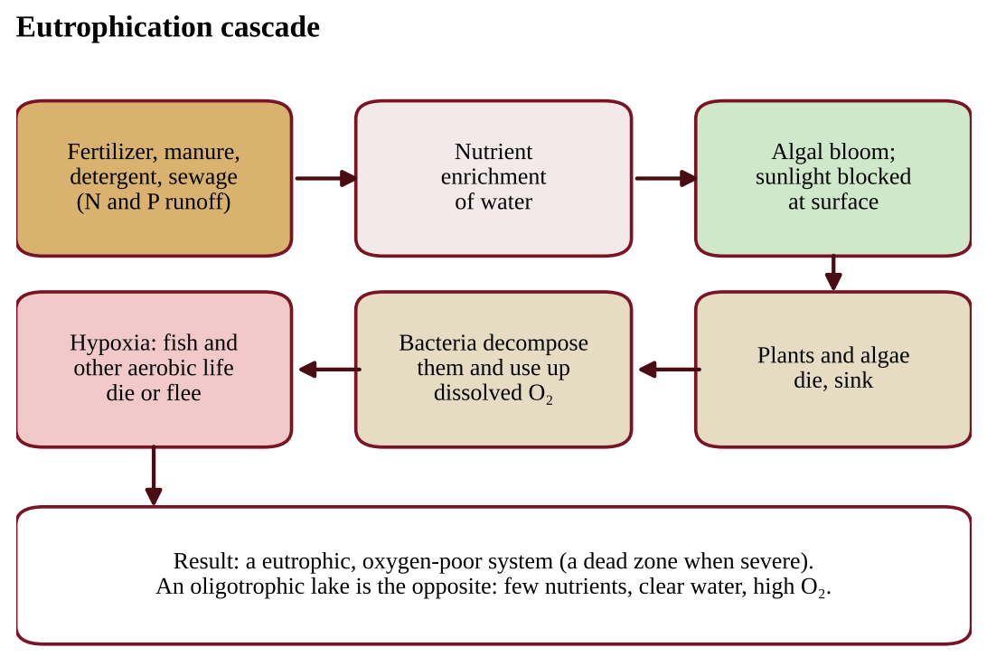
Figure 8.2 — The eutrophication cascade, from nutrient input to oxygen depletion and die-offs.
PROCESS & CAUSE-AND-EFFECT
Fertilizer, manure, detergent, or sewage runs into water → nutrient (N, P) levels rise → algal bloom → algae shade the plants below and eventually die → decomposers digest the dead algae and use oxygen → dissolved oxygen falls (hypoxia) → fish and other organisms die.

The increase in nutrients causes an algal bloom. When the bloom dies, microbes digest the algae, along with the oxygen in the water, leading to a decrease in dissolved oxygen levels. The lack of oxygen can result in large die-offs of fish and other aquatic organisms. The bloom may also block sunlight, killing submerged plants, and some algae release toxins.
Anthropogenic causes of eutrophication are agricultural runoff (fertilizer and animal manure) and wastewater release (sewage and phosphate detergents). Natural eutrophication happens slowly over centuries as a lake fills with sediment; human-caused (cultural) eutrophication can happen in a few years.
KEY DEFINITIONS
Eutrophic — a water body enriched in nutrients, with frequent algal blooms and low dissolved oxygen. Oligotrophic — a water body with very low nutrients, stable algae populations, clear water, and high dissolved oxygen. Hypoxic — low in dissolved oxygen.

Solutions include limiting fertilizer use and applying it at the right time and amount, planting buffer strips and keeping wetlands along streams, banning phosphate detergents, upgrading wastewater plants to remove nitrogen and phosphorus (tertiary treatment), and managing manure.
COMMON STUDENT MISTAKES
• Saying the algae "use up the oxygen." The living algae produce oxygen in daylight. The oxygen is consumed by bacteria decomposing the dead algae.
• Describing eutrophic water as "clean" because it looks green and productive.

AP EXAM STRATEGY
In a cause-and-effect FRQ about eutrophication, write the full chain with each link, naming the nutrient and the oxygen-consuming step: nutrients → bloom → death → decomposition → low DO → die-off. Missing the decomposition link is the most common lost point.

Designing an investigation of a pollution problem
Design questions on the exam (Free-Response Question 1) follow one pattern. Build your answer in this order, using the eutrophication problem as the model.
1. Question and hypothesis. Write an "if … then …" prediction that can be tested: If runoff from the fertilized lawns adds nutrients to the pond, then nitrate and phosphate concentrations will be higher at sites closer to the lawns than at sites farther away.
2. Variables. The independent variable is what you change or compare (distance from the source, or the nutrient added). The dependent variable is what you measure in response (nitrate concentration, chlorophyll or algal density, dissolved oxygen).
3. Control and constants. A control receives no treatment (a site above the source, or a container with no added nutrient). Constants are other factors held the same or recorded for every sample: sampling depth, time of day, water temperature, rainfall in the last 24 hours, and the method and instrument.
4. Procedure. Say where (sites above and below the source), when (the same time of day, repeated through the season, and after rain if runoff is the question), and how often (for example weekly), and name the measurement and the tool (nitrate test kit, DO meter, thermometer).
5. Replication. Take several samples per site and repeat on several dates, then average them. Replication lowers the effect of chance and makes the result more reliable.6. Analysis and conclusion. Average the replicates, graph the dependent variable against the independent variable, and say what pattern would support the hypothesis (for example, nitrate highest at the outfall and decreasing downstream). Correlation alone does not prove cause; a control and a plausible mechanism strengthen the claim.
Which nutrient limits growth? Use identical containers of lake water, each with the same light, temperature, and starting algae, and give them four treatments: nothing (control), nitrogen only, phosphorus only, and both. Replicate each treatment, then measure chlorophyll or algal cell counts after several days. If only the phosphorus treatments grow much more than the control, phosphorus is limiting. Putting nitrogen in one place and phosphorus in another changes the location along with the nutrient, so you could not tell which caused the difference.
Biomagnification hypothesis. A testable form is: If a pollutant biomagnifies in this food web, then tissue concentration will be higher at each higher trophic level. A statement about laws, or one that only tests the top organism, cannot be tested this way.
CLASSROOM EXAMPLE SG-U8-E012
A farm pond turns green each July after a nearby field is fertilized. A student suspects that phosphorus in the runoff is the cause. Four sampling sites are available: S1 in the drainage ditch next to the field, S2 at the pond inlet, S3 at the pond center, and S4 in a similar pond with no farm nearby. (a) Write an "if … then …" hypothesis. (b) Identify the independent and dependent variables and the site that serves as the control. (c) Describe a sampling plan that states when and how often samples are taken and how replication is achieved. (d) Name two variables that must be kept constant or recorded at every site. (e) Describe the results that would support the hypothesis.

CLASSROOM EXAMPLE SG-U8-E003
In an outdoor experiment, four identical tanks received lake water and the same number of fish. Different amounts of phosphate were added once at the start. After 14 days:
Tank | Phosphate added (mg/L) | Algal density (cells per mL) | DO at the bottom (mg/L)
1 | 0 | 2,000 | 8.1
2 | 0.05 | 18,000 | 6.4
3 | 0.20 | 95,000 | 3.2
4 | 0.50 | 210,000 | 1.1

(a) Identify the control tank. (b) Describe the trend in algal density and in bottom DO as phosphate increases. (c) Explain, step by step, how higher phosphate led to lower bottom DO. (d) Classify tank 1 and tank 4 as oligotrophic-like or eutrophic-like.

QUICK CONCEPT SUMMARY
• Eutrophication is nutrient enrichment; causes include fertilizer runoff and wastewater.
• Blooms die, decomposers use oxygen, DO falls, and fish die; low DO is called hypoxia.
• Oligotrophic water has few nutrients, stable algae, and high DO.

Topic 8.6 — Thermal Pollution
LEARNING OBJECTIVES
• Describe the effects of thermal pollution on aquatic ecosystems.
• Explain why warm water holds less dissolved oxygen.

CONCEPT MADE SIMPLE
Think of a soda: a cold bottle stays fizzy but a warm one goes flat quickly because gas escapes from warm liquid. Water works the same way for oxygen. Warm water holds less. If a factory heats a river, the fish face two problems at once: less oxygen in the water and a faster metabolism that demands more.

Thermal pollution occurs when heat released into the water produces negative effects to the organisms in that ecosystem. The usual source is cooling water: power plants and factories take in river water, use it to carry off waste heat, and return it warmer.
Why warm water is a problem. Warm water does not contain as much dissolved oxygen as cold water. Also, the metabolic rates of cold-blooded aquatic animals rise with temperature, so they need more oxygen just when less is available. Cold-water species such as trout have narrow tolerance ranges and may die or leave.
Water temperature (°C) | 5 | 10 | 20 | 30
Maximum DO at saturation (mg/L, fresh water, sea level) | 12.8 | 11.3 | 9.1 | 7.5

Heat also enters streams when clear-cutting removes the shade of streamside trees, so sunlight warms the water directly, and when runoff crosses hot pavement. Cooling towers, recycled cooling water, waste-heat reuse, and shade trees along streams reduce thermal pollution.
KEY DEFINITIONS
Thermal pollution — heat added to water by human activities that harms organisms.

CLASSROOM EXAMPLE SG-U8-E004
A power plant takes in river water at 10°C and discharges it at 30°C. Use the saturation table above. (a) Calculate the percent decrease in the maximum DO the water can hold when it warms from 10°C to 30°C. (b) State two reasons, other than the lower oxygen capacity, that the warmed discharge could harm cold-water fish. (c) Propose one engineering and one landscape solution that would reduce the thermal impact.

QUICK CONCEPT SUMMARY
• Thermal pollution is heat added to water by humans, mainly power-plant cooling water.
• Warm water holds less oxygen and speeds up organisms' metabolism, so stress and fish kills occur.
• Cooling towers, shade, and heat reuse reduce the problem.

Topic 8.7 — Persistent Organic Pollutants (POPs)
LEARNING OBJECTIVES
• Explain why POPs persist in the environment.
• Describe why they accumulate in fatty tissues and why they travel long distances.

CONCEPT MADE SIMPLE
Most natural substances are like paper: microbes eventually digest them. POPs are like plastic: man-made molecules that microbes do not know how to break. They last for years, they dissolve in fat rather than water, so animals store them, and they ride the wind and ocean currents far from where they were first used.

Persistent organic pollutants (POPs) do not easily break down in the environment because they are synthetic, carbon-based molecules (such as DDT and PCBs). Since decomposers have no enzymes evolved for these structures, they remain in soil, sediment, and water for years or decades. "Organic" here means carbon-based, not "grown without pesticides."
POPs can be toxic to organisms because they are soluble in fat (lipid-soluble) rather than water. Water-soluble chemicals are excreted in urine; fat-soluble ones are retained and accumulate in organisms' fatty tissues, such as body fat, liver, and eggs (Topic 8.8).
POPs can travel over long distances via wind and water before being redeposited. Evaporating in warm regions, riding air currents, and condensing in cold regions, they can contaminate places where they were never used, such as Arctic wildlife and the people who eat it.
KEY DEFINITIONS
POP — a synthetic, carbon-based pollutant that resists breakdown, dissolves in fat, and can be transported long distances. Examples: DDT, PCBs.

Topic 8.8 — Bioaccumulation and Biomagnification
LEARNING OBJECTIVES
• Define bioaccumulation and biomagnification and tell them apart.
• Calculate concentrations in a food chain.
• Describe the effects of DDT, mercury, and PCBs on organisms, including humans.

CONCEPT MADE SIMPLE
Bioaccumulation happens inside one animal: it takes in a pollutant faster than it gets rid of it, so the amount in its body keeps rising over its lifetime. Biomagnification happens up a food chain: a predator eats many contaminated prey, so the concentration climbs at each step. An osprey ends up with far more toxin per gram than the water it fishes in.

Bioaccumulation is the selective absorption and concentration of elements or compounds by cells in a living organism, most commonly fat-soluble compounds. Biomagnification is the increase in concentration of substances per unit of body tissue that occurs in successively higher trophic levels of a food chain or food web.
Why does it magnify? Only about 10% of energy passes up each trophic level, so a predator eats many prey over its lifetime; if the toxin is stored and not excreted, the predator collects the whole load. A common rule of thumb is about 10× per trophic level, though real factors vary.
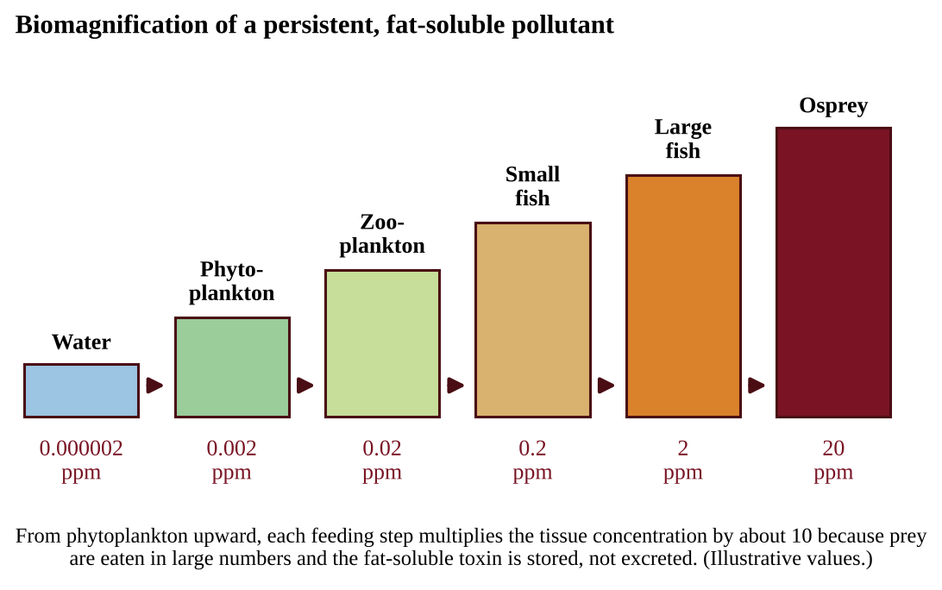
Figure 8.3 — Biomagnification of a persistent, fat-soluble pollutant in an aquatic food chain (illustrative values).
FORMULA & MATH SKILL
Biomagnification factor (BMF) = concentration in the consumer ÷ concentration in its food (or the trophic level below) Concentration at level n ≈ starting concentration × (BMF)ⁿ Units: ppm, ppb, or mg/kg of tissue (the same units for both levels).

For example, if plankton hold 0.04 ppm and each step multiplies by 10, small fish hold 0.4 ppm, larger fish 4 ppm, and a fish-eating bird 40 ppm after three steps (0.04 × 10³ = 40).
Effects
Effects in an ecosystem include eggshell thinning and developmental deformities in top carnivores at the higher trophic levels. DDT famously thinned the eggshells of birds of prey such as eagles, ospreys, and peregrine falcons, so eggs broke in the nest and populations crashed. Humans also experience harmful effects from biomagnification, including issues with the reproductive, nervous, and circulatory systems.
Three substances to know: DDT (insecticide), PCBs (industrial chemicals), and mercury (converted to methylmercury by aquatic bacteria; it harms the nervous system, which is why people are advised to limit large predatory fish). All three bioaccumulate and have major impacts.
Mercury follows a clear path: coal burning releases it to the air, wind carries it, rain or dry fallout deposits it on lakes and oceans, bacteria convert it to methylmercury, and it biomagnifies in fish. Because concentrations are lower at lower trophic levels, eating fish that are low in the food chain exposes a person to less of the toxin than eating large predators. A persistent chemical that is banned in one country can still turn up in its people because it lasts for years and travels in imported food.
KEY DEFINITIONS
Bioaccumulation — the buildup of a substance, especially a fat-soluble one, in the tissues of a single organism over time. Biomagnification — the increase in a substance's concentration per unit of tissue at successively higher trophic levels.

COMMON STUDENT MISTAKES
• Using the terms interchangeably. Accumulation is within one organism's body over time; magnification is across trophic levels.
• Assuming the producers have the highest concentrations. They have the lowest tissue concentration among organisms in the chain; the top consumer has the highest.
• Saying the pollutant "disappears" at each step. The food chain concentrates it.

CLASSROOM EXAMPLE SG-U8-E005
Tissue samples from a pond food chain contained the following concentrations of a persistent pesticide:
Organism | Trophic level | Concentration (ppm)
Algae | Producer | 0.8
Minnows | Primary consumer | 6.4
Trout | Secondary consumer | 52
Heron | Tertiary consumer | 416

(a) Calculate the biomagnification factor for each step (consumer ÷ food), rounded to one decimal. (b) Calculate the overall factor from algae to heron. (c) Explain why the heron's concentration is much higher than the algae's even though the pond water is only slightly contaminated. (d) Identify one effect this pesticide might have on the heron population.

QUICK CONCEPT SUMMARY
• Bioaccumulation: buildup in one organism; biomagnification: increase up trophic levels.
• Fat-soluble, persistent, non-excretable substances such as DDT, PCBs, and methylmercury do both.
• Effects: eggshell thinning and deformities in top predators; reproductive, nervous, and circulatory harm in humans.

Topic 8.9 — Solid Waste Disposal
LEARNING OBJECTIVES
• Describe the types and sources of solid waste, including e-waste.
• Describe the parts of a sanitary landfill and what controls decomposition in it.
• Compare landfills, incineration, and ocean dumping, and describe the problems of illegal dumping.

CONCEPT MADE SIMPLE
Throw something "away" and it does not vanish; it goes somewhere. Most places bury it in a lined landfill, some burn it, and some dump it where it should not go. Each choice trades one problem for another: buried trash can leak liquid and gas, burned trash makes smoke and ash.

Solid waste is any discarded material that is not a liquid or a gas. It is generated in domestic, industrial, business, and agricultural sectors. Electronic waste (e-waste) is composed of discarded electronic devices including televisions, cell phones, and computers; it contains valuable metals but also hazardous materials such as lead and mercury.
Landfills
Solid waste is most often disposed of in landfills. A sanitary municipal landfill is engineered to limit harm. It consists of a bottom liner (plastic or clay), a storm water collection system, a leachate collection system, a cap (cover), and a methane collection system. Leachate is the polluted liquid that forms when water percolates through waste. Without a liner, leachate can contaminate groundwater; without gas collection, methane (a greenhouse gas that is also flammable) escapes.
PROCESS & CAUSE-AND-EFFECT
Rain falls on the waste → water seeps down and picks up dissolved contaminants (leachate) → liner stops it from reaching groundwater → collection pipes pump it to treatment. Meanwhile, microbes decompose organic waste → methane and CO₂ form → gas wells collect the methane for flaring or energy.

Landfills can still contaminate groundwater and release harmful gases when liners fail or when they were built before modern standards. Crushed or shredded waste releases more contaminants into water than large pieces because smaller pieces expose more surface area. Factors in landfill decomposition include the composition of the trash and the conditions needed for microbial decomposition: moisture, temperature, and oxygen availability. Tightly compacted, covered waste is deprived of oxygen and moisture, so even paper and food can last for decades, and plastics last far longer.
Incineration
Waste can also be burned at high temperatures. Incineration significantly reduces the volume of solid waste (often by about 90%) but releases air pollutants such as particulates, NOₓ, SO₂, and sometimes toxic metals and dioxins, and leaves ash that must be disposed of, often as hazardous waste. When the heat is used to generate electricity, the process is called waste-to-energy.
Illegal dumping and ocean dumping
Some items are not accepted in sanitary landfills and may be disposed of illegally, leading to environmental problems. One example is used rubber tires, which, when left in piles, become breeding grounds for mosquitoes that can spread disease. Tire piles also burn and release toxic smoke. Some countries dispose of waste by dumping it in the ocean. This practice, along with other sources of plastic, has led to large floating islands of trash in the oceans. Wildlife can become entangled in the waste and can ingest it. Plastic is especially persistent because few microbes can break it down, so it lasts for decades to centuries and only breaks into smaller pieces. Cutting the flow of plastic at its source (using less, reusing, recycling incentives) is more effective than cleaning up what has already spread.
Hazardous waste is waste that is toxic, flammable, or corrosive, such as batteries, paint, motor oil, pesticides, and electronics. It needs special handling and should never go into an ordinary landfill. Two U.S. laws apply: RCRA regulates hazardous waste from creation to disposal ("cradle to grave"), and CERCLA (the Superfund law) pays for and organizes cleanup of abandoned or uncontrolled hazardous waste sites, with the responsible parties billed for the cost.
KEY DEFINITIONS
Solid waste — discarded material that is not a liquid or a gas. E-waste — discarded electronic devices such as televisions, phones, and computers. Leachate — liquid that has percolated through waste and carries dissolved contaminants.

QUICK CONCEPT SUMMARY
• Solid waste is any discarded non-liquid, non-gas material; e-waste is discarded electronics.
• A sanitary landfill has a liner, storm water system, leachate system, cap, and methane collection.
• Incineration cuts volume but releases air pollutants; illegal and ocean dumping cause serious harm.

Topic 8.10 — Waste Reduction Methods
LEARNING OBJECTIVES
• Describe reduction practices (reuse, recycling, composting, e-waste handling, landfill mitigation) and their benefits and drawbacks.
• Calculate waste per capita and percent diversion.

CONCEPT MADE SIMPLE
The best trash is trash that never exists. After that, use it again, then turn it into something new, then recover energy, and only then bury it. The more you move up this ladder, the less damage is done at the landfill.

Recycling is a process by which certain solid waste materials are processed and converted into new products. Recycling is one way to reduce the current global demand on minerals (for example aluminum and copper), but this process is energy-intensive and can be costly (collection, sorting, and reprocessing). It still usually takes far less energy to recycle aluminum than to mine and refine new aluminum.
Composting is the process of organic matter such as food scraps, paper, and yard waste decomposing. The product of this decomposition can be used as fertilizer or a soil conditioner. Drawbacks to composting include odor and rodents, which are reduced by good management.
E-waste can be reduced by recycling and reuse. E-wastes may contain hazardous chemicals, including heavy metals such as lead and mercury, which can leach from landfills into groundwater if they are not disposed of properly.
Landfill mitigation strategies range from burning waste for energy to restoring habitat on former landfills for use as parks. The combustion of gases produced from decomposition of organic material in landfills can be used to turn turbines and generate electricity. This process reduces landfill volume.
Method | Main benefit | Main drawback
Landfill | Cheap; methane can be captured | Land use; leachate and gas risks
Incineration | Volume cut ~90%; energy | Air pollutants; toxic ash
Recycling | Saves minerals and landfill space | Energy-intensive, costly
Composting | Makes fertilizer; diverts organics | Odor, rodents

Calculations
Waste per capita = total waste ÷ population (then use dimensional analysis to change units). Percent diversion = (mass recycled + mass composted) ÷ total waste generated × 100.
FORMULA & MATH SKILL
Per capita waste = total mass of waste ÷ number of people (kg per person per day or per year) Percent diversion = (mass diverted from disposal ÷ total mass generated) × 100 Years of landfill life = remaining capacity ÷ annual mass buried (same mass units)

Worked illustration. A town of 20,000 people generates 14,600 metric tons of waste per year. Per capita: 14,600 t × 1,000 kg/t ÷ 20,000 people = 730 kg per person per year, and 730 ÷ 365 = 2.0 kg per person per day. If 3,650 t is recycled and composted, the diversion is 3,650 ÷ 14,600 × 100 = 25%.
Source reduction means making less waste in the first place, for example by redesigning products with less packaging. It is the preferred strategy, ahead of reuse and recycling, because the waste never has to be collected or processed.
Landfill space and landfill energy
Landfill capacity is measured in volume, but waste is measured in mass, so you need the density of the compacted waste. Convert units first, then divide.
FORMULA & MATH SKILL
Volume (m³) = mass (kg) ÷ density (kg/m³) Landfill life (years) = remaining capacity (m³) ÷ volume buried per year (m³/yr) Electricity from landfill gas (MJ) = gas volume (m³) × energy content (MJ/m³) × efficiency (as a decimal) Electricity (kWh) = energy (MJ) ÷ 3.6, because 1 kWh = 3.6 MJ

Illustration. A landfill receives 30,000 metric tons per year at a compacted density of 500 kg/m³. Mass = 30,000 × 1,000 = 3.0 × 10⁷ kg; volume = 3.0 × 10⁷ ÷ 500 = 6.0 × 10⁴ m³ per year. With 1.2 × 10⁶ m³ of space left, life = 1.2 × 10⁶ ÷ 6.0 × 10⁴ = 20 years. If recycling and composting divert part of the waste, only the remainder (100% minus the diverted share) is buried, so the life is longer by that factor.
Illustration of energy. Capturing 5.0 × 10⁵ m³ of methane per year at 36 MJ/m³ gives 1.8 × 10⁷ MJ. A generator that is 30% efficient delivers 1.8 × 10⁷ × 0.30 = 5.4 × 10⁶ MJ, which is 5.4 × 10⁶ ÷ 3.6 = 1.5 × 10⁶ kWh. At 8,000 kWh per home per year, that supplies 1.5 × 10⁶ ÷ 8,000 ≈ 190 homes.
Scientific notation. To divide, divide the coefficients and subtract the exponents: (5 × 10⁴) ÷ (2 × 10¹²) = 2.5 × 10⁻⁸. This is how you find the average mass of one item when the total mass and number of items are both given in scientific notation.
COMMON STUDENT MISTAKES
• Treating all diversion as free. Recycling and composting need energy, money, and clean sorting.
• Dividing in the wrong order for per capita (waste ÷ people, not people ÷ waste).
• Forgetting to convert tons to kilograms or years to days.

CLASSROOM EXAMPLE SG-U8-E006
A city of 125,000 people sends 82,125 metric tons of solid waste to its landfill in one year (365 days). (a) Calculate the waste per person per day, in kilograms. (b) The city sets a goal of reducing the per capita rate by 20%. Calculate the goal in kilograms per person per day and the annual mass of waste, in metric tons, if the population stays the same. (c) Name two methods, one for plastics and metals and one for food scraps, that could help meet the goal.

CLASSROOM EXAMPLE SG-U8-E007
A county landfill has 1,200,000 metric tons of remaining capacity. At present 40,000 t of waste is buried each year. The county considers a plan that would recycle 25% and compost 15% of the 40,000 t generated each year, burying only the remainder. (a) Calculate the percent diversion under the plan. (b) Calculate the number of years the landfill will last under the current practice and under the plan. (c) Describe one benefit and one drawback of the plan other than landfill life.

CLASSROOM EXAMPLE SG-U8-E013
A town of 80,000 people produces 1.6 kg of solid waste per person per day. It recycles 20% and composts 10%; the rest goes to a landfill and is compacted to 550 kg/m³. The landfill has 2.0 × 10⁶ m³ of space left. (a) Calculate the mass landfilled in one year (365 days), in metric tons. (b) Calculate the volume this occupies, in m³ per year. (c) Calculate how many years the landfill will last. (d) The landfill also captures 4.0 × 10⁵ m³ of methane per year at 36 MJ/m³ and burns it in a generator that is 35% efficient. Calculate the electricity produced, in kWh per year.

QUICK CONCEPT SUMMARY
• Reduce and reuse first; then recycle, compost, and recover energy; landfill last.
• Recycling saves minerals but is energy-intensive and costly; composting makes fertilizer but can cause odor and rodents.
• E-waste contains lead and mercury and should be recycled or reused; landfill gas can run turbines.
• Per capita = waste ÷ people; diversion % = diverted ÷ generated × 100.

Topic 8.11 — Sewage Treatment
LEARNING OBJECTIVES
• Describe primary, secondary, and tertiary sewage treatment and disinfection.
• Interpret a flow diagram of a treatment plant.
• Calculate the percent removal of BOD at each stage.

CONCEPT MADE SIMPLE
A sewage plant is a series of cleaning steps. First, take out what you can pick or settle out. Second, let bacteria eat the dissolved waste. Third, polish the water to remove leftovers. Finally, kill germs before letting the water go.

Sewage (wastewater from toilets, sinks, and industry) carries organic matter, nutrients, and disease-causing microbes. Without treatment it would produce high BOD, oxygen sags, eutrophication, and disease.
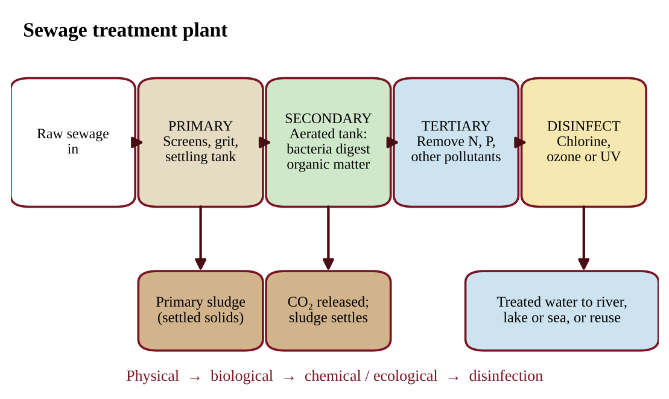
Figure 8.4 — Stages of sewage treatment from raw sewage to disinfected effluent.
• Primary treatment is the physical removal of large objects, often through screens and grates, followed by the settling of solid waste in the bottom of a tank. It removes solids and some of the BOD without using biology.
• Secondary treatment is a biological process in which bacteria break down organic matter into carbon dioxide and inorganic sludge, which settles in the bottom of a tank. The tank is aerated to increase the rate at which the bacteria break down the organic matter, because the bacteria are aerobic and need oxygen. This stage removes most of the remaining BOD.
• Tertiary treatment is the use of ecological or chemical processes to remove any pollutants left in the water after primary and secondary treatment. Examples are constructed wetlands, filters, and chemical precipitation of phosphorus or biological removal of nitrogen to reduce nutrients that cause eutrophication.
• Disinfection. Prior to discharge the treated water is exposed to one or more disinfectants (usually chlorine, ozone, or UV light) to kill bacteria.
PROCESS & CAUSE-AND-EFFECT
Raw sewage → screens and grates remove large objects → settling tank removes solids (primary sludge) → aerated tank where bacteria digest organic matter (secondary) → sludge settles → chemical or ecological polishing removes nutrients and leftovers (tertiary) → chlorine, ozone, or UV kills pathogens → release or reuse.

KEY DEFINITIONS
Primary treatment — physical removal by screens and settling. Secondary treatment — aerated biological breakdown of organic matter by bacteria. Tertiary treatment — ecological or chemical removal of remaining pollutants. Disinfection — killing pathogens with chlorine, ozone, or UV light before discharge.

CLASSROOM EXAMPLE SG-U8-E008
A treatment plant measured BOD at three points: raw sewage entering, 240 mg/L; after the primary settling tank, 168 mg/L; after the aerated secondary tank, 21 mg/L. (a) Calculate the percent of BOD removed by primary treatment, relative to the raw sewage. (b) Calculate the percent of the remaining BOD removed by the secondary stage, relative to the water entering the secondary tank. (c) Calculate the overall percent removal. (d) Explain why the secondary stage removes BOD by a different mechanism than the primary stage, and why aeration is required.

QUICK CONCEPT SUMMARY
• Primary: physical (screens and settling). Secondary: aerated bacteria convert organics to CO₂ and sludge. Tertiary: chemical or ecological removal of leftover pollutants such as nutrients.
• Disinfection (chlorine, ozone, UV) kills pathogens before discharge.
• Percent removal = (in − out) ÷ in × 100.

Topic 8.12 — Lethal Dose 50% (LD50)
LEARNING OBJECTIVES
• Define LD50 and use it to compare toxicity.
• Use LD50 to calculate a dose for a given body mass.

CONCEPT MADE SIMPLE
To compare how poisonous two chemicals are, scientists ask: how much does it take to kill half of a test group? That amount is the LD50. A tiny LD50 means very toxic; a huge LD50 means much less toxic.

Lethal dose 50% (LD50) is the dose of a chemical that is lethal to 50% of the population of a particular species. It is determined in controlled tests on groups of test animals given different doses, and it is usually reported as milligrams of the chemical per kilogram of body mass (mg/kg), so that animals of different sizes can be compared. Because the dose is per kilogram, the total dose for an individual is the LD50 multiplied by its body mass.
FORMULA & MATH SKILL
Total dose (mg) = dose (mg/kg) × body mass (kg) LD50 comparison: the lower the LD50, the more toxic the chemical. Units: mg of chemical per kg of body mass (mg/kg).

Illustration. If a pesticide has an LD50 of 40 mg/kg in rats, a 0.25 kg rat given 10 mg has received 10 ÷ 0.25 = 40 mg/kg, so about half of rats given this dose would be expected to die.
How many times more toxic? Divide the larger LD50 by the smaller one. The chemical with the smaller LD50 is that many times more toxic. If chemical A has an LD50 of 12 mg/kg and chemical B has 480 mg/kg, then 480 ÷ 12 = 40, so A is 40 times more toxic than B (it takes one-fortieth of the dose). Do not subtract the two values.
The LD50 measures death only (not illness or cancer), applies to one species and one route of exposure, and says nothing about long-term low-level exposure. It is also not a safe dose: some animals die at doses well below the LD50, and the LD50 for rats cannot be assumed for humans, whose size and metabolism differ.
KEY DEFINITIONS
LD50 — the dose of a chemical lethal to 50% of a test population of one species.

Topic 8.13 — Dose Response Curve
LEARNING OBJECTIVES
• Describe and interpret a dose response curve.
• Identify threshold, LD50, and compare toxicity of chemicals from graphs.

CONCEPT MADE SIMPLE
A dose response curve answers the question "how much is too much?" The x-axis shows how much of a substance an organism gets. The y-axis shows how many are affected or how strong the effect is. More dose, more effect, usually in an S-shape.

A dose response curve describes the effect on an organism or mortality rate in a population based on the dose of a particular toxin or drug. The dose goes on the horizontal axis (often on a logarithmic scale because the doses span a wide range) and the response (percent of the population affected or dying) on the vertical axis.
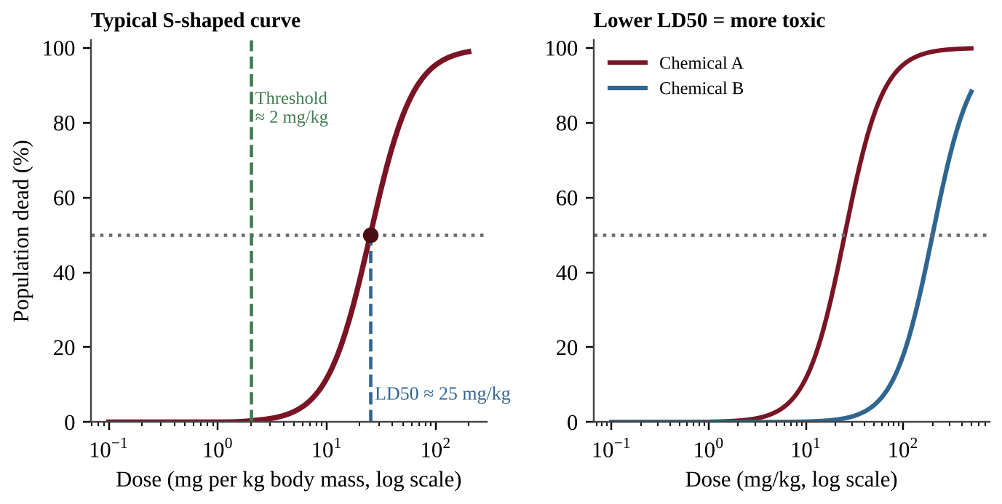
Figure 8.5 — Left: an S-shaped dose response curve with a threshold dose and the LD50 marked. Right: the chemical with the curve farther left (lower LD50) is more toxic.
Reading the curve
1. Flat start (threshold). At very low doses there may be no measurable effect. The dose below which no effect is seen is the threshold dose. Some substances, such as some carcinogens, may have no safe threshold in practice.
2. Steep middle. Over a narrow range of doses the response climbs rapidly; small increases in dose cause big increases in effect.
3. Plateau. At high doses nearly everyone is affected, so the curve levels off near 100%.
4. LD50. Draw a horizontal line from 50% on the y-axis to the curve, then drop down to the x-axis. That x-value is the LD50.
5. Comparing chemicals. A curve shifted to the left reaches 50% at a smaller dose, so that chemical is more toxic. A steeper curve means a narrow range between "no effect" and "high effect," which makes a safe dose harder to set.
Risk reasoning. Risk depends on hazard and exposure: a very toxic chemical sealed in a drum poses low risk; a moderately toxic one in daily drinking water may pose high risk.
Curve shapes, log axes, and toxicity tests
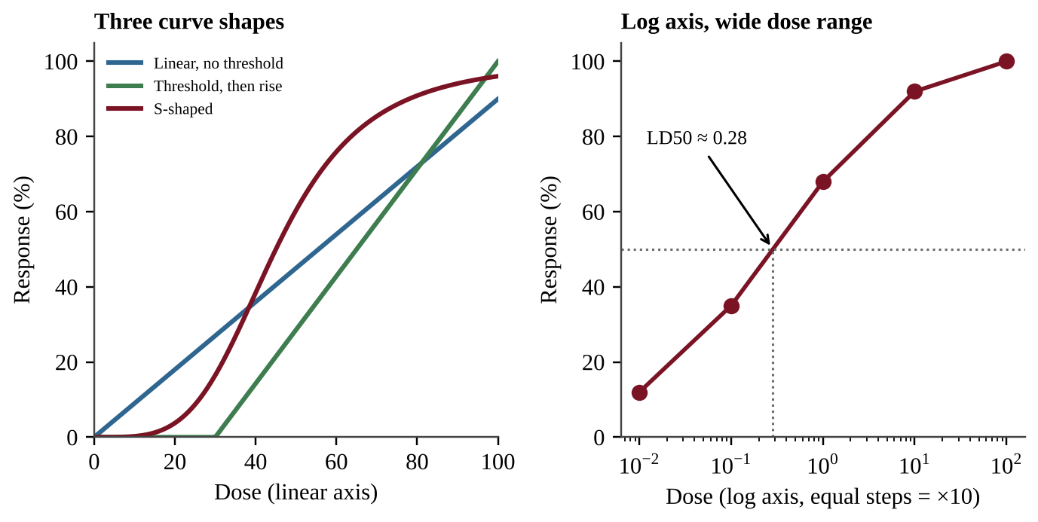
Figure 8.5b — Left: three curve shapes on a linear axis. Right: the same kind of data on a log dose axis, with the LD50 found by interpolation.
• Shapes. A threshold curve is flat until a dose is reached. A linear, no-threshold curve rises from the first dose, so even a small dose has some effect (the working assumption for many carcinogens). A steady rise in effect with dose suggests a linear relationship; no effect up to a certain dose suggests a threshold. A curve can also fall with dose, for example when a drug lowers the response being measured; read the axis labels before deciding what the trend means. Most mortality curves are S-shaped.
• Reading a point from the graph. To state the response at a given dose (say, the percent of tadpoles that die at 40 mg/kg), go up from the dose to the curve, then across to the y-axis. A dose below the LD50 can still kill some animals, so "below the LD50" never means "safe."
• Log axis. When doses range from 0.001 to 100, a log axis spaces each tenfold step equally. Equal gaps on the axis mean multiplication, not addition. To interpolate an LD50 between two plotted doses, interpolate the exponent: if 35% die at 0.1 and 68% die at 1, then 50% is (50 − 35) ÷ (68 − 35) = 0.45 of the way from the exponent −1 to the exponent 0, so the exponent is −0.55 and the dose is 10⁻⁰·⁵⁵ ≈ 0.28. Reading it straight off the graph gives about the same answer.
• Expected deaths. Multiply the percent by the number exposed: 30% of 40,000 organisms is 12,000.
Setting up a toxicity test. Expose several identical groups of one species to different doses, plus a control group that receives none. Keep temperature, age, food, and exposure time the same, use many animals per group, and count responses after a fixed time. The dose is the independent variable and the percent responding is the dependent variable. The test shows the effect on the test species only: using the results to predict harm to humans requires care because bodies differ, and a one-day test cannot show chronic effects.
KEY DEFINITIONS
Dose response curve — a graph of the effect on an organism, or mortality in a population, versus the dose of a toxin or drug. Threshold dose — the highest dose at which no effect is observed.

COMMON STUDENT MISTAKES
• Reading the dose on the y-axis. Dose is on the x-axis; response is on the y-axis.
• Picking the dose for 50% response by looking at the 50 on the x-axis. The 50 is on the y-axis.
• Saying the chemical with the curve farther right is more toxic. It is less toxic.

CLASSROOM EXAMPLE SG-U8-E009
Two insecticides were tested on separate groups of identical laboratory mice, with the following percent mortality after 24 hours:
Insecticide X dose (mg/kg) | 5 | 10 | 20 | 40 | 80
Mice dead (%) | 8 | 22 | 46 | 72 | 94

Insecticide Y dose (mg/kg) | 100 | 200 | 400 | 800
Mice dead (%) | 30 | 52 | 80 | 96

(a) For each insecticide, estimate the LD50 by linear interpolation between the two tested doses whose mortalities bracket 50%. Give the answer to the nearest 1 mg/kg. (b) State which insecticide is more toxic and justify your answer using the LD50 values. (c) Using your rounded LD50 for insecticide X, calculate the total dose, in mg, for a mouse of body mass 0.025 kg. (d) Give one limitation of using LD50 to decide whether either insecticide is safe in a river.

CLASSROOM EXAMPLE SG-U8-E014
Brine shrimp (100 per dish) were exposed to a salt of a heavy metal. A control dish received no metal. After 48 hours:
Concentration (mg/L) | Shrimp dead (of 100)
0 (control) | 3
0.01 | 8
0.1 | 24
1 | 61
10 | 93
100 | 100

(a) Explain why a log scale is appropriate for the concentration axis and describe how you would set up the axes. (b) Estimate the concentration that kills 50% by interpolating the exponent between the two doses that bracket 50%. (c) State the lowest tested concentration at which mortality clearly exceeds the control, and explain why the control matters. (d) Give one reason the result cannot be used directly to set a safe level for people.

QUICK CONCEPT SUMMARY
• A dose response curve plots response against dose; it is typically S-shaped, with a threshold and a plateau.
• LD50 is read at 50% response; a curve farther left means a lower LD50 and greater toxicity.
• Risk depends on both toxicity (dose response) and exposure.

Topic 8.14 — Pollution and Human Health
LEARNING OBJECTIVES
• Identify human health issues linked to pollution: dysentery, mesothelioma, and respiratory problems from ozone.
• Explain why linking a pollutant to a health outcome is difficult and describe research methods.

CONCEPT MADE SIMPLE
When people get sick, many things could be responsible: air, water, food, jobs, genes, habits. Pinning an illness on one pollutant means untangling a knot of causes. Scientists do it with careful studies that compare exposed groups to similar unexposed groups.

It can be difficult to establish a cause and effect between pollutants and human health issues because humans experience exposure to a variety of chemicals and pollutants. People also move, change jobs, have different genes, and may not show disease for decades (a latency period). This is why investigations use large samples, control groups, and statistics to find associations, and then look for mechanisms that explain them.
Health issue | Linked pollutant or cause | Key facts
Dysentery | Untreated sewage in streams and rivers | Intestinal infection with severe diarrhea; spreads when drinking water is contaminated with feces
Mesothelioma | Asbestos | A cancer of the lining of the lungs and chest, caused mainly by asbestos fibers that are inhaled (insulation and old building materials); appears decades after exposure
Respiratory problems | Elevated tropospheric (ground-level) ozone | Ozone irritates the airways and reduces lung function, worsening asthma and other lung disease

Research methods
A controlled experiment (used with lab animals, or in cell studies) changes one variable, the dose, while holding others constant. For people, researchers use epidemiological studies that compare the rates of disease among people with different exposures. These show correlation; further evidence, such as a dose response relationship (more exposure, more disease), a plausible biological mechanism, and consistent results in several studies, builds the case for causation.
KEY DEFINITIONS
Epidemiology — the study of how often diseases occur in different groups of people and what factors are associated with them. Latency period — the delay between exposure and the appearance of disease.

QUICK CONCEPT SUMMARY
• Cause and effect between pollutants and illness is hard to establish because of multiple exposures.
• Untreated sewage in water causes dysentery; asbestos causes mesothelioma; elevated ground-level ozone harms the lungs.
• Studies rely on controls, large samples, and dose-dependent patterns.

Topic 8.15 — Pathogens and Infectious Diseases
LEARNING OBJECTIVES
• Explain how human pathogens cycle through the environment and how they adapt.
• Describe the specific diseases named in the course, their causes, and their transmission.
• Explain how climate, poverty, and sanitation affect disease spread.

CONCEPT MADE SIMPLE
A pathogen is a germ that causes disease. It needs a way to get from one host to the next: through water, air, bites from insects, or contact. Break the route (clean water, sewage treatment, mosquito control) and you stop the disease, even if the germ is still around.

A pathogen is an organism or virus that causes disease. Vectors are animals, such as mosquitoes, that carry pathogens from one host to another. Pathogens adapt to take advantage of new opportunities to infect and spread through human populations: crowding, travel, changes in land use, and contact between people and animals. Pathogens also move through the environment in cycles: from an infected person or animal, into water, air, or a vector, and into a new host.
Specific pathogens can occur in many environments regardless of the appearance of sanitary conditions. Clear-looking water or a clean-looking kitchen can still carry bacteria, so appearance is not a reliable test; water must be tested or treated.
Climate and poverty
As equatorial-type climate zones spread north and south into what are currently subtropical and temperate climate zones, pathogens, infectious diseases, and any associated vectors are spreading into these areas where the disease has not previously been known to occur. Warmer conditions allow mosquitoes to survive in new regions and for more months of the year.
Poverty-stricken, low-income areas often lack sanitary waste disposal and have contaminated drinking water supplies, leading to havens and opportunities for the spread of infectious diseases. Crowding and poor nutrition add to the problem. Other drivers of spread are flooding, which mixes sewage with drinking water; warmer temperatures, which extend the range and season of vectors; and air travel, which can carry a pathogen between continents within a day. When a table shows that districts with less sewer coverage have more cases, the pattern is an association; it fits the fecal-contamination route but does not by itself rule out other causes. Providing clean water and sewage treatment is therefore one of the most powerful public health measures.
Diseases to know
Disease | Type of pathogen | Spread / source
Plague | Bacterium | Carried by infected animals such as rodents and their fleas; transferred to humans by the bite of an infected organism or contact with contaminated fluids or tissues
Tuberculosis (TB) | Bacterium | Typically attacks the lungs; spread by breathing in bacteria from the bodily fluids of an infected person
Malaria | Parasite | Bites from infected mosquitoes; most often found in sub-Saharan Africa
West Nile virus | Virus | Bites from infected mosquitoes
SARS | Virus; a form of pneumonia | Transferred by inhaling or touching infected fluids
MERS | Virus; respiratory illness | Transferred from animals to humans
Zika | Virus | Bites from infected mosquitoes; can also be transmitted through sexual contact
Cholera | Bacterium | Contracted from infected water

PROCESS & CAUSE-AND-EFFECT
Infected host sheds the pathogen (feces, fluids, blood) → pathogen enters environment (water, air, or a vector) → new person exposed (drinking, breathing, bite, contact) → infection → more shedding. Break any arrow, and the cycle stops: treat sewage, purify water, control vectors, isolate the sick.

KEY DEFINITIONS
Pathogen — an organism or virus that causes disease. Vector — an organism that carries a pathogen from one host to another.

CLASSROOM EXAMPLE SG-U8-E010
Three villages along one river were surveyed for cholera during one rainy season:
Village | Drinking water | Sewage handling | Cases per 10,000 people
A | Chlorinated, from a protected well | Latrines connected to a treatment plant | 2
B | Untreated river water | Latrines connected to a treatment plant | 14
C | Untreated river water | Open disposal upstream of the intake | 61

(a) Calculate how many times higher the case rate is in village C than in village A. (b) Make a claim about the factor most strongly associated with the difference between A and B, and support it with data. (c) Explain the transmission route that links open sewage disposal to cases in village C. (d) State one reason this survey alone cannot prove that sewage handling caused the difference in cases, and propose one low-cost intervention for village C.

QUICK CONCEPT SUMMARY
• Pathogens adapt to new opportunities and can occur even where conditions look sanitary.
• Spreading warm climates carry diseases and vectors into new regions; poverty and poor sanitation create havens.
• Know the routes: plague (infected animals, fleas), TB (inhaled bacteria), malaria, West Nile, Zika (mosquitoes), SARS (infected fluids), MERS (animal to human), cholera (infected water).

Math & Skills Toolkit
Most Unit 8 calculations use a handful of tools. Always show the formula, the substitution with units, and the answer with units.
1. Percent change or percent removal. (initial − final) ÷ initial × 100. Example: DO drops from 8.0 to 3.0 mg/L, so (8.0 − 3.0) ÷ 8.0 × 100 = 62.5% decrease. Use the same idea for BOD removal at a treatment stage.
2. Biomagnification. Factor = consumer ÷ food. Over several steps multiply the factors: 5 × 5 × 5 = 125. To project a concentration forward, multiply the starting value by the factor for each trophic step.
3. Per capita and unit conversion (dimensional analysis). Write the units as fractions and cancel them. Example: 9,000 t/yr × 1,000 kg/t ÷ 365 days/yr ÷ 15,000 people = 1.64 kg per person per day.
4. Percent diversion. (recycled + composted) ÷ total generated × 100.
5. Landfill life and dose. Landfill life = remaining capacity ÷ annual waste buried. Total dose = (mg/kg) × body mass in kg (convert grams to kilograms first).
6. Reading S-curves. Locate 50% on the y-axis, go across to the curve, then down to the x-axis. Interpolate between two bracketing points if no exact value is plotted: LD50 ≈ low dose + [(50 − low response) ÷ (high response − low response)] × (high dose − low dose).
7. Loads, volume, and energy. Load (g) = mg/L × m³ (since 1 mg/L = 1 g/m³). Landfill volume = mass ÷ density. Electricity (kWh) = MJ ÷ 3.6. Toxicity ratio = larger LD50 ÷ smaller LD50.
QUICK CONCEPT SUMMARY
Unit 8 at a glance.
• Point sources have one outlet; nonpoint sources are diffuse.
• Pollutants push organisms outside their tolerance range; organic waste raises BOD and lowers DO (oxygen sag); nutrients cause eutrophication; warm water holds less oxygen.
• Endocrine disruptors upset hormones; wetlands and mangroves purify, protect, and shelter.
• POPs persist and dissolve in fat; they bioaccumulate in one body and biomagnify up the food chain.
• Waste: sanitary landfills, incineration, recycling, composting; sewage: primary, secondary, tertiary, disinfection.
• LD50 and dose response curves compare toxicity (lower LD50, more toxic); pathogens spread by water, air, vectors, and animals, and climate and poverty widen the risk.

Unit 9 — Global Change
Unit 9 carries 15–20% of the AP exam, the heaviest weight of any unit. It ties together almost everything you have learned: energy, atmospheric layers, the carbon cycle, population ecology, pollution and conservation. The big idea is simple to state and hard to master: local and regional human activities can have impacts at the global level, and the health of a species is closely tied to its ecosystem, so even minor environmental changes can have large effects. Every topic in this unit is a case study of one of those two ideas.
Topic 9.1 — Stratospheric Ozone Depletion
LEARNING OBJECTIVES
• Explain why stratospheric ozone matters to life on Earth.
• Describe the natural and human causes of ozone depletion, including the CFC reaction cycle.
• Connect lower ozone to higher ultraviolet (UV) exposure and to human health effects.

CONCEPT MADE SIMPLE
Ozone in the stratosphere is a thin sunscreen wrapped around the planet. Humans released long-lived chemicals (CFCs) that drift up, get broken apart by sunlight, and free chlorine atoms. Each chlorine atom destroys ozone over and over, so the sunscreen thins and more UV reaches the ground.

Where the ozone is, and why it matters
Ozone (O₃) is a molecule made of three oxygen atoms. It is found in two places, and the same molecule plays opposite roles. Tropospheric ozone, near the ground, is an air pollutant that irritates lungs (you met it in smog, Unit 7). Stratospheric ozone sits mostly between about 15 and 35 km above the surface, with the highest concentrations near 20–30 km. This is the "good" ozone, and this topic is about it.
Stratospheric ozone is formed and destroyed continuously by sunlight. High-energy UV radiation splits an oxygen molecule (O₂) into two oxygen atoms; each atom can attach to another O₂ to make O₃. Ozone in turn absorbs UV radiation, especially the harmful UV-B and UV-C wavelengths, and is split apart again, converting that energy to heat. Under natural conditions creation and destruction are roughly balanced, so the ozone layer holds a steady thickness. In symbols: O₂ + UV → O + O; O + O₂ → O₃; O₃ + UV → O₂ + O. Because ozone absorbs UV and turns it into heat, the stratosphere warms with altitude, the reverse of the troposphere (Unit 4).
The layer matters because UV radiation damages living tissue. UV-B can damage DNA and proteins. Early life on Earth was confined to the oceans, where water shielded it from UV. The evolution of an ozone layer, produced as photosynthesis added oxygen to the atmosphere, helped make life on land possible. Today the layer continues to protect land organisms and the shallow-water plankton that anchor ocean food webs.
What depletes ozone
Anthropogenic (human) causes. The key culprits are chlorofluorocarbons (CFCs), synthetic compounds of carbon, chlorine and fluorine. They were used as refrigerants and air-conditioning coolants, as propellants in aerosol cans, as blowing agents for foam, and as solvents. CFCs are stable and unreactive in the lower atmosphere, which is exactly why they were considered safe and why they are a problem: they survive long enough (decades to a century) to drift upward into the stratosphere. Related ozone-depleting substances include halons (fire suppressants, which contain bromine), carbon tetrachloride and methyl bromide (a soil fumigant).
Natural causes. Some ozone loss is natural. Volcanic eruptions and the formation of ice crystals in polar stratospheric clouds play a role. During the long Antarctic winter, air circulates in an isolated polar vortex and becomes extremely cold, so thin ice clouds (polar stratospheric clouds) form. During the dark winter, reactions on the surfaces of these ice crystals convert stable chlorine "storage" compounds into reactive forms such as Cl₂. Little ozone is lost yet, because freeing chlorine atoms needs sunlight. When sunlight returns at the beginning of the Antarctic spring, UV splits the reactive chlorine into free Cl atoms, and ozone is destroyed rapidly until the air warms and the clouds break up. This is why the Antarctic ozone hole (a large seasonal thinning of the layer) appears each September–October. The natural cold-vortex conditions set the timing, but the chlorine that makes the hole so severe comes from human-made chemicals.
PROCESS & CAUSE-AND-EFFECT
CFC at the surface (stable) → carried by winds and mixing up into the stratosphere → UV-C breaks a C–Cl bond, freeing a chlorine atom (Cl) → Cl + O₃ → ClO + O₂ (ozone destroyed) → ClO + O → Cl + O₂ (Cl regenerated) → the same Cl atom attacks another ozone molecule → one Cl atom can destroy thousands of ozone molecules.

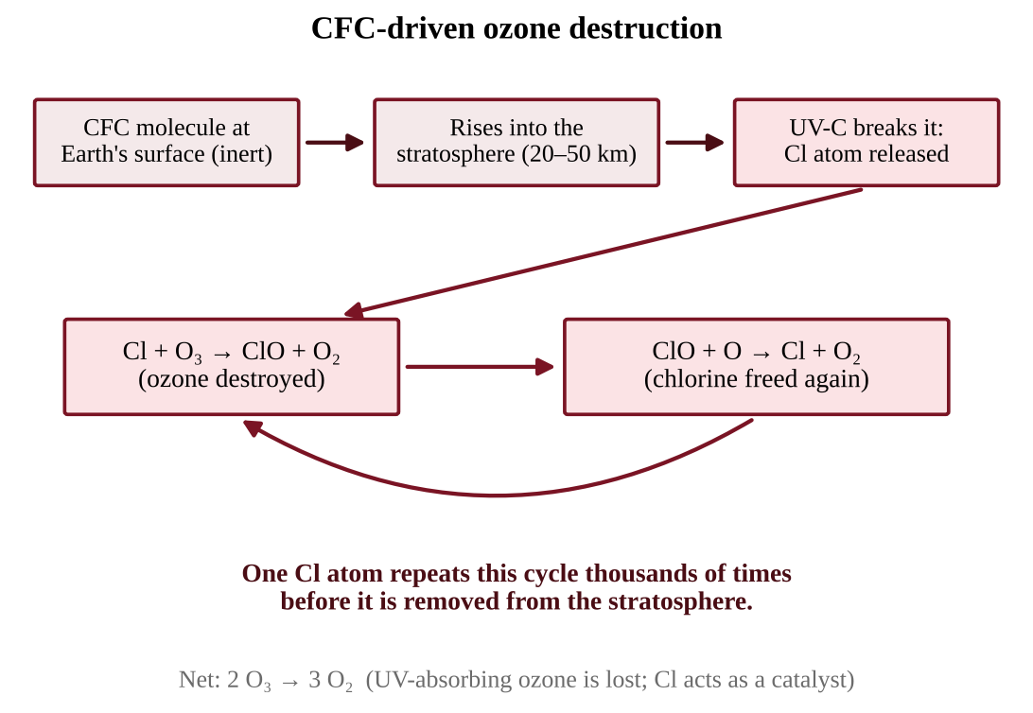
Figure 9.1 — Chlorine is a catalyst: it is released, destroys ozone, and is released again to repeat the cycle
The word to remember is catalyst. A catalyst speeds up a reaction without being used up. Because chlorine comes out of the cycle unchanged, a small amount of CFC can wreck an enormous amount of ozone. That is why a trace gas measured in parts per trillion can thin a layer that spans the globe.
Reading ozone data
Ozone is measured as a column: the total amount of O₃ in a vertical strip of air, in Dobson units (DU). A typical global value is about 300 DU, and values below about 220 DU are called an ozone hole. To read an ozone graph or table, find (1) the season of the minimum (September–October over Antarctica), (2) how deep the minimum is in different years, and (3) the direction of the trend. A strong answer links a lagged ozone record to the chlorine record: ozone cannot rise until stratospheric chlorine has fallen for years, so the ozone minimum and hole area bottom out after chlorine peaks. "Recovered" means back to the earlier (about 1980) level, so a minimum that has risen from 100 DU to 125 DU has improved but has not recovered.
Effects of more UV at the surface
When stratospheric ozone decreases, more UV radiation reaches Earth's surface. For humans this raises the risk of skin cancer and cataracts (clouding of the eye's lens), and can suppress immune function. Higher UV also harms phytoplankton and the larvae of fish and amphibians, lowers crop yields, and damages plastics and paints. In tank experiments, phytoplankton under a UV-blocking filter photosynthesize more than those under natural or boosted UV. Because phytoplankton are the base of marine food webs and a major CO₂ sink, UV damage can travel up the food web. Places close to the ozone hole, such as southern Australia and Chile, show the clearest rise in UV-related skin cancer.
KEY DEFINITIONS
Ozone layer — the region of the stratosphere with relatively high O₃ concentration that absorbs most incoming UV-B and UV-C. CFC (chlorofluorocarbon) — a stable, human-made compound containing chlorine; the main cause of anthropogenic ozone loss. Catalyst — a substance that accelerates a reaction without being consumed. Ozone hole — a seasonal, severe thinning of the ozone layer over a polar region, strongest over Antarctica in spring.

COMMON STUDENT MISTAKES
• Mixing up the two ozones: ground-level ozone is a pollutant; stratospheric ozone is protective. "Ozone is good" and "ozone is bad" are both wrong without a location.
• Saying ozone depletion causes global warming. Ozone depletion lets in more UV; it is a different problem (though CFCs are also greenhouse gases, see Topic 9.3).
• Saying UV causes skin cancer "by heat." UV damages DNA directly; it is not a temperature effect.
• Expecting global warming to change surface UV. Warming does not; only the ozone layer's thickness does.

AP EXAM STRATEGY
When asked to describe how CFCs deplete ozone, name the sequence: CFCs reach the stratosphere, UV frees chlorine, chlorine breaks down ozone, and chlorine is regenerated (catalyst). Finish by linking to the impact: more UV at the surface, skin cancer and cataracts.

CLASSROOM EXAMPLE SG-U9-E001
A city's meteorological office reports that over ten years, the average stratospheric ozone concentration above the region fell, while a separate monitor shows ground-level ozone in the same city rose. (a) Identify which of the two changes increases the UV that reaches residents and explain why. (b) State one human health effect of the increased UV exposure and one effect of the increased ground-level ozone.

QUICK CONCEPT SUMMARY
• Stratospheric ozone absorbs harmful UV and made life on land possible.
• CFCs are stable, rise to the stratosphere, and release chlorine under UV; chlorine is a catalyst.
• Natural factors (polar vortex, ice crystals melting in Antarctic spring) set the timing of the ozone hole.
• Less ozone → more UV → skin cancer, cataracts, damage to plankton and crops.

Topic 9.2 — Reducing Ozone Depletion
LEARNING OBJECTIVES
• Describe the chemicals that have been used as substitutes for CFCs.
• Explain the success and limits of the Montreal Protocol approach.

CONCEPT MADE SIMPLE
We solved a global problem by removing the cause at its source: governments agreed to stop making the chemicals. The substitutes are better for ozone, but one family of them is a powerful greenhouse gas, so solving one problem can create another.

The Montreal Protocol
In the 1970s and 1980s, scientists linked CFCs to ozone loss, and observers documented the Antarctic ozone hole. In 1987 nations signed the Montreal Protocol on Substances that Deplete the Ozone Layer, an international agreement to phase out the production and use of CFCs, halons and other ozone-depleting substances. It was later strengthened several times, and nearly every country joined. It is widely seen as the most successful international environmental treaty, for three reasons: the science was clear, affordable substitutes existed, and the treaty let developing countries phase out on a slower schedule with financial help.
Because CFCs persist for decades, recovery is slow. Chlorine levels in the stratosphere peaked in the late 1990s and have been declining since; the ozone layer is expected to return to earlier levels around the middle of this century. This lag is a useful example of how long environmental problems can take to reverse.
Substitutes for CFCs
Replacements have come in generations:
Substitute | Contains chlorine? | Ozone effect | Other concern
HCFCs (hydrochlorofluorocarbons) | Yes, but less | Much less depleting than CFCs; interim step | Greenhouse gases; also being phased out
HFCs (hydrofluorocarbons) | No | Do not deplete ozone | Many are strong greenhouse gases
Hydrocarbons, ammonia, CO₂ as coolants | No | None | Some flammable or toxic; need careful design

HFCs are the substitute the CED highlights. Because they contain no chlorine, they do not harm the ozone layer. But some HFCs trap heat many hundreds to thousands of times more strongly per molecule than CO₂ (their GWP is high), so their growing use in air conditioning worsens climate change. This is why an amendment to the Montreal Protocol (adopted in 2016) now phases down HFCs as well. The lesson for the exam: a solution to one environmental problem can create an unintended consequence elsewhere, and evaluating substitutes means checking more than one impact.
Two separate scales rate a chemical. Ozone depletion potential (ODP) compares its ozone-destroying power with a CFC reference of 1. GWP compares its heat trapping with CO₂. A substance can score 0 on one and high on the other (an HFC has ODP 0 yet GWP in the thousands), so never use one scale to answer a question about the other. To convert a release into CO₂e, multiply its mass by its GWP: 4 kg of a gas with GWP 1,500 acts like 6,000 kg of CO₂.
KEY DEFINITIONS
Montreal Protocol — the 1987 international treaty that phased out ozone-depleting substances. HFC (hydrofluorocarbon) — a CFC substitute containing no chlorine; ozone-safe but often a potent greenhouse gas. Phase-out — a scheduled, step-by-step reduction in production and use of a substance until it is eliminated.

COMMON STUDENT MISTAKES
• Writing that the Montreal Protocol "fixed" the ozone layer. It stopped new damage; recovery takes decades.
• Calling HFCs "harmless." They are ozone-safe, not climate-safe.

CLASSROOM EXAMPLE SG-U9-E002
Three coolants are being considered for a new refrigeration plant. Coolant X contains chlorine and has low heat-trapping ability. Coolant Y contains no chlorine and has a very high heat-trapping ability per molecule. Coolant Z contains no chlorine and has low heat-trapping ability but is flammable. (a) Which coolant would harm the stratospheric ozone layer most? Explain using the chlorine cycle. (b) Which coolant would contribute most to the greenhouse effect per kilogram released? (c) Make a claim for which coolant should be chosen and justify it, naming one precaution you would take.

CLASSROOM EXAMPLE SG-U9-E013
A monitoring station reports stratospheric chlorine (ppb) and the lowest yearly ozone column over a polar site (DU): 1985: 2.2 ppb, 190 DU; 1995: 3.6 ppb, 120 DU; 2005: 3.5 ppb, 110 DU; 2015: 3.0 ppb, 120 DU. A refrigerant has an ODP of 0.04 and a GWP of 900. (a) Calculate the percent decrease in chlorine from 1995 to 2015. (b) Explain why ozone in 2015 was still below its 1985 value although chlorine had been falling for 20 years. (c) Calculate the CO₂e of releasing 50 kg of the refrigerant and state whether it harms ozone more or less than a CFC (ODP 1).

QUICK CONCEPT SUMMARY
• The Montreal Protocol (1987) phased out CFCs and other ozone-depleting substances.
• Substitutes: HCFCs (interim), HFCs (no chlorine but often high GWP), and non-halogen options.
• Recovery is slow because CFCs persist; solutions can create new problems.

Topic 9.3 — The Greenhouse Effect
LEARNING OBJECTIVES
• Identify the principal greenhouse gases and explain why water vapor is not a major driver of climate change.
• Explain how the greenhouse effect sets Earth's surface temperature.
• Identify the sources and relative potency (GWP) of the greenhouse gases.

CONCEPT MADE SIMPLE
Sunlight passes through the atmosphere and warms the ground. The ground sends the energy back out as invisible infrared heat. Greenhouse gases absorb some of that heat and re-emit it in all directions, including back down, like a blanket that slows heat loss. Without the blanket Earth would be frozen; with a thicker blanket, Earth gets hotter.

The natural greenhouse effect: an energy balance
Earth receives most of its energy as shortwave radiation (visible light and some UV) from the Sun. Roughly 30% is reflected straight back to space by clouds, aerosols, ice and bright surfaces (this reflectivity is the albedo). The rest is absorbed by the atmosphere and surface, warming them. A warm surface emits longwave (infrared) radiation. To keep a steady temperature, Earth must send out as much energy as it absorbs.
Greenhouse gases are transparent to incoming sunlight but absorb outgoing infrared. After absorbing it, they re-emit infrared in every direction; about half goes outward to space and part goes back downward, warming the surface and lower atmosphere further. Nitrogen (N₂) and oxygen (O₂), which make up about 99% of air, do not absorb infrared significantly, so they are not greenhouse gases.
This natural greenhouse effect is essential: it keeps the average surface temperature near 15°C instead of about −18°C, which would freeze the oceans. The environmental problem is the enhanced greenhouse effect: human activities add greenhouse gases, strengthening the blanket and raising the equilibrium temperature.
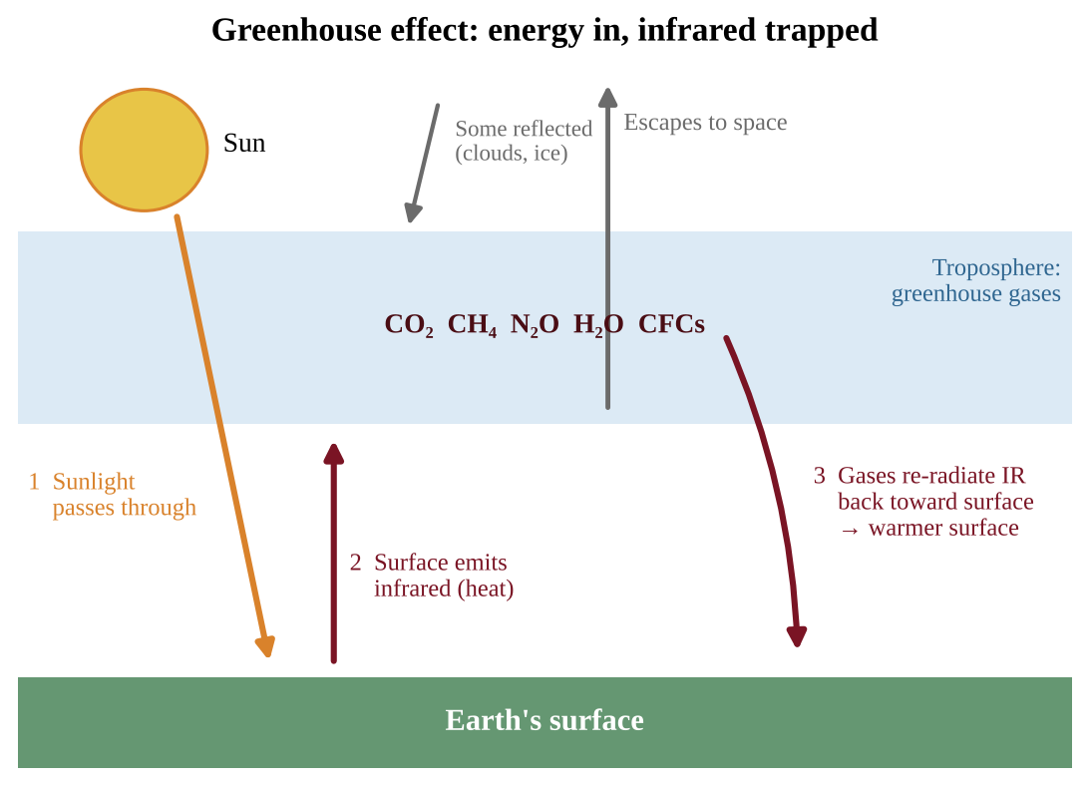
Figure 9.2 — Greenhouse effect: shortwave sunlight arrives, infrared leaves the surface, and greenhouse gases return part of it downward
PROCESS & CAUSE-AND-EFFECT
More greenhouse gas in the atmosphere → more outgoing infrared absorbed and re-emitted downward → less net heat escapes to space → energy balance shifts (Earth absorbs more than it emits) → lower atmosphere, land and oceans warm → warming continues until outgoing radiation again matches incoming energy at a higher temperature.

Following the energy in numbers
Energy budgets are often drawn with units out of 100 arriving sunlight units. Two checks always work: (1) at the surface, sunlight absorbed + infrared returned from the atmosphere = infrared emitted by the surface; (2) at the top of the atmosphere, reflected sunlight + infrared escaping to space = sunlight arriving. In the figure, 45 + 75 = 120 is both what the surface absorbs and what it emits, and 30 + 15 + 55 = 100 balances the sunlight. The surface receives more energy from the atmosphere (75) than from the Sun (45), which is the greenhouse effect in one number. More greenhouse gas raises the 75 and lowers the 15 that escapes straight through, so the budget is briefly out of balance until a warmer surface emits enough to restore it. That last step is a negative feedback: a warmer surface emits more infrared, which limits how far warming can go.
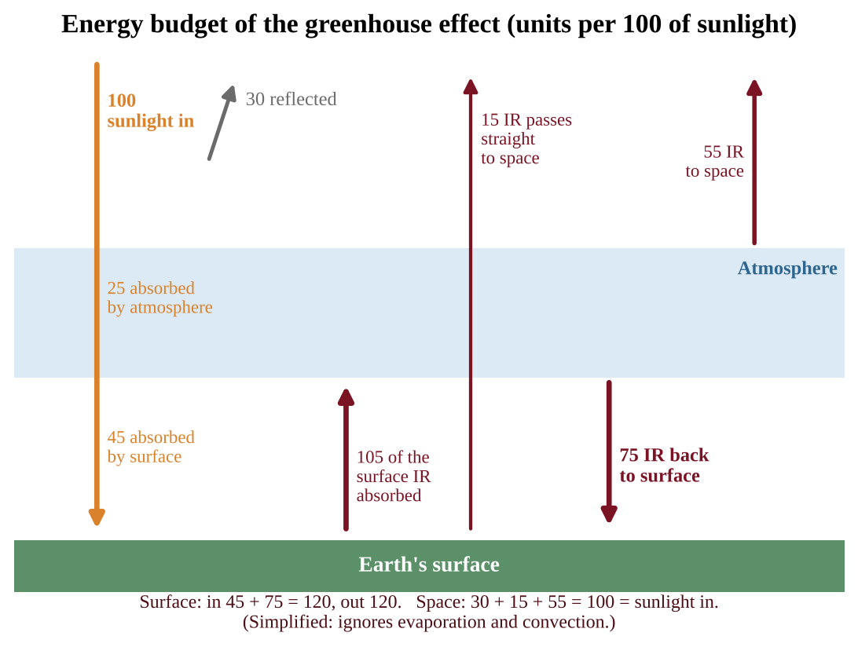
Figure 9.3 — A simplified energy budget: the surface absorbs more energy from the atmosphere than directly from the Sun
Not every particle warms. Aerosols such as sulfate droplets from volcanoes or coal smoke scatter sunlight back to space and cool the surface for a few years, the opposite push to CO₂.
The principal greenhouse gases
The CED's principal greenhouse gases are carbon dioxide (CO₂), methane (CH₄), water vapor (H₂O), nitrous oxide (N₂O) and chlorofluorocarbons (CFCs).
Water vapor is the most abundant greenhouse gas and a powerful absorber, yet it is not counted as a major cause of human-driven climate change. Its residence time in the atmosphere is short (days), so it cycles out as rain or snow. Its concentration is controlled by temperature rather than by emissions: human activity does not directly add much, and the amount of vapor rises or falls in response to warming (a feedback, see Topic 9.5).
Sources and potency of each gas
Global warming potential (GWP) compares how much heat a gas traps relative to CO₂ over a set period (usually 100 years), per unit mass. CO₂ is the reference, so its GWP = 1. A gas with GWP 28 traps about 28 times as much heat as the same mass of CO₂. Remember the CED order: CFCs have the highest GWP, followed by nitrous oxide, then methane, with CO₂ lowest.
Gas | Main sources | Approx. GWP (100 yr) | Notes
CO₂ | Burning fossil fuels, deforestation, cement production | 1 | Largest total effect because emitted in huge amounts and long-lived
CH₄ | Livestock digestion, rice paddies, landfills, natural-gas leaks, wetlands, thawing permafrost | about 25–30 | Shorter life (about a decade) but much stronger per molecule
N₂O | Synthetic fertilizer and manure, fuel combustion, industrial processes | about 265–300 | Also depletes stratospheric ozone
CFCs | Old refrigerants, foams, aerosols | thousands (up to about 10,000+) | Very potent but present in small amounts; now declining

CO₂, CH₄, N₂O and water vapor all have natural sources as well as human ones. CFCs and HFCs have no natural source, so any amount in the air is human-made. They are so potent because each molecule absorbs infrared at wavelengths CO₂ lets through, and persists for decades to centuries. Ground-level ozone, formed by sunlight acting on NOₓ and volatile organic compounds, is also a greenhouse gas. Methane forms where organic matter decays without oxygen: wetlands, rice paddies, landfills, manure lagoons and the guts of cattle and termites. Burning biomass, including forest fires, releases mainly CO₂.
Which carbon counts? Burning fossil fuel moves carbon that was locked underground for millions of years into the air, a net addition. Burning recently grown plant material (wood, or biogas from manure) returns carbon that plants took from the air a short time ago, so analysts often treat it as part of the existing cycle, though it still releases CO₂. Burning methane (CH₄ + 2O₂ → CO₂ + 2H₂O) converts a gas with GWP about 28 into CO₂ with GWP 1; 16 g of CH₄ yields 44 g of CO₂, so 1 t of CH₄ gives 2.75 t of CO₂. The warming effect still falls sharply.
Two ideas matter together. Potency (GWP) tells you how strong a gas is per kilogram. Total contribution depends on potency and how much is emitted and how long it stays. CO₂ has the lowest GWP yet is the largest driver because humans emit billions of tonnes of it a year and part of it stays for centuries.
FORMULA & MATH SKILL
CO₂-equivalent (CO₂e) = mass of gas × GWP Mass in tonnes (or kg) of the gas; GWP is a unitless multiplier; CO₂e is in the same mass unit as the input. Use CO₂e to add different gases into one total.

KEY DEFINITIONS
Greenhouse effect — warming of Earth's lower atmosphere and surface because gases absorb and re-emit outgoing infrared radiation. Global warming potential (GWP) — a gas's heat-trapping ability relative to the same mass of CO₂. Residence time — the average time a molecule stays in the atmosphere before being removed. Albedo — the fraction of incoming sunlight a surface reflects.

COMMON STUDENT MISTAKES
• "The greenhouse effect is bad." The natural effect is necessary for life; the enhanced effect is the problem.
• "Greenhouse gases trap sunlight." They mainly absorb outgoing infrared from the surface.
• Listing water vapor as the main reason for climate change because it is "the most abundant." Short residence time and control by temperature are the key points.
• Confusing the ozone hole with the greenhouse effect.
• Treating the energy budget as "energy gets trapped forever." At equilibrium energy out equals energy in; the greenhouse effect only raises the temperature at which that balance is reached.

AP EXAM STRATEGY
If a question gives amounts of several gases and asks which has the biggest climate impact, calculate CO₂e (mass × GWP) for each. Do not pick the gas with the highest GWP automatically.

CLASSROOM EXAMPLE SG-U9-E003
A dairy and crop farm reports its annual emissions: 600 tonnes of CO₂, 40 tonnes of CH₄ and 3 tonnes of N₂O. Use GWP values of 1 for CO₂, 28 for CH₄ and 265 for N₂O. (a) Calculate the farm's total emissions in tonnes of CO₂e. (b) Calculate the percentage of the total that comes from methane. (c) Identify one source of each of the three gases on a farm.

CLASSROOM EXAMPLE SG-U9-E014
In a simplified budget, 100 units of sunlight arrive. Clouds and ice reflect 28; the atmosphere absorbs 22 and the surface absorbs 50. The surface emits 130 units of infrared, of which 10 pass directly to space. (a) Calculate how many units of infrared the atmosphere returns to the surface. (b) Calculate how many units the atmosphere emits to space. (c) Extra greenhouse gas now absorbs 4 of the 10 units that used to pass directly to space. Predict the immediate effect on the total energy leaving Earth compared with the 100 units arriving, the long-term effect on surface temperature, and the feedback that finally restores balance.

QUICK CONCEPT SUMMARY
• Greenhouse gases absorb outgoing infrared and re-emit it; the natural effect keeps Earth habitable.
• Principal gases: CO₂, CH₄, H₂O, N₂O, CFCs. Water vapor is not a major driver (short residence time).
• GWP is relative to CO₂ = 1; CFCs > N₂O > CH₄ > CO₂.

Topic 9.4 — Increases in the Greenhouse Gases
LEARNING OBJECTIVES
• Explain how concentrations of greenhouse gases have changed and why.
• Identify threats to human health and the environment from increasing greenhouse gases: sea-level rise, disease vector spread, and population movements.
• Interpret visual representations (graphs, ice-core records) of greenhouse gas trends.

CONCEPT MADE SIMPLE
For hundreds of thousands of years CO₂ rose and fell inside a fairly narrow range. Since the Industrial Revolution it has shot far above that range, and the cause is us. More gas means a thicker blanket, and a thicker blanket means a warmer planet with consequences for coasts, health and people.

Reading the record: ice cores and the Keeling curve
Two data sets are essential in AP Environmental Science.
Ice cores. In Antarctica and Greenland, snow piles up year after year and is compressed into ice that traps tiny bubbles of ancient air. Scientists drill long cylinders of ice and measure the gases in those bubbles. Deeper ice is older, so the cores give a record going back about 800,000 years. The ratios of oxygen isotopes in the ice also provide an estimate of past temperatures. Over that time, atmospheric CO₂ cycled between roughly 180 parts per million (ppm) in cold glacial periods and about 280 ppm in warm interglacial periods, and temperature and CO₂ rose and fell together. These natural swings were triggered by slow changes in Earth's orbit and tilt, and amplified by feedbacks.
The Keeling curve. Beginning in 1958, direct measurements of CO₂ at an observatory on Mauna Loa, Hawaii, far from city pollution, recorded a steady, accelerating rise from about 315 ppm to well over 420 ppm today. The line has a small up-and-down sawtooth pattern each year: in the Northern Hemisphere growing season plants take up CO₂ and the concentration dips; in the winter, plants and soil release it and the concentration climbs. Underneath the seasonal wiggle, each year is higher than the last. That long-term climb matches the amount of fossil fuel burned and land cleared.
Putting the two together: today's CO₂ is about 50% higher than the pre-industrial level of about 280 ppm, and higher than anything in the ice-core record. Methane and nitrous oxide have also risen well above their pre-industrial concentrations.
Reading an ice-core graph. (1) Match the peaks and troughs of CO₂ and temperature: they rise and fall together. (2) Quote values, such as the 180–300 ppm range of the past, and compare them with the dashed line for today, which lies far above it. (3) Use careful verbs: CO₂ and temperature "coincided" or are "closely linked." Do not claim that CO₂ alone caused every change, or that CO₂ always rose first; the natural cycles were started by orbital changes, with CO₂ and other feedbacks amplifying them. (4) If asked to scale a temperature change per ppm, state the assumption that CO₂ is the only driver and that the relationship is constant, and note that other gases, aerosols and feedbacks break it.
Why concentrations are rising
• CO₂: fossil fuel combustion for electricity, transport and industry; deforestation and forest fires (remove carbon-absorbing trees and release stored carbon when burned or decayed); cement production. Rail and efficient vehicles cut CO₂ because they burn less fuel per passenger or tonne moved.
• CH₄: expanded livestock herds, rice cultivation, landfills, leaks from gas production, and thawing permafrost.
• N₂O: fertilizer use and manure.
• Fluorinated gases: refrigeration and industrial uses.
Threats to human health and the environment
CED-required consequences of excess greenhouse gases include:
• Rising sea level from melting ice sheets and from the thermal expansion of ocean water (Topic 9.5).
• Disease vectors spreading from the tropics toward the poles. Mosquitoes and ticks that carry malaria, dengue and Lyme disease are limited by cold. As winters shorten and temperatures rise, their ranges expand into new latitudes and higher elevations, exposing people who have no immunity or prepared public-health systems. The same happens up mountains: mosquitoes moving to higher, once-cold elevations bring malaria to forest birds that had a disease-free refuge and West Nile virus to higher towns.
• Changes in population dynamics and movements. Drought, flooded coasts, failed crops and heat can reduce a region's carrying capacity for people and other species, pushing human migration (climate refugees) and changing birth, death and migration patterns in both the places people leave and those they move to.
COMMON STUDENT MISTAKES
• Interpreting the seasonal wiggle in a CO₂ graph as evidence the trend is up and down overall. The annual average is the trend.
• Saying CO₂ is the only greenhouse gas that has increased.

CLASSROOM EXAMPLE SG-U9-E004
Atmospheric CO₂ was about 280 ppm before the Industrial Revolution and 420 ppm in a recent year. (a) Calculate the percent increase. (b) An ice-core record shows that CO₂ over the last 800,000 years never exceeded 300 ppm. Explain in one or two sentences what this comparison suggests about the present concentration. (c) A graph of CO₂ measured monthly at one observatory shows a yearly zigzag. Explain what causes the zigzag and why it does not contradict the long-term increase.

QUICK CONCEPT SUMMARY
• Ice cores give an 800,000-year record; CO₂ ranged about 180–280 ppm and tracked temperature.
• The Keeling curve shows a continuous rise since 1958 with a seasonal sawtooth.
• Human sources: fossil fuels, deforestation, agriculture, refrigerants.
• Threats: sea-level rise, vector-borne disease spread, migration and shifting population dynamics.

Topic 9.5 — Global Climate Change
LEARNING OBJECTIVES
• Explain how climate change, over short and long terms, affects ecosystems.
• Describe effects: temperature, permafrost and sea ice, sea level, soil, circulation and ocean currents.
• Explain positive feedback loops in polar regions and the loss of ice-dependent habitat.
• Distinguish mitigation from adaptation.

CONCEPT MADE SIMPLE
Climate has always changed, but now it is changing faster, and the polar regions change fastest because melting ice triggers a runaway loop: ice reflects sunlight, so when it melts the dark surface beneath absorbs more heat, which melts more ice.

Climate change through geologic time
Earth's climate has shifted between ice ages and warm periods many times, recorded in ice cores, ocean sediments and tree rings. Natural drivers include changes in Earth's orbit and tilt, solar output, volcanic eruptions and shifts in greenhouse gas levels. What is different now is the speed and the cause: average global temperature has risen by about 1.1–1.2°C since the late 1800s, far faster than natural transitions, and the pattern matches the rise in human-emitted greenhouse gases.
Weather is the condition of the atmosphere at a place and time; climate is the long-term average (30 years or more). A single cold winter does not disprove warming, just as one hot day does not prove it.
Feedback loops
A positive feedback loop amplifies a change (the output pushes the system further in the same direction). A negative feedback loop counteracts a change and tends to stabilize the system. Positive feedbacks speed up climate change; negative ones slow it.
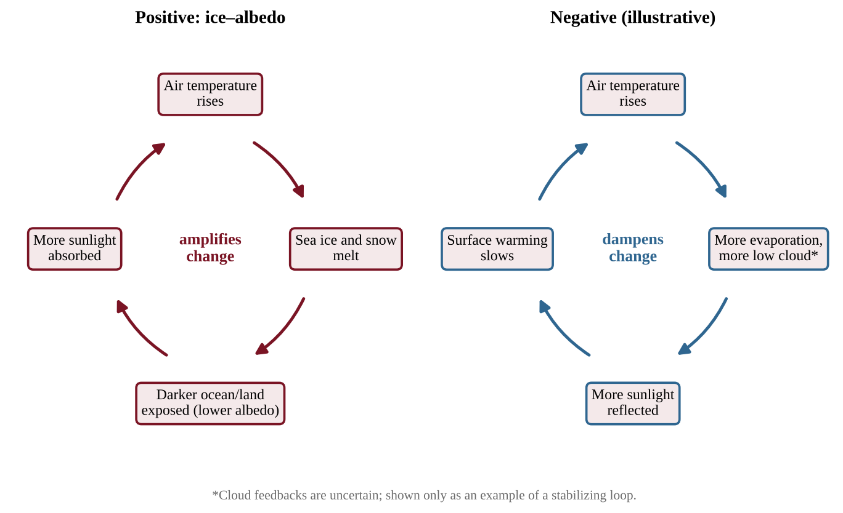
Figure 9.4 — A positive feedback loop amplifies warming; a negative loop dampens it
Key positive feedbacks:
• Ice–albedo. Snow and ice are bright and reflect much sunlight. Warming melts them, exposing darker water and land that absorb more sunlight, which causes more warming and more melting. Because polar regions are covered in ice and snow, they show a faster response time to global climate change than most places, and the Arctic warms roughly two to four times faster than the global average.
• Permafrost thaw. Frozen tundra soil stores vast quantities of dead plant matter. When it thaws, microbes decompose it and release CO₂ and methane, adding greenhouse gas, which warms the Arctic further, thawing more permafrost. The active layer is the surface soil that thaws each summer above the permafrost; as it deepens, more buried carbon becomes available to microbes. Thawing also makes the ground unstable, so buildings, roads and pipelines tilt or collapse. Adaptation options include foundations on piles driven into stable ground, insulated pads, or relocating buildings.
• Vegetation albedo. Taller, darker shrubs spreading across tundra poke above the snow and absorb more sunlight than snow-covered ground, adding to the warming.
• Water vapor. Warmer air holds more water vapor, a greenhouse gas, which adds warming.
• Declining ocean uptake. Warmer water dissolves less CO₂, leaving more in the air.
Negative feedbacks exist too: more CO₂ can boost plant growth in some places, and a warmer planet radiates more infrared to space. Scientists study these to decide how strongly Earth will respond.
Effects on the physical environment
• Rising temperatures and more frequent extreme heat.
• Melting permafrost and sea ice, as above.
• Rising sea level, from two sources: (1) thermal expansion, because water expands as it warms, and (2) melting land ice (mountain glaciers and the Greenland and Antarctic ice sheets), which adds new water to the ocean. Melting of floating sea ice does not raise sea level noticeably (like an ice cube in a full glass), but it contributes to the albedo feedback.
• Displacement of coastal populations as flooding, storm surge and saltwater intrusion into groundwater make low-lying areas uninhabitable. Island nations and river deltas are exposed first. Estuaries and marshes suffer too: salt water moves farther upstream and kills species with narrow salt tolerance, and drowned marsh and mangrove nurseries disappear. Where seawalls or development sit just inland, wetlands cannot migrate and are squeezed out. Policy choices include zoning and building codes that discourage coastal building, limiting subsidized flood insurance, restoring wetlands as buffers, and planned retreat. For numbers, convert rate × time to the same unit before using a flooding table (see the toolkit).
• Atmospheric circulation. Winds carry heat around the planet. Warm air rises at the equator and flows poleward in giant overturning loops called Hadley cells; the jet stream is a fast river of air near the tropopause that steers storms. A warming climate shifts the temperature contrast driving these systems, so cells can widen and the jet stream can become wavier, changing rainfall belts, drought and storm tracks.
• Ocean currents. Currents, sometimes called the ocean conveyor belt, carry heat across the globe. Cold, salty water sinks in the North Atlantic and drives circulation. Melting ice adds fresh water, which is less dense and sinks less readily, so the conveyor may slow. A change could shift climates, especially in coastal regions such as northwestern Europe, which relies on warm Atlantic water.
• Soils. Higher temperatures increase evaporation and microbial decomposition; changing rainfall can mean drought (which leaves soil bare and dry) or intense storms (which increase erosion). Soil viability for crops can decline and erosion can increase.
Effects on ecosystems
• Species ranges shift toward the poles and uphill; those unable to move or adapt decline, such as mountaintop species with no higher ground and cold-water fish whose streams warm. Timing mismatches arise when, for example, insects emerge earlier than the birds that feed on them.
• Ice-dependent species such as polar bears and seals lose hunting and breeding platforms as sea ice shrinks; algae under the ice, the base of the food web, are lost too.
• Marine ecosystems and sea level. Rising seas create new shallow habitat over now-flooded continental shelves, a positive effect for some species. But communities that depend on light, like seagrass beds and corals, can find themselves deeper than the photic zone (the sunlit surface layer where photosynthesis is possible) and decline. Coastal wetlands and mangroves can be squeezed between rising water and human development.
Responses: mitigation and adaptation
Mitigation reduces the cause: cut greenhouse gas emissions (renewable energy, efficiency, public transit, reducing methane leaks) or remove carbon (reforestation, soil carbon storage). Adaptation reduces the damage from changes already happening: sea walls, drought-tolerant crops, early-warning systems, managed retreat from flood-prone land, wildlife corridors. A strong answer says we need both, because mitigation limits how bad things get while adaptation helps societies cope with what cannot be avoided.
KEY DEFINITIONS
Positive feedback loop — a process in which a change produces effects that amplify the original change. Negative feedback loop — a process in which a change produces effects that reduce the original change. Permafrost — ground frozen for two or more years, holding large stores of carbon. Mitigation — action to reduce the causes (emissions) of climate change. Adaptation — action to adjust to the effects of climate change.

PROCESS & CAUSE-AND-EFFECT
Warming → sea ice and snow melt → albedo falls (less sunlight reflected) → more sunlight absorbed by dark ocean and land → more warming → more melt. Warming → permafrost thaws → decomposition releases CO₂ and CH₄ → greenhouse effect strengthens → more warming → more thaw.

COMMON STUDENT MISTAKES
• Calling every feedback "good" or "bad" — positive and negative are about direction (amplify or dampen), not about whether the result is desirable.
• Claiming melting sea ice raises sea level the way melting land ice does.
• Writing "global warming" and "ozone depletion" as the same thing.
• Forgetting thermal expansion when explaining sea-level rise.

AP EXAM STRATEGY
In a feedback FRQ, write the chain one link at a time, then state the label ("positive feedback, because the change is amplified"). Always give the specific mechanism (albedo, methane release) rather than "ice melts and it gets hotter."

CLASSROOM EXAMPLE SG-U9-E005
The table shows global mean sea level rise measured by satellites for a small island nation's region.
Year | Sea level above 2000 baseline (mm)
2000 | 0
2010 | 32
2020 | 66

(a) Calculate the average rate of rise per year for 2000–2010 and for 2010–2020. (b) State whether the rate is speeding up or slowing and by how many mm/yr. (c) Identify the two main physical processes that raise sea level in a warming world.

CLASSROOM EXAMPLE SG-U9-E006
In a high-latitude lake region, a scientist records that each year the ice-free period lengthens, exposing dark water. (a) Describe how this is a positive feedback loop, including the role of albedo. (b) Explain why a loop in which warmer air increases evaporation, forming bright low clouds that reflect more sunlight, would be a negative feedback loop. (c) Identify one effect on an ice-dependent species.

QUICK CONCEPT SUMMARY
• Climate has changed naturally; present change is faster and linked to human greenhouse gases.
• Positive feedback (ice–albedo, permafrost methane) amplifies warming, especially at the poles.
• Sea level rises from thermal expansion plus melting land ice.
• Impacts: ocean currents, Hadley cells and jet stream, soil and coasts, ice-dependent species.
• Mitigation cuts causes; adaptation reduces damage.

Topic 9.6 — Ocean Warming
LEARNING OBJECTIVES
• Explain the causes of ocean warming.
• Describe effects on marine species and ecosystems, including coral bleaching.

CONCEPT MADE SIMPLE
The oceans are Earth's heat sponge. They soak up most of the extra heat trapped by greenhouse gases. Warmer water stresses animals that are adapted to narrow temperature ranges, and in coral reefs the stress makes corals expel the algae that feed them.

Cause: the oceans absorb the excess heat
Ocean warming is caused by the increase in greenhouse gases in the atmosphere. Water has a very high heat capacity, so the oceans absorb the large majority (more than 90%) of the extra heat trapped by the enhanced greenhouse effect. Surface waters warm first; the heat is mixed to deeper layers slowly. Because the oceans are so large and change temperature slowly, they also keep warming long after emissions are reduced, which is why ocean changes lag behind the atmosphere.
Effects on marine species and ecosystems
• Loss of habitat. Species with narrow temperature tolerances lose suitable range. Cold-water fish, kelp forests and sea-ice communities shrink; many species move toward cooler waters near the poles, changing fisheries and food webs.
• Metabolic changes. Many marine animals are ectotherms, so their body temperatures follow the water. Warming speeds their metabolism and raises their oxygen needs, while warmer water holds less dissolved oxygen. The combination can stress fish and invertebrates, reduce growth, and cause lower oxygen zones.
• Reproductive changes. Spawning, hatching and larval survival are timed to temperature. In some species the sex ratio is set by temperature (as in sea turtles, where warm nests produce more females). Mismatches between larvae and their plankton food can reduce recruitment.
• Stratification. Warm surface water is less dense and mixes less with colder deep water, limiting the upwelling of nutrients that fuels productive fisheries.
Coral bleaching
Reef-building corals are animals that host microscopic algae (zooxanthellae) in their tissues. The algae photosynthesize and give the coral most of its food and color; the coral provides shelter and nutrients (a mutualism). When water temperatures stay a degree or two above the normal summer maximum for several weeks, the algae produce harmful compounds and the coral expels them. Without the algae the transparent coral tissue shows the white skeleton: this is coral bleaching. Bleached corals are not dead, but they are starving. If temperatures fall soon enough, algae can re-colonize and some corals recover; if the stress lasts too long, the corals die, and the reef loses the habitat that supports a quarter of marine species, the fisheries and the coastal protection reefs provide. Bleaching is made worse by ocean acidification, pollution, and sediment runoff (Topic 9.7).
KEY DEFINITIONS
Ectotherm — an organism whose body temperature depends on the surrounding environment. Coral bleaching — the loss of symbiotic algae from coral tissue under stress, leaving the coral white. Mutualism — an interaction that benefits both species.

COMMON STUDENT MISTAKES
• Saying bleached coral is always dead.
• Saying coral bleaching is caused by ocean acidification. Bleaching is caused mainly by heat stress, though acidification harms coral in a different way.
• Forgetting the oxygen effect: warm water holds less dissolved oxygen.

CLASSROOM EXAMPLE SG-U9-E007
A coral reef's summer maximum sea temperature is normally 29.0°C. During one summer the water stays at 30.8°C for six weeks, and many corals turn white. Three months later, survey teams find that corals in a shaded, deeper part of the reef have regained their color while corals on the shallow, sunny flat are covered in algae growth and have no living tissue. (a) Calculate by how many degrees the water exceeded the normal maximum. (b) Explain what the corals lost to turn white and why this harms them. (c) State which part of the reef shows recovery and which shows mortality, and cite the evidence from the survey.

QUICK CONCEPT SUMMARY
• Ocean warming is caused by greenhouse gases; oceans absorb most of the excess heat.
• Effects: habitat loss and range shifts, faster metabolism, less dissolved oxygen, reproductive changes.
• Coral bleaching: loss of algae under heat stress; some recover, some die.

Topic 9.7 — Ocean Acidification
LEARNING OBJECTIVES
• Explain the causes and effects of ocean acidification, using chemical equations.
• Identify human activities that raise atmospheric CO₂ and therefore acidify oceans.
• Explain how acidification harms corals and other shell-building organisms.

CONCEPT MADE SIMPLE
The ocean absorbs a big share of the CO₂ we emit. In the water, CO₂ forms a weak acid that releases hydrogen ions, so the pH drops. The extra hydrogen ions also use up the carbonate ions that corals and shellfish need to build their hard parts.

The chemistry
Ocean acidification is the decrease in pH of the oceans, primarily due to increased CO₂ in the atmosphere. The oceans absorb roughly a quarter to a third of the CO₂ humans emit. When CO₂ dissolves in seawater it reacts with water:
CO₂ + H₂O ⇌ H₂CO₃ (carbonic acid) H₂CO₃ ⇌ H⁺ + HCO₃⁻ (bicarbonate)
The released hydrogen ions (H⁺) lower the pH. Some of the H⁺ is then consumed by carbonate ions (CO₃²⁻):
H⁺ + CO₃²⁻ ⇌ HCO₃⁻
The net effect is that more CO₂ means more H⁺ and less carbonate. Shell- and skeleton-building animals make calcium carbonate from calcium and carbonate ions:
Ca²⁺ + CO₃²⁻ → CaCO₃
With less carbonate available, building shells costs more energy, and in sufficiently acidic water calcium carbonate can start to dissolve.
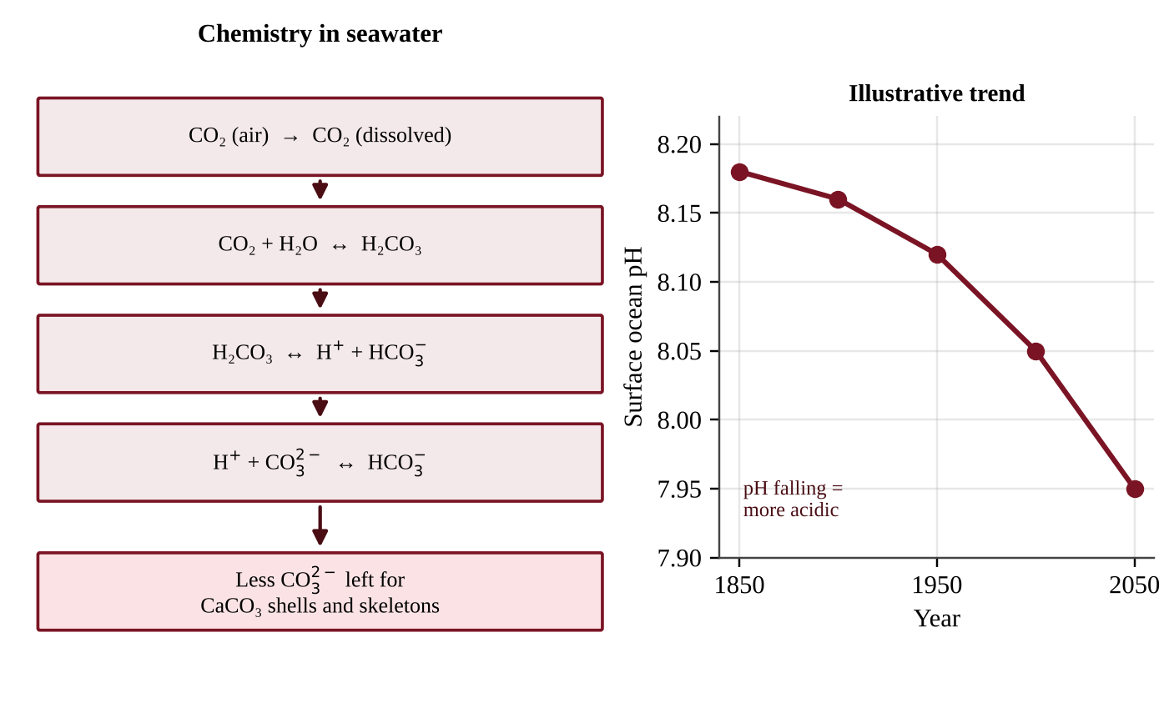
Figure 9.5 — CO₂ dissolves and releases H⁺, lowering pH and removing carbonate; the pH values shown are illustrative
Understanding pH numbers
The pH scale is logarithmic: a change of 1 pH unit is a 10-fold change in H⁺ concentration. Average surface ocean pH has dropped from about 8.2 to about 8.1 since the Industrial Revolution. That 0.1 decrease means H⁺ concentration has risen by a factor of 10^0.1 ≈ 1.26, or about 26%. The ocean is still slightly basic (pH above 7), so "acidification" means it is becoming less basic, moving toward the acid side of the scale. For other drops use the formula below on a calculator, then subtract 1 and multiply by 100 to get a percent:
pH drop | Factor 10^drop | Increase in H⁺
0.05 | 1.12 | 12%
0.10 | 1.26 | 26%
0.20 | 1.58 | 58%
0.30 | 2.00 | 100%
1.00 | 10 | 900%

A pH graph and a CO₂ graph for the same years mirror each other: as atmospheric CO₂ climbs, ocean pH falls (an inverse relationship).
Local pH can swing far more than the global average. In coastal upwelling, winds push surface water offshore and draw up cold deep water, which holds extra CO₂ from the decay of sinking organic matter and so has a lower pH. On top of an ocean already acidified by the atmosphere, upwelled water can fall low enough to kill oyster larvae that are building their first shells. A hatchery can respond by drawing intake water only when its pH is high, or by adding a base to raise pH; the first limits production time, the second adds cost and chemical handling.
Causes and effects
Human activities that raise atmospheric CO₂, and therefore acidify the ocean, include burning fossil fuels, vehicle emissions and deforestation. Note that the cause is the same as for global warming, which is why acidification is sometimes called the other CO₂ problem.
Effects:
• Damage to corals and shellfish. Corals, oysters, clams, sea urchins and tiny planktonic snails called pteropods have calcium carbonate shells or skeletons. Acidification makes it harder to build and maintain them, so growth slows, larvae are weak, and structures dissolve.
• Food web consequences. Pteropods and other calcifying plankton are food for fish such as salmon; shellfish fisheries lose income. Reefs lose structure that shelters fish and shields shorelines.
• Synergy with warming. Coral exposed to both heat stress and acidification fares worse than from either alone.
KEY DEFINITIONS
Ocean acidification — the decline in ocean pH caused mainly by absorption of atmospheric CO₂. Carbonic acid (H₂CO₃) — a weak acid formed when CO₂ dissolves in water. Calcification — the process by which organisms build calcium carbonate shells or skeletons.

FORMULA & MATH SKILL
Change in H⁺ concentration = 10^(pH₁ − pH₂) (as a ratio: new [H⁺] ÷ old [H⁺]) pH₁ is the higher (earlier) value; pH₂ is the lower (later) value. Each 1.0 pH decrease means 10 times more H⁺; each 0.3 decrease means about 2 times more.

COMMON STUDENT MISTAKES
• Saying the ocean is "now acidic." It is still basic, only less so.
• Thinking a drop from 8.2 to 8.1 is "small" (it is a 26% increase in H⁺).
• Mixing up bleaching (heat) and acidification (carbonate loss).
• Forgetting that the ocean's absorption of CO₂ is what causes the pH change.

AP EXAM STRATEGY
If asked to "explain how burning fossil fuels harms coral reefs," write the chain: CO₂ rises → more dissolves in ocean → H₂CO₃ forms → H⁺ rises and pH falls → carbonate decreases → calcium carbonate skeletons harder to build. Add a second effect (warming) for extra points where allowed.

CLASSROOM EXAMPLE SG-U9-E008
Average surface-ocean pH in a monitored bay was 8.20 in 1990 and 8.10 in 2020. (a) By what factor did the hydrogen ion concentration change between those years? Express it as a percent increase. (b) Write the chemical equation showing how dissolved CO₂ combines with water to form carbonic acid. (c) Explain why this change makes it harder for oysters in the bay to build shells.

QUICK CONCEPT SUMMARY
• CO₂ + H₂O ⇌ H₂CO₃ ⇌ H⁺ + HCO₃⁻; more H⁺ lowers pH and removes carbonate.
• Causes: fossil fuels, vehicles, deforestation (all raise atmospheric CO₂).
• Corals and shellfish struggle to build calcium carbonate structures.
• pH is logarithmic: 0.1 pH unit ≈ 26% more H⁺.

Topic 9.8 — Invasive Species
LEARNING OBJECTIVES
• Explain what invasive species are and why they are a problem.
• Relate invasiveness to species traits (generalist, r-selected).
• Describe strategies to control invasive species.

CONCEPT MADE SIMPLE
An invasive species is an organism that moves into a place where it did not evolve and spreads in a way that harms the native community. The newcomer is often a tough, fast-breeding generalist that has escaped the predators and diseases that kept it in check at home.

What makes a species invasive
A native species evolved in an ecosystem. A non-native (introduced) species arrives from elsewhere. Many non-natives do no harm (most crops and garden plants stay where they are put). An invasive species is one that can live, and sometimes thrive, outside its normal habitat and spreads so that it threatens native species. Invasive species can occasionally be beneficial (for instance, providing food or erosion control), but they are classified as invasive when they threaten natives.
Ways they arrive: ballast water of cargo ships, shipping crates and packing wood, the pet and aquarium trade, deliberate introduction for farming, sport or ornamental use, and accidental transport on boats, vehicles or clothes. Global trade and travel increase these pathways. Boat hulls, trailers, bilge and bait water carry aquatic invaders from lake to lake, canals open new routes, and roads and trails carry seeds on tires, shoes and animals into disturbed ground beside them, which is why invasive plants are often densest near trails and roads.
Traits of successful invaders
Invasive species are often generalist, r-selected species, so they may outcompete native species for resources:
• Generalists tolerate a wide range of conditions and eat many kinds of food, so they can survive in many habitats.
• r-selected traits: rapid growth, early maturity, many offspring, short lifespan, effective dispersal, so population numbers can explode.
• Few natural enemies in the new range (predators, parasites and diseases that control them at home are absent), often called "enemy release."
• Aggressive behavior or traits like allelopathy (chemicals that suppress other plants).
Natives, especially specialists on islands, often lack defenses against these new predators or competitors.
Invaders also change the physical environment, which makes life harder for natives. Invasive earthworms eat the leaf litter that shades and feeds forest soil, leaving it drier, more eroded and less fertile; a deep-rooted shrub can draw down soil moisture until native grasses fail; filter-feeding zebra mussels clear the water, so more light reaches the bottom and plant growth changes; and nitrogen fallout from air pollution can favor fast-growing invasive grasses over slow native wildflowers.
Reading invasion data
Compare the shape of a graph of area or numbers over time. Linear growth adds the same amount each year. Exponential (accelerating) growth adds more each year; the curve bends upward and the population doubles every fixed time, so after n doublings the size is N₀ × 2ⁿ. For example, 25 ha that doubles every 5 years covers 25 × 2³ = 200 ha after 15 years. Logistic growth bends upward and then levels off near the carrying capacity. The management lesson is the same each time: while the invader is on the upward bend, control is cheap and effective, and each year of delay costs more.
Examples and effects
• Zebra mussels (Great Lakes, from ballast water) clog water intakes and filter out the plankton that native species need.
• Kudzu vine smothers trees in the southeastern United States.
• Burmese pythons in the Everglades prey on native mammals and birds.
• Cane toads in Australia poison native predators that eat them.
• Lionfish in the Atlantic and Caribbean eat reef fish that have no defenses.
• Emerald ash borer kills millions of ash trees.
Consequences include loss of native biodiversity and extinctions, altered food webs and nutrient cycles, economic costs (damage to crops, infrastructure and fisheries), disruption of ecosystem services, and sometimes spread of disease.
Controlling invasive species
Control is easiest early. Strategies, each with trade-offs:
Strategy | Example | Advantage | Disadvantage
Prevention | Inspecting cargo, cleaning boats, ballast-water rules, bans on selling certain plants | Cheapest, most effective | Requires monitoring and cooperation
Physical removal | Hand-pulling plants, trapping, hunting | Targeted, no chemicals | Labor-intensive; hard for large populations
Chemical control | Herbicides, pesticides | Fast, covers large areas | Can harm non-target species; resistance
Biological control | Releasing a natural predator or pathogen from the species' home range (ideally one that attacks only the pest, such as a virus infecting only rabbits) | Self-sustaining | The control species may attack natives or itself become invasive
Habitat management | Prescribed burns, restoring native vegetation | Strengthens natives | Needs ongoing effort
Legislation and education | Laws on transport and release of species; public awareness campaigns | Broad impact | Enforcement challenges

KEY DEFINITIONS
Invasive species — a non-native species that spreads and threatens native species or ecosystems. Generalist — a species that tolerates a wide range of conditions and uses many resources. r-selected species — a species with high reproductive rate and little parental care (see Unit 3). Biological control — using a living organism to suppress a pest species.

COMMON STUDENT MISTAKES
• Equating "non-native" with "invasive." Only those that spread and cause harm are invasive.
• Saying invasive species are always predators. Many are plants, insects or pathogens.
• Recommending biological control without noting its risk.

CLASSROOM EXAMPLE SG-U9-E009
A shrub introduced as a garden ornamental has spread into a wetland. A 2-hectare study plot was surveyed twice.
Year | Native sedge cover (% of plot) | Introduced shrub cover (% of plot)
2018 | 80 | 5
2024 | 44 | 38

(a) Calculate the percent change in native sedge cover from 2018 to 2024. (b) Identify two traits of the shrub that could explain its spread. (c) Propose one control method and state one disadvantage of it.

QUICK CONCEPT SUMMARY
• Invasive species thrive outside their native range and threaten natives.
• Typical invaders: generalist, r-selected, few natural enemies.
• Control: prevention first; removal, chemicals, biological control, habitat management, laws; each has trade-offs.

Topic 9.9 — Endangered Species
LEARNING OBJECTIVES
• Explain how species become endangered or extinct.
• Explain why species differ in their vulnerability and the role of selective pressures and competition.
• Describe and evaluate strategies to protect species.

CONCEPT MADE SIMPLE
A species is in danger when its numbers are low and falling and it can't easily adapt or move. Specialists with small ranges, slow reproduction and heavy hunting pressure are most at risk. Protecting species means protecting habitat, stopping illegal killing, and backing both with law.

Categories of risk
Conservation organizations classify species by how close they are to extinction. The International Union for Conservation of Nature (IUCN) Red List uses categories running from Least Concern, through Near Threatened, Vulnerable, Endangered, Critically Endangered, to Extinct in the Wild and Extinct. In the United States the Endangered Species Act (1973) protects species listed as endangered (in danger of extinction throughout all or a large part of their range) or threatened (likely to become endangered). The international treaty CITES regulates trade in wild plants and animals.
How species become endangered
A variety of factors can lead to a species being threatened with extinction:
• Being extensively hunted or collected (overharvest, poaching for ivory, horn, fur, pets).
• Having a limited diet (a specialist that depends on one food, like pandas and bamboo or koalas and eucalyptus; if the food goes, the species goes).
• Being outcompeted by invasive species.
• Having specific and limited habitat requirements (a narrow range, an island or a single mountain top).
• Other risk factors are K-selected traits (large body, slow maturity, few offspring, so populations recover slowly), small population size (inbreeding and loss of genetic diversity), and being a top predator.
Not every species is at equal risk. Not all species are in danger of extinction when exposed to the same changes. Generalists and those able to adapt (through variation in behavior or genes) or to move to a new environment (disperse) are less likely to go extinct. A species that can't do either, like an island specialist, is more vulnerable.
Small populations are fragile for three reasons: chance events such as a storm or disease can remove a large share of them; a bottleneck leaves little genetic diversity, so inbreeding and weak response to new stresses follow (Unit 2); and mates are hard to find. This is why small island populations, and species such as cheetahs that passed through a bottleneck, are prone to extinction.
Selective pressures and competition
Selective pressures are any factors that change the behaviors and fitness of organisms in an environment: predation, disease, climate change, food shortage, a new competitor, hunting. Individuals with traits that help them survive and reproduce under the pressure leave more offspring, so over generations the population evolves. But evolution requires time and genetic variation. When change is faster than adaptation, the population shrinks.
Species in an ecosystem compete for resources such as territory, food, mates and habitat. If a human-caused change intensifies competition (an invader eats the same prey, land is cleared so fewer territories exist), the weaker competitor may become endangered or extinct.
Protecting species
• Criminalizing poaching and trade in endangered species, with enforcement and penalties.
• Protecting animal habitats through national parks, reserves and conservation easements, since habitat loss is the leading cause.
• Legislation such as the Endangered Species Act and CITES, which restrict harm, require recovery plans and limit trade.
Match the strategy to the threat. Given a table or graph of threats, find the largest category and choose the action that targets it. If habitat loss affects the most species, paying landowners to keep land undeveloped (conservation easements) or creating reserves protects more species than any other single step. Extinction-by-century graphs show higher bird and mammal losses in the 1900s, matching faster land clearing, hunting and introduced species. To compare centuries, subtract the bar values (a difference) or compute a percent change. For a population whose births add 5% a year and whose deaths (including poaching) remove 9%, the net change is −4% a year; the Rule of 70 (Unit 3) gives about 70 ÷ 4 ≈ 18 years to halve.
Each has trade-offs: protected areas can limit land use for local communities; captive breeding is costly and may produce animals that cannot survive in the wild; laws are effective only if enforced.
KEY DEFINITIONS
Endangered species — a species at risk of extinction across all or a large part of its range. Extinction — the permanent loss of a species. Specialist — a species with a narrow niche (limited diet or habitat). Selective pressure — a factor in the environment that affects survival and reproduction. Endemic species — a species found naturally in only one region.

REAL-WORLD EXAMPLE
A small island lizard lives only on one 12 km² island, eats a single kind of berry, and lays two eggs a year. Rats, introduced by ships, now eat the eggs, and a hurricane has destroyed part of the berry forest. Every risk factor is stacked: small range, specialist diet, low reproduction, new predator, and habitat loss. A recovery plan removes the rats, fences the remaining forest, replants berries, and sets up a captive-breeding colony as insurance.

COMMON STUDENT MISTAKES
• Claiming that all species will go extinct under the same environmental change. Vulnerability varies with traits.
• Saying habitat loss is the same as extinction. It is a leading cause, not a synonym.
• Treating "endangered" as meaning "no individuals remain."

AP EXAM STRATEGY
If asked "why is species A more at risk than species B," compare them trait by trait: range size, diet breadth, reproduction rate, population size, hunting pressure and ability to disperse. Use "because" statements.

CLASSROOM EXAMPLE SG-U9-E010
Two mammals live in the same mountain forest that is being logged and warmed by a changing climate. Species P is a generalist omnivore that breeds at one year of age, produces five young per year and can move to nearby valleys. Species Q eats only the bark of one tree species, breeds at five years of age with one young every two years, and lives only above 2,000 m. (a) Identify which species is more at risk of extinction and give three traits that support your claim. (b) Define selective pressure and give one example from this scenario. (c) Propose one strategy to protect Species Q and describe one limitation of it.

QUICK CONCEPT SUMMARY
• Risk rises with hunting, narrow diet, limited habitat, small population, K-selected traits and invasive competitors.
• Species differ in vulnerability; adaptability and ability to move reduce risk.
• Selective pressures and competition shape survival.
• Protection: anti-poaching laws, habitat protection, legislation, plus supporting actions.

Topic 9.10 — Human Impacts on Biodiversity
LEARNING OBJECTIVES
• Use HIPPCO to explain the main factors that decrease biodiversity.
• Explain habitat fragmentation, its causes and effects.
• Explain how climate change and domestication affect biodiversity.
• Describe and evaluate strategies to conserve biodiversity.

CONCEPT MADE SIMPLE
Biodiversity is falling because of six human pressures that you can remember with the word HIPPCO. The biggest idea is that most species aren't killed directly. Their home is removed, chopped into pieces, polluted or changed faster than they can adjust.

HIPPCO
Biodiversity includes genetic diversity within species, species diversity within ecosystems, and ecosystem diversity across a region. High biodiversity gives ecosystems stability and resilience, and provides food, medicines, materials, pollination, water purification and recreation. The main drivers of its decline are summarized by HIPPCO:
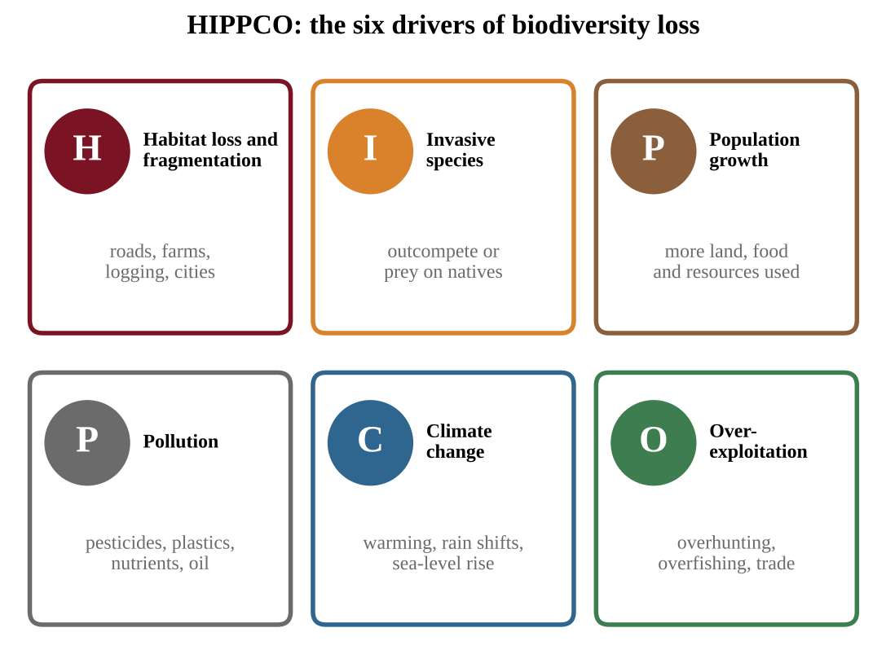
Figure 9.6 — HIPPCO: the six main factors reducing biodiversity
Letter | Factor | How it reduces biodiversity
H | Habitat destruction | Conversion to farms, cities, mines; loss of forests, wetlands and reefs; fragmentation
I | Invasive species | Outcompete or prey on natives (Topic 9.8)
P | Population growth (human) | More people use more land, water and resources, increasing every other pressure
P | Pollution | Pesticides, plastics, nutrients, oil and heavy metals poison or alter habitats
C | Climate change | Warming, shifting rainfall, sea-level rise, ocean acidification
O | Over-exploitation | Overhunting, overfishing, overharvesting, illegal wildlife trade

Habitat fragmentation
Habitat fragmentation occurs when large habitats are broken into smaller, isolated areas. Its causes include the construction of roads and pipelines, clearing for agriculture or development, and logging.
Fragmentation does harm even if some habitat is left:
• Each patch holds fewer individuals, so populations are small and more vulnerable to chance events and inbreeding.
• Animals cannot move between patches to find mates, food or new territory, and gene flow is cut.
• Edge effects. The boundary of a patch has more light, wind and temperature extremes, more predators and parasites (cowbirds, for example, lay eggs in forest birds' nests), and more invasive species. A smaller patch has proportionally more edge and less protected interior. (A 10 × 10 km square has a perimeter of 40 km; four 5 × 5 km squares have the same total area but a total perimeter of 80 km.)
• Roads cause mortality when animals try to cross.
The scale at which fragmentation becomes harmful varies from species to species. A road may be a minor inconvenience to a bird that flies, and a barrier to a salamander or a large carnivore that needs a wide range. Species that need large territories or interior habitat are hit hardest.
Counting interior habitat
If the edge zone is w wide on every side, the interior of a rectangle a × b is (a − 2w) × (b − 2w); if a side is 2w or shorter, the interior is zero. A road or pipeline creates new edges, so apply the rule to each piece separately and add. The percent of interior habitat left is new interior ÷ old interior × 100.
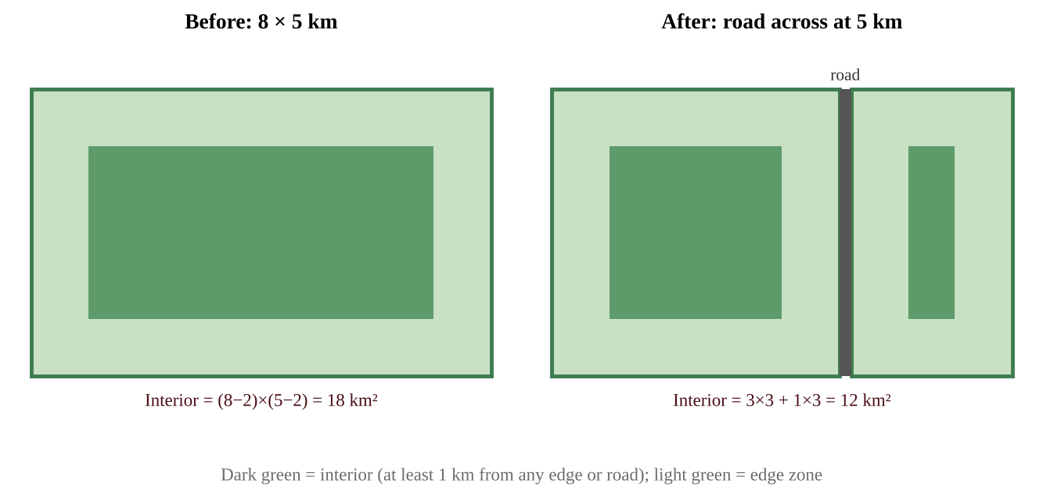
Figure 9.7 — A road cuts an 8 × 5 km forest in two; with a 1 km edge zone, interior habitat falls from 18 km² to 12 km²
Climate change, domestication
Climate change can cause habitat loss via changes in temperature, precipitation and sea-level rise: mountain species run out of higher ground, coral reefs bleach, coastal wetlands drown, and arid regions expand.
Domestication. Some organisms have been somewhat or completely domesticated and are managed for economic returns, such as honeybee colonies and domestic livestock. Domestication can reduce the genetic diversity of that organism: farmers select a few high-yield breeds and clone or replicate them, so thousands of local varieties disappear and the remaining population is vulnerable to a single disease or climate stress. Wild relatives can also be displaced or hybridize with domestic forms. Large areas of habitat are converted for livestock and monoculture crops, adding to habitat loss.
Strategies to mitigate loss of biodiversity
• Creating protected areas (parks, reserves, marine protected areas).
• Habitat corridors: strips of habitat connecting fragments (wildlife overpasses and underpasses, riparian strips) that let animals move and genes flow.
• Sustainable land use: agroforestry, selective logging, rotational grazing, sustainable fisheries, compact urban development.
• Restoring lost habitat: replanting forests, rewetting wetlands, removing dams, restoring reefs.
• Addressing the other HIPPCO factors: controlling invasives, cutting pollution and greenhouse gases, regulating harvest.
Evaluate them honestly: protected areas conserve the most but can restrict local livelihoods and may be too small or isolated without corridors; corridors cost land and money and may also help invasives or disease move; restoration is slow and rarely recreates the original ecosystem; sustainable-use rules require monitoring and enforcement.
KEY DEFINITIONS
Biodiversity — the variety of life: genetic, species and ecosystem diversity. HIPPCO — habitat destruction, invasive species, population growth, pollution, climate change, over-exploitation. Habitat fragmentation — the division of a large habitat into smaller, isolated patches. Edge effect — the change in conditions at the boundary of a habitat patch. Habitat corridor — a strip of habitat connecting isolated patches.

REAL-WORLD EXAMPLE
A highway cuts a forest that is home to a population of bears. The state builds a wildlife overpass planted with native trees and fences the road to funnel animals to it. Camera traps record bears using the crossing and roadkill falls. This corridor reconnects the patches, though the highway still occupies habitat and the structure cost millions.

COMMON STUDENT MISTAKES
• Treating HIPPCO as a list to memorize without examples. Each letter needs a mechanism and an example.
• Saying fragmentation reduces total habitat area only; the problem is also isolation and edge effects.
• Assuming domesticated species have no biodiversity concerns.

CLASSROOM EXAMPLE SG-U9-E011
A square reserve measures 10 km on each side. Assume that within 1 km of any edge the habitat is "edge habitat," and the remaining area is "interior habitat." A new road and pipeline cross the reserve and divide it into four equal squares, each 5 km on a side, with the same edge-zone width of 1 km on every side of every square. (a) Calculate the interior area of the original reserve and of the four squares combined. (b) Calculate the percentage of the total area that is interior habitat in each case. (c) Explain how this change would affect a forest-interior bird and name one measure that could help it.

QUICK CONCEPT SUMMARY
• HIPPCO: habitat destruction, invasive species, population growth, pollution, climate change, over-exploitation.
• Fragmentation isolates small populations and creates edge effects; the harmful scale depends on the species.
• Domestication can reduce genetic diversity.
• Solutions: protected areas, corridors, sustainable land use, restoration, with trade-offs.

Math & Skills Toolkit
This unit's calculations are short, but they appear on both multiple-choice and free-response questions. Practice them until they are automatic.
1. CO₂-equivalent (CO₂e). Multiply the mass of each gas by its GWP, then add.
Pattern: total CO₂e = (mass₁ × GWP₁) + (mass₂ × GWP₂) + …
Demonstration (invented numbers): a landfill releases 200 t of CH₄ and a nearby plant releases 1,000 t of CO₂. With GWP of CH₄ = 25: CH₄ contributes 200 × 25 = 5,000 t CO₂e, CO₂ contributes 1,000 × 1 = 1,000 t CO₂e. Total = 6,000 t CO₂e. Methane is 5,000 ÷ 6,000 × 100 ≈ 83% of the climate effect even though its tonnage is small. Always keep units: tonnes of CO₂e.
2. Percent change.
FORMULA & MATH SKILL
Percent change = (new value − old value) ÷ old value × 100 A positive result is an increase; a negative result is a decrease. The old (starting) value is always the denominator.

Demonstration: summer sea-ice extent falls from 7.0 million km² to 4.2 million km². Change = 4.2 − 7.0 = −2.8; −2.8 ÷ 7.0 = −0.40; so −40%. Do not divide by the new value.
3. Rate of change from a graph or table. Rate = (change in y) ÷ (change in x), with units. Read two points on the line, subtract, divide. Demonstration: a CO₂ graph passes through 340 ppm in 1980 and 390 ppm in 2010. Rate = (390 − 340) ÷ (2010 − 1980) = 50 ÷ 30 ≈ 1.7 ppm per year. A steeper segment means a faster rate; a curve that bends upward means an accelerating rate. Compare rates for different intervals to say whether change is speeding up.
4. Logarithmic pH comparison. The ratio of H⁺ concentrations is 10 raised to the pH difference. A decline of 0.2 gives 10^0.2 ≈ 1.58, so about 58% more H⁺.
5. Cost per unit of benefit. To compare solutions, divide total cost by total benefit: for instance cost per tonne of CO₂e avoided = total cost ÷ (annual reduction × number of years).
Reading graphs: a quick checklist.
• Identify axes, units and the time span.
• Quote at least two data values when describing a trend.
• Describe shape: rising, falling, accelerating, seasonal cycle.
• Say what a trend shows and what it can't show (correlation vs. cause).
• For "illustrative" or "model" data, reason from the pattern, not from memorized real values.
CLASSROOM EXAMPLE SG-U9-E012
A city is choosing between two ten-year plans to reduce greenhouse gases. Plan A (replace coal heating with a district heat network) costs $18 million and cuts emissions by 1,500 t CO₂e per year. Plan B (capture methane at the landfill) costs $6 million and captures 400 t of CH₄ per year; use a GWP of 25 for CH₄ to convert captured methane to CO₂e. Assume each plan works for the whole ten years and ignore interest. (a) Calculate the total CO₂e avoided by each plan over ten years. (b) Calculate the cost per tonne of CO₂e avoided for each plan. (c) Make a claim for which plan the city should fund first and give one advantage and one disadvantage of the plan you chose. (d) Classify each plan as mitigation or adaptation.

QUICK CONCEPT SUMMARY
Unit 9 at a glance
• Ozone (9.1–9.2): CFCs → Cl catalyst → less stratospheric ozone → more UV (skin cancer, cataracts). Montreal Protocol worked; HFCs are ozone-safe but potent greenhouse gases.
• Greenhouse effect (9.3–9.4): greenhouse gases absorb outgoing infrared; natural effect makes Earth habitable, human additions enhance it. GWP: CFCs > N₂O > CH₄ > CO₂ = 1; water vapor is short-lived. Ice cores and the Keeling curve document the rise.
• Climate change (9.5): warming, melting permafrost and ice, sea-level rise (thermal expansion plus land-ice melt), altered circulation and currents; positive feedbacks amplify change, especially at the poles. Mitigation reduces causes; adaptation reduces damage.
• Oceans (9.6–9.7): oceans absorb heat and CO₂; warming drives habitat loss, metabolic and reproductive effects, and coral bleaching; CO₂ + H₂O ⇌ H₂CO₃ lowers pH and removes carbonate, impairing shell and coral growth.
• Biodiversity (9.8–9.10): invasive generalist r-selected species outcompete natives; specialists with limited ranges, slow reproduction and hunting pressure are most endangered; HIPPCO drives biodiversity loss; fragmentation, domestication and climate change reduce habitat and diversity; protected areas, corridors, laws, sustainable use and restoration are the main responses, each with trade-offs.
• Skills: CO₂e = mass × GWP; percent change; rate of change; logarithmic pH comparison; cost per unit of benefit.

Connect with Success4Sure Academy
Scan a code or click a link to reach the academy and the author.
SUCCESS4SURE ACADEMY WEBSITE  https://www.success4sureacademy.com | 

MR. WASEEM ALLABADI — INSTAGRAM  https://www.instagram.com/waseemabed19/ | 

SUCCESS4SURE ACADEMY — INSTAGRAM  https://www.instagram.com/success4surejo/ | 

Success4Sure Academy — International academic programs, exam preparation and professional training.

Success4Sure Academy
AP ENVIRONMENTAL SCIENCE
COMPLETE STUDY GUIDE
All Nine Units • Skills • Unsolved Classroom Examples
Every unit of the 2026 curriculum explained simply, accurately and completely — with original diagrams and unsolved classroom examples whose full solutions are in Book Three.
Prepared by Mr. Waseem Allabadi
www.success4sureacademy.com
© 2026 Success4Sure Academy | All Rights Reserved | Unauthorized Printing, Copying, Reproduction & Distribution Prohibited.

