
Success4Sure Academy
BOOK TWO
AP ENVIRONMENTAL SCIENCE
CLASSIFIED PRACTICE QUESTIONS
& FOUR PREDICTED EXAMS

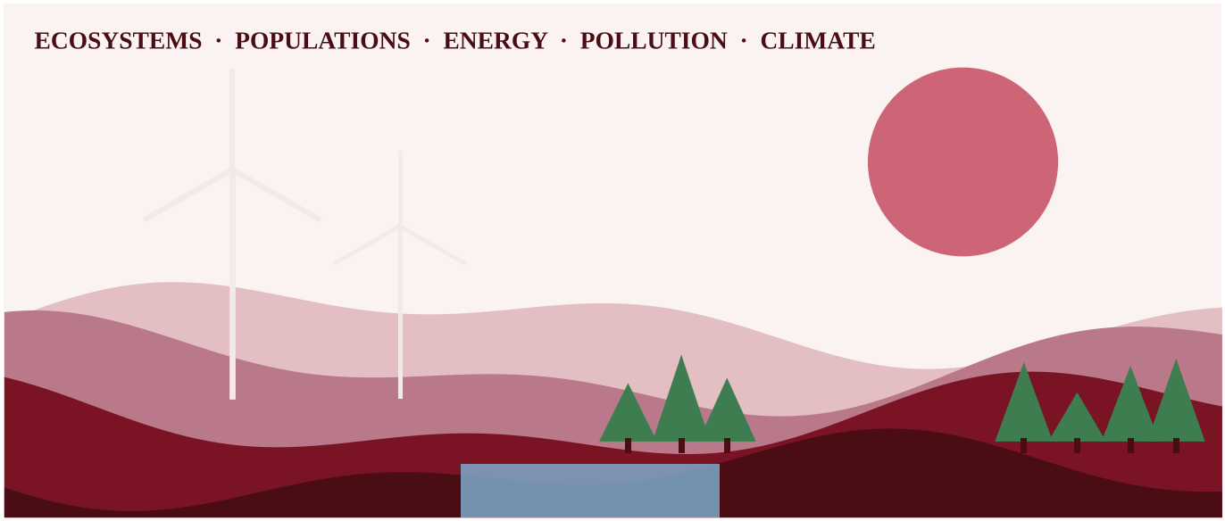
Unit-by-unit MCQ and FRQ practice, then four complete exams built for the 2026 format.
Prepared by Mr. Waseem Allabadi
Published by Success4Sure Academy
2026–2027 Edition | Aligned to the 2026 Course and Exam Description

AP ENVIRONMENTAL SCIENCE
CLASSIFIED PRACTICE QUESTIONS
& FOUR PREDICTED EXAMS

Unit-by-unit MCQ and FRQ practice, then four complete exams built for the 2026 format.
Prepared by
Mr. Waseem Allabadi
Published by
Success4Sure Academy
2026–2027 Edition
Copyright & Important Information
© 2026 Success4Sure Academy | All Rights Reserved | Unauthorized Printing, Copying, Reproduction & Distribution Prohibited.
All questions in this book are original works written for Success4Sure Academy. No solutions appear in this book; complete solutions are in Book Three.
AP® and Advanced Placement® are registered trademarks of the College Board. This publication was produced independently by Success4Sure Academy and is not endorsed by, affiliated with, or sponsored by the College Board.
All explanations, diagrams, examples, practice questions and solutions identified as original were written for Success4Sure Academy. Unless a page states otherwise, no College Board question text or figure is reproduced in this book.
Prepared by Mr. Waseem Allabadi. Published by Success4Sure Academy. First edition, 2026–2027.
Table of Contents
How to Use This Book 5
Unit 1 — The Living World: Ecosystems 6
Section A — Multiple-Choice Questions 6
Section B — Free-Response Questions 17
Unit 2 — The Living World: Biodiversity 24
Section A — Multiple-Choice Questions 24
Section B — Free-Response Questions 33
Unit 3 — Populations 39
Section A — Multiple-Choice Questions 39
Section B — Free-Response Questions 54
Unit 4 — Earth Systems and Resources 61
Section A — Multiple-Choice Questions 61
Section B — Free-Response Questions 78
Unit 5 — Land and Water Use 85
Section A — Multiple-Choice Questions 85
Section B — Free-Response Questions 98
Unit 6 — Energy Resources and Consumption 105
Section A — Multiple-Choice Questions 105
Section B — Free-Response Questions 119
Unit 7 — Atmospheric Pollution 124
Section A — Multiple-Choice Questions 124
Section B — Free-Response Questions 136
Unit 8 — Aquatic and Terrestrial Pollution 142
Section A — Multiple-Choice Questions 142
Section B — Free-Response Questions 153
Unit 9 — Global Change 159
Section A — Multiple-Choice Questions 159
Section B — Free-Response Questions 173
Four Complete AP Environmental Science Predicted Practice Exams 180
Predicted Practice Exam 1 181
Section I — Multiple-Choice Questions (80) 181
Section II — Free-Response Questions (3) 206
Predicted Practice Exam 2 212
Section I — Multiple-Choice Questions (80) 212
Section II — Free-Response Questions (3) 237
Predicted Practice Exam 3 243
Section I — Multiple-Choice Questions (80) 243
Section II — Free-Response Questions (3) 266
Predicted Practice Exam 4 271
Section I — Multiple-Choice Questions (80) 271
Section II — Free-Response Questions (3) 298
How to Use This Book
This book contains original AP Environmental Science practice material written by Success4Sure Academy. It has two parts: nine unit-by-unit question banks and four complete predicted examinations.
LEARNING OBJECTIVES
• Practice every unit with multiple-choice questions (MCQ) first and free-response questions (FRQ) second.
• Build exam stamina with four full-length predicted exams that follow the 2026 exam format.
• Check your work in Book Three, which contains a complete solution for every question here.

The 2026 exam format
Section | Questions | Weight | Time
I — Multiple choice | 80 (four choices, A–D) | 60% | 90 minutes
II — Free response | 3 (10 points each) | 40% | 70 minutes

The three free-response questions follow a fixed pattern: FRQ 1 asks you to design an investigation, FRQ 2 asks you to analyze and interpret quantitative data, and FRQ 3 asks you to analyze an environmental problem by doing calculations. A calculator is allowed on both sections.
Suggested study plan
1. Finish a unit in Book One, then do that unit's MCQ section without notes.
2. Mark every question you miss, find the matching topic number (printed in the solution), and re-read that topic in Book One.
3. Write full responses to the FRQs on separate paper before you read the solutions.
4. Take each predicted exam under timed conditions. Take Exam 1 early to find weak units, and Exam 4 close to test day.
Task verbs in free-response questions
Verb | What it asks for
Calculate | Show the formula, the substitution with units, and the final answer with units
Describe | Give the relevant characteristics of the topic
Explain | Say how or why, using evidence or reasoning
Identify | State the answer without elaboration
Justify | Support a claim with evidence and the reasoning that connects it
Make a claim | State a position based on evidence or knowledge
Propose a solution | Offer a solution supported by evidence or knowledge

Answers and explanations are not included in this book. See Book Three, Parts II and III.
Unit 1 — The Living World: Ecosystems
NOTE
Exam weight: Unit 1 accounts for about 6–8% of the AP Environmental Science exam score. This section assesses species interactions, terrestrial and aquatic biomes, the carbon, nitrogen, phosphorus and hydrologic cycles, productivity, trophic levels, the 10% rule and food webs (Topics 1.1–1.11). Expect cycle diagrams, climate graphs, energy-flow calculations and food-web predictions.

Section A — Multiple-Choice Questions
Question 1 QB-U1-MCQ001
Mycorrhizal fungi form a sheath around the roots of a spruce tree. The fungal threads absorb phosphorus and water from a large volume of soil and pass them to the tree, while the tree supplies the fungus with sugars made by photosynthesis. Both organisms grow better together than apart. Which term best describes this relationship?
A. Commensalism
B. Mutualism
C. Parasitism
D. Interspecific competition

Question 2 QB-U1-MCQ002
A biome has a layer of permanently frozen soil beneath its surface, a very short growing season, and vegetation made up mostly of mosses, lichens and low shrubs. Which biome is this?
A. Taiga
B. Temperate grassland
C. Desert
D. Tundra

Question 3 QB-U1-MCQ003
Which of the following is the largest reservoir of water at Earth's surface?
A. The oceans
B. Polar ice caps
C. Groundwater
D. The atmosphere

Question 4 QB-U1-MCQ004
Which process removes carbon dioxide from the atmosphere and stores the carbon in the sugars of living plants?
A. Cellular respiration
B. Decomposition
C. Photosynthesis
D. Combustion

Question 5 QB-U1-MCQ005
Which statement correctly describes nitrogen fixation?
A. Certain bacteria convert N₂ from the air into ammonia.
B. Certain bacteria convert nitrate in waterlogged soil into N₂ gas.
C. Plant roots absorb nitrate from the soil water.
D. Decomposers convert nitrogen in dead tissue into ammonium.

Question 6 QB-U1-MCQ006
Which statement correctly compares the phosphorus cycle with the nitrogen cycle?
A. Both cycles have their largest reservoir in the atmosphere.
B. Phosphorus is returned to the atmosphere by bacteria in the same way that nitrogen is.
C. Phosphorus has no significant atmospheric component, and its major reservoirs are rocks and sediments.
D. Phosphorus is abundant in most ecosystems because rocks weather quickly.

Question 7 QB-U1-MCQ007
In a prairie, grass is eaten by grasshoppers, grasshoppers are eaten by frogs, frogs are eaten by snakes, and snakes are eaten by hawks. At which trophic level, and as which type of consumer, does the snake feed?
A. Second trophic level, primary consumer
B. Third trophic level, secondary consumer
C. First trophic level, producer
D. Fourth trophic level, tertiary consumer

Question 8 QB-U1-MCQ008
Salinity in one aquatic biome rises and falls with the tides and with the amount of river flow, because freshwater from a river mixes with seawater there. Which biome is described?
A. Coral reef
B. Estuary
C. Open ocean
D. Lake

Question 9 QB-U1-MCQ009
Producers in a meadow capture 50,000 kcal/m²/yr of energy. Using the 10% rule, about how much energy is available to secondary consumers?
A. 5 kcal/m²/yr
B. 50 kcal/m²/yr
C. 500 kcal/m²/yr
D. 5,000 kcal/m²/yr

Question 10 QB-U1-MCQ010
A shrubland has a gross primary productivity (GPP) of 6,000 kcal/m²/yr. The plants use 4,500 kcal/m²/yr in respiration. What is the net primary productivity (NPP) of the shrubland?
A. 1,500 kcal/m²/yr
B. 4,500 kcal/m²/yr
C. 6,000 kcal/m²/yr
D. 10,500 kcal/m²/yr

Question 11 QB-U1-MCQ011
Four species of warbler live in the same spruce forest and all eat insects. One species feeds mainly near the treetop, another on the middle branches, a third near the trunk, and a fourth at the outer tips of the lower branches. Which concept best explains how the four species can coexist?
A. Commensalism, because each species benefits without harming the others
B. Intraspecific competition, because individuals of one species compete only with each other
C. Parasitism, because the species depend on insects living on the tree
D. Resource partitioning, which reduces the negative effects of competition

Question 12 QB-U1-MCQ012
The climate diagram below shows monthly precipitation (bars) and mean monthly temperature (line) at a lowland station.
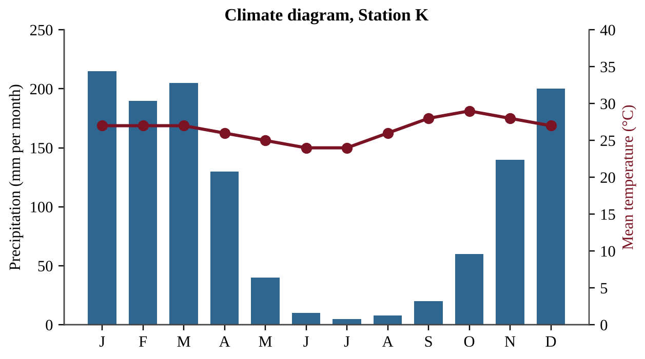
Figure — Monthly precipitation and mean temperature at one station
Which biome is most likely found at this station?
A. Tropical rainforest
B. Savanna
C. Temperate grassland
D. Desert

Question 13 QB-U1-MCQ013
A fisheries scientist compares four marine sites and wants to find where the base of the food web is most productive. The table shows the measurements.
Site | Setting | Nitrate (µmol/L) | Turbidity | Water temperature (°C)
W | Mid-ocean region | 0.2 | Very low | 27
X | Coastal zone where deep water rises | 18 | Moderate | 12
Y | River mouth after a flood | 3 | Very high | 20

Which statement is best supported by the data?
A. Site W should be most productive, because its very low turbidity lets sunlight reach the greatest depth in the water column.
B. Site Y should be most productive, because high turbidity means abundant food particles for fish.
C. Site X should be most productive, because its high nutrient level can support abundant phytoplankton.
D. Site W should be most productive, because warm water always holds more dissolved nutrients.

Question 14 QB-U1-MCQ014
The diagram shows annual carbon fluxes among three reservoirs. Arrows A and C move carbon out of the atmosphere; arrows B, D and E move carbon into it.
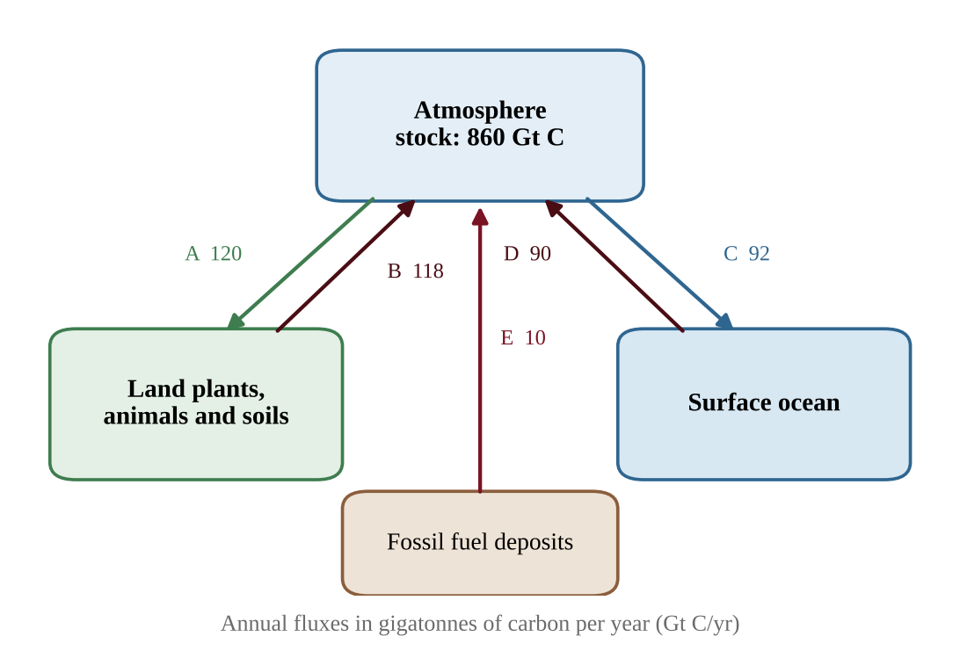
Figure — Annual carbon fluxes (Gt C/yr) between the atmosphere and other reservoirs
According to the diagram, what is the net change in the carbon stored in the atmosphere each year?
A. An increase of 6 Gt C
B. An increase of 8 Gt C
C. An increase of 10 Gt C
D. A decrease of 6 Gt C

Question 15 QB-U1-MCQ015
The diagram shows steps in the nitrogen cycle, labeled P through T.
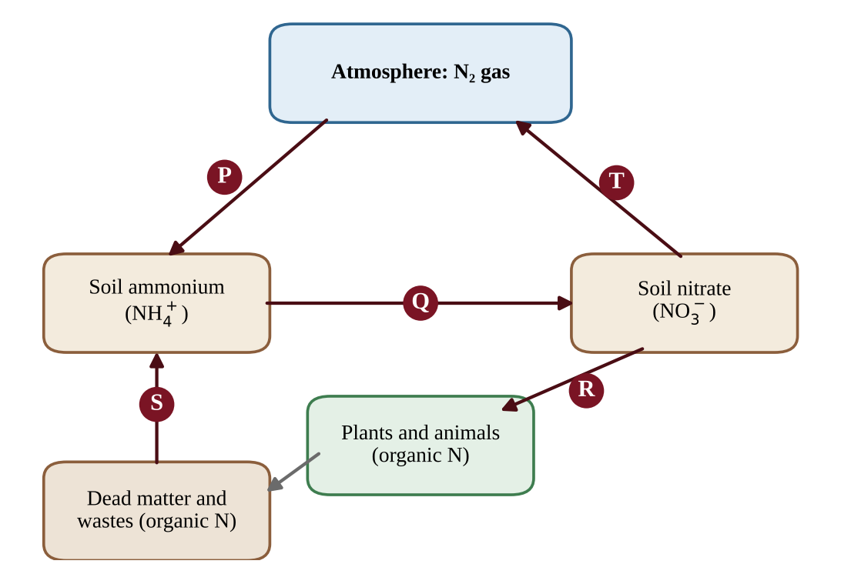
Figure — Steps in the nitrogen cycle
After heavy rain, a low field stays waterlogged and its soil contains almost no oxygen. Bacteria in the soil begin to speed up the step that removes nitrogen from the soil and returns it to the atmosphere. Which step is this?
A. P
B. Q
C. S
D. T

Question 16 QB-U1-MCQ016
A researcher fills clear bottles with water from a freshwater lake, adds nutrients as shown, and measures algal chlorophyll a after three weeks under identical light and temperature.
Treatment | Mean chlorophyll a (µg/L)
No nutrients added (control) | 4.1
Nitrogen added | 4.5
Phosphorus added | 17.8
Nitrogen and phosphorus added | 41.3

Which conclusion is best supported by the data?
A. Nitrogen is the main limiting nutrient, because adding it increased chlorophyll a above the level in the control bottles.
B. Phosphorus is the main limiting nutrient, because algal growth rose sharply when it was added.
C. Neither nutrient is limiting, because algae grew in the control bottles.
D. Both nutrients must be added together for any increase in algal growth to occur.

Question 17 QB-U1-MCQ017
A city replaces a meadow with parking lots, roofs and storm drains. Compared with the meadow, which change in the local hydrologic cycle is most likely?
A. More surface runoff and less infiltration into the soil
B. More infiltration and more groundwater recharge
C. More transpiration from plants
D. Less surface runoff and slower stream flow after storms

Question 18 QB-U1-MCQ018
The table gives net primary productivity (NPP) per unit area and the area covered by three ecosystems.
Ecosystem | NPP (kcal/m²/yr) | Area (10⁶ km²)
Open ocean | 600 | 360
Tropical rainforest | 9,000 | 17
Estuary | 8,000 | 1.4

(1 km² = 10⁶ m²)
Which statement is supported by the data?
A. The tropical rainforest has the largest total NPP because it has the highest NPP per square meter.
B. The open ocean has the lowest total NPP because it has the lowest NPP per square meter.
C. The open ocean has the lowest NPP per square meter but the largest total NPP because of its enormous area.
D. All three ecosystems have similar total NPP because NPP per area and area offset each other.

Question 19 QB-U1-MCQ019
Which statement correctly contrasts the movement of energy and matter in an ecosystem?
A. Both energy and matter cycle repeatedly among producers, consumers and decomposers.
B. Matter cycles, while energy flows in one direction and leaves each trophic level partly as heat.
C. Energy cycles back to the producers through decomposers, while matter flows in one direction.
D. Both energy and matter flow in one direction and are lost from the ecosystem at every transfer.

Question 20 QB-U1-MCQ020
In a lake food chain, algae are eaten by water fleas, water fleas by minnows, and minnows by pike. The pike population stores 2.5 × 10⁶ kcal of energy per year. Assuming 10% of energy is passed on at each transfer, how much energy must the algae capture per year to support the pike?
A. 2.5 × 10⁶ kcal
B. 2.5 × 10⁷ kcal
C. 2.5 × 10⁸ kcal
D. 2.5 × 10⁹ kcal

Question 21 QB-U1-MCQ021
Use the grassland food web below. Arrows point from the food to the organism that eats it.
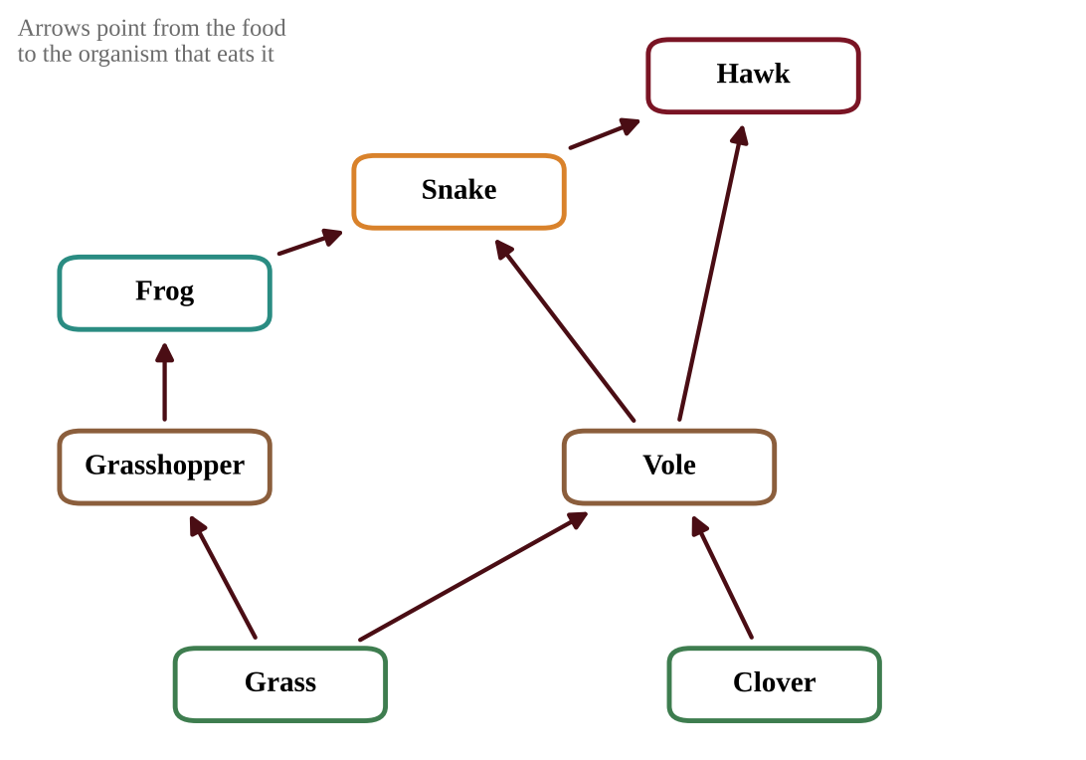
Figure — A grassland food web
Which of the following organisms feeds at more than one trophic level?
A. Grasshopper
B. Frog
C. Snake
D. Clover

Question 22 QB-U1-MCQ022
In the grassland food web shown below, frogs eat only grasshoppers. A disease eliminates the frogs.
Figure — The same grassland food web (arrows point from food to eater)
Which is the most likely immediate effect within the food web?
A. Grasshopper numbers increase because they lose their only predator in this web.
B. Grasshopper numbers decrease because the frogs, their competitors, are gone.
C. Clover biomass decreases because grasshoppers switch to eating clover.
D. Hawk numbers increase because snakes now face less competition from frogs.

Question 23 QB-U1-MCQ023
Over several decades, average temperatures at high northern latitudes rise steadily. Which change in the distribution of biomes is most likely?
A. Tundra expands equatorward and replaces the taiga.
B. Desert expands poleward into the taiga.
C. Temperate seasonal forest retreats toward the equator.
D. Taiga shifts poleward into areas that are currently tundra.

Question 24 QB-U1-MCQ024
Which statement best supports the claim that algae in marine biomes influence the composition of Earth's atmosphere?
A. Marine algae release most of the nitrogen gas in the atmosphere during photosynthesis.
B. Marine algae supply a large portion of Earth's oxygen and take in carbon dioxide through photosynthesis.
C. Marine algae absorb oxygen and release carbon dioxide during photosynthesis.
D. Marine algae convert atmospheric carbon dioxide into phosphorus compounds in sediments.

Question 25 QB-U1-MCQ025
A large aquifer holds 8.0 × 10³ km³ of water. Water enters (recharge) and leaves (discharge) the aquifer at the same rate of 16 km³ per year. What is the average residence time of water in the aquifer?
A. 0.002 years
B. 50 years
C. 500 years
D. 1.3 × 10⁵ years

Question 26 QB-U1-MCQ026
In very clear tropical ocean water, most red light is absorbed in the upper 1 m, while blue light can penetrate below 100 m. A scientist finds photosynthetic organisms growing at a depth of 40 m. Which statement best explains how they can photosynthesize there?
A. They have pigments that capture blue-green light, which penetrates to that depth.
B. They rely mainly on red light, which is the most abundant wavelength at that depth.
C. Photosynthesis is faster at 40 m than at the surface because the water is warmer.
D. They do not need light because nutrients at depth replace the need for sunlight.

Question 27 QB-U1-MCQ027
The figure shows the energy stored at each trophic level of a spring ecosystem.
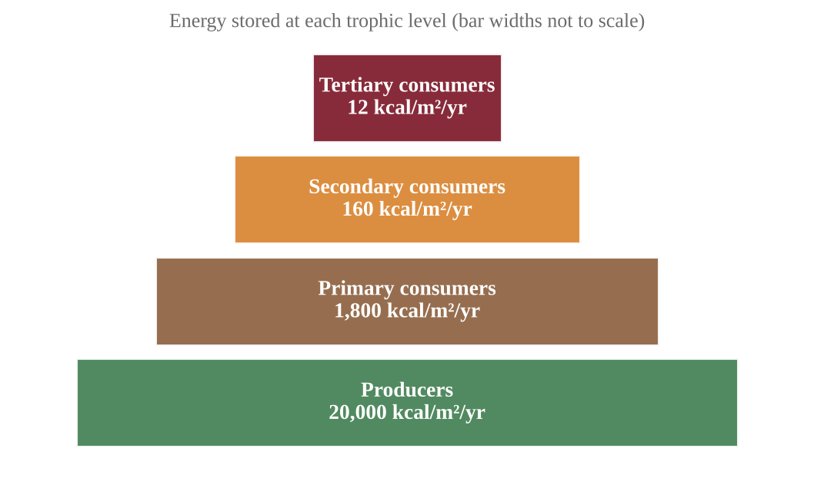
Figure — Energy stored at each trophic level
Which statement is best supported by the data?
A. The data contradict the 10% rule, because no transfer passes on exactly 10% of the energy.
B. Each transfer passes on roughly 7.5% to 9% of the energy, close to the 10% rule, and the rest is mostly lost as heat.
C. The energy not passed on at each transfer is destroyed, which shows that energy is not conserved in ecosystems.
D. Each transfer passes on roughly 90% of the energy, so very little energy is lost between trophic levels.

Question 28 QB-U1-MCQ028
A fish farm manager wants to harvest 60 kg of largemouth bass per year from a pond. The food chain is algae → water fleas → minnows → bass. Bass tissue contains 2,000 kcal per kg. The pond's algae have an NPP of 2,400 kcal/m²/yr. Assume 10% of energy is transferred at each step and that all the NPP is available to the chain. What is the minimum area of pond needed? (1 ha = 10⁴ m²)
A. 0.0050 ha
B. 0.050 ha
C. 0.50 ha
D. 5.0 ha

Question 29 QB-U1-MCQ029
The graph shows monthly atmospheric CO₂ concentration at a remote station in the Northern Hemisphere over four years.
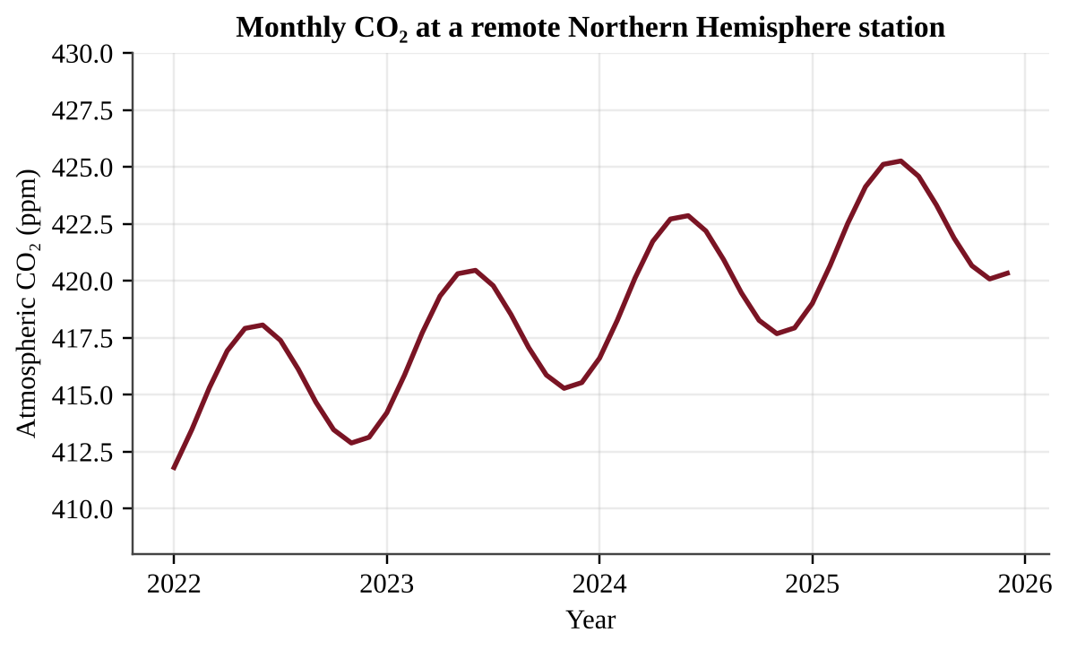
Figure — Monthly atmospheric CO₂ concentration at a remote Northern Hemisphere station
Which explanation accounts for both the yearly decline from late spring to autumn and the long-term upward trend?
A. The decline is caused by less fossil fuel burning in summer, and the rise is caused by CO₂ released by the oceans.
B. The decline is caused by cooling of the ocean, and the rise is caused by volcanic eruptions each year.
C. The decline is caused by net photosynthesis by land plants in the growing season, and the rise is caused by fossil fuel burning.
D. The decline is caused by peak decomposition in summer, and the rise is caused by increased respiration of plants each year.

Question 30 QB-U1-MCQ030
A grassland ecologist suspects that nitrogen limits plant growth on a prairie. Which investigation is best designed to test this idea?
A. Mark out several equal plots; add nitrogen fertilizer to half of them and none to the rest, keep all other conditions the same, and compare plant biomass at the end of the growing season.
B. Add nitrogen fertilizer to one plot in the prairie and compare its biomass with an unfertilized plot in a different field.
C. Add nitrogen, phosphorus and extra water together to treated plots and compare their biomass with untreated plots.
D. Add nitrogen fertilizer to every plot and measure plant biomass before and after the growing season.

Question 31 QB-U1-MCQ031
Anglers remove most of the bass from a lake, and the lake is monitored for two years.
Year | Bass (per ha) | Minnows (per ha) | Zooplankton (mg/L) | Chlorophyll a (µg/L)
0 | 12 | 4,000 | 90 | 5
1 | 2 | 9,500 | 40 | 12
2 | 1 | 15,000 | 15 | 31

Which statement best explains the pattern?
A. Algae increased first, which caused minnows to increase and zooplankton to decrease.
B. With fewer bass, minnows increased and ate more zooplankton, so less grazing let chlorophyll a rise.
C. Removing bass directly increased the nutrients in the lake, which caused zooplankton to decrease.
D. Zooplankton decreased because bass eat zooplankton, so fewer bass means fewer zooplankton.

Question 32 QB-U1-MCQ032
Two similar watersheds receive 1,200 mm of precipitation per year. In one, the forest is left intact; in the other, the forest is cleared. Annual measurements are shown.
Watershed | Evapotranspiration (mm/yr) | Stream runoff (mm/yr)
Forested | 700 | 380
Cleared | 450 | 600

Which statement correctly interprets the data?
A. Runoff increased by 220 mm because the cleared watershed received more precipitation.
B. Runoff increased by 220 mm mainly because infiltration of precipitation increased after clearing.
C. Runoff decreased by 220 mm because evapotranspiration fell after clearing.
D. Runoff increased by 220 mm because lower evapotranspiration left more precipitation to leave as streamflow.

Section B — Free-Response Questions
Question 1 QB-U1-FRQ001
Lake Verrin is a freshwater lake surrounded by dairy farms and cropland. Every July a thick scum of algae covers its surface, and local residents complain that the water smells bad. Farmers apply manure and fertilizer containing both nitrogen and phosphorus to their fields, and rain washes some of it into the inlet stream. Measurements of surface water in July are shown in the figure.
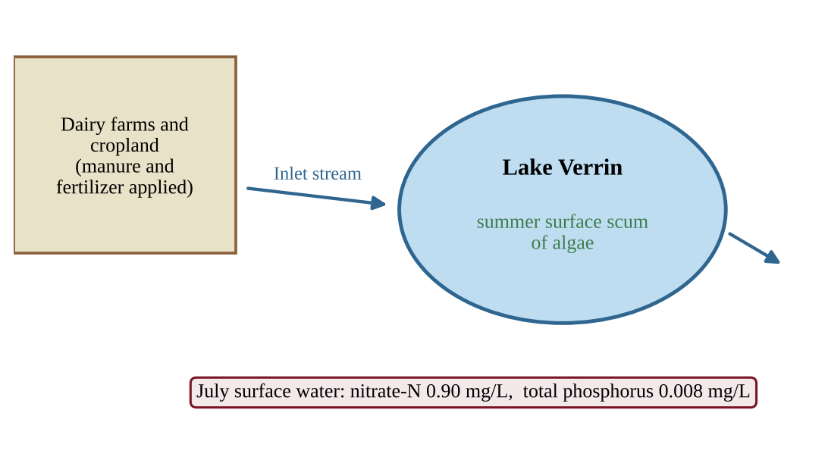
Figure — Lake Verrin and its inlet stream
A student proposes an experiment to find out which nutrient, nitrogen or phosphorus, limits algal growth in the lake.
(a) Identify the environmental problem that the investigation is designed to address. [1]
(b) Write a testable hypothesis about which nutrient limits algal growth in Lake Verrin, and state the reasoning behind it. [1]
(c) For the experiment, identify (i) the independent variable [1] (ii) the dependent variable [1]
(d) Describe a procedure that uses clear bottles of lake water. Your description must include the treatments, a control, and how the design ensures reliable results. [2]
(e) Identify one variable that must be kept constant among the bottles and explain why. [1]
(f) Describe the result that would support your hypothesis. [1]
(g) Propose one action that the farmers or local government could take to reduce the problem, and justify your proposal with reference to a nutrient cycle. [2]

Question 2 QB-U1-FRQ002
Ecologists measured the monthly gross primary productivity (GPP) and the respiration of the plants in a temperate seasonal forest for one year. The data are shown in the table and graph.
Month | GPP (kcal/m²/month) | Plant respiration (kcal/m²/month)
January | 40 | 90
February | 80 | 90
March | 260 | 150
April | 600 | 280
May | 1,100 | 450
June | 1,500 | 620
July | 1,550 | 700
August | 1,400 | 650
September | 900 | 480
October | 400 | 260
November | 120 | 130
December | 40 | 90

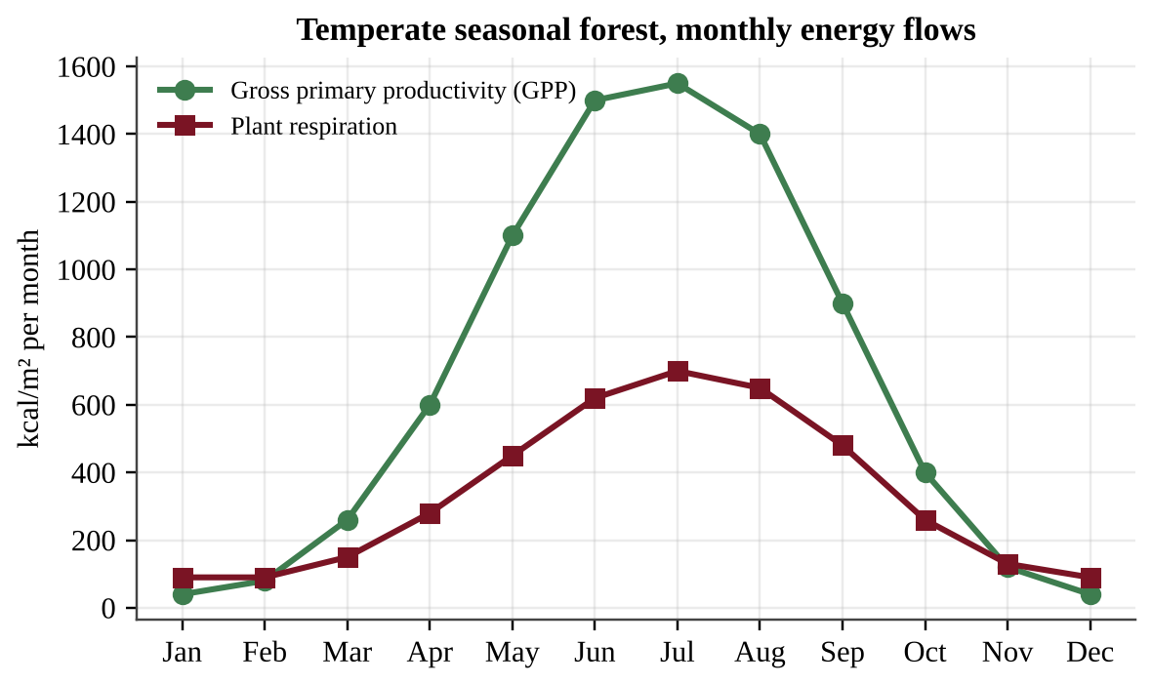
Figure — Monthly GPP and plant respiration in a temperate seasonal forest
(a) Describe the seasonal pattern of GPP shown in the data. [1]
(b) Explain two environmental factors that account for the difference between GPP in July and GPP in January. [2]
(c) Identify the months in which the net primary productivity (NPP) is negative, and explain how NPP can be negative. [2]
(d) Calculate the percentage of the forest's annual GPP that is used in plant respiration. Show your work. [2]
(e) Make a claim about whether the forest's plants gain or lose energy over the full year, and justify your claim with data. [1]
(f) An outbreak of leaf-eating caterpillars removes about half of the leaf area from June through August. Predict the effect on GPP and on annual NPP, and justify your prediction. [1]
(g) Propose one management action that would help keep forest productivity high over the long term, and justify it. [1]

Question 3 QB-U1-FRQ003
A rural region has 400 hectares (ha) of grassland with an NPP of 4,500 kcal/m²/yr. Cattle graze the grass, and local people eat beef. Assume that 10% of the energy is transferred at each step in the food chain and that a person needs 2,500 kcal per day. (1 ha = 10⁴ m²; use 365 days per year.)
(a) Calculate the total NPP of the grassland in kcal/yr. [1]
(b) Calculate the energy available to people who eat beef from the cattle (grass → cattle → people), in kcal/yr. [2]
(c) Calculate the number of people whose energy needs could be met by the beef in part (b). [2]
(d) Suppose the same 400 ha were planted with a crop with the same NPP, and, for simplicity, assume that people could eat all of that NPP directly. Calculate the number of people whose energy needs could then be met. [1]
(e) Explain, using the second law of thermodynamics, why fewer people can be fed per hectare when they eat beef rather than plants. [1]
(f) Explain why the assumption in part (d) is not realistic. [1]
(g) Propose one change in food production or diet that would feed more people from the same land, and justify your proposal. [2]

Question 4 QB-U1-FRQ004
Marine biologists surveyed two rocky reefs off a temperate coast in 2025. One reef lies inside a marine reserve where fishing is banned; the other is open to fishing. Large predatory fish eat sea urchins, and sea urchins graze on kelp. The data are shown below.
Measure | Reserve | Fished area
Large predatory fish (per 100 m²) | 14 | 2
Sea urchins (per m²) | 3 | 22
Kelp canopy cover (%) | 82 | 9

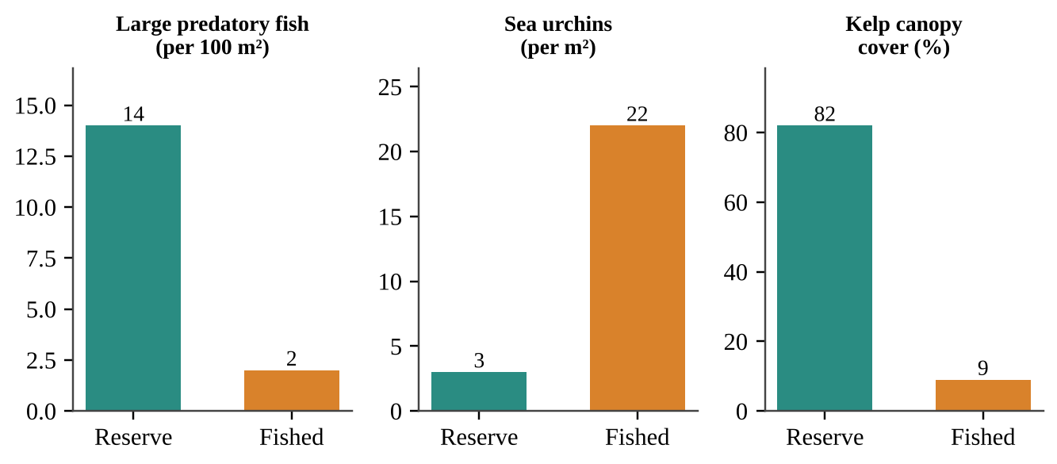
Figure — Survey results at the two reefs
(a) Describe the difference in sea urchin density and in kelp canopy cover between the reserve and the fished area. [1]
(b) Identify the trophic level of the sea urchins and of the large predatory fish. [1]
(c) Explain how fishing could lead to the lower kelp cover in the fished area. Your answer should describe the chain of effects through the food web. [2]
(d) Calculate the percentage decrease in kelp canopy cover in the fished area compared with the reserve. [1]
(e) A student claims, "The data prove that fishing caused the loss of kelp." Justify why the data alone cannot prove this claim, and describe one additional piece of evidence or study design that would strengthen it. [2]
(f) A disease kills most of the sea urchins in the fished area. Predict what will happen to kelp cover over the next two years and explain your prediction. [1]
(g) Propose one management action to restore kelp in the fished area and justify it. [2]

Unit 2 — The Living World: Biodiversity
NOTE
Exam weight: Unit 2 accounts for 6–8% of the AP Environmental Science exam score (CED Topics 2.1–2.7). This section assesses levels of biodiversity, ecosystem services, island biogeography, ecological tolerance, natural disruptions, adaptation, and ecological succession. Expect data in tables and graphs, short calculations (percent change, totals, differences), and scenarios that ask you to explain, justify, or propose a solution.

Section A — Multiple-Choice Questions
Question 1 QB-U2-MCQ001
Which of the following best describes genetic diversity?
A. The number of different species living in a wetland
B. The number of distinct habitat types within a river basin
C. The total number of individuals counted in a population
D. The variety of alleles carried by the individuals of a population

Question 2 QB-U2-MCQ002
A coastal salt marsh absorbs storm-surge water that would otherwise flood nearby homes. Which category of ecosystem service does this represent?
A. Regulating
B. Provisioning
C. Cultural
D. Supporting

Question 3 QB-U2-MCQ003
Which of the following situations would most likely lead to primary succession?
A. A hay field that has been abandoned for several years
B. A forest after a wildfire that left the soil intact
C. Bare rock exposed as a glacier retreats
D. A logged hillside where the topsoil remains

Question 4 QB-U2-MCQ004
Brook trout survive in stream water between 2°C and 20°C and die when the temperature moves outside that range. This temperature range is an example of the trout's
A. carrying capacity
B. ecological tolerance
C. biotic potential
D. species richness

Question 5 QB-U2-MCQ005
According to the theory of island biogeography, which island is expected to support the greatest number of species at equilibrium?
A. A large island close to the mainland
B. A large island far from the mainland
C. A small island close to the mainland
D. A small island far from the mainland

Question 6 QB-U2-MCQ006
Which of the following natural disruptions is best described as periodic?
A. A meteorite impact that triggers a mass extinction
B. A lightning strike that ignites a single wildfire
C. An earthquake that collapses a hillside
D. Flooding of a river floodplain every spring

Question 7 QB-U2-MCQ007
Which statement best describes how natural selection leads to adaptation in a population?
A. Individuals develop useful traits during their lives and pass those traits directly to their offspring.
B. Individuals with heritable traits that raise survival and reproduction leave more offspring, so those traits become more common.
C. A population changes its genes in response to a need, so every member adapts within a single generation.
D. A change in the environment causes mutations that are beneficial to the population.

Question 8 QB-U2-MCQ008
A lava flow cools and hardens into bare rock. Which organisms are most likely to colonize it first?
A. Hardwood tree saplings
B. Grazing mammals
C. Lichens and mosses
D. Perennial shrubs

Question 9 QB-U2-MCQ009
A disease reduced a kestrel population on a small island, and the population later recovered. Genetic surveys of the population are shown below.
Year | Population size | Alleles found at one gene
1990 | 400 | 14
1995 | 12 | 5
2020 | 380 | 5

Which statement best explains why the 2020 population is more vulnerable to new environmental stressors than the 1990 population?
A. Population growth after a crash further reduces the number of alleles.
B. Alleles lost in the bottleneck were not restored, so less variation is available to respond to stress.
C. The number of species on the island fell during the disease outbreak.
D. The 2020 population is smaller than the 1990 population, so it has less habitat diversity.

Question 10 QB-U2-MCQ010
A city drains a floodplain wetland to build housing. In the following years, downstream flooding becomes more frequent and nitrate levels in the drinking-water reservoir rise. Which ecosystem services were most directly reduced?
A. Provisioning services, such as fish and timber harvests
B. Cultural services, such as recreation and spiritual value
C. Supporting services, such as soil formation and primary production
D. Regulating services, such as flood control and water filtering

Question 11 QB-U2-MCQ011
The graph shows a model of island biogeography for a mainland species pool of 60 species. Immigration curves are shown for a near island and a far island, and extinction curves are shown for a large island and a small island.
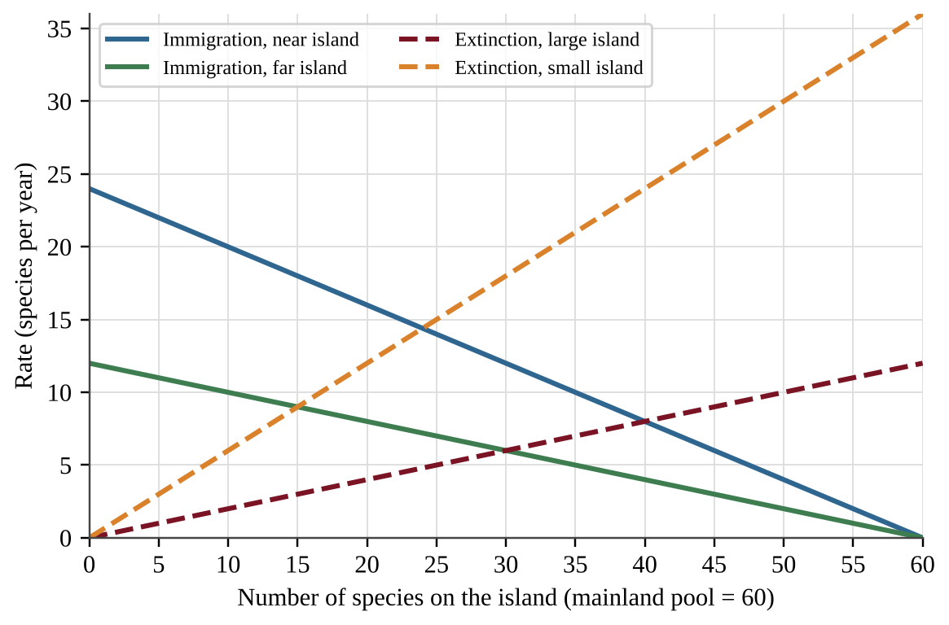
Figure — Immigration and extinction rates as a function of the number of species present
According to the model, how many more species would be expected at equilibrium on a large, near island than on a small, far island?
A. 25
B. 10
C. 16
D. 15

Question 12 QB-U2-MCQ012
The graph shows how the growth rate of three aquatic species changes with water temperature.
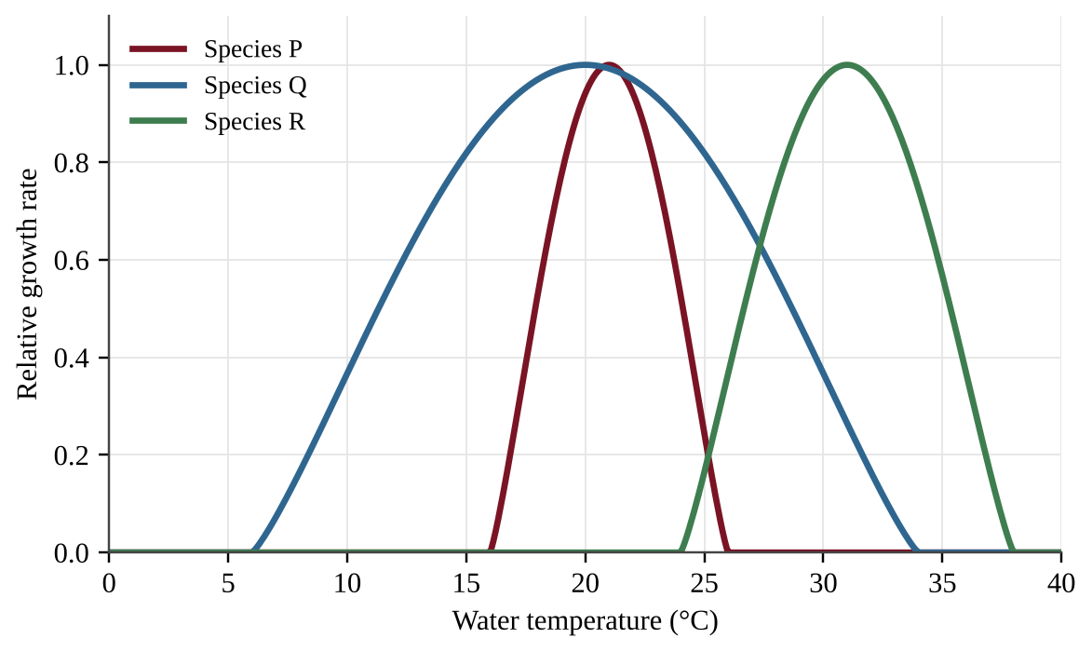
Figure — Relative growth rate of three species across a range of water temperatures
A lake warms from 20°C to 30°C. Which statement is best supported by the graph?
A. Species R has the widest range of tolerance of the three species.
B. Species Q is the most vulnerable to warming because it has the narrowest range of tolerance.
C. Species P would be eliminated, while Species Q and Species R would remain within their tolerance ranges.
D. All three species were within their tolerance ranges at 20°C.

Question 13 QB-U2-MCQ013
Several islands on a shallow continental shelf contain the same small-mammal species found on the nearby mainland, even though these mammals cannot cross open water. Which of the following is the most likely explanation?
A. The mammals evolved identical traits independently on each island.
B. Ocean currents regularly carried mammals from the mainland to every island.
C. Mutations on the islands repeatedly produced the same species.
D. Land bridges exposed by lower sea levels in glacial periods were later flooded.

Question 14 QB-U2-MCQ014
Shell thickness was measured in a population of marine snails before and 25 generations after predatory crabs were introduced to their shoreline.
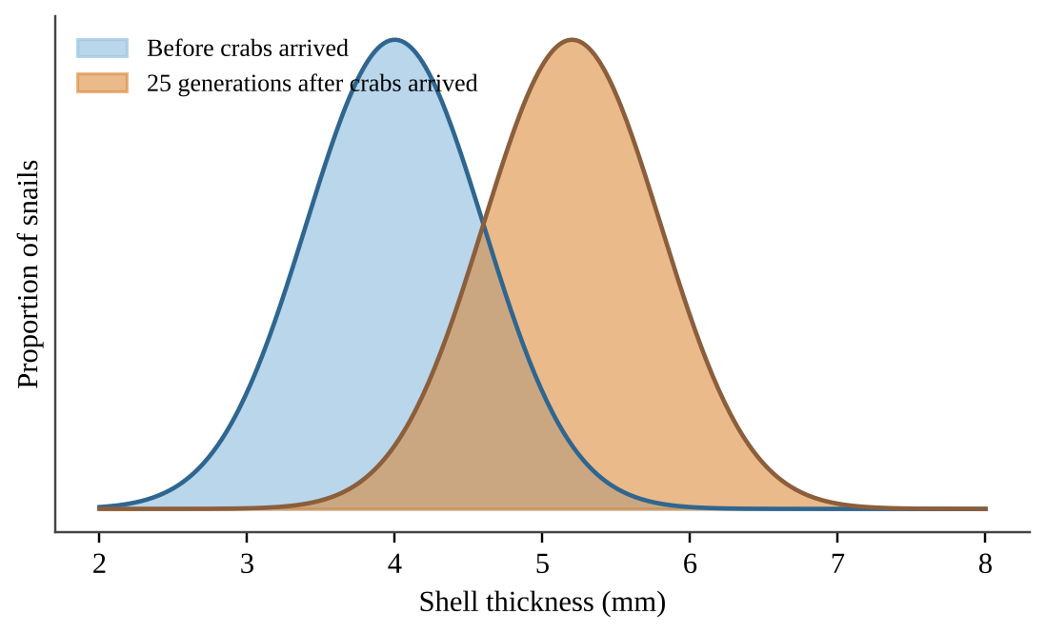
Figure — Distribution of shell thickness in the snail population
Which of the following best explains the change shown?
A. Snails with thicker shells survived crab predation more often and passed the heritable trait to their offspring.
B. Each snail thickened its shell after sensing the crabs, and the thicker shells were inherited by its offspring.
C. The crabs caused mutations that produced thicker shells in the snails.
D. The snail population needed thicker shells, so its genes changed to meet that need.

Question 15 QB-U2-MCQ015
Researchers surveyed a forest plot at several times after a wildfire.
Years since fire | Species richness
1 | 8
10 | 22
30 | 35
80 | 31

By what percent did species richness increase between year 10 and year 30?
A. 13%
B. 37%
C. 59%
D. 160%

Question 16 QB-U2-MCQ016
A 100-ha block of forest is divided by roads and farm fields into four isolated 25-ha patches, as shown.
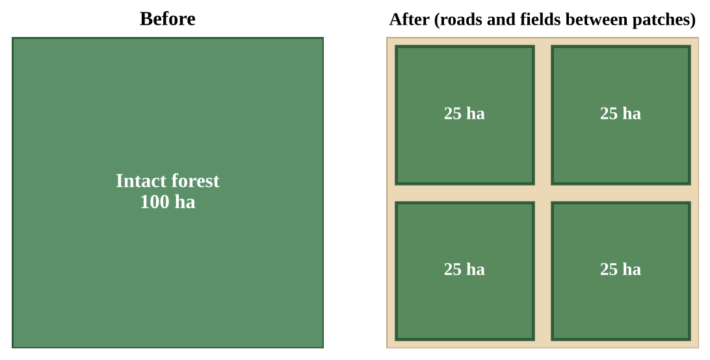
Figure — A forest before and after fragmentation
Which species is most likely to disappear from the landscape first?
A. A generalist rodent that eats seeds, insects, and fruit in many habitats
B. A specialist forest-interior bird that needs one 40-ha territory of mature forest
C. A generalist deer that browses in both forests and fields
D. A weedy plant that colonizes disturbed forest edges

Question 17 QB-U2-MCQ017
A 60-ha oyster reef removes excess nitrogen from a bay. A water utility would spend $1,500 per hectare per year to remove the same nitrogen by other means. The reef also supports a harvest of 800 kg of oysters per hectare per year, sold for $6 per kilogram. What is the total annual value of these two services?
A. $378,000
B. $90,000
C. $288,000
D. $6,300

Question 18 QB-U2-MCQ018
Rats are accidentally introduced to an island where several bird species eat only one kind of seed and nest only in one kind of shrub. Which statement best explains why these island birds are especially vulnerable?
A. Island birds have more genetic diversity than the introduced rats.
B. Island birds are usually larger than the introduced rats and need more food.
C. Island birds reproduce more slowly than all mainland species.
D. Island birds are often specialists that generalist invaders can outcompete or prey on.

Question 19 QB-U2-MCQ019
A researcher wants to determine the range of salinity that tadpoles of a frog species can tolerate. Which design would best accomplish this?
A. Place 20 tadpoles in a single tank at 15 ppt salinity and record survival after one week.
B. Place 20 tadpoles in each of six tanks with salinities from 0 to 20 ppt, keep temperature and food the same, and record survival after seven days.
C. Collect tadpoles from creeks with different salinities and compare their body sizes.
D. Place tadpoles in one tank and slowly add salt while observing their behavior.

Question 20 QB-U2-MCQ020
After a hurricane destroys the mangrove roosting sites on a barrier island, thousands of herons fly 40 km inland and use freshwater marshes for the rest of the season. This behavior is best described as
A. the formation of a new species
B. the start of primary succession
C. a short-term migration in response to a natural disruption
D. a loss of genetic diversity through a bottleneck

Question 21 QB-U2-MCQ021
Which population is most likely to adapt through natural selection to the environmental change described?
A. A long-lived tree species with little genetic variation, facing a sudden, severe drought
B. A small population of large predators with low genetic variation, facing a sudden loss of prey
C. An isolated amphibian population with few breeding adults, facing a sudden new disease
D. A short-lived insect with high genetic variation, facing a gradual warming trend

Question 22 QB-U2-MCQ022
Mayfly nymphs are sensitive to low dissolved oxygen. A stream was sampled at five sites, with a wastewater outfall at Site 3.
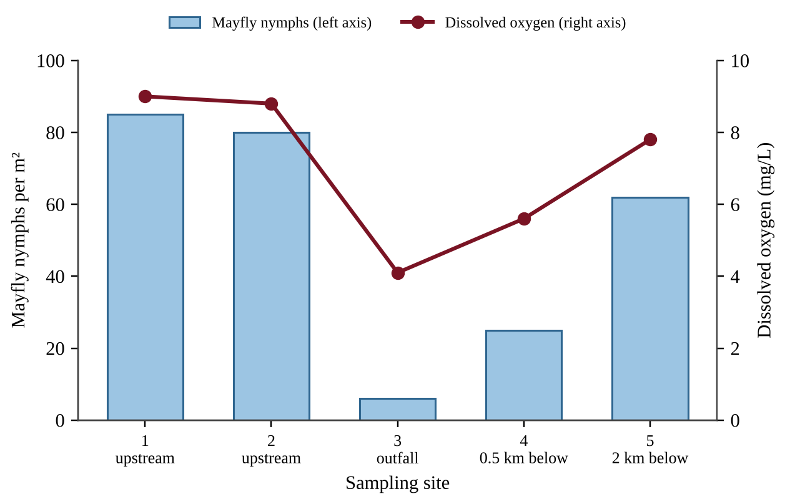
Figure — Mayfly nymph density and dissolved oxygen at five stream sites
Which conclusion is best supported by the data?
A. Low mayfly density near the outfall suggests poor water quality, consistent with an indicator species.
B. Mayflies are a keystone species because their decline at Site 3 caused oxygen to fall.
C. The outfall increases mayfly reproduction, so densities recover downstream.
D. Mayfly density does not depend on oxygen because some mayflies survive at Site 3.

Question 23 QB-U2-MCQ023
In an intertidal zone, a predatory sea star made up about 2% of the total biomass. Researchers removed the sea star from 8 pools and left it in 8 other pools. Mussels covered 20% of the rock surface in all pools at the start.
Treatment | Species per pool at start | Species per pool after 2 years | Mussel cover after 2 years
Sea star removed | 15 | 6 | 85%
Sea star left in place | 15 | 14 | 20%

Which conclusion is best supported by the data?
A. The sea star is an indicator species because species richness fell when it was removed.
B. The decline in species richness resulted from natural variation, since the control pools also changed.
C. The sea star is a keystone species because removing it, despite its small biomass, changed the community.
D. Mussels are the keystone species because they covered most of the rock in the removal pools.

Question 24 QB-U2-MCQ024
A city can protect its drinking water in one of two ways. A treatment plant would cost $24 million to build and $1.2 million per year to operate. Alternatively, the city could restore 800 ha of wetland that provides equivalent purification, at $9,000 per hectare once plus $150 per hectare per year for maintenance. Over 20 years, how much less would the wetland option cost than the treatment plant?
A. $16.8 million
B. $38.4 million
C. $40.8 million
D. $14.4 million

Question 25 QB-U2-MCQ025
Ecologists surveyed the birds of a small island 30 km from the mainland in two years.
Survey year | Species recorded | Species recorded in both surveys
2010 | 31 | 24
2020 | 31 | 24

Which interpretation is best supported by the data?
A. Seven species were lost and seven arrived, consistent with a dynamic equilibrium.
B. No species arrived or went extinct, because species richness stayed the same.
C. Twenty-four species went extinct and 24 species arrived between the surveys.
D. Species richness was constant, so the extinction rate on the island must be zero.

Question 26 QB-U2-MCQ026
Coral colonies of one species were held at several temperatures for 1 week or for 4 weeks.
Temperature (°C) | Survival after 1 week | Survival after 4 weeks
28 | 98% | 98%
30 | 96% | 85%
31 | 90% | 55%
32 | 70% | 5%
33 | 20% | 0%

Which conclusion is best supported by the data?
A. The species tolerates temperatures up to 33°C because some colonies survived for a week.
B. Temperature has no measurable effect on survival below 32°C.
C. The tolerance range of the species is fixed at 28°C to 33°C regardless of exposure time.
D. The harm caused by a temperature depends on how long the colonies are exposed to it.

Question 27 QB-U2-MCQ027
A grower sprays the same insecticide on a field each season. The fraction of the pest population that is resistant is shown below.
Season | 1 | 2 | 3 | 4 | 5
Resistant fraction | 0.02 | 0.08 | 0.28 | 0.62 | 0.90

Which management change would most effectively slow the evolution of resistance?
A. Apply a higher dose of the same insecticide each season.
B. Spray the same insecticide more often so that susceptible insects cannot recover.
C. Leave untreated refuge plots where susceptible insects survive and breed.
D. Wait until more than half of the pests are resistant before changing the insecticide.

Question 28 QB-U2-MCQ028
Data were collected from forest stands of different ages after a disturbance.
Stand age (years) | Total biomass (kg/m²) | Net primary productivity (kg/m²/yr)
5 | 0.8 | 0.60
20 | 4.0 | 1.20
80 | 18.0 | 1.00
200 | 22.0 | 0.90

Which statement is best supported by the data?
A. Net primary productivity rises throughout succession as biomass accumulates.
B. Net productivity per unit of biomass declines during succession, even though total biomass increases.
C. Total biomass is highest in the 20-year-old stand.
D. Both total biomass and net primary productivity are highest in the 200-year-old stand.

Section B — Free-Response Questions
Question 1 QB-U2-FRQ001
Wood frogs breed in small seasonal ponds called vernal pools. In a northeastern watershed, a highway runs along one edge of the forest and is treated with road salt (sodium chloride) every winter. Spring meltwater carries chloride into nearby pools. A biologist counted wood frog egg masses and measured chloride in four pools at different distances from the highway.
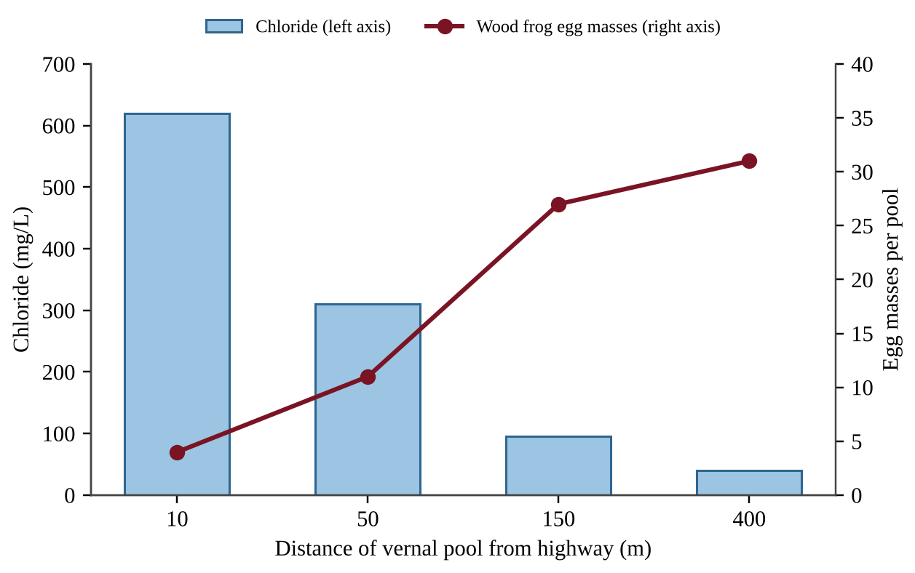
Figure — Chloride concentration and wood frog egg masses in four vernal pools
(a) Describe the relationship shown in the figure between a pool's distance from the highway and (i) its chloride concentration and (ii) the number of egg masses. [1] (b) Explain why the survey data alone do not show that chloride caused the low number of egg masses near the highway. [1] (c) State a testable hypothesis about the effect of chloride on wood frog eggs, and justify it using the concept of ecological tolerance. [2] (d) The biologist will test the hypothesis in a laboratory experiment. Identify the independent variable and the dependent variable. [2] (e) Describe an experimental procedure that includes the chloride treatments, a control, and replication, and identify two variables that should be held constant. [2] (f) Describe how the biologist should use the results to identify the range of chloride that the eggs can tolerate. [1] (g) Propose one solution that would reduce chloride entering vernal pools, and describe one tradeoff of your solution. [1]

Question 2 QB-U2-FRQ002
Ecologists studied vegetation on lava flows of different ages on a volcanic island. Each lava flow cooled to bare rock with no soil. Data from one plot on each flow are shown below.
Age of lava flow (years) | Dominant vegetation | Species richness | Total biomass (kg/m²) | NPP (kg/m²/yr)
5 | Lichens and mosses | 3 | 0.05 | 0.03
15 | Ferns and grasses | 9 | 0.4 | 0.25
30 | Shrubs | 18 | 2.1 | 0.80
60 | Young trees | 26 | 9.5 | 1.30
120 | Mixed mature forest | 24 | 18.0 | 1.10
250 | Old-growth forest | 22 | 21.0 | 1.00

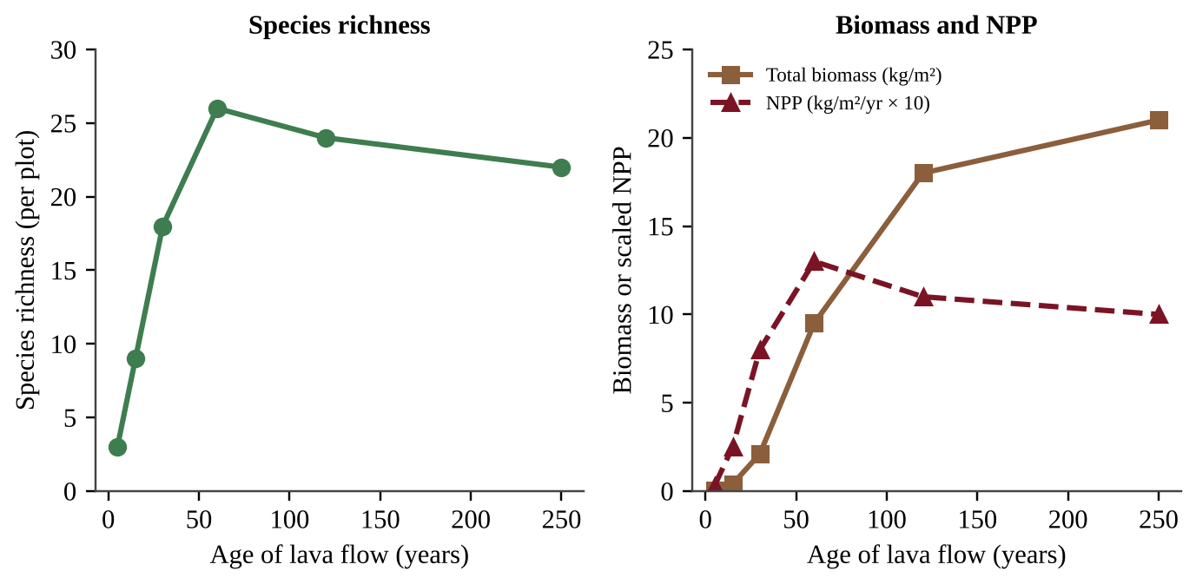
Figure — Species richness, total biomass, and scaled NPP on lava flows of different ages
(a) Identify the type of ecological succession shown, and justify your answer with evidence from the stem. [2] (b) Describe the trend in species richness from year 5 to year 250. [1] (c) Calculate the percent increase in total biomass between the 30-year-old and the 60-year-old flows. [1] (d) Calculate the ratio of NPP to total biomass (in yr⁻¹) for the 15-year-old flow and for the 250-year-old flow. [2] (e) Explain one reason that species richness declines slightly after year 60. [2] (f) A hurricane topples most of the trees on the 250-year-old flow but leaves the soil in place. Predict whether recovery will be faster or slower than the original colonization of the bare lava, and justify your prediction. [2]

Question 3 QB-U2-FRQ003
A coastal region contains 1,500 ha of mangrove forest. A developer proposes converting 20% of the mangrove area to shrimp ponds. Estimated values of three ecosystem services provided by the mangroves are shown below.
Ecosystem service | Value or rate (per hectare per year)
Storm protection (avoided property damage) | $7,200
Harvested fish and crabs | 380 kg, selling for $4.50 per kg
Carbon storage | 6.0 metric tons of CO₂, valued at $50 per metric ton

The shrimp ponds would produce a net profit of $3,800 per hectare per year for the developer.
(a) Calculate the total annual value of the three ecosystem services that would be lost if the proposal goes ahead. Show the area converted, the value per hectare of the fish and crab harvest, the value per hectare of all three services, and the total. [4] (b) Calculate the developer's total annual profit from the shrimp ponds, and calculate the net difference between the services lost and the profit gained. [2] (c) Calculate the mass of CO₂, in metric tons per year, that the converted area would no longer sequester. [1] (d) Identify the category of ecosystem service represented by (i) the fish and crab harvest and (ii) storm protection. [1] (e) Make a claim about whether the conversion benefits society, and justify it using your calculations. [1] (f) Propose one solution that would allow shrimp production while reducing the loss of ecosystem services. [1]

Question 4 QB-U2-FRQ004
Biologists surveyed land bird species on eight islands in an archipelago. Four islands lie close to the mainland and four lie far from it.
Island | Area (km²) | Distance from mainland (km) | Land bird species
A | 2 | 15 | 12
B | 10 | 12 | 20
C | 50 | 18 | 30
D | 200 | 10 | 41
E | 2 | 120 | 5
F | 10 | 140 | 9
G | 50 | 110 | 15
H | 200 | 130 | 22

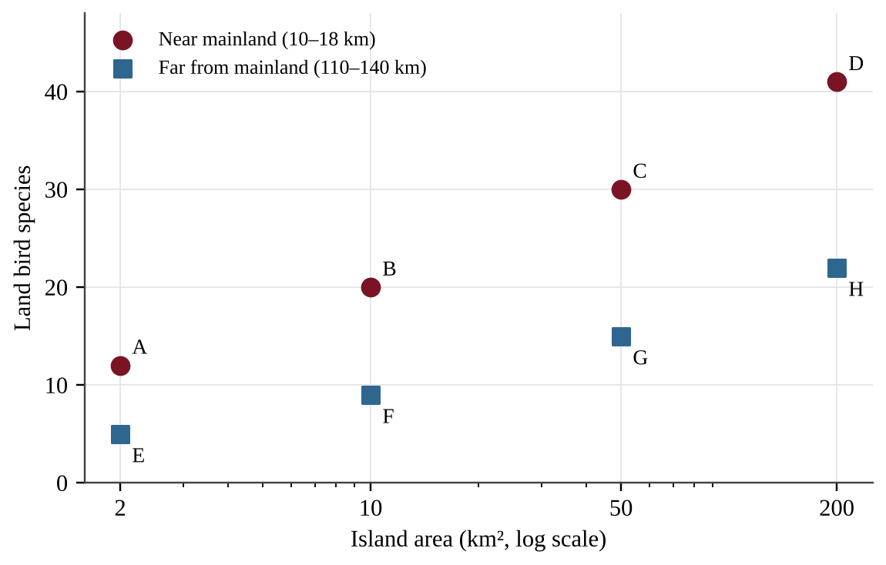
Figure — Land bird species richness and island area for near and far islands
Twenty years after black rats were accidentally introduced to Island C, a second survey found that the number of island specialist bird species had fallen from 18 to 9, while the number of generalist species had changed from 12 to 11.
(a) Describe the relationship between island area and species richness for the islands near the mainland. [1] (b) Calculate the percent difference in species richness between Island C and Island G, which have the same area but different distances from the mainland, relative to Island C. [1] (c) Using the theory of island biogeography, explain (i) why larger islands tend to support more species and (ii) why islands far from the mainland support fewer species than near islands of the same size. [2] (d) Calculate the percent change in the number of specialist species on Island C after the rats were introduced. [1] (e) Explain why the specialist birds on Island C were affected more than the generalists. [2] (f) Propose one solution that would protect the remaining specialist birds on island C. [1] (g) A new island of 100 km² lies 20 km from the mainland. Predict whether it would support more or fewer than 30 land bird species, and justify your prediction using the data. [2]

Unit 3 — Populations
NOTE
Exam weight: 10–15% of the AP Environmental Science exam (about 12–13 class periods). This unit assesses population ecology (generalists, r- and K-selection, survivorship, carrying capacity, resource limits) and human demography (age structure, fertility, growth calculations, the demographic transition). Expect data interpretation, rule-of-70 and rate-of-natural-increase calculations, and explanations of population trends from graphs and tables.

Section A — Multiple-Choice Questions
Question 1 QB-U3-MCQ001
Which statement best describes a specialist species?
A. It tolerates a wide range of conditions and is generally advantaged where its habitat is changing.
B. It reproduces rapidly and is generally advantaged where its habitat is repeatedly disturbed.
C. It has narrow habitat or resource requirements and is generally advantaged where its habitat stays constant.
D. It feeds on many different foods and is therefore rarely harmed by habitat loss.

Question 2 QB-U3-MCQ002
Which set of characteristics is typical of a K-selected species?
A. Few offspring, no parental care, early maturity, and a short life span
B. Many offspring, extensive parental care, late maturity, and a long life span
C. Many offspring, little parental care, short life span, and reproduction often only once
D. Few offspring, extensive parental care, long life span, and repeated reproduction

Question 3 QB-U3-MCQ003
A female oyster releases millions of eggs each season. Nearly all of the resulting larvae are eaten or die within days, but the few that settle on a reef may live for years. Which survivorship curve and reproductive strategy best fit this species?
A. Type II curve; K-selected strategy
B. Type III curve; r-selected strategy
C. Type I curve; K-selected strategy
D. Type III curve; K-selected strategy

Question 4 QB-U3-MCQ004
Which statement best defines the carrying capacity of an environment for a species?
A. The population size at which the number of individuals added per year is greatest
B. The maximum population size that the environment can sustain indefinitely given its available resources
C. The maximum number of offspring a population could produce in one year under ideal conditions
D. The number of individuals originally introduced to or present in a new habitat

Question 5 QB-U3-MCQ005
A few rabbits are released on an island that has abundant grass, water, and shelter, and no predators. During the first several years, which pattern of population growth is most likely?
A. Growth stays constant at the same number of rabbits added each year.
B. Growth slows from the start because the population has reached carrying capacity.
C. Growth stops almost immediately because the island's resources are finite.
D. Growth accelerates because each new generation includes more reproducing individuals.

Question 6 QB-U3-MCQ006
An age structure diagram has a very wide base for the youngest age groups and becomes much narrower at each successive older age group. What does this shape indicate?
A. Many young people, so the population is likely to grow rapidly
B. A high proportion of retirees relative to working-age adults
C. A declining population because the oldest age groups are small in number
D. A nearly stable population in which births and deaths are about equal

Question 7 QB-U3-MCQ007
A country has a total fertility rate (TFR) of 2.1 and negligible immigration and emigration. Which prediction is most reasonable?
A. Its population will be relatively stable over the long term.
B. Its population will decline sharply because 2.1 is a low fertility rate.
C. Its population will double in about 35 years.
D. Its population will grow rapidly because every woman has at least two children.

Question 8 QB-U3-MCQ008
Which pair of processes adds individuals to a human population?
A. Deaths and immigration
B. Deaths and emigration
C. Births and immigration
D. Births and emigration

Question 9 QB-U3-MCQ009
In the four-stage demographic transition model, which stage has both high birth rates and high death rates, resulting in very slow population growth?
A. Stage 1
B. Stage 2
C. Stage 3
D. Stage 4

Question 10 QB-U3-MCQ010
When a population grows well above the carrying capacity of its environment, which outcome is most likely?
A. Birth rates increase because competition for each resource declines.
B. The population stabilizes immediately at its new, larger size.
C. The carrying capacity rises permanently because a larger population uses resources more efficiently.
D. Resources become depleted, and the population experiences a dieback.

Question 11 QB-U3-MCQ011
Which pattern is characteristic of a Type I survivorship curve?
A. Survivorship drops steeply in mid-life and then levels off for the oldest individuals.
B. Mortality is highest among the youngest individuals, and survivors live much longer.
C. Most individuals survive to old age, and mortality is concentrated late in life.
D. The probability of dying is about the same at every age.

Question 12 QB-U3-MCQ012
Which of the following is a density-independent factor that can limit a population?
A. Competition among crowded birds for scarce nesting sites
B. A wildfire that kills organisms in its path
C. Faster spread of an infectious disease through a crowded herd of animals
D. Depletion of the local food supply by a large, dense population

Question 13 QB-U3-MCQ013
Which statement best defines the biotic potential of a species?
A. The number of individuals that enter a population each year through immigration
B. The maximum reproductive rate of a population under ideal conditions
C. The average number of offspring that survive to adulthood in a natural habitat
D. The maximum number of individuals an environment can support indefinitely

Question 14 QB-U3-MCQ014
A coastal lagoon is dredged, and its seagrass beds are replaced by bare mud. Before dredging, two fish species lived in the lagoon. Species 1 eats almost only seagrass shoots and lays eggs only in seagrass. Species 2 eats seagrass, worms, small crustaceans, and dead organic matter, and spawns in many habitats. Which prediction is best supported?
A. Both species will decline by the same amount because both fed on seagrass before dredging.
B. Species 1 is more likely to persist because specialization makes it efficient in new habitats.
C. Species 2 is more likely to persist because it can use a wider range of foods and habitats.
D. Species 1 will switch to worms and crustaceans as easily as Species 2 can.

Question 15 QB-U3-MCQ015
The table lists four species. Assume ideal conditions for all of them.
Species | Adult mass | Offspring per reproductive event | Age at first reproduction | Typical life span
P | 0.03 kg | 400 eggs | 0.4 years | 1 year
Q | 4,000 kg | 1 calf | 11 years | 65 years
R | 6 kg | 3 young | 4 years | 18 years
S | 0.5 kg | 8 young | 1 year | 4 years

Which species most likely has the highest biotic potential?
A. Species P, because it produces many offspring and matures very early
B. Species Q, because its large body size gives it the greatest resource reserves
C. Species S, because it has the best balance of litter size and age at maturity
D. Species R, because it has several young and lives long enough to reproduce repeatedly

Question 16 QB-U3-MCQ016
A predatory fish is introduced to a lake that contains two native species. One native is K-selected (large, few young, long-lived), and the other is r-selected (small, many young, short-lived). Which statement best explains why the K-selected native is typically more adversely affected by the invasive species over the long term?
A. It reproduces so quickly that its numbers soon exceed the lake's carrying capacity.
B. It has a short life span, so each individual is exposed to the invader only briefly.
C. It reproduces slowly, so it cannot quickly replace the individuals lost to predation or competition.
D. It faces less competition for resources than the r-selected species, so it declines first.

Question 17 QB-U3-MCQ017
The graph shows three possible survivorship curves, plotted on a logarithmic vertical axis.
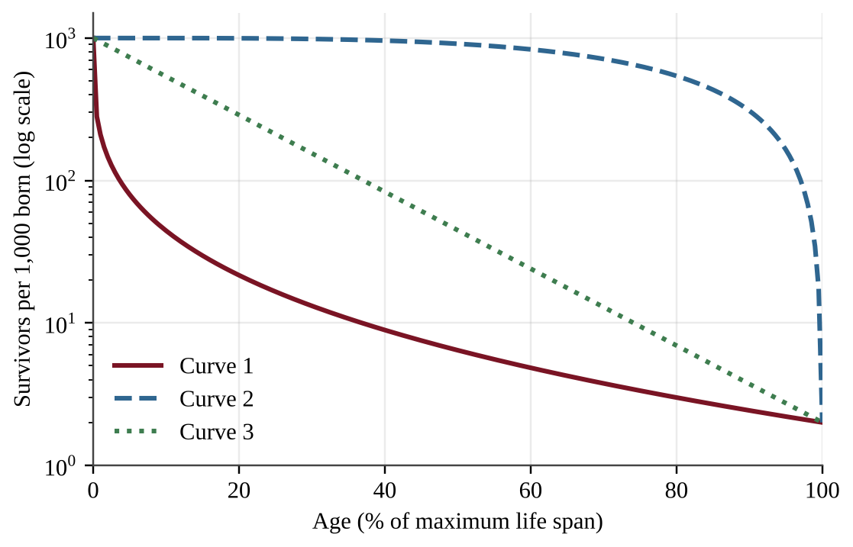
Figure — Survivorship curves 1, 2, and 3 for cohorts of 1,000 individuals
Which curve is most likely to describe a large mammal that bears one calf at a time and provides years of parental care?
A. Curve 1, because a species with few offspring must lose most of them early in life
B. Curve 3, because the chance of dying is about the same at every age
C. Curve 1, because mortality is highest among the youngest individuals
D. Curve 2, because most individuals survive until old age

Question 18 QB-U3-MCQ018
Refer to the same graph of survivorship curves.
Figure — Survivorship curves 1, 2, and 3 for cohorts of 1,000 individuals
A researcher finds that in a certain lizard species, an individual has about the same probability of dying at any age. Which curve best represents this species?
A. Curve 3, because a constant percentage of survivors dies in each time interval
B. Curve 2, because lizards are small and therefore have few predators
C. Curve 2, because the same number of individuals dies in every time interval
D. Curve 1, because the probability of dying declines steadily with age

Question 19 QB-U3-MCQ019
A population of bighorn sheep was introduced to a mountain basin. The graph shows population size over time; the dashed line is the carrying capacity.
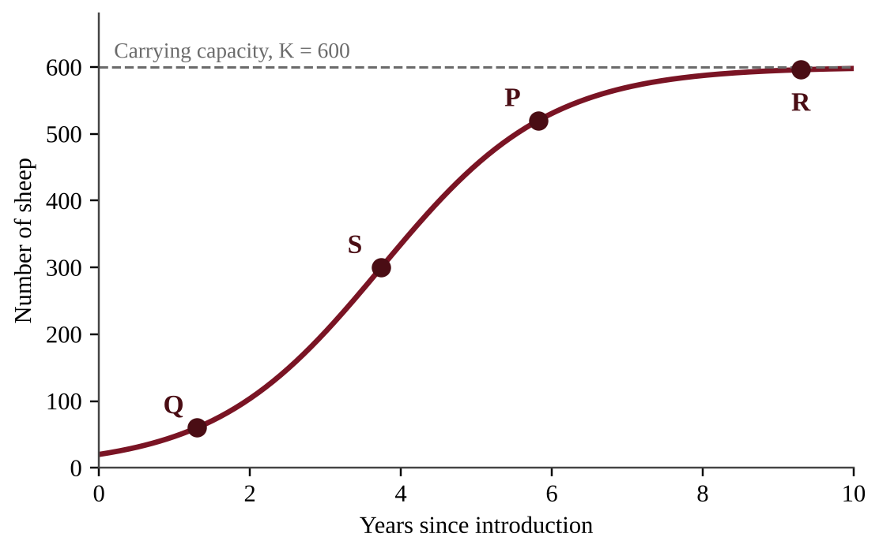
Figure — Bighorn sheep population after introduction, with points P, Q, R, and S marked
At which point is the population increasing by the greatest number of individuals per year?
A. Point P
B. Point Q
C. Point R
D. Point S

Question 20 QB-U3-MCQ020
A deer herd was introduced to an island with no predators, and its size and the biomass of the available browse (leaves and twigs) were measured for 14 years. Weather records show no unusual storms, droughts, or cold snaps during the study.
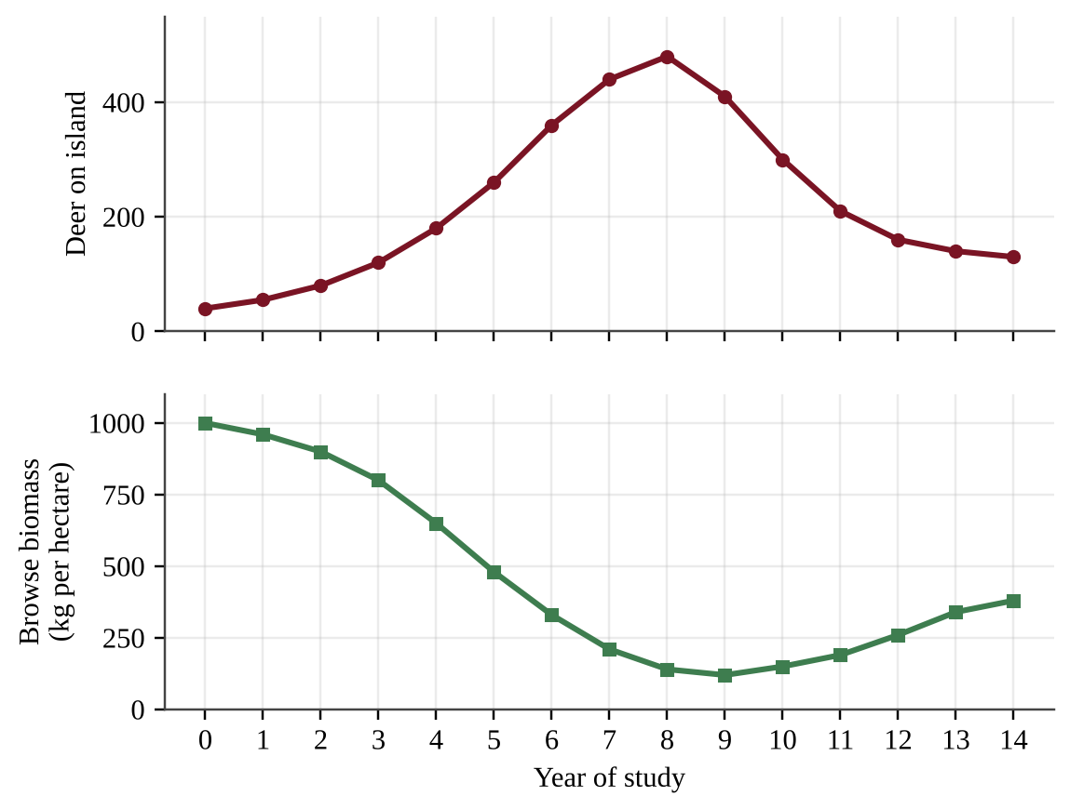
Figure — Deer population and browse biomass on an island over 14 years
Which statement best explains the decline in the deer population after year 8?
A. A density-independent event, such as a severe winter or storm, killed deer regardless of herd size.
B. The herd exceeded the carrying capacity set by browse, depleted that resource, and then experienced dieback.
C. The biotic potential of the deer decreased because food was too plentiful in the early years of the study.
D. The carrying capacity of the island increased as the browse became less abundant.

Question 21 QB-U3-MCQ021
A student wants to test the hypothesis that the surface area of a pond limits the growth of a floating duckweed population. Which experimental design is best?
A. Grow one tub with a large surface area in bright light and one with a small surface area in dim light, and count plants weekly.
B. Start equal numbers of plants in replicate tubs of identical solution and light, vary only the surface area, and count plants every three days.
C. Start different numbers of plants in same-sized tubs of identical solution and compare final counts after three weeks.
D. Use one tub for each surface area and add extra fertilizer to the largest tub to be sure that growth is not limited by nutrients.

Question 22 QB-U3-MCQ022
Three yeast cultures were started with the same small number of cells in flasks that differed only in glucose concentration. All flasks were kept at the same temperature and shaken the same way.
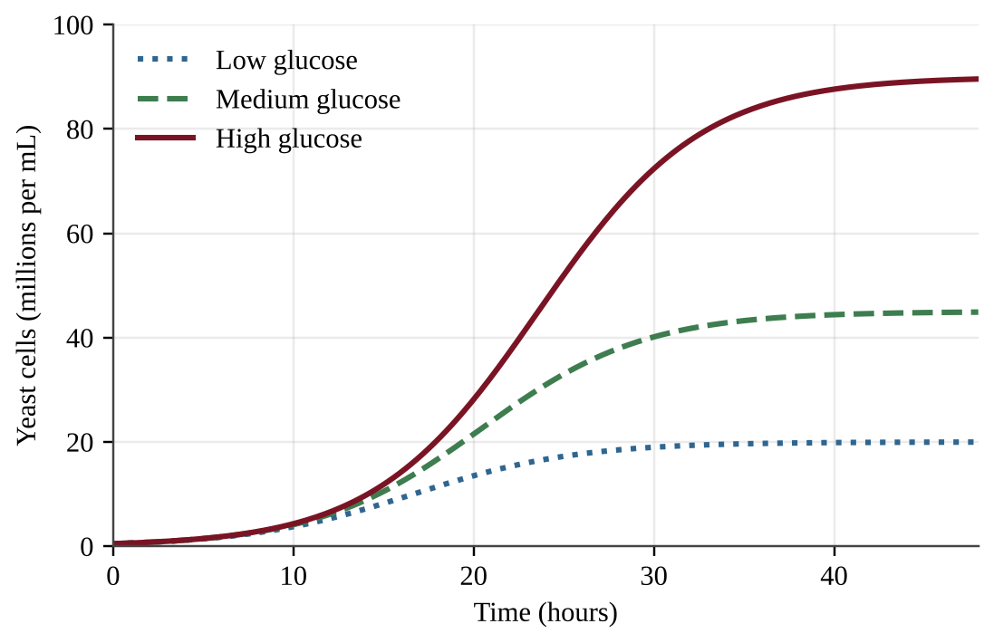
Figure — Yeast population growth in flasks with low, medium, and high glucose
Which conclusion is best supported by the data?
A. The leveling off was caused by a density-independent factor, because the temperature and shaking were the same in all flasks.
B. All three cultures leveled off at the same carrying capacity, because the flasks were the same size and temperature.
C. The amount of available glucose set the carrying capacity: more glucose supported a larger plateau population.
D. Glucose concentration had no effect on population growth because all cultures grew rapidly at first.

Question 23 QB-U3-MCQ023
The figure shows age structure diagrams for four countries.
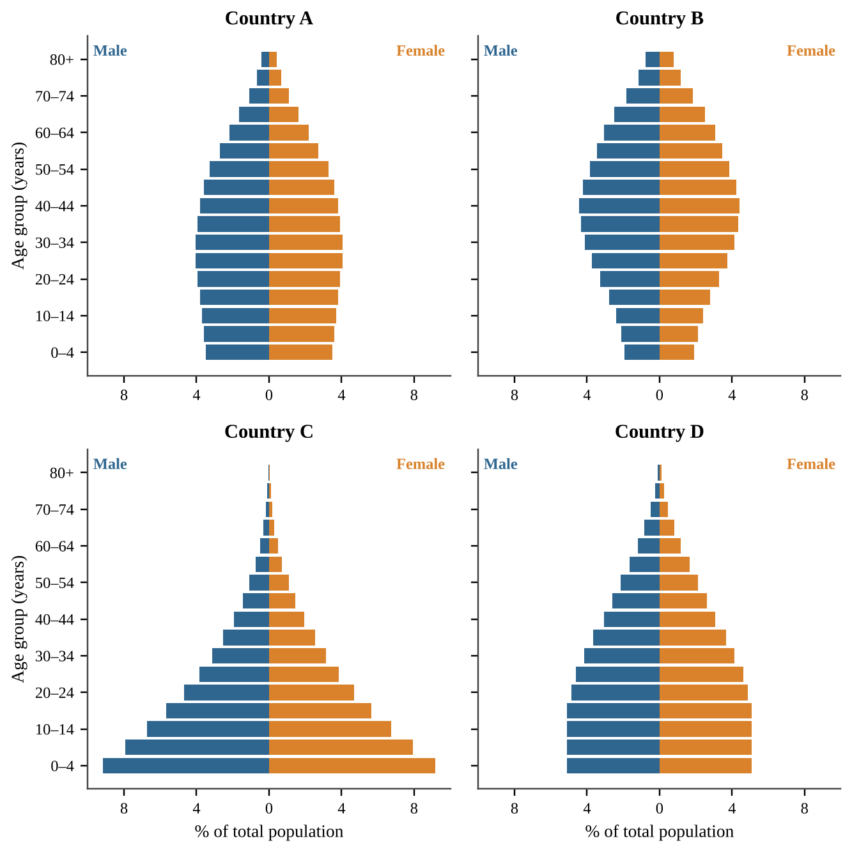
Figure — Age structure diagrams for Countries A, B, C, and D
Assuming negligible migration, which country is likely to have the highest population growth rate over the next decade?
A. Country A
B. Country B
C. Country C
D. Country D

Question 24 QB-U3-MCQ024
Refer to the age structure diagrams for Countries A–D.
Figure — Age structure diagrams for Countries A, B, C, and D
Which country will most likely experience the largest increase in the number of retirees per working-age adult over the next 30 years?
A. Country A
B. Country B
C. Country C
D. Country D

Question 25 QB-U3-MCQ025
A country passes a law requiring girls to stay in school through age 18 and opens family planning clinics in rural districts. Which change in TFR over the next 20 years is most likely?
A. TFR will increase because healthier, better-educated women will have more children.
B. TFR will decrease only if the infant mortality rate rises at the same time.
C. TFR will stay the same because fertility is determined only by biology.
D. TFR will decrease as the average age at first birth rises and more women can plan family size.

Question 26 QB-U3-MCQ026
Region 1 has an infant mortality rate of 9 deaths per 1,000 live births, and Region 2 has a rate of 71 deaths per 1,000 live births. Which difference between the regions most likely explains the gap?
A. Region 1 has a larger total population.
B. Mothers in Region 1 have better access to healthcare and nutrition.
C. Region 1 has a higher total fertility rate.
D. Region 1 has a larger proportion of children in the workforce.

Question 27 QB-U3-MCQ027
A country's population is growing at 0.7% per year. Using the rule of 70, about how many years will it take the population to double?
A. 10 years
B. 49 years
C. 70 years
D. 100 years

Question 28 QB-U3-MCQ028
A country has a crude birth rate of 17 and a crude death rate of 11, both per 1,000 people per year. Migration is negligible. What is the rate of natural increase (RNI)?
A. 0.6%
B. 6%
C. 28%
D. 60%

Question 29 QB-U3-MCQ029
During an outbreak of an infectious disease, health workers recorded the following in four villages.
Village | Population density (people per km²) | People infected (%)
1 | 20 | 2
2 | 60 | 5
3 | 150 | 14
4 | 300 | 31

Which conclusion is best supported by the data?
A. Disease affected the villages equally because the number of infected people rose in each one.
B. Disease acted as a density-independent factor because every village had infected people.
C. Disease can only limit a population that is already below its carrying capacity.
D. Disease acted as a density-dependent factor because the share infected rose with density.

Question 30 QB-U3-MCQ030
The graph shows birth and death rates through the four stages of the demographic transition model.
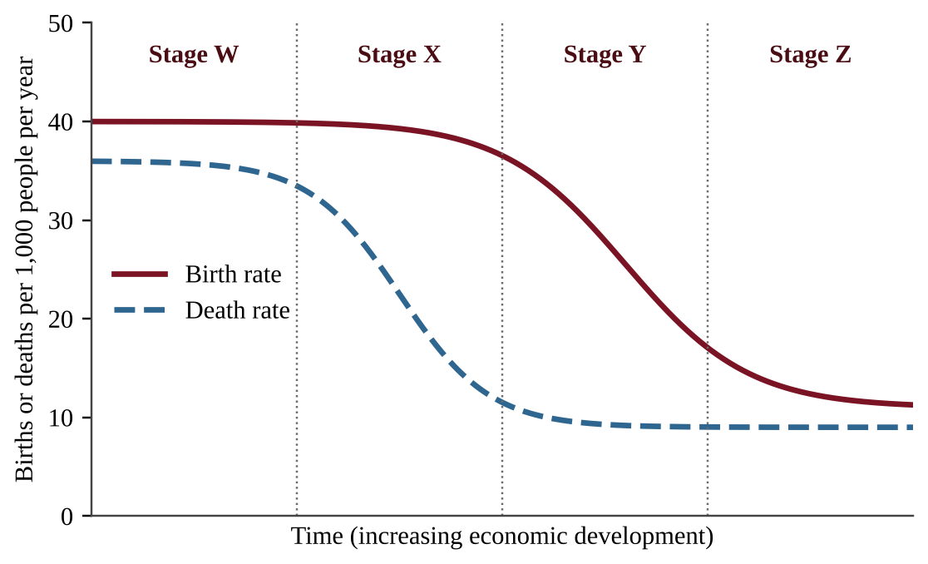
Figure — Birth rate and death rate across Stages W, X, Y, and Z
Which stage best fits a country in which vaccination and clean drinking water have caused the death rate to fall sharply while the birth rate remains high?
A. Stage X
B. Stage W
C. Stage Y
D. Stage Z

Question 31 QB-U3-MCQ031
Compared with developed countries, developing countries typically have which pair of characteristics?
A. Higher infant mortality rates and more children in the workforce
B. Lower infant mortality rates and more children in the workforce
C. Higher infant mortality rates and fewer children in the workforce
D. Lower infant mortality rates and lower birth rates

Question 32 QB-U3-MCQ032
In the late 1700s Thomas Malthus argued that human populations are ultimately limited by food supply. Which statement best summarizes the Malthusian view?
A. Population growth always slows as nations industrialize because families choose to have fewer children, so food supply is never the limit.
B. Technology will always increase carrying capacity as quickly as population grows, preventing shortages.
C. Population tends to grow exponentially while food supply grows only linearly, so famine, disease, and conflict eventually check growth.
D. Food supply grows faster than population, so shortages can occur only through unequal distribution of food among regions.

Question 33 QB-U3-MCQ033
Which statement about r-selected and K-selected reproductive strategies is most accurate?
A. r-selected species are always larger than K-selected species of the same group.
B. K-selected species have a higher biotic potential than r-selected species do.
C. Many species show a mix of traits or shift strategy, so the categories form a continuum.
D. Every species can be placed into exactly one of the two categories without overlap.

Question 34 QB-U3-MCQ034
Which change would most likely increase the carrying capacity of a grassland for bison?
A. Several years of above-average rainfall
B. A long-term drought that reduces grass growth
C. The addition of more bison from another herd
D. The introduction of cattle that graze the same grassland

Question 35 QB-U3-MCQ035
The graph shows total fertility rate and the percentage of girls enrolled in secondary school for ten countries.
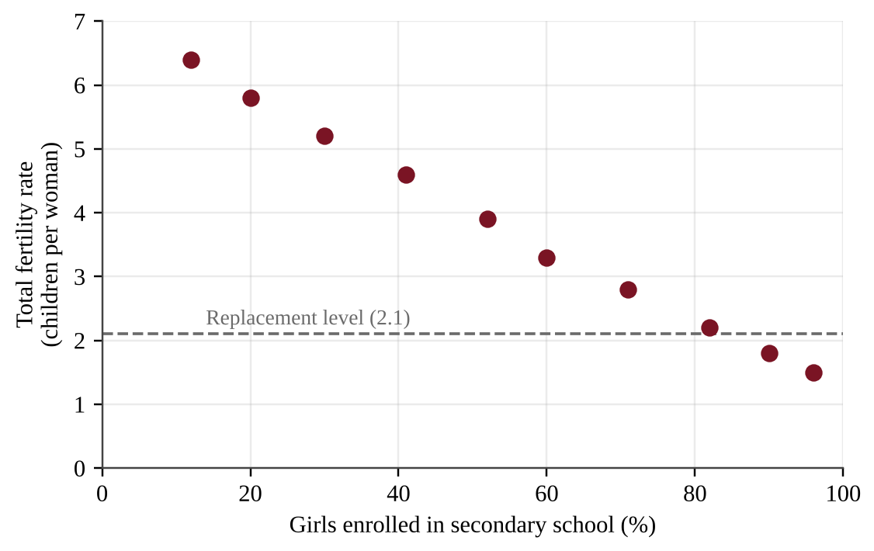
Figure — Total fertility rate versus girls' secondary school enrollment in ten countries
Which statement is best supported by the data?
A. Raising enrollment by 10 percentage points will lower the TFR of any country by about 0.6 children per woman.
B. Countries with a TFR above 4 have more than half of their girls enrolled in secondary school.
C. Total fertility rate does not vary with girls' secondary school enrollment.
D. Every country in which at least 90% of girls are enrolled has a TFR below the replacement level of about 2.1.

Question 36 QB-U3-MCQ036
Country Z lowered its total fertility rate from 5.8 to 2.1 over the past 15 years, but its population is still growing by about 1.8% per year with negligible migration. Which is the best explanation?
A. A TFR of 2.1 is well above replacement level, so rapid growth is still expected.
B. A large share of its population is entering the reproductive years, so births still exceed deaths.
C. Replacement-level fertility cannot reduce growth in any country that has had a high birth rate.
D. TFR does not count children who die, so true fertility must still be near 5.8 per woman.

Question 37 QB-U3-MCQ037
A wildlife reserve produces 150,000 kg of usable winter forage each year, and each elk needs 1,500 kg of forage per winter. The reserve currently has 130 elk. Assuming that forage is the only limiting resource, by approximately what percent does the current herd exceed the carrying capacity?
A. 23%
B. 30%
C. 77%
D. 130%

Question 38 QB-U3-MCQ038
A country has 18 million people and a population growth rate of 2.5% per year. If this rate stays constant, about how large will the population be in 56 years?
A. 36 million
B. 54 million
C. 72 million
D. 144 million

Question 39 QB-U3-MCQ039
A country has a crude birth rate of 14 and a crude death rate of 9 per 1,000 people per year. Net migration adds 4 people per 1,000 per year. Using the rule of 70 with the total annual growth rate, about how long will the population take to double?
A. 8 years
B. 39 years
C. 78 years
D. 140 years

Question 40 QB-U3-MCQ040
Researchers counted a population of ground squirrels introduced to an island with limited food.
Year | 0 | 1 | 2 | 3 | 4 | 5 | 6 | 7 | 8 | 9
Squirrels | 50 | 120 | 270 | 480 | 650 | 740 | 780 | 790 | 792 | 790

Which option correctly identifies the interval with the greatest increase in number of squirrels and the best estimate of the carrying capacity?
A. Years 2 to 3; carrying capacity of about 790 squirrels
B. Years 2 to 3; carrying capacity of about 480 squirrels
C. Years 5 to 6; carrying capacity of about 740 squirrels
D. Years 0 to 1; carrying capacity of about 120 squirrels

Question 41 QB-U3-MCQ041
A country has a crude birth rate of 41 and a crude death rate of 11 per 1,000 people per year, with negligible migration. Which option correctly identifies its stage in the demographic transition model and its approximate doubling time?
A. Stage 2; about 230 years
B. Stage 1; about 2.3 years
C. Stage 4; about 23 years
D. Stage 2; about 23 years

Question 42 QB-U3-MCQ042
Researchers followed a cohort of 5,000 newly hatched fish for five years.
Age (years) | 0 | 1 | 2 | 3 | 4 | 5
Survivors | 5,000 | 400 | 300 | 225 | 150 | 80

Which option correctly gives the survivorship curve type and the percentage of the cohort that died before age 1?
A. Type III; 92%
B. Type III; 8%
C. Type I; 92%
D. Type II; 8%

Question 43 QB-U3-MCQ043
An ecologist wants to test whether partial clearcutting of a forest favors generalist small mammals over specialist small mammals. Which study design is best?
A. Count all small mammals in cut plots and compare the total with a published average from a different forest and decade.
B. Count only the generalist species in one cut plot before and after the cutting takes place, with no uncut comparison plot.
C. Compare one cut plot at low elevation with one uncut plot at high elevation, trapping each for one night.
D. Trap and count a generalist and a specialist in several pairs of similar cut and uncut plots, using equal trapping effort in every plot.

Question 44 QB-U3-MCQ044
Researchers place 10, 40, 160, or 640 flour beetles in identical containers that each hold the same amount of flour, with five containers per density. After two weeks they count the eggs laid per female. Which result would indicate that fecundity is limited by a density-dependent factor?
A. Eggs per female are nearly identical at all four densities.
B. Eggs per female decrease steadily as the starting density increases.
C. Eggs per female increase steadily as the starting density increases.
D. Eggs per female vary randomly among containers with no link to starting density.

Section B — Free-Response Questions
Question 1 QB-U3-FRQ001
A population of mountain goats lives on an alpine plateau in a national park with no hunting and few predators. Park biologists counted the goats each summer and measured the biomass of winter forage (grasses and sedges) each spring. The goat population rose for ten years and then declined and leveled off.
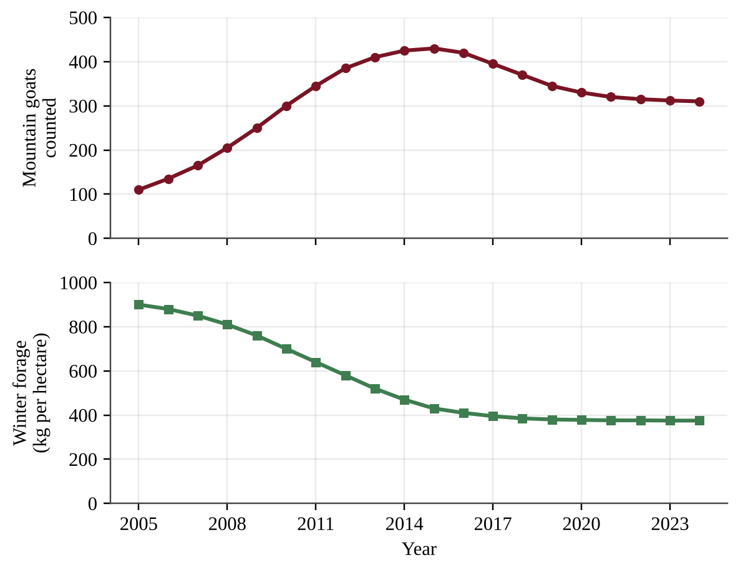
Figure — Mountain goat counts and winter forage biomass, 2005–2024
A biologist hypothesizes that the amount of winter forage, rather than disease or predation, limits the size of the goat population. To test this, the park proposes a supplemental-feeding experiment in six separate winter ranges on the plateau. Three ranges would receive supplemental forage pellets and three would not.
(a) Describe the pattern shown in the data for the goat population and for winter forage between 2005 and 2024. [1]
(b) Write a testable hypothesis, in an if–then format, that predicts how supplemental feeding will affect the goat population. [1]
(c) For the proposed experiment, identify the following. [3] (i) The independent variable (ii) One dependent variable (iii) One variable that should be controlled
(d) Describe two features of the experimental procedure that would increase the reliability or validity of the results. [2]
(e) Describe the results that would support the biologist's hypothesis. [1]
(f) If the hypothesis is supported, propose a management solution to keep the goat population within the plateau's carrying capacity and justify your proposal. [2]

Question 2 QB-U3-FRQ002
The table and graph show demographic data for the country of Oren, which has had negligible migration. Infant mortality rate (IMR) is in deaths per 1,000 live births, and TFR is in children per woman.
Year | Crude birth rate (per 1,000) | Crude death rate (per 1,000) | TFR | IMR | Girls enrolled in secondary school (%)
1960 | 44 | 24 | 6.4 | 140 | 9
1980 | 42 | 13 | 5.9 | 95 | 18
2000 | 30 | 8 | 3.7 | 48 | 46
2020 | 19 | 7 | 2.2 | 17 | 84

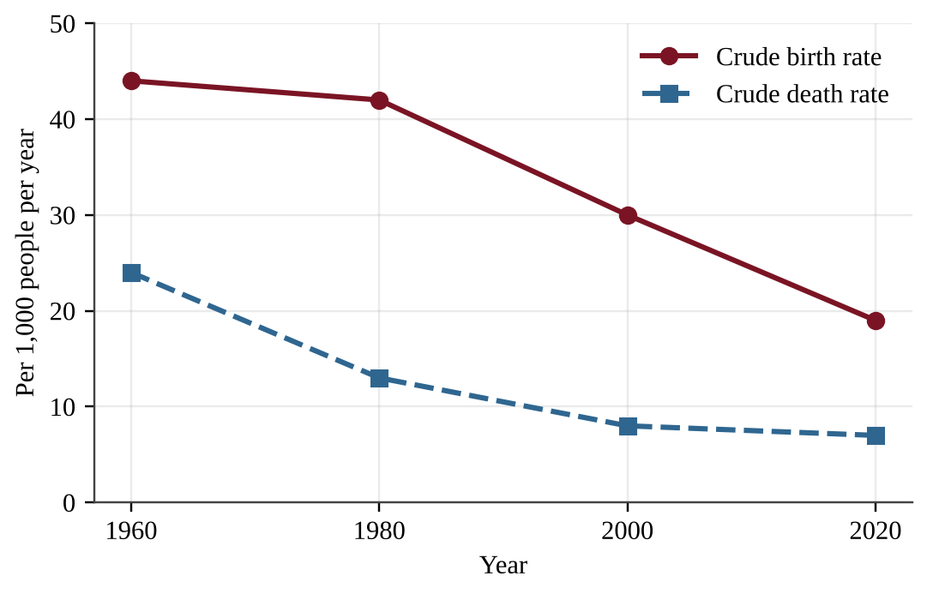
Figure — Crude birth rate and crude death rate in Oren, 1960–2020
(a) Describe the trends in the crude birth rate and the crude death rate between 1960 and 2020. [2]
(b) Calculate the rate of natural increase (RNI) for 1980 as a percentage. Show your work. [1]
(c) Using your answer to part (b) and the rule of 70, calculate the doubling time of Oren's population in 1980. Show your work. [1]
(d) Explain how two of the factors shown in the table contributed to the decline in TFR. [2]
(e) Identify the stage of the demographic transition model that Oren was in during 1980 and justify your answer with data. [2]
(f) Predict how the age structure diagram of Oren in 2040 will differ from the one in 1980, assuming TFR remains near replacement level. [1]
(g) Propose one government action to prepare for the change in age structure you described in part (f), and justify it. [1]

Question 3 QB-U3-FRQ003
The island nation of Teluva has a population of 5.0 million people. In the most recent year there were 125,000 births, 45,000 deaths, 20,000 immigrants, and 5,000 emigrants. The average person in Teluva eats 0.55 kg of grain per day. Teluva's farms produce 850,000 metric tons of grain per year. (1 metric ton = 1,000 kg.) Assume a 365-day year.
(a) Calculate the annual population growth rate of Teluva as a percentage, including migration. Show your work. [2]
(b) Calculate the rate of natural increase (RNI) of Teluva as a percentage. Show your work. [1]
(c) Using your answer to part (a) and the rule of 70, calculate the doubling time of Teluva's population and the population size at the end of one doubling time. Show your work. [2]
(d) Calculate the current annual grain demand of Teluva in metric tons. Show your work. [1]
(e) Calculate the current annual grain shortfall in metric tons. [1]
(f) Explain one reason that Teluva's population growth rate might decline over the next several decades as the country develops. [1]
(g) Propose a solution to the grain shortfall that Teluva is likely to face as its population grows, and justify your proposal using your results above. [2]

Question 4 QB-U3-FRQ004
Researchers followed two cohorts of 1,000 newborns each. Species X is a large, hunted mountain mammal that gives birth to one young at a time and cares for it for a year. Species Y is a small marine fish that releases about 40,000 eggs per female each year and provides no parental care. The table and graph show the number of survivors at each age.
Age (years) | Species X survivors | Species Y survivors
0 | 1,000 | 1,000
1 | 950 | 60
2 | 880 | 45
4 | 840 | 25
6 | 790 | 12
8 | 700 | 5
10 | 520 | none alive
12 | 250 | none alive
14 | 40 | none alive

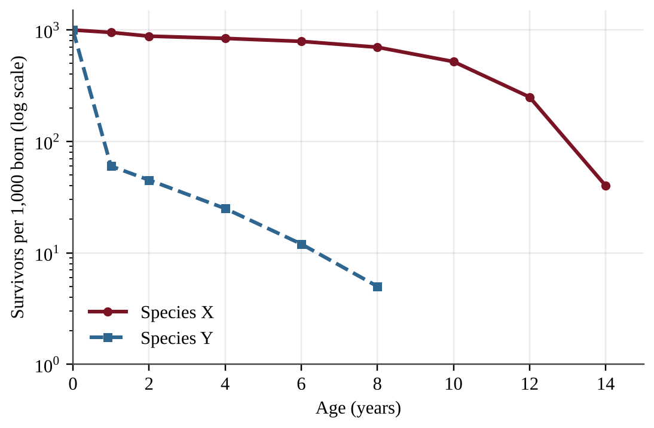
Figure — Survivors per 1,000 born for Species X and Species Y (logarithmic scale)
(a) Describe two differences between the survivorship patterns of Species X and Species Y. [2]
(b) Calculate the percentage of the Species Y cohort that died before age 1, and the percentage of the Species X cohort that survived to age 10. Show your work. [2]
(c) Identify the survivorship curve type for each species, and identify the reproductive strategy (r-selected or K-selected) of each. [2]
(d) Explain how the survivorship pattern of Species Y accounts for the very large number of eggs it releases. [1]
(e) Suppose that hunting removes 30% of the adults from each species in a single year. Make a claim about which species will recover faster, and justify it with a characteristic of each species. [2]
(f) Propose a management measure that would help prevent a decline in Species X, and justify it. [1]

Unit 4 — Earth Systems and Resources
NOTE
Exam weight: Unit 4 accounts for 10–15% of the AP Environmental Science exam score. This set assesses plate tectonics, soil formation and properties, the atmosphere, global wind patterns, watersheds, solar radiation and seasons, geography and climate, and El Niño and La Niña (Topics 4.1–4.9). It also tests how you read maps, soil profiles, graphs, and climatograms, and how you apply calculations; a calculator is allowed.

Section A — Multiple-Choice Questions
Question 1 QB-U4-MCQ001
Two oceanic plates converge, and the older, denser plate sinks beneath the other. Which landform is most likely to develop on the overriding plate?
A. A rift valley with new crust forming along its axis
B. A mid-ocean ridge running parallel to the boundary
C. A long transform fault that offsets the seafloor
D. A curved chain of volcanic islands (an island arc)

Question 2 QB-U4-MCQ002
Which statement best describes how an earthquake occurs along a locked fault?
A. Rising magma fractures the crust, and the escaping gases make the ground shake along the fault.
B. The plates stop moving completely, and the stored thermal energy escapes as seismic waves.
C. The fault slips smoothly and continuously, so the stored energy is released at a steady rate.
D. Stress builds until it exceeds the strength of the fault, and the stored energy is released as the rocks slip.

Question 3 QB-U4-MCQ003
Soils develop from parent material. Which of the following best describes parent material?
A. The rock or sediment that is weathered to form the mineral part of a soil
B. The dark surface layer of humus and partly decomposed leaves in the soil
C. The dissolved nutrients that plant roots take up from the soil water
D. The solid, unweathered bedrock that lies below every soil profile

Question 4 QB-U4-MCQ004
Assume parent material, slope, and time are the same at four sites. At which site would soil form most rapidly?
A. A cold, dry site where water and biological activity are limited
B. A hot, arid site where rainfall is very low
C. A warm, humid site where chemical weathering and decomposition are fastest
D. A cold, wet site where water is present but frozen much of the year

Question 5 QB-U4-MCQ005
How do soils help protect the quality of water that moves through them?
A. Soil changes every dissolved pollutant into harmless minerals, no matter how much is applied.
B. Soil particles and organisms filter, adsorb, and break down some contaminants as water percolates.
C. Soil prevents water from reaching groundwater, so pollutants cannot spread below the surface.
D. Soil increases surface runoff, which dilutes pollutants before they can enter streams.

Question 6 QB-U4-MCQ006
Which soil particle class, when it dominates a soil, generally gives the highest permeability?
A. Sand, because its large particles leave large, well-connected pores
B. Silt, because its medium particles pack together loosely
C. Clay, because its many tiny pores add up to the largest passageways
D. Loam, because a mixture of particle sizes opens the widest channels

Question 7 QB-U4-MCQ007
The table gives the approximate composition of dry air near Earth's surface, with the gases hidden as W, X, Y, and Z.
Gas | Percent by volume
W | 78
X | 21
Y | 0.93
Z | 0.04

Which identification of the four gases is correct?
A. W = oxygen, X = nitrogen, Y = argon, Z = carbon dioxide
B. W = nitrogen, X = oxygen, Y = argon, Z = carbon dioxide
C. W = nitrogen, X = oxygen, Y = carbon dioxide, Z = argon
D. W = nitrogen, X = argon, Y = oxygen, Z = carbon dioxide

Question 8 QB-U4-MCQ008
Scientists divide the atmosphere into the troposphere, stratosphere, mesosphere, thermosphere, and exosphere. These layers are distinguished mainly by
A. large differences in the proportions of nitrogen and oxygen from layer to layer.
B. the altitude at which air pressure drops to zero.
C. the presence or absence of water vapor in the air.
D. reversals in the direction of temperature change with increasing altitude.

Question 9 QB-U4-MCQ009
Winds do not blow in straight lines between the equator and the poles. Which factor causes moving air to be deflected to the right in the Northern Hemisphere?
A. Earth's rotation (the Coriolis effect)
B. Greater heating of land than of ocean
C. The Moon's gravitational pull on the atmosphere
D. The tilt of Earth's axis of rotation

Question 10 QB-U4-MCQ010
A ridge of high ground that separates one watershed from the neighboring watershed is called a
A. floodplain.
B. divide.
C. delta.
D. recharge zone.

Question 11 QB-U4-MCQ011
Which statement best explains why the Northern Hemisphere has warmer summers than winters?
A. In summer Earth is closer to the Sun than it is in winter, so it receives more energy.
B. The Sun gives off noticeably more energy in June than in December, which warms the whole planet.
C. In summer the Northern Hemisphere is tilted toward the Sun, giving more direct sunlight and longer days.
D. Earth rotates faster in summer, so the Sun heats the surface more strongly.

Question 12 QB-U4-MCQ012
A city on the leeward side of a mountain range that lies across the prevailing wind is much drier than a city on the windward side. Which explanation is best?
A. Air loses moisture as precipitation while rising and cooling on the windward side, then descends and warms on the leeward side.
B. Mountains absorb water vapor from the passing air and keep it, leaving little moisture for the leeward side.
C. Mountains block sunlight from the leeward side, which cools the air there and reduces evaporation and rainfall.
D. Winds reverse direction at the crest, so no moist air from the ocean ever reaches the leeward side of the range.

Question 13 QB-U4-MCQ013
During an El Niño event, sea surface temperatures in the central and eastern tropical Pacific Ocean are
A. unusually cold.
B. close to average, while the Atlantic Ocean warms sharply.
C. unusually warm.
D. unusually warm only in the far western Pacific.

Question 14 QB-U4-MCQ014
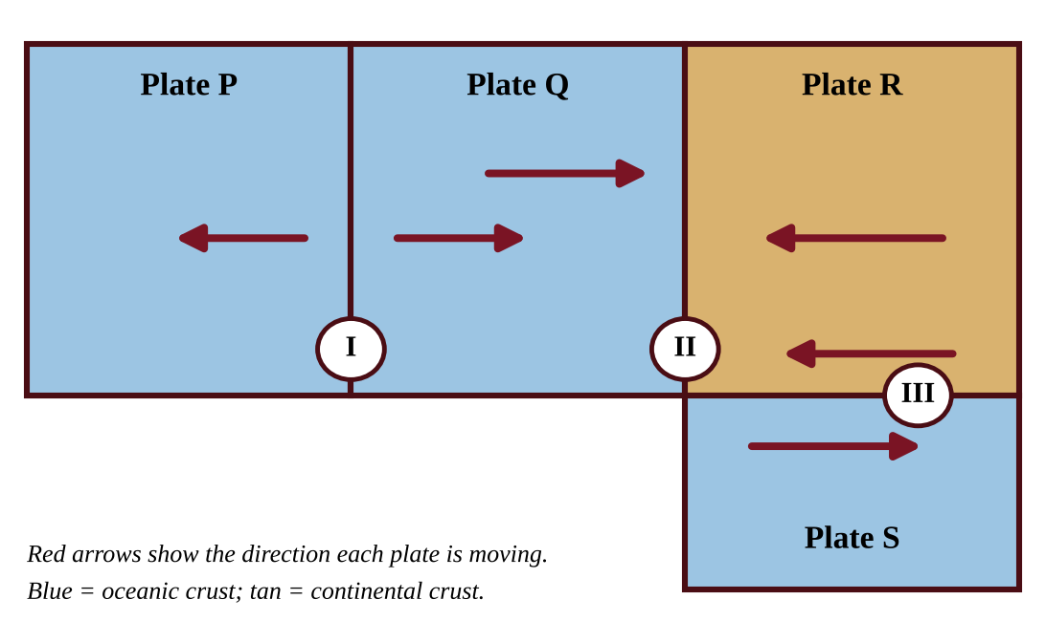
Figure — Map view of four lithospheric plates and three plate boundaries
Plate Q is oceanic crust and Plate R is continental crust. Which statement best describes events along Boundary II?
A. Plates Q and R pull apart, forming a rift valley with new crust.
B. Plate Q sinks beneath Plate R, producing a trench, volcanoes, and earthquakes on Plate R.
C. Plates Q and R slide horizontally past each other, causing shallow earthquakes but no volcanoes.
D. Plate R sinks beneath Plate Q, producing volcanoes on the ocean floor.

Question 15 QB-U4-MCQ015
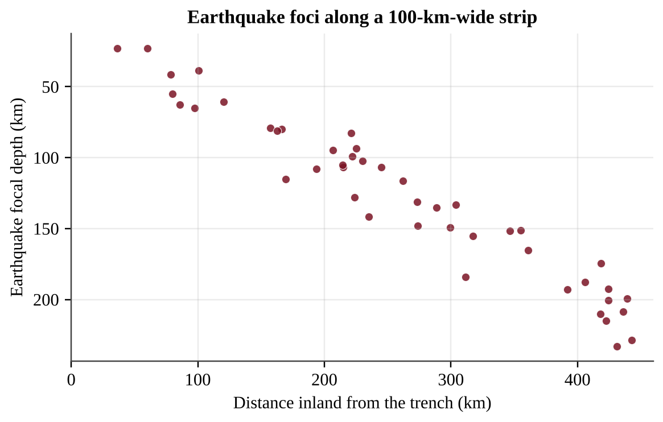
Figure — Focal depth of earthquakes versus distance inland from an ocean trench
Earthquakes in a coastal region occur at increasing depth with increasing distance inland from the trench. Which process best explains this pattern?
A. A mantle plume rises vertically beneath the trench and fractures the overlying rock.
B. Two plates slide horizontally past each other along a near-vertical fault.
C. A cool, dense oceanic plate descends into the mantle at an angle beneath the neighboring plate.
D. New crust forms along a ridge and pushes older crust inland.

Question 16 QB-U4-MCQ016
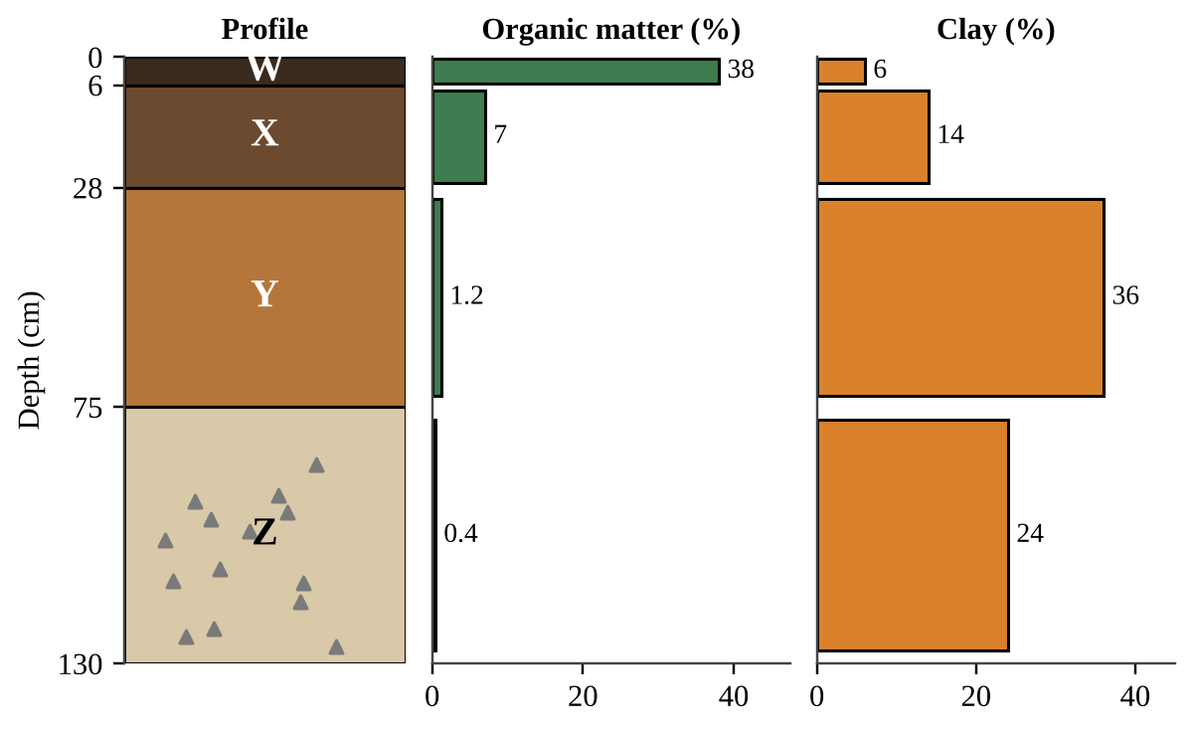
Figure — Soil horizons with organic matter and clay content
The figure shows a soil profile with four horizons (W–Z) and the organic matter and clay content of each. Z contains fragments of partly weathered rock. Which horizon is most likely the subsoil (B horizon), where fine particles and dissolved minerals carried down from above accumulate?
A. Horizon Y, because it has the most clay and little organic matter
B. Horizon W, because it has the highest organic matter and lies closest to the surface
C. Horizon X, because it is the first layer below the surface and holds the most humus
D. Horizon Z, because it contains rock fragments and the lowest organic matter

Question 17 QB-U4-MCQ017
A soil scientist tests four soil samples. The composition of each is given below and plotted on the soil texture triangle.
Sample | Sand (%) | Silt (%) | Clay (%)
1 | 80 | 10 | 10
2 | 40 | 40 | 20
3 | 15 | 25 | 60
4 | 20 | 65 | 15

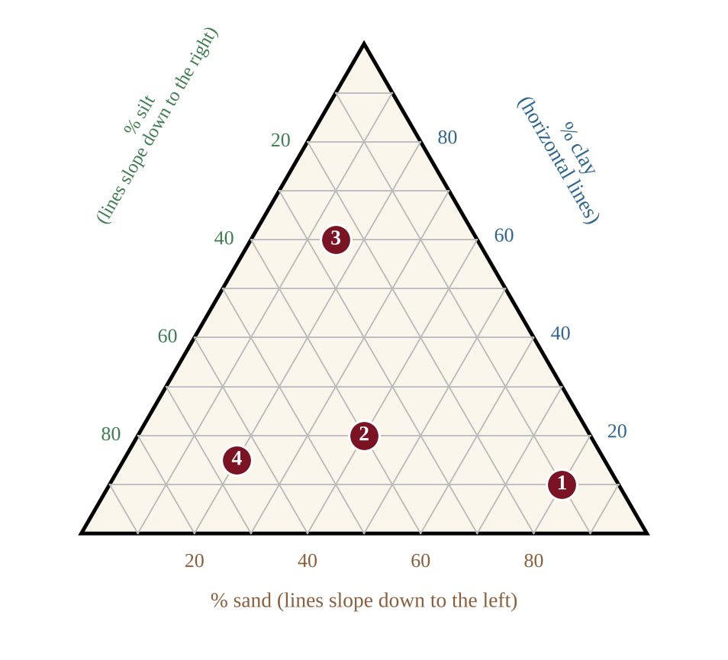
Figure — Soil texture triangle with four samples plotted
Which sample would most likely have the greatest water-holding capacity and the lowest permeability?
A. Sample 1, because the large pores of sand hold the greatest amount of water
B. Sample 2, because loam balances all particle sizes and so holds the most water
C. Sample 4, because silt always has the smallest pores of any soil particle
D. Sample 3, because its high clay content gives tiny pores that hold water but pass it slowly

Question 18 QB-U4-MCQ018
A clay soil can have more total pore space (porosity) than a sandy soil, yet water moves through the clay much more slowly. Which statement best explains this?
A. Clay particles are larger than sand particles and block the pores that sand leaves open.
B. Clay soils contain less water-holding capacity than sandy soils, so they fill with air.
C. The pores in sand are smaller than those in clay, so water is drawn out of sand more quickly.
D. The pores in clay are extremely small, so water is held tightly by adhesion and moves through slowly.

Question 19 QB-U4-MCQ019
A student places 300 g of oven-dried soil in a funnel lined with filter paper above a graduated cylinder. She pours 200 mL of water onto each soil and measures the water that has drained into the cylinder after 15 minutes. Soil X drains 150 mL, and Soil Y drains 60 mL. Which conclusion is best supported?
A. Soil Y has the greater water-holding capacity: it retained about 140 mL, compared with about 50 mL for Soil X.
B. Soil X has the greater water-holding capacity, because 150 mL of water passed through it.
C. The soils have equal water-holding capacity, because the same 200 mL was added to each.
D. Soil X has the greater water-holding capacity, because it retained 150 mL and Soil Y retained 60 mL.

Question 20 QB-U4-MCQ020
A ring pushed into the ground is filled with 40 mm of water. The water completely soaks into Field P in 16 minutes and into Field Q in 200 minutes. A storm delivers rain at 30 mm per hour. Assuming the infiltration rates stay constant, which prediction is correct?
A. Field P produces about 120 mm of runoff per hour, and Field Q absorbs all of the rain.
B. Both fields absorb all of the rain, because every soil infiltrates some water.
C. Field P absorbs all of the rain, and Field Q produces about 18 mm of runoff for each hour of rain.
D. Field Q produces about 30 mm of runoff per hour, because its infiltration is negligible.

Question 21 QB-U4-MCQ021
A vegetable farm on a soil that is 80% sand irrigates once a week with a large application. Plants show water stress by day 5, and soil tests show water has moved below the root zone. Which change is most consistent with the properties of this soil?
A. Apply smaller amounts of water more often, because the soil has high permeability and low water-holding capacity.
B. Apply even larger amounts less often, so that sand pores fill and hold the water for the whole week.
C. Stop irrigating, because sandy soils have the greatest water-holding capacity of all soils.
D. Add more sand to the field, which will increase the volume of water the soil can hold.

Question 22 QB-U4-MCQ022
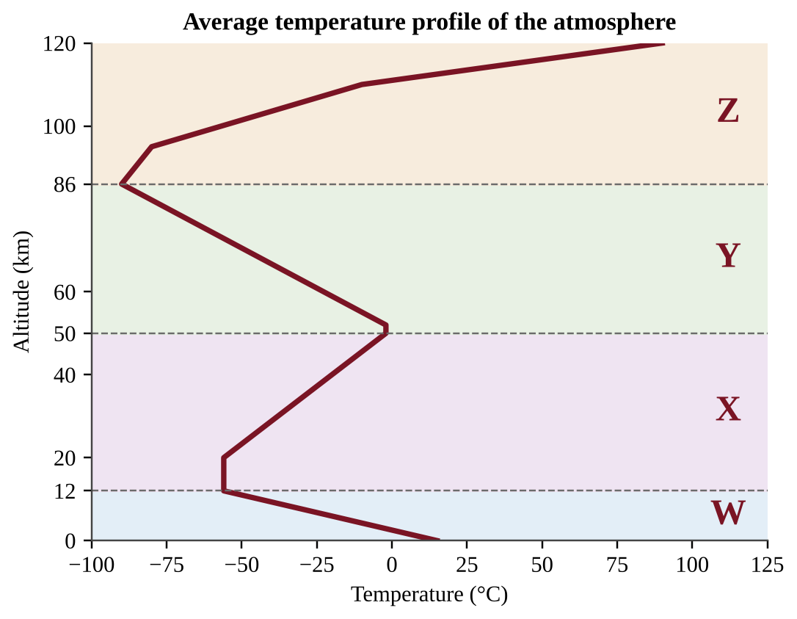
Figure — Average temperature profile of the atmosphere with four layers labeled W–Z
In the figure, the layers are labeled W through Z from lowest to highest. In which layer does temperature increase with altitude mainly because ozone absorbs ultraviolet radiation?
A. Layer W
B. Layer X
C. Layer Y
D. Layer Z

Question 23 QB-U4-MCQ023
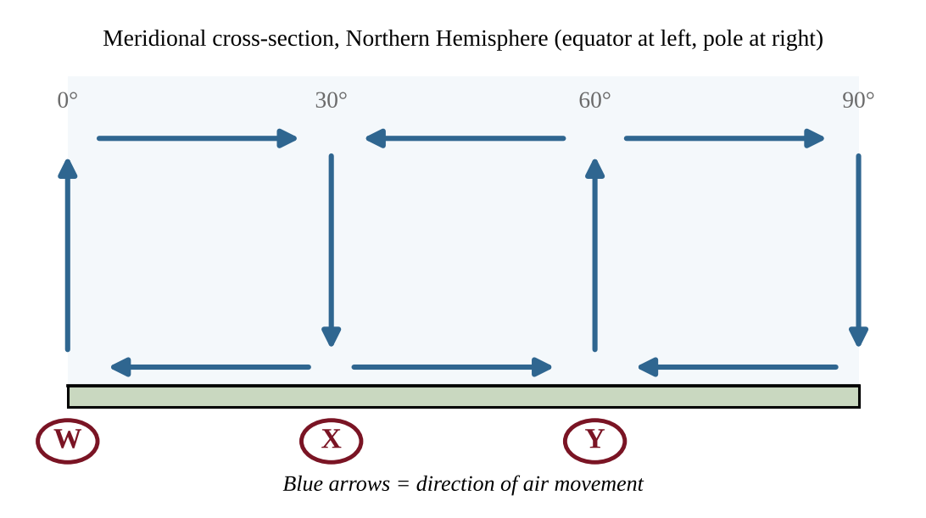
Figure — Meridional cross-section of air movement in the Northern Hemisphere
Many of the world's major deserts lie near the latitude marked X. Which statement best explains this using the figure?
A. Air rises at this latitude, cooling and condensing, which produces heavy rainfall nearby.
B. Cold polar air spreads along the surface here and prevents evaporation from the land.
C. Air descends at this latitude, warming and becoming drier, which suppresses cloud formation and rainfall.
D. Strong westerly winds at the surface carry dry air from the ocean onto the land.

Question 24 QB-U4-MCQ024
A sailor traveling at 15° N latitude finds that the surface wind blows steadily and gently from the same direction day after day. From which direction does it blow, and why?
A. From the southeast, because air flowing toward the equator is deflected to the left by Earth's rotation
B. From the northeast, because air flowing toward the equator is deflected to the right by Earth's rotation
C. From the northwest, because air flowing away from the equator is deflected to the right by Earth's rotation
D. From the southwest, because air flowing away from the equator is deflected to the left by Earth's rotation

Question 25 QB-U4-MCQ025
The heaviest and most consistent rainfall on Earth occurs near the equator. Which explanation is best?
A. Cold, dense air sinks at the equator and releases its water vapor as it is compressed.
B. The Coriolis effect is strongest at the equator and spins the air into storm systems.
C. Trade winds are forced upward by coastal mountains that surround the equator.
D. Intense solar heating makes the air less dense, so it rises, cools, and condenses its water vapor.

Question 26 QB-U4-MCQ026
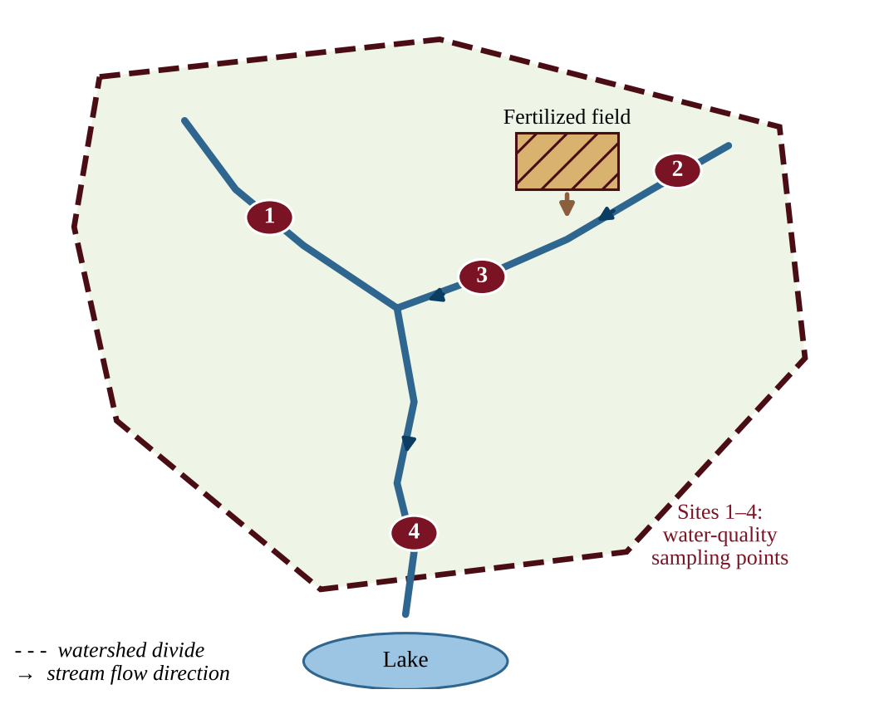
Figure — A watershed with a fertilized field and four sampling sites
Rain washes nitrate fertilizer from the field shown into the stream it borders. Assuming nitrate stays dissolved in the flowing water, which sites would most likely show elevated nitrate?
A. Sites 3 and 4 only
B. Sites 1, 3, and 4
C. Sites 2 and 3 only
D. Sites 1 and 2 only

Question 27 QB-U4-MCQ027
Loggers clear-cut the forest on the steep, thin-soiled slopes of the upper part of a watershed, leaving bare soil. Which downstream change is most likely over the next several years?
A. Lower peak stream flows, because water spreads evenly across bare soil
B. Higher peak stream flows after storms and increased sediment (turbidity) in the stream
C. Cleaner, clearer stream water, because the soil is no longer disturbed by roots
D. Greater groundwater recharge, because bare soil absorbs more rain than forest soil

Question 28 QB-U4-MCQ028
A watershed has an area of 250 km². It receives an average of 1,000 mm of precipitation per year, and 35% of the precipitation leaves the watershed as runoff in the river. What is the average annual runoff volume?
A. 8.8 × 10⁴ m³
B. 8.8 × 10⁷ m³
C. 2.5 × 10⁸ m³
D. 7.1 × 10⁸ m³

Question 29 QB-U4-MCQ029
Two watersheds of equal area receive the same storm. Watershed R is mostly forest; Watershed U is mostly roofs and parking lots. The table shows the discharge of each stream at the outlet.
Hours after storm began | 0 | 2 | 4 | 6 | 8 | 10 | 12
Watershed R (m³/s) | 2 | 3 | 6 | 9 | 8 | 6 | 4
Watershed U (m³/s) | 2 | 14 | 30 | 22 | 12 | 6 | 3

Which statement is best supported by the data?
A. Watershed U's peak was about 3 times higher than R's and came 2 hours earlier, consistent with less infiltration.
B. Watershed R had the higher peak discharge, because its forest soil released water more quickly than U's.
C. Both watersheds reached the same peak discharge, but Watershed U reached it later than R did.
D. Watershed U drained more slowly, because its discharge stayed above R's after 10 hours of the storm.

Question 30 QB-U4-MCQ030
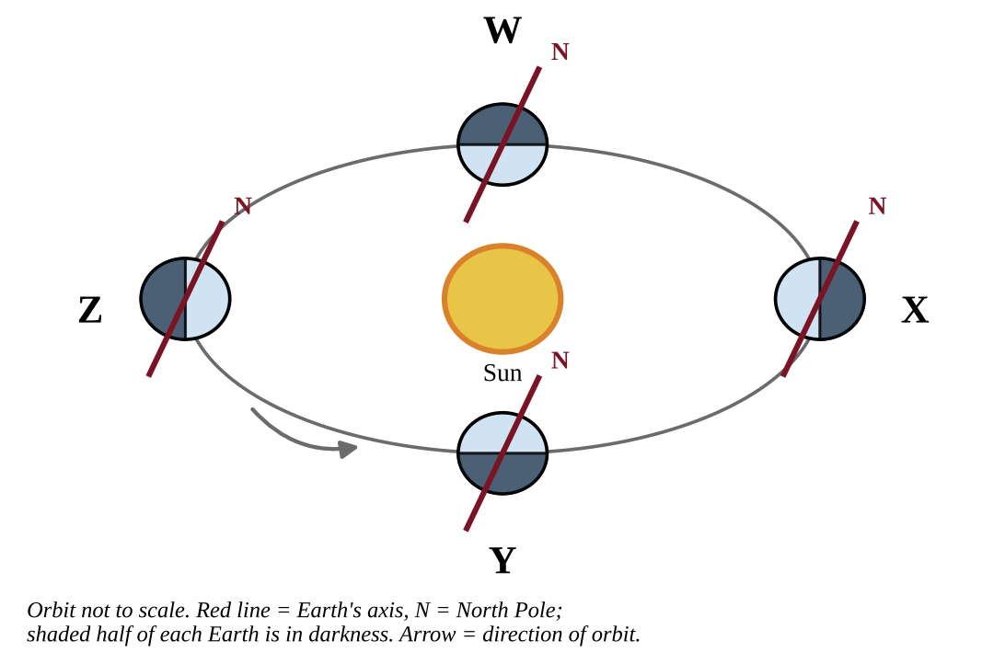
Figure — Earth at four positions in its orbit around the Sun
In the figure, the axis of Earth keeps the same direction in space throughout the orbit. Which position corresponds to the Northern Hemisphere summer solstice?
A. Position W
B. Position X
C. Position Y
D. Position Z

Question 31 QB-U4-MCQ031
At the March equinox, why is the solar radiation received per square meter of surface lower at 60° N than at the equator, even at local noon?
A. Earth is much farther from the Sun at 60° N than it is at the equator, so less energy arrives.
B. At the equinox, daylight at 60° N lasts far fewer hours than daylight at the equator.
C. The Sun's rays strike at a more oblique angle, spreading the energy over a larger area.
D. Cooler air at 60° N reflects more of the incoming rays back into space before they reach the surface.

Question 32 QB-U4-MCQ032
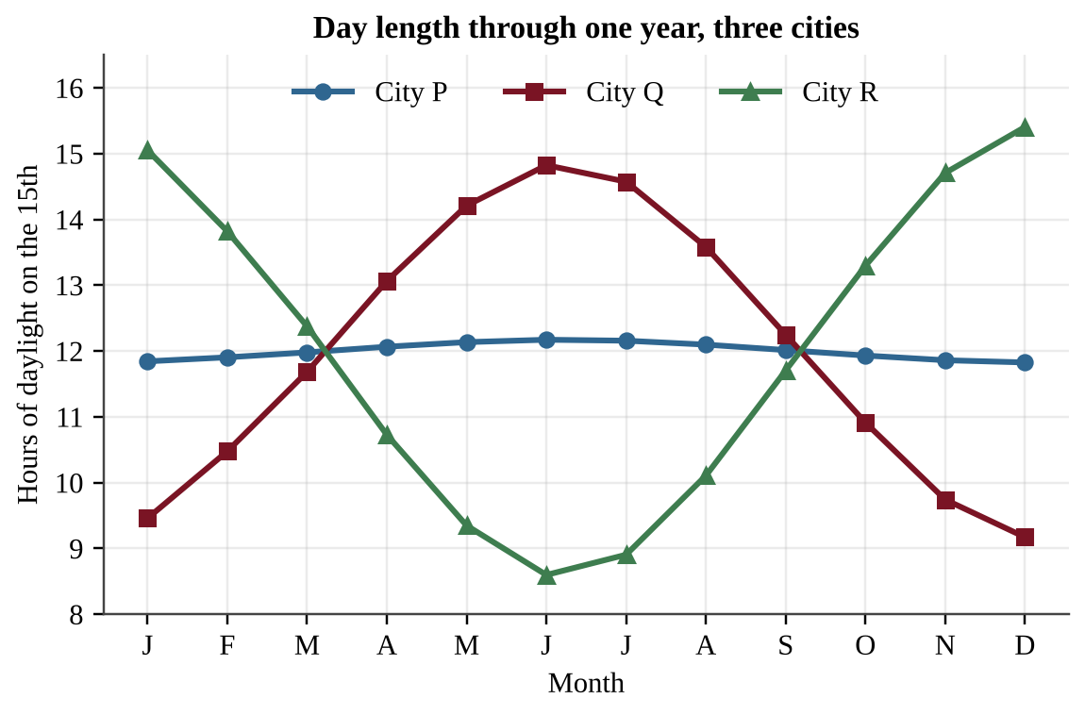
Figure — Hours of daylight on the 15th of each month for three cities
Which interpretation of the graph is best supported?
A. City Q is closest to the equator because its day length changes the most, and City R is in the Northern Hemisphere.
B. City P is nearest the equator because its day length changes least, and City R is south of the equator because its longest days are in December.
C. City P is closest to the equator because its day length is longest in June, and City Q is in the Southern Hemisphere.
D. City R is closest to the equator because its day length is the greatest of the three, and City P is near the pole.

Question 33 QB-U4-MCQ033
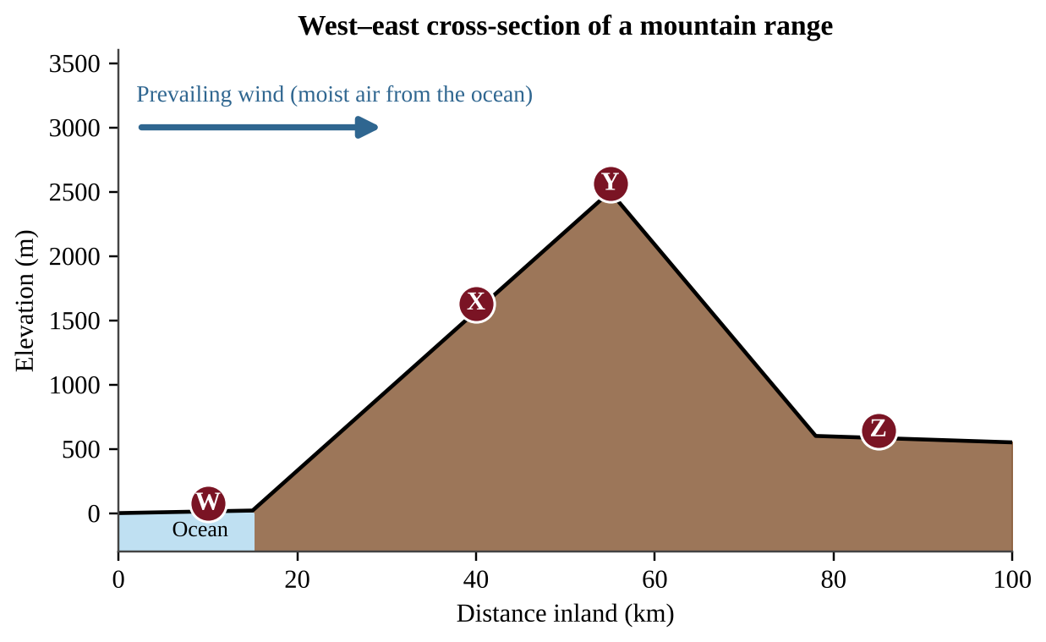
Figure — Cross-section of a mountain range with four weather stations
Annual precipitation at the four stations is given below.
Station | Elevation (m) | Annual precipitation (mm)
W | 20 | 900
X | 1,570 | 2,300
Y | 2,500 | 1,700
Z | 590 | 350

Which interpretation of the data is best supported?
A. Precipitation decreases steadily with distance from the ocean, so the mountains have little effect on the pattern.
B. Station Z is dry because it is at lower elevation than Station Y, and low elevations always receive less rain.
C. Station X is wet because moist air sinks and warms on the windward slope.
D. Rising air on the windward side loses moisture, and the descending air at Z is warmer and drier, producing a rain shadow.

Question 34 QB-U4-MCQ034
Two cities are at the same latitude and elevation in the middle latitudes. City A is on the coast and has an annual temperature range of 8°C. City B is 500 km inland and has an annual temperature range of 28°C. Which statement best explains the difference?
A. Ocean air is always warmer than air over land, so City A is warmer all year.
B. City B receives more intense solar radiation because it is farther from the ocean.
C. Sea breezes blow at City A only in winter, which keeps winter temperatures high.
D. Water heats and cools more slowly than land, so air over the ocean moderates City A's temperatures.

Question 35 QB-U4-MCQ035
Peru's anchovy fishery is monitored along with Pacific sea surface temperature (SST).
Year | SST anomaly in the eastern Pacific (°C) | Anchovy landings (million metric tons)
1 | −0.3 | 8.4
2 | +0.1 | 8.1
3 | +2.3 | 2.6
4 | +0.4 | 6.9
5 | −1.2 | 9.3

Which statement best explains the landings in Year 3?
A. Warm water deepened the warm surface layer and weakened upwelling, so fewer nutrients reached the phytoplankton.
B. Warm water holds more dissolved oxygen, which caused the anchovies to leave the coastal waters.
C. Stronger trade winds increased upwelling, which scattered the anchovy schools across the open Pacific.
D. Colder water in Year 3 killed the anchovies directly, so landings fell sharply.

Question 36 QB-U4-MCQ036
A volcanic island chain forms as a plate moves over a stationary hot spot. The table shows the distance of three extinct volcanic islands from the active volcano above the hot spot and the age of each.
Island | Distance from active hot spot (km) | Age (millions of years)
B | 300 | 6.0
C | 750 | 15
D | 1,250 | 25

An island lies 1,600 km from the hot spot along the same chain. Which choice gives the plate's speed and the predicted age of this island?
A. 0.5 cm/yr; 320 million years
B. 5 cm/yr; 32 million years
C. 5 cm/yr; 320 million years
D. 50 cm/yr; 3.2 million years

Question 37 QB-U4-MCQ037
A mountain range of tall, folded peaks lies where two continental plates are colliding. The region has frequent earthquakes but no active volcanoes. Which explanation is best?
A. One plate subducts deeply, but its magma cools before it can reach the surface.
B. The plates slide past each other, so crust is neither compressed nor destroyed.
C. Neither continental plate is dense enough to subduct, so the crust thickens instead of melting.
D. The plates are moving apart, so pressure on the underlying mantle is released.

Question 38 QB-U4-MCQ038
A student wants to test whether grass cover reduces soil erosion. She prepares two trays of the same soil. Tray 1 has bare soil on a 10° slope. Tray 2 has grass sod on a 25° slope. She applies simulated rain from the same sprinkler for 5 minutes and measures the dry mass of sediment collected from each tray. Tray 2 loses much less sediment. Which change would most improve the validity of her conclusion about grass cover?
A. Apply rain to the grass tray for twice as long so the test is more rigorous
B. Measure only the volume of runoff from each tray and ignore the sediment
C. Replace the bare soil in Tray 1 with sand so that the soils are different
D. Set both trays at the same slope so that ground cover is the only difference between them

Question 39 QB-U4-MCQ039
Large volcanic eruptions and high-flying aircraft can place particles in the lower stratosphere. These particles generally remain in the air far longer than particles released into the troposphere. Which statement best explains this?
A. Temperature rises with altitude in the stratosphere, so the layer is stable with little mixing, and little precipitation removes particles.
B. The stratosphere has more water vapor than the troposphere, and the water vapor holds the particles aloft for years.
C. Strong convection currents in the stratosphere keep the particles suspended for years at a time.
D. Gravity is much weaker in the stratosphere, so particles fall far more slowly than in the troposphere.

Question 40 QB-U4-MCQ040
Imagine Earth stopped rotating but kept the same uneven heating by the Sun (greatest at the equator). Which statement best describes the expected surface winds in the Northern Hemisphere?
A. The same three-cell pattern as today, including the northeast trade winds and westerlies
B. Surface winds blowing from the equator straight toward the pole in each hemisphere
C. No steady winds at all, because the Sun would heat every place equally
D. One cell in the hemisphere, with surface winds blowing from the pole straight toward the equator

Question 41 QB-U4-MCQ041
The intensity of sunlight on a horizontal surface at noon is proportional to cos z, where z is the angle between the Sun's rays and the vertical. At noon on the June solstice the Sun is directly overhead at 23.5° N, and at noon on the December solstice it is directly overhead at 23.5° S. Approximately how many times greater is the noon intensity of sunlight on a horizontal surface at 40° N on the June solstice than on the December solstice?
A. 0.47
B. 1.3
C. 2.1
D. 3.8

Question 42 QB-U4-MCQ042
City P is on the west coast and City Q is on the east coast of the same mid-latitude continent. Both are at 45° N and at sea level.
City | Mean January temperature (°C) | Mean July temperature (°C)
P | 4 | 17
Q | −8 | 22

Which explanation best accounts for the difference in temperature range?
A. City P is closer to the equator and therefore receives more solar radiation throughout the year.
B. Trade winds bring warm tropical air to City P in winter but never reach City Q at all.
C. Prevailing westerlies bring ocean-moderated air to City P, while City Q receives air that crossed the continent.
D. City Q lies in a rain shadow, which makes its winters colder and its summers warmer.

Question 43 QB-U4-MCQ043
The table shows conditions during four years. Rainfall is given as a percentage of the long-term average.
Year | Eastern Pacific SST anomaly (°C) | Northern Peru coast rainfall (%) | Indonesia rainfall (%)
W | +2.1 | 380 | 62
X | −1.6 | 35 | 135
Y | +0.1 | 105 | 98
Z | +0.9 | 190 | 80

Which year is most consistent with a strong La Niña?
A. Year W
B. Year X
C. Year Y
D. Year Z

Question 44 QB-U4-MCQ044
Which sequence best describes the development of an El Niño event?
A. Trade winds strengthen → warm water piles up in the western Pacific → upwelling off South America increases → eastern Pacific cools
B. Upwelling off South America increases → surface water cools → trade winds weaken → warm water spreads eastward
C. Trade winds weaken → warm surface water spreads eastward → upwelling off South America declines → rainfall shifts toward the central and eastern Pacific
D. Warm water spreads eastward → trade winds strengthen → upwelling off South America increases → rainfall shifts west

Section B — Free-Response Questions
Question 1 QB-U4-FRQ001
Growers manage an apple orchard on a hillside above a stream. After heavy rains the stream runs muddy, and the growers suspect that soil is washing off the orchard rows, where the soil between the trees is kept bare by tilling. A grower proposes planting a perennial grass cover between the tree rows to reduce erosion. The orchard has four blocks, all planted in the same year with the same tree variety. The slope and soil texture of each block are shown below. The growers can install identical sediment traps at the downhill edge of any block and can measure rainfall with a rain gauge.
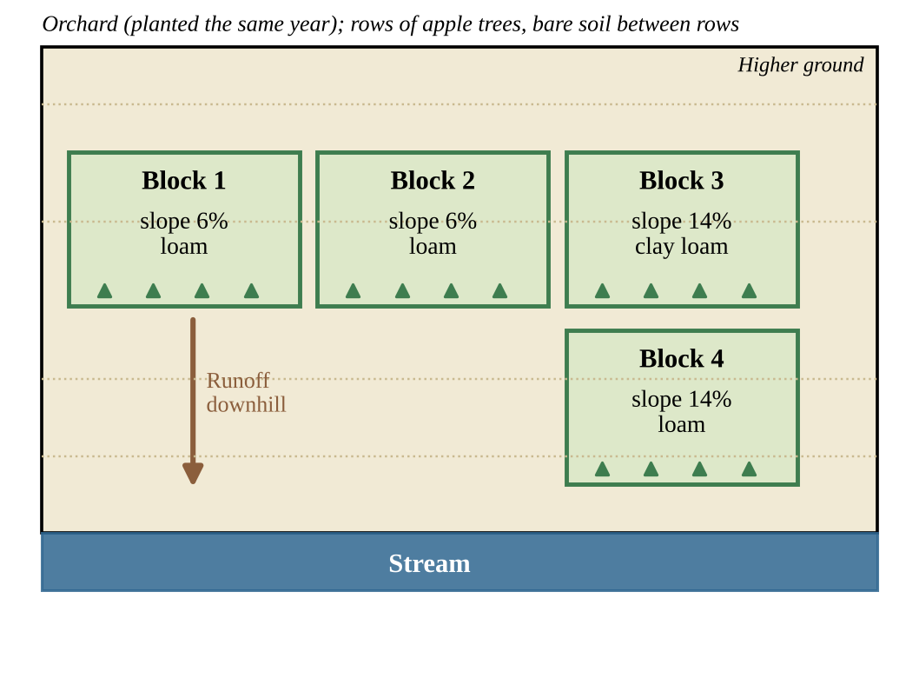
Figure — Layout of four orchard blocks above a stream, with slope and soil type of each
(a) Identify the environmental problem that the growers are trying to address. [1] (b) Write a testable hypothesis, in if–then form, that predicts how a grass cover will affect soil loss from the orchard. [1] (c) Identify the independent variable and the dependent variable in the investigation. [2] (d) Identify the two blocks that should be used to test the hypothesis, and explain why you chose them. [2] (e) Describe a procedure for the investigation. Include how the treatments will be applied, how soil loss will be measured, and how the reliability of the results will be improved. [2] (f) Describe the pattern of results that would support the hypothesis. [1] (g) Propose one additional practice, other than grass cover between rows, that the growers could use to reduce soil loss from the orchard, and justify your proposal. [1]

Question 2 QB-U4-FRQ002
Along the coast of Peru, cold, nutrient-rich water normally rises (upwelling) near the shore and supports a large fishery for anchovies. A research team monitored the sea surface temperature (SST) anomaly in the eastern equatorial Pacific (the difference from the long-term average), annual anchovy landings, and January–March rainfall in northern Peru for 12 years. The figure shows the SST anomaly and landings, and the table gives all of the data.
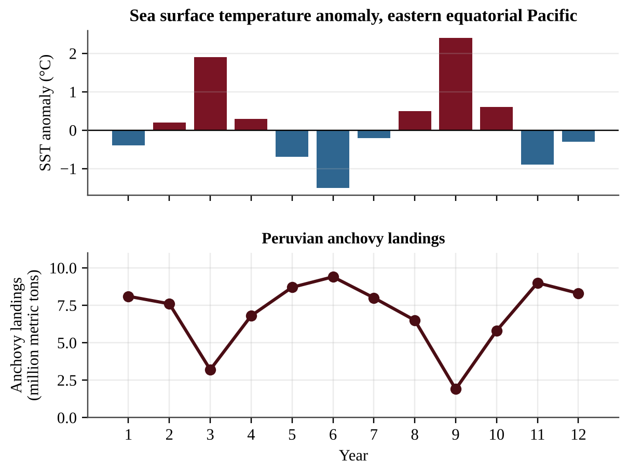
Figure — Sea surface temperature anomaly and anchovy landings over 12 years
Year | SST anomaly (°C) | Anchovy landings (million metric tons) | Northern Peru rainfall (mm)
1 | −0.4 | 8.1 | 110
2 | +0.2 | 7.6 | 140
3 | +1.9 | 3.2 | 640
4 | +0.3 | 6.8 | 160
5 | −0.7 | 8.7 | 70
6 | −1.5 | 9.4 | 40
7 | −0.2 | 8.0 | 105
8 | +0.5 | 6.5 | 220
9 | +2.4 | 1.9 | 910
10 | +0.6 | 5.8 | 260
11 | −0.9 | 9.0 | 60
12 | −0.3 | 8.3 | 95

For this question, a year is classified as an El Niño year if the SST anomaly is +1.0°C or greater and as a La Niña year if the anomaly is −0.5°C or less.
(a) Identify the years that are El Niño years and the years that are La Niña years. [1] (b) Calculate the mean anchovy landings for the El Niño years and for the La Niña years. Show your work. [2] (c) Calculate the percent decrease from the mean landings in La Niña years to the mean landings in El Niño years. [1] (d) Explain, in terms of ocean processes, why anchovy landings are lower in El Niño years. [2] (e) Describe the effect of El Niño on rainfall in northern Peru shown by the data, and explain one atmospheric or ocean cause of that effect. [2] (f) Propose one solution that a fishing community could use to reduce its economic risk during El Niño years. [1] (g) Make a claim about which El Niño event, Year 3 or Year 9, was stronger, and justify your claim with two types of data from the table. [1]

Question 3 QB-U4-FRQ003
Kestrel Creek drains a watershed with an area of 180 km². The watershed receives an average of 1,100 mm of precipitation per year, and 40% of the precipitation leaves the watershed as runoff in Kestrel Creek. Monitoring shows that the creek carries an average suspended sediment concentration of 150 mg/L. Cropland covers 30% of the watershed, and you may assume that all of the sediment in the creek comes from erosion of the cropland. The soil on the cropland has a bulk density of 1.3 metric tons per cubic meter (1.3 t/m³), and soil forms on the cropland at an average rate of 0.05 mm per year.
Use these conversions as needed: 1 km² = 10⁶ m²; 1 m³ = 1,000 L; 1 metric ton = 10⁹ mg; 1 year = 3.15 × 10⁷ s.
(a) Calculate the volume of runoff, in cubic meters, that flows out of the watershed in one year. Show your work. [2] (b) Calculate the average discharge of Kestrel Creek in cubic meters per second. Show your work. [2] (c) Calculate the mass of sediment, in metric tons, carried by the creek in one year. Show your work. [2] (d) Calculate the average depth, in millimeters, of soil lost from the cropland in one year. Show your work. [2] (e) Justify whether the rate of soil loss on the cropland is sustainable, using your answer to part (d). [1] (f) Propose one action that farmers in the watershed could take to reduce the amount of sediment entering the creek. [1]

Question 4 QB-U4-FRQ004
Harbor is a coastal city and Plain is a city 150 km inland, on the opposite side of a mountain range. Both cities are at about 45° N latitude. The prevailing wind carries air from the ocean toward the land. The figure shows a climatogram for each city, and the table gives the data.
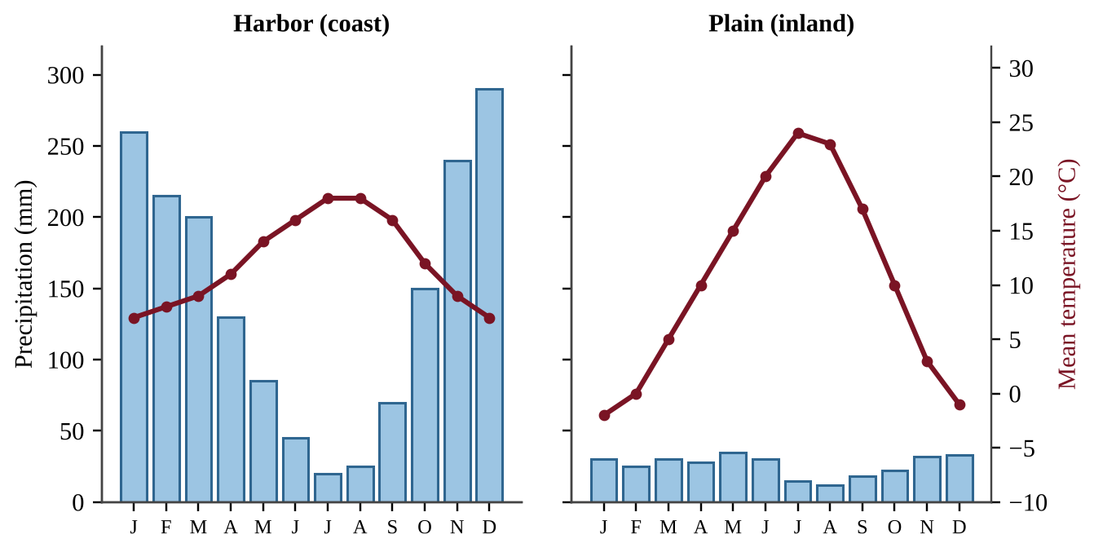
Figure — Monthly precipitation (bars) and mean temperature (line) for Harbor and Plain
Month | J | F | M | A | M | J | J | A | S | O | N | D
Harbor precipitation (mm) | 260 | 215 | 200 | 130 | 85 | 45 | 20 | 25 | 70 | 150 | 240 | 290
Plain precipitation (mm) | 30 | 25 | 30 | 28 | 35 | 30 | 15 | 12 | 18 | 22 | 32 | 33
Harbor temperature (°C) | 7 | 8 | 9 | 11 | 14 | 16 | 18 | 18 | 16 | 12 | 9 | 7
Plain temperature (°C) | −2 | 0 | 5 | 10 | 15 | 20 | 24 | 23 | 17 | 10 | 3 | −1

(a) Describe two differences between the climate of Harbor and the climate of Plain shown by the climatograms. [2] (b) Calculate the percent by which the annual precipitation at Plain is less than the annual precipitation at Harbor. Show your work. [2] (c) Explain, in terms of the movement of air over the mountain range, why Plain receives much less precipitation than Harbor. [2] (d) Explain why the annual temperature range at Plain is greater than that at Harbor. [2] (e) Identify the global wind pattern that carries air from the ocean toward the land at 45° N latitude. [1] (f) Propose one solution that farmers at Plain could use to cope with the low precipitation. [1]

Unit 5 — Land and Water Use
NOTE
Exam weight: Unit 5 accounts for 10–15% of the AP Environmental Science exam score (about 8–12 of the 80 multiple-choice questions and parts of the free-response questions). This section assesses how humans use land and water (agriculture, irrigation, pest control, meat production, fishing, mining, urbanization, and forestry), ecological footprints, and the sustainable practices that reduce those impacts. Skills practiced: explaining processes, analyzing data and graphs, doing calculations, evaluating experimental designs, and proposing and justifying solutions.

Section A — Multiple-Choice Questions
Choose the single best answer for each question.
Question 1 QB-U5-MCQ001
A coastal village's families all graze goats on one shared, unfenced pasture with no rules. Each family gains the full benefit of adding a goat but shares the cost of a more damaged pasture with everyone else. Which outcome does the tragedy of the commons predict?
A. Each family acts in its own self-interest, herds keep growing, and the shared pasture is depleted.
B. Families notice the damage and spontaneously agree to reduce their herds, so the shared pasture stays productive.
C. Manure from the added goats raises pasture growth enough to support unlimited herd expansion.
D. Depletion occurs only if a single family owns the entire pasture.

Question 2 QB-U5-MCQ002
A steep forested hillside above a trout stream is clearcut. Which set of changes is most likely?
A. Bare soil absorbs more rain than the forest floor did, so infiltration rises sharply and the risk of downstream flooding falls.
B. Loss of canopy and roots increases soil erosion and runoff, and the stream becomes warmer and more prone to flooding.
C. More sunlight reaches the stream and cools it, while sediment input to the stream decreases.
D. Erosion declines because exposed soil quickly forms a protective crust that holds it in place.

Question 3 QB-U5-MCQ003
Which agricultural practice most directly increases the risk of soil erosion by wind and water?
A. Repeated tilling that leaves loosened, bare soil between crops
B. Planting a perennial grass strip along the contour of a slope above the field
C. Leaving crop residue on the field surface after harvest
D. Planting rows of trees along the edges of a field

Question 4 QB-U5-MCQ004
Approximately what share of human freshwater consumption worldwide is used for agriculture?
A. About 7%
B. About 30%
C. About 50%
D. About 70%

Question 5 QB-U5-MCQ005
A cotton grower sprays the same insecticide on every field each week. After several years the spray kills far fewer aphids. Which is the best explanation?
A. Aphids with genetic resistance survived each spraying and reproduced, so resistant aphids became a larger share of the population.
B. Individual aphids gradually developed tolerance during their lives, and they passed that tolerance on to their offspring as they reproduced.
C. The insecticide caused the aphids to mutate in ways that made them resistant.
D. Aphids learned to avoid sprayed leaves, so fewer of them were exposed.

Question 6 QB-U5-MCQ006
Beef cattle are kept in crowded pens, fed grain and soy, and produce large amounts of manure in a small area. Compared with rotational grazing, this system is more likely to
A. use more land per animal, which raises the cost of meat to consumers.
B. eliminate the need for antibiotics because disease cannot easily spread among animals that are kept in confinement.
C. lower the cost of meat to consumers but risk contaminating nearby waterways with manure and antibiotics.
D. reduce nutrient pollution because manure is spread evenly over large pastures.

Question 7 QB-U5-MCQ007
Which is a likely consequence of overfishing a commercially important fish species?
A. Higher genetic diversity within the fish population as the number of fish falls
B. Increased catch per unit of fishing effort over time as the fish become easier to find
C. Reduced biodiversity in the aquatic system and economic hardship for fishing communities
D. Faster recovery of the stock because fewer fish compete for food

Question 8 QB-U5-MCQ008
In surface mining, what is overburden?
A. Waste material left after the minerals are separated from the ore
B. Glassy waste produced when metal is smelted from ore
C. The valuable mineral deposit that the mine is trying to extract
D. Soil and rock removed to reach the ore beneath

Question 9 QB-U5-MCQ009
A meadow is replaced by a large shopping-center parking lot. Which change in the local water cycle is most likely?
A. More infiltration and groundwater recharge because the pavement stores water and releases it slowly
B. More evapotranspiration, which lowers the risk of downstream flooding
C. No change in runoff because the same amount of rain falls on the site
D. Less infiltration and more surface runoff, which raises the risk of flooding downstream

Question 10 QB-U5-MCQ010
Which statement describes what an ecological footprint compares?
A. The resources a person or society uses and the waste it produces, compared with what the environment can supply and absorb
B. The number of people living in a country, compared with the land area of that country
C. The amount of renewable energy generated per person, compared with the fossil fuel energy used
D. The number of species lost per year in a region, compared with the number present before

Question 11 QB-U5-MCQ011
Which change to a city's parking lots would most directly increase water infiltration?
A. Replacing asphalt with permeable pavement and planting trees in the lot
B. Installing larger storm drains to carry the runoff to the nearest stream faster
C. Lining drainage ditches with concrete
D. Paving over grass medians to reduce maintenance

Question 12 QB-U5-MCQ012
Which statement best describes integrated pest management (IPM)?
A. Spraying a broad-spectrum pesticide on a fixed schedule regardless of how many pests are present or how large their natural enemy populations are
B. A combination of biological, physical, and limited chemical methods that controls pests with minimal harm to the environment
C. Eliminating every pest organism in a field using chemical methods alone
D. Planting a single crop over a large area to simplify pest control

Question 13 QB-U5-MCQ013
A farmer wants to reduce water erosion on a steep, sloping field. Which practice is best?
A. Plowing in straight rows up and down the slope
B. Leaving the soil bare between growing seasons so that it dries
C. Removing perennial plants from the field edges to expand the planted area
D. Terracing the slope and plowing along the contour lines

Question 14 QB-U5-MCQ014
Which situation is the best example of the tragedy of the commons?
A. A landowner clear-cuts her own woodlot for quick income, then regrets the lost timber and the topsoil that washed off the slope afterward.
B. A water district assigns household quotas during a drought, and the reservoir recovers.
C. A fishing cooperative sets a harvest quota for its own lake, and every member follows it.
D. Fishing fleets from several countries each catch as much as they can from a stock in open international waters until it collapses.

Question 15 QB-U5-MCQ015
A forest stores 150 metric tons of carbon per hectare in its trees. A 50-ha stand is clearcut and burned, and 60% of the stored carbon is released to the atmosphere as CO₂. About how many metric tons of CO₂ are released? (Molar masses: C = 12 g/mol; CO₂ = 44 g/mol.)
A. 1.2 × 10³
B. 4.5 × 10³
C. 1.65 × 10⁴
D. 2.75 × 10⁴

Question 16 QB-U5-MCQ016
The Green Revolution began a major shift in agriculture in the mid-1900s. Which statement best describes it?
A. It raised yields mainly by cutting back fertilizer and irrigation, which lowered the energy needed to farm and kept food prices low for consumers throughout the developing world.
B. It replaced machinery with draft animals, which reduced dependence on fossil fuels.
C. It increased food production through high-yield crops, fertilizer, irrigation, pesticides, and mechanization, but raised reliance on fossil fuels.
D. It promoted traditional polyculture on small plots, which lowered yields but also lowered costs.

Question 17 QB-U5-MCQ017
The table shows changes on farms in one region after they adopted Green Revolution methods.
Measure | 1965 | 1995
Wheat yield (t/ha) | 1.2 | 3.1
Nitrogen fertilizer applied (kg/ha) | 5 | 60
Irrigated share of cropland (%) | 20 | 85
Tractors per 1,000 ha | 2 | 14

Which conclusion is best supported by the table?
A. Higher yields came with much greater use of fertilizer, irrigation, and machinery, so the farms became more dependent on inputs.
B. Yield rose faster than fertilizer use, so fertilizer was not important to the yield gain.
C. Production increased without any increase in the use of irrigation water.
D. Mechanization reduced the number of tractors needed per 1,000 ha of cropland, which cut fossil fuel use on the farms and across the region.

Question 18 QB-U5-MCQ018
Farmers in a tropical forest region cut and burn patches of forest, grow crops on each patch for two or three years, and then move to a new patch. Which statement best describes the environmental effects of this practice?
A. Burning permanently raises soil fertility because the nutrients in the ash stay bound in the soil for decades after the fire.
B. Burning adds no CO₂ to the atmosphere because the carbon in the trees returns to the soil.
C. Removing the forest reduces erosion because crops intercept rain better than a forest canopy does.
D. Burning releases CO₂ and gives a short-term pulse of nutrients from ash, but the nutrients are soon lost or used up.

Question 19 QB-U5-MCQ019
The figure shows a cross-section of a flood-irrigated field in an arid valley after 25 years of irrigation with pumped groundwater. Farmers report declining yields, and some plants have wilted in the wet soil.
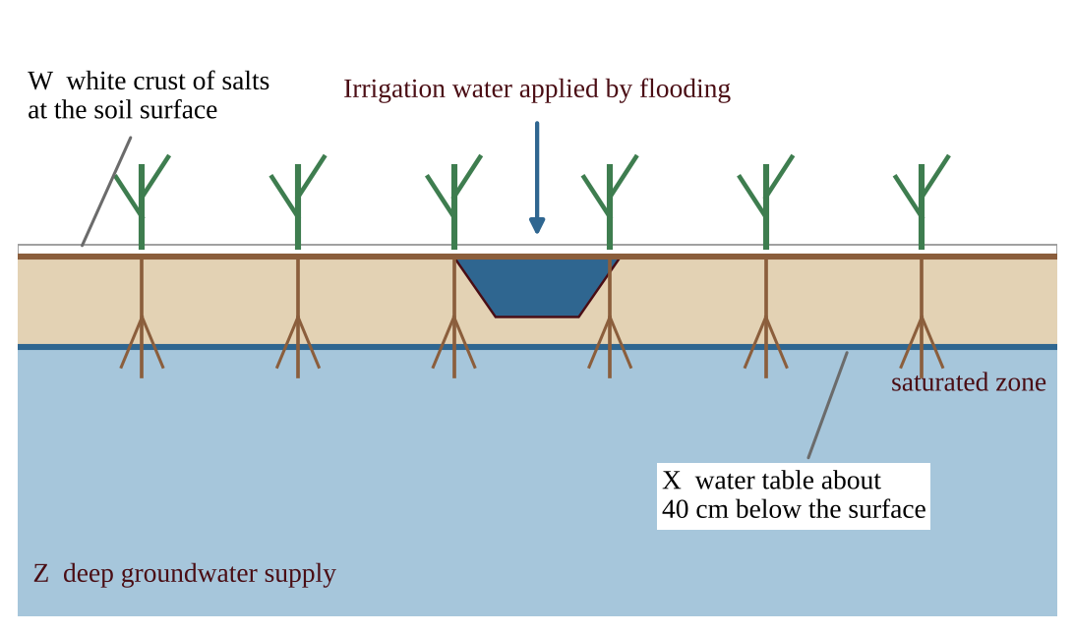
Figure — Cross-section of a flood-irrigated field in an arid valley after 25 years of irrigation. Features W, X, and Z are labeled.
Which pair of processes does the figure illustrate?
A. Salinization from salty rainfall, and waterlogging from a water table that has dropped far below the roots
B. Eutrophication from fertilizer runoff, and desertification from overgrazing
C. Saltwater intrusion from coastal pumping, and soil compaction from heavy machinery
D. Salinization from salts left behind as irrigation water evaporates, and waterlogging from a water table that has risen into the root zone

Question 20 QB-U5-MCQ020
A grower irrigates 25 ha of crops by furrow irrigation, in which about one-third of the applied water is lost to evaporation and runoff. The crop needs 6,000 m³ of water per hectare delivered to its roots. If the grower switches to drip irrigation, in which about 5% of the applied water is lost, how much less water in total must be applied?
A. 7.5 × 10⁴ m³
B. 6.7 × 10⁴ m³
C. 4.3 × 10⁴ m³
D. 7.5 × 10³ m³

Question 21 QB-U5-MCQ021
Which statement about irrigation methods is accurate?
A. Spray irrigation loses about one-third of the water and needs no energy to operate.
B. Furrow irrigation is the most efficient method, losing only about 5% of the water.
C. Drip irrigation is inexpensive to install, which is why it is the most widely used method worldwide.
D. Flood irrigation loses about 20% of the water to evaporation and runoff and can cause waterlogging.

Question 22 QB-U5-MCQ022
Two cotton fields infested with aphids were treated with the same insecticide for eight growing seasons. The graph shows the percentage of aphids resistant to the insecticide in each field.
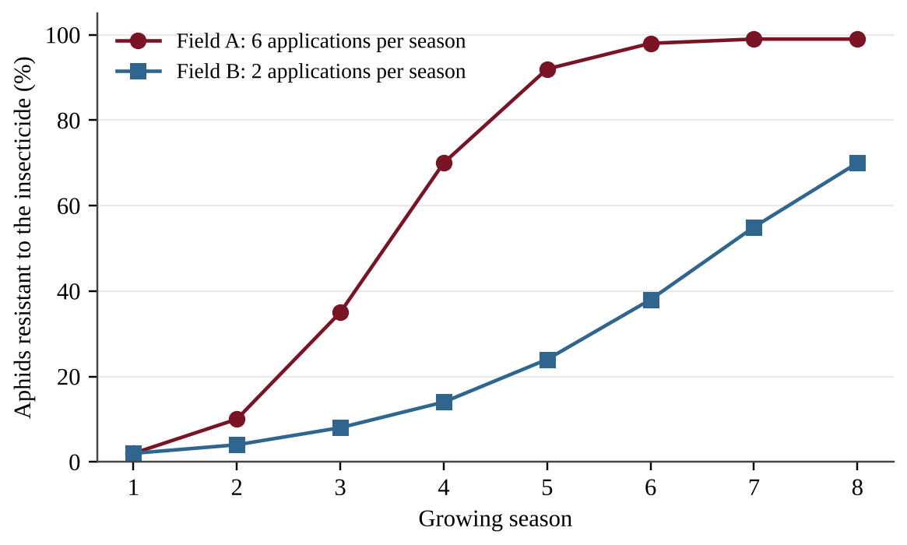
Figure — Percentage of aphids resistant to an insecticide over eight growing seasons in two fields.
Which conclusion is best supported by the graph?
A. The insecticide caused new resistance mutations to appear in Field A, but it did not do so in Field B.
B. Resistance develops only in fields that are sprayed more than four times per season.
C. The aphids in Field B are not evolving at all, because their resistant share stays below 100% in every season.
D. More frequent applications imposed stronger selection, so resistant aphids dominated sooner in Field A.

Question 23 QB-U5-MCQ023
A region plants one genetically engineered, pest-resistant variety of corn on nearly all of its cropland. Which statement about this practice is most accurate?
A. Planting a single variety reduces the crop's genetic diversity, which could leave the whole region vulnerable to a new disease or pest.
B. The engineered trait guarantees that the targeted pest species will never evolve resistance, even after many years of exposure to the crop.
C. Genetically engineered crops can be grown only with more synthetic fertilizer, so yields soon collapse.
D. Planting one variety increases the crop's genetic diversity because the trait is spread to every field.

Question 24 QB-U5-MCQ024
A semi-arid rangeland carries about twice as many cattle as its vegetation can regrow to support. Bare patches, gullies, and compacted soil are spreading. Which action would best slow desertification there?
A. Reduce the herd to the land's carrying capacity and rotate the cattle among rested pastures.
B. Add more cattle so that hooves break the soil crust and plant seeds.
C. Irrigate the pastures heavily with pumped groundwater to keep plants growing through every dry season.
D. Remove the fences so that animals graze wherever the forage is greenest.

Question 25 QB-U5-MCQ025
The graph shows annual landings and spawning stock biomass for a fishery. The number of fishing vessels doubled between 1960 and 1985, and vessels added sonar to locate schools of fish.
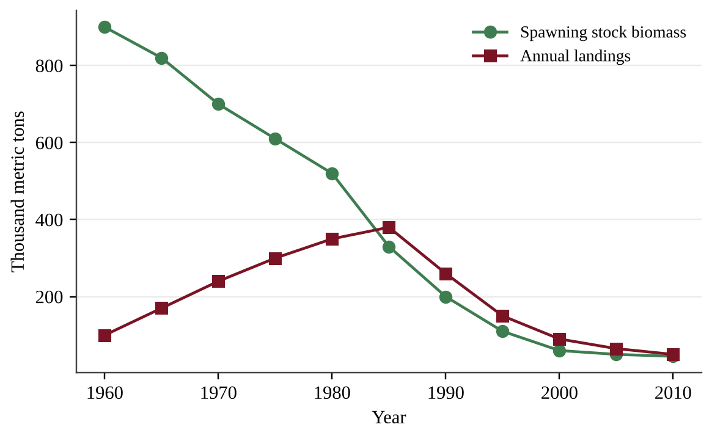
Figure — Annual landings and spawning stock biomass of a fish stock, 1960–2010.
Which interpretation of the graph is best supported?
A. Greater fishing effort and technology kept landings high for years while the stock shrank; then landings collapsed.
B. Rising landings through 1985 show that the stock was increasing in size, so no management action was needed at that time.
C. Landings fell after 1985 because fishing effort decreased, which let the stock rebuild.
D. Landings and stock biomass changed independently, so fishing had little effect on the stock.

Question 26 QB-U5-MCQ026
As the most accessible coal seams are exhausted, a mining company shifts from surface mining to deeper subsurface mining. Which result is most likely?
A. A lower cost per ton, because no overburden has to be removed to reach seams that lie deep underground
B. A complete end to methane release from the coal
C. A higher cost of extracting each ton of coal because the remaining reserves are harder to reach
D. A larger supply of low-cost coal available to consumers

Question 27 QB-U5-MCQ027
Two watersheds of similar size and soil received the same storm. One is 8% covered by impervious surfaces; the other is 62% impervious. The graph shows stream discharge in each.
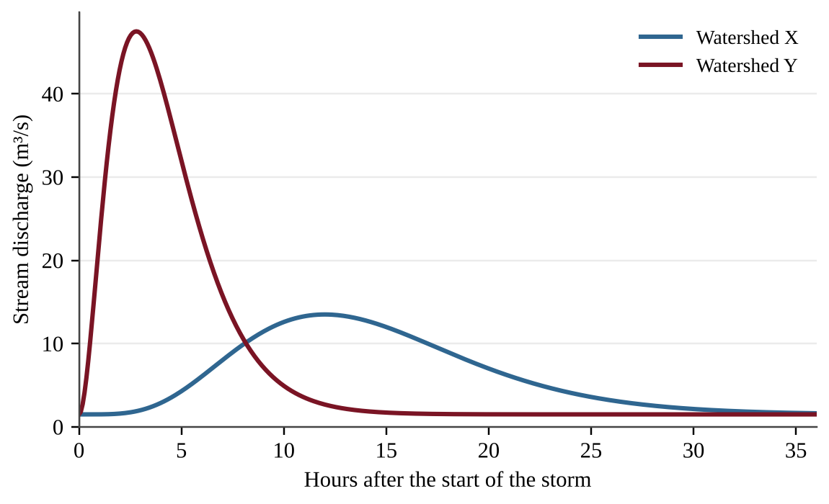
Figure — Stream discharge after the same storm in two watersheds, X and Y.
Which statement is best supported?
A. Watershed X is the more urbanized; its slower rise shows that water moves across the pavement more slowly than through soil.
B. Watershed Y is the more urbanized; reduced infiltration sends runoff to the stream faster, giving a higher, earlier peak.
C. Watershed Y is the more urbanized; its higher peak shows that more rain fell on it.
D. Watershed X is the more urbanized; its lower peak shows that storm drains stored most of the water.

Question 28 QB-U5-MCQ028
The graph shows the average ecological footprint and biocapacity per person in four countries.
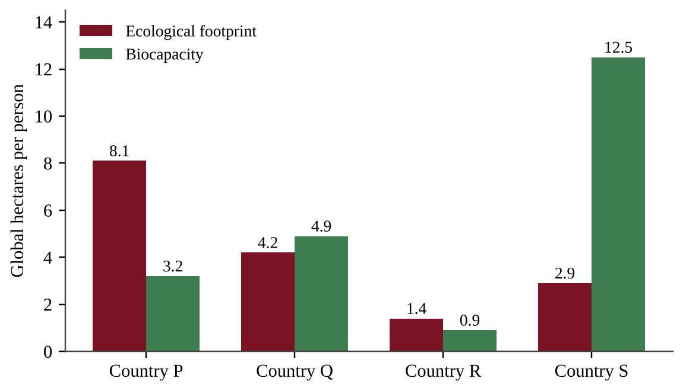
Figure — Ecological footprint and biocapacity per person (global hectares) in four countries.
Which conclusion is best supported by the graph?
A. Country S has the largest biocapacity, so it must also have the largest footprint.
B. Country R has a small footprint but still demands more than its land supplies, because its biocapacity is even smaller.
C. Country P uses resources at a rate below its biocapacity, because it has the largest footprint of the four countries shown in the graph.
D. Country Q has an ecological deficit because its footprint is greater than that of Country R.

Question 29 QB-U5-MCQ029
Earth's biocapacity is about 1.6 global hectares per person. If everyone lived like the average resident of a country whose ecological footprint is 5.6 global hectares per person, how many Earths would be needed to sustain humanity?
A. 9.0
B. 4.0
C. 3.5
D. 0.29

Question 30 QB-U5-MCQ030
A city engineer wants to know whether permeable pavement reduces runoff compared with asphalt. Which investigation provides the best evidence?
A. Measure runoff from an existing asphalt lot in one storm and from a permeable lot across town during a different storm several months later.
B. Build test plots of equal area and slope with each surface, apply the same simulated rainfall, and measure the runoff volume from each.
C. Build one permeable plot and measure its runoff during several storms without any comparison surface.
D. Compare runoff from plots that differ in surface type and in slope so that more conditions are tested.

Question 31 QB-U5-MCQ031
Researchers measured soil loss on four plots with the same slope and soil, each managed differently for several years. The bars show the mean annual soil loss, with error bars showing the range among replicates.
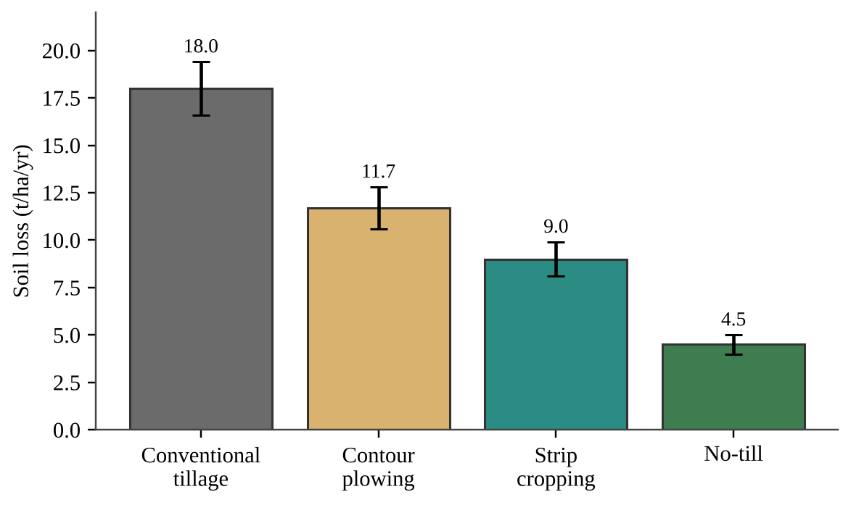
Figure — Mean annual soil loss under four management practices on identical slopes.
Which practice produced the greatest reduction in soil loss compared with conventional tillage, and about how large was the reduction?
A. No-till, about 25%
B. Strip cropping, about 50%
C. Contour plowing, about 35%
D. No-till, about 75%

Question 32 QB-U5-MCQ032
Which statement gives a reason aquaculture has expanded?
A. It lowers the risk of disease because the fish are kept together at high density in pens.
B. It needs no added feed because fish eat natural prey.
C. It can raise fish efficiently in small areas of water while using little fuel.
D. It has no effect on the quality of surrounding water.

Question 33 QB-U5-MCQ033
A coastal farm raises salmon in open net pens at high density. Which pair of problems is most likely?
A. Crowding lowers disease risk, but escaped fish easily outcompete wild fish.
B. Fuel use is very high, but the quality of the surrounding water improves.
C. Nutrient-rich waste enters the surrounding water, and parasites or disease can spread to wild fish.
D. Fish density reduces nutrient pollution, and escaped fish cannot breed with wild fish.

Question 34 QB-U5-MCQ034
Forest managers set a low-intensity fire under controlled conditions in a pine forest. What is the main purpose of a prescribed burn?
A. To convert the forest to cropland for the local community
B. To reduce built-up fuel so that natural fires are less frequent or less severe
C. To permanently eliminate the possibility of any wildfire in the forest, including natural ones
D. To increase carbon stored in the forest by killing all of the trees

Question 35 QB-U5-MCQ035
A county forestry office wants to reduce deforestation and also protect a forest from a bark beetle outbreak. Which plan is most consistent with sustainable forestry and both goals?
A. Clear-cut the whole forest at once to remove beetle habitat, then plant a single fast-growing species.
B. Spray a broad-spectrum insecticide over the entire forest every year and harvest all of the oldest trees.
C. Replant after harvest, favor wood from sustainable sources, remove infested trees, and use integrated pest management.
D. Stop all harvesting, replant nothing, and leave infested trees standing so that the outbreak runs its course.

Question 36 QB-U5-MCQ036
A student wants to test whether the amount of nitrogen fertilizer applied to lawn plots affects the nitrate concentration in runoff. She has six identical plots on the same slope with the same soil and grass. Which design is best?
A. Apply the same fertilizer amount to all six plots and measure nitrate in runoff after storms of different sizes.
B. Use a different fertilizer type and a different amount of simulated rainfall on each plot so that many variables are tested at the same time in a single experiment.
C. Fertilize one plot heavily and compare its runoff with that of an unfertilized plot on a steeper slope with different soil.
D. Apply 0, 25, and 50 g/m² of fertilizer to two plots each, give every plot the same simulated rainfall, and measure nitrate in the runoff.

Question 37 QB-U5-MCQ037
Farmers pump an aquifer that currently has 24 m of saturated thickness. Pumping lowers the water table by 0.9 m per year, and natural recharge raises it by 0.1 m per year. If these rates stay constant, about how many years until the aquifer is depleted?
A. 24 years
B. 27 years
C. 30 years
D. 240 years

Question 38 QB-U5-MCQ038
The table shows greenhouse gas emissions for producing 100 g of protein from four foods.
Food | Emissions (kg CO₂-equivalent per 100 g protein)
Beef | 50
Pork | 8
Chicken | 6
Lentils | 1

A school cafeteria serves 800 servings per day, each containing 20 g of protein from beef. If the cafeteria replaces the beef with chicken that supplies the same 20 g of protein per serving, by how much will its daily emissions decrease?
A. 0.70 metric tons CO₂-eq
B. 7.0 metric tons CO₂-eq
C. 8.0 metric tons CO₂-eq
D. 35 metric tons CO₂-eq

Question 39 QB-U5-MCQ039
Consumers often assume that beef from free-range or pasture-based systems is always better for the environment than beef from feedlots. Which statement best evaluates this assumption?
A. Pasture-based systems can be more sustainable, especially with rotational grazing, but they need more land, can still cause runoff and erosion at high animal density, and are not always antibiotic-free.
B. The assumption is correct because cattle that graze on pasture do not produce methane, unlike feedlot cattle.
C. The assumption is incorrect because pasture-based systems always cause more pollution than CAFOs do.
D. The assumption is correct because manure deposited on pasture is spread out and can never reach nearby water.

Question 40 QB-U5-MCQ040
A copper mine processes ore averaging 0.50% copper by mass and produces 500 metric tons of copper per year. As richer ore is mined out, the average grade falls to 0.25% copper. To keep producing 500 metric tons of copper per year, how many metric tons of ore per year must it process?
A. 5.0 × 10⁴
B. 1.0 × 10⁵
C. 2.0 × 10⁵
D. 4.0 × 10⁵

Question 41 QB-U5-MCQ041
A coastal city draws drinking water from a freshwater aquifer that lies above saltwater. Over 15 years the city's population doubled and groundwater pumping increased. Chloride concentration in the wells rose from 40 to 380 mg/L. Which process best explains the change?
A. Heavy pumping lowered the freshwater level in the aquifer, letting saltwater move inland into the wells.
B. Increased paving raised recharge of the aquifer, which flushed salts from the soil and into the city's wells.
C. Sea level fell, which drew salt from the ocean floor into the aquifer.
D. Fossil fuel burning acidified the groundwater, which released chloride from the rock.

Question 42 QB-U5-MCQ042
A fish stock's net growth depends on its size, as shown in the graph. The current stock is 600 metric tons, and managers set a fixed harvest of 150 metric tons per year.
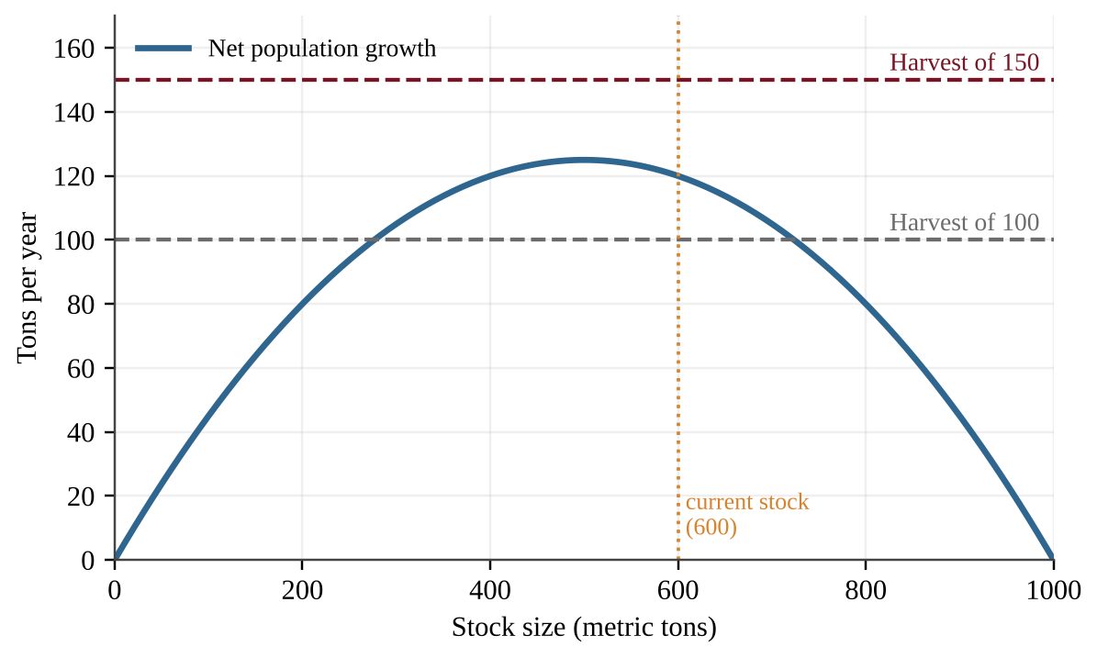
Figure — Net growth of a fish stock as a function of stock size, with two possible fixed harvest levels.
Which outcome is most likely over time?
A. The stock levels off near 500 tons, where net growth is greatest.
B. The stock declines every year because the harvest exceeds net growth at every stock size, and it eventually collapses.
C. The stock rises toward 1,000 tons because net growth is positive at 600 tons.
D. The stock stabilizes near 725 tons, the right-hand point where the growth curve meets one of the harvest lines on the graph.

Question 43 QB-U5-MCQ043
A grower wants to test whether releasing ladybugs, which prey on aphids, reduces aphid damage in a greenhouse bean crop. Which design is best?
A. Release ladybugs on the benches with the most aphids, where they are needed most, and compare them with the benches that have the fewest aphids.
B. Randomly choose half of the similar benches for ladybug release, keep growing conditions the same on all benches, and count aphids per plant at regular intervals on every bench.
C. Release ladybugs on all benches this season and compare the aphid counts with those of last year's crop grown in the same greenhouse.
D. Release ladybugs on half the benches and also spray insecticide on those benches, then compare with unsprayed benches.

Question 44 QB-U5-MCQ044
The soil in a field is acidic (pH 4.9) and low in nitrogen. Which pair of practices would most directly raise both the soil pH and the nitrogen available to crops?
A. Adding elemental sulfur and plowing in a legume cover crop
B. Adding limestone and plowing in a legume cover crop as green manure
C. Adding limestone and planting corn in the same field every single year
D. Terracing the field and plowing along the contour lines

Section B — Free-Response Questions
Each question is worth 10 points. Show all calculations, include units, and write in complete sentences where an explanation is requested.
Question 1 QB-U5-FRQ001
A rancher manages 120 ha of semi-arid grassland along a creek. Cattle have grazed the land continuously for many years, and the rancher has noticed bare patches, gullies, and cloudy water in the creek after storms. She wants to test whether rotational grazing can restore the vegetation. She divides the land into six 20-ha paddocks with similar soil, slope, and starting vegetation, as shown in the figure. Each continuous-grazing paddock (C1–C3) holds 40 cattle all season. One herd of 120 cattle is rotated among the three rotational-grazing paddocks (R1–R3), spending 10 days in each before moving on.
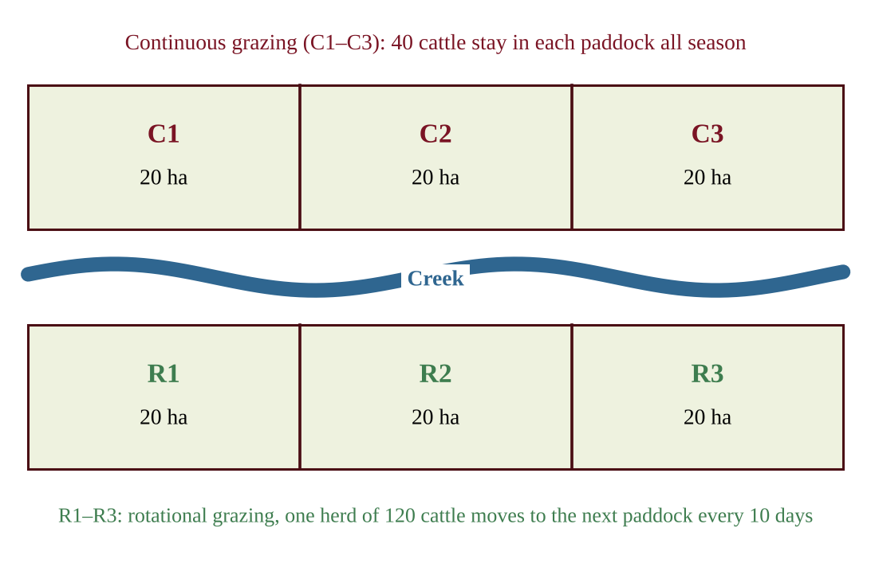
Figure — Layout of six 20-ha paddocks beside a creek. C1–C3 are grazed continuously; R1–R3 are grazed in rotation.
(a) Identify the environmental problem that the rancher's continuous grazing most likely has caused. [1] (b) Write a testable hypothesis for the rancher's investigation. Your hypothesis must state the expected direction of the result. [1] (c) Identify each of the following for the investigation. [3] (i) The independent variable (ii) One dependent variable (iii) Two variables that should be kept constant (controlled) (d) Describe a method the rancher could use to collect data on plant cover in each paddock, and state how often she should collect it. [2] (e) Describe the results that would support the hypothesis in part (b). [1] (f) Describe one measurement the rancher could make in the creek to gather additional evidence about the effect of the grazing methods, and state the result expected if rotational grazing reduces erosion. [1] (g) Propose a solution, other than changing the grazing system, that the rancher could use to restore the bare patches and justify it by describing one advantage. [1]

Question 2 QB-U5-FRQ002
Farmers in an arid plains region irrigate with groundwater from a shallow aquifer that is recharged slowly by rainfall. The table and graph show irrigated cropland, groundwater pumped for irrigation, and the average saturated thickness of the aquifer (the thickness of water-bearing rock) between 1960 and 2020.
Year | Irrigated cropland (thousand ha) | Groundwater pumped (million m³/yr) | Saturated thickness (m)
1960 | 40 | 300 | 62
1970 | 90 | 700 | 58
1980 | 160 | 1,350 | 50
1990 | 210 | 1,700 | 42
2000 | 230 | 1,850 | 35
2010 | 225 | 1,600 | 30
2020 | 215 | 1,300 | 27

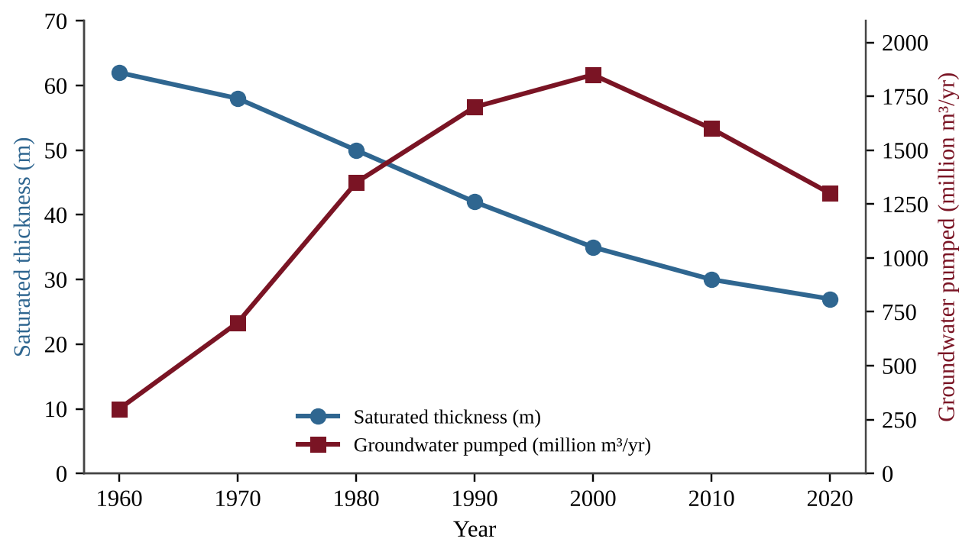
Figure — Groundwater pumped for irrigation and aquifer saturated thickness, 1960–2020.
Most of the cropland is irrigated by flood irrigation.
(a) Describe the trend in the aquifer's saturated thickness from 1960 to 2020. [1] (b) Calculate the average annual rate of decline in saturated thickness, in meters per year, from 1970 to 2000. Show your work. [1] (c) Explain why the saturated thickness continued to decrease between 2000 and 2020 even though the amount of groundwater pumped decreased. [2] (d) Make a claim about whether groundwater use in this region in 2020 was sustainable, and justify your claim with data from the table. [2] (e) Describe one environmental problem that flood irrigation can cause on this cropland, and explain how it occurs. [2] (f) Propose one solution that would extend the life of the aquifer, and describe one advantage and one drawback of your solution. [2]

Question 3 QB-U5-FRQ003
A developer plans to replace a 40-ha forest with a shopping center and parking lots. Rainfall in the area can reach 5.0 cm in a single storm. The proportion of rainfall that leaves a surface as runoff is given below.
Surface | Fraction of rainfall that becomes runoff
Forest | 0.10
Conventional roofs and asphalt | 0.90
Permeable pavement | 0.30

Use 1 ha = 10,000 m². The forest stores 120 metric tons of carbon per hectare. Molar masses: C = 12 g/mol; CO₂ = 44 g/mol.
(a) Calculate the volume of rain, in m³, that falls on the 40-ha site during a 5.0 cm storm. Show your work. [1] (b) Calculate the volume of runoff, in m³, produced by the forested site during the storm. [1] (c) Assume the entire 40 ha is covered by conventional roofs and asphalt after development. Calculate (i) the runoff volume, in m³, produced by the developed site during the storm and (ii) the percent increase in runoff compared with the forested site. [2] (d) Explain why developing the forest increases runoff, and describe one environmental effect of this increased runoff on a nearby stream. [2] (e) The developer proposes using permeable pavement on half of the 40-ha site, with the other half remaining conventional roofs and asphalt. Calculate the runoff volume, in m³, from the site during the storm and the percent reduction compared with your answer to part (c)(i). [2] (f) If clearing the forest releases 75% of its stored carbon to the atmosphere as CO₂, calculate the mass of CO₂, in metric tons, released. [1] (g) Propose one action, other than permeable pavement, that the developer could take to reduce the effects of the project on both runoff and carbon dioxide, and justify it by describing one advantage. [1]

Question 4 QB-U5-FRQ004
Global fisheries supply a large share of the protein in many diets. The table shows the mass of fish and shellfish produced by wild capture and by aquaculture, together with the percentage of assessed wild fish stocks that were overfished, for four years.
Year | Wild capture (million t) | Aquaculture (million t) | Assessed stocks overfished (%)
1990 | 80 | 15 | 10
2000 | 90 | 35 | 25
2010 | 90 | 60 | 30
2020 | 90 | 90 | 35

(a) Describe the trends in wild capture and aquaculture production between 1990 and 2020. [2] (b) Calculate the percentage of total production that came from aquaculture in 2020. Show your work. [1] (c) Explain why wild capture production stayed at about 90 million t from 2000 to 2020 even though fishing effort and technology continued to grow and the percentage of overfished stocks increased. [2] (d) Identify one reason that aquaculture has expanded. [1] (e) Describe two environmental drawbacks of aquaculture. [2] (f) Propose a solution to reduce overfishing of wild stocks, and justify it by using data from the table or by describing one advantage. [2]

Unit 6 — Energy Resources and Consumption
NOTE
Exam weight: Unit 6 accounts for 10–15% of the AP Environmental Science exam score. This set assesses your knowledge of renewable and nonrenewable energy sources, global energy use, and their environmental effects (Topics 6.1–6.13). It also tests data analysis and energy, efficiency, cost, and emissions calculations; a calculator is allowed.

Section A — Multiple-Choice Questions
Question 1 QB-U6-MCQ001
A student sorts energy sources into renewable and nonrenewable categories and gives a reason for each. Which classification and reason are both correct?
A. Wind is renewable because moving air is replenished naturally at or near the rate people use it.
B. Uranium is renewable because a very small mass of fuel releases a very large amount of energy.
C. Natural gas is renewable because new deposits are continually being discovered by drilling.
D. Biomass is nonrenewable because burning it always releases carbon dioxide into the air.

Question 2 QB-U6-MCQ002
Which statement best describes how the world currently meets most of its energy demand?
A. Fossil fuels supply the largest share of energy used worldwide.
B. Hydroelectric dams supply the largest share of energy used worldwide.
C. Nuclear power supplies the largest share of energy used worldwide.
D. Wind and solar together supply the largest share of energy used worldwide.

Question 3 QB-U6-MCQ003
In many rural areas of developing countries, households use firewood and charcoal as their main fuel. Which is the most likely reason?
A. Wood releases more energy per kilogram than any fossil fuel.
B. Wood is easily accessible and can often be gathered at little or no cost.
C. Burning wood produces no particulates or carbon monoxide indoors.
D. Wood is a fuel that is never harvested faster than it regrows.

Question 4 QB-U6-MCQ004
Natural gas is considered the cleanest-burning fossil fuel. Which compound makes up most of natural gas?
A. Bitumen
B. Methane
C. Ethanol
D. Carbon dioxide

Question 5 QB-U6-MCQ005
Which list places three types of coal in order from lowest to highest carbon content and energy released per kilogram?
A. Bituminous, lignite, anthracite
B. Anthracite, bituminous, lignite
C. Lignite, anthracite, bituminous
D. Lignite, bituminous, anthracite

Question 6 QB-U6-MCQ006
Which sequence correctly describes how a coal-fired power plant produces electricity?
A. Coal is burned to release heat, the heat turns a generator directly, and the generator makes steam for a turbine.
B. Coal is split into smaller nuclei, the nuclei release heat, and the heat spins a turbine connected to a generator.
C. Coal is burned to release heat, the heat turns water to steam, the steam spins a turbine, and the turbine spins a generator.
D. Coal is converted to hydrogen, the hydrogen reacts with oxygen, and the reaction directly produces electricity.

Question 7 QB-U6-MCQ007
Which process releases the heat that is used to make steam in a commercial nuclear power plant?
A. Uranium-235 is burned in oxygen to form carbon dioxide and water.
B. Hydrogen nuclei combine to form helium in the reactor core.
C. Uranium-235 is chemically oxidized to produce a hot gas.
D. Neutrons strike uranium-235 nuclei, splitting them into smaller nuclei.

Question 8 QB-U6-MCQ008
A homeowner in the Northern Hemisphere builds a house with large south-facing windows and a dark stone floor that absorbs heat on winter days and releases it at night. No pumps or fans are used. This is an example of
A. an active solar energy system.
B. a photovoltaic solar energy system.
C. a geothermal energy system.
D. a passive solar energy system.

Question 9 QB-U6-MCQ009
A river is dammed to create a large reservoir for a hydroelectric plant. Which is a likely environmental effect of the project?
A. The plant releases large amounts of sulfur dioxide into the air.
B. Habitats upstream and downstream of the dam are lost or changed.
C. The plant produces radioactive solid waste that must be stored.
D. The plant releases hydrogen sulfide gas from underground steam.

Question 10 QB-U6-MCQ010
Which sequence correctly describes the energy transformations in a wind turbine?
A. Thermal energy of the air, then chemical energy in the blades, then electrical energy
B. Chemical energy in the tower, then thermal energy in the generator, then electrical energy
C. Electrical energy from the grid, then rotational energy of the blades, then kinetic energy of the air
D. Kinetic energy of moving air, then rotational energy of the blades and generator, then electrical energy

Question 11 QB-U6-MCQ011
Which action is an example of conserving energy in a home?
A. Raising the temperature setting on the water heater
B. Leaving lights on in empty rooms for security
C. Running the dishwasher when it is only half full
D. Lowering the thermostat setting on cold winter days

Question 12 QB-U6-MCQ012
A city bus powered by a hydrogen fuel cell is operating on a street. What is the only substance the fuel cell itself emits from the bus?
A. Water
B. Carbon dioxide
C. Nitrogen oxides
D. Carbon monoxide

Question 13 QB-U6-MCQ013
Residents living near a geothermal power plant report a “rotten egg” odor near the plant’s steam vents. Which gas is the most likely cause?
A. Carbon monoxide
B. Ground-level ozone
C. Hydrogen sulfide
D. Radon

Question 14 QB-U6-MCQ014
In a rural region, villagers harvest forest trees for fuelwood at about twice the rate at which the forest regrows. Which statement best describes the resource?
A. Wood is acting like a nonrenewable resource because it is being used faster than it is replenished.
B. Wood remains renewable because trees are living organisms and always grow back.
C. Wood is nonrenewable because it is made of carbon that was stored for millions of years.
D. Wood is renewable because burning it adds no carbon dioxide to the atmosphere.

Question 15 QB-U6-MCQ015
The graph below shows the share of primary energy supplied by each source for three groups of countries.
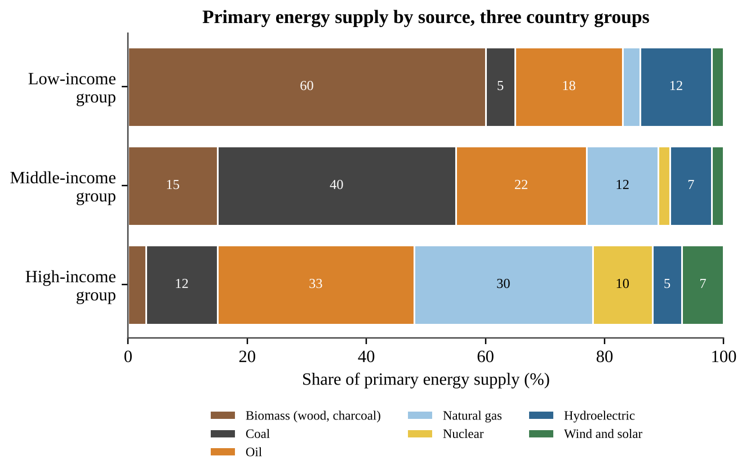
Figure 6.1 — Primary energy supply by source for three country groups
Which conclusion is best supported by the data?
A. Moving from the low-income group to the middle-income group, the combined share from fossil fuels rises sharply while the share from biomass falls.
B. Moving from the middle-income group to the high-income group, the combined share from fossil fuels continues to rise sharply.
C. Wind and solar supply a larger share of primary energy than hydroelectric power in every country group.
D. The high-income group relies on biomass for a larger share of its energy than the low-income group.

Question 16 QB-U6-MCQ016
A rapidly industrializing country has annual energy demand that is growing by 3.5% per year. Using the rule of 70, about how many years will it take for its annual energy demand to double if this growth rate continues?
A. 10 years
B. 20 years
C. 35 years
D. 245 years

Question 17 QB-U6-MCQ017
Some coal-fired plants capture part of the waste heat that would otherwise be released and pipe it to nearby buildings for heating. The diagram below shows the energy flow in one plant per 100 units of fuel energy.
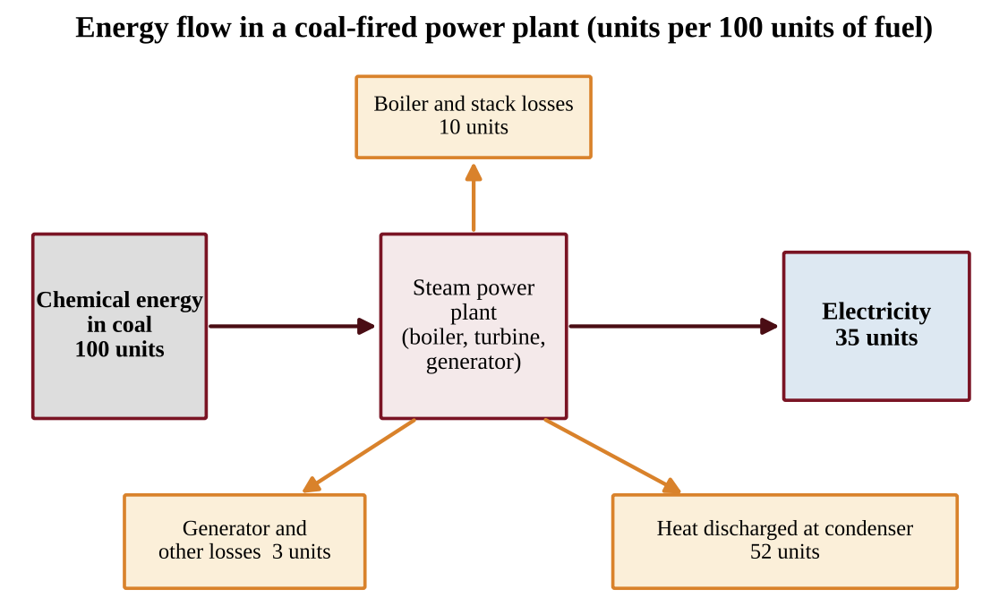
Figure 6.2 — Energy flow in a coal-fired power plant
The plant is converted to cogeneration, and 30 of the 52 units discharged at the condenser are now delivered as useful heat. What is the new overall efficiency of fuel use, counting both electricity and useful heat?
A. 30%
B. 35%
C. 65%
D. 87%

Question 18 QB-U6-MCQ018
Which description best matches tar sands?
A. Partially decomposed plant material that can be dried and burned for fuel
B. A mixture of clay, sand, water, and bitumen from which crude oil can be recovered
C. A dense carbon-rich rock formed from buried swamp vegetation under heat and pressure
D. A fine-grained rock with natural gas trapped in tiny pores between its particles

Question 19 QB-U6-MCQ019
The graph below compares each region’s share of world proved crude oil reserves with its share of world crude oil consumption.
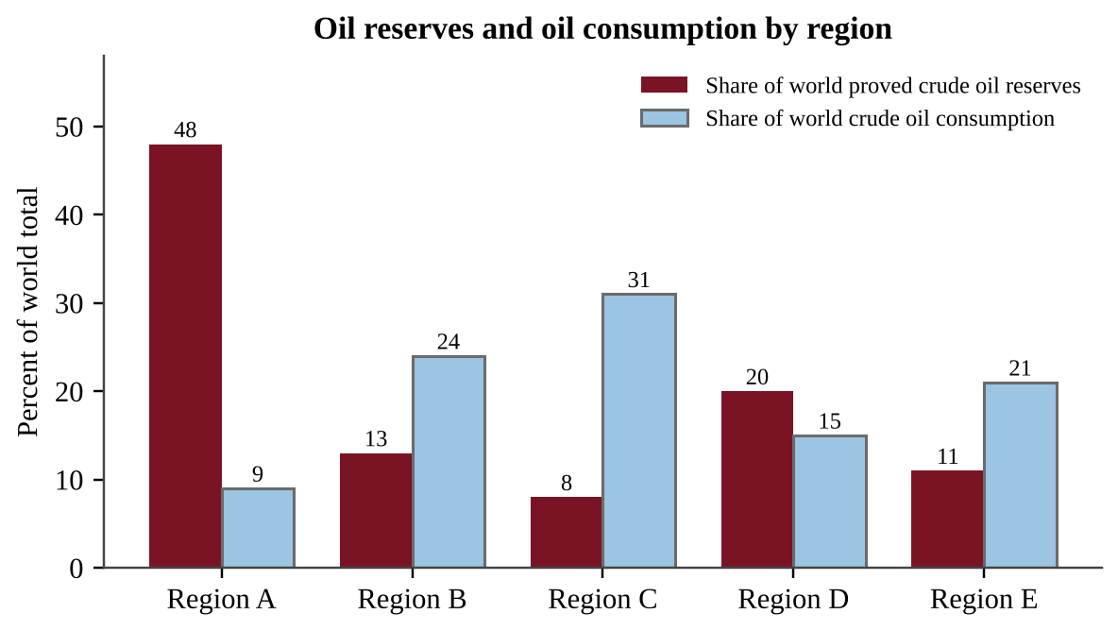
Figure 6.3 — Oil reserves and consumption by region
Which statement is best supported by the graph?
A. Region C has the largest share of world reserves because it has the largest share of consumption.
B. In every region, the share of reserves is close to the share of consumption, so oil is mostly used where it is found.
C. Region A holds about five times as large a share of reserves as its share of consumption, showing that where oil is located does not match where it is used.
D. Region E’s share of reserves is larger than its share of consumption.

Question 20 QB-U6-MCQ020
Large coal deposits occur in some regions of the world but not in others. Which is the best explanation?
A. Coal forms where plant material from ancient swamps was buried and then exposed to heat and pressure, so deposits depend on a region’s geologic history.
B. Coal forms wherever large human populations live because people produce organic waste that becomes coal.
C. Coal forms only in regions that now receive the most rainfall, because water converts soil into coal.
D. Coal is distributed evenly in Earth’s crust but only some governments have chosen to mine it.

Question 21 QB-U6-MCQ021
A community near a proposed hydraulic fracturing (fracking) site asks about the environmental risks of the process. Which pair of concerns is most directly associated with fracking?
A. Release of hydrogen sulfide and loss of habitat from flooding a valley
B. Contamination of groundwater and release of volatile organic compounds
C. Release of radioactive waste and thermal pollution of rivers
D. Death of birds and bats and disturbance of desert ecosystems

Question 22 QB-U6-MCQ022
Which pairing of a fossil fuel with an appropriate method of extraction is correct?
A. Shallow coal seam — strip (surface) mining
B. Crude oil in a reservoir — mountaintop removal mining
C. Natural gas in shale — open-pit mining of the gas
D. Tar sand deposits — hydraulic fracturing with salt water

Question 23 QB-U6-MCQ023
The diagram shows a nuclear power plant. Reactor water, turbine steam, and river water move in separate sealed pathways. Locations 1–4 are marked on pipes or channels.
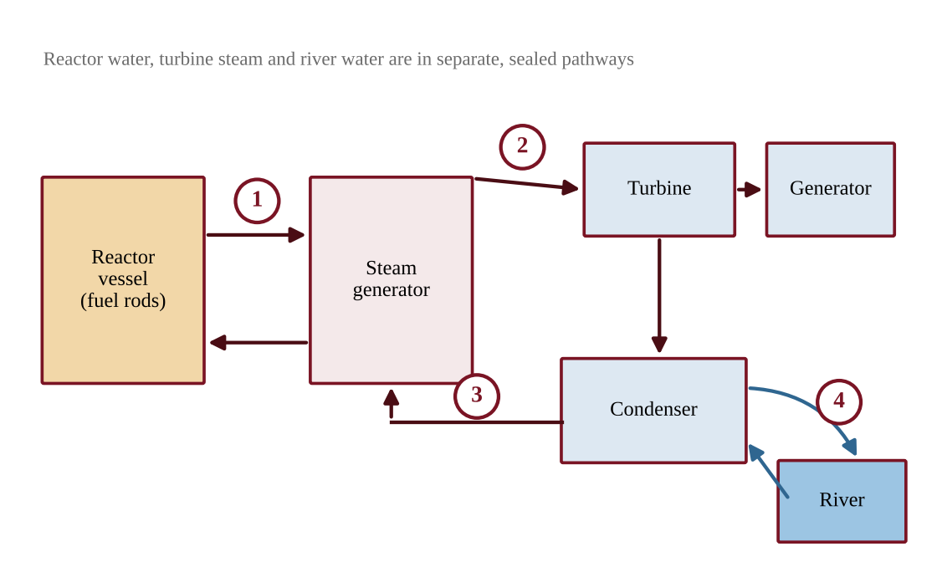
Figure 6.4 — Simplified diagram of a nuclear power plant
Water leaving which numbered location is most directly responsible for thermal pollution of the river?
A. Location 1
B. Location 2
C. Location 3
D. Location 4

Question 24 QB-U6-MCQ024
The graph shows how the radioactivity of isotope Q in spent fuel decreases with time.
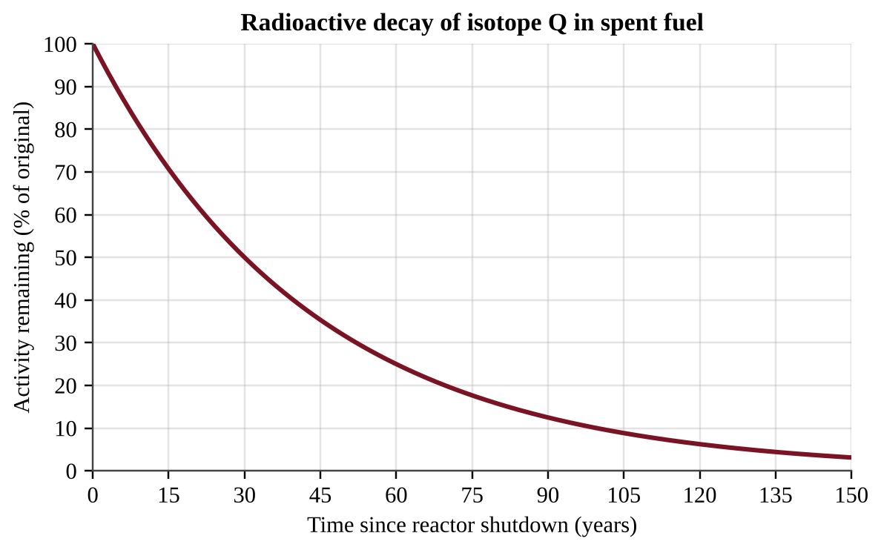
Figure 6.5 — Decay of isotope Q
About how many years after shutdown will the activity be 12.5% of its original value?
A. 53 years
B. 60 years
C. 90 years
D. 120 years

Question 25 QB-U6-MCQ025
Which statement correctly describes a nuclear power plant during normal operation?
A. It emits no air pollutants from fission, but it releases waste heat and produces hazardous solid waste.
B. It emits large amounts of sulfur dioxide and nitrogen oxides from burning uranium.
C. It releases no waste heat and produces no solid waste that must be stored.
D. It is a renewable source because uranium-235 is replaced by natural decay.

Question 26 QB-U6-MCQ026
A farmer-owned cooperative argues that corn ethanol blended into gasoline is better for the climate than gasoline. Which statement best weighs the evidence about ethanol?
A. Burning ethanol adds no carbon to the atmosphere, and its energy return on investment is higher than that of oil because corn is grown with free sunlight.
B. Burning ethanol releases carbon that was stored underground for millions of years, so it adds more carbon than gasoline.
C. Ethanol can substitute for gasoline, but it can be produced only from fossil fuels.
D. The carbon released by burning ethanol was recently taken up by the crop, but the net energy gain is small because growing and processing the corn takes energy.

Question 27 QB-U6-MCQ027
A homeowner plans to install 20 m² of photovoltaic panels with an efficiency of 18%. The site receives an average of 5 kWh of sunlight energy per square meter per day. About how much electricity will the panels produce per day?
A. 0.9 kWh
B. 3.6 kWh
C. 18 kWh
D. 100 kWh

Question 28 QB-U6-MCQ028
The graph shows the output of a rooftop photovoltaic system and a household’s electricity demand during one sunny day.
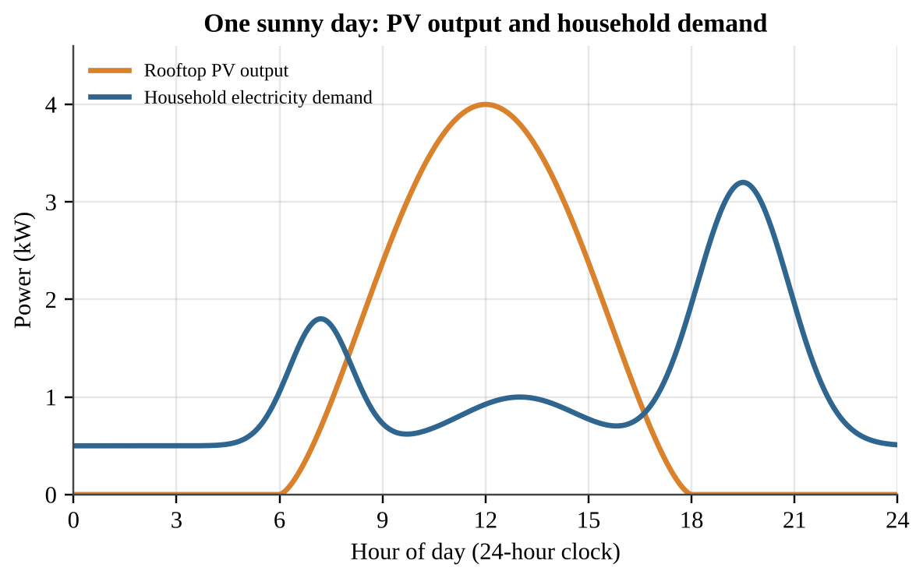
Figure 6.6 — PV output and household demand over one day
Which conclusion is best supported by the graph?
A. PV output and household demand reach their highest values at about the same time of day.
B. The household’s highest demand occurs after PV output has nearly stopped, so evening needs would depend on stored energy or the grid.
C. The PV system supplies more than the household’s demand at every hour of the day.
D. PV output is greatest at night because the cells store sunlight during the day.

Question 29 QB-U6-MCQ029
A small turbine is placed directly in a flowing stream without building a dam or reservoir. Compared with a large dam, what is the most likely result?
A. More land is flooded and more habitat is lost, but more electricity is produced steadily.
B. No electricity is produced because turbines work only when water falls from a reservoir.
C. Less land is flooded and habitat change is smaller, but less electricity is produced and it depends on stream flow.
D. Tidal flows are required to spin the turbine, so it works only near the ocean.

Question 30 QB-U6-MCQ030
Geothermal power plants supply a large share of electricity in a few places, such as areas near tectonic plate boundaries, but little in most of the world. Which statement best explains this pattern?
A. Geothermal energy is used up quickly in every location, so only a few plants can be built.
B. Heat can be reached at a reasonable depth only in some places, and drilling to reach it elsewhere can be prohibitively expensive.
C. Geothermal plants require large amounts of sunlight and so work only in desert regions.
D. Geothermal plants release more carbon dioxide than coal plants, so most countries ban them.

Question 31 QB-U6-MCQ031
How does a hydrogen fuel cell produce electricity?
A. Hydrogen combines with oxygen from the air to form water, releasing electrical energy.
B. Hydrogen is burned in a boiler to make steam that spins a turbine.
C. Hydrogen is split apart by sunlight into protons and neutrons, which are collected as current.
D. Hydrogen reacts with nitrogen in the air to form ammonia, releasing electrical energy.

Question 32 QB-U6-MCQ032
The graph shows the power curve of a wind turbine.
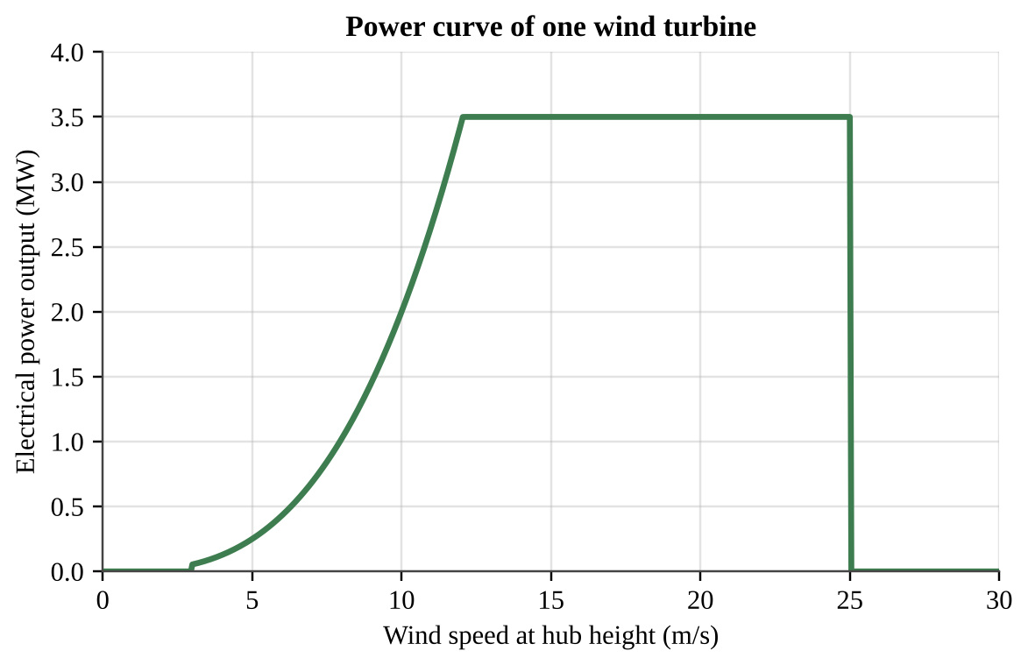
Figure 6.7 — Power curve of one wind turbine
The wind speed at the site increases from 5 m/s to 10 m/s. About how many times greater is the turbine’s power output at 10 m/s than at 5 m/s?
A. 2 times
B. 4 times
C. 8 times
D. 16 times

Question 33 QB-U6-MCQ033
A household replaces a 60 W incandescent bulb with a 10 W LED bulb that gives the same light. The bulb is used 3 hours per day. About how much electricity is saved in one year (365 days)?
A. 11 kWh
B. 55 kWh
C. 66 kWh
D. 548 kWh

Question 34 QB-U6-MCQ034
A driver travels 12,000 miles per year. Replacing a car that gets 25 miles per gallon with a more efficient car that gets 40 miles per gallon will save about how many gallons of fuel per year?
A. 480 gallons
B. 300 gallons
C. 180 gallons
D. 15 gallons

Question 35 QB-U6-MCQ035
The bar graph compares illustrative values of energy return on energy investment (EROI) for several energy sources.
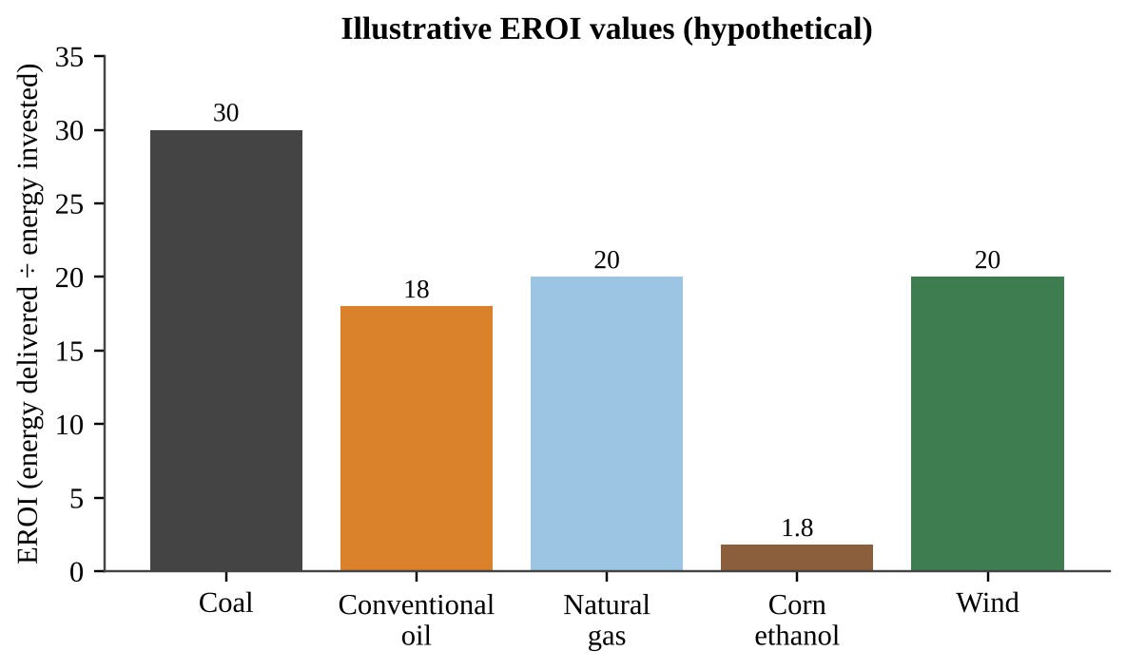
Figure 6.8 — Illustrative EROI values
Based on the graph, how much net energy gain results from every 100 MJ of energy invested in producing corn ethanol?
A. 180 MJ
B. 80 MJ
C. 56 MJ
D. 44 MJ

Question 36 QB-U6-MCQ036
A coal-fired plant produces 500 MW of electrical power at an overall efficiency of 38%. The coal contains 24 MJ of energy per kilogram, and 1 MW = 1 MJ/s. About how many metric tons of coal does the plant burn each hour? (1 metric ton = 1,000 kg)
A. 197 metric tons
B. 75 metric tons
C. 54.8 metric tons
D. 28.5 metric tons

Question 37 QB-U6-MCQ037
A 900 MW nuclear plant generated 6.30 × 10⁶ MWh of electricity during a year of 8,760 hours. What was its capacity factor (actual output divided by output if run at full power all year)?
A. 125%
B. 80%
C. 70%
D. 7%

Question 38 QB-U6-MCQ038
Residents worry that hydraulic fracturing is contaminating their drinking-water aquifer with methane and other chemicals. Which investigation is best designed to test whether fracturing at a new site changes groundwater quality?
A. Sample monitoring wells at several distances up and down the flow direction from the site before and after fracturing, measuring methane, volatile organic compounds, and chloride.
B. Sample one well beside the drilling pad only after fracturing and compare the result with a drinking-water standard.
C. Sample wells once at several different gas fields with different geology and compare the average concentrations.
D. Survey residents about the taste and smell of their tap water before and after drilling begins.

Question 39 QB-U6-MCQ039
A city replaces its diesel buses with hydrogen fuel cell buses. The hydrogen is made by using electricity from a coal-fired power plant to split water. Which statement is best supported?
A. The change eliminates carbon dioxide emissions because fuel cells combine hydrogen and oxygen to form water, with no carbon-containing fuel involved.
B. The change increases carbon dioxide emissions because fuel cells burn the hydrogen and release carbon dioxide.
C. The change has no energy cost because the hydrogen is obtained from water, which is renewable.
D. The buses emit only water, but overall CO₂ emissions depend on the electricity used to make the hydrogen, so they are shifted to the power plant.

Question 40 QB-U6-MCQ040
At a wind farm, researchers counted bat fatalities and recorded wind speed at hub height. The turbine in the study begins generating power at 3 m/s and produces little power below 6 m/s.
Wind speed band (m/s) | Bat fatalities per turbine per night
3–4 | 0.80
4–6 | 0.60
6–8 | 0.20
Above 8 | 0.05

Which operating change would most reduce bat deaths while giving up the least electricity?
A. Shut down all turbines on every night of the year regardless of wind speed.
B. Keep blades turning at low wind speeds but stop them whenever winds exceed 8 m/s.
C. Replace the turbines with taller turbines without changing when they operate.
D. Keep blades from turning below 6 m/s on bat-migration nights.

Question 41 QB-U6-MCQ041
Data were collected for five years before and five years after a dam was completed on a river.
Measurement | Before dam | After dam
Reservoir surface area (km²) | 0 | 38
Downstream suspended sediment (mg/L) | 120 | 18
Downstream summer water temperature (°C) | 15 | 10
Migratory salmon counted moving upstream (fish/year) | 24,000 | 3,100

Which conclusion is best supported by the data?
A. The dam had no effect on downstream conditions because the river still flows after the dam.
B. Downstream water became warmer and muddier after the dam, which explains the changes in salmon numbers.
C. The dam is associated with habitat changes upstream and downstream, including less sediment and cooler summer water below it.
D. The dam eliminated all aquatic habitat in the river, as shown by the reservoir’s surface area.

Question 42 QB-U6-MCQ042
A state’s electric utilities reported the following changes between two years.
Measurement | 2018 | 2024
Coal share of generation (%) | 46 | 22
Natural gas share of generation (%) | 30 | 41
Wind and solar share of generation (%) | 7 | 25
Delivered natural gas price ($ per million BTU) | 5.00 | 3.00
State limit on power-plant CO₂ emissions | None | In effect since 2020

Which explanation for the decline in coal use is best supported by the table?
A. Coal reserves in the state were depleted, so coal could no longer be mined.
B. Total electricity demand in the state fell sharply, so fewer plants were needed.
C. Hydroelectric capacity expanded, replacing coal with the most affordable source.
D. A drop in natural gas prices and a new emissions limit made coal less competitive than other sources.

Question 43 QB-U6-MCQ043
A homeowner is considering new windows that cost $2,400. A utility rebate of $400 is available, and the windows are expected to reduce the household’s heating and cooling costs by $250 per year. What is the simple payback period for the homeowner?
A. 11.2 years
B. 9.6 years
C. 8.0 years
D. 1.6 years

Question 44 QB-U6-MCQ044
A school district compares burning wood pellets with burning natural gas to deliver the same amount of heat. Emissions per megawatt-hour of heat delivered are shown.
Emission | Wood pellets | Natural gas
Particulate matter (kg/MWh) | 0.30 | 0.01
Nitrogen oxides (kg/MWh) | 0.40 | 0.18
CO₂ from fossil fuel use, including processing and trucking (kg/MWh) | 25 | 200

Which statement is best supported by the table?
A. Switching to pellets would lower every pollutant listed in the table.
B. Switching to pellets would produce no pollutants because wood is renewable.
C. Switching to pellets would lower particulate emissions but increase fossil-fuel CO₂ emissions.
D. Switching to pellets would lower fossil-fuel CO₂ emissions but increase particulate and nitrogen oxide emissions.

Section B — Free-Response Questions
Question 1 QB-U6-FRQ001
A rural county overlies a freshwater aquifer that supplies household drinking-water wells. A company plans to use hydraulic fracturing (fracking) to extract natural gas from a shale layer about 2,000 m below the surface. Residents are concerned that the process could change the quality of their well water. A hydrogeologist proposes monitoring the aquifer with three monitoring wells (M1, M2, and M3) installed at different distances from the planned well pad, as shown below.
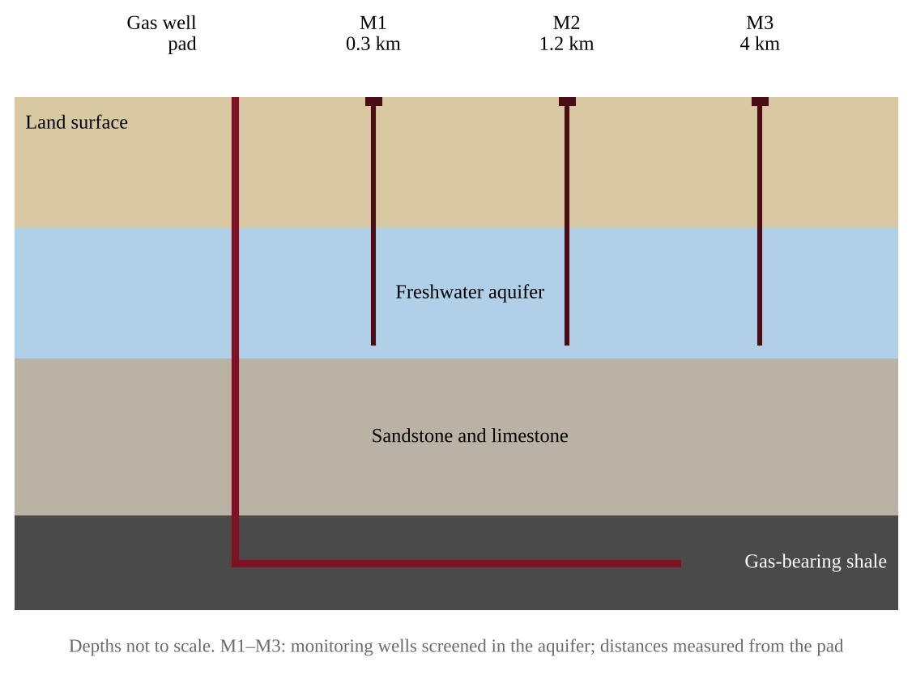
Figure 6.9 — Cross-section of a proposed gas well pad and three monitoring wells
(a) Identify the environmental problem that the residents are concerned could result from fracking and affect their drinking water. [1] (b) Write a testable hypothesis, in if–then form, that predicts how the dissolved methane concentration in the aquifer will differ with distance from the pad after fracking begins. [1] (c) Describe a procedure the hydrogeologist could follow to test the hypothesis. Include when and where samples will be collected and how the reliability of the data will be improved. [2] (d) Identify the independent variable and the dependent variable in the investigation. [2] (e) Identify one variable that should be kept constant during sampling, and explain why. [1] (f) Describe the pattern of results that would support the hypothesis, and explain how the hydrogeologist should decide that a change in methane is greater than natural variation. [2] (g) Propose one action the gas company could take to reduce the risk of groundwater contamination, and justify it. [1]

Question 2 QB-U6-FRQ002
A region tracks how it generates electricity. Hydroelectric power supplied 10 TWh in each of the three years shown. All other generation came from the sources in Table 1. Table 2 gives total generation, power-sector carbon dioxide emissions, and the estimated number of birds and bats killed at the region’s wind farms.
Table 1. Generation by source (TWh)
Year | Coal | Natural gas | Wind | Solar
2015 | 60 | 30 | 6 | 1
2020 | 36 | 40 | 14 | 6
2025 | 12 | 38 | 30 | 18

Table 2. Totals and impacts
Year | Total generation (TWh) | Power-sector CO₂ (million metric tons) | Birds and bats killed at wind farms (per year)
2015 | 107 | 73.5 | 1,200
2020 | 106 | 54.0 | 5,600
2025 | 108 | 29.1 | 12,000

(a) Describe the trend in electricity generated from coal and the trend in electricity generated from wind between 2015 and 2025, citing data for each. [2] (b) Calculate the percentage of the region’s total generation that came from wind and solar combined in 2025. Show your work. [2] (c) Using the data, explain why power-sector CO₂ emissions fell between 2015 and 2025 even though total generation stayed nearly constant. [1] (d) Calculate the percent decrease in power-sector CO₂ emissions from 2015 to 2025. Show your work. [2] (e) Describe one environmental disadvantage of wind power shown by the data, and use the data to support your answer. [2] (f) Propose one action that could reduce the wildlife deaths at wind farms and justify it. [1]

Question 3 QB-U6-FRQ003
A school district plans to install a rooftop photovoltaic (PV) array on a high school. Use the information below to analyze the project.
• School’s electricity use: 450,000 kWh per year
• PV array area: 1,200 m²
• Average sunlight reaching the array: 5.0 kWh per m² per day (annual average)
• PV panel efficiency: 20%
• Net installed cost after incentives: $630,000
• Price of electricity purchased from the grid: $0.12 per kWh
• Emissions from the local grid: 0.40 kg CO₂ per kWh
(a) Calculate the electrical energy, in kWh per year, that the array will produce. Show your work, including units. [2] (b) Calculate the percentage of the school’s annual electricity use that the array will supply. [1] (c) Calculate the annual electricity cost savings, and then calculate the simple payback period in years. [2] (d) Calculate the mass of CO₂, in metric tons per year, that is not emitted because of the PV array. (1 metric ton = 1,000 kg) [2] (e) Describe one environmental advantage and one limitation of using photovoltaic solar energy. [2] (f) Propose one way the district could address the limitation you described in part (e), and justify your answer. [1]

Question 4 QB-U6-FRQ004
A nuclear power plant has an electrical output (capacity) of 1,000 MW and an efficiency of 33%. During one year (8,760 hours) it operates at 90% of its full capacity. The plant uses water from a river that flows at 150 m³/s. Assume that all of the plant’s waste heat is absorbed by the river water, that 1 m³ of water has a mass of 1,000 kg, and that the specific heat of water is 4.18 kJ/(kg·°C).
(a) Calculate the electrical energy, in MWh, that the plant generates in one year. Show your work. [2] (b) Calculate the plant’s waste heat output, in MW. (Thermal power = electrical power ÷ efficiency.) [2] (c) Calculate the increase in river temperature, in °C, caused by the waste heat. (Heat absorbed = mass flow × specific heat × temperature change.) [2] (d) Describe one effect of this increase in water temperature on the river ecosystem. [1] (e) Propose one way to reduce the amount of heat the plant discharges to the river. [1] (f) If the electricity generated in part (a) replaced electricity from coal-fired plants that emit 0.95 metric tons of CO₂ per MWh, calculate the metric tons of CO₂ emissions avoided in one year. [1] (g) Strontium-90, a component of nuclear waste, has a half-life of 29 years. Calculate how many years are required for the radioactivity of a sample to fall to 6.25% of its original value. [1]

Unit 7 — Atmospheric Pollution
NOTE
Exam weight: Unit 7 accounts for about 7–10% of the AP Environmental Science exam score. This section assesses air pollutant sources and effects, photochemical smog, thermal inversion, indoor air pollutants, pollution controls, acid deposition, and noise. Expect data and graph interpretation, short calculations, and experimental-design judgments, so show units and reason from evidence.

Section A — Multiple-Choice Questions
Question 1 QB-U7-MCQ001
Which of the following is a secondary air pollutant?
A. Carbon monoxide released from a vehicle tailpipe
B. Lead released from the burning of leaded fuel
C. Ground-level ozone formed from reactions of nitrogen oxides and volatile organic compounds in sunlight
D. Sulfur dioxide released from the combustion of coal

Question 2 QB-U7-MCQ002
Which of the following is a natural source of atmospheric carbon dioxide?
A. Decomposition of leaf litter by soil microbes
B. Combustion of natural gas in a home furnace
C. Heating of limestone in cement kilns
D. Burning of diesel fuel in cargo ships

Question 3 QB-U7-MCQ003
Which of the following is a documented effect of chronic noise pollution on wildlife?
A. Increased absorption of ultraviolet light by skin and feathers
B. Faster decomposition of animal waste in affected habitats
C. Greater genetic diversity within each affected species
D. Masking of sounds that animals use to communicate or locate prey

Question 4 QB-U7-MCQ004
Which indoor air pollutant is classified as an asphyxiant because it interferes with the delivery of oxygen to body tissues?
A. Radon
B. Carbon monoxide
C. Formaldehyde
D. Asbestos

Question 5 QB-U7-MCQ005
Gasoline vapors escape into the air each time a driver refuels a car. Which pollution control device on the fuel pump directly reduces this release?
A. Vapor recovery nozzle
B. Catalytic converter
C. Electrostatic precipitator
D. Wet scrubber

Question 6 QB-U7-MCQ006
Which pair of air pollutants contributes most to the formation of acid deposition?
A. Carbon dioxide and methane
B. Carbon monoxide and ozone
C. Lead and mercury
D. Sulfur dioxide and nitrogen oxides

Question 7 QB-U7-MCQ007
Which statement correctly describes a thermal inversion?
A. The air at the surface is warmer than the air above it, so pollutants rise and mix quickly into the upper atmosphere.
B. Strong upward air currents carry surface pollutants into the upper atmosphere.
C. A layer of warmer air lies above cooler air near the ground, limiting vertical mixing.
D. Strong winds blow along the surface and disperse pollutants over a wide area.

Question 8 QB-U7-MCQ008
Photochemical smog forms when sunlight drives chemical reactions among which two groups of pollutants?
A. Sulfur dioxide and particulate matter
B. Nitrogen oxides and volatile organic compounds
C. Carbon monoxide and lead
D. Carbon dioxide and water vapor

Question 9 QB-U7-MCQ009
Concentrations of lead in the atmosphere of the United States fell dramatically after the Clean Air Act was passed. Which EPA action was primarily responsible?
A. Requiring scrubbers on coal-burning power plants
B. Limiting carbon dioxide emissions from power plants
C. Requiring vapor recovery nozzles at gas stations
D. Phasing out lead additives in motor fuel

Question 10 QB-U7-MCQ010
How does radon-222 most commonly enter a home?
A. It seeps up from soil and rock through cracks in the foundation and basement floor.
B. It evaporates from the adhesives used under new carpeting.
C. It is released when natural gas burns in a stove or furnace.
D. It is produced by mold growing on damp walls.

Question 11 QB-U7-MCQ011
Figure 1 shows the concentrations of three pollutants measured at an urban site during one sunny July day.
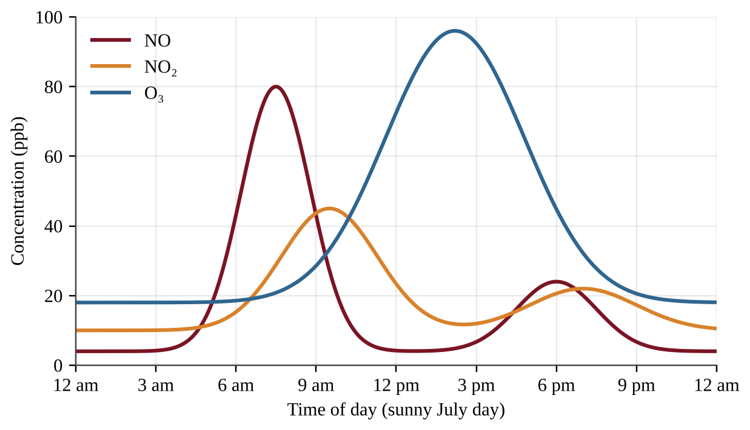
Figure 1 — Hourly concentrations of NO, NO₂, and O₃ at an urban monitoring site on a sunny July day
Which statement best explains why the ozone peak occurs several hours after the nitric oxide (NO) peak?
A. Ozone is emitted directly from vehicle tailpipes during the afternoon commute.
B. Ozone forms from reactions of nitrogen oxides and VOCs driven by sunlight, so it accumulates as light intensity and temperature rise.
C. Sunlight breaks down nitrogen oxides in the morning, which delays the formation of ozone until evening.
D. Ozone forms only after all of the NO has been removed from the air by rainfall.

Question 12 QB-U7-MCQ012
Figure 2 shows air temperature at different heights above the ground in a valley city on two mornings.
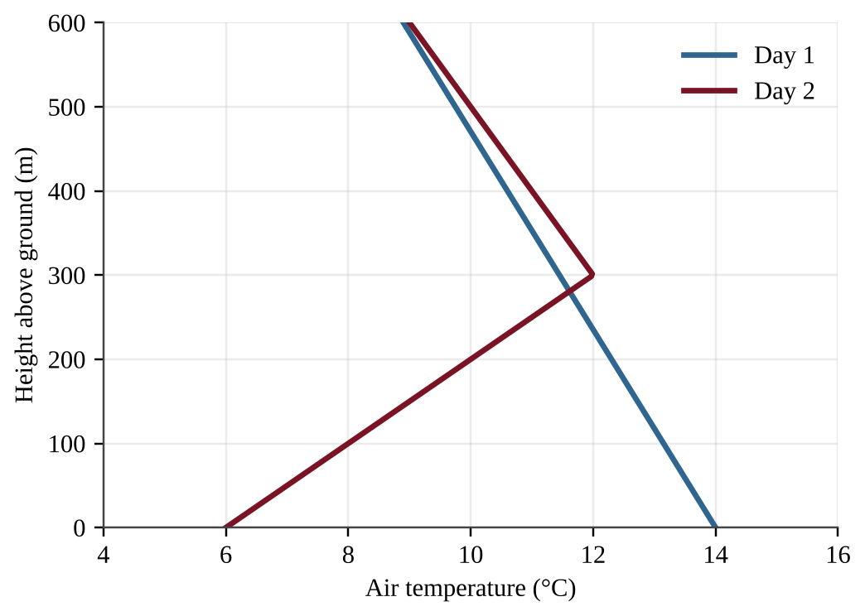
Figure 2 — Air temperature versus height above ground on two mornings
On which morning would smog and particulates be most likely to build up near the ground, and why?
A. Day 1, because temperature decreases with height, which holds pollutants in place
B. Day 2, because the cooler air aloft dissolves pollutants and returns them to the surface
C. Day 2, because the warmer layer above the cool surface air limits vertical mixing
D. Day 1, because the warm surface air destroys pollutants chemically before they can rise

Question 13 QB-U7-MCQ013
A catalytic converter on a gasoline-powered car converts which pollutants into which less harmful products?
A. Carbon monoxide, nitrogen oxides, and unburned hydrocarbons into carbon dioxide, nitrogen gas, and water
B. Carbon dioxide, nitrogen gas, and water into carbon monoxide, nitrogen oxides, and hydrocarbons
C. Sulfur dioxide and particulates into calcium sulfate sludge
D. Lead and mercury into harmless mineral salts

Question 14 QB-U7-MCQ014
A school measured indoor air in a classroom before and after a summer renovation that installed new particleboard cabinets and wall-to-wall carpet.
Indoor pollutant | Before renovation | After renovation
Formaldehyde (ppb) | 11 | 78
Carbon monoxide (ppm) | 1 | 1
Radon (pCi/L) | 2.1 | 2.0
PM2.5 (µg/m³) | 8 | 9

Which conclusion is best supported by the data?
A. Radon-bearing soil gas is entering through new cracks in the floor.
B. The gas furnace is burning fuel incompletely.
C. Mold is growing in the damp basement.
D. The new cabinets and carpet are releasing volatile organic compounds into the room.

Question 15 QB-U7-MCQ015
Two lakes in the same region receive rain with an average pH of 4.5. Their measured pH values differ.
Lake | Bedrock of watershed | Lake water pH
Flint Lake | Granite | 4.9
Marl Lake | Limestone | 6.8

Which statement best explains the difference?
A. Marl Lake receives much more precipitation than Flint Lake.
B. The limestone around Marl Lake contains carbonates that neutralize acid before it lowers the lake pH.
C. Granite releases basic compounds that raise the pH of Marl Lake.
D. Limestone is a source of sulfur dioxide that raises the pH of Marl Lake.

Question 16 QB-U7-MCQ016
Figure 3 shows the exhaust path of a coal-burning power plant that has two pollution control devices.
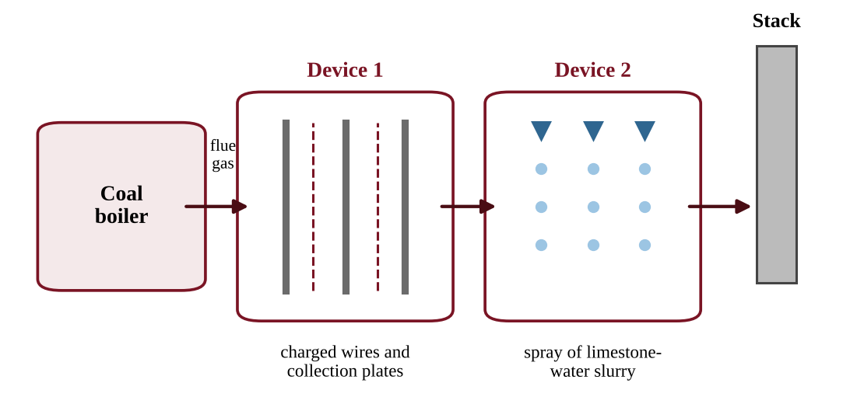
Figure 3 — Flue gas pathway through two control devices at a coal-burning power plant
Which statement correctly describes how these devices reduce emissions?
A. Device 1 removes sulfur dioxide gas using a limestone slurry, and Device 2 removes fly ash particles using electric charge.
B. Device 1 removes sulfur dioxide gas, and Device 2 removes nitrogen oxides.
C. Device 1 removes fly ash particles using electric charge, and Device 2 removes sulfur dioxide by reacting it with a limestone slurry.
D. Both devices remove carbon dioxide so that it cannot reach the stack.

Question 17 QB-U7-MCQ017
Which of the following lists contains only natural sources of particulate matter?
A. Wildfires, diesel trucks, and volcanic eruptions
B. Windblown dust, coal fly ash, and sea spray
C. Pollen, tire wear, and wildfire smoke
D. Volcanic ash, windblown dust, and sea spray

Question 18 QB-U7-MCQ018
Which set of pollutants is released directly by the combustion of coal in a power plant?
A. Carbon dioxide, sulfur dioxide, particulates, and toxic metals such as mercury
B. Ozone, chlorofluorocarbons, peroxyacyl nitrates, and formaldehyde
C. Radon, mold spores, asbestos, and dust
D. Methane, ammonia, and nitrous oxide only

Question 19 QB-U7-MCQ019
Figure 4 shows typical sound levels near six common sources. The dashed line marks 85 dB, the level above which long daily exposure is considered a risk to hearing.
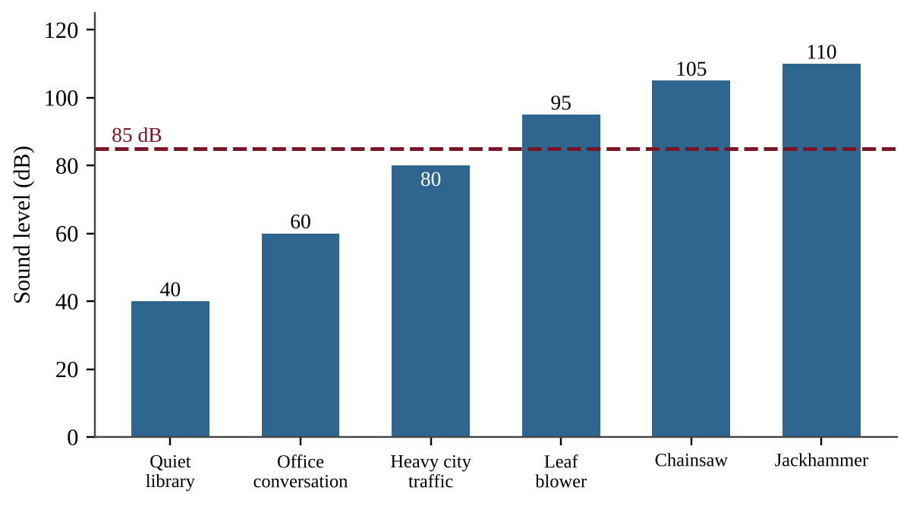
Figure 4 — Typical sound levels of six sources compared with an 85 dB reference line
Which conclusion is best supported by Figure 4?
A. Only construction equipment exceeds the 85 dB level.
B. Heavy city traffic exceeds the 85 dB level, so nearby residents should wear hearing protection.
C. Three of the six sources exceed 85 dB, so workers who use them for long periods risk hearing loss.
D. The chainsaw is below the 85 dB level, so it is safe to use all day without protection.

Question 20 QB-U7-MCQ020
A city wants to reduce the number of summer days on which photochemical smog forms. Which action would most directly target the cause?
A. Installing scrubbers on all coal-burning power plants
B. Cutting emissions of nitrogen oxides and VOCs by expanding public transit
C. Banning the use of leaded paint in older buildings
D. Raising the height of smokestacks on industrial facilities

Question 21 QB-U7-MCQ021
A coal-burning power plant lies in a region where the prevailing wind blows from west to east. Four communities are being compared for risk of damage from acid deposition from this plant.
Community | Location relative to plant | Underlying rock and soil
Town E | 150 km east | Thin soils over granite
Town F | 20 km west | Limestone-rich soils
Town G | 150 km east | Limestone-rich soils
Town H | 20 km west | Thin soils over granite

Which community is most likely to suffer the greatest harm from acid deposition?
A. Town E
B. Town F
C. Town G
D. Town H

Question 22 QB-U7-MCQ022
Which set of conditions is most likely to produce a persistent thermal inversion over a city surrounded by mountains in winter?
A. Strong winds that mix the air across the valley
B. Thick cloud cover that keeps the ground warm all night
C. A warm surface heated by strong afternoon sun
D. Clear, calm nights when the ground cools quickly and the surrounding mountains block air movement

Question 23 QB-U7-MCQ023
A coal-burning power plant would emit 1,200 metric tons of sulfur dioxide per year with no controls. After a scrubber that removes 92% of the SO₂ is installed, how much SO₂ does the plant emit per year?
A. 9.6 metric tons
B. 92 metric tons
C. 96 metric tons
D. 1,104 metric tons

Question 24 QB-U7-MCQ024
Short-term radon test kits were placed on the lowest lived-in level of four homes. The EPA action level for radon is 4.0 pCi/L.
Home | Radon (pCi/L)
1 | 2.8
2 | 3.9
3 | 4.6
4 | 7.2

Which homes should install a radon mitigation system?
A. Home 4 only
B. Homes 3 and 4 only
C. Homes 2, 3, and 4
D. All four homes

Question 25 QB-U7-MCQ025
Figure 5 shows ozone concentrations on one summer day at three sites along the downwind direction from a large city.
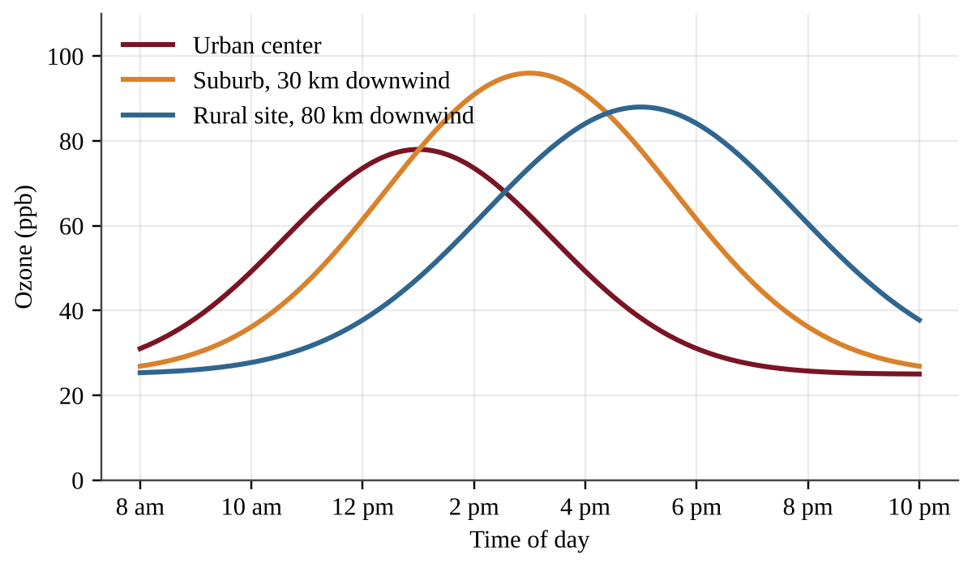
Figure 5 — Ozone concentrations at three sites downwind of a city on one summer day
Which conclusion is best supported by Figure 5?
A. Ozone peaks earliest at the rural site because it has the cleanest air.
B. Ozone is released directly from the city center and is carried unchanged to the other sites.
C. Ozone concentration is the same at all three sites at 2 p.m.
D. The ozone peak occurs later at sites farther downwind, consistent with ozone forming as polluted air travels.

Question 26 QB-U7-MCQ026
Researchers measure CO₂ concentrations 1 km downwind of an active volcanic vent. They also place an identical sensor 1 km upwind of the vent. What is the main purpose of the upwind sensor?
A. It measures the background CO₂ from other sources so the vent's contribution can be estimated.
B. It doubles the sample size of the downwind sensor.
C. It calibrates the downwind sensor for changes in its own accuracy.
D. It measures how much CO₂ nearby plants absorb from the vent.

Question 27 QB-U7-MCQ027
Ecologists counted songbird nests at four distances from a busy highway and recorded the average sound level at each location.
Distance from highway (m) | Sound level (dB) | Nests that fledged young (%)
50 | 72 | 38
200 | 60 | 52
500 | 48 | 71
1,000 | 45 | 74

Which inference is best supported by the data?
A. Highway noise is the proven cause of every nest failure.
B. Nest success is lower where noise is higher, which is consistent with noise interfering with communication, although other factors were not ruled out.
C. Nest success depends only on distance from the highway and is unrelated to noise.
D. Noise above 45 dB prevents all nesting.

Question 28 QB-U7-MCQ028
Unpolluted rain has a pH of about 5.6. Rain in a downwind region has an average pH of 4.3. Because the pH scale is logarithmic, with each whole unit representing a tenfold change in hydrogen ion concentration, about how many times greater is the hydrogen ion concentration in the downwind rain?
A. 1.3 times
B. 13 times
C. 20 times
D. 200 times

Question 29 QB-U7-MCQ029
A utility emits 8,000 metric tons of SO₂ per year and is comparing two options.
• Option 1: Install scrubbers that remove 90% of the SO₂ at a cost of $36 million per year.
• Option 2: Switch to low-sulfur coal that cuts SO₂ emissions by 60% at a cost of $14.4 million per year.
Which option has the lower cost per metric ton of SO₂ removed, and what is that cost?
A. Option 2, about $3,000 per metric ton
B. Option 1, about $5,000 per metric ton
C. Option 2, about $1,800 per metric ton
D. Option 1, about $4,500 per metric ton

Question 30 QB-U7-MCQ030
A city's 250,000 vehicles each travel an average of 12,000 miles per year and emit 0.4 g of NOₓ per mile. A new rule requires catalytic converter upgrades that cut NOₓ emissions per mile by 75%. Using 1 metric ton = 10⁶ g, how many metric tons of NOₓ per year will the rule prevent?
A. 300
B. 1,200
C. 90
D. 900

Question 31 QB-U7-MCQ031
A weather balloon measured air temperature on a winter morning above a valley city.
Height above ground (m) | 0 | 100 | 200 | 300 | 400 | 500
Temperature (°C) | 4 | 6 | 9 | 11 | 10 | 8

Based on these data, which prediction about fine particulate matter from local vehicles and heating is best supported?
A. Concentrations will be highest at 300–500 m, where the air is coolest.
B. Concentrations will be highest near the surface, because the 0–300 m layer is stable and limits mixing.
C. Concentrations will be highest at 400–500 m, because the temperature falls normally there.
D. Concentrations will be the same at all heights because gases diffuse evenly.

Question 32 QB-U7-MCQ032
A student tests how acid rain affects seed germination. Twenty bean seeds are placed in each of three dishes. The dishes are watered daily with vinegar solutions of pH 6, pH 5, and pH 4. The pH 6 dish sits on a sunny windowsill, the pH 5 dish sits on a shelf in the room, and the pH 4 dish is in a dark cabinet. Germination is counted after one week. Which modification would most improve the student's ability to attribute differences in germination to pH?
A. Use a different bean variety in each dish
B. Use vinegar for the pH 4 dish and lemon juice for the pH 5 dish
C. Place all dishes in the same light and temperature conditions and add a control dish watered with neutral water
D. Count only the tallest seedling in each dish

Question 33 QB-U7-MCQ033
Read the following excerpt from a research summary.
"Between 2012 and 2022, the number of ships using Harrow Strait doubled. Over the same period, underwater recorders showed a steady rise in low-frequency noise, and visual surveys counted 40% fewer fin whale sightings. Fin whales communicate over long distances with low-frequency calls. The authors conclude that ship noise probably contributed to the decline by masking these calls, but they note that populations of the whales' prey were not surveyed."
Which statement best describes the authors' reasoning?
A. The authors prove that ship noise caused the decline by means of a controlled experiment.
B. The authors argue that prey scarcity is the sole cause of the decline and that noise played no role in it.
C. The authors reject any link because noise and sightings were measured with different methods.
D. The authors support a link with correlated trends and a plausible mechanism, but acknowledge an unmeasured factor.

Question 34 QB-U7-MCQ034
Figure 6 shows national trends from 1990 to 2020, each expressed as an index with the 1990 value set to 100.
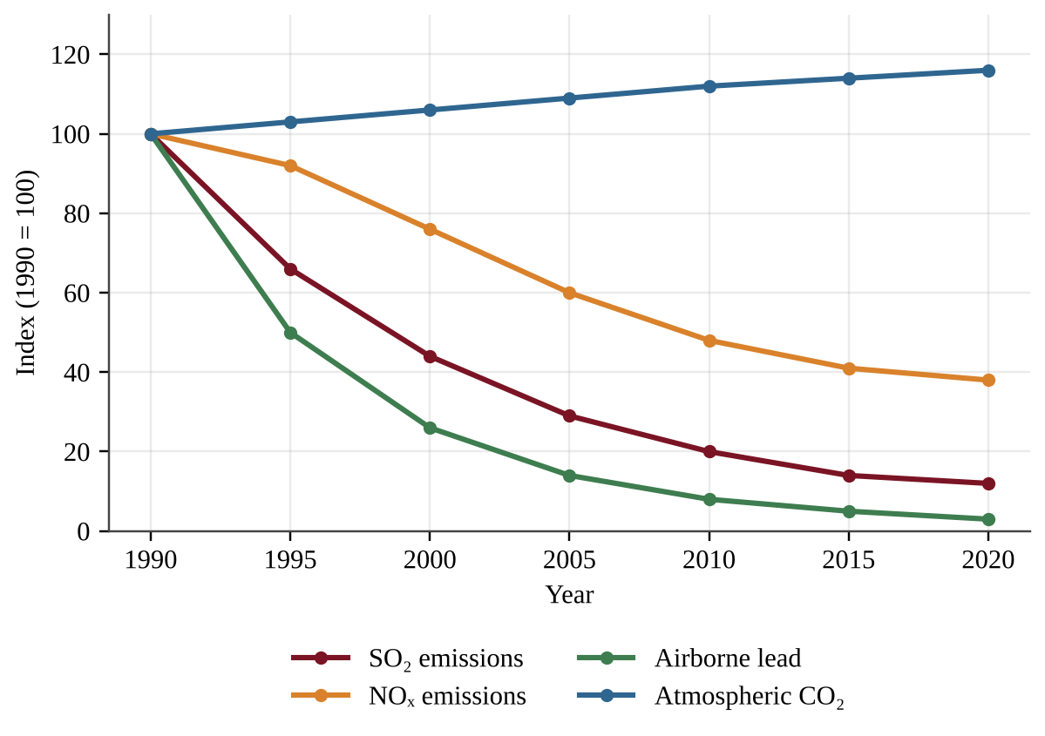
Figure 6 — Index of emissions of three pollutants and atmospheric CO₂ concentration, 1990–2020 (1990 = 100)
Which interpretation is best supported by Figure 6?
A. Emission controls and fuel standards aimed at SO₂, NOₓ, and lead coincided with large declines in those pollutants, while CO₂, which those measures do not remove, continued to rise.
B. Because NOₓ fell less than SO₂, catalytic converters must be less effective than scrubbers.
C. Because lead fell the most, the regulation of lead must have caused the decline in SO₂.
D. Rising CO₂ shows that overall air quality for human health worsened between 1990 and 2020.

Section B — Free-Response Questions
Question 1 QB-U7-FRQ001
After a summer renovation of Wing B of Maple Ridge Middle School, several teachers and students in Wing B reported headaches and eye irritation. Few such complaints came from Wing A, which was not renovated. Wing B received new carpet, particleboard cabinets, and fresh paint. Figure 7 is a floor plan of the two wings, each with four classrooms. A single ventilation unit serves both wings.
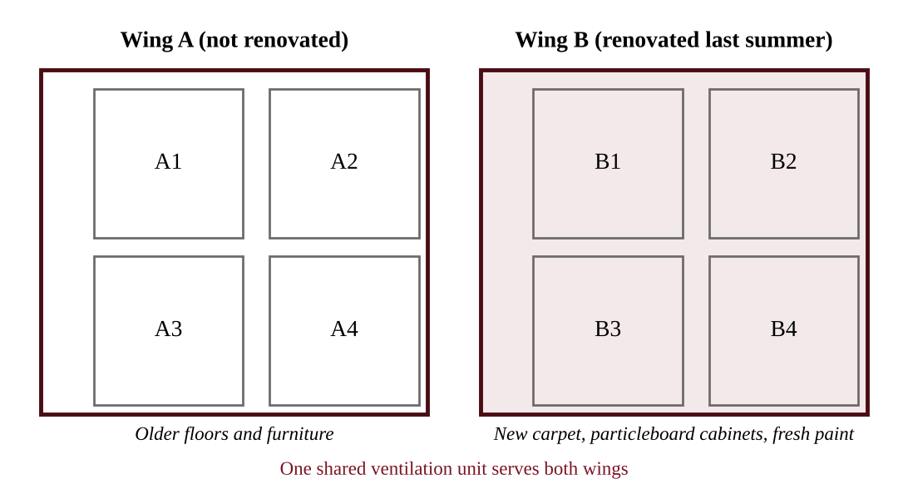
Figure 7 — Floor plan of Wing A and Wing B showing four classrooms in each wing
The school's environmental science club proposes to test whether the renovation materials are releasing an indoor air pollutant.
(a) Identify one category of indoor air pollutant that is the most likely cause of the complaints in Wing B, and identify one building material that could be its source. [1]
(b) State a testable hypothesis for the investigation, including the predicted direction of the difference between the wings. [1]
(c) Identify the independent variable and the dependent variable, and identify two variables that should be controlled. [2]
(d) Describe a procedure for collecting the data, including where and when the air samples will be taken and how the investigation will address variability. [3]
(e) Describe the results that would support the hypothesis. [1]
(f) Propose one action the school could take to reduce occupants' exposure. [1]
(g) Justify your proposed action by explaining how it would lower the concentration of the pollutant. [1]

Question 2 QB-U7-FRQ002
A coal-burning power plant has been upwind of two lakes for several decades. Lake Alder lies in a watershed with granite bedrock and thin soils. Lake Birch lies in a watershed with limestone bedrock. Beginning in 1990 the plant installed scrubbers and other controls. Figure 8 shows the plant's annual SO₂ emissions and the pH of both lakes.
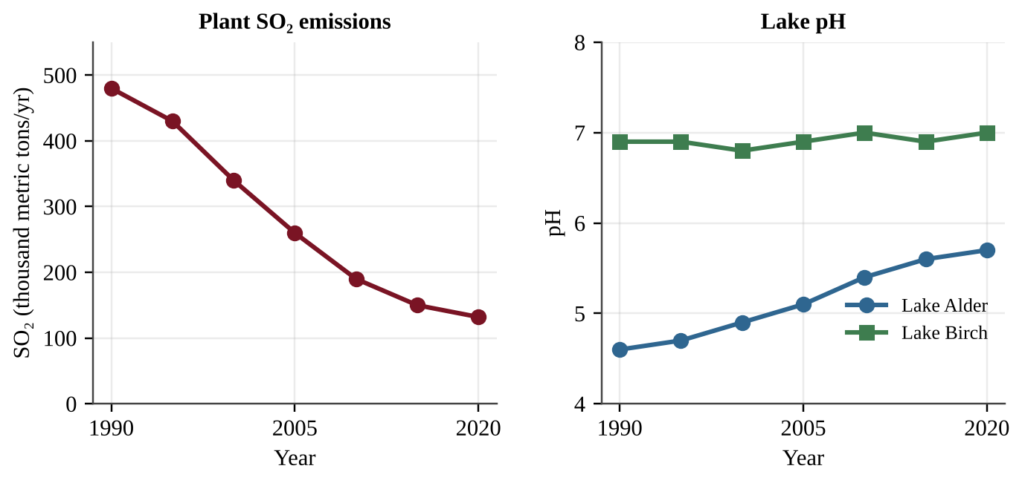
Figure 8 — Annual SO₂ emissions from the plant (left) and pH of two lakes (right), 1990–2020
Year | SO₂ emissions (thousand metric tons/yr) | Lake Alder pH | Lake Birch pH
1990 | 480 | 4.6 | 6.9
2000 | 340 | 4.9 | 6.8
2010 | 190 | 5.4 | 7.0
2020 | 132 | 5.7 | 7.0

(a) Describe the relationship between the plant's SO₂ emissions and the pH of Lake Alder from 1990 to 2020. [1]
(b) Calculate the percent decrease in the plant's SO₂ emissions from 1990 to 2020. Show your work. [1]
(c) Explain why the pH of Lake Birch stayed near 7 even when SO₂ emissions were highest. [2]
(d) Describe how sulfur dioxide released from the plant's stack becomes acid deposition downwind. [1]
(e) Identify two environmental or economic effects of acid deposition other than the acidification of lakes. [2]
(f) Make a claim about whether reducing SO₂ alone will fully restore Lake Alder, and justify your claim with data from the figure or table. [1]
(g) Propose a solution, other than scrubbers, that would further reduce acid deposition in the region, and justify why it would work. [2]

Question 3 QB-U7-FRQ003
A coal-burning power plant burns 2.0 × 10⁶ metric tons of coal per year. The coal is 1.5% sulfur by mass. When the coal burns, all of the sulfur is converted to sulfur dioxide by the reaction S + O₂ → SO₂. The atomic mass of sulfur is 32 and the molecular mass of SO₂ is 64.
The plant's owners are considering a wet scrubber that removes 95% of the SO₂ from the flue gas at a total cost of $48 million per year.
(a) Calculate the mass of sulfur, in metric tons, in the coal burned each year. [1]
(b) Calculate the mass of SO₂, in metric tons, that the plant would release each year without any control device. Show your work. [2]
(c) Calculate the mass of SO₂, in metric tons per year, that the plant would release with the scrubber operating. [1]
(d) Calculate the cost of the scrubber per metric ton of SO₂ removed. Report your answer to two significant figures. [2]
(e) Describe two effects of acid deposition on communities and ecosystems downwind of the plant. [2]
(f) Propose one way, other than installing the scrubber, that the owners could reduce SO₂ emissions, and describe one trade-off of your proposal. [2]

Question 4 QB-U7-FRQ004
A mountain-ringed city monitors fine particulate matter (PM2.5) during winter. On some days a thermal inversion forms. The table and Figure 9 show eight days of data. Inversion days are those on which the temperature at 300 m is higher than the temperature at the surface.
Date | Surface temperature (°C) | Temperature at 300 m (°C) | Daily mean PM2.5 (µg/m³)
Dec 2 | 2 | −1 | 14
Dec 3 | 3 | 0 | 18
Dec 4 | −4 | 3 | 61
Dec 5 | −5 | 4 | 78
Dec 6 | −3 | 5 | 92
Dec 7 | 1 | −2 | 23
Dec 8 | 4 | 1 | 12
Dec 9 | −6 | 2 | 85

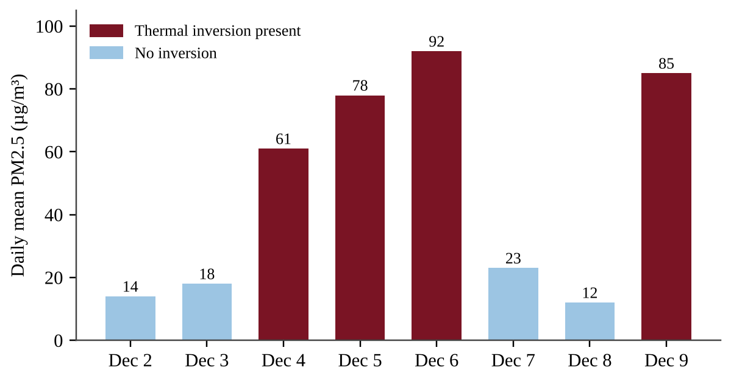
Figure 9 — Daily mean PM2.5 for eight winter days, shaded by whether a thermal inversion was present
(a) Describe the relationship between the presence of a thermal inversion and the daily mean PM2.5 concentration. [1]
(b) Calculate the mean PM2.5 concentration for the inversion days and for the non-inversion days. Show your work. [2]
(c) Explain how a thermal inversion causes pollutant concentrations near the ground to increase. [2]
(d) Identify one human activity that contributes PM2.5 to the air of a city in winter. [1]
(e) Identify one human health effect of breathing high concentrations of particulate matter. [1]
(f) Propose a solution that the city could apply on forecast inversion days, and justify it. [2]
(g) Make a claim about whether eight days of data are sufficient to conclude that inversions cause high PM2.5, and support your claim. [1]

Unit 8 — Aquatic and Terrestrial Pollution
NOTE
Exam weight: Unit 8 accounts for about 7–10% of the AP Environmental Science exam score. This section assesses point and nonpoint sources, water pollutants, eutrophication, thermal pollution, POPs and biomagnification, solid waste and sewage, and toxicity (LD50 and dose-response). Expect conceptual items, graph and diagram interpretation, dimensional-analysis calculations, and investigation design.

Section A — Multiple-Choice Questions
Question 1 QB-U8-MCQ001
Which of the following is an example of a nonpoint source of water pollution?
A. Wastewater flowing from a pipe at a textile factory
B. An overflow pipe at a sewage treatment plant
C. Fertilizer and pesticides washed by rain from many farm fields into a river
D. Fuel leaking from a single underground tank at a gas station

Question 2 QB-U8-MCQ002
Endocrine disruptors are best described as
A. bacteria and viruses that infect the reproductive organs of animals.
B. chemicals that interfere with the hormone systems of animals.
C. gases that lower the dissolved oxygen available to aquatic animals.
D. metals that kill organisms by coating their fur or feathers.

Question 3 QB-U8-MCQ003
Mangrove forests along a tropical coast are cleared to build shrimp ponds. Which ecological service is most directly reduced for the nearby villages?
A. Buffering against storm surge and coastal flooding
B. Conversion of saltwater into drinking water
C. Production of oil that fuels fishing boats
D. Removal of ultraviolet light from sunlight

Question 4 QB-U8-MCQ004
A power plant takes in river water to cool its equipment and returns the warmed water to the river. Which change is most likely in the river just downstream of the discharge?
A. Dissolved oxygen increases because warm water holds more gas.
B. Dissolved oxygen is unchanged because temperature does not affect gases.
C. Sediment increases because warm water carries more soil.
D. Dissolved oxygen decreases because warm water holds less oxygen.

Question 5 QB-U8-MCQ005
Why do persistent organic pollutants (POPs) such as PCBs remain in ecosystems for decades?
A. They are naturally occurring elements that cannot be destroyed.
B. They are synthetic, carbon-based molecules that break down only very slowly.
C. They dissolve completely in water and are diluted to zero.
D. They are quickly absorbed by plants and removed from the food web.

Question 6 QB-U8-MCQ006
A sanitary municipal landfill is built with a bottom liner of compacted clay or plastic. The main purpose of the liner is to
A. keep leachate from seeping into the groundwater.
B. speed up decomposition by trapping oxygen in the waste.
C. collect methane so it can be burned for electricity.
D. keep rainwater from entering the top of the landfill.

Question 7 QB-U8-MCQ007
Which of the following best defines the LD50 of a chemical?
A. The dose that produces any visible symptom in half of a population
B. The concentration of the chemical in tissue after half of it has broken down
C. The time needed for half of a dose to be excreted by an organism
D. The dose that is lethal to 50% of a population of a particular species

Question 8 QB-U8-MCQ008
Which process takes place during the primary treatment of sewage?
A. Bacteria in an aerated tank break down organic matter.
B. Ultraviolet light kills disease-causing bacteria.
C. Screens remove large objects and solids settle to the bottom of a tank.
D. A constructed wetland removes remaining nutrients.

Question 9 QB-U8-MCQ009
A pollutant in a stream rises above the optimum range for a fish species but stays below the level that kills fish quickly. Which outcome is most likely for the fish population?
A. All fish die within hours.
B. Physiological stress, slower growth and reduced reproduction
C. No effect, because every organism tolerates every level of a pollutant equally
D. Faster growth, because organisms always adapt immediately

Question 10 QB-U8-MCQ010
A town generates 480 metric tons of solid waste in one month and recycles 120 metric tons of it. What is the town's recycling rate for the month?
A. 25%
B. 33%
C. 75%
D. 400%

Question 11 QB-U8-MCQ011
A lake receives large inputs of phosphorus, and an algal bloom develops and then dies. Which process is the main cause of the fish kill that follows the collapse of the bloom?
A. Dead algae release heat that warms the water above the fish's tolerance.
B. Algal cells clog the gills of the fish.
C. Phosphorus poisons the gills of the fish at the concentrations found in lakes.
D. Microbes digesting the dead algae use up the dissolved oxygen.

Question 12 QB-U8-MCQ012
Heavy rain washed lawn fertilizer into Lake Tamarack in late May. The lake was sampled monthly.
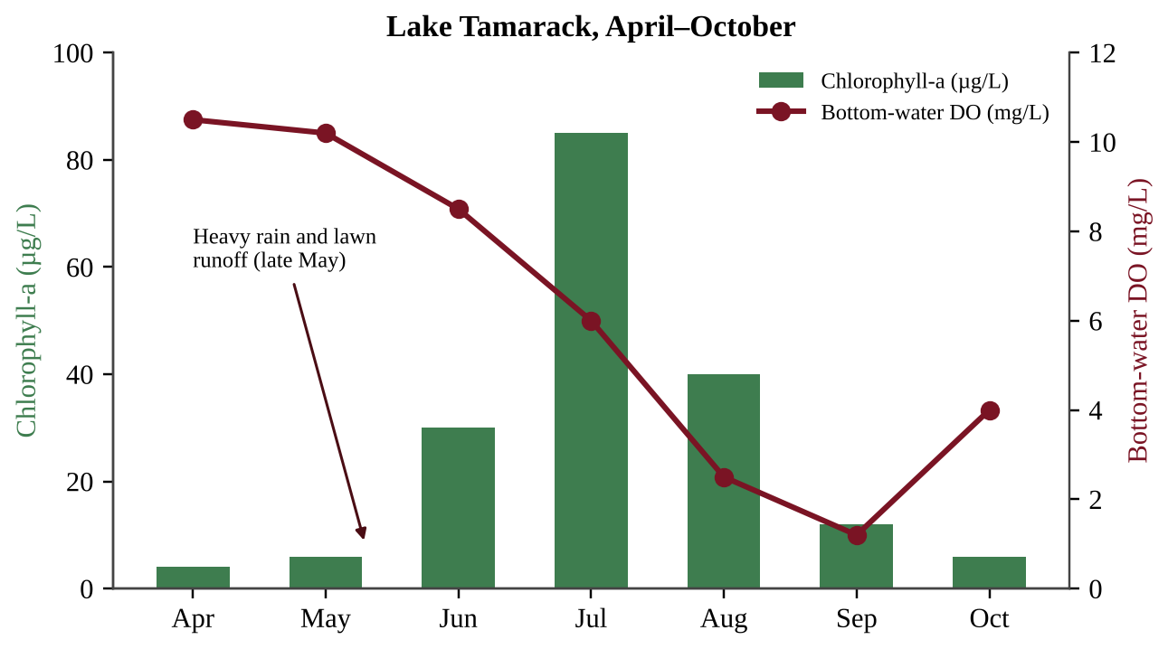
Figure — Chlorophyll-a concentration and bottom-water dissolved oxygen (DO) in Lake Tamarack, April–October
Which conclusion is best supported by the data?
A. Bottom-water DO declined after July because there were fewer algae left to produce oxygen by photosynthesis.
B. Higher chlorophyll concentrations cause higher DO in every month because of photosynthesis.
C. Bottom-water DO was lowest after the chlorophyll peak, consistent with decomposers using oxygen on dead algae.
D. Because chlorophyll returned to its April level by October, the nutrient input had no ecological effect.

Question 13 QB-U8-MCQ013
A county measured the annual nitrogen load reaching a river from four sources.
Source | Nitrogen load (kg/yr)
Wastewater treatment plant outfall pipe | 9,000
Food-processing plant discharge pipe | 6,000
Runoff from cropland | 36,000
Runoff from residential lawns and streets | 9,000

What percentage of the total nitrogen load comes from nonpoint sources?
A. 75%
B. 25%
C. 60%
D. 15%

Question 14 QB-U8-MCQ014
Deforestation on hillsides above a tropical coast greatly increases the amount of sediment carried to the sea. Which is the most direct way this sediment harms nearby coral reefs?
A. It raises the salinity of the water above the tolerance of the coral.
B. It reduces the light reaching the coral's photosynthetic algae and smothers coral as it settles.
C. It adds oxygen to the water, which burns the coral's tissues.
D. It attracts fishing boats that damage the reef.

Question 15 QB-U8-MCQ015
Weeks after a tanker spill, dead clams and crabs are found on the seafloor 15 km from shore, although no oil is visible on the surface there. Which statement best explains this observation?
A. Surface oil blocked sunlight from reaching the sediments.
B. Seabirds carried oil down to the bottom.
C. Oil dissolved completely and became harmless to bottom dwellers.
D. Some components of oil sink to the ocean floor and kill bottom-dwelling organisms.

Question 16 QB-U8-MCQ016
Researchers find many male fish with developing eggs in their testes in a river downstream of a wastewater outfall. Fish upstream are normal, and temperature and dissolved oxygen are similar at both sites. Which hypothesis is best supported by these observations?
A. A bacterial infection spread by the effluent changed the fishes' chromosomes.
B. Low dissolved oxygen in the effluent is feminizing the male fish.
C. The effluent contains chemicals that interfere with the fishes' hormone systems.
D. Thermal pollution from the outfall is changing the fishes' sex.

Question 17 QB-U8-MCQ017
A developer fills in a floodplain marsh upstream of a town. After the next heavy rain, the town floods more severely than in the past. Which statement best explains the change?
A. The marsh used to absorb storm water and release it slowly, and its loss let runoff reach the river faster.
B. The marsh plants used to release extra water to the river by transpiration.
C. Filling the marsh increased the soil's ability to store storm water.
D. The loss of the marsh increased groundwater recharge, which raised the river.

Question 18 QB-U8-MCQ018
A river upstream of a power plant is 15 °C. The plant's discharge raises the river to 25 °C downstream. Assume the water is saturated with oxygen at both temperatures.
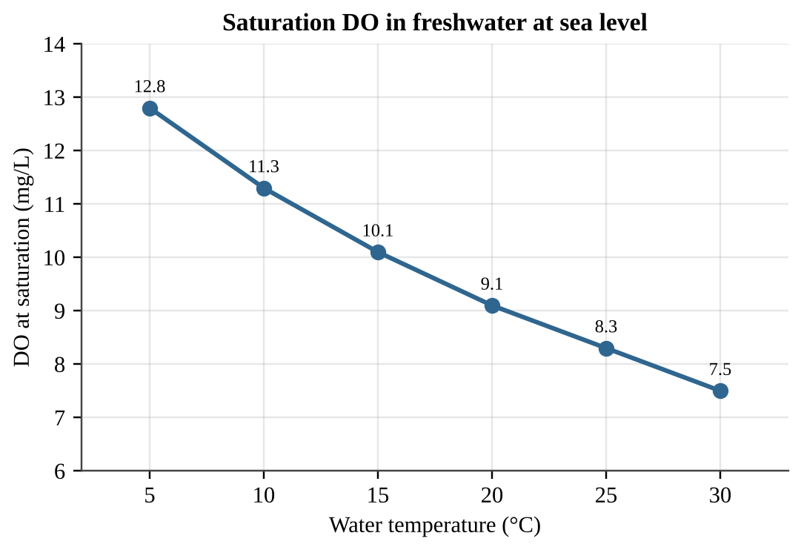
Figure — Saturation dissolved oxygen (DO) of freshwater at sea level versus water temperature
By about what percentage does the saturation DO decrease from the upstream to the downstream temperature?
A. 8%
B. 18%
C. 22%
D. 82%

Question 19 QB-U8-MCQ019
Fat tissue of polar bears contains DDT even though DDT has never been used in the Arctic. Which statement best explains this finding?
A. Polar bears eat crops that were treated with DDT.
B. DDT is produced naturally in sea ice.
C. DDT dissolves in water, so it is quickly carried into the Arctic and then excreted by the polar bears.
D. POPs travel long distances by air and water and accumulate in fatty tissues.

Question 20 QB-U8-MCQ020
A pesticide residue was measured in organisms from one lake food chain.
Organism | Concentration (µg/kg wet mass)
Phytoplankton | 0.05
Zooplankton | 0.4
Minnows | 2.0
Lake trout | 10
Osprey | 60

The concentration in the osprey is how many times the concentration in the phytoplankton?
A. 6
B. 60
C. 1,200
D. 120

Question 21 QB-U8-MCQ021
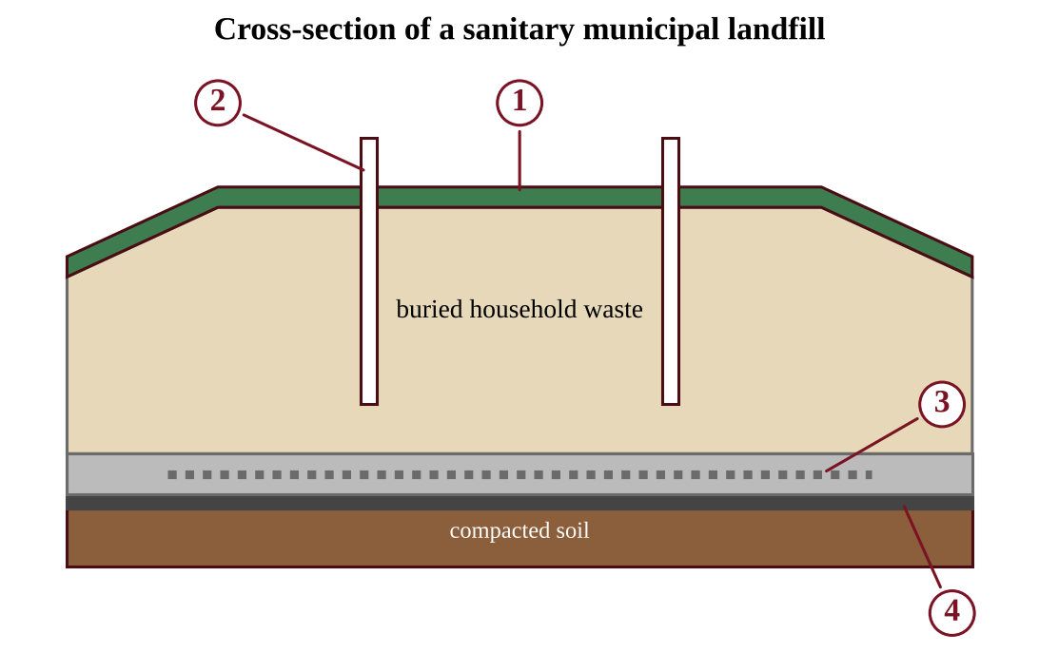
Figure — Cross-section of a sanitary municipal landfill with four numbered components
Which numbered component collects the water that has trickled through the waste so that it can be pumped out and treated?
A. 3
B. 1
C. 2
D. 4

Question 22 QB-U8-MCQ022
A household has a drawer of old phones and laptops. Which option is most effective at keeping the lead and mercury in them out of groundwater?
A. Mixing them with household trash in a municipal landfill, where leachate can eventually escape
B. Burning them in a backyard fire pit
C. Burying them in a pit on the property
D. Taking them to a certified e-waste recycler that recovers the materials

Question 23 QB-U8-MCQ023
A town generates 150,000 tons of municipal solid waste per year. Currently 30% is recycled, 10% is composted, and the rest is landfilled. A new plan raises composting to 25% and leaves recycling unchanged. How many fewer tons will be landfilled each year?
A. 15,000
B. 22,500
C. 37,500
D. 67,500

Question 24 QB-U8-MCQ024
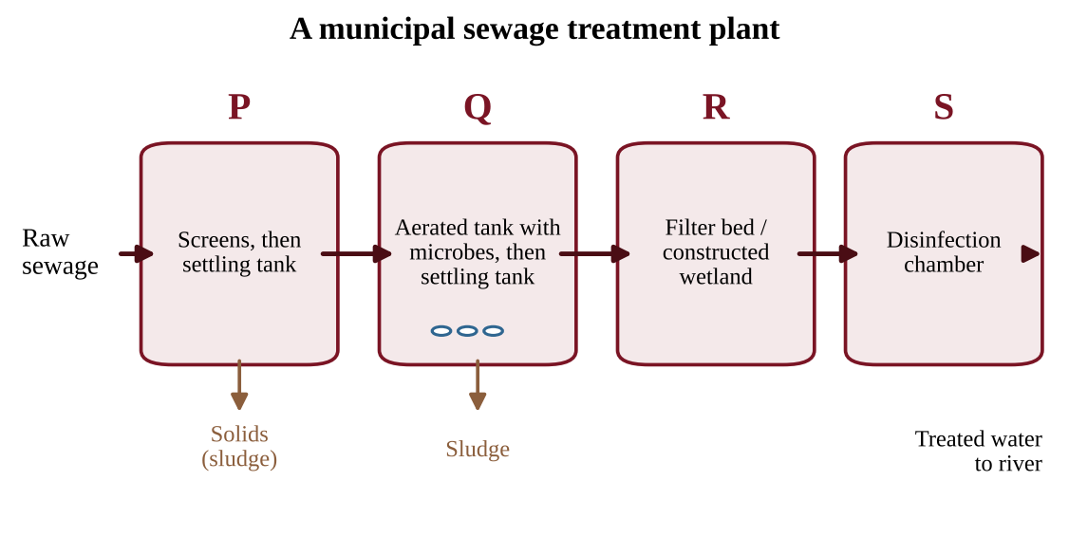
Figure — Stages of a municipal sewage treatment plant, labeled P through S
Which statement best describes the treatment that occurs in tank Q?
A. Screens and grates remove large objects from the incoming sewage.
B. Solids settle by gravity alone, with no biological activity involved.
C. Microbes break down organic matter, and added air speeds up the process.
D. Chemical or ecological processes remove nutrients left after earlier stages.

Question 25 QB-U8-MCQ025
The LD50 of an insecticide for laboratory mice is 25 mg per kg of body mass. What dose would be expected to kill half of a group of mice that each have a mass of 0.040 kg?
A. 0.0016 mg per mouse
B. 1.0 mg per mouse
C. 25 mg per mouse
D. 625 mg per mouse

Question 26 QB-U8-MCQ026
Tadpoles were given single doses of two chemicals, and mortality was recorded after 48 hours.
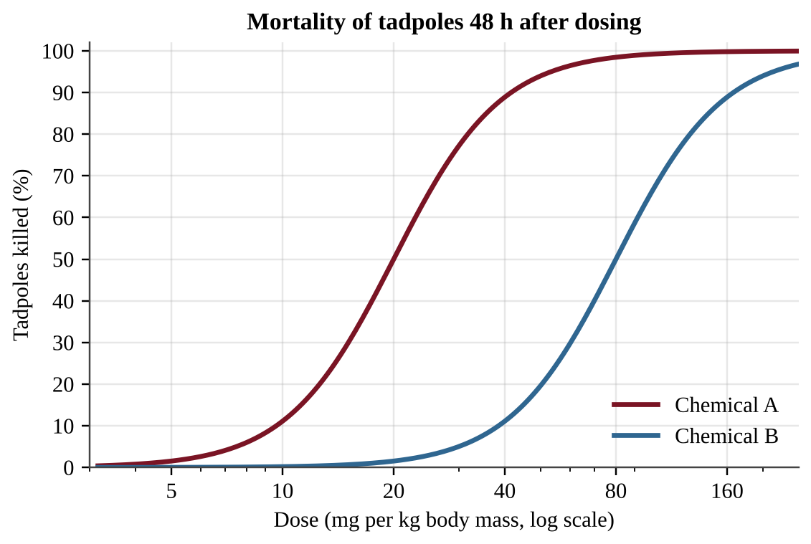
Figure — Dose-response curves for chemicals A and B in tadpoles
Which statement is best supported by the graph?
A. Chemical A is more toxic than chemical B because a lower dose of A kills half of the tadpoles.
B. Chemical B is more toxic than chemical A because its curve lies farther to the right.
C. The two chemicals are equally toxic because both eventually kill nearly all tadpoles.
D. Chemical A causes no mortality below 10 mg/kg because its curve is flat there.

Question 27 QB-U8-MCQ027
As average temperatures rise, mosquitoes that carry dengue virus are detected for the first time in a temperate city. Which statement best explains this observation?
A. Rising carbon dioxide makes the dengue virus airborne so that it spreads directly between people.
B. Disease vectors can spread only through ocean currents.
C. A city with clean drinking water cannot have vectors, so the report must be an error.
D. Warming lets vectors and their pathogens spread poleward into areas that previously had no cases of the disease.

Question 28 QB-U8-MCQ028
Researchers want to determine whether nitrogen or phosphorus limits algal growth in Lake Corbin. Which design best answers the question?
A. Add both nitrogen and phosphorus to every container and vary the light level.
B. Add nitrogen to containers filled at one end of the lake and phosphorus to containers filled at the other end.
C. Use identical containers of lake water with four replicated treatments (none, N, P, N + P), the same light and temperature, and measure chlorophyll after 10 days.
D. Add increasing amounts of nitrogen to a single container of lake water and measure chlorophyll each day for two weeks.

Question 29 QB-U8-MCQ029
A biologist finds PCBs in the tissues of sea otters and wants to investigate whether PCBs biomagnify in the otters' coastal food web. Which is the most testable hypothesis?
A. If PCBs biomagnify in this food web, then PCB concentrations in tissue samples will be higher in sea otters than in the clams and sea urchins they eat.
B. If PCBs are harmful to wildlife, then the law should protect sea otters and other marine mammals from them.
C. If PCB levels are measured only in sea otters, then PCBs must be present in the food web.
D. If PCBs are fat soluble, then they will be found everywhere in the ocean, even in the deepest water.

Question 30 QB-U8-MCQ030
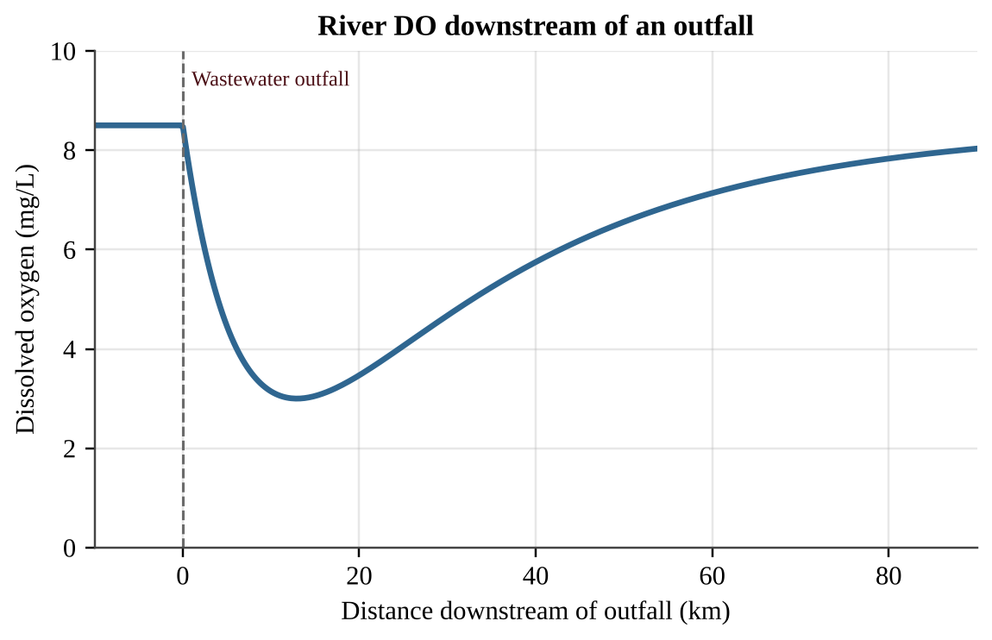
Figure — Dissolved oxygen (DO) in a river upstream and downstream of a wastewater outfall
The outfall discharges untreated organic waste. Which statement best explains why DO keeps falling for about 13 km below the outfall and then rises?
A. The concentration of organic waste is highest 13 km downstream.
B. The water becomes colder as it moves downstream, so it holds less oxygen than before.
C. Photosynthesis by decomposing bacteria adds oxygen to the water after 13 km.
D. Decomposers use oxygen faster than it is replaced until much of the waste is gone; then reoxygenation exceeds use.

Question 31 QB-U8-MCQ031
Three compounds were measured in tissues at five trophic levels of one food chain.
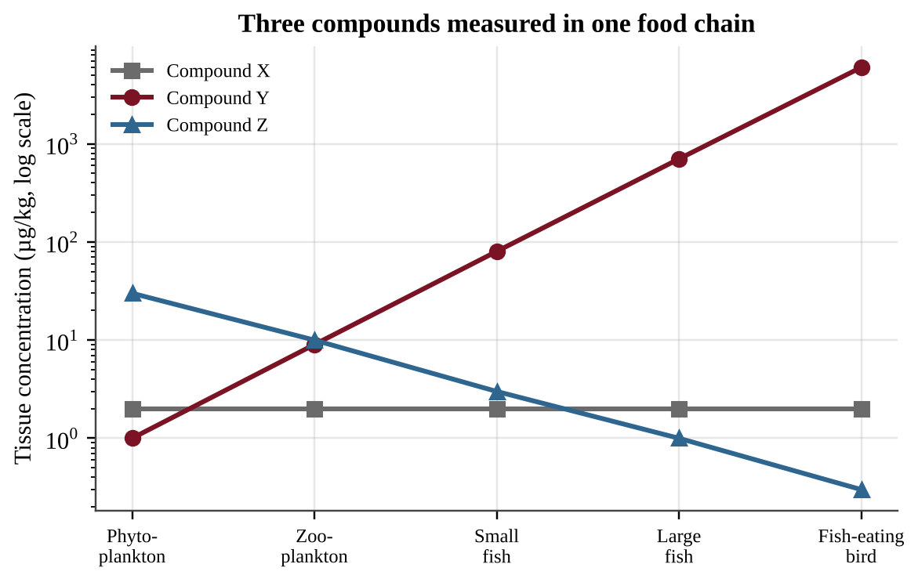
Figure — Tissue concentrations (log scale) of compounds X, Y and Z at five trophic levels
Which compound shows biomagnification, and which property best explains this pattern?
A. Compound Z, because its concentration is highest at the base and it is therefore very persistent
B. Compound Y, because it is persistent and fat soluble, so it is retained in tissues and passed up the food chain
C. Compound X, because its constant concentration shows it is fat soluble and stable
D. Compound Y, because it is water soluble and rapidly excreted at each level

Question 32 QB-U8-MCQ032
Researchers want to test whether higher tropospheric ozone is linked to reduced lung function in children. It would be unethical to assign children to breathe different ozone levels. Which approach would give the strongest evidence?
A. Measure lung function in 20 children from the city with the highest ozone only.
B. Compare lung function in one high-ozone city and one low-ozone city without recording any other differences between the children.
C. Measure lung function in many children from high- and low-ozone neighborhoods, recording age, asthma, household smoking and time outdoors, then analyze the association.
D. Ask parents whether their child ever coughs and compare the answers between the two cities.

Question 33 QB-U8-MCQ033
A landfill captures 2.0 × 10⁶ m³ of methane per year. Each m³ of methane releases 36 MJ of energy when burned. A generator converts 30% of that energy to electricity. One household uses 10,000 kWh per year (1 kWh = 3.6 MJ). About how many households could be supplied?
A. 600
B. 2,000
C. 2,160
D. 7,200

Question 34 QB-U8-MCQ034
A pest manager claims that chemical B is "safe" at 40 mg/kg for tadpoles because its LD50 is 80 mg/kg.
Figure — Dose-response curves for chemicals A and B in tadpoles
Which statement best evaluates the claim?
A. The claim is valid because doses below the LD50 cause no deaths.
B. The claim is not supported, because the curve shows that about one in ten tadpoles would still die at 40 mg/kg.
C. The claim is valid because the curve shows less than 5% mortality at 40 mg/kg.
D. The claim is not supported, because chemical A kills more tadpoles than chemical B at that dose.

Section B — Free-Response Questions
Question 1 QB-U8-FRQ001
Cedar Pond is a small recreational pond that receives water from two inlet streams. Inlet 1 drains a housing development with fertilized lawns and storm drains. Inlet 2 drains a forested hillside. For the past two summers, residents have seen dense green scum on the pond in July, and several dead fish washed up in August. Residents suspect that lawn fertilizer in the runoff is responsible. A student team plans to test this idea using four sampling sites, S1 through S4.
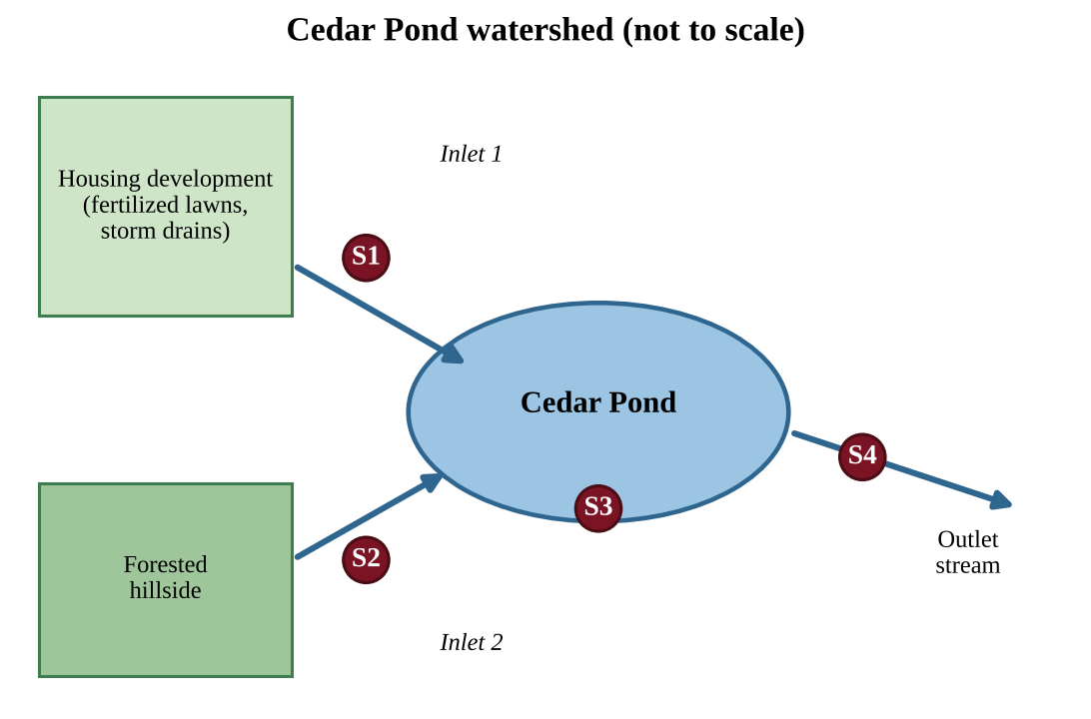
Figure — Map of the Cedar Pond watershed showing sampling sites S1–S4
(a) Identify the environmental problem the residents have observed in Cedar Pond. [1] (b) State a testable hypothesis, in if-then form, that links the runoff from the housing development to the problem identified in part (a). [1] (c) Identify the independent variable and the dependent variable for the team's investigation. [2] (d) Describe a procedure the team could follow to test the hypothesis. In your description, identify at least one nutrient or water-quality measurement, state when and how often samples are collected at the four sites, and identify one variable that must be kept constant or recorded for every sample. [3] (e) Describe the pattern of data across the four sites that would support the hypothesis. [1] (f) Explain how a bloom of algae in the pond can lead to the August fish kill. [1] (g) Propose one action the housing development could take to reduce nutrient runoff into Inlet 1 and justify why it would work. [1]

Question 2 QB-U8-FRQ002
Lake Alder is in a protected forest. Lake Birch is similar in size and depth, but it lies downwind of a coal-fired power plant. Biologists measured total mercury in tissue of five organisms from each lake. The values are in the table and the graph (log scale).
Organism | Lake Alder (mg/kg wet mass) | Lake Birch (mg/kg wet mass)
Plankton | 0.01 | 0.02
Mayfly larvae | 0.02 | 0.05
Yellow perch | 0.06 | 0.20
Northern pike | 0.20 | 0.90
Common loon | 0.80 | 3.6

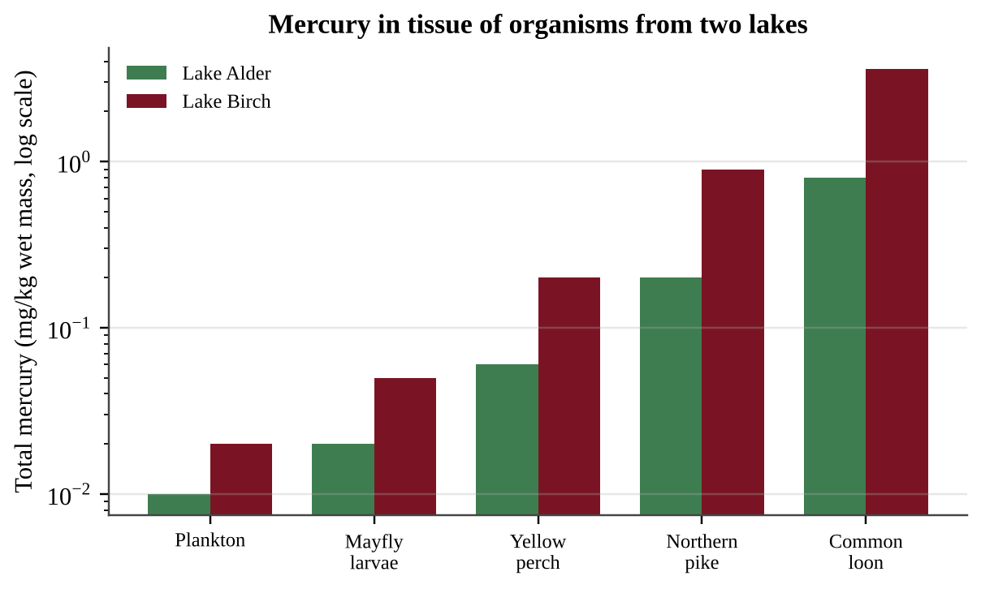
Figure — Mercury in tissue of organisms from Lake Alder and Lake Birch
(a) Describe the trend in mercury concentration from plankton to loon in Lake Birch. [1] (b) Calculate how many times greater the mercury concentration is in Lake Birch pike than in Lake Birch plankton. Show your work. [1] (c) Explain why the mercury concentration increases at higher trophic levels. [2] (d) Identify one human activity that could account for the higher mercury values in Lake Birch, and explain how elemental mercury that reaches the lake becomes the form that accumulates in organisms. [2] (e) A health agency advises people not to eat fish with more than 0.5 mg/kg of mercury. Make a claim about whether people can safely eat pike from each lake, and justify your claim with data from the table. [2] (f) Propose one solution that would reduce mercury levels in fish from Lake Birch over the long term, and identify one drawback of the solution. [2]

Question 3 QB-U8-FRQ003
The city of Riverton has a population of 250,000. Residents generate an average of 1.8 kg of municipal solid waste (MSW) per person per day. Currently 22% of the MSW is recycled and 12% is composted. The rest is landfilled. Landfilled waste is compacted to a density of 600 kg/m³. The city's landfill has 4.0 × 10⁶ m³ of unused capacity. (1 metric ton = 1,000 kg; use 365 days per year.)
(a) Calculate the mass of MSW generated by Riverton in one year, in metric tons. Show your work. [2] (b) Calculate the mass of MSW landfilled in one year, in metric tons. [1] (c) Calculate the volume of landfill space used in one year, in m³. [2] (d) Calculate the number of years until the landfill is full at the current rate. [1] (e) The city proposes to raise the combined recycling and composting rate from 34% to 50% of MSW. Calculate how many years the landfill's remaining capacity would last under the proposal. [2] (f) Describe one drawback of a larger composting program, and propose one change besides increased recycling or composting that would further extend the life of the landfill. Justify your proposal. [2]

Question 4 QB-U8-FRQ004
Beekeepers noticed hive losses near fields sprayed with two insecticides. Researchers dosed groups of honeybees with each insecticide and recorded the percentage of bees killed after 24 hours.
Dose (µg per bee) | Insecticide N, bees killed (%) | Insecticide M, bees killed (%)
0.01 | 2 | 0
0.03 | 8 | 3
0.1 | 30 | 12
0.3 | 72 | 38
1 | 95 | 74
3 | 100 | 96

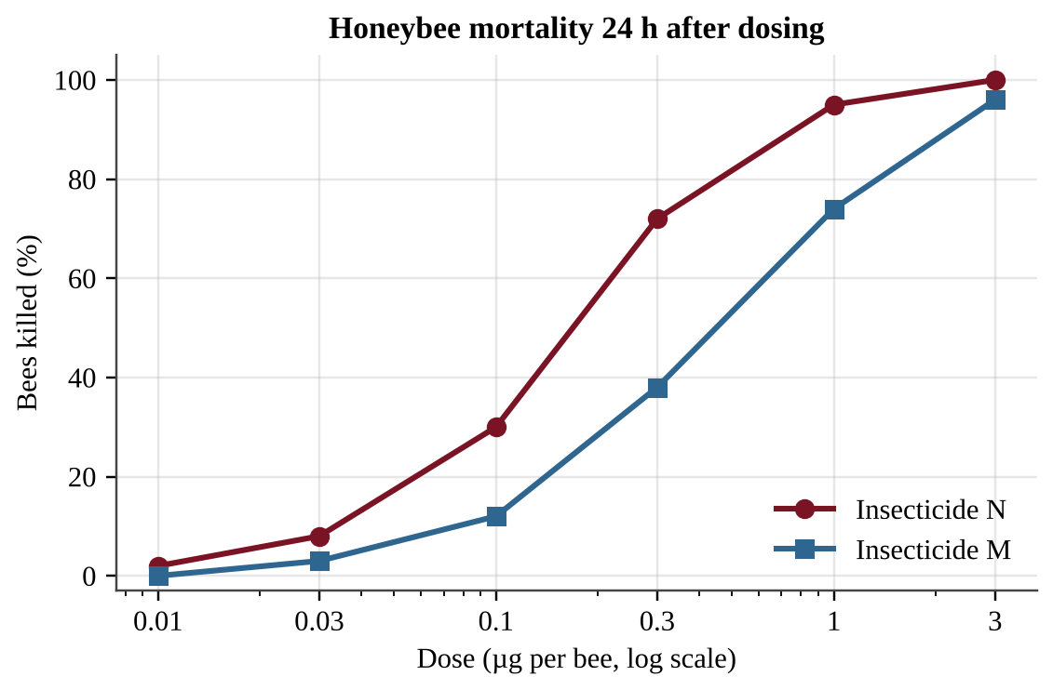
Figure — Dose-response curves for honeybees exposed to insecticides N and M
(a) Describe the relationship between dose and mortality for the two insecticides, and identify one difference between the curves. [2] (b) Estimate the LD50 of each insecticide from the data, in µg per bee. [2] (c) Identify which insecticide is more toxic to honeybees and justify your answer with data. [1] (d) A hive has 40,000 foraging bees, and each bee receives a dose of 0.3 µg of insecticide N. Calculate the number of bees expected to die. [1] (e) Explain two reasons why the LD50 alone is not enough to judge the risk an insecticide poses to a honeybee colony. [2] (f) Propose one practice that would reduce harm to bees from insecticide use, and justify it. [2]

Unit 9 — Global Change
NOTE
Exam weight: Unit 9 accounts for about 15–20% of the AP Environmental Science exam score, the largest share of any unit. This section assesses stratospheric ozone depletion and its solutions, the greenhouse effect and greenhouse gases, global climate change and its effects, ocean warming and acidification, invasive and endangered species, and human impacts on biodiversity. Expect conceptual items, graph and table interpretation, GWP, rate and percent calculations, and investigation design.

Section A — Multiple-Choice Questions
Question 1 QB-U9-MCQ001
Which statement best describes the importance of the stratospheric ozone layer to life on Earth?
A. It supplies most of the oxygen that organisms use for cellular respiration.
B. It filters visible light so that plants receive only the wavelengths used in photosynthesis.
C. It absorbs most of the Sun's harmful ultraviolet radiation before it reaches the surface.
D. It traps outgoing infrared radiation and keeps the surface warm enough for liquid water.

Question 2 QB-U9-MCQ002
A thinner stratospheric ozone layer lets more ultraviolet radiation reach the surface. Which pair of human health problems is most directly linked to increased UV exposure?
A. Skin cancer and cataracts
B. Cholera and typhoid fever
C. Asthma and chronic bronchitis
D. Hearing loss and high blood pressure

Question 3 QB-U9-MCQ003
Hydrofluorocarbons (HFCs) were adopted as substitutes for chlorofluorocarbons (CFCs) mainly because HFCs
A. absorb more ultraviolet radiation than CFCs do and so shield the ozone layer.
B. contain no chlorine and therefore do not destroy stratospheric ozone.
C. have a global warming potential of zero and therefore cannot affect climate.
D. break down completely in the troposphere within hours of being released.

Question 4 QB-U9-MCQ004
Which international agreement, signed in 1987, required countries to phase out the production of CFCs and other ozone-depleting substances?
A. The Montreal Protocol
B. The Basel Convention
C. The Kyoto Protocol
D. The Ramsar Convention

Question 5 QB-U9-MCQ005
Which list contains only principal greenhouse gases?
A. Nitrous oxide, argon, and oxygen gas
B. Methane, oxygen, and sulfur dioxide
C. Carbon dioxide, nitrogen, and argon gas
D. Carbon dioxide, methane, and nitrous oxide

Question 6 QB-U9-MCQ006
Which statement about the greenhouse effect is correct?
A. It occurs because holes in the ozone layer let extra heat reach the surface.
B. It is caused entirely by human activities that began in the industrial era.
C. It is the absorption of incoming ultraviolet radiation by carbon dioxide.
D. It is a natural process that keeps Earth's surface warm enough for life to exist.

Question 7 QB-U9-MCQ007
Which pair of processes both contribute to a rise in global sea level as the climate warms?
A. Melting of floating sea ice and increased evaporation from the ocean
B. Melting of land-based ice sheets and thermal expansion of ocean water
C. Thermal contraction of ocean water and growth of glaciers
D. Increased snowfall in polar regions and formation of sea ice

Question 8 QB-U9-MCQ008
Which health-related change is predicted as global temperatures rise?
A. Mosquito-borne diseases spreading from the tropics toward higher latitudes
B. A decrease in heat-related illness among people living in large cities
C. A shift of tropical diseases toward the equator and away from the poles
D. Fewer insect-borne diseases at mid-latitudes as winters become milder

Question 9 QB-U9-MCQ009
Which of the following provides direct evidence of atmospheric CO₂ concentrations hundreds of thousands of years ago?
A. The pH of lake sediment at the surface today
B. Records of fossil fuel sales from the 1800s
C. Air bubbles trapped in layers of glacial ice cores
D. Satellite images of present-day cloud cover

Question 10 QB-U9-MCQ010
Coral bleaching caused by unusually warm ocean water occurs when corals
A. absorb too much calcium carbonate from the water.
B. lose the symbiotic algae that live in their tissues.
C. produce extra pigment to block ultraviolet light.
D. are covered by a layer of floating plastic.

Question 11 QB-U9-MCQ011
The primary cause of ocean acidification is that the oceans
A. absorb atmospheric carbon dioxide, which forms carbonic acid in seawater.
B. absorb oil from spills and tanker accidents that coats the surface water.
C. receive more rainfall as the global temperature increases over time.
D. receive nitrate and phosphate runoff from farms that causes algal blooms.

Question 12 QB-U9-MCQ012
Which description best defines an invasive species?
A. Any species that is found in a garden or farm field rather than a wild area.
B. A non-native species planted in a yard that never spreads beyond it.
C. A native species whose population has declined sharply because of habitat loss.
D. A non-native species that spreads in a new area and threatens native species.

Question 13 QB-U9-MCQ013
Which of the following is a common way that aquatic invasive species are introduced to new regions?
A. Natural recolonization of a forest after a fire
B. Discharge of ballast water from cargo ships
C. Seed dispersal by wind within a native plant's existing range
D. Seasonal migration of native songbirds along their usual routes

Question 14 QB-U9-MCQ014
Which species would be most vulnerable to extinction if its habitat were altered?
A. A fast-reproducing rodent that eats seeds from many kinds of plants
B. A migratory bird that is able to use many different wetland types
C. An omnivore that lives in forests, farmland, and suburbs of many regions
D. A bird that nests in one type of old-growth tree and eats a single insect

Question 15 QB-U9-MCQ015
Which action most directly addresses the overexploitation of elephants for their ivory?
A. Converting part of the protected land to farmland
B. Building new roads through reserves to allow more tourism
C. Criminalizing poaching and penalizing the ivory trade
D. Introducing a non-native predator into the elephants' habitat

Question 16 QB-U9-MCQ016
In the acronym HIPPCO, which two factors are represented by the letter P?
A. Population growth and pollution
B. Predation and parasitism
C. Pesticides and precipitation
D. Poaching and preservation

Question 17 QB-U9-MCQ017
Which of the following is an example of habitat fragmentation?
A. Wolves reintroduced to a protected valley
B. A forest that regrows over abandoned farmland
C. A highway built through a large continuous forest
D. A national park expanded by purchasing adjacent land

Question 18 QB-U9-MCQ018
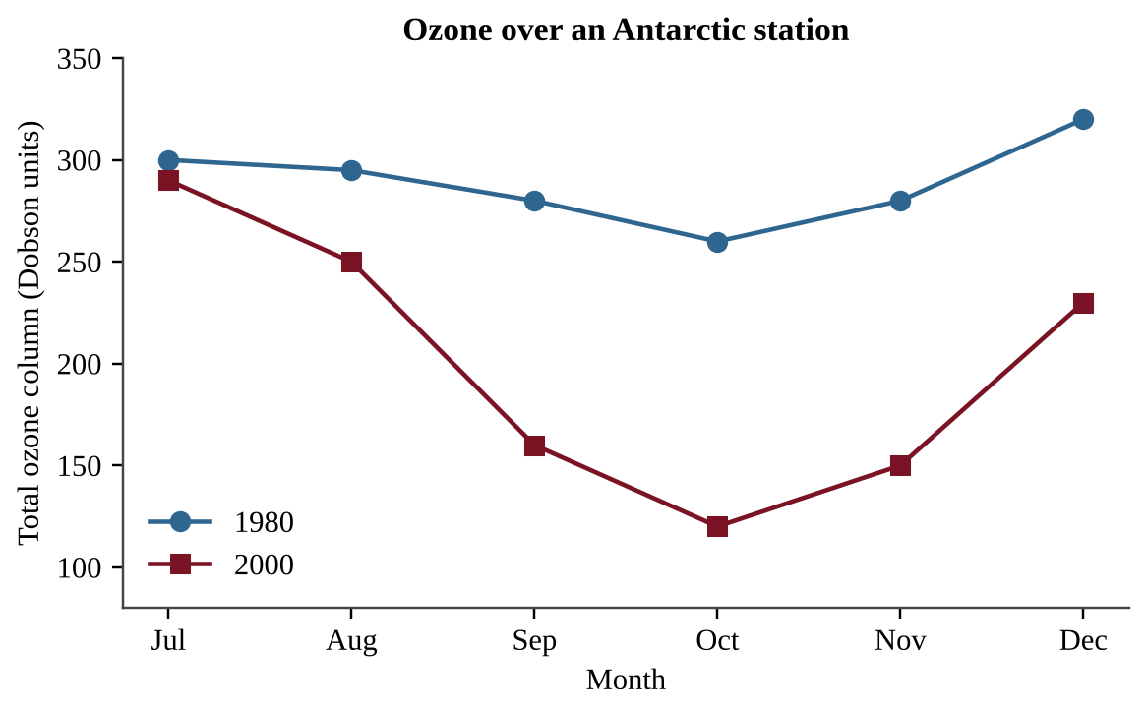
Figure — Total ozone column over an Antarctic station, by month, in 1980 and 2000
Which explanation best accounts for the sharp drop in ozone between August and October in 2000?
A. Ultraviolet radiation breaks ozone into oxygen on its own, without help from any chemicals in the air.
B. Returning spring sunlight frees chlorine from ice crystals, and the chlorine destroys ozone.
C. Most CFCs are produced in Antarctica and are released into the air in October each year.
D. Winter darkness lets stratospheric ozone leak down into the troposphere over the pole.

Question 19 QB-U9-MCQ019
Which sequence correctly describes how a chlorofluorocarbon (CFC) molecule damages the ozone layer?
A. UV light frees a chlorine atom from the CFC, and it destroys many ozone molecules.
B. The CFC reacts directly with ozone in the troposphere, and rain then removes the products.
C. The CFC absorbs UV radiation and then converts the ozone it meets into carbon dioxide.
D. A chlorine atom is used up as it reacts with a single ozone molecule in the stratosphere.

Question 20 QB-U9-MCQ020
A company replaces the CFC refrigerant in its freezers with a hydrofluorocarbon (HFC). Which statement best evaluates this change?
A. It protects ozone, but many HFCs are potent greenhouse gases that add to climate change.
B. It does not help the ozone layer because HFCs still release large amounts of chlorine.
C. It increases ozone depletion but reduces greenhouse warming.
D. It protects the ozone layer and has no effect on climate because HFCs do not absorb infrared radiation.

Question 21 QB-U9-MCQ021
Over 100 years, the global warming potential (GWP) of methane (CH₄) is 28 and that of nitrous oxide (N₂O) is 265, relative to CO₂ = 1. A wastewater plant emits 200 metric tons of CH₄ and 10 metric tons of N₂O in a year. What is the total emission in metric tons of CO₂ equivalent?
A. 210
B. 2,650
C. 5,600
D. 8,250

Question 22 QB-U9-MCQ022
Water vapor is a greenhouse gas, yet it is not considered a principal driver of human-caused climate change. Which statement best explains why?
A. Its short residence time means its amount follows temperature, not emissions.
B. Its global warming potential is higher than that of CFCs and nitrous oxide.
C. It does not absorb any infrared radiation emitted from the surface.
D. It is present in the atmosphere only in the polar regions where air is cold.

Question 23 QB-U9-MCQ023
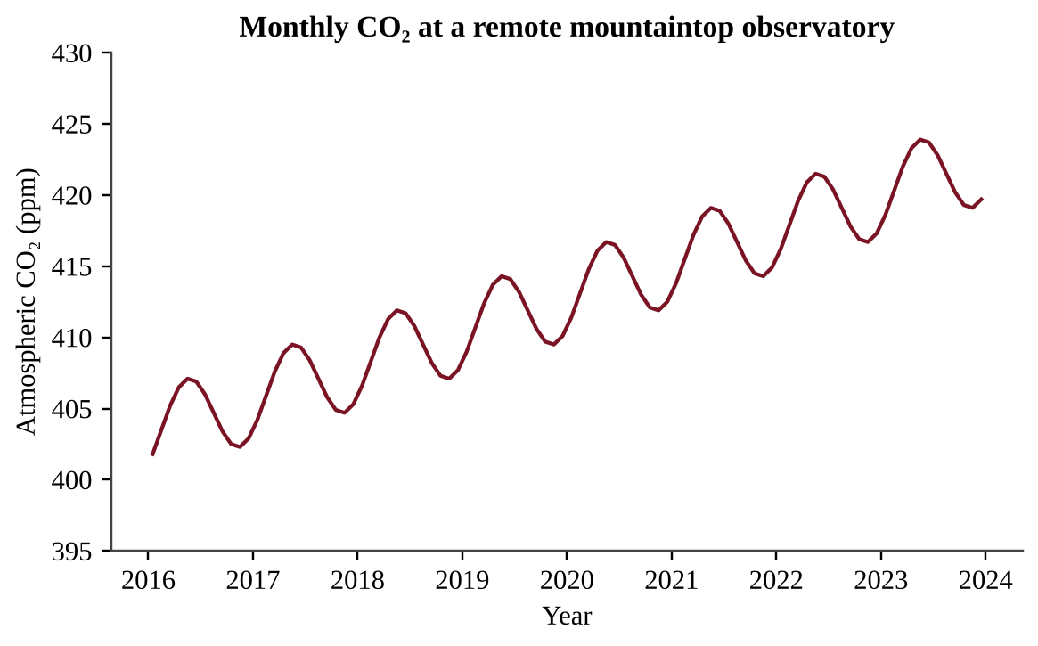
Figure — Monthly atmospheric CO₂ at a remote mountaintop observatory, 2016–2023
Which process best explains the regular yearly rise and fall superimposed on the long-term upward trend?
A. Northern Hemisphere plants take up CO₂ in summer, and decay returns it in winter.
B. Oceans release all of their CO₂ every spring and absorb it all again every winter.
C. A volcano erupts every autumn and releases a large amount of CO₂ to the air.
D. Fossil fuel burning stops completely at the observatory during the summer months.

Question 24 QB-U9-MCQ024
A low-lying island nation expects sea level to rise by 0.6 m during this century. Which population-level response is most likely?
A. Immigration to the island because rising seas create new shallow fishing areas
B. Higher birth rates because saltwater makes groundwater richer in nutrients
C. Displacement of coastal residents who relocate inland or abroad
D. No change in where people live because the sea rises evenly everywhere

Question 25 QB-U9-MCQ025
Annual mean atmospheric CO₂ was 396 ppm in 2013 and 420 ppm in 2023. If CO₂ continues to rise at the average yearly rate observed between 2013 and 2023, in which year will it reach 444 ppm?
A. 2029
B. 2033
C. 2038
D. 2043

Question 26 QB-U9-MCQ026
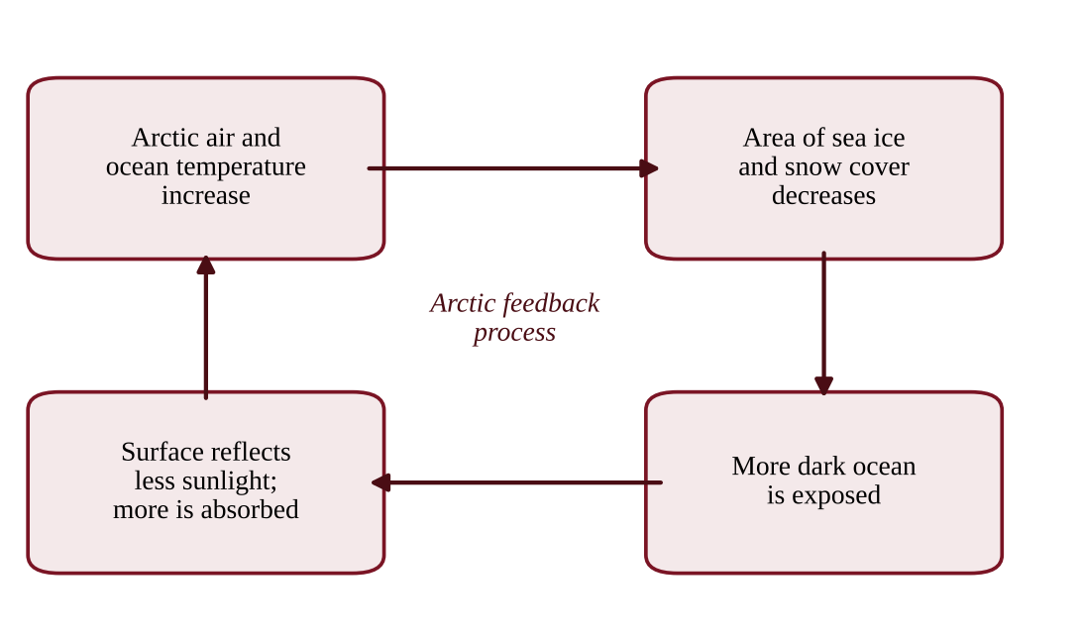
Figure — Linked processes in the Arctic
Which statement correctly identifies the type of feedback shown and its effect?
A. It is a negative feedback that reduces the initial warming.
B. It is a negative feedback because loss of ice cools the surface.
C. It is a positive feedback because open ocean reflects more sunlight than ice does.
D. It is a positive feedback that amplifies the initial warming.

Question 27 QB-U9-MCQ027
How does the thawing of Arctic permafrost amplify climate change?
A. Microbes decompose the thawed organic matter and release methane and CO₂.
B. Thawing releases CFCs that were trapped in the frozen soil for thousands of years.
C. Thawed soil reflects more sunlight than frozen soil does, which increases cooling.
D. Thawed ground absorbs large amounts of atmospheric methane and carbon dioxide.

Question 28 QB-U9-MCQ028
Climate models project that a farming region will receive heavier rainstorms separated by longer droughts. Which effect on the region's soil is most likely?
A. Less erosion because dry soil binds together more tightly
B. Increased fertility because extra rain flushes out salts
C. Higher soil organic matter from more frequent flooding
D. Greater erosion and reduced soil viability

Question 29 QB-U9-MCQ029
Rising sea level will affect marine ecosystems in different ways. Which is the most likely positive effect?
A. A coastal freshwater aquifer receives more fresh water as the sea level rises.
B. A coastal salt marsh with a seawall built behind it can migrate farther inland.
C. A seagrass bed near its lower limit of light penetration receives more light from above.
D. Newly flooded low-lying coastal land provides shallow habitat that species can colonize.

Question 30 QB-U9-MCQ030
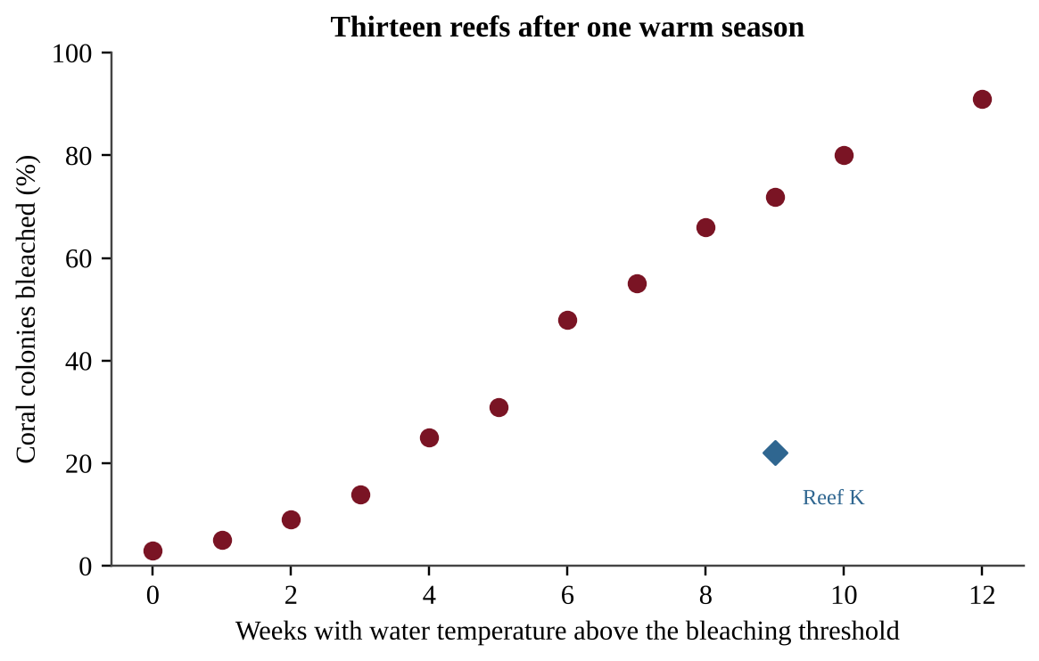
Figure — Percentage of coral colonies bleached versus weeks of water temperature above the bleaching threshold at thirteen reefs
Which statement is best supported by the data?
A. No bleaching occurred at reefs that were above the threshold for fewer than three weeks.
B. Heat stress is the only factor that causes coral bleaching.
C. Reefs with more weeks above the threshold generally had a larger percentage of bleached colonies.
D. Every reef above the threshold for more than four weeks had over 50% of its colonies bleached.

Question 31 QB-U9-MCQ031
Which is a likely effect of ocean warming on a population of cold-water fish?
A. An increase in the dissolved oxygen available to the fish in the water
B. A shift in its range toward the poles or into deeper water
C. A shift in its range toward the equator into warmer water
D. A decrease in metabolic rate, so the fish need less food to survive

Question 32 QB-U9-MCQ032
Which set of reactions represents what happens when atmospheric CO₂ dissolves in seawater?
A. SO₂ + H₂O → H₂SO₃ → H⁺ + HSO₃⁻
B. CO₂ + H₂O → H₂CO₃ → H⁺ + HCO₃⁻
C. CO₂ + H₂O → C₆H₁₂O₆ + O₂
D. CaCO₃ → Ca²⁺ + CO₃²⁻ + H⁺

Question 33 QB-U9-MCQ033
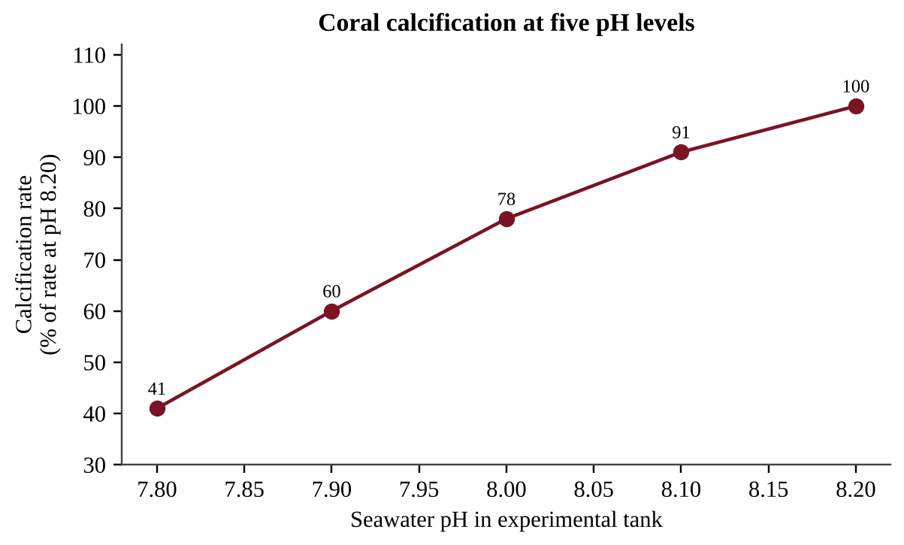
Figure — Coral calcification rate at five pH levels, shown as a percentage of the rate at pH 8.20
By approximately what percent does the calcification rate decrease, relative to its value at pH 8.10, when the pH drops from 8.10 to 7.90?
A. 2.5%
B. 31%
C. 34%
D. 66%

Question 34 QB-U9-MCQ034
Because pH is a logarithmic scale, a drop in surface ocean pH from 8.2 to 8.0 corresponds to which change in H⁺ concentration?
A. An increase of about 20%
B. An increase of about 60%
C. An increase of about 100%
D. An increase of about 900%

Question 35 QB-U9-MCQ035
Which action would most directly slow the increase in ocean acidification over the long term?
A. Cutting CO₂ emissions from fossil fuel use and deforestation
B. Reducing sulfur dioxide emissions from coal-fired power plants
C. Adding nitrogen fertilizer to coastal waters to boost algal growth
D. Building seawalls along the coast to block storm waves

Question 36 QB-U9-MCQ036
Which combination of traits would most likely help a non-native plant become invasive?
A. Long life span, few offspring, and large parental investment
B. Specialist habitat needs, slow reproduction, and low seed dispersal
C. Generalist habitat needs, rapid reproduction, and high seed dispersal
D. Narrow tolerance of soil conditions and a need for one specific pollinator

Question 37 QB-U9-MCQ037
An invasive vine now covers 40 hectares of a watershed. Its infested area doubles every 3 years. If no control measures are taken, what area will it cover after 12 years?
A. 160 hectares
B. 480 hectares
C. 640 hectares
D. 1,280 hectares

Question 38 QB-U9-MCQ038
Which control strategy for an invasive species has the greatest risk of unintended consequences for native ecosystems?
A. Inspecting and cleaning boat hulls at busy lake launch sites
B. Pulling invasive plants by hand from small patches near a trail or road
C. Replanting native vegetation after an invader has been removed from a site
D. Releasing an untested non-native predator from the invader's home range

Question 39 QB-U9-MCQ039
A county compares three ways to manage an invasive aquatic weed over 10 years. Costs are shown below.
Option | Cost
Eradicate now | $2.0 million one time, plus $0.1 million per year monitoring
Contain only | $0.35 million per year
No action | $0.6 million per year in damage

Which option has the lowest total 10-year cost, and what is that cost?
A. Contain only; $3.5 million
B. No action; $6.0 million
C. Eradicate now; $3.0 million
D. Eradicate now; $2.1 million

Question 40 QB-U9-MCQ040
A frog lives only in cloud forest above 2,000 m on one mountain range and eats a single insect species. Which statement best explains why it is at high risk of extinction as the climate warms?
A. Species at high elevation are never affected by competition for resources.
B. Frogs produce so many eggs that they cannot survive in cooler habitats.
C. Warming always increases the number of insects available for frogs to eat.
D. Its narrow habitat and limited diet leave it little ability to adapt or move.

Question 41 QB-U9-MCQ041
Anti-poaching patrols were introduced at a reserve. Records of rhinoceroses poached are shown.
Year | Patrol days per month | Rhinos poached
2019 | 0 | 60
2021 | 30 | 38
2023 | 60 | 15

What was the percent decrease in rhinos poached between 2019 and 2023?
A. 25%
B. 75%
C. 300%
D. 400%

Question 42 QB-U9-MCQ042
A conservation agency plants a strip of forest connecting two isolated forest reserves. What is the main benefit of this habitat corridor?
A. It increases the total forest area by a large amount, giving each species more room.
B. It allows animals to move between reserves, supporting gene flow and recolonization.
C. It prevents invasive species from entering either of the two reserves.
D. It eliminates edge effects in both of the reserves it connects.

Question 43 QB-U9-MCQ043
Honeybee colonies and dairy cattle are managed for economic returns. How can domestication of an organism affect the biodiversity of that organism?
A. It has no effect on diversity, because managed animals still breed randomly.
B. Large managed populations always increase the species' genetic diversity.
C. Selective breeding for a few high-yield traits can reduce its genetic diversity.
D. It increases the size of the wild populations of the same species.

Question 44 QB-U9-MCQ044
A fishing fleet catches bluefin tuna faster than the population can reproduce. Which HIPPCO category does this represent?
A. Over exploitation
B. Habitat destruction
C. Climate change
D. Pollution

Question 45 QB-U9-MCQ045
An alpine butterfly lives only above 2,800 m on a mountain whose peak is 3,000 m. As average temperatures rise, which outcome is most likely?
A. Its suitable habitat will expand because more of the mountain becomes warm enough for it.
B. Its population will move downslope to settle in the cooler valleys at the base.
C. Its habitat will be unaffected because the mountain itself does not move or change.
D. Its suitable habitat will shift upslope and shrink, raising the risk of local extinction.

Question 46 QB-U9-MCQ046
Researchers hypothesize that thinner stratospheric ozone increases the UV-B reaching the surface. Which dataset would best test this hypothesis?
A. Multi-year measurements of ozone and surface UV-B at the same sites
B. Average summer temperatures recorded at several different latitudes
C. Yearly skin cancer rates recorded in the same region over many years
D. Atmospheric CFC concentrations measured at one monitoring location

Question 47 QB-U9-MCQ047
The table lists three refrigerants.
Substance | Ozone depletion potential | 100-year GWP
CFC-12 | 1.0 | 10,200
HCFC-22 | 0.05 | 1,760
HFC-134a | 0 | 1,430

A technician releases 4.0 kg of HFC-134a. Which statement is correct?
A. It has no climate effect because its ozone depletion potential is zero.
B. Its warming effect over 100 years equals about 4 kg of CO₂.
C. Its warming effect equals about 41,000 kg of CO₂, because all CFC substitutes share the GWP of CFC-12.
D. Its warming effect over 100 years equals about 5,700 kg of CO₂, and it does not deplete ozone.

Question 48 QB-U9-MCQ048
A landfill flares (burns) 500 metric tons of methane per year that had been venting. Each ton of CH₄ burned produces 2.75 tons of CO₂, and the GWP of CH₄ is 28. What is the net change in CO₂ equivalent emissions, treating the CO₂ as new emissions?
A. A decrease of 14,000 t CO₂e
B. A decrease of 12,625 t CO₂e
C. A decrease of 1,375 t CO₂e
D. An increase of 15,375 t CO₂e

Question 49 QB-U9-MCQ049
Methane has a global warming potential of 28 per metric ton, yet CO₂ is the largest contributor to human-caused warming. Which statement best explains this?
A. Human CO₂ emissions are far larger, and CO₂ persists for centuries.
B. CO₂ has a higher global warming potential per ton than methane does.
C. Methane is produced only by natural processes such as wetlands.
D. Methane does not absorb infrared radiation emitted by the surface.

Question 50 QB-U9-MCQ050
Large amounts of freshwater from melting Greenland ice flow into the North Atlantic. Freshwater is less dense than seawater. Which consequence is most plausible?
A. Freshwater would mix in completely, so ocean circulation would be unchanged.
B. Weaker sinking of dense water would slow the conveyor belt and cool northwestern Europe.
C. Hadley cells would stop moving air, causing the tropics to cool.
D. The conveyor belt would strengthen and make northwestern Europe warmer.

Question 51 QB-U9-MCQ051
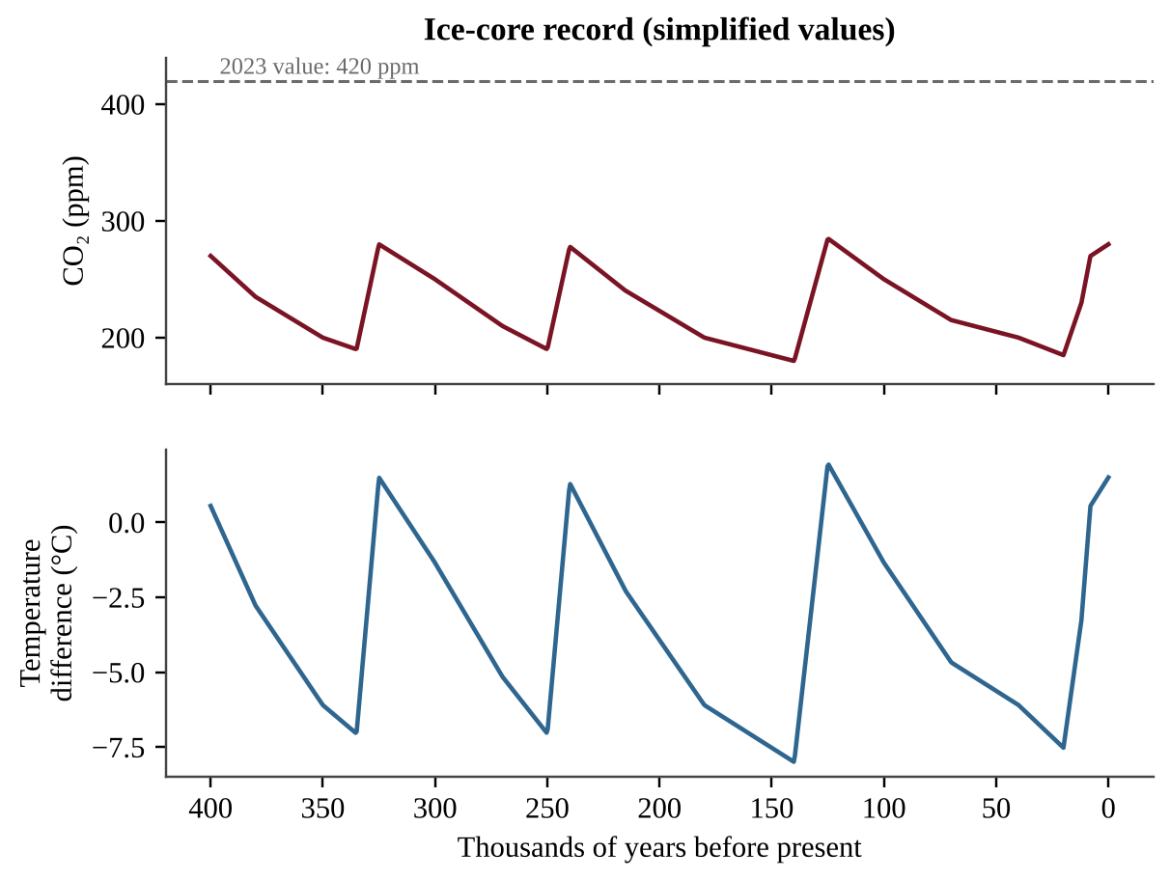
Figure — Atmospheric CO₂ and temperature difference from present over 400,000 years from ice-core data (simplified values), with the 2023 CO₂ concentration shown as a dashed line
Which conclusion is best supported by the figure?
A. CO₂ and temperature changed independently of each other over time.
B. Higher CO₂ coincided with warmer temperatures, and 2023 CO₂ exceeds all past values.
C. The figure proves that CO₂ was the only cause of every temperature change.
D. CO₂ concentrations were always above 300 ppm during the warm periods.

Question 52 QB-U9-MCQ052
A scientist wants to test whether warming increases CO₂ released from tundra soil. Which design is best?
A. Heat one plot for a single afternoon and compare it with its flux before heating.
B. Measure CO₂ flux once in a warm tropical soil and once in a cold tundra soil.
C. Heat replicate plots, keep unheated control plots, and measure CO₂ flux regularly.
D. Measure CO₂ flux only in unheated plots during several different seasons.

Question 53 QB-U9-MCQ053
Researchers place coral fragments in tanks of seawater at pH 8.1, 7.9, and 7.7 to test the effect of acidification on calcification. Which set of conditions should be kept the same in all tanks?
A. Light intensity and salinity, with temperature allowed to vary with pH level
B. Seawater pH, temperature, and salinity in every tank
C. Temperature, salinity, light intensity, and the source colony of the fragments
D. Calcification rate, light intensity, and water temperature

Question 54 QB-U9-MCQ054
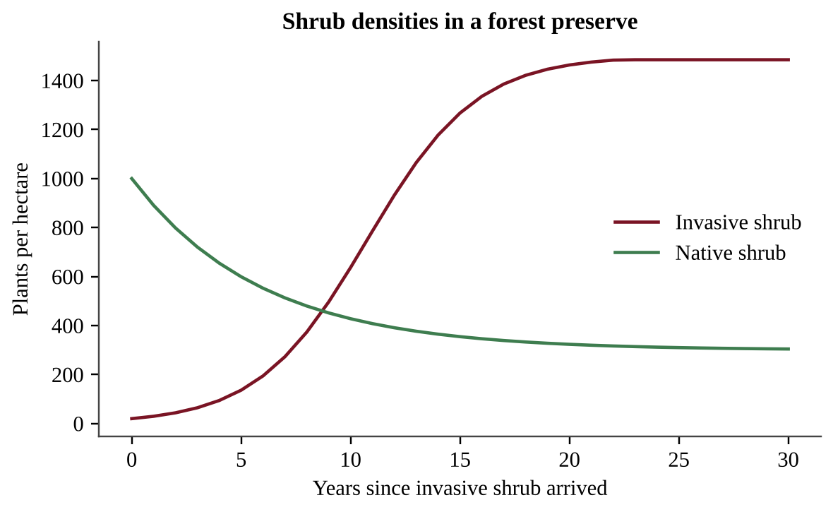
Figure — Density of a native shrub and an invasive shrub over 30 years in a forest preserve
Which conclusion is best supported by the data?
A. The native shrub was completely eliminated from the preserve by the end of the 30 years.
B. The invasive shrub's growth rate stayed the same no matter how dense its own population became.
C. The invasive population kept growing exponentially throughout the entire 30-year period.
D. The invasive shrub leveled off near carrying capacity, and the native shrub stayed below its original density.

Question 55 QB-U9-MCQ055
A herd's births add 9% per year, but poaching removes 15% per year, so the herd shrinks by a net 6% per year. Using the rule of 70, about how many years until the herd is half its size?
A. 3 years
B. 5 years
C. 8 years
D. 12 years

Question 56 QB-U9-MCQ056
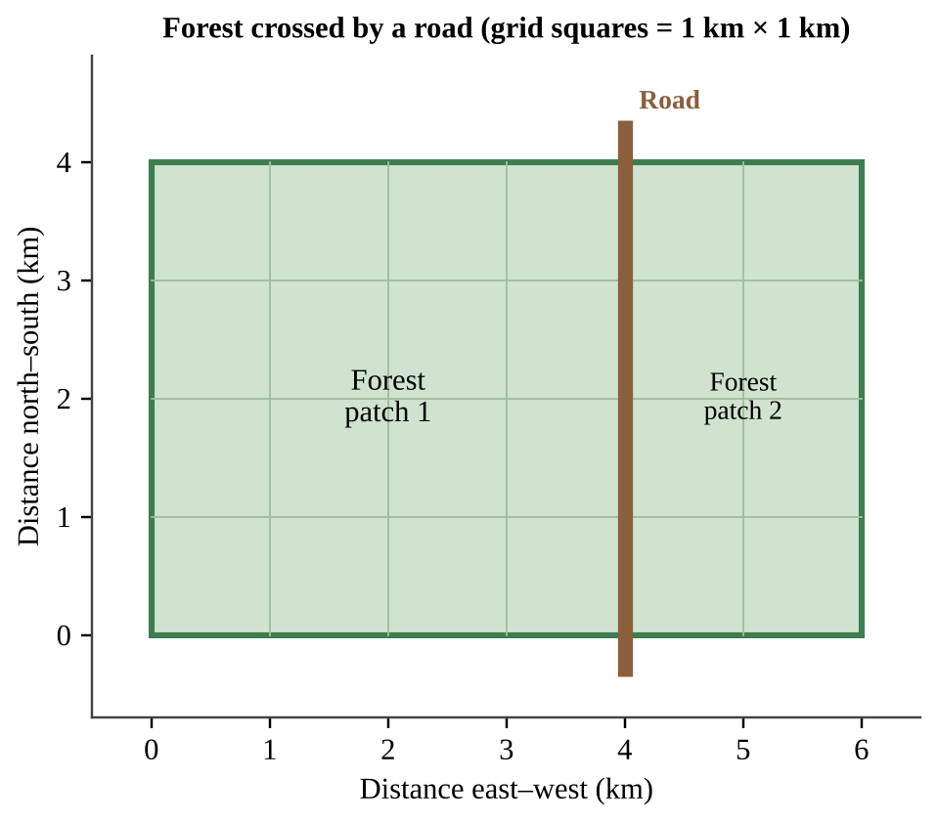
Figure — A 4 km × 6 km forest crossed by a road at the 4 km mark
A forest-interior bird needs habitat at least 1 km from any forest edge or road. Ignoring the width of the road, what percentage of the forest's original interior habitat remains after the road is built?
A. 25%
B. 33%
C. 50%
D. 67%

Section B — Free-Response Questions
Question 1 QB-U9-FRQ001
A shellfish hatchery on a coastal bay raises oyster larvae in seawater pumped from the bay. Staff recorded the pH of the intake water and the percentage of larvae surviving to day 14 in batches started each month (figure). Larval survival is lowest in summer, when winds draw cold, CO₂-rich deep water to the surface near the intake pipe.
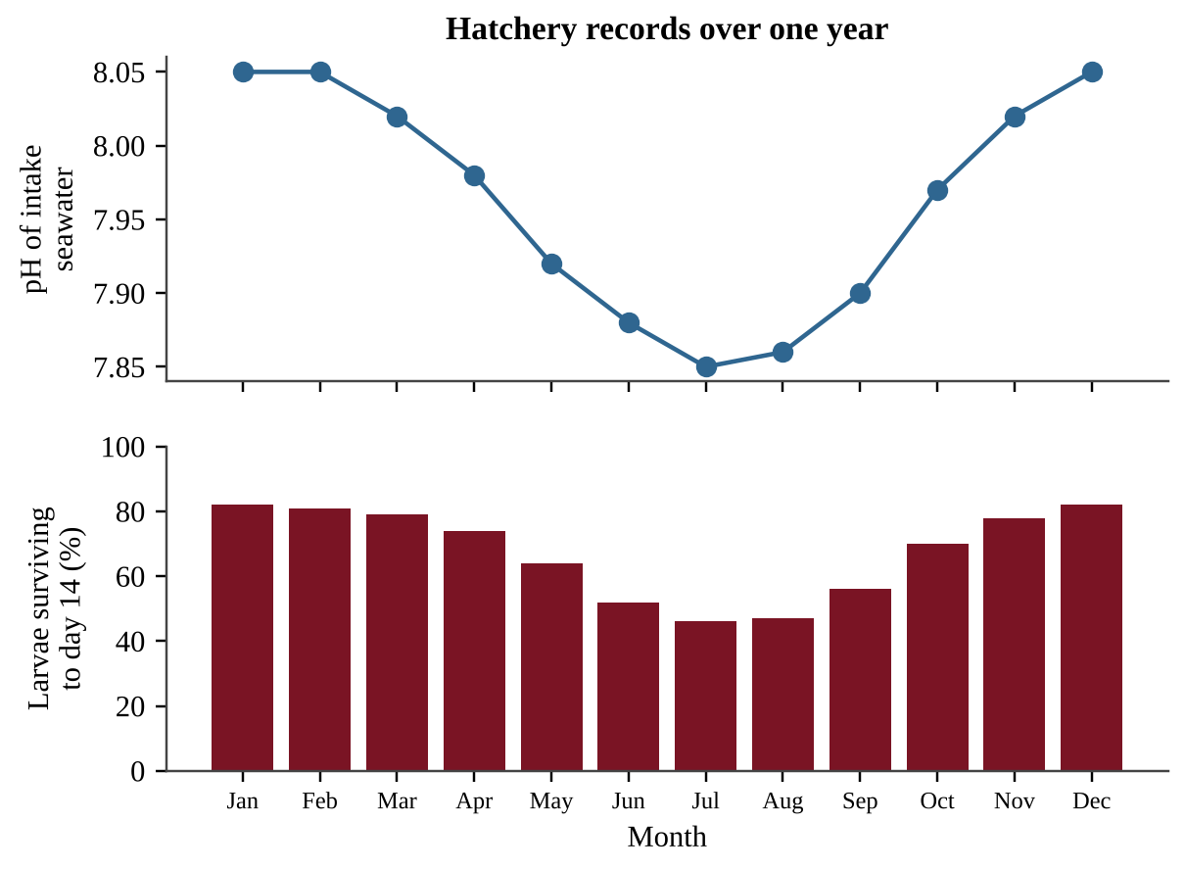
Figure — Monthly pH of hatchery intake water and percentage of larvae surviving to day 14
(a) Describe the seasonal relationship between intake-water pH and larval survival shown in the figure. [1] (b) Identify the global environmental process most likely responsible for a long-term decrease in the bay's baseline pH, and identify one human activity that contributes to it. [1] (c) State a testable hypothesis, in if-then form, about the effect of seawater pH on oyster larval survival. [1] (d) Design an experiment to test your hypothesis using larvae from one group of parent oysters. In your design, identify (i) the independent variable and the dependent variable [1] (ii) two variables that must be held constant [1] (e) Describe the procedure, including the levels of the independent variable, how the experiment is replicated, and the control. [2] (f) Describe the pattern of results that would support your hypothesis. [1] (g) Propose one action the hatchery could take to protect larvae during low-pH months, and describe one disadvantage or unintended consequence of that action. [2]

Question 2 QB-U9-FRQ002
A nature preserve contains a mature deciduous forest crossed by a hiking trail. Rangers have noticed a dense, non-native shrub, introduced decades ago as a garden ornamental, growing mostly near the trail. They suspect that the shrub is reducing the number of native wildflower species on the forest floor. The diagram shows a sketch of the shrub's pattern at three possible sampling plots.
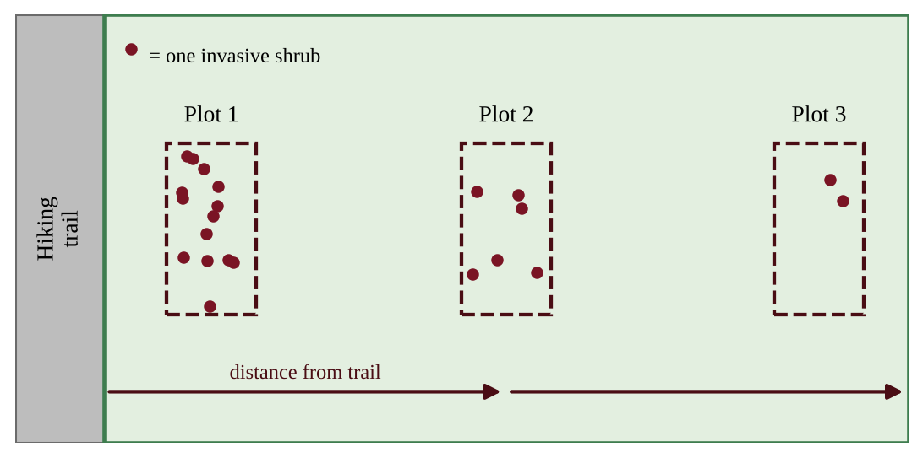
Figure — Sketch of the forest preserve showing the trail and three plots at increasing distances from the trail
(a) Identify one characteristic of invasive species that helps them outcompete native species. [1] (b) State a testable hypothesis, in if-then form, relating distance from the trail, invasive shrub density, and native wildflower richness. [1] (c) Identify the independent variable and the dependent variable for an investigation of your hypothesis. [1] (d) Describe how data could be collected, including the number and size of plots and how replication and randomness are achieved. [2] (e) Identify two variables that should be kept the same or similar when selecting plots. [1] (f) Describe the pattern of data that would support your hypothesis. [1] (g) Propose one method for controlling the shrub and describe one disadvantage or unintended consequence of that method. [2] (h) Explain why the trail is a likely pathway for the introduction and spread of the shrub. [1]

Question 3 QB-U9-FRQ003
Scientists monitor stratospheric chlorine, which comes mainly from chlorofluorocarbons (CFCs), and ozone over Antarctica. The table gives data for selected years.
Year | Stratospheric chlorine (ppb) | Minimum ozone column (Dobson units) | Largest ozone-hole area (million km²)
1980 | 1.7 | 225 | 3
1990 | 2.9 | 130 | 22
2000 | 3.4 | 100 | 29
2010 | 3.0 | 115 | 24
2020 | 2.5 | 125 | 21

(a) Describe the trend in stratospheric chlorine between 1980 and 2020. [1] (b) Calculate the percent decrease in stratospheric chlorine from 2000 to 2020. [1] (c) Calculate the average rate of change in the minimum ozone column from 1980 to 2000. Include units. [2] (d) Explain how CFCs destroy ozone, and explain why the largest losses of ozone occur over Antarctica in the spring. [2] (e) Identify one international policy responsible for the decline in chlorine after 2000, and explain why ozone recovery has lagged behind the decline in chlorine. [2] (f) Make a claim about whether the data support the statement "By 2020 the ozone layer over Antarctica had fully recovered." Justify your claim with data from the table. [1] (g) Describe one human health effect of an increase in ultraviolet radiation at the surface. [1]

Question 4 QB-U9-FRQ004
Polar bears hunt seals from the surface of sea ice. Researchers recorded the minimum Arctic sea ice extent in September, the average summer air temperature anomaly (difference from the 1951–1980 average), and the percentage of polar bear cubs surviving their first year in one study region.
Year | September sea ice extent (million km²) | Summer air temperature anomaly (°C) | Cubs surviving first year (%)
2000 | 6.3 | +0.4 | 66
2005 | 5.6 | +0.8 | 61
2010 | 4.9 | +1.3 | 52
2015 | 4.5 | +1.8 | 44
2020 | 3.9 | +2.2 | 35

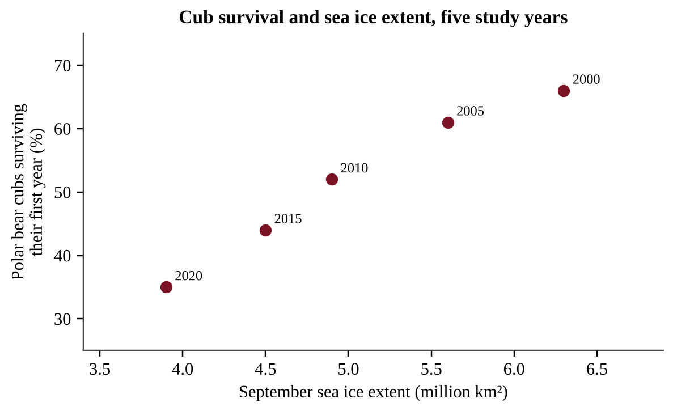
Figure — Cub survival versus September sea ice extent for the five study years
(a) Describe the trend in September sea ice extent from 2000 to 2020. [1] (b) Calculate the percent change in sea ice extent from 2000 to 2020. [1] (c) Calculate the average rate of change in sea ice extent per decade between 2000 and 2020. Include units. [1] (d) Assuming the rate you calculated in part (c) continues, calculate the year in which September ice extent would reach zero. [1] (e) Explain one reason why the prediction in part (d) might be inaccurate. [1] (f) Explain how the ice-albedo feedback helps explain why the Arctic is warming faster than the global average. [2] (g) Describe the relationship between sea ice extent and cub survival shown in the figure, and explain one ecological reason for it. [2] (h) Propose one solution that would slow the long-term loss of Arctic sea ice. [1]

Question 5 QB-U9-FRQ005
A dairy farm keeps 800 cows. Each cow emits 110 kg of methane (CH₄) per year, and the farm's manure lagoons emit a total of 4,000 kg of nitrous oxide (N₂O) per year. Use 100-year global warming potentials (GWP) of 28 for CH₄ and 265 for N₂O, relative to CO₂ = 1. Of the farm's total methane, 25% comes from manure and 75% from digestion in the cows. 1 metric ton = 1,000 kg.
(a) Calculate the total mass of CH₄ the farm emits per year, in kg. [1] (b) Calculate the farm's total annual emissions of CH₄ and N₂O combined, in metric tons of CO₂ equivalent (t CO₂e). [2] (c) Calculate the percentage of the farm's total CO₂e emissions that is due to CH₄. [1] (d) The farm installs a digester that captures 80% of the methane from manure and burns it. Calculate the annual reduction in emissions, in t CO₂e. Treat the CO₂ released when the methane is burned as having no net climate effect, because it comes from recently grown plants. [2] (e) Calculate the percent reduction in the farm's total CO₂e emissions achieved by the digester. [1] (f) A carbon price of $50 per t CO₂e is paid for each ton of reduction. The digester costs $350,000. Calculate the annual payment for the reduction and the number of years to pay back the cost from this payment alone. [2] (g) Propose one additional change in animal feed or manure management that would reduce the farm's greenhouse gas emissions, and explain how it works. [1]

Question 6 QB-U9-FRQ006
A coastal district of 62 km² is protected by a natural shoreline. Planners are comparing two sea-level scenarios from 2025 to 2100 (75 years): a low-emission scenario with a rise of 4.0 mm per year, and a high-emission scenario with a rise of 10.0 mm per year. The table gives the land area that would be flooded at each total rise, and the district's population density is 2,400 people per km², distributed uniformly. 1 m = 1,000 mm.
Total sea-level rise (m) | Land area below that elevation (km²)
0.30 | 7
0.75 | 22
1.50 | 41

(a) Calculate the total sea-level rise, in meters, between 2025 and 2100 under each scenario. [2] (b) Using the table, calculate the number of people living on land that would be flooded under each scenario. [2] (c) Calculate how many more people would be displaced under the high-emission scenario than under the low-emission scenario. [1] (d) Explain two processes that cause global sea level to rise as the climate warms. [2] (e) A seawall to protect the district's shoreline would cost $18 million per km of coastline and 14 km would be needed. Calculate the total cost. [1] (f) Calculate the cost of the seawall per person in the high-emission scenario. [1] (g) Propose one solution to the flooding problem other than building the seawall, and justify why it could be effective. [1]

Four Complete AP Environmental Science Predicted Practice Exams
The four exams that follow each contain 80 multiple-choice questions and 3 free-response questions, built to the 2026 exam blueprint. They are original practice exams written by Success4Sure Academy; they are not official, leaked or guaranteed College Board questions. Complete answer keys and solutions are in Book Three, Part III.
Predicted Practice Exam 1
NOTE
Format and timing (2026 AP Environmental Science exam). This is a complete predicted exam. Section I has 80 multiple-choice questions (60% of the score) and is allotted 90 minutes. Section II has 3 free-response questions (40% of the score, 10 points each) and is allotted 70 minutes. A calculator is allowed for both sections.
Instructions. In Section I, choose the single best answer for each question. There is no penalty for guessing. In Section II, answer every part of every question, show all calculations with units, and use complete sentences when a task verb asks you to describe, explain, justify, or propose. Question 1 asks you to design an investigation, Question 2 asks you to analyze quantitative data, and Question 3 asks you to analyze an environmental problem using calculations.

Section I — Multiple-Choice Questions (80)
Question 1 PE1-MCQ001
A river meets the Pacific Ocean in a broad coastal bay. Which description best fits the estuary biome that forms where the fresh water and seawater mix?
A. Brackish water whose salinity shifts with the tides and river flow, supporting high productivity
B. Fresh water of constant low salinity that stays nutrient-poor because rain keeps diluting it
C. Fully marine water of stable salinity and low productivity because strong tides scour the bottom
D. Cold, nutrient-poor water in which sunlight never reaches the sediment or the producers

Question 2 PE1-MCQ002
On a temperate farm, a grower plants soybeans one year and corn the next, and applies much less fertilizer to the corn. Which process most directly explains the extra nitrogen available to the corn?
A. Denitrifying bacteria convert nitrate in the soil into N₂ gas that the corn roots then absorb
B. Nitrogen-fixing bacteria in soybean root nodules convert atmospheric N₂ into ammonia that remains in the soil
C. Nitrification converts N₂ in the air directly into nitrate inside the soybean leaves after harvest
D. Leaching carries nitrate from deep soil layers upward to the corn roots during the spring rains

Question 3 PE1-MCQ003
Researchers studying a salt marsh on a Pacific island coast measured a gross primary productivity (GPP) of 3,400 kcal/m²/yr. Respiration by the marsh producers used 1,500 kcal/m²/yr. What is the net primary productivity (NPP) of the marsh?
A. 1,500 kcal/m²/yr
B. 1,900 kcal/m²/yr
C. 3,400 kcal/m²/yr
D. 4,900 kcal/m²/yr

Question 4 PE1-MCQ004
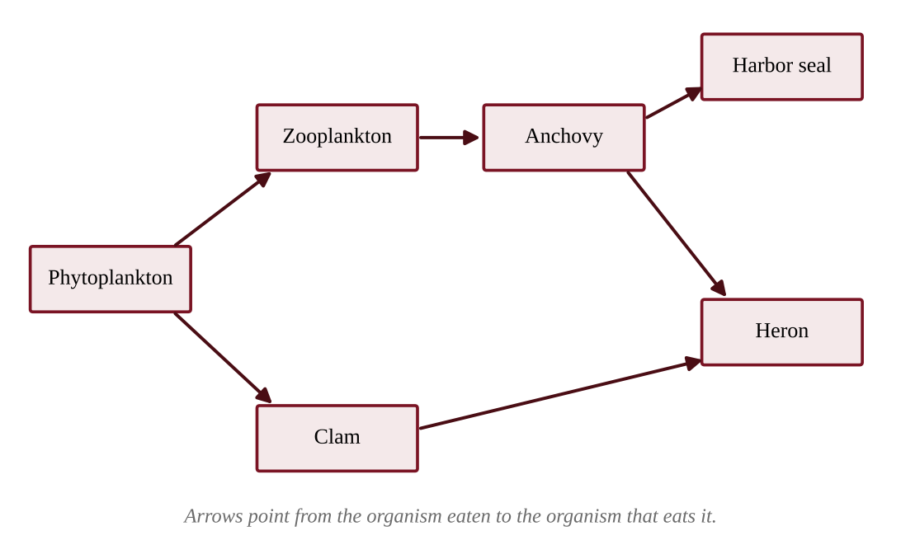
Figure — Feeding relationships in a Pacific estuary. Each arrow points toward the consumer.
According to the food web shown, which statement is correct?
A. The heron acts as both a secondary consumer and a tertiary consumer
B. The anchovy is a primary consumer because it is the smallest fish in the web
C. The zooplankton are secondary consumers because they eat microscopic organisms
D. The harbor seal and the clam feed at the same trophic level

Question 5 PE1-MCQ005
In a kelp forest off a Pacific island, producers store 480,000 kJ/m²/yr of net primary productivity. The food chain is kelp → sea urchins → sea otters → orcas. If energy transfer between trophic levels is 10%, how much energy per square meter per year is available to the orcas?
A. 48 kJ/m²/yr
B. 480 kJ/m²/yr
C. 4,800 kJ/m²/yr
D. 48,000 kJ/m²/yr

Question 6 PE1-MCQ006
Mangrove soils store large amounts of carbon. A coastal reserve measured the carbon in the top 1 m of soil before and after part of a mangrove forest was drained for shrimp ponds.
Condition | Soil carbon (Mg C per hectare)
Intact mangrove | 380
Five years after draining | 290

Drainage exposes the formerly waterlogged soil to oxygen, and assume all of the lost carbon was oxidized to CO₂ (1 Mg C = 3.67 Mg CO₂). About how much CO₂ was released per hectare?
A. 24 Mg CO₂
B. 90 Mg CO₂
C. 330 Mg CO₂
D. 1,390 Mg CO₂

Question 7 PE1-MCQ007
A coastal village relies on a mangrove stand that weakens storm waves during typhoons and protects homes behind it. Which category of ecosystem service does this protection represent?
A. A provisioning service, because it supplies a material good
B. A cultural service, because it provides recreational value
C. A supporting service, because it cycles nutrients for other services
D. A regulating service, because it moderates a natural hazard

Question 8 PE1-MCQ008
A volcanic eruption builds a new island of bare lava rock near Hawaiʻi. Which organisms are most likely to colonize the island first, and why?
A. Hardwood trees, which grow quickly on fresh lava and shade out other species
B. Lichens and mosses, which can grow on bare rock and begin forming soil
C. Grasses and shrubs, which need a deep layer of fertile soil to germinate
D. Large grazing mammals, whose manure forms the first soil on bare rock

Question 9 PE1-MCQ009
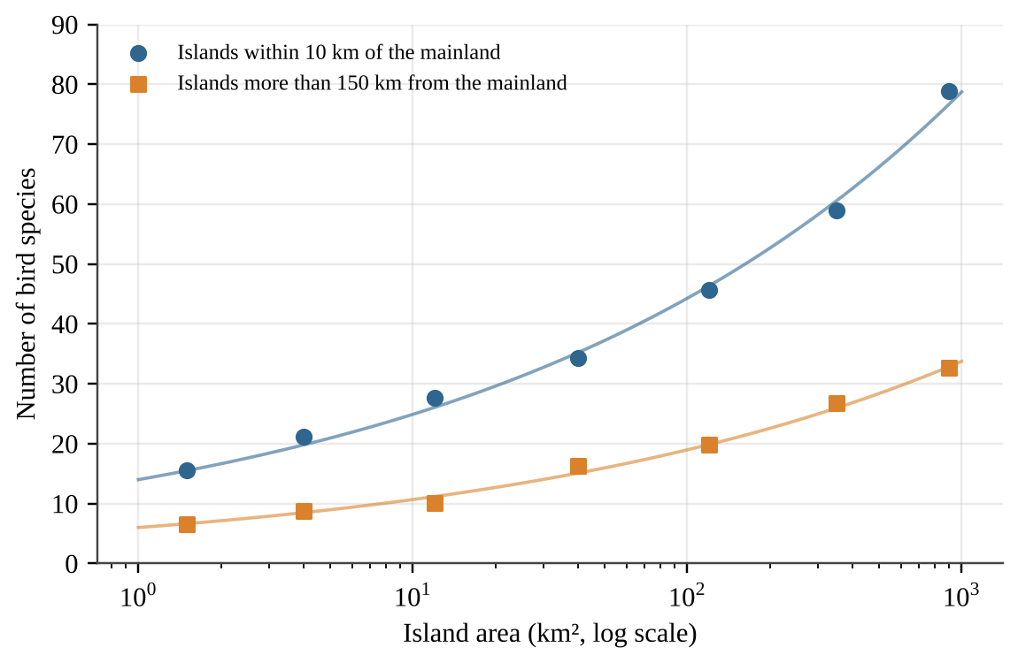
Figure — Bird species richness on islands of different size and distance from the mainland.
Which conclusion is best supported by the graph?
A. Near-mainland islands hold more species than distant islands of the same area, and richness rises with area
B. Distance from the mainland changes species richness only for small islands, those under about 10 km²
C. Species richness on distant islands stays about the same whatever the island area
D. Distant islands support more species at every island area because they have fewer competing species

Question 10 PE1-MCQ010
Heavy rain floods an estuary and lowers its salinity to 8 ppt for three weeks. The table shows the salinity tolerance range of four sessile species living there.
Species | Salinity tolerance (ppt)
Estuarine clam | 5–30
Pacific oyster | 12–32
Blue mussel | 15–35
Acorn barnacle | 20–35

Which species is most likely to survive the flood event?
A. The estuarine clam, because 8 ppt lies inside its range of 5–30 ppt
B. The Pacific oyster, because its range spans 20 ppt, which is wide enough to buffer salinity swings
C. The blue mussel, because it tolerates the highest salinities and therefore the greatest stress
D. The acorn barnacle, because species with narrow ranges are the best adapted to stable salinity

Question 11 PE1-MCQ011
After a typhoon flattened sections of a Pacific island forest, ecologists surveyed plots that had been recovering for different lengths of time.
Time since the typhoon | Tree species per plot
2 years | 18
8 years | 31
25 years | 36
80 years | 24

Which explanation best accounts for the lower richness in the 80-year plot?
A. Shade-tolerant late-successional trees have competitively excluded many sun-loving early-successional species
B. The 80-year plot lost species because primary succession starts again after every typhoon that strikes
C. Old forests have more disturbance, so the plot has been reset to bare mineral soil several times
D. Tree species richness declines as forests age because the soil gradually loses all of its nutrients

Question 12 PE1-MCQ012
On a small Pacific island, one bird species feeds only on nectar from a single native flower, and a second bird species eats seeds, insects, and fruit. A disease eliminates the flower. What is the most likely result?
A. Both species will decline equally because they share the same island habitat
B. The nectar specialist will decline sharply, while the generalist can switch to other foods
C. The generalist will decline faster because it is less efficient at using any one food
D. Neither species will be affected because birds can digest any type of plant material

Question 13 PE1-MCQ013
Polar bears in the Arctic are K-selected species. Which set of traits is characteristic of K-selected species?
A. Many offspring, little parental care, short life span, and rapid growth after a disturbance
B. Few offspring, no parental care, short life span, and populations far below carrying capacity
C. Few offspring, extensive parental care, long life span, and populations near carrying capacity
D. Many offspring, extensive parental care, long life span, and a very small body size

Question 14 PE1-MCQ014
A country has a total fertility rate (TFR) of 1.4, low infant mortality, and almost no immigration. Replacement-level fertility is about 2.1 children per woman. Which outcome is most likely over the next several decades?
A. The population will keep growing indefinitely because the death rate is low
B. The population will stabilize because any TFR below 2.1 makes births equal deaths
C. The population will grow rapidly because fewer children are dying in infancy
D. The population will shrink and the share of older residents will increase

Question 15 PE1-MCQ015
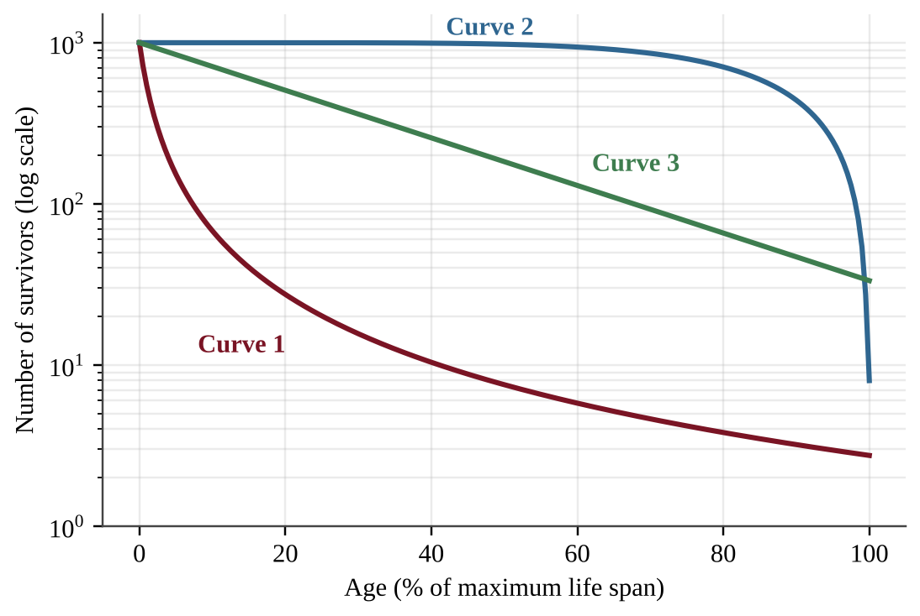
Figure — Three survivorship curves.
Pacific oysters release millions of eggs, most of the larvae die within days, and the few that settle on a hard surface can live for years. Which curve best represents the survivorship of oysters, and why?
A. Curve 2, because most individuals survive until near the maximum life span
B. Curve 3, because the death rate is nearly constant across all ages
C. Curve 1, because the largest mortality occurs early in life and survivors live long
D. Curve 2, because high parental investment gives young a high chance of survival

Question 16 PE1-MCQ016
Deer introduced to a temperate island multiplied rapidly and then leveled off at about 800 animals. Which factor is density-dependent and most likely helped hold the population near its carrying capacity?
A. A severe windstorm that kills about the same percentage of deer in any given year
B. A volcanic eruption that buries part of the island's grazing land under thick ash
C. A hard freeze that kills deer in about the same proportion whatever the herd size
D. Greater competition for winter forage and faster spread of disease when deer are crowded

Question 17 PE1-MCQ017
An island nation has a crude birth rate of 14 per 1,000 people, a crude death rate of 6 per 1,000, 2 immigrants per 1,000, and 4 emigrants per 1,000 each year. What is the annual population growth rate?
A. 0.6%
B. 0.8%
C. 1.0%
D. 6.0%

Question 18 PE1-MCQ018
A small Pacific island nation installs clean-water systems and vaccination clinics, but its birth rates remain high for now. According to the demographic transition model, what is happening?
A. Stage 1, in which both rates are high and fluctuating, so the population stays about the same
B. Stage 3, in which birth rates fall sharply, so the population growth rate slows to zero
C. Stage 4, in which both rates are low, so the population stabilizes at a high number
D. Stage 2, in which death rates fall faster than birth rates, so the population grows rapidly

Question 19 PE1-MCQ019
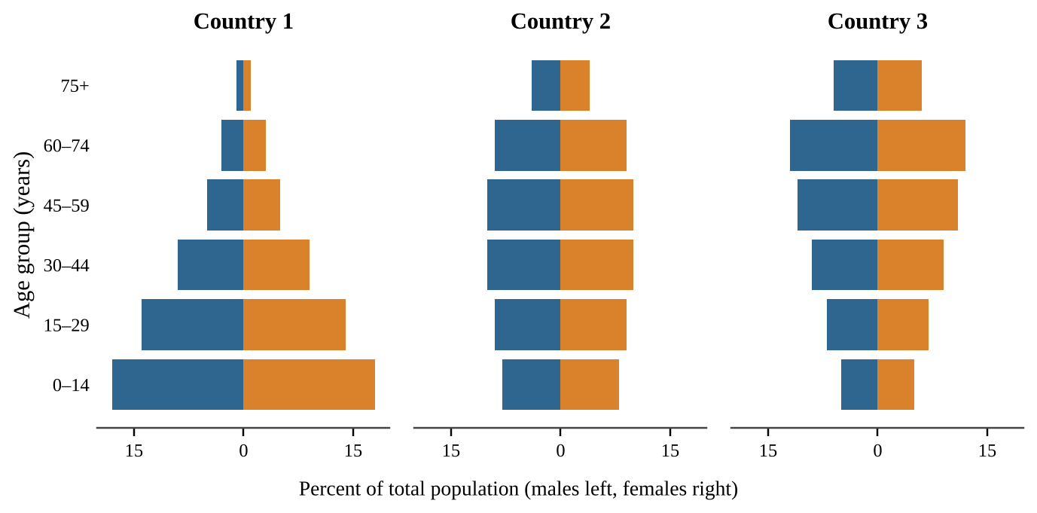
Figure — Age-structure diagrams for three countries.
Assuming no migration, which country is most likely to see its population shrink over the next 30 years, and why?
A. Country 1, because its large youngest group indicates a high rate of infant mortality that will cut the population
B. Country 3, because its narrow base means fewer young people are reaching reproductive ages than the older groups leaving them
C. Country 2, because its large middle-aged groups will soon die in numbers that exceed all births
D. No country, because every population keeps growing as long as its older residents remain healthy

Question 20 PE1-MCQ020
A coastal city of 600,000 people grows at a constant 2.8% per year. Using the rule of 70, which population is expected after 50 years?
A. 1,200,000
B. 1,440,000
C. 2,400,000
D. 4,800,000

Question 21 PE1-MCQ021
A national health survey in three provinces produced these data.
Province | Girls in secondary school (%) | Women using modern contraception (%) | TFR
North | 22 | 18 | 5.4
Central | 51 | 40 | 3.6
South | 83 | 68 | 2.1

Which conclusion is best supported?
A. Female education directly causes lower fertility, which shows that contraception has no real effect on it
B. Contraceptive use has no relationship to fertility, because education alone already explains the pattern
C. Education and contraceptive use are both associated with lower fertility, but the data cannot show which one causes it
D. Fertility declines only when national income rises, as these data from the three provinces demonstrate

Question 22 PE1-MCQ022
A soil scientist digs a profile in a temperate forest near the Pacific Northwest coast. Which horizon consists mostly of partly decomposed leaves, needles, and other plant litter?
A. The A horizon beneath the surface
B. The B horizon, where clay and minerals accumulate
C. The O horizon at the surface
D. The C horizon of weathered parent material

Question 23 PE1-MCQ023
The Aleutian Islands form an arc of volcanic islands above a deep ocean trench in the North Pacific. At which type of plate boundary did this island chain most likely form?
A. A divergent boundary, where two plates move apart along a mid-ocean ridge
B. A convergent boundary, where dense oceanic crust sinks beneath another plate
C. A transform boundary, where two plates slide horizontally past each other
D. A convergent boundary, where two continental plates collide to form folded mountains

Question 24 PE1-MCQ024
In which layer of the atmosphere does temperature rise with increasing altitude because the ozone layer absorbs ultraviolet radiation?
A. The troposphere
B. The mesosphere
C. The stratosphere
D. The exosphere

Question 25 PE1-MCQ025
A student performs a jar test on a soil sample using water and a dispersing agent. Sand settles first, then silt, then clay. The cumulative depth of sediment is 3.6 cm after 1 minute, 7.2 cm after 2 hours, and 9.0 cm after 24 hours. What percent of the soil sample is silt?
A. 20%
B. 40%
C. 60%
D. 80%

Question 26 PE1-MCQ026
Many of the world's large deserts lie near 30° N and 30° S latitude. Which process best explains this pattern?
A. Ocean currents near 30° always flow away from the land, which prevents any evaporation from happening there
B. The Coriolis effect stops winds from blowing near 30°, so moisture cannot be transported across the region
C. Sunlight is weakest near 30° latitude, which prevents clouds from forming over the land surface
D. Air that rose at the equator and lost its moisture sinks near 30°, warming and suppressing cloud formation

Question 27 PE1-MCQ027
Precipitation was measured along an east-west line across a mountain range in the Pacific Northwest, with prevailing winds from the west.
Station | Elevation (m) | Annual precipitation (mm)
Coast | 20 | 2,800
Windward slope | 800 | 3,400
Crest | 1,500 | 2,100
Leeward valley | 400 | 380

Which process best explains the very low precipitation in the leeward valley?
A. Cold ocean currents block moisture from reaching any inland station, whatever the elevation
B. Air forced up the windward slope cools and drops its moisture, then warms and dries as it descends the lee side
C. Air rising on the lee side expands and cools, which forms clouds that stay over the crest
D. The leeward valley lies at lower elevation, and low elevations receive less rain at every latitude

Question 28 PE1-MCQ028
A storm drops 40 mm of rain on a 5.0 km² urban watershed. Because of pavement and roofs, 85% of the rainfall becomes surface runoff (runoff coefficient = 0.85). What volume of runoff reaches the river?
A. 30,000 m³
B. 170,000 m³
C. 200,000 m³
D. 235,000 m³

Question 29 PE1-MCQ029
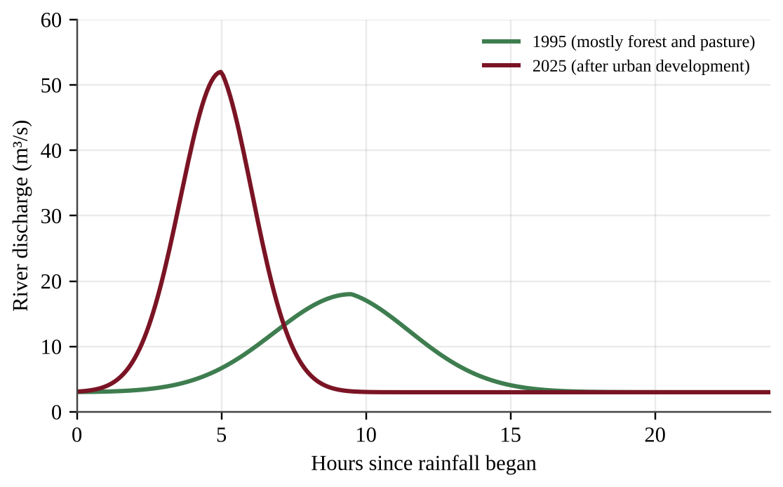
Figure — River discharge after the same storm, before and after development of a watershed.
Which change in the hydrograph is most likely caused by the development of the watershed?
A. A lower peak discharge that arrives later, because more water infiltrates and recharges groundwater
B. A higher peak discharge that arrives later, because pavement and buildings store rainfall before releasing it
C. A higher peak discharge that arrives sooner, because impervious surfaces and storm drains move water quickly to the river
D. No change in the timing of the peak, because only the volume of rainfall controls the shape of the curve

Question 30 PE1-MCQ030
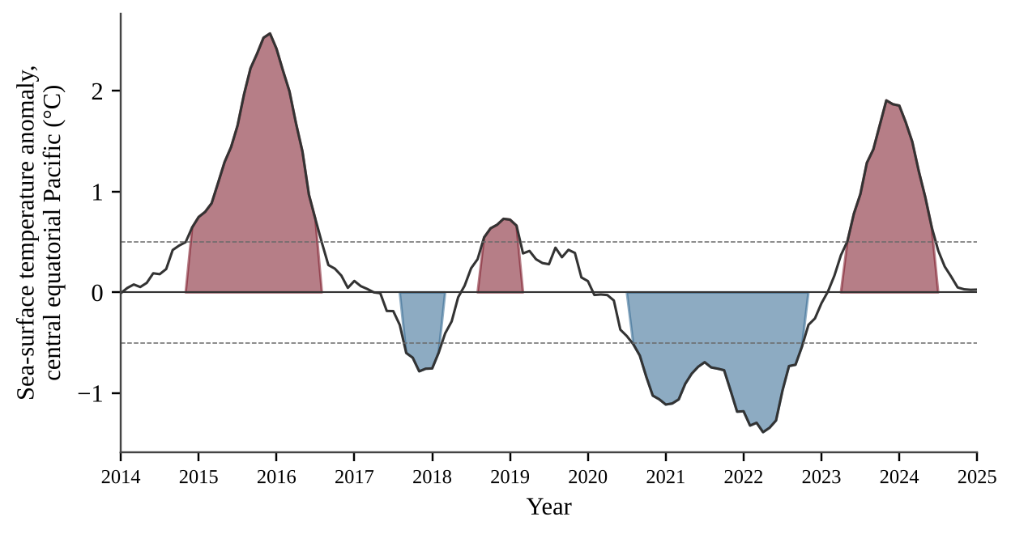
Figure — Sea-surface temperature anomaly in the central equatorial Pacific. Red shading marks anomalies above +0.5 °C and blue shading marks anomalies below −0.5 °C.
During which interval was upwelling of cold, nutrient-rich water off the coast of Peru most likely strongest, and why?
A. 2015–2016, when the strongly positive anomaly marked an El Niño with strengthened trade winds that drove upwelling
B. 2017–2018, when the anomaly was briefly positive and warm water piled up near South America
C. 2023–2024, when positive anomalies strengthened the trade winds and cooled the eastern Pacific
D. 2021–2022, when the strongly negative anomaly marked a La Niña with strong trade winds pushing warm water west

Question 31 PE1-MCQ031
In the Arctic, fresh sea ice has an albedo of about 0.80 and open ocean water has an albedo of about 0.07. Suppose 300 W/m² of sunlight reaches the surface. How much more solar energy is absorbed per square meter when the ice is replaced by open water?
A. 21 W/m²
B. 219 W/m²
C. 240 W/m²
D. 279 W/m²

Question 32 PE1-MCQ032
Fishing boats from several villages harvest herring from the same open-access bay. Each boat owner keeps adding nets because the catch from each extra net belongs entirely to that owner. Which concept does this behavior illustrate?
A. The tragedy of the commons, because each user gains fully while the cost of depletion is shared by all
B. Sustainable yield, because harvesting more fish each year keeps the fish population growing steadily
C. Bioaccumulation, because the fish absorb toxins from the water faster than they can excrete them
D. Ecological succession, because heavily fished bays recover to a climax community within a year or two

Question 33 PE1-MCQ033
A steep Pacific Northwest hillside above a salmon-bearing stream is clearcut. Which short-term effect on the stream is most likely?
A. Higher sediment loads and warmer water because erosion increases and streamside shade is lost
B. Lower water temperature because there are fewer leaves to absorb heat from the sun
C. Clearer water because the roots of cut trees filter the runoff more effectively
D. Greater dissolved oxygen because larger volumes of falling leaves enter the water

Question 34 PE1-MCQ034
Tailings from a surface mine contain sulfide minerals that are exposed to air and rainwater. Which environmental problem is most directly associated with this situation?
A. Acid mine drainage that lowers stream pH and releases dissolved metals
B. Cultural eutrophication that fertilizes the stream and triggers algal blooms
C. Thermal pollution that raises the stream temperature and drives out cold-water fish
D. Saltwater intrusion that raises the salinity of the stream and its surrounding wetlands

Question 35 PE1-MCQ035
A temperate-zone orchard uses flood irrigation, applying 1,000 m³ of water per hectare in a season while the trees use 450 m³ per hectare. Drip irrigation would deliver the same 450 m³ to the trees but apply 520 m³ per hectare because of small losses. By what percentage would switching to drip irrigation reduce the water applied?
A. 45%
B. 48%
C. 52%
D. 86%

Question 36 PE1-MCQ036
A farm grows 5,000 kg of corn per hectare. Corn provides 3,500 kcal/kg, and beef provides 2,500 kcal/kg. Feedlot cattle need 8 kg of corn to gain 1 kg of beef. About how many times more food energy per hectare would people obtain by eating the corn directly rather than feeding all of it to cattle?
A. 0.09
B. 1.4
C. 8
D. 11

Question 37 PE1-MCQ037
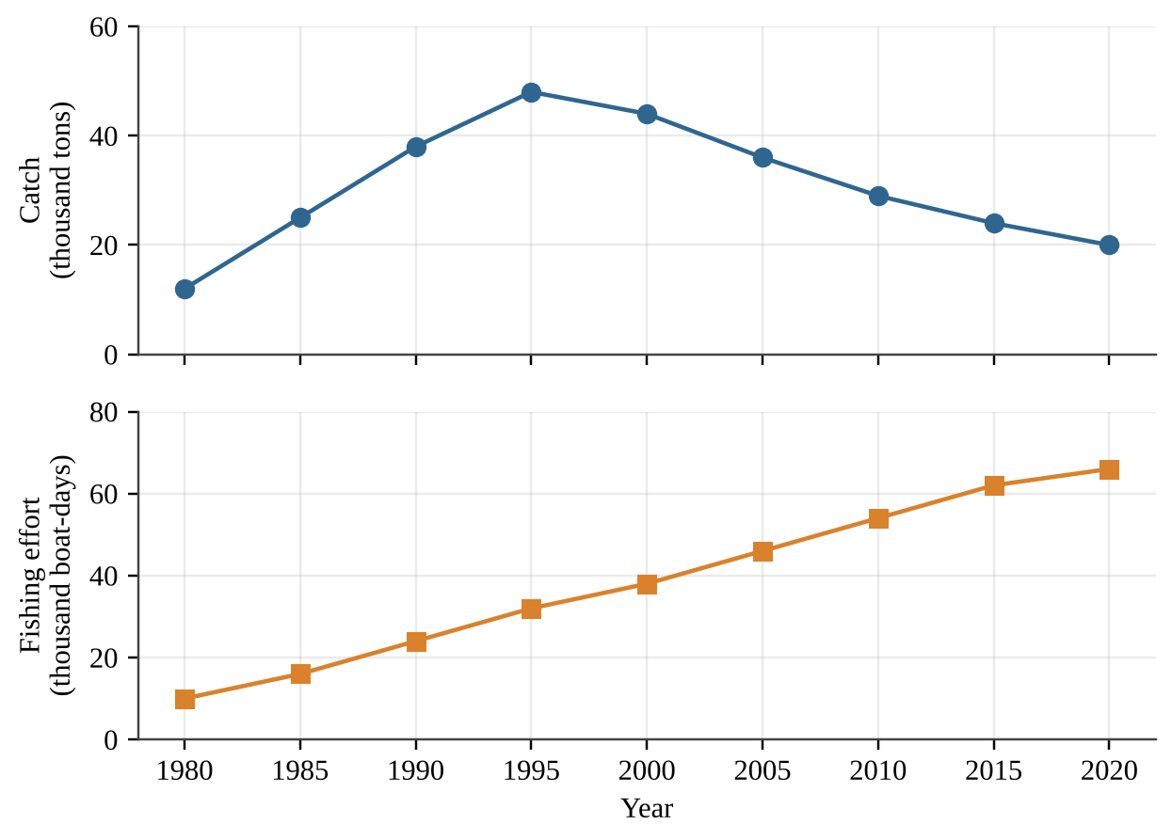
Figure — Catch and fishing effort in a coastal fishery.
Which interpretation of the data is best supported?
A. After 1995, catch per unit of effort fell while effort kept rising, consistent with an overfished stock
B. Rising effort after 2000 helped the stock rebuild, so catch should soon start to rise again
C. The decline in catch after 1995 happened because fishers gradually reduced their fishing effort
D. Catch per unit of effort stayed constant through 2020, so the stock remained healthy

Question 38 PE1-MCQ038
A mid-size coastal city plans to rebuild a large parking lot so that less polluted stormwater reaches a nearby estuary. Which design change would be most effective?
A. Add curbs and larger storm drains that carry rainwater directly to the creek
B. Increase the paved area so that the rain flows off faster before it can pick up pollutants
C. Salt the pavement each winter so that snowmelt moves through the drains quickly
D. Replace asphalt with permeable pavers over a gravel reservoir and add planted bioswales along the edges

Question 39 PE1-MCQ039
Data from a rice-growing region during the Green Revolution are shown below.
Year | Rice yield (t/ha) | Nitrogen fertilizer (kg/ha) | Irrigated cropland (%)
1965 | 2.0 | 12 | 20
1985 | 3.4 | 58 | 41
2005 | 4.6 | 125 | 57

Which environmental concern is most directly linked to the trends shown?
A. Fertilizer runoff that causes eutrophication and heavier withdrawals from rivers and aquifers
B. Declining yields as the soil becomes depleted of nitrogen from overuse of fertilizer
C. Reduced fossil fuel use on farms because of lower demand for machinery and pumping
D. Greater genetic diversity among the rice varieties as more farmers adopt irrigation

Question 40 PE1-MCQ040
A city of 250,000 people has an ecological footprint of 3.8 global hectares (gha) per person. The biocapacity available to the city's region is 620,000 gha. By what percentage must the per-person footprint fall for the city to live within its regional biocapacity, assuming the population stays constant?
A. 35%
B. 53%
C. 65%
D. 153%

Question 41 PE1-MCQ041
In an apple orchard, growers sprayed the same miticide each year and tracked the percentage of the mite population that survived a standard dose.
Year of spraying | 1 | 2 | 3 | 4 | 5
Mites surviving a standard dose (%) | 2 | 9 | 31 | 68 | 93

Which statement best explains the trend, and which management response is most consistent with integrated pest management (IPM)?
A. Each spraying selected for mites already carrying resistance genes; rotating methods and using biological controls would slow the trend
B. Each mite individually became more resistant after repeated exposure, so growers should raise the dose and spray more often
C. The pesticide caused the resistance mutations, so growers should spray less often but keep using only the same chemical
D. The mite population is migrating into the orchard from other farms, so growers should spray the entire valley each season

Question 42 PE1-MCQ042
A Pacific island utility wants to replace diesel generators with another energy source. Which option below is a renewable energy source?
A. Liquefied natural gas turbines
B. Ocean wave energy converters
C. A uranium-fueled micro-reactor
D. Coal-fired boilers

Question 43 PE1-MCQ043
Which statement about electricity generation from nuclear fission is accurate?
A. It emits almost no CO₂ in operation but produces spent fuel that stays radioactive for thousands of years
B. It emits large amounts of SO₂ and soot because uranium ore is burned in the reactor core
C. Its spent fuel becomes harmless within a few years and can be disposed of in ordinary landfills
D. It is considered renewable because the chain reaction in the fuel rods can never run out

Question 44 PE1-MCQ044
A large dam with a reservoir is proposed on a river with a salmon run. Which impact is most directly associated with the dam?
A. Increased river sediment downstream because the reservoir releases more soil than the river carried before
B. Higher river temperatures downstream because the dam gives off waste heat from its turbines
C. Blocked upstream fish migration and trapped sediment that would otherwise build downstream deltas and estuaries
D. More air pollution near the river because hydroelectric turbines burn small amounts of fuel

Question 45 PE1-MCQ045
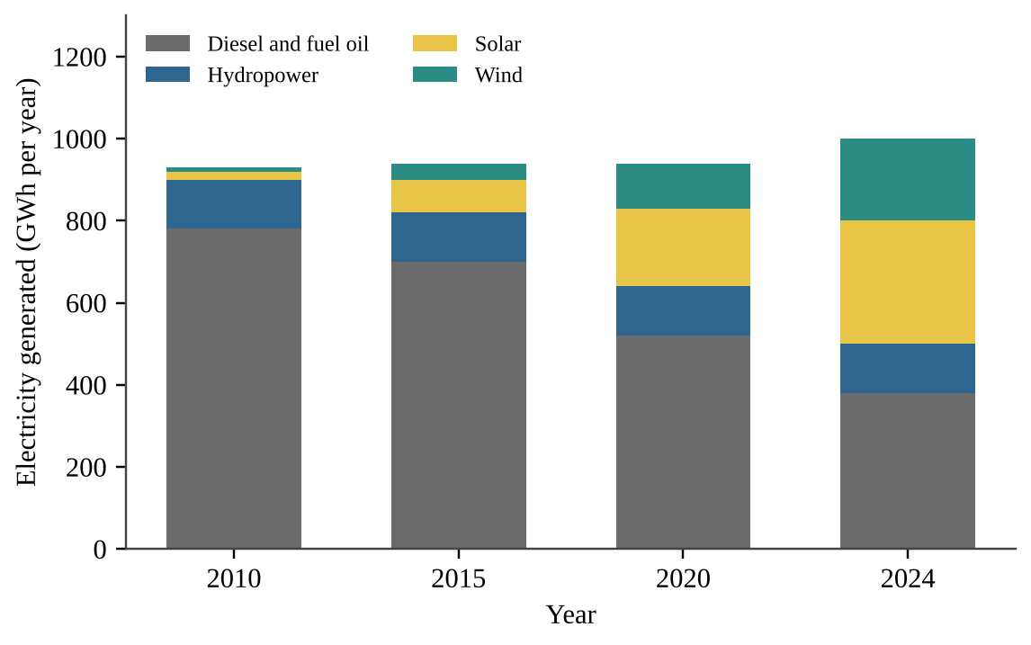
Figure — Electricity generation on a Pacific island grid by source.
What percentage of the island's electricity in 2024 came from wind and solar combined?
A. 20%
B. 30%
C. 38%
D. 50%

Question 46 PE1-MCQ046
The power available in the wind is proportional to the cube of wind speed. Site A has an average wind speed of 5.0 m/s at hub height, and Site B has an average of 7.5 m/s. About how many times greater is the wind power available at Site B?
A. 1.5
B. 2.3
C. 3.0
D. 3.4

Question 47 PE1-MCQ047
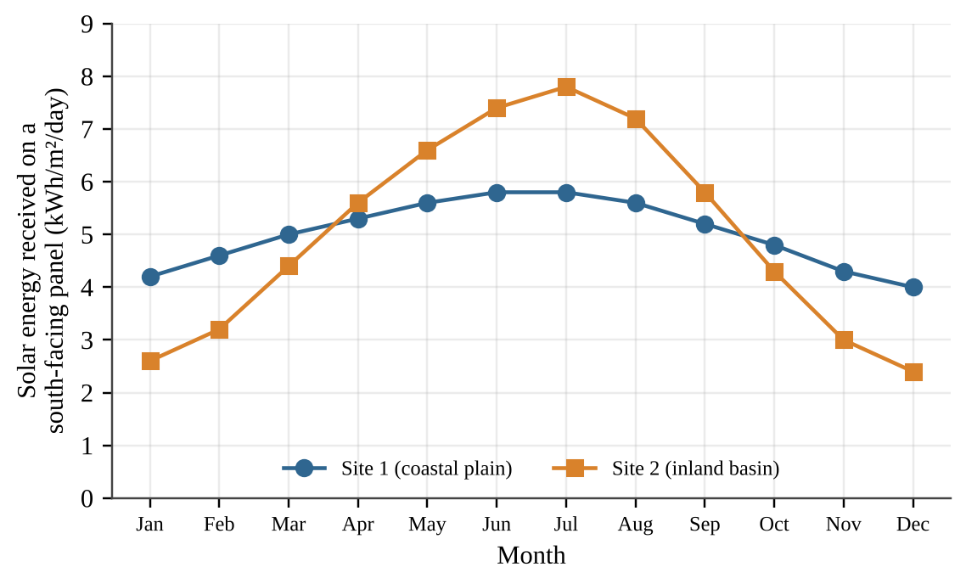
Figure — Average daily solar energy on a south-facing panel at two candidate sites. Both sites average about 5.0 kWh/m²/day over the year.
A utility will build a solar farm with very little battery storage and wants steady output across the year. Which conclusion is best supported?
A. Site 2 should be chosen because its higher summer peak means it collects more energy over the whole year
B. Site 1 collects more energy than Site 2 in every month, so it is the better site in all seasons
C. Site 1 would need less storage or backup generation because its monthly output varies much less through the year
D. Site 2 should be chosen because its winter output is higher than Site 1 and balances its summer peak

Question 48 PE1-MCQ048
A school replaces 200 incandescent bulbs rated at 40 W with LED bulbs rated at 8 W. The lights are on 6 hours per day for 180 days per year. How much electricity does the school save each year?
A. 1,728 kWh
B. 6,912 kWh
C. 8,640 kWh
D. 69,120 kWh

Question 49 PE1-MCQ049
Which environmental concern is most specifically associated with hydraulic fracturing (fracking) to obtain natural gas?
A. It uses large volumes of water, and wastewater can contaminate groundwater or, injected deep, trigger small earthquakes
B. It releases long-lived radioactive waste that must be stored in deep underground repositories for many centuries
C. It floods river valleys and displaces whole communities when the production wells are drilled
D. It emits sulfur-rich particulates when wet biomass is burned in the production process

Question 50 PE1-MCQ050
A wind farm has a nameplate capacity of 40 MW and a capacity factor of 0.32. An average household in the region uses 10,000 kWh per year. About how many households can the wind farm supply in a year?
A. 1,120
B. 11,200
C. 35,040
D. 112,128

Question 51 PE1-MCQ051
A city plans to replace gasoline buses with hydrogen fuel cell buses. Which statement is most accurate regarding the environmental benefit?
A. Hydrogen is a primary energy source that can be mined directly, so its use adds no emissions
B. Hydrogen produced by electrolysis always has zero carbon emissions, regardless of the source of electricity
C. The overall benefit depends on how the hydrogen is produced, since a fuel cell only converts stored chemical energy
D. Fuel cells emit large amounts of nitrogen oxides because they burn hydrogen at very high temperatures

Question 52 PE1-MCQ052
Which of the following is a secondary air pollutant in a mid-size city?
A. Carbon monoxide released from incomplete combustion of fuel in car engines
B. Sulfur dioxide released directly from coal-fired power plants near the city
C. Ground-level ozone formed from NOₓ and volatile organic compounds reacting in sunlight
D. Lead dust released from older leaded-paint removal operations in the city

Question 53 PE1-MCQ053
A home in a mid-size city built over granite bedrock has a radon test result above the recommended action level. What is the most likely source of the radon?
A. Combustion of natural gas in the home's furnace, which releases radon gas into the living space
B. Outgassing of formaldehyde from the plywood and glue used in the home's furniture
C. Radioactive decay of uranium in the underlying rock, with the gas seeping in through foundation cracks
D. Vehicle exhaust from the city's streets, which enters the home through open windows

Question 54 PE1-MCQ054
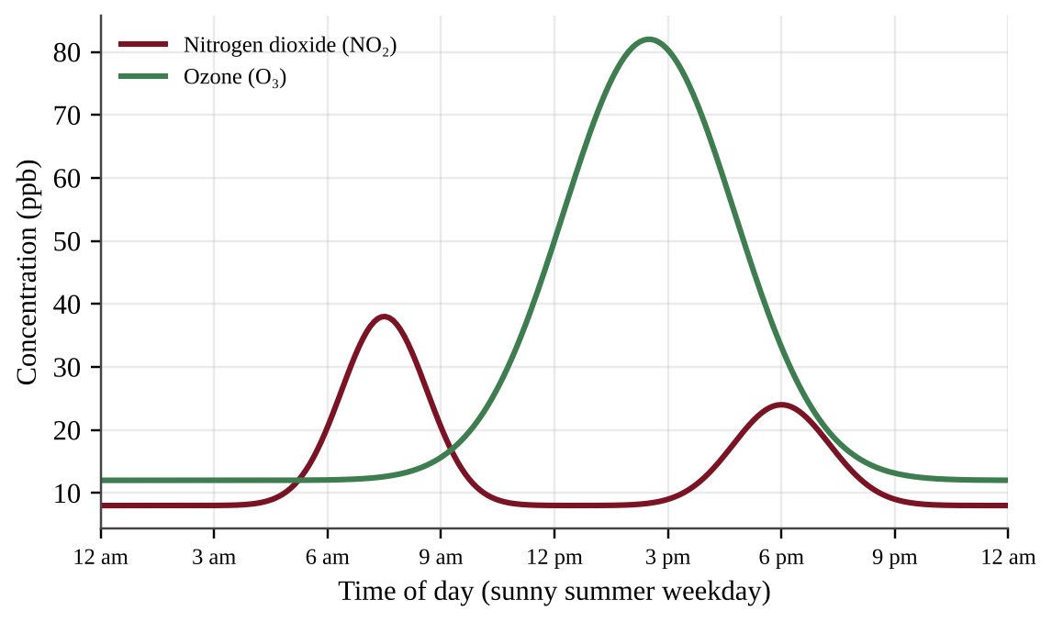
Figure — Average concentrations of nitrogen dioxide and ozone on a sunny summer weekday in a mid-size city.
Which explanation best accounts for the ozone peak occurring in the afternoon, after the morning NO₂ peak?
A. Ozone is emitted directly from tailpipes on busy city streets at midday when traffic is at its heaviest
B. NO₂ is converted to ozone only at night, when the air is cooler and winds are calm
C. Ozone concentrations peak when NO₂ is highest because the two pollutants are emitted together by vehicles
D. Sunlight drives photochemical reactions of NOₓ and VOCs from rush hour, so ozone accumulates as the sun climbs

Question 55 PE1-MCQ055
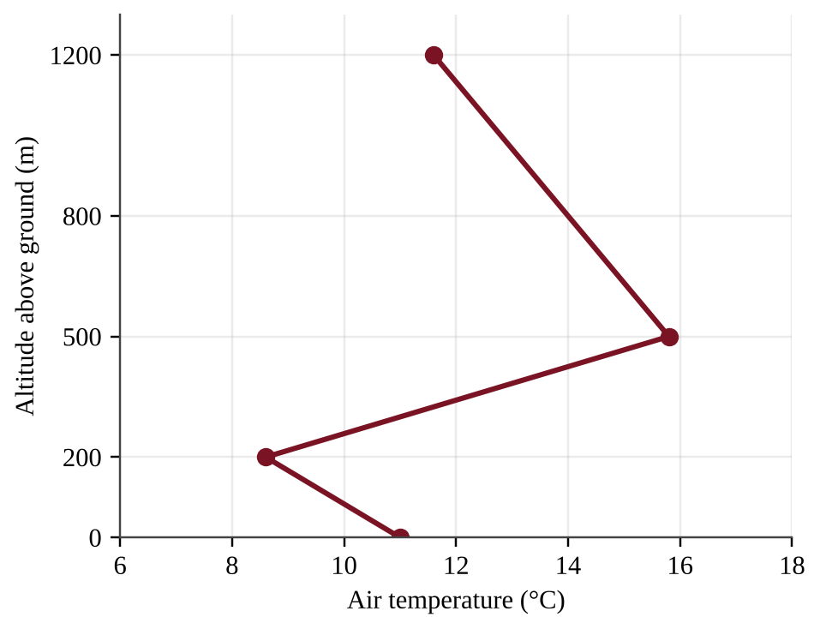
Figure — Air temperature at different altitudes above the ground over a valley city on a calm winter morning.
Which statement best describes how this temperature profile affects air pollution near the ground?
A. Between 0 m and 200 m, temperature decreases with altitude, so the layer is stable and traps pollutants
B. Between 500 m and 1,200 m, temperature decreases with altitude, so the layer prevents any vertical mixing
C. Across the full profile, temperature differs little, so pollutants spread evenly through the whole depth
D. Between 200 m and 500 m, temperature rises with altitude, so the warm layer acts as a lid over the pollutants

Question 56 PE1-MCQ056
A coal-fired power plant near a mid-size city emits 4,800 tons of SO₂ per year. Installing flue-gas desulfurization (scrubbers) removes 92% of the SO₂. How much SO₂ will the plant emit per year after the scrubbers are installed?
A. 384 tons
B. 440 tons
C. 4,416 tons
D. 4,800 tons

Question 57 PE1-MCQ057
Two lakes in the same region receive acid rain of the same pH. One lake sits on granite bedrock and the other on limestone bedrock. Why is the granite lake more likely to become acidified?
A. Granite releases hydrogen ions that lower the pH, while limestone absorbs rainfall
B. Limestone retains more acid because it dissolves slowly, which keeps the lake pH low
C. Limestone contains calcium carbonate that neutralizes acid, while granite provides little buffering
D. Granite lakes receive more rainfall because rock type changes the amount of precipitation

Question 58 PE1-MCQ058
A city monitors fine particulate matter (PM2.5) at four sites in summer and winter.
Site | Summer PM2.5 (µg/m³) | Winter PM2.5 (µg/m³)
Downtown (heavy traffic) | 14 | 16
Highway corridor | 22 | 24
Valley residential area | 9 | 38
Hilltop park | 6 | 8

Which hypothesis best explains why only the valley residential site shows a large winter increase?
A. Heavier winter traffic, because traffic is greatest at the valley residential site
B. Industrial emissions that rise in winter and affect all four sites equally
C. Residential wood burning combined with winter thermal inversions trapping smoke in the valley
D. Photochemical reactions that create more particles in the weak winter sunlight

Question 59 PE1-MCQ059
Fertilizer from cornfields washes into a coastal bay. Which sequence correctly describes the resulting cultural eutrophication?
A. More nutrients → algal bloom → algae photosynthesis raises dissolved oxygen → fish populations increase
B. More nutrients → water cools → algae die and release oxygen → fish populations increase
C. More sediment → light penetration increases → algae bloom disappears → dissolved oxygen rises
D. More nutrients → algal bloom → algae die and are decomposed by aerobic bacteria → dissolved oxygen falls → fish die

Question 60 PE1-MCQ060
A power plant discharges heated cooling water into a river. What is the most direct effect on aquatic life downstream?
A. Warm water holds more dissolved oxygen, which speeds the growth of cold-water fish
B. Warm water raises the salinity of the river, which kills freshwater fish within hours
C. Warm water lowers the amount of algae in the river, which starves the fish of food
D. Warm water holds less dissolved oxygen, which stresses cold-water fish such as trout

Question 61 PE1-MCQ061
Concentrations of a persistent organic pollutant (PCBs) were measured in an Arctic marine food chain.
Organism | PCB concentration (ppm)
Ice algae | 0.002
Arctic cod | 0.07
Ringed seal | 1.4
Polar bear | 20

The concentration in polar bears is how many times the concentration in the ice algae?
A. 20
B. 286
C. 700
D. 10,000

Question 62 PE1-MCQ062
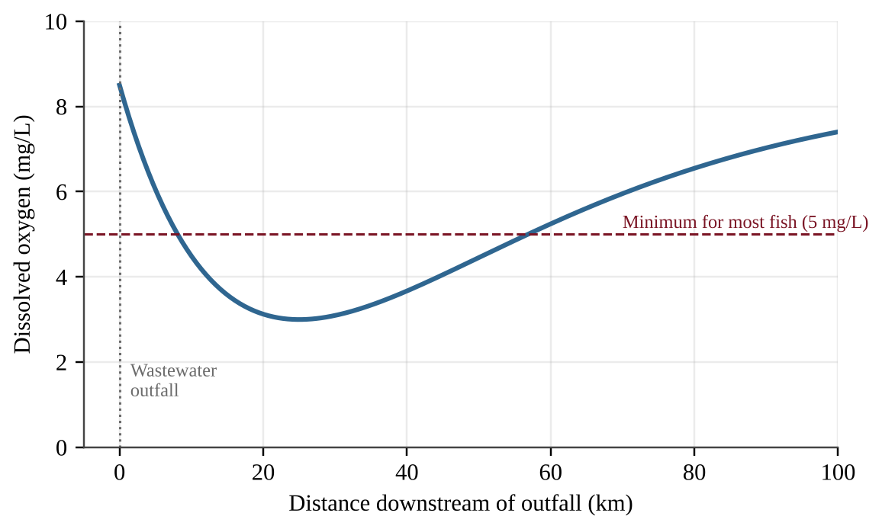
Figure — Dissolved oxygen in a river downstream of a wastewater outfall.
Which explanation best accounts for the lowest dissolved oxygen occurring about 25 km downstream rather than at the outfall?
A. The outfall water is hottest at 25 km, so oxygen is least soluble at that distance
B. Aerobic bacteria decomposing the organic waste use oxygen faster than it is replenished until the waste is used up
C. Photosynthesis by phytoplankton reaches its daily peak 25 km downstream, which removes oxygen from the water
D. The river becomes much shallower at 25 km, so oxygen can no longer dissolve from the air

Question 63 PE1-MCQ063
A mid-size city generates 120,000 tons of municipal solid waste per year. It recycles 21,600 tons, composts 14,400 tons, and landfills the remaining 84,000 tons. What percent of the city's waste is diverted from the landfill?
A. 12%
B. 18%
C. 30%
D. 70%

Question 64 PE1-MCQ064
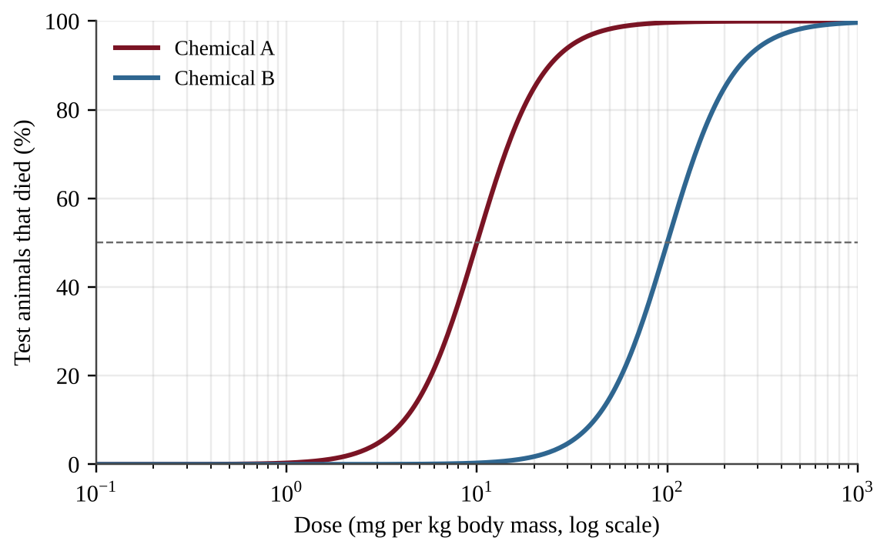
Figure — Percent of test animals killed at different doses of two chemicals.
Which statement is supported by the graph?
A. Chemical B is about 10 times more toxic than Chemical A because its curve lies farther to the right
B. Chemical A is about 10 times less toxic than Chemical B because it kills 50% at the lower dose
C. Chemical A is about 10 times more toxic than Chemical B because its LD50 is about 10 times lower
D. The two chemicals are equally toxic because both eventually kill 100% of the test animals

Question 65 PE1-MCQ065
A tidal creek delivers 40,000 m³ of water per day to a bay, with a nitrate-nitrogen concentration of 5 mg/L. A salt marsh along the creek removes 60% of the nitrate-nitrogen before the water reaches the bay. If the marsh is filled to build a port, how much additional nitrate-nitrogen will reach the bay each day?
A. 12 kg
B. 80 kg
C. 120 kg
D. 200 kg

Question 66 PE1-MCQ066
How do chlorofluorocarbons (CFCs) reduce the ozone layer?
A. UV light frees chlorine atoms from CFCs in the stratosphere, and each atom catalytically destroys many ozone molecules
B. CFCs react with ozone in the troposphere, which prevents it from rising into the stratosphere where it is needed
C. CFCs absorb infrared radiation in the stratosphere, which warms the air and causes ozone molecules to decompose
D. CFCs dissolve in ocean water and release chlorine, which then rises to the stratosphere as a gas

Question 67 PE1-MCQ067
Which statement best describes the natural greenhouse effect?
A. Greenhouse gases absorb visible light from the Sun before it reaches the surface, which keeps the surface cool and stable
B. Greenhouse gases reflect sunlight back to space, which keeps the average surface temperature constant over time
C. Greenhouse gases in the stratosphere absorb ultraviolet light and release it as heat that warms the oceans
D. Greenhouse gases absorb infrared radiation from Earth's surface and re-emit part of it downward, warming the lower atmosphere

Question 68 PE1-MCQ068
Which set of characteristics makes a species most likely to become invasive after it is introduced to a Pacific island?
A. Low reproductive rate, a specialist diet, and strong dependence on one native host plant
B. High reproductive rate, a generalist diet, and few natural predators or diseases in the new range
C. Long life span, small population size, and a need for stable, undisturbed habitat
D. High reproductive rate, a specialist diet, and strong control by predators from its home range

Question 69 PE1-MCQ069
Which international agreement regulates trade in threatened and endangered species such as sea turtles and elephants?
A. The Montreal Protocol on substances that deplete the ozone layer
B. The Kyoto Protocol on greenhouse gas emission targets
C. The Basel Convention on transboundary movement of hazardous waste
D. CITES, the Convention on International Trade in Endangered Species

Question 70 PE1-MCQ070
Production of CFCs was largely phased out under the Montreal Protocol beginning in the late 1980s, yet the Antarctic ozone layer is not expected to recover fully until about the middle of this century. Which statement best explains the delay?
A. CFCs persist for decades to a century, so chlorine keeps reaching the stratosphere after emissions fall
B. The replacement compounds used since the phase-out destroy ozone faster than CFCs did in the past
C. Ozone is destroyed only during the Antarctic winter, so recovery cannot begin until each winter ends
D. Ozone is rebuilt slowly because the ozone layer cannot form again once chlorine is present in the air

Question 71 PE1-MCQ071
Over a 100-year period, one ton of methane (CH₄) traps as much heat as about 28 tons of CO₂ (global warming potential of 28). A landfill near a mid-size city leaks 50 tons of CH₄ per year. What is this leakage in tons of CO₂ equivalent per year?
A. 1.8
B. 50
C. 78
D. 1,400

Question 72 PE1-MCQ072
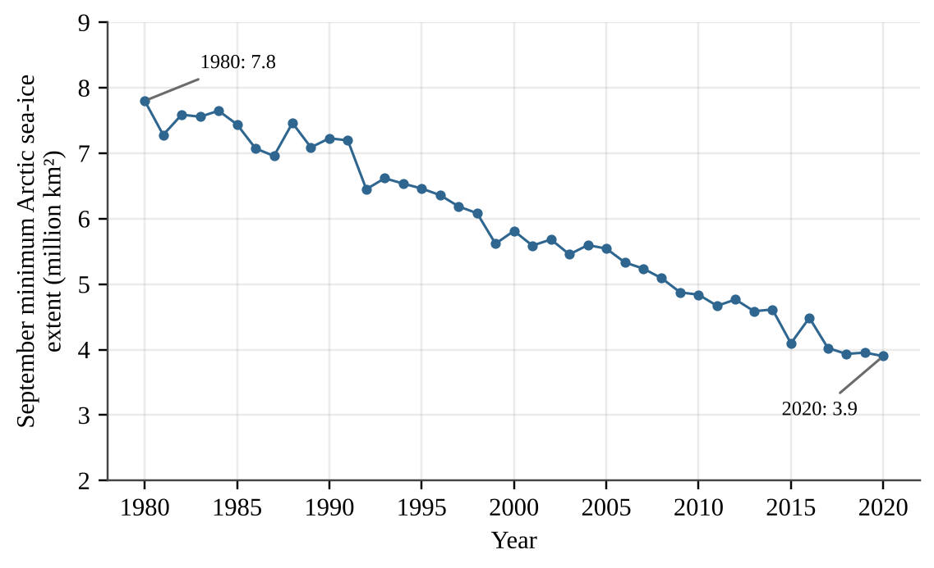
Figure — September minimum extent of Arctic sea ice.
By about what percent did the September minimum extent of Arctic sea ice decrease between 1980 and 2020?
A. 3.9%
B. 50%
C. 100%
D. 200%

Question 73 PE1-MCQ073
Which process is a positive feedback in Arctic warming?
A. Warmer air increases plant growth, which absorbs more CO₂ and so lowers the temperature of the air
B. Thawing permafrost releases cold fresh water that cools the ocean surface and slows the warming
C. Thawing permafrost releases CO₂ and CH₄ from decomposing organic matter, causing more warming and more thawing
D. Warming leads to more sea ice in autumn, which reflects sunlight and cools the Arctic surface

Question 74 PE1-MCQ074
Residents of a low Pacific atoll are concerned about rising sea level. Which pair of factors is the main contributor to global sea-level rise?
A. Thermal expansion of warming seawater and meltwater from land-based glaciers and ice sheets
B. Melting of floating Arctic sea ice and increased evaporation from tropical oceans
C. Increased rainfall on the oceans and melting of ice shelves that float on the ocean surface
D. Contraction of warming seawater and the growth of ice sheets over Greenland

Question 75 PE1-MCQ075
Hatcheries for Pacific oysters on the Oregon coast have reported die-offs of larvae when upwelled seawater has unusually low pH. Which explanation is most accurate?
A. Lower pH raises the carbonate ion concentration, which makes the larval shells too thick to open
B. Lower pH warms the seawater, which reduces its salinity and dissolves the larval shells
C. Lower pH reduces the nitrate supply, which starves the larvae of nitrogen needed to make shells
D. Lower pH reduces carbonate ion availability, so larvae have difficulty building calcium carbonate shells

Question 76 PE1-MCQ076
Atmospheric CO₂ measured at a Pacific mountain observatory was 316 ppm in 1959 and 421 ppm in 2023. What was the average annual increase in CO₂ concentration over this period?
A. 0.61 ppm per year
B. 1.6 ppm per year
C. 6.6 ppm per year
D. 105 ppm per year

Question 77 PE1-MCQ077
Which statement correctly compares ozone in the troposphere with ozone in the stratosphere?
A. Ground-level ozone is a secondary pollutant that harms lungs and plants, while stratospheric ozone absorbs UV-B
B. Ground-level ozone is emitted directly from tailpipes, while stratospheric ozone forms from smokestack emissions
C. Both layers of ozone absorb UV-B radiation and benefit living organisms, so both should be increased
D. Stratospheric ozone harms lung tissue, while ground-level ozone shields plants from UV-B radiation

Question 78 PE1-MCQ078
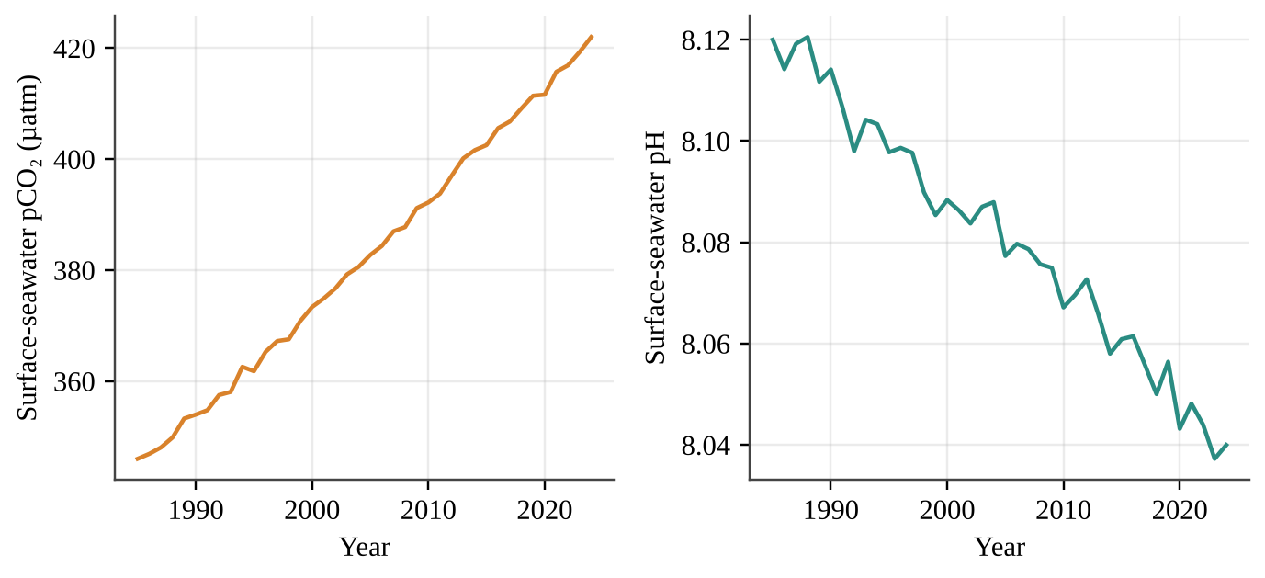
Figure — Surface-seawater pCO₂ and pH at a Pacific island station. Station pH fell from 8.12 in 1985 to 8.04 in 2024.
The pH scale is logarithmic: a decrease of 1.0 pH unit means a tenfold increase in hydrogen ion (H⁺) concentration. By about what percent did the H⁺ concentration increase between 1985 and 2024?
A. 1%
B. 8%
C. 20%
D. 80%

Question 79 PE1-MCQ079
Native forest birds on a Pacific island were surveyed along an elevation gradient. Avian malaria, carried by mosquitoes, is a major cause of bird death.
Elevation band | Native forest cover (%) | Mosquitoes | Native birds (per ha)
0–600 m | 35 | Abundant | 2
600–1,200 m | 80 | Present, moderate | 9
Above 1,200 m | 85 | Rare (too cold) | 41

Which interpretation is best supported, and what is the implication for climate warming?
A. Forest cover alone explains bird abundance, so warming that increases forest growth would help the birds
B. Mosquitoes do not influence bird numbers, so warming would have no effect on the birds at any elevation
C. Birds prefer high elevations because they are far from people, so warming would not change their distribution
D. Cool temperatures limit mosquitoes at high elevation, so warming could push mosquitoes upslope and shrink the birds' refuge

Question 80 PE1-MCQ080
European green crabs recently invaded a Pacific coast estuary. Managers suspect they reduce the density of native clams. Which investigation design would best test this hypothesis?
A. Compare clam density in one invaded estuary with that in one distant crab-free estuary measured on a single day
B. Set up replicate plots at matched tidal height and sediment, cage half to exclude crabs, and compare clams over a season
C. Count the clams in one plot before and again after the first crabs were seen in that plot, then compare them
D. Survey many plots once and conclude that crabs reduce clams because the plots with more crabs have fewer clams

Section II — Free-Response Questions (3)
Question 1 PE1-FRQ001
Harbor Bay is a Pacific coastal estuary that supports a commercial oyster fishery. Two creeks drain temperate farmland (corn and vegetables) into the bay. Harbor Creek flows through a 40-hectare salt marsh that was restored in 2019, whereas Mill Creek reaches the bay with no marsh. During summer, oyster growers report that dissolved oxygen (DO) near the mouth of Mill Creek often falls below 3 mg/L at dawn and that thick green algal mats cover the mud flats. Managers suspect that nitrogen fertilizer carried by drainage ditches is causing the problem, and they wonder whether the restored marsh is intercepting nitrogen in Harbor Creek. The map shows four existing water-quality access points (H1, H2, M1, M2).
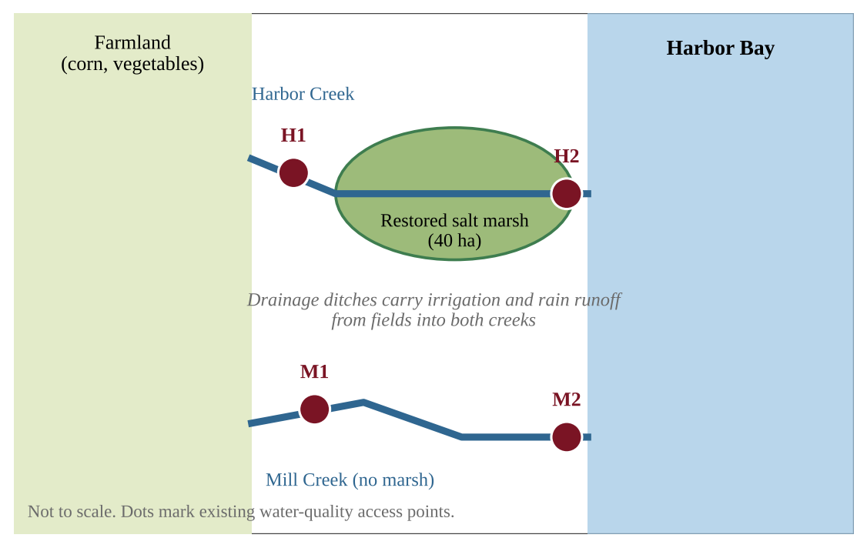
Figure — Harbor Bay, its two creeks, the restored marsh, and four sampling access points.
You have one summer growing season, a boat, and standard field equipment (water-sample bottles, a nitrate test kit or spectrophotometer, a dissolved-oxygen meter, and a thermometer).
(a) Identify the environmental problem described in the scenario. [1]
(b) Write a testable hypothesis, in the form of a prediction, about nitrate concentration at the access point nearest the bay compared with the access point nearest the farmland in each creek. [1]
(c) For an investigation that tests your hypothesis, identify: (i) the independent variable [1] (ii) the dependent variable [1]
(d) Identify one variable that must be controlled (held constant) in your investigation and explain why it must be controlled. [1]
(e) Describe a procedure for collecting the data, including where, when, and how often samples will be taken and how replication will be achieved. [2]
(f) Describe how you would analyze the data to determine whether your hypothesis is supported. [1]
(g) Propose a solution that would reduce low-oxygen events in Harbor Bay and justify your proposal with an environmental or ecological reason. [2]

Question 2 PE1-FRQ002
Scientists have monitored a coastal tundra site on the Arctic coast of Alaska since 2000. The table shows data collected every five years. The active layer is the upper layer of ground that thaws each summer above the permafrost.
Year | Mean July air temperature (°C) | Active-layer depth (cm) | Shrub cover (% of ground)
2000 | 3.1 | 42 | 12
2005 | 3.4 | 45 | 14
2010 | 4.0 | 52 | 19
2015 | 4.6 | 60 | 25
2020 | 5.1 | 68 | 31
2025 | 5.7 | 77 | 38

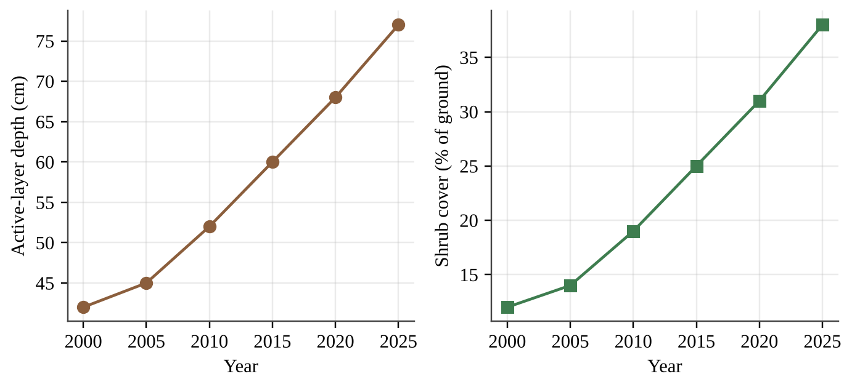
Figure — Active-layer depth and shrub cover at the tundra site, 2000–2025.
(a) Describe the trend in active-layer depth between 2000 and 2025, using data from the table. [1]
(b) Calculate the percent increase in active-layer depth from 2000 to 2025. Show your work. [1]
(c) Explain how thawing of permafrost can act as a positive feedback that increases the rate of global warming. [2]
(d) Tall shrubs are darker than snow-covered tundra and stick up above the snow. Explain one way that increasing shrub cover could further warm the tundra. [1]
(e) A student claims that rising July temperature is responsible for the increase in shrub cover. (i) Make a claim about whether the data support the student's claim. [1] (ii) Justify your claim with evidence from the table, including one limitation of the data. [1]
(f) Assuming the recent trend continues, predict the active-layer depth in 2030 and explain how you made your prediction. [1]
(g) A village on the coast has buildings built directly on the frozen ground. Propose a solution to reduce damage to the buildings from thawing permafrost and justify your proposal. [2]

Question 3 PE1-FRQ003
Willow Creek Farm is a 120-hectare corn and dairy farm in a temperate Pacific Northwest valley. The owner is considering a solar array on the barn roofs and a change in fertilizer practice. Use the data below. Assume that the array supplies the farm's electricity use first (up to the farm's annual use) and that any surplus is sold to the grid.
Quantity | Value
Farm electricity use | 310,000 kWh per year
Solar array nameplate capacity | 250 kW
Capacity factor of the array | 18%
Installed cost of the array | $325,000
Value of electricity used on the farm | $0.13 per kWh
Price paid for surplus electricity sold to the grid | $0.06 per kWh
Grid emission factor (CO₂ displaced) | 0.40 kg CO₂ per kWh
Lifespan of the array | 25 years
Nitrogen fertilizer on corn | 160 kg N per hectare on 120 hectares
Expected reduction in nitrogen use with cover crops | 25%

Assume that 1 year = 8,760 hours.
(a) Calculate the electricity, in kWh, that the array will generate in one year. Show your work. [2]
(b) Calculate the total annual financial benefit of the array (value of electricity used on the farm plus the income from surplus electricity sold). Show your work. [2]
(c) Calculate the simple payback period, in years, for the array. Show your work. [1]
(d) Calculate the metric tons of CO₂ emissions avoided over the 25-year lifespan, assuming all of the electricity generated displaces grid electricity. Show your work. [1]
(e) Calculate the mass of nitrogen fertilizer, in kg, that would be saved each year by using cover crops. Show your work. [1]
(f) Explain one environmental or siting limitation of relying on solar electricity at this temperate farm. [1]
(g) Propose a solution that would help the farm meet its electricity needs at night and during dark winter weeks, and justify your proposal. [2]

Predicted Practice Exam 2
NOTE
Format and timing (2026 AP Environmental Science). This predicted exam follows the structure of the AP exam: Section I has 80 multiple-choice questions (90 minutes, 60% of the score); Section II has 3 free-response questions (70 minutes, 40% of the score, 10 points each). A scientific or four-function calculator is allowed on both sections.
Instructions. In Section I, choose the single best answer for each question and mark it on your answer sheet; there is no penalty for guessing. In Section II, answer every part in complete sentences where an explanation is requested, show all work for calculations, and include units. Question 1 asks you to design an investigation, question 2 asks you to analyze and interpret quantitative data, and question 3 asks you to analyze an environmental problem by doing calculations.

Section I — Multiple-Choice Questions (80)
Question 1 PE2-MCQ001
The soils beneath lowland tropical rainforests in the Amazon basin and Borneo are often thin and nutrient-poor, even though the vegetation is extremely productive. Which statement best explains this?
A. Frequent wildfires volatilize the nutrients in the soil during each dry season.
B. Most nutrients are held in living biomass and are recycled quickly, so little accumulates in the soil.
C. Cool temperatures slow decomposition, so nutrient-rich organic matter remains locked in frozen ground.
D. Dense shade prevents soil microorganisms from decomposing leaf litter on the forest floor.

Question 2 PE2-MCQ002
A coastal estuary in Southeast Asia is bordered by mangroves, and its salinity ranges from 5 to 25 ppt over the tidal cycle. Which description best fits this aquatic biome?
A. Deep, cold water where sunlight never penetrates, so food webs depend on organic matter from above.
B. Brackish, nutrient-rich water that is highly productive and serves as a nursery for juvenile fish and shellfish.
C. Permanently stratified, nutrient-poor water with little primary production near the surface.
D. Freshwater with fast flow and low productivity because few nutrients enter from the surrounding land.

Question 3 PE2-MCQ003
Researchers measured carbon fixation in a lowland tropical forest plot. Gross primary productivity (GPP) was 3,200 g C/m²/yr, and plants released 2,000 g C/m²/yr through cellular respiration. What was the net primary productivity (NPP) of the plot?
A. 1,200 g C/m²/yr
B. 1,600 g C/m²/yr
C. 2,000 g C/m²/yr
D. 5,200 g C/m²/yr

Question 4 PE2-MCQ004
In a coastal food chain, phytoplankton (trophic level 1) fix 80,000 kcal/m²/yr. Energy passes from phytoplankton to zooplankton, then to sardines, and finally to tuna (trophic level 4). Assuming 10% of energy is transferred at each step, how much energy reaches the tuna?
A. 8 kcal/m²/yr
B. 80 kcal/m²/yr
C. 800 kcal/m²/yr
D. 8,000 kcal/m²/yr

Question 5 PE2-MCQ005
Large areas of tropical peat swamp forest in Southeast Asia are drained and burned for plantations. Which statement best describes the effect on the carbon cycle?
A. Carbon in the atmosphere moves into the peat because plantation crops photosynthesize faster than forest trees.
B. Carbon stored in peat and trees moves to the atmosphere as CO₂ through combustion and faster decomposition.
C. Carbon stored in peat is converted into fossil fuels within a few years once it is exposed to heat.
D. Carbon moves from the atmosphere to the ocean sediments because burning produces carbonate rock directly.

Question 6 PE2-MCQ006
The food web below describes a coral reef community.
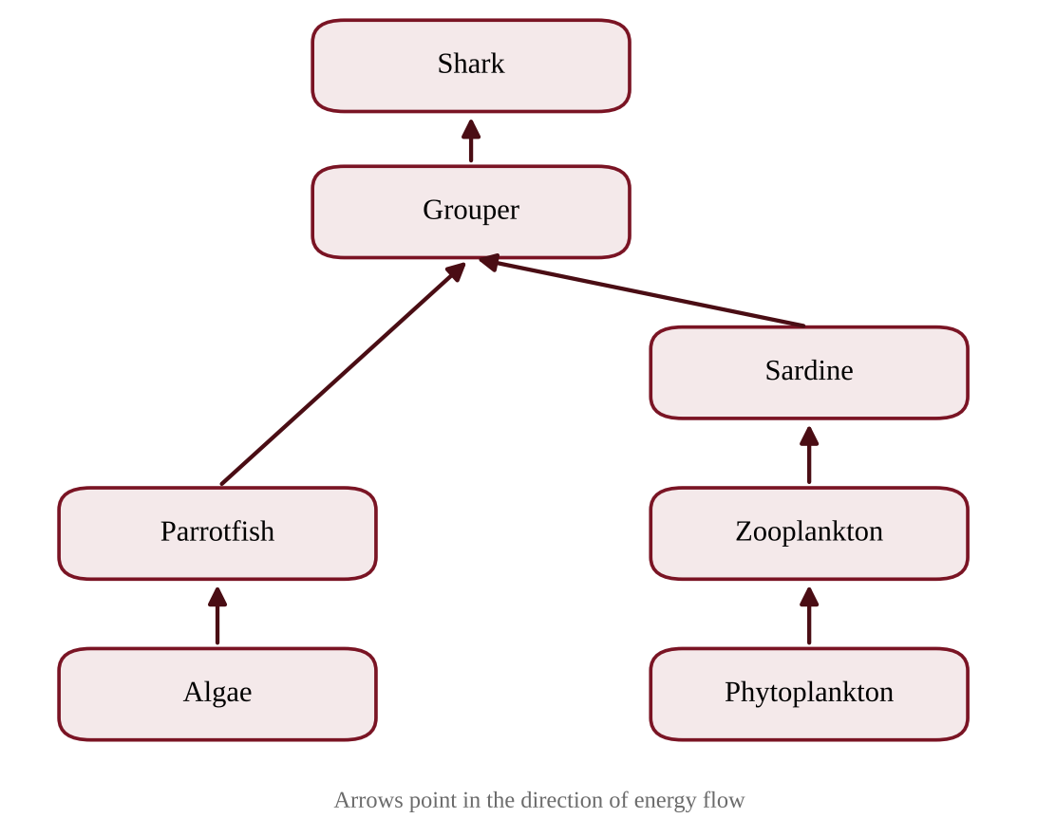
Figure — A simplified coral reef food web
Overfishing removes almost all of the grouper from the reef. Which short-term change is most likely?
A. Zooplankton abundance rises because sardines are released from predation.
B. Algae biomass rises because fewer groupers are present to graze on it.
C. Parrotfish abundance rises and algae biomass falls.
D. Shark abundance rises because the food chain becomes shorter.

Question 7 PE2-MCQ007
Which statement best defines a biodiversity hotspot?
A. A region in which all species are legally protected by national governments and international treaties.
B. A region dominated by generalist species that tolerate human disturbance and spread widely.
C. A region with exceptionally high numbers of endemic species that has lost a large share of its original habitat.
D. A region with the largest area of intact forest and the lowest human population density on Earth.

Question 8 PE2-MCQ008
Villagers on a Vietnamese coast depend on mangroves that buffer storm surge, trap sediment, and shelter juvenile shrimp that are later harvested and sold. Which pair correctly classifies two of these benefits as ecosystem services?
A. Sediment trapping is a cultural service; shrimp harvest is a regulating service.
B. Sediment trapping is a provisioning service; shrimp harvest is a supporting service.
C. Storm-surge buffering is a provisioning service; shrimp harvest is a cultural service.
D. Storm-surge buffering is a regulating service; shrimp harvest is a provisioning service.

Question 9 PE2-MCQ009
A survey counted forest bird species in 16 forest fragments of different sizes in a biodiversity hotspot. The fitted line is shown.
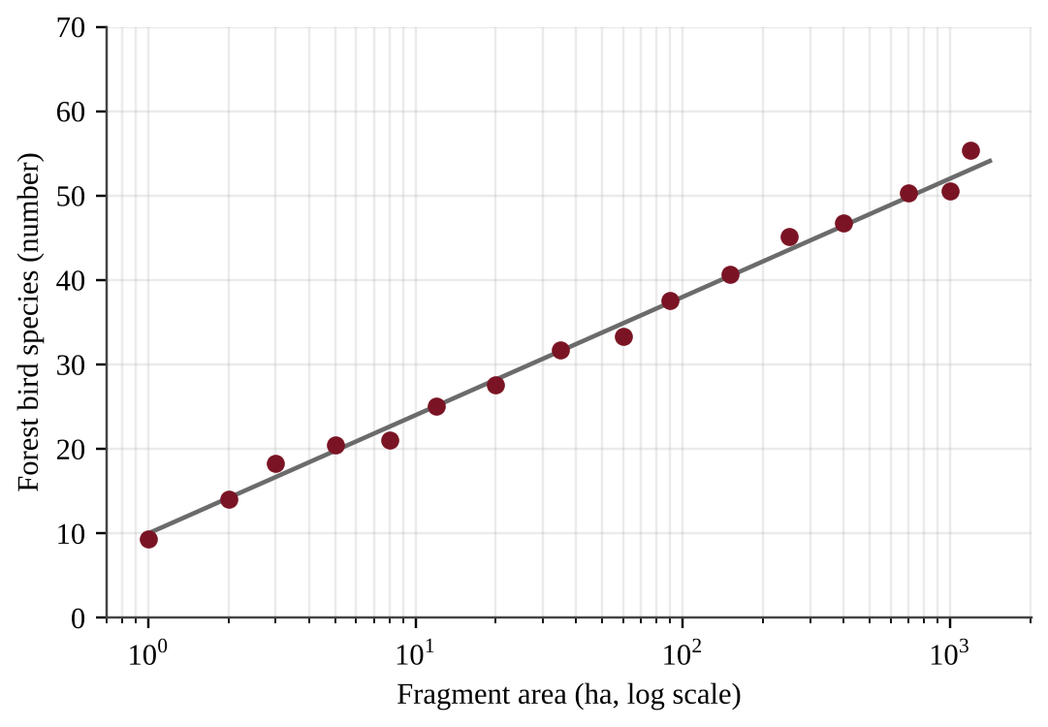
Figure — Bird species richness versus fragment area (note the logarithmic horizontal axis)
Based on the fitted line, about how many bird species are expected in a 300-ha fragment?
A. 38
B. 41
C. 45
D. 52

Question 10 PE2-MCQ010
A logging concession in a lowland tropical forest is abandoned. The soil and seed bank remain intact. Which description of the recovery is most accurate?
A. A climax community re-establishes immediately because the soil was never removed.
B. Secondary succession begins with fast-growing, light-demanding pioneer plants.
C. Primary succession begins with lichens that slowly form new soil from rock.
D. Secondary succession begins with shade-tolerant canopy trees that dominate immediately.

Question 11 PE2-MCQ011
Growth rates of three reef-building coral species were measured across water temperatures.
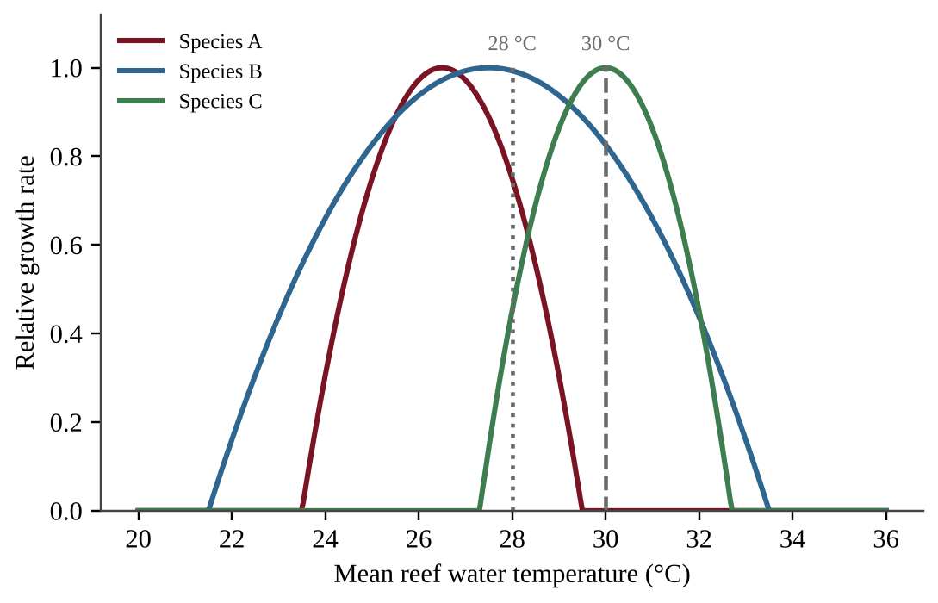
Figure — Relative growth rate of three coral species at different water temperatures
A reef warms from 28 °C to 30 °C for several months. Which prediction is best supported by the graph?
A. All three species would grow at similar rates because each tolerates 30 °C.
B. Species C would be eliminated first because it has the highest optimum temperature.
C. Species A would fall outside its tolerance limits, while species C would grow best.
D. Species B would be eliminated first because it has the widest tolerance range.

Question 12 PE2-MCQ012
Two bird species live in a forest in Borneo. Species X eats only the figs of one tree species and nests only in hollows of old-growth trees. Species Y eats fruit, insects, and seeds and nests in many habitat types. After the forest is converted to a mosaic of plantations and small woodlots, which prediction is most reasonable?
A. Species Y is more likely to persist because its broad niche lets it use the altered habitat.
B. Species X is more likely to persist because specialization reduces competition with other birds.
C. Species X is more likely to persist because old-growth hollows form quickly in plantations.
D. Both species are equally likely to persist because both are birds that can fly between habitats.

Question 13 PE2-MCQ013
Which set of traits best describes an r-selected species such as a sardine?
A. Large body size, late maturity, many offspring, and extensive parental care.
B. Small body size, early maturity, many offspring, and little parental care.
C. Small body size, early maturity, few offspring, and a long life span.
D. Large body size, late maturity, few offspring, and extensive parental care.

Question 14 PE2-MCQ014
Sea turtles lay about 100 eggs per nest and give no parental care. Most hatchlings die, but turtles that reach adulthood can live for decades.
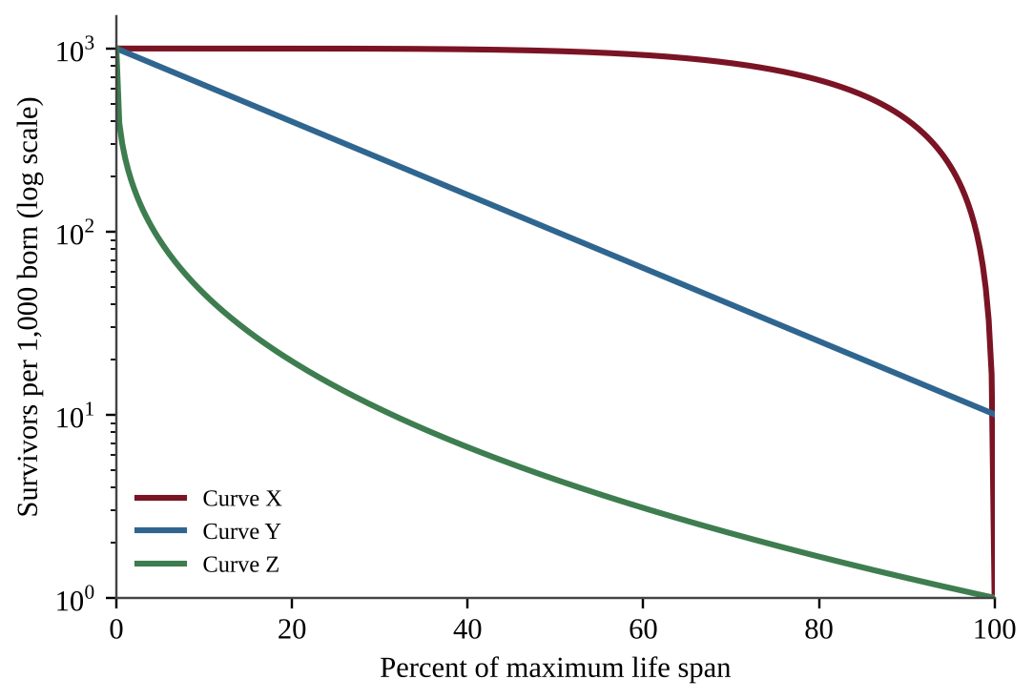
Figure — Survivorship curves for three species (curves X, Y and Z)
Which curve best represents sea turtles?
A. Curve Z, because mortality is highest early in life.
B. Curve Y, because parental care is minimal.
C. Curve Y, because the death rate is constant throughout life.
D. Curve X, because most individuals survive until old age.

Question 15 PE2-MCQ015
Which change would most likely reduce the carrying capacity of an orangutan population living in an isolated forest fragment?
A. Logging that removes the trees that produce fruit each year.
B. A ban on hunting that lowers the death rate of adults.
C. Building a forest corridor that links the fragment to a larger forest.
D. A single typhoon that temporarily kills 20% of the orangutans.

Question 16 PE2-MCQ016
A rapidly growing city reports the following annual rates per 1,000 residents: births 14, deaths 6, immigration 5, emigration 1. What is the city's annual population growth rate?
A. 0.8%
B. 1.2%
C. 1.3%
D. 1.4%

Question 17 PE2-MCQ017
The age structure diagrams below show two countries.
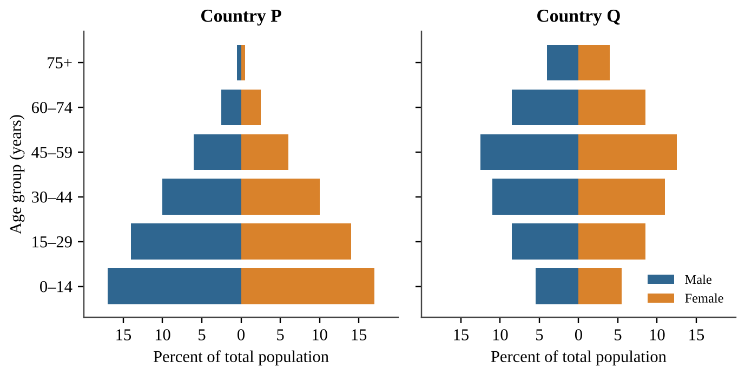
Figure — Age structure diagrams for Country P and Country Q
Which statement is best supported by the diagrams?
A. Country Q will probably face a shrinking workforce and a growing share of elderly people, while Country P will keep growing for decades.
B. Country Q has the faster growth rate because it has more people in the oldest age groups.
C. The two countries will grow at similar rates because both have people in every age group.
D. Country P will stop growing within a decade because most of its people are past reproductive age.

Question 18 PE2-MCQ018
Replacement-level fertility in most countries is about 2.1 children per woman. A megacity in East Asia reports a total fertility rate of 0.9. Which factor most likely contributes to such a low rate?
A. High housing costs and greater educational and career opportunities for women.
B. Limited access to contraception and family planning services.
C. High infant mortality that leads parents to have fewer children.
D. A need for children to provide labor on family farms.

Question 19 PE2-MCQ019
In some countries, the total fertility rate has fallen to replacement level (2.1), yet the population continues to grow for several decades. What is the best explanation?
A. Immigration is always greater than emigration whenever fertility declines.
B. Death rates are rising faster than birth rates, which raises the population.
C. A large share of the population is of reproductive age or younger, so births still exceed deaths.
D. Fertility rate is an inaccurate measure and is always lower than the real birth rate.

Question 20 PE2-MCQ020
A megacity of 8 million people is growing at 2.8% per year. Use the rule of 70 and assume the growth rate stays constant. About how large will the population be after 50 years?
A. 16 million
B. 19 million
C. 32 million
D. 64 million

Question 21 PE2-MCQ021
The graph shows the demographic transition model with a vertical line marking the position of Country M.
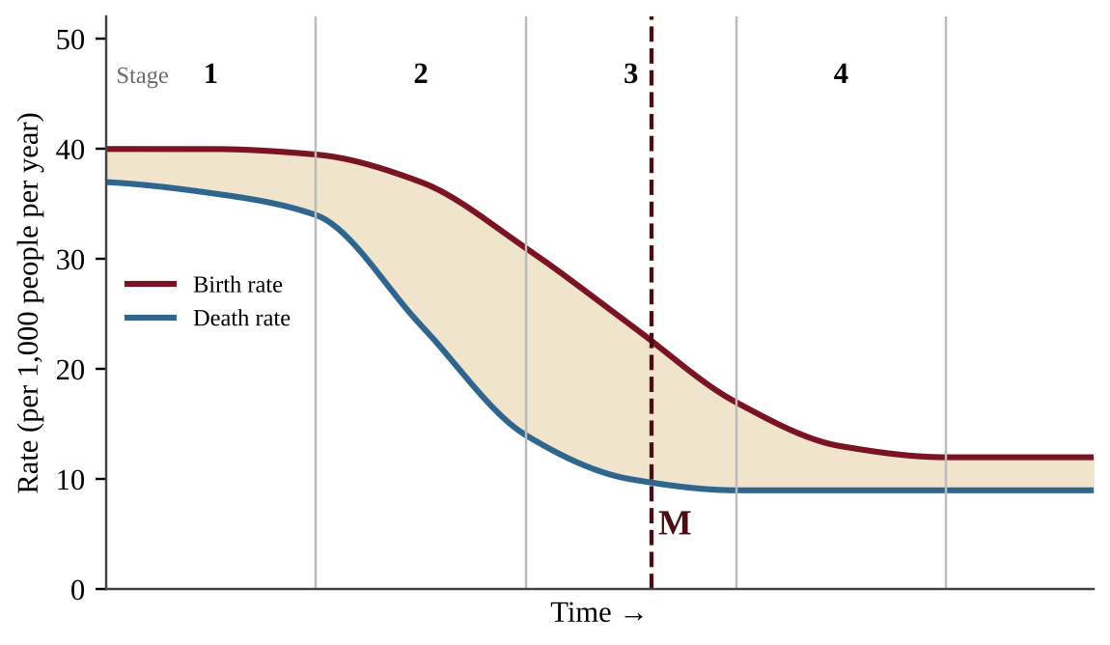
Figure — Birth and death rates through the stages of the demographic transition; the dashed line marks Country M
Which statement best describes Country M and the most likely cause of its trend?
A. It is in Stage 3: the death rate is rising because of aging, so the population is declining.
B. It is in Stage 4: birth and death rates are low and nearly equal, so the population is stable.
C. It is in Stage 2: improved sanitation and medicine are lowering death rates faster than birth rates, so growth is accelerating.
D. It is in Stage 3: urbanization, education and contraceptive access are lowering the birth rate, so growth is slowing but still positive.

Question 22 PE2-MCQ022
Tokyo, Manila and Jakarta lie near subduction zones, where an oceanic plate sinks beneath another plate. Which hazards are most characteristic of such a boundary?
A. Earthquakes and explosive volcanoes caused by melting of the descending plate.
B. Gentle shield volcanoes formed where new crust is created at a mid-ocean ridge.
C. Earthquakes only, because the plates slide horizontally past one another without melting.
D. Mountain building without earthquakes, because the plates move smoothly.

Question 23 PE2-MCQ023
A steep hillside forest in Madagascar is cleared for farming. Which soil layer is lost first, and why does erosion increase?
A. The parent material (C horizon), because it is the layer in contact with the surface.
B. The subsoil (B horizon), because it holds the most organic matter and is exposed first.
C. The bedrock (R horizon), because rain dissolves it faster once the trees are removed.
D. The topsoil (A horizon), because roots and canopy no longer slow the movement of runoff.

Question 24 PE2-MCQ024
Most weather occurs in, and ground-level pollutants such as smog accumulate in, which layer of the atmosphere?
A. The troposphere, the lowest layer, which holds most of the atmosphere's mass and water vapor.
B. The thermosphere, where temperatures are highest and auroras form.
C. The stratosphere, which contains the ozone layer and very little water vapor.
D. The mesosphere, where most meteors burn up as they enter the atmosphere.

Question 25 PE2-MCQ025
Students measured the water percolation rate (how fast water drains through soil) in three soils from an irrigated area.
Soil | Sand (%) | Silt (%) | Clay (%) | Percolation rate (mm/h)
X | 65 | 25 | 10 | 40
Y | 40 | 40 | 20 | 15
Z | 10 | 45 | 45 | 2

Which conclusion is best supported by the data?
A. Percolation rate is unrelated to soil texture because all three soils contain some silt.
B. Soil Z is best for crops that need rapid drainage because it has the fewest sand particles.
C. As clay content increases, percolation speeds up because clay particles are the largest.
D. As clay content increases, percolation slows because the pore spaces are smaller.

Question 26 PE2-MCQ026
Tropical rainforests occur mainly near the equator. Which explanation based on global wind and pressure patterns is best?
A. Intense sunlight makes moist air rise at the equator, where it cools and releases heavy rainfall.
B. Prevailing westerly winds deposit moisture from the oceans uniformly across all tropical land.
C. Air sinks at the equator and warms, which absorbs moisture and produces steady rainfall.
D. The Coriolis effect pushes cold, wet air from the poles to the equator throughout the year.

Question 27 PE2-MCQ027
A megacity draws drinking water from a reservoir fed by a watershed of mountain forests and farms. Which activity within the watershed would most likely reduce the quality of the city's drinking water?
A. Adding wetlands that filter nutrients from agricultural runoff before it reaches the reservoir.
B. Terracing farmland to slow the flow of water down slopes.
C. Restoring native vegetation along streams to trap sediment before it reaches the water.
D. Clearing steep forested slopes for plowed fields, which increases sediment and nutrient runoff.

Question 28 PE2-MCQ028
Jakarta (6° S) has a nearly constant temperature through the year, while Seoul (37° N) has hot summers and cold winters. What is the best explanation?
A. Seoul receives more solar energy in winter because it faces the Sun more directly.
B. Jakarta is warmed throughout the year by the Moon's gravitational pull on tropical oceans.
C. Near the equator, the angle of the Sun and the day length change very little through the year.
D. Earth is much closer to the Sun during Seoul's summer than during Jakarta's warmest month.

Question 29 PE2-MCQ029
The windward side of the Western Ghats in India receives about 2,500 mm of rain per year, while the interior plateau on the leeward side receives about 600 mm. What best explains this difference?
A. Moist air rises on the windward slope, cools and drops rain, then descends dry on the leeward side.
B. Air descending on the windward slope warms and absorbs moisture from the ocean surface.
C. The leeward plateau is much closer to the equator, so it receives more intense sunlight and rain.
D. Ocean currents divert rain clouds away from the interior in every season.

Question 30 PE2-MCQ030
A researcher wants to know whether adding compost increases the water retained by a sandy soil. She fills three identical columns with the same sandy soil, mixing in 0%, 5% and 10% compost by volume (one column of each), pours 500 mL of water through each, and measures the water retained after drainage stops. Which change would most improve her ability to draw a reliable conclusion?
A. Use at least three replicate columns for each compost level and compare the mean retained water.
B. Use a different soil type for each compost level to increase variation among treatments.
C. Pour more water through the 10% compost column to test its limits.
D. Remove the 0% compost column because only soils with compost are of interest.

Question 31 PE2-MCQ031
The graphs show sea-surface temperature (SST) anomalies in the eastern Pacific and annual landings of a coastal anchovy fishery.
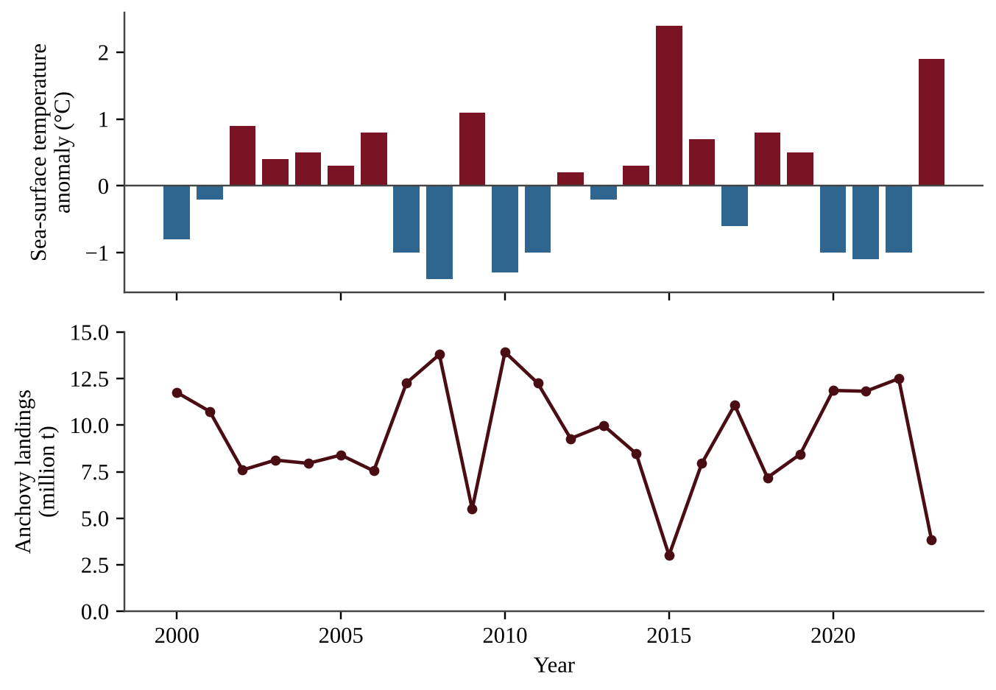
Figure — Sea-surface temperature anomaly and anchovy landings, 2000–2023
Which explanation best accounts for the low landings in years with large positive SST anomalies?
A. Weakened trade winds reduce upwelling of cold, nutrient-rich water, so phytoplankton and the anchovies that eat them decline.
B. Strengthened trade winds increase upwelling of nutrient-rich water, which reduces the plankton that anchovies eat.
C. Warm anomalies increase fishing effort, so anchovies are caught too quickly to be counted.
D. Warmer water holds more dissolved oxygen, which draws anchovies to deeper water where nets cannot reach them.

Question 32 PE2-MCQ032
Dozens of small boats fish in a shared coastal lagoon with no catch limits. Each fisher increases effort even though fish stocks are falling. Which statement best explains this behavior?
A. Government regulations require every boat to catch a fixed quota each day.
B. Each fisher owns a part of the lagoon and manages it for long-term profit.
C. Fishers are unaware that fish are a renewable resource that can recover.
D. Each fisher gets the full benefit of an extra catch while the cost of depletion is shared among all users.

Question 33 PE2-MCQ033
Compared with selective cutting, clearcutting a hillside forest is most likely to cause which effect?
A. Greater retention of soil nutrients because fewer roots are decomposing.
B. Greater soil erosion and sediment in nearby streams.
C. A smaller change in the stream's water temperature and flow.
D. More shade on the forest floor, which favors shade-tolerant seedlings.

Question 34 PE2-MCQ034
Streams near an abandoned gold and copper mine have a pH of 3.5 and contain high concentrations of dissolved metals. Which process most likely caused this pollution?
A. Heated cooling water from the mine increasing stream temperatures.
B. Excess nitrogen from fertilizers causing algal blooms and oxygen depletion.
C. Chlorofluorocarbons released from mine tailings destroying stratospheric ozone.
D. Exposed sulfide minerals reacting with air and water to produce sulfuric acid.

Question 35 PE2-MCQ035
A farm in a region with a falling water table wants to reduce groundwater pumping for irrigation. Which method best meets this goal?
A. Drip irrigation, because water is delivered slowly at the base of each plant with little evaporation.
B. Flood irrigation, because water covers the whole field and is fully absorbed by roots.
C. Furrow irrigation, because water flows in channels that prevent any seepage.
D. Spraying water high into the air at midday so it cools the crop.

Question 36 PE2-MCQ036
Poultry requires about 2.2 kg of feed to produce 1 kg of meat, and beef requires about 7.0 kg. A megacity eats 90,000 kg of chicken per day. If the same mass of meat were beef, how much additional feed would be needed per day?
A. 198,000 kg
B. 432,000 kg
C. 630,000 kg
D. 828,000 kg

Question 37 PE2-MCQ037
Data from a coastal fishery are shown.
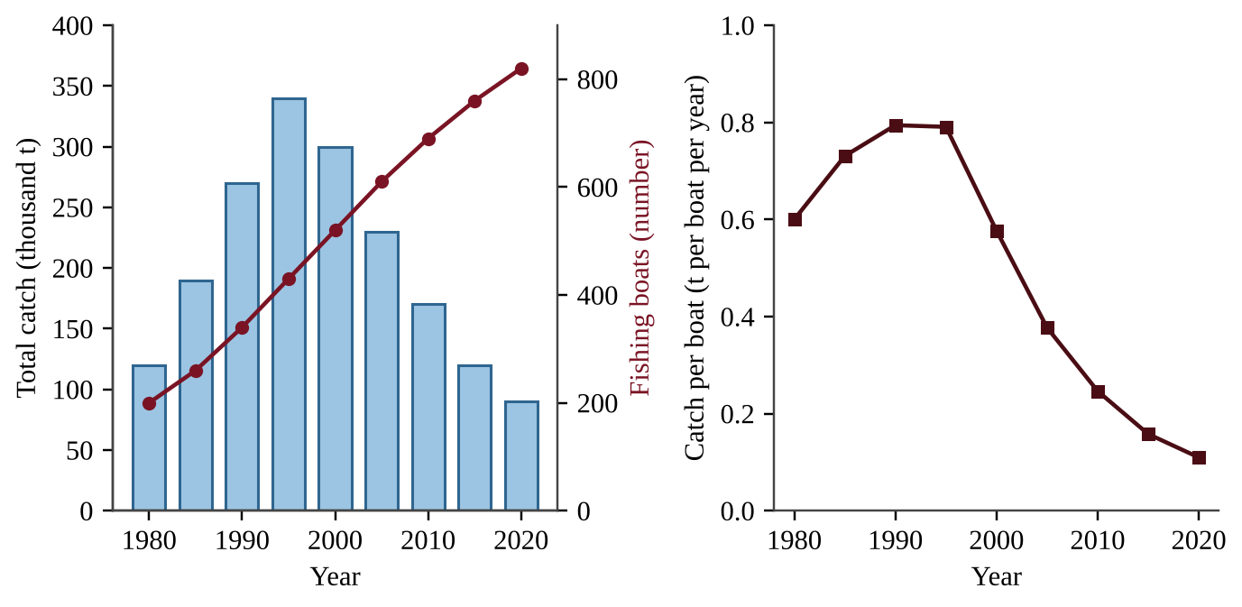
Figure — Total catch and number of fishing boats (left); catch per boat (right)
Which conclusion is best supported by the data for 2000–2020?
A. Total catch fell because fewer boats were fishing.
B. The fishery is sustainable because catch per boat remains well above its 1980 value.
C. Fish stocks are recovering because the number of boats keeps rising.
D. Fish stocks have been depleted: more boats are fishing, yet each boat catches less.

Question 38 PE2-MCQ038
Which of the following is a recognized environmental disadvantage of coastal shrimp aquaculture (fish farming) compared with wild-capture fisheries?
A. Higher bycatch of sea turtles and other non-target species.
B. Greater use of fossil fuels for towing trawl nets over the sea floor.
C. Lower yield per hectare than that of wild-capture fishing.
D. Nutrient-rich, antibiotic-laden pond effluent that can pollute nearby waters.

Question 39 PE2-MCQ039
The graph shows stream discharge after the same storm in two watersheds. One is a densely paved district of a large Asian city and the other is a forested catchment.
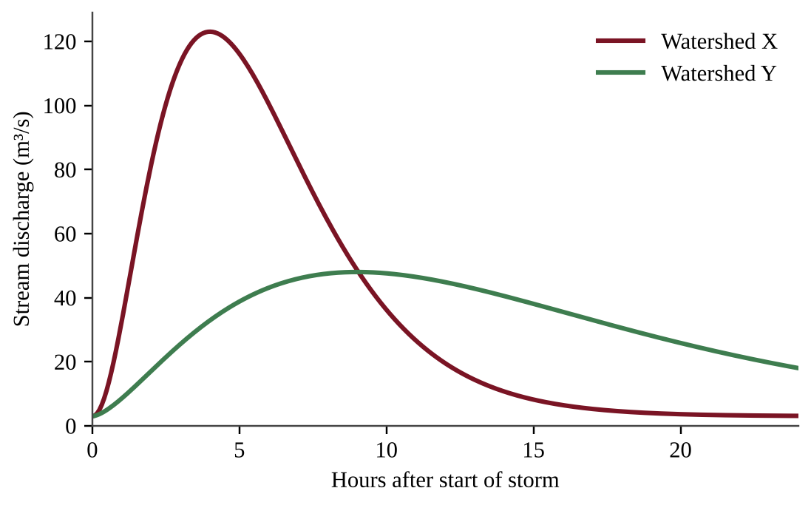
Figure — Stream discharge after a storm in Watershed X and Watershed Y
Which option correctly identifies the urban watershed, explains the pattern and names a way to reduce its peak?
A. Watershed Y; its lower peak reflects fast storm pipes, so widening them would flatten the peak.
B. Watershed Y; impervious surfaces temporarily store water and delay the peak, so storm drains would flatten it.
C. Watershed X; impervious surfaces speed runoff and reduce infiltration, so permeable pavement would lower its peak.
D. Watershed X; forest soils quickly shed water, so planting more trees would raise its peak.

Question 40 PE2-MCQ040
A country has an ecological footprint of 3.0 global hectares (gha) per person and a biocapacity of 1.2 gha per person. Its population is 50 million. What is the country's total ecological deficit?
A. 60 million gha
B. 90 million gha
C. 150 million gha
D. 210 million gha

Question 41 PE2-MCQ041
Scouting in a rice field in the Philippines finds 6 brown planthoppers per plant stem. The economic threshold for treatment is 10 per stem, and predatory spiders are abundant. Which action best follows integrated pest management (IPM)?
A. Apply a preventive insecticide on a fixed weekly schedule all season.
B. Spray a broad-spectrum insecticide now to prevent any future outbreak.
C. Release a non-native predator immediately to eliminate all planthoppers.
D. Do not spray; keep monitoring and protect the natural predators.

Question 42 PE2-MCQ042
Which pair consists of two nonrenewable energy resources?
A. Biomass and coal
B. Coal and uranium
C. Geothermal and natural gas
D. Wind and uranium

Question 43 PE2-MCQ043
Many fast-growing Asian cities depend on coal for electricity. Compared with natural gas, burning coal releases which of the following per unit of energy produced?
A. More CO₂, sulfur dioxide and particulate matter.
B. The same amount of CO₂ but less sulfur dioxide.
C. Less CO₂ and fewer particulates because it burns hotter.
D. Less CO₂ but more methane.

Question 44 PE2-MCQ044
Coal is classified into ranks. Which rank contains the most carbon and releases the most energy per kilogram when burned?
A. Peat
B. Bituminous coal
C. Anthracite
D. Lignite

Question 45 PE2-MCQ045
The graph shows the share of each energy source in the electricity supply of four countries.
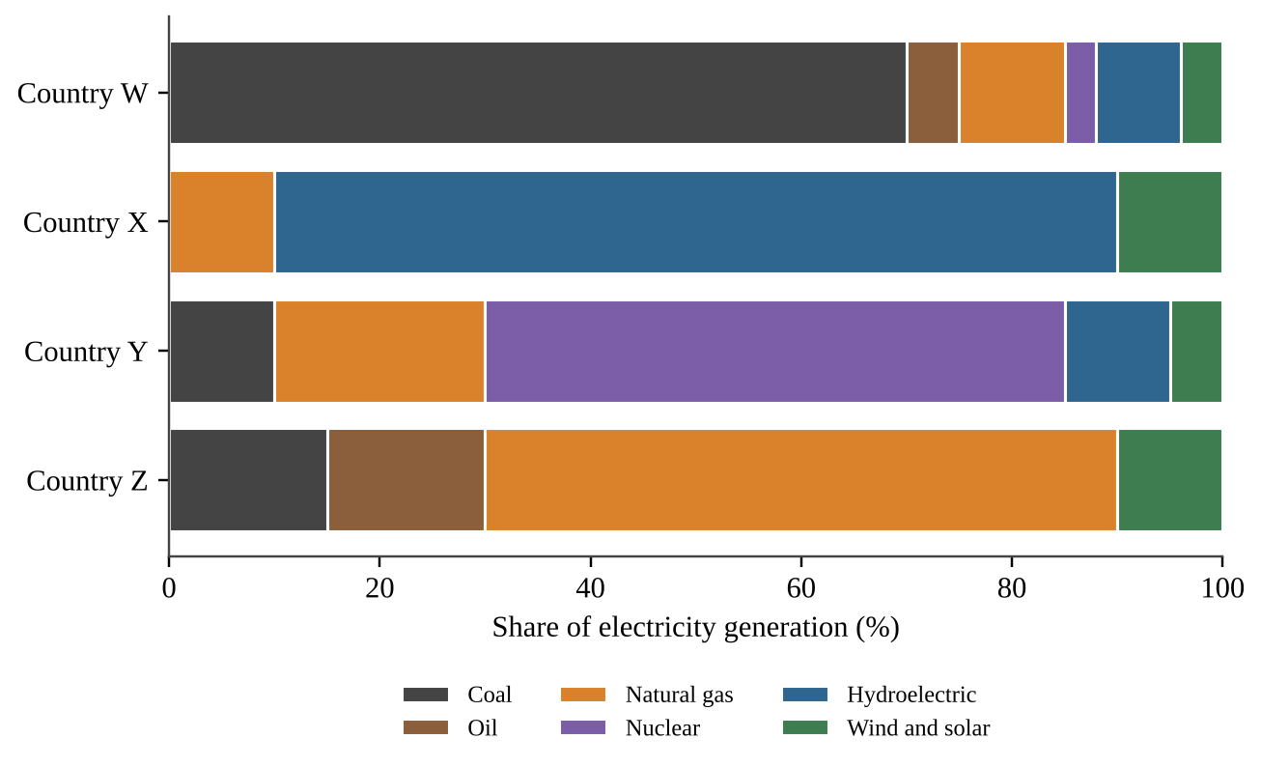
Figure — Electricity generation by source in four countries
Which country's electricity supply would be most vulnerable to a multi-year drought, and why?
A. Country Z, because natural gas plants stop operating when river levels fall.
B. Country W, because coal plants require large amounts of rainfall to produce steam.
C. Country Y, because nuclear power is the largest share and requires the most water.
D. Country X, because most of its electricity is generated by hydroelectric dams that depend on river flow.

Question 46 PE2-MCQ046
A coastal Asian megacity is considering a nuclear power plant. Which statement is most accurate?
A. Operation emits little CO₂, but spent fuel is radioactive and needs secure storage for thousands of years.
B. Uranium is a renewable resource, so waste storage is not a long-term concern.
C. Nuclear plants release no heat to the environment, so they cannot cause thermal pollution in rivers or coastal waters.
D. Operation releases large amounts of SO₂, but the radioactive waste is safe to handle within a few years.

Question 47 PE2-MCQ047
Which of the following is a well-documented ecological effect of a large hydroelectric dam on a river downstream?
A. Higher seasonal flood peaks that maintain downstream wetlands.
B. Greater deposition of sediment on the floodplains because flows become more variable.
C. Trapped sediment reduces nutrient delivery to floodplains and the delta.
D. Increased upstream migration of fish to spawning grounds.

Question 48 PE2-MCQ048
A program replaces open wood fires in rural homes with improved biomass cookstoves. Which statement about burning biomass is most accurate?
A. It releases more sulfur dioxide than coal because wood contains much more sulfur than coal does.
B. It is always carbon-neutral because plants absorb CO₂ whenever they grow, regardless of how fast the wood is harvested.
C. It can be nearly carbon-neutral if regrowth reabsorbs the CO₂ released, but combustion still produces particulates and carbon monoxide.
D. It produces no air pollutants at all, because wood is a natural product rather than a fossil fuel.

Question 49 PE2-MCQ049
A 250 MW solar farm in a desert produces 438,000 MWh of electricity in one year (8,760 hours). What is its capacity factor?
A. 5%
B. 20%
C. 25%
D. 50%

Question 50 PE2-MCQ050
A hospital replaces 1,000 fluorescent tubes (60 W each) with LEDs (24 W each). Each runs 4,000 hours per year, electricity costs $0.12 per kWh, and the LEDs cost $27 each. What is the simple payback period?
A. 0.9 years
B. 1.6 years
C. 2.3 years
D. 3.1 years

Question 51 PE2-MCQ051
A wind farm has 60 turbines rated at 3 MW each and a capacity factor of 35%. An average household uses 4,000 kWh per year. About how many households can the wind farm supply in one year (8,760 hours)?
A. 13,800
B. 138,000
C. 394,000
D. 1,380,000

Question 52 PE2-MCQ052
Which of the following is a secondary air pollutant?
A. Lead particles released directly from smelters.
B. Carbon monoxide released from incomplete combustion in car engines.
C. Sulfur dioxide released directly from coal-burning plants.
D. Ground-level ozone formed from NOₓ and volatile organic compounds in sunlight.

Question 53 PE2-MCQ053
Families in many rural homes cook over open fires indoors with poor ventilation. Which pollutants are most strongly associated with the health effects of this practice?
A. Sulfur dioxide and heavy-metal vapors from industrial smelters.
B. Chlorofluorocarbons and halons.
C. Particulate matter and carbon monoxide.
D. Tropospheric ozone and nitrogen dioxide from vehicles.

Question 54 PE2-MCQ054
A city in a basin has severe smog on calm winter mornings, when a layer of warm air lies above cooler air at the surface. Why does this condition worsen air pollution?
A. The warm layer acts as a lid that prevents surface air and pollutants from rising and dispersing.
B. Strong winds in the cool layer carry pollutants into the surrounding region.
C. The warm layer absorbs the pollutants and destroys them before they reach people.
D. The cool air above the warm layer lifts pollutants high into the atmosphere.

Question 55 PE2-MCQ055
Which device removes sulfur dioxide from the exhaust gases of a coal-fired power plant?
A. An electrostatic precipitator.
B. A catalytic converter.
C. A positive crankcase ventilation valve.
D. A flue-gas desulfurization system (scrubber).

Question 56 PE2-MCQ056
Air-quality monitors in a city measured pollutant concentrations through a sunny day.
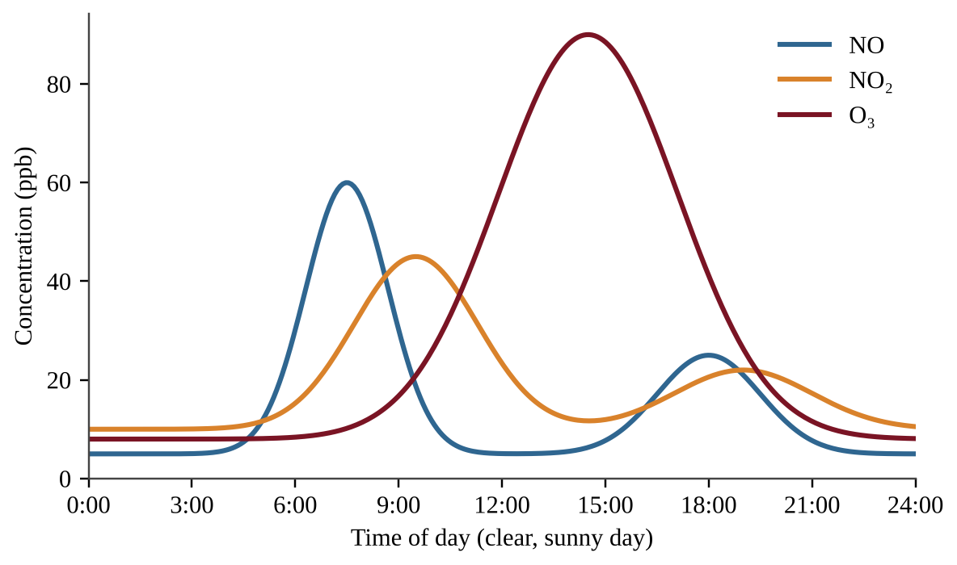
Figure — Concentrations of NO, NO₂ and O₃ over one day
Which statement best explains why ozone peaks in the afternoon instead of during the morning rush hour?
A. Vehicles emit most of their ozone directly in the afternoon.
B. Sunlight-driven reactions of NO₂ and volatile organic compounds take hours to produce ozone.
C. Nitrogen oxides are produced only by sunlight and not by vehicles.
D. Ozone is removed by sunlight in the morning and reformed at night.

Question 57 PE2-MCQ057
To compare fine-particle (PM2.5) pollution with distance from a coal plant, researchers place identical monitors at 0.5, 2, 5 and 10 km along a line east of the plant and record readings for a month. Which additional measurement would best reduce a confounding factor in the interpretation?
A. Wind speed and direction at the monitoring sites.
B. The height of each monitor above the ground, chosen at random.
C. A single midday reading at each site instead of daily averages.
D. Using a different brand of monitor at each distance.

Question 58 PE2-MCQ058
Rain over a region downwind of coal-fired power plants and smelters has an average pH of 4.2. Unpolluted rain has a pH of about 5.6. About how many times more acidic is the polluted rain?
A. 1.4
B. 14
C. 25
D. 140

Question 59 PE2-MCQ059
Which of the following is a point source of water pollution?
A. Airborne mercury from coal plants falling on a lake.
B. Fertilizer washing off many farm fields into a stream after rain.
C. Oil and heavy metals washing from city streets into storm drains.
D. A pipe that discharges untreated wastewater from a factory into a river.

Question 60 PE2-MCQ060
An unlined open dump in a developing megacity contaminates nearby groundwater. Which feature of a modern sanitary landfill most directly prevents this?
A. Impermeable liners and a leachate collection system.
B. Leaving waste uncovered so rain washes toxic compounds away.
C. Mixing discarded electronics with the garbage to speed decomposition.
D. Daily burning of waste to reduce its volume.

Question 61 PE2-MCQ061
Dissolved oxygen (DO) and biochemical oxygen demand (BOD) were measured downstream of a sewage outfall.
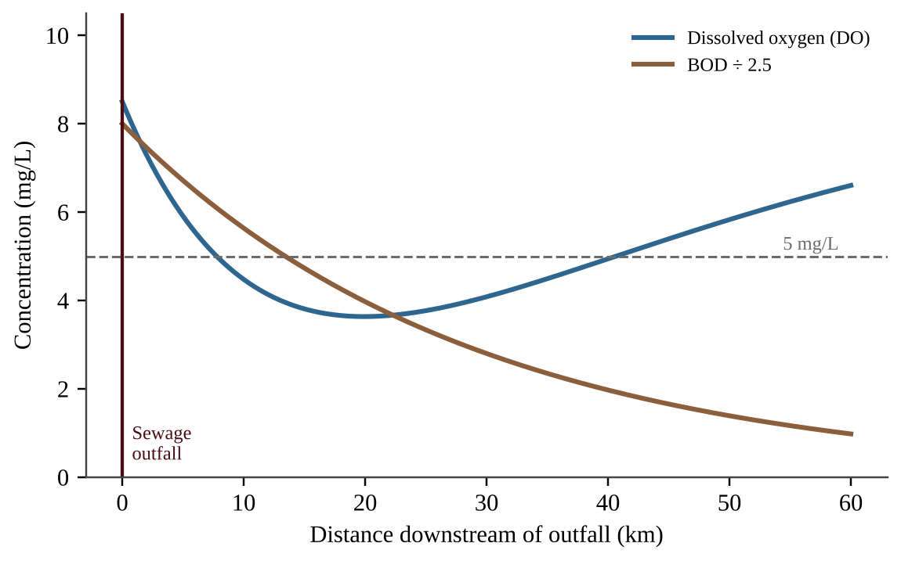
Figure — DO and BOD downstream of a sewage outfall
Which statement best explains why DO reaches its lowest value several kilometers below the outfall?
A. The sewage itself contains no oxygen and is not diluted until the stream reaches that point.
B. Algae in the stream stop photosynthesizing as soon as the sewage enters, so oxygen is never produced.
C. Decomposers consume oxygen as they break down the organic waste faster than oxygen is replaced.
D. BOD increases with distance, so more oxygen is needed far from the outfall.

Question 62 PE2-MCQ062
Mercury concentrations in a marine food chain were measured.
Organism | Trophic level | Mercury (ppm)
Phytoplankton | 1 | 0.002
Zooplankton | 2 | 0.010
Sardine | 3 | 0.050
Tuna | 4 | 0.400

By what factor is the concentration in tuna higher than in phytoplankton, and what is this process of increase through the food chain called?
A. 200-fold; bioaccumulation
B. 200-fold; biomagnification
C. 20-fold; bioaccumulation
D. 20-fold; biomagnification

Question 63 PE2-MCQ063
A city of 12 million people produces 1.1 kg of municipal solid waste per person per day and recycles 22% of it. Approximately how many metric tons of waste are not recycled each year (365 days)?
A. 1.06 million t
B. 3.76 million t
C. 4.82 million t
D. 5.88 million t

Question 64 PE2-MCQ064
Two chemicals were tested on laboratory animals.
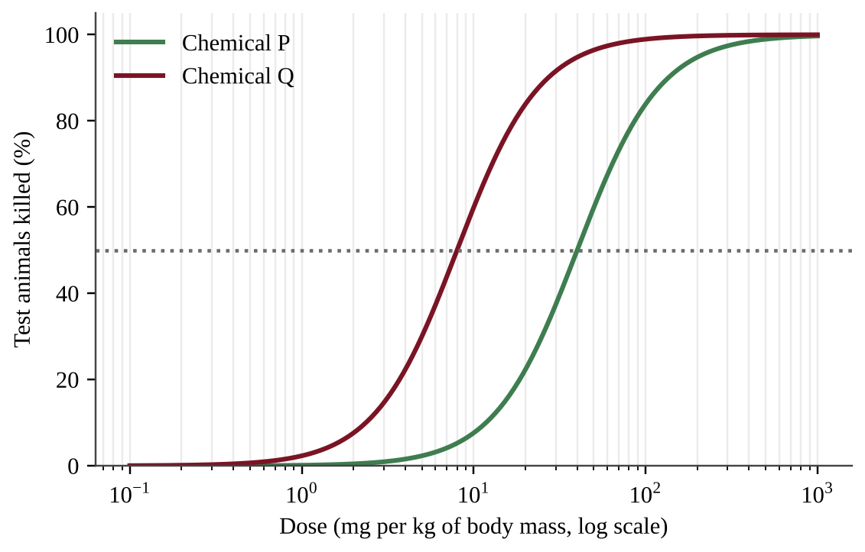
Figure — Percent of test animals killed at different doses of chemicals P and Q
Which statement is best supported by the graph?
A. The chemicals are equally toxic because both eventually kill all of the animals.
B. Chemical Q is about eight times more toxic than P because its LD50 is about 8 mg/kg and P's is 1 mg/kg.
C. Chemical Q is about five times more toxic than P because its LD50 is about one-fifth as large.
D. Chemical P is about five times more toxic than Q because its LD50 is about five times larger.

Question 65 PE2-MCQ065
Public-health officials in a monsoon-flooded megacity compared four districts.
District | Households connected to sewers (%) | Cholera cases per 100,000
1 | 90 | 12
2 | 60 | 55
3 | 20 | 210
4 | 5 | 380

Which statement is the best conclusion from the data?
A. Cholera spreads mainly through the air, so districts with fewer sewers have more cases because the air is more crowded.
B. Districts with less sewer coverage had higher cholera rates, which is consistent with fecal contamination of drinking water; expanding sewage collection could reduce cases.
C. Because district 1 still has some cholera cases, the data show that sewers have no effect on the spread of the disease.
D. Sewer coverage is the only cause of cholera in these districts, so no other factors need to be considered or studied.

Question 66 PE2-MCQ066
Which statement best describes how chlorofluorocarbons (CFCs) deplete stratospheric ozone?
A. CFCs produce ground-level ozone that rises through the atmosphere and displaces the ozone layer.
B. CFCs react with CO₂ in the troposphere and form acids that rise to the stratosphere.
C. CFCs absorb ultraviolet radiation and warm the stratosphere, which breaks down ozone.
D. Ultraviolet radiation breaks CFCs apart, and the released chlorine atoms repeatedly convert ozone to oxygen.

Question 67 PE2-MCQ067
Which action has been most responsible for the recovery of stratospheric ozone since the 1990s?
A. The installation of scrubbers on coal-fired power plants worldwide.
B. The ban on lead in gasoline in most countries.
C. The reduction of carbon dioxide emissions under the Kyoto Protocol.
D. The international phase-out of CFCs and other ozone-depleting substances under the Montreal Protocol.

Question 68 PE2-MCQ068
Which statement best describes the natural greenhouse effect?
A. Greenhouse gases reflect visible sunlight back into space, which cools the lower atmosphere.
B. Greenhouse gases absorb infrared radiation from Earth's surface and re-emit some of it downward, warming the lower atmosphere.
C. Greenhouse gases trap incoming ultraviolet radiation before it reaches Earth's surface.
D. Greenhouse gases in the ozone layer block heat from leaving the stratosphere.

Question 69 PE2-MCQ069
The golden apple snail, introduced to Asian rice paddies from South America, has spread rapidly and damages young rice plants. Which trait most likely helped it become invasive?
A. A narrow range of tolerance for temperature and salinity.
B. A specialized diet restricted to one plant species.
C. A high reproductive rate and few natural predators in the new range.
D. Slow maturation and long periods between breeding seasons.

Question 70 PE2-MCQ070
Flooded rice paddies emit methane (CH₄). A farm emits 150 kg CH₄ per hectare per year. If the global warming potential of methane over 100 years is 28 times that of CO₂, what is the farm's annual emission per hectare in CO₂ equivalents?
A. 5.4 kg CO₂e
B. 150 kg CO₂e
C. 4,200 kg CO₂e
D. 42,000 kg CO₂e

Question 71 PE2-MCQ071
Atmospheric CO₂ was monitored for nine years.
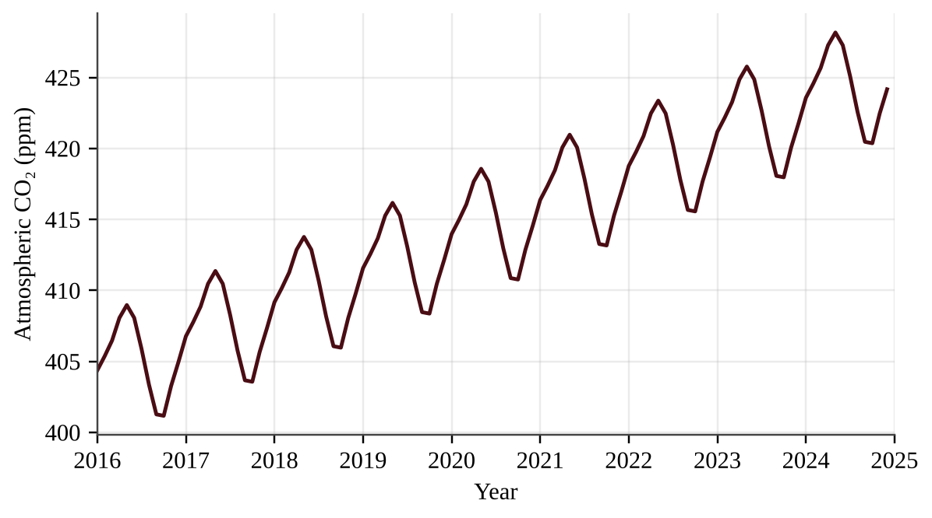
Figure — Monthly atmospheric CO₂ concentration, 2016–2024
Which statement best explains the yearly oscillation and the long-term upward trend?
A. The yearly oscillation is caused by seasonal volcanic eruptions, and the upward trend by gradual cooling of the oceans that releases stored CO₂.
B. The oscillation results from ocean outgassing in summer, and the upward trend from steadily declining respiration by plants and soil organisms.
C. Seasonal photosynthesis in the Northern Hemisphere removes CO₂ in the growing season, while fossil fuel burning and deforestation add more CO₂ than is removed over the long term.
D. The oscillation reflects yearly changes in the Sun's output, and the upward trend reflects slower decomposition of carbon stored in soils.

Question 72 PE2-MCQ072
Low-lying delta cities such as Dhaka and Jakarta face rising seas. Which pair of processes accounts for most of the current rise in global sea level?
A. Thermal expansion of seawater and melting of land-based glaciers and ice sheets.
B. Land subsidence and increased evaporation from the oceans.
C. Melting of Arctic sea ice and increased river discharge.
D. Thermal expansion of seawater and melting of floating sea ice.

Question 73 PE2-MCQ073
The graph shows coral bleaching and maximum summer sea-surface temperature (SST) at a reef over 13 years.
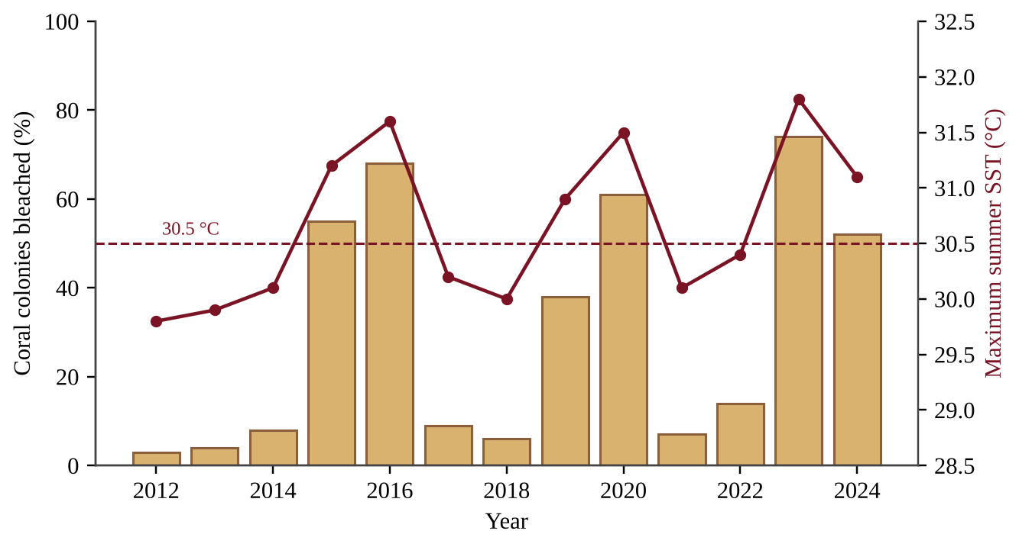
Figure — Percent of coral colonies bleached and maximum summer SST, 2012–2024
Which statement is best supported by the data?
A. Bleaching exceeded 35% only in years when maximum SST was above 30.5 °C.
B. Bleaching was highest in years when maximum SST was below 30.5 °C.
C. Bleaching is unrelated to water temperature at this reef.
D. Bleaching has decreased steadily since 2012 as corals adapted to warmer water.

Question 74 PE2-MCQ074
Surface ocean pH has declined from about 8.2 to 8.1 since the Industrial Revolution. By approximately what percent has the hydrogen ion concentration increased?
A. 1%
B. 10%
C. 26%
D. 100%

Question 75 PE2-MCQ075
Pangolins are among the most heavily trafficked wild mammals. Which international agreement specifically regulates cross-border trade in threatened species?
A. The Basel Convention on hazardous waste.
B. The Convention on International Trade in Endangered Species (CITES).
C. The Montreal Protocol.
D. The Ramsar Convention on wetlands.

Question 76 PE2-MCQ076
Forest area in three regions of a biodiversity hotspot was measured in 2000 and 2020.
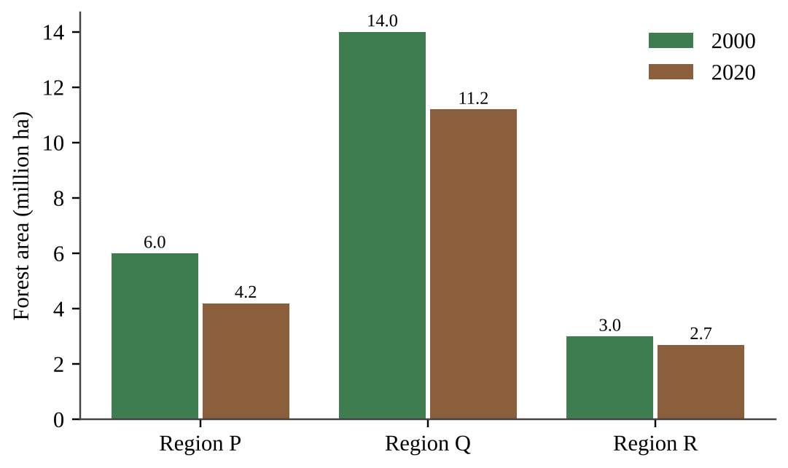
Figure — Forest area in three regions, 2000 and 2020
Which region lost the greatest percentage of its forest, and what was the loss?
A. Region P, 30%
B. Region Q, 20%
C. Region R, 10%
D. Region Q, 2.8 million ha

Question 77 PE2-MCQ077
As Arctic summer sea ice melts, dark ocean water is exposed. Which statement best describes the resulting feedback?
A. No feedback: ocean water at 0 °C does not alter the energy balance.
B. A positive feedback: higher albedo means more energy is absorbed, causing more warming.
C. A negative feedback: lower albedo means more energy is reflected, which cools the surface.
D. A positive feedback: lower albedo means more solar energy is absorbed, causing more warming and more melting.

Question 78 PE2-MCQ078
A project restores 5,000 hectares of mangrove forest that stores 6 metric tons of carbon per hectare per year. Carbon (atomic mass 12) is stored as part of CO₂ (molecular mass 44). About how much CO₂ is removed from the atmosphere each year?
A. 8,200 t
B. 30,000 t
C. 110,000 t
D. 360,000 t

Question 79 PE2-MCQ079
To test whether removing invasive lionfish raises native fish richness, researchers removed lionfish from four reef patches near a marine reserve and left four patches farther from the reserve untouched. Mean native species per patch rose from 18 to 24 in removal patches and from 17 to 18 in the others. Which is the most serious limitation of this design?
A. A comparison group of untouched patches was included.
B. Four patches per treatment is too many to analyze statistically.
C. Native fish were counted both before and after the lionfish were removed.
D. Patches were not assigned at random, so proximity to the reserve may explain the difference.

Question 80 PE2-MCQ080
Hydrofluorocarbons (HFCs) replaced CFCs in refrigeration. HFCs contain no chlorine, but many are thousands of times more effective than CO₂ at trapping heat. Which statement best evaluates this replacement?
A. It makes ozone depletion worse because HFCs react with stratospheric oxygen.
B. It has no environmental effect because HFCs are used in closed systems.
C. It solves both ozone depletion and climate change because HFCs have no chlorine.
D. It protects the ozone layer but increases the greenhouse effect, so a transition to low-GWP substitutes is needed.

Section II — Free-Response Questions (3)
Question 1 PE2-FRQ001
Question 1 (10 points). Across Southeast Asia, lowland rainforest, one of the most species-rich ecosystems on Earth, is being replaced by oil-palm plantations. The remaining forest survives in fragments. A conservation biologist is studying a 400-ha rainforest fragment that is bordered on one side by a plantation, as shown in the diagram. A pilot study found that leaf-litter temperature was 31.5 °C at the forest edge and 29.0 °C at 300 m inside the forest, and that humidity was lower at the edge.
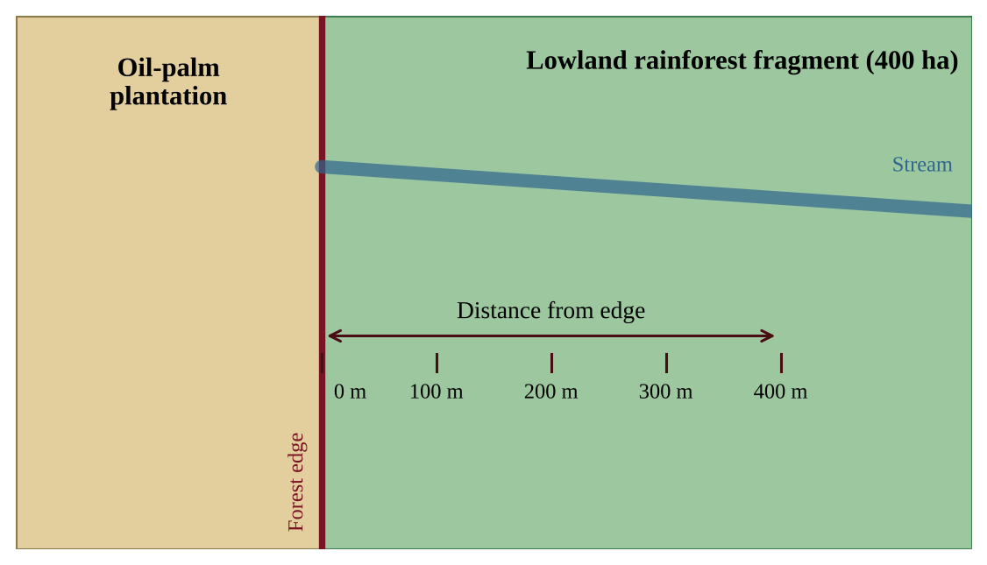
Figure — A forest fragment bordered by an oil-palm plantation, with possible sampling distances from the forest edge
The biologist wants to investigate whether the number of forest-interior understory bird species changes with distance from the forest edge.
(a) Identify the environmental problem illustrated by the scenario. [1]
(b) Write a testable hypothesis for the investigation, including the predicted direction of the relationship. [1]
(c) Identify the independent variable and the dependent variable of the investigation. [2]
(d) Describe a procedure the biologist could use to collect data, including the locations of sampling, how replication will be achieved, and how birds will be counted in a standardized way. [3]
(e) Identify one variable that the biologist should keep constant (control) and explain why. [1]
(f) Describe the pattern of results that would support your hypothesis. [1]
(g) Propose one action that could reduce the loss of forest-interior bird species and justify your proposal using an ecological principle. [1]

Question 2 PE2-FRQ002
Question 2 (10 points). A megacity in South Asia has experienced severe air pollution, and public-health officials monitor the concentration of fine particulate matter (PM2.5) and hospital admissions for respiratory illness. In 2022 the city began phasing out coal-fired boilers in industry and created a low-emission zone that limits older diesel vehicles in the center of the city. Table 1 gives annual data.
Table 1. Annual mean PM2.5 and respiratory admissions
Year | Annual mean PM2.5 (µg/m³) | Respiratory admissions per 100,000 residents
2017 | 118 | 410
2018 | 124 | 428
2019 | 131 | 447
2020 | 126 | 441
2021 | 134 | 462
2022 | 121 | 438
2023 | 104 | 401
2024 | 92 | 372

Figure 1 shows the monthly mean PM2.5 in 2024 and the number of days each month on which a thermal inversion was recorded.
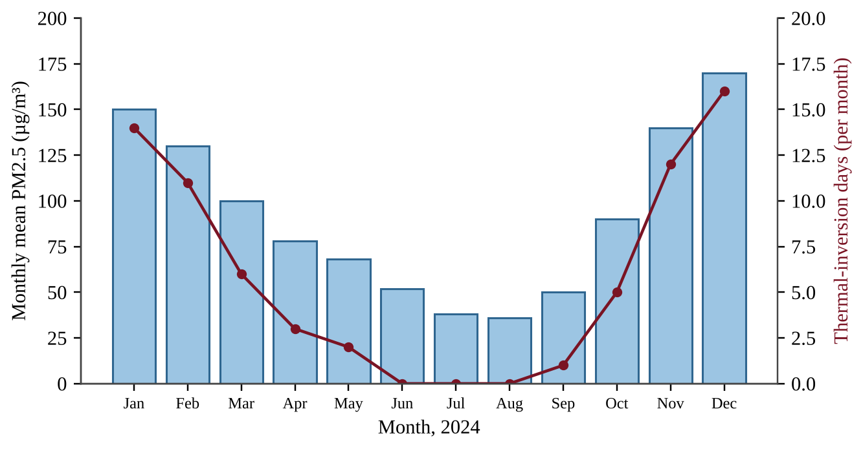
Figure — Monthly mean PM2.5 and number of thermal-inversion days in 2024
(a) Describe the trend in the annual mean PM2.5 concentration from 2017 to 2021. [1]
(b) Calculate the percent change in annual mean PM2.5 between 2021 and 2024. Show your work. [2]
(c) Describe the relationship between annual mean PM2.5 and respiratory admissions shown in Table 1. [1]
(d) Identify one factor other than PM2.5 that could also affect respiratory admissions and explain why this limits the conclusion that PM2.5 alone caused the changes. [1]
(e) Using Figure 1, explain why PM2.5 is highest in December and January. In your answer, describe the pattern shown in the figure and explain how thermal inversions affect pollutant concentrations. [2]
(f) Justify the claim that the 2022 policies contributed to the decline in PM2.5 after 2021, using data from Table 1. [2]
(g) Propose one additional action to reduce PM2.5 in the city and describe one advantage or disadvantage of the action. [1]

Question 3 PE2-FRQ003
Question 3 (10 points). A river in Southeast Asia is dammed to supply electricity and water to a megacity of 5.0 million people. The dam and reservoir have the characteristics given in the table. The alternative would be to generate the same electricity at a coal-fired power plant.
Characteristic | Value
Installed capacity of hydroelectric plant | 800 MW
Capacity factor | 0.50
Surface area of reservoir | 200 km²
Evaporation from reservoir surface | 1.2 m per year
CO₂ emitted by coal-fired generation | 0.95 metric tons per MWh
Household and commercial water use in the city | 150 L per person per day

Useful conversions: 1 year = 8,760 hours; 1 km² = 10⁶ m²; 1 m³ = 1,000 L.
(a) Calculate the electricity generated by the hydroelectric plant in one year, in MWh. Show your work. [2]
(b) Calculate the mass of CO₂, in metric tons per year, that would be emitted if the same amount of electricity were instead produced by the coal-fired plant. Show your work. [2]
(c) Calculate the volume of water, in m³ per year, that evaporates from the reservoir. Show your work. [1]
(d) Calculate the city's annual water use in m³ per year, and then compare it with the volume that evaporates from the reservoir by calculating the evaporation as a percentage of the city's water use. [2]
(e) Describe one environmental disadvantage of the dam for ecosystems downstream. [1]
(f) Propose one action to reduce the environmental or social effects of the dam and justify it. [2]

Predicted Practice Exam 3
NOTE
Exam format and timing (2026 AP Environmental Science)
• Section I: 80 multiple-choice questions, 90 minutes, 60% of the exam score. Each question has four choices (A–D) and one best answer.
• Section II: 3 free-response questions, 70 minutes, 40% of the exam score, 10 points each: (1) design an investigation, (2) analyze and interpret quantitative data, (3) analyze an environmental problem and perform calculations.
• A scientific or four-function calculator is allowed for both sections. Show your work in calculation questions and include units.
• Suggested pacing: about 1 minute 7 seconds per multiple-choice question and about 23 minutes per free-response question.
• Mark only one answer per multiple-choice question; there is no penalty for guessing, so answer every question. Write free-response answers in complete sentences, using the task verbs in each part.

Section I — Multiple-Choice Questions (80)
Question 1 PE3-MCQ001
A savanna food chain is grass → zebra → lion. Which statement about the lion is correct?
A. It is a primary consumer because it feeds on another animal.
B. It is a tertiary consumer and receives about 10% of the energy fixed by the grass.
C. It is a secondary consumer and receives about 90% of the energy stored in the zebra's tissues.
D. It is a secondary consumer and receives about 10% of the energy stored in the zebra's tissues.

Question 2 PE3-MCQ002
Acacia trees in an African savanna have root nodules that contain bacteria. These bacteria increase the nitrogen available to nearby grasses. Which process do the bacteria carry out?
A. Nitrification, which converts nitrogen gas into nitrate
B. Denitrification, which converts nitrate into ammonium in the soil
C. Nitrogen fixation, which converts atmospheric N₂ into ammonia
D. Ammonification, which converts atmospheric N₂ into amino acids

Question 3 PE3-MCQ003
The graphs show mean monthly precipitation (bars, left axis) and mean monthly temperature (line, right axis, same scale in all three panels) at three sites.
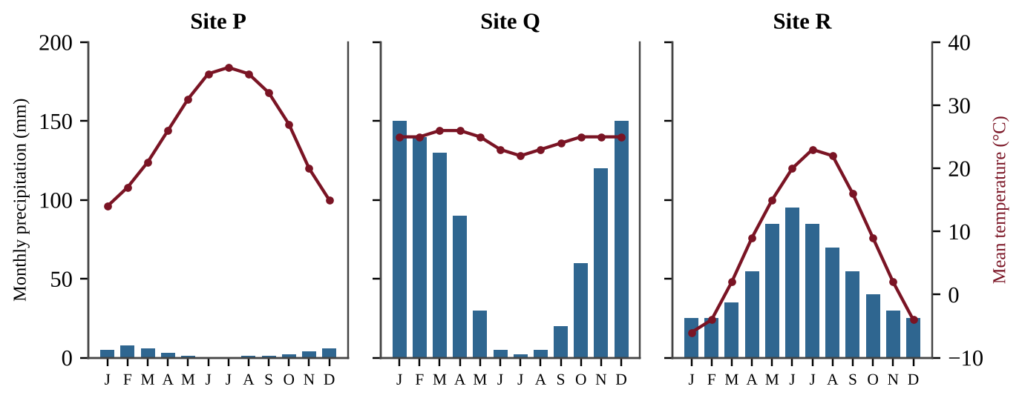
Figure — Monthly precipitation and temperature at three sites
Which biome best describes Site Q?
A. Hot desert, because several months receive almost no precipitation at all
B. Temperate grassland, because rainfall is concentrated in the warmest months
C. Tropical rainforest, because total annual rainfall is high and temperatures stay warm
D. Tropical savanna, because warmth all year is combined with a long dry season

Question 4 PE3-MCQ004
Net primary productivity of a savanna plot is 250,000 kJ per year. Energy passes through the chain grass → grasshopper → lizard → hawk. Assuming 10% of energy is transferred between trophic levels, about how much energy per year is available to the hawk, a tertiary consumer?
A. 25 kJ
B. 250 kJ
C. 2,500 kJ
D. 25,000 kJ

Question 5 PE3-MCQ005
Researchers measure gross primary productivity (GPP) of 3,200 g C/m²/yr on a grassland plot. The plants respire 1,950 g C/m²/yr. What is the net primary productivity (NPP) of the plot?
A. 1,250 g C/m²/yr
B. 1,950 g C/m²/yr
C. 3,200 g C/m²/yr
D. 5,150 g C/m²/yr

Question 6 PE3-MCQ006
A rancher plows 100 ha of native prairie and plants wheat. Over the next decade, soil carbon in the field declines. Which explanation is best?
A. Tillage breaks up soil aggregates and exposes organic matter to oxygen, so microbes release more CO₂.
B. Plowing kills soil bacteria, so organic carbon is slowly oxidized by chemical reactions without any biological activity.
C. Fertilizer applied to the wheat converts soil carbon into methane that escapes as a gas, lowering soil carbon.
D. Deep tillage moves carbon-rich topsoil below the water table, where it dissolves and is carried away as CO₂.

Question 7 PE3-MCQ007
Which of the following is an example of a behavioral adaptation to life in a hot desert?
A. Foraging mainly at night, when air temperatures are lower
B. Producing very concentrated urine to conserve water
C. Storing water in thick, fleshy stems
D. Having large, thin ears that release body heat

Question 8 PE3-MCQ008
Deep-rooted native grasses on a savanna watershed slow runoff and reduce downstream flooding. Which ecosystem service category does this best represent?
A. Provisioning service
B. Cultural service
C. Supporting service
D. Regulating service

Question 9 PE3-MCQ009
After a lightning-caused fire burns a grassland, grasses resprout within weeks from surviving roots and the soil seed bank. Why is this recovery classified as secondary succession?
A. The soil remained intact and still contained seeds and roots.
B. No soil was left, so pioneer species had to colonize bare rock.
C. Fire is a human-caused disturbance, and primary succession follows only natural disturbances.
D. The community immediately returned to its climax stage without intermediate stages.

Question 10 PE3-MCQ010
Remnant grassland patches in a farming region were surveyed. All lie in a landscape in which the nearest source of grassland birds is a large national park.
Patch | Area (ha) | Distance to park (km) | Bird species recorded
W | 400 | 2 | 41
X | 400 | 25 | 29
Y | 20 | 2 | 22
Z | 20 | 25 | 12

Which conclusion is best supported by the table?
A. Species richness depends only on patch area, so distance from the source park has no effect on richness.
B. Richness is higher in larger patches and in patches nearer the source park, as island biogeography predicts.
C. Species richness is higher in patches farther from the park because there are fewer competitors for resources.
D. Species richness depends only on distance from the source park, so patch area has no effect on richness.

Question 11 PE3-MCQ011
Two grass species grow on a rangeland. The graph shows the relative abundance of each along a gradient of mean annual rainfall. A prolonged drought lowers rainfall at one site to the value marked by the dashed line.
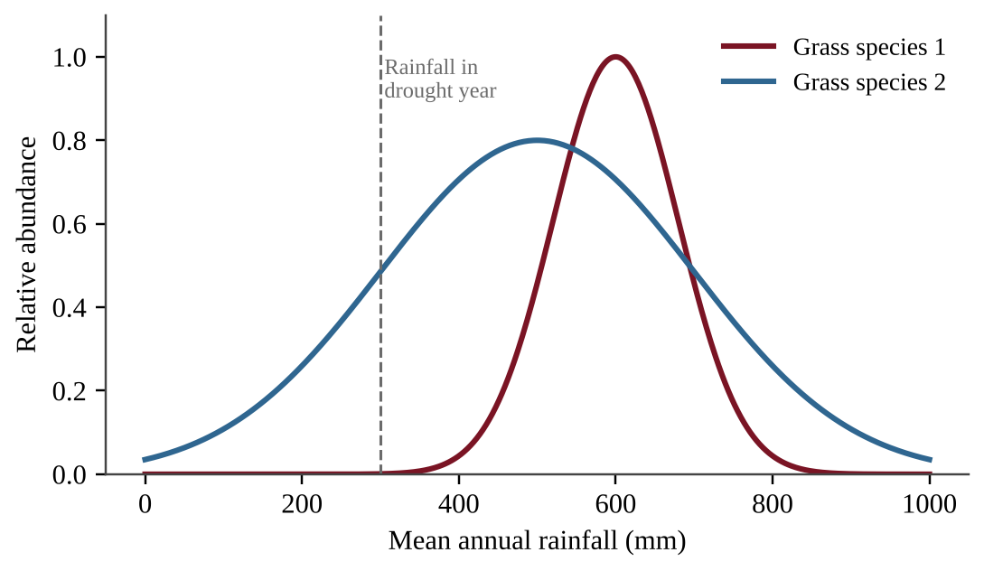
Figure — Relative abundance of two grass species along a rainfall gradient
Which prediction is best supported by the graph?
A. Species 1 will persist because it has the highest peak abundance, which shows that it has greater tolerance.
B. Both species will disappear because 300 mm is below the optimum rainfall for each.
C. Species 2 will persist at lower abundance because 300 mm is within its tolerance range, but Species 1 will likely disappear.
D. Species 2 will disappear because 300 mm is below its optimum, while Species 1 is a generalist that tolerates drought.

Question 12 PE3-MCQ012
A grassland bird feeds almost exclusively on the seeds of one native grass. An invasive shrub replaces that grass across much of the bird's range. What will most likely happen to the bird population?
A. It will remain stable because birds can quickly switch to a wide variety of foods.
B. It will increase because the shrub removes competitors for seeds.
C. It will decline sharply because the bird is a specialist with a narrow niche.
D. It will stay unchanged because specialists are less affected than generalists by habitat change.

Question 13 PE3-MCQ013
African elephants live more than 60 years, usually give birth to a single calf every few years, and provide extended parental care. Which description fits elephant life history?
A. r-selected, with many small offspring and early maturity
B. r-selected, because large body size allows rapid exponential growth
C. K-selected, because individuals reproduce rapidly when resources are abundant
D. K-selected, with few offspring and high parental investment

Question 14 PE3-MCQ014
The total fertility rate (TFR) of a Latin American country fell from 6.0 in 1960 to 1.9 in 2020. Which pair of changes most likely contributed?
A. Higher infant mortality and greater reliance on children for farm labor
B. Expanded education for girls and wider access to contraception
C. Slower urbanization and lower costs of raising children
D. Lower average income and reduced access to family-planning services

Question 15 PE3-MCQ015
A female desert tortoise lays about ten eggs. Most hatchlings are eaten or die of heat, but the few that reach adulthood may live more than 50 years. The graph shows three survivorship curves (log scale).
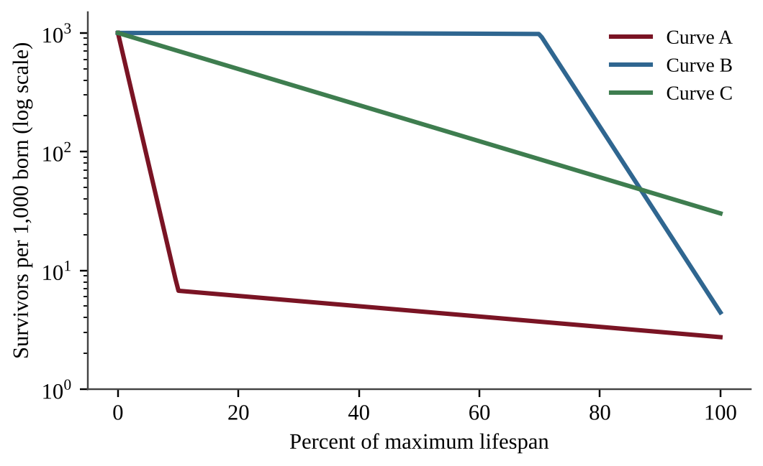
Figure — Survivorship curves A, B and C
Which curve best represents the tortoise?
A. Curve B, because most individuals survive until they are near the maximum lifespan
B. Curve C, because the chance of dying is about the same at every age of life
C. Curve B, because long-lived species always have low juvenile mortality rates
D. Curve A, because few individuals survive the juvenile stage but survivors live long

Question 16 PE3-MCQ016
Sheep were released on an isolated island with no predators and no later additions or removals of sheep. The graph shows the population over time.
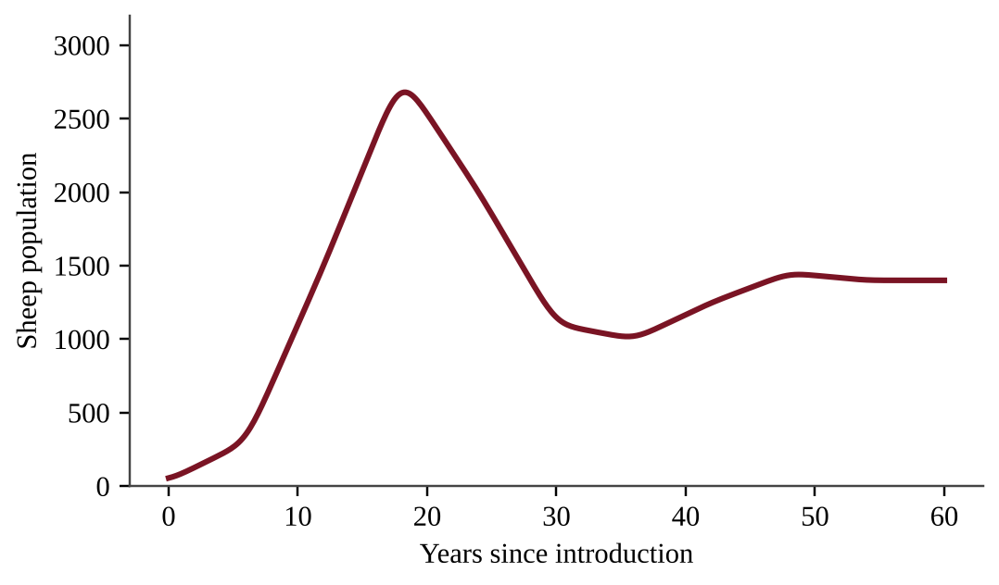
Figure — Sheep population on an island over 60 years
Which statement best interprets the population after year 18?
A. The carrying capacity is about 2,800 sheep, and the population has been in permanent decline since year 18.
B. The population grew exponentially for the entire 60 years, so resources never limited it.
C. The population overshot the island's carrying capacity, and forage depletion drove it to a lower, steadier level.
D. Immigration of sheep from the mainland stabilized the population near 1,400 animals.

Question 17 PE3-MCQ017
A country in East Africa has a population growth rate of 2.8% per year. Using the rule of 70, about how long will it take for its population to double if the growth rate stays constant?
A. 7 years
B. 25 years
C. 28 years
D. 196 years

Question 18 PE3-MCQ018
Country E in southern Europe has a total fertility rate of 1.4. In one year it records 9 births, 11 deaths, 6 immigrants, and 2 emigrants per 1,000 people. What is its annual population growth rate?
A. −0.2%
B. +0.2%
C. +0.4%
D. +2.0%

Question 19 PE3-MCQ019
The age-structure diagrams show three countries.
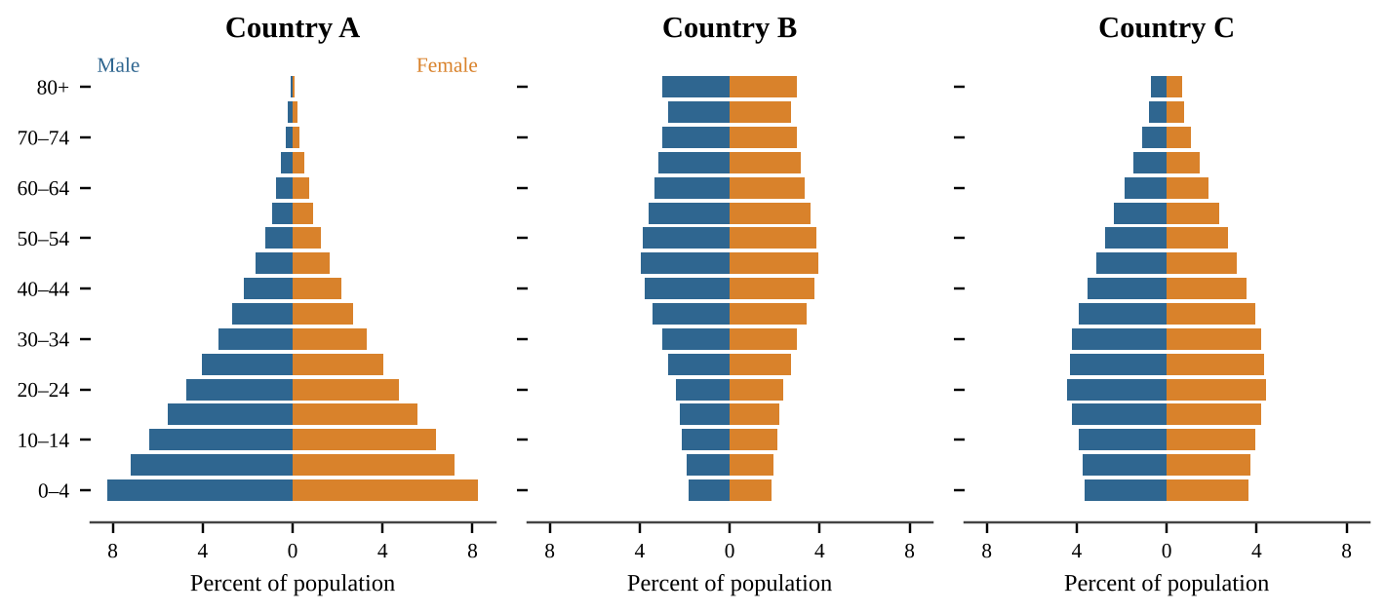
Figure — Age-structure diagrams for Countries A, B and C
Suppose each country's fertility rate fell immediately to replacement level (2.1). Which country's population would most likely keep growing for several decades, and why?
A. Country A, because its large pre-reproductive cohorts will move into childbearing ages
B. Country B, because its largest cohorts are middle-aged and will live longer
C. Country C, because its birth rate will exceed its death rate for the next 100 years
D. Country B, because replacement fertility always produces growth in aging societies

Question 20 PE3-MCQ020
Country B in southern Europe has 12% of its population under age 15, 64% aged 15–64, and 24% aged 65 or older. About how many working-age people (15–64) are there for each person aged 65 or older?
A. 0.4
B. 2.7
C. 3.2
D. 5.3

Question 21 PE3-MCQ021
The graph shows birth and death rates over 120 years in a Latin American country.
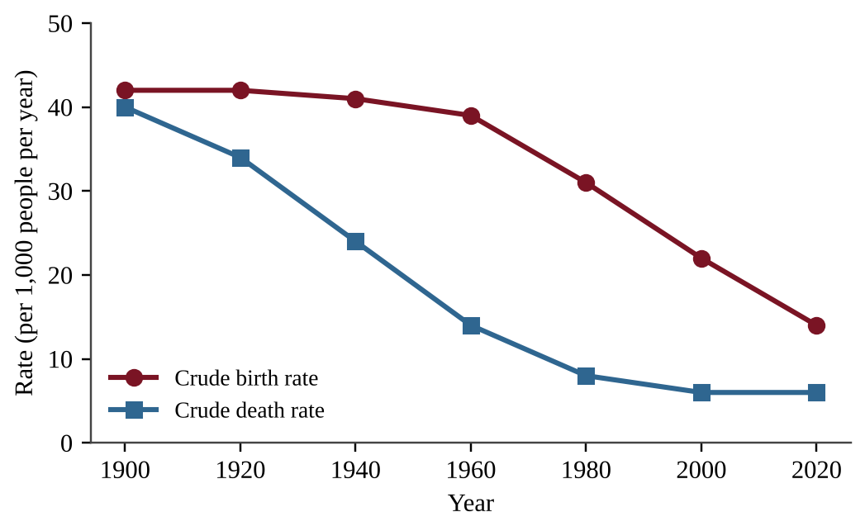
Figure — Crude birth and death rates, 1900–2020
When was natural increase greatest, and why?
A. Near 1960, when death rates had fallen sharply but birth rates stayed high, a gap of about 25 per 1,000
B. Near 1900, when both rates were high, which gave the largest natural increase of the century
C. Near 1980, when falling birth rates produced a gap of about 23 per 1,000, the maximum gap
D. Near 2020, when very low death rates produced the largest gap between the two rates

Question 22 PE3-MCQ022
Which layer of the atmosphere contains most of Earth's weather and most of its water vapor?
A. Stratosphere
B. Troposphere
C. Mesosphere
D. Thermosphere

Question 23 PE3-MCQ023
The East African Rift is a long valley where the crust is slowly being pulled apart and where volcanoes and hot springs occur. Which type of plate boundary is forming it?
A. Convergent boundary, where one plate subducts beneath another
B. Transform boundary, where plates slide horizontally past each other
C. Divergent boundary, where plates move apart and magma rises
D. Convergent boundary, where two continental plates collide to form folded mountains

Question 24 PE3-MCQ024
In a grassland soil profile, which horizon is the mineral topsoil rich in humus where most plant roots and soil organisms are found?
A. B horizon
B. A horizon
C. C horizon
D. Bedrock

Question 25 PE3-MCQ025
Many of the world's large hot deserts, including the Sahara, lie near 30° N and 30° S latitude. What best explains this pattern?
A. Dry air descending near 30° warms and absorbs moisture rather than releasing it as precipitation.
B. Moist air rising near 30° drops its water on the way to higher latitudes.
C. Strong solar heating at 30° makes air rise rapidly, creating a low-pressure zone with clear skies.
D. Trade winds blowing from the equator carry nearly all the moisture past 30° toward the poles.

Question 26 PE3-MCQ026
Three soil samples were tested for how fast water enters the soil and how much water is held after drainage.
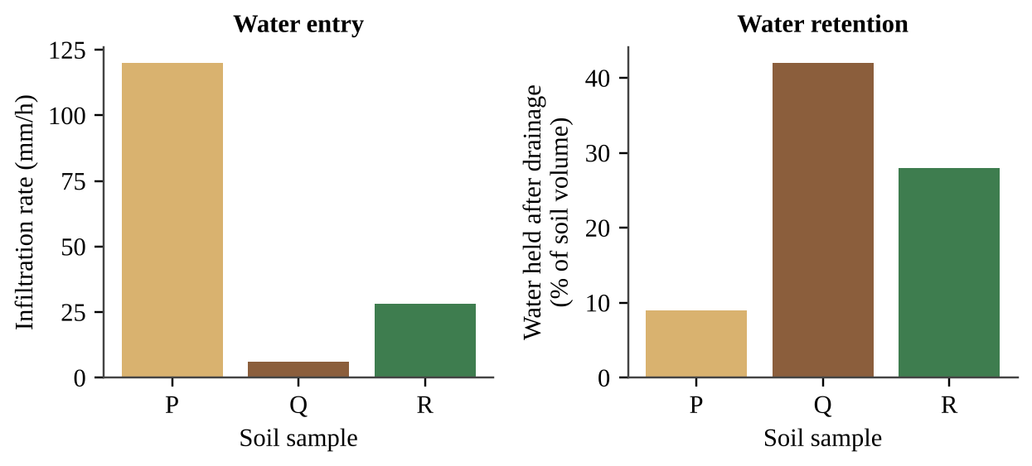
Figure — Infiltration rate and water retention of soils P, Q and R
Which description of soil Q is best supported by the data?
A. Sand-rich, with large pores that allow rapid water entry and quick drainage
B. Clay-rich, with tiny pores that slow water entry but hold water tightly
C. Sand-rich, because it holds the most water after drainage
D. Loam with balanced pores, giving intermediate infiltration and retention

Question 27 PE3-MCQ027
Overgrazing strips ground cover from a cattle ranch located in the headwaters of a watershed. Which downstream effect is most likely?
A. More runoff and sediment reach the stream, increasing turbidity and flood peaks.
B. Less sediment reaches the stream because bare soil absorbs more rain.
C. Groundwater recharge increases because water moves quickly across the surface.
D. Stream nutrient levels fall because grazing removes plant material.

Question 28 PE3-MCQ028
A 40-ha rangeland loses soil to erosion at 9.0 metric tons per hectare per year, while new soil forms at 1.5 metric tons per hectare per year. If these rates continue for 20 years, what is the net soil loss from the entire rangeland?
A. 150 metric tons
B. 1,200 metric tons
C. 6,000 metric tons
D. 7,200 metric tons

Question 29 PE3-MCQ029
Why is it summer in the Southern Hemisphere when it is winter in the Northern Hemisphere in December?
A. Earth is closer to the Sun in December, which heats the Southern Hemisphere more than the Northern.
B. Earth's axis is tilted, so the Southern Hemisphere is angled toward the Sun and gets more direct light.
C. Earth rotates more slowly in December, which gives the Southern Hemisphere longer days and shorter nights.
D. Ocean currents carry heat across the equator in December and warm the whole Southern Hemisphere.

Question 30 PE3-MCQ030
The diagram shows moist ocean air moving inland over a mountain range.
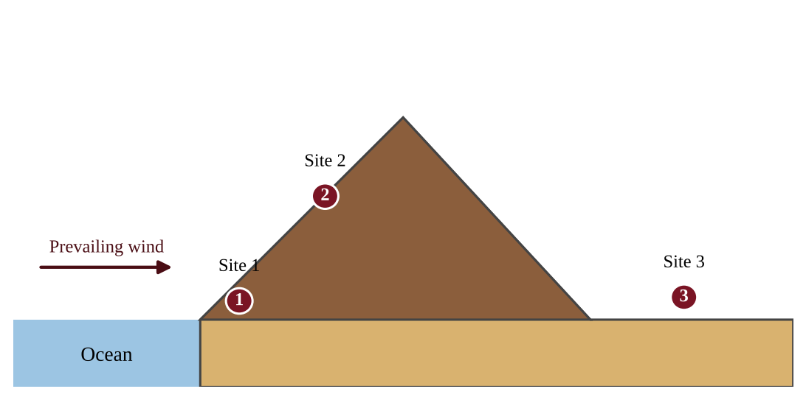
Figure — Cross-section of a coastal mountain range with three marked sites
At which site is annual precipitation most likely lowest, and why?
A. Site 1, because it is at the lowest elevation, where air holds the least moisture
B. Site 2, because thin air at high elevation holds less moisture
C. Site 3, because air descending the leeward slope warms and holds its remaining moisture
D. Site 2, because winds are strongest at the summit and blow rain away

Question 31 PE3-MCQ031
The graph shows sea-surface temperature anomalies off the coast of Peru and the catch of anchovies in the same years.
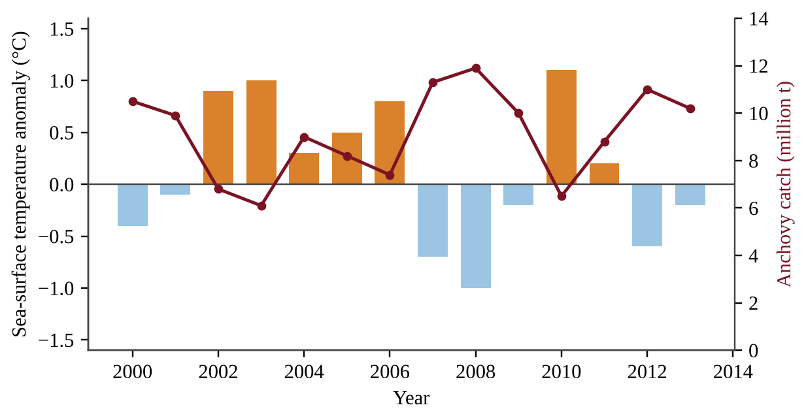
Figure — Sea-surface temperature anomaly (bars) and anchovy catch (line), 2000–2013
Which statement is best supported by the data and by what is known about El Niño?
A. Warm anomalies coincide with higher catches because warmer water speeds up anchovy growth and reproduction.
B. There is no relationship between temperature anomalies and catches, because the catch varies randomly from year to year.
C. Cold anomalies coincide with lower catches because cold water holds less dissolved oxygen for fish.
D. Warm anomalies coincide with lower catches, consistent with weakened upwelling that reduces nutrient supply.

Question 32 PE3-MCQ032
Herders in a semi-arid region graze cattle on shared communal pasture. Each herder gains the full benefit from adding one more animal, but the damage from overgrazing is shared by everyone. Which concept best explains why the pasture is likely to be degraded?
A. Bioaccumulation
B. Ecological succession
C. The precautionary principle
D. The tragedy of the commons

Question 33 PE3-MCQ033
Compared with continuous grazing, which practice best reduces damage to rangeland vegetation?
A. Keeping the herd in one pasture all year so manure is concentrated
B. Grazing the same paddock every year at the start of the growing season
C. Removing ground cover so livestock can reach grass roots
D. Moving livestock among paddocks so grazed plants can recover

Question 34 PE3-MCQ034
In an arid region, farmers flood-irrigate their fields with river water for several decades. Crop yields decline and a white crust appears on the soil surface. What is the most likely cause?
A. Evaporating irrigation water leaves dissolved salts behind, causing salinization.
B. Acid rain has leached nitrogen and other nutrients out of the soil.
C. Heavy tractors have compacted the soil so that much more water infiltrates.
D. Heavy rainfall has flushed nutrients out of the root zone.

Question 35 PE3-MCQ035
Which is a documented environmental drawback of the high-yield crop varieties introduced during the Green Revolution?
A. They produce lower yields per hectare than the traditional varieties they replaced.
B. They increase soil organic matter, which lowers the fertilizer needs of later crops.
C. They require much less water, which raises local groundwater levels.
D. They depend on heavy fertilizer, pesticide, and water inputs and reduce crop genetic diversity.

Question 36 PE3-MCQ036
A sorghum cooperative adopts integrated pest management (IPM). Which action is part of IPM?
A. Scouting fields and spraying only when pest numbers exceed an economic threshold
B. Spraying a broad-spectrum pesticide on a fixed calendar schedule every season
C. Planting the same crop every year so that pest populations stay predictable
D. Eliminating natural predators of pests so that they cannot spread crop diseases

Question 37 PE3-MCQ037
The graphs show fishing effort and catch in an inland lake fishery.
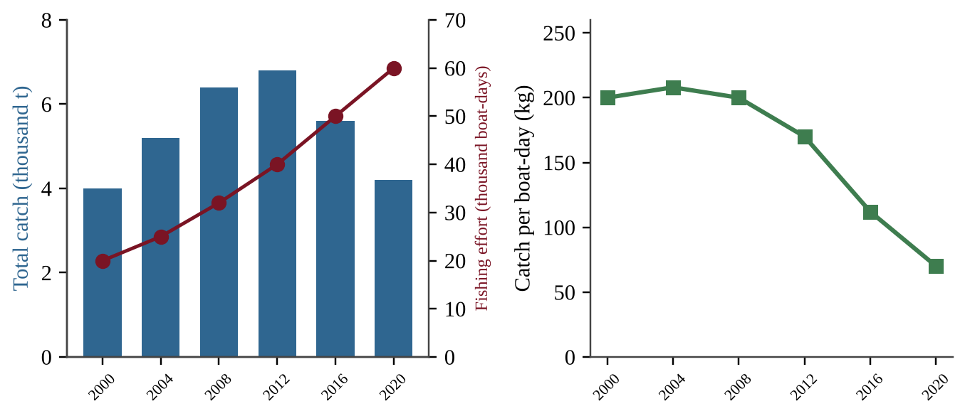
Figure — Total catch, fishing effort, and catch per boat-day, 2000–2020
Which interpretation is best supported?
A. Effort kept rising while catch per boat-day fell, indicating that the stock is being depleted.
B. Falling catch per boat-day shows that the fish population is increasing in the lake.
C. Total catch rose until 2012, so the stock was not overfished in any year of the record.
D. Rising effort shows that the fish stock is recovering and can support more boats.

Question 38 PE3-MCQ038
Which is a direct environmental impact of open-pit (surface) mining?
A. Habitat destruction and waste rock that can produce acidic runoff
B. Increased groundwater recharge across the mined area
C. Higher soil fertility at the site as deep layers are exposed
D. Reduced sediment in nearby streams due to removal of vegetation

Question 39 PE3-MCQ039
A rancher manages 800 ha of rangeland. Forage production averages 2,400 kg of dry matter per hectare per year, and to prevent overgrazing no more than 50% may be eaten by cattle. Each cow eats about 4,000 kg of forage per year. What is the maximum number of cows the rangeland can support sustainably?
A. 120 cows
B. 240 cows
C. 480 cows
D. 960 cows

Question 40 PE3-MCQ040
Country K has 25 million people, an average ecological footprint of 4.5 global hectares (gha) per person, and a biocapacity of 2.7 gha per person. What is Country K's total ecological deficit?
A. 1.8 million gha
B. 45 million gha
C. 67.5 million gha
D. 112.5 million gha

Question 41 PE3-MCQ041
A 40-ha neighborhood (400,000 m²) receives a 25 mm rainstorm. Runoff volume = rainfall depth × area × runoff coefficient (C). C is 0.90 for impervious surfaces and 0.20 for vegetated surfaces. The neighborhood is now 50% impervious; after rain gardens and permeable pavement are installed it will be 20% impervious. By how much does runoff from this storm decrease?
A. 2,100 m³
B. 3,400 m³
C. 5,500 m³
D. 8,900 m³

Question 42 PE3-MCQ042
Which of the following energy sources is nonrenewable?
A. Heat from Earth's interior used for geothermal power
B. Wind
C. Flowing river water used for hydroelectric power
D. Uranium-235 used in nuclear fission

Question 43 PE3-MCQ043
Natural gas is often called a "bridge fuel" in the transition away from coal. Which statement best supports this description?
A. Burning it releases less CO₂, and almost no SO₂, per unit of energy than coal does.
B. It is a renewable fuel because natural gas forms continuously in shallow soils and wetlands.
C. Burning it releases no carbon dioxide, only water vapor and heat.
D. Leaks of methane during extraction and transport have no effect on climate.

Question 44 PE3-MCQ044
Which is a significant disadvantage of nuclear power compared with natural gas power plants?
A. It releases more CO₂ per kilowatt-hour than a gas plant does during operation.
B. It continuously emits large amounts of SO₂ from burning its uranium fuel.
C. It produces more particulate air pollution than a gas plant during normal operation.
D. Spent fuel stays radioactive for thousands of years and needs secure storage.

Question 45 PE3-MCQ045
Geothermal power plants such as those in the Rift Valley of Kenya can be built only in certain regions. Why?
A. Geothermal plants require large amounts of daily sunlight to heat the rock beneath them.
B. Geothermal plants require strong, steady winds to drive the turbines that make electricity.
C. Hot water or steam must be near the surface, which occurs mainly near plate boundaries or hot spots.
D. Geothermal plants must be located near coal or gas deposits that supply the heat for steam.

Question 46 PE3-MCQ046
Which environmental concern is most directly associated with hydraulic fracturing (fracking) to obtain natural gas?
A. Release of radioactive spent fuel rods into nearby surface waters
B. Thermal pollution from the cooling water of steam turbines
C. Large water use and possible groundwater contamination by fracturing fluid
D. Acid mine drainage from open-pit excavation of the shale

Question 47 PE3-MCQ047
Burning fuelwood from savanna woodlands can be considered carbon-neutral only if which condition is met?
A. The wood is burned in an open fire rather than in a closed, efficient stove.
B. The wood releases no CO₂ when it burns, because it is a renewable resource.
C. The land is permanently cleared after harvest and then planted with annual crops.
D. The harvested trees regrow fast enough to re-absorb about as much CO₂ as burning releases.

Question 48 PE3-MCQ048
A nuclear waste sample contains an isotope with a half-life of 30 years. Its initial activity is 800 units. What will its activity be after 90 years?
A. 25 units
B. 100 units
C. 267 units
D. 400 units

Question 49 PE3-MCQ049
A school replaces 200 fluorescent fixtures (80 W each) with LED fixtures (30 W each). Each fixture operates 3,000 hours per year, and electricity costs $0.12 per kilowatt-hour. What are the annual electricity savings?
A. $2,160
B. $3,600
C. $5,760
D. $36,000

Question 50 PE3-MCQ050
The graph shows the shares of electricity generation by source in three countries.
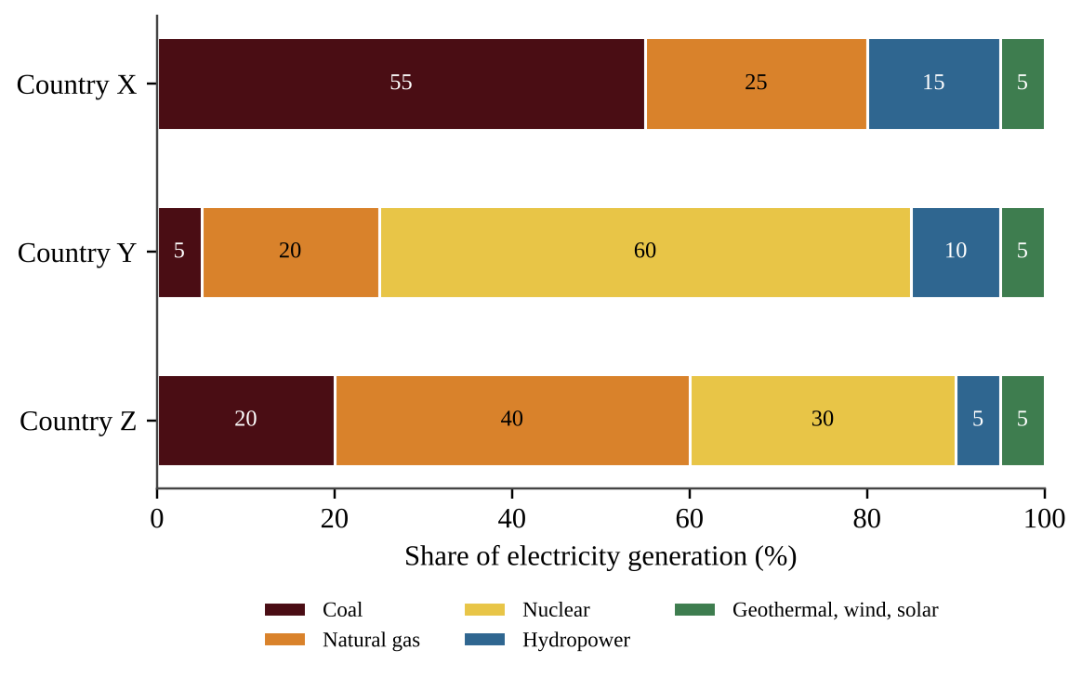
Figure — Electricity generation by source in Countries X, Y and Z
Average CO₂ emissions are 1.0 kg per kWh for coal and 0.45 kg per kWh for natural gas; the other sources are treated as zero. What are the average emissions per kWh of Country Z's electricity?
A. 0.18 kg CO₂/kWh
B. 0.20 kg CO₂/kWh
C. 0.38 kg CO₂/kWh
D. 0.60 kg CO₂/kWh

Question 51 PE3-MCQ051
A pressurized-water reactor produces 3,000 MW of thermal power. Its steam turbines convert 33% of this heat to electricity. At what rate is waste heat released to the cooling water?
A. 990 MW
B. 2,010 MW
C. 3,000 MW
D. 9,091 MW

Question 52 PE3-MCQ052
What happens during a thermal inversion over a valley city?
A. Cool air above warm surface air lets pollutants rise and disperse.
B. Strong winds increase and sweep pollutants out of the valley.
C. A layer of warm air above cooler surface air traps pollutants near the ground.
D. Surface air warms and rises, carrying pollutants into the stratosphere.

Question 53 PE3-MCQ053
Which statement about radon-222 is accurate?
A. It is a gas from incomplete combustion that binds to hemoglobin and causes oxygen deprivation.
B. It is a radioactive gas from uranium decay that collects in basements and raises lung cancer risk.
C. It is a volatile organic compound released by new carpets and paints that irritates the eyes.
D. It is a fungal spore that grows on damp building materials and triggers allergies and asthma.

Question 54 PE3-MCQ054
Unpolluted rain has a pH of about 5.6. Rain collected downwind of a coal-fired power plant has a pH of 4.6. How many times more acidic is the polluted rain?
A. 1.0 times
B. 10 times
C. 100 times
D. 1,000 times

Question 55 PE3-MCQ055
Noise at a quarry fence is 60 dB, and at the edge of the pit it is 80 dB. The decibel scale is logarithmic, with each 10 dB increase representing a tenfold increase in sound intensity. How many times more intense is the sound at the pit edge?
A. 1.3 times
B. 20 times
C. 100 times
D. 1,000 times

Question 56 PE3-MCQ056
The graph shows 24-hour average indoor PM2.5 concentrations in kitchens using three cooking methods.
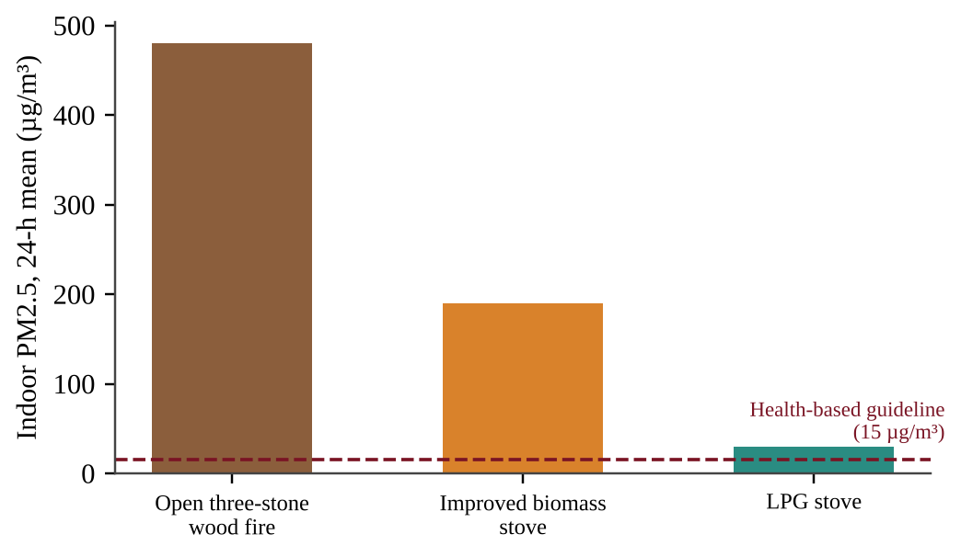
Figure — Indoor PM2.5 by cooking method compared with a health guideline
By what percent does switching from the open wood fire to an LPG stove reduce indoor PM2.5?
A. 6%
B. 60%
C. 94%
D. 1,500%

Question 57 PE3-MCQ057
Families in a rural area cook on open wood fires inside poorly ventilated huts. Which action would most effectively reduce residents' exposure to indoor particulates and carbon monoxide?
A. Using air fresheners and incense to mask the smell of the smoke
B. Cooking only at night when the indoor air is cooler
C. Opening one small window while still cooking over the open fire
D. Replacing the open fire with a clean-burning stove vented outdoors

Question 58 PE3-MCQ058
The graph shows hourly concentrations of nitrogen oxides and ozone at an urban site on a sunny day.
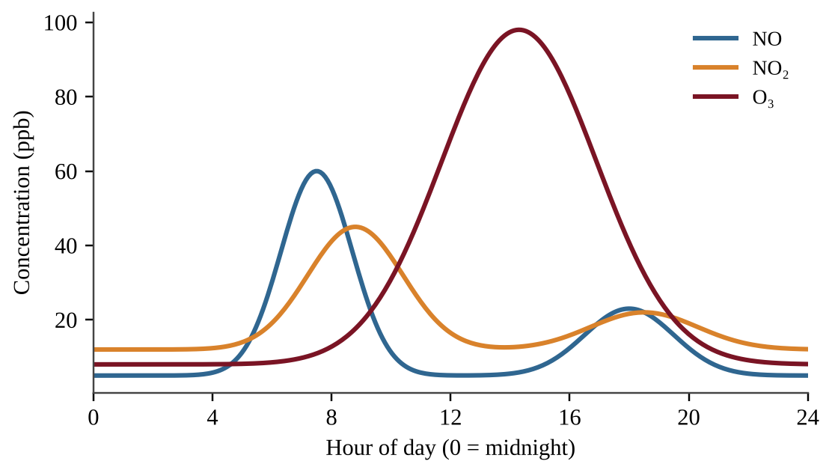
Figure — Hourly NO, NO₂ and O₃ concentrations at an urban site
Which best explains why ozone peaks in the early afternoon rather than during the morning rush hour?
A. Vehicles emit ozone directly from their tailpipes, and traffic is heaviest in the afternoon.
B. A thermal inversion forms at midday and traps the ozone near the ground until evening.
C. Sunlight drives reactions of NO₂ and volatile organic compounds that form ozone slowly.
D. Ozone from the stratosphere sinks to the surface once the morning traffic has ended.

Question 59 PE3-MCQ059
In a municipal sewage treatment plant, which stage uses aerobic microorganisms to break down dissolved and suspended organic matter?
A. Primary treatment, which screens and settles solids
B. Tertiary treatment, which removes nitrogen and phosphorus
C. Chlorine disinfection before discharge
D. Secondary treatment

Question 60 PE3-MCQ060
A village well tests positive for fecal coliform bacteria. This most directly indicates that the water is contaminated with:
A. Excess nitrate from fertilizer runoff into the well
B. Dissolved heavy metals such as lead or arsenic
C. Fecal matter, so disease-causing pathogens may be present
D. Low dissolved oxygen from algal blooms and decay

Question 61 PE3-MCQ061
Dissolved oxygen (DO) was measured along a river downstream from a wastewater outfall.
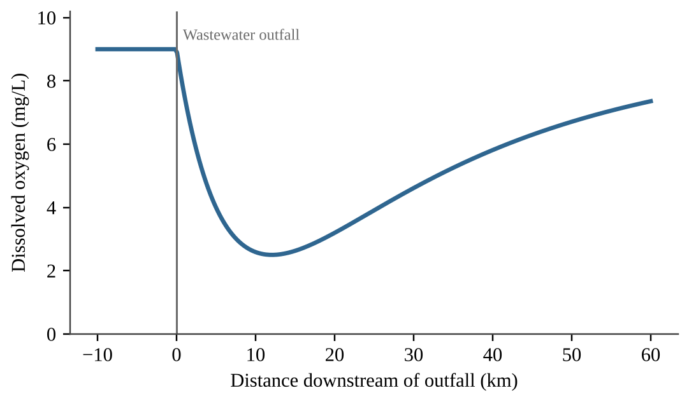
Figure — Dissolved oxygen along a river downstream of a wastewater outfall
Organism | Minimum DO needed (mg/L)
Stonefly nymph | 7
Freshwater mussel | 5
Carp | 3
Tubifex worm | 1

Which organism would most likely be found at the point of lowest DO?
A. Tubifex worm
B. Stonefly nymph
C. Freshwater mussel
D. Carp

Question 62 PE3-MCQ062
The graph shows the percent of test animals killed by two toxicants at increasing doses.
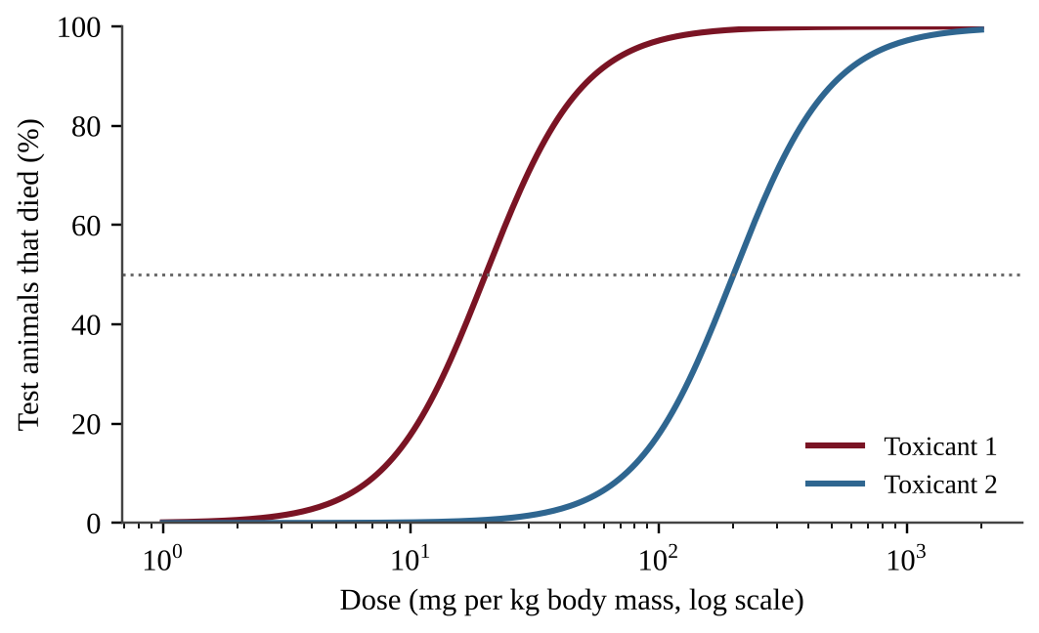
Figure — Dose-response curves for Toxicants 1 and 2
Which statement is best supported by the graph?
A. Toxicant 2 is more toxic because a larger dose is needed to kill half the animals.
B. The two toxicants are equally toxic because each eventually kills 100% of animals.
C. Toxicant 1 is less toxic because its curve lies farther to the left.
D. Toxicant 1 is more toxic; about one-tenth the dose of Toxicant 2 kills half the animals.

Question 63 PE3-MCQ063
The table shows the concentration of a persistent pesticide in organisms of a lake food web.
Organism | Concentration (ppm, wet weight)
Phytoplankton | 0.04
Zooplankton | 0.3
Small fish | 1.6
Large fish | 5
Osprey | 25

By what factor is the concentration in the osprey higher than in phytoplankton?
A. 5
B. 62.5
C. 625
D. 6,250

Question 64 PE3-MCQ064
A city of 200,000 people generates 2.0 kg of municipal solid waste per person per day. The city recycles and composts 30% of the waste, and the rest goes to a landfill. How many metric tons of waste are sent to the landfill per year? (Use 365 days.)
A. 280 metric tons per year
B. 43,800 metric tons per year
C. 102,200 metric tons per year
D. 146,000 metric tons per year

Question 65 PE3-MCQ065
Biologists sampled male fish at sites along a river that receives treated wastewater. They recorded the percentage of males with eggs developing in their testes (a sign of hormone disruption).
Site | Males with eggs in testes (%)
Upstream of outfall | 4
At outfall | 41
5 km downstream | 22
15 km downstream | 9

Which conclusion is best supported by the data?
A. Something in the treated wastewater likely disrupts hormones in fish, and the effect weakens downstream.
B. The data prove that estrogen from birth control pills is the specific cause of the effect on the fish.
C. The data show that conventional wastewater treatment removes all endocrine-disrupting compounds.
D. Because some upstream males are affected, endocrine disruptors are unrelated to the wastewater discharge.

Question 66 PE3-MCQ066
How do chlorofluorocarbons (CFCs) destroy ozone in the stratosphere?
A. Each chlorine atom reacts with a single ozone molecule and is permanently used up in the reaction.
B. CFCs absorb UV light and convert the stratospheric ozone directly into carbon dioxide.
C. UV light frees chlorine atoms, and each atom catalyzes the breakdown of many ozone molecules.
D. CFCs sink to the troposphere, where they react with ozone at ground level and destroy it.

Question 67 PE3-MCQ067
Which statement best describes how greenhouse gases warm Earth's lower atmosphere?
A. They absorb infrared radiation from Earth's surface and re-emit part of it back toward the surface.
B. They reflect most incoming visible light back to space before it can reach the surface.
C. They absorb ultraviolet radiation in the stratosphere and release that energy as heat to the surface.
D. They increase the amount of energy that is emitted by the Sun toward Earth.

Question 68 PE3-MCQ068
Which characteristic most helps a non-native plant become invasive in a new rangeland?
A. Slow growth and low seed production, which let it avoid competition with native plants
B. Rapid growth and seed production plus no natural herbivores or diseases from its native range
C. A requirement for soil fungi that are found only in its native range
D. A narrow tolerance range for temperature and for rainfall

Question 69 PE3-MCQ069
Which statement best describes the Montreal Protocol?
A. An international treaty that sets binding limits on global CO₂ emissions from industry
B. An international agreement that regulates trade in endangered species and their products
C. A national law that regulates pollutant discharges into the surface waters of a country
D. A treaty that phased out production of ozone-depleting substances such as CFCs

Question 70 PE3-MCQ070
A ranching region has 5,000 cattle, and each animal emits an average of 60 kg of methane (CH₄) per year. Over 100 years, the global warming potential of methane is 28 times that of CO₂. What is the herd's annual emission in metric tons of CO₂ equivalent?
A. 11
B. 300
C. 8,400
D. 84,000

Question 71 PE3-MCQ071
The graph shows atmospheric CO₂ concentration measured at a remote station for 11 years.
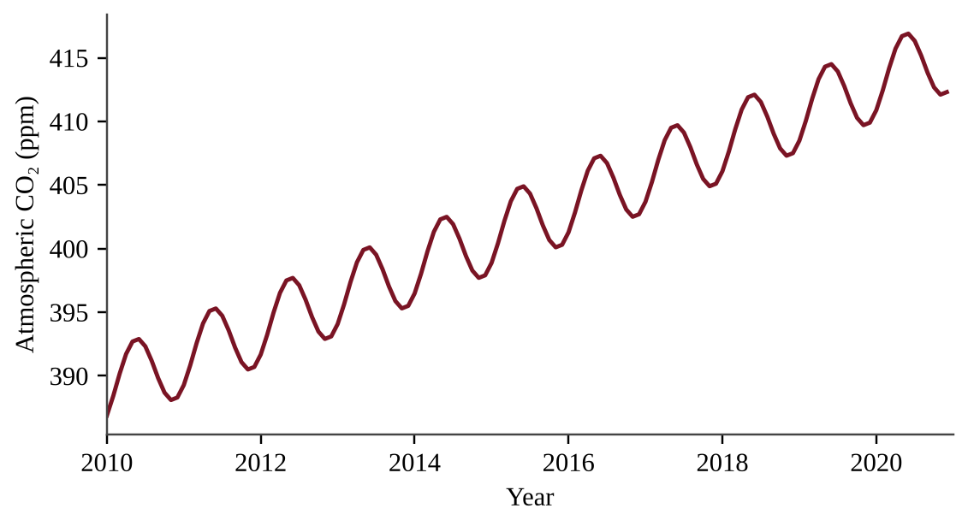
Figure — Monthly atmospheric CO₂ concentration, 2010–2020
Which statement best explains the pattern?
A. The yearly cycle reflects changes in solar output, while the long-term rise reflects seasonal plant growth and decay.
B. The yearly cycle is caused by ocean upwelling, while the long-term rise reflects increased volcanic eruptions worldwide.
C. The yearly cycle is measurement error, while the long-term rise shows that natural sources are the main cause.
D. The yearly cycle reflects seasonal plant uptake, while the long-term rise reflects fossil fuel burning and land clearing.

Question 72 PE3-MCQ072
Which is an example of a positive feedback loop in the climate system?
A. Warming thaws Arctic permafrost, releasing CH₄ and CO₂ that cause further warming.
B. Warming increases plant growth, which removes more CO₂ from the atmosphere.
C. Higher CO₂ concentrations increase ocean uptake, reducing atmospheric CO₂.
D. A warmer surface radiates more heat to space, which reduces warming.

Question 73 PE3-MCQ073
Which pair of consequences results directly from ocean warming?
A. Sea-level rise from melting of floating sea ice and higher ocean pH
B. Sea-level rise from thermal expansion of seawater and coral bleaching
C. Higher dissolved oxygen levels and expansion of cold-water fisheries
D. Reduced thermal expansion of seawater and greater absorption of atmospheric CO₂

Question 74 PE3-MCQ074
A thorny shrub invaded a rangeland, and surveys of the infested area are shown.
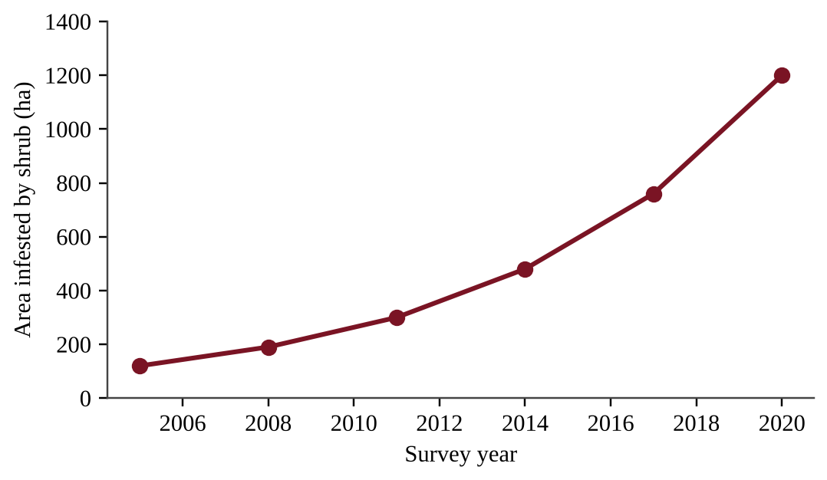
Figure — Area infested by an invasive shrub, 2005–2020
Which statement best describes the pattern and its management implication?
A. The infested area is increasing at a constant rate, so control can be delayed with no added cost.
B. The infested area is leveling off, showing the population has reached its carrying capacity.
C. The infested area is decreasing, showing that native grasses are outcompeting the shrub.
D. The infested area is increasing at an accelerating rate, so early control is more effective than waiting.

Question 75 PE3-MCQ075
Land managers propose releasing a leaf beetle from an invasive shrub's native range to reduce the shrub's spread. What is the greatest risk of this biological control?
A. The beetle may feed on native plants or itself become a new invasive species.
B. The beetle will contaminate groundwater with pesticide residues from its body.
C. The beetle will increase the soil's salt content and cause salinization.
D. The beetle will raise the need for herbicides to protect the native grasses.

Question 76 PE3-MCQ076
Illegal killing of rhinos for their horns has sharply reduced their populations in African savannas. Which pair correctly identifies the threat and an appropriate management response?
A. Overexploitation; anti-poaching enforcement and efforts to reduce demand
B. Invasive species; removing non-native grazers from the rhino habitat
C. Pollution; adding wastewater treatment plants near the rhino habitat
D. Habitat loss; establishing wildlife corridors between reserves

Question 77 PE3-MCQ077
The average pH of surface ocean water has dropped from 8.20 to 8.10 since pre-industrial times. By about what percent has the hydrogen ion concentration increased?
A. 1%
B. 10%
C. 26%
D. 100%

Question 78 PE3-MCQ078
A 10 km × 10 km grassland reserve is divided by roads and farms into four separate 5 km × 5 km fragments. Edge effects extend 1 km inward from every boundary, and only the interior beyond that is high-quality habitat. What is the total interior habitat area after fragmentation?
A. 28 km²
B. 36 km²
C. 64 km²
D. 100 km²

Question 79 PE3-MCQ079
Researchers hypothesize that grazing by native antelope limits the establishment of an invasive shrub in a savanna. Which design best tests this hypothesis?
A. Compare shrub density in one fenced plot and one unfenced plot at a single site after several years.
B. Count shrubs along random transects and correlate shrub density with counts of antelope dung along each.
C. Remove all shrubs from the fenced plots only and compare grass cover in fenced and unfenced plots.
D. Set up paired fenced and unfenced plots at several sites, seed them equally, and compare seedling survival.

Question 80 PE3-MCQ080
The Antarctic ozone hole forms each September and October, not during the dark polar winter. Which explanation is best?
A. Chlorine forms only in sunlight, so ozone is lost evenly throughout the entire summer and autumn.
B. Spring warming releases CFCs from melting ice, and the released CFCs immediately destroy ozone.
C. Winter winds carry CFCs to the equator, from which they return to the pole in spring.
D. Winter cold forms polar stratospheric clouds that activate chlorine; spring sunlight then destroys ozone.

Section II — Free-Response Questions (3)
Question 1 PE3-FRQ001
On a semi-arid savanna rangeland in East Africa, a pastoral community grazes cattle and goats. Thirty years ago a thorny, deep-rooted shrub from another continent was planted along village boundaries to provide fuelwood and shade. The shrub has since spread across the rangeland. Herders report that perennial grasses are disappearing, livestock are losing weight, and soil under dense shrub thickets looks hard and crusted.
A rangeland ecologist surveyed 36 plots of equal size, 12 in each of three categories based on shrub canopy cover: not invaded (0%), lightly invaded (1–30%), and heavily invaded (more than 60%). She measured perennial grass cover and soil moisture in the top 20 cm at the end of the dry season. The mean values are shown below.
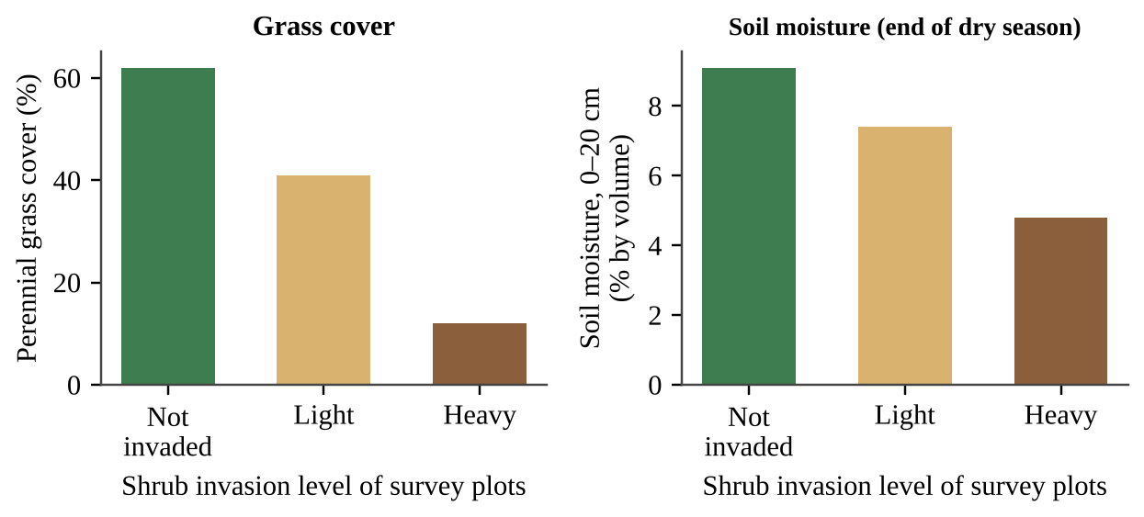
Figure — Mean perennial grass cover and soil moisture in survey plots with three levels of shrub invasion
The ecologist hypothesizes that the shrub reduces grass cover by drawing down soil moisture. She plans an experiment to test whether removing the shrub restores grass growth.
(a) Answer both parts about the scenario. (i) Identify the type of environmental problem described in the scenario. [1] (ii) Describe the relationship between the level of shrub invasion and end-of-dry-season soil moisture shown in the figure. [1] (b) Write a testable hypothesis, in "if … then …" form, for the shrub-removal experiment. [1] (c) Identify the independent variable and the dependent variable in the experiment. [2] (d) Identify one variable that must be controlled in the experiment and explain why it must be controlled. [1] (e) Describe a procedure for the experiment. Include (i) how the treatments and replication will be set up and (ii) how and when the dependent variable will be measured. [2] (f) Describe how the results would be used to decide whether the data support or refute the hypothesis. [1] (g) Propose one solution, other than shrub removal alone, for restoring the rangeland and justify it. [1]

Question 2 PE3-FRQ002
Three countries in different regions are tracked over time. Country A is in East Africa, Country B is in southern Europe, and Country C is in Latin America. Table 1 gives 2020 vital statistics, Table 2 gives infant mortality and age structure, and the figure shows total fertility rate (TFR) from 1960 to 2020.
Table 1. 2020 vital rates (per 1,000 people per year)
Country | Birth rate | Death rate | Net migration
A | 41 | 9 | −1
B | 8 | 11 | +3
C | 15 | 6 | −1

Table 2. Infant mortality and age structure
Country | Infant deaths per 1,000 births, 2000 | Infant deaths per 1,000 births, 2020 | % of population under 15, 2020 | % of population 65 and older, 2020
A | 88 | 44 | 46 | 3
B | 5 | 3 | 13 | 22
C | 28 | 12 | 22 | 10

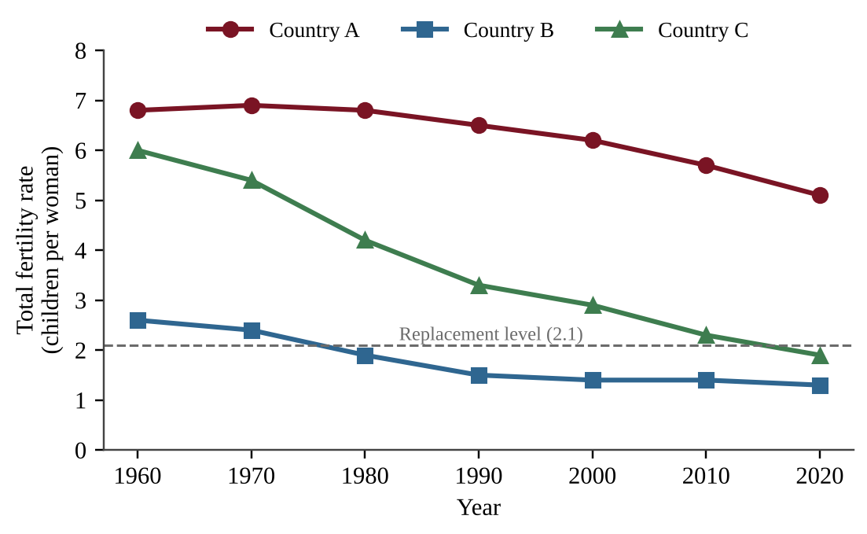
Figure — Total fertility rate of Countries A, B and C, 1960–2020
(a) Describe the trend in the TFR of Country C from 1960 to 2020. [1] (b) Calculate the annual percent population growth rate of Country A in 2020, including migration. Show your work. [1] (c) Using data for Country A, explain why its population is likely to keep growing for decades even if its TFR were to fall to replacement level soon. [2] (d) Identify the stage of the demographic transition that best describes Country A in 2020 and justify your answer with two pieces of data from the tables. [2] (e) Make a claim about which of the three countries will face the greatest difficulty supporting its older residents in the next 20 years, and justify your claim with data. [2] (f) Propose one solution that Country A could use to lower its TFR and justify it using evidence from the data. [2]

Question 3 PE3-FRQ003
A 2,500-ha ranch in a semi-arid savanna produces beef. The grass on the ranch has a net primary productivity of 3,000 kg of dry matter per hectare per year, and each kilogram of dry grass contains 16 megajoules (MJ) of energy. The ranch's grazing plan allows cattle to consume 40% of this production each year. Cattle convert 10% of the energy they eat into body tissue, and 40% of the energy in cattle body tissue is edible meat. An adult person needs about 10 MJ of food energy per day.
(a) Calculate the total energy contained in the grass produced on the ranch each year, in MJ. Show your work. [1] (b) Calculate the amount of energy stored in cattle body tissue each year, in MJ, if cattle consume the planned 40% of the grass. [2] (c) Calculate the number of people whose food energy needs for an entire year (365 days) could be met by the edible meat. [2] (d) A proposal would plow the same 2,500 ha to grow sorghum for people to eat directly. The sorghum would yield 1,000 kg per hectare per year with an energy content of 15 MJ per kilogram. Calculate the number of people it could feed for one year, and calculate how many times larger this number is than your answer to part (c). [2] (e) Each cow eats about 4,000 kg of forage per year, and the ranch currently keeps 900 cattle. Determine whether the herd exceeds the amount of forage that the grazing plan allows, and by what percent. [1] (f) Explain, in terms of energy transfer between trophic levels, why the sorghum could feed so many more people than the beef. [1] (g) Propose one management solution to prevent overgrazing on the ranch and justify your proposal. [1]

Predicted Practice Exam 4
NOTE
Format and timing (2026 AP Environmental Science). This is a complete practice exam in two sections. Section I has 80 multiple-choice questions (60% of the score) and takes 90 minutes. Section II has 3 free-response questions (40% of the score) worth 10 points each and takes 70 minutes. A scientific or four-function calculator is allowed on both sections.
Instructions. In Section I choose the one best answer for each question; there is no penalty for guessing, so answer every question. In Section II write your answers in complete sentences, show every step of each calculation with units, and use the task verbs (calculate, describe, explain, identify, justify, make a claim, propose a solution) as cues for the type of response each part requires. Answer each part in order.

Section I — Multiple-Choice Questions (80)
Question 1 PE4-MCQ001
Surveyors working at a high-latitude site describe long, dark winters, a thin seasonally thawed soil layer above permanently frozen ground, very slow decomposition, and vegetation limited to mosses, lichens, sedges, and low shrubs. Which biome are they describing?
A. Arctic tundra
B. Taiga (boreal forest)
C. Temperate grassland
D. Cold desert

Question 2 PE4-MCQ002
A river empties into a bay. In the shallow zone where fresh and salt water mix, the water is brackish and nutrient-rich, and many commercially important fish and shellfish spend their juvenile stages there. Which aquatic biome is this?
A. Coral reef
B. Lake littoral zone
C. Open-ocean pelagic zone
D. Estuary

Question 3 PE4-MCQ003
After a desert field is flood-irrigated, parts of the soil become waterlogged and oxygen-poor. Bacteria in these zones convert nitrate (NO₃⁻) in the soil into nitrogen gas (N₂), which returns to the atmosphere. Which nitrogen cycle process is this?
A. Nitrification
B. Ammonification
C. Nitrogen fixation
D. Denitrification

Question 4 PE4-MCQ004
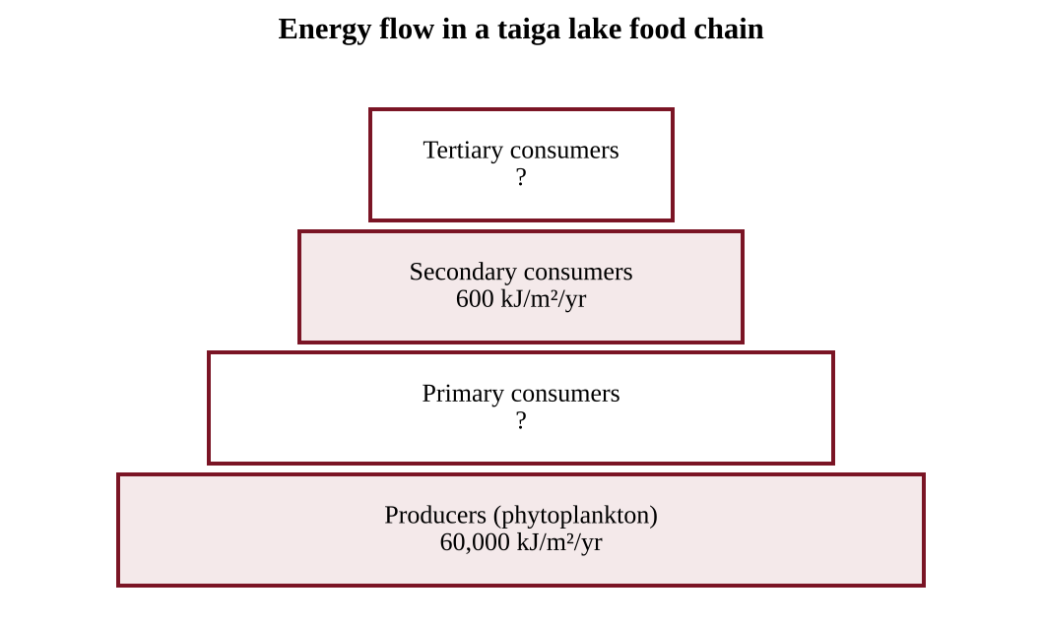
Figure — Energy flow through a food chain in a taiga lake
Assume the same percentage of energy is transferred from each trophic level to the next. What is that percentage, and how much energy reaches the tertiary consumers?
A. 10% per level; 60 kJ/m²/yr
B. 1% per level; 6 kJ/m²/yr
C. 10% per level; 6 kJ/m²/yr
D. 1% per level; 60 kJ/m²/yr

Question 5 PE4-MCQ005
A boreal forest stand has a gross primary productivity (GPP) of 1,300 g C/m²/yr, and its plants release 780 g C/m²/yr through cellular respiration. What is the net primary productivity (NPP) of the stand?
A. 520 g C/m²/yr
B. 780 g C/m²/yr
C. 1,300 g C/m²/yr
D. 2,080 g C/m²/yr

Question 6 PE4-MCQ006
Researchers measured carbon flows at a tundra site over one year. Positive GPP is carbon taken up by plants; respiration is carbon released by plants and soil microbes combined.
Season | GPP (g C/m²) | Ecosystem respiration (g C/m²)
Winter | 0 | 45
Spring | 40 | 35
Summer | 230 | 160
Fall | 60 | 80

Which conclusion is best supported by the data?
A. The site is a net carbon source of about 10 g C/m² for the year, because respiration continues in winter when there is no uptake.
B. The site is a net carbon sink of about 330 g C/m² for the year, because that is the total carbon taken up by plants.
C. The site is a small net carbon sink of about 10 g C/m² for the year, because annual GPP exceeds annual respiration.
D. The site is carbon neutral for the year, because summer uptake exactly cancels respiration in the other seasons.

Question 7 PE4-MCQ007
Along a tropical coast, dense mangrove forests absorb wave energy during storms, reducing shoreline erosion and flood damage to nearby villages. This benefit is best classified as which type of ecosystem service?
A. Provisioning
B. Cultural
C. Regulating
D. Supporting

Question 8 PE4-MCQ008
Farmer A plants a single cotton cultivar across all of her fields. Farmer B plants six cultivars that differ in disease and drought resistance. A new fungal disease sweeps through the valley. Which type of biodiversity best explains why Farmer B is less likely to lose her entire crop?
A. Species diversity
B. Genetic diversity
C. Ecosystem diversity
D. Habitat diversity

Question 9 PE4-MCQ009
Five years after a wildfire burned a section of taiga, the area is covered by fireweed, grasses, and aspen seedlings growing in the surviving soil. Which statement correctly identifies the process and the reason?
A. Primary succession, because all of the trees were removed by the fire.
B. Secondary succession, because the climax community has already returned.
C. Primary succession, because fireweed is a pioneer species.
D. Secondary succession, because soil and a seed bank remained after the disturbance.

Question 10 PE4-MCQ010
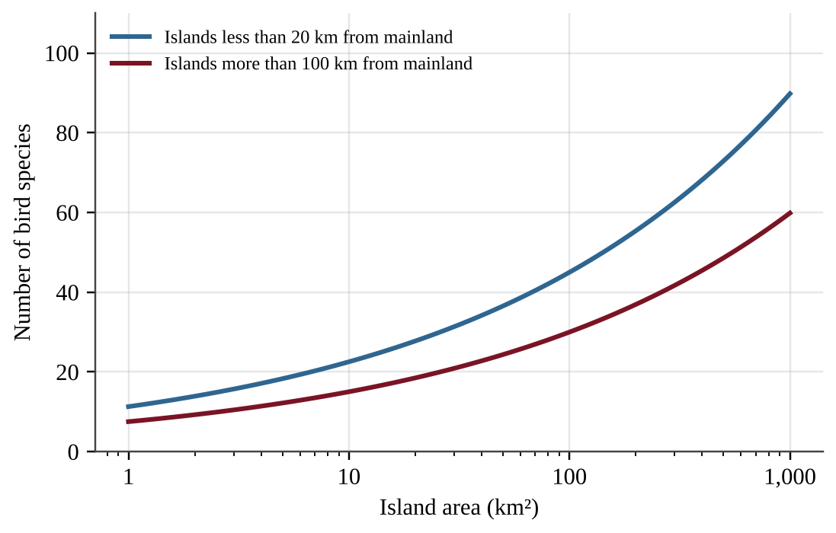
Figure — Bird species richness and island area for islands at two distances from the mainland
Island P is 100 km² and lies 12 km from the mainland. Island Q is also 100 km² but lies 150 km from the mainland. Which statement best explains the difference in bird species richness expected on the two islands?
A. Island Q should have fewer species because its isolation lowers the rate at which new species arrive.
B. Island Q should have fewer species because its small area raises the extinction rate on the island.
C. Island Q should have more species because fewer mainland competitors are able to reach it.
D. The islands should have the same richness because area alone determines the number of species.

Question 11 PE4-MCQ011
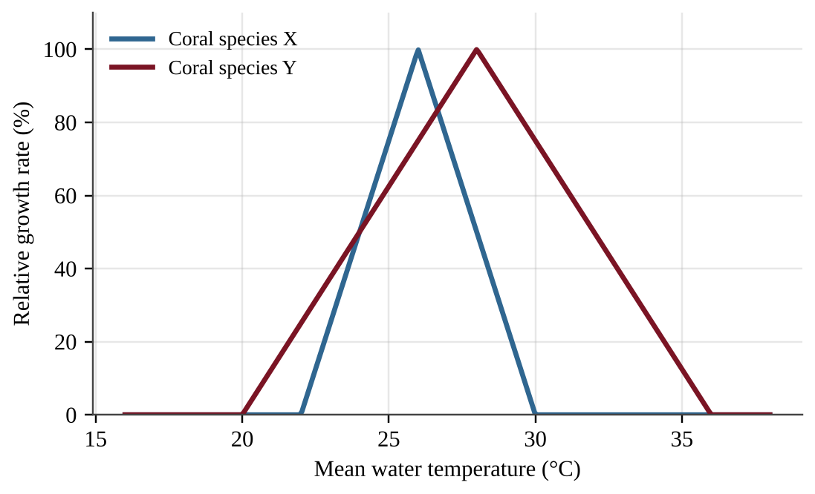
Figure — Relative growth rate of two coral species at different mean water temperatures
A lagoon currently has a mean water temperature of 28°C. Because of ocean warming, the mean temperature rises to 31°C. Based on the figure, which prediction for the lagoon's coral community is best supported?
A. Species Y will persist with reduced growth, but species X will exceed its tolerance range and decline.
B. Both species will grow faster because higher temperatures increase metabolic rates in coral tissue.
C. Species X will persist because it is a specialist adapted to warm water, while species Y will decline.
D. Both species will stop growing because 31°C is above the upper tolerance limit of each species.

Question 12 PE4-MCQ012
Caribou in northern taiga feed almost entirely on ground lichens that grow in old, undisturbed forest. Coyotes in the same region eat rodents, birds, berries, and carrion. If wildfires destroy much of the lichen-rich forest, which prediction is best supported?
A. Coyotes will be affected more because generalists need a single habitat.
B. Caribou will be affected more because they are specialists with a narrow niche.
C. Both species will be affected equally because both depend on the forest.
D. Neither species will be affected because wildfires are natural events.

Question 13 PE4-MCQ013
After each pesticide spray, a spider mite population on a cotton farm rebounds within weeks. Mites mature in days, lay hundreds of eggs, and give no parental care. Which statement describes this species and the reason for the rebound?
A. It is r-selected, and it lives near carrying capacity where competition is intense.
B. It is K-selected, and its offspring survive well because of parental care.
C. It is r-selected, and its high reproductive rate allows rapid population recovery.
D. It is K-selected, and its long life span lets the population recover slowly.

Question 14 PE4-MCQ014
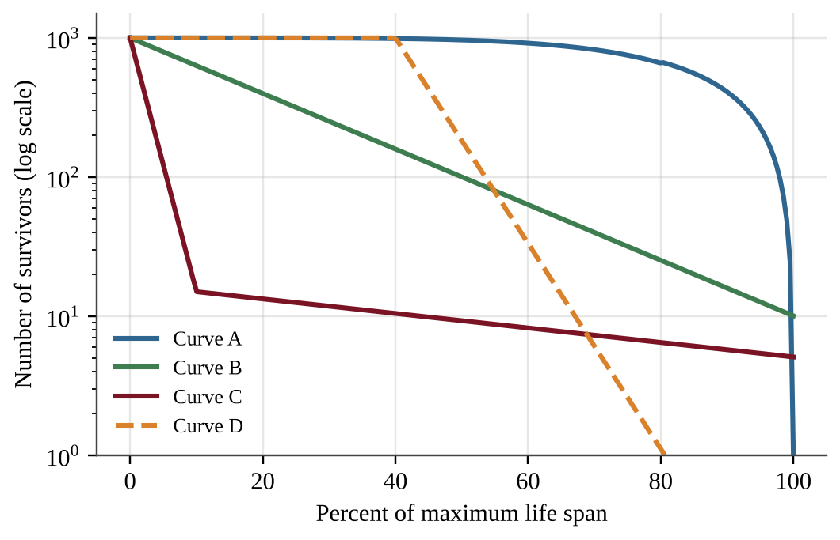
Figure — Survivorship curves for four hypothetical species
A broadcast-spawning reef coral releases millions of larvae each year. Most larvae die within days, but the few that settle and survive can live for decades. Which curve in the figure best represents this pattern?
A. Curve A
B. Curve B
C. Curve C
D. Curve D

Question 15 PE4-MCQ015
In one year a country of 5,000,000 people recorded 110,000 births, 40,000 deaths, 20,000 immigrants, and 10,000 emigrants. What was the population growth rate for the year?
A. 0.8%
B. 1.2%
C. 1.4%
D. 1.6%

Question 16 PE4-MCQ016
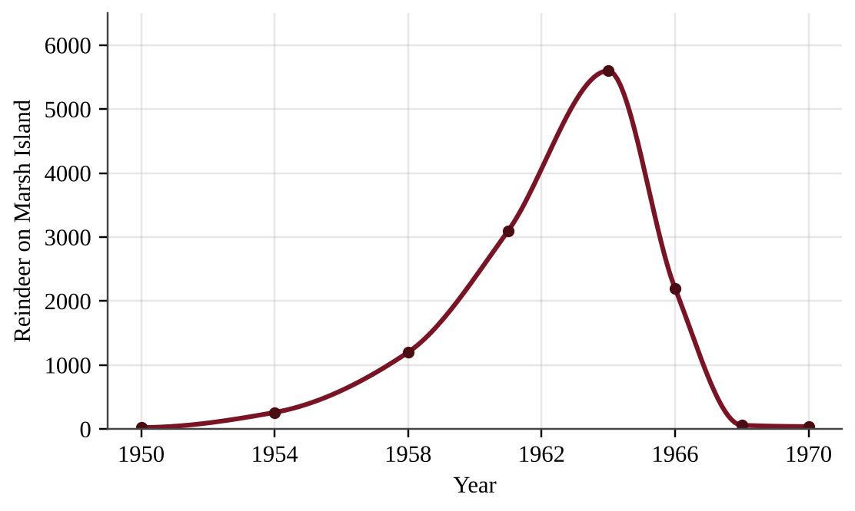
Figure — Population of reindeer introduced to an island with no predators
In 1950, 25 reindeer were introduced to a 300 km² Arctic island that has no predators. Which statement best explains the decline in the population between 1964 and 1968?
A. Predators colonized the island and killed most of the herd within a few years.
B. The carrying capacity of the island increased, so the population adjusted downward to match.
C. The herd overshot the carrying capacity, depleted its lichen, and the capacity then fell.
D. Birth rates rose sharply after 1964, which caused density-independent mortality to increase.

Question 17 PE4-MCQ017
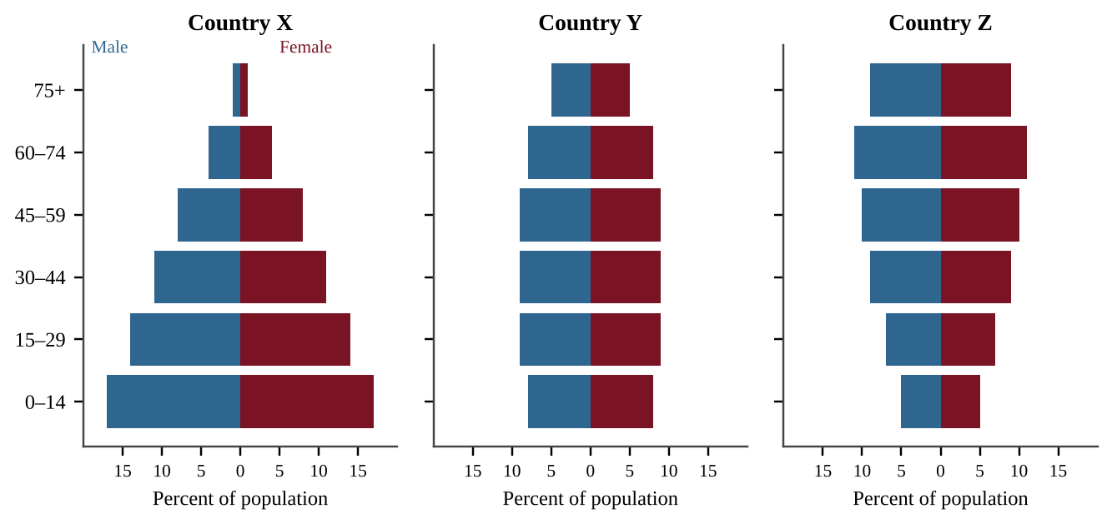
Figure — Age-structure diagrams for three countries
Even if the total fertility rate fell to the replacement level immediately in all three countries, which country would most likely continue to add the most people over the next 30 years?
A. Country Y, because its evenly distributed age groups produce the fastest growth.
B. Country X, because its large group under age 15 will soon reach reproductive age.
C. Country Z, because its large group of older adults will produce more children.
D. All three equally, because replacement fertility stops growth immediately in every country.

Question 18 PE4-MCQ018
A country tracked its total fertility rate (TFR) and the percentage of women who had completed secondary school.
Year | TFR (children per woman) | Women with secondary education (%)
1990 | 5.2 | 12
2000 | 4.1 | 28
2010 | 3.0 | 47
2020 | 2.2 | 65

Which statement is best supported by the data? (Replacement-level fertility is about 2.1.)
A. As the percentage of educated women increased, the TFR decreased, showing an association between the two variables.
B. The increase in women's education caused the TFR to fall, because the two changed together.
C. The TFR has been above 4 throughout the period, so the country is far from replacement level.
D. By 2020 the TFR was below replacement level, so the population is already declining.

Question 19 PE4-MCQ019
A country has had a total fertility rate of about 1.3 for several decades and has little immigration. Which outcome is most likely if this pattern continues?
A. The population will double within the next two decades because of momentum.
B. The proportion of children will rise, causing overcrowded schools in most cities.
C. The country will move back to stage 2 of the demographic transition.
D. The share of older adults will rise as the working-age group shrinks.

Question 20 PE4-MCQ020
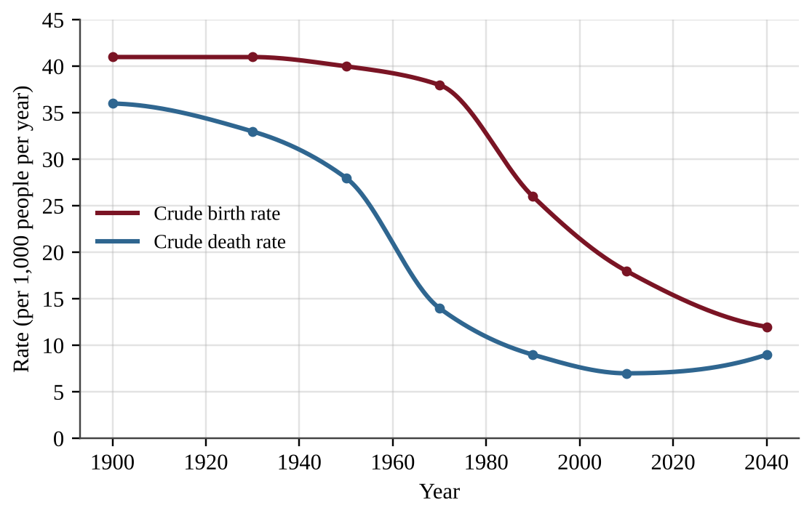
Figure — Birth and death rates in a country, 1900–2040 (2040 values projected)
According to the graph, what was the annual rate of natural increase in 1970, and approximately how long would it take the population to double at that rate (rule of 70)?
A. 2.4%; about 29 years
B. 5.2%; about 13 years
C. 0.24%; about 290 years
D. 2.4%; about 170 years

Question 21 PE4-MCQ021
Researchers measured per capita birth and death rates in a deer population at five densities.
Density (deer per km²) | Births per deer per year | Deaths per deer per year
2 | 0.52 | 0.10
4 | 0.44 | 0.16
6 | 0.36 | 0.22
8 | 0.28 | 0.28
10 | 0.20 | 0.34

A drought reduces food and raises the death rate by 0.07 deaths per deer per year at every density, while birth rates are unchanged. Assuming the trends in the table are linear, what is the new carrying capacity?
A. 8 deer per km²
B. 7 deer per km²
C. 6 deer per km²
D. 5 deer per km²

Question 22 PE4-MCQ022
Along the western coast of South America, a dense oceanic plate slides beneath the continental plate. Which set of features is most likely to be found there?
A. A deep trench with a volcanic arc and frequent earthquakes
B. A mid-ocean ridge where new oceanic crust forms from rising magma
C. A continental rift valley where the crust is stretched and pulled apart
D. A transform fault with horizontal sliding motion and no volcanism

Question 23 PE4-MCQ023
In a desert valley, native shrubs were removed to plant cotton, leaving bare soil between rows during the windy season. Which result is most likely?
A. Increased wind and water erosion of topsoil
B. Faster formation of new soil horizons
C. Greater accumulation of organic matter in the topsoil
D. Increased infiltration and reduced runoff

Question 24 PE4-MCQ024
A farmer in a desert valley irrigates a sandy soil and a clay soil with the same volume of water. Which statement correctly describes the sandy soil?
A. It has low permeability and high water-holding capacity, so the water stays near the surface.
B. It has high permeability and high water-holding capacity, so it is ideal for crops.
C. It has low permeability and low water-holding capacity, so the water runs off.
D. It has high permeability and low water-holding capacity, so the water drains quickly.

Question 25 PE4-MCQ025
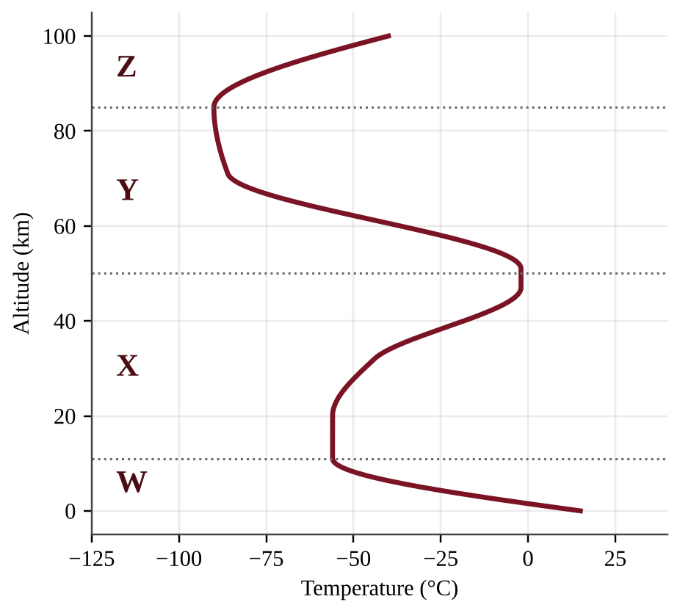
Figure — Temperature profile of Earth's atmosphere
Which layer contains most of the ozone that absorbs harmful ultraviolet radiation, and why does temperature increase with altitude in the upper part of that layer?
A. Layer W; ozone produced from pollution absorbs infrared radiation.
B. Layer Y; greenhouse gases trap heat that rises from the surface.
C. Layer X; heat radiating from Earth's surface warms the air higher up.
D. Layer X; ozone absorbs ultraviolet radiation and converts it to heat.

Question 26 PE4-MCQ026
Many of the world's largest deserts lie near 30° north and 30° south latitude. Which statement best explains this pattern?
A. Air rising near 30° cools and condenses, but the ocean there is too cold to supply moisture.
B. Polar easterlies carry cold, dry air from the poles to 30° latitude.
C. Sunlight is most intense at 30° latitude, evaporating nearly all of the available water.
D. Moist air rises at the equator, loses its water, and descends near 30°, drying the land below.

Question 27 PE4-MCQ027
A student compares the drainage of two desert soils. She pours 250 mL of water onto 200 g of soil A in a wide funnel and 250 mL onto 400 g of soil B in a narrow funnel, then records the volume of water collected after 5 minutes. Which change would most improve the validity of the comparison?
A. Use equal masses of soil in identical funnels for both soils.
B. Use more water for the soil that appears to contain more clay.
C. Record the volume collected after different times for each soil.
D. Repeat the test several times with soil A only.

Question 28 PE4-MCQ028
Sunlight reaching the Arctic surface delivers 200 W/m². Sea ice has an albedo of 0.85, and open ocean has an albedo of 0.07. When the ice melts and exposes open water, how much more solar energy is absorbed per square meter?
A. 14 W/m²
B. 30 W/m²
C. 156 W/m²
D. 170 W/m²

Question 29 PE4-MCQ029
A desert lies on the leeward (downwind) side of a mountain range. Moist winds blow in from the ocean on the opposite side. Which sequence best explains the desert?
A. Air descends on the windward side, warms and absorbs moisture, then rises and cools on the leeward side.
B. Air rises on the windward side, cools and drops precipitation, then descends and warms on the leeward side.
C. Air rises on the leeward side, drops its precipitation, and flows toward the ocean.
D. Air is forced upward on both sides of the mountains, so both sides receive equal precipitation.

Question 30 PE4-MCQ030
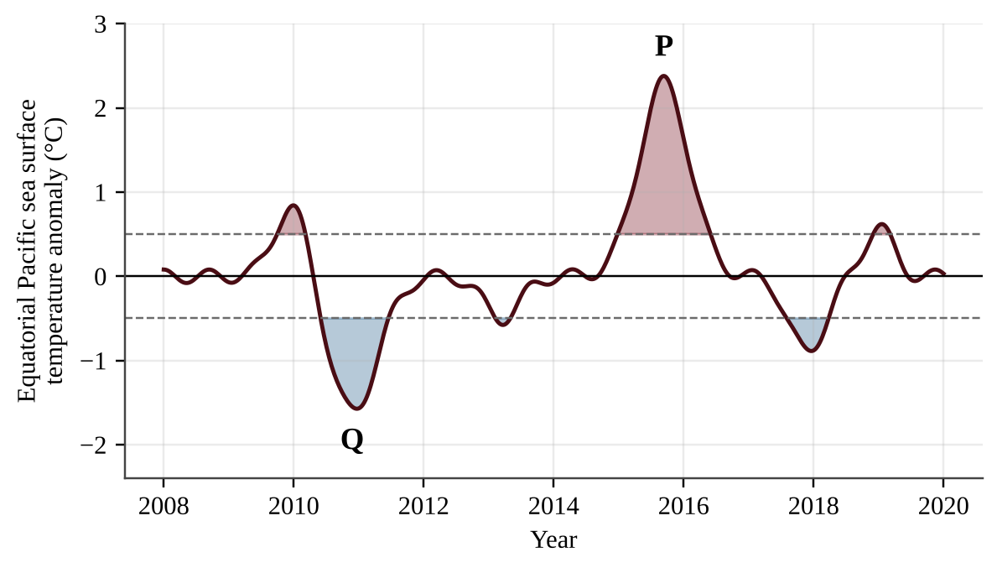
Figure — Equatorial Pacific sea surface temperature anomaly, 2008–2020
Which statement best describes the conditions most likely present near point P compared with normal conditions?
A. Strengthened trade winds, increased upwelling off South America, more anchovies, and drought in coastal Peru
B. Weakened trade winds, increased upwelling off South America, more anchovies, and drought in coastal Peru
C. Strengthened trade winds, reduced upwelling off South America, fewer anchovies, and heavy rain in coastal Peru
D. Weakened trade winds, reduced upwelling off South America, fewer anchovies, and heavy rain in coastal Peru

Question 31 PE4-MCQ031
A desert river watershed has an area of 25 km² and receives 600 mm of precipitation per year. About 30% of the precipitation becomes surface runoff that carries fertilizer and pesticide residues toward a reservoir. What is the annual runoff volume? (1 km² = 10⁶ m²; 1 m = 1,000 mm)
A. 4.5 × 10³ m³
B. 4.5 × 10⁶ m³
C. 1.5 × 10⁷ m³
D. 4.5 × 10⁹ m³

Question 32 PE4-MCQ032
Fishing boats from many villages harvest a shared, unregulated coastal fishery. Each fisher receives the full profit from each additional fish caught, but the cost of a declining fish population is shared by everyone. Which concept best explains the likely outcome?
A. Maximum sustainable yield
B. Tragedy of the commons
C. Ecological footprint
D. Green Revolution

Question 33 PE4-MCQ033
Which of the following is a negative environmental consequence associated with the Green Revolution's high-yield, irrigated monocultures?
A. Greater water withdrawal and fertilizer runoff
B. Reduced soil salinization in irrigated arid regions
C. Greater genetic diversity among the crop varieties grown
D. Lower fossil fuel use per hectare of farmland

Question 34 PE4-MCQ034
Farmers in an arid valley irrigate heavily for many decades. Crop yields decline, and a white crust appears on the soil surface. Which process is the most likely cause?
A. Acid deposition from nearby power plants
B. Eutrophication of the soil from excess nitrogen
C. Leaching of calcium from the topsoil by heavy rain
D. Salinization as evaporation leaves dissolved salts behind

Question 35 PE4-MCQ035
Which of the following is the best example of integrated pest management (IPM)?
A. Spraying a broad-spectrum pesticide on a fixed 10-day schedule all season long
B. Switching to a different synthetic pesticide each year but spraying every field at planting time
C. Applying a single heavy dose of pesticide before planting to eliminate all pests for the season
D. Scouting fields, setting pheromone traps, releasing beneficial insects, and spraying only above an economic threshold

Question 36 PE4-MCQ036
The table lists the ecological footprint and biocapacity of four countries in global hectares (gha) per person.
Country | Footprint (gha/person) | Biocapacity (gha/person)
P | 2.1 | 4.8
Q | 5.6 | 1.9
R | 3.0 | 3.0
S | 1.2 | 0.8

Which statement is best supported by the data?
A. Country P has the largest ecological deficit because it has the greatest biocapacity.
B. Country Q has the largest deficit, using 3.7 gha per person more than its land regenerates.
C. Country R is running a deficit of 3.0 gha per person because its footprint is 3.0.
D. Country S is sustainable because it has the smallest footprint of the four countries.

Question 37 PE4-MCQ037
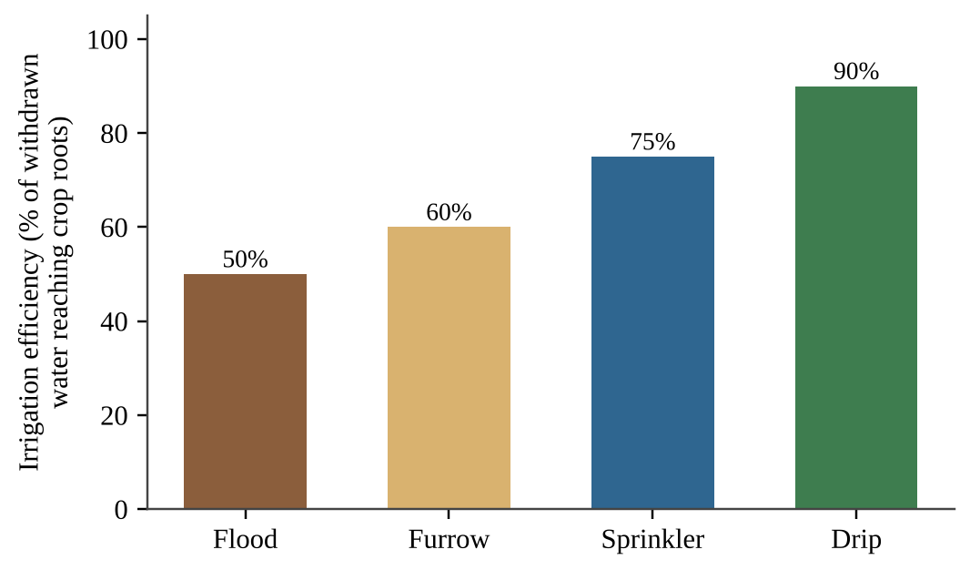
Figure — Efficiency of four irrigation methods
A desert farm needs 4,500 m³ of water per hectare to reach crop roots each season. If the farm switches from flood irrigation to drip irrigation, how much less water must be withdrawn per hectare?
A. 1,800 m³
B. 4,000 m³
C. 5,000 m³
D. 9,000 m³

Question 38 PE4-MCQ038
A coastal fishery recorded the following data.
Year | Total catch (tonnes) | Fishing boats
2000 | 90,000 | 150
2010 | 95,000 | 300
2020 | 70,000 | 450

Which conclusion is best supported?
A. Total catch increased every decade, so fish stocks are healthy and can support more boats.
B. Catch per boat increased because more boats were fishing, so each boat became more efficient.
C. Catch per boat fell from 600 to about 156 tonnes as boats tripled, consistent with overfishing.
D. The decline in total catch in 2020 shows that fishing effort was too low to sustain the fleet.

Question 39 PE4-MCQ039
A desert city experiences street flooding during short, intense monsoon storms because most surfaces are paved. Which action would most directly reduce peak runoff?
A. Replace parking-lot asphalt with permeable pavement and build retention basins
B. Widen storm drains so water reaches the river faster and street flooding ends
C. Pave additional vacant lots so more surface area directs water to drains
D. Spread road salt to melt standing water after storms

Question 40 PE4-MCQ040
A salmon farm produces 200,000 kg of fish per year. Its feed conversion ratio is 1.3 kg of feed per kg of salmon, the feed is 30% fishmeal by mass, and each kg of fishmeal requires 4.5 kg of wild-caught forage fish. How many kilograms of wild forage fish are needed per year?
A. 78,000 kg
B. 260,000 kg
C. 351,000 kg
D. 1,170,000 kg

Question 41 PE4-MCQ041
A pest population of 2,000,000 insects contains 0.1% individuals that carry a gene for resistance to an insecticide. A spray kills 99% of the susceptible insects and none of the resistant insects. What percentage of the survivors is resistant?
A. 0.1%
B. 1%
C. 9.1%
D. 50%

Question 42 PE4-MCQ042
Which list contains only nonrenewable energy resources?
A. Coal, geothermal heat, oil
B. Natural gas, uranium, wood from managed forests
C. Coal, natural gas, uranium
D. Oil, hydropower, uranium

Question 43 PE4-MCQ043
A county in a desert region proposes to meet part of its transportation fuel needs with ethanol made from irrigated corn. Which is a potential disadvantage of this plan?
A. Cropland and irrigation water may shift from food to fuel.
B. Burning ethanol releases radioactive waste that must be stored for centuries.
C. Corn plants cannot absorb CO₂ from the atmosphere during photosynthesis.
D. Ethanol contains no usable energy compared with gasoline or diesel.

Question 44 PE4-MCQ044
A city bus is powered by a hydrogen fuel cell. Which substance is the only emission from its tailpipe?
A. Carbon dioxide and water vapor
B. Nitrogen oxides
C. Water vapor
D. Fine particulate matter

Question 45 PE4-MCQ045
Which statement correctly describes electricity generation at a nuclear fission power plant?
A. Fusion of hydrogen nuclei releases heat to make steam; the waste is harmless within a few decades.
B. Fission of uranium-235 makes steam; it emits little CO₂, but spent fuel stays radioactive for millennia.
C. Burning uranium releases about as much CO₂ per kWh as burning coal does.
D. Splitting uranium atoms produces electricity directly without a steam cycle or cooling water.

Question 46 PE4-MCQ046
A natural gas power plant uses fuel containing 9.0 × 10⁹ kJ of energy per hour and delivers 3.6 × 10⁹ kJ of electricity per hour. What is its efficiency, and how much energy is released as waste heat each hour?
A. 40%; 3.6 × 10⁹ kJ
B. 60%; 5.4 × 10⁹ kJ
C. 60%; 3.6 × 10⁹ kJ
D. 40%; 5.4 × 10⁹ kJ

Question 47 PE4-MCQ047
A 50-MW solar photovoltaic farm in a desert has a capacity factor of 30%. About how much electricity does it generate in a year of 8,760 hours?
A. 13,140 MWh
B. 131,400 MWh
C. 219,000 MWh
D. 438,000 MWh

Question 48 PE4-MCQ048
A school replaces 200 incandescent bulbs (60 W each) with LED bulbs (9 W each). Each bulb is on 8 hours a day for 180 days a year. How much electrical energy does the school save per year?
A. 29,784 kWh
B. 17,280 kWh
C. 14,688 kWh
D. 2,592 kWh

Question 49 PE4-MCQ049
Hydrogen is an energy carrier rather than a primary energy source, so its climate benefit depends on how it is produced. Which production method has the lowest net CO₂ emissions?
A. Steam reforming of natural gas with the CO₂ vented to the air
B. Electrolysis of water using electricity from wind and solar farms
C. Electrolysis of water using electricity from a coal-fired plant
D. Gasification of coal to produce a hydrogen-rich gas

Question 50 PE4-MCQ050
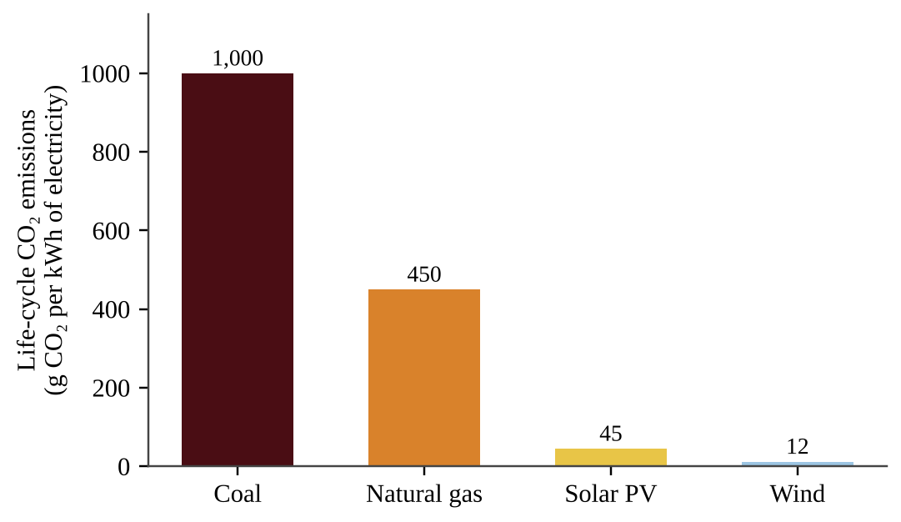
Figure — Life-cycle CO₂ emissions per kWh for four electricity sources
A utility replaces 2,000 GWh of coal-fired electricity per year with natural gas generation. (1 GWh = 10⁶ kWh; 1 metric ton = 10⁶ g.) Approximately how much CO₂ is avoided each year?
A. 1.1 × 10³ metric tons
B. 9.0 × 10⁵ metric tons
C. 1.1 × 10⁶ metric tons
D. 2.0 × 10⁶ metric tons

Question 51 PE4-MCQ051
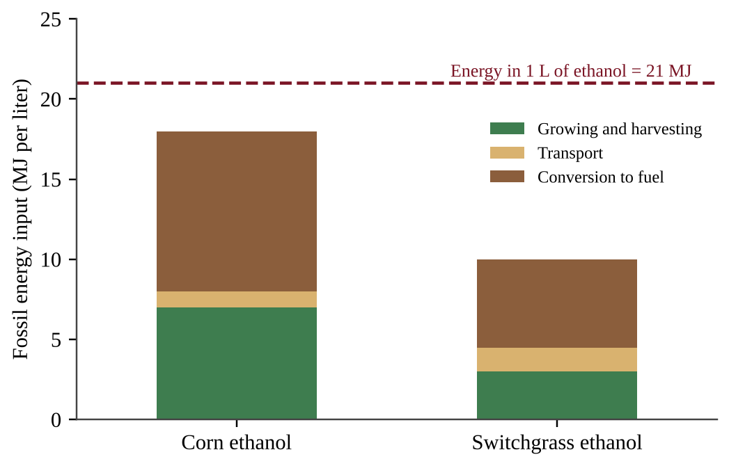
Figure — Fossil energy used to produce one liter of ethanol from two feedstocks
Net energy equals the energy contained in the fuel minus the fossil energy used to make it. Which conclusion is supported by the figure?
A. Corn ethanol provides about 1.8 times as much net energy per liter as switchgrass ethanol.
B. Both fuels provide the same net energy because each liter contains 21 MJ.
C. Switchgrass ethanol provides about 2.1 times as much net energy per liter as corn ethanol.
D. Switchgrass ethanol provides about 3.7 times as much net energy per liter as corn ethanol.

Question 52 PE4-MCQ052
Ground-level ozone is not emitted directly by vehicle tailpipes. It forms in the air when nitrogen oxides and volatile organic compounds react in sunlight. How should ground-level ozone be classified?
A. Secondary pollutant
B. Primary pollutant
C. Particulate pollutant
D. Persistent organic pollutant

Question 53 PE4-MCQ053
Which pair of air pollutants is primarily responsible for acid deposition?
A. Carbon dioxide and methane
B. Carbon monoxide and ozone
C. Chlorofluorocarbons and halons
D. Sulfur dioxide and nitrogen oxides

Question 54 PE4-MCQ054
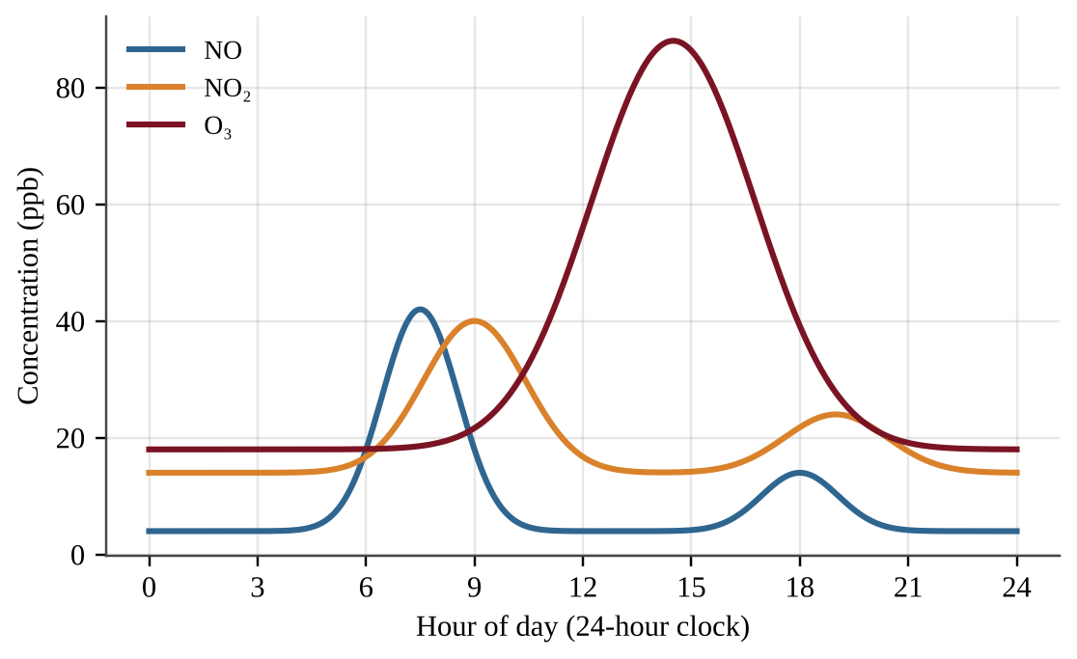
Figure — Concentrations of three pollutants in a city over one day
Which statement best explains why the ozone peak occurs in the early afternoon rather than during the morning rush hour?
A. Vehicles emit ozone directly, and traffic emissions of ozone peak in the afternoon.
B. Ozone is produced only after the NO₂ concentration has fallen to zero in the afternoon.
C. Sunlight-driven reactions of NO₂ and VOCs take hours to build ozone, and NO removes ozone in the morning.
D. Cooler afternoon air lets ozone persist near the ground instead of breaking down.

Question 55 PE4-MCQ055
In winter, a basin city sits under a layer of warm air that lies above colder air at the surface. Smog accumulates over several days. Which statement best explains why pollutants accumulate?
A. Cold surface air rises quickly and carries pollutants into the stratosphere.
B. Strong winter sunlight causes the pollutants to react faster than they are emitted.
C. Warm surface air spreads the pollutants evenly through the troposphere.
D. The warm layer above stops vertical mixing, trapping pollutants.

Question 56 PE4-MCQ056
Smoke from a large boreal wildfire raises the concentration of PM2.5 in a city 800 km away. Why is PM2.5 especially hazardous to human health?
A. The particles are large enough to be trapped easily by nose hairs.
B. The particles are radioactive and cause cancer within hours.
C. The particles convert to ozone in the stratosphere and thin the ozone layer.
D. The particles are small enough to reach deep into the lungs.

Question 57 PE4-MCQ057
A homeowner finds that the basement radon level is 6 pCi/L, above the recommended action level of 4 pCi/L. Radon is a radioactive gas produced by the decay of uranium in soil and rock. Which action is the most effective way to lower the level?
A. Seal foundation cracks and vent soil gas from beneath the slab with a pipe and fan
B. Install a carbon monoxide detector and test it every month in the basement
C. Place an ozone generator in the basement and run it whenever the room is occupied
D. Replace the gas stove with an electric stove and ventilate the kitchen

Question 58 PE4-MCQ058
A coal-fired plant burns 2.0 × 10⁶ metric tons of coal per year. The coal is 1.5% sulfur by mass, and each metric ton of sulfur burned forms 2.0 metric tons of SO₂. A scrubber removes 92% of the SO₂. How many metric tons of SO₂ does the plant emit per year?
A. 2,400 metric tons
B. 4,800 metric tons
C. 55,200 metric tons
D. 60,000 metric tons

Question 59 PE4-MCQ059
Fertilizer runoff enters a shallow lake. Which sequence best describes the resulting eutrophication?
A. Excess nutrients → algal bloom → decomposition of dead algae by aerobic bacteria → low dissolved oxygen
B. Excess nutrients → higher dissolved oxygen → growth of fish populations → decline in algae
C. Warm water inflow → decrease in algae → increased dissolved oxygen → fish kill
D. Excess nutrients → algal bloom → more sunlight reaches submerged plants → higher dissolved oxygen

Question 60 PE4-MCQ060
A county wants to reduce the volume of solid waste sent to its landfill. Which of the following is an example of source reduction, the preferred waste management strategy?
A. Placing recycling bins on every street corner of the city
B. Collecting yard waste at the curb for composting at a central facility
C. Burning trash in an incinerator that generates electricity for the grid
D. Requiring product designs that use less packaging

Question 61 PE4-MCQ061
In ponds near irrigated fields, male frogs exposed to a herbicide in the water develop ovarian tissue. Which statement best describes how a chemical can cause this kind of effect?
A. It destroys the immune cells that protect the frogs from infectious disease.
B. It acidifies the pond water until the frogs' bones begin to dissolve.
C. It only has effects at doses well above the LD50 for the species.
D. It interferes with hormone signaling in the endocrine system, even at very low doses.

Question 62 PE4-MCQ062
Insecticide A has an LD50 of 12 mg/kg in rats, and insecticide B has an LD50 of 480 mg/kg in rats. Which statement is correct?
A. B is 40 times more toxic than A, because B has the larger LD50 value.
B. The two are equally toxic because each one kills 50% of the animals at its own LD50.
C. A is 40 times more toxic than B, because one-fortieth of the dose kills half of the test animals.
D. A is 468 times more toxic than B because the LD50 values differ by 468 mg/kg.

Question 63 PE4-MCQ063
A persistent organic pollutant was measured in tissues of organisms in a lake food chain.
Organism | Concentration (µg/kg of tissue)
Zooplankton | 5
Small fish | 40
Lake trout | 320
Osprey | 4,000

By what factor did the concentration increase from zooplankton to osprey?
A. 3,995
B. 800
C. 12.5
D. 8

Question 64 PE4-MCQ064
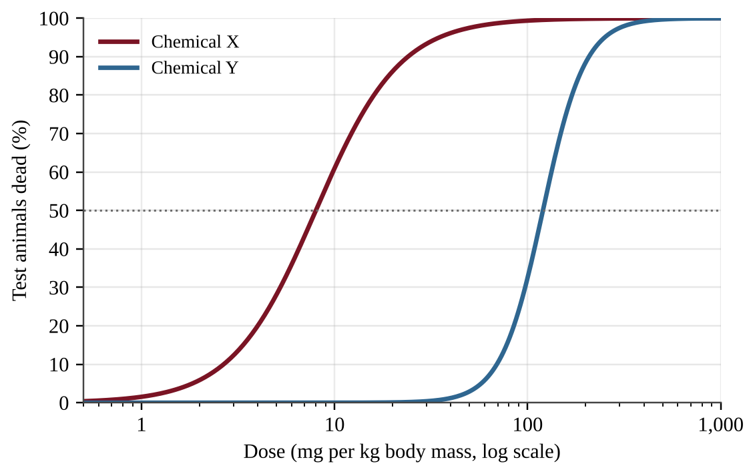
Figure — Percentage of test animals that died after exposure to two chemicals
Which interpretation of the dose-response curves is best supported by the figure?
A. Chemical X is about 15 times more toxic than Chemical Y, based on LD50 values of about 8 and 120 mg/kg.
B. Chemical Y is more toxic than Chemical X because its dose-response curve is steeper.
C. The chemicals are equally toxic because both curves eventually reach 50% mortality.
D. Chemical Y is about 15 times more toxic than Chemical X because its LD50 is larger.

Question 65 PE4-MCQ065
A city generates 600,000 metric tons of municipal solid waste per year. Of this, 28% is recycled, 12% is composted, and 10% is incinerated (ignore ash). The rest is landfilled at a compacted density of 0.75 metric tons per m³. A landfill has 12 million m³ of remaining capacity. About how many years until it is full?
A. 40 years
B. 30 years
C. 25 years
D. 15 years

Question 66 PE4-MCQ066
Which group of human-made compounds is the primary cause of the thinning of the stratospheric ozone layer?
A. Chlorofluorocarbons (CFCs)
B. Sulfur dioxide and nitrogen oxides
C. Carbon dioxide and methane
D. Volatile organic compounds

Question 67 PE4-MCQ067
Which statement best describes the greenhouse effect?
A. Greenhouse gases reflect incoming visible sunlight back to space, cooling the surface.
B. Greenhouse gases create gaps in the atmosphere that let more ultraviolet radiation reach the surface.
C. Gases such as CO₂ absorb infrared radiation from the surface and re-emit some of it downward.
D. Greenhouse gases absorb ultraviolet radiation in the stratosphere and radiate it to the ground.

Question 68 PE4-MCQ068
Global mean sea level is rising as the climate warms. Which two processes contribute most to this rise?
A. Thermal expansion of warming seawater and melting of glaciers and ice sheets on land
B. Thermal expansion of seawater and melting of floating Arctic sea ice in summer
C. Increased evaporation from the ocean and melting of floating sea ice
D. Melting of floating sea ice and increased river runoff into the sea

Question 69 PE4-MCQ069
Which set of characteristics makes a nonnative species most likely to become invasive?
A. Slow reproduction, a narrow diet, and many natural predators in the new range
B. Rapid reproduction, tolerance of many conditions, and no natural predators or pathogens in the new range
C. A few offspring with extensive parental care and a requirement for a single host plant
D. A narrow tolerance range and dependence on stable, undisturbed habitat

Question 70 PE4-MCQ070
The Montreal Protocol phased out the production of ozone-depleting substances, but the Antarctic ozone layer is expected to take decades to recover. Which statement best explains this delay?
A. CFCs persist in the atmosphere for decades, so chlorine continues to be released in the stratosphere.
B. Countries continue to produce CFCs at the same rates as before the agreement was signed.
C. The replacement compounds destroy ozone faster than the CFCs they replaced did.
D. Ozone formation requires carbon dioxide levels to decline before the layer can recover.

Question 71 PE4-MCQ071
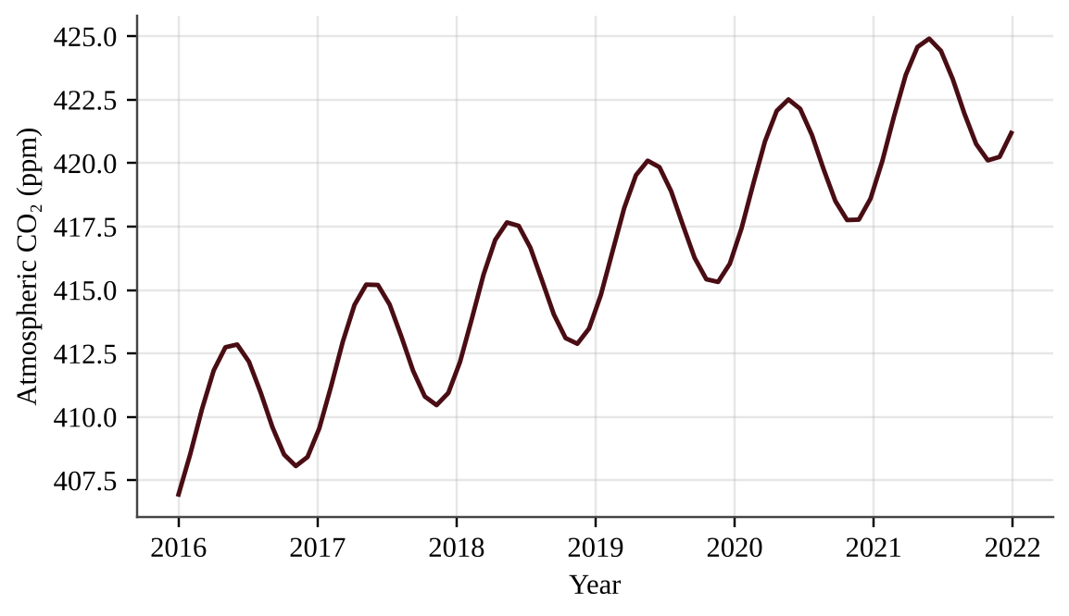
Figure — Monthly atmospheric CO₂ concentration at a Northern Hemisphere monitoring station
Which statement best explains the regular yearly rise and fall superimposed on the long-term trend?
A. Fossil fuel combustion occurs only during the winter heating season in northern countries.
B. Northern plants absorb CO₂ in the growing season, and respiration and decay return it in winter.
C. Volcanic eruptions follow a regular annual schedule that peaks each spring.
D. The ocean releases CO₂ only in summer and absorbs CO₂ only in winter each year.

Question 72 PE4-MCQ072
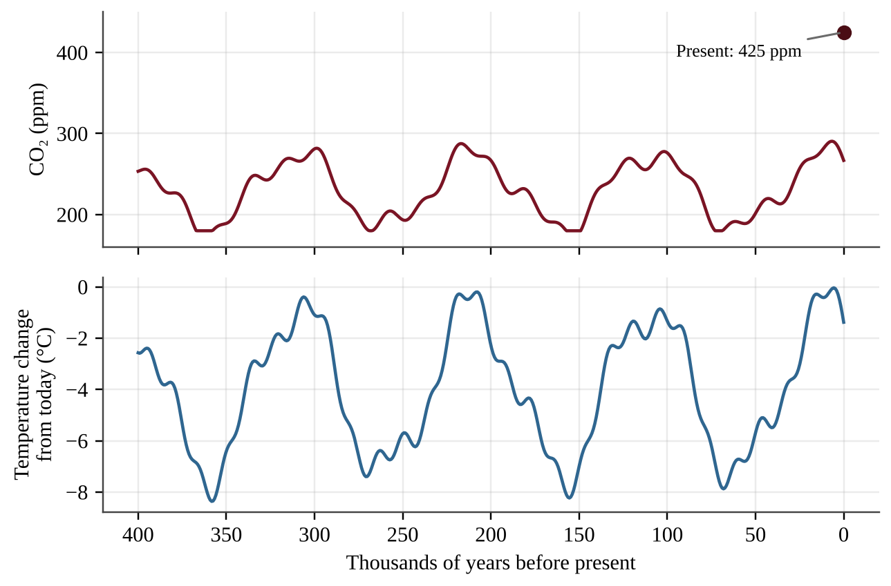
Figure — Atmospheric CO₂ and temperature change estimated from ice cores, and present-day CO₂
Which conclusion is best supported by the figure?
A. CO₂ concentration has always risen before temperature during each warming period shown in the record.
B. Warmer periods coincided with higher CO₂, and present-day CO₂ is far above the range of the ice-core record.
C. The present CO₂ concentration lies within the natural range of the past 400,000 years.
D. Temperature changes in the record were caused only by changes in atmospheric CO₂ concentration.

Question 73 PE4-MCQ073
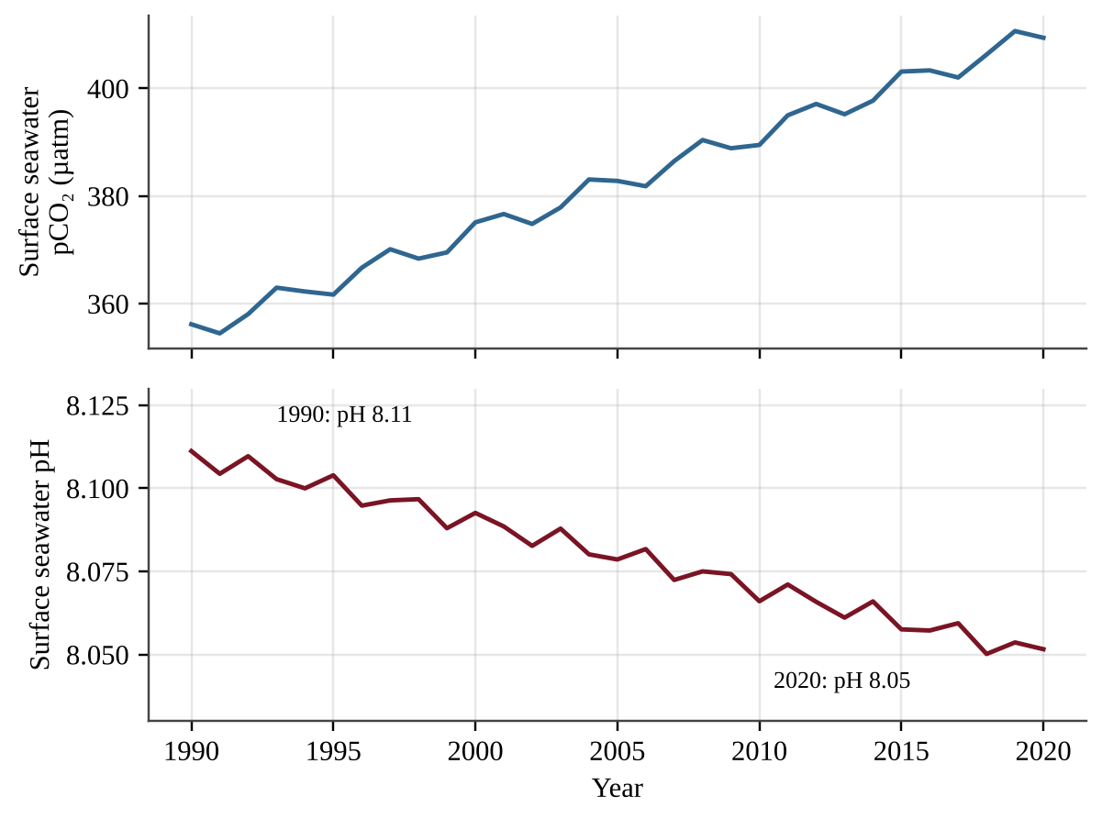
Figure — Surface seawater pCO₂ and pH at an ocean monitoring station, 1990–2020
Because pH is a logarithmic scale, a change of 1 pH unit corresponds to a tenfold change in hydrogen ion concentration. By approximately what percentage did the hydrogen ion concentration increase from 1990 to 2020?
A. 0.7%
B. 6%
C. 15%
D. 60%

Question 74 PE4-MCQ074
During a marine heat wave, the corals on a reef turn white. Which statement best explains coral bleaching?
A. Rising ocean pH dissolves the corals' calcium carbonate skeletons and exposes the white rock beneath.
B. Excess nutrients cause algae to overgrow the coral and bleach its tissue with chlorine.
C. Heat stress makes corals expel their symbiotic algae, leaving transparent tissue and cutting off much of their food supply.
D. Ultraviolet radiation from a thinner ozone layer directly burns the coral tissue and removes pigment.

Question 75 PE4-MCQ075
An international agreement in which more than 180 nations regulate or ban trade in listed species and their products, such as elephant ivory and certain tropical hardwoods, is called which of the following?
A. The U.S. Endangered Species Act
B. The Montreal Protocol
C. The Kyoto Protocol
D. CITES

Question 76 PE4-MCQ076
A pipeline corridor and access road cut through intact taiga, dividing a large forest into smaller patches. Which effect is most likely for an interior-forest species such as the American marten?
A. Increased interior habitat, which lets populations grow larger over time
B. Higher genetic diversity because isolated populations can no longer interbreed
C. Reduced competition from generalist species that avoid the forest edges
D. Less habitat area and more edge effects, isolating populations and limiting gene flow

Question 77 PE4-MCQ077
Thawing permafrost in a region releases 5,000 metric tons of methane (CH₄) per year. Methane has a 100-year global warming potential of 28 relative to CO₂. What is the annual release in CO₂ equivalents?
A. 179 metric tons
B. 5,028 metric tons
C. 140,000 metric tons
D. 1,400,000 metric tons

Question 78 PE4-MCQ078
A country emitted 480 million metric tons (Mt) of CO₂e in 2015 and has pledged to reach 30% below its 2015 level by 2035. Emissions in 2025 were 440 Mt. What average annual reduction is needed from 2025 to 2035 to meet the pledge?
A. 5.2 Mt per year
B. 10.4 Mt per year
C. 13.2 Mt per year
D. 14.4 Mt per year

Question 79 PE4-MCQ079
Which of the following responses to Arctic warming is a negative feedback that slows further warming?
A. Thawing permafrost releases methane and CO₂ from decomposing organic matter.
B. As the surface warms, it emits more infrared energy to space, which limits further warming.
C. Melting sea ice exposes dark ocean water that absorbs more sunlight.
D. Warmer air holds more water vapor, which absorbs additional infrared radiation.

Question 80 PE4-MCQ080
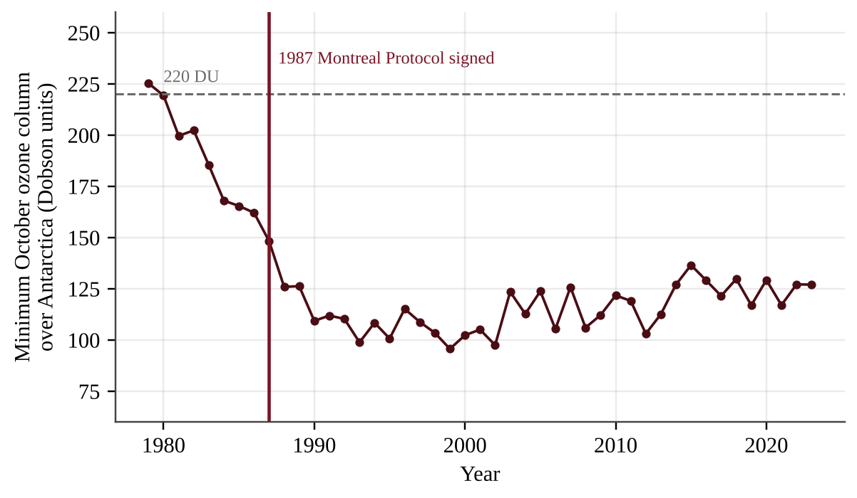
Figure — Minimum October ozone column over Antarctica, 1979–2023
Which conclusion is best supported by the figure?
A. The ozone minimum began to rise immediately after the 1987 agreement was signed.
B. By 2023 the ozone minimum had recovered to the level recorded in 1979.
C. The minimum stopped falling by about 2000 and has risen slightly since but remains far below the 1979 value.
D. The ozone minimum fell steadily through 2023, showing that the agreement had no effect.

Section II — Free-Response Questions (3)
Question 1 PE4-FRQ001
Question 1 — Design an investigation
In a desert valley, cotton fields are flood-irrigated and sprayed each spring with a triazine herbicide, a suspected endocrine disruptor. Excess irrigation water drains through a return-flow canal into a wetland pond that is the main breeding habitat for leopard frogs. Local biologists report that many male frogs at the pond have ovarian tissue in their testes and that tadpole survival has declined. A researcher wants to determine whether herbicide runoff is responsible. The figure shows the setting and four proposed sampling sites.
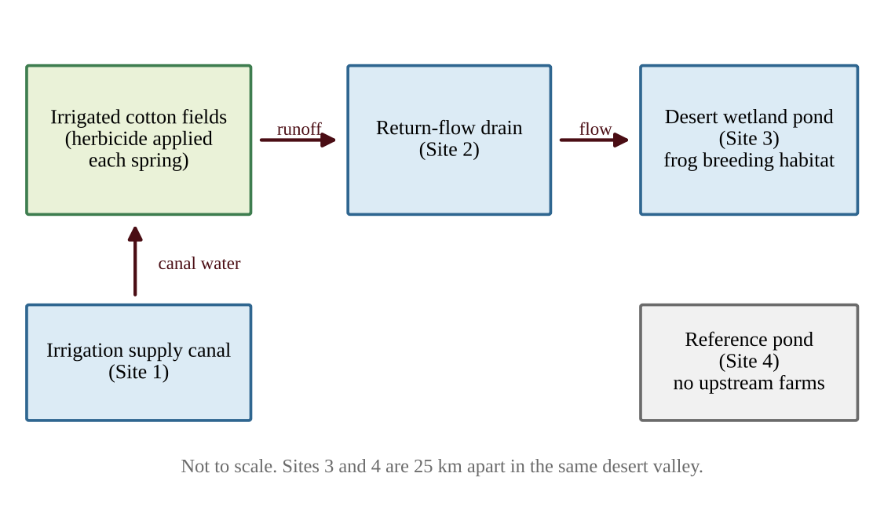
Figure — Layout of the irrigated valley and four proposed sampling sites
(a) Identify the environmental problem that the researcher is investigating. [1]
(b) Write a testable hypothesis, in an "if … then …" statement, that links herbicide concentration to the frog abnormalities. [1]
(c) Identify the independent variable and the dependent variable in the researcher's field study. [2]
(d) Identify two variables that should be controlled so that the results can be attributed to herbicide exposure. [1]
(e) Describe a procedure for collecting the data. Your description must explain (i) how Site 4 will be used and (ii) how replication will increase the reliability of the data. [2]
(f) Describe the data that should be collected, and explain what results would support the hypothesis. [1]
(g) Propose one solution to reduce the amount of herbicide reaching the pond, and justify it by describing one advantage or one disadvantage of the solution. [2]

Question 2 PE4-FRQ002
Question 2 — Analyze and interpret quantitative data
Scientists monitoring a tundra research station recorded atmospheric CO₂ concentration, the thickness of the active layer (the surface soil layer above permafrost that thaws each summer), and the minimum extent of Arctic sea ice each September.
Year | Atmospheric CO₂ (ppm) | Active-layer thickness (cm) | Sea-ice minimum extent (million km²)
2000 | 369 | 42 | 6.3
2005 | 380 | 44 | 5.6
2010 | 390 | 47 | 4.9
2015 | 401 | 51 | 4.6
2020 | 413 | 56 | 3.9
2025 | 425 | 61 | 3.6

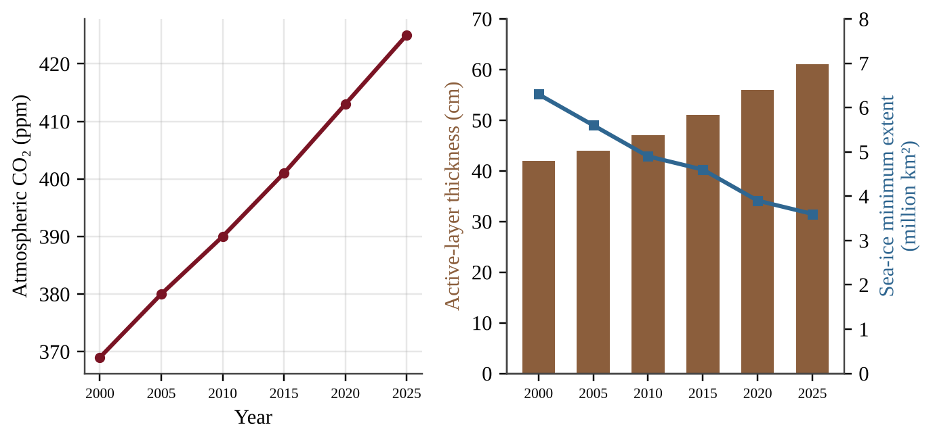
Figure — Atmospheric CO₂, active-layer thickness, and sea-ice minimum extent
(a) Describe the trend in atmospheric CO₂ concentration from 2000 to 2025. [1]
(b) Calculate the average annual rate of increase in atmospheric CO₂, in ppm per year, from 2000 to 2020. [1]
(c) Calculate the percent increase in active-layer thickness from 2000 to 2025. [1]
(d) Explain how a deeper active layer can lead to additional atmospheric warming. In your answer, identify one greenhouse gas released and the process that releases it, and explain why this is a positive feedback. [2]
(e) Explain how the decline in sea-ice extent can cause additional warming of the Arctic. [2]
(f) Assuming the 2020–2025 rate of increase continues, predict the atmospheric CO₂ concentration in 2040. Show your work. [1]
(g) Propose one policy or action to slow the increase in atmospheric CO₂, and justify it using evidence from the data. [2]

Question 3 PE4-FRQ003
Question 3 — Analyze an environmental problem doing calculations
A county operates 50 diesel buses to reduce traffic in a desert city. The county is considering switching to B20, a blend that is 20% biodiesel and 80% petroleum diesel by volume. The biodiesel would be made from oilseed crops grown on irrigated land in the county.
Data | Value
Number of buses | 50
Distance driven per bus | 48,000 km per year
Fuel consumption of each bus | 50 L per 100 km
Life-cycle emissions, petroleum diesel | 3.2 kg CO₂e per L
Life-cycle emissions, biodiesel | 1.1 kg CO₂e per L
Oilseed biodiesel yield | 1,200 L per hectare per year
Irrigation water for oilseed crop | 5,500 m³ per hectare per year

(a) Calculate the total volume of diesel fuel the fleet uses in one year, in liters. [1]
(b) Calculate the fleet's annual life-cycle emissions, in metric tons of CO₂e, if all of the fuel is petroleum diesel. (1 metric ton = 1,000 kg) [1]
(c) Calculate the fleet's annual life-cycle emissions using B20, and then calculate the percent reduction compared with your answer to (b). [2]
(d) Calculate the area of cropland, in hectares, needed each year to produce the biodiesel for B20. [1]
(e) Calculate the volume of irrigation water, in cubic meters, needed each year to grow that crop. [1]
(f) Describe one environmental disadvantage of growing oilseed crops for biodiesel in a desert region. [1]
(g) Make a claim about whether the county should adopt B20 or pursue another option (such as using waste cooking oil as the feedstock or buying electric buses). Justify your claim with at least two pieces of evidence from your calculations or from the data. [3]

Connect with Success4Sure Academy
Scan a code or click a link to reach the academy and the author.
SUCCESS4SURE ACADEMY WEBSITE  https://www.success4sureacademy.com | 

MR. WASEEM ALLABADI — INSTAGRAM  https://www.instagram.com/waseemabed19/ | 

SUCCESS4SURE ACADEMY — INSTAGRAM  https://www.instagram.com/success4surejo/ | 

Success4Sure Academy — International academic programs, exam preparation and professional training.

Success4Sure Academy
AP ENVIRONMENTAL SCIENCE
CLASSIFIED PRACTICE QUESTIONS
& FOUR PREDICTED EXAMS
Original multiple-choice and free-response questions for all nine units, followed by four full-length predicted examinations. Complete solutions are in Book Three.
Prepared by Mr. Waseem Allabadi
www.success4sureacademy.com
© 2026 Success4Sure Academy | All Rights Reserved | Unauthorized Printing, Copying, Reproduction & Distribution Prohibited.

