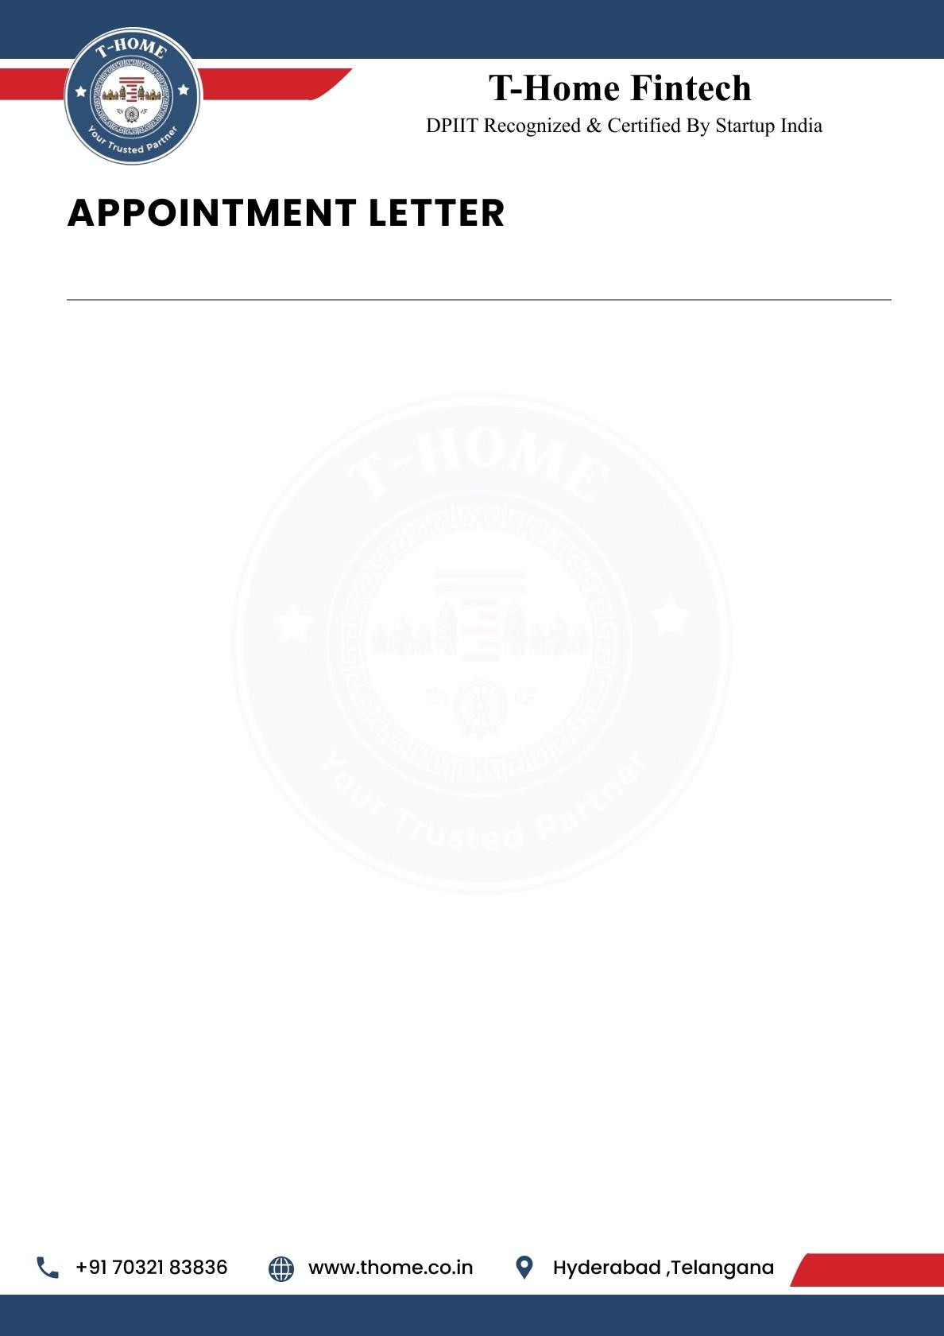

{{Letter_date}}

To,
{{name}},
{{phone}},
Hyderabad.
Dear {{name}},
We are delighted to offer you the position of Public Relation Intern at T-Home. Your strong analytical skills and enthusiasm for data-driven solutions make you a valuable addition to our team as we innovate at the intersection of real estate and smart loans technology. We are excited to see how your expertise will help us enhance our products and services.

This is an Online (Remote Work) position with a duration of 6 months. Your start date will be
{{joining_date}} and your Work ID is {{work_id}}.

Job Responsibilities:

As a Public Relation Intern, you will play a crucial role in developing and deploying
Webpages that improve the Users experience. Your responsibilities will include:

- Media Relations: Draft press releases, media kits, and official statements. Build and maintain relationships with journalists, bloggers, and influencers.
- Brand Communication: Assist in shaping and maintaining T-Home’s public image. Ensure consistent messaging across all communication channels.
- Content Creation: Develop engaging content for social media, newsletters, and blogs. Support campaigns that highlight T-Home’s innovations in real estate and smart loan technology.
- Event Coordination: Help organize webinars, product launches, and community engagement events. Manage logistics and communication for PR-related activities.

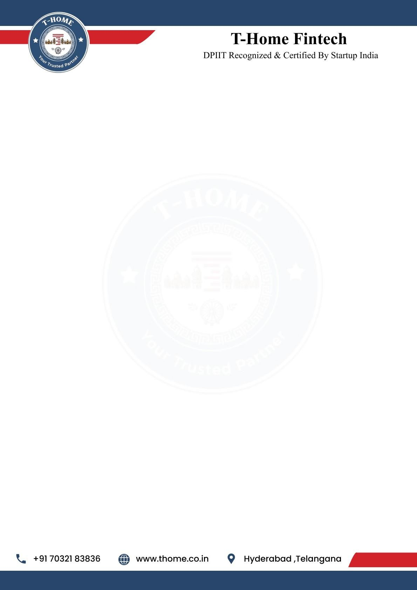

- Monitoring & Reporting: Track media coverage and public sentiment. Prepare reports on PR campaign effectiveness and suggest improvements.
- Collaboration: Work closely with marketing, product, and leadership teams to align PR strategies with company goals. Contribute creative ideas to enhance brand visibility and reputation.

Pre-Placement Offer
Following the completion of your 6-month internship, you will be considered for a
Pre-Placement Offer. This is a great opportunity for you to potentially secure a full-time
position with T-Home based on your performance and contributions during the internship period.

General Terms of Internship
T-Home reserves the right to terminate your internship at any time due to unsatisfactory performance, misconduct, or a violation of company policy.
If you choose to resign from your internship, you are required to provide 30 days' written notice. This allows for a smooth transition and ensures project continuity.
This internship offers a valuable opportunity to gain hands-on experience and contribute to the growth of the company.

Acknowledged and Accepted By:

Ravinder Reddy Attapuram (Founder & CEO T-Home)
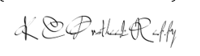
Kesara Chenna Pratheek Reddy (Co-Founder & CTO T-Home)

Appointee:

{{name}}

