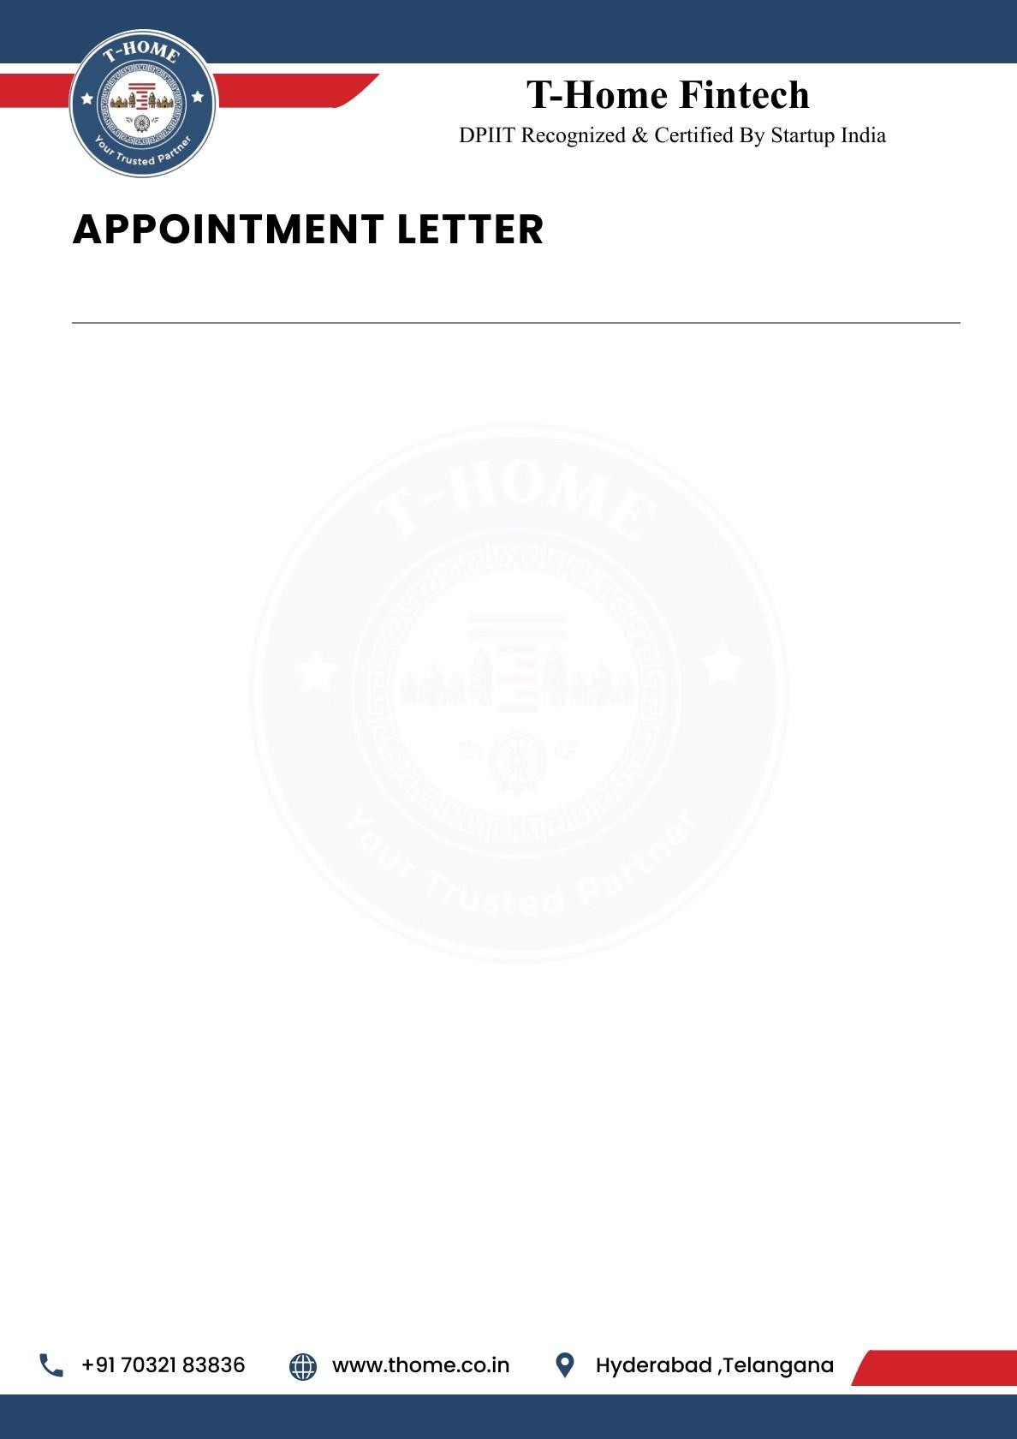

{{Letter_date}}

To,
{{name}},
{{phone}},
Hyderabad.
Dear {{name}},
We are delighted to offer you the position of Research and Development Intern at T-Home. Your strong analytical skills and enthusiasm for data-driven solutions make you a valuable addition to our team as we innovate at the intersection of real estate and smart loans technology. We are excited to see how your expertise will help us enhance our products and services.

This is an Online (Remote Work) position with a duration of 6 months. Your start date will be
{{joining_date}} and your Work ID is {{work_id}.

Job Responsibilities:

As a Research and Development Intern, you will play a crucial role in developing and deploying
Webpages that improve the Users experience. Your responsibilities will include:

- Innovation & Prototyping: Explore emerging technologies in real estate and smart loan solutions. Develop proof-of-concept prototypes to validate new ideas.
- Data Analysis & Insights: Conduct market research and competitor analysis to identify trends. Analyze user behavior and loan/property data to inform product improvements.
- Product Development Support: Collaborate with engineering teams to design and test new features. Assist in integrating research findings into product roadmaps.
- Documentation & Reporting: Prepare detailed technical reports, white papers, and research summaries. Maintain clear documentation of experiments, methodologies, and outcomes.



- Collaboration & Knowledge Sharing: Work closely with product managers, developers, and business teams. Present findings and recommendations to stakeholders. Stay updated with the latest industry innovations in fintech, AI, and real estate technology.

Pre-Placement Offer
Following the completion of your 6-month internship, you will be considered for a
Pre-Placement Offer. This is a great opportunity for you to potentially secure a full-time
position with T-Home based on your performance and contributions during the internship period.

General Terms of Internship
T-Home reserves the right to terminate your internship at any time due to unsatisfactory performance, misconduct, or a violation of company policy.
If you choose to resign from your internship, you are required to provide 30 days' written notice. This allows for a smooth transition and ensures project continuity.
This internship offers a valuable opportunity to gain hands-on experience and contribute to the growth of the company.

Acknowledged and Accepted By:

Ravinder Reddy Attapuram (Founder & CEO T-Home)
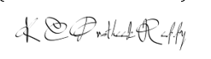
Kesara Chenna Pratheek Reddy (Co-Founder & CTO T-Home)

Appointee:

{{name}}

