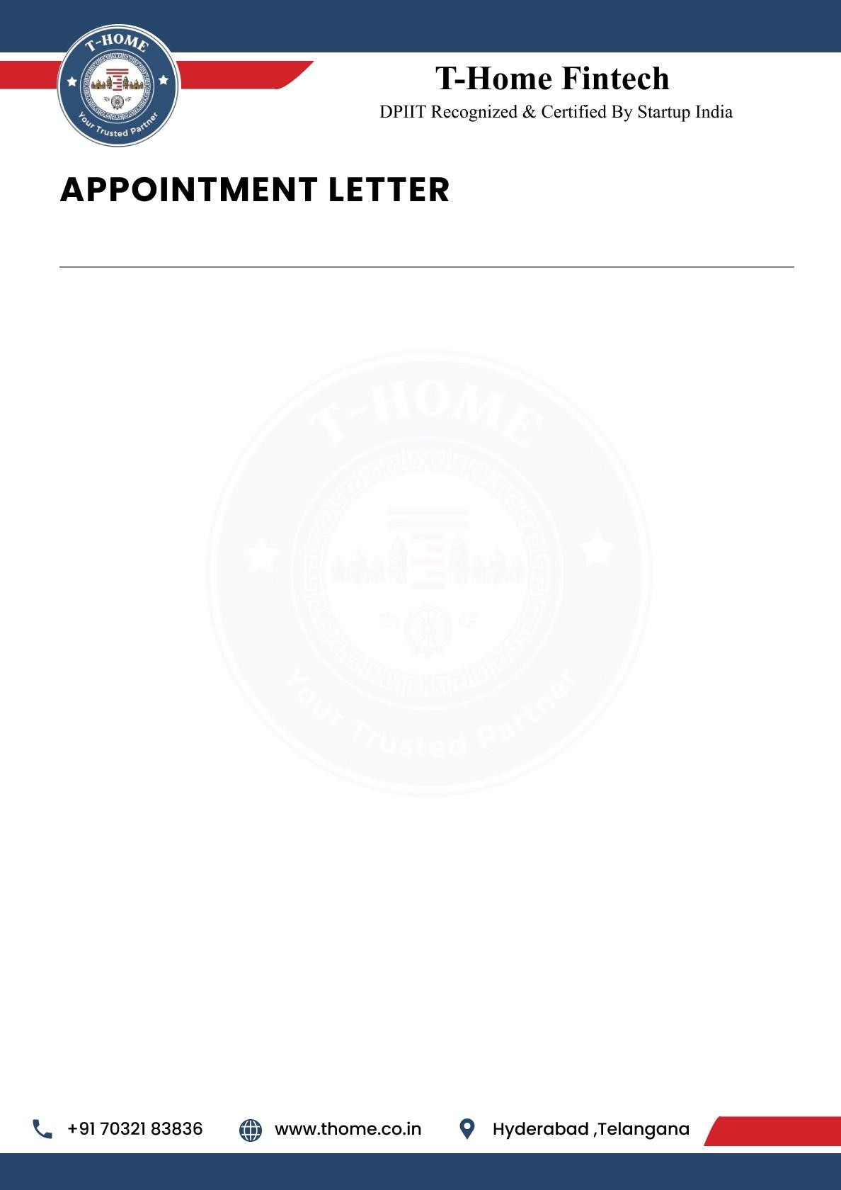

{{Letter_date}}

To,
{{name}},
{{phone}},
Hyderabad.
Dear {{name}},
We are delighted to offer you the position of Content and Video Editor Intern at T-Home. Your strong analytical skills and enthusiasm for data-driven solutions make you a valuable addition to our team as we innovate at the intersection of real estate and smart loans technology. We are excited to see how your expertise will help us enhance our products and services.

This is an Online (Remote Work) position with a duration of 6 months. Your start date will be
{{joining_date}} and your Work ID is THFT-INT-{{work_id}}.

Job Responsibilities:
As a Content and Video Editor, you will be responsible for creating compelling content that communicates our message clearly while delivering visually engaging videos. Your responsibilities will include:

- Content Creation and Script Development:
Writing engaging scripts, captions, and promotional content aligned with brand tone and target audience.
- Video Editing and Storytelling:
Editing videos with a strong storytelling approach, ensuring content flow, clarity, and audience engagement.
- Content Strategy and Optimization:
Researching trending topics, optimizing content for SEO and social media reach, and tailoring content for different platforms.



Review and Refinement:
Proofreading content, improving structure, correcting grammar, and ensuring consistency in messaging across all platforms.

Team Collaboration and Innovation:
Coordinating with design, marketing, and technical teams to develop creative campaigns and continuously exploring new content formats and storytelling styles.

Pre-Placement Offer
Following the completion of your 6-month internship, you will be considered for a
Pre-Placement Offer. This is a great opportunity for you to potentially secure a full-time
position with T-Home based on your performance and contributions during the internship period.

General Terms of Internship
T-Home reserves the right to terminate your internship at any time due to unsatisfactory performance, misconduct, or a violation of company policy.
If you choose to resign from your internship, you are required to provide 30 days' written notice. This allows for a smooth transition and ensures project continuity.
This internship offers a valuable opportunity to gain hands-on experience and contribute to the growth of the company.

Acknowledged and Accepted By:

Ravinder Reddy Attapuram (Founder & CEO T-Home)
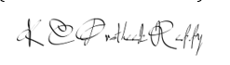
Kesara Chenna Pratheek Reddy (Co-Founder & CTO T-Home)

Appointee:

{{name}}

