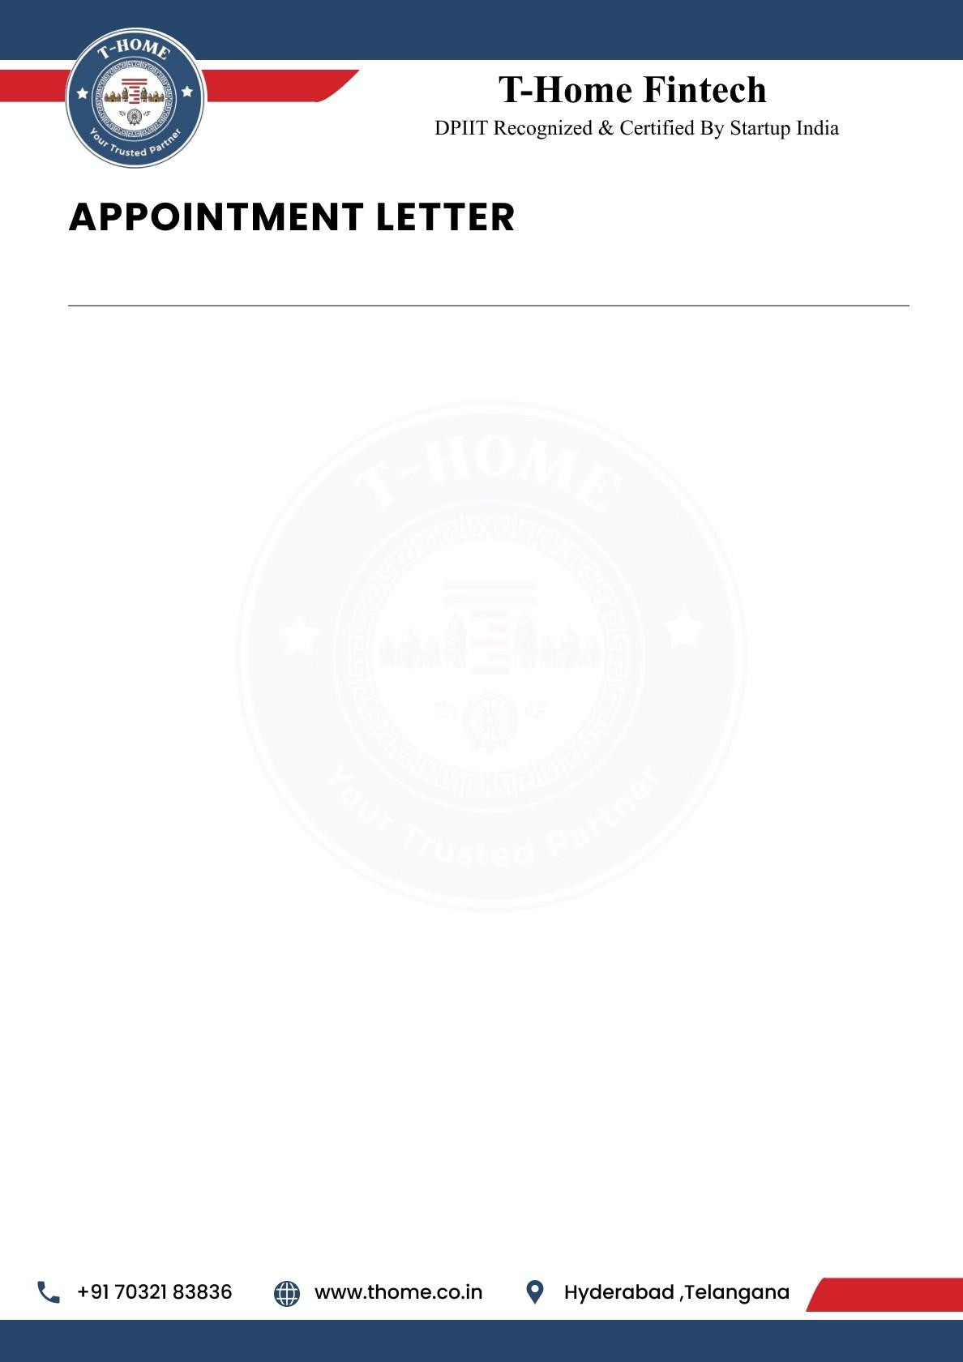

{{Letter_date}}

To,
{{name}},
{{phone}},
Hyderabad.
Dear {{name}},
We are delighted to offer you the position of Digital Marketing Intern at T-Home. Your strong analytical skills and enthusiasm for data-driven solutions make you a valuable addition to our team as we innovate at the intersection of real estate and smart loans technology. We are excited to see how your expertise will help us enhance our products and services.

This is an Online (Remote Work) position with a duration of 6 months. Your start date will be
{{joining_date}} and your Work ID is THFT-INT-{{work_id}}.

Job Responsibilities:
As a Digital Marketing Intern, you will play a crucial role in executing strategies that drive brand awareness and user acquisition. Your responsibilities will include:
- Social Media Management: Developing and scheduling engaging content across various platforms (LinkedIn, Twitter, Instagram) to build a strong community presence around our smart loan and real estate solutions.
- Content Strategy s Creation: Crafting compelling blog posts, newsletters, and ad copy that simplifies complex financial concepts, establishing T-Home as a thought leader in the fintech space.
- SEO s Performance Optimization: conducting keyword research and optimizing web content to improve organic search rankings, ensuring our products reach the right audience efficiently.

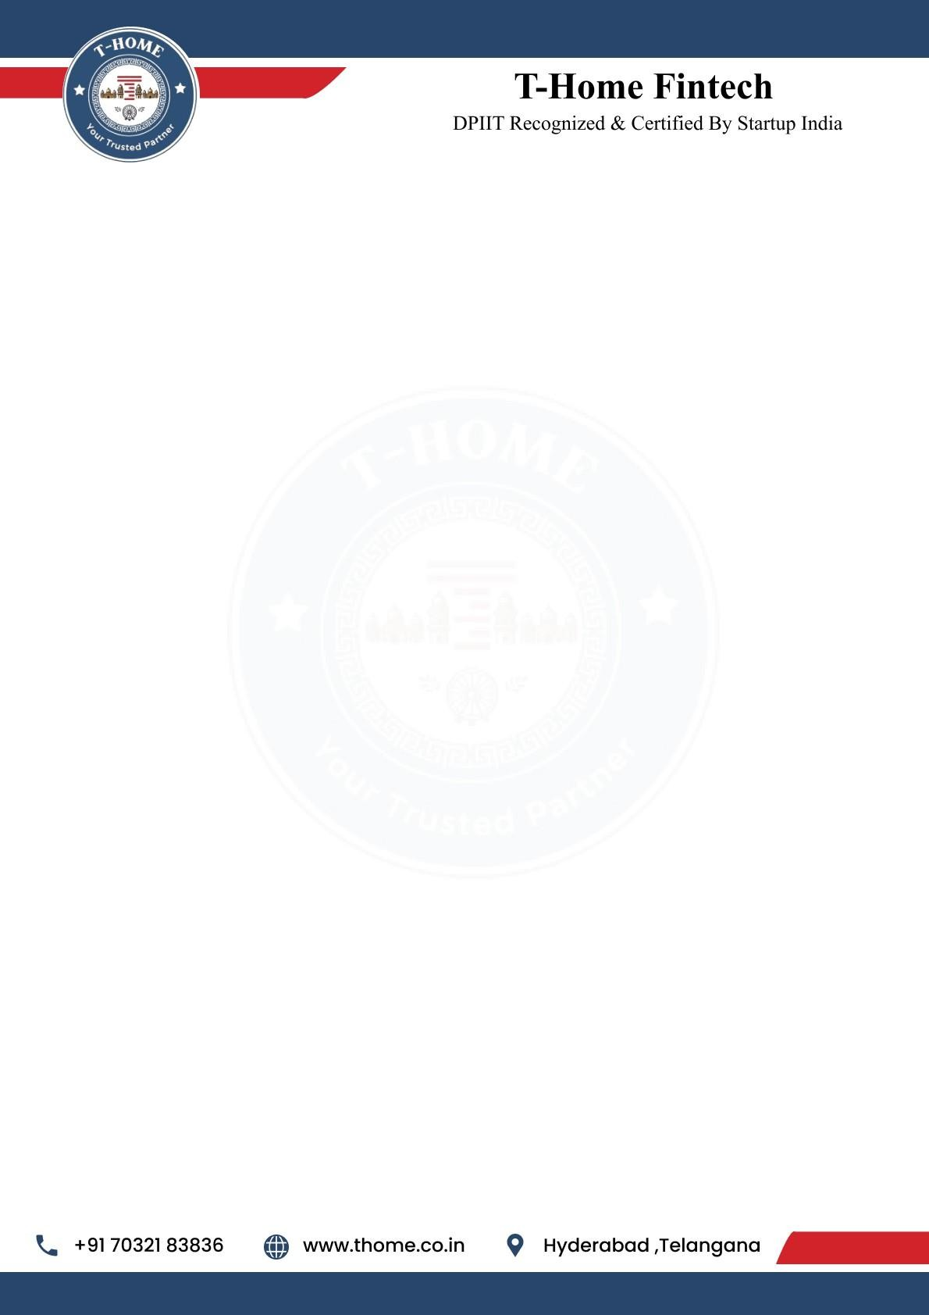

- Campaign Analytics: Monitoring and analyzing key performance indicators (KPIs) from marketing campaigns using tools like Google Analytics, providing actionable insights to refine our strategies.
- Collaboration and Communication: Working closely with the design and product teams to align marketing messages with new feature launches, brainstorming creative campaign ideas, and staying updated with the latest trends in digital marketing and fintech.

Pre-Placement Offer
Following the completion of your 6-month internship, you will be considered for a
Pre-Placement Offer. This is a great opportunity for you to potentially secure a full-time
position with T-Home based on your performance and contributions during the internship period.

General Terms of Internship
T-Home reserves the right to terminate your internship at any time due to unsatisfactory performance, misconduct, or a violation of company policy.
If you choose to resign from your internship, you are required to provide 30 days' written notice. This allows for a smooth transition and ensures project continuity.
This internship offers a valuable opportunity to gain hands-on experience and contribute to the growth of the company.

Acknowledged and Accepted By:

Ravinder Reddy Attapuram (Founder & CEO T-Home)
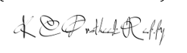
Kesara Chenna Pratheek Reddy (Co-Founder & CTO T-Home)

Appointee:

{{name}}

