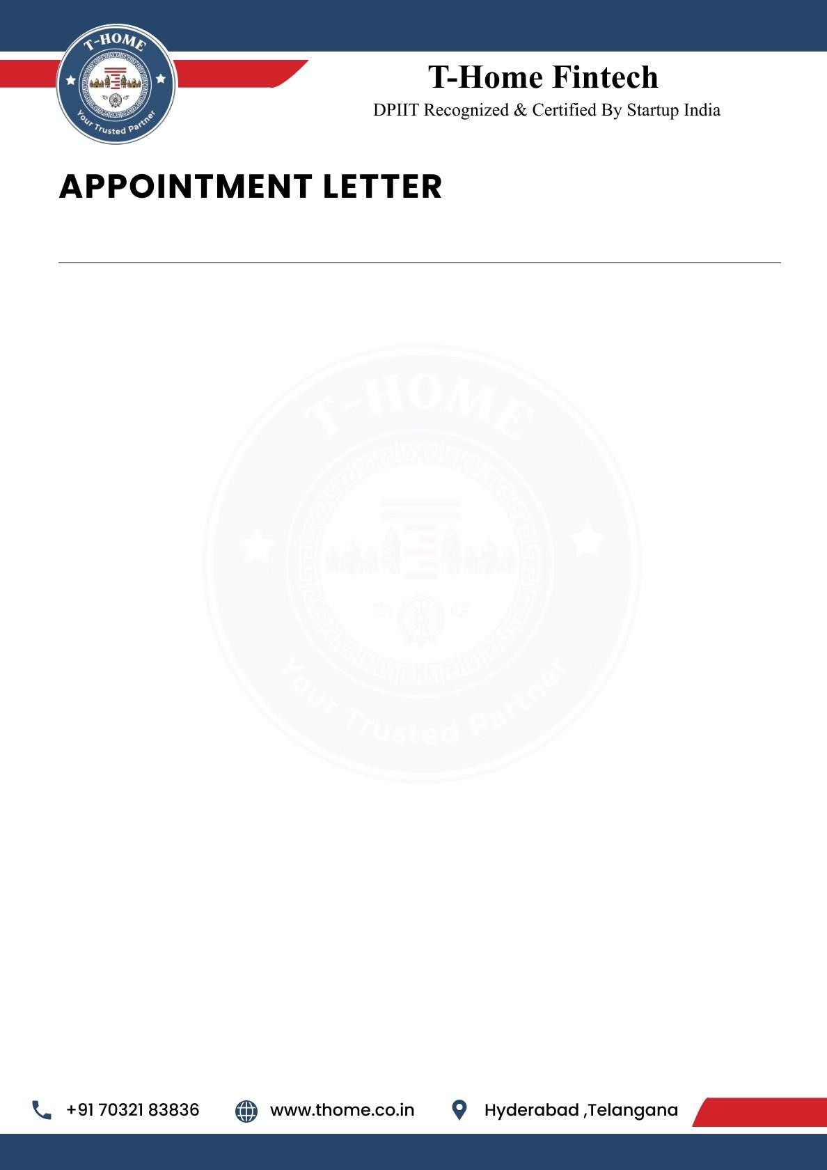

{{Letter_date}}

To,
{{name}},
{{phone}},
Hyderabad.
Dear {{name}},
We are delighted to offer you the position of Machine Learning Developer Intern at T-Home. Your strong analytical skills and enthusiasm for data-driven solutions make you a valuable addition to our team as we innovate at the intersection of real estate and smart loans technology. We are excited to see how your expertise will help us enhance our products and services.

This is an Online (Remote Work) position with a duration of 6 months. Your start date will be
{{joining_date}} and your Work ID is THFT-INT-{{work_id}}.

Job Responsibilities:
As a Machine Learning Developer, you will play a crucial role in developing and deploying intelligent models that enhance product capabilities. Your responsibilities will include:

- Model Development and Training: Designing, developing, and training machine learning models for features like predictive maintenance for smart appliances or optimizing energy usage based on resident behavior.
- Data Analysis: Analyzing large, complex datasets from our smart loans to uncover insights into resident behavior and identify opportunities for new, personalized features.
- Integration and Deployment: Assisting in integrating and deploying machine learning models into our existing cloud infrastructure and smart loan app, ensuring optimal Performance and Scalability.



- Testing and Debugging: Identifying and fixing bugs or performance issues in models, implementing security measures, and continuously monitoring and improving model performance.
- Collaboration and Communication: Working closely with our engineering and product teams to brainstorm and implement new solutions, writing technical documentation, and staying updated with the latest industry trends in loans C technology.

Pre-Placement Offer
Following the completion of your 6-month internship, you will be considered for a
Pre-Placement Offer. This is a great opportunity for you to potentially secure a full-time
position with T-Home based on your performance and contributions during the internship period.

General Terms of Internship
T-Home reserves the right to terminate your internship at any time due to unsatisfactory performance, misconduct, or a violation of company policy.
If you choose to resign from your internship, you are required to provide 30 days' written notice. This allows for a smooth transition and ensures project continuity.
This internship offers a valuable opportunity to gain hands-on experience and contribute to the growth of the company.

Acknowledged and Accepted By:

Ravinder Reddy Attapuram (Founder & CEO T-Home)
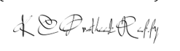
Kesara Chenna Pratheek Reddy (Co-Founder & CTO T-Home)

Appointee:

{{name}}

