Amazon Products Data Analysis Report

Executive Summary
The dataset contains 1465 records and 17 columns. The average discounted price is 3125.31, the average discount is 47.7%, and the average customer rating is 4.10/5.

Key Findings
- Electronics is the largest product category.
- Nearly half of the listed price is discounted on average.
- Most products are rated above 4 stars.
- Price distribution is heavily skewed due to expensive outliers.
- A small number of products receive a very large share of customer reviews.
- Discount level alone does not strongly explain product ratings.

Recommendations
- Prioritize Electronics and Computer Accessories.
- Promote highly rated products with many reviews.
- Track the performance of heavily discounted products.
- Use the median price in addition to the average in business reports.
- Encourage customer reviews for newer products.

Charts

Products by Category
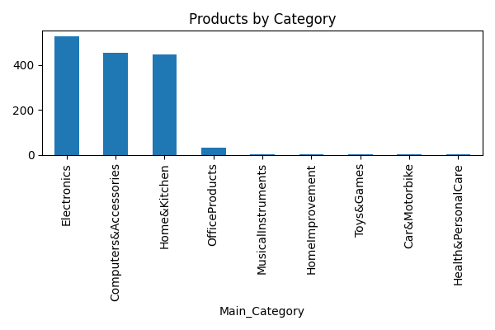

Price Distribution
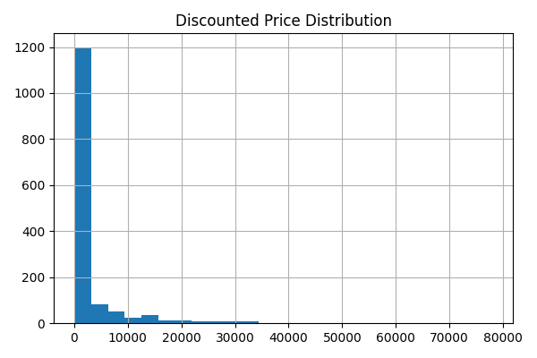

Rating Distribution
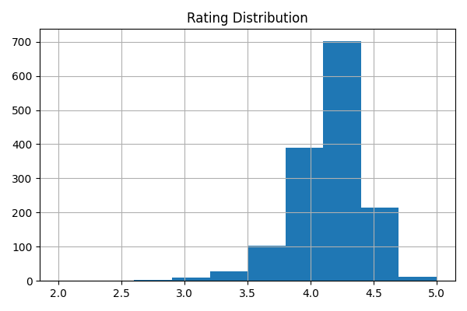

Discount vs Rating
