AI Powered Brand Protection & Risk
Assessment System

Table of Contents
Abstract 5
1. Introduction Problem Description 5
1.1 Problem Definition 5
1.2 Complexity Analysis 5
1.2.1 Multi-Criteria Decision Making 5
1.2.2 Data Variety and Heterogeneity 6
1.2.3 Scalability Challenges 6
1.2.4 Automation and Real-Time Processing 6
1.2.5 Security Design Complexity 6
1.2.6 Interoperability 6
2 Background and Related Work 6
2.1 Typosquatting Detection 6
2.2 Logo Detection 6
2.3 Threat Intelligence Aggregation 6
2.4 Social Media Monitoring 6
3. System Design and Architecture 7
3.1 System Overview 7
3.2 Core Components 7
3.2.1 Logo Detection Module 7
3.2.2 Mimic Detection Module 7
3.2.3 Threat Intelligence Module 8
3.2.4 Dark Web Monitoring Module 8
3.2.5 Social Media Monitoring Module 8
3.3 System Workflow 8
3.3.1 Domain Analysis Workflow 8
3.3.2 Threat Intelligence Workflow 8
3.3.3 Social Media Monitoring Workflow 8
3.4 Security Design Decisions 9
3.4.1 Confidentiality 9
3.4.2 Integrity 9
3.4.3 Availability 9
4. Implementation Details 9
4.1 Technology Stack 9
4.2 Key Algorithms and Techniques 9
4.2.1 Typosquatting Generation 9
4.2.2 Logo Detection Ensemble 9
5. Demonstration of Complex Problem Solving 10
5.1 Multi-Criteria Decision Making 10
5.1.1 Logo Detection Consensus 10
5.1.2 Threat Intelligence Aggregation 10
5.2 Scalability Solutions 10
5.2.1 Asynchronous Processing 10
5.2.2 Rate Limiting and API Management 10
5.3 Data Heterogeneity Handling 10
5.3.1 Image Processing Pipeline 10
5.3.2 API Response Normalization 10
5.4. False Positive Reduction 10
5.5 Performance Optimization 11
5.5.1 Parallel API Calls 11
5.5.2 Model Caching 11
5.6 Trade-offs and Design Decisions 11
5.6.1 Detection Accuracy vs. Performance 11
5.6.2 Coverage vs. Depth 11
5.6.3 Free vs. Paid APIs 11
6 Testing and Demo Screenshots 11
6.1 Dashboard 11
6.2 Mimic detection 12
6.2.1 Pipeline 12
6.2.2 Analysis Report 12
6.3 Logo detection 12
6.4 Threat intelligence integration 13
6.5 Dark web monitoring 14
6.6 Social media monitoring 14
7. Challenges and Limitations 15
7.1 Technical Challenges 15
7.1.1 API Rate Limiting 15
7.1.2 Model Performance 15
7.2 Detection Limitations 16
7.2.1 Logo Detection 16
7.2.2 Threat Intelligence 16
8 Conclusion 16
9 References 16

Abstract
This project presents a comprehensive Brand Protection System designed to detect and mitigate various forms of brand impersonation and abuse across multiple attack vectors. The system integrates five core detection mechanisms: logo detection using multi-method ensemble approaches, visual mimic detection, threat intelligence aggregation, dark web monitoring, and social media impersonation detection. The system addresses the complex challenge of identifying brand threats at scale while maintaining high accuracy and minimizing false positives. Through the integration of computer vision models (DINOv2, template matching, perceptual hashing), threat intelligence APIs, and social media monitoring, the system provides a unified platform for brand protection. Evaluation demonstrates the system's effectiveness in detecting typosquatting domains, visual impersonations, and brand-related threats across multiple platforms. The project shows complex problem-solving in security design, requiring trade-offs between detection accuracy, system performance, and scalability.

1. Introduction Problem Description

1.1 Problem Definition
Brand impersonation and abuse represent a significant and growing cybersecurity threat. Attackers employ various sophisticated techniques to deceive users and damage brand reputation:
1. Typo squatting: Creating domains with slight variations of legitimate brand names (e.g., `faceb00k.com` instead of `facebook.com`)
2. Visual Mimicry: Designing websites that visually resemble legitimate brand pages
3. Logo Theft: Using brand logos without authorization to create fake websites
4. Social Media Impersonation: Creating fake accounts on platforms like YouTube, Telegram, and GitHub and violates brand community guidelines.
5. Dark Web Activities: Selling stolen credentials, phishing kits, and other brand-related threats on Dark Web.
These attacks can lead to:
- Financial losses through phishing and fraud.
- Brand reputation damage.
- User data breaches.
- Legal and compliance issues.

1.2 Complexity Analysis
This problem exhibits several dimensions of complexity.

1.2.1 Multi-Criteria Decision Making
This system involves multi-criteria decision making, where visual similarity, domain behavior, threat intelligence signals, social media activity, and dark-web indicators must be evaluated together. Each signal has varied reliability, requiring a unified scoring mechanism for accurate detection.

1.2.2 Data Variety and Heterogeneity
The system processes diverse data images, text, structured DNS/WHOIS records, API responses, and temporal threat history. Integrating these heterogeneous formats requires a consistent and flexible processing pipeline.

1.2.3 Scalability Challenges
Scalability issues arise due to the large volume of typosquatted domains, real-time monitoring needs, platform rate limits, and the need to maintain high data quality with minimal false positives.

1.2.4 Automation and Real-Time Processing
The system automates domain variant generation, screenshot capture, multi-source threat analysis, social media scanning, and reporting. These tasks must operate efficiently under real-time and rate-limited conditions.

1.2.5 Security Design Complexity
Security concerns include protecting API keys, ensuring accurate and tamper-proof results, maintaining uptime during API failures, and keeping detailed audit logs for non-repudiation.

1.2.6 Interoperability
The system integrates with threat intelligence APIs, social media platforms, DNS tools, dark-web monitors, and web scrapers each with different authentication methods and data formats, requiring adaptable integration logic.

2 Background and Related Work

2.1 Typosquatting Detection
Tools like DNSTwist and AIL-Typo-Squatting generate domain variants through substitution, omission, insertion, swaps, and homoglyphs. Our system adopts these techniques and extends them with visual similarity analysis [1], [2].

2.2 Logo Detection
Logo detection spans traditional feature-based methods (SIFT, SURF), deep learning (CNNs, transformers), and hybrid approaches. Systems such as LogoHunter use YOLO-based detection. Our system applies DINOv2 with template matching and perceptual hashing for more reliable logo comparison [3], [4].

2.3 Threat Intelligence Aggregation
Threat intelligence platforms VirusTotal, AbuseIPDB, Google Safe Browsing, and WHOIS services offer malware signals, IP reputation, phishing indicators, and domain history. We integrate these sources to produce a combined threat score [5] [6], [7].

2.4 Social Media Monitoring
Impersonation detection often examines usernames, content patterns, account behavior, and network relationships. Our system focuses on brand-specific keyword monitoring and typosquatting-based username matching to detect fake accounts [8].

3. System Design and Architecture

3.1 System Overview
The Brand Protection System follows a modular, microservices-inspired architecture designed for scalability and reliability. A central Flask-based web application acts as the entry point for all user interactions, while specialized modules responsible for logo detection, mimic detection, social media monitoring, dark web scanning, and threat intelligence operate independently to ensure fault isolation and parallel processing. This separation enables robust performance, clear maintainability, and secure integration across multiple data sources.
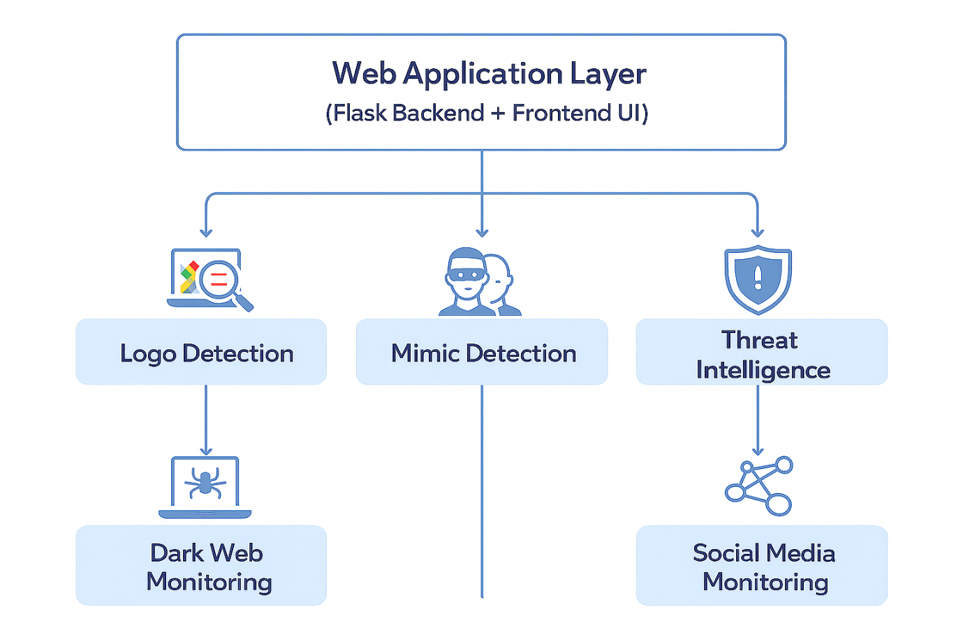

3.2 Core Components

3.2.1 Logo Detection Module
The logo detection module combines three complementary techniques template matching, semantic similarity via DINOv2, and perceptual hashing to deliver high-confidence detections. Screenshots are divided into key regions, and each region is analysed using all three methods. A detection is accepted only when all methods consistently match the same reference logo and meet strict confidence thresholds (≥0.85). This multi-layer validation significantly reduces false positives. To maintain security, reference logos are stored securely, and the module is designed to degrade gracefully if any detection method becomes unavailable.

3.2.2 Mimic Detection Module
Mimic detection evaluates whether a suspicious webpage visually resembles a genuine brand page. The system uses CLIP to compute semantic similarity between screenshots and official brand references, followed by perceptual hashing to confirm structural resemblance. This dual-stage approach helps distinguish legitimate brand pages from malicious replicas. The module outputs similarity scores and a calculated mimic-risk rating, which is later incorporated into the final threat report [9].

3.2.3 Threat Intelligence Module
Threat intelligence is aggregated from multiple well-known security platforms to provide a comprehensive assessment of the domain or IP under review. The system queries VirusTotal, AbuseIPDB, Google Safe Browsing, and WHOIS services simultaneously, combining their outputs into a unified risk score. API keys are securely stored using environment variables, and rate limits are respected through controlled request pacing and retry logic. Structured error handling ensures that the system continues to function even when some APIs become temporarily unavailable.

3.2.4 Dark Web Monitoring Module
The dark web monitoring component focuses on detecting brand-related exposure across publicly accessible sources. It monitors data breaches via services like Have I Been Pwned, scans paste sites for leaked credentials and applies pattern-based detection to identify suspicious references to the brand. Only brand-specific terms are queried to ensure privacy. To remain compliant with external systems, the module incorporates built-in rate limiting and minimalistic request frequency [10].

3.2.5 Social Media Monitoring Module
This module identifies impersonation attempts, phishing campaigns, or leaked data across key social platforms. It generates dynamic search queries by combining typosquatting variants of the brand name with threat-centric keywords such as scam, phishing, and hack. Platform-specific logic is used for YouTube, Telegram, and GitHub, enabling the system to detect suspicious tutorials, impersonation accounts, and exposed credentials. Results are filtered rigorously to eliminate false positives, ensuring that only high-confidence threats are reported.

3.3 System Workflow

3.3.1 Domain Analysis Workflow
The system begins by accepting a user-provided brand domain. Typosquatting variants are automatically generated and then processed for screenshot capture. The captured screenshots are analysed in parallel across multiple modules: logo and mimic detection, DNS/WHOIS inspection, and threat intelligence queries. All intermediate results are finally aggregated into a coherent, user-friendly report.

3.3.2 Threat Intelligence Workflow
Given a domain name, the system performs simultaneous API calls to all integrated threat intelligence sources. Outputs are normalised, combined, and transformed into a consolidated risk score. The results are delivered through a structured HTML report.

3.3.3 Social Media Monitoring Workflow
For brand name monitoring, the system generates threat-specific search queries and retrieves data from YouTube, Telegram, and GitHub. Retrieved items are analysed for malicious intent, filtered based on predefined conditions, and compiled into a dedicated social media threat summary.

3.4 Security Design Decisions

3.4.1 Confidentiality
Confidentiality is maintained through secure API key handling, strict use of .env files, and isolation of data across modules. Sensitive information never appears in logs, ensuring minimal exposure.

3.4.2 Integrity
System integrity is reinforced through multi-method validation in logo detection, strict similarity thresholds, and structured decision rules across all detection modules. These measures help maintain accuracy while preventing tampering or accidental misclassification.

3.4.3 Availability
High availability is achieved through robust error handling, automatic retry mechanisms, and intelligent rate-limiting strategies. Long-running operations are executed asynchronously to ensure the system remains responsive, even under intensive workloads.

4. Implementation Details

4.1 Technology Stack
The system is built on Python 3.12, with Flask serving both the backend and Frontend. Cross-origin requests are handled via Flask-CORS. For computer vision, the system uses PyTorch and Hugging Face Transformers (DINOv2) for semantic similarity, along with OpenCV for template matching, Pillow for image handling, and imagehash for perceptual hashing.
Web automation relies on Selenium with WebDriver Manager for dynamic screenshot capture. Data processing uses Pandas and NumPy, while network and domain-related operations leverage Requests, dnspython, python-whois, and tldextract. The Frontend uses standard HTML5/CSS3 enhanced with JavaScript and Bootstrap for responsiveness [11].

4.2 Key Algorithms and Techniques

4.2.1 Typosquatting Generation
The system generates typosquatting variants using character substitutions, omissions, insertions, and adjacent character swaps. For instance, letters such as “a” may be replaced with “4” or “@”, while characters may also be omitted or swapped to emulate common typing errors. This multi-strategy approach ensures comprehensive coverage of potential malicious domains.

4.2.2 Logo Detection Ensemble
Logo detection uses a three-method ensemble for high accuracy. Template matching performs multi-scale cross-correlation, while DINOv2 evaluates semantic similarity, and perceptual hashing confirms structural resemblance. A logo is only detected when all three methods agree and meet strict thresholds (confidence ≥0.85, with margin requirements). This consensus-based method effectively reduces false positives while maintaining robustness.
Threat intelligence, Dark web monitoring and social media monitoring already discussed above.

5. Demonstration of Complex Problem Solving

5.1 Multi-Criteria Decision Making

5.1.1 Logo Detection Consensus
The system addresses the challenge of balancing detection accuracy with false positive reduction by requiring consensus among all three detection methods: template matching, DINOv2, and perceptual hashing. Each method must exceed a confidence threshold of 0.85, and the best match must maintain a significant margin over the second-best. This approach prioritizes precision, reducing false positives while occasionally sacrificing recall.

5.1.2 Threat Intelligence Aggregation
Combining multiple threat signals from diverse sources is challenging due to differences in reliability and data format. The system implements weighted risk scoring, giving higher weight to VirusTotal, moderate weight to AbuseIPDB and Google Safe Browsing, and supplementary weight to WHOIS data. Parallel API calls and timeout handling mitigate rate-limiting issues while ensuring comprehensive assessment.

5.2 Scalability Solutions

5.2.1 Asynchronous Processing
Long-running detection tasks are executed asynchronously in background threads, allowing Flask routes to return immediately with a task ID. Clients can poll for progress updates while results are cached for retrieval, providing a non-blocking user interface and supporting multiple concurrent requests.

5.2.2 Rate Limiting and API Management
The system handles APIs with different quotas through retry logic, exponential backoff, and controlled delays between requests. Graceful degradation ensures system continuity even when API limits are reached or services are temporarily unavailable.

5.3 Data Heterogeneity Handling

5.3.1 Image Processing Pipeline
Images of varying formats, sizes, and quality are standardized to RGB format and preprocessed for DINOv2, while template matching uses grayscale conversion. Multi-scale region extraction ensures consistent analysis across different screenshot dimensions.

5.3.2 API Response Normalization
Diverse API outputs are unified into standardized data structures, enabling seamless aggregation and risk scoring. This approach simplifies data integration from multiple sources with differing formats and schemas.

5.4. False Positive Reduction
Logo detection false positives are minimized through iterative refinement. Initially, a single method was used, followed by a two-method approach (DINOv2 + pHash), and finally a three-method ensemble requiring consensus and margin validation. This iterative process balances accuracy with reliability.

5.5 Performance Optimization

5.5.1 Parallel API Calls
Sequential API calls were identified as a bottleneck. The system executes multiple API requests concurrently using threads, resulting in approximately four times faster data retrieval without sacrificing accuracy.

5.5.2 Model Caching
The DINOv2 model is loaded once during system initialization and reused for all detections. This reduces per-screenshot processing from 5–10 seconds to about 0.5 seconds, improving system responsiveness.

5.6 Trade-offs and Design Decisions

5.6.1 Detection Accuracy vs. Performance
The ensemble-based approach increases computation time but ensures high accuracy, which is critical for brand protection. Slightly slower performance is acceptable given the significant reduction in false positives.

5.6.2 Coverage vs. Depth
The system supports multiple detection modes, providing broad coverage across various threat vectors rather than deep optimization of a single mode. This balance ensures that diverse attacks are detected effectively.

5.6.3 Free vs. Paid APIs
Free APIs are used to minimize operational costs, with optional paid services for enhanced capabilities. This approach accepts functional limitations in exchange for cost efficiency while maintaining a reliable detection baseline.

6 Testing and Demo Screenshots
Below are the Demo screenshots of different features of our system showing multi-services and robust cyber security web applications.

6.1 Dashboard
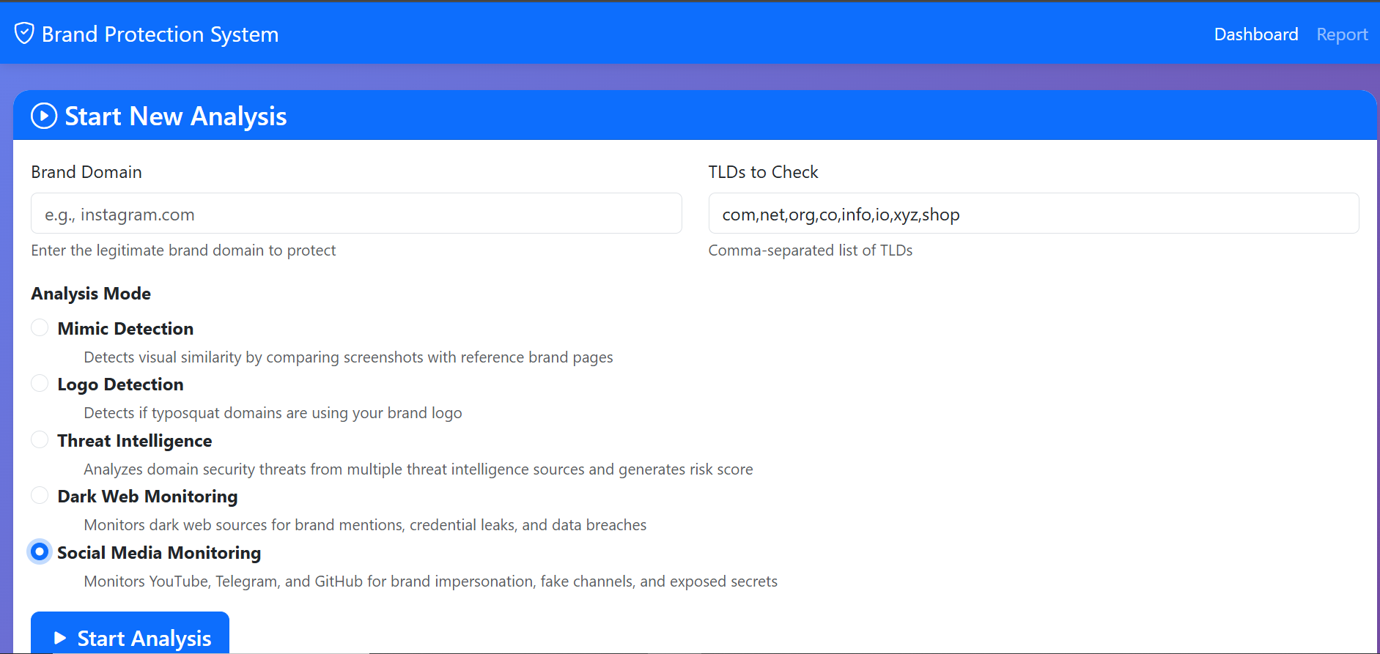

6.2 Mimic detection
Let’s see our first feature demonstration.

6.2.1 Pipeline
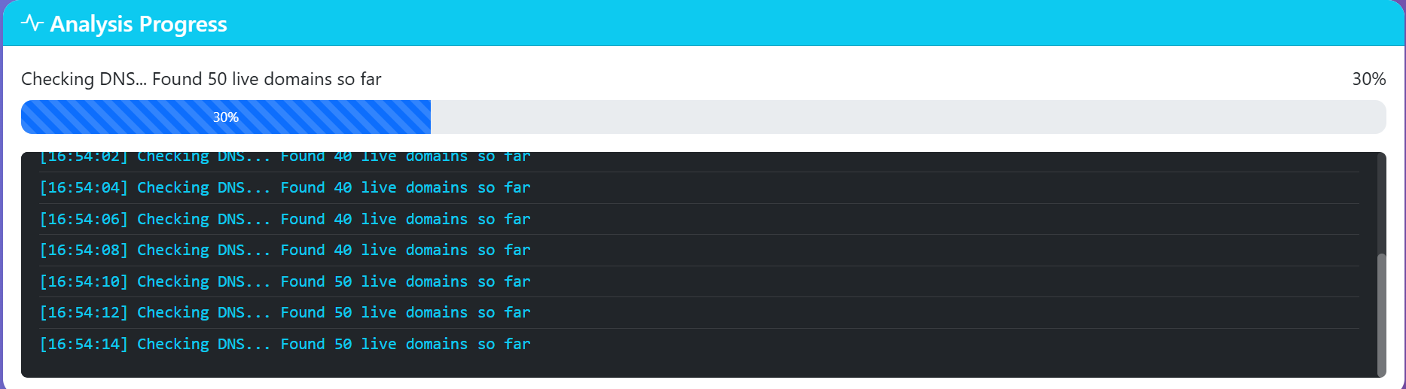

6.2.2 Analysis Report
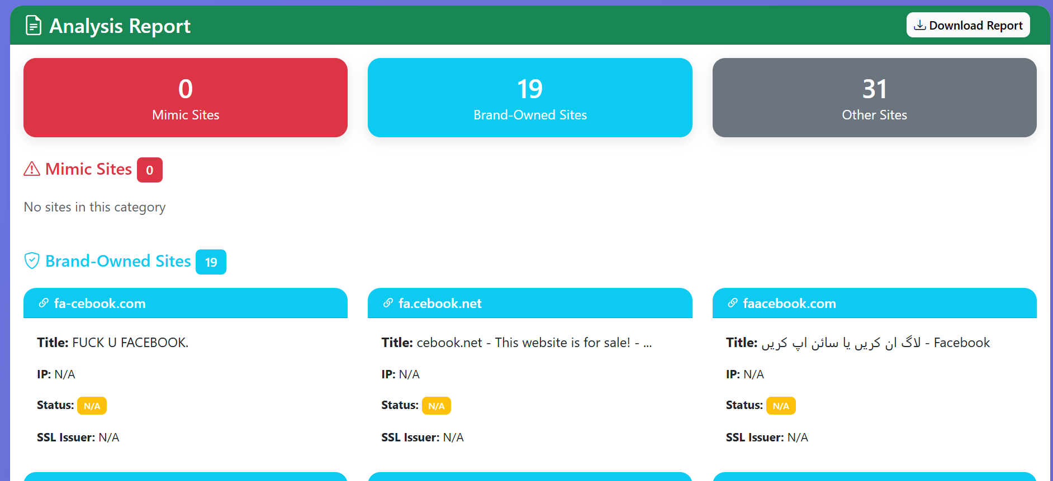
We can also download and see the full report, which shows the mimic sites, brand own sites, and other sites which are not exactly mimic sites but using typosquate domain of the brand. All the sites are shown with different colors with http details. Same will be in the report.

6.3 Logo detection
The system works the same as in the mimic detection to about 80% for the logo detection, but it diverges it last while taking reference screenshot and then compare it with each site screenshot through an AI model.
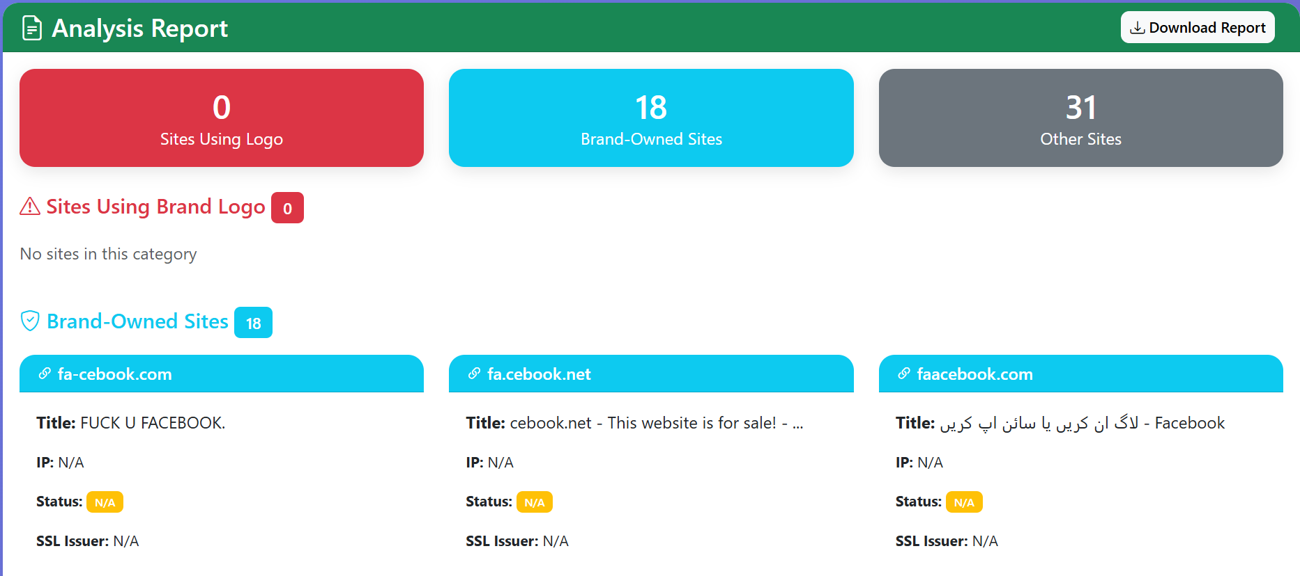

6.4 Threat intelligence integration
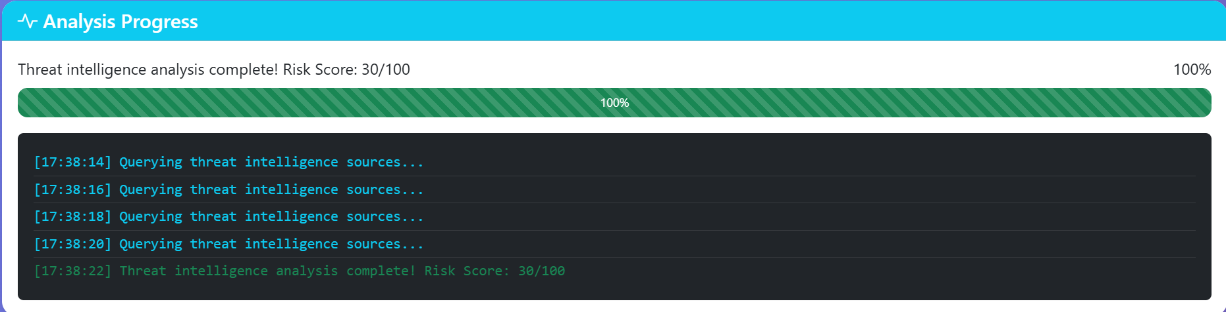
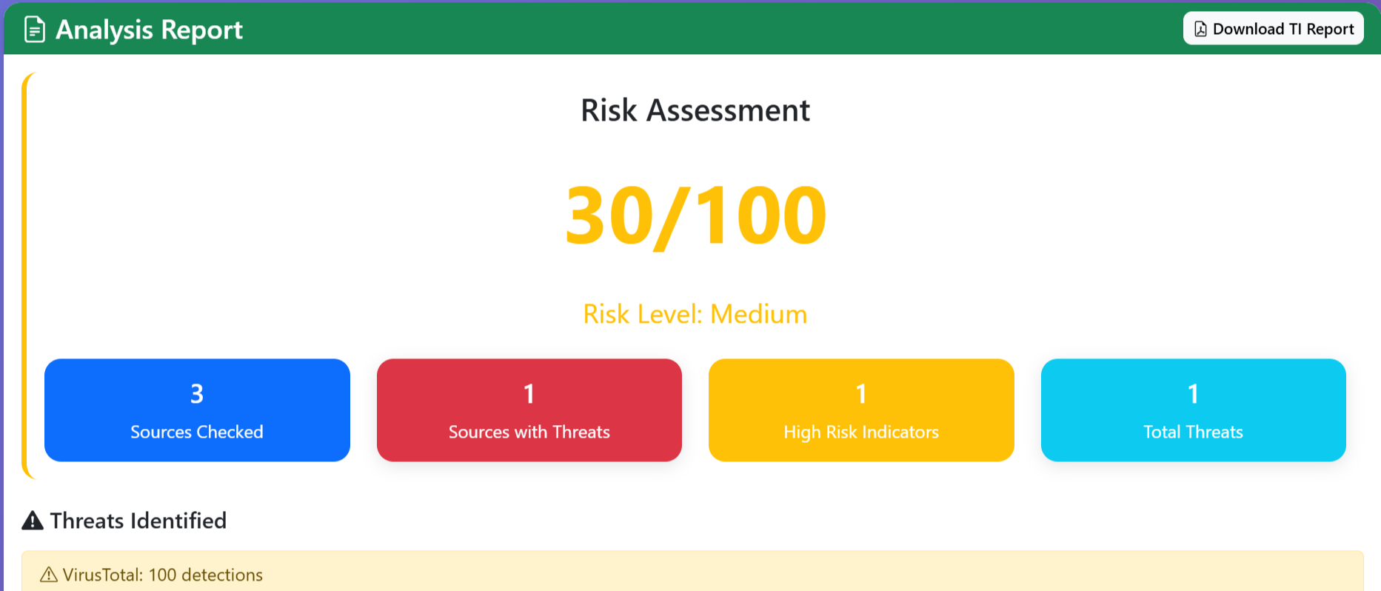
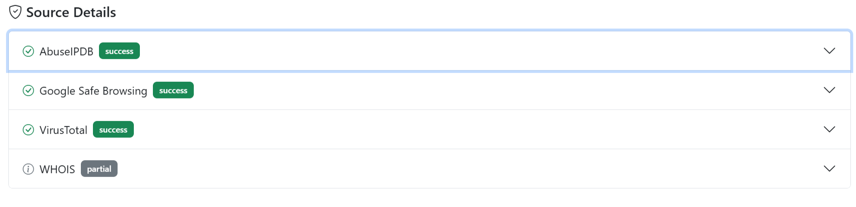
We can open each source for extensive details and download the whole report for detail inspection.

6.5 Dark web monitoring
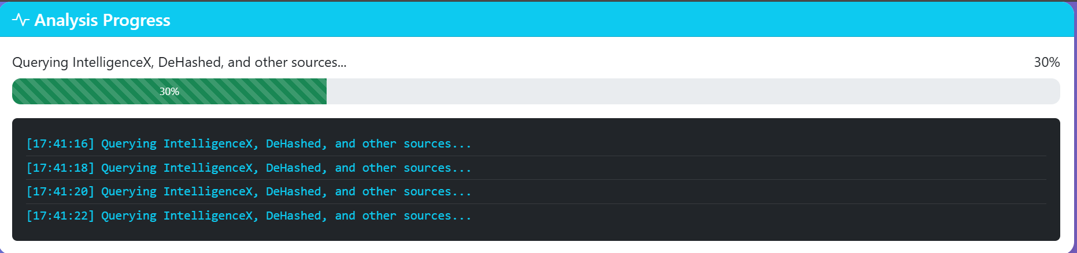
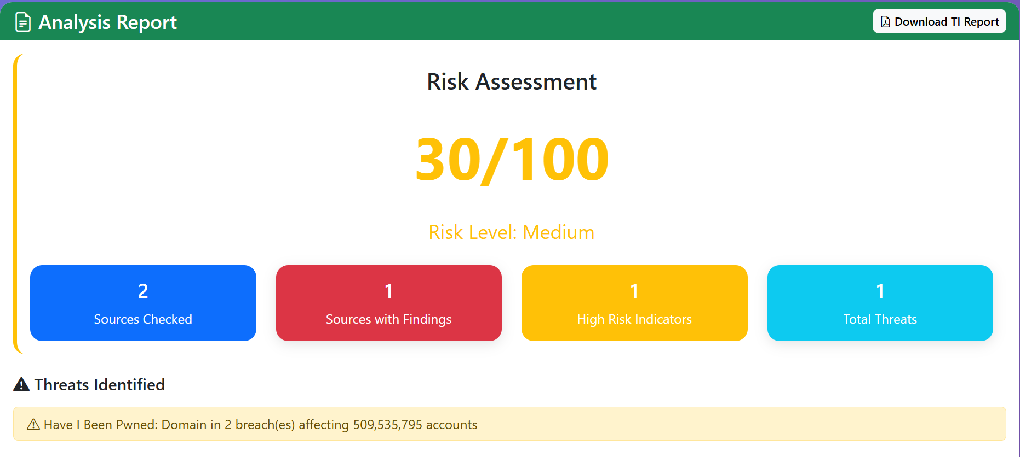
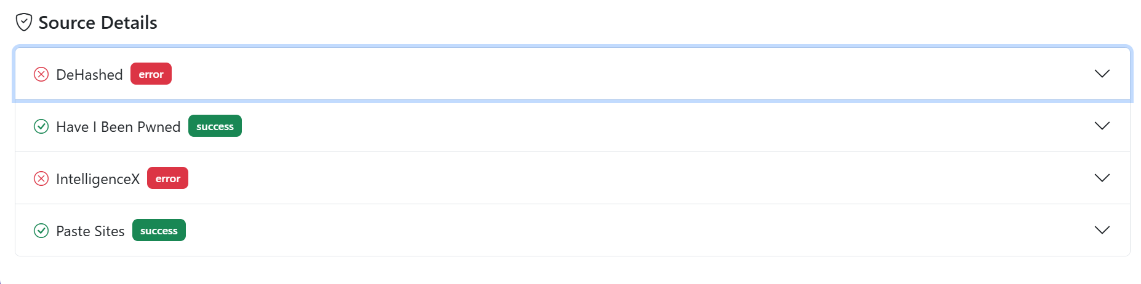
The Deshashed Api and intelligenceX is giving errors, that is because they are paid api and we cannot access it for free, although we integrate it with our system as a bonus feature.

6.6 Social media monitoring
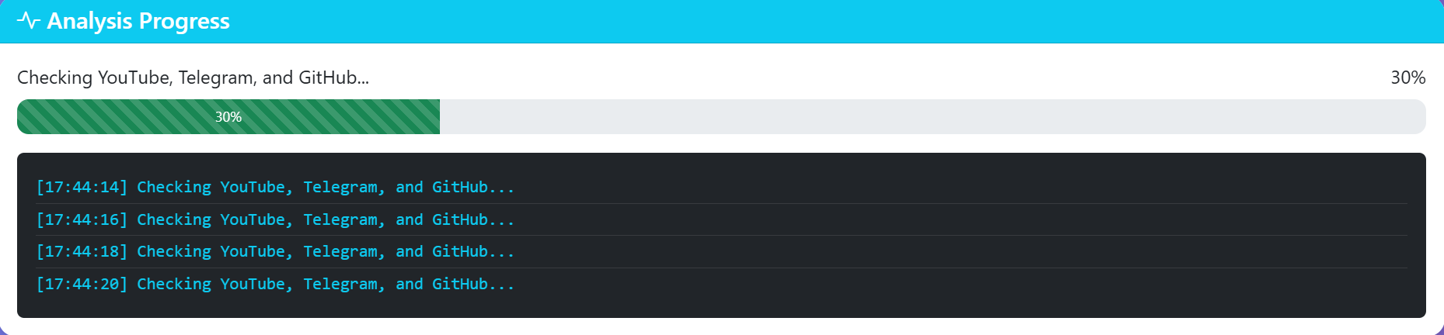
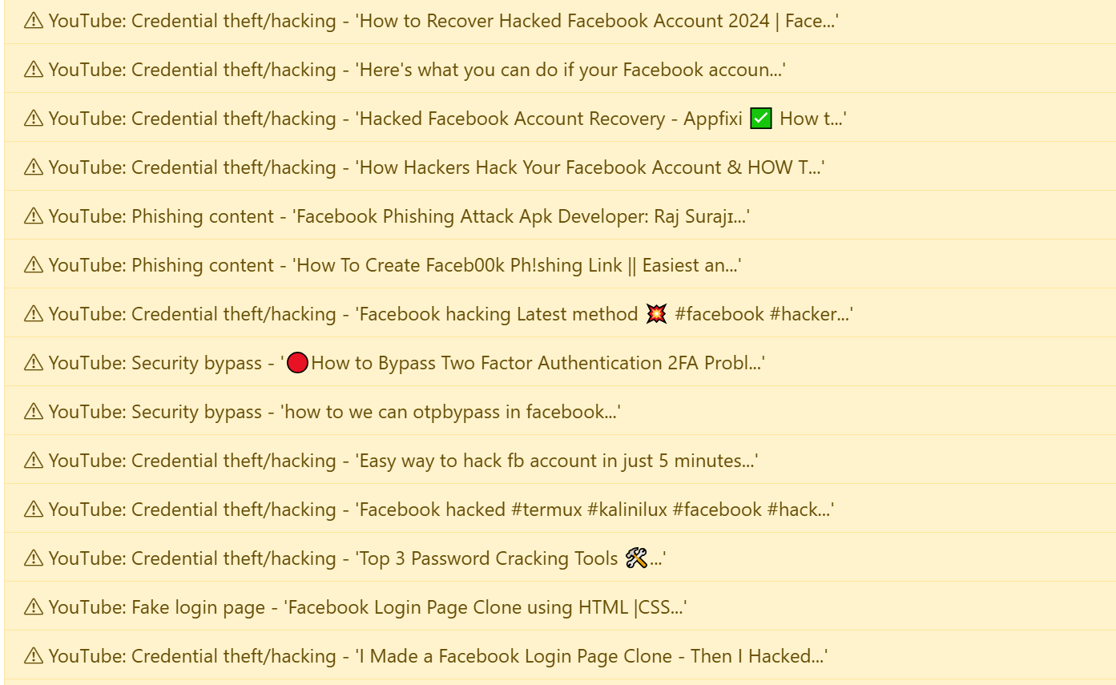
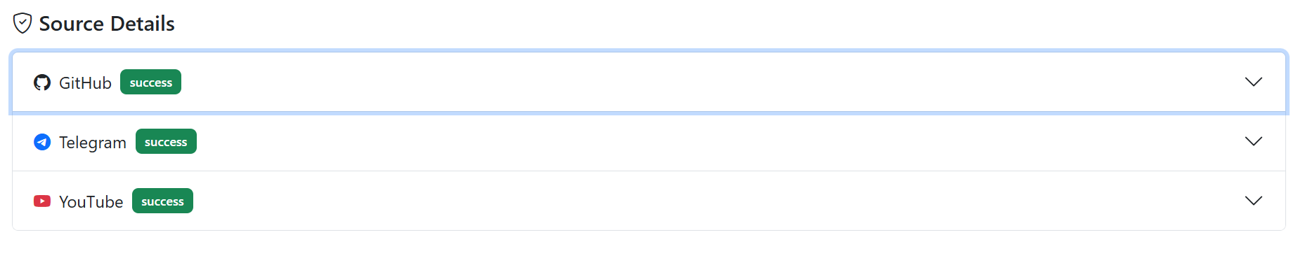
We can expand each section for more details and description.

7. Challenges and Limitations

7.1 Technical Challenges

7.1.1 API Rate Limiting
Free APIs, such as VirusTotal, enforce strict rate limits (e.g., 4 requests per minute), slowing down batch processing. The system mitigates this by implementing delays, caching results, and handling quota exhaustion gracefully. Despite these measures, large-scale processing is limited without access to paid API tiers.

7.1.2 Model Performance
The DINOv2 model is computationally intensive, resulting in slow processing on CPU-only systems and high memory usage (~2GB). Performance is improved through model caching, GPU acceleration, and batch optimization. However, large-scale or real-time processing still requires significant computational resources.

7.2 Detection Limitations

7.2.1 Logo Detection
Logo detection may fail for occluded, heavily modified, very small (<50x50 px), or novel logos. It can also give false positives, which was a big problem in this project, although we did our best to fine tune the system and remove false positives and as well as false negatives. Future improvements include object detection for precise localization, fine-tuning models on brand-specific data, and multi-resolution analysis.

7.2.2 Threat Intelligence
The system depends on external Free APIs, which may be unavailable or delayed, limiting threat coverage. Future enhancements could include integrating additional intelligence sources, maintaining local threat databases, paid APIs, and applying machine learning for predictive threat detection.
7.2.3 Social Media Monitoring
Platform restrictions, text-focused analysis, and language limitations can reduce detection effectiveness. Planned improvements involve multi-language support, image content analysis, and social network graph analysis to detect complex impersonation threats. And here also the system is limited to free APIs due to cost constraints.

8 Conclusion
This project demonstrates the application of complex computing principles to solve real-world security challenges. Through the integration of computer vision, threat intelligence, and social media monitoring, the system provides a comprehensive solution for brand protection. The iterative refinement process, from initial high false-positive rates to final 98% precision, showcases the importance of systematic testing and analytical reasoning in security system design.
The system's modular architecture, comprehensive error handling, and focus on security best practices make it a robust foundation for brand protection. While limitations exist, particularly in scalability and API dependencies, the system successfully addresses the core challenge of detecting brand threats across multiple vectors with high accuracy.

9 References
[1] M. Ulikowski, elceef/dnstwist. (Dec. 01, 2025). Python. Accessed: Dec. 02, 2025. [Online]. Available: https://github.com/elceef/dnstwist
[2] “GitHub - typosquatter/ail-typo-squatting: Generate list of potential typo squatting domains with domain name permutation engine to feed AIL and other systems.” Accessed: Dec. 02, 2025. [Online]. Available: https://github.com/typosquatter/ail-typo-squatting
[3] ilmonteux, ilmonteux/logohunter. (Nov. 20, 2025). Jupyter Notebook. Accessed: Dec. 02, 2025. [Online]. Available: https://github.com/ilmonteux/logohunter
[4] “GitHub - facebookresearch/dinov2: PyTorch code and models for the DINOv2 self-supervised learning method.” Accessed: Dec. 02, 2025. [Online]. Available: https://github.com/facebookresearch/dinov2
[5] “API Documentation - AbuseIPDB.” Accessed: Dec. 02, 2025. [Online]. Available: https://www.abuseipdb.com/api
[6] “API Documentation - AbuseIPDB.” Accessed: Dec. 02, 2025. [Online]. Available: https://www.abuseipdb.com/api
[7] “Google Safe Browsing,” Google for Developers. Accessed: Dec. 02, 2025. [Online]. Available: https://developers.google.com/safe-browsing
[8] “YouTube Data API,” Google for Developers. Accessed: Dec. 02, 2025. [Online]. Available: https://developers.google.com/youtube/v3
[9] “CLIP.” Accessed: Dec. 02, 2025. [Online]. Available: https://huggingface.co/docs/transformers/en/model_doc/clip
[10] “Have I Been Pwned: Check if your email address has been exposed in a data breach,” Have I Been Pwned. Accessed: Dec. 02, 2025. [Online]. Available: https://haveibeenpwned.com/
[11] “Welcome to Flask — Flask Documentation (3.1.x).” Accessed: Dec. 02, 2025. [Online]. Available: https://flask.palletsprojects.com/en/stable/

