

**Project and Application of**

**Kash Cart**

**E-Commerce Site for Online Shopping**

**By**

**Waseem Farooq**

KashCart E-Commerce Site for Online Shopping

**INTRODUCTION:**

E-commerce is fast gaining ground as an accepted and used business paradigm. More and more business houses are implementing web sites providing functionality for performing commercial transactions over the web. It is reasonable to say that the process of shopping on the web is becoming commonplace.

The objective of this project is to develop a general purpose e-commerce store where product like clothes, electronic gadgets, household items and other items can be bought from the comfort of home through the Internet.

An online store is a virtual store on the Internet where customers can browse the catalog and select products of interest. The selected items may be collected in a shopping cart. At checkout time, the items in the shopping cart will be presented as an order. At that time, more information will be needed to complete the transaction. Usually, the customer will be asked to fill or select a billing address, a shipping address, a shipping option, and payment information such as credit card number. An e-mail notification is sent to the customer as soon as the order is placed.

**2.0 OVERALL DESCRIPTION:**

**Description:**

* Any member can register and view available products.
* Only registered member can purchase multiple products regardless of quantity.
* ContactUs page is available to contact Admin for queries.
* There are three roles available: Visitor, User and Admin.
* Visitor can view available products.
* User can view and purchase products.
* An Admin has some extra privilege including all privilege of visitor and user.
* Admin can add products, edit product information and add/remove product.
* Admin can add user, edit user information and can remove user.
* Admin can ship order to user based on order placed by sending confirmation mail.

**2.1 TECHNOLOGY USED:**

**Frontend:**

* **Html**
* **CSS**
* **Bootstrap**
* **React**

**Backend:**

* **JavaScript**
* **CI / CD with AWS**

**Database:**

* **MongoDB**
* **JSON Data**
* **Node JS**

**2.2 WEB PAGES CONSISTS:**

* Home Page
* About Us Page
* Accessories Page
* Order Us Page
* ContactUs Page
* Admin Page
* Login Page
* Signup Page
* Track

**2.3 PROJECT DETAILS:**

**KashCart - 3 Layer Architecture**

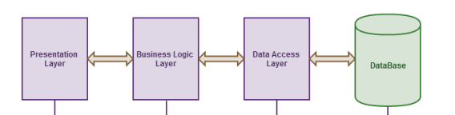

**2.4 SYSTEM REQUIREMENTS:**

**CASE DIAGRAM:**

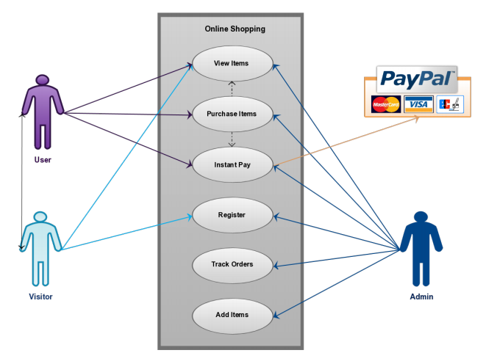

**2.5 ONLINE SHOPPING APPLICATION:**

**Homepage:** The Home Screen will consist of screen were one can browse through the products which we have on our website

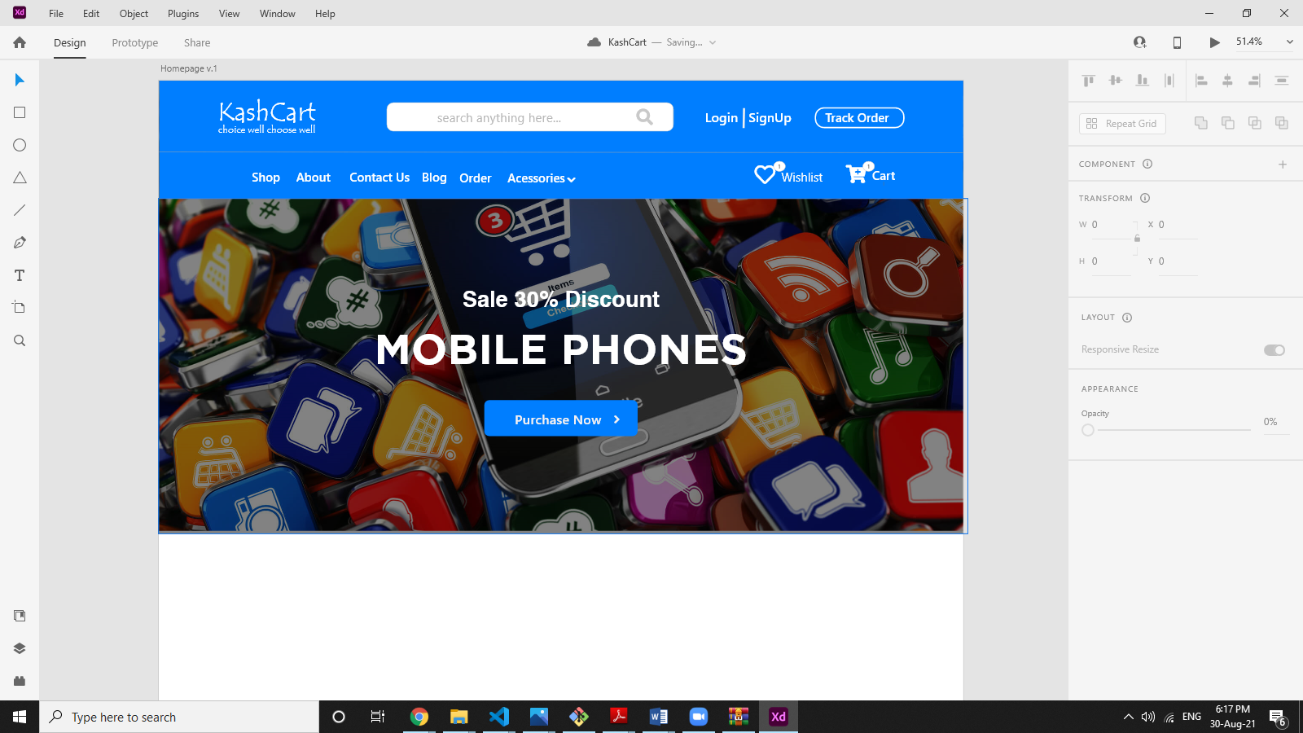

**About:** This page describes about website and owners

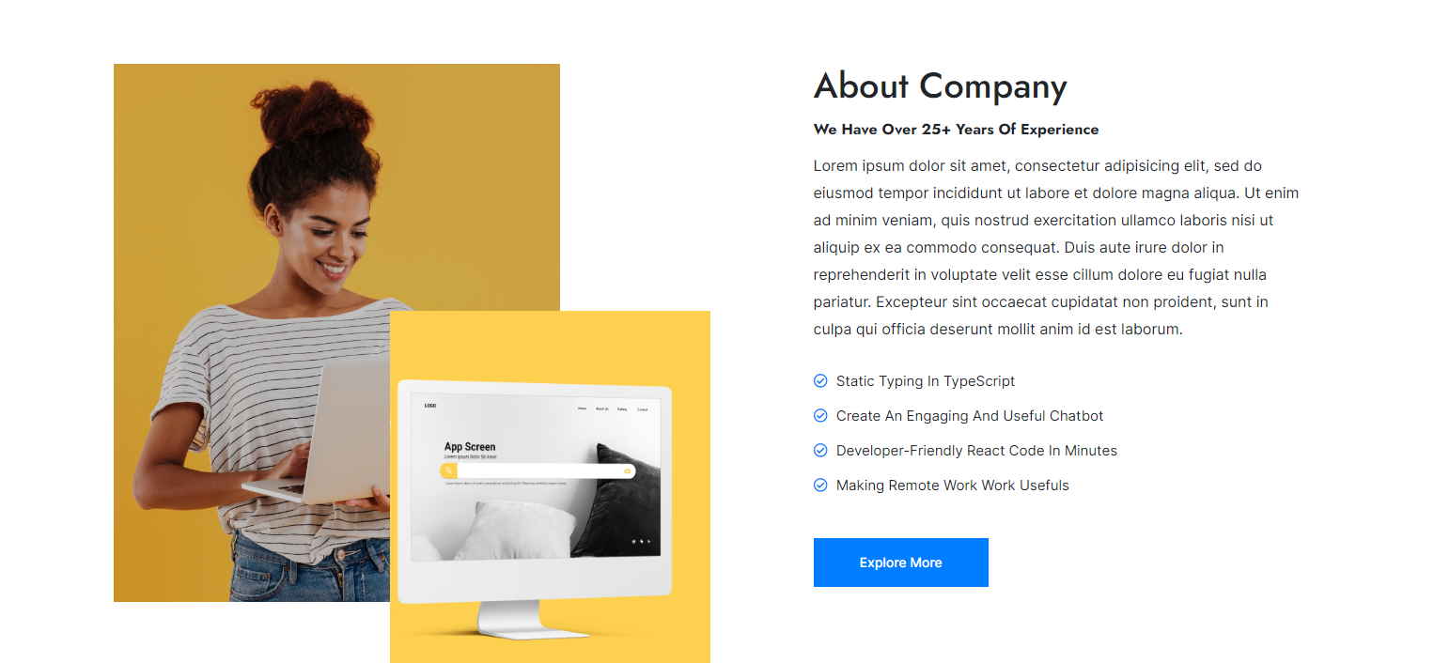



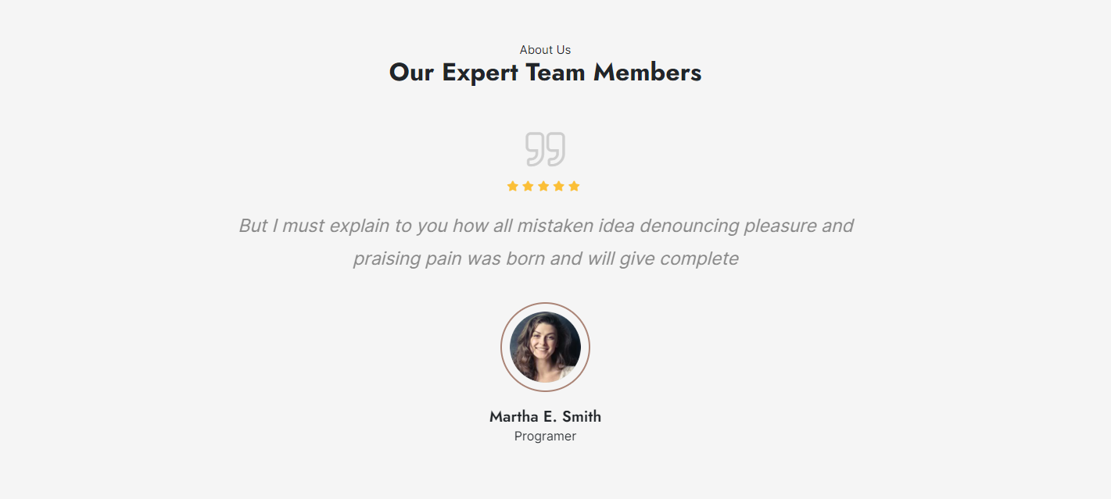

**Accessories & Order Us:** This page consists of product details. This page appears same for both visitors and users.

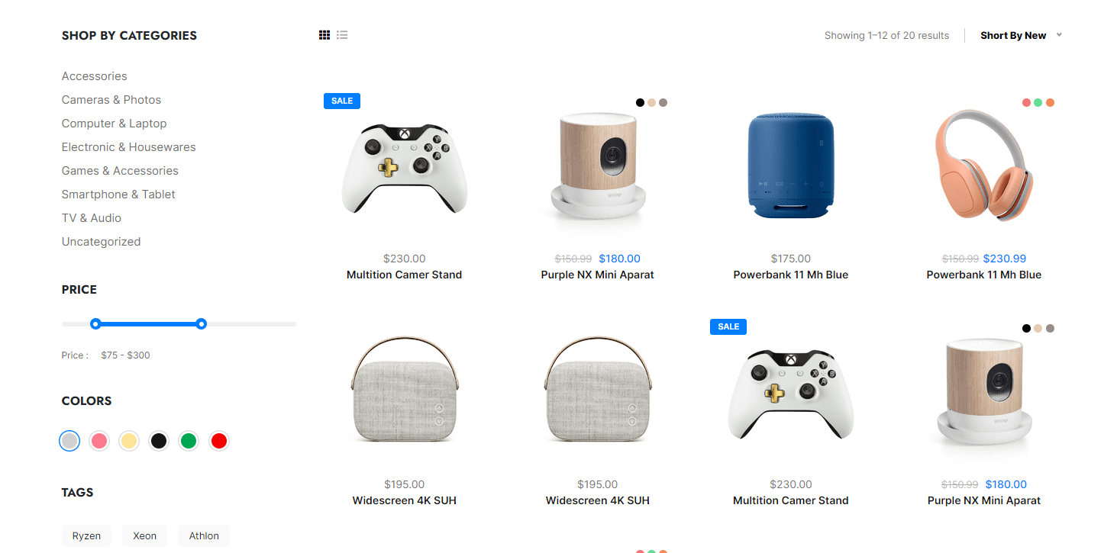

After clicking on product details will be like below mentioned.

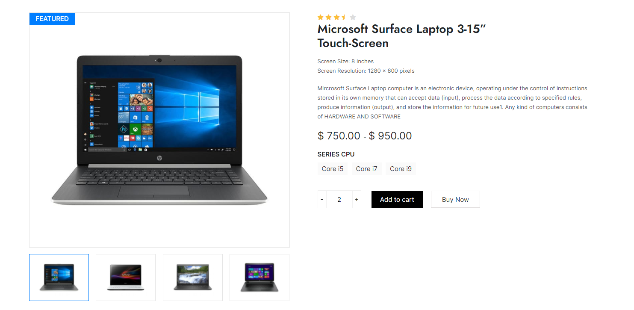

**Contact Us:** Visitors and Registered users can contact website owners or administrators from here

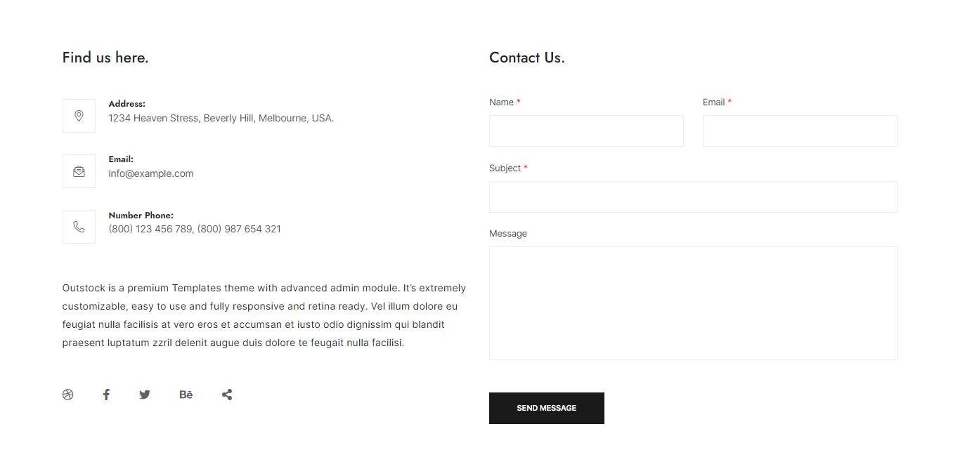

**Amin page:** Only difference you see in this page is Role: Admin. User and Admin role will be checked once the page was login and Session [“role”] will be either Admin or User. If credentials belong to Admin, then role will be Admin and if credentials belong to User then role will be User.

**Login:** Login page for both users and administrators.

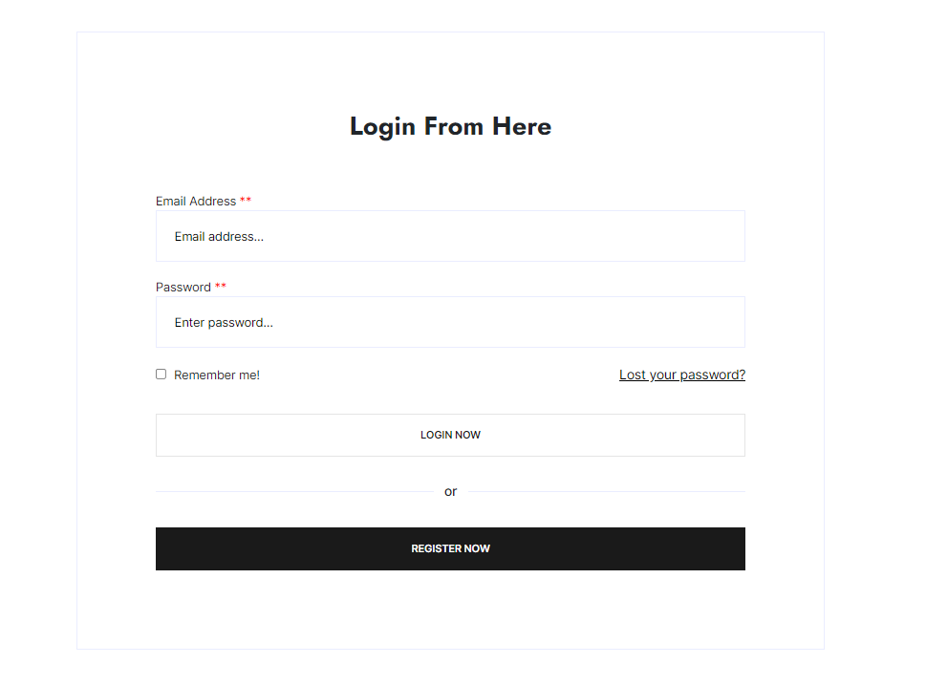

**Signup:** New users can register here.

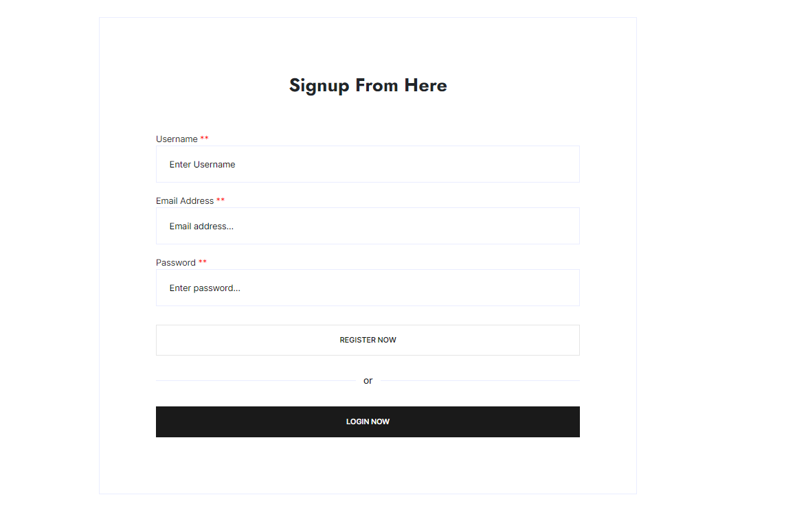

**Track:** Website Administrators can track and ship orders here.



**Payment:** Once users orders products they are redirected to payment page.

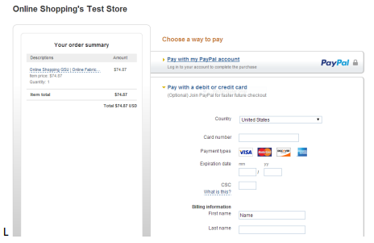

**Success URL:** Once the payment transaction is successfully done.



**Failed URL:** Once the payment transaction is failed.



**Relationships**

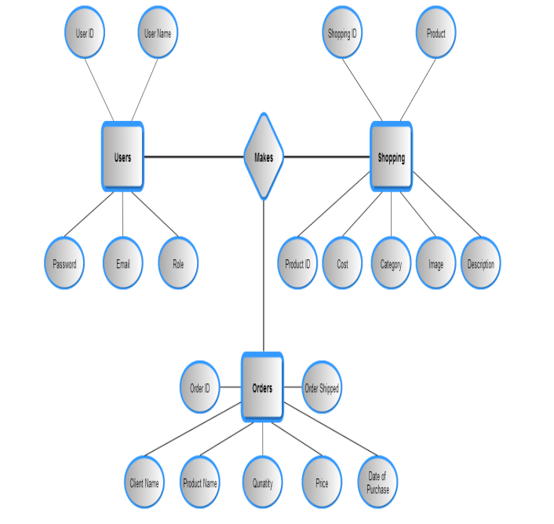

**Conclusion:** A good shopping cart design must be accompanied with user-friendly shopping cart application logic. It should be convenient for the customer to view the contents of their cart and to be able to remove or add items to their cart. The shopping cart application described in this project provides a number of features that are designed to make the customer more comfortable. For the entrepreneur, electronic shopping generates new business opportunities and for the customer, it makes comparative shopping possible. To implement this as a web application we used latest technology to enhanced performance, scalability, built-in security and simplicity.