Development Document: BIG NEWS

# COMS W4170: User Interface Design

# Team: Bow Flex Designers

## Team Members

## Waseem Ilahi ([wki2001@columbia.edu](mailto:wki2001@columbia.edu))

## Michael Glass ([mgg2102@columbia.edu](mailto:mgg2102@columbia.edu))

## David Flerlage ([dff2103@columbia.edu](mailto:dff2103@columbia.edu))

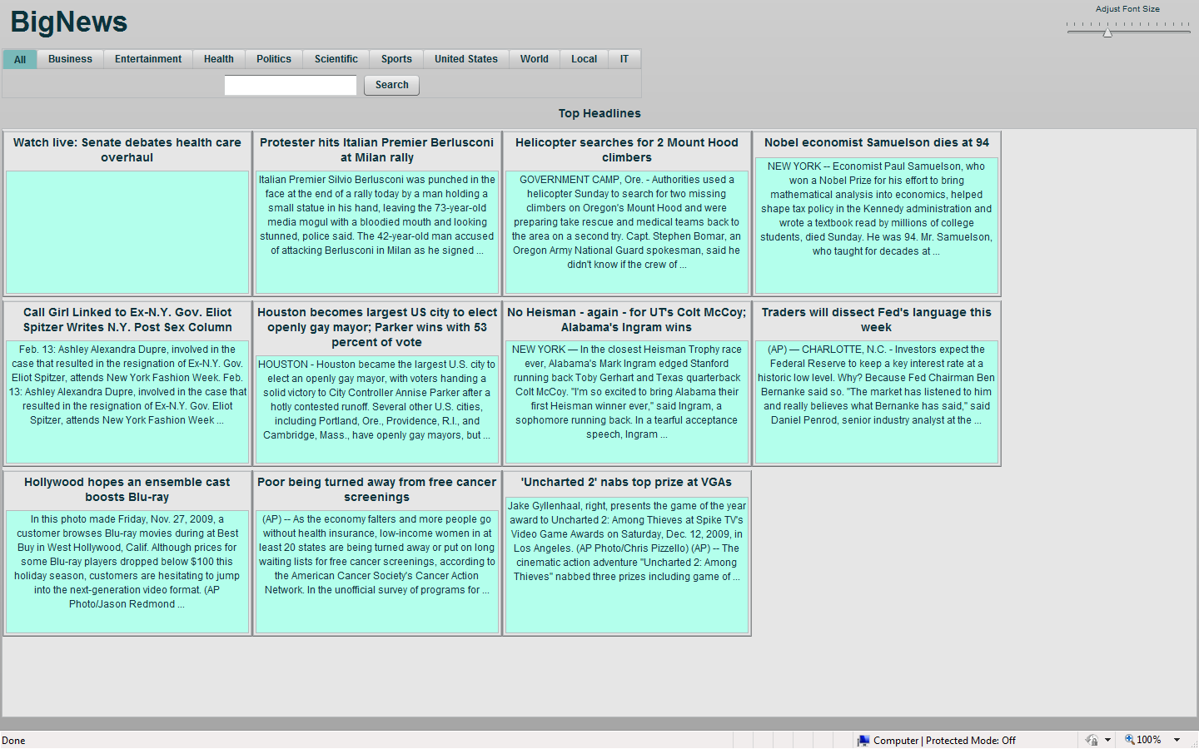

# Overview

This development document contains the high level description of the development process for Big News, implemented by the “Bow Flex Designers”. It will mention the roles of each team member and then go on describing various decisions/steps taken while implementing the system, including the prototyping phase and figuring out the target user groups.

## Process

The development team consists of three members. The task for actual development was divided such that:

* The entire team sat down and figured out a target user group. Then took a couple of personas from the user group and wrote a use case scenario for each.
* Now that we had the target in sight, we started figuring out a UI for the system, based on the use cases. The lo-fi prototyping technique was used.
* After deciding on a design that will follow the Ten Usability heuristics, the implementation phase started. Now, one member was assigned to research the Bing API, especially the NEWS source type and figure out the proper way to use it with flex.
* Meanwhile the other two members started working on the UI for the system.
* First, very simple UI was created and very basic query returned. After that, improvements were made and the various proposed functionalities were added to the system.
* This document was completed, after the system had been created and tested properly.

## Target Users

Big News will be a news searcher for people with visual and motor disabilities.  As a side objective, we'll also try to make our application usable for people not completely familiar with computers.  Perhaps we will split up these feature sets, so that in-program help for new users doesn't get in the way of speed and usability for power users.

### Personas:

### Persona: Tootsie Glass

Tootsie Glass is not a computer user.  She is a great typist, but she can't use a mouse, and is unwilling to learn.  She's 94, I don't really blame her.  Her grandson has tried and tried again to get her to start using a computer, and she's perpetually resisted.  She reads the Times every day, and skims the paper for references to anyone she knows -- her son has been in the news recently.  Her grandson, Michael, catches her doing this, and sees an opportunity to make a computer application that she might even use.

### Use Scenario for Tootsie Glass

Tootsie sits down at her news console, (the application is run full screen, and so the computer appears to only run Big News).  She types in "cookies" and sees a slew of articles about cookies in the recent news, displayed as if it was in a newspaper.  She arrows down to one of the results, presses enter, and reads an article about thanksgiving and eating.  She again types another query, her daughter's name, "Ellen Glass" and finds nothing of interest, however on the side of the screen, the application tells her, "you last searched for cookies", and is reminded to get back to preparing for thanksgiving.

### Persona: Joe

Joe, 50 years old, is an airline pilot, but has been on disability leave for several years because of a plane crash he was in, leaving him with visual and motor disabilities.  Joe is an avid reader and spends a good deal of his time reading current news.  Unfortunately, the print in the newspaper is too small to read, and most websites are too difficult and too time consuming to navigate.  Joe wants an easier and quicker way to read the news.

### Use Scenario for Joe

Joe starts up “Big News” with the intent of looking up the scores and statistics from the most recent game between the Denver Broncos and the New York Giants.  He opens up the program and clicks on the sports category.  He looks at the sports headlines, but does not see any information on the game he is interested in.  He then decides to execute a search query, specifically, he types in "Giants scores".  A bunch of news results come up.  He looks through a few of them and finds some interesting information on the Broncos.  To this end, he types in "Broncos scores".  The first search results that appear are those headlines that were common between his previous searches.  Unfortunately, the Giants and Broncos have been playing against each other for years, resulting in some of the news articles being outdated.  He decides to sort the results by their date of publish.  He clicks the "sort by time" button, reorganizing the data so that the most recent articles are displayed first.  He reads a bunch of articles and is very satisfied with his experience, except that he remembers that he forgot to read an article from the previous query ("Giants scores").  He moves the mouse to the right side of the screen to the previous searches box, locates the desired query, and clicks on it.  All of the search results from his previous search are displayed.  He reads the article he forgot, and then leaves.

## Design Decisions

* Design decisions. Explain the design decisions you made, including ones that were intended to address the specific needs of your target users and tasks. Your goal is to justify what you did. For example, you could reference one or more of the heuristics listed in <http://www.useit.com/papers/heuristic/heuristic_list.html>, and describe how your decision satisfies them. Alternatively, you could provide a rationale for a decision based on a user need or task. If parts of your user interface are inspired by or borrowed from any existing user interface designs or techniques, please cite them (whether or not they were covered in the course).
* Prototyping and testing process.Provide a description of your prototyping and testing process. Diagrams and screen shots are strongly encouraged. Explain the prototyping techniques that you used and why you chose them. While testing with subjects outside of your own team is encouraged, it is not required. However, you will need to explain how you tested your design and program (i.e., at least with members of your own team). Explain how the results of the prototyping and testing processes informed the final design of your program.
* Software engineering. Briefly describe the tools that you used including any third party code, libraries, dlls, or other resources.