User Manual: BIG NEWS

# COMS W4170: User Interface Design

# Team: Bow Flex Designers

## Team Members

## Waseem Ilahi ([wki2001@columbia.edu](mailto:wki2001@columbia.edu))

## Michael Glass ([mgg2102@columbia.edu](mailto:mgg2102@columbia.edu))

## David Flerlage ([dff2103@columbia.edu](mailto:dff2103@columbia.edu))

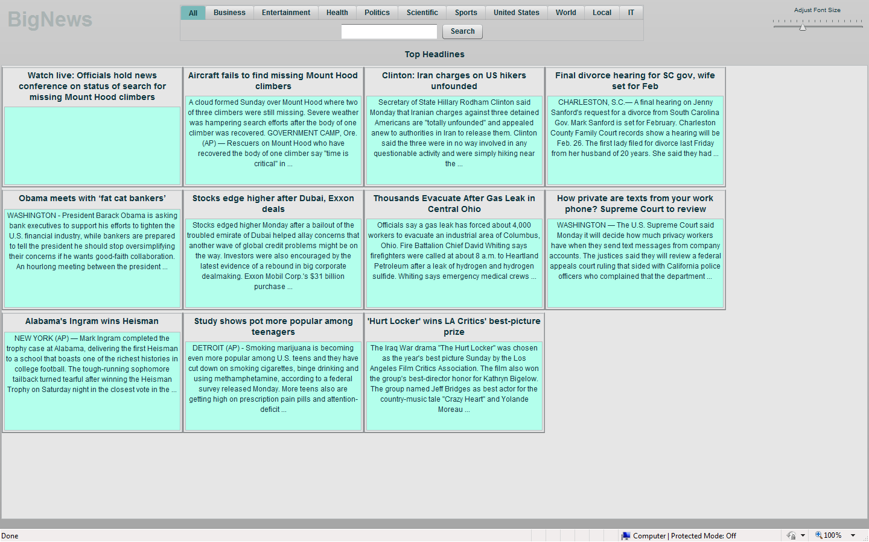

# Introduction

This document lists the basic functionality provided by BigNews. Then it briefly tries to state how to use each of these functionalities.

When the application starts up, it shows the current headlines (title + snippet). At the top of UI, at the left side, there is a list of selection choices, so the user can search for a specific category. Below it, is the search box, which the user can type in the search terms. Next to it is the search button. To the right,, there is a slider, this slider allows the user to change the size of the text on the screen.

Here is a list of possible things a user can do from this point on.

## Read the Article

If the user wants to read an article they like, they have to double click on the article. This opens up a new browser window. The original BigNews window stays the same. After the user is done reading the article, they can simply close the window and come back to the BigNews.

## Adjust Text Size

At the top right of “every” page inside the BigNews, is a horizontal slider. The user can increase the size of the text, by moving the slider to the right. Similarly, the size of the text can be decreased by sliding the slider to the left.

## Select Category

Originally the category “all” is selected. As the name represents, this category searches the news, regardless of any specific category. There are ten other options, the user can select from. The user clicks on a category for the future searches to be in that category.

## Search (request and response)

Now that the user has selected the category they want to search in, they can simply type in the term(s), they want to search for and click the search button next to the search box.

When the user searches for something, the response shows up in a little different view. The search results are not in the square boxes anymore. However, to read the whole article, the user has to do the same thing, double click on it. The effect of this is the same as double clicking on the article from the headlines “view”.

## Pagination

Top fifteen search results are shown on the main results window. To view more results, the user can click on the “>>” button at the bottom of the screen. The current page number is shown under it for the user to know, where they are in navigation of the results. Similarly “<<” button can be used to move back.



## Sort the Results

Originally we planned to provide the functionality for sorting the search results, according to their date of publication, but we have decided to drop the option. The search results are sorted by relevance. However, within each relevance group, the most recent one comes before the others.

## Previous Searches

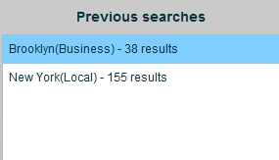BigNews also shows the recent searches (for current session) in the “list” to the right of the currently visible searches. The user can make multiple search requests and then toggle among them. If the user clicks on any one of the search terms on the right, the results for that search term get loaded to the left and the user can navigate through them the same way.

These are the basic user manipulated functionalities BigNews supports. Here, is a scenario for a user “Tootsie Glass” searching for “cookies” then for “Ellan Glass” and then using the “Previous Search” pan, going back to the search results for cookies.

**P – T – O 🡪**

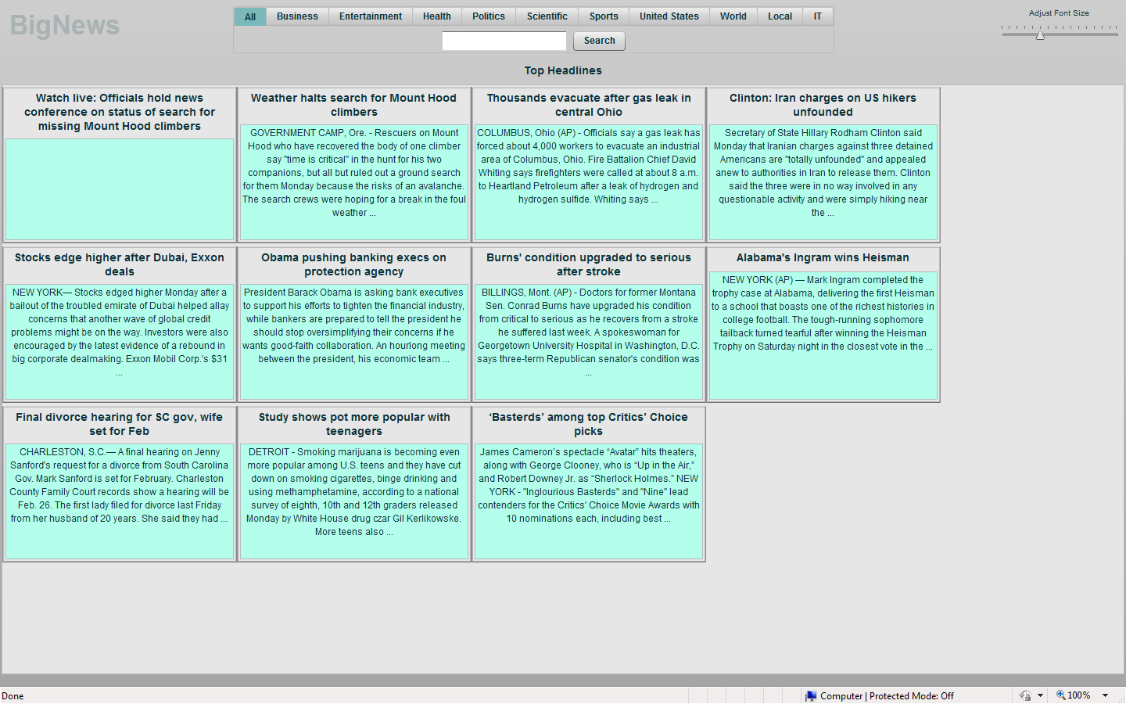Main screen when the application loads.

Tootsie types in “cookies” and clicks search. The following screen shows up.

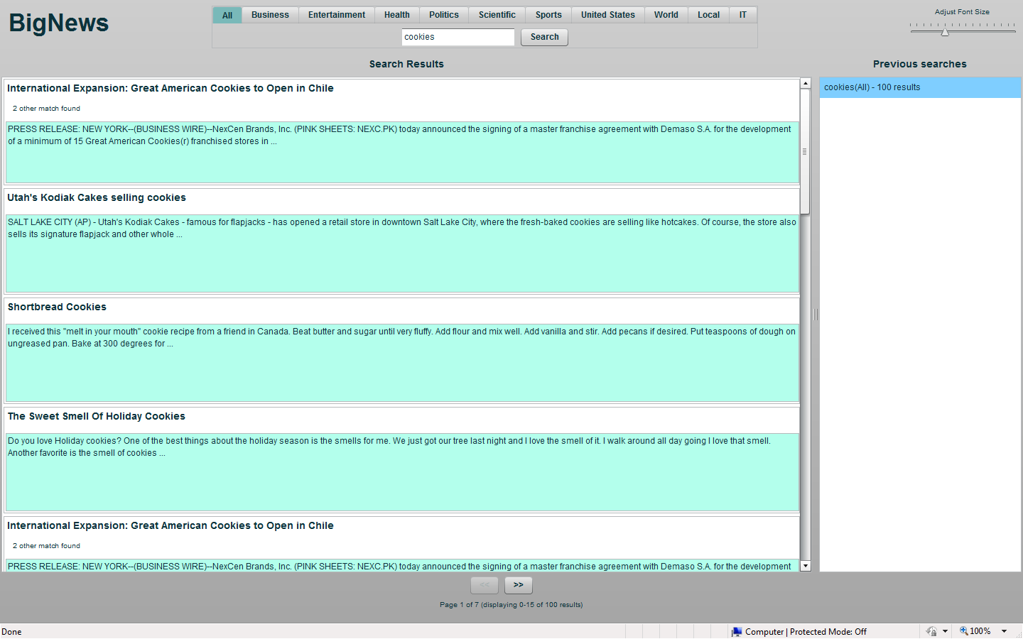

From the search results, Tootsie double clicks the one she likes. This opens up another browser windows, provided below.

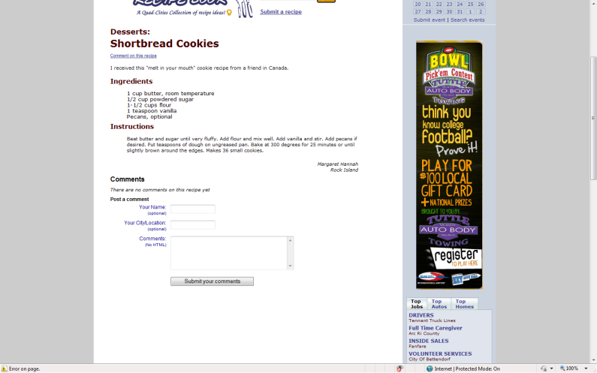

Tootsie goes back to BigNews, and types in “Ellan Glass” in the search box and clicks search. The following screen comes up.

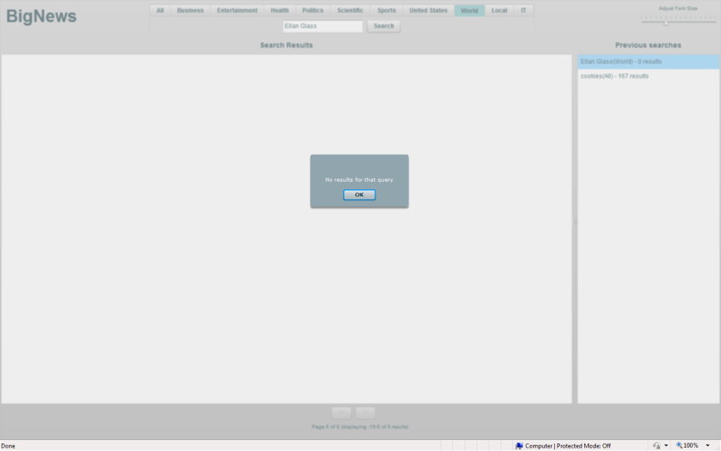

Tootsie clicks on the “cookies” entry in the “previous searches” to open the previous search. The following page shows up.

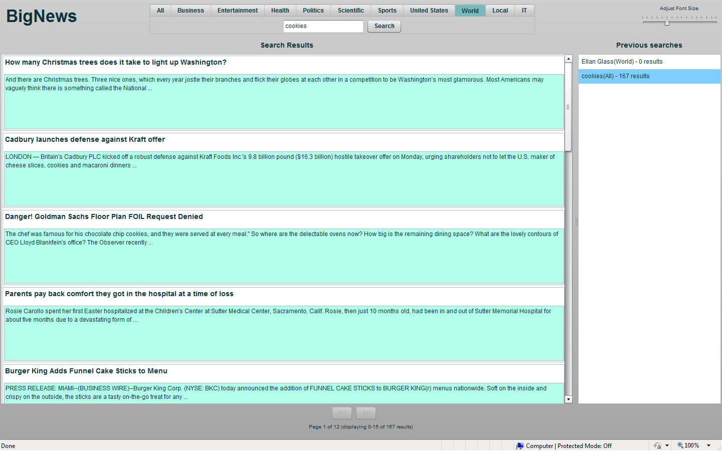

**THE END**