Project Report: Sport... Streaming Sports Videos

# COMS W4170: User Interface Design

# Group: 5

# Team: 1001 (5 + 4)

## Team Members

## 1’s: Laima Tazmin (lt2233@columbia.edu)

## Anwesha Deb (ad2773@columbia.edu)

## 0’s: Waseem Ilahi (wki2001@columbia.edu)

## Dongouk Moon (dm2615@columbia.edu)

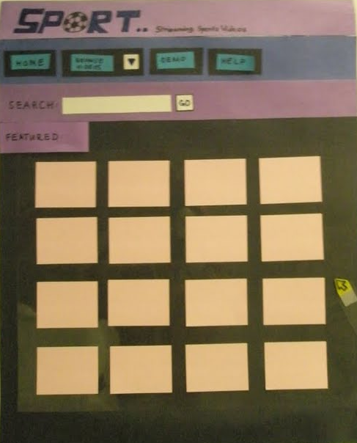

**Tentative Outline**

I. Introduction/Brainstorming

    a. Introduce the assignment?

    b. Use scenarios and personas ideas (generalized & rough; bulleted list)

    c. Include images of sketches and our "brainstorming" session with brief captions

III. Initial Design

    a. Description of approach with influences (L)

    b. Use Scenarios

        - Detailed user scenario descriptions (based on index cards)

        - Storyboard of each use scenario with heuristics in mind (M)

            * Images w/ Description Captions

            * Image of Moon trying it out

IV. Testing (A)

    a. Overall summary of the test (Pretend there were 2- one with Matt and one with Dave)

        * Images of the observation index cards for each test

        * Image of one of the testers trying it out

V. Evaluation (W)

    a. Overall explanation of the evaluation: changes we planned to make and how

        * Images of the annotated prototype w/ brief captions

VI. Revision

    a. Explain how our changes addresses the issues (with heuristics in mind)

        * Images of revised parts of prototype

    b. New set of storyboards (M)

VII. Conclusion