Assignment 1 — South German Credit
Student 1: [Name] - [r-number]
Student 2: [Name] - [r-number]

Part 1: Explore the Data
Variable & Grouping Choices: We chose credit_history (past financial behavior) and duration (discretized into bins). Combining these allows us to see how past behavior interacts with the length of the new liability.
Highest Bad-Credit Rate: The group with the highest default rate is applicants with past payment delays combined with long credit durations (>36m).
Most Bad Credits Volume: The highest absolute number of bad credits falls in average durations (13-24m) with neutral/existing credit histories (credit_history = 3), due to this being the largest population group.
Business Takeaway: The bank should implement stricter collateral or guarantor requirements for long-duration loans, especially when the applicant has any prior history of payment delays.
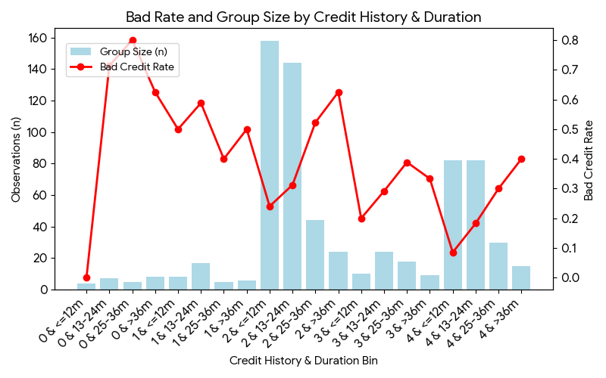

Part 2: Build and Evaluate the Model
Predictor Choices: We selected duration (binned), amount (binned into quartiles), credit_history, and savings. These provide a robust mix of the applicant's current financial buffer, historical reliability, and the parameters of the loan itself.
Information Value (IV): credit_history yielded the highest Information Value (0.238) in the training set, classifying it as the most predictive characteristic.
WOE Interpretation: A positive WOE value indicates a specific level has a higher proportion of good credits relative to bad credits (lower risk). For example, higher savings levels produce positive WOE.
Model Evaluation: The ROC curve shows a solid distinction. The Training AUC is 0.744 and Test AUC is 0.673, indicating that the model generalizes well.
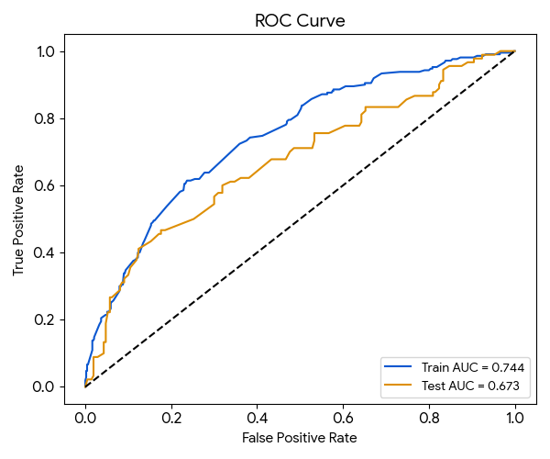

Part 3: Construct the Scorecard
Predictor | Level | Points
duration_bin | 13-24m | 116
duration_bin | 25-36m | 131
duration_bin | <=12m | 101
duration_bin | >36m | 138
amount_bin | Q4 | 123
amount_bin | Q3 | 112
amount_bin | Q2 | 111
amount_bin | Q1 | 116
credit_history | 4 | 98
credit_history | 2 | 119
credit_history | 1 | 140
credit_history | 0 | 146
credit_history | 3 | 117
savings | 1 | 126
savings | 3 | 88
savings | 2 | 119
savings | 4 | 69
savings | 5 | 87
The scorecard verification confirms that as scores increase, the predicted risk decreases.
The highest-scoring bad observation (533) highlights a false negative—a client who looked excellent on paper but still defaulted.
The lowest-scoring good observation (384) highlights a false positive—an applicant who was deemed highly risky but managed to repay the loan duly.


