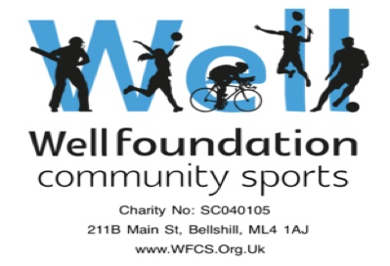


Well Foundation Community Sports Photography / Images Policy

1. Use of images (Still or Moving) - Guidelines

Well Foundation Community Sports takes its guidance on the use of images from guidelines issued by The FA.

All photographic images – still or moving – will be taken by Club Coaches or Helpers who have completed Safeguarding training.

Club Guidelines

· Before taking photographs of children and young people involved with Well Foundation Community Sports, parental consent is sought in writing at the start of the season or prior to the event (as part of the completion of the Club Membership Form).
· Parents / Carers are responsible for informing the Club of any change of circumstances within
the season which may affect consent.
· Parents and carers will be informed of how the image will be used. The Club will not allow an
image to be used for something other than that for which it was initially agreed.
· All children and young people featured in Club publications will be appropriately dressed.
· Where possible, the image will focus on the activity taking place and not a specific child /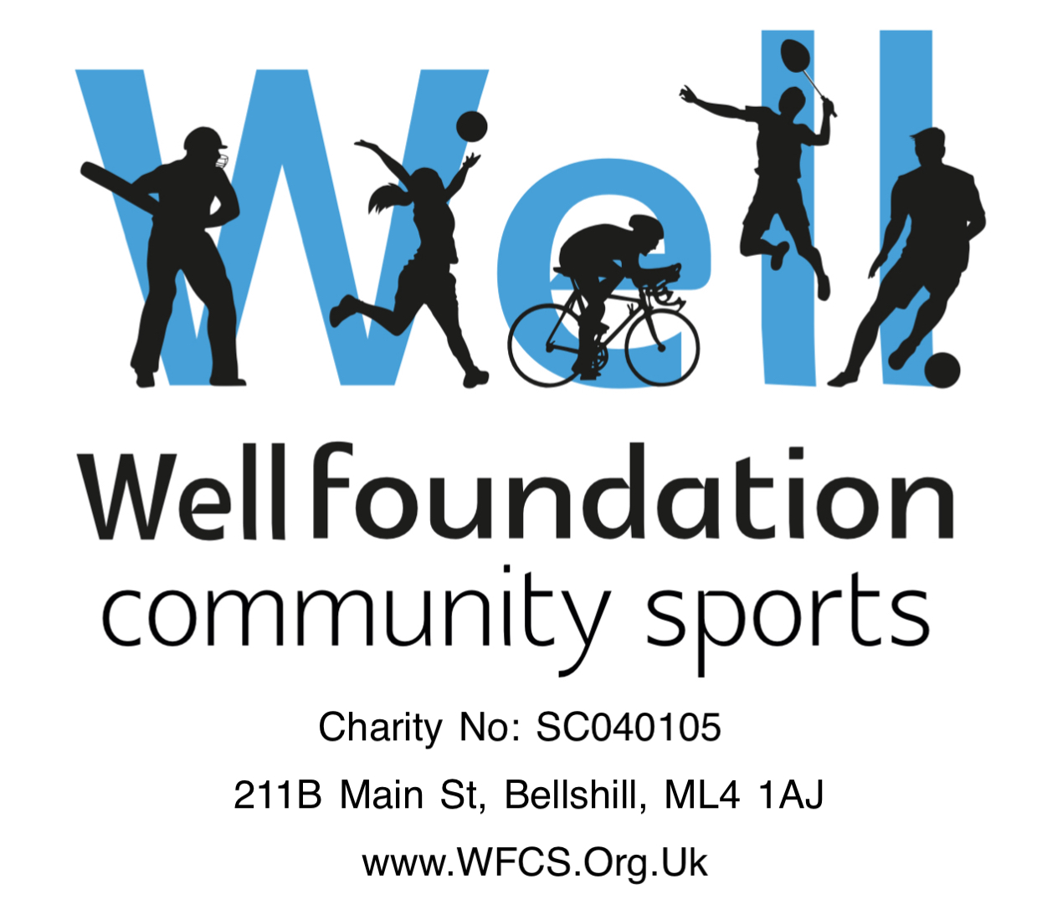
young person.
· Club Identification will be worn at all times by anyone taking photographs.
· Children and young people who are under a court order will not have their images published
in any Club medium (website or other social media, marketing material, etc.). It is the responsibility of the parent / carer to inform the Club of such circumstances.
· No images of children and young people featured in Club publications will be accompanied by
personal details such as their school or home address.

Parental Guidelines

· Any instances of inappropriate images in football should be reported to the Club Welfare
Officer.
· Parents are not to take photographs either at training, matches or any other Club event unless
permission is given.
· If parents see what they deem to be unauthorized photography they should immediately
report it to a Coach or Helper who in turn are responsible for reporting it to the Club Welfare Officer.
· If parents / carers become aware that images are being used inappropriately you should
inform the Club Welfare Officer immediately.

WFCS Football Club recognizes the need to ensure the welfare and safety of all players in football. As part of our commitment to ensure the safety of players we will not permit photographs, video or other images of players to be taken or used without the written consent of the parent/guardian or the player.

WFCS Football Club will take all steps to ensure these images are used solely for the purposes they are intended which is the promotion and celebration of the activities of Norristhorpe Junior Football Club.

Policy Version 1: July 2017 1

Well Foundation Community Sports Photography / Images Policy

2. Mobile Phones

There are situations when access to a mobile phone will make a positive contribution to the safety and welfare of children and young people, particularly when an emergency occurs.

However, the use of mobile phones by Coaches during training or at competitions, except for the purposes of making or receiving an emergency call, would be considered to be both unsafe and inappropriate conduct.

Children and young people will only ever be contacted in the case of an emergency and when an appropriate adult cannot be contacted. Ideally contact by Coaches would be primarily on a face to face basis. Additional communication relating to events, training and other information should be directed to the child or young person's parents or legal guardian.

WFCS Football Club recognizes that text messaging is rarely an appropriate response to a child in a crisis situation or at risk of harm. It should only be used as a last resort when other forms of communication are not possible.

No mobile phones – or any other type of filming equipment, are to be used in the toilet areas or changing rooms at any venue.

3. Videoing as a Coaching Aid

On occasions the Club may wish to video a game or training session using video equipment as a legitimate coaching aid.

However, performers and their parents/carers should be made aware that this is part of the coaching programme and their consent obtained.

The recorded images would only be shared with parents via a closed social media site and only if prior consent has been received.

Policy Version 1: July 2017 2

