Table of Contents

Screenshots of part 1 2

Screenshots of part 2 3

Screenshots of part 3 3

# Screenshots of part 1

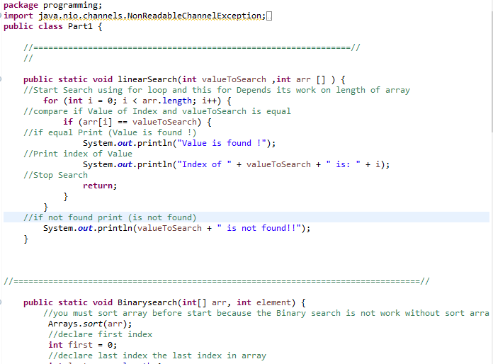

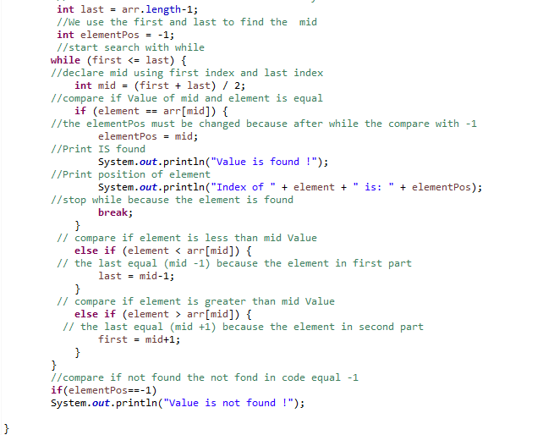

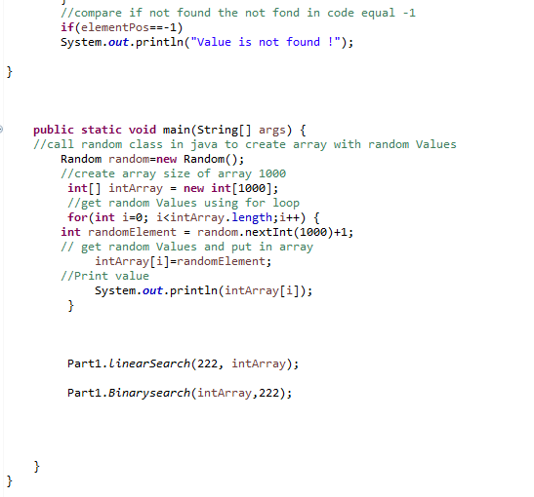

# 

# Screenshots of part 2

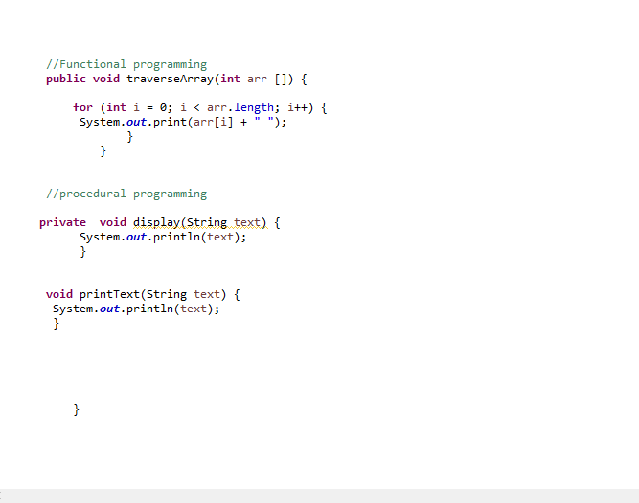

# Screenshots of part 3

