**Program 9:**

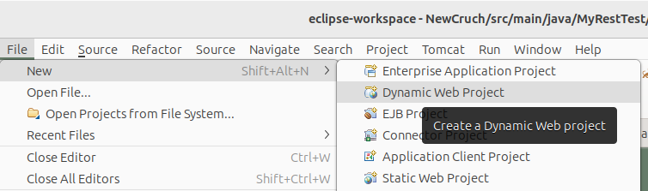

POM.xml

<dependencies>

<dependency>

<groupId>asm</groupId>

<artifactId>asm</artifactId>

<version>3.3.1</version>

</dependency>

<dependency>

<groupId>com.sun.jersey</groupId>

<artifactId>jersey-bundle</artifactId>

<version>1.19.4</version>

</dependency>

<dependency>

<groupId>org.json</groupId>

<artifactId>json</artifactId>

<version>20170516</version>

</dependency>

<dependency>

<groupId>com.sun.jersey</groupId>

<artifactId>jersey-server</artifactId>

<version>1.19.4</version>

</dependency>

<dependency>

<groupId>com.sun.jersey</groupId>

<artifactId>jersey-core</artifactId>

<version>1.19.4</version>

</dependency>

</dependencies>

add the jar files in the following folder:

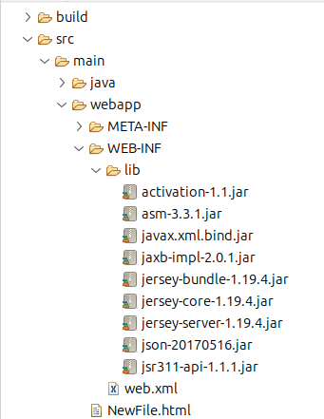

update web.xml

<servlet>

<servlet-name>Jersey Web Application</servlet-name>

<servlet-class>com.sun.jersey.spi.container.servlet.ServletContainer</servlet-class>

<load-on-startup>1</load-on-startup>

</servlet>

<servlet-mapping>

<servlet-name>Jersey Web Application</servlet-name>

<url-pattern>/rest/*</url-pattern>

</servlet-mapping>

program:

package MyRestTest;

import javax.ws.rs.DELETE;

import javax.ws.rs.GET;

import javax.ws.rs.POST;

import javax.ws.rs.PUT;

import javax.ws.rs.Path;

import javax.ws.rs.Produces;

@Path("/home")

public class TestRestBasedAPP {

@GET

@Produces("text/html")

public String getMethod() {

return "Hello from REST based API";

}

@POST

@Path("/post")

@Produces("text/html")

public String postMethod() {

return "In the post method Hello from REST based API";

}

@PUT

@Produces("text/html")

public String putMethod() {

return "In the put method Hello from REST based API";

}

@DELETE

@Produces("text/html")

public String delteMethod() {

return "In the post method Hello from REST based API";

}

}

**check folder with jar files**