EED Development supplementary materials

# Supplementary Appendix A: Spline plots

Each panel of the plots below show the generalized additive model fit between the exposure and outcome denoted in the panel header, with simultaneous confidence intervals for the fitted line. The dashed vertical lines indicate the first and third quartiles of the exposure distribution. The plots are faceted by exposure and outcome subdomain, with the x-axis limits set to the 5th and 95th percentiles of the exposure distribution within each facet to remove tail effects in the outlier ranges of the exposure distributions.

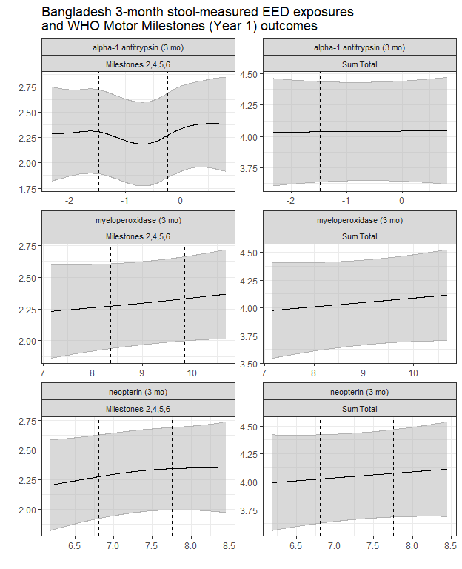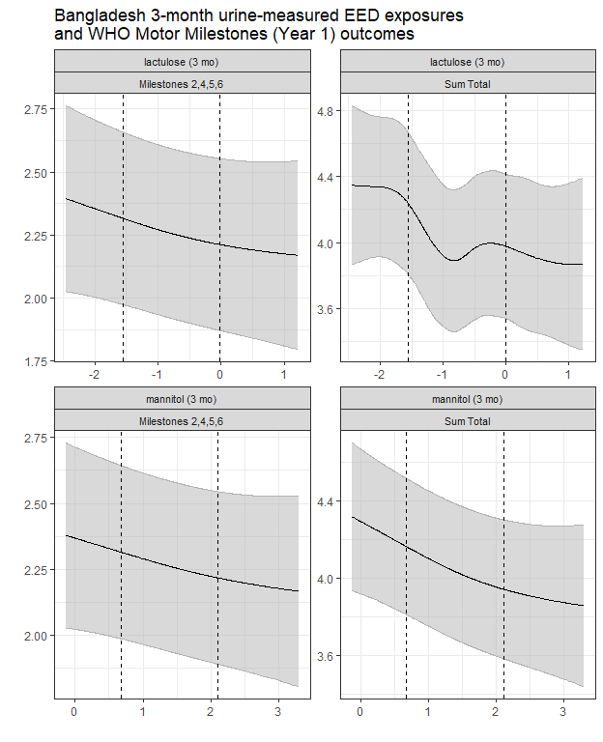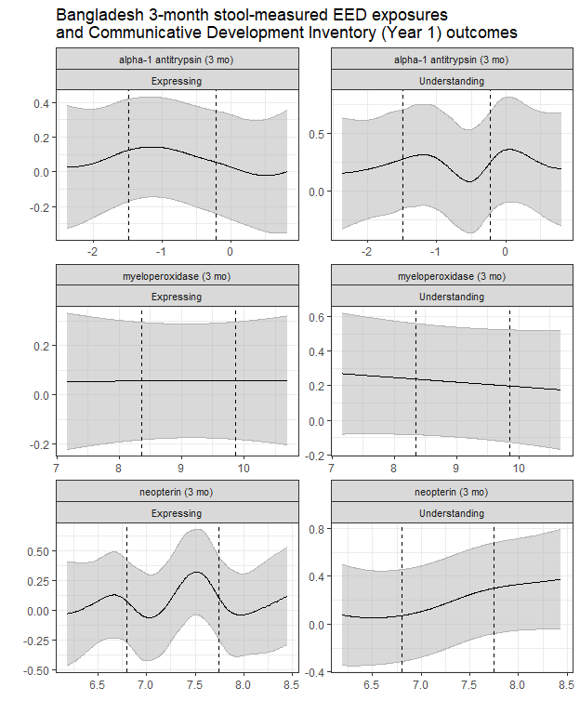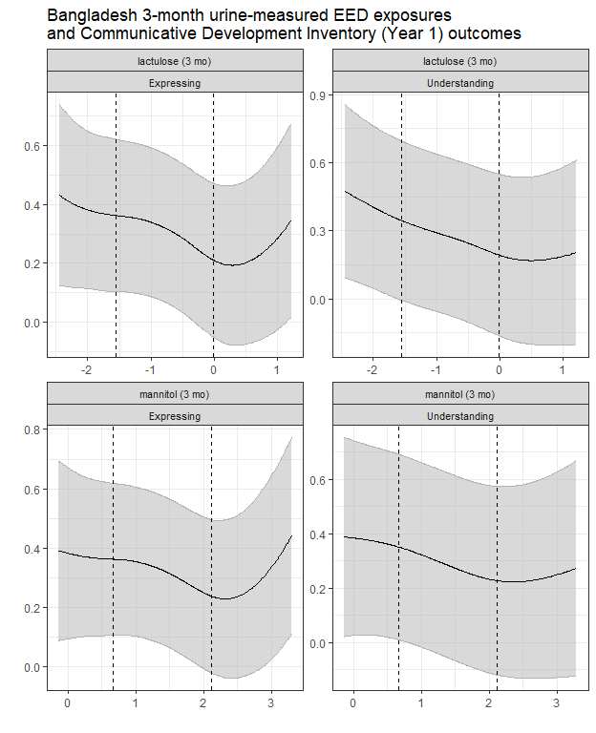

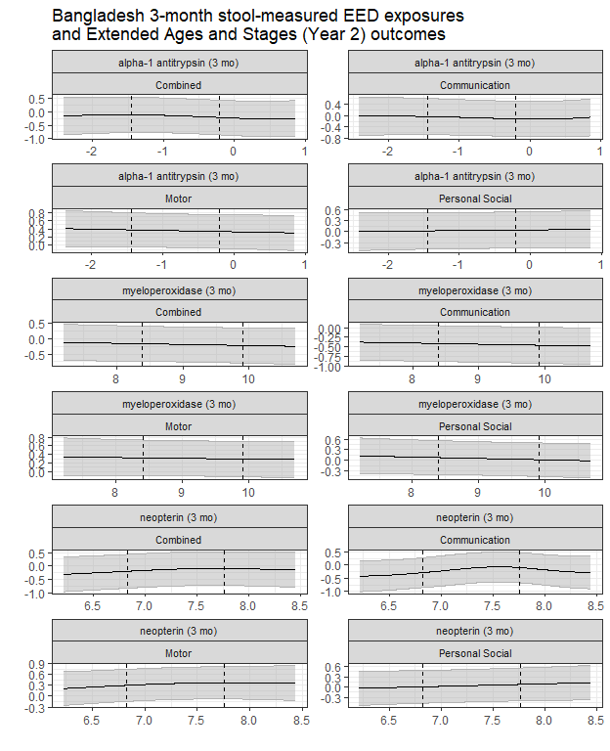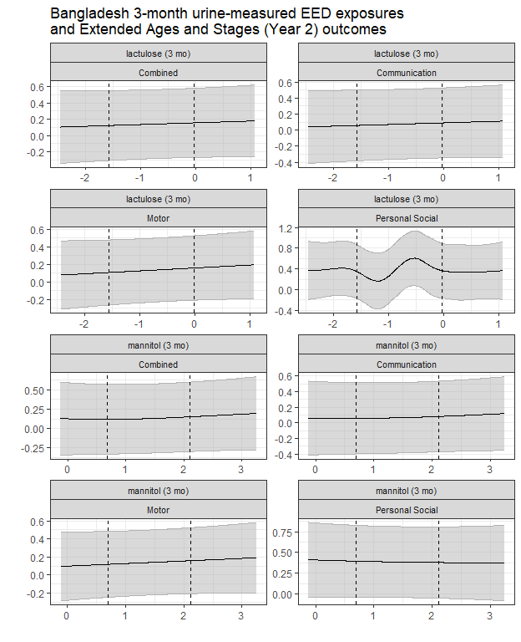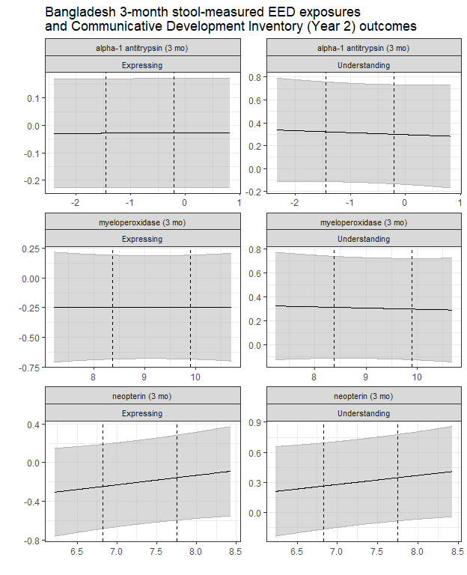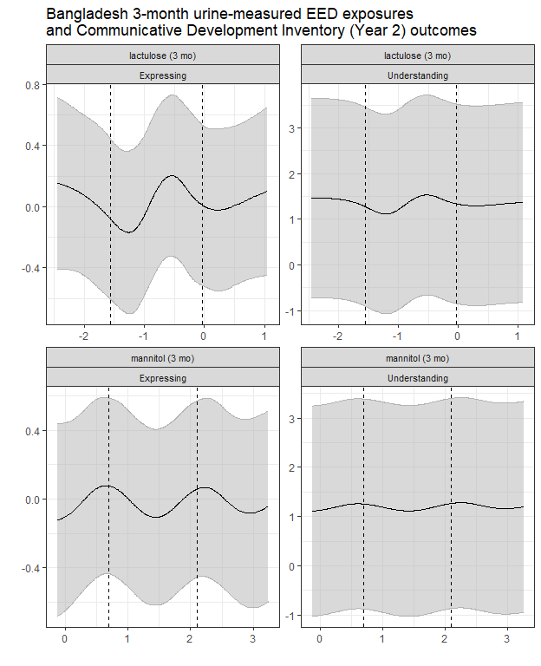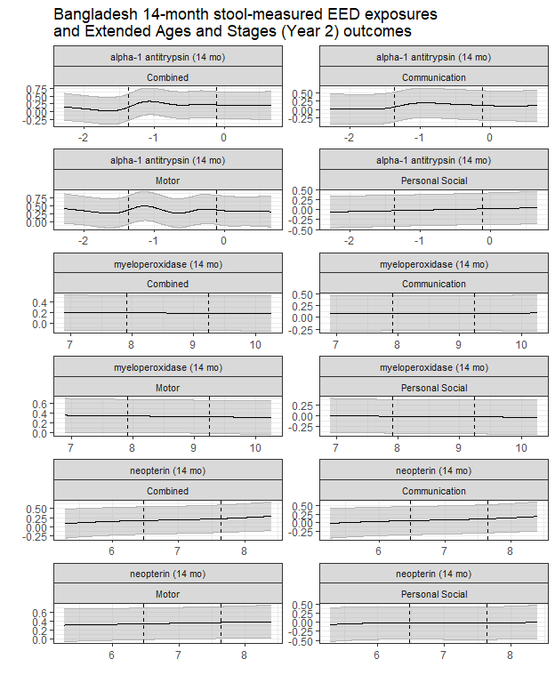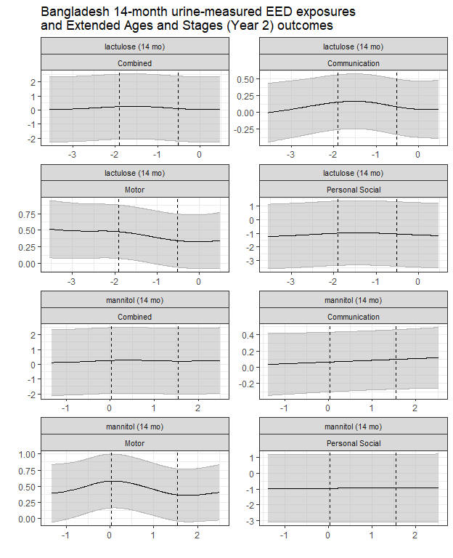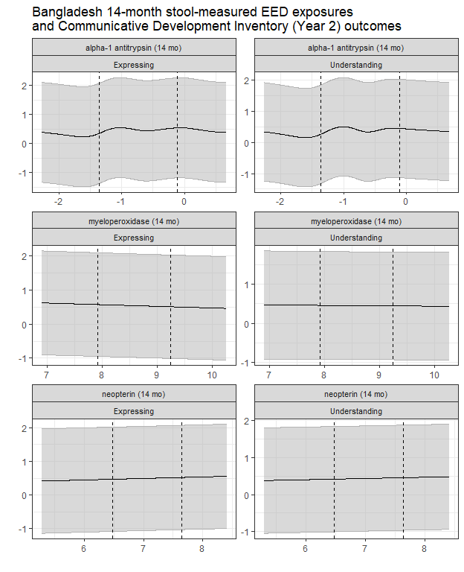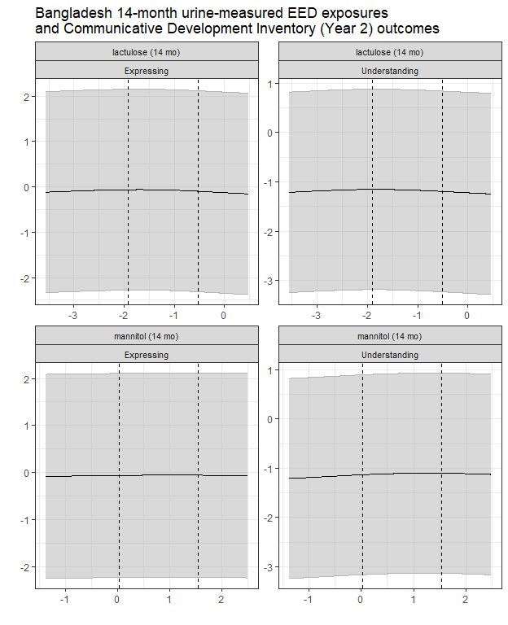

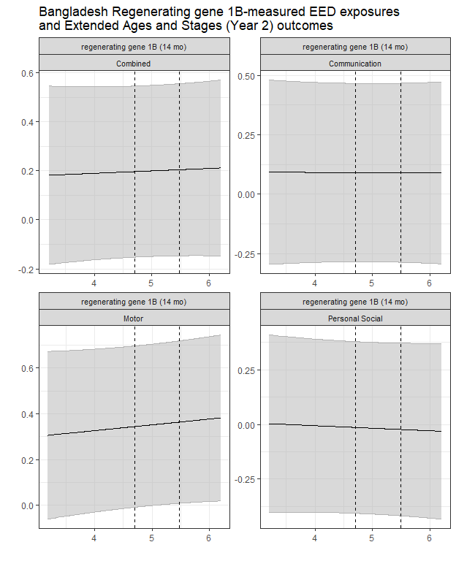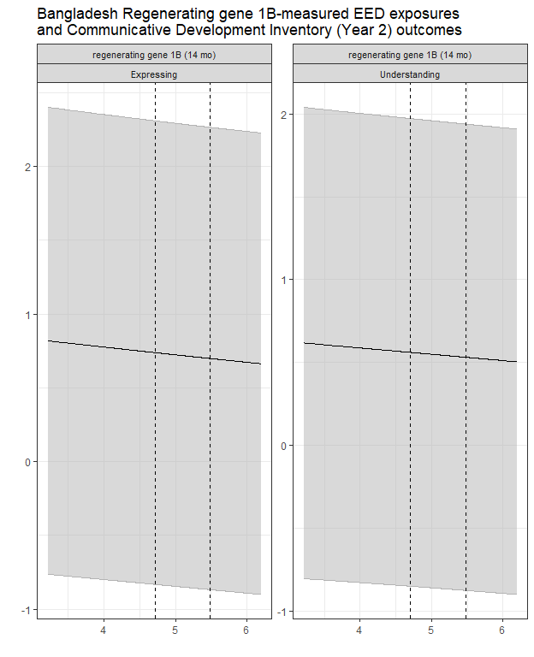

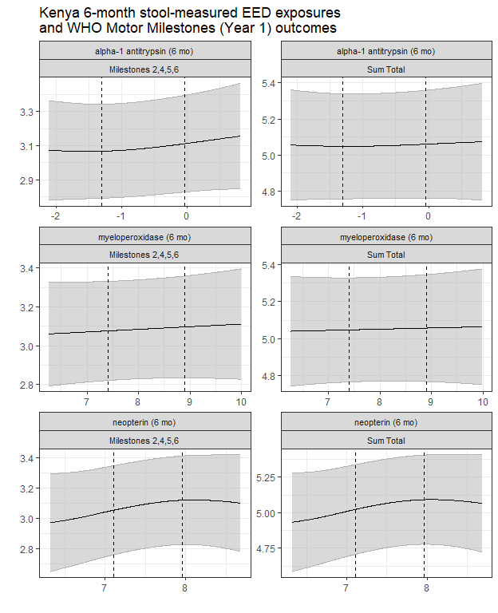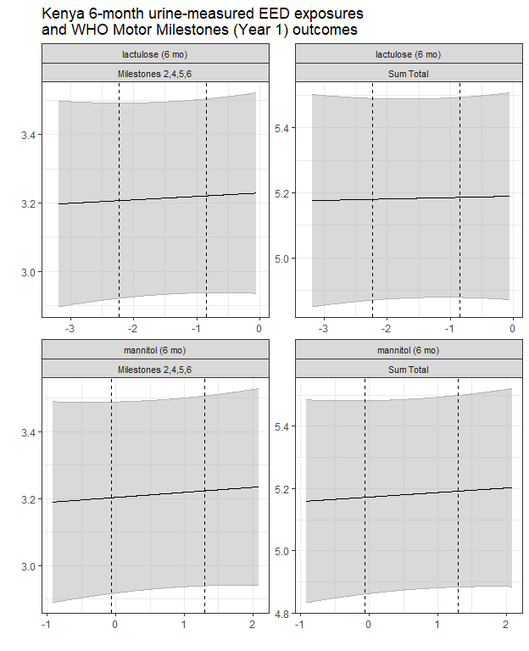

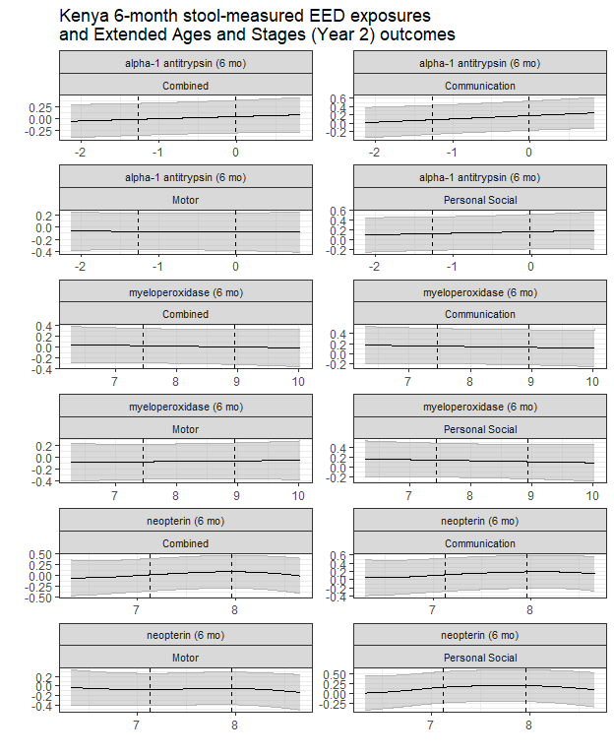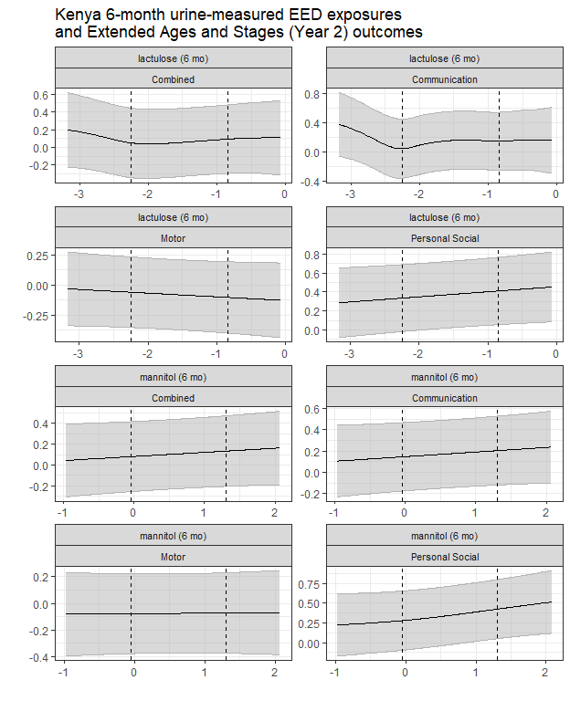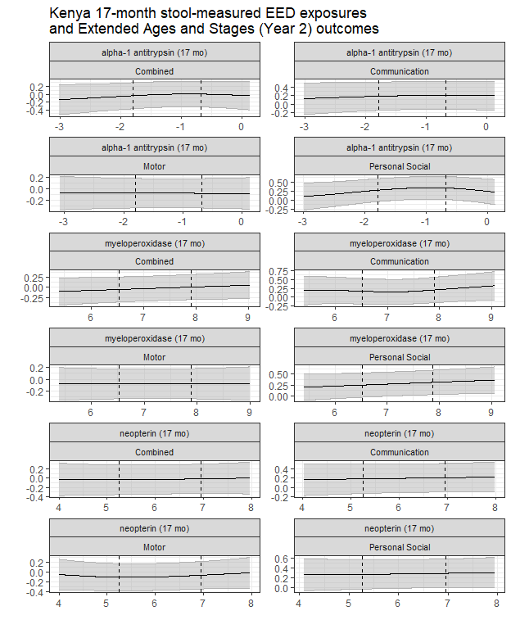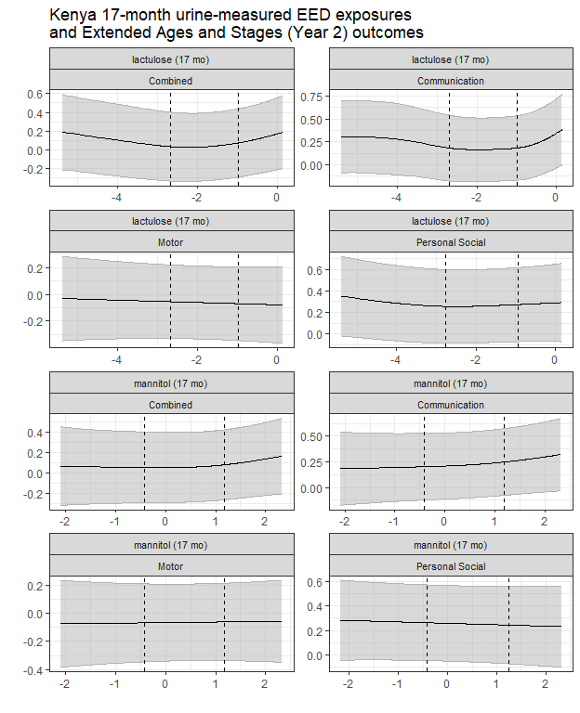

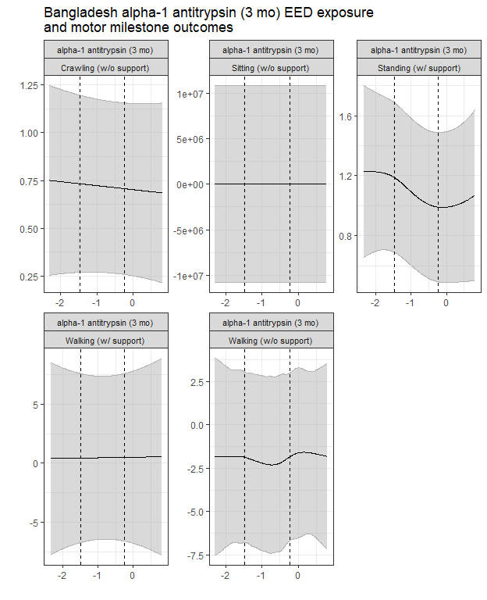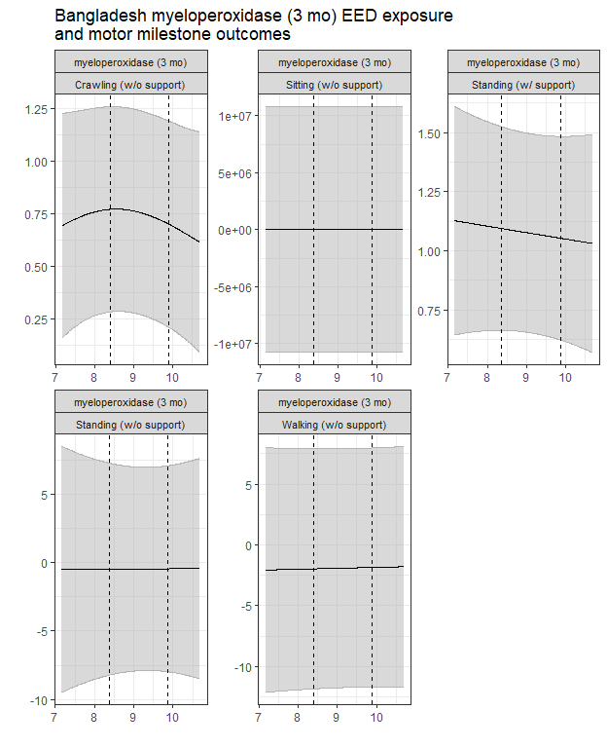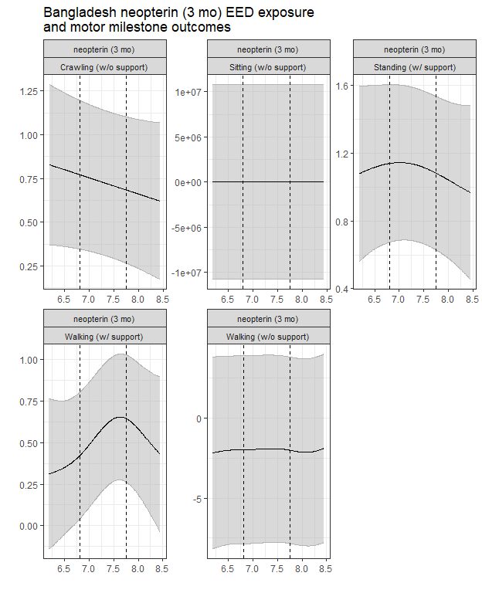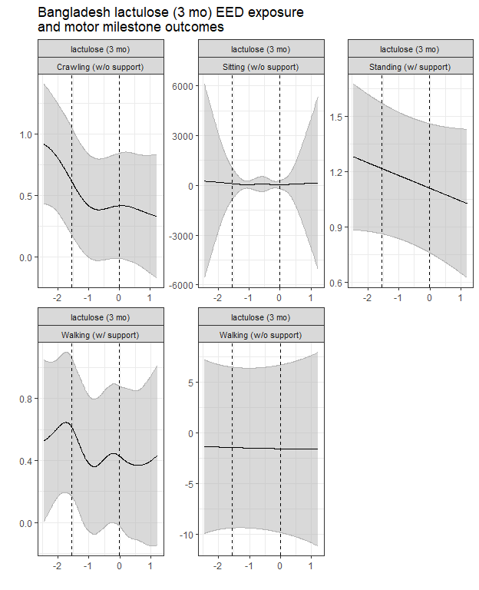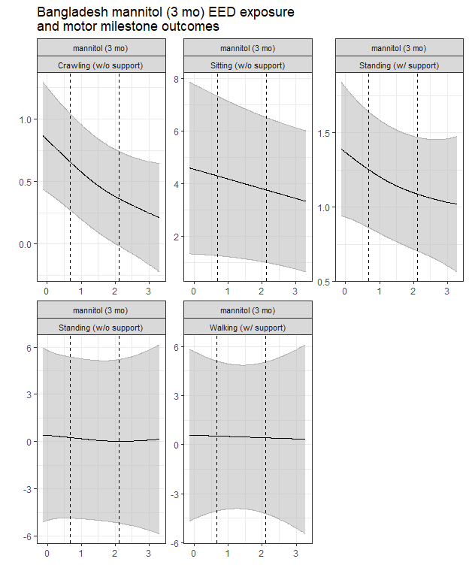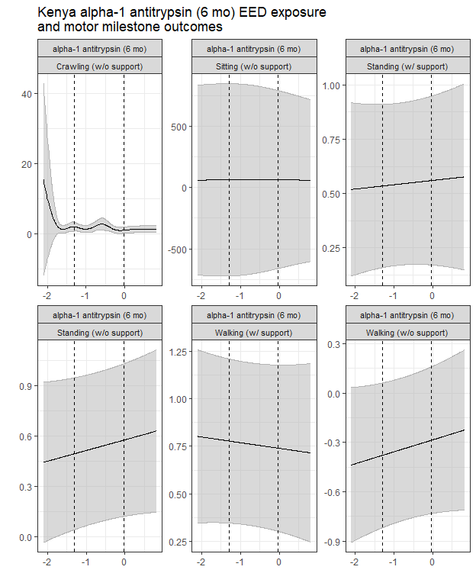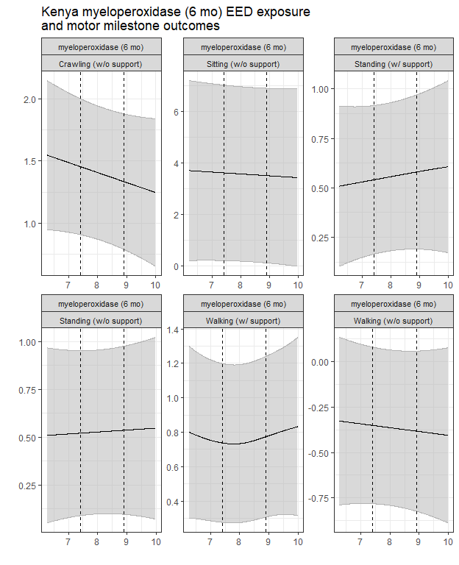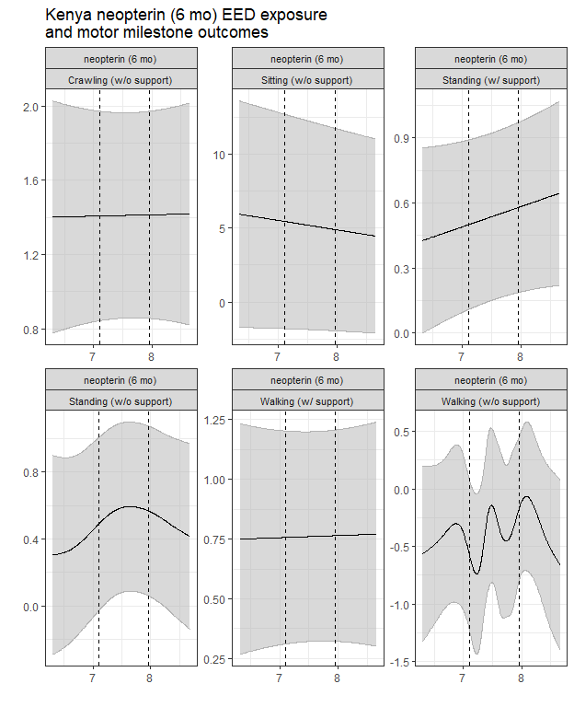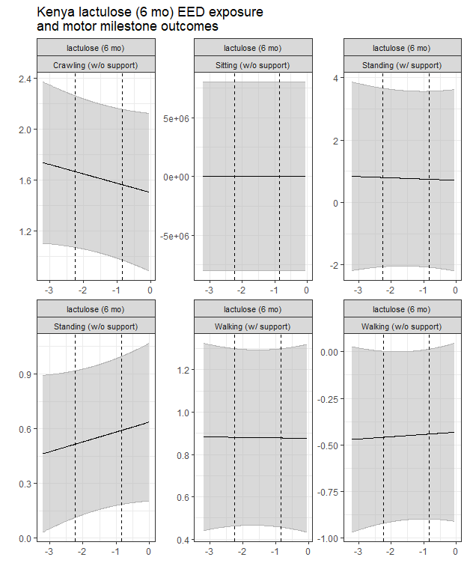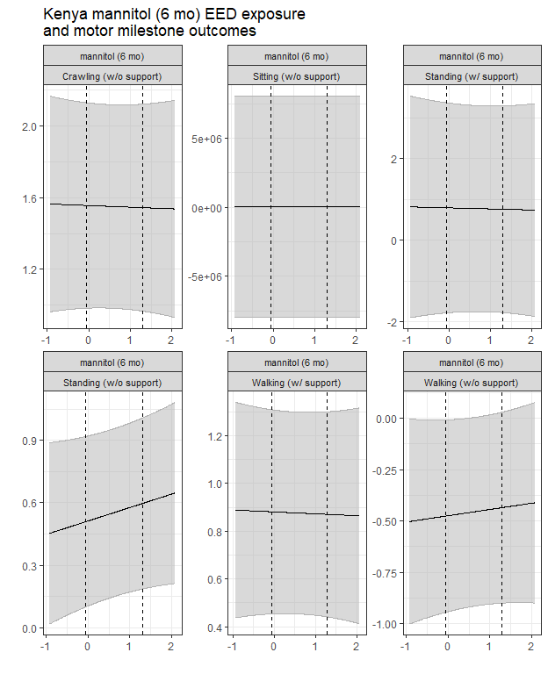

# Supplementary Appendix B: GLM-GAM comparison sensitivity analysis

The plots below show the comparison of the GLM and GAM models for the EED exposures and outcomes. The GLM model is shown in blue, while the GAM model is shown in red. The X-axes are labeled with the exposures and each panel is a different outcome, with the panel title indicating the exposure and outcome. The y-axes are labeled with the model estimates, with the GLM estimates being the coefficient of the exposure and corresponding bootstrap-based 95% confidence interval, while the GAM estimates are the contrast between the 25th and 7th percentiles of the exposure distribution and corresponding bootstrap-based 95% confidence interval. The dashed vertical lines indicate the first and third quartiles of the exposure distribution, with the corresponding confidence interval around the estimated difference.

### Bangladesh cohort

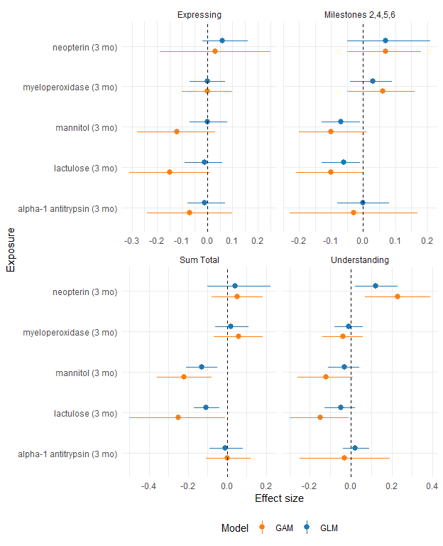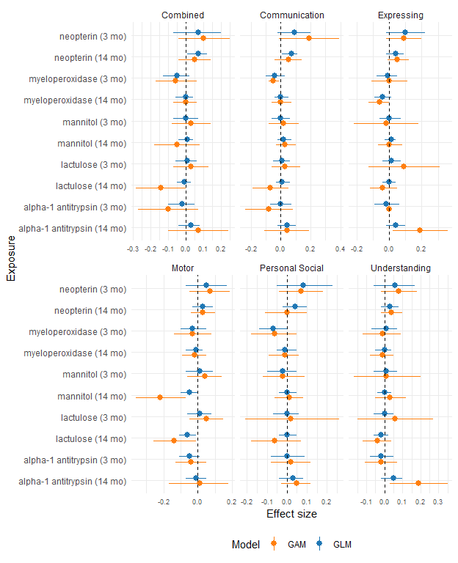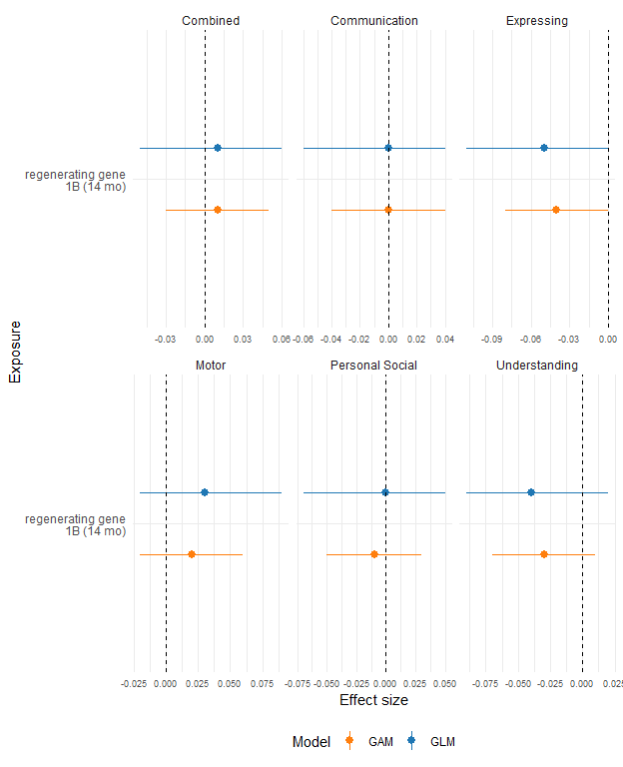

### Kenya cohort

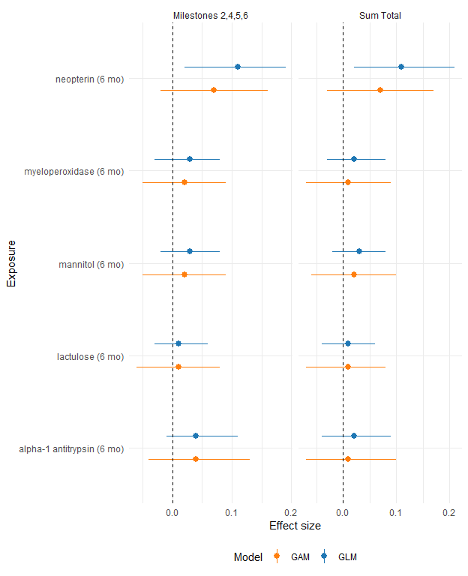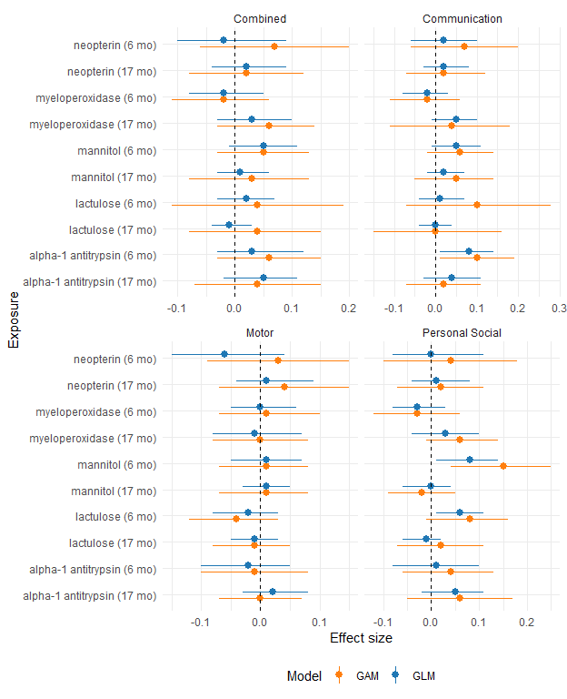

# Supplementary Appendix C: Diarrhea sensitivity analysis

The plots below show the comparison of models fit without prior diarrheal disease included in the model as a confounder (main analysis) versus a sensitivity analysis of models adjusting for prior diarrheal disease.

### Bangladesh cohort

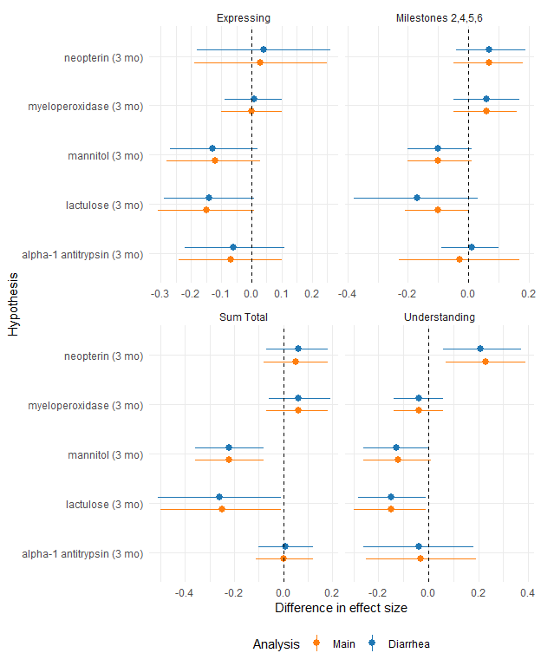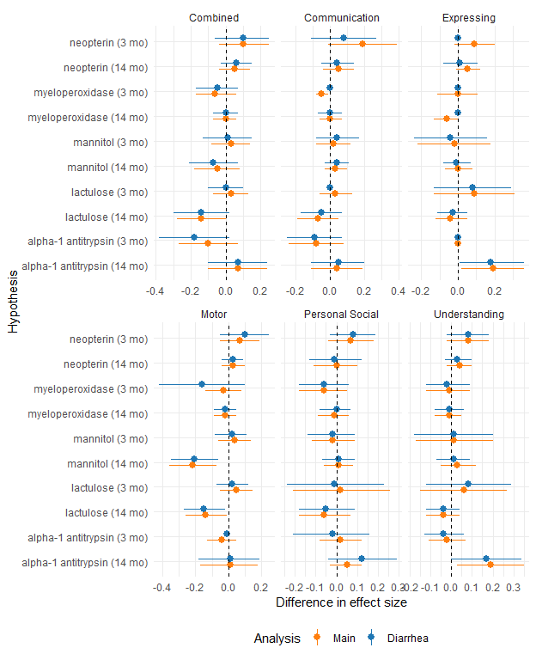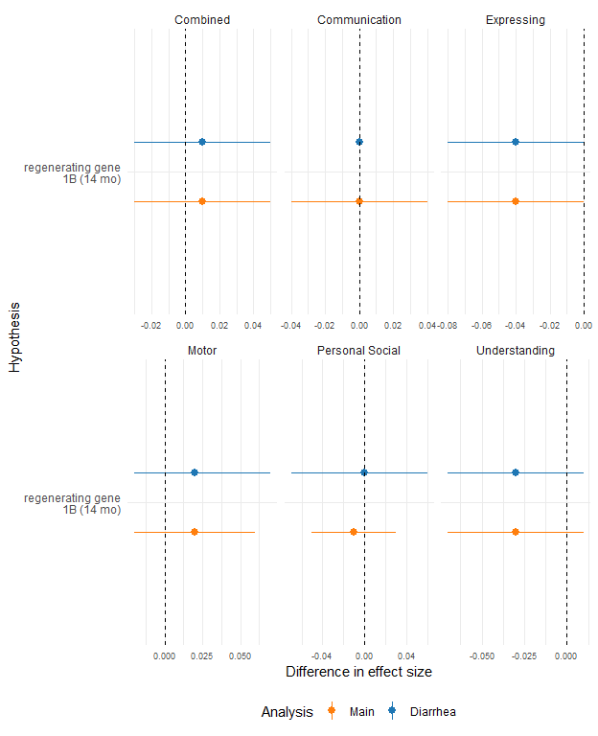

### Kenya cohort

