Security+ Cloud Infrastructure Lab
Building a Simulated AWS Environment Using Docker, LocalStack, Kali Linux, Terraform, and AWS CLI
Professional Student Lab Guide

Lab Overview
In this lab students will build a simulated enterprise cloud environment that mimics core AWS services without requiring a real AWS account. Students will learn how cloud infrastructure is deployed, managed, secured, and automated using modern Infrastructure as Code techniques.

Learning Objectives
- Understand cloud infrastructure concepts
- Explain Infrastructure as Code (IaC)
- Deploy simulated AWS infrastructure
- Use Terraform to automate cloud resources
- Use AWS CLI to manage cloud infrastructure
- Create VPCs and subnets
- Deploy EC2 instances
- Create S3 cloud storage buckets
- Configure security groups
- Understand cloud security risks

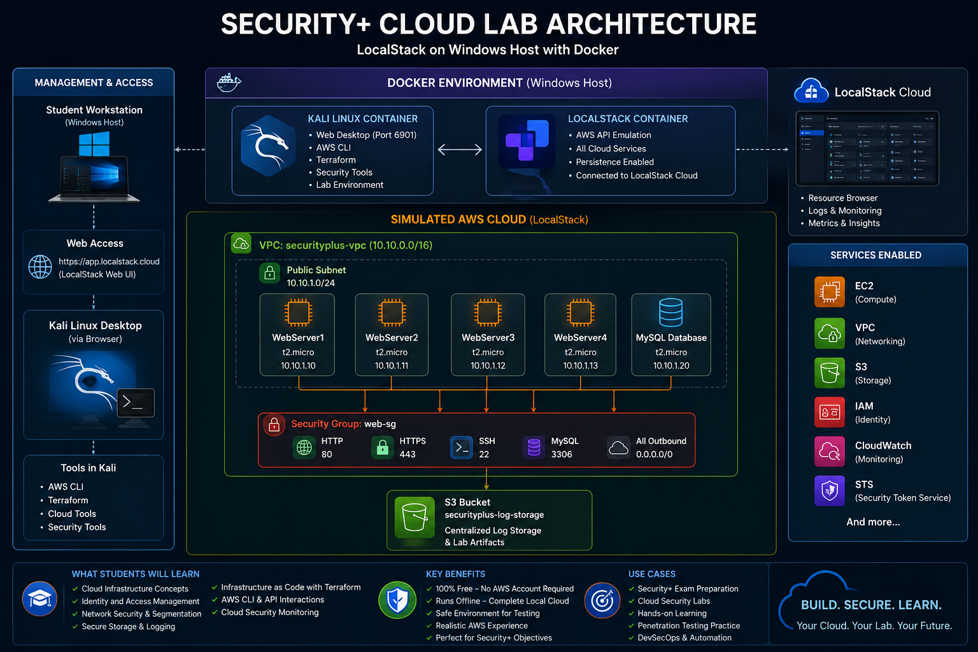
Cloud Architecture
The following architecture will be built during this lab:

System Requirements
Requirement | Recommendation
Operating System | Windows 10 or Windows 11
RAM | 16 GB Recommended
CPU | Quad-Core Processor
Disk Space | 50 GB Free Space
Internet | Required for downloads

Part 1 — Install Docker Desktop
Docker Desktop provides the container platform used to run LocalStack and Kali Linux.

Step 1 — Download Docker Desktop
Navigate to the following website and download Docker Desktop for Windows:
https://www.docker.com/products/docker-desktop/

Step 2 — Install Docker Desktop
During installation ensure the following options are enabled:
- Use WSL2 backend
- Add Docker to PATH
- Enable virtualization support

Step 3 — Verify Docker Installation
Open Windows PowerShell and run:
docker --version
docker compose version

Part 2 — Create a Free LocalStack Account
LocalStack simulates AWS cloud services locally on the Windows host system.

Step 1 — Create Account
Navigate to the following website:
https://app.localstack.cloud/sign-up
Create a free LocalStack account using your email address and select Hobby Plan

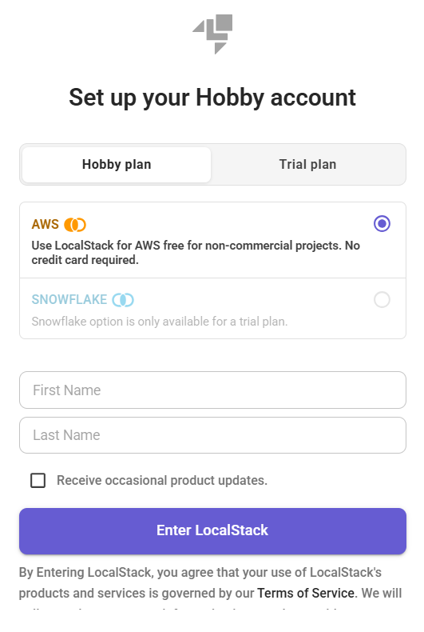

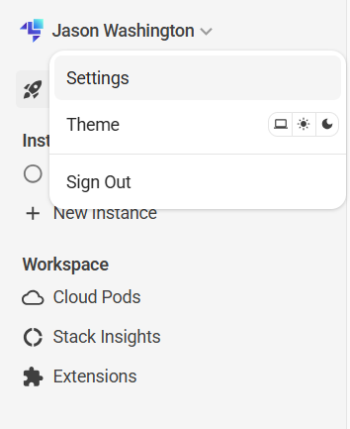
Step 2 — Generate Auth Token
After logging in:
- Click Profile
- Click Auth Tokens
- Click Create Token
- Copy the generated token

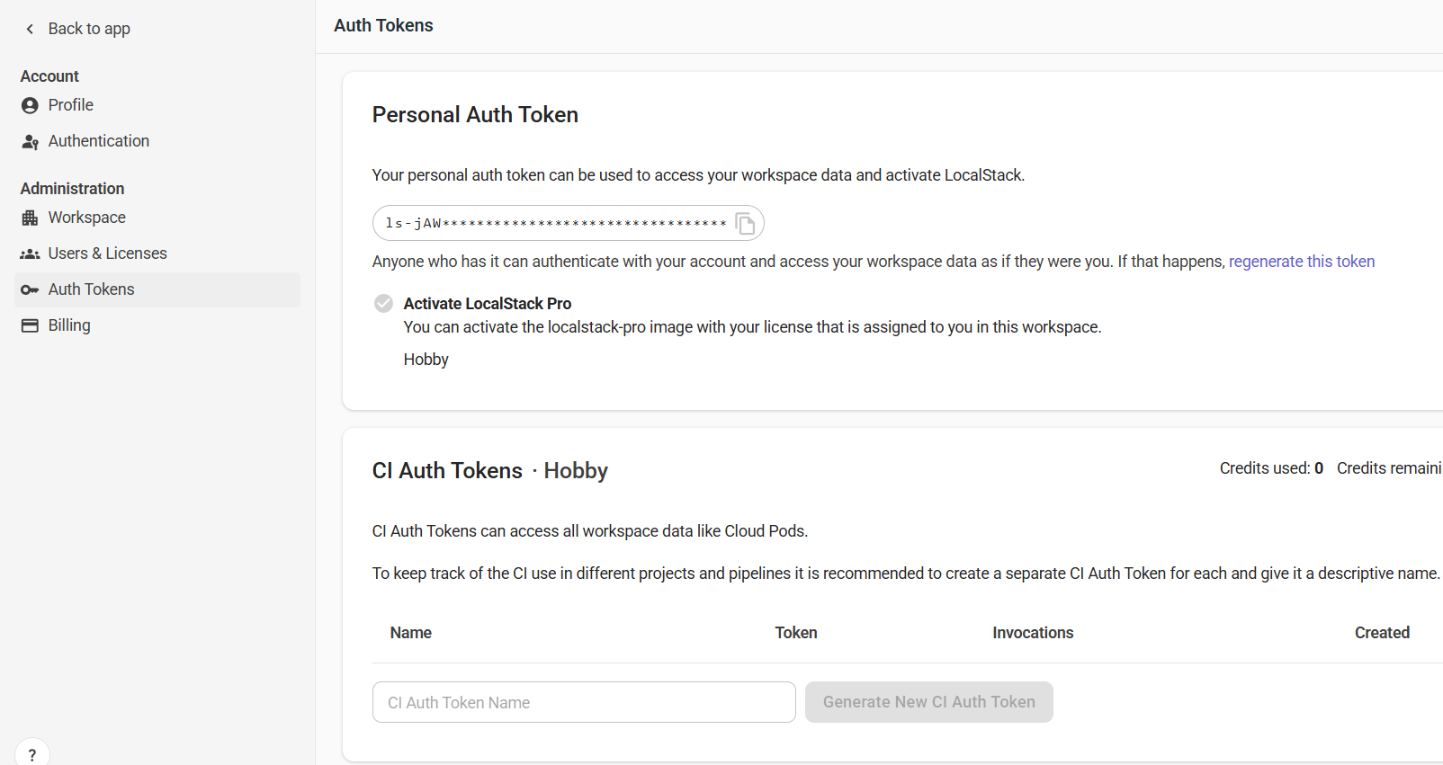

Part 3 — Create the Lab Folder Structure
Students will create the cloud lab folder structure on the Windows host PC.

Step 1 — Create Main Folder
mkdir C:\cloudlab
cd C:\cloudlab

Step 2 — Create Subfolders
mkdir terraform
mkdir localstack-data
mkdir docker-share

Part 4 — Create Docker Compose
Docker Compose will start both the LocalStack and Kali Linux containers.

Step 1 — Create docker-compose.yml
Inside C:\cloudlab create a file named docker-compose.yml.
Paste the provided instructor Docker Compose configuration into the file.

Part 5 — Start the Cloud Lab

Step 1 — Start Containers
docker compose up –d
Note: If the docker port need to be changed to something else. The change needs to be added to the docker-compose.yml as well as the terraform file.

Step 2 — Verify Running Containers
docker ps
Expected containers:
- localstack
- kali
-----------------------------------------------------------------------------------------
You can check the localstack health by the following options:

curl http://localhost:7788/_localstack/health
or
Invoke-RestMethod http://localhost:7788/_localstack/health

--------------------------------------------------------------------------------------------

Part 6 — Access Kali Linux Desktop

Step 1 — Open Kali Linux
https://localhost:6901
Use the following password:
password

Part 7 — Install AWS CLI and Terraform
The Kali Linux container will be used to manage cloud infrastructure.

Step 1 — Open Terminal
Inside Kali Linux open the terminal application.

Step 2 — Install AWS CLI
apt update
apt install -y awscli unzip curl wget jq

Step 3 — Install Terraform
wget https://releases.hashicorp.com/terraform/1.8.5/terraform_1.8.5_linux_amd64.zip
unzip terraform_1.8.5_linux_amd64.zip
mv terraform /usr/local/bin/

Part 8 — Configure AWS CLI
These are fake credentials used only for LocalStack.
aws configure
AWS Access Key ID: test
AWS Secret Access Key: test
Default region name: us-east-1
Default output format: json

Part 9 — Deploy Cloud Infrastructure
Terraform will create the following simulated cloud resources:
- 1 Virtual Private Cloud (VPC)
- 1 Public Subnet
- 1 Security Group
- 4 Web Servers
- 1 MySQL Database Server
- 1 S3 Log Storage Bucket

Step 1 — Create Terraform File
Inside the /terraform folder create a file named main.tf.
Paste the Terraform configuration provided by the instructor.

Step 2 — Initialize Terraform
cd /terraform
terraform init

Step 3 — Deploy Infrastructure
terraform apply
When prompted type:
yes

Part 10 — Verify Infrastructure
Students will verify that the infrastructure was successfully created.

List VPCs
aws --endpoint-url=http://localhost:4566 ec2 describe-vpcs

List EC2 Instances
aws --endpoint-url=http://localhost:4566 ec2 describe-instances

List S3 Buckets
aws --endpoint-url=http://localhost:4566 s3 ls

Part 11 — Security+ Concepts Demonstrated
- Cloud Infrastructure
- Shared Responsibility Model
- Infrastructure as Code
- Cloud APIs
- Virtual Networking
- Network Segmentation
- Security Groups
- Cloud Storage
- Identity and Access Management
- Cloud Automation

Instructor Discussion Topics
- Why public S3 buckets are dangerous
- Least privilege and IAM
- Why databases should not be public
- Flat networks vs segmented networks
- Infrastructure as Code advantages
- Cloud attack surface
- Automation and orchestration

Part 12 — Cleanup
Students should safely remove infrastructure after completing the lab.
terraform destroy
When prompted type:
yes

Conclusion
Students successfully deployed and managed a simulated enterprise cloud environment while learning core Security+ cloud infrastructure and cloud security concepts.
