Security+ Cloud Infrastructure CI/CD Lab
Student Walkthrough: LocalStack Desktop, Docker Compose, Terraform, GitHub, and CI/CD
Lab Goal
Students will build a simulated AWS-style cloud environment locally with LocalStack, then push the same Terraform code to GitHub where GitHub Actions automatically tests the infrastructure in a CI/CD pipeline.

1. What You Will Build
- LocalStack Desktop account and auth token
- Docker Compose environment with LocalStack and Kali
- Terraform infrastructure: VPC, subnet, security group, 4 web servers, 1 MySQL server, and S3 log bucket
- GitHub repository
- GitHub Actions CI/CD pipeline
- Security scanning with Checkov

2. Big Picture
Your Windows PC
├── Docker Desktop
├── LocalStack + Kali containers
├── LocalStack Desktop GUI
├── Terraform local testing
└── Git pushes code to GitHub
GitHub Actions Runner
├── Temporary Ubuntu machine
├── Starts its own LocalStack container
├── Runs Terraform
├── Runs security scan
└── Shows green/red pipeline result
Important
GitHub Actions does not connect to your Windows LocalStack. GitHub creates a separate temporary LocalStack environment inside the GitHub runner.

3. Required Software
- Docker Desktop for Windows
- Git for Windows
- Terraform
- AWS CLI
- LocalStack Desktop
- GitHub account
- Visual Studio Code or Notepad

4. Step 1 — Create a LocalStack Account
- Open a browser and go to the official LocalStack website.
- Click Sign Up, Start for Free, or Get Started.
- Create a free account using email, Google, or GitHub sign-in if available.
- Verify your email if prompted.
- Sign in to the LocalStack web dashboard.
Checkpoint: You should be signed in to the LocalStack dashboard.

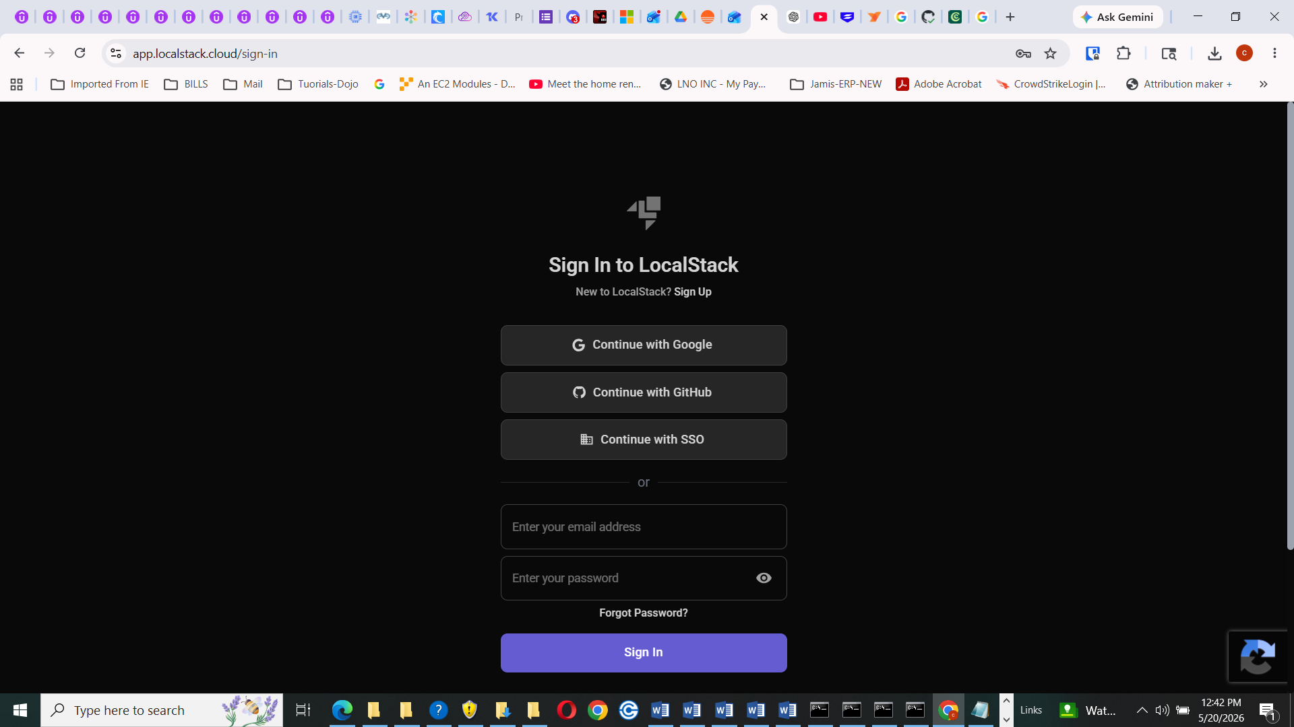
https://app.localstack.cloud/
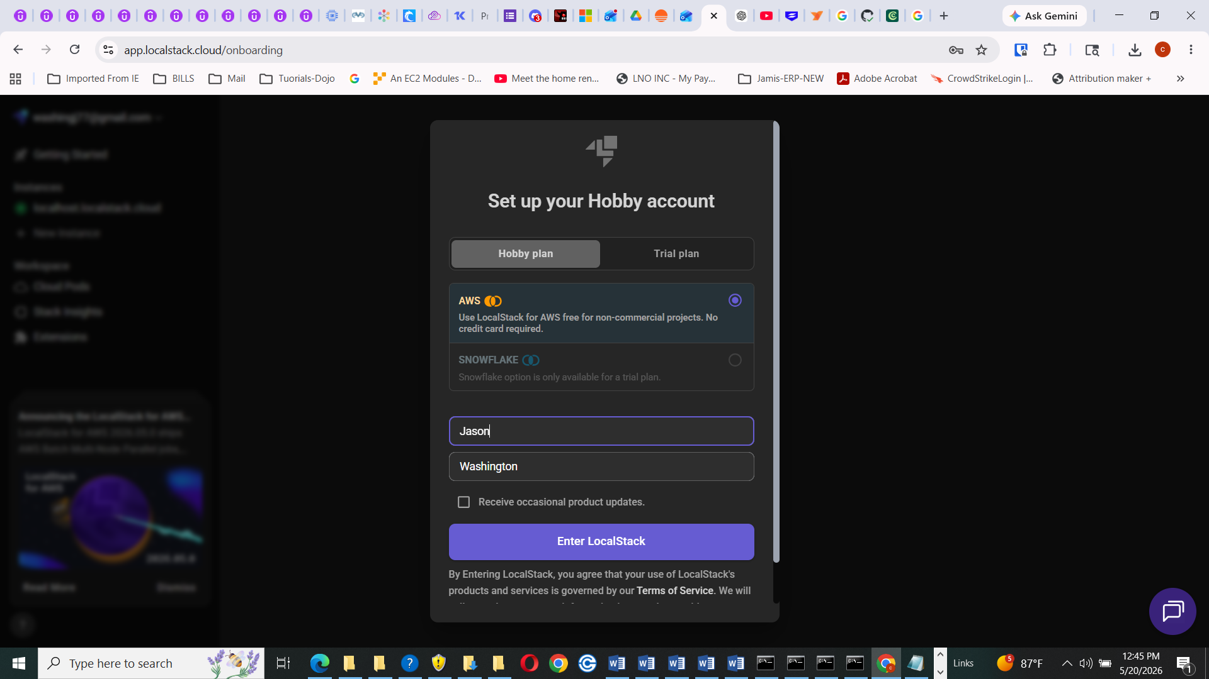
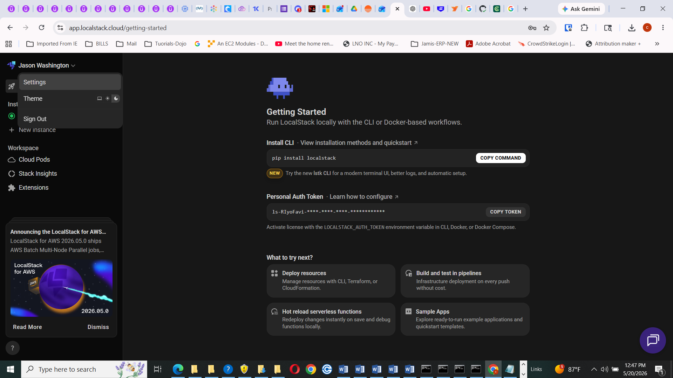

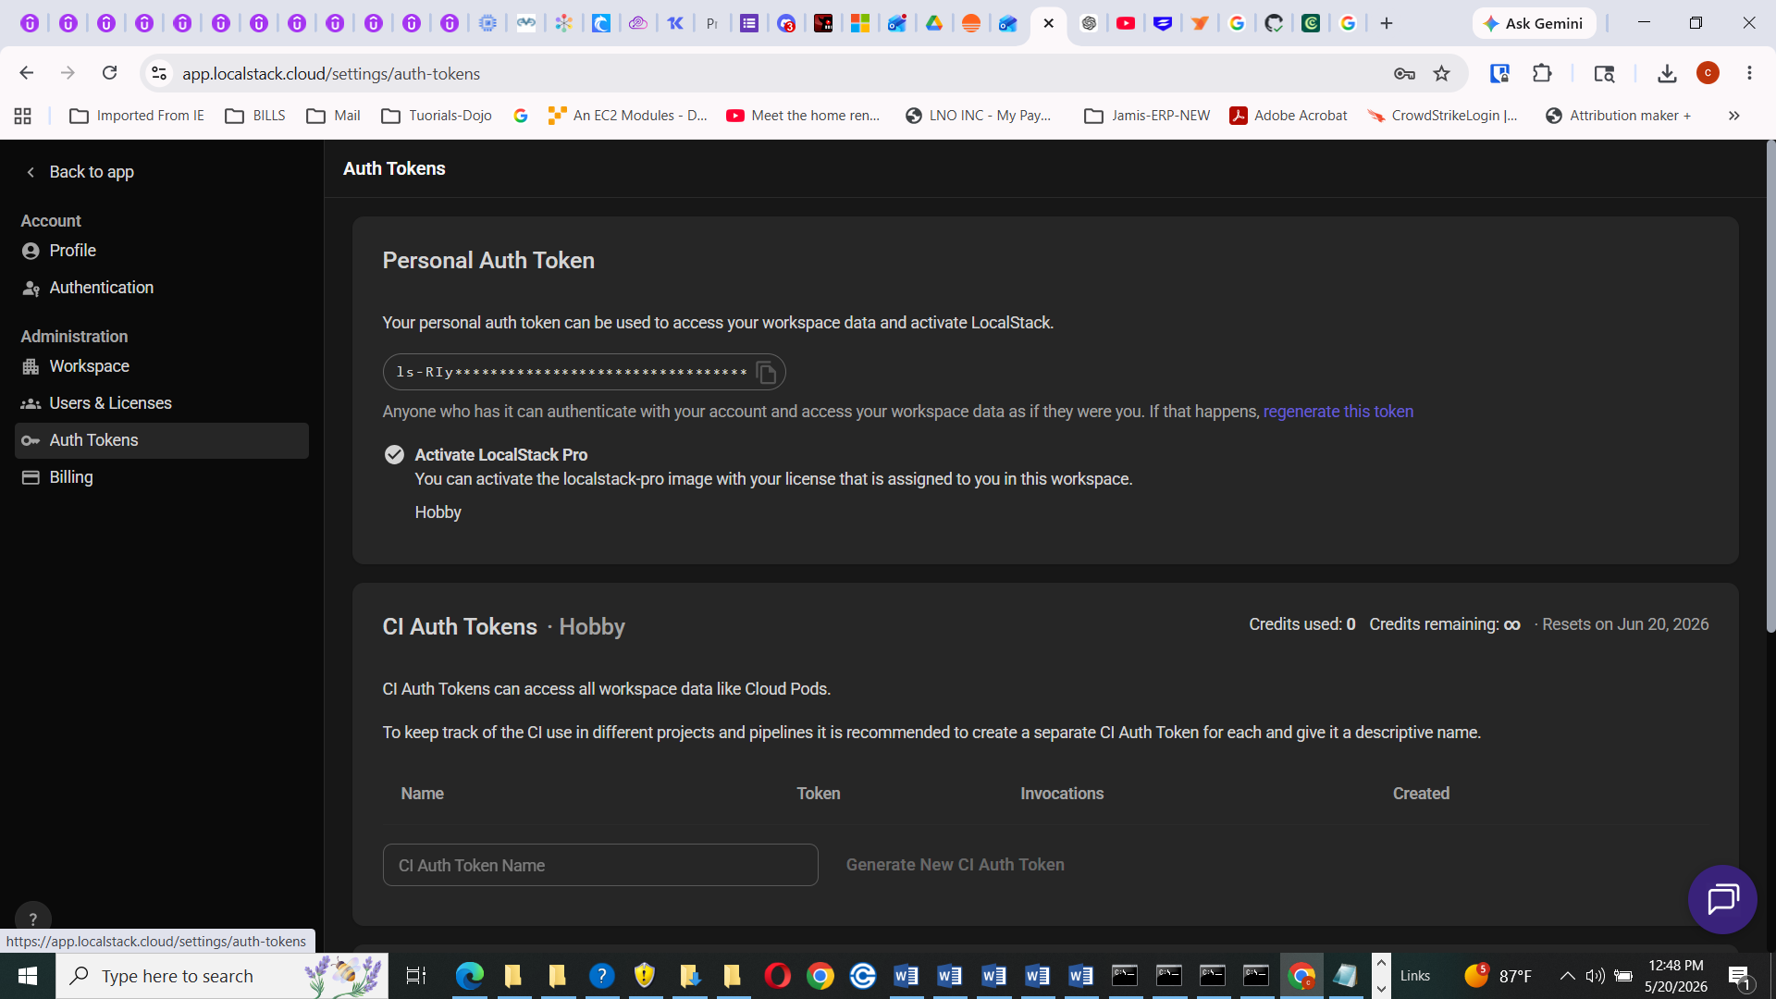

5. Step 2 — Install LocalStack Desktop
- While signed in to LocalStack, find LocalStack Desktop or Desktop App.
- Download the Windows installer.
- Run the installer.
- Open LocalStack Desktop from the Windows Start Menu.
- Sign in using the same LocalStack account.
- Confirm Docker Desktop is also running.
If You Cannot Find It
Search the LocalStack website for LocalStack Desktop download. The website layout may change, but the goal is to install the Windows LocalStack Desktop app.

6. Step 3 — Copy Your LocalStack Auth Token
- Open LocalStack Desktop or the LocalStack web dashboard.
- Go to Account, Settings, Profile, or Auth Token.
- Find Auth Token, LOCALSTACK_AUTH_TOKEN, or LocalStack Auth Token.
- Click Copy Token.
- Do not share this token.
- Do not paste it into GitHub, screenshots, email, or chat.
Security+ Tie-In
The auth token is a secret. This demonstrates credential handling, secret protection, and secure configuration management.

7. Step 4 — Create the Project Folder
mkdir C:\cloudlab
cd C:\cloudlab
mkdir terraform
mkdir .github
mkdir .github\workflows

8. Step 5 — Create the .env File for the LocalStack Token
notepad C:\cloudlab\.env
Paste this line. Replace the example text with your real token:
LOCALSTACK_AUTH_TOKEN=replace-this-with-your-real-token
Important
There should be no spaces around the equals sign.

9. Step 6 — Create .gitignore
notepad C:\cloudlab\.gitignore
# Terraform
.terraform/
terraform/.terraform/
*.tfstate
*.tfstate.backup
.terraform.lock.hcl
# LocalStack
localstack-data/
# Secrets
.env
# Logs
*.log
# Windows
Thumbs.db
Desktop.ini
# VS Code
.vscode/

10. Step 7 — Create docker-compose.yml
notepad C:\cloudlab\docker-compose.yml
services:
localstack:
image: localstack/localstack-pro:3.8.1
container_name: localstack
ports:
- "4566:4566"
- "4510-4559:4510-4559"
environment:
- LOCALSTACK_AUTH_TOKEN=${LOCALSTACK_AUTH_TOKEN}
- SERVICES=ec2,s3,iam,sts
- DEBUG=1
- PERSISTENCE=1
volumes:
- "./localstack-data:/var/lib/localstack"
- "/var/run/docker.sock:/var/run/docker.sock"
networks:
- lan1
kali:
image: kasmweb/kali-rolling-desktop:1.18.0
container_name: kali
privileged: true
user: root
environment:
VNC_PW: password
ports:
- "6901:6901"
cap_add:
- NET_RAW
- NET_ADMIN
volumes:
- C:/docker-share:/shared
tty: true
stdin_open: true
networks:
- lan1
networks:
lan1:
driver: bridge
Why .env Matters
Docker Compose reads the .env file automatically. This keeps the token out of docker-compose.yml and out of GitHub.

11. Step 8 — Start LocalStack and Kali
cd C:\cloudlab
docker compose up -d
docker ps
You should see containers named localstack and kali.

12. Step 9 — Verify LocalStack Locally
curl http://localhost:4566/_localstack/health
aws --endpoint-url=http://localhost:4566 sts get-caller-identity
aws --endpoint-url=http://localhost:4566 s3 ls
It is okay if S3 is empty. Terraform has not created the bucket yet.

13. Step 10 — Open LocalStack Desktop
- Open LocalStack Desktop.
- Confirm you are signed in.
- Look for the running local LocalStack instance.
- Open the instance.
- If no resources are visible yet, continue to Terraform. Resources appear after Terraform creates them.
Verification Source of Truth
LocalStack Desktop is useful, but AWS CLI and Terraform state are the best verification methods for this lab.

14. Step 11 — Create Terraform main.tf
notepad C:\cloudlab\terraform\main.tf
terraform {
required_providers {
aws = {
source = "hashicorp/aws"
version = "~> 5.0"
}
}
}
variable "localstack_endpoint" {
description = "LocalStack endpoint URL"
type = string
default = "http://localhost:4566"
}
provider "aws" {
access_key = "test"
secret_key = "test"
region = "us-east-1"
skip_region_validation = true
skip_credentials_validation = true
skip_metadata_api_check = true
skip_requesting_account_id = true
s3_use_path_style = true
endpoints {
ec2 = var.localstack_endpoint
s3 = var.localstack_endpoint
iam = var.localstack_endpoint
sts = var.localstack_endpoint
}
}
resource "aws_vpc" "securityplus_vpc" {
cidr_block = "10.10.0.0/16"
tags = { Name = "securityplus-vpc", Environment = "SecurityPlus-Lab" }
}
resource "aws_subnet" "public_subnet" {
vpc_id = aws_vpc.securityplus_vpc.id
cidr_block = "10.10.1.0/24"
tags = { Name = "securityplus-public-subnet", Environment = "SecurityPlus-Lab" }
}
resource "aws_security_group" "web_sg" {
name = "securityplus-web-security-group"
description = "Allow web, SSH, and MySQL lab traffic"
vpc_id = aws_vpc.securityplus_vpc.id
ingress {
description = "Allow HTTP from anywhere for demo purposes"
from_port = 80
to_port = 80
protocol = "tcp"
cidr_blocks = ["0.0.0.0/0"]
}
ingress {
description = "Allow HTTPS from anywhere for demo purposes"
from_port = 443
to_port = 443
protocol = "tcp"
cidr_blocks = ["0.0.0.0/0"]
}
ingress {
description = "Allow SSH from anywhere for demo purposes"
from_port = 22
to_port = 22
protocol = "tcp"
cidr_blocks = ["0.0.0.0/0"]
}
ingress {
description = "Allow MySQL only inside the VPC"
from_port = 3306
to_port = 3306
protocol = "tcp"
cidr_blocks = ["10.10.0.0/16"]
}
egress {
description = "Allow all outbound traffic"
from_port = 0
to_port = 0
protocol = "-1"
cidr_blocks = ["0.0.0.0/0"]
}
}
resource "aws_instance" "webserver1" {
ami = "ami-12345678"
instance_type = "t2.micro"
subnet_id = aws_subnet.public_subnet.id
vpc_security_group_ids = [aws_security_group.web_sg.id]
tags = { Name = "webserver1", Role = "Web Server" }
}
resource "aws_instance" "webserver2" {
ami = "ami-12345678"
instance_type = "t2.micro"
subnet_id = aws_subnet.public_subnet.id
vpc_security_group_ids = [aws_security_group.web_sg.id]
tags = { Name = "webserver2", Role = "Web Server" }
}
resource "aws_instance" "webserver3" {
ami = "ami-12345678"
instance_type = "t2.micro"
subnet_id = aws_subnet.public_subnet.id
vpc_security_group_ids = [aws_security_group.web_sg.id]
tags = { Name = "webserver3", Role = "Web Server" }
}
resource "aws_instance" "webserver4" {
ami = "ami-12345678"
instance_type = "t2.micro"
subnet_id = aws_subnet.public_subnet.id
vpc_security_group_ids = [aws_security_group.web_sg.id]
tags = { Name = "webserver4", Role = "Web Server" }
}
resource "aws_instance" "mysql_database" {
ami = "ami-12345678"
instance_type = "t2.micro"
subnet_id = aws_subnet.public_subnet.id
vpc_security_group_ids = [aws_security_group.web_sg.id]
tags = { Name = "mysql-database", Role = "Database Server" }
}
resource "aws_s3_bucket" "log_bucket" {
bucket = "securityplus-log-storage"
tags = { Name = "securityplus-log-storage", Purpose = "Log Storage" }
}
output "vpc_id" { value = aws_vpc.securityplus_vpc.id }
output "log_bucket_name" { value = aws_s3_bucket.log_bucket.bucket }

15. Step 12 — Run Terraform Locally
cd C:\cloudlab\terraform
terraform init
terraform validate
terraform apply
Type yes when prompted.

16. Step 13 — Verify the Local Terraform Deployment
terraform state list
aws --endpoint-url=http://localhost:4566 ec2 describe-vpcs
aws --endpoint-url=http://localhost:4566 ec2 describe-instances
aws --endpoint-url=http://localhost:4566 s3 ls

17. Step 14 — Create a GitHub Repository
- Go to GitHub.
- Create a new repository named Security-Cloud-Lab.
- Do not add a README from GitHub if your local folder already has files.
- Copy the HTTPS repository URL.

18. Step 15 — Initialize Git and Push to GitHub
cd C:\cloudlab
git init
git add .
git commit -m "Initial Security+ cloud lab"
git branch -M main
git remote add origin https://github.com/washingj77/Security-Cloud-Lab.git
git push -u origin main
Reminder
The .env file should not upload because .gitignore protects it.

19. Step 16 — Create the GitHub Actions Pipeline
notepad C:\cloudlab\.github\workflows\deploy.yml
name: SecurityPlus LocalStack CI/CD
on:
push:
branches:
- main
env:
FORCE_JAVASCRIPT_ACTIONS_TO_NODE24: true
jobs:
terraform-localstack:
runs-on: ubuntu-latest
steps:
- name: Checkout repository
uses: actions/checkout@v4
- name: Setup Terraform
uses: hashicorp/setup-terraform@v3
- name: Start Free LocalStack with Docker
run: |
docker run -d \
--name localstack \
-p 4566:4566 \
-e SERVICES=ec2,s3,iam,sts \
-e DEBUG=1 \
localstack/localstack:3.8.1
- name: Wait for LocalStack
run: |
for i in {1..40}; do
if curl -s http://localhost:4566/_localstack/health; then
echo "LocalStack is ready"
exit 0
fi
echo "Waiting for LocalStack..."
sleep 3
done
echo "LocalStack failed to start"
docker logs localstack
exit 1
- name: Terraform Init
working-directory: terraform
run: terraform init
- name: Terraform Validate
working-directory: terraform
run: terraform validate
- name: Terraform Security Scan with Checkov
uses: bridgecrewio/checkov-action@master
with:
directory: terraform
framework: terraform
soft_fail: true
- name: Terraform Apply
working-directory: terraform
run: terraform apply -auto-approve
- name: Verify LocalStack Resources
run: |
aws --endpoint-url=http://localhost:4566 ec2 describe-vpcs
aws --endpoint-url=http://localhost:4566 ec2 describe-instances
aws --endpoint-url=http://localhost:4566 s3 ls
Why GitHub Uses Free LocalStack
The local Windows lab uses the student's LocalStack token. The GitHub runner uses a separate free LocalStack container to keep the CI/CD lab simple and avoid putting tokens into GitHub.

20. Step 17 — Push the Pipeline
cd C:\cloudlab
git add .github\workflows\deploy.yml
git commit -m "Add LocalStack GitHub Actions pipeline"
git push

21. Step 18 — Watch the Pipeline
Go to GitHub > Repository > Actions > SecurityPlus LocalStack CI/CD.
Green means the pipeline successfully started LocalStack, ran Terraform, scanned the code, applied the infrastructure, and verified resources.
Red means one of the steps failed. Open the failed step and read the error.

22. Troubleshooting

LocalStack asks for a license locally
Confirm .env exists in C:\cloudlab and contains LOCALSTACK_AUTH_TOKEN=your-token.

Docker Compose says token is blank
Make sure .env is in the same folder as docker-compose.yml.

GitHub asks for a LocalStack license
Confirm deploy.yml uses localstack/localstack:3.8.1, not localstack/localstack-pro.

GitHub rejects a large Terraform file
Make sure .terraform/ and terraform/.terraform/ are in .gitignore before committing.

Everything says up to date
Run git status and confirm you are inside C:\cloudlab.

LocalStack Desktop shows no resources
Run Terraform apply first, then refresh LocalStack Desktop. Also verify with AWS CLI.

23. Student Reflection Questions
- Why is the LocalStack token stored in .env instead of docker-compose.yml?
- Why does GitHub Actions use its own LocalStack instead of your Windows LocalStack?
- What does a green pipeline prove?
- What does Checkov add to the pipeline?
- Why should Terraform state files not be uploaded to GitHub?

