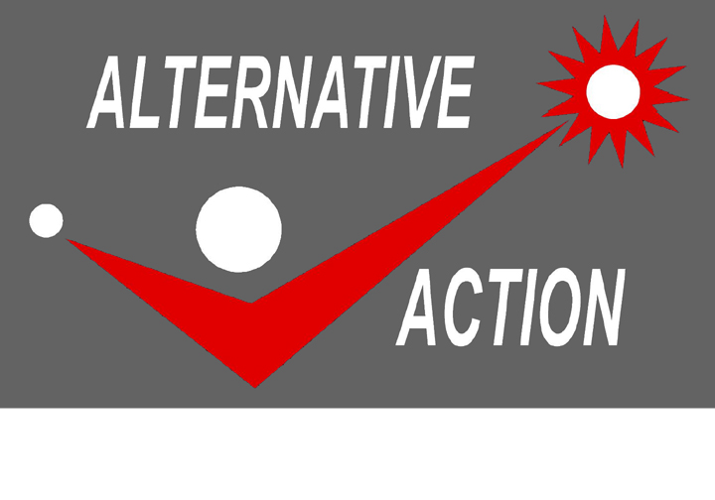

A PARTY LIST
FOR THE NEW ECONOMY

AND

NEW POLITICS

Helping the Grassroots Manage the Future
The Legislative Agenda of Alternative Action relating to Information Technology, will be guided by the following overlapping themes:

- Computer and Internet Connectivity in every student’s home.
- Bringing down the benefit of Information Technology to the grassroots level.
- Establishment of Low Interest Adequately Time-spread Credit Facilities for PC acquisition.
- Incubation services for Small Economies in Transition (SET are small and people based enterprises like cooperatives in transition to becoming new economy compatible.)
- Building of E-commerce critical mass.
- IT enabled Good and Trans-parent Governance
- Organizing the building blocks of New Politics and New Economy.
- Establishment of Community-based Information Technology Centers.
- Establishment of Information and Communication Technology Infrastructure in rural Areas.
- Bridging the Digital Divide

ALTERNATIVE ACTION is a newly formed partylist organization. It is supported by former leading youth activists who worked with the poverty stricken people, listened to their cries and felt their pains. Like the proverbial wave, activists are deeply immersed (within the grassroots) when the sea is calm but rise to heights when there is storm. With today’s realities, the activists are ready to rise once again to new heights as the strong wind of change is blustering the country.

The birthing of ALTERNATIVE ACTION came amidst a social condition where CHANGE in the economic and political arena was so rapid that while it offers rich opportunities it is also loaded with dangers to humanity, our country, our organizations and ourselves.

With the swiftness of change, the compression of the three
dimensions of time: past, present, and the future is transpiring in ALTERNATIVE ACTION. Drawing inspiration from the past, ALTERNATIVE ACTION relives the wisdom, dedication, creativity, fervor, passion and selflessness of former youth activists. With in ALTERNATIVE ACTION, such attributes are being relevantly imbued to the effort of all parties especially the youth and students in facing the challenges of the present reality . This in turn leads ALTERNATIVE ACTION to identify new development imperatives in preparing the whole country for the fast approaching future.

ALTERNATIVE ACTION recognizes the important role of the Youth in bridging the lessons of the past to the conduct of the present and to the vision of the future.

Building farm to market roads in the Digital Economy….

A New Politics…

We believe that people power phenomenon in Edsa2 is a rejection of old politics which is based on wealth and violence. That historical event resembles our new politics which is based on knowledge and information.

We believe that the spontaneity of the Edsa people power can be elevated into a higher form – more organized and institutionalized nationwide- that shall allow for broader ownership, wider participation, sharpening of its perspectives in reaping and protecting its gains and even creating new victories.

We believe that the youth and students armed with means to rapid information exchanges between them, represented the most formidable force in Edsa2.

We believe the same truth will hold to a knowledge-based New Politics we profess as it evolves into its higher form.

We believe that the hope of sustaining the gains of Edsa2 lies mainly on the youth and students who are advocates of the principles of New Politics.

We believe that Edsa 2 is a manifestation of the first Edsa’s strength and shortcoming. Strength in the sense that power mainly based on knowledge and information was revalidated as potent enough to oust even a popularly elected, well entrenched but corrupt government. A shortcoming in the sense that Edsa 1 failed to address the ensuing complacency and apathy of people especially the youth who seemingly fell into slumber after a euphoric victory – thus allowing the rise to power of an incompetent government.

We believe, that more than ever, the current reality is akin to a knowledge-based and Information Technology enabled politics, with the youth as its pillar and bridgehead.

…anchored in the New Economy

We believe that in the immediate future, knowledge and information shall represent the most important resource of the new system of wealth creation in the unfolding new economy.

We believe that in the new economy, People’s access to information technology is as important as providing them access to other factors of production like, land, raw material and capital.

We believe again that the youth shall play a very important role for our country ‘s effective participation in the highly competitive and connected world with a so called digital economy.

We believe that the youth possesses the greatest potential to effectively steer societies and small economies in transition, (like cooperatives and other grassroots-based enterprises) to the new economic order.

We believe that the youth in a conducive environment, shall serve as a well-spring of novel business ideas and shall play the role of an accelerator in the new economy where speed and innovation is of prime importance.

We believe that the youth especially the students, being a pulsating sector, is in the best position to bring the benefit of the new economy in general and information technology in particular, to the grassroots level, thus, narrowing the Digital Divide.

We believe that with a favorable environment, the youth can immediately emulate the “learn and earn” opportunities in the knowledge-based new economy turning campuses into one of its building block.

We believe that, today and more true than ever in this country’s history, the youth indeed, is the hope of the fatherland.

ALTERNATIVE ACTION: Promoting Grassroots Participation in the New Economy and New Politics

We stand on the shoulders of the Youth…

