./

Constructor University
Software Engineering Project
Spring 2026
Instructor: Prof. Peter Baumann

Bug world

Contents
Overview 4
Bug world 4
Project Structure 4
Simulator Class 4
Named Pipes 5
Launching the Simulator 5
Opening the Pipes 5
Communication 5
Cleanup 6
MainWindow 6
Execution Modes 6
MANUAL Mode 6
Simulation Controls 6
Runtime Behavior 6
Winner Detection 7
WorldWidget 7
client.pro 7
Sprint 1 progress: 8
Testing: 8
handover note: 8
Sprint 2 progress: 8
Modification work 9
Qt GUI setup 9
Visual front-end features 9
Build and test 9
What will happen: 10
Interactive Controls for simulation: 11
Simulation Status Display 11
TESTING 12
Test Structure 13
Simulator Tests (test_simulator.cpp) 13
WorldWidget Tests (test_worldwidget.cpp) 14
Integrated GUI Test (test_together.cpp) 14
Test Mode Design 14
Runtime Behavior Verification 15
Edge Case 15
Handover notes: 15
Document log: 16

Overview
In this project we implemented the client side for the BugWorld simulator. The client communicates with the simulator using two named pipes (FIFOs). One pipe is used to send commands to the simulator and the other one is used to receive responses.
The simulator itself runs as a separate process. Our client starts the simulator and then interacts with it through the pipes.

Bug world
Bug World is an environment where the behavior of swarms of bugs can be observed. There are competitive swarms having the same goal, but with their own home. The best swarm is the one with the most food in its home base after a given amount of time (i.e., simulation steps). Hunting for food is competitive, and bugs may kill each other.

Project Structure
├── asm
├── bugs/
├── client.pro
├── README.md
├── sim
├── Document.docx
├── src
│ ├── main.cpp Start QApplication
│ ├── MainWindow.cpp
│ ├── MainWindow.h Controls user interaction+ timers
│ ├── Simulator.cpp
│ ├── Simulator.h Pipe communication + parsing
│ ├── WorldWidget.cpp
│ └── WorldWidget.h Responsible for visualization world
└── worlds/

Simulator Class
Most of the logic is implemented in the Simulator class.
This class is responsible for:
- creating the temporary pipe directory
- creating the named pipes
- launching the simulator process
- opening the pipes
- cleaning up resources when the program finishes
The main initialization happens in the function:
bool openSimulator();
This function prepares everything needed for the client to communicate with the simulator.

Named Pipes
The client creates two named pipes inside a temporary directory:
- cmd.pipe – used to send commands to the simulator
- data.pipe – used to receive responses from the simulator
The temporary directory is created inside /tmp and includes the process id so that each run is unique.
Example directory:
/tmp/bugworld_/
This prevents conflicts if multiple clients are running at the same time.

Launching the Simulator
After creating the pipes, the client launches the simulator using fork() and execl().
The simulator is started with the following arguments:
./sim --cmd-pipe <cmd.pipe> --data-pipe <data.pipe> <world_file> <red_bug_file> <black_bug_file>
These arguments allow the simulator to know which pipes to use for communication.

Opening the Pipes
To avoid deadlocks, the pipes must be opened in a specific order.
First, the command pipe is opened for writing. After that, the data pipe is opened for reading.
This matches the order used by the simulator and ensures that both processes can connect correctly.

Communication
The client sends commands through the command pipe and reads the simulator responses from the data pipe.
Some example commands that can be sent are:
STEP N FETCH QUIT
The simulator processes these commands and sends back the current world state or other information.

Cleanup
When the program exits, the client performs cleanup to avoid leaving unused files on the system.
This includes:
- closing the pipe file descriptors
- stopping the simulator process if it is still running
- removing the named pipes
- deleting the temporary directory

MainWindow
The MainWindow class manages:
- GUI creation
- Simulation execution control
- User interaction
- Statistics display
- Reset logic
- Winner detection
The automatic mode is controlled using a QTimer.

Execution Modes
AUTO Mode
Controlled via QTimer
Executes STEP ticks_per_frame periodically
Mode label shows: Mode: AUTO

MANUAL Mode
Triggered by pressing Step
Sends STEP N
Stops auto mode automatically
Mode label shows: Mode: MANUAL

Simulation Controls
Control | Function
Start / Pause | Toggle auto execution
Step N | Manually advance N ticks
Reset | Restart simulator
Trace Length | Adjust trace memory

Runtime Behavior
When “Start” is pressed:
timer.start()
updateSimulation()
performStep(ticks_per_frame)
STEP command sent
state updated
WorldWidget repaint
When Step is pressed:
timer.stop()
performStep(N)

Winner Detection
If redAlive == 0 OR blackAlive == 0,
Then: Timer stops
Winner banner shown
Simulation freezes

WorldWidget
The WorldWidget class is for visualizing the bug world.
The WorldWidget class manages:
- Draw hex grid dynamically scaled
- Coloring:
  - Walls (#)
  - Red bugs
  - Black bugs
  - Home bases
  - Food
- Render fading traces
- Display winner

client.pro
Configures a Qt Widgets application.
Compiles main.cpp and Simulator.cpp.
Adds src as include path.
Ensures main.cpp exists at build time.

Sprint 1 progress:
Sprint 1 established a working console-based simulator foundation and created the initial project structure. Completed Console-based interface of the Bug world. Commands and fetching from the simulator are exercised via the command/data pipes.
Created main.cpp and implemented Simulator class (Simulator.cpp / Simulator.h) that allow FETCH, STEP N, and QUIT.

Testing:
Build and test :
make clean
qmake
make
These commands were run successfully to confirm the project builds and the console-based simulator loop functions for manual testing.
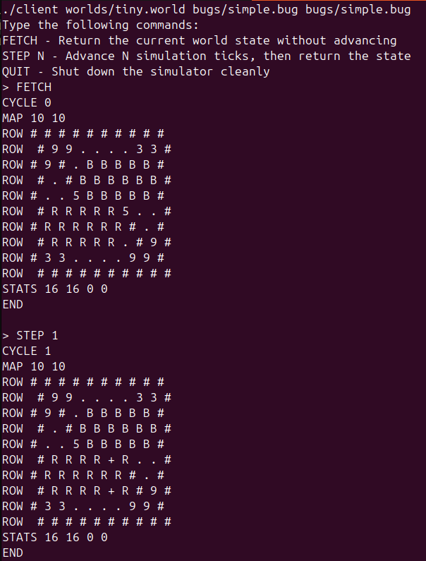

Handover note:
TODO: use QApplication for GUI implementation
#include <QApplication>

Sprint 2 progress:
Sprint 2 focused on improving the simulator class from a console-frontend from previous sprint. Then, extend it to a Qt-based visual frontend. Visualize the bug world dynamically and implement trace lines that fade to show previous bug positions. Also, allow interactive adjustment of trace length. Provide basic simulation controls (Start, Step, Reset) and STAT.

Modification work
- Created Document.docx describing design decisions, test and progress
Code modification:
- added argc validation
if (argc < 4) // argc check
{
cerr << "Usage: ./client <world> <bug1> <bug2> [ticks_per_frame] [fps]" << endl;
return 1;
}
- parsing improvements update parsing ROW:
Fixed ROW parsing to read an entire row of cells instead of only a single cell.
while (line_stream >> cell) // read each cell in the row
{
rowChars += cell; // append to a string (cell)
}
- Cleaner simulator shutdown
Avoided force kill in destructor
if (cmd_fd != -1)
{
string quit = "QUIT\n";
write(cmd_fd, quit.c_str(), quit.length());
close(cmd_fd);
}
if (sim_pid > 0)
{
// kill(sim_pid, SIGTERM);
waitpid(sim_pid, nullptr, 0); // Wait for simulator process to exit
}
- Read loop simplification
Modified readResponse to cleaner read loop: No usleep, No EAGAIN.

Qt GUI setup
To build and run the Qt frontend, Qt 5 development tools are required.
Install Qt 5 development packages and tools:
sudo apt update
sudo apt install qtbase5-dev qttools5-dev-tools
Reminder: add appropriate “include paths” so QHeader files (QPoint, QWidget, etc.) are found.

Visual front-end features
Build and test:
make clean
qmake
make
./client worlds/tiny.world bugs/stupid.bug bugs/beetle.bug 5 7

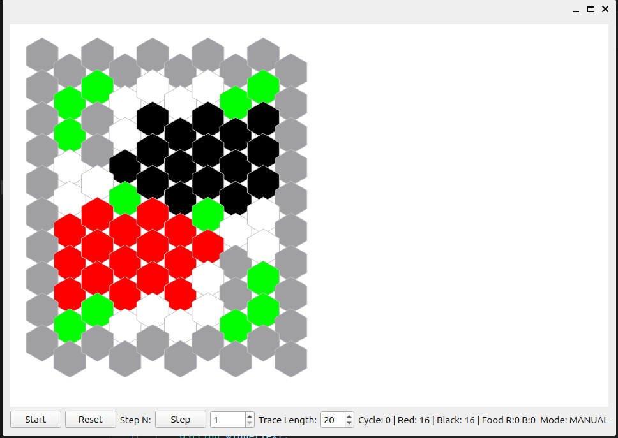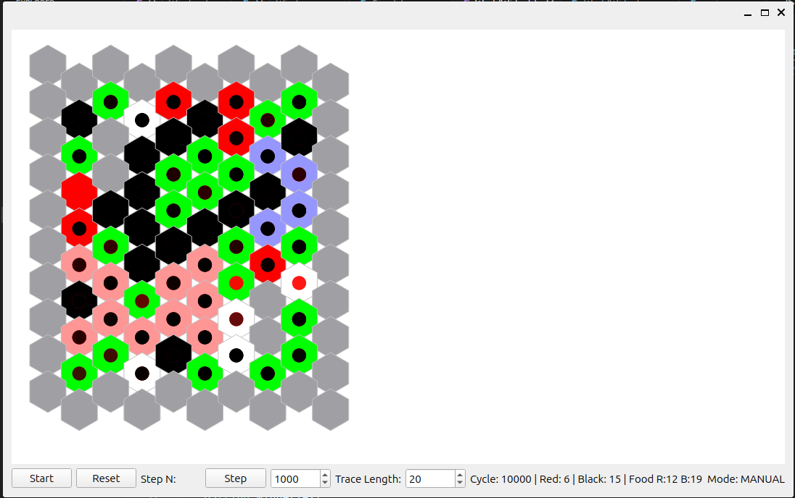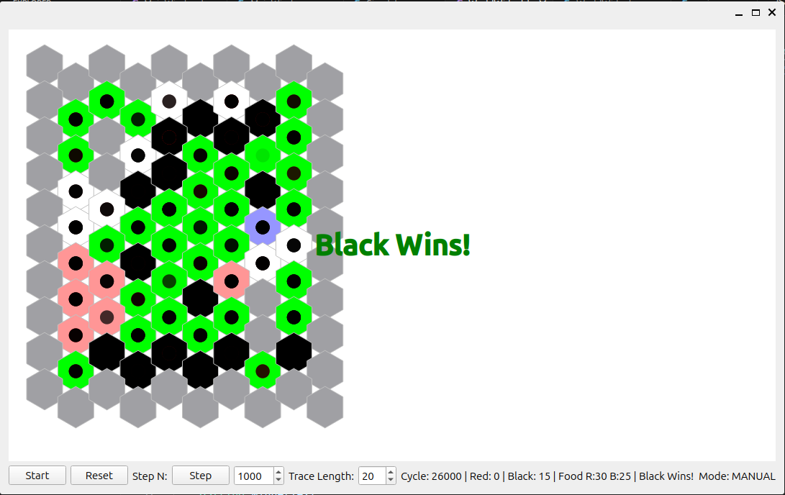
make clean
qmake
make
./client worlds/cross.world bugs/stupid.bug bugs/beetle.bug
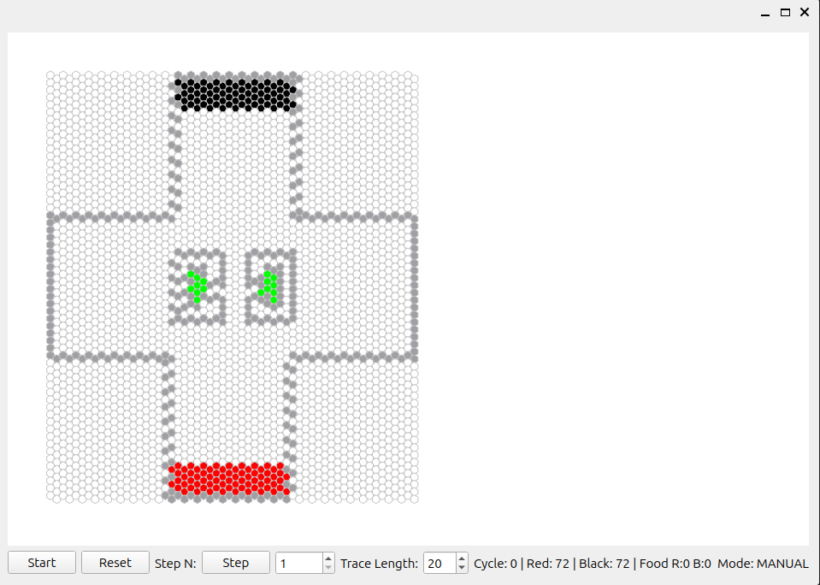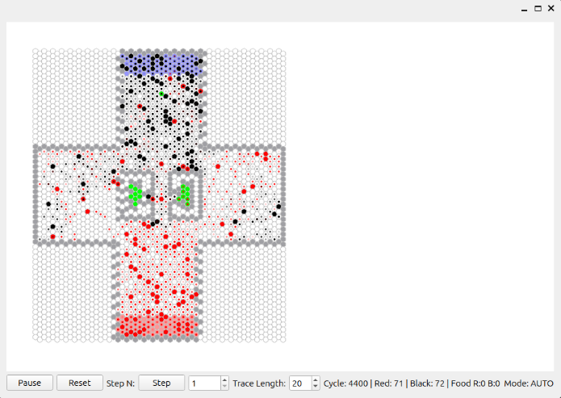

What will happen:
World Visualization
- A dynamically scaled hexagonal grid, which depends on the world file
- Walls gray
- Food green
- Black Team:
  - Black hexagon → Black bug
  - Blue hexagon → Black home base
  - Black dots → Trace history of black bugs
- Red Team
  - Red hexagon → Red bug
  - Pink hexagon → Red home base
  - Red dots → Trace history of red bugs
Trace Lines with Fading
- The last N positions of each bug are stored in Trace length
- These positions are drawn as small dots
- The most recent position is fully opaque
- Older positions gradually fade out

Interactive Controls for simulation:
A toolbar at the bottom of the window provides interactive controls.
Start / Pause
- Starts automatic stepping using a timer
- Mode indicator switches between:
  - Mode: AUTO
  - Mode: MANUAL
- AUTO mode repeatedly sends:
- STEP ticks_per_frame
Reset
- Stops simulation
- Restarts the simulator process
- Clears trace history
- Reloads initial world state
Step N
Stops AUTO mode N range: [1, 10000]
Trace Length Control
Default trace length: 20 Range: [0, 200]

Simulation Status Display
The bottom toolbar displays:
- Current cycle number
- Number of red bugs alive
- Number of black bugs alive
- Food collected by each team
- Winning bug
- Mode indicator
Example:
Cycle: 120 | Red: 8 | Black: 5 | Food R:3 B:4 Mode: AUTO
if a team wins:
Cycle: 120 | Red: 0 | Black: 5 | Food R:3 B:4| Black wins! Mode: MANUAL

TESTING
To ensure the correctness of the visual frontend, unit test suites were implemented using the Qt Test. The testing approach focuses on:
- Verifying correct initialization of core components
- Ensuring stable runtime behavior
- Testing edge cases

Test Structure
tests/
├── test_sim/
├── ├── test_sim.pro
├── test_tgt/
├── ├── test_tgt.pro
├── test_world/
├── ├── test_world.pro
├── test_simulator.cpp
├── test_worldwidget.cpp
└── test_together.cpp
Build test target in test:
cd test
cd test_sim
make clean
qmake
make
./test_simulator
cd test_world
make clean
qmake
make
./test_worldwidget
cd test_tgt
make clean
qmake
make
./test_together
if error in “make”, try “make distclean” and redo qmake.
Expected output:
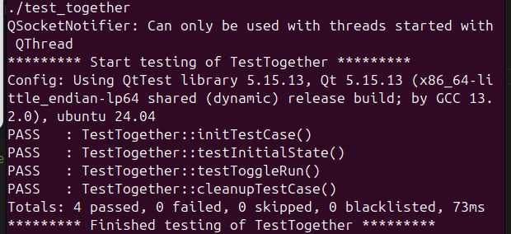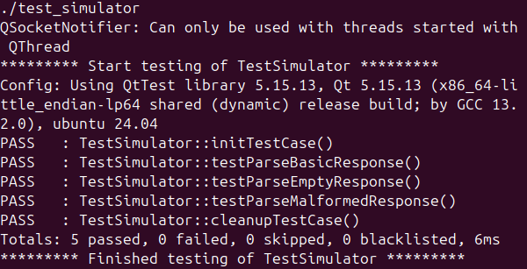
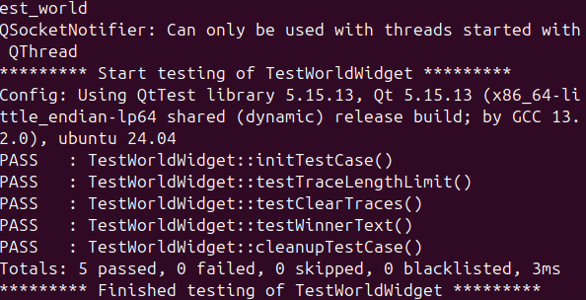

Simulator Tests (test_simulator.cpp)
testParseBasicResponse() verifies:
- parsing of CYCLE
- MAP dimensions
- STATS
- row collection
testParseEmptyResponse() verifies:
- default values are preserved
- parser doesn't corrupt state
testParseMalformedResponse()
- Handling of invalid or malformed responses
Key Edge Cases Tested:
- Simulator returns incomplete data
- Simulator process fails to open
- Unexpected cycle values
- Zero bugs alive

WorldWidget Tests (test_worldwidget.cpp)
To verify correct behavior of visualization logic without relying on the simulator.
testTraceLengthLimit() verifies:
- Ensure that trace history does not exceed the specified length
testClearTraces() verifies:
- Trace length = 0 clears history
testWinnerText() verifies:
- Winner display can be set and cleared safely
Key Edge Cases Tested:
- Zero trace length
- Empty world state
- Reset behavior clears traces correctly

Integrated GUI Test (test_together.cpp)
To verify that the full system initializes without crashing and behaves correctly.
testInitialState() verifies:
- MainWindow initializes correctly in test mode
testToggleRun() verifies:
- toggling run mode starts and stops the timer as expected

Test Mode Design
When testMode = true:
- openSimulator() is NOT called
- No named pipes are created
- No external process is launched
- No FETCH or STEP commands are sent
- No QUIT command is sent
This directly addresses runtime behavior consistency.

Runtime Behavior Verification
Manual Mode
- STEP N increases cycle by exactly N
- Auto mode is stopped when manual step is triggered
- Step range is restricted to [1, 10000]
Auto Mode
- Timer advances simulation periodically
- Mode indicator updates correctly
- Simulation stops when one team dies
Reset
- Simulator restarts correctly
- Traces are cleared
- Stats reset to initial state
- No memory leak or crash occurs

Edge Case
Cases | code | result
Step Range Boundary | stepSpin->setRange(1, 10000) | STEP range prevent step = 0 and prevent overflow values (<=10000)
Trace length = 0 | traceSpin->setRange(0, 200);  int alpha = traceLength > 0 ? 255 - (i * 255 / traceLength) : 0; | prevents division by zero
Stop When One Team Dies | if (state.redAlive == 0 || state.blackAlive == 0) | Display "Black Wins!", if R=0  Display “Red Wins!”, if B=0
Test Mode | if (!isTestMode) | Prevent Simulator launch during tests

Handover notes:
Things can be improved:
Set simulation steps: Setting a maximum simulation cycle limit
a possible issue with the unfair scoring: when the red bug brings food back to the home base, the points don’t seem to be updated correctly.
tournament (not implemented yet)

Document log:
Sprint | Date | Member
1 | Mar 12, 2026 | Alizada, Zaur  Choi, Kyu In | Created main.cpp and Simulator.cpp  Pipe handling
2 | Mar 24,  2026 | Sin, Wai Huen  Dauti, Erza | Created Document.docx  Created visual frontend (worldWidget, MainWindow)  Added unit test suite
3

