github extension (remote ssh)
remote ssh

need push and pull (choose activite clone) – push off

we need ranking.
what I have done:
download all files
wget -r -np -nH --cut-dirs=1 https://teaching.peter-baumann.org/worlds/
wget -r -np -nH --cut-dirs=1 https://teaching.peter-baumann.org/bugs/
wget -r -np -nH --cut-dirs=1 https://teaching.peter-baumann.org/bin/
wget --no-check-certificate -r -np -nH --cut-dirs=3 https://teaching.peter-baumann.org/~pbaumann/BugWorld/docs/
Otherwise they will not execute (asm/sim):
cd bin
chmod +x sim
chmod +x asm
created two pipes:
mkfifo cmdpipe
mkfifo datapipe
then create main.cpp for creating pipes in /tmp:
why? pipes are runtime-only files
what the program does? mkdir mkfifo exit
try if works:
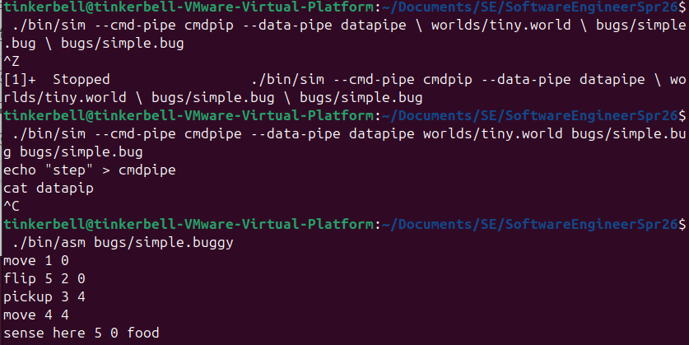

start working on Cpp:
main.cpp

bug world
Objective: Visual game interface
showing the state of the map at each tick
bug program
tournament – winner ranking – grades for that sprint
Goal of the bugs is to collect food and bring it to their own home (red/black). The best swarm is the one with the most food in its home base after a given amount of time (i.e., simulation steps). Hunting for food is competitive, and bugs may kill each other.
Complexity: different shapes and obstacles for each game
Bug brain is in finite state automaton
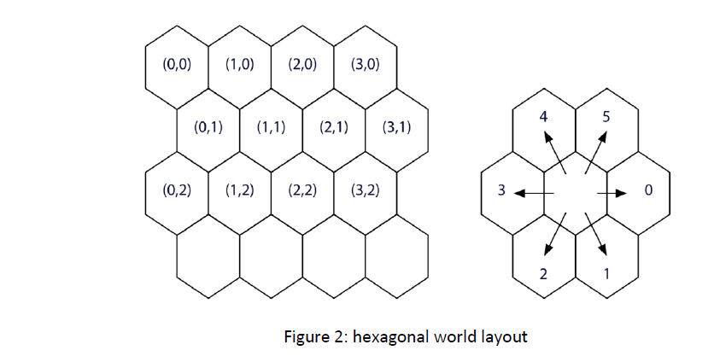
Bug can stay or move
A free cell can simultaneously contain:
- One bug at most
- A non-negative number of food packages
- Markers from each swarm.

Several functions serve to read and set a cell state:
- Occupied(pos): true if cell at pos contains a bug
- Bug_at(pos): returns the bug sitting at position pos
- Place(pos,b): assign bug b to position pos
- Free(pos): clear cell at position pos from bugs

A bug can carry at most one food package at a time.
These functions manage food:
- food_at (pos): return the number of food units in the cell at position pos
- set_food_at(pos,n): set cell at position pos to hold n food units

Each bug swarm has a homebase, its nest. Corresponding functions are:
- base_at(pos,c): returns true if cell at position pos is part of the nest of the swarm with color c
- other_base_at (pos,c): returns true of cell at pos belongs to the adversarial nest

• sim = the game engine (already built)
• asm = the compiler for bug programs
• worlds/ + bugs/ = input files
• client/ = YOUR job

