Your Friendly Neighbourhood
Software and Data Requirements Specification
A two-iteration implementation plan for a renter-focused Greater Melbourne SA2 comparison website.

Document | Value
Version | 1.0
Status | Proposed baseline for team approval
Date | 6 September 2026
Project | Your Friendly Neighbourhood
Primary audience | Renters unfamiliar with Melbourne
SDG | Goal 11 Sustainable Cities and Communities
Delivery model | Two iterations using GitHub and Render

Decision requested from the team: approve the scope, datasets, formulas, schema and Iteration 1 acceptance conditions before development begins.

1 Purpose and baseline
This specification replaces earlier UrbanLens Melbourne and planner-focused requirements. The approved product name is Your Friendly Neighbourhood and the primary user is a renter who is unfamiliar with Melbourne, including a new immigrant, international student or interstate migrant. The three current wireframes are the Iteration 1 user-interface baseline.

1.1 Product objective
Provide a simple starting point for comparing two or three Greater Melbourne Statistical Areas Level 2 using rent, public transport access, recent population change and green-space provision. The product helps users identify trade-offs and decide which areas to investigate further.

1.2 Product boundaries
- The product compares SA2s, not individual properties or exact suburb boundaries.
- It does not rank areas or recommend a best place to live.
- It does not provide financial, tenancy, safety or migration advice.
- It requires no login and stores no personal information.
- It does not include a map in either iteration unless the team formally changes the approved scope.
- Source years, calculations, missing data and limitations must remain visible.

1.3 Primary user needs
- Search for a familiar Melbourne area name and recognise its corresponding SA2.
- Compare the same measures across two or three areas.
- Understand what each value means without statistical expertise.
- See recent population change and evidence behind each result.
- Continue external research before making a rental decision.

1.4 Success measures
- A test user can complete Home to Compare to Area Details without assistance.
- A test user can identify at least one meaningful trade-off between two SA2s.
- Every displayed value has a source, reference period, unit and plain-language explanation.
- No critical calculation, API, accessibility or deployment defect remains at release.

2 Iteration scope
Each iteration must be a usable, deployed product. Because the approved Iteration 1 wireframes display all four indicators, Iteration 1 requires the complete baseline data pipeline rather than population and housing alone.
Area | Iteration 1 baseline | Iteration 2 improvement
Pages | Home, Compare Areas and Area Details | Refine the same journey; add no new page unless justified by testing
Coverage | Eligible Greater Melbourne SA2s with sufficient source coverage | Resolve coverage gaps and improve area-name search
Comparison | Select and compare two or three SA2s | Improve responsive comparison and change selected areas more easily
Indicators | Median weekly rent, transport score, recent population growth and green space per resident | Improve explanations, quality flags and trend presentation
Evidence | Source, year, unit and limitation for each result | Method version, data freshness and richer source detail
Quality | Core functional, data, API and accessibility tests | Broader device, usability, performance and security testing
Deployment | Public Render deployment from GitHub | Harden CI/CD, monitoring, recovery and release documentation

2.1 Out of scope
- User accounts, saved favourites, forums, reviews or personal profiles.
- Property listings, rental applications, route planning or live transport information.
- Machine-learning forecasts, neighbourhood rankings or a combined overall score.
- Redis, a writable production database or runtime modification of the packaged SQLite file.

2.2 Required iteration sequencing
1. Freeze field definitions, formulas, source versions and eligible-area rules.
2. Build and validate the complete offline data pipeline.
3. Populate the read-only SQLite database and agree the API response contract.
4. Build the three pages against sample JSON, then connect the real API.
5. Deploy a complete Iteration 1 journey and collect feedback.
6. Use feedback and test evidence to select Iteration 2 refinements.

3 Functional requirements

3.1 Home page
ID | Requirement | Acceptance condition
FR-01 | Present the project name, renter-focused purpose and SA2 boundary warning. | Content matches the approved Home wireframe and is readable on desktop and mobile.
FR-02 | Search eligible Greater Melbourne SA2s by area name. | Results appear for partial, case-insensitive input and show unique SA2 names.
FR-03 | Start a comparison from the selected area. | The selected SA2 is carried to the Compare page.
FR-04 | Show four comparison categories. | Rent and housing, public transport, population change and green space are present.

3.2 Compare Areas page
ID | Requirement | Acceptance condition
FR-05 | Add or remove SA2s and compare two or three areas. | Duplicate areas are prevented and a maximum of three is enforced.
FR-06 | Show each area using identical measures and units. | Each selected SA2 displays rent, transport, population growth and green-space values.
FR-07 | Explain each comparison measure. | The What it means column uses concise, consistent wording.
FR-08 | Represent missing values honestly. | Missing or insufficient data displays Not available and never displays zero by substitution.
FR-09 | Open Area Details for a compared SA2. | The correct SA2 code is used and the comparison can be revisited.

3.3 Area Details page
ID | Requirement | Acceptance condition
FR-10 | Show the selected SA2 identity and boundary disclaimer. | The page displays the requested SA2 code/name and explains that SA2 is not necessarily a suburb.
FR-11 | Show four indicator cards. | Each card displays value, unit, reference period, source and interpretation.
FR-12 | Show recent annual population values as a trend. | The chart uses real years and values; a five-year change uses 2020 to 2025, including six annual observations.
FR-13 | Provide navigation back to comparison. | The user can return without losing valid selected areas.

3.4 Supporting information
ID | Requirement | Acceptance condition
FR-14 | Explain how the product works in plain language. | A short explanation covers SA2 selection, relative transport scores and limitations.
FR-15 | Present data-source information. | Publisher, dataset, reference period, URL, licence and key limitation are available.
FR-16 | Do not imply personal suitability. | All comparison and details views state that results are a starting point, not a recommendation.

4 Data sources and acquisition plan
The team should download and inspect all five sources at the beginning because transport and green-space preparation depend on compatible SA2 geometry. Raw files remain unchanged and are not served to website users.
ABS Regional Population 2024-25
File: 32180DS0003_2001-25.xlsx
Use: SA2 annual estimated resident population, 2020-2025, growth calculation and chart.
Limitation: Estimates may be revised; reference years and release must be recorded.
Source and download page
ABS 2021 Census General Community Profile for Victoria SA2
File: 2021_GCP_SA2_for_VIC_short-header.zip; use G02 Selected medians and included metadata
Use: SA2 median weekly rent for the baseline housing measure.
Limitation: This is 2021 reported rent, not a current advertised market rent. UI wording must say so.
Source and download page
DataVic Public Transport Accessibility Level Melbourne metro
File: PTALmetro SHP package
Use: Spatial PTAL values aggregated to SA2 and converted to a relative transport score.
Limitation: Area-weighted results may under-represent where residents actually live within large SA2s.
Source and download page
DataVic Metropolitan Melbourne Open Space
File: Open Space GeoJSON, with SHP as fallback
Use: Eligible open-space polygons intersected with SA2s to calculate square metres per resident.
Limitation: The dataset is not maintained and includes restricted or private land; category filtering is mandatory.
Source and download page
ABS Statistical Areas Level 2 2021 boundaries
File: SA2_2021_AUST_SHP_GDA2020.zip
Use: Greater Melbourne filtering and offline spatial intersection for PTAL and open space.
Limitation: Use the 2021 boundary edition to match Census and Regional Population geography; do not mix with 2026 SA2 codes.
Source and download page

4.1 Required data fields
Dataset | Fields retained after review
SA2 | SA2 code, SA2 name, GCCSA code/name, area square kilometres, geometry during processing
Population | SA2 code, year, estimated resident population for 2020-2025
Census | SA2 code, median weekly rent, reference year
PTAL | Geometry, PTAL numeric value/category, dataset year
Open space | Geometry, category, access/ownership classification, dataset year

5 Data preparation plan

5.1 Repository data zones
Zone | Purpose | Repository treatment
raw | Original downloads preserved unchanged | Exclude large source files from Git; retain download manifest, licence and checksum
staging | One cleaned, source-specific CSV or Parquet file | Generated output; useful for inspection and debugging
curated | One consistent SA2-level indicator dataset plus population history | Generated and validated before database load
database | Read-only SQLite application database | Package with backend if within repository size limits

5.2 Processing workflow
1. Register each source URL, filename, licence, download date, reference period and checksum.
2. Profile columns, types, missing values, duplicates, suppressed values, geometry validity and coordinate systems.
3. Standardise names and types. Preserve SA2 codes as text so leading zeroes cannot be lost.
4. Filter the 2021 SA2 boundary layer to Greater Melbourne using GCCSA code/name.
5. Reproject spatial layers to a suitable projected coordinate system for area calculations.
6. Intersect PTAL and eligible open-space polygons with SA2 boundaries and calculate coverage measures.
7. Dissolve overlapping open-space polygons before summing area to avoid double counting.
8. Join source-specific results through 2021 SA2 code and calculate the approved indicators.
9. Assign null and a data-quality status where evidence is missing or coverage is insufficient; never substitute zero.
10. Load the curated results into a newly created SQLite database using parameterised bulk operations in a transaction.
11. Run validation tests and compare a sample of SA2 results with the original files.

5.3 Repeatability
The pipeline must be executable by documented Python commands and produce the same database from the same source versions. Scripts should be source-specific, testable and idempotent. Manual spreadsheet editing must not be part of the production workflow.
Suggested command | Purpose
python scripts/profile_sources.py | Generate source structure and data-quality summaries
python scripts/prepare_population.py | Create annual SA2 population staging data
python scripts/prepare_census.py | Create SA2 rent staging data
python scripts/prepare_ptal.py | Create SA2 PTAL aggregation
python scripts/prepare_open_space.py | Create SA2 open-space aggregation
python scripts/build_database.py | Validate curated data and recreate SQLite

6 Business logic

6.1 Eligible area universe
- Use 2021 SA2 codes whose GCCSA is Greater Melbourne.
- Exclude non-spatial special-purpose records and areas with zero population.
- Retain an area only when its identity and population are valid; individual indicators may still be null.
- Calculate percentiles against the same eligible-area universe and record the method version.

6.2 Indicator rules
Indicator | Displayed calculation | Display rule
Median weekly rent | 2021 Census median weekly rent for the SA2 | Show dollars per week and 2021. Do not label as current advertised rent.
Recent population growth | ((ERP 2025 - ERP 2020) / ERP 2020) x 100 | Show percentage, start/end years and annual values from 2020 through 2025.
Transport access | Area-weighted mean PTAL, then percentile rank across eligible SA2s | Round score to integer 0-100 and show rating plus source year.
Green space per resident | Eligible public open-space square metres intersecting the SA2 / ERP 2025 | Show square metres per person and source/population years.

6.3 Transport ratings
Score | Rating | Meaning
0-24 | Limited access | Lower relative PTAL result among eligible Greater Melbourne SA2s
25-49 | Moderate access | Below the middle of the eligible comparison set
50-74 | Stronger access | Above the middle of the eligible comparison set
75-100 | Very strong access | Highest relative PTAL result within the eligible comparison set

6.4 Data-quality rules
- Missing, suppressed, invalid or insufficient-coverage values are null, not zero.
- Every API result includes source year and quality status: available, limited or unavailable.
- Transport scores are relative and must not be presented as travel time or service frequency.
- Green-space area excludes categories the team cannot justify as publicly accessible.
- No overall neighbourhood score is calculated.
- Formulas and thresholds are versioned and tested with known examples.

7 Recommended SQLite schema
The schema separates area identity, reusable indicator metadata, observations, population history and provenance. A database view provides the simple record shape required by the API.
Table | Key fields | Purpose
area | sa2_code PK; sa2_name; gccsa_code; gccsa_name; area_sq_km; is_eligible | Area search and identity
area_alias | alias PK; sa2_code FK | Optional suburb/locality search aliases added in Iteration 2
indicator | indicator_key PK; label; unit; explanation; method_version | Consistent definitions and UI wording
area_indicator | sa2_code FK; indicator_key FK; raw_value; score; rating; start_year; end_year; source_id; quality_status | Current display values per SA2
population_history | sa2_code FK; year; population; source_id | Area Details trend chart
data_source | source_id PK; publisher; dataset_name; url; licence; reference_period; downloaded_at; limitation | Traceability and Data page
pipeline_run | run_id PK; built_at; method_version; source_manifest_hash; validation_status | Reproducibility and release audit

7.1 Constraints and indexes
- Store SA2 codes as TEXT and enforce foreign keys.
- Use a unique constraint on area_indicator(sa2_code, indicator_key).
- Use a unique constraint on population_history(sa2_code, year).
- Index area(sa2_name), area_alias(alias) and all foreign-key columns.
- Add checks for scores between 0 and 100, positive population, and valid quality-status values.
- Expose a view named v_area_summary containing the four wireframe values and their years.

7.2 Database build policy
SQLite is rebuilt offline and deployed as a read-only artefact with FastAPI. The application performs SELECT operations only. Use parameterised bulk inserts or SQLAlchemy/Pandas loading inside a transaction; do not construct SQL by joining strings.

8 API and user interface contract
Endpoint | Purpose | Key response content
GET /api/v1/areas?query= | Home and Compare search | SA2 code, name and optional matched alias
GET /api/v1/compare?sa2=code1,code2,code3 | Comparison table | Four values, scores/ratings, years, units and quality statuses
GET /api/v1/areas/{sa2_code} | Area Details | Area identity, four indicators, population history, sources and limitations
GET /api/v1/sources | Data information | Publisher, dataset, reference period, URL, licence and limitation
GET /health | Deployment monitoring | Service status and database readiness without sensitive details

8.1 API rules
- Version endpoints under /api/v1 and return JSON over HTTPS.
- Allow two or three unique valid SA2 codes for comparison; reject invalid input with clear 4xx responses.
- Return null with quality status and explanation for unavailable values.
- Use consistent field names, units and rounding across comparison and details responses.
- Do not expose filesystem paths, SQL errors, stack traces or configuration secrets.

8.2 Frontend rules
- Use JavaScript, Vue, Nuxt.js and Tailwind CSS; Node.js is the build tool.
- Generate and serve the frontend as a static site from Render's CDN.
- Match the approved wireframe structure before adding visual decoration.
- Provide loading, empty, invalid-search, partial-data and API-error states.
- Avoid a methodology section in the main renter journey; explain only what users need and provide supporting data information separately.

9 Architecture deployment and quality

9.1 Deployment architecture
- GitHub is the source repository and CI/CD trigger.
- Render Static Site builds and serves the Nuxt frontend.
- Render Web Service runs Python FastAPI and reads the packaged SQLite database.
- The browser loads static assets and requests JSON from FastAPI over HTTPS.
- The Python preparation pipeline runs before deployment, not during a renter request.
- Render services are configured separately, preferably through render.yaml after the initial deployment is proven.

9.2 Non-functional requirements
Quality area | Minimum requirement
Security | HTTPS; strict production CORS origin; GET-only public API; input validation; dependency scanning; no secrets in Git; safe errors; security headers
Privacy | No login, cookies for profiling, personal data entry or retention; analytics must be privacy-conscious and disclosed if enabled
Accessibility | Target WCAG 2.2 AA; keyboard navigation; visible focus; semantic headings/tables; labels; adequate contrast; chart values available as text
Performance | Static assets through CDN; compact JSON; database indexes; comparison response target under one second after warm-up
SEO | Unique title and description, canonical URL, sitemap/robots configuration and meaningful static content; comparison results need not be indexed
Reliability | Health endpoint, startup database check, graceful API error states and documented Render free-tier cold-start procedure
Maintainability | Documented setup, consistent formatting, modular source-specific pipeline scripts, API versioning and code review

9.3 Testing requirements
Test level | Required coverage
Data | Schema, duplicates, nulls, ranges, spatial validity, aggregation coverage, formula examples and source-to-output spot checks
Backend | Endpoint success, validation errors, unknown SA2, partial data, database unavailable and consistent response schema
Frontend | Search, selection limits, remove area, compare, details navigation, loading/error/empty states and responsive layouts
Accessibility | Keyboard-only journey, automated scan, headings, form labels, focus order, contrast and table/chart alternatives
End to end | Deployed Home to Compare to Area Details journey using at least two known SA2s
Security | CORS, headers, malformed parameters, dependency audit, secrets review and absence of write endpoints

10 Acceptance and team decisions

10.1 Iteration 1 definition of done
- All three approved wireframes are implemented and deployed.
- Two or three eligible SA2s can be searched, selected and compared.
- All four indicator categories use real processed data or a clearly marked unavailable state.
- Area Details shows real annual population history and source information.
- The data pipeline rebuilds SQLite from documented source versions and passes validation.
- API, UI, accessibility, security and end-to-end acceptance tests pass without critical defects.
- Trello contains scope, user stories, acceptance criteria, ownership, evidence and status.

10.2 Iteration 2 candidate backlog
- Improve area searching with reviewed locality-to-SA2 aliases.
- Improve mobile comparison and accessibility based on user testing.
- Add clearer data-quality flags and method/source explanations.
- Automate source-version checks and database validation in GitHub Actions.
- Review whether a more recent rent source can be mapped to SA2 without misleading precision.
- Review a maintained green-space replacement; retain the existing source only with a clear date limitation.
- Add privacy-conscious aggregate analytics only if the team approves a defined evaluation need.

10.3 Decisions to finalise before coding
Decision | Recommended baseline
Geography | 2021 SA2 and Greater Melbourne GCCSA
Housing measure | 2021 Census median weekly rent, explicitly dated
Population window | 2020-2025 with six annual observations
Transport method | Area-weighted PTAL mean converted to 0-100 percentile
Open-space eligibility | Count only categories agreed as publicly accessible; record the filter list
Iteration 1 scope | All four wireframe indicators and all three pages
Database delivery | Reproducibly generated read-only SQLite packaged with FastAPI
Hosting | Render Static Site plus Render Web Service

10.4 Key risks
Risk | Treatment
Source-year mismatch | Display years per indicator; do not imply a single current snapshot
SA2/suburb confusion | Use SA2 consistently and display the boundary disclaimer
Open-space source is unmaintained | Apply transparent filters, show source date and review replacement in Iteration 2
Ratings appear prescriptive | No overall score; describe transport as a relative dataset result
Spatial processing delays | Prototype two known SA2s first, then run the same automated pipeline across Greater Melbourne
Render cold start during demonstration | Warm the service before presentation and document a recovery check

Appendix A Wireframe baseline
These wireframes define the Iteration 1 page structure. Visual styling may improve, but visible fields, explanations and primary actions must not be removed without team approval.
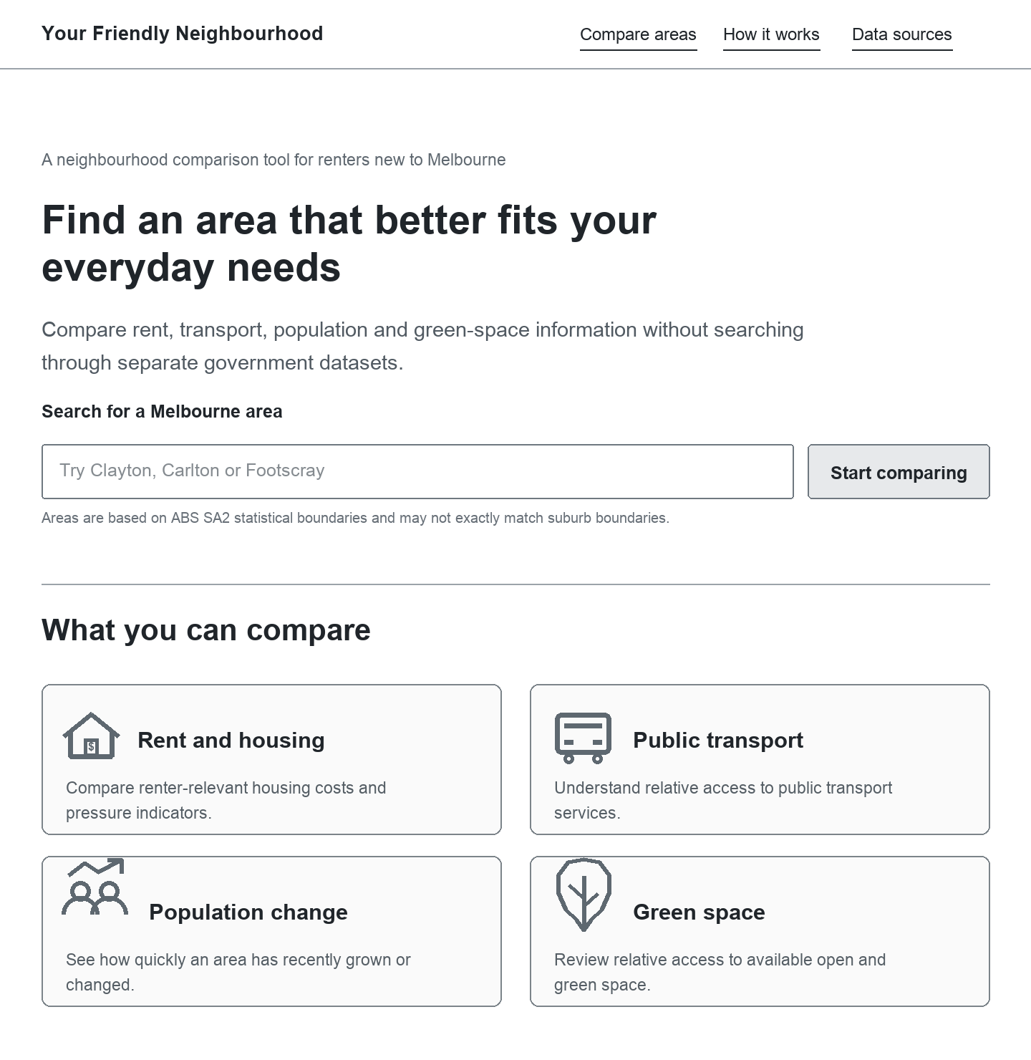
Figure A1 Home page wireframe

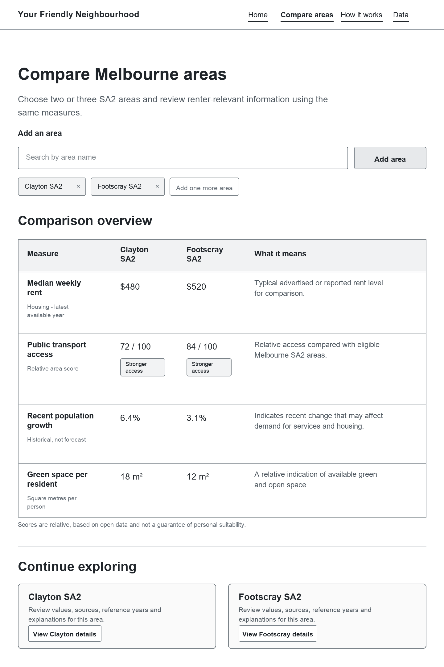
Figure A2 Compare Areas page wireframe

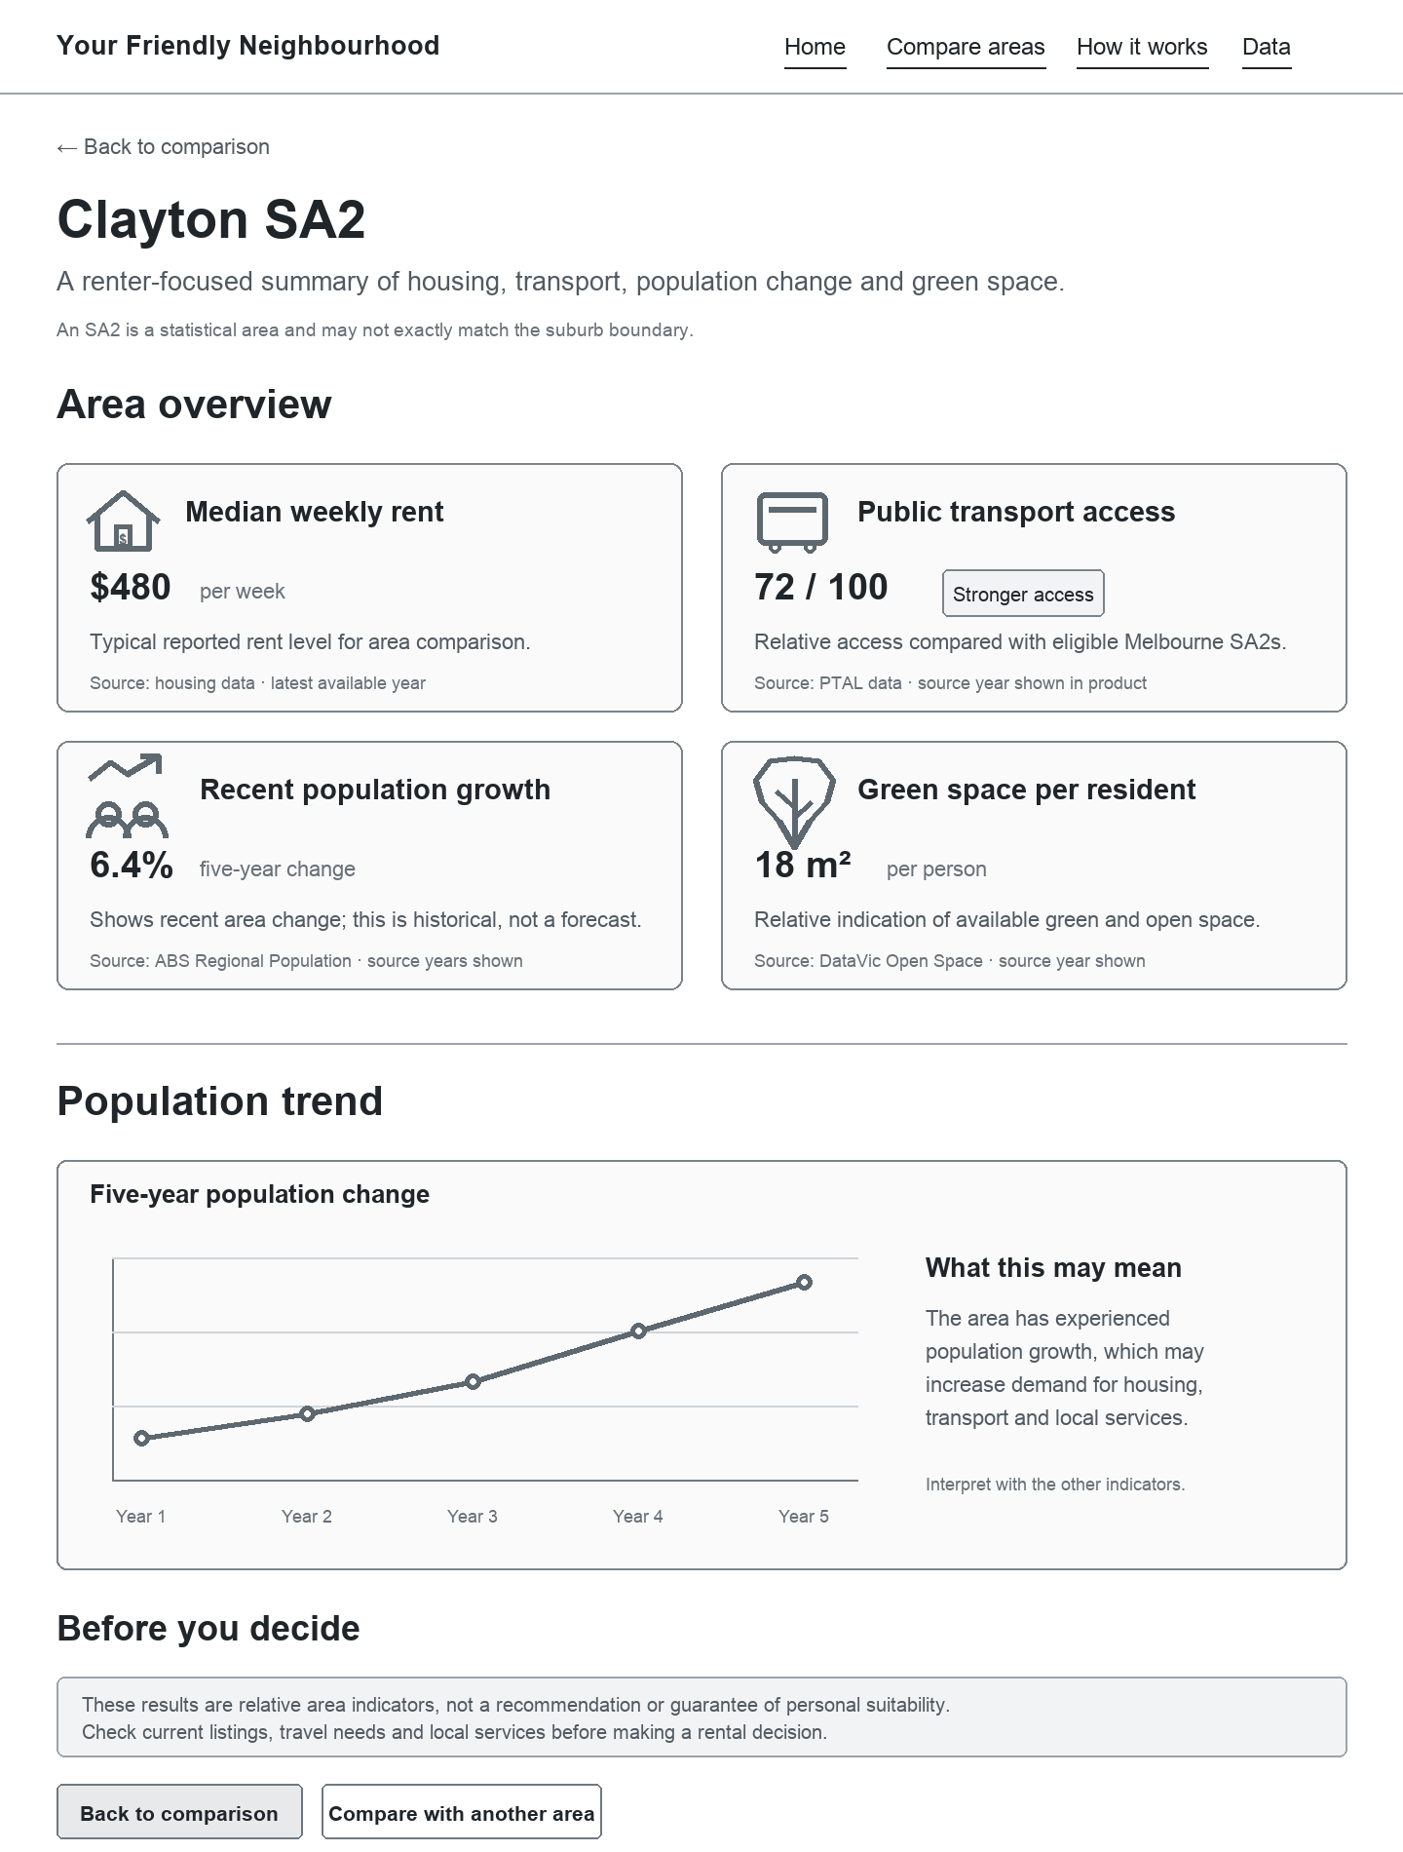
Figure A3 Area Details page wireframe

